

M-Government Service Quality and Customer Satisfaction:
A Study in United Arab Emirates

Doctor of Business Administration Dissertation

By
Hajar Saeed Hamad Al Hubaishi

In Partial Fulfillment
of the Requirements for the Degree
of Doctor of Business Administration

Abu Dhabi University
College of Business Administration

Abu Dhabi, UAE
October 12, 2016

M-Government Service Quality and Customer Satisfaction:
A Study in United Arab Emirates

_________________________
Hajar Saeed Hamad Alhubaishi

Approved:

_________________________
Syed Zamberi Ahmad, PhD
Associate Professor, College of Business Administration
Abu Dhabi University
Committee Chair

_________________________
Matloub Hussein, PhD
Associate Professor, College of Business Administration
Abu Dhabi University
Committee Member

_________________________
Robert Buchanan, PhD
Associate Professor of International Business
Indiana University of Pennsylvania
Committee Member

_________________________
Dr. Jacob Chacko
Dean, College of Business Administration
Abu Dhabi University

Copyright Information

I hereby declare that this dissertation constitute original work. Permission had been requested and granted by the author for all the material used in data collection. To my knowledge I had referred to all articles used in this dissertation and I had taken all the precautions to observe the copyrights of others.

© Copyright 2016 by
Hajar Saeed Hamad Al Hubaishi

All rights reserved

Hajar Saeed Hamad Al Hubaishi

i

Acknowledgment
I start by thanking God for giving me strength throughout my study journey. It was not an easy time; there were moments when I felt sad and frustrated, but there were always individuals who encouraged me and turned these moments into happy times. I am thankful to my family, professors, friends, and colleagues who supported and encouraged me through this journey.

I thank my supervisors, Drs. Syed Zamberi Ahmad and Matloub Hussein, for advising me and being patient throughout my study. They shared their expertise in research and pointed me in the right direction. They encouraged me to always keep writing and not stop. I acknowledge contributions from my external committee Dr. Robert Buchanan for constructive feedback, and I appreciate contributions from Dr. Chowdhury Hossan for his assistance during statistical analyses.

I am grateful to my manager, His Excellency Saeed Saif Al Matrooshi. I consider him a family member as my father and brother. No words can express my thanks to him for all his support and help; it is countless. He always approved my educational leave to complete my dissertation. Sometimes I felt lost about something technical regarding mobile fields, and he was most patient with me while explaining it simply. I am also thankful to my manager, His Excellency Sultan Faisal Al Rumaithi. He gave me all the time I needed to complete my study, and never hesitated to give advice. He shared ideas with me so we both felt encouraged to finish our study.

I thank all my friends, but there were also friends like sisters who walked with me closely and made this journey enjoyable. We celebrate each successful moment. Thanks for always being there.

Finally, and the most importantly, I am greatly blessed to have a faithful family. Without their support, this journey might not have been completed. This dissertation is dedicated to the memory of my father, Saeed Hamad Alhubaishi, who passed away while I pursuit my Master’s degree. He was very proud that I had the passion to complete and accomplish a higher level of education. Special thanks go to my lovely brothers for their encouragement. I express deep appreciation and special thanks to my Mom, “my life”. Without her, I would not have been able to finalize my research project. She gave me support and love through the entire doctoral program. She believed in me and cheered me constantly. I appreciate her tolerance for my continued absences from home and family gathering events while working on my dissertation. Thanks, Mom, for your prayers and encouragement, and helping me in so many ways. I love you.

M-Government Service Quality and Customer Satisfaction
A Study in United Arab Emirates

Abstract

Tremendous usability of mobile devices, coupled with their increasingly lower rates, has brought about huge increases in the appeal of public mobile service (m-service). This, in turn, encouraged governments worldwide to deploy community services through this channel. The United Arab Emirates (UAE) government provides m-services to improve delivery of services to citizens. The initiative is called mobile government (m-government). From a research viewpoint, there is need to identify various factors that constitute mobile service quality in UAE, and assess the service regarding customer satisfaction and quality perceptions. This study is backed by a comprehensive review of literature concerning m-government and m-service quality. Service quality models were reviewed, including SERVQUAL and SERVPERF, with a focus on the multi-dimensional and hierarchical model of service quality. Extant literature contains few studies that assess service quality of mobile services in the context of m-government, and no study has been conducted in UAE. This study highlights these gaps in the field, and hence this study was conducted in the context of UAE. The first purpose of this study is to identify and understand factors that influence mobile service quality in the context of m-government from customers' perspectives, including primary and sub-dimensions. Second, it examines factors of interaction, environment, information, system, network, and outcome quality that influence m-government service quality in UAE. Third, it determines the relationship between quality of m-government service and customer satisfaction. Finally, it investigates the role of perceived switching costs as an integral part of the m-government service quality and customer satisfaction relationship. Understanding the time, cost, and effort of switching from traditional ways of getting services to mobile services was necessary to assess the relationship. The result is a multi-dimensional, hierarchical model of m-government service quality. This study used a quantitative design, incorporating a mix of measurement scales for dimensions adapted from various studies. An online questionnaire was developed to collect data from a random sample of 437 m-government services users. Analyses, including reliability, validity, and structural equation modeling (SEM), were conducted using the Statistical Package for the Social Sciences (SPSS) version 18 and LISREL version 8. Findings suggest that interaction quality, environment, information, system, network, and outcome quality correlate positively with m-government service quality. M-government service quality also had a strong, positive correlation with customer satisfaction. Results failed to suggest a direct relationship between perceived switching costs and m-government service quality, but perceived switching costs correlated negatively with customer satisfaction. Thus, the hypothesis that perceived switching costs moderate the relationship between mobile government service quality and customer satisfaction was supported partially. Implications, limitations, and recommendations for future research are included. This study is first in the UAE to define m-government service quality factors (both primary and sub-dimensions) and examine the relationship between m-government service quality and customer satisfaction using SEM, and to explore the role of perceived switching cost in this relationship.

Publication List:

AlHubaishi, H., Ahmad, Z., & Hussain, M. (in press). Exploring mobile government from service quality perspective. Journal of Enterprise Information Management.

AlHubaishi, H., Ahmad, Z., & Hussain, M. (2015, November). The service quality dimensions of mobile government. Paper presented at the International Conference on Organization and Management (ICOM), Abu Dhabi, UAE.

AlHubaishi, H., Hussain, M., & Ahmad, Z. (2015, November). Assessment of SERVQUAL in public organizations of Dubai. Paper presented at the International Conference on Organization and Management (ICOM), Abu Dhabi, UAE.

Table of Contents
Copyright Information 2
Acknowledgment 2i
Abstract iv
Publication List: vii
List of Tables: ix
List of Figures x
Chapter I: Introduction of the Dissertation 1
1.0 Statement of the Problem: 2
1.1 Justification of Research 5
1.2 Research Questions, Research Objectives, and Research Hypotheses: 11
1.3 Research Scope: 14
1.4 Significance of the Study 14
1.5 Research Program: 17
1.6 Structure of the Dissertation: 18
Chapter II: Literature Review and Research Model 20
2.0 Introduction 20
2.1 Literature Review 20
Mobile Government 20
Mobile Government in UAE 22
Service Quality 27
M-Government Service Quality 38
Service Quality and Customer Satisfaction 41
Perceived Switching Cost 43
2.2 Variables, Hypotheses and Research Model 45
Dimensions of Service Quality 45
The Relationship between Service Quality and Customer Satisfaction 64
The Role of Perceived Switching Costs 66
2.3 Conclusion 68
Chapter III: Research Methodology 69
3.0 Introduction 69
3.1 Research Philosophical Assumption 69
3.2 Designing the Questionnaire 71
3.3 Sampling and Data Collection 79
3.4 Data Analysis 81
3.5 Conclusion 81
Chapter IV: Research Results 83
4.0 Introduction 83
4.1 Sample Profile (General Information Questions) 83
4.2 Analysis of Reliability and Validity 85
4.3 Structural Equation Modeling (SEM) 89
4.4 Conclusion 101
Chapter V: Discussion of Results, Implications, and Recommendations 102
5.0 Introduction 102
5.1 Discussion of Results 102
5.2 Theoretical and Practical Implications 110
5.3 Recommendations, Limitations, and Future Research 112
References 114
Appendixes 137
Appendix A: The Questionnaire 137
Appendix B: The Invitation E-mail 153
Appendix C: Covariance Matrix and Correlation Matrix 154

List of Tables:

Table 1.0: Research questions, objectives and research hypotheses 13

Table 2. 0: Key Finding for UAE Rank 23
Table 2. 1: Innovative SERVPERF methodologies 37
Table 2. 2 : Sub Dimensions of Interaction Quality 48
Table 2. 3: Sub dimensions of Environment Quality 51
Table 2. 4: Sub-dimensions of Information Quality 54
Table 2. 5: Sub-dimensions of System Quality 58
Table 2. 6: Sub-dimensions of Network Quality 61
Table 2. 7: Sub-dimensions of Outcome Quality 64
Table 2. 8: Resaeach Hupotheses 68

Table 3. 0: Summary of Research Design 70
Table 3. 1: Construct, Sub dimension, Supporting Literature and its Related Questions 72

Table 4. 0: Description of Samples 84
Table 4. 1: Mobile Service Information - Description of Samples 84
Table 4. 2: Results of Reliability 86
Table 4. 3: Parameter Estimates, t-values, R², Error of Variance, and Incremental Fit Statistics for Interaction Quality 92
Table 4. 4: Parameter Estimates, t-values, R², Error of Variance, and Incremental Fit Statistics for Environment Quality 92
Table 4. 5: Parameter Estimates, t-values, R², Error of Variance, and Incremental Fit Statistics for Information Quality 93
Table 4. 6: Parameter Estimates, t-values, R², Error of Variance, and Incremental Fit Statistics for System Quality 94
Table 4. 7: Parameter Estimates, t-values, R², Error of Variance, and Incremental Fit Statistics for Network Quality 94
Table 4. 8: Parameter Estimates, t-values, R², Error of Variance, and Incremental Fit Statistics for Outcome Quality 95
Table 4. 9: Assessment of Structural Model 1: M-government Service Quality-Parameter Estimates λ, λ Error, and t-values for Pathways Defined in the Structural Model 96
Table 4. 10: Assessment of Structural Model 2: Higher-order Latent Construct with Moderating Effect-Parameter Estimates λ, λ error, and t-values for Pathways Defined in the Structural Model 100

Table 5. 0: Research Questions, Hypotheses, and Results Error! Bookmark not defined.

List of Figures

Figure 1.0: Research Programme 17

Figure 2. 0: Proposed Research Model 67

Figure 3. 0: Research Procedure Outline 82

Figure 4. 0: Assessment of structural model 1—M-government service quality (pathway coefficient for the structural model) 97
Figure 4. 1 : Assessment of structural model 2-Higher-order latent construct with moderating effect (Pathway coefficient for the structural model) 99

Chapter I: Introduction of the Dissertation

Governments worldwide shifted recently to m-government to provide quick, reliable services to citizens. Although Sharma & Gupta (2004) identify that governments are compelled to provide essential services in the form of m-government, it is necessary to further this argument to include the fact that technology is ever-changing and it is necessary for governments to understand developments particularly regarding mobile devices and how people access data and information, and seek new ways to communicate. The UAE government is endeavoring to transfer nearly all of its government services to mobile services, and thus the UAE m-government introduced an initiative called the Centre of Digital Innovation (CODI) (mgovlab.government, 2014). This center provides services for testing and verifying security and functionalities of mobile applications for governmental departments within the UAE and other GCC countries. They ensure that all m-services are secure and reliable (Sutton, 2015). Improving service delivery to customers allows m-governments to use mobile technologies, services, applications, and devices strategically (Malik, Malik, & Ramay, 2013; Sareen, Punia, & Chanana, 2013). Characteristics such as personalization and enhanced accessibility make m-services more user-centric ( Wang, Feng, Fang, & Lu, 2012). Thus, a user-centric approach during design and delivery is necessary due to the diversity of users’ characteristics and the devices used to access m-government services, and to enhance user value (Wang et al., 2012) and achieve customer satisfaction (Akter, D’ambra, & Ray, 2010).

1.0 Statement of the Problem:

The primary responsibility of government is to deliver essential community services such as public health, education, police, ambulance, and utilities (Mohammed Bin Rashid School of Government, 2014). In Arab culture, citizen expectations from governments regarding provision of quality public services are rising (Sareen et al., 2013), and consequently, governments are tapping the convenience offered by Internet and mobile technologies to deliver these services. Worldwide, it is obvious that governments are trying tremendously and investing significant financial resources to provide community services through cellular devices. The reason for this transfer from traditional to m-services is that a huge percentage of the world’s population is widely using mobile phones. M-government enables governmental departments to reach out to citizens instead of citizens having to reach out to the government. This is due to large-scale use of cellular devices and that governments expect that the influence of the transition will be overwhelmingly positive (Belong interactive, 2013). The significance of these services cannot be underestimated since these represent fundamental facilities that governments have committed to provide to citizens. In addition to the degree of comfort extended to citizens through these services, applications that will be used to provide the services are also critical. UAE wishes to be among leading countries of the world that offer the most secure m-government services (Singh, 2015). The UAE government started this transition by investing $54 million in 2013 (Malek, 2013). These mobile services present all necessary information to citizens at the click of a button, and are hence extremely sensitive. The success of mobile devices and their widespread use by billions of people worldwide, even for sensitive issues such as banking transactions, has made this mode of service provision feasible for communities and government services. Use of mobile devices was facilitated by various types of smartphones available worldwide (Ziani, Elareshi, & Gunter, 2015). The number of mobiles user worldwide and in UAE is increasing rapidly. According to statistics from February 2016, 18,590,811 people have active mobile subscriptions in UAE (Telecommunications Regulatory Authority [TRA], 2016). Governments across the world are shifting from traditional e-government services to m-government services and its applications. In the UAE, there was a remarkable 93% success rate regarding the transition from traditional to m-government services in 2014 and 2015 (Emirates24|7, 2015). M-government services are characterized by tremendous flexibility, versatility, efficacy, and efficiency (Trimi & Sheng, 2008), include services available at all times, wherever required, and represent an extended form of the previously prevalent electronic government (Malik et al., 2013; Sareen et al., 2013). This dissertation highlights quality factors in which government organizations can invest regarding mobile services that lead to the greatest customer satisfaction through efficient allocation of resources. By efficient allocation of resources, the researcher means having in-depth knowledge of factors that bring about high service quality and customer satisfaction, and then deploying resources efficiently. To achieve this, this study first divides the primary purpose into components, including m-government services and their characteristics, service quality in terms of m-government, and what customers perceive is high quality in the context of m-government services. Essential components of service quality were identified from an extensive literature review. These components are interaction, environment, information, system, network, and outcome and service quality. The relevance of these factors in the context of this study is described in the literature review. Another factor—switching costs of changing services—was also found to play a role in this context. Switching from a traditional service to a mobile service includes determinants such as cost, time, and effort. However, changing from a traditional system to a mobile service is influenced by, and depends on, how customers perceive the change in term of time, cost, and effort, which is called perceived switching costs (Srivastava & Rai, 2014). Similar to governments across the world, the UAE government began transferring services from e-government to m-government, and its performance was among the best worldwide (mgovernment, n.d.). Tremendous emphasis on m-government presents the reason to maximize the efficiency of these services to reduce costs, increase customer satisfaction, and increase the overall success of the project. This dissertation identifies factors that influence mobile service quality in the context of m-government from customers' perspective by measuring user satisfaction. This study was conducted to answer questions that are presented in a later section.
Based on a review of the literature, a model was developed that suggests relationships among service quality, satisfaction, and m-government. The target audience of this study was the entire population of UAE that uses government services, meaning that the sample was extremely diverse. To ensure inclusion from all sectors of society, random sampling was used. The survey was conducted online to ensure extended reach to the target audience, ease data collection and analysis, and reduce human error (Granello & Wheaton, 2004). Online surveys were also helpful since at times, people overstate or understate the truth to please the surveyor (Crowne & Marlowe, 1960); participants sometimes fake responses, either positively or negatively, to present themselves in a socially desirable (or undesirable) light to a person or party who conducts a survey. However, the absence of a surveyor during an online survey causes people to answer honestly (Granello & Wheaton, 2004). Findings from the survey were used to assess the validity of the research model. The model represents relationships among both observed and latent variables. This study also included descriptive analyses to assess demographics, frequency distributions, and measures of central tendency. Findings were used to construct a conceptual model of service quality and customer satisfaction in the context of m-government in UAE. Findings were also used to offer recommendations to the government regarding how to use customer perceptions of service quality and their expectations to improve services. This study can also be used to infer outcomes for other regions worldwide.

1.1 Justification of Research

Why Mobile Service Quality:
Use of cellular devices has become a huge part of everyday life (Malik et al., 2013; Norazah, 2013), as there are around 7 billion mobile subscriptions worldwide, and this number, according to the International Telecommunication Union, is equal to approximately 95.5% of the world’s population (Mobithinking, 2014). This figure is expected to grow to 8 billion by 2016 (Malik et al., 2013). One factor this study considers is service quality of m-services. Due to its tremendous influence on business performance, service quality has become a major topic for researchers, practitioners, and managers (Lassar, Manolis & Winsor, 2000; Silvestro & Cross, 2000). Emphasis on service quality is even higher in service organizations (Yang, Chou and Ding, 2012).
In UAE, the number of mobile cell phone subscriptions, including post- and pre-paid, increased in 2015, with active subscriptions to mobile phones rising from 16,806,749 in January to 17,774,480 by October. Post-paid cell phone subscriptions in UAE were 2,753,909 by the end of 2015, and pre-paid subscriptions were 15,020,571 (TRA, 2012). In February 2016, statistics showed that 18,590,811 people have active mobile subscriptions in UAE (Telecommunications Regulatory Authority [TRA], 2016). Insights into consumer perceptions of service quality allow organizations to enhance the quality of their services, providing them with a competitive differentiator (Brady & Cronin, 2001). Consumers’ perceptions regarding service quality emanate from use of a product and evaluation of services in comparison to expectations (Al-Nasser, Yusof, Islam & AlNasser, 2013). Due to the vast scale of mobile service use, coupled with the significance and seriousness of transactions related to government services, the assurance of high quality of applications that offer these services becomes increasingly important.
Analysis of service models reveals two primary theories—SERVQUAL and SERVPERF. The concept behind SERVQUAL is that service quality is evaluated against customer expectations, minus the performance of the service provider (Parasuraman, Zeithaml & Berry, 1988). However, SERVQUAL has been criticized for its unstable dimensionality in various service situations, and its varying interpretations concerning service expectations (Landrum & Prybutok, 2004). Researchers such as Cronin and Taylor (1992) modified the model into another method called SERVPERF (i.e., measurement of service quality with respect to only service performance) (Lu, Zhang, & Wang, 2009). The complexity of service quality scores is one reason many have failed to use or replicate the existing model in a new context, due solely to the fact that measurement of service quality varies according to the context and objective of a study (Akter et al., 2010; Brady & Cronin, 2001), and across service type (Zhao, Lu, Zhang, & Chau, 2012). Regarding mobile service quality, some research measures m-service quality, which allows mobile service providers to improve overall services (Lu et al., 2009). Therefore, to measure it, there is a need to define factors that influence mobile service quality and their relationships with each other, and to customer satisfaction.
Governments began to focus on new ways of delivering services by using e-government. E-government enabled provision of services with higher efficiency, cost effectiveness, transparency, and accountability (Shareef, Kumar, Kumar & Dwivedi, 2009). However, due to limited reach of e-government, especially regarding access, equipment, connectivity, and costs, governments began switching to m-services. M-Government was facilitated by widespread use of low-cost, handheld devices among citizens. M-services are much more flexible, versatile, effective, and efficient for accessing government services (Trimi & Sheng, 2008), and use of m-services allows continuous access to information. In simplest terms, m-government includes services that are available at all times, wherever required, and is an extended form of the previously prevalent electronic government (Malik et al., 2013; Sareen et al., 2013). Features such as mobility, portability, location, and personalization are specific to m-government, which did not exist in e-government (Wang et al., 2012). These qualities, in addition to all factors mentioned above, make m-government a viable and critical channel to deliver government services (Alomar, Elrehail, & Al Shibly, 2013). Considerable research has been conducted on e-government service quality, examining m-government service quality as an extension of e-government, which adds complexity due to its unique characteristics (Wang et al., 2012).
Various models have been proposed to assess the service quality of mobile commerce and mobile services (Lim et al., 2006; Tan and Chou, 2008; Shin and Kim, 2008). However, there is need for a comprehensive model of m-government service quality. Negi (2009) highlights the absence of a scale to measure mobile service quality since most researchers adapt e-service quality scales to a mobile context. Akter et al. (2010) argue that there is need for an integrated, validated mobile service quality model. Thus, this highlights a gap and need for a comprehensive model of m-government service quality. To construct the model, factors important to m-government service quality must be identified and defined.

Why Switching Costs:
Switching costs represent the cost of switching services, including time, psychological factors, and money (Lee, 2013). Perceived switching costs, as Srivastava and Rai (2014) define them, are consumers’ perceptions regarding the time, effort, and money associated with changing service providers. Lee (2013) highlights that switching costs include both transaction and search costs. Transaction costs are costs of time and effort, and search costs are the costs of time spent searching for information, including setup costs and learning (Ranaweera & Neely, 2003). Jahanzeb, Fatima, and Khan (2011), who conducted a study of 146 phone users in the telecommunication industry in Pakistan, found that switching costs influence customer loyalty. Lee, Lee, and Feick (2001) investigate the effects of switching costs on the satisfaction-loyalty link of customers, using an example from the mobile phone service market in France. The study highlighted that when customers assume they must spend greater amounts of time and effort on a new service (regardless of satisfaction), they are more willing to keep their current services. This offers insights into customer service; even if customer satisfaction is low with a current service, customers keep using it because the cost of using a new service would be greater in terms of time and effort. This accords with Hauser, Simester, and Wernerfelt (1994), who argue that switching costs lessen customers’ sensitivities to satisfaction regarding current service providers. However, a recent study by Srivastava and Rai (2014) suggests that switching costs moderate the relationship between service quality and customer satisfaction, though most recent studies on switching costs investigate its role in loyalty, the customer satisfaction-loyalty link, the service quality-loyalty link, or a mix of them in various industries, especially telecommunications (Ting, 2014; Nagengast, Evanschitzky, Blut & Rudolph, 2014; Malhotra & Claudia, 2013; Manoj&Sahadev, 2011; Aydin & Özer, 2006; Chadha & Kapoor, 2009). Nonetheless, this highlights the importance of switching costs and its effects on other constructs such as service quality and customer satisfaction. From the researcher’s knowledge and searches conducted on government mobile services, it is clear that extant research offers no indication of the relationship between m-government service quality and customer satisfaction. Thus, this study examines the perceived switching cost effect on the relationship between m-government service quality and customer satisfaction.
Why a Government Entity:
A fundamental purpose of every government is to provide essential community services to its people, including public health, education, police, ambulance, and utilities (Mohammed Bin Rashid School of Government, 2014). With increasing awareness in society, citizens of UAE, much like the rest of the world, expect more from their governments in terms of high-quality, public services (Sareen, Punia, & Chanana, 2013). Traditionally, governments used top-down approach in the sense that people used services that were offered (Zarei & Ghapanchi, 2008). However, paradigmatic shifts in government-citizen relationships are transforming the delivery of government services, calling for creative approaches to service design and delivery (Mohammed Bin Rashid School of Government, 2014). Thus, in the last decade, governments have paid unprecedented attention to increasing information access, but challenges lie in effective and efficient delivery of these services, achieving citizen satisfaction and continued loyalty (Mayer-Schonberger & Lazer, 2007). In addition, governments worldwide are using the latest advancements in Internet and cellular technologies to their benefit. Rapid growth of Internet connectivity and wide-scale use of mobile devices made the transition from e-government to m-government feasible and easy. Cellular devices have become a huge part of everyday life (Malik et al., 2013; Norazah, 2013). M-government offers the opportunity to provide essential services sustainably since mobile technology allows users to access services anywhere and anytime. The public expects governments to be increasingly responsive, transparent, and available 24/7 (HP, 2014), and because of this, m-government has been developed and is currently implemented in many countries (Malik et al., 2013) such as Japan, South Korea, Hong Kong, and Singapore (Mahmood, 2014). Regardless of the fact that the presence of m-government has made use of community services much more convenient for citizens, there remains much room for improvements to these services to maximize effectiveness. Characteristics such as personalization and enhanced accessibility can make m-services even more user-centric (Wang, Feng, Fang, & Lu, 2012). Thus, a user-centric approach is necessary during design of m-government services since the audience is vastly diverse and it is only through a user-centric approach that governments can increase user value (Wang et al., 2012) and achieve greater customer satisfaction (Akter, D’ambra, & Ray, 2010).
Why UAE:
Government in developed and developing countries have attempted to transition from e-government to m-government. However, some countries are excelling regarding commitment to the transition. The UAE is one such country that is setting an example for dedication to the transition from e-government to m-government (Waqas, 2013). The reason for choosing UAE for this research is the impressive commitment its government has to switching from traditional e-government to the new m-government. The UAE government has not only worked impressively in this regard, but has pioneered delivery of m-government services to excel at service delivery (UAE Interact, 2015; Waqas, 2013). His Highness Sheikh Mohammed bin Rashid Al Maktoum, Vice President and Prime Minister of UAE, few years back launched the Mobile Government Initiative to provide government services through mobile phones, smart devices, and kiosks. According to him, in the near future, government services will be available 24/7, 365 days a year. As part of the initiative, nearly all UAE government departments provide services through mobile devices. An application store was created as part of the initiative that offers approximately 100 apps that cover 700 services (Cherrayil, 2014). To espouse the significance of the initiative, in 2015, the government highlighted major milestones achieved by the Mobile Government Initiative. The announcement demonstrated to citizens how far the UAE government had gone to fulfill its purpose of transitioning from e-government to m-government (WAM, 2015). In doing so, the government allotted Cisco, a network infrastructure provider, the project of providing a cloud infrastructure to the Telecommunications Regulatory Authority (TRA) so services provided through m-government are safe and reliable, and not faulty concerning performance. Cisco will provide a secure means of m-government through the Fednet Network and Fednet Shared Services (Eyeofdubai.net, 2015). However, the successes of these services, as opposed to customer expectations, have not yet been investigated. UAE is a leading country of smartphone use (McNabb, 2013), and there is great cell phone use in UAE (TRA, 2012). This contributes to peoples’ demand for mobile services from the government. Literature on m-services suggests that user needs and adoption of m-services vary according to context (Lu, Zhang, & Wang, 2009). Since user quality expectations and satisfaction are affected by context, the quality of m-government services can be improved by improving performance regarding customer expectations. Increased satisfaction with service quality of government m-services might lead to higher use and positive word-of-mouth, thereby increasing both adoption and customer loyalty toward m-government services (Akter et al., 2010). The UAE government is spending much money on these services, and hence there exists a need to assess the performance of these services to develop suggestions for improvement and further streamlining. Citizens have the option to use traditional means of contacting or visiting government offices. It is their consideration of using m-service options, the reliability of them, and the degree of comfort with these services that will define how successful the initiative has been. The government facilitated organizations to ensure that the internal operations of the firms aligned with the government’s systems and rules. The UAE government has been enthusiastic toward ensuring that all government and private projects work toward the transition of the online systems to m-government within next two years, which has been the biggest initiative of the UAE government. Thus, this adds to the reasons behind choosing UAE for this study.

1.2 Research Questions, Research Objectives, and Research Hypotheses:

This section contains research questions, objectives, and hypotheses. Based on the discussion above and gaps found in the literature, this dissertation addresses three research questions:
Research Questions
- What factors influence m-government service quality in UAE?
- What is the relationship between m-government service quality and customer satisfaction?
- What role does perceived switching costs play in the relationship between m-government service quality and customer satisfaction?

Research Objectives
In line with the research questions, the objectives of this dissertation are to:

- Determine factors that influences the service quality of m-government;
- Gain deep insight into the influence of factors identified in the study in accordance with customers’ perceptions;
- Determine the relationship between m-government service quality and customer satisfaction;
- Explore interaction, environment, information, system, network, and outcome quality as influencers of m-government service quality in UAE;
- Determine and evaluate the role played by switching costs among m-government service quality and customer satisfaction.
The purpose of this study was to identify factors that influence mobile service quality in the context of m-government from customers' perspectives by measuring user satisfaction. The factors of mobile service quality were then used to develop a conceptual model that can be used to enhance the quality of mobile service applications. These improvements were identified in the context of mobile government, but inferences can be used for other mobile services too. To achieve these objectives, extant literature and current statistics were studied and analyzed to develop related hypotheses as will be highlighted in the following section. Literature in the domains of mobile service quality, government services, and mobile government were studied thoroughly.
Research Hypotheses
Hypotheses were developed based on the research questions and objectives (Table 1.0).
Table 1.0: Research Questions, Objectives and Research Hypotheses
Research Question | Research Objectives | Research Hypotheses
What factors influence m-government service quality in UAE? | To determine the factors that influences the service quality of m-government.  To explore the different factors of interaction, environment, information, system, network and outcome quality influencing the m-government service quality in UAE. | H1: Interaction quality correlates positively with mobile government service quality.  H2: Environment quality correlates positively with mobile government service quality.  H3: Information quality correlates positively with mobile government service quality.  H4: System quality correlates positively with mobile government service quality.  H5: Network quality correlates positively with mobile government service quality.  H6: Outcome quality correlates positively with mobile government service quality.
What is the relationship between m-government service quality and customer satisfaction? | To get a deep insight into the influence of factors that has been identified in study in accordance with customer perception.  To determine the relationship among the quality of m-government service and the customer satisfaction | H7: Mobile government service quality correlates positively with customer satisfaction.
What role does perceive switching costs play in the relationship between m-government service quality and customer satisfaction? | To determine and evaluate the role that has been played by the switching cost among the m-government quality service and the satisfaction level of customers. | H8: Perceived switching costs moderate the relationship between mobile government service quality and customer satisfaction.

1.3 Research Scope:
The purpose of this dissertation is identify and gain deep insight into evaluations regarding factors that influence m-government quality service and customer satisfaction. This research initially assesses factors that contribute to mobile service quality, keeping the context of customer perceptions. The research develops a conceptual model that describes interactions among all factors, which is then applied to the UAE’s m-government. Thus, this study examines countries’ mobile industries, and provides a basis for research on m-government and customer satisfaction perceptions among developing and developed nations. Although the study was conducted in UAE, inferences can be applied to other mobile services. Since there has been a flood of mobile phone users in Asian countries, this study allows developing Asian nations to identify and determine the importance of m-government, along with the influence of environments, information, system, outcome, networks, interactions, and switching costs as moderators that influence the service quality of m-government, which in turn affects customer satisfaction. This study was conducted to target users of m-government services. Random sampling was used, with the purpose of collecting responses from a minimum of 385 m-services users. The survey was conducted online. Since the survey involved service quality of government mobile services, permissions were sought from concerned authorities to conduct the survey. This study also includes descriptive analyses to report demographics, frequency distributions, and measures of central tendency.

1.4 Significance of the Study

Uniqueness and Novelty:
Growing use of mobile devices and services has made the shift from traditional e-governments to new m-governments feasible worldwide. The UAE government has particularly emphasized providing the highest quality mobile government services to citizens. The government initiated several measures to allow the transition to m-government in 2015. It also addressed its citizens, informing them of milestones achieved during the transition. This demonstrates that the dedication the UAE government has toward the transition is very high (WAM, 2015). A tremendous amount of money is being spent on the shift to m-services. This study consequently seeks to increase knowledge about factors that contribute to forming customers’ perceptions of good service quality in comparison to expectations. Such insights will allow governmental decision-makers to strategize and execute m-government in a manner that brings about greater customer success and in turn greater overall success of the Mobile Government Initiative. The results of this study will be useful to all government departments that provide services through m-government. After identifying UAE’s vision of m-government, it has become more important to study and analyze the effects of mobile service quality. Since the launch of the Mobile Government Initiative, many private service providers have begun launching mobile services. The huge number of initiatives and variety of services that have been developed prompted the government to establish a regulatory body to oversee that services being provided are of quality (Gulf Business, 2014). Extant studies highlight the importance of understanding mobile services from a customer’s perspective to avoid mobile service failures (Jeon, 2008; Van der Heijden, 2006). The few studies on this topic largely adapt SERVQUAL, and a few use hierarchical modeling, to examine service quality. However, in the context of m-government, only a few assess service quality of m-services offered by governments. Thus, in-depth understanding of customer perceptions of mobile government services is necessary so that mobile service providers can allocate resources efficiently to improve overall services (Kleijnen, Ruyter, &Wetzels, 2007). Investigation into factors of service quality and citizen satisfaction with m-services will result in increases in the use of such services.

Contribution to Knowledge and Practice:
The contributions of this study to the extant body of knowledge and practice include:
- This study provides information about customer perceptions regarding m-service and customer preferences. This insight into customer thinking can be used by m-government decision-makers to enhance service quality.

- This study contributes to literature on quality of service dimensions in the context of m-government since few extant studies examine this topic (Akter et al., 2010; Lu et al., 2009).

- No confirmed relationship exists among service quality variables in terms of m-government. This study will fill the gap on the literature.

- This study will help decision-makers of m-government service applications to make much more informed decisions regarding applications and services.

- Considering the speed at which mobile technology is progressing, to capitalize on these technological advancements it is important to lay groundwork on customer perceptions and satisfaction variables, and their relationships. This groundwork will transform customer satisfaction from a mere outcome to a calculative series of measures that can be taken to arouse customer satisfaction.

- An understanding of customer perceptions and variables related to customer satisfaction will add to the overall understanding of the topic, and inferences can be made for other sectors too.

1.5 Research Program:
In line with the purpose of this study, the research program was divided into four steps. This summary the steps been taken to do this dissertation. Step 1, review the literature, step 2, conduct the main study, step 3, mobile government service quality model and finally conclusion and recommendation. Figure 1.0 describe in more the details the step, programs and the outcomes.
Figure 1.0: Research Program
Step
Outcome
Program

- Establishing a problem statement, , research question, research objectives, and research hypotheses
- Development a conceptual model of Service quality and Satisfaction of Customers in the context of M-government
- Development of the hypotheses
- Development of a methodology including sampling method and list of statistical analysis to run to achieve the desired information. procedure

- A review of evolution of m-government services
- A review of the significance of improvement in m-government in UAE
- A review of significance of service quality concept and theories
- A review of service quality models in context if mobile government
- A review of the relationship between service quality and customer satisfaction
- A review of role of perceived switching cost
Step 1:
Literature Review

- Assess the validity of the contributing factors of service quality
- Assess the validity of developed model
- SEM analysis using SPSS
- Detailed analysis of the relationship between all identified variables
- Conduct a descriptive analysis
- Conduct a survey using random sampling of 2000 UAE citizens
- Presentation of results
- Statistical analysis via SPSS using SEM to validate the model inferred from literature review
- Further analysis of relationships among observed and latent variables

Step 2:
Main Study

- Explore the various m-government services and the customers’ perceptions and expectations of their service quality
- Identifying the influence of improving all service quality factors on customer satisfaction

- Developing a conceptual model of Service quality and Satisfaction of Customers in the context of M-government
Step 3:
Conceptual Model of M-Government and Customer Satisfaction
- Synthesis of data collection from survey conducted

Step 4:
Conclusion and Recommendations

1.6 Structure of the Dissertation:
This dissertation consists of five chapters, and a description of each follows.

Chapter I: Introduction of Dissertation
This chapter includes the background, rationale, and overall content of the dissertation. It introduces a review of the need to conduct this study, building from a history of governmental shifts from traditional e-governments to m-governments, reasons for the worldwide shift, characteristics of m-government, the role of the UAE government in implementing m-government, and constructs of service quality and their relationships with customer satisfaction. The chapter outlines the current problem, justification of the study, research purpose, research questions, objectives and hypotheses, research scope, significance of the study, research contribution to knowledge, the reach program, and the dissertation’s structure.

Chapter II: Literature Review and Research Model
This chapter contains two sections. Section A is literature review, and Section B presents the research model and hypotheses. The literature review examines extant literature on mobile government, service quality, customer satisfaction, and perceived switching costs. This chapter provide a critical analysis of related empirical and theoretical literature about service quality models and dimensions related to mobile government that considers when customers evaluate the service quality. It also presents the UAE environment concerning mobile government. Construction of a hypothesized, conceptual model was based on foundations addressed during the literature review. Hypotheses are also presented in this chapter, along with a conceptual model.

Chapter III: Research Methodology
This chapter discusses the methodology used during the study. It presents philosophical assumptions and the reasons behind selecting a quantitative approach. The chapter presents how the researcher designed and finalized a questionnaire, and discusses methods of sampling, data collection, questionnaire distribution, and data analyses and their rationale.

Chapter IV: Research Results
This chapter presents the results of the dissertation. The first section presents sample profile descriptions, and reliability and validity analyses, and the second presents results from SEM analyses and hypotheses results.

Chapter V: Discussion, Implications, and Recommendations
This chapter presents answers to the research questions and discusses results and findings, and includes theoretical and practical implications. It concludes with a presentation of the study’s limitations and recommendations for future research.

Chapter II: Literature Review and Research Model

2.0 Introduction

Chapter one discusses the rationale for this study on quality of mobile government (m-government) services and customer satisfaction in the context of United Arab Emirates (UAE). It covers the significance of quality of m-government services and customer satisfaction, particularly in the context of UAE. It presents the research questions, research objectives, hypotheses, scope and outline the research framework of this study.
This chapter includes two primary sections—a literature review and discussion of a research model. The first section provides a general introduction on mobile government in the UAE context. It then provides an in-depth analysis of service quality, including service quality theories. What follows is a discussion and analysis of service quality in mobile government. Next, service quality, customer satisfaction, and perceived switching costs are discussed. Section B formulates a research model and hypotheses by providing an in-depth analysis related to dimensions of m-government service quality, the relationship between service quality and customer satisfaction, and the role of perceived switching costs.

2.1 Literature Review

Mobile Government
Governments are continually looking for new ways to deliver services with higher efficiency, cost effectiveness, transparency, and accountability, begun through e-government (Shareef, Kumar, Kumar & Dwivedi, 2009). However, the limited reach of e-government due to issues related to access, equipment, connectivity, and costs led to governments attempting to deliver services through mobile devices—m-government. Behn (1995) defines manual governments (M-Gov) as those with manual, paper-intensive processes. Electronic governments (E.Gov.) use electronic tools similar to those used in e-commerce, and are defined by little more than automated manual processes. Information governments (I-Gov.) use computer technology not simply to automate or reengineer existing processes, but to innovate processes. This dissertation characterizes m-government terminology as mobile government, principally through mobile devices. Mobile government services are governmental services provided through mobile applications (or apps), interactive SMS, push and pull services, or kiosks (TRA, 2013). Growing interest in m-government also stems from the frustration of citizens regarding tradition delivery of governmental services (Reddick, 2009). M-government makes the public service system cost effective, efficient, and high quality (Shareef et al., 2009). Mobile services have been offered as new ways to provide services due to increased use of mobile technology in recent years (Özer, Argan & Argan, 2013). Due to widespread use of low-cost, handheld devices among citizens, m-government represents a more flexible, versatile, effective, and efficient method for accessing government services (Trimi & Sheng, 2008). When real-time information is essential, m-government is even more important.
M-government can be described simply as services that are available everywhere and at all the times, as an extension of e-government (Malik et al., 2013; Sareen et al., 2013). It is an improved form of e-government services by means of mobile technology. Wang et al. (2012) describe m-government as a “government that provides information and services to citizens and firms using wireless user infrastructure, service software application and mobile devices.” That is, m-government offers the opportunity for governments to reach out to remote areas (Sareen et al., 2013). M-government is not limited to mobile phones; it extends to all mobile and intelligent devices (e.g., kiosks) (TRA, 2013). In this case, the government is a service provider, with telecommunication companies as network providers.

Mobile Government in UAE
Worldwide, many cities are adopting smart technologies and approaches that help them transform into more efficient, effective cities (Hassan, 2014). Smart initiatives are offering simple solutions to meet everybody’s needs such as paying bills, assessing real-time information, and requesting services. This trend of smart cities cascaded into UAE. In 2000, the UAE government was first in the region and seventh in the world to launch an e-government project (Waqas, 2013a). E-government means that most government services are available online (Hassan, 2014). Due to robust online use of government services, aided by high Internet penetration, the government was ready for a mobile-centric transition (Hassan, 2014).
In May 2013, His Highness Sheikh Mohammed bin Rashid Al Maktoum, Vice President and Prime Minister of the UAE and Ruler of Dubai, announced an m-government initiative (WAM, 2014). The initiative aimed to encourage government entities to offer services through mobile phones, portable devices, short messages service (SMS), and applications to ensure 24-hour, 7-day access to government services (Sheikhmohammed.ae, 2013; TRA, 2013). The focus was to relocate customer service centers into every customer’s device (Waqas, 2013a). The purpose was to offer simple, highly efficient, transparent procedures to meet customers’ needs and expectations (Sheikhmohammed.ae, 2013). His Highness said, “The government of the future works 24/7 and 365 days a year. A successful government is one that goes to the people and does not wait for them to come to it” (Emirates 24|7, 2015a).

UAE Strengths
The m-government initiative draws its strength from UAE’s accomplishments related to infrastructure, its mobile phone market, and individual use. UAE has one of the world’s best infrastructures in the field of communication, with the number of mobile phone subscribers reaching approximately 14 million, which is an average of two telephones per capita (Sheikhmohammed.ae, 2013). A report released at end of year 2014 by Euro monitor forecasts that the mobile platform in the UAE will see no slowdown in the coming years, and experience growth of 4.3 million devices by 2018 (Kippreport, 2015).
Regarding readiness, the UAE is ranked first among all Arab countries on the Networked Readiness Index (NRI), issued by the World Economic Forum, and twenty-third among all 143 countries assessed in 2015 (TRA, 2015). In terms of the NRI’s individual indicators, the UAE ranked first among Arab countries in terms of business-to-consumer Internet use, the E-participation Index, Internet access in schools, secure Internet servers, software piracy rates, and percentage of software installed (TRA, 2015). Table 2.0 summarizes UAE rankings in the Global Competitiveness Report.
Table 2.0: Key Finding for UAE Rank

Indicators | Raking
World ranking in government procurement of advanced tech. products | 2
World ranking in quality of overall infrastructure | 3
World ranking in burden of government regulation | 3
World ranking in Foreign Direct Investment (FDI) and technology transfer (investment new technologies) | 3
World ranking in mobile telephone subscriptions/100 population | 6
World ranking in in effectiveness of anti-monopoly policy | 6
World ranking in firm level technology absorption | 7
World ranking in availability of latest technologies | 8
World ranking in intensity of local competition | 9
World ranking in individuals using internet | 10
World ranking in extent of market dominance | 10
World ranking in mobile broadband subscriptions/100 population | 11
Source: (TRA, 2015)
There is robust online use of government services in the UAE. According to data from 2015, 38.1% of services are accessible on the Web (Hassan, 2014), and another report indicates aggressive online use through smartphones (Hassan, 2013). Online use is catalyzed by numerous, affordable data plans offered by two national telecom service providers (Etisalat and Du) (Hassan, 2013).
About Telecommunications Regulatory Authority (TRA)
The UAE telecommunications industry is served by two full-scaled telecommunications operators, Emirates Telecommunications Corporation known as (Etisalat) and Emirates Integrated Telecommunications Company PJSC known as (Du). Competition in the UAE telecommunications industry started by ending Etisalat’s monopoly in early 2007, when DU launched its mobile network services (TRA, 2015). However, there are too many stakeholders in m-government since it operates across UAE. Experts stress that there is need for a single authority to manage the entire project (Gulf Business, 2014). The Telecommunications Regulatory Authority (TRA) was tasked with implementing the m-government initiative, and it worked closely with all stakeholders (TRA, 2013). The goals of TRA are derived from UAE Telecommunications Law, including the following objectives (TRA, 2016; Eyeofdubai.net, 2015):
- ensuring adequacy of telecommunications services throughout the UAE;
- encouraging telecommunications and IT services within UAE;
- promoting and enhancing the telecommunications industry in UAE;
- ensuring that licensed operators follow regulations;
- protecting the interests of subscribers.
Each Emirate has its own regulatory body such as Abu Dhabi e-Government in Abu Dhabi, Dubai Smart Government in Dubai, the Sharjah e-Government department in Sharjah, and Ajman e-government in Ajman, and they work closely with TRA.

TRA Support
With the announcement of the m-government initiative, TRA supports the entities during transition. It allocated 200 million Emirati Dirhams (around 54,449,184.00 USD) under the Information and Communication Technology (ICT) Fund to support mobile phone applications as part of the project (Waqas, 2013a). It also conducted several workshops and meetings with various stakeholders to achieve the initiative of m-government and set its guidelines (Waqas, 2013b). Governmental guidelines were kept overt for review by stakeholders, and feedback was sought before finalization, which demonstrates considerable maturity and seriousness on the part of the government regarding its commitment to developing a system that is relevant and resourceful for government (Waqas, 2013b). In July 2013, TRA formally announced the first m-government guidelines to serve as a detailed reference document for entities. This was done with assistance from the Abu-Dhabi e-government, Dubai e-government, and Ras-AlKhaimah e-government (Waqas, 2013b).
With the m-government initiative’s deadline set by His Highness Sheikh Mohammed bin Rashid Al Maktoum, Vice President and Prime Minister of the UAE and Ruler of Dubai, many government entities launched their own portable services, including mobile applications (apps) (Sutton, 2015) such as bill payments, security and emergency cases, health, travel and transportation, finance, consumer rights, jobs and employment, visas and residences, Islamic affairs, housing, and public affairs (Gulf Business, 2014). However, there was the challenge of ensuring quality, security, and usability of the apps (Sutton, 2015). The TRA’s Centre of Digital Innovation (CODI) supported many entities during this time (Sutton, 2015), helping them shift to m-government. It focused on capacity-building, smart-application testing, and virtual-reality research and development (Sutton, 2015).
In October 2015, TRA worked with Cisco and deploy a Cisco Network infrastructure to power the Electronic Federal Network (FedNet), which will host the UAE government’s smart cloud and connect all of UAE’s federal government entities (Eyeofdubai.net, 2015). FedNet is a secure government platform that will offer secured connectivity, ensure shared services, and enable the provision of all government services on mobile platforms. The FedNet platform is set to offer agility and speed without compromising the government’s security policies (Eyeofdubai.net, 2015). All of the above support government entities to achieve the m-government initiative.

M-Government Results
Two years after the announcement of m-government, His Highness Sheikh Mohammed bin Rashid Al Maktoum, Vice President and Prime Minister of the UAE and Ruler of Dubai, said, “An accomplishment rate of 96.3% was reported by the government's most important 337 services on daily basis to customers at the end of the two-year timeline set for shifting to m-government and m-services” (Emirates 24|7, 2015). His Highness ordered the media to share reports that showed the results of the transition. In summary, the report revealed that the largest 41 government departments succeeded in achieving the shift to m-services within 730 days (WAM, 2014).
His Highness also stated that the next stage was to link all services, improve the quality of mobile service, and achieve high satisfaction (Emirates 24|7, 2015). The goal is to enhance the use of available smart services provided by the government. (Emirates 24|7, 2015).
Based on the information above, this study will help the government evaluate the service quality of its current mobile services, and define areas it can improve them, which might lead to greater satisfaction. The next section discusses a review of the literature related to service quality, mobile government, customer satisfaction, and perceived switching costs.

Service Quality
There has been growing interest recently in services among researchers and practitioners (Karmarkar, 2004; Rai & Sambamurthy, 2006), especially with the increase of information technologies that revolutionized interactions between service providers and consumers (Lee, Chiu, Liu & Chen, 2011). Found in a recent review, service research subdivides into three areas: classification of services, service design, and service quality (SQ) (Hu et al., 2009). Among these, service quality is a core (Carrillat, Jarmillo & Mulki, 2007) or popular topic (Leong, Hew, Lee & Ooi, 2015) in service scholarship. Service quality is essential since it has great influence on business performance (Lassar, Manolis & Winsor, 2000; Silvestro & Cross, 2000), key organizational outcomes and competitiveness (Brady & Cronin, 2001), and overall success of organizations (Caro & García, 2008). Consequently, service quality is an organization-wide concern, and the concept has become increasingly critical to service organizations (Yang et al., 2012). By studying consumer perceptions of service quality, organizations gain insights on and enhance service quality since it is a competitive differentiator. Consumer perceptions of service quality are borne from processes of using and evaluating a service, where a consumer compares expectations with the perceived service received (Grönroos, 1984; Parasuraman, Zeithaml & Berry, 1988).

The Concept of Service Quality (SQ)
Services encompass four features: a) intangibility because they have no physical manifestation (Schneider & White, 2004) and their performance cannot be assessed fully before delivery (Khan, 2003), b) heterogeneity, which means extreme variance across places, times, and the nature of providers and customers (Parasuraman, Zeithaml & Berry, 1985), c) perishability because they cannot be stored, returned, or resold (Zeithaml & Bitner, 2003), and d) inseparability of production and consumption, which occur simultaneously. Noted in an early classification of what constitutes a service (Grönroos, 1984; Strawderman & Koubek, 2008), both what is offered (i.e., technical outcome) and how it is offered to a customer (i.e., functional outcome) matter. Services are therefore offered and consumed immediately, and at their core are the object and mode of delivery.
Various authors offer definitions of service quality, considering these four characteristics of services. Zeithaml, Berry, and Parasuraman (1988) define service quality as a consumer’s assessment of overall excellence or superiority of a service. Bitner, Booms, and Mohr (1994) define it as a customer’s overall impression of the relative inferiority/superiority of an organization and its services.
More recently, authors referred to service quality (SQ) as a construct (Ladhari, 2009) or multidimensional construct (Akter, D’Ambra & Ray, 2013; Akter et al., 2010; Lu, Zhang & Wang, 2009). Service quality has been described as a relationship between customer and service provider (Soita, 2012), and between perceptions of service delivered and expectations of that service (Al-Nasser, Yusof, Islam & AlNasser, 2013). In this sense, quality represents the ability to deliver a service that meets a customer’s expectations, requirements, and satisfaction (Leong et al., 2015, p. 3). Service quality (SQ) should not be confused with quality of service (QoS), an engineering term that describes a network’s ability to serve its users (Möller & Rake, 2014; Raake & Egger, 2014), where common users include network administrators who require network connections, and managers wanting cheap VoIP calling and differentiated router services (Farhang & Kopeikin, 2004). QoS is a separate, established research domain (Varela, Skorin-Kapov & Ebrahimi, 2014).
The bulk of service quality research is rooted in marketing (Varela, Skorin-Kapov and Ebrahimi, 2014), and focuses on operationalizing the construct by developing reliable and replicable instruments for measurement. That task has been challenging. As Abdullah (2006) notes, “There seems to be a broad consensus that service quality is an attitude of overall judgement about service superiority, although the exact nature of this attitude is still hazy” (p. 33). Two popular instruments or models have been the center of service quality research for decades—SERVQUAL, developed by Parasuraman et al. (1985) and later revised (Parasuraman et al., 1988), and SERVPERF, developed by Cronin and Taylor (1992) as an alternative. Over the years, many typologies and methods have been proposed, usually revolving around SERVQUAL and SERVPERF. Valuable insights on the historical progression of research can be found in a substantial review by Ladhari (2009), and a meta-analysis from Carrillat et al. (2007).
There is an effort to operationalize the service quality (SQ) construct into workable instruments, usable by both researchers and practitioners. As Akter, D’Ambra, and Ray (2010) argue, conceptualization and measurement of service quality should be based on user perceptions and context-specific, and in a hierarchical and multidimensional way (Grönroos, 1984; Parasuraman et al., 1988; Lu et al., 2009). This has been particularly important with the advent of digital technologies. For example, Zhao, Lu, Zhang, anf Chau (2012) built on an early distinction of service quality dimensions of service product, delivery, and environment (Rust and Oliver, 1994) to study influences of service quality and justice on customer satisfaction in the context of mobile services. Bataineh and Al-Hazaymeh (2011) examine the effects of human resources on service quality in the context of healthcare, identifying tangibility, reliability, responsiveness, assurance, and empathy as essential dimensions.
It is therefore evident that services are on the rise, and that the quality associated with them is becoming increasingly important to organizations. Thus, quality of service assumes critical importance in service organizations (Yang, Chou and Ding, 2012), motivating considerable industry- and case-specific research. Service quality matters in all industries (Landrum, Prybutok and Zhang, 2007), with notable examples including:
- education (Khalifa, 2015; Yeo & Li, 2014; Yousapronpaiboon, 2014; Lupo, 2013; Akhlaghi, Amini & Akhlaghi, 2012; Udo, Bagchi & Kirs, 2011);
- healthcare (Al-Borie & Damanhouri, 2013; Purcarea, Gheorghe & Petrescu, 2013; Butt & de Run, 2010);
- telecommunications and information technologies (Morales & Medina, 2015; Yang, Chou and Ding, 2012);
- airline (Leong, Hew, Lee & Ooi, 2015; Chou et al., 2011) and related spaces such as airport management (Lupo, 2014);
- land transportation such as urban bus transports (Barabino, Deiana & Tilocca, 2012) and taxi services (Yao & Ding, 2011);
- hospitality and tourism (Li, 2010, Mok and Amstrong, 1998; Knutson, Stevens, and Patton, 1995; Getty and Thompson, 1994).
Based on the above, this dissertation takes a classic approach to service quality (SQ), analyzing m-government based on contextual user perceptions, considering that service quality is both hierarchically and multi-dimensionally construct.

Service Quality Theory
Service quality is controversial in terms of conceptualization and measurement (Khalifa, 2015), and the bulk of “research effort regarding service quality has been devoted to the development of reliable and replicable instruments for measuring the construct” (Ladhari, 2009, p. 172). The difficulty stems from the features of services—intangibility, heterogeneity, perishability, and inseparability—which are challenging to operationalize due to ephemerality (Carrillat et al., 2007). Consequently, researchers study service quality from disparate perspectives and using competing models (Seth, Deshmukh & Vart, 2005). Seth et al. (2005) review 19 models of service quality. The differences in these models are subtle, and the researchers adapt previous models or incorporate new dimensions of service quality suitable for varying service environments and changing customer perceptions. Among numerous service quality models, some of the most widely referenced are discussed below.

- Nordic Model

Grönroos (1984) characterizes service quality as having two dimensions—technical quality, or outcomes a consumer receives, and functional quality, or the process that defines how a consumer receives a service, which is important to formation of service perceptions. He highlights the role of the image a firm creates through technical and functional qualities, and its influence on perceived service quality. However, as an early conceptualization of service quality, the model does not suggest how to measure technical or functional aspects of quality.

- SERVQUAL VS. SERVPERF
Since the 1980s and 1990s, two models endured and experienced popularity within service scholarship—SERVQUAL and SERVPERF (Gilmore & McMullan, 2009; Abdullah, 2006; Ladhari, 2009). They are quantitative, multi-attribute measurements (Abdullah, 2006), and both are used consistently as fundamental measures of service quality across industries and cases. However, the question of which is intrinsically better, or more adequate in individual cases, is unclear. Noted in a meta-analysis, “In spite of recent attempts in the literature toward settling this issue, the SERVQUAL-SERVPERF debate has never been so relevant” (Carrillat et al., 2007, p. 473).

Parasuraman, Zeithaml, and Berry (1985) laid a foundation for SERVQUAL, which is today the most widely used model of service quality (Ladhari, 2009; Duff and Hair, 2008, as quoted in Rodrigues et al., 2011, p. 630). More recently, scholarship focused on online services, offering elaboration on the model called E-S-Qual (Parasuraman, Zeithaml & Malhotra, 2005). SERVQUAL is the most common model or scale used to measure service quality, which is a refined version of the GAP model (Parasuraman et al., 1985). SERVQUAL conceptualizes service quality as a gap between what consumers expect a service to offer and perceptions of service performance. For this reason, SERVQUAL is called a deficiencies model (Khalifa, 2015). The Service Quality Gaps Model highlights gaps in service quality:
- Gap 1, or Market Research Gap – This occurs when an organization does not understand customers’ needs and expectations. Hence, it is a gap between customer expectations and management’s perceptions, occurring due to lack of market research and customer-needs surveys.
- Gap 2, or Service Design Gap – This occurs between management’s perceptions of consumer’s expectations and a service’s specifications. This results from management’s inability to ensure that a product designed and sent to market is what customers want.
- Gap 3, or Conformance Gap – This is a gap between service delivery specifications provided to customers. One reason for this gap is lack of quality control during manufacturing or delivery.
- Gap 4, or Communication Gap – This is the difference between service delivery and what was communicated to customers. This gap arises from lack of information provided to customer service representatives. So, for example, although a company’s advertisements say it is giving a 10% discount to repeat customers, customer care agents do not give the discount.
- Gap 5, or Customer Satisfaction – This gap is the difference between what customers expect and what is received. To minimize this difference, the focus should be on minimizing Gaps 1 through 4.

Gap 5 is the basis of SERVQUAL, the only one that is beyond the control of the organization. By acting on the first four, an organization can reach consumers’ expectations. SERVQUAL is operationalized by administering questionnaires to consumers, and assessing multiple dimensions by which consumers compare expectations and perceptions. Parasuraman et al. (1985) identify the following ten dimensions: 1) tangibles, 2) reliability, 3) responsiveness, 4) communication, 5) credibility, 6) security, 7) competence, 8) courtesy, (9) understanding/knowing customers, and 10) access. Collaborating with other researchers, Parasuraman later revised and improved the model using several iterations (Parasuraman, Zeithaml & Berry, 1988; Parasuraman, Zeithaml & Berry, 1991; 1994a), and defined five dimensions:
- Tangible: physical surroundings, tools, and equipment used to deliver the service;
- Reliability: perform services as promised, both dependably and accurately (e.g., on time, fewer errors, use same process each time, etc.);
- Responsiveness: readiness to help the customer;
- Assurance: employees’ knowledge, abilities, and attitude;
- Empathy: caring and paying attention to the customer.

Although the process—acting on gaps under an organization’s control to bridge the service quality gap—remained constant throughout SERVQUAL’s iterations and adaptations, the dimensions used in the scale changed, in both Parasuraman’s subsequent research and adaptations of the model to disparate cases and industries. There have been countless adaptations of SERVQUAL, in tourism and hospitality, for example. Examples include DINESERV, a 29-item instrument that measures service quality in restaurants (Knutson, Stevens, and Patton, 1995), LODGQUAL, which measures service quality in the lodging industry (Getty and Thompson, 1994), and other heavily modified SERVQUAL instruments (usually by adding items) (e.g. Mok and Amstrong, 1998). Despite its popularity, SERVQUAL has been criticized heavily, and points reflecting these criticisms include (Ladhari, 2009, p. 183):
- use of disparate scores;
- reliability of the model;
- emphasis on process rather than outcome;
- applicability of a generic scale that measures service quality in all service settings;
- applicability of SERVQUAL to online environments;
- applicability of SERVQUAL in disparate cultures.
Delving into these topics in detail is beyond the purview of this dissertation, but one criticism of SERVQUAL has to do with its applicability to contexts, particularly online environments. For example, in the context of the information services industry, Landrum and Prybutok (2004) found the instrument to be dimensionally unstable when varying service situations, suggesting multiple interpretations of service expectations. The context-related weaknesses of SERVQUAL are best described in the conclusion of Ladhari’s (2009) review:
“After reviewing the numerous applications and critiques of SERVQUAL, the present study concludes that, despite legitimate concerns about the validity of the scale, it remains a useful tool for measuring and managing service quality. Nevertheless, it is important to note that the SERVQUAL scale should not be used as it is in all circumstances. Researchers should either: adapt the SERVQUAL methodology to develop their own instrument for a specific industry or specific study context; or validate the instrument after data collection through reliability and validity analysis.” (Ladhari, 2009, p. 191)

Although criticisms of SERVQUAL focus on its weaknesses and applicability, the greatest debate goes deeper to the paradigmatic nature of service quality. Parasuraman’s disconfirmation paradigm (Abdullah, 2006) compares perceptions of service received by customers and their expectations. SERVQUAL is an expectation-perception (EP) approach.
In one critique, Cronin and Taylor (1992) challenge Parasuraman’s paradigm, suggesting that perceptions are insufficient measures because performance best reflects customers’ perceptions of service quality. A literature review and empirical results suggest that service quality should be conceptualized as an attitude (Cronin & Taylor, 1992). Hence, Cronin and Taylor (1992) developed SERVPERF, which captures perceptions of performance while excluding expectations. The importance associated with performance in SERVPERF in Cronin and Taylor’s (1992) original paper was motivated by substantial marketing literature, which supports the superiority of single, performance-based measures. Cronin and Taylor (1992) found that the unweighted SERVPERF measure (i.e., performance only) outperforms any other measure of service quality, and it provides a more accurate service quality score than SERVQUAL. They argue that current performance best reflects a customer’s perceptions of service quality, and that expectations are not part of this concept. Caro and García (2008) state that SERVPERF offers a psychometrically superior assessment of service quality, has improved reliability and validity, and explains more variance during the overall evaluation of perceived service.

Besides SERVPERF, several models that use performance scores have been proposed to measure service quality, examples of which include the retail service quality scale (RSQS) from Dabholkar et al. (1996), and the hierarchical and multidimensional model by Brady and Cronin (2001). All measure performance, but not expectations.
Mentioned earlier, the debate on whether SERVQUAL or SERVPERF offers better predictive power is heated, as it was in the early days. A few recent comparison studies of the models have emerged, most notably Carrillat et al. (2007) and an empirical study from Rodrigues, Barkur, Varambally, and Motlagh (2011). Carrillat et al. (2007) conducted a meta-analysis of empirical service quality research, relying on “42 effect sizes from 17 empirical studies conducted across five continents spanning 17 years” (p. 474). In summary, they found the following (p. 485):
- Both scales are adequate and equally valid predictors of service quality;
- SERVQUAL has greater interest to practitioners because of its richer diagnostic value. By comparing customer expectations of service versus perceived service across dimensions, managers can identify service shortfalls and use the information to allocate resources to improve service quality;
- Practitioners using SERVQUAL for diagnostics must invest greater effort in modifying the scale for context.

Rodrigues et al. (2011) engaged in one of the first attempts to demonstrate the concurrence between SERVQUAL and SERVPERF empirically in terms of outcomes produced. The goal of the study (based on a non-generalizable, albeit representative, sample of education service quality at a single engineering college) was not to find which instrument was better, but to test how outcomes from one compared to the other. The researchers explain their findings:
“The study has indicated that SERVQUAL and SERVPERF do not concur in their outcomes and there is a significant difference in their outcomes. This point was strengthened by Correlation study, which revealed the fact these two instruments do not concur in relation to the correlation of the Service quality dimensions. The findings make the point clear that if meaningful outcome on Service quality measurement is required, both these metrics may have to be used and inferences will have to be drawn on combined basis than relying on any one of the instruments”. (Rodrigues et al., 2011, p. 638)

Besides modified models and industry-specific rationales, both SERVPERF and SERVQUAL are complemented by innovative research methods in recent studies. Table 2.1 shows some recent research on the topic.
Table 2. 1: Innovative SERVPERF Methodologies
Researcher(s) | Country | Industry | Unit of Analysis | Measurement model | Contribution to Research
Leong et al. (2015) | Malaysia | Airline | Customer satisfaction and loyalty in low cost and full service airlines | SERVPERF with an SEM–artificial-neural-networks predictive analytic approach (artificial intelligence) | Use of SERVPERF instead of the well-studied SERVQUAL dimensions using multiple group analysis may provide better understanding from a new perspective.
Lupo (2014) | Italy | Airports | Three international airports | Fuzzy set extension of SERVPERF combined with ELECTRE III | Novel framework enabled identifying a gaps and proposing an improvement strategy, while overcoming quantification of scores
Lupo (2013) | Italy | Higher education | 200 students and 20 decision makers | Fuzzy set extension of SERVQUAL combined with AHP | Gaps are effectively quantified and effective performance evaluation is conducted

One topic that recently appeared in research advances the idea of complementing SERVQUAL and SERVPERF with fuzzy set theory (FST), arguing that their advantage is the ability to derive weighted scores from customers’ linguistic expressions. An example is a study of airline service from Chou et al. (2011), and more recently Lupo (2013; 2014), who further complemented the fuzzy method with decision-making such as Analytical Hierarchy Process (AHP) (Lupo, 2013) and ELECTRE III (Lupo, 2014). In the former case, a modified SERVQUAL was used and tested on Italian higher-education institutions, while in the latter, the unit of analysis was international airports in Sicily. Although this new direction appears promising, it is still emerging, and not without its difficulties. Although Lupo (2013; 2014) does not mention limitations in the paper, Chou et al. (2011) notes, “The major disadvantage of fuzzy weighted SERVQUAL method is that it is difficult to justify appropriately and accurately the membership function of passenger’s perception and expectation” (p. 2126). AHP also has its uses, for example, when selecting among alternatives (i.e., decision-making) and prioritization.
Therefore, there is no definitive answer regarding which model is better, but both the context and purpose of the study are important. For this reason, recent research still uses industry-/context-specific extant research to motivate choice of concept. For example, Khalifa (2015) uses SERVPERF in a study of higher education in Syria, explaining that instruments such as Abdullah’s (2006) HEdPERF are still nascent. Regarding the mobile context, more relevant, concrete, context mobile service quality studies depend on service quality of performance and do not measure expectations (Akter et al., 2010; Akter et al., 2013; Lu et al., 2009; Özer et al., 2013 Zhao et al., 2012). Based on this discussion, this dissertation applies SERVPERF, which assesses actual service performance. However, to evaluate mobile service quality, especially regarding governments, a researcher must first discover which dimensions affect service quality.

M-Government Service Quality
To evaluate mobile service quality, especially regarding governments, a researcher must first discover which dimensions affect service quality. Thus, this study develops an m-government service quality framework, contributing to literature on service quality dimensions in the context of m-government since few studies have been conducted on this topic (Akter et al., 2010; Lu et al., 2009). M-government also has some unique characteristics such as mobility, portability, location, and personalization (Wang et al., 2012), which makes it a unique channel to deliver e-services (Alomari, Elrehail, & Al Shibly, 2013). Various models have been proposed to understand the service quality of mobile commerce and mobile services as will be discussed later. These models are adapted to contexts such as banking and m-commerce. However, there is need for a comprehensive model of m-government service quality. Negi (2009) highlights the absence of a scale to measure mobile service quality since most researchers adapt e-service quality scales to a mobile context. However, mobile services have their own characteristics such as mobility, anytime/anywhere computing, and social conditions (Lu et al., 2009). Lu et al. (2009) argue that when evaluating service quality, context plays an important role, with no single method to measure every industry perfectly. They further argue that there is a scarcity of literature on mobile service quality. Akter et al. (2010) suggest a need for an integrated, validated, mobile service quality model. Thus, this highlights a gap and need for a comprehensive model of m-government service quality. To construct a model, factors essential to m-government service quality must be identified and defined.
This study defines factors of mobile service that a customer might perceive during evaluations of mobile services. Additional in-depth analyses extend extant findings at the level of primary factors, or dimensions and sub-dimensions. Since only a few studies assess m-government service quality from customer perspectives directly, literature from other areas such as m-banking, m-commerce, electronic services, and Internet studies was reviewed to develop a pool of constructs. Researchers largely use extant service quality models to evaluate mobile service quality (Negi, 2009), but using models from disparate contexts to assess the mobile context makes it difficult since mobile services has its own features (Lu et al., 2009; Wang et al., 2012). Thus, there is absence of a scale that measures mobile service quality (Özer et al., 2013), and so extant studies use various service quality dimensions. There have also been no attempts to construct a comprehensive model that contains both primary dimensions and sub-dimensions. Examples include:

- Lim et al. (2006) highlight that customers evaluate service quality of mobile service providers based on attributes of pricing plans, network quality, data services, messaging services, entertainment services, locator services, billing system, and customer service.
- Tan and Chou (2008) consider seven dimensions of mobile service quality, including perceived usefulness, perceived ease of use, content, variety, feedback, experimentation, and personalization.
- Shin and Kim (2008) suggest factors such as quality, pricing structure, mobile devices, value-added services, convenience with procedures, and customer support to measure mobile service quality.
- Lu et al. (2009) propose a multidimensional, hierarchical model of mobile brokerage service quality. According to them, service quality in m-brokerage revolves around three dimensions—interaction, environment, and outcome quality—which are similar to models that Brady and Cronin (2001) and Rust and Oliver (1994) recommend. Each of the three dimensions has its own sub-dimensions. Interaction quality includes attitudes, expertise, problem-solving, and information, environment quality includes equipment, design, and situation, and outcome quality includes punctuality, tangibles, and valence.
- Akter et al. (2010) investigate service quality of m-health using three dimensions: interaction, platform, and outcome quality.
- Stiakakis and Georgiadis (2011) present core and sub-dimensions of m-service quality: interaction quality (comprised of expertise, information, security/privacy, problem-solving, and customization/personalization), environment quality (comprised of context, design, and equipment), and outcome quality (comprised of reliability, tangibility, and valence).
- Zhao et al. (2012) develop a model of quality specific to the Chinese mobile communications market, exploring the effects of service quality and justice on customer satisfaction in mobile services. They use dimensions similar to Lu et al. (2009)—interaction, environment, and outcome quality—to measure m-service quality.
- Akter et al. (2013) develop and validate an instrument to measure user-perceived service quality of m-health using three dimensions: interaction, system, and information quality.

Noted above, extant studies use disparate mobile service quality dimensions across industries, with varying sub-dimensions. One purpose of this study is to develop a holistic, comprehensive model to evaluate mobile government service quality, both its dimensions and sub-dimensions. Thus, the research model section discusses factors that affect mobile government service quality. The following sections discuss relationships among service quality, customer satisfaction, and the role of perceived switching costs.

Service Quality and Customer Satisfaction
Customer satisfaction
Customer satisfaction has been a critical research topic for many years (Sirikit, 2000), and the topic regarding online interactions and e-satisfaction became an area of interest for researchers (Hou, 2005). However, there is no unanimous definition of customer satisfaction in the literature for both areas (Hou, 2005). To define customer satisfaction, various perspectives emerged (Gannage, 2009). Wu (2006) reports that the first study to measure customer satisfaction appeared in the mid-1960s, which found that customer satisfaction was influenced not only by perceived product quality, but also overall shopping experiences and expectations (Sirikit, 2000). Regarding dissatisfaction, customer satisfaction reduces customer complaints that lead to dissatisfaction. From a consequences perspective, customer satisfaction leads to repeat purchases, or customer loyalty (Sirikit, 2000).
Other researchers use two levels of aggregation to define customer satisfaction (Hou, 2005; Deng, Wei & Zhang, 2010): a transactional-specific assessment and an overall assessment of satisfaction. Transaction-specific means evaluation of a service encounter at a single point in time (Zhao, Lu, Zhang & Chau, 2012), and overall assessment means overall satisfaction or dissatisfaction with an organization based on all encounters, and experiences with the organization. From these descriptions, overall satisfaction is a combination of all previous transaction-specific satisfaction evaluations (Deng et al., 2010; Zhao et al., 2012). Some researches argue that focusing only on transaction-specific evaluations narrows conceptual boundaries (Deng et al., 2010), and they call for overall satisfaction. In mobile government, customers experience disparate attributes of mobile services. Thus, in this dissertation’s conceptualization of the m-government context, customer satisfaction is defined based on overall satisfaction, which avoids narrowing it to only transaction-specific satisfaction.
Service Quality and customer Satisfaction
Extant studies on customer satisfaction fall into three categories (Hou, 2005):
- Psycho-cognitive, comparing expected benefits with perceived performance, and analyzing a measurement model of customer satisfaction;
- Operational, detecting the relationship between customer satisfaction and service quality, trust, or customer loyalty;
- Strategic, regarding customer satisfaction as a factor of a company’s survival, profitability, and development.
Operational customer satisfaction measurement is espoused in current research as a unified approach to customer satisfaction because it involves quality of both results and process (Hou, 2005). Following the purpose of this dissertation and the trend above, this study focuses on the operational orientation of customer satisfaction in a mobile context, finding its relationship with service quality. Service quality is the most important variable affecting user satisfaction, according to DeLone and Mclean’s IS Model ( Udo, Bagchi, & Kirs, 2010). Many studies, including Zhao et al. (2012), Almossawi (2012), and Negi (2009) support a relationship between service quality and customer satisfaction. However, extant findings suggest that there are disparate approaches to considering this relationships (Cronin & Taylor, 1992; Zeithaml, Berry & Parasuraman, 1996; Kim, 2003; Gannage, 2009; Udo et al., 2010). Regarding customer satisfaction and service quality, the first approach suggests that satisfaction is an antecedent of perceived service quality (satisfactionservice quality), and the second approach suggests that service quality is an antecedent of satisfaction (service quality satisfaction). In a third model, neither service quality nor satisfaction is an antecedent of the other (service quality satisfaction).
An intensive literature review conducted by Jeon (2008) suggests that many studies support the causal ordering of service quality as an antecedent of satisfaction. Due to the absence of empirical support for the first and third approaches, and strong empirical support for the second (Kim, 2003), the second was applied to the conceptual model constructed in this dissertation (service quality satisfaction). The next section explores perceived switching costs; while using mobile services, customers shift from traditional ways of receiving services (e.g., visiting a services center) to m-government, and this might affect satisfaction.

Perceived Switching Cost
An important factor during adoption of any new technology or idea is the cost of switching from the old to new (Dagger, & David, 2012). Switching costs are costs a customer incurs when leaving a service provider and moving to a new one, including costs of availing new services, installation and continued-use costs, and costs associated with quality disparities (Dagger & David, 2012). Switching costs are costs “of changing services in terms of time, monetary value, and psychological factor” (Lee, 2013). Perceived switching costs, defined by Srivastava and Rai (2014), are “consumer perceptions of the time, money and effort associated with changing service providers”. Perceived switching costs consist of not only monetary costs, but costs associated with time and energy spent switching and risks involved with using new services (Dagger & David, 2012). Lee (2013) highlights that switching costs includes both transaction and search costs. A transaction cost is a cost of time and effort, whereas a search cost is a cost of time spent searching for information. It also includes setup costs and learning (Ranaweera & Neely, 2003).
When transitioning from traditional ways of receiving government services to m-government, governments must ensure that customers do not perceive switching costs as inhibitory. According to Lee (2013), the monetary value of switching costs is calculated as both transaction and search costs. So, customers assess the time and money they need to invest to adapt to the new method and search costs, including time and energy needed to educate themselves about the new method and obtain authentic information about it. Switching to m-government includes costs such as upgrading phone devices, time to understand the new method, searching for new handsets, and learning to operate m-government apps. It also involves effort needed to develop familiarity with the new method, and using it accurately. Although new technologies and ideas related to m-government service might sound exciting to citizens, it is likely that they will conduct a cost/benefit analysis using switching costs associated with the mobile service before adopting it.
According to Srivastava and Rai (2014), one way to ensure this is to develop efficiency of service delivery that leads to cost benefits to customers, and hence to better customer satisfaction. By reducing the ultimate cost to customers over longer periods of m-government use, switching costs are minimized and customers are encouraged to transition. In addition to monetary costs, customers might also experience psychological reluctance to move away from tried and tested technologies and start using m-applications in m-government (Lee, 2013). These psychological factors are based on customers’ perceptions regarding whether a new technology will be beneficial for them and whether they will be able to derive benefits without having to invest too much energy and money in learning new skills or buying new resources. Since there is a transition from traditional ways of getting services to m-government, this construct was included in this study, and its role is discussed later in the next section.

2.2 Variables, Hypotheses, and Research Model
There is need to develop a comprehensive model of m-government service quality. Many extant studies propose that service quality should be a hierarchical, multidimensional structure (i.e., include dimensions and sub-dimensions) because this is the only correct way to assess global mobile service quality (Stiakakis & Georgiadis, 2011). Consequently, this study suggests a hierarchical, multidimensional model. Its dimensions and sub-dimensions were derived from in-depth analyses and exhaustive literature reviews. The next section discusses dimensions that affect m-government service quality by considering customer perspectives and its sub-dimensions, along with hypotheses. Relationships among m-government service quality, customer satisfaction, and perceived switching costs are discussed to justify hypotheses.

Dimensions of Service Quality
This study defines factors of mobile service that customers perceive during evaluations of mobile service. Since few studies measure m-government service quality from customer perspectives directly, literature from other fields such as mobile commerce, banking, and Internet was reviewed to develop a pool of constructs. The following sections explore these constructs and sub-constructs.

- Interaction Quality

Interaction quality refers to quality of customer interactions with an m-service provider (e.g., government) or system during service delivery (Lu et al., 2009; Zhao et al., 2012). The interaction can be with people or a system/machine (Nysveen et al., 2005). Interaction in mobile services occurs, for example, when a customer uses a kiosk to request a service or when he or she call the customer service to answer an enquiry about mobile service. Since services are inherently intangible, interactions that occur during service delivery have the greatest effect on service quality (Brady & Cronin, 2001). The importance of the interaction with customers has been highlighted and supported by many classic and recent studies. For example, Bitner et al. (1994) and Hartline and Ferrell (1996) demonstrate that interaction quality has the largest effect on service quality, and many subsequent studies support this finding. Parasuraman, Zeithaml, and Berry (2005) capture the importance of user perceptions of front offices (i.e., interactive quality) with their E-SQUAL model. Zhao et al. (2012) and Lu et al. (2009) likewise conclude that interactive quality influences service quality in a mobile context. Boohene and Agyapong (2011) investigate the telecommunications industry in Ghana using 460 of Vodafone’s clients, finding that since the mobile industry is not providing a tangible product, the service provider’s relationship with customers is important. Thus, regarding service quality in mobile industries, it is vital that service managers pay attention to the skills and attitudes of staff members who deal directly with customers. The same observation of interaction is supported by various studies, including Brady and Cronin (2001), Caro and García (2008), and Kim, Park, and Jeong (2004). The importance of customer care in the mobile industry has been reported by McDougall and Levesque (2000), who find that all telecommunications service providers in Malaysia differentiate themselves using a high degree of customer service, which is the most important driver of customer satisfaction. Yang et al. (2012) evaluate service quality of mobile applications in Taiwan, finding that service providers should handle user problems timely, with sincerity, and by providing quality responses to user questions to build long-term customer service relationship.
To develop comprehensive measurability regarding service quality, Martínez Caro and Martínez García (2008) construct a robust model that measures service quality in the travel and tourism industry. They propose a multipurpose, hierarchical model of service quality consistent with extant literature. Using in-depth interviews with travel agencies’ employees and customers, it was found that the service quality is a third-order construct, comprised of several dimensions and sub-dimensions. The first dimension is personal interaction, which has three sub-dimensions: conduct, expertise, and problem-solving. The study also suggests that consumers are sensitive to service providers’ responses when attending to complaints and problems. Many customers felt that personal interactions and problems were one-dimensional.
Akter et al. (2010) consider commonly cited dimensions that influence service quality perceptions in mobile healthcare, identifying three dimensions—platform, interaction, and outcome quality. To reconfirm assumptions regarding the multidimensional nature of service quality, they conducted an exploratory, qualitative study using three focus-group discussions and 10 in-depth interviews with mobile telemedicine customers in Bangladesh. Findings suggest that interaction quality is a dyadic interplay between a service provider and user over mobile networking platforms. The three sub-dimensions of interaction quality are responsiveness, assurance, and outcome. Responsiveness is a willingness of a service provider to help users and ensure prompt delivery of a service. Assurance refers to a service provider’s knowledge and courtesy, a component that instills trust and confidence among users. Interaction quality represents empathy, which reflects caring and personalized attention to users.
Lu et al. (2009) combine findings from qualitative research on mobile service and conclude that interaction quality reflects the quality of users’ interactions with a mobile service provider during service delivery. Their findings confirm the observation that interaction quality has a significant effect on service quality, which is also supported by other studies such as Brady and Cronin (2001) and Zeithaml et al. (1985). Lu et al. (2009) also found that interaction quality consists of four sub-dimensions, unlike other researchers who found this dimension to have only three. The four sub-dimensions are attitudes, expertise, problem-solving, and information. Caro and Gacia (2007) recognize information as a sub-dimension of service quality, but not as part of interaction quality. Attitudes and skills of users’ perceptions of service quality are also influential (Lu et al., 2009)
From disparate literature, interaction quality is clearly one of the most important dimensions in government mobile service quality, with sub-dimensions attitudes, problem-solving, and expertise and skills (Table 2.2). However, empirical testing must examine how interaction affects service quality in mobile contexts. Therefore:
H1: Interaction quality correlates positively with mobile government service quality.
Table 2. 2: Sub-dimensions of Interaction Quality
Sub dimension | Main Supported literature (Researcher (Year)) | Main Findings Related to Factors Affecting Service Quality
Attitude | (Yang et al.,2012 )(Lu et al., 2009) (Akter et al., 2010) | In the context where is interaction between customer and employee, it been concluded that attitude or interpersonal process is essential to customer. It also affects satisfaction.
Problem solving | (Yang et al., 2012 ) (Lu et al., 2009) (Shin & Kim, 2008) | Many studies found that problem-solving is important. It is an area of concern when customer evaluated service quality.
Expertise & skills | (Yang et al., 2012 ) (Lu et al., 2009) | Researchers pointed out that the expertise level of an employee and his skills influences customer experience with service quality.

- Environment Quality

Extant literature on traditional service highlights the influence and importance of physical aspects on service evaluations (Brady & Cronin, 2001; Parasuraman et al., 1985; Fassnacht & Koese, 2006). In a mobile content, environment quality is “how a consumer considers the overall environment of the service delivery by the service providers” (Lu et al., 2009; Zhao et al., 2012). Martínez Caro and Martínez García (2008) posit that a physical environment can have overall influence on perceptions of service quality. Bauer et al. (2006) examine the functionality of the environment dimension, finding that the functionality and design aspects of environment quality are important to the service quality dimension. Many studies consider environment quality to be one tangible feature of overall service quality (Brady and Cronin 2001, Rust and Oliver 1994, Zeithaml et al., 1988). This reflects the basic requirement of using such services. Example include interface design (e.g., font, navigation, color, etc.) (Lee & Benbasat, 2004; Cyr, Head & Ivanov, 2006; Lin, 2013; Nysveen et al., 2005) and equipment (e.g., mobile device), both of which many researchers consider in mobile contexts (Fassnacht & Koese, 2006; Zhao et al., 2012; Lu et al., 2009; Awwad, 2012; Yang et al., 2012; Kleijnen et al., 2007).
Yang et al. (2012) examine service quality of mobile applications in three telecommunications companies in Taiwan, applying fuzzy perception-importance analysis. Data were collected from 314 respondents, who defined 33 service quality attributes based on opinions from consumers and experts knowledgeable about mobile services, and then classified them into 10 dimensions such as equipment and design. One finding suggests that “the service provider applications should work to ensure a successful transaction over mobile device” (Yang et al., 2012), one factor that contributes to service quality (Yang et al., 2012). Service providers (e.g., government) should not ignore the importance of interface design to users. Thus, this study proposes that mobile services should function across mobile devices, called compatibility. Yang et al. (2012) also noted that good interface design should make users more confident when using a service, thus enabling them to learn functions more quickly. The same conclusion was supported by Nikou and Mezei (2013), who explore factors that affect mobile services in Finland. They found that usability, which is high when a “user can easily understand how mobile service work,” was the second factor important to mobile service users (Nikou & Mezei, 2013). Fassnaccht and Koese (2006) argue that environment quality links with the appearance of a user interface. They also point to two corresponding sub-dimensions—graphic quality and layout clarity. Graphic quality captures whether components of a user interface such as icons, images, and background look visually appealing. Layout clarity refers to the degree to which the design structure of a user interface helps users ascertain how to use a system. Some researchers treat these sub-dimensions as one (Collier and Bienstock, 2003), and some such as Montoya-Weiss, Vos, and Grewal (2003) treat them separately. The importance of equipment and design is also reported by Lu et al. (2009), who investigates service quality in mobile service using mobile brokerage services as an example. They propose and test a multidimensional, hierarchical model of mobile services using both qualitative and quantitative methods in China. Findings suggest that service quality in mobile service is affected by three dimensions—interaction, environment, and outcome quality—and their sub-dimensions. The research model was tested using quantitative data from 338 respondents, with results supporting the model. Thus, environment quality is an important factor for government mobile service quality, along with its three sub-dimensions: ease of use, compatibility, and design (Table 2.3). Therefore:
H2: Environment quality correlates positively with mobile government service quality.

Table 2. 3: Sub-dimensions of Environment Quality
Sub dimension | Supported literature (Researcher (Year)) | Main Findings Related to Factors Affecting Service Quality
Easy to use | (Fassnacht & Koese, 2006) (Özer et al.,2013) (Kim & Lee, 2013) (Bauer, Falk & Hammerschmidt, 2006) | In mobile or electronic context, the element “easy to use” is one of the common point among the studies when discussing environment quality. They highlight that easy to use is considered more important to new customer who use mobile service users than those who have experience.
Compatibility | (Lu et al., 2009) (Yang et al., 2012) (Özer et al., 2013) | Previous studies noted that customer use different electronic devices. However, through the literature a vary degree of importance been given to the importance of successful transaction over a different mobile device, to the customer to evaluate the service quality. Customers want that the system used to request the service to be compatible with their devices. In other words, customer still can get the services using different mobile or electronic devices.
Design | (Lu et al., 2009) (Özer et al.,2013) (Lin, 2013) (Chae et al., 2002) | It been found that the design is important to customers. It is been noted that good interface design make customer more confident and enable them to learn the functions more quickly.

- Information Quality

Information quality is “the ability of the system to convey the intended meaning of information” (Wang & Lin, 2012, p. 187). In some research, information quality is called content or content quality that affects service quality (Cheong & Park, 2005; Lin, 2013; Tan & Chou, 2008). Extant studies suggest that quality in a mobile technology context should be viewed as information quality due to its importance (Lee & Benbasat, 2004; Chae et al., 2002). Many studies also treat information quality as an element of mobile service quality (Awwad, 2012; Lu et al., 2009; Yang et al., 2012; Tan & Chou, 2008; Kim & Lee, 2013; Kuo, Wu & Deng, 2009). Akter et al. (2010) highlight that any service provided through mobile devices is affected by various attributes, and one is information. The importance of mobile service users requiring updated, accurate information to meet their needs is reported by Wang and Lin (2012), who conduct a study of mobile, value-added services in Taiwan using 304 respondents. They recommend that information received through a provider’s (e.g., government) system should facilitate user understanding to aid completion of tasks, leading to customer satisfaction with the service. For example, location-based services should provide updated, accurate, and easy to understand information (Wang & Lin, 2012). This result is identical to that from Choi, Seol, Lee, Cho, and Park (2008) regarding mobile commerce in Korea. They collected data from 247 respondents in Seoul, and conclude that content influences customer satisfaction through mobile service experiences. A recent study from Nikou and Mezei (2013) that evaluates mobile services using Analytics Hierarchy Process (AHP) in Turku, Finland also suggests that content is important. They collected 50 questionnaires from students, researches, lectures, and employees from two universities who are knowledgeable about the topic. They found that content quality ranked fourth among mobile service users.
Lin (2013) proposes and examines a multidimensional, hierarchical model of the relative importance of mobile banking quality factors using fuzzy analytic hierarchy process (AHP) to develop a fuzzy evaluation model and prioritize the relative worth of mobile banking quality factors among low- and high-experienced groups. The study considers three quality factors, including system, information, and interface design quality, with which mobile banking was provided. It offers perspectives on mobile banking quality factors that can be called content-based such as information quality versus function-based factors such as interface design service. Al Thunibat et al. (2011) demonstrate how the Malaysian government gained better understanding of citizens’ needs during a mobile government project. The purpose of the study was to improve government-based services and expand acceptance of the services by the public. Results suggest that the m-government in Malaysia is in a nascent stage, and more effort is required to expand m-government services, which might include improved access to information, ease of use regarding information, security, and customer support.
Building on extant literature and findings from a qualitative study, Fassnacht and Koese (2006) develop a broad hierarchical and applicable model for electronic services, comprised of three dimensions and nine sub-dimensions. To develop a comprehensive model, they integrate information quality because it reoccurs consistently in the literature. Information quality is used as a sub-dimension of delivery quality, defined as the extent to which complete, accurate, and timely information is provided to a customer during interactions. This study integrates findings from extant literature, and empirical evidence supports the notion of the multidimensional, hierarchical nature of the construct.
From various literature reviews, information quality includes features such as currency, completeness, accuracy (Jeon, 2008; Nelson et al., 2005; Lin, 2013), and relevancy (Lin, 2013; Fassnacht & Koese, 2006; Kim & Lee, 2013; Wang & Lin, 2012). In the context of mobile services, information quality plays an important role (Wang & Lin, 2012; Kim & Lee, 2013). This is also when the sub-dimensions of information quality—currency, accuracy, completeness, and relevancy—become critical. By empirically examining its aptness, Nelson et al. (2014) develop a model consisting of nine determinants of quality in IT. They examine information quality as intrinsic or contextual. The intrinsic view considers aspects of information largely in isolation from users, tasks, and activities. The context-based view extends the notion of information quality to the user of information, tasks completed, and applications employed. This study suggests that the sub-dimensions of information quality are accuracy, completeness, currency, and relevancy. Accuracy is the most common sub-dimension, defined as the correctness of mapping of stored information in the context that the information represents. Another aspect of accuracy is non-ambiguous information. The second sub-dimension is completeness, which refers to all possible states and levels of users represented in stored information. Currency refers to the degree to which information is updated, and relevancy requires that information pertain to a transaction or inquiry. In combination, these four sub-dimensions capture the essence of information quality (Table 2.4).
Table 2. 4: Sub-dimensions of Information Quality
Sub dimension | Supported literature (Researcher (Year)) | Main Findings Related to Factors Affecting Service Quality
Currency | (Lin, 2013) (Fassnacht & Koese, 2006)(Kim & Lee, 2013)(Jeon, 2008)(Al Thunibat, Zin & Sahari, 2011) | Researchers noted that customer should get the right information. Thus, any information provided to the customers should be up to date (currency).
Completeness | (Lin, 2013) (Fassnacht & Koese, 2006) | Previous findings suggested that in order the information to be useful it should be complete. In mobile context, the information received through the mobile system must be complete so it facilitate customer understanding to complete the requested transaction.
Accurate | (Lin, 2013) (Lu et al., 2009) (Wang & Lin, 2012) | Findings from study showed that “Accuracy” ranked as first in importance for customer who have experience. Researchers pointed out that the information provided to customers should be accurate.
Relevance | (Lin, 2013) (Fassnacht & Koese, 2006) (Kim & Lee, 2013) (Wang & Lin, 2012) | Literature highlight that any information provided to the customer should be relevance to what been requested from the customer. However the importance of this element vary among different group of customers.

Information quality is critical to mobile services. Information received through a provider’s (e.g., government) system must facilitate user understanding to aid task completion, updated content, accuracy, and relevancy regarding what was requested. For example, location-based services must provide timely, relevant, accurate, and easy-to-understand information. Thus, information quality is an important factor of government mobile service quality. Therefore:
H3: Information quality correlates positively with mobile government service quality.

- System Quality

System quality refers to a “user’s perceptions regarding the technical level of communication” (Akter et al., 2010, p. 213); it is “the assessment of the information processing system itself and focuses on the outcome of the interaction between user and system” (Jeon, 2008, p. 48). Sousa and Voss (2006) suggest using both front- and back-office (system quality) dimensions when evaluating any service delivered over a mobile platform. Stiakakis and Georgiadis (2011) identify dimensions of mobile service quality, and of 11 components extracted using confirmatory, principal-component analysis through an empirical survey conducted among mobile service users, they found that reliability/responsiveness and privacy sub-dimensions are also part of the factors. Recent research on service quality measurability suggests that system quality is measured through perceived networks, speed, and system stability of mobile banking services (Lin, 2013). Similarly, Lee and Chung (2009) recommend system quality as a measure in m-banking services, based on an earlier model from DeLone and McLean (2003).
Jeon (2008) conducted a study of 316 mobile Internet users from universities in the Republic of Korea, defining reliability, flexibility, integration accessibility, and less time (i.e., speed) as dimensions of system quality. He notes that attributes of a mobile device and the nature of mobile services support the importance of system quality. For example, one important mobile attribute is availability, or ubiquity, which refers “to the ability to obtain information and perform transactions anywhere and at any time” (Jeon, 2008). Thus, mobile services users expect services to be available every time they requests them, and to experience quick responses. They conclude that ubiquity is one of the most important attributes of mobile service quality.
Nikou and Mezei (2013) support this finding in a mobile services context. They report that mobile service users rank accessibility first, reflecting that mobile services should be accessible anytime and anywhere. Akter et al. (2013) measure user perceived service quality of mobile services in the healthcare industry to develop and validate an m-health service quality instrument. Findings suggest that consumers of m-health base perceptions on three dimensions, of which system quality is one, along with information and interactive quality. Findings also suggest that mangers and decision-makers can improve service quality by improving these three dimensions.
Wang and Lin (2012) argue that unlike information quality, system quality focuses on the technical side of the success of a system in the information system and during generation. They investigate system quality and its role in mobile, value-added services adoption. Sub-dimensions of system quality found include usability, availability, reliability, adaptability, accessibility, and responsiveness, based on user demand. They suggest that system quality is one of the most useful predictors of perceived ease of us and perceived usefulness. Earlier studies (DeLone and McLean, 2003; Lin and Lu, 2000) support a positive effect of system quality on perceived ease of use and usefulness. System quality affects users’ beliefs and attitudes in terms of mobile, value-added services.
According to Nelson et al. (2014), system quality receives less attention than information quality in IS. One reason is because it links closely with service quality and ease of use. System quality also reflects the information-processing required to produce output of an IS. Therefore, sub-dimensions of system quality represent users’ perceptions of interactions with a system over a period. Extant research suggests five sub-dimensions of system quality: accessibility, reliability, flexibility, responsiveness, and integration. Accessibility refers to the extent to which a system and the information it contains requires low effort; information access is essential to accessibility. Reliability refers to the dependability of a system over a period, dealing largely with metrics. Responsiveness refers to the extent to which a system offers quick responses to requests of action. Flexibility relates to the extent to which a system can adapt to user needs and changing conditions. Integration is the degree to which a system contains a variety of information from various sources to help make business decisions, a task-oriented property of system quality. For example, regarding improving perceptions of system quality, managers should increase the reliability, efficiency, and privacy of a service system.
Akter et al. (2010) found that system reliability, availability, efficiency, and privacy are core themes of system quality. Their findings are similar to those from Özer et al. (2013), who study mobile service quality dimensions and their effects on customer satisfaction. They develop a scale for mobile service quality, with results suggesting that availability of services is one of the most important dimensions, and that it should be considered for mobile service quality and its effects on customer satisfaction. This can be achieved by ensuring network and system quality, which also affect users’ beliefs regarding mobile service (Wang & Lin, 2012). System quality provides assurance to a user concerning the reliability of a system to produce or exchange required information (Wang & Lin, 2012). For example, during mobile payments, security and privacy, which are part of system quality, have become critical issues (Chen, 2008). This dissertation defines system reliability, availability, system privacy, response time, and system security as sub-dimensions of system quality (Table 2.5).

Table 2. 5: Sub-dimensions of System Quality
Sub dimension | Supported literature (Researcher (Year)) | Main Findings Related to Factors Affecting Service Quality
System Reliability | (Akter et al., 2010)(Wang & Lin, 2012) (Akter et al., 2013) (Fassnacht & Koese, 2006) | Finding support that Reliability is important to insure customer continue using the service. Previous researches frequently considered system reliability as an important parameter of system quality.
Availability | (Akter et al., 2010) (Wang & Lin, 2012)(Lin, 2013) (Rahman et. al., 2010) | Previous studies results showed that availability of the system has always been cites as crucial indicator for system Quality. This reflects the customer’s need that mobile services should be accessible anytime and anywhere.
System privacy | (Akter et al., 2010) (Özer et al., 2013) (Lin, 2013) (Akter et al., 2013)(Al Thunibat et al., 2011) | From Literature it been noted that Privacy has always been cited as an important theme to win customer trust and gain reliance on the service system. That is customers want to feel that their personal information is protected.
Response Time | (Özer et al., 2013) (Lin, 2013)(Wang & Lin, 2012) (Al Thunibat et al., 2011) | Many researchers recognized the importance of response time. Results showed that customer who experience delay in response will hesitant to use the service in the future.
System Security | (Lin, 2013) ( Özer et al., 2013) | Studies found that system security is one of critical issue for customers. They system should provide a secure way to interact or to exchange any information. Thus, system security is essential to build high quality service.

It is important to consider system quality when evaluating services delivered over mobile platforms (Akter et al., 2013; Özer et al., 2013; Sousa and Voss, 2006). Shin (2010) stresses the importance of system quality in mobile services because users who experience delays in response, poor security, and lack of access hesitate to use mobile services in the future. Although much research recognizes the importance of system quality in e-service (Fassnacht & Koese, 2006; Al-Nasser, Yusof, Islam & AlNasser, 2013; O'Cass & Carlson, 2012), and its use in mobile contexts (Kuo & Yen, 2009; Kim, Oh, Shin & Chae, 2009), few studies investigate its role as a dimension in mobile services (Wang & Lin, 2012; Akter et al., 2010; Akter et al., 2013). Due to a lack of m-government research, it would be interesting to examine the system quality that governments provide through mobile services, and how they influence overall m-government service quality. Therefore:
H4: System quality correlates positively with mobile government service quality.

- Network quality

Another important factor is network quality. Reachability is a mobile attribute that represents the “degree to which users can obtain mobile service anytime and anywhere and how it can be restricted to context” (Jeon, 2008). Network quality refers to excellent indoor and outdoor coverage, and no connection breakdowns (Gerpott, Rams & Schindler, 2001). It also refers to instant connectivity, which represents the ability to connect easily and instantly (Jeon, 2008). In a mobile context, many studies found that network quality is important to mobile service quality (Lim, Widdows & Park, 2006; Chae et al., 2002; Varshney, 2005; Yang, 2012; Rahman, Haque & Ahmad, 2010; Kuo et al., 2009). That is, disconnection and lack of access lead to user reluctance to use a mobile service (Shin, 2010).
Rahman, Haque, and Ahmad (2010) investigate the telecommunications industry in major cities of Malaysia. The study surveyed 400 mobile users, and analyses using structural equation model suggest that network quality is one of the important factors of overall service quality. These findings are similar to those from Almossawi (2012), who investigate the mobile industry in Bahrain using 203 mobile users. The study found that signal quality ranked second in terms of importance when determining customer satisfaction. Yang et al. (2012) also examine the service quality of mobile application in three telecommunications companies in Taiwan by applying fuzzy, perception-importance analysis. They found that stable network connection services and providing a precise connection signal are factors that are important to service quality. This implies that all transactions and download services should be stable. However, as the number of mobile user increases, network congestion causes services to deteriorate. If many mobile users use mobile application services to a degree that exceeds the load capacity of a local network, network overcrowding occurs, which reduces network efficiency and affects mobile users’ satisfaction with network quality. The same is explained by Wood and Chatterjee (2002), who argue that network quality refers to managing a network and its bandwidth to provide consistency when delivering data. Network quality should be a concern of the service provider to prioritize and manage network traffic (Wood & Chatterjee, 2002). Mobile services require connections to a network, and network quality should be a concern of the service provider to prioritize and manage network traffic (Wood & Chatterjee, 2002). Stiakakis and Georgiadis (2011) identify service quality measures, including network quality. Technical parameters measure network performance of a service provider’s network such as dropped calls, reachability, and stability of a connection. The relative importance of service quality can be measured through network quality, apart from other dimensions. Lim, Widdows, and Park (2006) identify five dimensions of perceived quality of mobile services, and one is network quality, including network performance of mobile communications and other managerial functions. In a similar study, Chae and Kim (2002) determine factors for mobile service quality and devices, and explore relationships among dimensions of service quality and customer satisfaction. In the study, network quality played a role in mobile services. Although it is difficult to evaluate services purely on technical grounds because of the homogeneity of regulations, standards, etc., it can be done this way. However, some users perceive differences from one service provider to another based on technical qualities such as network quality, mobile data plans, and pricing plans. Many countries have regulatory bodies that set standards and rules for both government and network service providers. Examples include the TRA in UAE (TRA, 2015), the Federal Communications Commission in the United States (Stevenson & Clement, 2010), the Ministry of Internal Affairs and Communications in Japan, and European telecom regulators in the European Union. Network quality seems to be an issue and critical point in the mobile context. Therefore, assessing this dimension from users’ viewpoints will help governments collaborate with network service providers to maintain m-government service quality. This study proposes that network quality is another important factor of mobile-government service quality, and defines stable connection and reachability as its sub-dimensions (Table 2.6). Therefore:
H5: System quality correlates positively with mobile government service quality.
Table 2. 6: Sub-dimensions of Network Quality
Sub dimension | Supported literature (Researcher (Year)) | Main Findings Related to Factors Affecting Service Quality
Stable connection | (Özer et al., 2013) (Fassnacht & Koese, 2006) (Yang et al., 2012) (Chae et al., 2002) | Previous studies found that stable connection is important in mobile context. That is, disconnection of the service will lead to customer’s reluctance to use the mobile service.
Reachability | (Jeon, 2008) (Gerpott, Rams & Schindler, 2001) | Few studies pointed that customers want to obtain service anytime and anywhere with no restricted to context (reachability). Level of the quality of excellent indoor and outdoor coverage will influence customer satisfaction.

- Outcome Quality

Many studies suggest that outcome quality affects service quality in traditional contexts (Grönroos, 1984; Fullerton, 2005). Brady and Cronin (2001) define outcome quality as “what the customer is left with after the service deliver.” Zhao et al. (2012) highlight that outcome quality is a reflection of service. In a mobile context, a number of studies treat outcome quality as a factor during service evaluations (Lu et al., 2009; Zhao et al., 2012; Akter et al., 2010). Akter et al. (2010) investigate service quality of m-health platforms in Bangladesh using a hierarchical model and partial least squares (PLS) analyses. Qualitative data were collected from 3 focus group discussions and ten in-depth interviews of 24 participants who are mobile telemedicine customers. Results support three dimensions of service quality—platform, interaction, and outcome quality— and their sub-dimensions. Regarding outcome quality, sub-dimensions are functional and emotional benefits. The researchers note that functional benefits refer to the degree to which services serve their purpose, and emotional benefits refer to the degree to which services arouse positive perceptions. Quantitative data from 283 surveys were collected through self-completion or from interviewers filling out surveys. They found that outcome quality explains 87% of overall quality variance, which was second after interaction quality.
The importance of outcome quality was also highlighted by Zhao et al. (2012), who explore the effect of service quality (i.e., interaction, environment, and outcome quality) and justice on customer satisfaction and continuance intentions of mobile services in China. Data were collected from 1075 users of mobile services in a major Chinese university. Results suggest that the three dimensions of service quality correlate positively with cumulative satisfaction, but the most significant effect was on outcome quality. Stiakakis and Georgiadis (2011) recommend three parameters of mobile service quality, and among them, outcome quality features prominently with three sub-dimensions—reliability, tangibility, and valence. Outcome quality deals with results of service use on user attitudes. The aspects of a service are affected directly by a client’s attitudes, which is the outcome dimension. Therefore, it consists of three sub-dimensions, the first of which is reliability. This sub-dimension is featured commonly in many studies. Reliability is an important part of overall service quality perceptions. The second is tangibility, which also influences outcome quality perceptions. Valence is the third, and encourages customer loyalty and retention.
Fassnacht and Koese (2006) view outcome quality as what a customer leaves after a service is delivered, and it contains three sub-dimensions. Reliability is the degree to which a service provider delivers a service as promised, but it does not indicate a service provider’s technical component. It also means timeliness and accuracy. Functional benefit is the extent to which a service provider serves its intent. The last sub-dimension is emotional benefit, which is the extent to which using a service creates positive feelings. The researchers do not use value to avoid confusion.
Caro and Garcia (2008) use outcome quality as one of three dimensions in a study of travel agents’ service quality perceptions. Parsuraman et al. (1985) suggest that punctuality as an important aspect of overall evaluation. Two sub-dimensions identified through findings and qualitative research are wait time and value (Caro and Garcia, 2008). Wait time appears extensively in service quality literature, and value captures a customer’s experience with a service, whether the outcome was good or bad.
In a study that assesses mobile service brokerages, Lu et al. (2009) propose a multi-dimensional, multi-level model of mobile service. They use a sample of 338 respondents from the two largest telecom service providers in China. Service quality correlated with marketing research, and qualitative research revealed three sub-factors—punctuality, tangibles, and valences. Valence reflects the attributes and understanding of a customer regarding service outcomes, good or bad, and irrespective of other aspects of the experience. The most repeated determinates of outcome quality in a mobile context are valance and service benefits (i.e., functional and emotional). Valance refers to “attributes that control whether customer believes the service outcome is good or bad, regardless of their evaluation of any other aspects of experience” (Brady & Cronin, 2001, p. 40). Consider a customer who requests a loan from a bank, and the request is rejected. In such a case, service performance might be unimportant (Brady & Cronin, 2001); the customer might have a positive view of each service dimension, but the negative valence of the outcome leads to an unfavorable service experience (Brady & Cronin, 2001). Functional and emotional benefits are also important elements of outcome quality (Akter et al., 2010). Functional benefits refer to the degree to which a service serves its purpose. Emotional benefits refer to the degree to which a service arouses positive feelings, for example, when a customer states, “I feel hopeful or I feel confident using this service” (Akter et al., 2010). In this study, the three sub-dimensions are used to reflect outcome quality (Table 2.7). Outcome quality plays a role in government mobile service quality. Therefore:
H6: Outcome quality correlates positively with mobile government service quality.
Table 2. 7: Sub-dimensions of Outcome Quality
Sub dimension | Supported literature (Researcher (Year)) | Main Findings Related to Factors Affecting Service Quality
Valence | (Lu et al., 2009) (Yang et al., 2012) | Previous results showed that valence is core theme underpin outcome quality. This is because it may affect the customer view of service quality even if all his experience to get the service is positive.
Functional benefit | (Fassnacht & Koese, 2006) (Akter et al., 2010) | Previous studies results showed that functional benefit is important elements to in develop a positive attitude toward using any service. This is because at the end customer want to get the service they requested.
Emotional benefit | (Akter et al., 2010) (Fassnacht & Koese, 2006) (Zhao et al., 2012) | Previous finding implies that emotional benefit has received much attention in recent years to stimulate customers’ beliefs regarding service quality perception.

The Relationship between Service Quality and Customer Satisfaction
Several studies suggest a direct relationship between service quality and satisfaction (Özer et al., 2013; Lim et al., 2006; Shin & Kim, 2008; Cronin & Taylor, 1992; Dagger, Sweeney & Jahnson, 2007; Mittal & Kamakura, 2001), and the majority shows that service quality influences customer satisfaction (Cronin & Taylor, 1992; Zeithaml et al., 1996; McDougall & Levesque, 2000; Lee, 2013). For example, Yap and Kew (2007) found that customer satisfaction and service quality had direct influences on customers’ re-purchase/re-patronage intentions in the 377 restaurants included in the study. Customer satisfaction was a more potent contributor to re-patronage than service delivery quality was. These findings highlight the importance of customer satisfaction on re-purchase intentions, and suggest the positive influence that quality service ultimately has on retaining customers. Research in the Iranian banking industry also highlights the influence of service quality on customer satisfaction and customer loyalty. Mosahab, Mahamad, and Ramayah (2010) study these three constructs using various instruments: SERVQUAL for service delivery quality, Bitner and Hubber’s (1994) model of customer satisfaction, and Gremler and Brown’s (1996) model of customer loyalty. The researchers found that customer perceptions of service quality determine satisfaction, and influence decisions to continue to use banks’ services.
Regarding mobile services studies, customer satisfaction is conceptualized as “the summary affective response or feeling of a customer in relation to her/his experience with all aspects developed in mobile service” (Lin & Wang, 2006). Deng, Wei, and Zhang (2010) examine determinants of customer satisfaction and loyalty of mobile instant messages (MIM) in China. They collected data from 350 respondents who use MIM, and findings suggest that service quality has the greatest effect on customer satisfaction. The influence of service quality on customer satisfaction was reported in a study by Adeleke and Suraju (2012) in Nigeria’s Global System of Mobile Communications (GSM) market. They used a cross-sectional survey with 252 respondents, conducted in Lagos State, the commercial capital of Nigeria. They found a moderate, positive relationship between service quality and customer satisfaction. Many studies support a relationship between service quality and customer satisfaction. For example, Kuo and Yen (2009) found the same result in a mobile service context. Zhao et al. (2012) explore the relationship between service quality and customer satisfaction in mobile services, finding that service quality dimensions have a positive effect on satisfaction. They also report that some studies suggest that service quality influences customer satisfaction positively in mobile services (Kim et al., 2004; Turel & Serenko, 2006; Kuo & Yen, 2009; Tung, 2004). Therefore:
H7: Mobile government service quality correlates positively with customer satisfaction.

The Role of Perceived Switching Costs
Jahanzeb, Fatima, and Khan (2011) conducted a study of 146 phone users in Pakistan’s telecommunications industry, finding that switching costs is one of the most important factors that affects customer loyalty. Lee, Lee, and Feick (2001) investigate the influence of switching costs on the customer satisfaction-loyalty link, using a sample from the French mobile phone services market. They interviewed 256 people, who responded to face-to-face questions, finding that when customers assume that they spend a greater amount of time and effort with a new service (regardless of satisfaction), they are more willing to remain with current services. This offers insights into customer service; even if a customer’s satisfaction is low with current services, that customer might remain with the service because the cost of using a new one costs more in terms of time and effort. This accords with Hauser, Simester, and Wernerfelt’s (1994) finding that “switching costs lessen customers’ degree of sensitivity towards satisfaction.” However, a recent study by Srivastava and Rai (2014) reports that many researchers find that switching costs moderate the relationship between service quality and customer satisfaction. However, most recent studies of switching costs investigate its role with loyalty, the customer satisfaction-loyalty link, the service quality-loyalty link, or a mix of them in various industries, or in the telecommunications industry specifically (Ting, 2014; Nagengast, Evanschitzky, Blut & Rudolph, 2014; Malhotra & Claudia, 2013; Manoj & Sahadev, 2011; Aydin & Özer, 2006; Chadha & Kapoor, 2009). This highlights the importance of switching costs, and its effects on other variables such as service quality and customer satisfaction. Extant research offers no evidence to explain the relationship between m-government service quality and customer satisfaction. Thus, this study examines the perceived switching cost effect on the relationship between m-government service quality and customer satisfaction.
H8: Perceived switching costs moderate the relationship between mobile government service quality and customer satisfaction.
Based on the discussions above, this study proposes the research model shown in Figure 2.0 and table 2.8 summarized the research hypotheses.
System Security
Environment Quality
Interaction Quality
Information Quality
System Quality
Network Quality
Outcome Quality
Perceived Switching Cost
M-Government Service Quality
Customer Satisfaction
Attitude
Problem Solving
Expertise & Skills
Easy to use
Compatibility
Design
Currency
Completeness
Accurate
Relevance
System Reliability
Availability
System Privacy
Response Time
Stable Connection
Reachability
Valance
Functional Benefits
Emotional Benefits
Figure 2. 0: Proposed Research Model

H1
H2
H3
H4
H5
H8
H6
H7

Table 2.8: Hypotheses
 | Hypotheses
H1: | Interaction quality correlates positively with mobile government service quality.
H2: | Environment quality correlates positively with mobile government service quality.
H3: | Information quality correlates positively with mobile government service quality.
H4: | System quality correlates positively with mobile government service quality.
H5: | Network quality correlates positively with mobile government service quality.
H6: | Outcome quality correlates positively with mobile government service quality.
H7: | Mobile government service quality correlates positively with customer satisfaction.
H8: | Perceived switching costs moderate the relationship between mobile government service quality and customer satisfaction.

2.3 Conclusion
Based on an extensive literature review, there is need for a comprehensive model of government mobile services in UAE, and it is appropriate to consider service quality as a hierarchical and multi-dimensional construct. This study uses real performance of services based on the fundamentals of SERVPERF since it is suitable to the purpose and context of the study. Due to the nature of mobile government, customer satisfaction is defined as overall satisfaction, not transaction assessments alone. Service quality is used as an antecedent to customer satisfaction, and since using government mobile service requires a shift away from traditional ways of obtaining services, perceived switching costs was added to the model. This section presents primary dimensions, sub-dimension, hypotheses, and a research model.

Chapter III: Research Methodology

3.0 Introduction
Chapter two discusses literature to introduce mobile government generally, and highlights the topic in a UAE context. It also provides an in-depth, critical analysis of related theoretical and empirical literature on service quality, mobile government service quality, customer satisfaction, and perceived switching costs. Finally, it presents research hypotheses and a model for the study. This chapter presents the research methods used to achieve the research objectives and test the hypotheses. The first section provides an overview of the study’s philosophical assumptions, and the second the design of a questionnaire, followed by details on sampling, data collection, and analysis.

3.1 Research Philosophical Assumption
A philosophical assumption is “a theoretical framework used by researchers to collect, analyze and interpret the data that is collected in a particular field of study” (Rehman, Ahmed, & Farooq, 2014). Philosophical assumptions categorize into two types—ontological and epistemological (Rehman, Ahmed & Farooq, 2014). Ontology is about discussing general things, or “what is true” (Abdur-Rahman, 2010), and epistemology is about “methods to figuring out the truth,” and deals with subjective evidence collected from a study field (Abdur-Rahman, 2010). Each assumption applies different tools and techniques, but they relate (Rehman, Ahmed, and Farooq, 2014); ontology explores a phenomenon, and then epistemology investigates it by using methods that determine whether the phenomenon is true, following empiricism or rationalism. These branches of philosophy influence research design (Rehman, Ahmed & Farooq, 2014). Based on this philosophy, two approaches, or research designs, were used—quantitative and qualitative (Table 3.0).
Table 3. 0: Summary of Research Design
 | Qualitative Research Design | Quantitative Research Design
Ontological Aspect | - Ends with hypothesis and grounded theory  - Emergence and portrayal  - Researcher as instrument  - Naturalistic  - Inductive  - Searches for pattern  - Seeks Pluralism, complexity  - Descriptive language in reporting | - Begins with hypothesis and theories  - Manipulation and control  - Used formal instruments  - Experimentation  - Deductive  - Component analysis  - Seeks consensus  - Reduces data to numerical indices  - Abstract language is reporting
Epistemological Aspect | - Reality is socially constructed  - Primacy of subject matter  - Variables are complex, interwoven and difficult to measure  - Takes an insider’s point of view | - Facts have an objective reality  - Primacy of method  - Variables can be identified and relationships measured  - Takes an outsider’s point of view
Research Purpose | - Generalization is fuzzy  - Interpretation is consensual  - Understanding actor’s perspective | - Generalization is scientific  - Prediction  - Causal explanations are scientific
Research Question | - Case study questions  - Ethnography questions  - Grounded theory questions  - Phenomenological questions | - Descriptive research questions  - Comparative research questions  - Relationship research questions
Source: (Rehman, Ahmed & Farooq, 2014)

A qualitative approach (i.e., non-numerical) was used to collect, investigate, and interpret data by observing subjects under study. The common instrument used to collect data was interviews and observations (Gelo, 2012). Qualitative research commonly associates with an inductive, or theory-generation, approach (Rehman, Ahmed, and Farooq, 2014). A quantitative approach (i.e., numerical) was used to collect data and investigate subjects, followed by statistical tests and interpretation of results. Common tools used to collect data include questionnaires and experiments (Gelo, 2012). Quantitative research associates with theory-testing, that is, a theory-first research approach (Rehman, Ahmed, and Farooq, 2014).
A qualitative method allows a researcher to understand the complexity of a phenomenon, and a quantitative method provides an objective measure of reality (Bernard, 2000). Both methods are designed to address a type of research question (Rehman, Ahmed & Farooq, 2014; Bernard, 2000). Researchers use qualitative designs when a study’s purpose is to explain why an event occurred, and understand it in-depth. However, if a study’s purpose is to discover an answer to an inquiry using numerical evidence, a quantitative design is appropriate. However, some studies use both types.
Based on the discussion above, this dissertation uses a quantitative design since it was most appropriate to the study’s purpose and research questions (Bernard, 2000; Rehman, Ahmed, & Farooq, 2014;). This study used a questionnaire to collect data, similar to extant research that examines similar contexts (Akter et al., 2010; Akter et al., 2013; Jeon, 2008; Lu et al., 2009; Özer et al., 2013; Zhao et al., 2012). The next section presents details on the questionnaire’s design, sampling, data collection, and analysis.

3.2 Designing the Questionnaire
To measure the constructs that appear in the research model, validated items from other studies were adapted, and all items were modified to fit a mobile services context (Table 3.1). The questionnaire used a Likert-type scale, a common rating scale that requires respondents to indicate degree of agreement or disagreement with a series of statements (Sarstedt, Schwaiger, & Taylor, 2011). Typically, the scale includes five, though preferably seven, categories (Allen & Seaman, 2007). A Likert-type rating scale is easy to construct and administer, and respondents already understand how to use the scale (Malhotra & Birks, 2003). Thus, all items in this study were measured using a seven-point, Likert-type scale, with anchors ranging from strongly disagree (1) to strongly agree (7). To ensure content validity, items for all constructs were adapted from extant literature (See Table 3.1). Items measuring customer satisfaction and perceived switching costs were adapted from several studies to fit a mobile-services context (See Table 3.1). Mobile government service quality was measured using items adapted from Lu et al. (2009). Scales for sub-dimensions of each construct were also defined based on a literature review (See Table 3.1).
Table 3. 1: Construct, Sub-dimensions, Supporting Literature, and Related Questions
Constructs | Sub-dimensions | Supporting literature | Question code | Question
Interaction Quality | Attitude | (Yang et al.,2012 )(Lu et al., 2009) (Akter et al., 2010) | 14(a)Inter.A | The attitude of the government support staff demonstrate their willingness to help me in matters related to mobile services
Interaction Quality | Attitude | (Yang et al.,2012 )(Lu et al., 2009) (Akter et al., 2010) | 14(b)Inter.A | The attitude of the government support staff shows me they understands my needs
Interaction Quality | Attitude | (Yang et al.,2012 )(Lu et al., 2009) (Akter et al., 2010) | 14(c)Inter.A | I can count on the government support staff being friendly
Interaction Quality | Attitude | (Yang et al.,2012 )(Lu et al., 2009) (Akter et al., 2010) | 14(d)Inter.A | The government support staff actively assist me with using mobile services
Interaction Quality | Problem solving | (Yang et al., 2012 ) (Lu et al., 2009) (Shin & Kim, 2008) | 15(a)Inter.P | When I have a problem, the government support staff shows a sincere interest in solving it
Interaction Quality | Problem solving | (Yang et al., 2012 ) (Lu et al., 2009) (Shin & Kim, 2008) | 15(b)Inter.P | The government support staff handles my problems and/or complaints related to mobile services directly and immediately
Interaction Quality | Problem solving | (Yang et al., 2012 ) (Lu et al., 2009) (Shin & Kim, 2008) | 15(c)Inter.P | The government support staff is conscious of how important that the resolution of the problems or complaints is for me
Interaction Quality | Expertise and skills | (Yang et al., 2012 ) (Lu et al., 2009) | 16(a)Inter.E | The government support staff answers my questions related to mobile services quickly
Interaction Quality | Expertise and skills | (Yang et al., 2012 ) (Lu et al., 2009) | 16(b)Inter.E | The government support staff gives sufficient information and answers to my inquiries about mobile services
Interaction Quality | Expertise and skills | (Yang et al., 2012 ) (Lu et al., 2009) | 16(c)Inter.E | I can count on the government support staff knowing its jobs
Interaction Quality | Expertise and skills | (Yang et al., 2012 ) (Lu et al., 2009) | 16(d)Inter.E | The government support staff understands that I rely on its knowledge to meet my needs

Table 3.1: (continued)
Constructs | Sub-dimensions | Supporting literature | Question code | Question
Environment Quality | Easy to use | (Fassnacht & Koese, 2006) (Özer et al.,2013) (Kim & Lee, 2013) (Bauer, Falk & Hammerschmidt, 2006) | 17(a)Env.EU | Mobile service directs me step by step to fulfill my request
Environment Quality | Easy to use |  | 17(b)Env.EU | It does not take much time to learn using mobile service
Environment Quality | Easy to use |  | 17(c)Env.EU | I find mobile service easy to use
Environment Quality | Easy to use |  | 17(d)Env.EU | My interaction with mobile service is clear and understandable.
Environment Quality | Compatibility | (Lu et al., 2009) (Yang et al., 2012) (Özer et al., 2013) | 18(a)Env.C | The government could supply the same service with different mobile devices
Environment Quality | Compatibility | (Lu et al., 2009) (Yang et al., 2012) (Özer et al., 2013) | 18(b)Env.C | I count on the mobile devices to successfully complete the entire transaction or information inquire
Environment Quality | Compatibility | (Lu et al., 2009) (Yang et al., 2012) (Özer et al., 2013) | 18(c)Env.C | Functionality of the mobile device that I used is appropriate for Mobile service
Environment Quality | Compatibility | (Lu et al., 2009) (Yang et al., 2012) (Özer et al., 2013) | 18(d)Env.C | During transactions of mobile service, mobile device can immediately respond
Environment Quality | Compatibility | (Lu et al., 2009) (Yang et al., 2012) (Özer et al., 2013) | 18(e)Env.C | When brands, specifications, or system of mobile device differs, government can provide consistent mobile services.
Environment Quality | Design | (Lu et al., 2009) (Özer et al.,2013) (Lin, 2013) (Chae et al., 2002) | 19(a)Env.D | Mobile service offers easy navigation or direction to complete my request
Environment Quality | Design |  | 19(b)Env.D | The interface design of the mobile service serves my purposes
Environment Quality | Design |  | 19(c)Env.D | The government understands that the interface design of the mobile service is important to me
Environment Quality | Design |  | 19(d)Env.D | Mobile service interface is visually appealing

Table 3.1: (continued)
Constructs | Sub-dimensions | Supporting literature | Question code | Question
Information Quality | Currency | (Lin, 2013) (Fassnacht & Koese, 2006)(Kim & Lee, 2013)(Jeon, 2008) (Al Thunibat, Zin & Sahari, 2011) | 20(a)Info.CU | Information provided by mobile service is always up to date
Information Quality | Currency |  | 20(b)Info.CU | Mobile service provides me with a complete set of information
Information Quality | Currency |  | 20(c)Info.CU | I count on the information that mobile service provides
Information Quality | Currency |  | 20(d)Info.CU | The information provided by mobile service is useful
Information Quality | Completeness | (Lin, 2013) (Fassnacht & Koese, 2006) | 21(a)Info.CO | Mobile service provides me with a complete set of information
Information Quality | Completeness | (Lin, 2013) (Fassnacht & Koese, 2006) | 21(b)Info.CO | Mobile service provides sufficient information to enable me complete my request
Information Quality | Completeness | (Lin, 2013) (Fassnacht & Koese, 2006) | 21(c)Info.CO | Mobile service provides all necessary information
Information Quality | Completeness | (Lin, 2013) (Fassnacht & Koese, 2006) | 21(d)Info.CO | Mobile service provides detailed information
Information Quality | Accurate | (Lin, 2013) (Lu et al., 2009) (Wang & Lin, 2012) | 22(a)Info.AC | Information provided by mobile services is accurate (Select one option)
Information Quality | Accurate | (Lin, 2013) (Lu et al., 2009) (Wang & Lin, 2012) | 22(b)Info.AC | I can trust the information and descriptions provided by the mobile service (Select one option)
Information Quality | Accurate | (Lin, 2013) (Lu et al., 2009) (Wang & Lin, 2012) | 22(c)Info.AC | Mobile service provides the precise information that I need
Information Quality | Accurate | (Lin, 2013) (Lu et al., 2009) (Wang & Lin, 2012) | 22(d)Info.AC | Mobile service provides information in a timely manner
Information Quality | Relevance | (Lin, 2013) (Fassnacht & Koese, 2006) (Kim & Lee, 2013) (Wang & Lin, 2012) | 23(a)Info.R | Mobile service provides relevant information to my request
Information Quality | Relevance |  | 23(b).Info.R | Mobile service provides information required by me
Information Quality | Relevance |  | 23(c)Info.R | The information provided by mobile service was helpful
Information Quality | Relevance |  | 23(d)Info.R | The mobile service suggests relevant options if exact information is not available

Table 3.1: (continued)
Constructs | Sub-dimensions | Supporting literature | Question code | Question
System Quality | System Reliability | (Akter et al., 2010)(Wang & Lin, 2012) (Akter et al., 2013) (Fassnacht & Koese, 2006) | 24(a)Sys.SR | The mobile service system works smoothly
System Quality | System Reliability |  | 24(b)Sys.SR | The mobile service system keeps transactions error-free.
System Quality | System Reliability |  | 24(c)Sys.SR | The mobile service system performs reliably (perform the task for which it was designed or intended for)
System Quality | System Reliability |  | 24(d)Sys.SR | The mobile service system does not crash
System Quality | System Reliability |  | 24(e)Sys.SR | The mobile service system performs as desired
System Quality | Availability | (Akter et al., 2010) (Wang & Lin, 2012)(Lin, 2013) (Rahman et. al., 2010) | 25(a)Sys.SA | The mobile service system is always available
System Quality | Availability |  | 25(b)Sys.SA | Mobile service system performs my request anytime
System Quality | Availability |  | 25(c)Sys.SA | Mobile service system performs my request anywhere
System Quality | Availability |  | 25(d)Sys.SA | I can receive my request right away from the mobile service system
System Quality | System privacy | (Akter et al., 2010) (Özer et al., 2013) (Lin, 2013) (Akter et al., 2013)(Al Thunibat et al., 2011) | 26(a)Sys.SP | I am confident with the protection of my personal information while using mobile service system
System Quality | System privacy |  | 26(b)Sys.SP | Mobile service system does not share my personal information with others.
System Quality | System privacy |  | 26(c)Sys.SP. | Mobile service system protects my information.
System Quality | System privacy |  | 26(d)Sys.SP | I am worried about my private information while using mobile service system
System Quality | Response Time | ( Özer et al., 2013) (Lin, 2013)(Wang & Lin, 2012) (Al Thunibat et al., 2011) | 27(a)Sys.RT | Mobile services systems have fast response times
System Quality | Response Time |  | 27(b)Sys.RT | The waiting time for loading my request is reasonable
System Quality | Response Time |  | 27(c)Sys.RT | The mobile service system enables me to complete a transaction quickly
System Quality | Response Time |  | 27(d)Sys.RT | The mobile service lets me know my request is in process (highlights like a circle or dots)
System Quality | System Security | (Lin, 2013) ( Özer et al., 2013) | 28(a)Sys.SS | Mobile service system provides enough security to conduct transactions
System Quality | System Security | (Lin, 2013) ( Özer et al., 2013) | 28(b)Sys.SS | I am confidence with the security of mobile service system
System Quality | System Security | (Lin, 2013) ( Özer et al., 2013) | 28(c)Sys.SS | The mobile service system is safe to interact for financial purpose
System Quality | System Security | (Lin, 2013) ( Özer et al., 2013) | 28(d)Sys.SS | I do not hesitate to provide information to mobile service system

Table 3.1: (continued)
Constructs | Sub-dimensions | Supporting literature | Question code | Question
Network quality | Stable connection | (Özer et al., 2013) (Fassnacht & Koese, 2006) (Yang et al., 2012 ) (Chae et al., 2002) | 29(a)Net.SC | The connectivity of mobile service is excellent
Network quality | Stable connection |  | 29(b)Net.SC | I can access mobile service system instantly
Network quality | Stable connection |  | 29(c)Net.SC | Transactions and downloading services of mobile service system are connected and work smoothly
Network quality | Stable connection |  | 29(d)Net.SC | The speed of download of mobile internet service is fast.
Network quality | Reachability | (Jeon, 2008) (Gerpott, Rams & Schindler, 2001) | 30(a)Net.RC | The connection of mobile service is available anytime
Network quality | Reachability | (Jeon, 2008) (Gerpott, Rams & Schindler, 2001) | 30(b)Net.RC | The connection of mobile service is available anywhere.
Network quality | Reachability | (Jeon, 2008) (Gerpott, Rams & Schindler, 2001) | 30(c)Net.RC | The connection of mobile service is not disconnected while in use.
Network quality | Reachability | (Jeon, 2008) (Gerpott, Rams & Schindler, 2001) | 30(d)Net.RC | The connection of mobile service is reliable.
Outcome quality | Valence | (Lu et al., 2009) (Yang et al., 2012 ) | 31(a)Out.V | When the service is completed, I usually feel that I had a good experience
Outcome quality | Valence | (Lu et al., 2009) (Yang et al., 2012 ) | 31(b)Out.V | Mobile service gives me a positive experiences
Outcome quality | Valence | (Lu et al., 2009) (Yang et al., 2012 ) | 31(c)Out.V | I believe the government tries to give me a good experience
Outcome quality | Valence | (Lu et al., 2009) (Yang et al., 2012 ) | 31(d)Out.V | I believe the government knows the type of mobile service experience its customer want (for example pre-usage testing & feedback was collected and implemented).
Outcome quality | Functional benefit | (Fassnacht & Koese, 2006) (Akter et al., 2010) | 32(a)Out.FB | The mobile service serves my purpose very well
Outcome quality | Functional benefit | (Fassnacht & Koese, 2006) (Akter et al., 2010) | 32(b)Out.FB | I believe using the mobile service has been worthwhile
Outcome quality | Functional benefit | (Fassnacht & Koese, 2006) (Akter et al., 2010) | 32(c)Out.FB | Mobile service is an easy way to conduct my request
Outcome quality | Functional benefit | (Fassnacht & Koese, 2006) (Akter et al., 2010) | 32(d)Out.FB | Mobile service has good functions
Outcome quality | Functional benefit | (Fassnacht & Koese, 2006) (Akter et al., 2010) | 32(e)Out.FB | Overall, this service is useful to me
Outcome quality | Emotional benefit | (Akter et al., 2010) (Fassnacht & Koese, 2006) (Zhao et al., 2012) | 33(a)Out.EB | I feel encouraged as a result of having this service
Outcome quality | Emotional benefit |  | 33(b)Out.EB | I feel confident using this service
Outcome quality | Emotional benefit |  | 33(c)Out.EB | I feel hopeful as a result of having this service
Outcome quality | Emotional benefit |  | 33(d)Out.EB | Mobile service makes me happy
Outcome quality | Emotional benefit |  | 33(e)Out.EB | I enjoyed using mobile services

Table 3.1: (continued)
Constructs | Supporting literature | Question code | Question
Perceived Switch cost | (Burnham, Frels & Mahajan, 2003)(Özer Arasil, 2005) | 34(a)Switch | It will takes time to go through the steps of switching to mobile service
Perceived Switch cost | (Burnham, Frels & Mahajan, 2003)(Özer Arasil, 2005) | 34(b)Switch | Switching to mobile service involve some monetary cost (data package fees, setup fees .etc.)
Perceived Switch cost | (Burnham, Frels & Mahajan, 2003)(Özer Arasil, 2005) | 34(c)Switch | Getting used with how mobile service work would be easy
Perceived Switch cost | (Burnham, Frels & Mahajan, 2003)(Özer Arasil, 2005) | 34(d)Switch | I worry that the service offered through mobile service won’t work as well as expected
Perceived Switch cost | (Burnham, Frels & Mahajan, 2003)(Özer Arasil, 2005) | 34(e)Switch | Even if I have enough information, comparing using mobile service to traditional way of getting the service (visit the service center) takes a lot of time and efforts.
Perceived Switch cost | (Burnham, Frels & Mahajan, 2003)(Özer Arasil, 2005) | 34(f)Switch | I will lose benefits of being a long term customer, if I stop using traditional way of getting the service (visit the service center)
Perceived Switch cost | (Burnham, Frels & Mahajan, 2003)(Özer Arasil, 2005) | 34(g)Switch | I am more comfortable interacting with the people at service center than I would be if I switched to mobile service
Customer Satisfaction | (Akter et al., 2010) (Jeon, 2008) (Özer et al., 2013) (Anderson &  Srinivasan, 2003) | 35(a)Satisfaction | Overall, I am very satisfied with the mobile service.
Customer Satisfaction |  | 35(b)Satisfaction | Mobile service exactly provides what I need
Customer Satisfaction |  | 35(c)Satisfaction | I think I did the right thing by using mobile service
Customer Satisfaction |  | 35(d)Satisfaction | I can easily recommend mobile services to my friends and family
Customer Satisfaction |  | 35(e)Satisfaction | I will most probably use mobile service
M-Government Service Quality | (Lu et al., 2009) | 36(a)Service Quality | I would say that the government provides superior mobile services
M-Government Service Quality | (Lu et al., 2009) | 36(b)Service Quality | I believe the government offers excellent mobile services
M-Government Service Quality | (Lu et al., 2009) | 36(c)Service Quality | The government always delivers excellent overall mobile services
M-Government Service Quality | (Lu et al., 2009) | 36(d)Service Quality | The mobile services exceed my expectations

Due to the country that this study examines, the researcher created an Arabic version of the questionnaire using the translation/back-translation method (Candell & Hulin, 1987; McGorr, 2000). First, a translator translated the questionnaire into Arabic by following Malinowski’s (1935) techniques, which involve four steps:
- word-by-word, or interlinear, translation;
- free translation, during which clarifying terms, conjunctions, etc. are added and the words reinterpreted;
- analysis and collation of the two translations;
- contextual specification of meaning;
Second, the Arabic questionnaire was back-translated into English by a bilingual expert to ensure that the original content was preserved, decreasing discrepancies between the English and Arabic versions.

Pilot study (Expert Feedback)
After developing a preliminary questionnaire in both Arabic and English, a pilot test was conducted to assess reliability, validity of the measures, question content, and wording. This helped solve any problems before progressing with the study. A panel of expert was asked to test the questionnaire that would be administered to the government mobile service users. The questionnaire was reviewed by 5 experts in the field. Two people were top-level government managers who are experts in government entities and mobile services. One was a mid-level employee from a smart government entity in UAE who is an expert on mobile services and various mobile channels (e.g., mobile application). Another was a statistics professor at UAE University who is an expert on service quality research and research methodology. Finally, a survey expert from a local, private company who has experience with mobile service surveys was part of the panel.
The panel provided feedback on the overall clarity of the questionnaire and the suitability of Arabic and English words that were used. Using their feedback, the researcher modified items and wording where necessary. Feedback collected from experts on how to improve the format and layout of the questionnaire was applied. Also the questionnaire been distributed to 15 person to take their feedback. Based on them no modification required. A screenshot of the final, revised questionnaire is shown in Appendix A. The questionnaire was divided into three sections. The first included general information such as gender, age, type of mobile service, etc., and the second included items related to six dimensions—switching costs, customer satisfaction, m-government service quality, and two open-ended questions. The reliability and validity test are provided in next chapter 4.

3.3 Sampling and Data Collection
This study used structural equation modeling (SEM), requiring a large sample because the estimation requirement for model fit is based on the assumption of a large sample (Hair, Black, Babin, & Anderson, 2010). Wu (2006) suggests a sample of 200 respondents as a minimum for SEM. The population of government mobile-service users is large, and it is difficult to estimate its size. Therefore, population size was ignored when using a sample-size determination formula (Hair, Bush, & Ortinau, 2002). With a confidence level of 95% and margin of error at 5%, the suggested sample was 385. The sample size in many extant studies in the context of mobile users and SEM ranges from 210 to 500 (Akter et al., 2010; Awwad, 2012; Jeon, 2008; Wang & Li, 2012; Young Im & Hancer, 2014). Consequently, this study targeted a minimum of 385 users who use any type of government mobile service. To reach this target, the researcher sent the questionnaire to a random list of people who might use government mobile services. More details are presented below.
Data were collected by publishing the questionnaire online, available in both Arabic and English. Collection was conducted from 27 July 2015 to 14 September 2015. The advantages of using online questionnaires are that a large number of invitations can be sent to geographically dispersed participants, participants feel more comfortable completing a questionnaire online since it removes the need to return questionnaires by post, and participants spend long periods online. In UAE, statistics published in 2015 show that approximately 8.81 million people are active Internet users, of 9.58 million people (GMI Blogger, 2015). On average, people spend more than 5 hours (i.e., computers users) or 3 hours (i.e., mobile phone users) online (GMI Blogger, 2015). Using an online questionnaire helped avoid incomplete responses or missing data. The researcher contacted a government entity to obtain e-mails of people who might use government mobile service. To reach a target sample of 385 respondents in short period, the researcher sent invitations randomly through e-mail (Appendix B) to approximately 20,000 people. However, the invitation was delivered to only 14,010 people; the remaining e-mail addresses were inactive. Only 1030 people opened the email. Since the survey system sent the e-mails to a large number of people, the invitation e-mails were flagged as spam, and did not reach many people. Also, many people might have ignored the invitation because they assumed the survey was lengthy or did not want to participate. Others might have been disqualified and did not participate. Statistics show that 64% of people say they open an e-mail because of the subject line (Hussain, 2016), and thus others might have ignored the invitation because they read the subject line “questionnaire” and decided to ignore it. However, 116 people reported that they did not use government mobile services, so they could not complete the survey, and 477 gave incomplete responses. Finally, 437 questionnaires were completed, of which 266 were completed in Arabic. This was an acceptable number since the required sample size of the study was 385.

3.4 Data Analysis
Data were analyzed using the SPSS version 18 and LISREL version 8. SPSS was used to assess respondents’ profiles, and test reliability and validity, and LISREL was used to conduct SEM analysis, discussed in Chapter 4.

3.5 Conclusion
It is important to select a research methodology that serves the purpose of a study. Based on the literature, this study uses a quantitative approach, and collected data through an online questionnaire. Questionnaire items were adapted from extant studies, and all items were modified to fit a mobile services context. The questionnaire was developed using expert feedback. The motivation to develop an online questionnaire was based on the fact that approximately 92% of the UAE population were active Internet users in 2015. Sending a questionnaire by e-mail reaches many people and is faster than other methods. The researcher developed an Arabic version of the questionnaire to allow more people to participate in the survey. Based on the nature of the study, the sample size was defined as a minimum of 385 users of mobile government. Figure 3.0 summarizes the steps used for sampling, designing the questionnaire, data collection, and analysis. Results are presented in the next chapter.
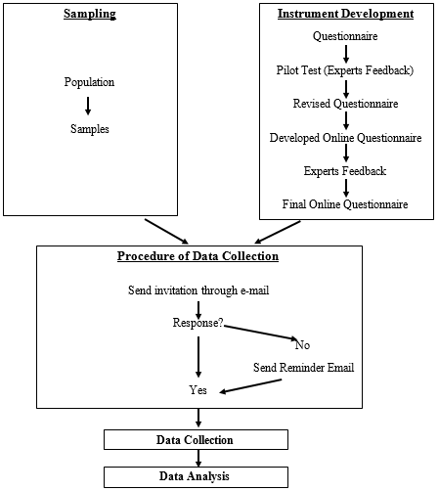
Figure 3.0: Summary of Steps for Sampling, Instrument Development, Data Collection and Data Analysis

Chapter IV: Research Results

4.0 Introduction
Chapter three provides details about methods used during this dissertation, starting with brief details on philosophical assumptions that explain use of a quantitative design. The questionnaire developed based on an intensive literature review, and scales used to measure constructs, are also outlined. The researcher used an online questionnaire and collected 437 responses. Data were analyzed using SPSS (version 18) and LISREL (version 8). This chapter presents the results of analyses.
The objectives of the study were to identify and understand factors that influence mobile service quality in the context of m-government from customers' perspective by measuring user satisfaction. This chapter is organized into two sections. The first presents sample profile descriptions, and reliability and validity analyses, and the second presents results from SEM analysis.

4.1 Sample Profile (General Information Questions)
The researcher collected 437 responses through an online questionnaire. To describe respondents’ demographic profiles, a frequency table were generated (Table 4.0). The sample was 437 users who used government mobile services. Males comprised 80.55% of users, and only 19.45% were female. The majority age of respondents, between 26 to 35 years and 36 to 45 years, were 37.07% and 37.30%, respectively. Most users were UAE nationals, representing 38.22% of the sample, followed by expatriate Arabs (24.71%), Asians (20.14%), others (15.56%), and Gulf Cooperation Council (GCC) (i.e., Saudi Arabia, Oman, Kuwait, Qatar, and Bahrain) (1.37%). Regarding education, the largest percentages of respondents’ degrees were Bachelor’s (43.48%) followed by Master’s (33.18%). A majority of respondents had used mobile government services for more than 2 years (61.56%). It is apparent that the respondents were experienced users of government mobile service
Table 4. 0: Description of Samples
Demographic | Category | Frequency (N=437) | Percentage
Your Age | Fewer than 20 years | 0 | 0%
 | 20–25 | 16 | 3.66%
 | 26–35 | 162 | 37.07%
 | 36–45 | 163 | 37.30%
 | 46–55 | 77 | 17.62%
 | 56+ | 19 | 4.35%
Your Gender | Female | 85 | 19.45%
 | Male | 352 | 80.55%
Nationality | United Arab Emirates | 167 | 38.22%
 | Gulf Cooperation Council (GCC) (Saudi Arabia, Oman, Kuwait, Qatar, and Bahrain) | 6 | 1.37%
 | Expatriate Arab | 108 | 24.71%
 | Asian | 88 | 20.14%
 | Other | 68 | 15.56%
Highest educational level | No formal education | 1 | 0.23%
 | Primary/Secondary | 6 | 1.37%
 | High school | 21 | 4.81%
 | Diploma | 30 | 6.86%
 | Higher Diploma | 26 | 5.95%
 | Bachelor | 190 | 43.48%
 | Master | 145 | 33.18%
 | Doctorate (PhD) | 15 | 3.43%
 | Other | 3 | 0.69%
Use of mobile government services | Less than 1 year | 36 | 8.24%
 | 1–2 years | 132 | 30.21%
 | More than 2 years | 269 | 61.56%
Table 4. 0: Description of Samples

The sample was also profiled by mobile service information (Table 4. 1). Results show that most users used government mobile services to conduct transactions such as paying electric bills, followed by searching for information. Most respondents used mobile applications, followed by government kiosks and SMS interactive services. Most users also used smart mobile devices, and preferred Etisalat as a telecommunications service provider.
Table 4. 1: Mobile Service Information - Description of Samples
Mobile service information | Category | Frequency (N=437)
Purpose of using mobile-government services | Looking for information/inquiries | 222
 | Transaction (e.g., request a service, make a payment, etc.) | 401
 | Others | 15
Types of mobile-government services | Government mobile application | 408
 | Interactive SMS | 149
 | Government kiosks (e.g., traffic and fines payment machine) | 209
Used device to request services | Smartphones (e.g., Apple iPhone, Samsung Galaxy, etc.) | 402
 | Mobile phone | 22
 | Mobile devices (e.g., Apple iPad, laptop, etc.) | 157
Telecommunications provider used for using mobile service | Du | 206
 | Etisalat | 340
Note: Multiple answers per participant possible. Percentages might exceed 100 since participants could select more than one answer.

4.2 Analysis of Reliability and Validity
Reliability is the degree to which a variable or concept was measured consistently (Jeon, 2008). To assess the internal reliability of the questionnaire, Cronbach’s alpha coefficient was computed. If the total Cronbach’s alpha coefficient is higher than 0.70, an instrument can be expected to give consistent responses across all variables. Table 4.2 shows results of the reliability analysis. The Cronbach’s alpha coefficient for each sub-dimension varied between 0.695 and 0.969, which are acceptable levels of 0.7 or higher (George and Mallery, 2003); questions for each sub-dimension measured the same dimension, and thus the internal consistencies of the measures were verified.
Table 4. 2: Results of Reliability

Constructs | Sub-dimensions | Number of questions | Items | Cronbach’s Alpha
Interaction Quality | Attitude | 4 | 14(a)Inter.A | 0.946
Interaction Quality | Attitude | 4 | 14(b)Inter.A | 0.946
Interaction Quality | Attitude | 4 | 14(c)Inter.A | 0.946
Interaction Quality | Attitude | 4 | 14(d)Inter.A | 0.946
Interaction Quality | Problem solving | 3 | 15(a)Inter.P | 0.948
Interaction Quality | Problem solving | 3 | 15(b)Inter.P | 0.948
Interaction Quality | Problem solving | 3 | 15(c)Inter.P | 0.948
Interaction Quality | Expertise and skills | 4 | 16(a)Inter.E | 0.965
Interaction Quality | Expertise and skills | 4 | 16(b)Inter.E | 0.965
Interaction Quality | Expertise and skills | 4 | 16(c)Inter.E | 0.965
Interaction Quality | Expertise and skills | 4 | 16(d)Inter.E | 0.965
Environment Quality | Easy to use | 4 | 17(a)Env.EU | 0.940
Environment Quality | Easy to use | 4 | 17(b)Env.EU | 0.940
Environment Quality | Easy to use | 4 | 17(c)Env.EU | 0.940
Environment Quality | Easy to use | 4 | 17(d)Env.EU | 0.940
Environment Quality | Compatibility | 5 | 18(a)Env.C | 0.931
Environment Quality | Compatibility | 5 | 18(b)Env.C | 0.931
Environment Quality | Compatibility | 5 | 18(c)Env.C | 0.931
Environment Quality | Compatibility | 5 | 18(d)Env.C | 0.931
Environment Quality | Compatibility | 5 | 18(e)Env.C | 0.931
Environment Quality | Design | 4 | 19(a)Env.D | 0.946
Environment Quality | Design | 4 | 19(b)Env.D | 0.946
Environment Quality | Design | 4 | 19(c)Env.D | 0.946
Environment Quality | Design | 4 | 19(d)Env.D | 0.946

Table 4.2: Results of Reliability (continued)
Constructs | Sub-dimensions | Number of questions | Items | Cronbach’s Alpha
Information Quality | Currency | 4 | 20(a)Info.CU | 0.930
Information Quality | Currency | 4 | 20(b)Info.CU | 0.930
Information Quality | Currency | 4 | 20(c)Info.CU | 0.930
Information Quality | Currency | 4 | 20(d)Info.CU | 0.930
Information Quality | Completeness | 4 | 21(a)Info.CO | 0.956
Information Quality | Completeness | 4 | 21(b)Info.CO | 0.956
Information Quality | Completeness | 4 | 21(c)Info.CO | 0.956
Information Quality | Completeness | 4 | 21(d)Info.CO | 0.956
Information Quality | Accurate | 4 | 22(a)Info.AC | 0.960
Information Quality | Accurate | 4 | 22(b)Info.AC | 0.960
Information Quality | Accurate | 4 | 22(c)Info.AC | 0.960
Information Quality | Accurate | 4 | 22(d)Info.AC | 0.960
Information Quality | Relevance | 4 | 23(a)Info.R | 0.927
Information Quality | Relevance | 4 | 23(b).Info.R | 0.927
Information Quality | Relevance | 4 | 23(c)Info.R | 0.927
Information Quality | Relevance | 4 | 23(d)Info.R | 0.927
System Quality | System Reliability | 5 | 24(a)Sys.SR | 0.926
System Quality | System Reliability | 5 | 24(b)Sys.SR | 0.926
System Quality | System Reliability | 5 | 24(c)Sys.SR | 0.926
System Quality | System Reliability | 5 | 24(d)Sys.SR | 0.926
System Quality | System Reliability | 5 | 24(e)Sys.SR | 0.926
System Quality | Availability | 4 | 25(a)Sys.SA | 0.947
System Quality | Availability | 4 | 25(b)Sys.SA | 0.947
System Quality | Availability | 4 | 25(c)Sys.SA | 0.947
System Quality | Availability | 4 | 25(d)Sys.SA | 0.947
System Quality | System privacy | 4 | 26(a)Sys.SP | 0.695
System Quality | System privacy | 4 | 26(b)Sys.SP | 0.695
System Quality | System privacy | 4 | 26(c)Sys.SP. | 0.695
System Quality | System privacy | 4 | 26(d)Sys.SP | 0.695
System Quality | Response Time | 4 | 27(a)Sys.RT | 0.937
System Quality | Response Time | 4 | 27(b)Sys.RT | 0.937
System Quality | Response Time | 4 | 27(c)Sys.RT | 0.937
System Quality | Response Time | 4 | 27(d)Sys.RT | 0.937
System Quality | System Security | 4 | 28(a)Sys.SS | 0.947
System Quality | System Security | 4 | 28(b)Sys.SS | 0.947
System Quality | System Security | 4 | 28(c)Sys.SS | 0.947
System Quality | System Security | 4 | 28(d)Sys.SS | 0.947

Table 4.2: Results of Reliability (continued)
Constructs | Sub-dimensions | Number of questions | Items | Cronbach’s Alpha
Network quality | Stable connection | 4 | 29(a)Net.SC | 0.955
Network quality | Stable connection | 4 | 29(b)Net.SC | 0.955
Network quality | Stable connection | 4 | 29(c)Net.SC | 0.955
Network quality | Stable connection | 4 | 29(d)Net.SC | 0.955
Network quality | Reachability | 4 | 30(a)Net.RC | 0.934
Network quality | Reachability | 4 | 30(b)Net.RC | 0.934
Network quality | Reachability | 4 | 30(c)Net.RC | 0.934
Network quality | Reachability | 4 | 30(d)Net.RC | 0.934
Outcome quality | Valence | 4 | 31(a)Out.V | 0.929
Outcome quality | Valence | 4 | 31(b)Out.V | 0.929
Outcome quality | Valence | 4 | 31(c)Out.V | 0.929
Outcome quality | Valence | 4 | 31(d)Out.V | 0.929
Outcome quality | Functional benefit | 5 | 32(a)Out.FB | 0.969
Outcome quality | Functional benefit | 5 | 32(b)Out.FB | 0.969
Outcome quality | Functional benefit | 5 | 32(c)Out.FB | 0.969
Outcome quality | Functional benefit | 5 | 32(d)Out.FB | 0.969
Outcome quality | Functional benefit | 5 | 32(e)Out.FB | 0.969
Outcome quality | Emotional benefit | 5 | 33(a)Out.EB | 0.965
Outcome quality | Emotional benefit | 5 | 33(b)Out.EB | 0.965
Outcome quality | Emotional benefit | 5 | 33(c)Out.EB | 0.965
Outcome quality | Emotional benefit | 5 | 33(d)Out.EB | 0.965
Outcome quality | Emotional benefit | 5 | 33(e)Out.EB | 0.965
Perceived Switch cost | 7 |  | 34(a)Switch | 0.878
Perceived Switch cost |  |  | 34(b)Switch | 0.878
Perceived Switch cost |  |  | 34(c)Switch | 0.878
Perceived Switch cost |  |  | 34(d)Switch | 0.878
Perceived Switch cost |  |  | 34(e)Switch | 0.878
Perceived Switch cost |  |  | 34(f)Switch | 0.878
Perceived Switch cost |  |  | 34(g)Switch | 0.878
Customer Satisfaction | 5 |  | 35(a)Satisfaction | 0.957
Customer Satisfaction |  |  | 35(b)Satisfaction | 0.957
Customer Satisfaction |  |  | 35(c)Satisfaction | 0.957
Customer Satisfaction |  |  | 35(d)Satisfaction | 0.957
Customer Satisfaction |  |  | 35(e)Satisfaction | 0.957
M-Government Service Quality | 4 |  | 36(a)Service Quality | 0.96
M-Government Service Quality |  |  | 36(b)Service Quality | 0.96
M-Government Service Quality |  |  | 36(c)Service Quality | 0.96
M-Government Service Quality |  |  | 36(d)Service Quality | 0.96

Validity is the degree to which an instrument measures what it is supposed to measure (Soita, 2012). Construct validity was examined using factor analysis, conducted on interaction quality, environment quality, information quality, system quality, network quality, outcome quality, perceived switching costs, customer satisfaction, and m-government service quality. Based on the analysis, one item (26, (d)) for system privacy and two items (34 (b/c)) for perceived switching costs were eliminated due to cross-loadings. Thus, the updated Cronbach’s alpha coefficients for system privacy and perceived switching cost were 0.961 and 0.904, respectively. The following section discusses analysis of an SEM. The measurement model was estimated using confirmatory factor analysis to examine overall fit and validity of the model (Wu, 2006). Then, hypotheses among constructs were examined using the structural model.

4.3 Structural Equation Modeling (SEM)
Measurement Model
SEM was used to conduct a simultaneous test of the entire system of variables in the hypothesized model to determine the extent to which it was consistent with the data (Byrne, 1994). Maximum-likelihood estimation was used to estimate the models because this technique has been found generally to generate reliable results even when data violate the assumptions of SEM, especially regarding normal distributions and large samples (Chou & Bentler, 1995). The methodology used to test the congeneric models was the strictly confirmatory approach (Jöreskog & Sörbom, 1993). This form of confirmatory test is most rigorous since it focuses on accepting or rejecting a model; the researcher either accepts or rejects a single, a priori measurement model. Similar to the present study, a priori models derive from a combination of both theory and data (Jöreskog & Sörbom, 1993).
The covariance matrix and parameter estimates for items in each a priori dimension were obtained using LISREL 8, and maximum likelihood was used to test model fit to assess each congeneric model (Jöreskog & Sörbom, 1989). Maximum-likelihood estimation using medium to large samples is robust, even with violations of a model’s multi-normality assumptions (Tabachnick & Fidell, 2001). Statistics used to evaluate model fit included parameter estimates (lambda), t-values, and goodness-of-fit indices. Lambda coefficients indicate loadings of a latent variable on items. An associated t-value indicates whether a lambda coefficient is different from zero (Byrne, 1994); t-values greater than 2.0 are statistically significant (Byrne, 1994). The goodness-of-fit indices used in this study were measures of incremental fit, which test the incremental fit of each a priori model against a null model. Thus, these indices provide measures of proportional improvements of the fit of a substantive model relative to a null model. The null model specifies zero, or null, covariance among manifest variables (manifest variables in this study were items for each dimension), and is the most widely accepted form of null model (Widaman & Thompson, 2003). The model tested suggests that covariance among items differs from zero (Widaman & Thompson, 2003).
Common incremental-fit indices operate independently of sample size, and thus represent appropriate goodness-of-fit measures for small to medium samples (Widaman & Thompson, 2003). Model fit was estimated using the Comparative Fit Index (CFI), the Incremental Fit Index (IFI), and Root Mean Square Residual (RMR) (Bentler, 1990; Bollen, 1989; Pedhazur & Pedhazur-Schmelkin, 1991). CFI is the index of choice for model fit when a sample is sufficient (Bentler, 1990), and IFI was developed to consider small samples (Bollen, 1989). CFI and IFI values greater than 0.9 indicate adequate model fit (Bollen, 1989). RMR is interpreted in relation to sizes of observed variances and covariance, with RMR values indicating average discrepancy between observed and hypothesized correlation matrices (Hu & Bentler, 1998). A value of 0.05 or less indicates adequate fit (Byrne, 1994), with values between 0.05 and 0.08 indicating acceptable fit (Hu & Bentler, 1998). The standardized measure of RMR was used for ease of comparison across scales.
One-factor, Congeneric Model
One-factor, congeneric measurement models were used to assess six constructs. The design of the study included estimation of both latent constructs and multiple dependence relationships. Use of SEM was justified given the confirmatory, rather than exploratory, nature of the research questions, and the suitability of addressing questions concerning the robustness of theoretically driven, a priori models through cross-validation (Kirk & Brown, 2003). One-factor, congeneric models allow a large number of observed variables to reduce to a single, composite scale that considers unique contributions of each item. Through the one-factor, congeneric models, observed indicator variables are regressed on a single, latent variable (Holmes-Smith & Rowe, 1994). LISREL 8 was used to analyze the models and provide estimates of the reliability and error of variances of the composite latent variables for interaction, environment, information, system, network, and outcome quality. A priori, congeneric measurement models offer advantages over traditional, exploratory approaches during scale construction. A traditional approach either employs unit-weight additive indices of indicators, or derives exploratory factor scores for computation of a composite scale. The traditional approach uses general linear techniques such as multiple linear regression, which assumes no scale measurement error. Conversely, congeneric models estimate error of variances (Holmes-Smith & Rowe, 1994).

- Measurement equations: Interaction quality
The interaction quality latent construct was measured using attitudes, problem-solving, and expertise/skills scales. The one-factor, congeneric model for interaction quality fit the data well, indicated by goodness-of-fit statistics. The CFI was 0.99, and the IFI was 0.99, which indicate good fit between model and data. The RMR of 0.038 also suggested good model fit.

Table 4. 3: Parameter Estimates, t-values, R², Error of Variance, and Incremental Fit Statistics for Interaction Quality
Interaction Quality |  | Lambda x | t-value | R² | Error
1 | Attitude | 1.05 | 23.08 | 0.77 | 0.32
2 | Problem Solving | 1.18 | 25.34 | 0.87 | 0.22
3 | Expertise and skills | 1.19 | 25.40 | 0.87 | 0.21
Note: Fit statistics: CFI= 0.99. IFI= 0.99. RMR= 0.038.
Table 4.3 shows that all scale items loaded on the latent variable (t-values above 2.00). Expertise and skills had the highest lambda (1.19), with the associated largest t-value of 25.40, and explained 87% of the variance of interaction quality. Problem-solving had a similar influence on interaction quality, with a lambda of 1.18 and t-value of 25.34, explaining 87% of the variance. Attitudes had a lambda of 1.05 and t-value of 23.08, explaining 77% of the variance. The most important source of interaction quality was expertise and skills.
- Measurement equations: Environment quality
The environment quality latent construct was measured using ease of use, compatibility, and design scales. The one-factor, congeneric model for environment quality was a good fit with the data, as indicated by goodness-of-fit statistics. The CFI was 0.99, and the IFI was 0.99, which indicate good fit between model and data. An RMR of 0.038 also suggests good model fit.
Table 4. 4: Parameter Estimates, t-values, R², Error of Variance, and Incremental Fit Statistics for Environment Quality
Environment Quality |  | Lambda x | t-value | R² | Error
1 | Easy to use | 0.83 | 22.24 | 0.74 | 0.24
2 | Compatibility | 0.77 | 20.40 | 0.67 | 0.33
3 | Design | 0.86 | 21.72 | 0.72 | 0.28
Note: Fit statistics: CFI= 0.99. IFI= 0.99. RMR= 0.038.
Table 4.4 shows that all items loaded on the latent variable (t-values above 2.00). Design had the highest lambda (0.86), with associated t-value of 21.72, explaining 72% of environment quality’s variance. Ease of use had a similar influence on environment quality, with a lambda of 0.83 and t-value of 22.24, explaining 74% of the variance. Compatibility had a lambda of 0.77 and t-value of 20.40, explaining 67% of the variance. The most important source of environment quality was design.
- Measurement equations: Information quality
Information quality was measured using currency, completeness, accuracy, and relevance. The one-factor, congeneric model for information quality was a good fit with the data, as goodness-of-fit statistics indicate. The CFI was 0.99, and the IFI was 0.99, which indicate good fit between model and data. An RMR of 0.038 suggests good fit.
Table 4. 5: Parameter Estimates, t-values, R², Error of Variance, and Incremental Fit Statistics for Information Quality
Information Quality |  | Lambda x | t-value | R² | Error
1 | Currency | 0.91 | 24.31 | 0.82 | 0.19
2 | Completeness | 1.01 | 24.11 | 0.81 | 0.24
3 | Accurate | 0.99 | 25.79 | 0.87 | 0.14
4 | Relevance | 0.85 | 23.29 | 0.78 | 0.21
Note: Fit statistics: CFI= 0.99. IFI= 0.99. RMR= 0.038.
Table 4.5 shows that scale items loaded on the latent variable (t-values above 2.00). Completeness had the highest lambda (1.01), with associated t-value of 24.11, explaining 81% of information quality’s variance. Accuracy had a similar influence on information quality, with a lambda of 0.99 and t-value of 25.79, explaining 87% of the variance. Currency had a lambda of 0.91 and t-value of 24.31, explaining 87% of the variance. All scales greatly influenced information quality.
- Measurement equations: System quality
System quality was measured using system reliability, availability, system privacy, response time, and system security. The one-factor, congeneric model for system quality was a good fit for the data, as goodness-of-fit statistics indicate. The CFI was 0.99, and the IFI was 0.99, which indicate good fit between model and data. An RMR of 0.038 suggests good model fit.

Table 4. 6: Parameter Estimates, t-values, R², Error of Variance, and Incremental Fit Statistics for System Quality
System Quality |  | Lambda x | t-value | R² | Error
1 | System Reliability | 0.98 | 22.96 | 0.77 | 0.29
2 | Availability | 0.91 | 21.43 | 0.70 | 0.35
3 | System privacy | 0.87 | 15.95 | 0.47 | 0.88
4 | Response time | 0.89 | 24.16 | 0.82 | 0.18
5 | System Security | 0.80 | 18.07 | 0.56 | 0.50
Note: Fit statistics: CFI= 0.99. IFI= 0.99. RMR= 0.038.
Table 4.6 shows that the scale items loaded on the latent variable (t-values above 2.00). System reliability had the highest lambda (0.98), with an associated t-value of 22.96, explaining 77% of system quality’s variance. Availability had a similar influence on system quality, with a lambda of 0.91 and t-value of 21.43, explaining 70% of system quality’s variance. Response time had a lambda of 0.89 and t-value of 24.16, explaining 82% of the variance. System privacy had a lambda of 0.87 and t-value of 15.95, explaining 47% of the variance, but with a very large variance error (0.88). System security had a lambda of 0.80 and t-value of 18.07, explaining 56% of the variance. The most important source of system quality was reliability.
- Measurement equations: Network quality
Network quality was measured using stable connection and reachability. The one-factor, congeneric model for network quality was a good fit for the data, as goodness-of-fit statistics indicate. The CFI was 0.99, and the IFI was 0.99, which indicate good fit between the model and data. An RMR of 0.038 suggests good model fit.
Table 4. 7: Parameter Estimates, t-values, R², Error of Variance, and Incremental Fit Statistics for Network Quality
Network Quality |  | Lambda x | t-value | R² | Error
1 | Stable connection | 0.91 | 23.49 | 0.81 | 0.19
2 | Reachability | 0.91 | 22.44 | 0.77 | 0.25
Note: Fit statistics: CFI= 0.99. IFI= 0.99 RMR= 0.038.
Table 4.7 shows that scale items loaded on the latent variable (t-values above 2.00). Stable connection had a lambda of 0.91, with the largest t-value of 23.49, explaining 81% of the variance. Reachability had a similar influence, with a lambda of 0.91 and t-value of 22.44, explaining 77% of the variance. These constructs had equal influence on network quality.
- The measurement Equations: Outcome Quality
Outcome quality was measured using valence, functional benefit, and emotional benefit. The one-factor, congeneric model for outcome quality was a good fit for the data, as goodness-of-fit statistics indicate. The CFI was 0.99, and the IFI was 0.99, which indicate good fit between the model and data. An RMR of 0.038 suggests good model fit.
Table 4. 8: Parameter Estimates, t-values, R², Error of Variance, and Incremental Fit Statistics for Outcome Quality
Outcome Quality |  | Lambda x | t-value | R² | Error
1 | Valence | 0.85 | 25.45 | 0.86 | 0.11
2 | Functional benefit | 0.82 | 25.28 | 0.86 | 0.11
3 | Emotional benefit | 0.84 | 22.73 | 0.76 | 0.23
Note: Fit statistics: CFI= 0.99. IFI= 0.99. RMR= 0.038.
Table 4.8 shows that items loaded on the latent variable (t-values above 2.00). Valence had the highest lambda (0.85), with a t-value of 25.45, explaining 86% of the variance. Functional benefit had a similar influence on outcome quality, with a lambda of 0.82 and t-value of 25.28, explaining 85% of the variance. Emotional benefit had a lambda of 0.84 and t-value of 22.73, explaining 76% of the variance. The most important source of outcome quality was valence.
Assessment of Structural Model 1: M-government Service Quality (Model Estimation and Hypotheses Testing)
Mentioned earlier, use of SEM was justified by the confirmatory, rather than exploratory, nature of the research questions, and the suitability of addressing questions concerning the robustness of theoretically driven, a priori models through cross-validation (Kirk & Brown, 2003). For the m-government service quality model, absolute fit indices suggest how well the a priori model fits the data (Table 4.9). Degrees of freedom of 231, a chi-square of 790.59 (p<0.01), a GFI of 0.87, and an AGFI of 0.83 demonstrate that the model fit the data. Incremental fit statistics (NFI=0.99, CFI=0.99, IFI=0.99, and RMR=.038) also suggest good fit. Extant literature suggests that each factor contributes positively to m-government service quality. The following section reports details on the nature of relationships found in this study (Figure 4.0).
Table 4. 9: Assessment of Structural Model 1: M-government Service Quality-Parameter Estimates λ, λ Error, and t-values for Pathways Defined in the Structural Model
Pathways between latent constructs | Λ (β) | λ error | t-value
INTERQL → M-government service quality | 0.63 | 0.03 | 20.24
ENVIRQL → M-government service quality | 0.83 | 0.02 | 42.47
INFORQL → M-government service quality | 0.77 | 0.02 | 36.39
SYSQL → M-government service quality | 0.78 | 0.02 | 35.86
NETQL → M-government service quality | 0.74 | 0.03 | 28.40
OUTQL → M-government service quality | 0.83 | 0.02 | 48.67
Note: Goodness of fit statistics: degrees of freedom=231, chi-square=790.59 (p<0.01), RMSEA=0.073, 90% confidence interval for RMSEA=(0.067; 0.079), p-value for test of close fit (RMSEA<0.05) = 0.00, normed fit index (NFI)=0.98, comparative fit index (CFI)=0.99, incremental fit index (IFI)=0.99, critical n (CN)=157.58, root mean square residual (RMR)=0.038, goodness of fit index (GFI)=0.87, adjusted goodness of fit index (AGFI)=0.83.

Compatibility

Q.36b

Attitude

Problem Solving

Expertise & Skills

0.32
0.22
0.21
1.05
(23.08)
1.19
(25.40)
Q.36c

Q.36d

M-Government Service Quality
Stable Connection

Reachability

Valance

Functional Benefits
Emotional Benefits

Q.36a

0.19
0.25
0.11
0.11
0.23
Easy to use

Design

0.24
0.33
0.28
0.83
(22.24)
0.77
(20.40)
0.86
(21.72)
Currency

Accurate

Relevance

0.19
0.24
0.14
0.21
0.91
(24.31)
1.01
(24.11)
0.99
(25.79)
0.85
(23.29)
System Reliability

Availability

Response Time

System Security

0.29
0.35
0.88
0.18
0.50
0.98
(22.96)
0.91
(21.43)
0.87
(15.95)
0.89
(24.16)
0.80
(18.07)
0.91
(23.49)
0.91
(22.44)
0.85
(25.45)
0.82
(25.28)
0.84
(22.73)
1.09
(26.05)
1.09
(27.82)
1.13
(26.52)
1.18
(22.84)
1.18
(25.34)
Information Quality
Environment Quality
Interaction Quality
System
Quality
Network Quality
Outcome Quality
Completeness

0.83
(48.67)
0.74
(28.40)
0.78
(35.86)
0.77
(36.39)
0.83
(42.47)
0.63
(20.24)
0.16
0.07
0.15
0.45
System Privacy

Figure 4. 0: Assessment of structural model 1—M-government service quality (pathway coefficient for the structural model)

Hypothesis 1 suggests that interaction quality influences mobile government service quality. The graphical model shows tighter fit between interaction quality and mobile government service quality. Shown in Table 4.9, the direct path between interaction quality and mobile government service quality suggests a positive relationship (β=0.63, t-value=20.24). More specifically, interaction quality helps achieve better mobile government service quality, a finding consistent with Hypothesis 1. Hypothesis 2 suggests that environment quality influences mobile government service quality. The graphical model shows tighter fit between environment quality and mobile government service quality. Shown in Table 4.9, the direct path between environment quality and mobile government service quality suggests a positive relationship (β=0.83, t-value=42.47). More specifically, environment quality helps achieve better mobile government service quality, and it is one of the most powerful factors, a finding consistent with Hypothesis 2.
Hypothesis 3 suggests that information influences mobile government service quality. The graphical model shows tighter fit between information quality and mobile government service quality. Shown in Table 4.9, the direct path between information quality and mobile government service quality suggests a positive relationship (β=0.77, t-value=36.39). More specifically, information quality helps achieve better mobile government service quality, a finding consistent with Hypothesis 3. Hypothesis 4 suggests that system quality influences mobile government service quality. The graphical model shows tighter fit between system quality and mobile government service quality. Shown in Table 4.9, the direct path between system quality and mobile government service quality suggests a positive relationship (β=0.78, t-value=35.86). More specifically, system quality helps achieve better mobile government service quality, a finding consistent with Hypothesis 4. Hypothesis 5 suggests that network quality influences mobile government service quality. The graphical model shows tighter fit between network quality and mobile government service quality. Shown in Table 4.9, the direct path between network quality and mobile government service suggests a positive relationship (β=0.74, t-value=28.40). More specifically, network quality helps achieve better mobile government service quality, a finding consistent with Hypothesis 5. Hypothesis 6 suggests that outcome quality influences mobile government service quality. The graphical model shows tighter fit between outcome quality and mobile government service quality. Shown in Table 4.9, the direct path between outcome quality and mobile government service quality suggests a positive relationship (β=0.83, t-value=48.67). More specifically, outcome quality helps achieve better mobile government service quality, and it is one of the most powerful factors, a finding consistent with Hypothesis 6.
Assessment of Structural Model 2: Higher-order Latent Constructs with Moderation
A higher-order model examined a direct relationship between mobile government service quality and customer satisfaction, and examined moderation of perceived switching costs on the relationship between mobile government service quality and customer satisfaction. Extant literature suggests that mobile government service quality has a direct, positive relationship with customer satisfaction. The following section reports details on this relationship (Figure 4.1).

Figure 4. 1: Assessment of structural model 2-Higher-order latent construct with moderating effect (Pathway coefficient for the structural model)

Customer satisfaction
M-government service quality
Perceived switching cost
0.77
(36.49)
-0.12
(-2.42)
0.08
(1.68)

For the higher-order model, absolute fit indices determined how well the model fit the data. Degrees of freedom of 74, a chi-square of 522.68 (p<0.01), a GFI of 0.84, and an AGFI of 0.77 suggest that the model was a weak fit with the data. However, incremental fit statistics (NFI=0.95, CFI=0.96, IFI=0.96, and RMR=0.13) suggest that mobile government service quality was a good fit with the data. Table 4. 10 shows that the direct path between mobile government service quality and customer satisfaction was positive, suggesting mobile government service quality is a positive (β=0.77, t-value=36.49) contributor to customer satisfaction; if the quality of mobile government service is good, customers are more satisfied. The strength of this relationship was strong. Therefore, Hypothesis 7 was supported.
Table 4. 10: Assessment of Structural Model 2: Higher-order Latent Construct with Moderating Effect-Parameter Estimates λ, λ error, and t-values for Pathways Defined in the Structural Model
Pathways between latent constructs | Λ (β) | λ error | t-value
M-government service quality → Customer satisfaction | 0.77 | 0.02 | 36.49
M-government service quality → Perceived switching costs | 0.08 | 0.05 | 1.68
Perceived switching costs → Customer satisfaction | -0.12 | 0.05 | -2.42
Note: Goodness of fit statistics: degrees of freedom=74, chi-square=522.68 (p<0.01), (RMSEA)=0.13, 90% confidence interval for RMSEA=(0.12; 0.14), p-value for test of close fit (RMSEA<0.05)=0.00, normed fit index (NFI)=0.95, comparative fit index (CFI)=0.96, incremental fit index (IFI)=0.96, critical n (CN)=88.76, root mean square residual (RMR)=0.13, goodness of fit index (GFI)=0.84, adjusted goodness of fit index (AGFI)=0.77.

This study failed to find a direct relationship between mobile government service quality and switching costs (β=0.08, t-value=1.68), implying that if service quality is unacceptable, high switching costs have little effect on a customer’s decision to change traditional channels of obtaining services. The direct path between switching costs and customer satisfaction was negative (β=- 0.12, t-value=-2.42), suggesting switching costs contribute negatively to customer satisfaction, and that high switching costs influence customer satisfaction negatively. The relationship was statistically significant, but had a marginal effect. Therefore, Hypothesis 8 was supported partially.

4.4 Conclusion
Results from analyzing the data are presented in this chapter. Reliability and validity analyses resulted in deletion of one item from system privacy and two items from perceived switching costs. SEM analysis suggests that the model is acceptable, and all hypotheses were supported. However, Hypothesis 8 was supported only partially. A discussion of these results are presented in the following chapter.

Chapter V: Discussion of Results, Implications, and Recommendations

5.0 Introduction
Chapter four provides results of several statistical analyses conducted to test the hypotheses. Generally, the results suggest that the model is acceptable.
This chapter consists of a discussion of results, implications, and recommendations for future research based on findings from this study. First, results drawn from the literature review, quantitative research, and hypotheses are discussed in consideration of the research questions. Second, theoretical and practical implications of the findings are explained. Finally, limitations of the study and recommendations for future study are discussed.

5.1 Discussion of Results
This section answers the research questions and interprets the hypotheses. From results presented in Chapter 4, of eight hypotheses in this study, seven were supported and one was supported partially. Table 5.1 summarizes the research questions, corresponding hypotheses, and whether the hypotheses were supported. The following section discusses each research question and its related hypothesis.

Table 5. 1: Research Questions, Hypotheses, and Results
Research Questions |  | Hypotheses | Results
What factors influence m-government service quality in UAE? | H1: | Interaction quality correlates positively with mobile government service quality. | Supported
 | H2: | Environment quality correlates positively with mobile government service quality. | Supported
 | H3: | Information quality correlates positively with mobile government service quality. | Supported
 | H4: | System quality correlates positively with mobile government service quality. | Supported
 | H5: | Network quality correlates positively with mobile government service quality. | Supported
 | H6: | Outcome quality correlates positively with mobile government service quality. | Supported
What is the relationship between m-government service quality and customer satisfaction? | H7: | Mobile government service quality correlates positively with customer satisfaction. | Supported
What role does perceive switching costs play in the relationship between m-government service quality and customer satisfaction? | H8: | Perceived switching costs moderate the relationship between mobile government service quality and customer satisfaction. | Partially Supported

- What factors influence m-government service quality in UAE?
Based on the literature review presented in Chapter 2 and results from Chapter 4, this study identifies six factors that influence m-government service quality, including interaction, environment, information, system, network, and outcome quality. The study hypothesizes that these factors have a relationship with m-government service quality in UAE (i.e., H1 through H6). Results supporting these hypotheses and are explained further. Also based on findings, it can be concluded that m-government service quality is a multidimensional construct comprised of the six dimensions mentioned above.
This supports the pervious extant findings that service quality should be treated as a multidimensional construct (Lu et al., 2009; Zaho et al., 2012; Akter et al., 2013). Regarding each hypothesis, interpretation of each follows.
H1: Interaction quality correlates positively with mobile government service quality.
Results indicate a direct correlation between interaction quality and m-government service quality, suggesting that interaction quality contributes to better m-government service quality in UAE. Interaction quality was represented by three sub-dimensions (attitudes, problem-solving, and expertise/skills). Analysis indicates that the model fit the data well; the sub-dimensions explain interaction. The most important sources were expertise and skills of the employees for mobile users, followed closely by problem-solving. Attitudes came last. This seem true and acceptable due to the nature of mobile services. Interaction in mobile contexts occurs most commonly with a system that includes mobile application, SMS, or kiosks. Thus, when an issue happens, the most important factor is the ability of the service provider (the government entity)—more specifically, an employee responsible for helping users—to have the skills and expertise to answer inquiries and solve problems the user is experiencing. Attitude appear less important. One explanation for this result concerns the nature of the service; users do not interact face-to-face with service providers. These findings suggest that UAE government must give m-service staff sufficient training to increase their skills and expertise. This supports the same suggestion from Boohene and Agyapong (2011), who suggest that staff skills are important in telecommunications. Also some degree of empowerment is needed so that employees can solve problems immediately. Response to user problem and ability to handle it will help to build long term relationship with the user (Yang et al., 2012).

H2: Environment quality correlates positively with mobile government service quality.
Results indicate a direct correlation between environment quality and m-government service quality in UAE, highlighting the importance of environment quality to achieve better m-government service quality. Analysis suggests that environment quality is comprised of three sub-dimension: ease of use, compatibility, and design. However, the most influencing sub-dimension was design, followed by ease of use and compatibility. If a design is good from the beginning, the rest follows. Designs based on details, needs, requirements, and expectations fit much better with the user. For example, if when designing mobile services, the foci are ease of use and compatibility across devices, the system will operate as intended. It is important that mobile services are easy to use so that users can get their requests completed easily. This might contribute to users returning to the service repeatedly. Ease of use was the second factor important to mobile service users, which is accords with Nikous and Mezei’s (2013) findings in Finland. Compatibility came last, suggesting that UAE government developed mobile services based on devices that are used broadly across the country. The government needs to test its mobile services on new technology devices before launch, and follow TRA guidelines and seek CODI support when developing mobile services. It is important for the government to track the market and changes to mobile devices to keep pace with m-service upgrades.

H3: Information quality correlates positively with mobile government service quality.
Analysis suggests a direct, positive relationship between information quality and mobile government service quality in UAE; better information quality leads to better mobile government service quality. The construct consists of currency (or updated), completeness, accuracy, and relevancy of information as sub-dimensions. Results indicate that completeness of information has the greatest influence on information quality, followed by the others (i.e., accurate, currency, and relevance). Therefore, users need to receive full information to assist them with completing mobile services, which supports findings from Wang and Lin (2012). Incomplete information might lead to incomplete inquiries and transaction. Information should also be accurate so users do not mistrust it and hesitate to complete transactions. User desires updated information, reflecting one of many benefits expected from mobile services. Finally, information should be relevant to what a user requests. For example, if users want information about paying an electric bill, they should receive that information. The finding stress that maintain information quality is important to the success of mobile service supporting the pervious claim by Kim and Lee (2013).

H4: System quality correlates positively with mobile government service quality.
Findings suggest that system quality correlates positively with mobile government service quality in UAE. Results showed good fit for a model comprised of five sub-dimensions: system reliability, availability, privacy, response time, and security. System reliability had the greatest positive influence on system quality. It is important that mobile services are dependable over time, followed by the importance that mobile services are available anytime and anywhere. Availability is a unique feature of mobile devices, so it is expected that it influences system quality, according with extant studies (Ozer et al., 2013). Response time, system privacy and system security followed with their influences on system quality. It is important that information be kept confidential, and that related concerns be shared with users. However, this result is different from findings from Chanana, Agrawal, and Punia (2016), who investigate service quality parameters in mobile government services in India. Their findings suggest that privacy ranks first among service quality variables. One explanation is that the authors’ sample was limited to experts in e-government and mobile government and didn’t not take user viewpoints. Another concern is response time to user requests. This is important because many users expect to get services quickly in comparison to when they visit a physical service center. Finally, system security was the least important influencer of system quality, challenging findings from Ozer et al. (2013) and Lin (2013). This might not necessarily indicate that it has low influence or low important, but that TRA ensures the system security of government entities, and users already feel safe and confident about it.

H5: Network quality correlates positively with mobile government service quality.
Results suggest a positive relationship between network quality and mobile government service quality in UAE, indicating that network quality contributes to better m-government service quality. This relationship was reflected by two sub-dimensions: stable connection and reachability. Analysis showed good fit between the model and data, and results suggest that both sub-dimensions have equal influence over network quality. This might be due to the fact that mobile services require connections to networks. Network quality is also important because users who experience disconnections and lack of access are reluctant to use mobile services again, as Shin (2010) reports. This finding accords with Yang et al. (2012), who suggest that stable connections are paramount to m-service quality. The government needs to consider the number of users for each service so it can avoid network congestion. This implies that TRA and government entities should work closely with telecom network providers (i.e., Du or Etisalat) to improve network quality, which leads to better service quality. This also highlights the importance of partnerships with stakeholders to provide better services to customers. Although network quality appears to be a governmental concern, findings suggest that assessing this dimension from a user’s perspective is important. The UAE government should maintain good network quality to ensure users obtain m-service anytime and anywhere, and with both indoor and outdoor coverage, supporting the importance of network quality, as Chae and Kim (2002) and Lim el at. (2009) suggest.

H6: Outcome quality correlates positively with mobile government service quality.
Results support a positive, direct correlation between outcome quality and mobile government service quality in UAE. Outcome quality had the largest influence on service quality among other predictors. At the conclusion of the process, what matters is the outcome of mobile services. In order of importance, valance, emotional benefits, and functional benefits influenced outcome quality. However, their degree of influence was similar. Valance is about user beliefs that a service is good or bad at its conclusion, regardless of experiences throughout the process. This is important because even if a user has a positive view of each service dimension, but a negative valence of the outcome, an unfavorable service experience is perceived. Lu et al. (2009) and Yang et al. (2012) note the importance of valance. Results show that emotional benefits that a user receives is the next most important influencer of outcome quality. Users want mobile services to give them positive feelings. This finding suggests that emotional benefit has received much attention in recent years, corroborating Zhao et al. (2012). Finally, it is important that services serve their purpose, which affects outcome quality and is crucial to users’ development of positive attitudes toward m-service.
- What is the relationship between m-government service quality and customer satisfaction?
This research question was hypothesizes as.
H7: Mobile government service quality correlates positively with customer satisfaction.
Results support the hypothesis, and show a strong, positive correlation, consistent with findings from Özer et al. (2013), Lim et al. (2006), and Shin and Kim (2008). This implies that if m-government service quality is high, customer satisfaction is also high in UAE. That is, high mobile government service quality leads to greater customer satisfaction. This also evidences that service quality is an antecedent of customer satisfaction in a mobile context. Discussed earlier, extant research challenges this finding. Some findings support that customer satisfaction is an antecedent of service quality (Bitner, 1990; Bitner and Hubert, 1994), and others suggest that neither customer satisfaction nor service quality is an antecedent of the other (Driver, 2002; McAlexander, Kaldenberg, & Koenig, 1994). Based on this study findings, for government entities to increase customer satisfaction, they must improve m-government service quality, and to achieve that, the government should work to improve the six factors of m-government service quality—interaction, environment, information, system, network, and outcome quality. This study also suggests that outcome quality, followed by environment quality, had the greatest influence on mobile government service quality. Information, system, and network quality followed in order. Interaction quality was least influential on mobile service quality, a result inconsistent with Akter et al. (2010), who argue that interaction quality reflects overall service quality in a similar context (m-health).

- What role does perceive switching costs play in the relationship between m-government service quality and customer satisfaction?
The hypothesis below reflects this research questions.
H8: Perceived switching costs moderate the relationship between mobile government service quality and customer satisfaction.
Results suggest that Hypothesis 8 was supported partially; if mobile government service quality is low, perceived switching costs have little influence on customer decisions to switch to traditional ways of receiving services. However, perceived switching costs contributed to customer satisfaction negatively. That is, high perceived switching costs affect customer satisfaction negatively. Therefore, government entities should reduce transaction, search, setup, and learning costs for users. This implies that the government should advertise mobile services to customers, and conduct awareness sessions, to facilitate customer transitions to mobile service. This will help with using mobile services correctly, and reduce customers concerns if any. All of this will help achieve better customer satisfaction.

5.2 Theoretical and Practical Implications
Theoretical Implications for Academics
Few studies assess mobile services to examine their unique characteristics and the nature of quality services Lu et al., 2009; Wang et al., 2012, and few researchers to develop theoretical frameworks to evaluate mobile services (Akter et al., 2010; Lu et al., 2009), representing gaps in the literature.
Scarce study has been conducted on mobile government service quality and its influence on customer satisfaction. This study develops a comprehensive, theoretical framework to evaluate mobile government service quality, its influence on customer satisfaction, and the role of perceived switching costs. The proposed framework of mobile government service quality is comprised of six dimensions (i.e., interaction, environment, information, system, network, and outcome quality) and the sub-dimensions required to achieve mobile government service quality, bridge the concept of service quality and the nature of mobile service, and achieve customer satisfaction. Therefore, this framework can be used as a foundation for future studies related to mobile services. Since this study measures mobile government service quality using primary dimensions, their sub-dimensions, and the relationship between mobile government service quality and customer satisfaction, it provides future researchers with detailed information with which to examine mobile users’ behaviors with mobile services.
Practical Implications for UAE Government
Using results from this study, the UAE government can improve customer satisfaction of mobile services by improving mobile service quality. Its mobile government service quality can be improved through six dimensions, according to importance: outcome, environment, system, information, network, and interaction quality, and their sub-dimensions. The government can improve outcome quality by assessing valance, functional benefits, and emotional benefits, and their influences on overall user experiences. Environmental quality can be improved through the design of mobile services, making them easy to use and compatible with multiple devices. The government can increase system quality by ensuring system reliability, availability, privacy, security, and system responsiveness. To increase information quality, the government should ensure completeness of information provided through mobile services, including updated, accurate, and relevant information. By managing stable connections and ensuring the reachability of mobile services, the government can improve network quality. Finally, interaction quality can be enhanced through expertise/skills, problem-solving, and employees’ attitudes.
The reliable and valid measurement scales developed in this study are useful for examining user satisfaction with mobile government service quality. They could serve as diagnostic and perspective tools, allowing the government to detail and more fully evaluate customer satisfaction and mobile service quality through the dimensions and their sub-dimensions by conducting surveys, thereby identifying problematic areas. The government can make better corrections by devoting management resources to problematic aspects of mobile government service quality, and make improvements by providing better services to encourage people to use mobile services. This is important because governments invest significantly to develop these services, and if people do not use them, it is a waste of effort and money.

5.3 Recommendations, Limitations, and Future Research

This section provides several limitation of this study and makes recommendation for future studies. The survey invitation might not have reached a representative sample of the population. This study sent invitations randomly to users across UAE, and did not consider collecting from each Emirate. This study used a one-time survey due to costs and limited time, but a longitudinal design would have been more revealing. Although this study assesses all aspects of mobile government service quality, there might be other aspects that develop from the evolution of mobile devices. Findings from this dissertation apply, but are limited to, the UAE context, and might differ in other contexts.
Future studies should use a different sampling method; for example quota sampling across UAE to ensure collecting representative responses from each emirates. Future studies should administer surveys at multiple times to capture users’ disparate experiences. Researchers should also refine the scale of mobile government service quality used in this study to incorporate new aspects and keep it updated; adding variables such as customer loyalty will make the framework more complete. Finally, future studies should examine relationships among socio-demographics, mobile service quality, perceived switching costs, and customer satisfaction.

References

Abdullah, F. (2006). Measuring service quality in higher education: HEdPERF versus SERVPERF. Marketing Intelligence & Planning, 24(1), 31-47. DOI 10.1108/02634500610641543.
Abdur-Rahman, P. (2010). Research Philosophy: Quantitative vs Qualitative. Pavel's Thought Wave... Retrieved 10 March 2016, from https://prahman.wordpress.com/2010/04/04/research-philosophy-quantitative-vs-qualitative/
Adeleke, A., &Suraju, A. A. (2012). The determinants of customer loyalty in Nigeria's GSM market. International Journal of Business and Social Science, 3(14), 209-222.
Akhlaghi, E., Amini, S. & Akhlaghi, H. (2012). Evaluating educational service quality in technical and vocational colleges using SERVQUAL model. Procedia - Social and Behavioral Sciences 46, 5285 – 5289. DOI 10.1016/j.sbspro.2012.06.424.
Akter, S., D’Ambra, J., & Ray, P. (2010). Service quality of mHealth platforms: development and validation of a hierarchical model using PLS. Electronic Markets, 20(3-4), 209-227.
Akter, S., D’Ambra, J., & Ray, P. (2013). Development and validation of an instrument to measure user perceived service quality of mHealth. Information & Management, 50(4), 181-195.
Al Thunibat, A., Zin, N., &Sahari, N. (2011). Identifying User Requirements of Mobile Government Services in Malaysia Using Focus Group Methodch. Journal of E-Government Studies and Best Practices, 1-14.
Al-Borie, H. M. & Damanhouri, A. M. S. (2013). Patients’ satisfaction of service quality in Saudi hospitals: a SERVQUAL analysis. International Journal of Health Care Quality Assurance, 26(1), 20-30. DOI 10.1108/09526861311288613.

Allen, I.E., & Seaman, C.A., (2007) Statistics Roundtable: Likert Scales and Data Analyses. Retrieved 19 January 2015, from http://asq.org/quality-progress/2007/07/statistics/likert-scales-and-data-analyses.html
Almossawi, M. M. (2012). Customer Satisfaction in the Mobile Telecom Industry in Bahrain: Antecedents and Consequences. International Journal of Marketing Studies, 4(6), 139–156.
Al-Nasser, M., Yusof, R., Islam, R., &AlNasser, A. (2013). E-SERVICE QUALITY AND ITS EFFECT ON CONSUMERS' PERCEPTIONS TRUST. American Journal of Economics and Business Administration, 5(2), 47-55.
Alomari, M. A., Elrehail, H. H., & Al Shibly, H. (2013). Mobile-Government: Challenges and Opportunities Jordan as Case study. International Journal of Business and Social Science, 4(12), 244-250.
Awwad, M. S. (2012). An application of the American Customer Satisfaction Index (ACSI) in the Jordanian mobile phone sector. TQM Journal, 24(6), 529–541.
Aydin, S., &Özer, G. (2006). How switching costs affect subscriber loyalty in the Turkish mobile phone market: An exploratory study. Journal of Targeting, Measurement and Analysis for Marketing, 14(2), 141-155.
Barabino, B., Deiana, E. & Tilocca, P. (2012). Measuring service quality in urban bus transport: a modified SERVQUAL approach. International Journal of Quality and Service Sciences, 4(3), 238-252. DOI 10.1108/17566691211269567.
Bataineh, M., & Al-Hazaymeh, A. (2011). The Role of Human Resources Practices on Service Quality: Jordanian King Abdullah University Hospital :(Case Study). Interdisciplinary Journal of Contemporary Research in Business, 3(7), 529–553.
Bauer, H., Falk, T., &Hammerschmidt, M. (2006). eTransQual: A transaction process-based approach for capturing service quality in online shopping. Journal Of Business Research, 59(7), 866-875.

Behn, R. D. (1995). The challenge of evaluating m-government, e-government, and i-government: What should be compared with what? [Manuscript in preparation].
Belong interactive, (2013). A Mobile Government and the impact on its citizens. Retrieved 16 December 2015, from http://www.belonginteractive.com/a-mobile-government-and-the-impact-on-its-citizens.php
Bernard, H. (2000). Social research methods. Thousand Oaks, Calif.: Sage Publications.
Bitner, M. J. (1990). Evaluating services encounters: The effects of physical surroundings and employee responses. Journal of Marketing, 55(2), 69–82.
Bitner, M. J. & Hubbert, A. R. 1994. Encounter satisfaction versus overall satisfaction versus quality: the customer's voice. Service quality: new directions in theory and practice, Thousand Oaks, CA: Sage (In Rust, R.T., & Oliver, R.L. (Eds.), 72-94.
Bitner, M. J., Booms, B. H., & Mohr, L. A. (1994). Critical service encounters: The employee’s viewpoint. Journal of Marketing, 58(4), 95–106.
Bollen, K.A. (1989) Structural equations with latent variables. NY: John Wiley and Sons.
Boohene, R., & Agyapong, G. K. Q. (2011). Analysis of the antecedents of customer loyalty of telecommunication industry in Ghana: The case of Vodafone (Ghana). International Business Research, 4(1), 229-240.
Brady, M., & Cronin, J. (2001). Some New Thoughts on Conceptualizing Perceived Service Quality: A Hierarchical Approach. Journal of Marketing, 65(3), 34-49.
Butt, M. M. & de Run, E. C. (2010). Private healthcare quality: applying a SERVQUAL model. International Journal of Health Care Quality Assurance, 23(7), 658-673. DOI 10.1108/09526861011071580.
Byrne, B. (1994) ‘Testing the factorial validity, replication, and inof variance of a measuring instrument: A paradigmatic application based on the Maslach Burnout Inventory.’ Multivariate Behavioural Research, 29: 289-311.
Candell, G. L., & Hulin, C. L. (1986). Cross-language and cross-cultural comparisons in scale translations: Independent sources of information about item nonequivalence. Journal of Cross-Cultural Psychology, 17(4), 417–440.
Caro, L., & Garcia, J. (2008). Developing a multidimensional and hierarchical service quality model for the travel agency industry. Tourism Management, 29(4), 706-720.
Carrillat, F. A., Jarmillo, F. & Mulki, J. P. (2007). The validity of the SERVQUAL and SERVPERF scales: A meta-analytic view of 17 years of research across five continents. International Journal of Service Industry Management, 18(5), 472-490. DOI 10.1108/09564230710826250.
Chadha, S. K., & Kapoor, D. (2009). Effect of switching cost, service quality and customer satisfaction on customer loyalty of cellular service providers in Indian market. IUP Journal of Marketing Management, 8(1), 23-37.
Chae, M., Kim, J., Kim, H., &Ryu, H. (2002). Information Quality for Mobile Internet Services: A Theoretical Model with Empirical Validation. Electronic Markets, 12(1), 38-46.
Chanana, L., Agrawal, R., & Punia, D. (2016). Service Quality Parameters for Mobile Government Services in India. Global Business Review, 17(1), 136-146. http://dx.doi.org/10.1177/0972150915610702
Chen, L. (2008). A model of consumer acceptance of mobile payment. International Journal Of Mobile Communications, 6(1), 32-52.
Cheong, J. H., & Park, M.-C. (2005). Mobile internet acceptance in Korea. Internet Research, 15(2), 125–140.
Cherrayil, N. (2014). UAE’s m-Government initiative ‘progressing well and on track’. Gulf News-Dubai. Retrieved from http://gulfnews.com/news/gulf/uae/general/uae-s-m-government-initiative-progressing-well-and-on-track-1.1342890
Choi, J., Seol, H., Lee, S., Cho, H., & Park, Y. (2008). Customer satisfaction factors of mobile commerce in Korea. Internet Research, 18(3), 313-335.
Chou C-P, Bentler PM. Estimates and tests in structural equation modeling. In: Hoyle RH, editor.Structural equation modeling: Concepts, issues, and applications. Thousand Oaks, CA: Sage; 1995. pp. 37–54.
Chou, C.-C., Liu, L.-J., Huang, S.-F., Yih, J.-M. & Han, T.-C. (2011). An evaluation of airline service quality using the fuzzy weighted SERVQUAL method. Applied Soft Computing 11(2), 2117–2128. DOI 10.1016/j.asoc.2010.07.010.
Collier, J. & Bienstock, C. (2003). A Conceptual Framework for Measuring E-Service Quality. Creating and Delivering Value In Marketing, 158-162. http://dx.doi.org/10.1007/978-3-319-11848-2_52
Cronin, J., & Taylor, S. (1992). Measuring Service Quality: A Reexamination and Extension. Journal of Marketing, 56(3), 55-68.
Crowne, D. P., & Marlowe, D. (1960). A new scale of social desirability independent of psychopathology. Journal of Consulting Psychology, 24(4), 349–354.
Cyr, D., Head, M., & Ivanov, A. (2006). Design aesthetics leading to m-loyalty in mobile commerce. Information & Management, 43(8), 950–963.
Dagger, T., Sweeney, J., & Johnson, L. (2007). A Hierarchical Model of Health Service Quality: Scale Development and Investigation of an Integrated Model. Journal Of Service Research, 10(2), 123-142.
DeLone, W.H., & McLean, E.R. (2003). The DeLone and McLean model of information systems success: a ten-year update, Journal of Management Information Systems, 19 (4), 9–30.
Deng, Z., Lu, Y., Wei, K. K., & Zhang, J. (2010). Understanding customer satisfaction and loyalty: An empirical study of mobile instant messages in china. International Journal of Information Management, 30(4), 289-300.
Dubai Chronicle (2014). UAE Smartphone Penetration Rate Surpasses Expectations. Retrieved 13 November 2014, from http://www.dubaichronicle.com/2014/09/08/uae-smartphone-penetration-rate/
Duff, X. G. A. & Hair, M. (2008), Service quality measurement in the Chinese corporate banking market. International Journal of Bank Marketing, 26(5), 305-327.
Emirates 24|7. (2015). UAE achieves 96.3% success rate in m-Government: Mohammed. Emirates 24|7. Retrieved 2 July 2015, from http://www.emirates247.com/news/government/uae-achieves-96-3-success-rate-in-m-government-mohammed-2015-05-24-1.591686
Eyeofdubai.net. (2015). UAE Telecommunications Regulatory Authority chooses Cisco infrastructure for the smart cloud of the UAE government. Retrieved from http://www.eyeofdubai.net/news/details/uae-telecommunications-regulatory-authority-chooses-cisco-infrastructure-for-the-smart-cloud-of-the-uae-government
Farhang, B. & Kopeikin, R. (2004). Policy-Based Quality of Service in 3G Networks. Bell Labs Technical Journal 9(1), 31–40. DOI: 10.1002/bltj.20003.
Fassnacht, M., &Koese, I. (2006). Quality of Electronic Services: Conceptualizing and Testing a Hierarchical Model. Journal of Service Research : JSR, 9(1), 19–37.
Fullerton, G. (2005). The service quality–loyalty relationship in retail services: does commitment matter?. Journal of Retailing And Consumer Services, 12(2), 99-111.
Gannage, G. J. (2009). Assessing SERVQUAL and the automotive service quality model: A comparative study (Order No. 3353662). Available from ProQuest Central; ProQuest Dissertations & Theses Full Text: The Humanities and Social Sciences Collection. (305172383). Retrieved from http://adezproxy.adu.ac.ae/docview/305172383?accountid=26149
Gelo, O. (2012). On research methods and their philosophical assumptions (2nd ed., pp. 109-128). Italy: University of Salento. Retrieved from http://www.unisalento.it/c/document_library/get_file?folderId=1083272&name=DLFE-113516.pdf
Gerpott, T., Rams, W., & Schindler, A. (2001). Customer retention, loyalty, and satisfaction in the German mobile cellular telecommunications market. Telecommunications Policy, 25(4), 249-269.
Getty, J. M., & Thompson, K. N. (1994). The relationship between quality, satisfaction and recommending behavior in lodging decisions. Journal of Hospitality and Leisure Marketing, 2(3), 3–22.
Gilmore, A. & McMullan, R. (2009). Scales in services marketing research: a critique and way forward. European Journal of Marketing, 43(5/6), 640-651.
GMI Blogger. (2015). UAE Internet social & mobile statistics 2015 [Infographic]. GlobleMediainsight. Retrieved from http://www.globalmediainsight.com/blog/uae-internet-stats-infographics-2015/
Granello, D., & Wheaton, J. (2004). Online Data Collection: Strategies for Research. Journal Of Counseling & Development, 82(4), 387-393.
Gremler, D. D., & Brown, S. W. (1996). Service loyalty: its nature, importance, and implications. Advancing service quality: A global perspective, 171-180.
Grönroos, C. (1984). A Service Quality Model and its Marketing Implications. European Journal of Marketing, 18(4), 36-44.
Gulf Business, (2014). UAE Focus: Taking the Smart Route. Gulf Business. Retrieved 2 August 2015, from http://gulfbusiness.com/uae-focus-taking-smart-route/#.V2MBwrt97IU
Hair, J., Black, W., Babin, B., & Anderson, R. (2010). Multivariate data analysis (7th ed.). Pearson Prentice Hall.
Hair, J.F. Jnr., Bush, R.P &Ortinau D.J. (2002). Marketing research: A practical approach for the new millennium. New York: Irwin McGraw-Hill
Hartline, M. D., & Ferrell, O. C. (1996). The management of customer-contact service employees: An empirical investigation. Journal of Marketing, 60(4), 52–70.
Hassan, W. (2013). Is UAE on the verge of a Smart Phone Revolution? - Research Konnection. Research Konnection. Retrieved 24 August 2015, from http://researchkonnection.com/uae-verge-smart-phone-revolution/
Hassan, W. (2014). Switching to mobile-Government; A Smart City Initiative in Dubai - Research Konnection. Research Konnection. Retrieved 25 August 2015, from http://www.researchkonnection.com/smart-city-dubai/
Hauser, J., Simester, D., &Wernerfelt, B. (1994). Customer Satisfaction Incentives. Marketing Science, 13(4), 327-350.
Holmes-Smith, P. and Rowe, K. J. (1994). The development and use of congeneric measurement models in school effectiveness research: improving the reliability and validity of composite and latent variables for fitting multilevel and structural equation models. World Congress Centre, Melbourne, Australia.
Hou, Y. (2005). Service quality of online apparel retailers and its impact on customer satisfaction, customer trust and customer loyalty (Order No. 3206302). Available from ProQuest Central; ProQuest Dissertations & Theses Full Text: The Humanities and Social Sciences Collection. (305394925). Retrieved from http://adezproxy.adu.ac.ae/docview/305394925?accountid=26149
HP Software (2014). Transform to m-government - for higher productivity, lower cost, improved interactions, Retrieved 13 November 2014, from https://ssl.www8.hp.com/us/en/ssl/leadgen/secure_document.html?objid=4AA4-7026ENW&siebelid=8-3G09H58&sectionid=pdf&returnurl=/us/en/secure/pdf/4aa4-7026enw.pdf&subbu=TSG.Software&simpletitle=federal%20government%20software%20solutions&docTitle=Transform%20to%20m-Government%20-%20For%20higher%20productivity%2C%20lower%20costs%2C%20and%20improved%20interactions%20-%20Business%20white%20paper%20-%20US%20English&parentUrl=http%3A//www8.hp.com/us/en/software-solutions/software.html%3FcompURI%3D1173866%26jumpid%3Dreg_r1002_usen_c-001_title_r000
Hu, L., and Bentler, P. M., (1998) ‘Fit Indices in coof variance structure modelling: sensitivity to under parameterized model misspecification.’ Psychological Methods, 3:424-453.
Hussain, A. (2016). 19 eye-opening statistics about sales email subject lines that affect open rates [Slideshare]. Retrieved from http://blog.hubspot.com/sales/subject-line-stats-open-rates-slideshare#sm.001okmsnc176idkvu7n1wysewdb4j
Jahanzeb, S., Fatima, T., & Khan, M. B. (2011). An empirical analysis of customer loyalty in Pakistan’s telecommunication industry. Journal of Database Marketing & Customer Strategy Management, 18(1), 5-15.
Jeon, S. (2008). Mobile internet service: Assessment of quality and satisfaction from the customer’s perspective (Ph.D.). The University of Nebraska - Lincoln, Ann Arbor. Retrieved from ProQuest Central; ProQuest Dissertations & Theses Full Text: The Humanities and Social Sciences Collection. (89142154)
Jöreskog, K. G. and Sörbom, D., (1989). LISREL 7: A guide to the programs and applications. Chicago: SPSS Inc.
Jöreskog, K. G., and Sörbom, D. (1993). LISREL 8: Structural equation modelling with the SIMPLIS command language. Hillsdale, NJ: Lawrence Erlbaum.
Karmarkar, U. (2004). Will you survive the services revolution? Harvard Business Review, 82(6), 100–107.
Khalifa, A. B. M. B. (2015). A confirmatory factor analysis for SERVPERF instrument based on a sample of students from Syrian universities. Education + Training, 57(3), 343 -359. DOI http://dx.doi.org/10.1108/ET-04-2014-0038.
Khan, M. (2003), “ECOSERV: ecotourists’ quality expectations.” Annals of Tourism Research, 30(1), 109-124.
Kim, C., Oh, E., Shin, N., &Chae, M. (2009). An empirical investigation of factors affecting ubiquitous computing use and U-business value. International Journal of Information Management, 29(6), 436-448.
Kim, J. (2003). A multidimensional and hierarchical model of integrated service quality for the internet golf stores (Order No. 3098383). Available from ProQuest Central; ProQuest Dissertations & Theses Full Text: The Humanities and Social Sciences Collection. (305328399). Retrieved from http://adezproxy.adu.ac.ae/docview/305328399?accountid=26149
Kim, J. Y., & Lee, H. S. (2013). Key Factors Influencing Customer Satisfaction in Korea’s Mobile Service Sector. Journal of Internet Banking and Commerce, 18(3), 1–13.
Kim, M.-K., Park, M.-C., &Jeong, D.-H. (2004). The effects of customer satisfaction and switching barrier on customer loyalty in Korean mobile telecommunication services. Telecommunications Policy, 28(2), 145–159.
Kippreport. (2015). UAE dominates Smartphone commerce industry. Kippreport. Retrieved 22 January 2016, from http://www.kippreport.com/fcs/uae-dominates-smartphone-commerce-industry/
Kirk, A., and Brown, D. (2003) ‘Latent constructs of proximal and distal motivation predicting performance under maximum test conditions.’ Journal of Applied Psychology, 88(1): 40.
Kleijnen, M., de Ruyter, K., &Wetzels, M. (2007). An assessment of value creation in mobile service delivery and the moderating role of time consciousness. Journal of Retailing, 83(1), 33-46.
Knutson, B. J., Stevens, P., & Patton, M. (1995). DINESERV: Measuring service quality in quick service, casual/theme and fine dining restaurants. Journal of Hospitality and Leisure Marketing, 3(2), 35–44.
Kuo, Y., & Yen, S. (2009). Towards an understanding of the behavioral intention to use 3G mobile value-added services. Computers in Human Behavior, 25(1), 103-110.
Kuo, Y., Wu, C., & Deng, W. (2009). The relationships among service quality, perceived value, customer satisfaction, and post-purchase intention in mobile value-added services. Computers in Human Behavior, 25(4), 887-896.
Ladhari, R. (2009). A review of twenty years of SERVQUAL research. International Journal of Quality and Service Sciences, 1(2), 172-198. DOI 10.1108/17566690910971445.
Landrum, H., &Prybutok, V. (2004). A service quality and success model for the information service industry. European Journal of Operational Research, 156(3), 628-642.
Landrum, H., Prybutok, V., & Zhang, X. (2007). A comparison of Magal's service quality instrument with SERVPERF. Information & Management, 44(1), 104-113. http://dx.doi.org/10.1016/j.im.2006.11.002
Lassar, W., Manolis, C., & Winsor, R. (2000). Service quality perspectives and satisfaction in private banking. Journal of Services Marketing, 14(3), 244-271.
Lee, H. (2013). Major Moderators Influencing the Relationships of Service Quality, Customer Satisfaction and Customer Loyalty. ASS, 9(2).
Lee, J., Lee, J., &Feick, L. (2001). The impact of switching costs on the customer satisfaction-loyalty link: Mobile phone service in France. The Journal of Services Marketing, 15(1), 35-48.
Lee, K. & Chung, N. (2009). Understanding factors affecting trust in and satisfaction with mobile banking in Korea: A modified DeLone and McLean’s model perspective. Interacting With Computers, 21(5-6), 385-392.
Lee, Y. E., &Benbasat, I. (2004). A Framework for the Study of Customer Interface Design for Mobile Commerce. International Journal of Electronic Commerce, 8(3), 79–102.
Leong, L.-Y., Hew, T.-S., Lee, V.-H. & Ooi, K.-B. (2015). An SEM–artificial-neural-network analysis of the relationships between SERVPERF, customer satisfaction and loyalty among low-cost and full-service airline. Expert Systems with Applications, article in press. DOI: http://dx.doi.org/10.1016/j.eswa.2015.04.043.
Li, Z. (2010). Measuring Customer Perceptions of Hotel Service Quality Based on a SERVPERF Approach. Journal of China Tourism Research, 6(1), 22-28. DOI: 10.1080/19388160903586547.
Lim, H., Widdows, R., & Park, J. (2006). M‐loyalty: winning strategies for mobile carriers. Journal Of Consumer Marketing, 23(4), 208-218.
Lin, H. (2013). Determining the relative importance of mobile banking quality factors. Computer Standards & Interfaces, 35(2), 195-204.
Lin, H.-H., & Wang, Y.-S. (2006). An examination of the determinants of customer loyalty in mobile commerce contexts. Information & Management, 43(3), 271–282.
Lin, J. & Lu, H. (2000). Towards an understanding of the behavioral intention to use a web site. International Journal of Information Management, 20(3), 197-208. http://dx.doi.org/10.1016/s0268-4012(00)00005-0
Lu, Y., Zhang, L., & Wang, B. (2009). A multidimensional and hierarchical model of mobile service quality. Electronic Commerce Research and Applications, 8(5), 228-240.
Lupo, T. (2013). A fuzzy ServQual based method for reliable measurements of education quality in Italian higher education area. Expert Systems with Applications 40, 7096–7110. DOI http://dx.doi.org/10.1016/j.eswa.2013.06.045.
Lupo, T. (2014). Fuzzy ServPerf model combined with ELECTRE III to comparatively evaluate service quality of international airports in Sicily. Journal of Air Transport Management, in press, 1-11. DOI http://dx.doi.org/10.1016/j.jairtraman.2014.11.006.
Mahmood, Z. (2014). Emerging mobile and Web 2.0 technologies for connected e-government. Hershey, PA: IGI Global.
Malek, C. (2013). Dh200m for UAE’s move towards m-Government | The National. The national. Retrieved 15 December 2015, from http://www.thenational.ae/uae/government/dh200m-for-uaes-move-towards-m-government
Malhotra, A., & Claudia, K. M. (2013). Exploring switching behavior of US mobile service customers. The Journal of Services Marketing, 27(1), 13-24.
Malhotra, N., & Birks, D. (2003). Marketing Research, An applied approach (2nd ed.). England: Pearson Education.
Malik, M. A., Malik, S. A., &Ramay, M. I. (2013). Initiative to develop the concept of Mobile Government System in Pakistan: Proposed Implementing Framework, Challenges and Advantages. Interdisciplinary Journal of Contemporary Research in Business, 4(11), 771–783.
Manoj, E., &Sahadev, S. (2011). Role of switching costs in the service quality, perceived value, customer satisfaction and customer retention linkage. Asia Pacific Journal of Marketing and Logistics, 23(3), 327-345.
Martínez Caro, L. & Martínez García, J. (2008). Developing a multidimensional and hierarchical service quality model for the travel agency industry. Tourism Management, 29(4), 706-720. http://dx.doi.org/10.1016/j.tourman.2007.07.014
Mayer-Schonberger, V. and Lazer, D. (2008). Governance and Information Technology: From Electronic Government to Information Government, Cambridge, Massachusetts, MIT Press.
McDougall, G., & Levesque, T. (2000). Customer satisfaction with services: putting perceived value into the equation. Journal of Services Marketing, 14(5), 392-410.
McGorry, S. Y. (2000). Measurement in a cross-cultural environment: Survey translation issues. Qualitative Market Research, 3(2), 74–81. Retrieved from http://adezproxy.adu.ac.ae/docview/213434976?accountid=26149
McNabb, A. (2013). UAE is world smartphone leader. Spotonpr. Retrieved 20 November 2015, from http://www.spotonpr.com/uae-is-world-smartphoneleader/
Mgovernmnet. (nd). From egovernment to mobile government (1st ed., pp. 3–55). UAE Government. Retrieved from http://www.government.ae/documents/10138/85892/mGov_Brochure_English_v06.pdf/b29a04f3-60b3-4a7b-b68e-ef5b835b43d1;jsessionid=AnK9MFzQop4yalfjsTZOQO9K.undefined
Mgovlab.government, (2014). mGov Centre of Digital Innovation. Retrieved 20 January 2016, from https://mgovlab.government.ae/about.php
Mittal, V., & Kamakura, W.A. (2001). Satisfaction, Repurchase Intent, and Repurchase Behavior: Investigating the Moderating Effect of Customer Characteristics, Journal of Marketing Research, 38(1), 131-142.
Mobithinking, (2014). Global mobile statistics 2014 Part A: Mobile subscribers; handset market share; mobile operators | mobiForge. Retrieved 13 November 2014, from http://mobiforge.com/research-analysis/global-mobile-statistics-2014-part-a-mobile-subscribers-handset-market-share-mobile-operators
Mohammed Bin Rashid School of Government. (2014). What Arab Governments Need to Know about Government Services: The Government Summit Through Leadership Series (1st Ed.). Dubai: The Government Summit. Retrieved from http://www.thegovernmentsummit.ae/media/496787/GS14_MBR_English_WEBV.pdf
Mok, C., & Armstrong, R. W. (1998). Expectations for hotel quality: Do they differ from culture to culture? Journal of Vacation Marketing, 4(4), 381–391.
Möller, S. & Raake, A. (2014). Motivation and Introduction. In S. Möller and A. Raake (eds.), Quality of Experience: Advanced Concepts, Applications and Methods (pp. 3-10). Cham: Springer.
Montoya-Weiss, M., Voss, G., & Grewal, D. (2003). Determinants of Online Channel Use and Overall Satisfaction with a Relational, Multichannel Service Provider. Journal of the Academy Of Marketing Science, 31(4), 448-458. http://dx.doi.org/10.1177/0092070303254408
Mosahab, R., Mahamad, O., & Ramayah, T. (2010). SERVICE QUALITY, CUSTOMER SATISFACTION AND LOYALTY: A TEST OF MEDIATION. International Business Research, 3(4), 72-80. http://dx.doi.org/10.5539/ibr.v3n4p72
Nagengast, L., Evanschitzky, H., Blut, M., & Rudolph, T. (2014). New insights in the moderating effect of switching costs on the satisfaction-repurchase behavior link. Journal of Retailing, 90(3), 408-427.
Negi, R. (2009). User's perceived service quality of mobile communications: experience from Ethiopia. International Journal Quality & Reliability Management, 26(7), 699-711.
Nelson, R., Todd, P., & Wixom, B. (2005). Antecedents of Information and System Quality: An Empirical Examination within the Context of Data Warehousing. Journal of Management Information Systems, 21(4), 199-235
Nikou, S., &Mezei, J. (2013). Evaluation of mobile services and substantial adoption factors with Analytic Hierarchy Process (AHP). Telecommunications Policy, 37(10), 915-929.
Norazah, M. S. (2013). Students’ dependence on smart phones. Campus - Wide Information Systems, 30(2), 124–134.
Nysveen, H., Pedersen, P. E., &Thorbjørnsen, H. (2005). Intentions to use mobile services: Antecedents and cross-service comparisons. Academy of Marketing Science Journal, 33(3), 330-346.
O'Cass, A., & Carlson, J. (2012). An empirical assessment of consumers' evaluations of web site service quality: conceptualizing and testing a formative model. Journal of Services Marketing, 26(6), 419-434.
Özer, A., Argan, M., &Argan, M. (2013). The Effect of Mobile Service Quality Dimensions on Customer Satisfaction. Procedia - Social and Behavioral Sciences, 99, 428-438.
Parasuraman, A., Zeithaml, V. A. & Berry, L. L. (1985). A conceptual model of service quality and its implications for future research. Journal of Marketing, 49(4), 41-50.
Parasuraman, A., Zeithaml, V., & Berry, L. (1988). SERVQUAL: a multiple-item scale for measuring consumer perceptions of service quality, Journal of Retailing, 64(1), 12-40.
Parasuraman, A., Zeithaml, V., & Berry, L. (2005). E-S-QUAL: a multiple-item scale for assessing electronic service quality, Journal of Service Research, 7(3), 213–233.
Pedhazur, E. J., and Pedhazur-Schmelkin, L. (1991) Measurement Design and Analysis: An Integrated Approach. Hillsdale, NJ: Erlbaum.
Purcarea, V. L., Gheorghe, I. R. & Petrescu, C. M. (2013). The Assessment of Perceived Service Quality of Public Health Care Services in Romania Using the SERVQUAL Scale. Paper presented at the International Economic Conference of Sibiu 2013 Post Crisis Economy: Challenges and Opportunities, IECS 2013. Procedia Economics and Finance 6, 573 – 585. DOI 10.1016/S2212-5671(13)00175-5.
Raake, A. & Egger, S. (2014). Quality and Quality of Experience. In S. Möller and A. Raake (eds.), Quality of Experience: Advanced Concepts, Applications and Methods (pp. 11-34). Cham: Springer.
Rahman, S., Haque, A., & Ahmad, M. (2010). Exploring influencing factors for the selection of mobile phone service providers: a structural equational modeling (SEM) approach on Malaysian consumers. African Journal of Business Management, 4(13), 2885-2898.
Rai, A., & Sambamurthy, V. (2006). Editorial notes—the growth of interest in services management: Opportunities for Information Systems scholars. Information Systems Research, 17(4), 327–331.
Ranaweera, C., & Neely, A. (2003). Some moderating effects on the service quality‐customer retention link. IntJrnlOf Op & Prod Mnagemnt, 23(2), 230-248.
Reddick, C. (2009). Factors that Explain the Perceived Effectiveness of E-Government. International Journal of Electronic Government Research, 5(2), 1-15.
Rehman, T., Ahmed, B., & Farooq, B. Qualitative and Quantitative Research Design and Philosophical Assumption also the Different Research Methods in Research Designs. Academia. Retrieved 10 February 2016, from https://www.academia.edu/10092792/Qualitative_and_Quantitative_Research_Design_and_Philosophical_Assumption_also_the_Different_Research_Methods_in_Research_Designs
Rodrigues, L. L. R., Barkur, G., Varambally, K. V. M. & Motlagh, F. G. (2011). Comparison of SERVQUAL and SERVPERF metrics: an empirical study. The TQM Journal, 23(6), 629-643. DOI 10.1108/17542731111175248.
Rust, R., & Oliver, R. (1994). Service quality: Insights and managerial implications from the frontier. In R. Rust, & R. Oliver (Eds.), Service quality: New directions in theory and practice. (pp. 1-21). Thousand Oaks, CA: SAGE Publications, Inc.
Sareen, M., Punia, D., &Chanana, L. (2013). Exploring factors affecting use of mobile government service in India. Problems and Perspectives in Management, 11(4), 86-93.
Sarstedt, M., Schwaiger, M., & Taylor, C. (2011). Measurement and research methods in international marketing. Bingley, U.K.: Emerald.
Schneider, B., & White, S. (2004). Service quality: Research perspectives. Thousand Oaks, CA: Sage.
Seth, N., Deshmukh, S. G., & Vrat, P. (2005). Service quality models: a review. The International Journal of Quality & Reliability Management, 22(8/9), 913–949.
Shareef, M., Kumar, U., Kumar, V., &Dwivedi, Y. (2009). Identifying critical factors for adoption of e-government. Electronic Government, 6(1), 70-96.
Sharma, S., & Gupta, J. (2004). Web services architecture for m-government: issues and challenges. Electronic Government, 1(4), 462-474.
Sheikhmohammed.ae. (2013). Mohammed announces the launch of m-Government. Sheikhmohammed. Retrieved 2 September 2015, from http://sheikhmohammed.ae/en-us/Pages/NewsDetails.aspx?nid=3154
Shin, D. (2010). MVNO services: Policy implications for promoting MVNO diffusion. Telecommunications Policy, 34(10), 616-632.
Shin, D., & Kim, W. (2008). Forecasting customer switching intention in mobile service: An exploratory study of predictive factors in mobile number portability. Technological Forecasting and Social Change, 75(6), 854-874.
Silvestro, R., & Cross, S. (2000). Applying the service profit chain in a retail environment. International Journal of Service Industry Management, 11(3), 244-268.
Singh, V. (2015). UAE Companies Should Think on Mobile Security. TechView. Retrieved 4 November 2015, from http://techview.me/2015/08/uae-companies-should-think-on-mobile-security/
Sirikit, A. (2000). Service quality, customer behavioral intentions, and customer retention of telecommunication services in Thailand (Order No. 9963643). Available from ProQuest Central; ProQuest Dissertations & Theses Full Text: The Humanities and Social Sciences Collection. (304678597). Retrieved from http://adezproxy.adu.ac.ae/docview/304678597?accountid=26149
Soita, P. W. (2012). Measuring Perceived Service Quality Using SERVQUAL: A Case Study of the Uganda Health and Fitness Sector. International Journal of Business and Social Science, 3(5), 261-271.
Sousa, R., & Voss, C. (2006). Service Quality in Multichannel Services Employing Virtual Channels. Journal of Service Research, 8(4), 356-371.
Srivastava, M., & Rai, A. K. (2014). An investigation into service quality-customer loyalty relationship: The moderating influences. Decision, 41(1), 11-31.
Stevenson, J., & Clement, A. (2010). Regulatory Lessons for Internet Traffic Management from Japan, the European Union, and the United States: Toward Equity, Neutrality, and Transparency. Global Media Journal - Canadian Edition, 3(1), 9-29.
Stiakakis, E. & Georgiadis, C. (2011). A Model to Identify the Dimensions of Mobile Service Quality. IEEE, 11(2), 195-204. http://dx.doi.org/10.1109/ICMB.2011.43
Strawderman, L. & Koubek, R. (2008). Human Factors and Usability in Service Quality Measurement. Human Factors and Ergonomics in Manufacturing, 18(4), 454–463. DOI: 10.1002/hfm.20102.
Sutton, M. (2015). CODI aids the m-government transformation. ITP.net. Retrieved 22 January 2016, from http://www.itp.net/605596-codi-aids-the-m-government-transformation
Tabachnick, B.G. and Fidell L.S. (2001) Using Multivariate Statistics. Fourth Edition. MA: Allyn and Bacon.
Tan, F., & Chou, J. (2008). The Relationship between Mobile Service Quality, Perceived Technology Compatibility, and Users' Perceived Playfulness in the Context of Mobile Information and Entertainment Services. International Journal of Human-Computer Interaction, 24(7), 649-671.
Telecommunications Regulatory Authority (TRA), (2016). Latest statistics - open data - Telecommunications Regulatory Authority (TRA). Retrieved from https://www.tra.gov.ae/en/open-data/latest-statistics.aspx
Telecommunications Regulatory Authority (TRA), (2012). Latest Statistics - Open Data - Telecommunications Regulatory Authority (TRA). Retrieved 4 November 2015, from https://www.tra.gov.ae/en/open-data/latest-statistics.aspx
Ting, S. (2014). The Relationship between Customers’ Switching Cost and Repurchase Intention: The Moderating Role of Satisfaction. JSSM, 07(04), 313-322.
TRA, (2013). MGOVERMENT. TRA. Retrieved 24 June 2015, from https://www.tra.gov.ae/en/services-and-activities/mgovernment/details.aspx#description
TRA, (2015). Annual Market Review 6th. TRA. Retrieved 24 June 2015, from http://www.tra.gov.ae/en/open-data/annual-market-review.aspx
TRA, (2016). About TRA. TRA. Retrieved 26 January 2016, from https://www.tra.gov.ae/en/about-tra/about-tra-vision-mission-and-values.aspx
Trade Arabia. (2014). UAE mobile penetration ‚’among highest worldwide’‚ Retrieved 13 November 2014, from http://www.tradearabia.com/news/IT_263245.html
Trimi, S., & Sheng, H. (2008). Emerging trends in M-government. Communications of the Association for Computing Machinery, 51(5), 53-58.
Tung, L. L. (2004). Service Quality and Perceived Value’s Impact on Satisfaction, Intention and Usage of Short Message Service (SMS). Information Systems Frontiers, 6(4), 353–368.
Turel, O., &Serenko, A. (2006). Satisfaction with mobile services in Canada: An empirical investigation. Telecommunications Policy, 30(5,6), 314–331.
UAE Interact, (2015). Third edition of Best m-Government Service Award launched. Retrieved 25 October 2015, from http://www.uaeinteract.com/french/news/default.asp?ID=449
Udo, G. J, Bagchi, K. K. & Kirs, P. J. (2011). Using SERVQUAL to assess the quality of e-learning experience. Computers in Human Behavior 27, 1272–1283. DOI 10.1016/j.chb.2011.01.009.
Udo, G. J., Bagchi, K. K., &Kirs, P. J. (2010). An assessment of customers’ e-service quality perception, satisfaction and intention. International Journal of Information Management, 30(6), 481-502.
Van der Heijden, H. (2006). Mobile decision support for in-store purchase decisions. Decision Support Systems, 42(2), 656-663.
Varela, M., Skorin-Kapov, L. & Ebrahimi, T. (2014). Quality of Service versus Quality of Experience. In S. Möller and A. Raake (eds.), Quality of Experience: Advanced Concepts, Applications and Methods (pp. 85-96). Cham: Springer.
Varshney, U. (2005). Pervasive healthcare: application, challenges and wireless solutions. Communications of the Association for Information Systems, 16(3), 57-72.
WAM, (2014). Mohammed bin Rashid views results of transition to m-Government. WAM. Retrieved 24 August 2015, from https://www.wam.ae/en/news/emirates/1395280952100.html
WAM, (2015). UAE m-Government launches an extensive campaign highlighting its key achievements | WAM. Retrieved 25 October 2015, from https://www.wam.ae/en/news/emirates/1395279304542.html
Wang, C., Feng, Y., Fang, R., & Lu, Z. (2012). Model for Value Creation in Mobile Government: an Integrated Theory Perspective. International Journal of Advancements in Computing Technology, 4(2), 16–23.
Wang, K., & Lin, C. (2012). The adoption of mobile value-added services: investigating the influence of is quality and perceived playfulness. Managing Service Quality: An International Journal, 22(2), 184-208.
Wang, W., & Li, H. (2012). Factors influencing mobile services adoption: a brand‐equity perspective. Internet Research, 22 (2), 142-179.
Waqas, M. (2013a). UAE mobile Government Is Here. Arabian Gazette. Retrieved 4 December 2015, from http://www.arabiangazette.com/uae-mobile-government-is-here-20130522/
Waqas, M. (2013b). UAE prepares m-government guidelines. Arabian Gazette. Retrieved 4 December 2015, from http://www.arabiangazette.com/uae-prepares-m-government-guidelines-20130721/
Widaman, K. F., and Thompson, J. S. (2003) ‘On Specifying the null model for Research incremental fit indices in structural equation modelling’ Psychological Methods, 8: 16-37.
Wood, S., & Chatterjee, S. (2002). Network quality of service for the enterprise: A broad overview. Information Systems Frontiers, 4(1), 63-84.
Wu, K. (2006). Service quality, customer satisfaction, and customer loyalty in consumer electronics e-tailers: A structural equation modeling approach (Order No. 3213334). Available from ProQuest Central; ProQuest Dissertations & Theses Full Text: The Humanities and Social Sciences Collection. (304911462). Retrieved from http://adezproxy.adu.ac.ae/docview/304911462?accountid=26149
Yang, L., Chou, T., & Ding, J. (2012). Evaluating service quality of mobile application stores: a comparison of three telecommunication companies in Taiwan. International Journal of Innovative, Computing, Information & Control, 8(4), 2563-2580.
Yang, S. (2012). Mobile applications and 4G wireless networks: a framework for analysis. Campus-Wide Information Systems, 29(5), 344-357.
Yao, Z. & Ding, X. (2011). Measuring Passenger’s Perceptions of Taxi Service Quality with Weighted SERVPERF. Applied Mechanics and Materials, 97-98, 1181-1184. DOI 10.4028/www.scientific.net/AMM.97-98.1181.
Yap, S. F., & Kew, M. L. (2007). Service quality and customer satisfaction: antecedents of customer's re-patronage intentions. Sunway Academic Journal, 4, 59-73.
Yeo, R. K. & Li, J. (2014). Beyond SERVQUAL: The competitive forces of higher education in Singapore. Total Quality Management & Business Excellence, 25(1-2), 95-123. DOI: 10.1080/14783363.2011.637802.
Young Im, J., &Hancer, M. (2014). Shaping travelers’ attitude toward travel mobile applications. Journal Of Hospitality And Tourism Technology, 5(2), 177-193.
Yousapronpaiboon, K. (2014). SERVQUAL: Measuring higher education service quality in Thailand. Paper presented at the 5th World Conference on Educational Sciences - WCES 2013. Procedia - Social and Behavioral Sciences 116, 1088 – 1095. DOI 10.1016/j.sbspro.2014.01.350.
Zarei, B., &Ghapanchi, A. (2008). Guidelines for government-to-government initiative architecture in developing countries. International Journal of Information Management, 28(4), 277-284.
Zeithaml, V. A., & Bitner, M. J. (2003). Services marketing: Integrating customer focus across the firm. New York: McGraw-Hill.
Zeithaml, V., Berry, L., &Parasuraman, A. (1996). The Behavioral Consequences of Service Quality. Journal of Marketing, 60(2), 31-46
Zhao, L., Lu, Y., Zhang, L., & Chau, P. (2012). Assessing the effects of service quality and justice on customer satisfaction and the continuance intention of mobile value-added services: An empirical test of a multidimensional model. Decision Support Systems, 52(3), 645-656.

Ziani, A., Elareshi, M., & Gunter, B. (2015). The Use of Mobile Phone and Internet in Obtaining Local News in GCC Regions: University Students’ Perspectives. Academia. Retrieved 16 January 2016, from https://www.academia.edu/9168204/The_Use_of_Mobile_Phone_and_Internet_in_Obtaining_Local_News_in_GCC_Regions_University_Students_Perspectives

Appendixes

Appendix A: The Questionnaire

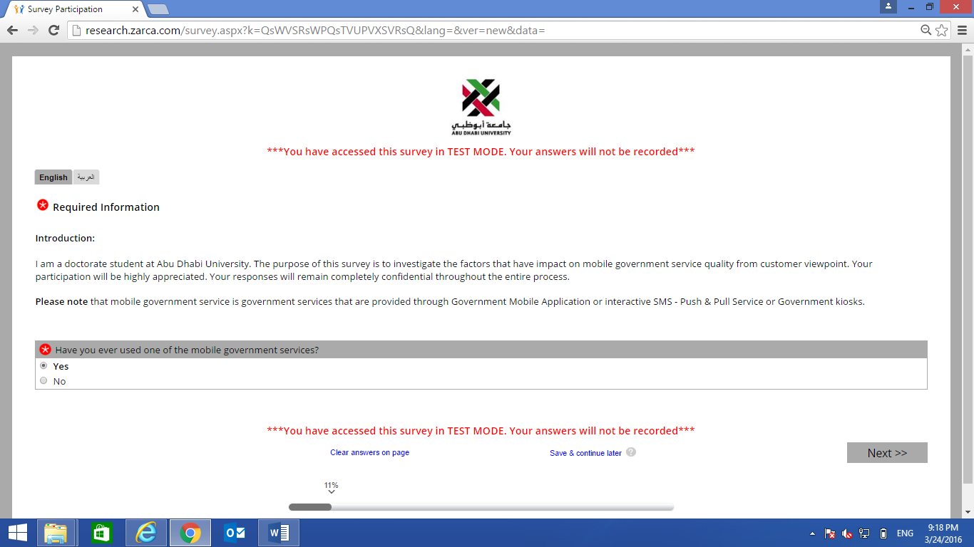

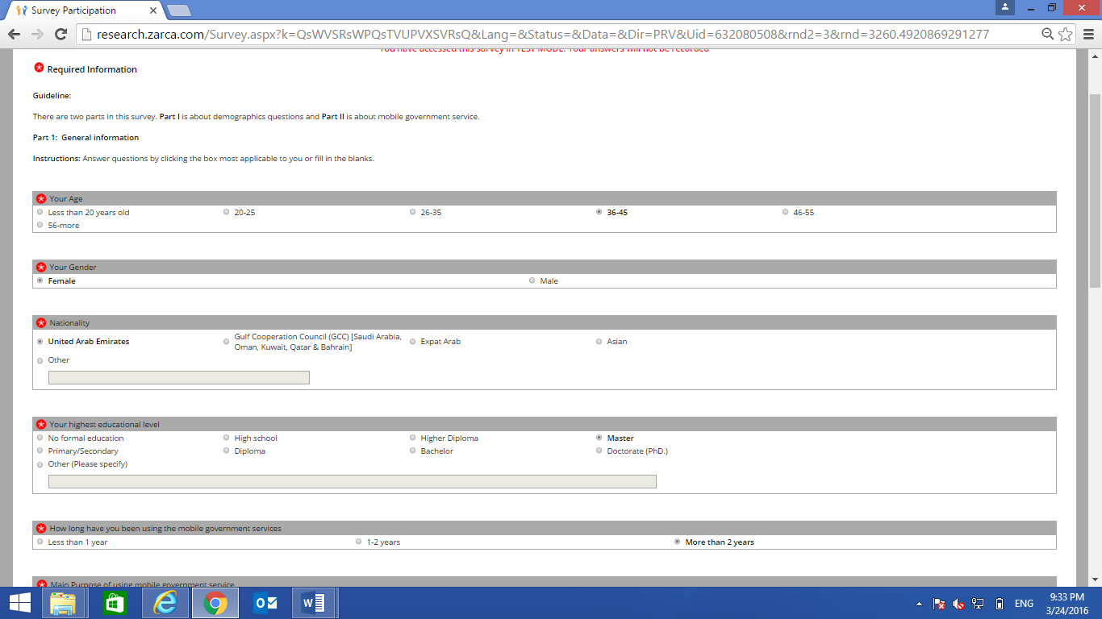

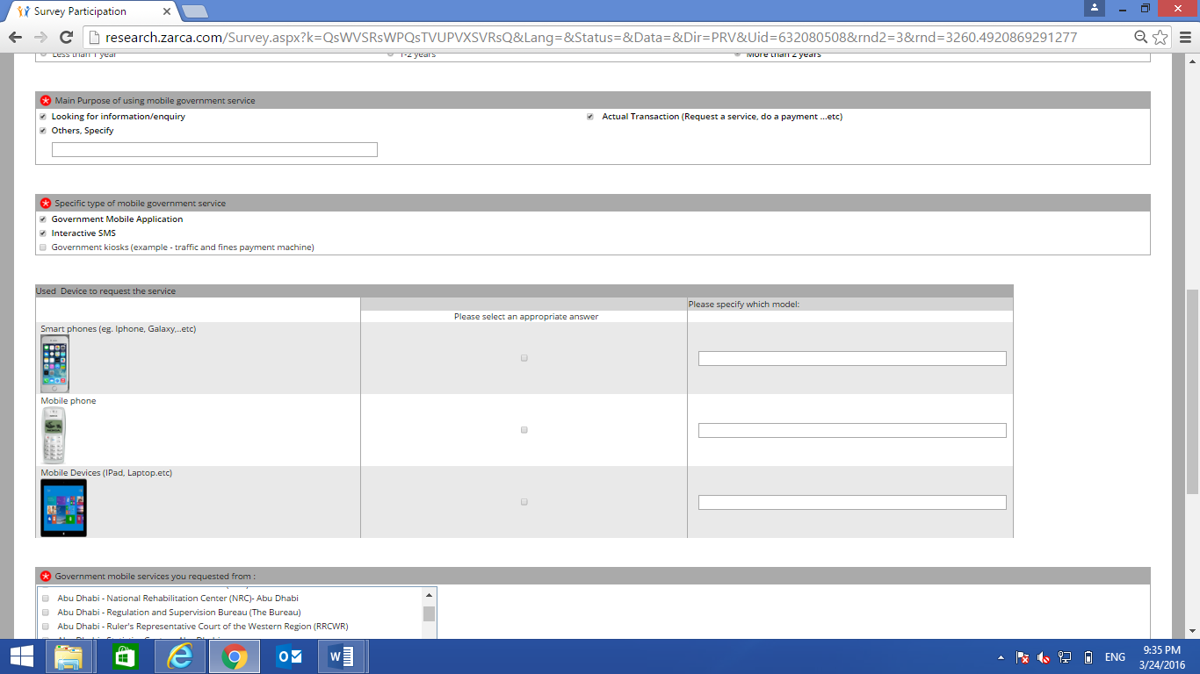

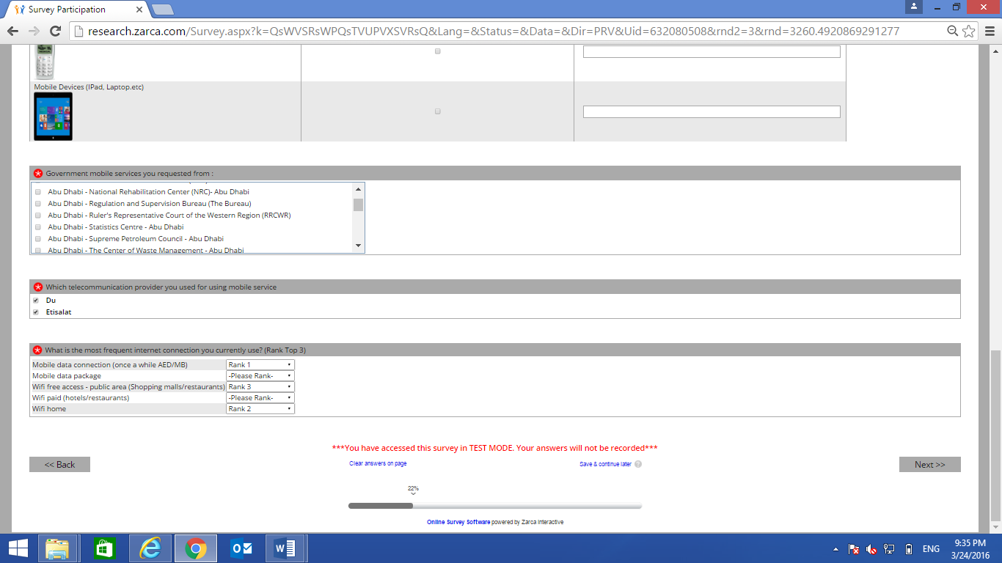

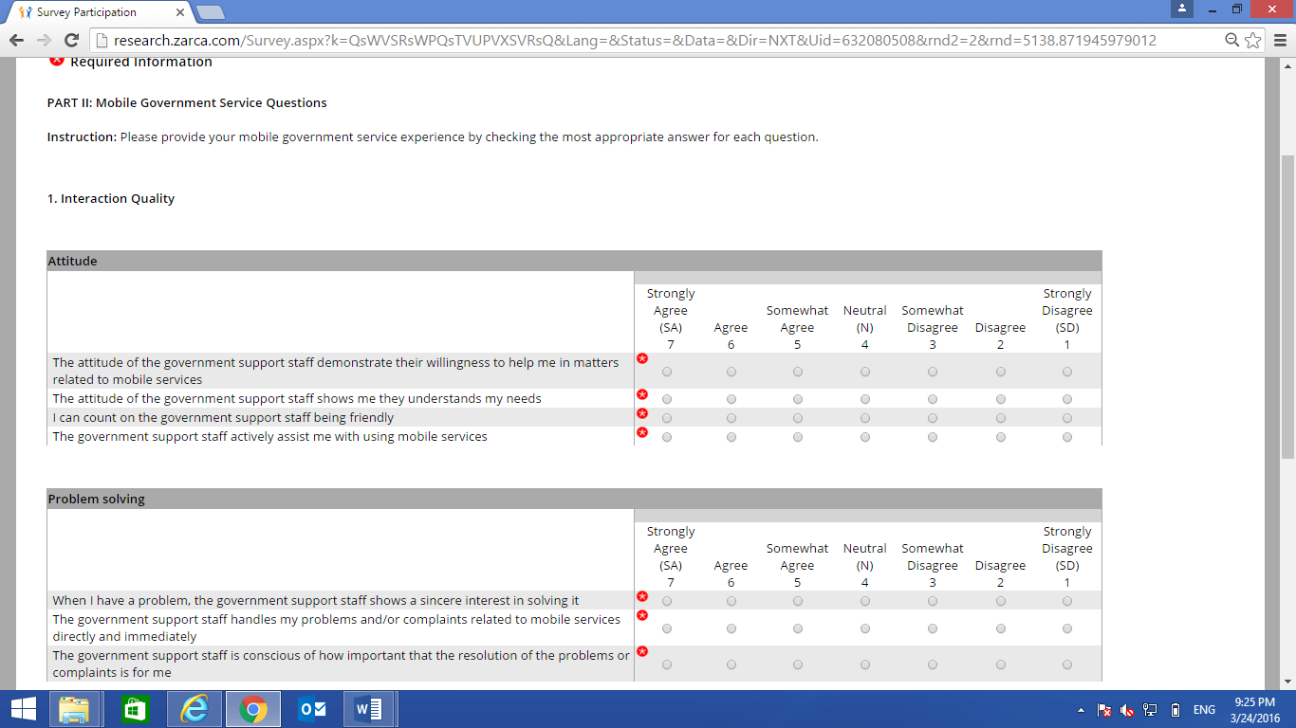

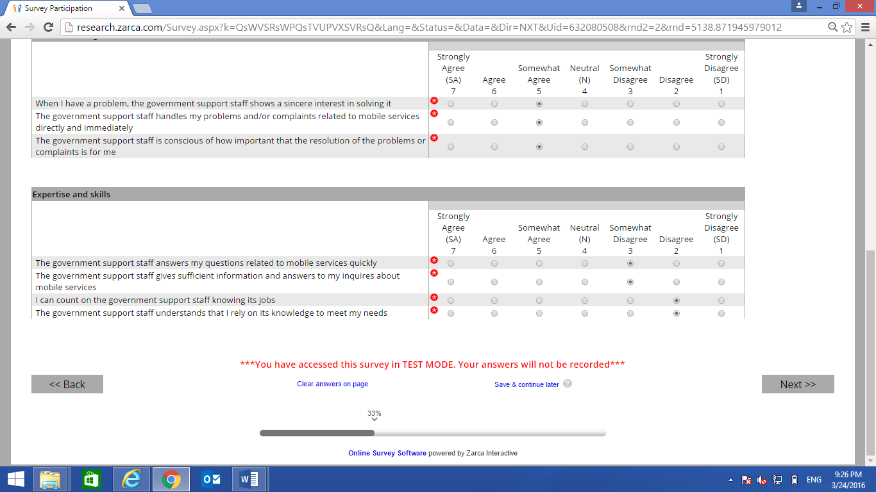

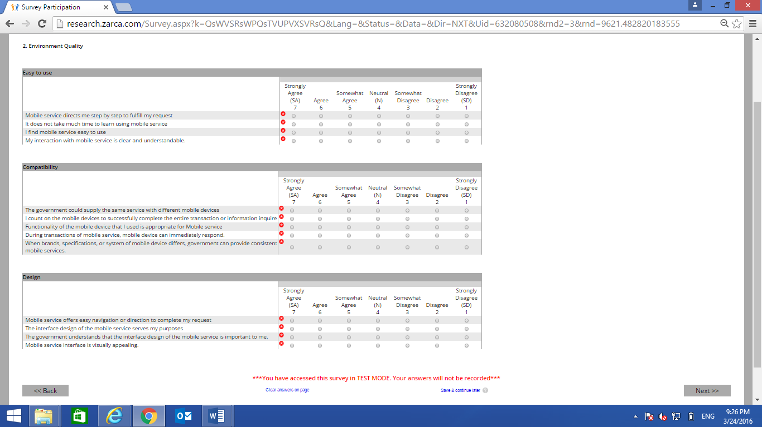

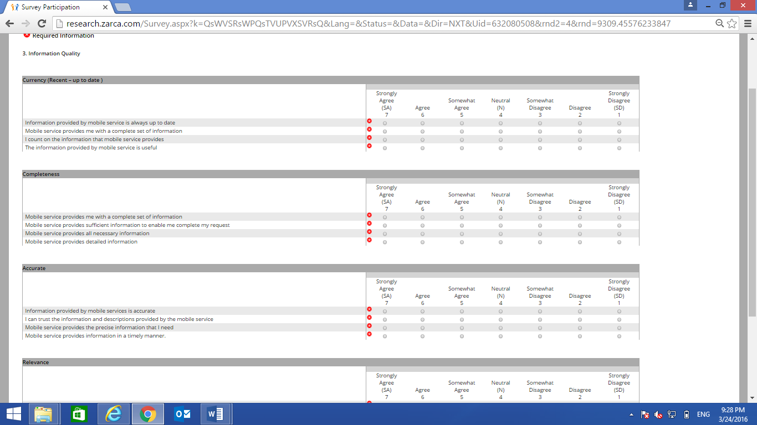

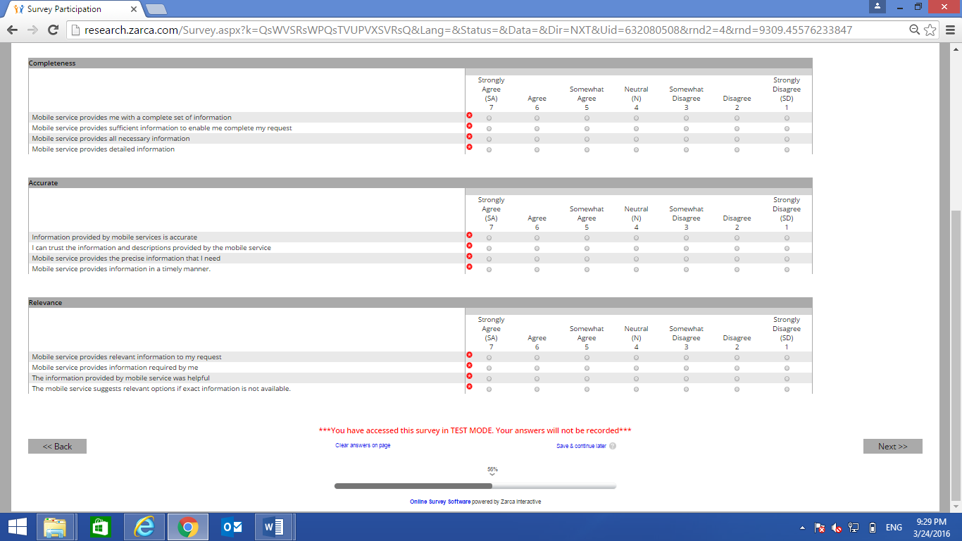

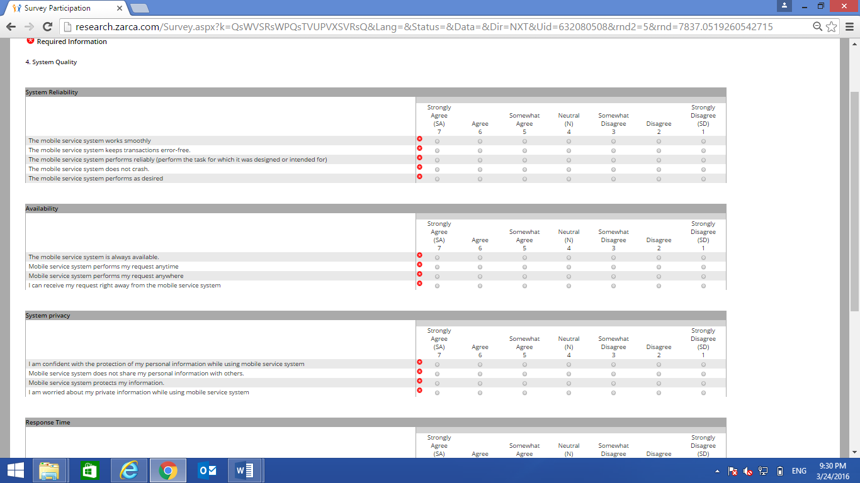

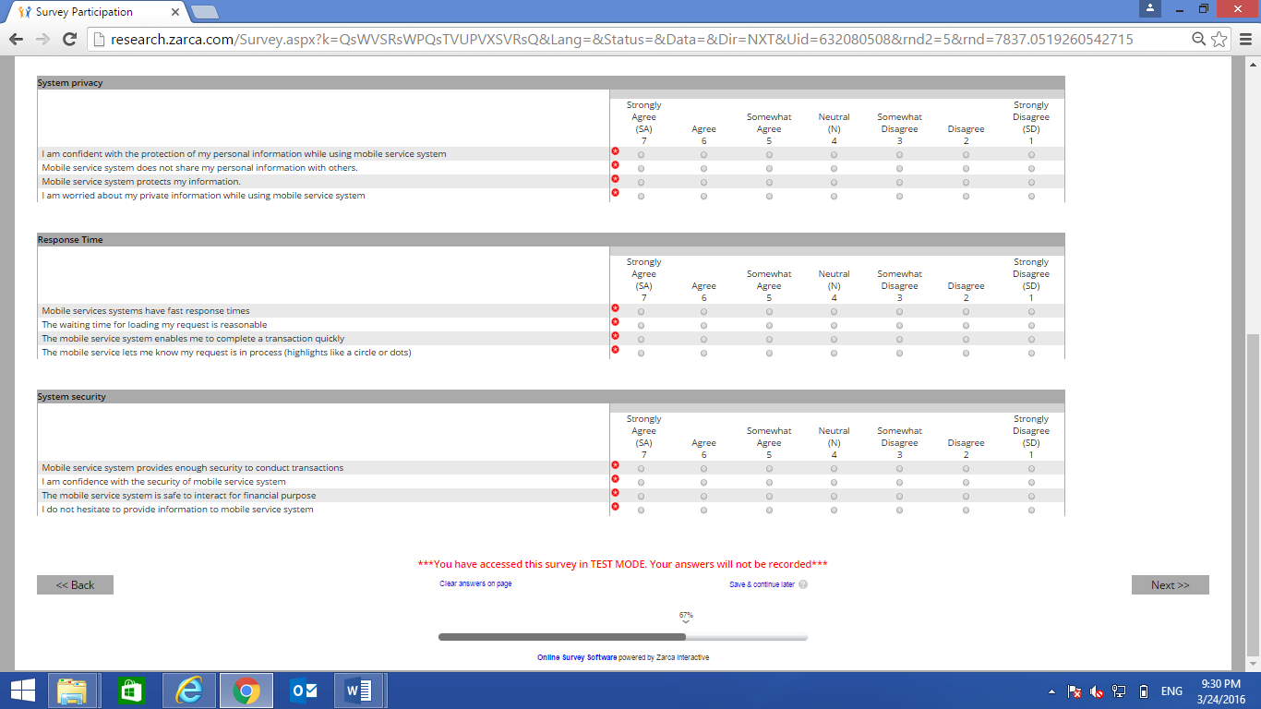

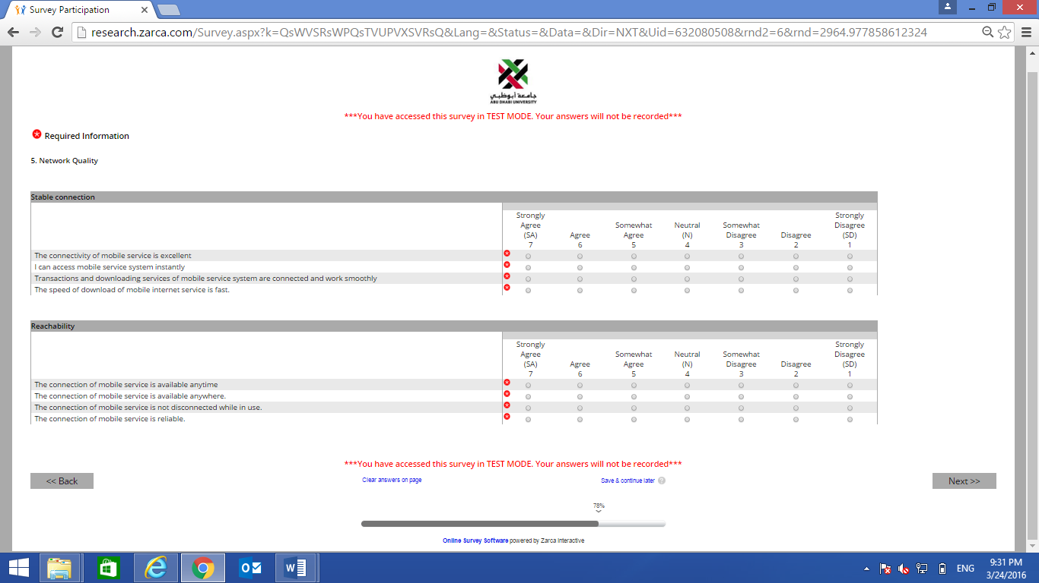

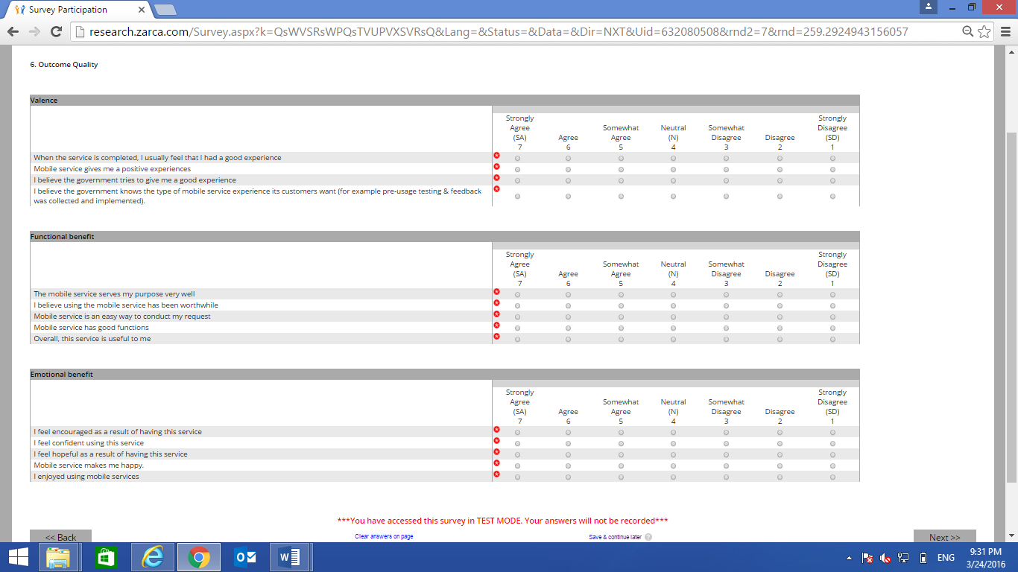

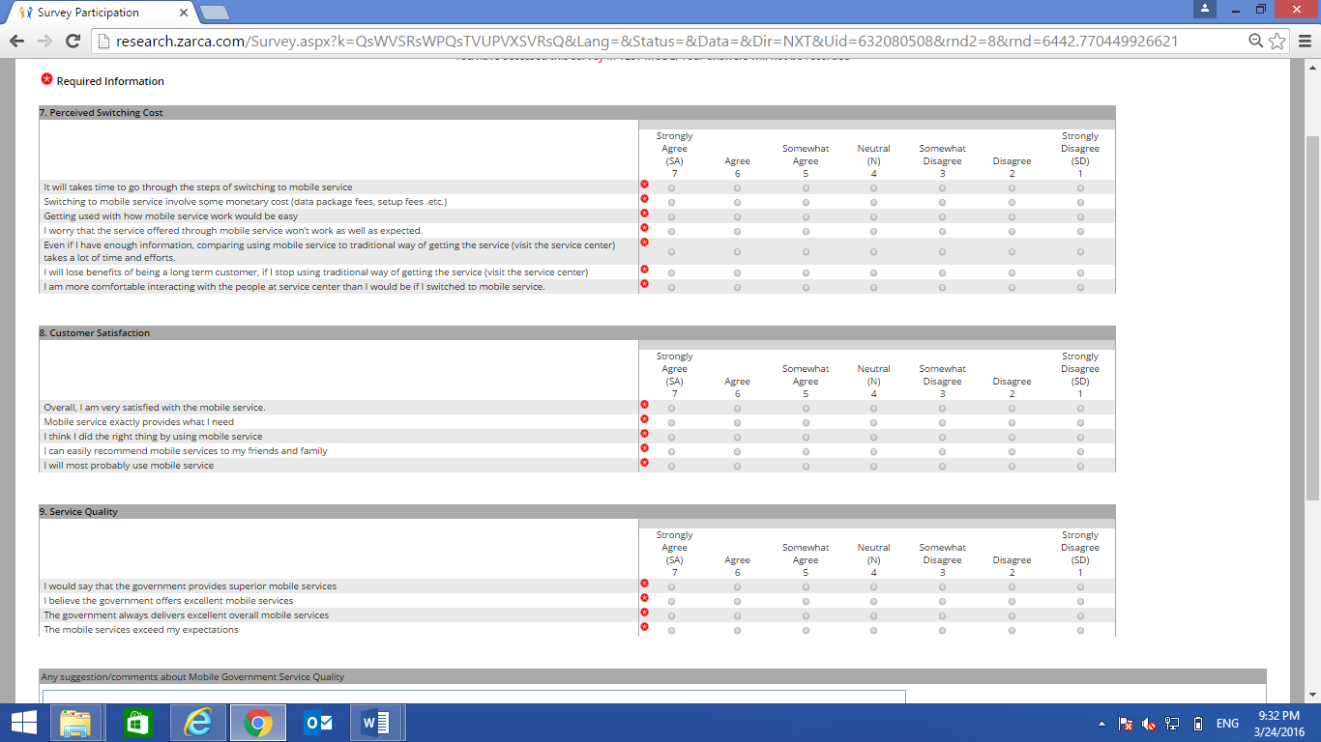

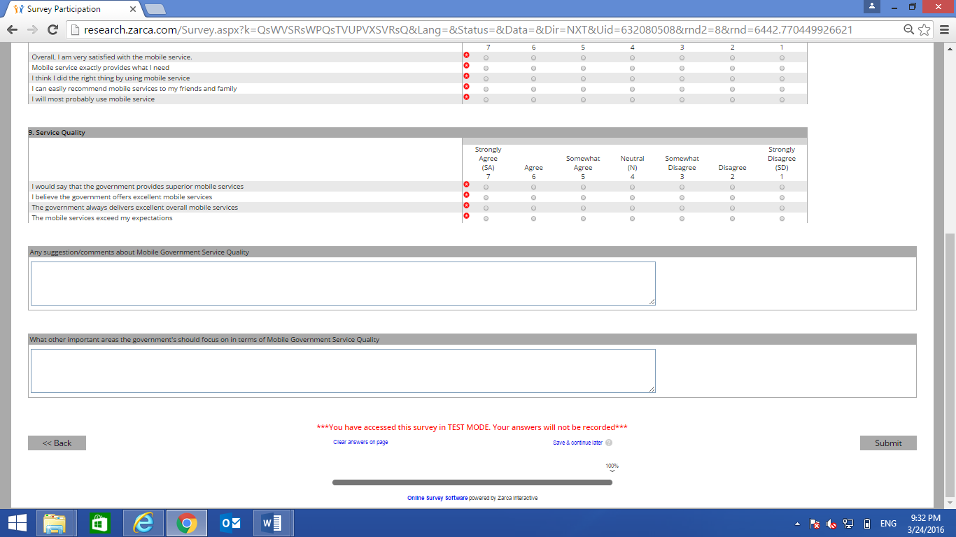

Appendix B: The Invitation E-mail
عزيزي المشارك،
أنا طالب دكتوراه في جامعة أبوظبي. والغرض من هذا الاستبيان هو بحث ودراسة العوامل التي توثر على جودة الخدمات الذكية التي تقدمها الحكومة عبر الأجهزة المتنقلة مثل الهاتف المتحرك أو المنصات الالكترونية الحكومية، وذلك من وجهة نظر العميل أو مستخدم الخدمة. وعليه فإن مشاركتك ستكون محل تقدير بالغ من طرفنا.
ونود إعلامكم بإن بياناتكم سوف تظل في طي الكتمان والسرية. سيستغرق منك الاستبيان من 10-15 دقيقة بحد أقصى.
من أجل المشاركة، يرجى إما :
 | 1. | الضغط هذه الوصلة
 |  | أو
 | 2. | إنسخ-ألصق كامل الوصلة التالية بين علامتي الإقتباس (غير شاملة علامتي الإقتباس) في متصف شبكة  " http://research.zarca.com/k/SsWVSRsWPQsPsPsQ "
تحياتي،،،
هاجر سعيد
Dear Participant
I am a doctorate student at Abu Dhabi University. The purpose is to investigate the factors that have impact on mobile government service quality from customer viewpoint. You participation will be highly appreciated. We have added an option SAVE & CONTINUE later at the bottom of the page on the right hand side, this will enable you to exit the survey at any time, by clicking this option the system will save your response. Once you come back to participate please click on the original link and your participation will begin from where you stopped
Your responses will remain completely confidential throughout the entire process. It takes approximately 10~15
minutes to finish this survey
In order to participate:
Click Here
Thank you for your participation
Regards
Hajar Saeed

Appendix C: Covariance Matrix and Correlation Matrix

M-government service quality—covariance matrix
Covariance Matrix

 | @36aServ | @36bServ | @36cServ | @36dServ | Attitude | Problem solving
@36aServ | 1.35
@36bServ | 1.20 | 1.26
@36cServ | 1.23 | 1.23 | 1.42
@36dServ | 1.25 | 1.27 | 1.40 | 1.85
Attitude | 0.73 | 0.74 | 0.74 | 0.80 | 1.43
Problem solving | 0.83 | 0.83 | 0.83 | 0.90 | 1.24 | 1.61
Expertise &Skills | 0.81 | 0.80 | 0.81 | 0.87 | 1.25 | 1.40
Easy to use | 0.75 | 0.76 | 0.74 | 0.79 | 0.56 | 0.57
Compatibility | 0.69 | 0.71 | 0.71 | 0.74 | 0.49 | 0.55
Design | 0.79 | 0.79 | 0.77 | 0.87 | 0.60 | 0.63
Currency | 0.79 | 0.77 | 0.78 | 0.86 | 0.62 | 0.68
Completeness | 0.87 | 0.83 | 0.88 | 0.99 | 0.67 | 0.73
Accurate | 0.84 | 0.83 | 0.84 | 0.90 | 0.64 | 0.73
Relevance | 0.74 | 0.74 | 0.75 | 0.82 | 0.65 | 0.66
System Reliability | 0.84 | 0.82 | 0.82 | 0.94 | 0.62 | 0.76
Availability | 0.71 | 0.70 | 0.69 | 0.78 | 0.53 | 0.62
Privacy | 0.77 | 0.79 | 0.82 | 0.80 | 0.61 | 0.71
Response Time | 0.76 | 0.78 | 0.76 | 0.85 | 0.55 | 0.63
System Security | 0.76 | 0.77 | 0.78 | 0.80 | 0.49 | 0.61
Stable Connection | 0.74 | 0.75 | 0.74 | 0.81 | 0.56 | 0.63
Reachability | 0.71 | 0.73 | 0.73 | 0.81 | 0.52 | 0.61
Valence | 0.82 | 0.80 | 0.82 | 0.87 | 0.55 | 0.59
Function benefits | 0.73 | 0.74 | 0.71 | 0.75 | 0.47 | 0.54
Emotion benefits | 0.73 | 0.76 | 0.76 | 0.80 | 0.53 | 0.58

Covariance Matrix (continued)

 | Expertise &Skills | Easy to Use | Compatibility | Design | Currency | Completeness
Expertise &Skills | 1.62
Easy to use | 0.59 | 0.92
Compatibility | 0.58 | 0.65 | 0.90
Design | 0.63 | 0.72 | 0.65 | 1.02
Currency | 0.69 | 0.69 | 0.67 | 0.74 | 1.02
Completeness | 0.73 | 0.73 | 0.67 | 0.81 | 0.95 | 1.26
Accurate | 0.74 | 0.74 | 0.70 | 0.75 | 0.90 | 1.00
Relevance | 0.66 | 0.63 | 0.62 | 0.68 | 0.75 | 0.85
System Reliability | 0.73 | 0.74 | 0.67 | 0.76 | 0.84 | 0.90
Availability | 0.60 | 0.65 | 0.55 | 0.63 | 0.72 | 0.74
Privacy | 0.68 | 0.58 | 0.54 | 0.66 | 0.70 | 0.76
Response Time | 0.62 | 0.66 | 0.61 | 0.69 | 0.71 | 0.78
System Security | 0.57 | 0.57 | 0.57 | 0.62 | 0.65 | 0.69
Stable Connection | 0.63 | 0.58 | 0.54 | 0.64 | 0.67 | 0.72
Reachability | 0.58 | 0.59 | 0.55 | 0.60 | 0.63 | 0.67
Valence | 0.59 | 0.63 | 0.59 | 0.65 | 0.65 | 0.70
Function benefits | 0.51 | 0.59 | 0.58 | 0.61 | 0.59 | 0.65
Emotion benefits | 0.56 | 0.57 | 0.60 | 0.60 | 0.60 | 0.63

Covariance Matrix (continued)

 | Accurate | Relevance | System Reliability | Availability | Privacy | Response  time
Accurate | 1.13
Relevance | 0.86 | 0.93
System Reliability | 0.91 | 0.78 | 1.24
Availability | 0.79 | 0.65 | 0.95 | 1.17
Privacy | 0.76 | 0.63 | 0.81 | 0.76 | 1.64
Response Time | 0.77 | 0.67 | 0.86 | 0.81 | 0.74 | 0.97
System Security | 0.73 | 0.58 | 0.70 | 0.66 | 1.08 | 0.71
Stable Connection | 0.71 | 0.61 | 0.74 | 0.73 | 0.63 | 0.74
Reachability | 0.68 | 0.60 | 0.76 | 0.82 | 0.67 | 0.70
Valence | 0.69 | 0.62 | 0.68 | 0.63 | 0.64 | 0.65
Function benefits | 0.67 | 0.59 | 0.64 | 0.58 | 0.60 | 0.63
Emotion benefits | 0.64 | 0.59 | 0.59 | 0.54 | 0.63 | 0.61

Covariance Matrix (continued)

 | System  Security | Stable connection | Reachability | Valence | Function benefits | Emotion  benefits
System Security | 1.14
Stable Connection | 0.65 | 1.01
Reachability | 0.63 | 0.82 | 1.08
Valence | 0.62 | 0.62 | 0.61 | 0.83
Function benefits | 0.58 | 0.59 | 0.58 | 0.70 | 0.79
Emotion benefits | 0.61 | 0.60 | 0.60 | 0.70 | 0.71 | 0.93

M-government service quality—correlation matrix

 | INTERQL | ENVIRQL | INFORQL | SYSQL | NETQL | OUTQL
INTERQL | 1.00
ENVIRQL | 0.61 | 1.00
 | (0.03)
 | 17.69
INFORQL | 0.63 | 0.91 | 1.00
 | (0.03) | (0.01)
 | 20.15 | 65.43
SYSQL | 0.61 | 0.88 | 0.89 | 1.00
 | (0.03) | (0.02) | (0.01)
 | 17.95 | 51.98 | 64.20
NETQL | 0.57 | 0.78 | 0.78 | 0.88 | 1.00
 | (0.04) | (0.03) | (0.02) | (0.02)
 | 15.55 | 30.64 | 32.63 | 52.51
OUTQL | 0.57 | 0.88 | 0.81 | 0.83 | 0.79 | 1.00
 | (0.04) | (0.02) | (0.02) | (0.02) | (0.02)
 | 16.15 | 52.81 | 41.76 | 43.85 | 34.29
mGOVQL | 0.63 | 0.83 | 0.77 | 0.78 | 0.74 | 0.83
 | (0.03) | (0.02) | (0.02) | (0.02) | (0.03) | (0.02)
 | 20.24 | 42.47 | 36.39 | 35.86 | 28.40 | 48.67

Correlation Matrix of Independent Variables (continued)

 | mGOVQL
mGOVQL | 1.00

M-government service quality HOM—Correlation matrix

Correlation matrix of independent variables

 | mGOv | Swich | CUSSAT
mGOv | 1.00
Swich | 0.08 | 1.00
 | (0.05)
 | 1.68
CUSSAT | 0.77 | -0.12 | 1.00
 | (0.02) | (0.05)
 | 36.49 | -2.42

M-government service quality HOM—Covariance matrix
Covariance matrix

 | @34aSwit | @34dSwit | @34eSwit | @34fSwit | @34gSwit | @35aSati
@34aSwit | 3.41
@34dSwit | 2.02 | 3.21
@34eSwit | 2.26 | 2.54 | 4.20
@34fSwit | 2.21 | 2.41 | 3.22 | 4.01
@34gSwit | 1.95 | 2.02 | 2.68 | 3.08 | 3.87
@35aSati | 0.05 | -0.28 | -0.20 | -0.03 | 0.07 | 1.10
@35bSati | 0.02 | -0.25 | -0.10 | 0.03 | 0.12 | 0.97
@35cSati | -0.10 | -0.29 | -0.33 | -0.17 | -0.07 | 0.86
@35dSati | -0.21 | -0.31 | -0.38 | -0.23 | -0.15 | 0.87
@35eSati | -0.17 | -0.28 | -0.40 | -0.21 | -0.11 | 0.79
@36aServ | 0.22 | -0.20 | 0.06 | 0.28 | 0.31 | 0.93
@36bServ | 0.15 | -0.21 | 0.00 | 0.19 | 0.26 | 0.91
@36cServ | 0.17 | -0.25 | 0.06 | 0.26 | 0.38 | 0.88
@36dServ | 0.37 | -0.10 | 0.34 | 0.48 | 0.57 | 0.94

Covariance matrix (continued)

 | @35bSati | @35cSati | @35dSati | @35eSati | @36aServ | @36bServ
@35bSati | 1.19
@35cSati | 0.88 | 1.01
@35dSati | 0.86 | 0.95 | 1.05
@35eSati | 0.79 | 0.82 | 0.87 | 0.94
@36aServ | 0.93 | 0.82 | 0.77 | 0.67 | 1.35
@36bServ | 0.90 | 0.82 | 0.79 | 0.67 | 1.20 | 1.26
@36cServ | 0.92 | 0.80 | 0.76 | 0.65 | 1.23 | 1.23
@36dServ | 1.00 | 0.82 | 0.80 | 0.64 | 1.25 | 1.27

Covariance matrix (continued)

 | @36cServ | @36dServ
@36cServ | 1.42
@36dServ | 1.40 | 1.85

Exchange rate 1 AED = 0.272246 USD

