

Knowledge Sharing, Firm Innovation Capability, Competitive Advantage and Financial Performance:
An Empirical Study

DBA Dissertation

By

AlShaima Taleb Hussein
ID#: 1012312

Abu Dhabi University, Abu Dhabi, UAE
College of Business Administration

Abu Dhabi, UAE

Dr. Sanjay Kumar Singh  College of Business Administration  Abu Dhabi University  DBA Committee Chair | Dr. Sherine Farouk  College of Business Administration  Abu Dhabi University  DBA Committee Member | Professor(Dr.) Amrik Singh Sohal  Department of Management,  Monash Business School,  Monash University, Australia  DBA Committee Member

November 22, 2016

To my
Father, Husband and Children
with love

Acknowledgments

I would like to express my deep-felt gratitude to my advisor, Dr. Sanjay Kumar Singh of the College of Business Administration, Abu Dhabi University, Abu Dhabi, UAE for his advice, encouragement, enduring patience and constant help. He provided me with professional and emotional support throughout this exceptional journey. He believed in my ability to complete this dissertation although I had many moments of doubt where I felt tired, lost, and unable to move forward. He always gave me his time and support, day and night, and made a tremendous effort to guide me for publishing my research paper out of DBA Dissertation in the Journal of Workplace Learning. I wish all students the honor and opportunity of experiencing his abilities as a committee chair.

I would like to thank the law enforcement agency under study, which provided me with all the help and support, especially the knowledge management team, who endured my constant demands for information and enquiries. I would also like to thank each and every employee who filled in my research questionnaire and contributed to my findings in my dissertation.

Furthermore, I would like to thank my husband and family members for all the positive messages and atmosphere when I felt tired and anxious. For listening to me talking about my dissertation hundreds of times. For my sister, spending hours reading my work. For pushing me forward to accomplish this work. For all the time I spent away from my family and children in order to complete my task, I nevertheless received more reinforcement and encouragement until the day I completed my dissertation.

I would like to thank Dr. Sherine Farouk of the College of Business Administration at Abu Dhabi University, Abu Dhabi, UAE and Prof. (Dr.) Amrik Singh Sohal of the Monash Business School, Monash University, Melbourne, Australia for every help and support they offered throughout my journey. They provided me with valuable feedback and comments whenever I needed them. Also, for their contribution to guide towards publications of research paper accepted in the Journal of Workplace Learning.

Finally, I would like to thank Dr. Jacob Chacko, Dean of College of Business Administration, Abu Dhabi University, Abu Dhabi, UAE for giving me this opportunity to complete a dissertation within my Doctor of Business Administration Program, and for providing me with all the help, support and resources needed to achieve my goal in providing a valuable contribution to the field of knowledge management research.

Abstract

In today’s knowledge-intensive society, organizations need to be able to effectively manage the increasingly important production factor “knowledge” in order to thrive. Previous studies have emphasized the importance of knowledge sharing, especially its influence on organizational innovation capability, competitive advantage and financial performance.

This study aims to develop a knowledge sharing framework across three dimensions: enablers, processes and outcomes in law enforcement in the United Arab Emirates (UAE). It examines the effect of six enablers (enjoyment in helping others, knowledge self-efficacy, top management support, organizational rewards, information and communication technology use, end-user focus) on knowledge donating and collecting, which together make up the bidirectional perspective of knowledge sharing. It also examines the impact of knowledge donating and collecting on organizational innovation capability, organizational competitive advantage and organizational financial performance. The model assesses additional relationships, such as the impact of organizational innovation capability on organizational competitive advantage, and the impact of organizational competitive advantage on organizational financial performance.

In this quantitative study, data is collected from a law enforcement agency using structured questionnaires. The sample size of this study is 605 middle managers. Several statistical tools are used to achieve study objectives, including descriptive analysis, one-way ANOVA, confirmatory factor analysis and structured equation modeling to test the 11 hypotheses provided by the structural model.

This study found that knowledge self-efficacy impacts knowledge donating behavior, top management support impacts knowledge collecting behavior, while information and communication technology use and end-user focus affect both knowledge donating and collecting. It also shows that knowledge collecting behavior of the employees impacts the agency’s innovation capability, competitive advantage and financial performance. Additionally, innovation capability affects competitive advantage, and competitive advantage affects financial performance in the law enforcement agency under study.

The findings also show that there are significant differences between the different general directorates in the law enforcement agency under study. By examining four of them, it is found that they share similar knowledge sharing behaviors, and have differences on others based on the units’ objectives, cultures and functions.

The present study highlights many limitations and opportunities for future research. For instance, more enablers and outcomes of knowledge sharing can be examined in the context of the United Arab Emirates (UAE). The barriers of knowledge sharing can also be addressed in future studies. Another alternative to studying knowledge sharing behavior is studying knowledge sharing intention. It might be beneficial to repeat this study in UAE sectors other than law enforcement to generalize the result in the UAE.

The study has significant theoretical and managerial contributions. It proposes a research model for empirical studies that links a three-dimensional framework, namely enablers, processes and outcomes. It has enormous opportunities for enhancements and adding more enablers and outcomes variables, which opens the door for scholars to improve and develop more frameworks that follow the same structure. The research model may also provide a clue regarding how knowledge-intensive organizations can promote knowledge sharing culture and create a successful knowledge sharing strategy, particularly in law enforcement agencies in the UAE.

The research model is novel and likely to be particularly valuable, especially in knowledge-intensive organizations such as the law enforcement sector. Knowledge sharing has often been neglected by organizations in the UAE, because of the lack of knowledge sharing culture and trust among and across organizations in the country, as well as the scarcity of relevant research in the area.

Keywords Knowledge sharing, innovation capability, competitive advantage, Financial performance, law enforcement, United Arab Emirates

Table of contents

Acknowledgments i
Abstract iii
Tables viii
Figures x
Abbreviations xi
1. Introduction 1
2. Literature review 6
2.1 Knowledge, knowledge management and knowledge sharing 6
2.1.1 Knowledge defined 6
2.1.2 Knowledge management defined 7
2.1.2 Knowledge sharing defined 10
2.2 Knowledge donating and knowledge collecting 12
2.3 Theorizing knowledge sharing 12
2.4 The barriers of knowledge sharing 15
2.5 Enablers, processes and outcomes dimensions 16
2.6 Knowledge sharing enablers and processes 16
2.6.1 Enjoyment in helping others and knowledge sharing processes 18
2.6.2 Knowledge self-efficacy and knowledge sharing processes 19
2.6.3 Top management support and knowledge sharing processes 19
2.6.4 Organizational rewards and knowledge sharing processes 20
2.6.5 Information and communication technology use and knowledge sharing processes 21
2.6.6 End-user focus and knowledge sharing processes 21
2.7 Knowledge sharing processes and outcomes 22
2.7.1 Knowledge sharing processes and organizational innovation capability 22
2.7.2 Knowledge sharing processes and organizational competitive advantage 22
2.7.3 Knowledge sharing processes and organizational financial performance 23
2.8 Organizational innovation capability and organizational competitive advantage 24
2.9 Organizational competitive advantage and organizational financial performance 25
2.10 Knowledge-intensive organizations defined 27
3. Methodology 30
3.1 Objectives of the study 30
3.2 Research model and hypotheses 31
3.3 Design of the study 32
3.4 Instruments 35
3.5 Statistical analysis 37
3.6 About the law enforcement agency 38
4. Results 41
4.1 Knowledge sharing enablers, processes and outcomes profile 42
4.2 The difference between the seven general directorates 45
4.3 Testing the measurement model 45
4.3 Testing the structural model 56
4.4 Testing the structural model for general directorates 59
4.4.1 Testing the structural model for GD1 60
4.4.2 Testing the structural model for GD2 62
4.4.3 Testing the structural model for the GD3 65
4.4.4 Testing the structural model for GD4 68
5. Discussion 72
5.1 Knowledge sharing enablers, processes and outcomes profile 72
5.2 Knowledge sharing enablers, processes and outcomes differences 73
5.3 Testing the measurement model 74
5.3 Testing the structural model 74
5.3.1 The impact of knowledge sharing enablers on knowledge sharing processes 76
5.3.2 The impact of knowledge sharing processes on knowledge sharing outcomes 78
5.3.3 The impact of knowledge sharing outcomes on one another 79
5.4 Testing the structural model for the general directorates 79
5.4.1 Testing the structural model for GD1 82
5.4.2 Testing the structural model for GD2 84
5.4.3 Testing the structural model for GD3 85
5.4.4 Testing the structural model for GD4 86
5.4.5 Comparing and contrasting the results 88
6. Conclusions, Implications, Limitations and Future Research 90
6.1 Conclusions 90
6.2 Implications 92
6.2.1 Theoretical contributions 92
6.2.2 Managerial contributions 93
6.3 Limitations and future research 95
6.4 Recommendations 96
References 98
Appendices 111
Appendix 1: Instruments 111
Appendix 2: Questionnaire 115

Tables

Table 2.1: Constructs’ literature summary 26
Table 3.1: Summary of demographic information of sample 34
Table 3.2: Summary of instruments used in the study 37
Table 4.1a: Descriptive analysis for the law enforcement agency 43
Table 4.1b: Descriptive analysis for the law enforcement agency 43
Table 4.2: One-way ANOVA analysis for the general directorates 45
Table 4.3: 1st Path coefficient analysis for enjoyment in helping others (EH), knowledge self-efficacy (SE), top management support (TM), organizational rewards (OR) and information and communication technology use (IT) 47
Table 4.4: 1st Standardized path coefficient analysis for enjoyment in helping others (EH), knowledge self-efficacy (SE), top management support (TM), organizational rewards (OR) and information and communication technology use (IT) 47
Table 4.5: 1st Path coefficient analysis for end-user focus (EU), knowledge donating (KD), knowledge collecting (KC), innovation capability (IC), competitive advantage (CA) and financial performance (FP) 49
Table 4.6: 1st Standardized path coefficient analysis for end-user focus (EU), knowledge donating (KD), knowledge collecting (KC), innovation capability (IC), competitive advantage (CA) and financial performance (FP) 50
Table 4.7: 2nd Path coefficient analysis for enjoyment in helping others (EH), knowledge self-efficacy (SE), top management support (TM), organizational rewards (OR) and information and communication technology use (IT) 52
Table 4.8: 2nd Standardized path coefficient analysis for enjoyment in helping others (EH), knowledge self-efficacy (SE), top management support (TM), organizational rewards (OR) and information and communication technology use (IT) 52
Table 4.9: 2nd Path coefficient analysis for end-user focus (EU), knowledge donating (KD), knowledge collecting (KC), innovation capability (IC), competitive advantage (CA) and financial performance (FP) 54
Table 4.10: 2nd Standardized path coefficient analysis for end-user focus (EU), knowledge donating (KD), knowledge collecting (KC), innovation capability (IC), competitive advantage (CA) and financial performance (FP) 54
Table 4.11: Goodness-of-fit indices for enjoyment in helping others (EH), knowledge self-efficacy (SE), top management support (TM), organizational rewards (OR) and information and communication technology use (IT) 55
Table 4.12: Goodness-of-fit indices for end-user focus (EU), knowledge donating (KD), knowledge collecting (KC), innovation capability (IC), competitive advantage (CA) and financial performance (FP) 55
Table 4.13: Pearson product-moment correlations for all variables under study 55
Table 4.14: Path coefficient results for all the variables under study during SEM 57
Table 4.15: Standardized path coefficient results for all the variables under study during SEM 58
Table 4.16: Goodness-of-fit indexed for SEM 58
Table 4.17: Path coefficient results fir the GD1 during the SEM 60
Table 4.18: Standardized path coefficient results fir the GD1 during the SEM 61
Table 4.19: Goodness-of-fit Index during the SEM for GD1 61
Table 4.20: Path coefficient results fir the GD2 during the SEM 63
Table 4.21: Standardized path coefficient results fir the GD2 during the SEM 64
Table 4.22: Goodness-of-fit Index during the SEM for GD2 64
Table 4.23: Path coefficient results fir the GD3 during the SEM 66
Table 4.24: Standardized path coefficient results fir the GD3 during the SEM 67
Table 4.25: Goodness-of-fit Index during the SEM for GD3 67
Table 4.26: Path coefficient results fir the GD4 during the SEM 69
Table 4.27: Standardized path coefficient results fir the GD4 during the SEM 70
Table 4.28: Goodness-of-fit Index during the SEM for GD4 70
Table 5.1: Summary of hypotheses testing 74
Table 5.2: Summary for hypotheses testing for the GD1, GD2, GD3 and GD4 80

Figures

Figure 2.1: Conceptual framework for knowledge sharing behavior (Source: Tangaraja et al. (2015) 29
Figure 3.1: Proposed research model 31
Figure 4.1: Steps undertaken for analysis in the study 42
Figure 4.2: 1st Confirmatory Factor Analysis for enjoyment in helping others (EH), knowledge self-efficacy (SE), top management support (TM), organizational rewards (OR) and information and communication technology use (IT) 46
Figure 4.3: 1st Confirmatory Factor Analysis for end-user focus (EU), knowledge donating (KD), knowledge collecting (KC), innovation capability (IC), competitive advantage (CA) and financial performance (FP) 48
Figure 4.4: 2nd Confirmatory Factor Analysis for enjoyment in helping others (EH), knowledge self-efficacy (SE), top management support (TM), organizational rewards (OR) and information and communication technology use (IT) 51
Figure 4.5: 2nd Confirmatory Factor Analysis for end-user focus (EU), knowledge donating (KD), knowledge collecting (KC), innovation capability (IC), competitive advantage (CA) and financial performance (FP) 53
Figure 4.6: Structual Equation Modeling (SEM) for the law enforcement agency 56
Figure 4.7: Structual Equation Modeling (SEM) for GD1 59
Figure 4.8: Structual Equation Modeling (SEM) for GD2 62
Figure 4.9: Structual Equation Modeling (SEM) for GD3 65
Figure 4.10: Structual Equation Modeling (SEM) for GD4 68
Figure 6.1: Summary of the findings of the present study 90

Abbreviations

ANOVA: Analysis of Variance
CA: Organizational Competitive Advantage
CFA: Confirmatory Factor Analysis
CFI: Comparative Fit Index
CMIN: Chi-Square
EH: Enjoyment in Helping Others
EU: End-user Focus
FP: Organizational Financial Performance
GFI: Goodness-of-Fit Index
GWCM: General Workplace Commitment Model
IC: Organizational Innovation Capability
IT: Information and Communication Technology use
KC: Knowledge Collecting
KD: Knowledge Donating
NFI: Normed Fit Index
OCB: Organizational Citizenship Behavior
OR: Organizational Rewards
RMSEA: Root Mean Square Error of Approximation
SCT: Social Capital Theory
SDT: Self-Determination Theory
SE: Knowledge Self-efficacy
SEM: Structured Equation Modeling
TLI: Tucker-Lowis Index
TM: Top Management Support
TPB: Theory of Planned Behavior
TRA: Theory of Reason Action
UAE: United Arab Emirates

Introduction

A knowledge sharing scenario in a law enforcement agency:
An investigation officer receives a case about a murder that happened last night. After visiting the crime scene, he starts collecting more information from the witnesses and the available criminal systems. The officer also contacts his colleagues to ask them about their previous experience with similar cases in the area. The top management keeps in touch with the assigned officer to follow up with the investigation’s progress and makes sure he has all the human and intellectual resources he needs. During the investigation, the latest communication technology is used to exchange knowledge between the investigation team, which aids in solving the case. Finally, all the criminal evidence is collected and the offender is prosecuted. After the case is closed, the investigation officer shares his experiences with the other officers to help solve future crimes, while during the investigation he made sure no information was leaked or communicated with unauthorized individuals. As a result, the law enforcement agency gains a positive image with other agencies for its innovative methods in investigating cases, and its professionalism and speed in solving crimes.

What if knowledge wasn’t shared in the above scenario? How can the law enforcement agency perform efficiently without acquiring and sharing the right knowledge? Unfortunately, in the field of knowledge management, the role of knowledge sharing has often been neglected by organizations in the UAE, because of the lack of knowledge sharing culture and trust among and across organizations in the country, as well as the scarcity of relevant research in the area (Ahmad and Daghfous, 2010).

This study therefore focused on examining knowledge sharing in the context of law enforcement in the UAE because it is considered essential for knowledge-intensive organizations such as law enforcement agencies (Collier, 2006). The agency under study is one of the largest law enforcement agencies in the country. It has more than 35,000 employees and it covers a wide geographical area. It includes seven General Directorates (GD) that depend intensively on different knowledge to perform their tasks and duties, such as investigations, surveillance and operations.

In the past few years, the law enforcement agency has emphasized on the importance of knowledge management processes for the whole organization to perform effectively and achieve its objectives. It established a knowledge management unit as part of its Strategy Department on 2010. Since then, many knowledge sharing initiatives were introduced, and it won several regional excellence awards in the field of knowledge management.

In today’s knowledge-intensive society, organizations need to be able to effectively manage the increasingly important production factor of “knowledge” in order to thrive (van den Hooff and de Ridder, 2004). Previous studies have emphasized the importance of knowledge sharing, especially its influence on firm innovation capability, competitive advantage and financial performance.

Knowledge sharing has been studied in the literature under different terms and by several authors (Hansen, 1999; Tsai, 2002). Some researchers refer to knowledge sharing as knowledge transfer (Mowery et al., 1996; Wijk van et al., 2008), or as knowledge flows (Gupta and Govindarajan, 2000; Schulz, 2001). Wijk van et al. (2008) defined it as “the process through which organizational actors – teams, units or organizations – exchange, receive and are influenced by the experience and knowledge of others (p. 832)”. It is a building block for organizational success and often considered an essential survival strategy in a knowledge-intensive era (Witherspoon et al., 2013).

An organization can successfully promote a knowledge sharing culture, not only by directly incorporating knowledge in its business strategy, but also by changing employee attitudes and behaviors to promote willing and consistent knowledge sharing (Connelly and Kelloway, 2003; Lin and Lee, 2004). Knowledge is also rooted in the intelligence of individuals and is visible in tasks, systems, and customs, all of which are very difficult to imitate (Davenport and Prusak, 1998). Davenport and Prusak (1997) stated that knowledge sharing is hard because people fear that by sharing their knowledge, they will lose status and power in their organizations.

Gruenfeld, Martesana and Fan (2000) demonstrated that knowledge sharing not only reduces the cost of production or service provision, but also contributes to the success of an organization, as it helps to develop innovation capability. It is also essential for any business because it creates chances to increase organizations’ ability to meet their needs and to find efficiencies and solutions to provide them with competitive advantage (Reid, 2003), as well as to enhance their financial performance (Wang et al., 2014).

This study developed a knowledge sharing framework across three dimensions: enablers, processes and outcomes that can be practically implemented as a knowledge sharing strategy in the law enforcement agency under study. The same agency is currently implementing a two-dimensional model, using enablers and processes, which is based upon the work of Bock and Kim (2002) and Yeh, Lai & Ho (2006). The knowledge sharing strategy mainly includes information technology use, top management support and organizational rewards as enablers, and knowledge collecting as a process. The choice of this strategy was not based on an empirical study and the outcome of its implementation is below satisfactory.

The study aimed to introduce a new framework to examine the effect of six enablers (enjoyment in helping others, knowledge self-efficacy, top management support, organizational rewards, information and communication technology use, end-user focus) of knowledge donating and collecting, which together make up the bidirectional perspective of knowledge sharing (van den Hooff and de Ridder, 2004). The proposed knowledge sharing model also examined the impact of knowledge donating and collecting on firm innovation capability, organizational competitive advantage and firm financial performance. In addition, the model assessed additional relationships, such as the impact of firm innovation capability on firm competitive advantage, and the impact of firm competitive advantage on firm financial performance.

In addition, the new framework is examined separately for four of the general directorates (GDs) of the law enforcement agency under study – GD1, GD2, GD3 and GD4. Each of these four general directorates has different characteristics, functions and culture. Comparing and contrasting the results of the study have provided interesting findings, with important managerial implications. It is hereby mentioned that from now onwards, “firm innovation capability” will by referred to as “organizational innovation capability”, because the law enforcement agency under study is a non-profit organization, unlike other firms that are typically for profits. The same applies to “organizational competitive advantage” and “organizational financial performance”.

In this quantitative study, data was collected from a law enforcement agency using a structured questionnaire. In this study, 1200 middle management employees of the law enforcement organization were approached using structured survey questionnaire to participate in the research. However, only 605 respondents returned completed survey questionnaire which indicates about 50% of the response rate. The sample in the study included police officers from colonel to lieutenant ranks, males and females, from seven different general directorates. Several statistical tools are used, including descriptive analysis to create a profile for the different constructs, Cronbach Alfa for reliability testing, One-way ANOVA to compare the different general directorates, confirmatory factor analysis for testing the measurement model, and structured equation modeling to test the 11 hypotheses provided by the structural equation model.

This study provides an added value to previous knowledge sharing studies. First, it extends the work of similar studies conducted previously, such as the work of Lin (2007) and Kumar and Rose (2012), where it introduces more enablers (end-user focus) and outcomes (organizational competitive advantage and organizational financial performance) for knowledge sharing. It also examines additional relationships that exist between outcomes, including organizational innovation capability and competitive advantage, as well as organizational competitive advantage and financial performance. Thus, the proposed model is considered more comprehensive and has never been introduced in previous literature.

Second, the role of knowledge sharing has never been introduced before in studies conducted in law enforcement agencies or any other sector in the Middle Eastern region of the world. This research raises many theoretical and managerial contributions, as it opens the door for researchers to improve and develop more knowledge sharing models that follow the same three-dimensional structure. It can also be utilized to develop practical knowledge sharing strategies for law enforcement agencies in the UAE. Several limitations are found in this study, including examining more enablers or outcomes, which provides many opportunities for researchers in the future.

Thus, this dissertation is intended to provide answers to the following six research questions (RQ):
- RQ1: What are the enablers that influence knowledge donating and collecting in law enforcement agencies in the UAE?
- RQ2: How do knowledge donating and collecting impact innovation capability in law enforcement agencies in the UAE?
- RQ3: How do knowledge donating and collecting impact competitive advantage in law enforcement agencies in the UAE?
- RQ4: How do knowledge donating and collecting impact financial performance in law enforcement agencies in the UAE?
- RQ5: What is the role played by innovation capability in influencing the competitive advantage of law enforcement agencies in the UAE?
- RQ6: What is the role played by competitive advantage in influencing the financial performance of law enforcement agencies the UAE?

Following this introduction, chapter 2 details the relevant literature review, such as defining knowledge sharing, theoretical background, knowledge sharing enabler, processes and outcomes, etc. Chapter 3 details the methodology, including the proposed model, hypotheses, instruments and the design of the study undertaken. Chapter 4 contains the results, based on structured equation modeling, followed by a detailed discussion of the results in chapter 5. Finally, the Chapter 6 covers the conclusion, limitations and future research opportunities, followed by theoretical and managerial contributions.

Literature review

This literature starts with defining knowledge as either a process or an object, and it describes two types of knowledge: tacit and explicit knowledge. Then it describes knowledge management and knowledge sharing as one of its key processes. Knowledge sharing behavior is then viewed as unidirectional or bidirectional. The bidirectional perspective of knowledge sharing includes knowledge donation and knowledge collecting. Then, past studies that conceptualize knowledge sharing behavior using theories such as Theory of Reasoned Action (TRA), Theory of Planned Behavior (TPB), Social Capital Theory (SCT) and Self Determination Theory (SDT) are reviewed.

After that, a three-dimensional model for knowledge sharing is introduced, which includes enablers, processes and outcomes of knowledge sharing behavior. Among various enablers of knowledge sharing processes, six are expanded in detail. These are enjoyment in helping others, knowledge self-efficacy, top management support, organizational rewards, information and communication technology use, and end-user focus. The knowledge sharing outcomes that are examined in-depth are organizational innovation capability, organizational competitive advantage and organizational financial performance.

2.1 Knowledge, knowledge management and knowledge sharing

2.1.1 Knowledge defined
In the literature, knowledge is seen from many different viewpoints. Knowledge is viewed by researchers as either an object (Zack, 1998) or as a process (Schubert et al., 1998). It can be viewed as either a state of mind, an object, a process, a condition of having access to information, or a capability (Schubert, Lincke, and Schmid, 1998). In general, knowledge can be defined as the state of knowing that constitutes facts, principles, concepts, laws, casual relationships, judgments, intuition, insights, and feelings (Koenig and Srikantaiah, 2004).

Some researchers argue the question of defining knowledge by differentiating between knowledge, information, and data. It assumes that, if knowledge is not something that is different from data or information, then there is nothing novel or interesting about knowledge (Fahey and Prusak, 1998). For example, Vance (1997) defines information as data decoded into a meaningful framework, and knowledge is information that has been authenticated and thought to be true. Maglitta (1996) suggests that data is raw numbers and facts, information is processed data, and knowledge is information made actionable. Dretske (1981) describes information as the raw material for producing a newly formed or sustained belief knowledge.

Knowledge has two main types: tacit and explicit. Explicit knowledge means knowledge that is objective, verbalized, and captured, and has a more tangible format (Nonaka et al., 2006). It is expressed, codified and communicated in a natural language and/or a symbolic form (Alavi and Leidner, 2001). It includes books, manuals, procedures, laws, documented experience, etc. On the other hand, tacit knowledge includes the subjective, personal and intangible knowledge (Nonaka et al., 2006). The ability to go through the processes related to identifying tacit knowledge and encouraging the worker to share it is very difficult to develop (Howells, 1996). Tacit knowledge is rooted in action, experience, and involvement in a specific context.

Tacit knowledge comprises cognitive and technical elements (Nonaka, 1994). The cognitive element refers to people’s mental models, consisting of mental maps, beliefs, paradigms and viewpoints. The technical component consists of actual know-how, crafts and skills that apply to a specific context (Alavi and Leidner, 2001). Nonaka (1994) has recognized two other types of knowledge: individual and social knowledge. Individual knowledge is created by and exists in the individual, and social knowledge is created by and is inherent in the collective actions and interactions of individuals acting as a group

2.1.2 Knowledge management defined
While there is debate as to whether knowledge itself is a process or an object, knowledge management is typically considered as a process (Alavi and Leidner, 2001). Knowledge management is defined as a process of identifying, capturing, and leveraging the collective knowledge in an organization to boost the organization’s competitive advantage (Von Krogh, 1998). Also, according to Wigg (1977), “Knowledge management is the systematic, explicit, and deliberate building, renewal, and application of knowledge to maximize an enterprise’s knowledge related effectiveness and returns from its knowledge assets” (p. 1).
All the knowledge management elements are grouped into the following pillars: leadership/management, organization, technology and learning. Leadership/management deals with the strategic, environmental and enterprise-level decision making and processes. Organization deals with the operational aspects of knowledge assets. Learning deals with social engineering and organizational behavioral aspects. Technology deals with various information technologies peculiar to support or enable knowledge strategies and operations. Learning focuses on the principles and practices to ensure that individuals collaborate and share efficiently (Stankosky, 2005).

The primary goals of knowledge management in organizations include: improving decision making, expediting response time to main issues, increasing profitability, improving productivity, creating new business opportunities, reducing costs, sharing best practices, increasing market share, increasing share price, and improving staff attraction/retention (KPMG, 1998).

As stated by Davenport and Prusak (1997), most knowledge management projects have one of the following three objectives: (1) to make knowledge visible and show the role of knowledge in an organization, mainly through models, maps and visual tools; (2) to develop a knowledge-intensive culture by encouraging and building behaviors such as knowledge sharing and proactively collecting and donating knowledge; (3) to build a knowledge infrastructure, not only a technical system, but a web of connections among people given space, time, tools, and encouragement to collaborate.

Different literature provided dissimilar presentations of knowledge management processes. Davenport, Jarvenpaa and Beers (1996) state four key processes: finding current knowledge, creating new knowledge, packaging knowledge created and externally using existing knowledge. KPMG (1998) presents seven processes of knowledge management: creation, application within the organization, exploitation outside the organization, sharing and dissemination, encapsulation (capturing and recording experience and know-how), sourcing (locating a person or record embodying the required knowledge), and learning.

Teece (1998) considers eight processes of knowledge management:
(1) Creating new knowledge,
(2) Retrieving valuable knowledge from outside sources,
(3) Utilizing accessible knowledge in decision making,
(4) Inserting knowledge in processes, products and services,
(5) Demonstrating knowledge in documents, databases and software,
(6) Facilitating knowledge growth through culture and incentives,
(7) Sharing existing knowledge with other parts of the organization,
(8) Measuring the value of knowledge assets and impact of knowledge management.

Finally, the Cranfield University study (1998) presents ten processes:
- Creating new knowledge,
- Finding knowledge internally,
- Acquiring knowledge externally,
- Having the knowledge,
- Processing the knowledge,
- Re-using the knowledge,
- Applying the knowledge to some benefit,
- Updating knowledge,
- Sharing knowledge internally,
- Sharing knowledge outside the organization.

These views of knowledge management share the process perspective and tend to include four major processes into which the more detailed processes can be included. The four major processes consist of the process of creating the knowledge, the process of storing and retrieving the knowledge, the process of sharing the knowledge, and the process of applying the knowledge (Alavi and Leidner, 2001).

There are three key applications of IT to organizational knowledge management initiatives: the coding and sharing of best practices, the creation of corporate knowledge directories, and the creation of knowledge networks. One of the most common applications is internal benchmarking with the aim of transferring internal best practices (O'Dell and Grayson, 1998; KPMG, 1998). For example, an insurance company was faced with the decrease of its market and declining profits. The company found that by applying the best decision making expertise via a new underwriting process supported by a knowledge management system enabled it to move into profitable niche markets and hence, to increase income (KPMG, 1998).

2.1.2 Knowledge sharing defined
Knowledge can be considered valuable for the organizations once it is shared with others. The purpose of focusing the activities of knowledge sharing is to discover every person's knowledge for a group of people (Li et al., 2006; Nonaka and Takeuchi, 1995). Also, knowledge sharing is a process in which a number of people participate. Thus, knowledge sharing is a vital stage for successful knowledge management and is considered one of its core processes (Iqbal, Rasli, Heng, and Mohamad Bin Bilal Ali, 2011). It is defined as the exchange of experience, skills and tacit and explicit knowledge among employees as part of an organization’s social interaction culture (Hogel, Partboteeah, and Munson, 2003). Knowledge sharing can be defined as “activities of transferring or disseminating knowledge from one person, group or organization to another” (Lee, 2001, p. 324). This definition includes tacit knowledge, that is personal, context-specific and consequently hard to formalize and communicate, and explicit knowledge that is transmittable in formal, systematic language (Nonaka and Takeuchi, 1995).

Organizations increasingly depend on creating and building a knowledge sharing base as an important resource capability (Huber, 1996). Inkpen (2000) stated that “unless individual knowledge is shared throughout an organization, the knowledge will have a limited impact on organizational effect” (p. 124). Knowledge sharing occurs at individual and organizational levels (Calantone, Cavusgil, and Zhao, 2002). At an individual level, it is about communicating with colleagues to help them get something done better, more rapidly and more efficiently (Calantone, Cavusgil, and Zhao, 2002), as well as transferring and sharing individual academic knowledge and skills to enhance workplace learning (Prince et al., 2015). At the organizational level, it is about capturing, organizing, sharing and reusing experience-based knowledge that is available in the organization and making it available to others in the business (Calantone et al., 2002).

Knowledge sharing has been identified as crucial process of managing knowledge in organizations (Brown and Woodland, 1999). The importance of creating a knowledge sharing culture among the employees has been noticed. It is considered a culture that helps convert tacit knowledge embedded in individuals into explicit knowledge through interaction (Hislop, 2013). Knowledge sharing is considered to be the building block of effective performance and plays a strategic role in enhancing the innovation of organizations. It also plays a large role in increasing the competitive advantage of an organization and is key to enhancing creativity (von Krogh et al., 2012).

Chou (2005) has argued about the link between knowledge sharing and knowledge creation. Furthermore, he said that three kinds of issues may have an impact on knowledge creation: the employee’s ability to collect and donate knowledge, organizational learning mechanisms, and the ability to store and retrieve knowledge. Absorptive capability refers to the individual’s ability to utilize available knowledge (Griffith, Sawyer, and Neale, 2003; Cohen and Levinthal, 1990).

Knowledge sharing is an issue that many organizations might face today. There are several reasons why people don’t share knowledge, such as: (1) others may not know with whom or how to share their knowledge; (2) sharing knowledge might seem too difficult or too time-consuming; (3) people resist sharing knowledge, especially in environments where trust is low (KMWG, 2001).

The main problem today is not how to find knowledge but how to share it. The big challenge for any organization is finding out how to promote a knowledge sharing culture and make knowledge available (Hislop, 2013). In addition, another issue with knowledge sharing within organizations is that it can be seen as a multifaceted, complex process that involves very intricate human behaviors (Hendriks, 1999).

Alavi and Leidner (2001) in a survey of European firms have found that almost half the organizations reported to have suffered significant damage from losing important staff with 43% experiencing supplier relations or/and impaired clients and 13% facing a loss of income because of the resignation of a single employee. 49% stated that knowledge of the best practice in a specific area of operations had been lost when an employee left the company. In another survey, the majority of organizations (61%) believed that much of the knowledge they needed existed inside the organization, but that identifying that it existed, finding it, and leveraging it remained a problem (Cranfield University, 1998).

2.2 Knowledge donating and knowledge collecting
Knowledge sharing behavior is generally viewed by scholars as either unidirectional or bidirectional, depending on the point of view (Tangaraja et al., 2015). Using a unidirectional perspective, sharing of knowledge is considered to occur in one direction, from the provider to the recipient (Yi, 2009). The bidirectional perspective claims that the sharing of knowledge involves both donating and collecting knowledge (van den Hooff and de Ridder, 2004). These perspectives were first introduced by Van der Rijt (2002) and Ardichvill, Page and Wentling (2003), who discussed knowledge sharing as involving both the supply and demand for new knowledge. This has since been supported by many other researchers (Karkoulian, Harake, and Messarra, 2010; Lin, 2007; Tohidinia and Mosakhani, 2010).

Knowledge donation is defined as an employee’s willingness to communicate actively with colleagues (Darroch and McNaughton, 2002). It can also mean the process of employees communicating their personal intellectual capital to others (Jantunen, 2005). The drive behind donating knowledge is to convert it from tacit to explicit and enable it to be owned by the entire organization (von Krogh, Nonaka, and Rechsteiner, 2012). Knowledge collecting means actively consulting with colleagues to learn from them (Darroch and McNaughton, 2002). It is also defined as the process of employees consulting with colleagues to encourage them to share their intellectual capital (Jantunen, 2005). It refers to the process of seeking out knowledge by consulting people, to improve the overall amount of knowledge available to the organization (von Krogh et al., 2012).

2.3 Theorizing knowledge sharing
In the past, the majority of studies conceptualized knowledge sharing behavior using the Theory of Reasoned Action (TRA) (Fishbein and Ajzen, 1975) or its extension, the Theory of Planned Behavior (TPB) (Ajzen, 1991). Both these are well-established theories with pre-determined variables that influence actual behavior and behavior intentions (Tangaraja et al., 2015). These theories were later integrated with others, such as Social Capital Theory (SCT), Self-Determination Theory (SDT), and Social Exchange Theory (SET). This showed how other factors can affect employee attitudes to knowledge sharing behavior, subjective norms and perceived behavioral control (Tohidinia and Mosakhani, 2010) as well as the General Workplace Commitment Model (GWCM) that includes commitment to organization, leader and unions (Meyer and Allen, 1991). Following this, TRA, TPB, SCT, SDT, SET, OCB and GWCM are examined in detail.

The Theory of Reasoned Action (TRA) by Ajzen and Fishbein (1975) has been widely accepted (Davis et al., 1989). As per the TRA, the employees’ attitude and subjective norms influence their intentions, and therefore develop their behavior. If it is perceived that a specific behavior will have a positive outcome, an individual will express a positive attitude towards performing that behavior and vice versa (Iqbal et al., 2011). TRA assumes the human being to be rational and explains that the human behavior is the determinant of three elements: (1) attitude toward the behavior, (2) subjective norms, and (3) behavior intention (Iqbal, et al., 2011). In different studies, attitude and subjective norms, independently and collectively, have shown positive relations with actual knowledge sharing (Bock et al., 2005; Kim and Lee, 2006; Kurland, 1995).

In addition, the Theory of Planned Behavior (TPB) by Ajzen (1991) has been developed to include a new determinant: perceived behavioral control, in TRA. Perceived power and control belief are the determinants of perceived behavioral control. In accordance with the theory, the behavioral intentions are the combined effect of subjective norms, attitude and perceived behavioral control (Ajzen, 1991). TPB further suggests that the behavior intention directly determines the performance of behavior. It is assumed that, if someone has strong intentions to perform good behavior, there are more chances that their performance increases. The intentions of an employee for knowledge sharing can be forecasted with high accuracy from approaches toward the knowledge sharing behavior, subjective norms, and perceived behavioral control (Iqbal et al., 2011).

Moreover, the Social Capital Theory (SCT) by Bourdieu (1984, 1986) refers to the levels of trust that groups or individuals may have, relations based on reciprocal systems, sets of norms, and networks between social communities. The Social Capital Theory is based on social relations and benefits for the people (Iqbal et al., 2011). In general, social capital can be seen in terms of five dimensions: trust, reciprocity-expectation, networks associations, social norms, and personal and collective efficacy (Bourdieu, 1984; Coleman, 1988). In light of the foregoing discussion, it can be assumed that people share knowledge with the people with whom they have some reciprocal relations. In this context, it can be considered that individuals share their knowledge with those who do the same in return (Iqbal et al., 2011).

Knowledge sharing behavior can be compared to organizational citizenship behavior (OCB) or prosocial organizational behaviors. Brief and Motowidlo (1986) stated that prosocial organizational behaviors are positive social acts performed to produce and maintain the integrity and the welfare of others. Prosocial behaviors include donating, sharing, volunteering and contributing. These behaviors, like knowledge sharing, can be directed towards individuals or organizations. Yet, for actions to be considered as organizational citizenship behavior, they must be carried out spontaneously and voluntarily. Although knowledge sharing must be voluntary, it is not necessarily spontaneous (Kelloway and Barling, 2000).

The GWCM developed by Meyer and Herscovitch (2001) is based on a previous Three-Component Model of Organizational Commitment of Meyer and Allen (1991). Hence, the GWCM can be applied to all forms of commitment in the workplace setting, such as commitment to profession, commitment to leaders, commitment to unions, and commitment to organization. Similar to the Three-Component Model of Organizational Commitment Model, the GWCM consists of three dimensions for the commitment variables: affective, normative and continuance (Tangaraja et al., 2015).

In accordance to the model, the major factor that distinguishes these three dimensions is the mind-set of the employee. The mind-set is defined as “a frame of mind or psychological state that compels an individual toward a course of action” (Meyer and Herscovitch, 2001, p. 303). Affective commitment is based on the mind-set characterized by “desire” to follow a course of action. Continuance commitment is based on the mind-set characterized by “perceived cost”, and normative commitment is based on the mind-set characterized by “perceived obligation”. As such, the underlying mechanisms to develop affective, continuance and normative commitments are to generate mind-sets of desire, perceived cost and perceived obligation (Meyer and Herscovitch, 2001).

2.4 The barriers of knowledge sharing
The opposite of a knowledge sharing enabler is also often described as a barrier (Lilleoere and Hansen, 2011). Some of these barriers are:
- no knowledge about the existence of valuable knowledge (O’Dell and Grayson, 1998),
- no knowledge of where knowledge is available (Gupta and Govindarajan, 2000),
- lacking access to knowledge (Hansen et al., 1999),
- being unknowledgeable about differences between tacit and explicit knowledge (Nonaka and Takeuchi, 1995; Szulanski, 2003),
- assuming that knowledge equals power (Bartol and Srivastava, 2002),
- large physical and social distance between individuals (McLaughlin et al., 2008),
- and how a certain belief made it difficult to engage in knowledge sharing processes (Cabrera and Cabrera, 2002).

Szulanski (1996) found that knowledge sharing is constrained by three major factors: lack of absorptive capacity of the recipient, unpremeditated ambiguity about the knowledge itself, and the nature of the relationship between the sender and the receiver. Szulanski (2003) also found that motivational factors played only a minor role in connection with the exchange of knowledge. These findings indicate that successful knowledge sharing requires more than just transferring knowledge. In addition, knowing that knowledge exists is not enough to start knowledge sharing (Szulanski, 1996). Napier and Ferris (1993) describe how physical distance between colleagues, or a different geographical region, makes it more difficult for them to particularly share tacit knowledge. Tacit knowledge is socially embedded and increasing its potential would require settings that simulate physical interaction (Cardinal and Hatfield, 2000).

2.5 Enablers, processes and outcomes dimensions
There are many studies that focus on the relationship between knowledge sharing enablers and processes (Bock and Kim, 2002; Yeh, Lai, and Ho, 2006), and between enablers and outcomes (Syed-Ikhsan and Rowland, 2004). A study by Lin (2007) suggested a framework that consists of three dimensions for knowledge sharing: knowledge sharing enablers, processes and outcomes. Kumar and Rose (2012) built on this framework and added a moderator variable between processes and outcome.

Knowledge sharing enablers are the instrument for developing individual and organizational learning, as well as facilitating employees’ learning among teams and the organization’s units. Knowledge sharing enablers include the employees’ motivators, organization contexts and information technology applications (Wasko and Faraj, 2005; Lin and Lee, 2006). Moreover, knowledge sharing processes show how employees within an organization share their work-related expertise, knowledge, values, experience, and information with other employees (Darroch and McNaughton, 2002). In this research, knowledge sharing behavior is considered bidirectional, involving both knowledge donating and collecting.

The outcomes dimension refers to the effect of knowledge sharing on different positive outcomes, including firm effectiveness (Yang, 2007), innovation capability (Yesil and Dereli, 2013), competitive advantage (Lin and Chen, 2008), improve productivity (Noaman and Fouad, 2014), team task performance (Cheng and Li, 2011) and financial performance (Wang et al., 2014). This dissertation focuses on organizational innovation capability, competitive advantage and financial performance (Lin, 2007; Yesil and Dereli, 2013; Lin and Chen, 2008; Almahamid et al., 2010; Wang et al., 2014).

2.6 Knowledge sharing enablers and processes
There are many enablers identified for knowledge sharing behavior. Literature agrees that sharing knowledge depends on the characteristics of individuals, which includes experience, beliefs and values such as enjoyment in helping others and knowledge self-efficacy (Wasko and Faraj, 2005). It includes intrinsic motivational enablers (enjoyment in helping others, public service motivation, knowledge self-efficacy) (Luthans, 2003; Painter, 2001; Park and Word, 2012), extrinsic motivational enabler (reciprocity) (Olatokun and Nwafor, 2012) and organizational socialization enablers (trust, social network) (Nahapiet and Ghoshal, 1998; Kim et al., 2013; Al-Alawi et al., 2007; Hooff and Huysman, 2009).

Trust is a complex concept (Hsu et al., 2007). McAllister (1995) defined interpersonal trust as the “extent to which a person is confident in and willing to act on the basis of the words, actions and decisions of another” (p. 25) and conceptualized interpersonal trust into two dimensions: cognition-based and affection-based trust. Cognition-based trust is based on accessible knowledge, capability and responsibility of employees, whereas affection-based trust is based on the emotional bonds between people (Casimir et al., 2012).

Reciprocity refers to sharing knowledge for the mutual benefit of both parties, who shares and who receives, which is seen as fair (Chiu, Hsu, and Wang, 2006). Therefore, reciprocity is a fair mutual behavioral response in knowledge sharing (Chai, Das, and Rao, 2012). Reciprocity is also about employees’ moral obligation and, as such, they will be more motivated to share knowledge (Cho, Chen, and Chung, 2010). Employees do not exhibit knowledge sharing freely without reciprocity expectations (Lin, 2007).

Social network refers to the existing strength of social relationships between the knowledge provider and the knowledge recipient (Wang and Noe, 2010). Lin (2007) regarded social network as the combination of emotional strength, amount of time spent, closeness and the reciprocal services shaping the relationship. Previous research supported that social network can positively influence knowledge sharing behavior (Chai et al., 2012).

Regarding organizational enablers, organizational climate is typically made to capture efficiently the benefits of innovation-supportive culture (Saleh and Wang, 1993). Many enablers related to organizations were identified, including top management support (Connelly and Kelloway, 2003; Lin, 2006), organizational rewards (Cabrera and Bonache, 1999; Bartol and Srivastava, 2002; Al-Alawi et al., 2007) and reciprocity (Hung and Chuang, 2009). Furthermore, referring to technology enablers, information and communication technology is efficiently used to facilitate codification, distribution and integration of knowledge in organizations (Song, 2002). Technology enablers include ICT use (Huysman and Wulf, 2006; Yeh et al., 2006) and end-user focus (Kim and Lee, 2006).

Other enablers include contextual enablers such as identification (Hooff and Huysman, 2009; Johnson et al., 1997) and pro-sharing norms (Hung and Chuang, 2009), as well as subjective norms enablers such as organizational culture (Nguyen and Mohamed, 2001) and leadership (Hai and Sherif, 2011; Politis, 2002). The creation of a knowledge sharing culture is considered one of the most crucial knowledge sharing enablers (Davenport and Prusak, 1998). Thus, one key challenge may be to facilitate effective knowledge sharing in the organization by ensuring absorptive capacity and a culture that supports knowledge sharing (Nielsen, 2006).

This dissertation focuses on only six enablers that belong to personal, organizational and technology enabler groups: enjoyment in helping others, knowledge self-efficacy, organizational rewards, top management support, ICT use and end-user focus. These are further discussed below

2.6.1 Enjoyment in helping others and knowledge sharing processes
Enjoyment in helping others was found to be a significant predictor of knowledge sharing behavior (Chee, 2009). It originated from the concept of altruism, whose definition of which includes discretionary behaviors of helping others with tasks or problems (Organ, 1988). Previous research indicates that employees are naturally motivated to share their knowledge because solving problems and engaging in intellectual pursuits is amusing and challenging, and also because people usually enjoy helping others (Wasko and Faraj, 2005). Wasko and Faraj (2000) emphasize that many people participate in the community with their knowledge because they enjoy learning and sharing with others. Also, because participating is fun, pleasurable and brings satisfaction.

Moreover, employees are motivated, intrinsically, to share their knowledge if they believe it is interesting and meaningful to help others solve crucial problems, besides their love of helping others (Davenport and Prusak, 1998; Kankanhalli et al., 2005). In organizations, previous studies confirmed that enjoyment in helping others significantly and positively influences knowledge sharing processes, especially in the public sector (Tangaraja et al., 2014).

2.6.2 Knowledge self-efficacy and knowledge sharing processes
Self-efficacy is defined as “the judgments of individuals regarding their capabilities to organize and execute courses of action required to achieve specific levels of performance” (Bandura, 1986, p. 391). Wasko and Faraj (2005) suggested that self-efficacy can strongly motivate employees to share knowledge with colleagues. It has therefore been identified as an enabler of knowledge sharing (Bandura, 1982; 1986; Igbaria and Iivari, 1995; Li, Li and Li, 2008). If knowledge sharing concerns are seen as important by individuals, and if they feel themselves capable enough or internally motivated to address them, the link between self-efficacy and knowledge sharing behavior (collecting and donating) becomes more obvious (Kumar and Jaurhari, 2016).

Employees who are expected to achieve tasks are those who are highly confident in their abilities to provide valued and useful knowledge (Constant, Kiesler, and Sproull, 1994). Knowledge self-efficacy is therefore usually seen in employees who believe that their knowledge can help to solve work-related problems and improve job efficacy (Luthans, 2003). Employees who believe that they can contribute to the performance of their organization by sharing knowledge will develop greater positive readiness to both donate and collect knowledge (Luthans, 2003; Lin, 2007).

2.6.3 Top management support and knowledge sharing processes
The level of top management support affects knowledge management practices such as knowledge sharing within organizations. Managers can create conditions that encourage knowledge sharing, allowing individuals to exercise their knowledge sharing skills, and expanding the organization’s pool of knowledge (Crawford, 2005; Politis, 2002). Politis (2002) suggested that the role of leaders and top managers is increasingly changing from information and knowledge gate-keeping to encouraging knowledge sharing among all employees. Top management support is therefore considered a key influence on knowledge sharing in organizations (Connelly and Kelloway, 2003), and was found to be crucial in creating a supportive culture and providing sufficient resources (Lin, 2006; 2007). A recent study by Han et al. (2016) also found that leaders’ support had a positive influence on knowledge sharing, with individual, team and organizational issues playing a mediating role.

MacNeil (2004) also highlighted the importance of top management support in creating a knowledge sharing culture in organizations. Lin and Lee (2004) observed that top management needs to encourage knowledge sharing intentions to develop a positive organizational knowledge sharing climate. Lin (2007) found that top management support has a positive impact on both knowledge donating and collecting in organizations.

2.6.4 Organizational rewards and knowledge sharing processes
Organizational rewards indicate how the values and practices of organizations shape employees’ behaviors (Cabrera and Bonache, 1999). Organizational rewards are considered an extrinsic motivation, which is defined as engaging in an action such as knowledge sharing behavior due to external forces such as receiving rewards, incentives or threats of punishment (Fortier and Farrell, 2009). Organizational rewards include increments, bonuses, promotion, acknowledgment and enhancement of reputation (Durmusoglu et al., 2013).

Researchers argue that employees are motivated by rewards and recognition and they would develop positive willingness to donate and receive knowledge if they believe that they would receive rewards in return (Bartol and Srivastava, 2002; Jarvenpaa and Staples, 2001). Therefore, many organizations are taking measures such as investing in rewards and knowledge networks for knowledge sharing to promote knowledge sharing processes among their employees (Bock et al., 2005; Ling et al., 2009). Another study in Bahrain found that organizational rewards, trust and information and communication technologies are positively correlated with organizational knowledge sharing (Al-Alawi et al., 2007).

2.6.5 Information and communication technology use and knowledge sharing processes
Knowledge sharing and information and communication technology are closely connected, because they can enable retrieval of information and rapid search access, and can also support collaboration and communication between employees in organizations (Huysman and Wulf, 2006). Within knowledge sharing, the use of information technology facilitates new systems and methods, such as online databases, intranet and virtual communities, and allows organizations to overcome geographical boundaries by expanding social networks and thus achieving more efficient collaborative activities (Pan and Leidner, 2003). Also, Darroch (2003) states that one of the constructs of knowledge sharing is using technology, such as teleconferencing and videoconferencing, to facilitate communication.

Furthermore, effective knowledge sharing requires employees to share their knowledge using information and communication technology tools because it provides communication channels for correcting flow processes, identifying the location of knowledge owners and requesters and obtaining all needed knowledge (Yeh et al., 2006). In addition, many previous researchers have shown in their work that information technology has a positive impact in facilitating knowledge sharing processes in organizations (Lin, 2007; Kasper et al., 2009; Bernus and Kalpric, 2006; Kearns and Lederer, 2003).

2.6.6 End-user focus and knowledge sharing processes
An important component of technology related to knowledge sharing is the level of end-user focus on the information system’s usage and development (Jarvenpaa and Staples, 2000; Hishamuddin et al., 2004; Kim and Lee, 2006). The systems that are user-friendly would encourage user acceptance and use to support knowledge sharing practices (Kim and Lee, 2006). Also, the system user-experience, design and delivery that address user needs are very important factors reflecting the benefits of the system (King, 1999). In addition, Noor and Salim (2011) conceptually proposed that end-user focus positively influences knowledge sharing.

2.7 Knowledge sharing processes and outcomes

2.7.1 Knowledge sharing processes and organizational innovation capability
Many studies have underlined the importance of knowledge sharing in enhancing innovation capability (Liao, Fei and Chen, 2007; Liebowitz, 2002; Lin, 2006). Firm innovativeness refers to an openness to new ideas as a characteristic of an organization’s culture (Hurley and Hult, 1998). Innovation is either described as changes in what an organization offers to the world (product/service innovation) or the approach it develops in delivering those offerings (process innovation) (Francis and Bessant, 2005). In the current business environment, it has been suggested that firms need innovation capabilities to survive in an unpredictable environment (Johnson, Meyer, Berkowitz, Ethington and Miller, 1997).

Motivation in organizations is also an important influence on both knowledge collecting and knowledge donating. It therefore leads to greater innovation capability (Jantunen, 2005). An organization that encourages employees to contribute knowledge within groups and organizations is likely to produce new ideas and create new business opportunities, facilitating innovation capabilities and activities (Darroch and McNaughton, 2002). WP2 Partners (2002) claimed that knowledge sharing speeds up the innovation process by encouraging interaction and combination of ideas. It is therefore expected that improved knowledge sharing processes would enhance the innovative capability of the organization. Another interesting study by Ness and Søreide (2014) developed six phases for creative knowledge processes that lead to innovation. These are initiation, knowledge distribution, polyphony, imagination, idea formulation and consolidation.

2.7.2 Knowledge sharing processes and organizational competitive advantage
Organizational competitive advantage can be defined as “a holistic conceptualization of a product or service design quality, including the superiority, or uniqueness of features, in addition to its fitness for use” (Swink and Song, 2007). Competitive advantage also refers to the benefits that customers get from a new service or product (Calantone and Di Benedetto, 1988). Previous papers suggested that new service or product attributes such as reliability, quality, uniqueness, newness, provides a competitive advantage for the firm, therefore a more solid image of a firm’s ability to meet customers’ needs (Crawford, 1997; Griffin and Hauser, 1993). Many scholars also found a firm’s competitive advantage to be significantly correlated with service or product success and market performance (Im and Workman, 2004; Li and Calantone, 1998).

Furthermore, knowledge sharing creates opportunities for organizations to maximize capabilities to meet their needs, as well as to generate solutions and competences that provide a business with competitive advantage (Reid, 2003). The first step toward the lack of trust elimination requires a full understanding of long-term superior performance and sustainable competitive advantage offered by organizational knowledge sharing (Ahmad and Daghfous, 2010). Moreover, knowledge sharing is one of the valuable, unique, and critical resources that are fundamental to developing a competitive advantage (Nonaka and Takeuchi, 1995). Manufacturing firms that adopted knowledge sharing practices were able to gain a competitive advantage (Almahamid et al., 2010). Similarly, in high-technology firms, teams and groups indicated that that shared knowledge enabled them to enhance their organizational competitive advantage and innovation capability (Lin and Chen, 2008).

2.7.3 Knowledge sharing processes and organizational financial performance
An organizational financial performance can be defined as “a subjective measure of how well a firm can use assets from its primary mode of business and generate revenues” (Investopedia LLC, 2015). Moreover, this term can be used as a general measure of an organization’s financial health over a given time period, and can be used to compare similar organizations within the same industry or sector. It is also an important resource of knowledge that tells a company how well it’s doing (Investopedia LLC, 2015). In addition, sharing knowledge across a firm can bring different knowledge sources together and turn them into a driving force for its financial performance (Lawson et al., 2009).

A firm’s financial performance benefits from sharing both the explicit and implicit knowledge of the organization and its employees (Wang et al., 2014). For example, Lee (2001) found that once successful explicit knowledge sharing takes place in outsourcing projects, organizations’ financial performance would be enhanced. Carr and Kaynak (2007) suggested that information and knowledge sharing within a firm or between firms is essential to help the employees identify critical issues, and eventually lead to products’ quality improvement and financial performance.

Wang and Wang (2012), as well, confirmed that explicit knowledge sharing practices facilitated organizational innovation capability and financial performance. It has also been observed that sharing value-creating capability that resides in implicit knowledge or know-how is also beneficial as it creates a sustainable competitive advantage (Harold, 2008). A firm’s financial performance tends to increase when the firm enhances its sharing of tacit knowledge, especially when it is related to sales, outsourcing, cost reduction, quality assurance, research and development, and customer management (Harold, 2008).

2.8 Organizational innovation capability and organizational competitive advantage
New products and services are a central mechanism by which organizations diversify, adapt, and reinvent themselves in changing market and technical conditions (Schoonhoven, Eisenhardt, and Lyman, 1990). There are four indicators to measure the potential of a firm resources to generate sustainable competitive advantages: rareness, value, imitability, and substitutability (Barney, 1991). If a company obtains valuable and rare resources, it can exploit those resources in implementing value-creating strategies that cannot be duplicated by other companies to obtain sustainable competitive advantages (Barney, 1991). If rareness, value, imitability, and substitutability are the characteristics of companies’ resources, they are helpful to innovation and companies can exploit them to gain competitive advantages (Learned, 1969; Porter, 1981).

Moreover, innovation is a key source of competitive advantage in the era of knowledge economy (Daghfous, 2004; Prajogo and Ahmed, 2006). Lin and Chen (2008) shed a new light on the mediating role played by knowledge sharing between organizational innovation capability and competitive advantage. In addition, innovation can create “isolation instruments” that protect profit margins and allow benefits to be gained for companies (Lavie, 2006). Innovation enables companies to create and deploy their capabilities that support the long-run business performance and competitive advantage (Teece, 2007; Chen, Linb and Chang, 2009). Organizational innovation capability also gives the new product and services an entrance into marketplaces promoting development and competitive advantage (Schoonhoven, Eisenhardt, and Lyman, 1990). Successful innovation can make external imitation more difficult and allow firms to sustain their advantages better (García-Morales, Ruiz-Moreno, and Llorens-Montes, 2007).

2.9 Organizational competitive advantage and organizational financial performance
According to Porter (1985), competitive advantage is the ability to earn returns on investment regularly above the average for the organization. Barney (1991) noted that competitive advantage can be attained if the firm implements a strategy that is not concurrently being implemented by any existing or potential competitors, leading to a better financial performance. Also, a better understanding of the relationship between corporate social performance and corporate financial performance can be contributed by developing a model that links innovation, change and competitive advantage (Minoja, Zollo and Coda, 2010).

Differentiation advantage is suggested to directly result in export performance such as profitability and market share, because it creates a stronger customer value than competitors (Murray, Gao, and Kotabe, 2011; Spyropoulou, Skarmeas, and Katsikeas, 2011). Thus, more customers are willing to use their products and services more frequently or with higher prices (Day and Wensley, 1988; Porter, 1980). As a result, superior export and financial performance can be achieved. Moreover, a study by Kamukama, Ahiauzu and Ntayi (2011) found that competitive advantage has a significant effect on organizational financial performance, as well as competitive advantage mediates the relationship between intellectual capital and organizational financial performance.

The following table summarizes the knowledge sharing enablers, processes and outcomes constructs’ literature (table 2.1). The research model (figure 1) and hypotheses in chapter 3 are based on it.

Table 2.1: Constructs’ literature summary

Constructs’ literature | References
Enjoyment in helping others and knowledge sharing processes | Organ (1988), Wasko and Faraj (2000), Davenport and Prusak (1998), Kankanhalli et al. (2005), Tangaraja et al., (2014) and Lin, (2007).
Knowledge self-efficacy and knowledge sharing processes | Wasko and Faraj (2005), Bandura (1982; 1986), Igbaria and Iivari (1995), Li, Li and Li (2008), Kumar and Jaurhari (2016), Constant, Kiesler and Sproull (1994), Luthans (2003) and Lin (2007).
Top management support and knowledge sharing processes | Crawford (2005), Politis (2002), Politis (2002) Connelly and Kelloway (2003), Lin (2006; 2007), Yoon (2016), MacNeil (2004) and Lin and Lee (2004).
Organizational rewards and knowledge sharing processes | Fortier and Farrell (2009), Durmusoglu et al. (2013), Bartol and Srivastava (2002), Jarvenpaa and Staples (2001), Bock et al. (2005), Ling et al., (2009) and Al-Alawi et al. (2007).
Information and communication technology use and knowledge sharing processes | Huysman and Wulf (2006), Pan and Leidner, (2003), Darroch (2003), Yeh et al. (2006), Lin (2007), Kasper et al. (2009), Bernus and Kalpric (2006) and Kearns and Lederer (2003).
End-user focus and knowledge sharing processes | Jarvenpaa and Staples (2000), Hishamuddin, Norliza et al. (2004), Kim and Lee (2006), King (1999) and Noor and Salim (2011).
Knowledge sharing processes and organizational innovation capability | Liao, Fei and Chen (2007), Liebowitz (2002), Lin, (2006), Johnson, Meyer, Berkowitz, Ethington and Miller (1997), Jantunen, (2005), Darroch and McNaughton (2002), WP2 Partners (2002) and Ness and Søreide (2014).
Knowledge sharing processes and organizational competitive advantage | Calantone and Di Benedetto (1988), Crawford (1997), Griffin and Hauser (1993), Im and Workman (2004), Li and Calantone (1998), Reid (2003), Ahmad and Daghfous (2010), Nonaka and Takeuchi (1995), Almahamid et al. (2010) and Lin and Chen (2008).
Knowledge sharing processes and organizational financial performance | Investopedia LLC (2015), Lawson et al. (2009), Wang et al. (2014), Lee (2001), Carr and Kaynak (2007), Wang and Wang (2012) and Harold (2008).
Organizational innovation capability and organizational competitive advantage | Schoonhoven, Eisenhardt and Lyman (1990), Barney (1991), Learned (1969), Porter (1981),  Daghfous (2004), Prajogo and Ahmed (2006), Lin and Chen (2008), Lavie (2006), Teece, (2007), Chen, Linb and Chang (2009), (Schoonhoven, Eisenhardt and Lyman (1990) and García-Morales, Ruiz-Moreno and Llorens-Montes (2007).
Organizational competitive advantage and organizational financial performance | Barney (1991), Minoja, Zollo and Coda (2010), Murray, Gao and Kotabe (2011), Spyropoulou, Skarmeas and Katsikeas (2011), Day and Wensley (1988), Porter (1980) and Ahiauzu and Ntayi (2011).

2.10 Knowledge-intensive organizations defined
The term knowledge-intensive mimics researchers’ labeling of organizations as capital-intensive or labor-intensive. These labels describe the importance of capital and labor as production or services inputs (Starbuck, 1992). For example, in a capital-intensive firm, capital has more importance than labor or knowledge. Similarly, labeling a firm as knowledge-intensive implies that knowledge has more significance than any other input. Although the term knowledge-intensive refers to inputs, it may also refer to outputs. As well, measuring the importance of knowledge is harder than comparing capital and labor. Knowledge itself is almost as ambiguous as ideas, value or importance, and it has many façades (Winters and Teece, 1987).

By a looking at different definitions for knowledge-intensive organization, the following conclusions can be reached at. First, a knowledge-intensive firm may not be information-intensive. Knowledge is a stock of expertise not a flow of information. Second, on deciding whether a firm is knowledge-intensive, one ought to weigh its importance on implicit expertise instead of widely shared knowledge (Starbuck, 1992). One should not label a firm as knowledge-intensive unless exceptional and valuable expertise dominates its knowledge. Also, a knowledge-intensive firm’s knowledge may not be in individual people. People convert their knowledge to physical forms when they write books or computer programs, design services or create financial instruments (Ekstedt, 1988; 1989).

Knowledge-intensive firms include professionals or experts in different fields. For instance, professional cultures carry valuable knowledge, such as law firms. The high-tech industry, which consists of knowledge-intensive firms such as telecommunication and electronics facilities, is one of the backbones of Taiwan’s economic growth (Tseng and Lee, 2009). Furthermore, some knowledge-intensive organizations depend on the amount of expertise in a certain profession, such as law enforcement agencies (Collier, 2006). R&D work is also knowledge-intensive (Collins and Smith, 2006) and knowledge-exchange behaviors among R&D workers are considered important to these companies’ success and survival (Kogut and Zander, 1992). Hence, new products and services development is quite an information-intensive and knowledge-intensive process and activity (Clark and Fujimoto, 1991).

In addition, many studies refer to knowledge-intensive firms as mission-critical knowledge organizations, wherein the organization’s knowledge is categorized into unstructured and structured knowledge, as well as undiffused and diffused knowledge within the same organization and across other organizations (Ihrig and MacMillan, 2015).

Information and knowledge management in a knowledge-intensive and time-critical environment presents a challenge to law enforcement professionals. Successful law enforcement depends upon information availability (Chen, et al., 2002). A police officer on the beat wants to know if the person being interviewed has been involved in previous incidents or is associated with a gang. A detective want to know if there is a verifiable crime trend in a neighborhood or whether a vehicle involved in one incident is linked to other incidents, but it is often difficult to obtain even such basic information rapidly. Effective knowledge sharing strategies and information technologies are the key success factor for sharing knowledge in a law enforcement agency (Chen, et al., 2002).

Case study in knowledge-intensive public organizations in Malaysia
Human resource development in Malaysia aims to establish a knowledge society, improve employees’ competencies and generate new knowledge through continuous development (Ismail and Osman-Gani, 2011), and to achieve that, knowledge sharing plays a key role. Past knowledge sharing research works have outlined many factors and ways to foster knowledge sharing behavior among employees. Compared to economic factors, the social factors, specifically intrinsic motivational factors, were continuously found to be more auspicious in establishing a knowledge sharing culture in organizations (Akhavan et al., 2013; Kumar and Rose, 2012), including in the Malaysian public service context (Kumar and Rose, 2012). Moreover, the organizations’ role in supporting knowledge sharing by providing technological and moral support was also found to be fundamental in the past (Lin, 2007). However, these efforts were still found to be insufficient in fostering knowledge sharing behavior among employees within an organization.
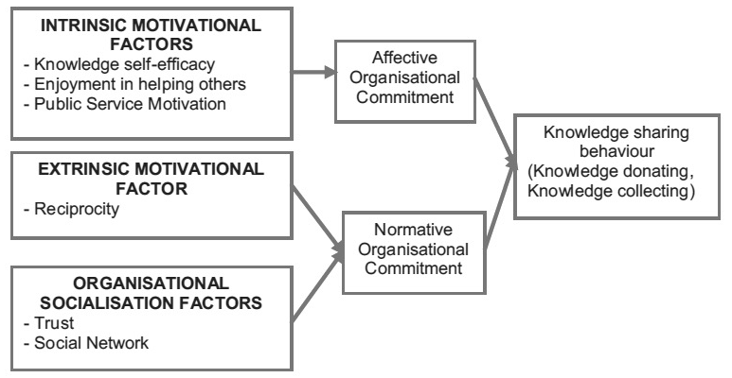
Figure 2.1: Conceptual framework for knowledge sharing behavior (Source: Tangaraja et al. (2015).

The above presented conceptual framework (figure 2.1) proposes that employees’ effective and normative commitment towards the organization have a mediating effect in facilitating knowledge sharing behavior among employees. Tangaraja, Rasdi, Ismail and Abu-Samah (2015) further propose that employees have to develop commitment towards the organization (effective and normative) in order to participate in knowledge sharing behavior. To develop effective organizational commitment, the researchers suggest focusing on the intrinsic motivational factors (knowledge self-efficacy, enjoyment in helping others). To develop normative organizational commitment, the authors propose focusing on extrinsic motivational factors (reciprocity) and organizational socialization factors (trust, social network). Hence, it is proposed that employees who are committed towards their organization both effectively and normatively will engage willingly in knowledge sharing behavior (Tangaraja et al., 2015).

In summary, the above chapter included the relevant literature to knowledge sharing. It started by defining knowledge, knowledge management and knowledge sharing. Then, different theories of knowledge sharing behavior were introduced. Enablers, processes of knowledge sharing were examined in details, as well as the outcomes of knowledge sharing including organizational innovation capability, competitive advantage and financial performance. Based on the literature above, the following chapter stated the the methodology of the dissertation, including the objectives of the study, proposed research model and the design of the study.

3. Methodology

This chapter describes the methods adopted for this study and the analytical tools used. Section 3.1 outlines the six objectives of study, followed by the proposed research model that consists of three dimensions of knowledge sharing: enabler, processes and outcomes in section 3.2. To examine the model, 11 hypotheses are tested. The data for this study is collected from a law enforcement agency using structured questionnaires and the sample size is 605 middle managers as stated in section 3.3. Section 3.4 outlines The instruments used to operationalize the constructs of the study. The following statistical tools were used in this study: descriptive analysis, Pearson correlation, Cronbach Alfa, confirmatory factor analysis and structured equation modeling as described in section 3.4. Finally, section 3.5 describes the law enforcement agency under study.

3.1 Objectives of the study
- To develop a profile for the knowledge sharing enablers, processes and outcomes in the law enforcement agency.
- To study the significant difference, if any, of knowledge sharing enablers, processes and outcomes between the seven general directorates in the law enforcement agency.
- To investigate the impact of the knowledge sharing enablers on knowledge sharing processes in the law enforcement agency as a whole and four of its seven general directorates separately.
- To study the impact of knowledge sharing processes on organizational innovation capability, competitive advantage and financial performance in the law enforcement agency as a whole and four of its seven general directorates separately.
- To study the impact of innovation capability on competitive advantage in the law enforcement agency as a whole and four of its seven general directorates separately.
- To study the impact of organizational competitive advantage on organizational financial performance in the law enforcement agency as a whole and four of its seven general directorates separately.

3.2 Research model and hypotheses
The proposed research model presented as figure 3.1 and the following hypotheses are examined and tested in this dissertation. The proposed research model illustrates three three-dimensions for knowledge sharing: enablers, processes and outcomes. The six enablers are considered as independent variables, namely: enjoyment in helping others, knowledge self-efficacy, top management support, organizational rewards, information and communication technology (ICT) use and end-user focus. The processes of knowledge sharing are considered as dependent variables, and are knowledge donating and knowledge collecting. The processes of knowledge sharing are also considered independent variables when examined in relation with knowledge sharing outcomes. The outcomes are dependent variables, namely, organizational innovation capability, organizational competitive advantage and organizational financial performance.

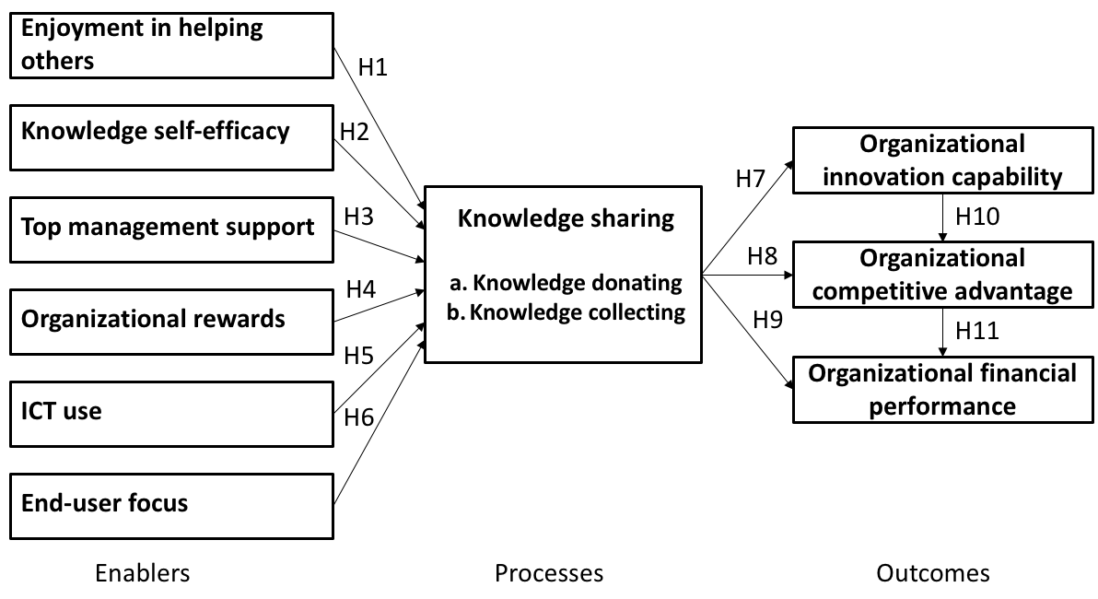
Figure 3.1: Proposed research model

The proposed research model as depicted in figure 3.1 suggest 11 main hypotheses as:
- H1: Enjoyment in helping others significantly and positively influences employee’s willingness (a) to donate knowledge and (b) to collect knowledge.
- H2: Knowledge self-efficacy significantly and positively affects employee’s willingness (a) to donate knowledge and (b) to collect knowledge.
- H3: Top management support significantly and positively influences employee’s willingness (a) to donate knowledge and (b) to collect knowledge.
- H4: Organizational rewards significantly and positively affect employee’s willingness (a) to donate knowledge and (b) to collect knowledge.
- H5: ICT use significantly and positively influences employee’s willingness (a) to donate knowledge and (b) to collect knowledge.
- H6: End-user focus significantly and positively affects employee’s willingness (a) to donate knowledge and (b) to collect knowledge.
- H7: Employee’s willingness (a) to donate knowledge and (b) to collect knowledge significantly and positively influence organizational innovation capability.
- H8: Employee’s willingness (a) to donate knowledge and (b) to collect knowledge significantly and positively affect organizational competitive advantage.
- H9: Employee’s willingness (a) to donate knowledge and (b) to collect knowledge significantly and positively influence organizational financial performance.
- H10: Organizational innovation capability significantly and positively affects organizational competitive advantage.
- H11: Organizational competitive advantage significantly and positively impacts organizational financial performance.

3.3 Design of the study
This is a pure quantitative study wherein the data were collected from the law enforcement agency under study using standard research instruments. Structured questionnaires were used to collect the data. First, ten experts in the field of knowledge management, working in the knowledge management unit in the law enforcement agency under study, pilot tested a draft of the questionnaire. They were asked to rate the suitability of the questionnaire items from 10 to 1 (very suitable to not suitable at all). The items that were rated with an average less than 70% were excluded. In the end, all the items were accepted and none was excluded.

The questionnaire was originally developed in the English language. Due to the fact that all employees in the law enforcement agency speak Arabic as their first language, the questionnaire was then translated by a legal translator into Arabic. To validate the accuracy of the translation, back translation was performed, which means the Arabic translation was translated again into English by a different legal translator. Finally, original and new English versions were compared to highlight differences in the meaning. The Arabic questionnaire was modified accordingly. The English version of the questionnaire is included as Appendix 2.

The target population for the questionnaire survey was selected to be middle management of the organization, which includes head of sections and branch managers and/or police officers. This population is considered the most suitable because they are not only aware of the strategies and objectives of the organization, but are also in direct contact with the operational level staff. An electronic survey system was used to distribute the questionnaire to all the targeted population, which are 1200 middle managers and/or officers (excluding field-based officers). The researcher received 715 filled-in questionnaires from the respondents. However, only 605 questionnaires were used for the purpose of the study, as 29 respondents failed to provide information for each and every item of the questionnaire, and 80 of the responses were outliers revealed by the Mahalanobis distance test. The response rate of this study is approximately 50%.

The following table 3.1 belong presents details relating to the demographics of the sample.

Table 3.1: Summary of demographic information of sample

Item |  | Quantity | Percentage | Cumulative percentage
General directorate | GD1 | 95 | 15.71% | 15.71%
 | GD2 | 148 | 24.46% | 40.17%
 | GD3 | 116 | 19.17% | 59.34%
 | GD4 | 107 | 17.69% | 77.03%
 | GD5 | 44 | 7.27% | 84.30%
 | GD6 | 40 | 6.61% | 90.91%
 | GD7 | 55 | 9.09% | 100%
Rank | Colonel | 22 | 3.64% | 3.64%
 | Lieutenant colonel | 23 | 3.80% | 7.44%
 | Major | 111 | 18.35% | 25.79%
 | Captain | 177 | 29.26% | 55.04%
 | First lieutenant | 150 | 24.79% | 79.83%
 | Lieutenant | 100 | 16.53% | 96.36%
 | Citizen | 22 | 3.64% | 100%
Position | Department manager | 19 | 3.14% | 3.14%
 | Section head | 84 | 13.88% | 17.02%
 | Branch manager | 255 | 42.15% | 59.17%
 | Officer | 247 | 40.83% | 100%
Gender | Male | 543 | 89.75% | 89.75%
 | Female | 62 | 10.25% | 100%
Nationality | UAE nationals | 605 | 100% | 100%
Total |  | 605

As shown in figure 3.1, the respondents include 543 male and 62 female employees working for the law enforcement agency under investigation. All the sampled employees are UAE nationals. The respondents were mainly middle managers’ employees, as department managers (3.14%), section heads (13.88%), branch managers (42.15%) and officers (40.83%) with police ranks including 22 colonels, 23 lieutenant colonels, 100 majors, 177 captains, 151 first lieutenants, 100 lieutenants and 20 citizens. The study sampled employees from seven different general directorates (GD1, GD2, GD3, GD4, GD5, GD6, GD7), each with different functions and objectives in the law enforcement agency under study.

3.4 Instruments
All the items used to operationalize the constructs were adopted/adapted from published research instruments suitable for the purpose of this study. Where no suitable instruments were found, standardized items were developed by the researcher for the constructs under study. All the constructs were measured using multiple items. A five-point Likert-type scale was used in the questionnaire, ranging 1 = strongly disagree to 5 = strongly agree.

The researcher adapted three items from Wasko and Faraj (2000) to measure enjoyment in helping others (EH). The sample items were: “I enjoy sharing my knowledge with colleagues” and “I enjoy sharing my work experience with colleagues”. The Cronbach alpha coefficient for the EH was calculated to be 0.891. The knowledge self-efficacy (SE) was measured using four items adapted from Riggs et al. (1994). The sample items were: “I have confidence in my ability to share knowledge with my colleagues” and “I have the skills needed to provide valuable knowledge to my colleagues”. The Cronbach alpha coefficient for the SE was calculated to be 0.707.

The top management support (TM) was assessed using four items adapted from Lee and Wong (2015). The sample items were: “My colleagues are happy with the amount of support given by the top management to knowledge management initiatives in the organization” and “My colleagues are satisfied with the commitment of the top management to knowledge management initiatives in my organization”. The Cronbach alpha coefficient for the TM was calculated to be 0.843. The organizational rewards (OR) was measured using five items adapted from Durmusoglu et al. (2013). The sample items were: “I am more likely to share my knowledge in my organization if I am rewarded with increments/bonuses” and “I am more likely to share my knowledge if I get promoted”. The Cronbach alpha coefficient for the OR was calculated to be 0.897.

The information and communication technology use (IT) was assessed using five items developed by the researcher. The sample items were: “My organization uses technology (such as computer systems and software) that allows me to share knowledge with colleagues” and “I make use of electronic storage (such as online databases and data warehousing) to share knowledge with colleagues”. The Cronbach alpha coefficient for the IT was calculated to be 0.797. The end-user focus (EU) was measured using two items adopted from Kim and Lee (2006). The items in this scale were: “In my organization, information systems and software are designed to be user friendly” and “It is easy for me to use information systems without extra training”. The Cronbach alpha coefficient for the EU was calculated to be 0.756.

The knowledge donating (KD) and knowledge collecting (KC) scales consisted of four and five items respectively adapted from Lawson (2003). The sample items were: “I provide my knowledge to my colleagues face-to-face or through the intranet and it’s accessible for everyone who needs it in my organization” and “I send out timely reports with valuable/important information to my colleagues” for KD and “I can receive knowledge easily from my colleagues face-to-face or through the intranet in my organization” and “I receive timely reports with valuable/important information from my colleagues” for KC. The Cronbach alpha coefficient for the KC was calculated to be 0.76 and foe the KD was calculated to be 0.743.

The organizational innovation capability (IC) was assessed by five items adapted from Zheng (2000). The sample items were: “My organization waits for a while when compared to the key competitors in providing any new services to the people” and “Compared to key competitors, my organization implements creative ideas very late into the services offered to the people/stakeholder”. The Cronbach alpha coefficient for the IC was calculated to be 0.82.

The organizational competitive advantage (CA) was measured using four items adapted from Barney (1995). The sample items were: “My organization provides valuable services compared to our key competitors” and “My organization provides rare and unique services compared to our key competitors”. The Cronbach alpha coefficient for the CA was calculated to be 0.866.

Finally, three items were adopted from Vaccaro et al. (2010) to measure organizational financial performance (FP). The sample items were: “Return on investment of my organization is better than that of key competitors” and “The profitability of our organization is better than that of key competitors”. The Cronbach alpha coefficient for the FP was calculated to be 0.839.

In general, the Cronbach alpha coefficient for the all the variables was calculated to be 0.891. The following table summarizes all the instruments of the study (table 3.2). The detailed instruments items are shown in appendix 1.

Table 3.2: Summary of the instruments used in the study

 | Construct | No. of items | Cronbach Alfa | Reference(s)
EH | Enjoyment in helping others | 3 | 0.891 | Adapted from Wasko & Faraj (2000)
SE | Knowledge self-efficacy | 4 | 0.707 | Adapted from Riggs et al. (1994)
TM | Top management support | 3 | 0.843 | Adapted from Lee & Wong (2015)
OR | Organizational rewards | 5 | 0.897 | Adapted from Durmusoglu et al. (2013)
IT | Information and communication  technology use | 4 | 0.797 | Developed by the researchers
EU | End user focus | 2 | 0.756 | Adopted from Kim & Lee (2006)
KD | Knowledge donating | 4 | 0.76 | Adapted from Lawson (2003)
KC | Knowledge collecting | 5 | 0.743 | Adapted from Lawson (2003)
IC | Innovation capability | 5 | 0.82 | Adapted from Zheng (2000)
CA | Competitive advantage | 4 | 0.866 | Adapted from Barney (1995)
FP | Financial performance | 3 | 0.839 | Adopted by Vaccaro et al. (2010)

3.5 Statistical analysis
The following statistical tools were used in this study: descriptive analysis to create a profile for the different constructs included in the research model, Cronbach Alfa to examine the reliability of the instruments, and one-way ANOVA to examine the significant differences between the seven general directorates in the law enforcement agency under study. Also, Pearson’s correlational analysis was performed to measure the strength and direction of association that exists between all the variables in the research model.

In addition, the research model in this paper was analyzed using Structured Equation Modeling (SEM), supported by IBM SPSS Amos 22.0 software. Some of the advantages of SEM are that it can be used to study the relationships among latent constructs that are indicated by multiple measures. The SEM is applicable to both experimental and non-experimental data, as well as being applicable for cross-sectional and longitudinal data (Lei and Wu, 2007). SEM is the most suitable approach for this research model because it includes eleven constructs with multiple items for each (Joreskog and Sorbom, 1996).

A two-step model-building processes for applying SEM was used in the analysis (Hair, Anderson and Tatham, 1998; Hair et al., 2014). First, Confirmatory Factor Analysis (CFA) is applied to validate and test all the items in the measurement model and assess the properties of the measures addressing all the constructs. The CFA was repeated twice to exclude poor-performing items from the measurement model. All standardized path coefficients must exceed 0.15 and each indicator must be significant at 0.01 levels (p < 0.01). Other fit indexes including the goodness-of-fit index (GFI), comparative fit index (CFI) and normed-of-fit index (NFI) must exceed the recommended cut-off level of 0.8. Also, Root Mean Square Error of Approximation (RMSEA) must be below 0.8 (Anderson and Gerbing, 1992). Second, path analysis was applied to test the structural model for the relations among the constructs. The standardized path coefficient must exceed 0.15 and each indicator must be significant at 0.01 levels (p < 0.01) for the test results to be supported (Loehlin, 1998).

3.6 About the law enforcement agency
The law enforcement agency under study is located in Abu Dhabi Emirate in the UAE which consists of seven Emirates, and considered the largest in the country. It covers a wide geographical area, around 80% of the country, including Abu Dhabi City, AlAin and the Western region. The agency includes more than 35,000 employees, 17% of which are middle managers and officers. The officers in the agency vary in their education level between doctorate to high school graduate. They also vary in their computer skills levels from beginner to expert levels. Based on the nature of their job, officers are either office-based or field-based.

There exist around 22 other regional and federal law enforcement agencies in the UAE. Each of the other six Emirates in the UAE have a law enforcement agency that provides almost the same objectives of the law enforcement under study. Also, each Emirates include three or more regional or federal law enforcement agencies such as the ministry of interior, civil defense, immigration and policing judicial agencies.

All of these law enforcement agencies are governmental non-profit agencies and they provide unique services within their geographical region, however they all strive to provide their customers with high quality services and a competitive edge comparing with the other agencies within and across other Emirates. The reason behind the existence of such competition is the country’s vision to provide the citizens with welfare, happiness and high quality of living in the country. To boost the healthy competition, many regional and federal excellence awards exist in the country, which includes awards for the best innovations, knowledge management practices, customers’ services, financial performance and overall outcomes. In 2015, the law enforcement agency won two excellence award on knowledge management, one of the is between law enforcement agencies in Abu Dhabi, and the second one is between all government entities in Abu Dhabi.

As a result, the law enforcement agency emphasized in the importance of developing their innovation capabilities, competitive advantage and financial performance. Yearly initiatives and projects are introduced to improve the innovation capabilities and outcomes of the organization, where an innovation center was established on 2012 as one of the newly added functions in the law enforcement agency under study. Moreover, organizational competitive advantage is not a straight-forward priority of the agency because they don’t have competitors who provide the same services in the Emirates, yet they compete with other agencies through providing the citizens with fast and high quality services in order to gain a positive image and reputation regionally and internationally. In addition, although the law enforcement agency receives it budget from the government, it is essential for government agencies to keep an acceptable financial performance in order to ensure continuous improvement and development of the agency.

The law enforcement agency consists of seven general directorates: GD1, GD2, GD3, GD4, GD5, GD6 and GD7. Each of them is responsible for different objectives and functions in the agency, including core business, supporting core business, strategic, technical, operational, surveillance, finances, services and human resources. Four of the general directorates mandated by the UAE government to play critical roles have been selected to be examined in detail in chapter 4 – these are GD1, GD2, GD3, and GD4.

The above four general directorates are specifically selected to be examined separately because of the following reasons. First, the is a minimum required sample size that must be available to perform SEM in relation to the number of items included in the questionnaire. GD1, GD2, GD3 and GD4 fulfil this requirement while GD5, GD6, and GD7 don’t. Also, the selected general directorates cover unique and distinguishable objectives and functions for agency as follows:
- 10% of employees are located in GD1, where the main functions are strategic, quality and knowledge management.
- 14% of employees are located in GD2, where their main responsibilities are managing and analyzing evidences, inspections and police dogs (K9).
- 19% are location in GD3, where the main functions are operations, information technology and emergencies.
- 31% of employees are located in GD4, which covers the core business of the organization, including investigations, incidents and traffic.

In summary, the above chapter consists of the methodology of the study, which includes the proposed research model and hypotheses, the design of the study, the instruments used to operationalize the constructs, the statistical analytics, as well as a detailed description of the law enforcement agency under study. The following chapter 4 and 5 details the results and discussion of the study.

4. Results

This chapter presents the results of the analyzes undertaken. It consists of the results of creating a profile for the knowledge sharing enablers, processes and outcomes variables using descriptive analysis. The arithmetic mean and standard deviation were calculated for the sample as a whole and also for each general directorate separately. This is followed by an examination of the difference between the results of the seven general directorates using One-way ANOVA. The F value significant at 0.01 level indicates the existence, or non-existence, of differences for any of the knowledge sharing enablers, processes and outcomes variables.

The hypotheses are tested using two steps: testing the measurement model using confirmatory factor analysis (CFA). Values with path coefficient significant at 0.001 level estimates are kept in the measurement model, while the rest must be omitted and the CFA must be repeated until all variables reach a satisfactory level estimate. Other goodness-of-fit tests were performed for the measurement model, which examine how well the results fit the set of observations. It includes Chi-Square test (CMIN), Goodness-of-Fit Index (GFI), Normed Fit Index (NFI), Comparative Fit Index (CFA), Tucker-Lowis Index (TLI) and Root Mean Square Error of Approximation (RMSEA).

A preliminary Pearson Product-Moment Correlation test was performed for all the variables in the model followed by testing the structural model using structured equation modeling. This indicates if each and every hypothesis is either supported or not using standardized path coefficient significant at 0.01 level. Other goodness-of-fit tests are performed for the measurement model, including the CMIN, the GFI, the NFI, the TLI, the CFI and the RMSEA.

In this study, the CFA and the SEM tests were performed five times namely for the law enforcement agency as a whole followed by for each of general directorates GD1, GD2, GD3 and GD4 for the purpose of comparing and contrasting the results. The following figure summarizes all the steps followed to obtain the results in this study (figure 4.1).

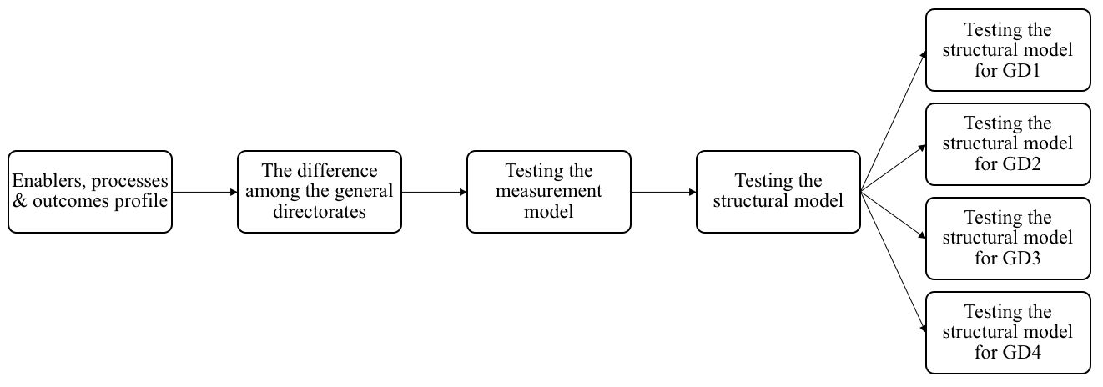
Figure 4.1: Steps undertaken for analysis in the study

4.1 Knowledge sharing enablers, processes and outcomes profile
Table 4.1a and 4.1b presents the profile results of the knowledge sharing enablers, processes and outcomes, including the mean, standard deviation, minimum and maximum for each of the constructs in the law enforcement agency as a whole and for each general directorate separately (GD1, GD2, GD3, GD4, GD5, GD6, GD7).

Table 4.1a: Descriptive analysis for the law enforcement agency

Variables GD |  | N | Mean | Std. deviation | Minimum | Maximum
Enjoyment in helping others | 7 | 55 | 13.82 | 1.479 | 10 | 15
Enjoyment in helping others | 6 | 40 | 14.18 | 1.279 | 11 | 15
Enjoyment in helping others | 5 | 44 | 13.61 | 1.434 | 11 | 15
Enjoyment in helping others | 4 | 107 | 13.60 | 1.619 | 8 | 15
Enjoyment in helping others | 3 | 116 | 13.91 | 1.405 | 8 | 15
Enjoyment in helping others | 2 | 148 | 13.57 | 1.845 | 6 | 15
Enjoyment in helping others | 1 | 95 | 14.25 | 1.263 | 10 | 15
Enjoyment in helping others | Total | 605 | 13.81 | 1.558 | 6 | 15
Knowledge self-efficacy | 7 | 55 | 12.93 | 1.538 | 9 | 15
Knowledge self-efficacy | 6 | 40 | 12.63 | 1.612 | 9 | 15
Knowledge self-efficacy | 5 | 44 | 12.34 | 1.697 | 8 | 15
Knowledge self-efficacy | 4 | 107 | 12.73 | 1.593 | 6 | 15
Knowledge self-efficacy | 3 | 116 | 12.71 | 1.390 | 10 | 15
Knowledge self-efficacy | 2 | 148 | 12.53 | 1.747 | 7 | 15
Knowledge self-efficacy | 1 | 95 | 13.07 | 1.431 | 9 | 15
Knowledge self-efficacy | Total | 605 | 12.71 | 1.582 | 6 | 15
Top management support | 7 | 55 | 10.93 | 2.930 | 4 | 15
Top management support | 6 | 40 | 11.28 | 2.100 | 6 | 15
Top management support | 5 | 44 | 10.61 | 2.233 | 6 | 15
Top management support | 4 | 107 | 11.11 | 2.195 | 4 | 15
Top management support | 3 | 116 | 11.09 | 2.283 | 3 | 15
Top management support | 2 | 148 | 11.46 | 2.251 | 6 | 15
Top management support | 1 | 95 | 11.52 | 2.128 | 7 | 15
Top management support | Total | 605 | 11.21 | 2.291 | 3 | 15
Organizational rewards | 7 | 55 | 16.69 | 3.305 | 9 | 20
Organizational rewards | 6 | 40 | 16.10 | 4.295 | 4 | 20
Organizational rewards | 5 | 44 | 15.36 | 3.551 | 4 | 20
Organizational rewards | 4 | 107 | 16.50 | 3.292 | 4 | 20
Organizational rewards | 3 | 116 | 16.71 | 3.751 | 4 | 20
Organizational rewards | 2 | 148 | 16.10 | 3.491 | 4 | 20
Organizational rewards | 1 | 95 | 16.46 | 3.035 | 8 | 20
Organizational rewards | Total | 605 | 16.34 | 3.489 | 4 | 20
Information and comm. technology use | 7 | 55 | 11.04 | 2.426 | 5 | 15
Information and comm. technology use | 6 | 40 | 11.30 | 2.221 | 6 | 15
Information and comm. technology use | 5 | 44 | 10.34 | 2.468 | 5 | 15
Information and comm. technology use | 4 | 107 | 11.14 | 2.081 | 6 | 15
Information and comm. technology use | 3 | 116 | 11.62 | 2.063 | 6 | 15
Information and comm. technology use | 2 | 148 | 11.01 | 2.195 | 6 | 15
Information and comm. technology use | 1 | 95 | 11.18 | 2.119 | 6 | 15
Information and comm. technology use | Total | 605 | 11.15 | 2.195 | 5 | 15
End-user focus | 7 | 55 | 7.16 | 1.607 | 4 | 10
End-user focus | 6 | 40 | 7.33 | 1.542 | 4 | 10
End-user focus | 5 | 44 | 6.84 | 1.539 | 2 | 10
End-user focus | 4 | 107 | 7.24 | 1.529 | 3 | 10
End-user focus | 3 | 116 | 7.48 | 1.506 | 4 | 10
End-user focus | 2 | 148 | 7.22 | 1.464 | 3 | 10
End-user focus | 1 | 95 | 7.17 | 1.742 | 2 | 10
End-user focus | Total | 605 | 7.24 | 1.554 | 2 | 10

Table 4.1b: Descriptive analysis for the law enforcement agency

Variables | GD | N | Mean | Std. deviation | Minimum | Maximum
Knowledge donating | 7 | 55 | 11.42 | 2.070 | 7 | 15
Knowledge donating | 6 | 40 | 11.45 | 2.087 | 6 | 15
Knowledge donating | 5 | 44 | 10.70 | 2.268 | 5 | 15
Knowledge donating | 4 | 107 | 10.98 | 2.019 | 7 | 15
Knowledge donating | 3 | 116 | 11.52 | 2.028 | 5 | 15
Knowledge donating | 2 | 148 | 11.18 | 1.738 | 7 | 15
Knowledge donating | 1 | 95 | 11.24 | 2.102 | 6 | 15
Knowledge donating | Total | 605 | 11.22 | 2.001 | 5 | 15
Knowledge collecting | 7 | 55 | 13.75 | 3.329 | 7 | 20
Knowledge collecting | 6 | 40 | 14.48 | 2.882 | 7 | 19
Knowledge collecting | 5 | 44 | 13.34 | 2.949 | 7 | 20
Knowledge collecting | 4 | 107 | 13.99 | 2.583 | 7 | 20
Knowledge collecting | 3 | 116 | 14.69 | 2.789 | 8 | 20
Knowledge collecting | 2 | 148 | 14.59 | 2.690 | 5 | 20
Knowledge collecting | 1 | 95 | 14.26 | 2.643 | 7 | 20
Knowledge collecting | Total | 605 | 14.28 | 2.795 | 5 | 20
Innovation capability | 7 | 55 | 7.07 | 1.814 | 3 | 10
Innovation capability | 6 | 40 | 8.03 | 1.368 | 6 | 10
Innovation capability | 5 | 44 | 7.16 | 1.976 | 2 | 10
Innovation capability | 4 | 107 | 7.23 | 1.830 | 2 | 10
Innovation capability | 3 | 116 | 7.88 | 1.452 | 4 | 10
Innovation capability | 2 | 148 | 7.36 | 1.513 | 2 | 10
Innovation capability | 1 | 95 | 7.66 | 1.790 | 2 | 10
Innovation capability | Total | 605 | 7.49 | 1.682 | 2 | 10
Competitive advantage | 7 | 55 | 10.62 | 2.586 | 5 | 15
Competitive advantage | 6 | 40 | 11.78 | 2.094 | 8 | 15
Competitive advantage | 5 | 44 | 10.23 | 2.261 | 3 | 15
Competitive advantage | 4 | 107 | 10.58 | 2.355 | 6 | 15
Competitive advantage | 3 | 116 | 11.45 | 2.095 | 7 | 15
Competitive advantage | 2 | 148 | 10.94 | 2.265 | 3 | 15
Competitive advantage | 1 | 95 | 11.28 | 2.211 | 6 | 15
Competitive advantage | Total | 605 | 11.00 | 2.290 | 3 | 15
Financial Performance | 7 | 55 | 9.64 | 2.585 | 3 | 15
Financial Performance | 6 | 40 | 9.90 | 1.985 | 5 | 15
Financial Performance | 5 | 44 | 9.32 | 2.360 | 3 | 15
Financial Performance | 4 | 107 | 9.17 | 2.292 | 3 | 15
Financial Performance | 3 | 116 | 9.79 | 2.401 | 4 | 15
Financial Performance | 2 | 148 | 9.65 | 1.791 | 4 | 15
Financial Performance | 1 | 95 | 9.77 | 2.050 | 4 | 15
Financial Performance | Total | 605 | 9.60 | 2.182 | 3 | 15

4.2 The difference between the seven general directorates
Table 4.2 describes the significant differences of knowledge sharing enablers, processes and outcomes between the seven general directorates in the law enforcement agency under study. One-way ANOVA statistical tool is used to calculate the (F) value in order to examine the normality distribution of all the constructs with general directorate as factor, significant at 0.01 level.
Table 4.2: One-way ANOVA analysis for the General Directorates
Construct | F | Sig.
EH | 2.790 | 0.011
SE | 1.749 | 0.107
TM | 1.309 | 0.251
OR | 1.083 | 0.371
IT | 2.062 | 0.056
EU | 1.038 | 0.400
KD | 1.359 | 0.229
KC | 2.126 | 0.049
IC | 3.353 | 0.003
CA | 3.545 | 0.002
FP | 1.210 | 0.299

4.3 Testing the measurement model
To validate and test all the items in the measurement model, confirmatory factor analysis was applied. Due to the number of variables, CFA was applied twice. The first time covered the items of the following variables: Enjoyment in helping others (EH), knowledge self-efficacy (SE), top management support (TM), organization rewards (OR) and information and communication technology use (IT). The second time covers the items of the following variables: end-user focus (EU), knowledge donating (KD), knowledge collecting (KC), innovation capability (IC), competitive advantage (CA) and financial performance (FP).

Figure 4.2 illustrates the results of applying CFA on the measurement model for the variables EH, SE, TM, OR and IT, which are all independent variables, with a total of 19 items tested and 19 error variables. Also, the path coefficient (table 4.3) and standardized path coefficient (table 4.4) results are calculated to depict the validity of the measurement model.

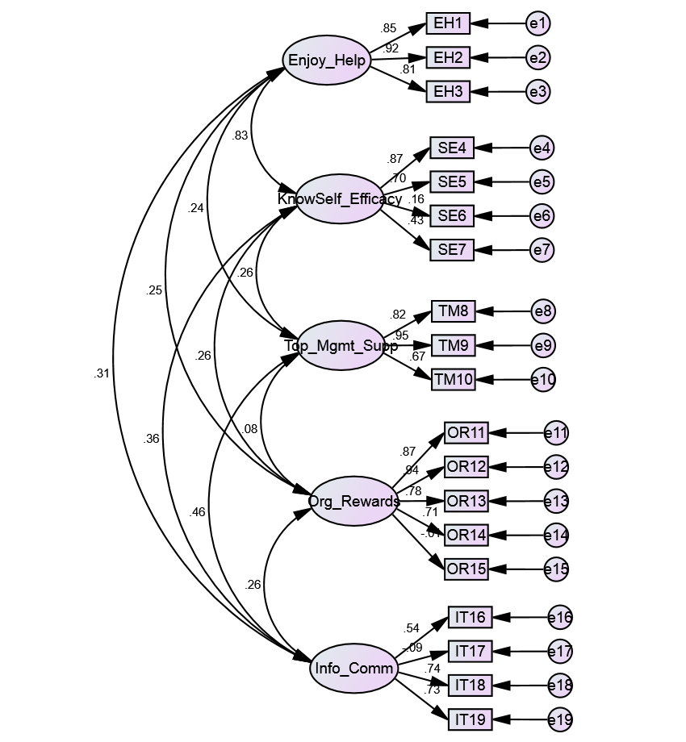

Figure 4.2: 1st Confirmatory Factor Analysis for enjoyment in helping others (EH), knowledge self-efficacy (SE), top management support (TM), organization rewards (OR) and information & communication technology use (IT)

Table 4.3: 1st Path Coefficients results for enjoyment in helping others (EH), knowledge self-efficacy (SE), top management support (TM), organization rewards (OR) and information & communication technology use (IT)

 |  |  | Estimate | S.E. | C.R. | P
EH1 | <--- | EH | 1.000
EH2 | <--- | EH | 1.029 | 0.034 | 30.009 | ***
EH3 | <--- | EH | 0.870 | 0.037 | 23.702 | ***
SE4 | <--- | SE | 1.000
SE5 | <--- | SE | 0.941 | 0.055 | 16.964 | ***
SE6 | <--- | SE | 0.420 | 0.114 | 3.670 | ***
SE7 | <--- | SE | 0.619 | 0.063 | 9.869 | ***
TM8 | <--- | TM | 1.000
TM9 | <--- | TM | 1.203 | 0.052 | 23.241 | ***
TM10 | <--- | TM | 0.940 | 0.053 | 17.768 | ***
OR11 | <--- | OR | 1.000
OR12 | <--- | OR | 1.097 | 0.033 | 33.100 | ***
OR13 | <--- | OR | 0.784 | 0.034 | 23.402 | ***
OR14 | <--- | OR | 0.753 | 0.037 | 20.332 | ***
IT16 | <--- | IT | 1.000
IT17 | <--- | IT | -.243 | .124 | -1.964 | .050
IT18 | <--- | IT | 1.512 | .154 | 9.804 | ***
OR15 | <--- | OR | -.011 | .054 | -.204 | .839
IT19 | <--- | IT | 1.494 | .153 | 9.799 | ***

Table 4.4: 1st Standardized Path Coefficients for enjoyment in helping others (EH), knowledge self-efficacy (SE), top management support (TM), organization rewards (OR) and information & communication technology use (IT)
 |  |  | Estimate
EH1 | <--- | EH | 0.855
EH2 | <--- | EH | 0.918
EH3 | <--- | EH | 0.813
SE4 | <--- | SE | 0.867
SE5 | <--- | SE | 0.697
SE6 | <--- | SE | 0.161
SE7 | <--- | SE | 0.433
TM8 | <--- | TM | 0.815
TM9 | <--- | TM | 0.952
TM10 | <--- | TM | 0.670
OR11 | <--- | OR | 0.872
OR12 | <--- | OR | 0.942
OR13 | <--- | OR | 0.777
OR14 | <--- | OR | 0.709
IT16 | <--- | IT | 0.536
IT17 | <--- | IT | -0.094
IT18 | <--- | IT | 0.738
OR15 | <--- | OR | -0.009
IT19 | <--- | IT | 0.732

Figure 4.3 presents the results of applying CFA on the measurement model for the variables EU, KD, KC, IC, CA and PF, of which one is independent and the rest are dependent variables, with total of 23 items tested and 23 error variables. Also, the path coefficient (table 4.5) and standardized path coefficient (table 4.6) results are calculated to reveal the validity of the measurement model.

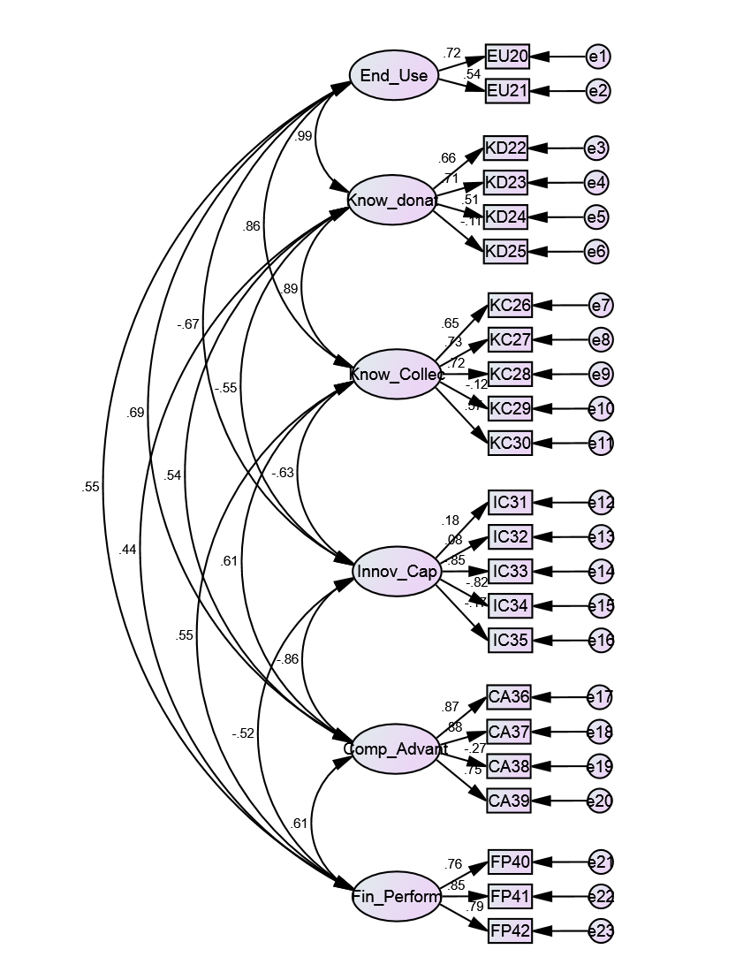

Figure 4.3: 1st Confirmatory factor analysis of end-user focus (EU), knowledge donating (KD), knowledge collecting (KC), innovation capability (IC), competitive advantage (CA) and financial performance (FP)

Table 4.5: 1st Path Coefficient results for end-user focus (EU), knowledge donating (KD), knowledge collecting (KC), innovation capability (IC), competitive advantage (CA) and financial performance

 |  |  | Estimate | S.E. | C.R. | P
EU20 | <--- | EU | 1.000
EU21 | <--- | EU | 0.793 | .066 | 12.072 | ***
KD22 | <--- | KD | 1.000
KD23 | <--- | KD | 1.306 | .097 | 13.506 | ***
KD24 | <--- | KD | 0.797 | .074 | 10.778 | ***
KD25 | <--- | KD | -0.241 | 0.096 | -2.510 | .012
KC26 | <--- | KC | 1.000
KC27 | <--- | KC | 1.453 | 0.104 | 13.992 | ***
KC28 | <--- | KC | 1.338 | 0.095 | 14.075 | ***
KC29 | <--- | KC | -0.262 | 0.100 | -2.609 | .009
KC30 | <--- | KC | 1.270 | 0.109 | 11.662 | ***
IC31 | <--- | IC | 1.000
IC32 | <--- | IC | 0.490 | 0.279 | 1.758 | .079
IC33 | <--- | IC | -4.346 | 1.027 | -4.233 | ***
IC34 | <--- | IC | -3.949 | 0.935 | -4.223 | ***
IC35 | <--- | IC | -1.096 | 0.396 | -2.766 | .006
CA36 | <--- | CA | 1.000
CA37 | <--- | CA | 1.031 | 0.037 | 28.041 | ***
CA38 | <--- | CA | -0.336 | 0.051 | -6.536 | ***
CA39 | <--- | CA | 0.849 | 0.040 | 21.041 | ***
FP40 | <--- | FP | 1.000
FP41 | <--- | FP | 1.168 | 0.062 | 18.846 | ***
FP42 | <--- | FP | 1.091 | 0.062 | 17.704 | ***

Table 4.6: 1st Standardized path coefficient results for end-user focus (EU), knowledge donating (KD), knowledge collecting (KC), innovation capability (IC), competitive advantage (CA), and financial performance (FP)

 |  |  | Estimate
EU20 | <--- | EU | 0.719
EU21 | <--- | EU | 0.537
KD22 | <--- | KD | 0.659
KD23 | <--- | KD | 0.705
KD24 | <--- | KD | 0.511
KD25 | <--- | KD | -0.115
KC26 | <--- | KC | 0.645
KC27 | <--- | KC | 0.729
KC28 | <--- | KC | 0.719
KC29 | <--- | KC | -0.119
KC30 | <--- | KC | 0.569
IC31 | <--- | IC | 0.185
IC32 | <--- | IC | 0.082
IC33 | <--- | IC | -0.846
IC34 | <--- | IC | -0.823
IC35 | <--- | IC | -0.167
CA36 | <--- | CA | 0.870
CA37 | <--- | CA | .877
CA38 | <--- | CA | -.273
CA39 | <--- | CA | .746
FP40 | <--- | FP | .759
FP41 | <--- | FP | .852
FP42 | <--- | FP | .792

Based on the standardized path coefficient results, significant at 0.001 level shown above, the following nine items were removed from the measurement model: SE6, IT17, OR15, KD25, KC29, IC31, IC32, IC35 and CA38, because of their poor performance, and CFA was re-conducted. It was applied twice, the first time covering the items of the following variables: EH, SE, TM, OR and IT. The second time covered the items of the following variables: EU, KD, KC, IC, CA and PF.

Figure 4.4 presents the results of applying CFA on the measurement model for the variables EH, SE, TM, OR and IT, which are all independent variables, with total of 16 items tested and 16 error variables. Also, the path coefficients (table 4.7) and standardized path coefficients (table 4.8) results are calculated to reveal the validity of the measurement model.

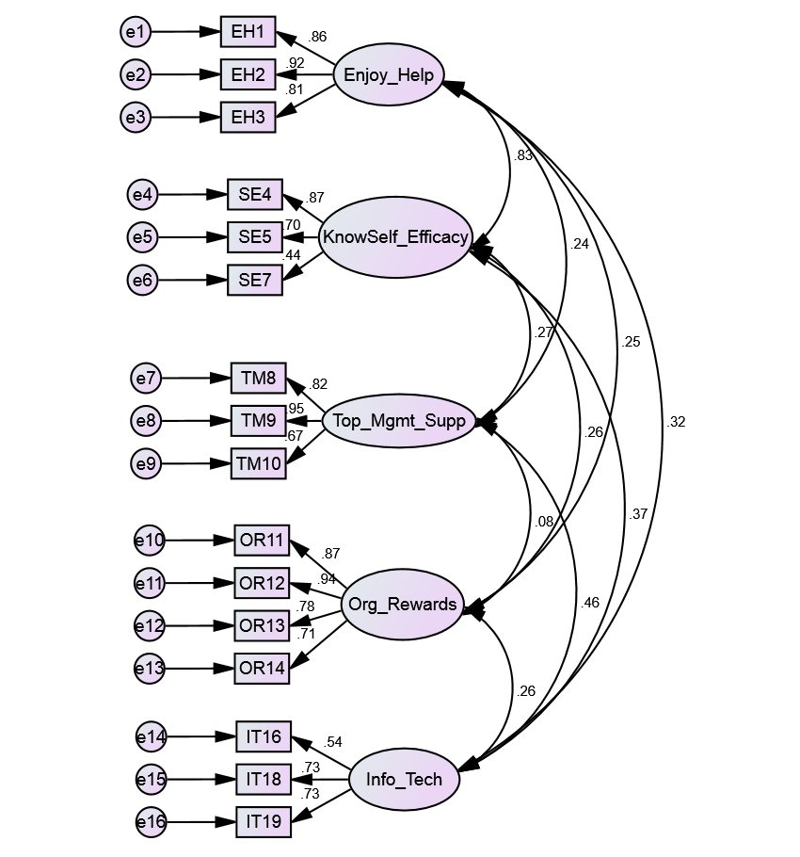
Figure 4.4: 2nd Confirmatory Factor Analysis for enjoyment in helping others (EH), knowledge self-efficacy (SE), top management support (TM), organization rewards (OR) and information & communication technology use (IT)

Table 4.7: 2nd Path coefficients results for enjoyment in helping others (EH), knowledge self-efficacy (SE), top management support (TM), organization rewards (OR) and information & communication technology use (IT)
 |  |  | Estimate | S.E. | C.R. | P
EH3 | <--- | EH | 1.000
EH2 | <--- | EH | 1.183 | 0.045 | 26.389 | ***
EH1 | <--- | EH | 1.150 | 0.047 | 24.391 | ***
SE7 | <--- | SE | 1.000
SE5 | <--- | SE | 1.502 | 0.153 | 9.797 | ***
SE4 | <--- | SE | 1.592 | 0.154 | 10.327 | ***
TM10 | <--- | TM | 1.000
TM9 | <--- | TM | 1.280 | 0.071 | 18.019 | ***
TM8 | <--- | TM | 1.064 | 0.060 | 17.799 | ***
OR14 | <--- | OR | 1.000
OR13 | <--- | OR | 1.042 | 0.057 | 18.368 | ***
OR12 | <--- | OR | 1.457 | 0.067 | 21.638 | ***
OR11 | <--- | OR | 1.328 | 0.065 | 20.540 | ***
IT19 | <--- | IT | 1.000
IT18 | <--- | IT | 1.008 | 0.081 | 12.501 | ***
IT16 | <--- | IT | 0.678 | 0.063 | 10.726 | ***

Table 4.8: 2nd Standardized path coefficients results for enjoyment in helping others (EH), knowledge self-efficacy (SE), top management support (TM), organization rewards (OR) and information & communication technology use (IT)

 |  |  | Estimate
EH3 | <--- | EH | 0.812
EH2 | <--- | EH | 0.918
EH1 | <--- | EH | 0.855
SE7 | <--- | SE | 0.439
SE5 | <--- | SE | 0.697
SE4 | <--- | SE | 0.865
TM10 | <--- | TM | 0.670
TM9 | <--- | TM | 0.952
TM8 | <--- | TM | 0.816
OR14 | <--- | OR | 0.709
OR13 | <--- | OR | 0.777
OR12 | <--- | OR | 0.942
OR11 | <--- | OR | 0.872
IT19 | <--- | IT | 0.730
IT18 | <--- | IT | 0.734
IT16 | <--- | IT | 0.541

Figure 4.5 presents the results of applying CFA on the measurement model for the variables EU, KD, KC, IC, CA and PF, of which one is independent and the rest are dependent variables, with total of 17 items tested and 17 error variables. Also, the path coefficient (table 4.9) and standardized path coefficient (table 4.10) results are calculated to reveal the validity of the measurement model.

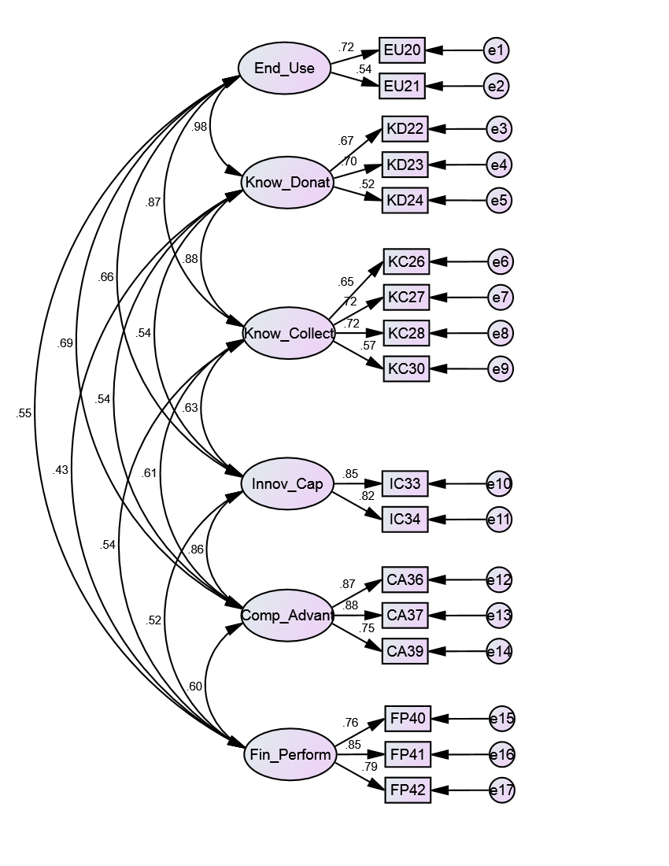

Figure 4.5: 2nd Confirmatory factor analysis for end-user focus (EU), knowledge donating (KD), knowledge collecting (KC), innovation capability (IC), competitive advantage (CA) and financial performance (FP)

Table 4.9: 2nd Path coefficient results for end-user focus (EU), knowledge donating (KD), knowledge collecting (KC), innovation capability (IC), competitive advantage (CA) and financial performance (FP)

 |  |  | Estimate | S.E. | C.R. | P | Label
KD22 | <--- | KD | 1.000
KD23 | <--- | KD | 1.285 | .091 | 14.198 | ***
KC26 | <--- | KC | 1.000
KC27 | <--- | KC | 1.425 | .098 | 14.509 | ***
KC28 | <--- | KC | 1.324 | .092 | 14.456 | ***
IC33 | <--- | IC | 1.000
IC34 | <--- | IC | .902 | .041 | 21.805 | ***
CA36 | <--- | CA | 1.000
CA37 | <--- | CA | 1.027 | .037 | 27.504 | ***
CA39 | <--- | CA | .847 | .039 | 21.522 | ***
FP40 | <--- | FP | 1.000
FP41 | <--- | FP | 1.168 | .060 | 19.510 | ***
FP42 | <--- | FP | 1.092 | .059 | 18.647 | ***
EU20 | <--- | EU | 1.000
EU21 | <--- | EU | .794 | .065 | 12.139 | ***
KD24 | <--- | KD | .799 | .073 | 10.998 | ***
KC30 | <--- | KD | 1.253 | .105 | 11.936 | ***

Table 4.10: 2nd Standardized path coefficient results for end-user focus (EU), knowledge donating (KD), knowledge collecting (KC), innovation capability (IC), competitive advantage (CA) and financial performance (FP)
 |  |  | Estimate
KD22 | <--- | KD | .666
KD23 | <--- | KD | .701
KC26 | <--- | KC | .652
KC27 | <--- | KC | .723
KC28 | <--- | KC | .719
IC33 | <--- | IC | .849
IC34 | <--- | IC | .820
CA36 | <--- | CA | .872
CA37 | <--- | CA | .875
CA39 | <--- | CA | .746
FP40 | <--- | FP | .759
FP41 | <--- | FP | .852
FP42 | <--- | FP | .792
EU20 | <--- | EU | .718
EU21 | <--- | EU | .538
KD24 | <--- | KD | .518
KC30 | <--- | KD | .568

The tables 4.11 and 4.12 compare the goodness-of-fit indexes, which include CMIN, GFI, NFI, TLI, CFI and RMSEA between the measurement model variables after running CFA for the first time and after running CFA for the second time.

Table 4.11: Goodness-of-fit indices for enjoyment in helping others (EH), knowledge self-efficacy (SE), top management support (TM), organization rewards (OR) and information & communication technology use (IT)

 | CMIN | P | GFI | NFI | TLI | CFI | RMSEA
1st CFA | 905.132*** | 0.000 | 0.854 | 0.844 | 0.837 | 0.865 | 0.094
2nd CFA | 393.681*** | 0.000 | 0.923 | 0.925 | 0.926 | 0.942 | 0.073

Table 4.12: Goodness-of-fit indices for end-user focus (EU), knowledge donating (KD), knowledge collecting (KC), innovation capability (IC), competitive advantage (CA) and financial performance (FP)

 | CMIN | P | GFI | NFI | TLI | CFI | RMSEA
1st CFA | 1623.550*** | 0.000 | 0.763 | 0.745 | 0.729 | 0.769 | 0.104
2nd CFA | 582.348*** | 0.000 | 0.898 | 0.889 | 0.877 | 0.906 | 0.087

4.3 Testing the structural model
Pearson correlation analysis is performed to examine the associations between all the variables in the proposed research model. The table 4.13 indicates that there exists positive and significant relationships at 0.01 level of significance among the variables under study.

Table 4.13: Pearson product-moment correlations for all variables under study

 | EH | SE | TM | OR | IT | EU | KD | KC | IC | CA | FP
EH | 1 | .630** | .250** | .259** | .287** | .280** | .294** | .217** | .235** | .287** | .110**
SE | .630** | 1 | .303** | .261** | .327** | .324** | .414** | .259** | .297** | .309** | .147**
TM | .250** | .303** | 1 | .104* | .422** | .504** | .462** | .621** | .494** | .543** | .408**
OR | .259** | .261** | .104* | 1 | .235** | .175** | .238** | .115** | .156** | .172** | .148**
IT | .287** | .327** | .422** | .235** | 1 | .626** | .598** | .548** | .375** | .411** | .328**
EU | .280** | .324** | .504** | .175** | .626** | 1 | .599** | .579** | .444** | .491** | .390**
KD | .294** | .414** | .462** | .238** | .598** | .599** | 1 | .620** | .413** | .424** | .328**
KC | .217** | .259** | .621** | .115** | .548** | .579** | .620** | 1 | .532** | .551** | .462**
IC | .235** | .297** | .494** | .156** | .375** | .444** | .413** | .532** | 1 | .733** | .453**
CA | .287** | .309** | .543** | .172** | .411** | .491** | .424** | .551** | .733** | 1 | .560**
FP | .110** | .147** | .408** | .148** | .328** | .390** | .328** | .462** | .453** | .560** | 1
**: p<0.05
***: p<0.01

To test the structural model, structured equation modeling was performed. Figure 4.6 presents the results of applying SEM on the structural model for all the variables. Also, the path coefficient (table 4.14) and standardized path coefficient (table 4.15) results are calculated to test all the relationships in the structural model. The model includes six independent variables, five dependent variables and five error variables.
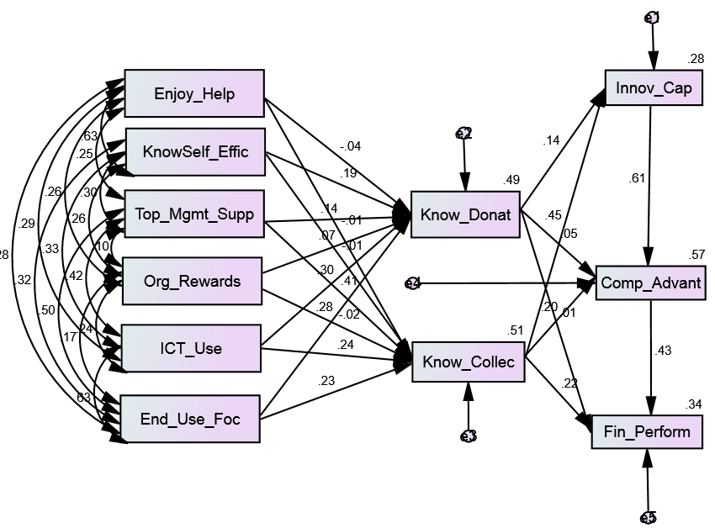

Figure 4.6: Structural Equation Modeling (SEM) for the law enforcement agency

Table 4.14: Path coefficient results for all the variables under study during the SEM

 |  |  | Estimate | S.E. | C.R. | P
KC | <--- | TM | 0.500 | 0.041 | 12.186 | ***
KC | <--- | OR | -0.016 | 0.024 | -0.676 | .499
KC | <--- | IT | 0.307 | 0.048 | 6.409 | ***
KC | <--- | EH | -0.017 | 0.066 | -0.252 | .801
KC | <--- | SE | -0.013 | 0.067 | -0.192 | .848
KD | <--- | IT | 0.271 | 0.035 | 7.734 | ***
KD | <--- | EU | 0.361 | 0.051 | 7.058 | ***
KC | <--- | EU | 0.414 | 0.070 | 5.919 | ***
KD | <--- | TM | 0.123 | 0.030 | 4.110 | ***
KD | <--- | OR | 0.038 | 0.018 | 2.144 | .032
KD | <--- | SE | 0.244 | 0.049 | 4.997 | ***
KD | <--- | EH | -0.056 | 0.049 | -1.160 | .246
IC | <--- | KD | 0.113 | 0.037 | 3.088 | .002
IC | <--- | KC | 0.270 | 0.026 | 10.305 | ***
CA | <--- | KD | 0.061 | 0.039 | 1.561 | .118
CA | <--- | KC | 0.159 | 0.030 | 5.292 | ***
CA | <--- | IC | 0.827 | 0.043 | 19.248 | ***
FP | <--- | KD | 0.008 | 0.046 | 0.181 | .857
FP | <--- | KC | 0.169 | 0.036 | 4.736 | ***
FP | <--- | CA | 0.417 | 0.038 | 11.017 | ***

Table 4.15: Standardized path coefficient results for all the variables under study during the SEM

 |  |  | Estimate
KC | <--- | TM | 0.410
KC | <--- | OR | -0.020
KC | <--- | IT | 0.241
KC | <--- | EH | -0.009
KC | <--- | SE | -0.007
KD | <--- | IT | 0.297
KD | <--- | EU | 0.280
KC | <--- | EU | 0.230
KD | <--- | TM | 0.141
KD | <--- | OR | 0.066
KD | <--- | SE | 0.193
KD | <--- | EH | -0.044
IC | <--- | KD | 0.136
IC | <--- | KC | 0.453
CA | <--- | KD | 0.054
CA | <--- | KC | 0.196
CA | <--- | IC | 0.608
FP | <--- | KD | 0.008
FP | <--- | KC | 0.218
FP | <--- | CA | 0.435

Table 4.16 summarizes the goodness-of-fit indexes for the law enforcement agency as a whole, which include CMIN, GFI, NFI, TLI, CFI and RMSEA, between the structural model variables.

Table 4.16: Goodness-of-fit indexed for the SEM

 | CMIN | P | GFI | NFI | TLI | CFI | RMSEA
SEM | 179.267 | 0.000 | 0.917 | 0.940 | 0.820 | 0.945 | 0.108

4.4 Testing the structural model for general directorates
The following results are for testing the structural model for each of the following general directorates separately: GD1, GD2, GD3 and GD4 in the law enforcement agency under study, using structural equation modeling.

4.4.1 Testing the structural model for GD1
Figure 4.7 presents the results of applying SEM on the structural model for all the variables in GD1. Also, the path coefficient (table 4.17) and standardized path coefficient (table 4.18) results are calculated to test all the relationships in the structural model, which includes six independent variables, five dependent variables and five error variables.

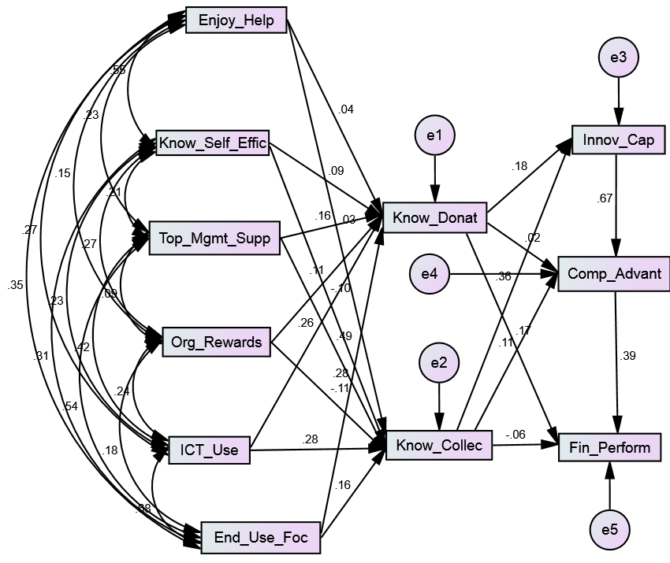

Figure 4.7: Structural Equation Modeling (SEM) for the GD1

Table 4.17: Path coefficient results for the GD1 during the SEM

 |  |  | Estimate | S.E. | C.R. | P
KD | <--- | SE | 0.120 | 0.117 | 1.019 | 0.308
KC | <--- | IT | 0.369 | 0.109 | 3.371 | ***
KC | <--- | EU | 0.267 | 0.148 | 1.806 | 0.071
KC | <--- | OR | -.088 | 0.050 | -1.746 | 0.081
KC | <--- | TM | 0.627 | 0.092 | 6.826 | ***
KC | <--- | SE | -.192 | 0.138 | -1.397 | 0.162
KC | <--- | EH | 0.071 | 0.162 | 0.442 | 0.658
KD | <--- | TM | 0.153 | 0.078 | 1.957 | 0.050
KD | <--- | EH | 0.060 | 0.138 | 0.435 | 0.664
KD | <--- | OR | 0.064 | 0.043 | 1.500 | 0.134
KD | <--- | IT | 0.258 | 0.093 | 2.769 | 0.006
KD | <--- | EU | 0.348 | 0.126 | 2.755 | 0.006
IC | <--- | KD | 0.148 | 0.082 | 1.799 | 0.072
IC | <--- | KC | 0.223 | 0.062 | 3.596 | ***
CA | <--- | KD | 0.018 | 0.082 | 0.213 | 0.831
CA | <--- | KC | 0.086 | 0.065 | 1.331 | 0.183
CA | <--- | IC | 0.848 | 0.091 | 9.365 | ***
FP | <--- | KD | 0.167 | 0.101 | 1.651 | 0.099
FP | <--- | KC | -0.045 | 0.080 | -0.561 | 0.574
FP | <--- | CA | 0.373 | 0.086 | 4.329 | ***

Table 4.18: Standardized path coefficient results for the GD1 during the SEM

 |  |  | Estimate
KD | <--- | SE | 0.086
KC | <--- | IT | 0.280
KC | <--- | EU | 0.164
KC | <--- | OR | -0.111
KC | <--- | TM | 0.489
KC | <--- | SE | -0.104
KC | <--- | EH | 0.033
KD | <--- | TM | 0.158
KD | <--- | EH | 0.036
KD | <--- | OR | 0.107
KD | <--- | IT | 0.260
KD | <--- | EU | 0.282
IC | <--- | KD | 0.179
IC | <--- | KC | 0.357
CA | <--- | KD | 0.017
CA | <--- | KC | 0.108
CA | <--- | IC | 0.666
FP | <--- | KD | 0.167
FP | <--- | KC | -0.059
FP | <--- | CA | 0.393

Table 4.19 summarizes the goodness-of-fit indexes, which include CMIN, GFI, NFI, TLI, CFI and RMSEA between the structural model variables in GD1.

Table 4.19: Goodness-of-fit Index during the SEM for the GD1

 | CMIN | P | GFI | NFI | TLI | CFI | RMSEA
SEM | 59.757*** | 0.000 | 0.918 | 0.896 | 0.789 | 0.923 | 0.129

4.4.2 Testing the structural model for GD2
Figure 4.8 presents the results of applying SEM on the structural model for all the variables in GD2. Also, the path coefficient (table 4.20) and standardized path coefficient (table 4.21) results are calculated to test all the relationships in the structural model, which includes six independent variables, five dependent variables and five error variables.

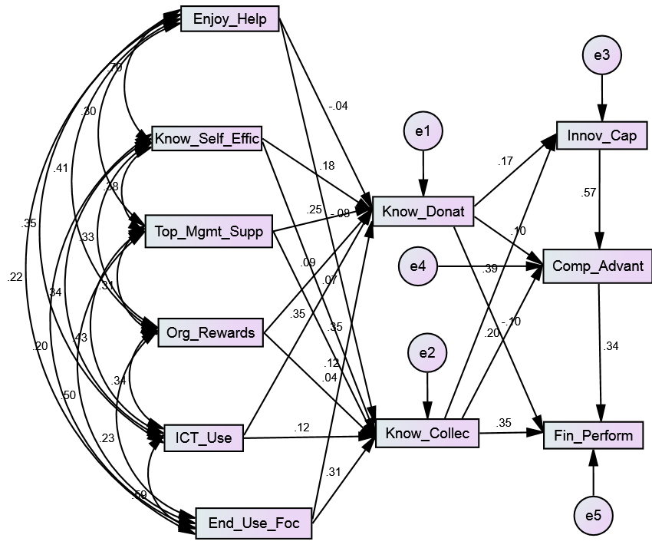

Figure 4.8: Structural Equation Modeling (SEM) for the GD2

Table 4.20: Path coefficient results for the GD2 during the SEM

 |  |  | Estimate | S.E. | C.R. | P
KD | <--- | SE | 0.175 | 0.085 | 2.066 | 0.039
KC | <--- | IT | 0.146 | 0.099 | 1.468 | 0.142
KC | <--- | EU | 0.576 | 0.150 | 3.845 | ***
KC | <--- | OR | 0.031 | 0.054 | 0.583 | 0.560
KC | <--- | TM | 0.423 | 0.091 | 4.644 | ***
KC | <--- | SE | 0.107 | 0.137 | 0.775 | 0.438
KC | <--- | EH | -0.123 | 0.131 | -0.936 | 0.349
KD | <--- | TM | 0.190 | 0.056 | 3.377 | ***
KD | <--- | EH | -0.035 | 0.081 | -0.434 | 0.664
KD | <--- | OR | 0.044 | 0.033 | 1.324 | 0.185
KD | <--- | IT | 0.277 | 0.061 | 4.511 | ***
KD | <--- | EU | 0.146 | 0.092 | 1.577 | 0.115
IC | <--- | KD | 0.146 | 0.079 | 1.855 | 0.064
IC | <--- | KC | 0.214 | 0.051 | 4.201 | ***
CA | <--- | KD | 0.129 | 0.092 | 1.407 | 0.160
CA | <--- | KC | 0.168 | 0.062 | 2.697 | 0.007
CA | <--- | IC | 0.858 | 0.095 | 9.029 | ***
FP | <--- | KD | -0.103 | 0.091 | -1.130 | 0.259
FP | <--- | KC | 0.237 | 0.062 | 3.798 | ***
FP | <--- | CA | 0.273 | 0.065 | 4.177 | ***

Table 4.21: Standardized path coefficient results for the GD2 during the SEM

 |  |  | Estimate
KD | <--- | SE | 0.176
KC | <--- | IT | 0.119
KC | <--- | EU | 0.313
KC | <--- | OR | 0.041
KC | <--- | TM | 0.354
KC | <--- | SE | 0.069
KC | <--- | EH | -0.084
KD | <--- | TM | 0.246
KD | <--- | EH | -0.037
KD | <--- | OR | 0.088
KD | <--- | IT | 0.350
KD | <--- | EU | 0.123
IC | <--- | KD | 0.170
IC | <--- | KC | 0.386
CA | <--- | KD | 0.101
CA | <--- | KC | 0.202
CA | <--- | IC | 0.575
FP | <--- | KD | -0.100
FP | <--- | KC | 0.355
FP | <--- | CA | 0.339

Table 4.22 summarizes the goodness-of-fit indexes, which include CMIN, GFI, NFI, TLI, CFI and RMSEA between the structural model variables in GD2.

Table 4.22: Goodness-of-fit Indexes during the SEM for the GD2

 | CMIN | P | GFI | NFI | TLI | CFI | RMSEA
SEM | 50.404*** | 0.000 | 0.942 | 0.932 | 0.878 | 0.956 | 0.102

4.4.3 Testing the structural model for the GD3
Figure 4.9 presents the results of applying SEM on the structural model for all the variables in GD3. Also, the path coefficient (table 4.23) and standardized path coefficient (table 4.24) results are calculated to test all the relationships in the structural model, which includes six independent variables, five dependent variables and five error variables.

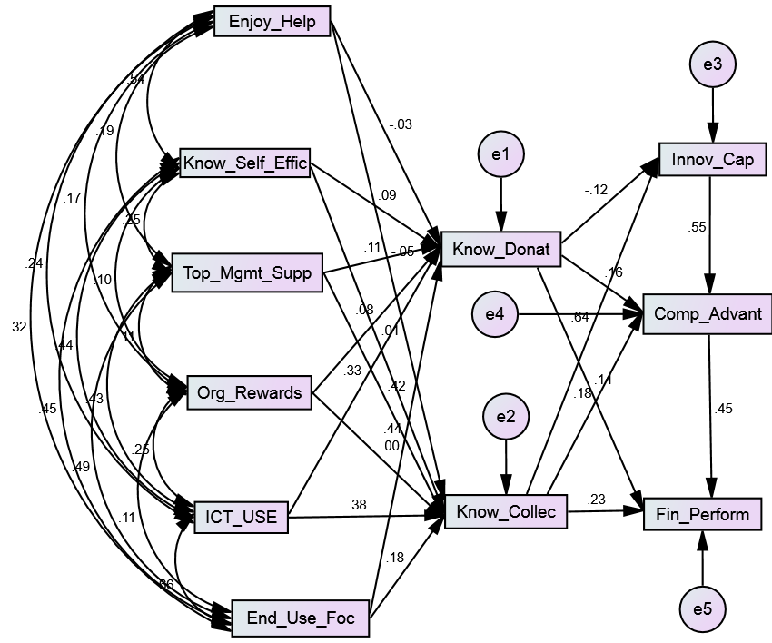

Figure 4.9: Structural Equation Modeling (SEM) for the GD3

Table 4.23: Path coefficient results for the GD3 during the SEM

 |  |  | Estimate | S.E. | C.R. | P
KD | <--- | SE | 0.132 | 0.102 | 1.294 | 0.196
KC | <--- | IT | 0.510 | 0.108 | 4.703 | ***
KC | <--- | EU | 0.335 | 0.151 | 2.215 | 0.027
KC | <--- | OR | 0.002 | 0.044 | 0.041 | 0.967
KC | <--- | TM | 0.509 | 0.080 | 6.333 | ***
KC | <--- | SE | 0.016 | 0.148 | 0.110 | 0.912
KC | <--- | EH | -0.104 | 0.136 | -0.763 | 0.445
KD | <--- | TM | 0.096 | 0.055 | 1.738 | 0.082
KD | <--- | EH | -0.047 | 0.094 | -0.499 | 0.618
KD | <--- | OR | 0.042 | 0.030 | 1.388 | 0.165
KD | <--- | IT | 0.324 | 0.075 | 4.339 | ***
KD | <--- | EU | 0.594 | 0.104 | 5.697 | ***
IC | <--- | KD | -0.087 | 0.076 | -1.149 | 0.250
IC | <--- | KC | 0.336 | 0.055 | 6.080 | ***
CA | <--- | KD | 0.160 | 0.089 | 1.794 | 0.073
CA | <--- | KC | 0.138 | 0.074 | 1.854 | 0.064
CA | <--- | IC | 0.782 | 0.109 | 7.188 | ***
FP | <--- | KD | 0.166 | 0.109 | 1.522 | 0.128
FP | <--- | KC | 0.195 | 0.088 | 2.221 | 0.026
FP | <--- | CA | 0.512 | 0.095 | 5.386 | ***

Table 4.24: Standardized path coefficient results for the GD3 during the SEM

 |  |  | Estimate
KD | <--- | SE | 0.091
KC | <--- | IT | 0.377
KC | <--- | EU | 0.181
KC | <--- | OR | 0.002
KC | <--- | TM | 0.417
KC | <--- | SE | 0.008
KC | <--- | EH | -0.052
KD | <--- | TM | 0.108
KD | <--- | EH | -0.033
KD | <--- | OR | 0.078
KD | <--- | IT | 0.330
KD | <--- | EU | 0.441
IC | <--- | KD | -0.121
IC | <--- | KC | 0.642
CA | <--- | KD | 0.156
CA | <--- | KC | 0.184
CA | <--- | IC | 0.549
FP | <--- | KD | 0.142
FP | <--- | KC | 0.229
FP | <--- | CA | 0.448

Table 4.25 summarizes the goodness-of-fit indexes, which include CMIN, GFI, NFI, TLI, CFI and RMSEA between the structural model variables in GD3.

Table 4.25: Goodness-of-fit indexes during the SEM for the GD3

 | CMIN | P | GFI | NFI | TLI | CFI | RMSEA
SEM | 61.715*** | 0.000 | 0. 915 | 0.912 | 0.823 | 0.936 | 0.135

4.4.4 Testing the structural model for GD4
Figure 4.10 presents the results of applying SEM on the structural model for all the variables in GD3. Also, the path coefficient (table 4.26) and standardized path coefficient (table 4.27) results are calculated to test all the relationships in the structural model, which includes six independent variables, five dependent variables and five error variables.

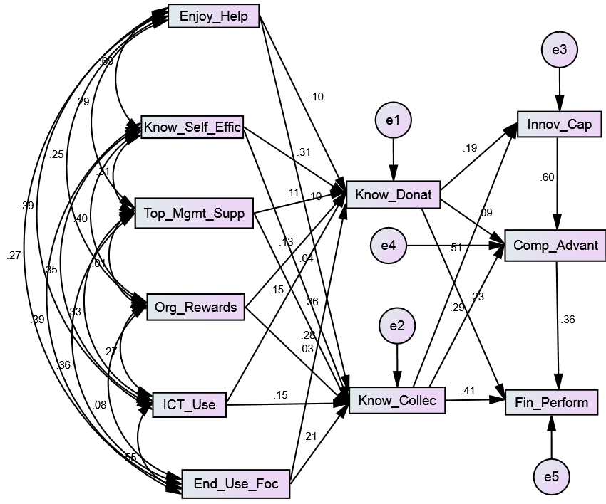

Figure 4.10: Structural Equation Modelling (SEM) for the GD4

Table 4.26: Path coefficient results during the SEM for the GD4

 |  |  | Estimate | S.E. | C.R. | P
KD | <--- | SE | 0.397 | 0.147 | 2.706 | 0.007
KC | <--- | IT | 0.191 | 0.121 | 1.584 | 0.113
KC | <--- | EU | 0.352 | 0.162 | 2.175 | 0.030
KC | <--- | OR | 0.020 | 0.067 | 0.295 | 0.768
KC | <--- | TM | 0.426 | 0.098 | 4.349 | ***
KC | <--- | SE | 0.073 | 0.188 | 0.388 | 0.698
KC | <--- | EH | 0.160 | 0.171 | 0.939 | 0.348
KD | <--- | TM | 0.104 | 0.076 | 1.362 | 0.173
KD | <--- | EH | -0.121 | 0.133 | -0.907 | 0.364
KD | <--- | OR | 0.082 | 0.052 | 1.576 | 0.115
KD | <--- | IT | 0.149 | 0.094 | 1.581 | 0.114
KD | <--- | EU | 0.369 | 0.127 | 2.916 | 0.004
IC | <--- | KD | 0.165 | 0.083 | 1.987 | 0.047
IC | <--- | KC | 0.354 | 0.065 | 5.442 | ***
CA | <--- | KD | -0.100 | 0.088 | -1.141 | 0.254
CA | <--- | KC | 0.262 | 0.076 | 3.450 | ***
CA | <--- | IC | 0.790 | 0.100 | 7.873 | ***
FP | <--- | KD | -0.268 | 0.104 | -2.570 | 0.010
FP | <--- | KC | 0.375 | 0.096 | 3.911 | ***
FP | <--- | CA | 0.358 | 0.093 | 3.834 | ***

Table 4.27: Standardized path coefficient results during the SEM for the GD4

 |  |  | Estimate
KD | <--- | SE | 0.313
KC | <--- | IT | 0.154
KC | <--- | EU | 0.208
KC | <--- | OR | 0.025
KC | <--- | TM | 0.362
KC | <--- | SE | 0.045
KC | <--- | EH | 0.100
KD | <--- | TM | 0.113
KD | <--- | EH | -0.097
KD | <--- | OR | 0.134
KD | <--- | IT | 0.154
KD | <--- | EU | 0.279
IC | <--- | KD | 0.186
IC | <--- | KC | 0.509
CA | <--- | KD | -0.086
CA | <--- | KC | 0.288
CA | <--- | IC | 0.605
FP | <--- | KD | -0.229
FP | <--- | KC | 0.411
FP | <--- | CA | 0.357

Table 4.28 summarizes the goodness-of-fit indexes, which include CMIN, GFI, NFI, TLI, CFI and RMSEA between the structural model variables in GD4.

Table 4.28: Goodness-of-fit indexed during the SEM for the GD4

 | CMIN | P | GFI | NFI | TLI | CFI | RMSEA
SEM | 46.447*** | 0.000 | 0. 928 | 0.915 | 0.852 | 0.946 | 0.112

5. Discussion

The following section discusses in detail the profile of knowledge sharing enablers, processes and outcomes. This is followed by an analysis of the differences in the results of the knowledge sharing enablers, processes and outcomes between the seven general directorates in the law agency under study. After that, the measurement model validity is discussed, the structural model is tested for the law enforcement agency as a whole.

Also, four of the general directorates in the law enforcement agency structural model results are discussed: GD1, GD2, GD3, and GD4. They are described in detail, then compared and contrasted, which led to instating observations.

5.1 Knowledge sharing enablers, processes and outcomes profile
Regarding the results presented in table 4.1, it is noticed that all the constructs are not normally distributed, as the results show that employees tend to display a positive image of themselves and the organization by answering questionnaire items with (strong agree), (agree) and (neutral) only. As for knowledge sharing enablers, the highest mean is ‘enjoyment in helping others’, followed ‘knowledge self-efficacy’, then ‘organizational rewards’. This implies that the employees in the law enforcement agency believe in their personal factors more than organizational and technology factors as enablers of knowledge sharing.

As for knowledge sharing processes, ‘knowledge collecting’ has a slightly higher mean than ‘knowledge donating’, which implies that employees tend to collect knowledge more than they are willing to donate their own.

Finally, regarding knowledge sharing outcomes, the highest mean belongs to ‘organizational competitive advantage’, while the lowest mean of all constructs belongs to ‘organizational financial performance’ (3.14). That might depict that employees in the organization don’t believe that financial performance is relevant to the organization because most employees answered the questionnaire items as (neutral).

In addition, the mean and standard deviation are calculated for each general directorate separately. The results are approximately analogous to each other, which depicts that all employees have a similar opinion about the enablers, processes and outcomes of knowledge sharing in the law enforcement agency. The roles and functions of each general directorate do not affect the general culture and beliefs of the employees.

Based on the Cronbach Alfa, it depicts the all instruments selected for testing the proposed model with an above satisfactory reliability level. In general, 89.1% of the respondents to the questionnaire are likely to give the same answers if given the questionnaire again. The highest variables results relate to ‘enjoyment in helping others’, ‘organizational rewards’, followed by ‘organizational competitive advantage’. The lowest variables results related to ‘knowledge self-efficacy’ and knowledge ‘collecting’.

5.2 Knowledge sharing enablers, processes and outcomes differences
In general, the study showed very significant differences on knowledge sharing enablers, processes and outcomes amongst the seven general directorates in the law enforcement agency. After examining the six enablers, two processes and three outcomes in table 4 with the ANOVA test, it showed that organizational competitive advantage and organizational innovation capability showed significant differences between the seven general directorates. The rest of the variables also showed differences between the seven general directorates, but not at 0.01 significant level.

By comparing the mean values in table 4.1a & table 4.1b for organizational innovation capability, the difference between the highest (GD6) and the lowest (GD7) mean is approximately 1.0. The same conclusion also applies to organizational competitive advantage, where the difference between the highest (GD6) and the lowest (GD5) mean is approximately 1.5. This shows that the different general directorates’ results differ significantly due to their different culture, characteristics and functions in the organization. Further investigation of the differences in the results, specifically in GD1, GD2, GD3 and GD4, will be discussed further in section 5.4.

5.3 Testing the measurement model
In order to validate and test the measurement model used in this study, confirmatory factor analysis was performed. The model includes 42 items to collect respondents’ opinion about 11 different variables. The results of the standardized path coefficient (table 4.4; table 4.6) show that nine of the items’ results were poor or/and below the acceptable significant level. These items belong to ‘knowledge self-efficacy’, ‘information and technology use’, ‘organizational rewards’, ‘knowledge donating’, ‘knowledge collecting’, ‘organizational competitive advantage’, as well as three ‘organizational innovation capability’ items.

To enhance the measurement model quality, the decision was to omit those nine items and re-conduct the confirmatory factor analysis with 33 instruments. All the results’ standardized path coefficients (table 4.8; table 4.10) appeared to be satisfactory; standardized path coefficient was more than 0.538 and significant at 0.01 level of significance.

Regarding the goodness-of-fit indexes, the results of the first and second CFA were compared (table 4.11; table 4.12). In general, the results of CMIN, GFI, NFI, TLI, CFI and RMSEA have been enhanced after omitting the items. GFI, NFI, TLI, CFI are all greater than 0.8, which is above the recommended cut-off level of 0.8. Also, RMSEA is close to zero, which is below the recommended cut-off value of 1.0. Therefore, the results support the overall validity of the measurement model, which anticipates that testing the structural model will provide higher accuracy and quality.

5.3 Testing the structural model
To achieve the objectives of this study, the hypotheses were tested using structured equation modeling for the law enforcement agency as a whole. Initially, Pearson correlation analysis was conducted on all the variables in the proposed research model (table 4.13). The results show that there exists a positive correlation between all the hypothesized paths significant at 0.01 level. Also, it is noticed that knowledge donating and knowledge collecting are positively correlated (0.620) significant at 0.01 level that supports the bidirectional perspective of knowledge sharing.

After that, standardized path coefficient was estimated for all the hypothesized paths in the research model. The results of the analysis are summarized in table 5.1, which supports the hypothesis only if the estimation is above 0.15, significant at 0.01.

Table 5.1: Summary of hypotheses testing

Hypothesized path | Results
H1a: Enjoyment in helping others knowledge donating | Not supported
H1b: Enjoyment in helping others knowledge collecting | Not supported
H2a: Knowledge self-efficacy knowledge donating | Supported
H2b: Knowledge self-efficacy knowledge collecting | Not supported
H3a: Organizational rewards knowledge donating | Not supported
H3b: Organizational rewards knowledge collecting | Not supported
H4a: Top management support knowledge donating | Not supported
H4b: Top management support knowledge collecting | Supported
H5a: Information and technology use knowledge donating | Supported
H5b: Information and technology use knowledge collecting | Supported
H6a: End user focus knowledge donating | Supported
H6b: End user focus knowledge collecting | Supported
H7a: Knowledge donating organizational innovation capability | Not supported
H7b: Knowledge collecting organizational innovation capability | Supported
H8a: Knowledge donating organizational competitive advantage | Not supported
H8b: Knowledge collecting organizational competitive advantage | Supported
H9a: Knowledge donating organizational financial performance | Not supported
H9b: Knowledge collecting organizational financial performance | Supported
H10: Organizational innovation capability organizational competitive advantage | Supported
H11: Organizational competitive advantage organizational competitive advantage | Supported

In summary, table 5.1 shows that 11 out of the 20 hypotheses are supported, while 9 are not supported. The 6 hypotheses support that knowledge collecting is impacted by the enablers or impacting the outcomes of knowledge sharing. By comparison, only 3 hypotheses support that knowledge donating is impacted by the enablers or impacting the outcomes of knowledge sharing. The following sections are a detailed explanation for each hypothesis result.

Regarding goodness-of-fit indices of the structural model (table 4.16), the results depict a high to moderate level of fitness. CMIN provides a significant at 0.01 level result. NFI, TLI, CFI indices are all above 0.82, which is above the recommended cut-off value of 0.8. The RMSEA result is 0.108, which indicates a good error of approximation because the recommended cut-off value is below 1.0.

5.3.1 The impact of knowledge sharing enablers on knowledge sharing processes
Hypotheses H1 to H6 suggest knowledge sharing enablers’ effect on knowledge donating and collecting. The enablers examined in this study are enjoyment in helping others, knowledge self-efficacy, organizational rewards, top management support, information and communication technology use, and end-user focus.

First of all, the enjoyment in helping others is an individual factor that was found by many previous studies to positively affect knowledge donating and collecting. Against the odds, there is no evidence that enjoyment in helping others affects knowledge donating and collecting in the law enforcement agency under study. That can be justified from different angles. According to the enjoyment in helping others variable profile, employees in the law enforcement agency enjoy helping others. It is part of their job as law enforcers as well as their regional culture. Yet, when it comes to knowledge donating and collecting, the knowledge level of information security is usually restricted, confidential, or highly confidential. Sharing knowledge for the sole purpose of enjoying is banned by the laws and regulations of the organization, as well as the ethical behavior of its employees.

Regarding the knowledge self-efficacy enabler, the results of this study support that it significantly and positively impacts knowledge donating. Nevertheless, there is no evidence that knowledge self-efficacy impacts knowledge collecting in the law enforcement agency under study. Social Capital theory (SCT) can be seen in terms several dimensions, including personal and collective efficacy (Bourdieu, 1984; Coleman, 1988), wherein it can be assumed that people share knowledge with those who are confident in their level of knowledge and are willing to share it back in return (Iqbal, et al., 2011).

This can also explain the fact that knowledge self-efficacy is an individual factor that depends mainly on the employees’ confidence in the level of knowledge that they acquire. Many employees work in positions in the law enforcement agency that lead to accumulating useful experience, skills and knowledge that is worth donating, especially in the fields of criminal investigations, security affairs or residents’ safety. The law enforcement agency also regularly has training sessions and workshops held by the employees to share the law enforcement skills and experiences with their colleagues within the same department or function.

Organizational rewards are the third enabler examined in the proposed research model. Some literature supports that organizational rewards affect knowledge donating and collecting (Al-Alawi et al., 2007; Durmusoglu et al., 2013; Fortier and Farrell, 2009; Ling et al., 2009). However, the results of this study do not support that organizational rewards affect both knowledge donating and collecting. Many previous empirical studies have also failed to prove that organizational rewards could foster positive knowledge sharing behavior (Bock and Kim, 2002; Lin, 2006, 2007; Olatokun and Nwafor, 2012).

Logically, giving organizational rewards such as incentives, gifts or acknowledgment contradict the true meaning of knowledge donating, or willingly given by employees, because it means employees were encouraged or forced to give their Organizational Citizenship Behavior (OCB) theory (Brief and Motowidlo, 1986), pro-social organizational behaviors are positive social acts performed to produce and maintain the integrity and the welfare of others. These behaviors, like knowledge sharing, can be directed towards individuals or organizations and must be carried out spontaneously. In addition, people are not expected to collect more knowledge to receive a reward. Collecting knowledge is usually done to achieve certain aims or perform a job in the organization.

In the law enforcement agency under study, leadership and top management highly affect employees’ behavior and the organization’s culture. The results of this study show the top management support significantly impacts knowledge collecting but not knowledge donating. Top managers encourage employees to collect information as part of the law enforcement’s functions, such as investigations, inspections and observation of criminal activities. It shows that the top managers favor the unidirectional perspective of knowledge sharing, whereby knowledge flows in one direction in the organization (Yi, 2009).

Regarding technology factors, it is found that information and communication technology use and end-user focus impact knowledge collecting and donating. As a knowledge-intensive organization, the law enforcement agency is considered very advanced in information and communication technologies, and has been for the past 30 years. It has its own business intelligence and data warehousing, electronic portal with terabytes of information, criminal and investigations records, advanced forensics labs and hi-tech surveillance and tracking systems, etc. In addition to the systems and tools, employees are highly trained and experienced in using those technologies. Therefore, employees are fully aware and comfortable with feeding these systems with their knowledge and searching for what they need.

5.3.2 The impact of knowledge sharing processes on knowledge sharing outcomes
The Hypotheses - H7 to H9 - explained the impact of knowledge donating and collecting on knowledge sharing processes, which include organizational innovation capability, organizational competitive advantage and organizational financial performance. The Theory of Reason Action (TRA) by Ajzen and Fishbein (1975) stated that a specific intention or behavior, such as knowledge sharing, will lead to positive outcomes such as organizational performance.

The law enforcement agency has an innovation center as part of their newly introduced functions. Their objectives are to make the agency a pioneer in their procedures, processes, tools and technologies. The study found that knowledge collecting affects organizational innovation capability, yet knowledge donating does not. The results conform to previous literature, but with the unidirectional perspective of knowledge sharing.

Regarding organizational competitive advantage, the results also show that only knowledge collecting affects organizational competitive advantage, which also demonstrates that the organization depends on sharing knowledge in one direction in order to gain a competitive advantage over the other law enforcement agencies. There has been healthy competition between law enforcement agencies for around ten years, through national and federal excellence awards.

Similar to organizational innovation capability and organizational competitive advantage, the study found that only knowledge collecting impacts organizational financial performance. Although the law enforcement agency is a non-profit organization, it is essential for them to maintain their return-on-investment, cost and revenues of services and their overall financial performance within the acceptable government budget. Again, there is no evidence that knowledge donating impacts organizational innovation capability.

5.3.3 The impact of knowledge sharing outcomes on one another
The Hypotheses - H10 and H11 - examined the effect of organizational innovation capability on organizational competitive advantage, as well as the effect of organizational competitive advantage on organizational financial performance in the law enforcement agency under study. The results support the existence of a significant positive impact of organizational innovation capability on organizational competitive advantage, which also shows that organizational innovation capability mediates the relationship between knowledge collecting and organizational innovation capability. Lin and Chen (2008) also explained the mediating role played by knowledge sharing behavior between organizational innovation capability and competitive advantage. In addition, it is found that organizational competitive advantage significantly and positively impacts organizational financial performance, which is also supported by previous literature.

5.4 Testing the structural model for the general directorates
To achieve the objectives of this study, the following 11 main hypotheses were tested using structured equation modeling for the selected four general directorates. GD1, GD2, GD3 and GD4 general directorates are selected precisely because of the significant differences in their objectives, functions and culture, which as expected, provided unique results and are justified accordingly in this section.

Regarding general directorates GD5, GD6 and GD7, they were not qualified to be tested using SEM because of their sample size deficiency. GD5 consists mainly of field-based employees having below-high school education levels. Their main objectives and functions are guarding and special missions. Their jobs require high physical fitness and following orders from superiors. Regarding GD6 and GD7, they have the lowest percentage of employees among different general directorates in the law enforcement agency. They handle pure business support functions, including finance, services and human resources.

The standardized path coefficient was estimated for all the hypothesized paths in the research model for each of GD1, GD2, GD3 and GD4 general directorates. The results of the analysis are summarized in table 5.2, which supports the hypothesis only if the estimation is above 0.15, significant at 0.01.

Table 5.2 presents the results of testing the hypotheses, and examines the impacts between knowledge sharing enablers, processes and outcomes for each of the four general directorates, GD1, GD2, GD3 and GD4. Eight out of the 20 hypotheses are supported and 12 are not supported for each of GD1, GD3 and GD4, while 9 out of the 20 hypotheses are supported and 11 are not supported for only GD2.

Table 5.2: Summary of hypotheses testing for the GD1, GD2, GD3 and GD4

Hypothesized path | GD1 | GD2 | GD3 | GD4
H1a: Enjoyment in helping others knowledge donating | Not supported | Not supported | Not supported | Not supported
H1b: Enjoyment in helping others knowledge collecting | Not supported | Not supported | Not supported | Not supported
H2a: Knowledge self-efficacy knowledge donating | Not supported | Not supported | Not supported | Supported
H2b: Knowledge self-efficacy knowledge collecting | Not supported | Not supported | Not supported | Not supported
H3a: Organizational rewards knowledge donating | Not supported | Not supported | Not supported | Not supported
H3b: Organizational rewards knowledge collecting | Not supported | Not supported | Not supported | Not supported
H4a: Top management support knowledge donating | Not supported | Supported | Not supported | Not supported
H4b: Top management support knowledge collecting | Supported | Supported | Supported | Supported
H5a: Information and technology use knowledge donating | Supported | Supported | Supported | Not supported
H5b: Information and technology use knowledge collecting | Supported | Not supported | Supported | Not supported
H6a: End-user focus knowledge donating | Supported | Not supported | Supported | Supported
H6b: End-user focus knowledge collecting | Not supported | Supported | Not supported | Not supported
H7a: Knowledge donating organizational innovation capability | Not supported | Not supported | Not supported | Not supported
H7b: Knowledge collecting organizational innovation capability | Supported | Supported | Supported | Supported
H8a: Knowledge donating organizational competitive advantage | Not supported | Not supported | Supported | Not supported
H8b: Knowledge collecting organizational competitive advantage | Not supported | Supported | Not supported | Supported
H9a: Knowledge donating organizational financial performance | Not supported | Not supported | Not supported | Not supported
H9b: Knowledge collecting organizational financial performance | Supported | Supported | Not supported | Supported
H10: Organizational innovation capability organizational competitive advantage | Supported | Supported | Supported | Supported
H11: Organizational competitive advantage organizational financial performance | Supported | Supported | Supported | Supported

Regarding goodness-of-fit indices of the structural model for each of GD1, GD2, GD3, GD4 (table 4.19; table 4.20; table 4.21; table 4.22), in general, the results depict a high to moderate level of fitness. CMIN is significant at 0.01 level result. NFI, TLI, CFI indices are all above 0.82, which is above the recommended cut-off value of 0.8. The RMSEA results are approximately 0.1, which indicates a good error of approximation fit-of-index because the recommended cut-off value is below 1.0. The following explains the results of testing the structural model for each of the four selected general directorate separately, then the results are compared and contrasted.

5.4.1 Testing the structural model for GD1
First of all, general directorate GD1 has unique functions and characteristics, compared to the other general directorates in the law enforcement agency under study. It directly follows the general commander of the agency. It consists of six departments that cover strategic planning and implementation, knowledge management, total quality management, advisory management, decision-making support, as well as other strategic-level functions. All the middle managers in those departments are office-based, centrally located with most having post-graduate qualifications. Therefore, the results of this general directorate reflect culture that is ingrained in knowledge management and includes many experts in its field.

Regarding personal factors, the results do not support that enjoyment in helping others and knowledge self-efficacy effect knowledge donating and collecting. Although the literature review supports both enablers of knowledge sharing, the result was nevertheless not as expected at all. GD1 is a general directorate staffed with employees who are experts in strategic, tactic and operations fields, yet it did not add any value to their personal enablers of knowledge sharing. Such enablers must be enriched and enforced by the management, especially in those departments.

Organizational rewards are also not supported as influencing knowledge donating and collecting. Such rewards were considered in the GD1 knowledge strategy but proved its failure in encouraging sharing knowledge behavior. The results support previous literature that is against rewarding employees in exchange for their knowledge (Bock and Kim, 2002; Lin, 2006, 2007; Olatokun and Nwafor, 2012). Regarding top management support, it has a significant effect on knowledge collecting only, which implies that the top manager follows the unidirectional approach of knowledge sharing. They encourage employees in GD1 to enquire about the needed knowledge based on their task’s requirement.

Regarding technology factors, the results absolutely supported that information technology use significantly impacts knowledge donating and collecting. All the employees of GD1 depend heavily on the organization’s electronic portal to access all the information and databases they need to perform their job, exchange knowledge and documents remotely, as well as communicate their strategic plans, announcements and quality standards with all the other departments in the law enforcement agency. Nevertheless, the employees only believe that end-user focus technologies affect knowledge donating because the more user-friendly the programs are, the more they are encouraged to willingly share their knowledge through them.

When it comes to the outcomes of knowledge sharing, both organizational innovation capability and organizational financial performance impact knowledge collecting only, while knowledge donating does not, follow the classic unidirectional perspective of knowledge sharing, which confirm the results shown in section 5.3.2 for the affect of knowledge collecting on the outcomes for the agency as a whole. Yet, the results do not support that organizational competitive advantage has an impact on knowledge donating or collecting. This can be justified by the fact that middle managers in GD1 believe that the law enforcement agency ought not to compete with other law enforcement agencies by any means to achieve their objectives because it is a non-profit organization. They are aware of the sole vision and goals of their agency, and competitive advantage is not one of its objectives.

In general, GD1 agrees that the outcomes of knowledge sharing have a positive effect on each other, which include organizational innovation capability that is significantly affecting organizational competitive advantage and organizational competitive advantage significantly affecting organizational financial performance. It indicates that knowledge collecting can possibly influence organizational competitive advantage through the mediation of the agency’s innovation capabilities. Also, knowledge collecting can possibly influence organizational financial performance through the mediation of the agency’s competitive advantages.

5.4.2 Testing the structural model for GD2
The departments following general directorate GD2 cover a great support for the core business of the law enforcement agency, including criminal evidence, crime scenes, securing ports, inspections, K9 and weapons and explosives. These functions are mainly knowledge-intensive and require management of knowledge through proper acquisition, storage, utilization and exchange of knowledge. For example, criminal evidence is a very sensitive function that deals basically with information and resources collected from crime scenes and chiefly affects the results of criminal investigations. The middle managers of this general directorate are mostly specialized and experts in their field.

As well, personal factors are not a driver for knowledge sharing in GD2. The results do not support that enjoyment in helping others and knowledge self-efficacy affect knowledge donating and collecting. Information security is paramount in the agency under study, especially when dealing with sensitive information. This information must not be shared out of a personal interest in sharing knowledge, in order to avoid compromising the integrity, security and outcomes of investigations.

Regarding top management support, GD2’s general manager is the leader of knowledge management excellence in the agency. His support significantly and positively impacts both knowledge donating and collecting. The proper exchange and sharing of experiences and knowledge plays a major role in achieving their departments’ roles. In addition, donating and collecting within one unit improves work performance and makes it easier to solve criminal cases and investigations more effectively and professionally. The results do not support that organizational rewards affect knowledge donating and collecting.

Furthermore, GD2 provides unique results when it comes to technology factors. It shows that information technology use by the employees significantly affects knowledge donating only. The functions of this general directorate concentrate on collecting evidence from crime scenes and inspections, processing and analyzing this, then to input them into the appropriate systems and databases for further usage. The main purpose of information technology, therefore, is to donate not collect knowledge. On the other hand, employees believe that the proper computer training and the existing user-friendly systems and programs positively impact knowledge collecting but not knowledge donating. Electronic evidence and knowledge collecting from information and communication technology requires a specific type of expertise and is not feasible by all the employees in GD2.

Regarding the outcomes of knowledge sharing, GD2 strictly follows the unidirectional perspective of knowledge sharing. The result shows that knowledge collection significantly and positively impacts organizational innovation capability, competitive advantage and financial performance. Supporting the core business of the agency would naturally achieve better outcomes if both knowledge collecting and donating were performed and therefore improving overall agency performance is enhanced. The results also support that organizational innovation capability impacts organizational competitive advantage, which also impacts organizational financial performance.

5.4.3 Testing the structural model for GD3
Regarding general directorate GD3, its departments provide supporting services, technical support and operational services for the whole organization. It includes the operations central room, information and communication technology, and the air wing, in addition to emergency and general safety. This department works twenty-four seven to support both internal and external customers with the aid of highly qualified employees. Providing the required and accurate knowledge within time is a key factor for GD3 to achieve its objectives. Individual factors are not a driver for knowledge sharing in GD3.

The results do not support that enjoyment in helping others and knowledge self-efficacy affect knowledge donating and collecting. Sensitive information, especially from an operations room or in an emergency case, must not be shared out of a personal interest in sharing knowledge because it might highly compromise work integrity, security and outcomes.

The results do not support that organizational rewards affect knowledge donating and collecting. Therefore, information and communication technology departments rewarding systems to employees and partners must be reconsidered accordingly, because it only leads to wasting agency’s resources. Furthermore, top management support significantly affects knowledge collecting but not knowledge donating, which supports the unidirectional perspective of knowledge sharing that is followed by the general commander and all the general directorates in the law enforcement agency under study.

When it comes to knowledge sharing outcomes, GD3 shows some interesting results. It shows that knowledge collecting only impacts organizational innovation capability, and knowledge donating only impacts organizational competitive advantage. That can be justified from the perspective of the cases of the operations room, air wing and emergencies. Donating useful, fast and accurate knowledge from the employees and the customers of the law enforcement agency can help prevent many incidents from occurring. Therefore, achieving a competitive advantage for the law enforcement agency, if and only if competitors exist in that specialty. It can also lead to creating a positive image for the agency by comparing it to other law enforcement agencies in the country and the region. The results do not provide support that knowledge donating and collecting affect organizational financial performance in GD3. The results also support that organizational innovation capability impacts organizational competitive advantage, which also impacts organizational financial performance.

5.4.4 Testing the structural model for GD4
GD4 is the most important general directorate because it covers the core business functions. It includes more than 50% of the employees, mostly field-based, located in three different geographical areas. Its functions include criminal investigations, policing operations, as well as traffic and accidents. Knowledge usually transfers from the different general directorates to GD4 so it can perform its job efficiently. Sharing knowledge among employees in one department plays a major role in achieving its objectives competitively and on time.

Regarding enjoyment in helping others, the results do not support that it affects both knowledge donating and collecting due to its consequences for the organization’s information security. Within the departments, it seems like employees’ knowledge self-efficacy significantly impacts their willingness to donate knowledge. For instance, an officer who recently solved a criminal case would gather with his colleagues and explain how they managed to collect all the evidence on time and arrest the suspects. This contributes to other police officers in GD4 solving future incidents. Knowledge self-efficacy does not affect knowledge collecting.

There is no support by the results that organizational rewards impact knowledge donating and collecting. Top management support significantly and positively impacts knowledge collecting, which follows the unidirectional perspective of knowledge sharing. The more managers encourage knowledge collecting, the more input is available for the departments to perform their job effectively.

Although technology is essential for policing work, unfortunately the results do not support that information technology use affects knowledge collecting and donating. That can be justified by the nature and culture of the general directorate, wherein most employees are field-based, with limited access to technology, or have a modest education level and computer skills and experience. Although mobile and communication technologies are widely used in the agency, they are utilized by a limited number of employees in GD4 departments. However, employees with more skills seem to donate their knowledge if the computer systems are end-user focused, which shows that end-user focus significantly affects knowledge donating but not collecting.

Regarding the outcomes of knowledge sharing, GD4 firmly follows the unidirectional perspective of knowledge sharing. The results show that knowledge collection significantly and positively impacts organizational innovation capability, competitive advantage and financial performance. Performing the core business tasks of the agency would naturally achieve better outcomes if both knowledge collecting and donating were performed, thereby improving the overall agency performance. The results also support that organizational innovation capability impacts organizational competitive advantage, which also impacts organizational financial performance.

5.4.5 Comparing and contrasting the results
By examining the results of the hypotheses summary for GD1, GD2, GD3 and GD4 (table 5.2), it is noticed that there are similarities and differences between the results of the different general directorates. The functions of the four units can be described as follows: GD1 handles strategy, quality, knowledge management and decision-making support, GD2 supports the core business of the organization through handling criminal evidence, crime scenes, inspections and K9, GD3 covers 24/7 operations, information technology, air wing and emergencies, and GD4 handles the core business of the agency including policing, investigations, traffic and accidents.

By comparing the results, it shows that all four general directorates agree that enjoyment in helping others does not affect knowledge donating and collecting. The results disagree with all literature reviews that were found to examine this relationship. This implies that the whole organization carries the same sense of information security and discretion about sharing their knowledge out of personal interest among and across the agency. In addition, the observed general directorates do not support that knowledge self-efficacy impacts knowledge collecting. As a personal factor, it is more likely that it affects the willingness to donate knowledge.

Regarding giving rewards within the organization, the results do not support that it affects both knowledge donating and collecting. All observed general directorates agree on that result with no exception, in addition to some previous literature (Bock and Kim, 2002; Lin, 2006, 2007; Olatokun and Nwafor, 2012). Also, the general directorates that top management support impacts knowledge collecting because the employees of the agency highly honor and are loyal to the leadership of the agency, which follows the unidirectional perspectives of knowledge collecting and promotes it across the agency.

Regarding the outcomes of knowledge sharing, GD1, GD2, GD3 and GD4 agree that knowledge collection positively and significantly impacts the innovation capability in the agency. Moreover, the results show no support that knowledge donating whatsoever affects the innovation capability and financial performance of the law enforcement agency under study. The comparison between the general doctorates shows that the agency’s innovation capability impacts its competitive advantage with other law enforcement agencies in the country, as well as its competitive advantage impacts its financial performance.

The results in table 5.2 show that most general directorates disagree that knowledge self-efficacy impacts knowledge donating, except for GD4. It is believed that highly specialized and experienced employees in policing and the investigations field tend to donate their knowledge to their colleagues in the same field because they assume that it will add to the pool of knowledge in the agency and will aid future incidents and investigations positively. As well, most general directorates do not support that top management support impacts knowledge donating. The exception is GD2 because, as explained earlier, its general manager is the leader of knowledge management in the agency and heads the higher committee of knowledge management excellence.

Regarding technology factors, there are variations in the four general directorates regarding the impact of information and communication technology use and end-user focus on knowledge donating and collection. None of the general directorates denies the role of information technology but they either support knowledge donating or collection based on the functions and objectives of the general directorates. Also, the following factors affect the employees’ perspective of information technology: education level, computer literacy level, the culture of the unit, and if they are an office- or a field-based employee.

Regarding the outcomes of knowledge, most general directorates disagree that knowledge donating impacts their competitive advantage, except GD3. They believe that their competitive power is derived from the amount of accurate and current knowledge that they receive, consequently allowing them to perform better in their job. Finally, most of the general directorates support that knowledge collecting positively influences the agency’s financial performance, except GD4. This is considered odd conclusion because adopting planned information technology would improve the return of investment and lower the cost of many operations and services in an organization.

6. Conclusions, Implications, Limitations and Future Research

This chapter includes a summary of the findings of this study, including the law enforcement agency as a whole and each of the four selected general directorates. Next, theoretical and managerial contributions of the findings are discussed. After that, a number of limitations and futures research opportunities are suggested. Finally, based on the findings, some recommendations and suggestion are proposed for the law enforcement agency under study.

6.1 Conclusions
Based on the results and discussion in chapters 4 and 5, it can be concluded the following:
- Knowledge donating behavior of the employees is predicted by their own knowledge self-efficacy beliefs.
- Knowledge collecting behavior of the employees is predicted by the top management support.
- Knowledge donating and knowledge collecting behaviors of the employees are predicted significantly by information and communication technology use and end-user focus.
- Employees’ enjoyment in helping others and granting organizational rewards showed no effect at all on both knowledge donating and knowledge collecting behavior in the law enforcement agency under study.
- Innovation capability, competitive advantage and financial performance of the law enforcement agency are predicted by employees’ willingness to collect knowledge.
- Employees’ willingness to collect knowledge have a bigger impact on knowledge sharing on knowledge sharing outcomes that employees’ willingness to donate knowledge.
- Innovation capability affects competitive advantage and competitive advantage affects financial performance in the law enforcement agency under study.

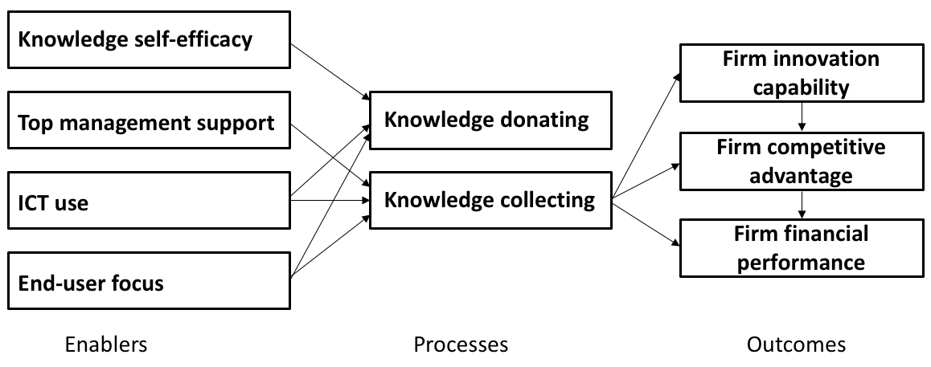

Figure 6.1: Summary of the findings of the present study

After examining the law enforcement agency as a whole, four of the general directorates in the law enforcement agency were examined separately: GD1, GD2, GD3 and GD4. Each of the general directorates has different business objectives and functions, including strategy, core business, operations and information technology. The results indicated that the aforementioned four general directorates share similar knowledge sharing behaviors, and have differences on others, based on the units’ objectives, cultures and functions. The factor that mainly affects the results between the general directorates is the nature of their jobs – some require more donating and collecting and vice versa. Another factor that matters is job location and whether it’s field-based or office-based.

For example, the personal factors, such as enjoyment in helping others and knowledge self-efficacy, are ignored by the employees and do not affect either knowledge donating or collecting. Also, there is clear variation in their use of information and communication technologies because it depends on many factors, such as the nature of their jobs and their computer literacy. All general directorates agree that the willingness of their employees to collect knowledge significantly affects the innovation capabilities of the law enforcement agency under study. All directorates except GD3 agree that the willingness of their employees to collect knowledge significantly affects the financial performance of the law enforcement agency under study.

6.2 Implications
The findings of the study have the following theoretical and managerial contributions:

6.2.1 Theoretical contributions
First of all, this study proposed a research model for empirical studies that linked a three-dimensional based on enablers, processes and outcomes. These dimensions were introduced in previous studies such as Lin (2007) and Kumar and Rose (2012). The model has enormous opportunities for enhancements and additions of more enablers and outcomes variables, which opens the door for scholars to improve and develop more frameworks that follow the same three dimensional structure.

The study is built upon previous studies that conceptualized knowledge sharing behavior such as the Theory of Reasoned Action (TRA) (Fishbein & Ajzen, 1975), Social Capital Theory (SCT) (Bourdieu, 1984; 1986) and organizational citizenship behavior (OCB) (Brief and Motowidlo, 1986). Those theories explained the factors that affect employees’ intentions and behavior, as well the impact of behavior, such as knowledge sharing on positive outcomes. Scholars can contribute to these theories by introducing more knowledge sharing intention and behavior frameworks.

The three-dimensional model for knowledge sharing showed unique findings regarding the impact of knowledge sharing enablers on knowledge sharing outcomes, and the impact of knowledge sharing processes on knowledge sharing outcomes in the context of law enforcement agencies in the UAE. The unexpected results were because of the special characteristics and culture of a law enforcement agency in a country in the Middle East. The researcher believes that replicating the same study in different regions of the world would lead to completely different findings.

By comparing the results of different general directorates, the findings imply that the culture and characteristics of the studied sample might provide a different perspective of knowledge sharing enablers, processes and outcomes. Introducing organizational culture as a moderator factor might provide an added value to the framework under study. Also, comparing results across different organizations can provide a wider view of knowledge sharing behavior in a certain region.

In general, this dissertation introduces great opportunities for academics to study knowledge sharing in the UAE and the Middle East, as there is great scarcity in this field of study in the area. Very few studies examined knowledge sharing, especially knowledge sharing enablers, processes and outcomes in organizations in the UAE, and very few research models have been introduced in the area.

6.2.2 Managerial contributions
The relationship between knowledge sharing enablers, processes and outcomes may provide a clue regarding how knowledge-intensive organizations in the UAE can promote knowledge sharing culture to sustain their innovation performance, competitive advantage and financial performance. The study establishes a number of implications for helping managers and decision makers to create a successful knowledge sharing strategy, particularly in law enforcement agencies in the region.

The findings of this study imply that, although employees enjoy helping each other, donating and collecting knowledge is nevertheless considered a complicated task. Information security rules and regulations in the agency have created a culture of restraining sharing knowledge because employees are afraid to compromise the agency’s information security. As a matter of fact, knowledge sharing internally within the same unit is crucial to reach better innovation performance, competitive advantage and financial performance, thereby achieving the law enforcement agencies’ objectives.

In addition, the study implies that top managers only prefer knowledge collecting and do not support knowledge donating because they are following the traditional unidirectional perspective of knowledge sharing. In return, knowledge collecting only impacts innovation capability, competitive advantage and the financial performance of law enforcement agencies. Promoting a new culture of knowledge donating is expected to have more significant and positive outcomes to the organization than found in previous literature.

One mistake that many organizations commit is offering rewards to their employees in return for sharing their knowledge or experience. The findings of this study significantly confirm that organizational rewards have no impact on knowledge donating and collecting. It might even have a negative effect instead, because employees can possibly refrain from sharing their knowledge or might share less valuable or accurate information with their colleagues. Yet, knowledge self-efficacy is the most effective enabler of knowledge donating in law enforcement agencies.

The study implies that the use of user-friendly information and communication technology is the winning card for knowledge donating and collecting in law enforcement agencies. This applies mostly for computer-literate employees in organizations, where employees need to access huge amounts of data in minimal time. Also, it can be effective in organizations that are spread across a wide geographical area and need to access sources of information in real-time, such as criminal and investigation records. The quality of the information and communication technology is also essential. Computer systems that are complicated to use or require special skills can negatively affect the process of knowledge collecting and donating.

Comparing and contrasting the results of different units gives the management of the organizations under study an insight into how different organizational culture and characteristics can be in each department and unit, what are the strengths and weaknesses of every unit, and also the probability of the need to build a specialized knowledge sharing strategy in certain departments instead of following a general strategy for the whole agency. Understanding the roles and functions of departments makes it easier to interpret knowledge sharing behavior in general.

Finally, there was a clear misconception from many employees in different general directorates of the existence, or not, of competitive advantage and financial performance in their agency. Working in a non-profit government organization does not mean that there is no competition among different teams, departments or even other law enforcement organizations. It is believed that creating a positive competitive culture in the organization enhances overall performance. The financial performance of the organization is an essential factor, and helps lower budgets, increase return on investment and/or decrease services costs. Many excellence awards exist in the UAE such as, Abu Dhabi Award for Excellence in Government Performance (www.adaep.ae), which aim to encourage different government organizations to build a distinguished competitive advantage, provide superior services and leverage their financial performance.

6.3 Limitations and future research
The findings of the study have significant academic and managerial implications. However, any scientific study is not limitation-free and neither is this study, which can create opportunities for future studies for scholars. If any further study in this domain is to be conducted by a researcher, they should consider the following:
- More enablers are discussed in literature, such as reciprocity (Olatokun and Nwafor, 2012), organizational culture (Saleh and Wang, 1993), trust (Al-Alawi et al., 2007), identification (Hooff and Huysman, 2009) and leadership (Hai and Sherif, 2011). Future studies can include examining more enablers and even prioritize them in the context of the UAE.
- More outcomes are discussed in literature, such as firm effectiveness (Yang, 2007), improve productivity (Noaman and Fouad, 2014) and team task performance (Cheng and Li, 2011). Future study can include examining more outcomes in the context of the UAE.
- Some studies addressed the barriers of knowledge sharing, which are not considered and examined in this study. Future studies might examine barriers as part of their research models, such as no knowledge of where knowledge is available (Gupta and Govindarajan, 2000), lacking access to knowledge (Hansen et al., 1999) and assuming that knowledge equals power (Bartol and Srivastava, 2002).
- An alternative to studying knowledge sharing behavior (donating and collecting) is studying knowledge sharing intention (Iqbal et al., 2011). Future study might examine intentions instead of behavior in the context of the UAE.
- Organization culture is an important factor that affects an organization’s behavior of knowledge sharing. Future studies might introduce culture as an enabler or an outcome of knowledge sharing (Connelly and Kelloway, 2003; Waheed, et al., 2013) or a moderator between enablers and processes of knowledge sharing (Nguyen & Mohamed, 2001).
- This study is examined in the context of the law enforcement sector in the UAE only. It might be beneficial to repeat this study in other sectors in the UAE, as well as comparing different sectors’ results to possibly generalize the result over the whole country.

6.4 Recommendations
Based on the managerial implications, many recommendations and suggestions can be presented to the law enforcement agency under study. Firstly, it should consider introducing and implementing a knowledge sharing strategy based on empirical studies such as the one offered in this dissertation in addition to the methods currently being used, which includes workshops and focus groups and experts’ opinions. Also, different general directorates must consider implementing specialized knowledge sharing strategies due to the special nature of their culture, objectives and functions.

There are many other enablers of knowledge sharing that must be considered such as reciprocity, leadership, culture and trust as well as many outcomes of knowledge sharing such as improving productivity and team task performance, hence the enablers and outcomes of knowledge sharing the law enfacement agency are not limited to the ones examined in this study.

Based on the findings of this study, employees with strong knowledge self-efficacy beliefs such as professionals and experienced officers in different fields must be encouraged to donate their knowledge with authorized employees within the same field in order to supplement to their pool of knowledge in certain expertise as such investigations, analyzing evidences and inspections. That can be achieved through mentoring, workshops, training and electronic mediums. Building a culture of knowledge donating leads to saving time in performing day-to-day tasks, therefore accomplishing the agency’s vision.

Moreover, offering organizational rewards are one of the drastic mistakes that was and still being performed in the law enforcement agency under study. The findings of the study ensure that organization awards do not impact knowledge donating and collecting. It might even restrain employees from sharing their knowledge or leads to sharing incomplete and wrong information, which leads to impairing the agency instead of benefiting it.

Also, the role of top management in encouraging knowledge sharing is crucial. Officers loyalty to the leaders and top managers in the law agency is a key motive for them to follow their commands to share their knowledge and experiences in different fields. The best approach to achieve that is through leading by example; top managers who share their knowledge, experiences and stories with their employees are more likely to encourage their employees to follow their lead. Public seminars for knowledge sharing from leaders to employees may be a good approach.

Regarding information and communication technology use, the law enforcement agency must be consciously aware of the major role played by technology in promoting knowledge donating and collecting. Using user-friendly and well-design systems proved to be a very affective and comprehensive tool for knowledge management including; creating, sharing, storing and utilizing of knowledge in the agency under study. The law enforcement agency is already advanced in donating and collecting knowledge using information technology tools, yet it must be utilized by all groups of employees, office-based and field-based equally, in the agency, as well as moving to mobile technologies more broadly.

Finally, the awareness of the role of knowledge donating and collecting on different outcomes is fundamental to efficiently achieve them. Knowledge selecting, in particular, significantly impact organizational innovation capability, competitive advantage and financial performance. Thus, for the agency to improve these outcomes, top management and decision makers must develop more knowledge sharing initiatives and projects, especially those that promote knowledge selecting among employees.

References

Ahmad, N., & Daghfous, A. (2010). Knowledge sharing through inter-organizational knowledge networks - Challenges and opportunities in the United Arab Emirates. European Business Review, 22(2), 153-174.
Ajzen, I. (1991). The theory of planned behavior. Organizational Behaviour and Human Decision Processes, 50(2), 179-211.
Akhavan, P., Rahimi, A., & Mehralian, G. (2013). Developing a model for knowledge sharing in research centers. The Journal of Information and Knowledge Management Systems, 43(3), 357-393.
Al-Alawi, A. I., Al-Marzooqi, N. Y., & Mohammed, Y. F. (2007). Organizational culture and knowledge sharing: critical success factors. Journal of Knowledge Management, 11(2), 22-42.
Alavi, M., & Leidner, D. E. (2001). Review: Knowledge management and knowledge management systems: Conceptual foundations and research issues. MIS quarterly, 107-136.
Alavi, M., & Leidner, D. E. (2001). Review: Knowledge management and knowledge management systems: Conceptual foundations and research issues. MIS quarterly, 107-136.
Almahamid, S., Awwad, A., & McAdams, A. C. (2010). Effects of Organizational Agility and Knowledge Sharing on Competitive Advantage: An Empirical Study in Jordan. International Journal of Management, 27(3), 387 - 404.
Anderson, J., & Gerbing, D. (1992). Assumptions of the two-step approach to latent variable modeling. Sociological Methods and Research, 20(3), 321-33.
Ardichvill, A., Page, V., & Wentling, T. (2003). Motivation and barriers to participation in virtual knowledge sharing communities of practice. Journal of Knowledge Management, 7(1), 64-77.
Bandura, A. (1982). The assessment and predictive generality of self-percepts of efficacy. J. Behav. Therapy Exp. Psychiatry, 13, 195-199.
Bandura, A. (1986). Social Foundations of Thought and Action: A Social Cognitive Theory. Englewood Cliffs, NJ: Prentice-Hall.
Barney, J. (1991). Firm resources and sustained competitive advantage. Journal of Management, 17(1), 99-120.
Barney, J. B. (1995). Looking inside for competitive advantage. Academy of Management Executive, 9(4), 49-61.
Bartol, K., & Srivastava, A. (. (2002). Encouraging knowledge sharing: the role of organizational reward systems. Journal of Leadership and Organization Studies, 19(1), 64-76.
Bernus, P., & Kalpric, B. (2006). Business process modeling through the knowledge management perspective. Journal of knowledge management, 10(3), 40-56.
Bock, G., & Kim, Y. (2002). Breaking the myths of rewards. International Resources Management Journal, 15(2), 14-21.
Bock, G., Zmud, R., Kim, Y., & Lee, J. (2005). Behavioral intention formation in knowledge sharing: examining the roles of extrinsic motivators, social-psychological forces, and organizational climate. MIS Quarterly, 29(1), 87-111.
Bourdieu, P. (1984). Distinction: A Social Critique of the Judgment of Taste. Cambridge, MA: Harvard Univ. Press.
Bourdieu, P. (1986). The forms of capital In JG Richardson (Ed.) Handbook of theory and research for the sociology of education. New York: Greenwood.
Brief, A., & Motowildo, S. (1986). Proscial organizational behaviors. Academy of Management Review, 11, 710-25.
Brown, R., & Wood, M. (1999). Managing knowledge wisely: A case study in organizational behavior. Applied Manage, 8, 175-198.
Cabrera, A., & Cabrera, E. (2002). Knowledge sharing dilemmas. Organization Studies, 23, 687-710.
Cabrera, E., & Bonache, J. (1999). An expert HR system for aligning organizational culture and strategy. Human Resource Planning, 22(1), 51-60.
Calantone, R., & Di Benedetto, C. (1988). An integration model of the new product development process: an empirical validation. Journal of Product Innovation Management, 5, 201-15.
Calantone, R., Cavusgil, S., & Zhao, Y. (2002). Learning orientation, organizational innovation, and firm performance. Industrial Marketing Management, 31(6), 515-24.
Cardinal, L., & Hatfield, D. (2000). Internal knowledge generation: the research laboratory and innovative productivity in the pharmaceutical industry. Journal of Engineering and Technology Management, 17, 247-71.
Carr, A., & Kaynak, H. (2007). Communication methods, information sharing, supplier development and performance – an empirical study of their relationships. International Journal of Operations & Production Management, 27(3-4), 346-370.
Casimir, G., Lee, K., & Loon, M. (2012). Knowledge sharing: influences of trust, commitment and cost. Journal of Knowledge Management, 16(5), 740-753.
Chai, S., Das, S., & Rao, H. (2012). Factors affecting bloggers’ knowledge sharing: an investigation across gender. Journal of Management Information Systems, 28(3), 309-342.
Chee, W. (2009). The predictability of individual, organizational, and technology factors on knowledge sharing processes in the construction industry of Hong Kong. Dissertation.
Chen, H., Schroeder, J., Hauck, R. V., Ridgeway, L., Atabakhsh, H., Gupta, H., . . . Clements, A. W. (2002). COPLINK Connect: information and knowledge management for law enforcement. Decision Support Systems, 34, 271-285.
Chen, Y.-S., Linb, M.-J. J., & Chang, C.-H. (2009). The positive effects of relationship learning and absorptive capacity on innovation performance and competitive advantage in industrial markets. Industrial Marketing Management, 38(2), 152–158.
Cheng, Z., & Li, C. (2011). Research on relationship between knowledge sharing and team performance in R and D team. Springer-Verlag Berlin: CCIS 209, Part II.
Chiu, C., Hsu, M., & Wang, E. (2006). Understanding knowledge sharing in virtual communities: an integration of social capital and social cognitive theories. Decision Support Systems, 42(3), 1872-1888.
Cho, H., Chen, M., & Chung, S. (2010). Testing an integrative theoretical model of knowledge sharing behavior in the context of Wikipedia. Journal of the American Society for Information Science and Technology, 61(6), 1198-1212.
Chou, S.-W. (n.d.). Knowledge creation: absorptive capacity, organizational mechanisms, and knowledge storage/retrieval capacities. Journal of Information Science, 31(6), 453-65.
Clark, K., & Fujimoto, T. (1991). Product Development Performance. Boston: Harvard Business School Press.
Cohen, W., & Levinthal, D. (1990). Absorptive capacity: a new perspective on learning and innovation. Administrative Science Quarterly, 35(1), 128-52.
Coleman, J. (1988). Social Capital in the Creation of Human Capital. Am. J. Sociol, 94, 95-120.
Collier, P. M. (2006). Policing and the intelligent application of knowledge. Public Money & Management, 26(2), 109-116.
Collins, C., & Smith, K. (2006). Knowledge Exchange and Combination: The Role of Human Resource Management Practices in the Performance of High-Technology Firms. Academy of Management Journal, 49(3), 544–560.
Connelly, C., & Kelloway, E. (2003). Predictors of employees’ perceptions of knowledge sharing culture. Leadership & Organization Development Journal, 24(5), 294-301.
Constant, D., Kiesler, S., & Sproull, L. (1994). What’s mine is ours or is it? A study of attitudes about information sharing. Information Systems Research, 5(4), 400-21.
Cranfield University. (1998). The Cranfield/Information Strategy Knowledge Survey: Europe's State of the Art in Knowledge Management. The Economist Group.
Crawford, C. (1997). New Products Management (5th ed. ed.). Homewood, IL: Irwin.
Crawford, C. (2005). Effects of transformational leadership and organizational position on knowledge management. Journal of Knowledge Management, 9, 6-16.
Daghfous, A. (2004). Absorptive capacity and the implementation of knowledge-intensive best practices. S.A.M. Advanced Management Journal, 69(2), 21-27.
Darroch, J. (2003). Developing a measure of knowledge management behaviours and practices. Journal of knowledge management, 7(5), 41-54.
Darroch, J., & McNaughton, R. (2002). Examining the link between knowledge management practices and type of innovation. Journal of Intellectual Capital, 3(3), 210-22.
Davenport, T., & Prusak, L. (1997). Working knowledge: How organizations manage what they know. Harvard Business School Press Books.
Davenport, T., & Prusak, L. (1998). Learn how valuable knowledge is acquired, created, bought and bartered. Aust. Lib. J., 47, 268.
Davis, F., Bagozzi, R., & Warshaw, P. (1989). User acceptance of computer technology: A comparison of two theoretical models Management science.
Day, G., & Wensley, R. (1988). Assessing advantage: a framework for diagnosing competitive superiority. Journal of Marketing, 52(2), 1-20.
Dretske, F. (1981). Knowledge and the Flow of Information. Cambridge: MIT Press.
Durmusoglu, S., Jacobs, M., Nayir, D. Z., Khilji, S., & Wang, X. (2013). The quasi-moderating role of organizational culture in the relationship between rewards and knowledge shared and gained. Journal of Knowledge Management, 18(1), 19-37.
Ekstedt, E. (1988). Human Capital in an Age of Transition: Knowledge Development and Corporate Renewal. Allmanna Forlaget.
Ekstedt, E. (1989). Knowledge renewal and knowledge companies. University of Uppsala, Department of Economic History. Uppsala Papers in Economic.
Fahey, L., & Prusak, L. (1998). The Eleven Deadliest Sins of Knowledge Management. California Management Review, 40(3), 265-276.
Fishbein, M., & Ajzen, I. (1975). Beliefs, Attitude, Intention and Behaviour: An Introduction to Theory and Research. Philippines: Addison-Wesley Publishing Company.
Fortier, M., & Farrell, R. (2009). Comparing self-determination and body image between excessive and healthy exercisers. Hellenic Journal of Psychology, 6, 223-243.
Francis, D., & Bessant, J. (2005). Targeting innovation and implications for capability development. Technovation, 25(3), 171-83.
García-Morales, V., Ruiz-Moreno, A., & Llorens-Montes, F. (2007). Effects of technology absorptive capacity and technology proactivity on organizational learning, innovation and performance: An empirical examination. Technology Analysis & Strategic Management, 19(4), 527–558.
Griffin, A., & Hauser, J. (1993). The voice of the customer. Marketing Science, 12, 1-27.
Griffith, T., Sawyer, J., & Neale, M. (2003). Virtualness and knowledge in teams: managing the love triangle of organizations, individuals, and information technology. MIS Quarterly, 27(2), 265-87.
Gruenfeld, D., Martorana, P., & Fan, E. (2000). What do groups learn from their worldliest members? Direct and indirect influence in dynamic teams. Organizational Behavior and Human Decision Processes, 82(1), 45-59.
Gupta, A., & Govindarajan, V. (2000). Knowledge flows within multinational corporations. Strategic Management Journal, 21(4), 473-96.
Hai, N. N., & Sherif, M. (2011). Leadership behaviors, organizational culture and knowledge management practices. The Journal of Management Development, 30(2), 206-221.
Hair, J., Anderson, R., & Tatham, W. (1998). Multivariate Data Analysis with Reading. Upper Saddle River, NJ: Prentice-Hall.
Hair, J., Black, W., Babin, B., & R.E, A. (2014). Multivariate Data Analysis (7th Ed ed.). Edinburgh Gate, Harlow: Pearson Education.
Han, S., Seo, G., Yoon, S., & Yoon, D. (2016). Transformational leadership and knowledge sharing Mediating roles of employee’s empowerment, commitment, and citizenship behaviors. Journal of Workplace Learning, 28(3), 130-149.
Hansen, M. (1999). The search-transfer problem: the role of weak ties in sharing knowledge across organizational subunits. Administrative Science Quarterly, 44(1), 82-111.
Hansen, M., Nohria, N., & Tierney, T. (1999). What is your strategy for managing knowledge? Harvard Business Review, 77(2), 106-16.
Harold, H. (2008). The effect of tacit knowledge on firm performance. Journal of Knowledge Management, 12(1), 148.
Hendriks, P. (1999). Why share knowledge? The influence of ICT on the motivation for knowledge sharing. Process Manage, 6, 91-100.
Hishamuddin, M. S., Norliza, M. S., Azlah, M. A., SitiZaleha, O., & Thuaibah, A. B. (2004). Knowledge management practices amongst top 1000 Malaysian organizations: An insight. Universiti Tenaga Nasional International Management Conference. Malaysia.
Hislop, D. (2013). Knowledge management in organisations (3rd ed.). UK: Oxford University Press.
Hogel, M., Partboteeah, K., & Munson, C. (2003). Team level antecedents of individuals knowledge networks. Decision sciences, 21(1), 40-51.
Hooff, B. V., & Huysman, M. (2009). Managing knowledge sharing: Emergent and engineering approaches. Information & Management, 46(1), 1-8.
Howells, J. (1996). Tacit knowledge. Technology analysis & strategic management, 8(2), 91-106.
Hsu, M., Ju, T., Yen, C., & Chang, C. (2007). Knowledge sharing behavior in virtual communities: the relationship between trust, self-efficacy, and outcome expectations. International Journal of Human-Computer Studies, 65 153-169.
Huber, G. (1996). Organizational learning: a guide for executives in technology-critical organizations”,. International Journal of Technology Management, 11(7), 821-32.
Hung, Y.-C., & Chuang, Y.-H. (2009). Factors affecting knowledge sharing behavior: A content analysis of empirical findings. International Conference of Pacific Rim Management.
Hurley, R., & Hult, G. (1998). Innovation, market orientation, and organizational learning: an integration and empirical examination. Journal of Marketing, 62, 42-54.
Huysman, M., & Wulf, V. (2006). IT to support knowledge sharing in communities: toward a social capital analysis. Journal of Information Technology, 21(1), 40-51.
Igbaria, M., & Iivari, J. (1995). The Effects of Self-Efficacy on Computer Usage. Omega, 23(6), 587-605.
Ihrig, M., & MacMillan, I. (2015, January–February). Managing mission-critical knowledge. Harvard Business Review.
Im, S., & Workman, J. (2004). Market orientation, creativity, and new product performance in high-technology firms. Journal of Marketing, 86(2), 114.
Inkpen, A. (2000). Learning through joint ventures: A framework of knowledge acquisition. Journal of Management Studies, 37(7), 1019-1043.
Investopedia LLC. (2015, October). Financial performance. Retrieved from Investopedia: Investopedia.com
Iqbal, M. J., Rasli, A., Heng, L. H., & Mohamad Bin Bilal Ali, I. H. (2011). Academic staff knowledge sharing intentions and university innovation capability. African Journal of Business Management, 5(27), 11051-11059.
Ismail, M., & Osman-Gani, A. (2011). Human Resource Development in Malaysia. Kuala Lumpur: Pearson Malaysia Sdn.
Jantunen, A. (2005). Knowledge-processing capabilities and innovative performance: an empirical study. European Journal of Innovation Management, 8(3), 336-49.
Jarvenpaa, S. L., & Staples, D. S. (2000). Using electronic media for information sharing activities: a replication and extension. In Proceedings of the twenty first international conference on Information systems (pp. 117-133). Association for Information Systems.
Jarvenpaa, S., & Leidner, D. (1998). Communication and Trust in Global Virtual Team. Organization Science.
Jarvenpaa, S., & Staples, D. (2001). Exploring perceptions of organizational ownership of information and expertise. Journal of management information systems, 18, 151-183.
Johnson, J., Meyer, M., Berkowitz, J., Ethington, C., & Miller, V. (1997). Testing two contrasting structural models of innovativeness in a contractual network. Human Communication Research, 24(2), 320-48.
Joreskog, K., & Sorbom, D. (1996). LISREL 8: Structural Equation Modeling. Chicago, IL: Scientific Software International Corp.
Kamukama, N., Ahiauzu, A., & Ntayi, J. M. (2011). Competitive advantage: mediator of intellectual capital and performance. Journal of Intellectual Capital, 12(1), 152-164.
Kankanhalli, A., Tan, B., & Wei, K. (2005). Contributing knowledge to electronic knowledge repositories: an empirical investigation. MIS Quarterly, 29(1), 113-4.
Karkoulian, S., Harake, N. A., & Messarra, L. (2010). Correlates of organizational commitment and knowledge sharing via emotional intelligence: an empirical investigation. The Business Review, Cambridge, 15(1), 89-96.
Kasper, H., Lehrer, M., Muhlbacher, J., & Muller, B. (2009). Integration-responsiveness and knowledge management perspectives on the MNC. J. Leadersh. Org. Stud, 15(3), 287-303.
Kearns, G., & Lederer, A. (2003). A resource-based view of strategic IT alignment: How knowledge sharing creates competitive advantage. J. Decis. Sci., 34(1), 1-29.
Kelloway, E., & Barling, J. (2000). Knowledge work as organizational behavior. International Journal of Management Reviews, 2, 287-304.
Kim, S., & Lee, H. (2006). The Impact of Organizational Context and Information Technology on Employee Knowledge-Sharing Capabilities. Public Administration Review, 66, 370–38.
Kim, T., Lee, G., Paek, S., & Lee, S. (2013). Social capital, knowledge sharing and organizational performance: what structural relationship do they have in hotels? International Journal of Contemporary Hospitality Management, 25(5), 683-704.
King, C. D. (1999). Developing individual freedom to act: Empowerment in the knowledge organization. Participation and Empowerment: An International Journal, 7(8), 204-212.
KMWG. (2001). Managing Knowledge at Work: An Overview of Knowledge Management. Federal CIO Council Knowledge Management Working Group.
Koenig, M., & Srikantaiah, T. (2004). Knowledge Management Lessons Learned: What Works and What doesn’t, information today. Monograph Series, American Society for Information Science and Technology, (pp. 87-112). Silver Spring, MD.
Kogut, B., & Zander, U. (1992). Knowledge of the Firm, Combinative Capabilities, and the Replication of Technology. Organization Science, 3(3), 383–397.
KPMG. (1998). Case Study: Building a Platform for Corporate Knowledge.
Kumar, M., & Jaurhari, H. (2016). Satisfaction of learning, performance, and relatedness needs at work and employees' organizational identification. International Journal of Productivity and Performance Management, 65(6), 760-772.
Kumar, N., & Rose, R. C. (2012). The impact of knowledge sharing and Islamic work ethic on innovation capability. Cross Cultural Management, 19(2), 142-165.
Kurland, N. (1995). Ethical intentions and the theories of reasoned action and planned behavior. J. Appl. Soc. Psychol., 25, 297-313.
Lavie, D. (2006). The competitive advantage of interconnected firms: An extension of the resource-based view. Academy of Management Review, 31(3), 638–658.
Lawson, B., Petersen, K., Cousins, P., & Handfield, R. (2009). Knowledge sharing in interorganizational product development teams: the effect of formal and informal socialization mechanisms. Journal of Product Innovation Management, 26(2), 156-172.
Lawson, S. (2003). Examining the relationship between organizational culture and knowledge management. Nova Southeastern University. Dissertation.
Learned, E. (1969). Business policy: Text and cases. Homewood, IL: RD Irwin.
Lee, C. S., & Wong, K. Y. (2015). Development and validation of knowledge management performance measurement constructs for small and medium enterprises. Journal of Knowledge Management, 19(4), 711-734.
Lee, H., & Choi, B. (2003). Knowledge management enablers, processes, and organizational performance: an integrative view and empirical examination. Journal of Management Information System, 20(1), 179-228.
Lee, J. (2001). The impact of knowledge sharing, organizational capability and partnership quality on IS outsourcing success. Information & management, 38(5), 323-335.
Lei, P., & Wu, Q. (2007). Introduction to structural equation modeling: Issues and practical considerations. Educational Measurement: Issues and Practice, 26(3), 33-43.
Li, T., & Calantone, R. (1998). The impact of market knowledge competence on new product advantage: conceptualization and empirical examination. Journal of Marketing, 62(4), 13-29.
Li, X., Montazemi, A., & Yuan, Y. (2006). Agent-based buddy-finding methodology for knowledge sharing. Information Management, 43, 283-296.
Li, Z., Li, M., & Li, J. (2008). An Empirical Research on the Influencing Factors of Knowledge Sharing Willingness among Virtual Community Members. Conference proceedings of 4th International Conference on Wireless Communications, Networking and Mobile Computing. IEEE, 1-4.
Liao, S., Fei, W., & Chen, C. (2007). Knowledge Sharing, Absorptive Capacity and Innovation Capability: An Empirical Study of Taiwan's Knowledge-Intensive Industries. J. Inform. Sci, 20(10), 1-20.
Liebowitz, J. (2002). Facilitating innovation through knowledge sharing: a look at the US Naval Surface Warfare Center-Carderock Division. Journal of Computer Information Systems, 42(5), 1-6.
Lilleoere, A.-M., & Hansen, E. H. (2011). Knowledge sharing enablers and barriers in pharmaceutical research and development. Journal of knowledge management, 15(1), 53-70.
Lin, H. (2006). Impact of organizational support on organizational intention to facilitate knowledge sharing. Knowledge Management Research and Practice, 4(1), 26-35.
Lin, H. (2007). Knowledge sharing and organizational innovation capability: an empirical study. International Journal of Manpower, 28(3/4), 315-332.
Lin, H., & Lee, G. (2004). Perceptions of senior managers toward knowledge sharing behaviour. Management Decision, 42(1), 108-25.
Lin, H., & Lee, G. (2006). Effects of socio-technical factors on organizational intention to encourage knowledge sharing. Management Decision, 44(1), 74-88.
Lin, M., & Chen, C. (2008). Integration and knowledge sharing; transforming to long-term competitive advantage. International Journal of organizational analysis, 16(1/2), 83-108.
Ling, C., Sandhu, M., & Jain, K. (2009). Knowledge sharing in an American multinational company based in Malaysia. Journal of workplace learning, 21(2), 125-142.
Loehlin, J. (1998). Latent Variable Models. An Introduction to Factor, Path, & Structural Analysis (3rd ed.). Hillsdale, NJ: Lawrence Erlbaum Associates.
Luthans, F. (2003). Positive organizational behavior: developing and managing psychological strengths. Academy of Management Executive, 16(1), 57-75.
Machlup, F. (1962). The Production and Distribution of Knowledge in the United States. Princeton University Press.
MacNeil, C. (2004). Exploring the supervisor role as a facilitator of knowledge sharing in teams. Journal of European Industrial Training, 28(1), 93-102.
Maglitta, J. (1996). Know-How, Inc. Computerworld, 30(1).
McAllister, D. (1995). Affect - and cognition-based trust as foundations for interpersonal cooperation in organizations. Academy of Management Journal, 38(1), 4-59.
McLaughlin, S., Paton, R., & Macbeth, D. (2008). Barrier impact on organizational learning within complex organizations. Journal of Knowledge Management, 12(2), 107-23.
Meyer, J., & Allen, N. (1991). A three-component conceptualisation of organisational commitment. Human Resource Management Review, 1(1), 61-89.
Meyer, J., & Herscovitch, L. (2001). Commitment in the workplace: toward a general model. Human Resource Management Review, 11(3), 299-326.
Minoja, M., Zollo, M., & Coda, V. (2010). Stakeholder cohesion, innovation, and competitive advantage. Corporate Governance, 10(4), 395-405.
Mowery, D., Oxley, J., & Silverman, B. (1996). Strategic alliances and interfirm knowledge transfer. Strategic Management Journal,, 17, 77-91.
Murray, J., Gao, G., & Kotabe, M. (2011). Market orientation and performance of export ventures: the process through marketing capabilities and competitive advantages. Journal of the Academy of Marketing Science, 39(2), 252-269.
Nahapiet, J., & Ghoshal, S. (1998). Social capital, intellectual capital, and the organizational advantage. The Academy of Management Review, 23(2), 242-266.
Napier, B., & Ferris, G. (1993). Distance in organizations. Human Resource Management View, 3(4), 321-57.
Ness, J., & Søreide, G. (2014). The Room of Opportunity: understanding phases of creative knowledge processes in innovation. Journal of Workplace Learning, 26(8), 545-560.
Nguyen, H. N., & Mohamed, S. (2001). Leadership behaviors, organizational culture and knowledge management practices An empirical investigation. Journal of Management Development, 30(2), 206-221.
Nielsen, A. (2006). Understanding dynamic capabilities through knowledge management. Journal of Knowledge Management, 10(4), 59-71.
Noaman, A., & Fouad, F. (2014). Knowledge sharing in universal societies of some developing nations. International Journal of Academic Research, 6(3), 205-212.
Nonaka, I. (1994). A Dynamic Theory of Organizational Knowledge Creation,. Organization Science, 5(1), 14-37.
Nonaka, I., & Takeuchi, H. (1995). The Knowledge-Creating Company. New York, NY: Oxford University Press.
Nonaka, I., Krogh, G. V., & Voelpel, S. (2006). Organizational knowledge creation theory: Evolutionary paths and future advances. Organization Studies, 27(8), 1179‐1208.
Noor, N., & Salim, J. (2011). Factors Influencing Employee Knowledge Sharing Capabilities in Electronic Government Agencies in Malaysia. International Journal of Computer Science Issues, 8(4), 106-114.
O’Dell, C., & Grayson, J. (1998). If only we knew what we know: identification and transfer of internal best practice. California Management Review, 40, 154-74.
Olatokun, W., & Nwafor, C. (2012). The effect of extrinsic and intrinsic motivation on knowledge sharing intentions of civil servants in Ebonyi State, Nigeria. Information Development, 28(3), 216-234.
Organ, D. (1988). Organizational Citizenship Behavior: The Good Soldier Syndrome. Lexington, MA: Lexington Books.
Painter, J. (2001). Autonomy, competence and intrinsic motivations in science education: a self-determination theory perspective. Unpublished doctoral dissertation.
Pan, S., & Leidner, D. (2003). Bridging communities of practice with information technology in pursuit of global knowledge sharing. Journal of Strategic Information Systems, 12(1), 71-88.
Park, S., & Word, J. (2012). Driven to service: intrinsic and extrinsic motivation for public and Nonprofit Managers. Public Personnel Management, 41(4), 705-734.
Politis, J. (2002). Transformational and transactional leadership enabling (disabling), knowledge acquisition of self-managed teams: the consequences for performance. Leadership & Organization Development Journal, 23, 186-97.
Porter, M. (1980). Competitive Strategy: Techniques for Analyzing Industries and Competitors. New York: Free Press.
Porter, M. (1985). Competitive advantage. New York: Free Press.
Prajogo, D., & Ahmed, P. (2006). Relationships between innovation stimulus, innovation capacity, and innovation performance. R & D Management, 26(5), 499–515.
Prince, M., Burns, D., Lu, X., & Winsor, R. (2015). Knowledge and skills transfer between MBA and workplace. Journal of Workplace Learning, 27(3), 207-225.
Reid, F. (2003). Creating a knowledge sharing culture among diverse business units. Employments Relations Today, 30(3), 43-9.
Riggs, M. L., Warka, J., Babasa, B., & Betancourt, R. (1994). Development and validation of self-efficacy and outcome expectancy scales for job-related application. Educational and Psychology Measurement, 54(3), 793-802.
Saleh, S., & Wang, C. (1993). The management of innovation: strategy, structure and organizational climate. IEEE Transactions on Engineering Management, 40(1), 497-510.
Schoonhoven, C., Eisenhardt, K., & Lyman, K. (1990). Speeding products to market: waiting time to first product introduction in new firms. Administrative Science Quarterly, 35, 177-207.
Schubert, P., Lincke, D., & Schmid, B. (1998). Global knowledge medium as a virtual community: the NetAcademy concept. Proceedings of the Fourth Americas Conference on Information Systems. 618-20: Baltimore, MD.
Schulz, M. (2001). The uncertain relevance of newness: organizational learning and knowledge flows. Academy of Management Journal, 44(4), 661-81.
Song, S. (2002). An internet knowledge sharing system. Journal of Computer Information Systems, 42(3), 25-30.
Spyropoulou, S., Skarmeas, D., & Katsikeas, C. (2011). An examination of branding advantage in export ventures. European Journal of Marketing, 45(6), 910-935.
Stankosky, M. A. (2005). Creating the Discipline of Knowledge Management, The Latest in University Research. Elsevier Inc.
Starbuck, W. (1992). Learning by knowledge-intensive firms. Journal of Management Studies, 29(6), 713-740.
Swink, M., & Song, M. (2007). Effects of marketing-manufacturing integration on new product development time and competitive advantage. Journal of Operations Management, 25, 203-17.
Syed-Ikhsan, S., & Rowland, F. (2004). Knowledge management in a public organization: a study on the relationship between organizational elements and the performance of knowledge transfer. Journal of Knowledge Management, 8(2), 95-111.
Szulanski, G. (1996). Exploring internal stickiness: impediments to the transfer of the best practice within the firm. Strategic Management Journal, 17, 27-43.
Szulanski, G. (2003). Sticky Knowledge Barriers to Knowing in the Firm. London: Sage Publications.
Tangaraja, G., Rasdi, R. M., Ismail, M., & Abu-Samah, B. (2015). Fostering knowledge sharing behaviour among public sector managers: a proposed model for the Malaysian public service. Journal of Knowledge Management, 19(1), 121-140.
Teece, D. (1998). Capturing Value from Knowledge Assets: The New Economy, Markets for Know-How, and Intangible Assets. California Management Review, 40(3), 55-79.
Teece, D. (2007). Explicating dynamic capabilities: The nature and microfoundations of (sustainable) enterprise performance. Strategic Management Journal, 28(13), 1319–1350.
Tohidinia, Z., & Mosakhani, M. (2010). Knowledge sharing behaviour and its predictors. Industrial Management and Data Systems, 110(4), 611-631.
Tsai, W. (2002). Social structure of ‘coopetition’ within a multiunit organization: coordination, competition, and intraorganizational knowledge sharing. Organization Science, 13(2), 179-90.
Tseng, Y.-F., & Lee, T.-Z. (2009). Comparing appropriate decision support of human resource practices on organizational performance with DEA/AHP model. Expert Systems with Applications, 36, 6548–6558.
Vaccaro, A., Parente, R., & Veloso, F. M. (2010). Knowledge Management Tools, Inter-Organizational Relationships, Innovation and Firm Performance. Technological Forecasting & Social Change, 77, 1076-1089.
van den Hooff, B., & de Ridder, J. (2004). Knowledge sharing in context: the influence of organizational commitment, communication climate and CMC use on knowledge sharing. Journal of Knowledge Management, 8(6), 117-130.
Van der Rijt, P. (2002). Precious Knowledge. Amsterdam: The Amsterdam school for Communications Research.
Vance, D. M. (1997). Information, Knowledge and Wisdom: The Epistemic Hierarchy and Computer-Based Information System. Proceedings of the 1997 America’s Conference on Information Systems.
Von Krogh, G. (1998). Care in Knowledge Creation. California Management Review, 40(3), 133-153.
von Krogh, G., Nonaka, I., & Rechsteiner, L. (2012). Leadership in organizational knowledge creation: A review and framework. Journal of Management Studies, 49(1), 240‐277.
Waheed, H., Qureshi, T. M., Khan, M. A., & Hijazi, S. T. (2013). Mediating role of knowledge sharing: Organizational performance for competitive advantage and innovation. African Journal of Business Management, 7(7).
Wang, S., & Noe, R. (2010). Knowledge sharing: a review and directions for future research. Human Resource Management Review, 20(2), 115-131.
Wang, Z., & Wang, N. (2012). Knowledge sharing, innovation and firm performance. Expert Systems with Applications, 39(10), 8899-8908.
Wang, Z., Wang, N., & Liang, H. (2014). Knowledge sharing, intellectual capital and firm performance. Management Decision, 52(2), 230-258.
Wasko, M., & Faraj, S. (2000). It is what one does: why people participate and help others in electronic communities of practice. Journal of Strategic Information Systems, 9(2), 155-73.
Wasko, M., & Faraj, S. (2005). Why should I share? Examining social capital and knowledge contribution in electronic networks of practices. MIS Quarterly,, 29(1), 35-57.
Wigg, K. (1977). Knowledge Management: Where Did It Come From and Where Will It Go?. Expert Systems With Applications – Pergamon Press/Elsevier 14.
van Wijk, R., Jansen, J., & Lyles, M. (2008). Inter- and intra-organizational knowledge transfer: a meta-analytic review and assessment of its antecedents and consequences. Journal of Management Studies, 45(4), 830-53.
Winters, G., & Teece, D. (1987). The Competitive Challenge: Strategies for Industrial Innovation and Renewal. Cambridge.
Witherspoon, C., Bergner, J., Cockrell, C., & Stone, D. (2013). Antecedents of organizational knowledge sharing: a meta-analysis and critique. Journal of Knowledge Management, 17(2), 250-277.
WP2 Partners. (2002). Analysis of the State of TheArt, Deliverable D 2.1. “State-Of-The-Art of Knowledge Management. Retrieved 16th August 2007, from Information Society Technologies: http://rocket.vub.ac.be/public_drafts/rocket-d2. 1-final-v 1 .pdf
Yang, J. (2007). The impact of knowledge sharing on organizational learning and effectiveness. Journal of Knowledge Management, 11(2), 83-90.
Yeh, Y., Lai, S., & Ho, C. (2006). Knowledge management enablers: a case study. Industrial Management & Data Systems, 106(6), 793-810.
Yesil, S., & Dereli, S. (2013). An empirical investigation of the organisational justice, knowledge sharing and innovation capability. Social and Behavioural Sciences, 75(1), 65-81.
Yi, J. (. (2009). A measure of knowledge sharing behavior: scale development and validation. Knowledge Management Research and Practice, 7(1), 65-81.
Zack, M. (1998). An architecture for managing explicated knowledge. Sloan Management Review, 45-58.
Zheng, C. (2009). A correlational study of organizational innovation capability and two factors: innovation drivers and organizational culture. University of Phoenix. Dissertation.

Appendices

Appendix 1: Instruments

(RC) Reverse coded

 | Construct | Operational definition | Items | Reference
EH1  EH2  EH3 | Enjoyment in helping others | Individual discretionary interest to share what they have with others, such as information and knowledge, as well as helping others with their work and tasks. | - I enjoy sharing my knowledge with colleagues.  - I enjoy sharing my work experience with colleagues.  - I enjoy helping colleagues at my workplace when they ask me to share my knowledge. | Adapted from Wasko & Faraj (2000)
SE4  SE5  SE6  SE7 | Knowledge self-efficacy | Individuals with high confidence in their capability to provide valued and important knowledge are more motivated to share their knowledge with others | - I have confidence in my ability to share knowledge with my colleagues.  - I have the skills needed to provide valuable knowledge to my colleagues.  - I doubt my ability to provide valuable knowledge to my colleagues (RC).  - I am an expert in sharing valuable knowledge with my colleagues. | Adapted from Riggs et al. (1994)
TM8  TM9  TM10 | Top management support | Top management in an organization supports and encourages knowledge sharing between its employees. | - My colleagues are happy with the amount of support given by the top management to knowledge management initiatives in the organization.  - My colleagues are satisfied with the commitment of the top management to knowledge management initiatives in my organization.  - Top managers constantly motivate and encourage employees to share their knowledge with colleagues. | Adapted from Lee & Wong (2015)
OR11  OR12  OR13  OR14  OR15 | Organizational rewards | By receiving organizations rewards (tangible or intangible), employees are more encouraged to share their knowledge with others. | - I am more likely to share my knowledge in my organization if I am rewarded with increments/bonuses.  - I am more likely to share my knowledge if I get promoted.  - I am more likely to share my knowledge if I receive thanks or acknowledgment.  - I am more likely to share my knowledge if it will enhance my reputation.  - I will lose my respect as an expert in my field if I share my knowledge in my organization (RC). | Adapted from Durmusoglu et al. (2013)
IT16  IT17  IT18  IT19 | ICT use | The use of all means of information and communication technology provided by an organization to communicate and exchange knowledge between its employees. | - My organization uses technology (such as computer systems and software) that allows me to share knowledge with colleagues.  - Technology is useless when it comes to sharing valuable knowledge with my colleagues (RC).  - I make use of electronic storage (such as online databases and data warehousing) to share knowledge with colleagues.  - I use networks (such as intranet and social networks) to share knowledge with colleagues. | Developed by the researcher
EU20  EU21 | End-user focus | To what extent computer systems, information systems and programs are user-friendly to sharing knowledge in an organization. | - In my organization, information systems and software are designed to be user friendly.  - It is easy for me to use information systems without extra training. | Adopted from Kim & Lee (2006)
KD22  KD23  KD24  KD25 | Knowledge donating | As part of knowledge sharing, employees in an organization willingly provide their knowledge and experience to colleagues without being asked to. | - I provide my knowledge to my colleagues face-to-face or through the intranet and it’s accessible for everyone who needs it in my organization.  - I send out timely reports with valuable/important information to my colleagues.  - I could provide my work experience and information in my organization through training courses, workshops and seminars.  - I avoid sharing my knowledge with colleagues if they didn’t ask about it (RC). | Adapted from Lawson (2003)
KC26  KC27  KC28  KC29  KC30 | Knowledge collecting | As part of knowledge sharing, employees in an organization acquire and collect knowledge and experience from colleagues by asking them. | - I can receive knowledge easily from my colleagues face-to-face or through the intranet in my organization.  - I receive timely reports with valuable/important information from my colleagues.  - My colleagues provide their work experience and information in my organization through training courses, workshops and seminars.  - I refuse to share my knowledge with my colleagues when they ask for it (RC).  - My organization provides many resources of knowledge (such as libraries, databases and research center) when I need any. | Adapted from Lawson (2003)
IC31  IC32  IC33  IC34  IC35 | Organizational innovation capability | The ability of an organization to develop and implement new services or develop and implement new processes to develop those services. | - My organization waits for a while when compared to the key competitors in providing any new services to the people (RC).  - Compared to key competitors, my organization implements creative ideas very late into the services offered to the people/stakeholder (RC).  - My organization is the first in the country to provide any new services.  - My organization utilizes the latest technologies in its services.  - Innovation is perceived as too risky in my organization and is resisted (RC). | Adapted from Zheng (2000)
CA36  CA37  CA38  CA39 | Organizational competitive advantage | The benefits that customers receive from the services provided by the organization, in comparison with similar services that other organizations in the same sector provide. | - My organization provides valuable services compared to our key competitors.  - My organization provides rare and unique services compared to our key competitors.  - My organization imitates and duplicates the services that are provided by our key competitors (RC).  - My organization’s internal operations and procedures are more organized than our key competitors. | Adapted from Barney (1995)
FP40  FP41  FP42 | Organizational financial performance | A subjective measurement of the financial health of an organization over a period of time in comparison with other organizations in the same sector. | - Return on investment of my organization is better than that of key competitors.  - The profitability of our organization is better than that of key competitors.  - Average financial performance of our organization is better than that of key competitors. | Adopted by Vaccaro et al. (2010)

Appendix 2: Questionnaire

Information sheet
Purpose of the study: As part of the requirements from Abu Dhabi University for granting a DBA degree, I have to conduct a dissertation. The research aims to develop a knowledge sharing model which examines the influence of different enablers on knowledge sharing. It also examines the influence of knowledge sharing on organizational innovation capability, competitive advantage and financial performance.
Why have you been asked to take part? You have been requested to take part because you are a police officer and/or a middle manager. Your information will be valuable to develop a useful knowledge sharing model for the organization.
Do you have to take part? Participation is voluntary. There is no pressure of any kind to participate or contribute.
Will your participation in the study be kept confidential? Yes, I can assure you that it will be totally confidential. It will harm no-one’s personal safety because all participants will be anonymous.
What will happen to the information that you give? The data will be kept confidential for the duration of the study. On completion of the dissertation, the data will be retained for a further two years and then destroyed.
What will happen to the results? The results the will be analyzed, discussed and presented in the form of a dissertation. They will be seen by my committee chair, internal and external committee members.
Any further queries? If you need any further information, you can contact me:
AlShaima Taleb Hussein. Email address: shemooo1892@yahoo.com
If you agree to take part in the research, please answer the following questions.

Personal details
General directorate: Departments following the Commander General office
Central Operations General Directorate
Policing Operations General Directorate
Security Affairs and Ports General Directorate
Guards and Establishment Protection General Directorate
Finance and Services General Directorate
Human Resources General Directorate

Rank: Colonel
Lieutenant colonel
Major
Captain
First lieutenant
Lieutenant
Civilian

Job position: Department manager
Head of section
Branch manager
Officer

Gender: Male
Female

Questions
 | Item | Strongly agree  (5) | Agree  (4) | Neutral  (3) | Disagree  (2) | Strongly disagree  (1)
1 | I enjoy sharing my knowledge with colleagues.
2 | I enjoy sharing my work experience with colleagues.
3 | I enjoy helping colleagues at my workplace when they ask me to share my knowledge.
4 | I have confidence in my ability to share knowledge with my colleagues.
5 | I have the skills needed to provide valuable knowledge to my colleagues.
6 | I doubt my ability to provide valuable knowledge to my colleagues.
7 | I am an expert in sharing valuable knowledge with my colleagues.
8 | My colleagues are happy with the amount of support given by the top management to knowledge management initiatives in the organization.
9 | My colleagues are satisfied with the commitment of the top management to knowledge management initiatives in my organization.
10 | Top managers constantly motivate and encourage employees to share their knowledge with colleagues.
11 | I am more likely to share my knowledge in my organization if I am rewarded with increments/bonuses.
12 | I am more likely to share my knowledge if I get promoted.
13 | I am more likely to share my knowledge if I receive thanks or acknowledgment.
14 | I am more likely to share my knowledge if it will enhance my reputation.
15 | I will lose my respect as an expert in my field if I share my knowledge in my organization.
16 | My organization uses technology (such as computer systems and software) that allows me to share knowledge with colleagues.
17 | Technology is useless when it comes to sharing valuable knowledge with my colleagues
18 | I make use of electronic storage (such as online databases and data warehousing) to share knowledge with colleagues.
19 | I use networks (such as intranet and social networks) to share knowledge with colleagues.
20 | In my organization, information systems and software are designed to be user friendly.
21 | It is easy for me to use information systems without extra training.
22 | I provide my knowledge to my colleagues face-to-face or through the intranet and it’s accessible for everyone who needs it in my organization.
23 | I send out timely reports with valuable/important information to my colleagues.
24 | I could provide my work experience and information in my organization through training courses, workshops and seminars.
25 | I avoid sharing my knowledge with colleagues if they didn’t ask about it.
26 | I can receive knowledge easily from my colleagues face-to-face or through the intranet in my organization.
27 | I receive timely reports with valuable/important information from my colleagues.
28 | My colleagues provide their work experience and information in my organization through training courses, workshops and seminars.
29 | I refuse to share my knowledge with my colleagues when they ask for it.
30 | My organization provides many resources of knowledge (such as libraries, databases and research center) when I need any.
31 | My organization waits for a while when compared to the key competitors in providing any new services to the people.
32 | Compared to key competitors, my organization implements creative ideas very late into the services offered to the people/stakeholder.
33 | My organization is the first in the country to provide any new services.
34 | My organization utilizes the latest technologies in their services.
35 | Innovation is perceived as too risky in my organization and is resisted.
36 | My organization provides valuable services compared to our key competitors.
37 | My organization provides rare and unique services compared to our key competitors.
38 | My organization imitates and duplicates the services that are provided by our key competitors.
39 | My organization’s internal operations and procedures are more organized than our key competitors.
40 | Return on investment of my organization is better than that of key competitors.
41 | The profitability of our organization is better than that of key competitors.
42 | Average financial performance of our organization is better than that of key competitors.

