

Self-Leadership in the UAE

Dissertation

Presented to
The Academic Faculty

By

Muhra Rashed AL Muhairi
ID:1031012
In partial fulfillment
of the requirements for the degree of
Doctor of Business Administration

Abu Dhabi University
College of Business
June, 5, 2016

Copy right Information
Permission had been requested and granted by the authors for all the material used in the data collection and analysis of the same. All permissions are included in the appendices. To my knowledge I had referred to all the articles used in this dissertation.

© Copyright 2016 by
Al Muhairi, Muhra R.
ID: 1031012

All rights reserved

Self-Leadership in the UAE

_________________________
Muhra Rashed AL Muhairi
ID: 1031012

APPROVED:

________________________
Dr Chowdhury Hossan
College of Business Administration
Abu Dhabi University
Committee Chair

_________________________
Dr Mohammad Parakandi
College of Business Administration
Abu Dhabi University
Committee Member

_________________________
Dr Konstantinos Eleftheriou
Lecturer, Department of Economics,
University of Piraeus, Piraeus, Greece
Committee Member

_________________________
Dr. Jacob Chacko
Dean, College of Business Administration
Abu Dhabi University

"It is my duty as the leader of the young people of this country to encourage them to work and to exert themselves in order to raise their own standards and to be of service to the country.”
—HH Shiekh Zayed bin Sultan Al Nahyan

Abstract
Although self-leadership strategies is popular in modern organizations, there is no clear use of self-leadership in the United Arab Emirates (UAE) or its neighbor countries. Self-leadership studies started more than fifty years ago with the focus on the use of self-leadership in organizations. Self-leadership is the main link in management efficiency. Too often, the focus is on ways to influence others, which neglects how mangers can better lead themselves toward their personal goals. The UAE culture, like many others, focuses on the family as a unit of the society and not the individual. Similarly, at work, the focus is on organizational objectives and needs rather than those of the individual. For many years and after many studies, it is important to now place more of an emphasis on individual control and the responsibility of individuals in organizations.
The aim of this study is to provide an overview of the nature of self-leadership in the UAE. It stresses the uses of self-leadership perceptions in the public and private sectors. The study includes middle management employees from different nationalities and backgrounds working in the UAE. This research is a pioneering examination of self-leadership in the UAE.
“Self-leadership involves the effort of motivation the individual apply over themselves to achieve the self-motivation and self-direction needed to behave in desirable ways (Manz, 1992b). Three different part of self-leadership influence succeeding result and outcomes: behavioral-focused strategies, natural reward strategies and constructive thought pattern strategies (Manz, 1986, 1992). Behavior-focused strategies include using self-goal setting, self-observation, self-cueing and self-reward. Natural reward strategies include” seeking work activities that are pleasant and enjoyable. Constructive thought strategies include engaging in positive self-talk visualizing performance, and observing individual beliefs and assumptions to support intuitions and cognitions with preferred behavior.
“The study uses a quantitative research methodology. There are 20 different organizations in both the private and public sector that participated in this study. The total number of participants in this study is 311 middle managers. Self-leadership is measured using the revised self-leadership questionnaire (RSLQ). The RSLQ consist of nine different sub-scales representing the three primary self-leadership dimensions. These dimensions are related to the main three sub-strategies: (1) behavior-focused strategies, (2) natural reward strategies and (3) constructive thought pattern strategies. The research questionnaire also includes questions on the main demographic variables of the participants.
Before starting the analysis, missing data were detached from the collected data. After that and the completed responses were analyzed. The survey data were analyzed using the multiple regression tool in the SPSS software. Statistical tests were conducted to present an examination, descriptive statics, and factor analyses. The researcher conducted a standard deviation test, mean evaluation, equal of variance analysis, and normality. In addition Cronbach’s alpha and Kuder–Richardson KS 20 were conducted for internal consistency as well as validity of scale. An analysis and test of the study hypothesis were performed. An examination of correction of coefficient (r) for the hypothesis, the relationship between X and Y was also checked. Also an explanation of the coefficient of determination (R square) amount of variance and ANOVA was explained and presented.“

“The tested module contains a representation of self-leadership in relation to self-leadership constraints. Those constraints are presented in order as follows: visualize successful performance, self-talk, self-goal setting, self-reward, evaluating beliefs and assumptions, self-learning, self-observation, natural reward strategy and self-cueing. The module was tested using the collected data. Structural equation modeling (SEM) was applied to conduct a simultaneous test of the whole system of variables in the hypothesized model to determine the amount of self-leadership in the organization. There are nine hypotheses related to the model. Each hypothesis is linked to each of the constraints. In addition, there are six hypotheses related to the relationships between self-leadership and demographic variables studied in this research.”
Conclusively, the results showed that self-leadership has positive outcomes. According to our study, the SME shows a direct path coefficient between self-leadership strategies and self-leadership latent construct, indicating that self-leadership is significantly and positively affected by focusing on self-goals, visualization of successful performance, self-observation, self-reward, self-learning, self-talk, self-cueing and natural reward strategies. These strategies can help to promote self-leadership among managers in the UAE.
“The findings indicate that self-leadership is significantly and positively affected by all nine constraints: visualizing successful performance, self-goals, self-rewards, self-talk, self-cueing, self-learning, evaluating beliefs and assumptions, natural reward strategies and self-observations. The findings also specify that the demographic variables have significant relationships with several constraints of self-leadership. More specifically, the leader sector (public or private) is significantly related to only the visualize successful performance constant.” Age is significantly related to most of self-leadership constraints. including self-goals, visualization of successful performance, self-rewards and self-cueing. Gender of the leader has a significant relationship to only two constructs, namely self-talk and self-cueing. Nationality is significantly related to self-rewards and self-learning. Education of the leader has a significant relationship to self-talk and visualization of successful performance. Similarly, the leader experience and this sector are significantly related to visualization of successful performance. The results of the study show that an acceptable and satisfactory level of self-leadership is present in middle management employees in the UAE.
“The current study contains some limitations that can be further developed in future research. The study did not examine the managerial practices by which self-leadership skills may be improved, especially those that are specific to people in the UAE. Future research might benefit from refining the design of the study to create self-leadership skills and sets of behaviors that may be specifically applied to UAE workers. Obviously, work outcome at the personal level is a multidimensional construct, and future studies may benefit from the integration of other descriptors of work outcome, such as creativity, job satisfaction and employee performance. Furthermore, future studies may also expand the sample to not only the managerial level but also to other levels in the organization.”

Abbreviations
Abbreviation | Meaning
UAE | United Arab Emirates
LR | Literature Review
SPSS | Statistical Package for the Social Sciences
SEM | Structural Equation Modelling
RSLQ | Revise Self-Leadership Questionnaire.
CFI | Comparative Fit Index
IFI | the Incremental Fit Index
RMSR | Root Mean Square Residual
H.H. | His Highness
SLT | Social learning theory
SCT | Social Cognitive Theory

Dedication
I dedicated this paper to my daughters Shamma, Meera, Aisha and Alyazia, may you find the path of self-leadership in your life.

Acknowledgments
To begin, I would like to thank Allah for giving me this blessing to finish my studies in the DBA program. In addition, I am grateful to my chair, Dr Chowdhury Hossan, for his encouragement, guidance, and support over the past years through the completion of my journey at Abu Dhabi University.
Second, I would like to thank the members of my committee, Dr Mohammad Parakandi and Dr Konstantinos Eleftheriou. Thank you for your valuable inputs into this process and for guiding this work to completion. Special thanks to Dr. Syed Zamberi and Dr. Jacob Chacko for their support throughout my study.
I would also like to thank my group members who started this journey with me four years ago. We have created a tight-knit family. Your support and laughter have made the past four years a wonderfully enjoyable experience.
Finally, I would like to thank my family members, my Mother for her prayer. My daughters Shamma Meera Aisha and Alyazia and my husband for their support and understanding. For my sisters Suhaila, Miatha, Fatima, Mariam, Moza Asma and my brother Saeed who so lovingly and patiently supported me during my study. My cousins, workmates and all my friends, you made me believe I could do it. Your belief in me has motivated me more than you can imagine. I am blessed to have each of you in my life.

Table of Contents

Abstract 5
Dedication 10
Acknowledgments 11
Table of Contents 12
List of Figures 19
List of Tables 20
Operational Definitions 23
Chapter 1: Introduction 25
1.1 United Arab Emirates and Self-leadership: 26
1.1.1 Leadership research in the UAE 30
1.2 Leadership Research in the Arab World 31
1.3 Statement of the Problem 32
1.4 Research Question 43
1.5 Purpose of the Research 41
1.5 Outline of the Dissertation 43
Chapter 2: Literature Review 45
2.1 Self-leadership: Theoretical Background and Definition 45
2.1.1 Behavior-focused self-leadership strategies 47
2.1.2 Natural reward strategies 51
2.1.3 Constructive thought strategies 51
2.2 Self-leadership and Employee Demographic Variables 53
2.2.1 Employee organization sector 53
2.2.2 Employee age 54
2.2.3 Employee educational level 55
2.2.4 Employee work experience 55
2.2.5 Employee nationality 56
2.2.6 Employee gender 56
2.3 Metatheories Related to Self-leadership 58
2.3.1 Self-determination 58
2.3.2 Social cognitive theory 59
2.3.3 Optimism 60
2.3.4 Self-esteem 61
2.3.5 Self-efficacy 61
2.3.6 Self-management 64
Chapter 3: Research Methodology 71
3.1 Introduction 71
3.2 Research Methods 72
3.2.1 Qualitative vs. quantitative research methods 73
3.2.2 Rationale for using the quantitative approach 74
3.3 Theoretical Background and Development of the RSLQ 75
3.3.1 Behavior-focused strategies 76
3.3.2 Natural reward strategies 78
3.3.3 Constructive thought strategies 78
3.4 Description and Applications of RSLQ 79
3.5 Demographic Variables 80
3.6 Research Questions and Hypotheses 81
3.6.1 Q1. What kind of relationship exists between employee sector (Public/Private) and self-leadership constructs in the UAE? 81
3.6.2 Q2. What kind of relationship exists between employee age and self-leadership constructs in the UAE? 83
3.6.3 Q3. What kind of relationship exists between an employee’s educational level and self-leadership constructs in the UAE? 84
3.6.4 Q4. What kind of relationship exists between employee work experience and self-leadership constructs in the UAE? 86
3.6.5 Q5. What kind of relationship exists between employee nationality and self-leadership constructs in the UAE? 87
3.6.6 Q6. What kind of relationship exists between employee gender and self-leadership constructs in the UAE? 88
3.6.7 Self-leadership model and hypothesis 89
3.6.7 Q7. To what extent is Visualize Successful Performance is a good fit to the data collected from UAE? 90
3.6.8 Q8. To what extent is Self-goal Performance is a good fit to the data collected from UAE? 90
3.6.9 Q9. To what extent is Self-talk is a good fit to the data collected from UAE? 91
3.6.10 Q10. To what extent is Self-rewards Performance is a good fit to the data collected from UAE? 91
3.6.11 Q11. To what extent is Evaluating believes and assumptions is a good fit to the data collected from UAE? 92
3.6.12 Q12. To what extent is Self-learn is a good fit to the data collected from UAE? 92
3.6.13 Q13. To what extent is Self-observation and assumptions is a good fit to the data collected from UAE? 92
3.6.14 Q14. To what extent is Natural Rewards and assumptions is a good fit to the data collectd from UAE? 93
3.6.15 Q15. To what extent is Self-cueing is a good fit to the data collected from UAE? 93
3.7 Data Collection Instrument and Analysis 94
3.8 Ethical Considerations 96
3.9 Conclusion 97
Chapter 4: Discussion of Results 98
4.1 Introduction 98
4.2 Data Preparation and Assumption Check 98
4.2.1 Descriptive statistics for the data 100
4.2.2 Treatment of missing values 101
4.2.3 Examination for Normality 101
4.3 Data Analysis 102
4.3.1 Reliability Statistics 102
4.3.2 Factor Analysis 102
4.3.3 Demographic Analysis 104
4.4 Research Questions and Hypotheses Related to the Demographic Variables 108
4.4.1 Q1. What kind of relationship exists between employee sector (Public/Private) and self-leadership constraints in the UAE. 108
4.4.2 Q2. What kind of relationship exists between employee age and self-leadership constraints in the UAE. 112
4.4.3 Q3. What kind of relationship exists between employee educational level and self-leadership constraints in the UAE. 117
4.4.4 Q4. What kind of relationship exists between employee work experience and self-leadership constraints in the UAE. 121
4.4.5 Q5. What kind of relationship exists between employee Nationality and self-leadership constraints in the UAE. 124
4.4.6 Q6. What kind of relationship exists between employee gender and self-leadership constraints in the UAE. 127
4.5 Conclusion 130
Chapter 5: Self-leadership Model and SEM Results 133
5.1 Introduction 133
5.2 Self-leadership Model 133
5.3 Measurement Model 134
5.4 Assessment of the Structural Model 134
5.4.1 Analysis of the self-leadership Model 135
5.5 Research Question, Model estimation and hypotheses testing 138
5.5.1 Q7. To what extent is Visualize Successful Performance is a good fit to the data collected from UAE? 139
5.5.2 Q8. To what extent is Self-goal Performance is a good fit to the data collected from UAE? 140
5.5.3 Q9. To what extent is Self-talk is a good fit to the data collected from UAE? 140
5.5.4 Q10. To what extent is Self-rewards Performance is a good fit to the data collected from UAE? 141
5.5.5 Q11. To what extent is Evaluating believes and assumptions is a good fit to the data collected from UAE? 142
3.6.12 Q12. To what extent is Self-learn is a good fit to the data collected from UAE? 142
5.5.7 Q13. To what extent is Self-observation and assumptions is a good fit to the data collected from UAE? 143
5.5.8 Q14. To what extent is Natural Rewards and assumptions is a good fit to the data collected from UAE? 144
5.5.9 Q15. To what extent is Self-cueing is a good fit to the data collected from UAE? 144
5.5.10 Summary of hypothesized relationships and answering the research questions 145
5.6 Conclusion 147
Chapter 6: Conclusion 150
6.1 Introduction 150
6.2 Context of Research 150
6.3 Summary of Findings 151
6.4 Recommendations 155
6.5 Theoretical and Practical Contributions 157
6.5.2 Practical contributions of the study 157
6.5.2 Theoretical contributions of the self-leadership model 157
6.6 Limitations of the Study 162
6.7 Future research 163
6.8 Conclusion 164
References 166
Appendix A. Permissions From Authors 184
Appendix B. Research Questionnaire 185
Appendix C. Covariance Matrix 194

List of Figures

Figure 1: Social Cognitive Theory. 33
Figure 2: Conceptual Model to be tested. 35
Figure 3: Social Cognitive Theory Module. 59
Figure 4: Source of Self-Efficacy 62
Figure 5: Scree Plot 140
Figure 6: Conceptual Model to be tested. 136
Figure 7: Coefficient for the Self-Leadership structured models 137

List of Tables
Table 1: Global Competitiveness Rank out of 140 27
Table 2: Population by nationality (National-Non National) and sex (2008 mid-year estimates) 28
Table 3: Population by nationality (National-Non National) and sex (2010 midyear estimates)
Table 4: RSLQ sub scale. 80
Table 5: Sub-hypotheses related to hypothesis 1 82
Table 6: Sub Research hypothesis related to hypothesis 2 83
Table 7: Sub Research hypothesis related to hypothesis 3 85
Table 8: Sub Research hypothesis related to hypothesis 4 86
Table 9: Sub Research hypothesis related to hypothesis 5 87
Table 10: Sub Research hypothesis related to hypothesis 6 88
Table 11: The organization that participated in this study. 94
Table 12 : Descriptive Statistics for Construct and demographic variables. 100
Table 13: Treatment for outliers at Construct Level 101
Table 14: Reliability Statistics. 102
Table 15: Explorative Factor Analysis 103
Table 16: KMO and Bartlett's Test 104
Table 17: Q35 Age 105
Table 18: Q36 Gender 105
Table 20: Q37 Nationality 105
Table 21: Q38 Education level 106
Table22: Q40 Years of experience 106
Table 23: Q41 Experience as supervisor 106
Table 24: Q42 Sector 107
Table 24: Sector and elf-leadership (significant) 110
Table 25: Sector and self-leadership (not significant) 110
Table 26: Sub Research Hypothesis related to hypothesis 1 111
Table 27: Age and Self-Leadership Constructs (significant) 114
Table 28: Age and Self-Leadership Constructs (not significant) 115
Table 29: Sub Research Hypothesis related to hypothesis 2 116
Table 30: Education and Self-Leadership Constructs (Significant) 118
Table 31: Education and Self-Leadership Constructs (not significant) 118
Table 32: Sub Research Hypothesis related to hypothesis 3 120
Table 33: Experience and Self-Leadership Constructs (Significant) 122
Table 34: Experience and Self-Leadership Constructs 122
Table 35: Sub Research Hypothesis related to hypothesis 4 124
Table 36: Nationality and Self-Leadership Constructs (Significant) 126
Table 37: Nationality and Self-Leadership Constructs (not significant) 126
Table 38: Sub Research Hypothesis related to hypothesis 5 127
Table 39: Gender and Self-Leadership Construct (Significant) 127
Table 40: Gender and Self-Leadership Constructs (not Significant) 129
Table 41: Sub Research Hypothesis related to hypothesis 6 130
Table 42: Parameter Estimates λ, λ error, t-values,
and R2 for Pathways defined in the structural model 138
Table 43. Summary of the Research Hypotheses Outcomes 147
Table 44: Summary of the age group results for self-leadership 158
Table 45: Assessment of outcome latent construct
(Covariance Matrix) 195
Table 46: Assessment of outcome latent construct
(Covariance Matrix continued) 195

Operational Definitions
Variables | Definitions
Self-leadership  (Manz, 1986; Manz and Neck, 2004). | Self-leadership is a self-influence process through which people reach the self-motivation and self-direction to complete tasks to reach desired goals. The associated self-influence process involves specific behavioral and cognitive strategies designed to positively stimulus personal effectiveness .
Behavior-focused self-leadership (Manz, 1992; Manz and Neck, 1999; Neck & Houghton, 2006).). | “Strategies are directed towards enhancing the self-consciousness and the management of important, sometimes unpleasant, behaviors This strategies focus on encouraging optimistic, appropriate behaviors that lead to successful consequences, whilst defeating negative, pessimistic behaviors that lead to unsuccessful consequences”
Natural reward strategies focus (Furnham, 1990 ; Manz & Neck, 2004) | “Natural reward strategies emphasis on the optimistic experience associated with a task and the process through which it is reached. The work itself is valued, rewarding and motivating as they find features in the assigned work valuable, rewarding and motivating. Natural Reward strategies enhance the important drive and motivation related to performance”
Constructive thought strategies (Neck & Houghton, 2006 ; Manz, 1992; Neck and Manz, 1992) | Constructive thought strategies are reward-focused strategies. They positively impact performance by facilitating the formation of constructive thought patterns and important habits. “Thought patterns are integrative and repetitive. Individuals can adapt constructive or destructive thought patterns, which affect their behavioral state and reactions. This pattern strategies refer to those thought patterns that are constructive in nature.”

Chapter 1: Introduction
“There are many studies on different types of leadership. Recently, the term self-leadership has been used to describe a leadership style. Self-leadership theory is theoretically founded under social cognitive theory (Bandura, 1991) and control theory (Carver and Scheier, 1981). Self-leadership strategies are framed to support active individual self-regulation by increasing self-focus, correct feedback, higher levels of self-efficacy, and suitable goals (Manz, 1986; Neck and Houghton, 2006). Self-leadership refers to the influence people use over themselves to accomplish the self-motivation and self-direction needed to achieve desirable outcomes (Manz, 1992). Self-leadership is a self-influence process through which people reach the self-motivation and self-direction to complete tasks and reach goals (Manz, 1986; Manz and Neck, 2004). The self-influence process involves “exact behavioral and cognitive strategies aimed to positively stimulate individual efficiency (Manz, 1986; Manz and Neck, 2004). Self-leadership theory is aimed to improve personal efficiency by persuading and enhancing individuals’ affect, cognition, and behaviors (Neck, 1996; Neck and Manz, 1996). Self-leadership strategies are divided into three main strategies: behavior-focused strategies, natural reward strategies, and constructive thought pattern strategies (Manz and Sims, 1980; Anderson and Prussia 1997; Manz and Neck, 2004). “Behavioral-focused strategies include using self-goal setting, self-observation, self-cueing, self-reward, and self-learning to encourage effective behavior and discourage ineffective behavior (Manz and Neck, 2004). Natural reward strategies are aimed to influence basic motivation to improve performance (Manz and Neck, 2004).” Constructive thought strategies involve visualizing performance, engaging in positive self-talk, and examining individual beliefs and assumptions to promote cognitions with anticipated behavior (Neck and Manz, 1996; Neck et al., 1995).”
The United Arab Emirates (UAE) is a greatly multicultural country, with residents from the Middle East, America, Europe, Australia, Asia, and Africa. Only 20% of the country’s population is Local. The demographics are varying as the government is growing the population by employing more Indians and Chinese. The advancement of leadership skills improvement is a main part of the government’s professional business development strategy.
This chapter reviews the importance of self-leadership in general and then discusses the position of the UAE. It then briefly reviews the literature on self-leadership and identifies a key gap in it. Finally, the chapter states the problem, discusses the purpose of the study, and explains the importance of this research to the UAE.”

1.1 United Arab Emirates and Self-leadership:
The UAE, established in 1970, is a federation of seven emirates that has developed a commercial and industrial center of the Middle East (Al-Ansari, 2014; Rettab, Brik, and Mellahi, 2009). The country is measured as the second-largest economy in the Arab world. The annual GDP growth rate of the UAE from 2000 to 2012 was at 4.7% (Schiliro, 2013); there is an excellent opportunity for businesses and investments to prosper and the economy to grow (Al-Banawi, 2012). An estimated 88% of the UAE’s population (UAEInteract, 2011) and more than 90% of its workforce is expatriate (UAEInteract, 2009).
As shown in table 1, the UAE ranks seventeenth in the Global Competitiveness Report 2013–2014.

Table 1: Global Competitiveness Rank out of 140
The trend of the last five years has been promising. The nation’s outstanding macroeconomic environment, extremely developed infrastructure (ranked fourth), and solid institutions (ranked ninth) provide a strong base, and the Emirati economy is significantly more spread than are those of other Golf countries (Schwab, 2015, p. 44).
Source: Global Competitiveness Report 2013–2014.

The UAE has a mix of different nationalities. Tables 2 and 3 show the country’s population by nationality in 2008 and 2010 respectively. According to the National Bureaus of Statistics, The UAE is a highly multicultural country with businesses comprised of employees from different nationalities. In 2015, 20% of the country was Emirati, 30% was Indian, 15% was Pakistani, and 15% was Iranian. Leadership skills development is a major part of the government’s business development strategy.
Table 2: Population by nationality (National-Non National) and sex (2008 mid-year estimates)
Nationality | Male | Female | Total
National | 457,248 | 447,609 | 904,857
Non-National | 5,582,723 | 1,586,046 | 7,163,769
Total | 6,039,971 | 2,033,655 | 8,073,626
Source: National Bureaus of statistics.

Table 3: Population by nationality (National-Non National) and sex (2010 midyear estimates)
Nationality | Male | Female | Total
National | 479,109 | 468,888 | 947,997
Non-National | 5,682,711 | 1,633,362 | 7,316,073
Total | 6,161,820 | 2,102,250 | 8,264,070
Source: National Bureaus of statistics.

UAE leaders have argued that Western-style democracy is not a necessity in the UAE. This is because Locals are able to express their problems directly to the leadership through traditional channel. One of these channels are the open councils held by many UAE leaders. Voting for a government or other representative body would certainly exaggerate long-dormant splits among tribes and could cause Islamist factions become a problem (Kenneth Katzman, 2013). The UAE leadership has been a great inspiration for UAE citizens since the UAE was founded by Sheik Zayed ben Sultan. On November 2, 2004, national leader Sheikh Zayed passed away after a long life of giving, achievement, and developing people and land. The nation has kept his vision under the leadership of UAE president His Highness Sheikh Khalifa bin Zayed Al Nahyan, the members of the Supreme Council of Rulers, and their crown princess (Katzman, 2013). HH Sheikh Khalifa has supervised histrionic changes in the government of Abu Dhabi, where specific attention has been paid to two aspects: efficiency and cost improvements in public services and the opening of much of the economy to enable greater scope for direct private investment and public–private partnerships (Katzman, 2013).
After His Highness Sheikh Mohammed bin Rashid Al Maktoum became the Ruler of Dubai, he exemplifies active and successful leadership. He is a man who keep promises; he has encourages government excellence; he shaped the role of leadership and has fulfilled it. Dubai is developing many outstanding projects that are gaining it international attention (Augsburg, Claus, and Randeree, 2009). Since Sheikh Mohammed became the Vice President and Prime Minister of the UAE and Ruler of Dubai, revolutionary initiatives have been revolved out at a surprising rate (Katzman, 2013). This has inspired all parts of Dubai society including organizations and businesses (Perry, 2011).
The UAE government seeks to improve the routine of the public sector by making substantial variations in its processes and principles. These changes will need creating innovative organizations, which will in turn require TL to be effective. To achieve this, organizations in the UAE—especially those in Dubai—have adapted to challenges through OI.
Amid this background, Dubai is seeking to implement a culture of innovation in all organizations. This underscores the importance of innovation and the access to OI in both the private and public sectors. Despite the growing reliance on innovation, no studies have yet examined the impact of leadership type (transformational versus transactional) within a Middle Eastern cultural setting. This research will provide a deeper understanding of this subject and investigate how leadership style affects OI.

1.1.1 Leadership research in the UAE
The UAE was ranked the thirty-first greatest-globalized market and the furthermost globalized Arab country in 2008–2009. It also the highest world’s third-largest economic expansion (World Economic Forum, 2008).
McLaurin (2008) examined leadership in Dubai by studying the teamwork competences of the leadership of Dubai Municipality as demonstrated by the teamwork. The participants were mid-and upper-level managers participating in the creation of strategic plan for the organization. The results of this study offer a unique look at leadership in Dubai by examining the realities of Dubai Municipality. According to the respondents, the teams in the municipality is strong in approving the active participation and not depending on rather than demanding modes of team management. This is shown through the teams’ high level of familiarity, leadership by example, strong communication, and consensual decision making. Such teamwork is important to benefiting from team members’ experience and diversity of thinking. (McLaurin, 2008).
“Butler (2008) studied how employees in a diverse organization preserve leadership of supervisors in the UAE. A large-scale questionnaire was designed and circulated to over 300 employees of the UAE’s university. The study found that the value of communication and relations between supervisors and dependents focused on work experience of workers, that leadership should be top-down and emphasize charisma to gain employees’ admiration and improve their satisfaction, and that obligation to the organization was related to the quality of supervisor–subordinate relationships.”
According to Prussia (1998) A key foundation of empowering organizations is employee self-leadership. This study examines the effects of self-leadership skills and self-efficacy perceptions on performance. Structural equations modeling determined whether the influence of self-leadership on performance is mediated by self-efficacy perceptions. Results for the sample of 151 respondents indicated self-leadership strategies had a significant effect on self-efficacy evaluations, and self-efficacy directly affected performance. Further, self-efficacy perceptions were found to fully mediate the self-leadership/performance relationship. Theoretical and practical implications are discussed. (Prussia., Anderson, and Manz,, 1998)

1.2 Leadership Research in the Arab World
Arab sociality is a unique setting, and many aspects affect its traditions and culture. Individuals in the Arab world have been affected by many elements, considering its location between East and West. Halim Barakat stated in his book The Arab World: Society, Culture, and State that
“Arab society is not a mere mosaic of sects, ethnic groups, tribes, local communities and regional entities. Rather, it carries within it the potential to assume that one or the other is necessarily dominant over time. This focus recognizes conditions that constantly pull contemporary Arab society between all sorts of polarities and conflicting orientations: unity versus fragmentation, tradition versus modernity, sacred versus secular, East versus West, local versus national.”

“Yaseen (2010) examined Arab women’s leadership styles (i.e., transformational, transactional, or laissez faire), The finding support that Arab men surpassed Arab women on two qualities: passive management by exception and active management by exception, whereas Arab women surpassed Arab men on contingent rewards. In contrary, Arab women surpassed Arab men on four transformational qualities: the attributes version of intellectual stimulation, individualized consideration, idealized influence, and inspirational motivation. Finally, Arab men was characterized with the laissez faire style (Yaseen, 2010).
Differing to social perceptions and stereotypes, In Oman, women in leading positions in different organization, public or private, are highly motivated. This is related to their upbringing and their childhood socialization experiences, which focused on education, highly supportive parents, and equality with their brothers. The main challenge to Omani women are their roles as female leaders. Practically relative to the dominating traditions, social values and society expectations towards women traditional role (Al-Lamky, 2007).”
Further discussion and explanation on Leadership Research in the Arab World is presented in chapter 2: Literature Review.

1.3 Self-leadership: Theoretical Background and Definition
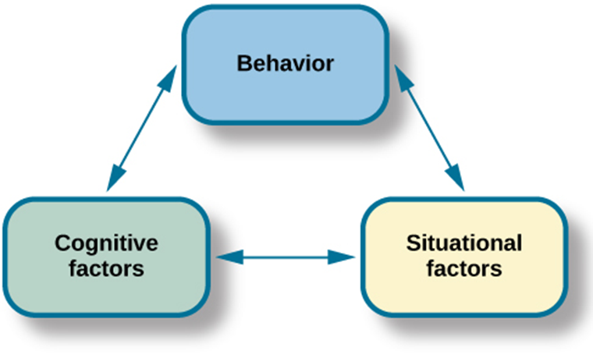
“ The theoretical basis of self-leadership is built on social cognitive theory (SCT), (Bandura, 1986) and social learning theory (Bandura, 1977). SCT the cognitive formulation of social learning theory that has been best articulated by Bandura, explains human behavior in terms of a three-way, dynamic, reciprocal model in which personal factors, environmental influences, and behavior continually interact. In a social learning system, a behavior may be acquired through direct experience or by observing the behavior of others. As a result of this behavior, individual follow a given action or task by rewarding and punishing consequences depend on the task result (Bandura, 1961). Social leaning theory presented in figure 1 (Bandura, 1977, 1997) illuminates how individuals may stimulus their own cognition, motivation, and behavior (Yun, 2006). According to Manz (1986) :self-leadership as a comprehensive self-influence perspective that involves leading oneself toward the performance of logically inspiring and motivating tasks as well as managing oneself to do work that must be done but is not naturally desired.
Figure 1: Social Cognitive Theory. Adapted from: Bandura, A. Social Foundations of Thought & Action: A Social Cognitive Theory, 1st Edition, 1986
Self-leadership influence Individuals to achieve the self-motivation and self-direction needed to behave in required ways (Manz, 1992b). There are three distinctive type of self-leadership impact consequences: behavioral-focused strategies, constructive thought pattern strategies, and natural reward strategies (Manz, 1986, 1992). Behavior-focused strategies focus on specific behaviors on self-assessment, self-reward, self-goal setting, self-learn and self-discipline. For example, performing a self-evaluation may enhance or modify certain behaviors depend on the analysis, applying rewarding events or activities, identifying short and long-term goals improving self by performing self-learning through different ways such as reading books and writing reflective journal, and practicing preferred actions behaviors or act (Manz, 1992b). Constructive thought pattern strategies emphasis on establishing thought patterns in appropriate ways, these patterns shape the thoughts therefore shape the action of individual. Those thinking patters may change by applying four different strategies: positive and constructive self-talk to assist performance, self-analysis and self-evaluation then improvement of belief and assumption systems, mental imagery of optimistic action and performance, and positive and” encouraging scripts or notes used in place of ineffective ones. This include rewarding notes placed on location that individual have constant access to. “Finally, Natural reward strategies relate to the positive insights and experiences associated with tasks to be accomplished. These include a commitment to, belief in, and enjoyment of work for its own sake (Manz, 1992a, 1992b). Manz (1986) states that the practice citrine strategy patters it result to individual counterparts to organizational rules, policies, and system. Therefore, each of those strategies contorts thought in a certain way to achieve objectives. “Further discussion and explanation on self-leadership theory and its strategies is presented in chapter 2: Literature Review.

1.4 Self-leadership Model
Structural equation modeling is used to conduct a simultaneous test of the entire system of variables in the hypothesized model to determine the extent to which it is consistent with the data (Byrne, 1994). The degree to which models are correctly specified and data are multivariate normal. Figure 1 represents the self-leadership model. The right-hand side of the figure is a representation of self-leadership. This is linked to a representation of each self-leadership construct. An arrow representing the tested relationships points from self-leadership to the list of self-leadership constructs. These are presented in order as follows: Visualize Successful Performance, Self-goal Setting, Self-talk, Self-reward, Evaluating Beliefs and Assumptions, Self-learn, Self-observation, Natural Reward Strategy, and Self-cueing.”
Figure 2: Conceptual Model to be tested.
0.23
0.11
0.14
0.34
0.73

Evaluating Beliefs and assumptions
Self-Learn
Self-Observation
Natural Reward Strategy
Self-Cueing

0.37
0.14
0.77
1.04
Self-Talk
Self- Reward
Self-Goal Setting
Visualize successful Performance

Self-Leadership
1.00

1.5 Metatheories Related to Self-leadership
“ Self-leadership is rooted in several related theories of self-influence, including self-regulation (Kanfer, 1989; Carver and Scheier, 1981), self-control (Cautela, 1969; Mahoney and Arnkoff, 1978, 1979; Thoresen and Mahoney, 1974), and self-management (Markham and Markham, 1998; Manz and Sims, 1980). Other related theories are self-determination, social cognitive theory, optimism, and self-esteems. Those theories are briefly explained below.”

1.5.1 Self-determination
“ This theory explains the degree of a person’s self-motivation. It is determined by the extent to which his or her behavior or actions are autonomous or controlled (Deci and Ryan, 1985). The external forces that pressure an individual to engage in particular behaviors produce controlled actions, whereas freely initiated behaviors that emanate from within a person produce autonomous actions (Edmunds et al., 2006; Reeve, 2002).”

1.5.2 Social cognitive theory
“”Social learning theory (SLT) has been renamed to Social Cognitive Theory (SCT)to accommodate later developments of theory focusing on motivational factors and the mechanisms of self-regulatory in relation to a person behavior. Social cognitive theory conceptualizes the interactional causal structure as triadic reciprocal causation, in which human functioning is a product of a reciprocal interplay of intrapersonal, behavioral, and environmental determinants (Bandura, 1977).” “Social cognitive theory provides insight into self-efficacy and explains where self-efficacy comes from and how it develops. In this theory, human behavior is motivated and regulated by the ongoing exercise of self-influence (Msaddux, 2002). The theory postulates that Individuals are active shapers of their environment, not merely passive reactors (Bandura, 1986, Barone, Maddux, and Snyder, 1997). The main self-regulative mechanism operates through three principal subfunctions, including the self-monitoring of behavior and of its determinants and effects and the judgment of behavior in relation to personal standards and the environment (Bandura, 1986).

1.5.3 Optimism
“ Optimism involves the perceived ability to move toward goals with valued outcomes and to avoid those that are undesirable (Carver and Scheier, 1999). The optimistic person has goals and strives to achieve them. Anticipated and actual goal-pursuit outcomes, especially those that are negative, are attributed to external rather than internal forces (Synder, 2002).”

1.5.4 Self-esteem
“According to Synder (2002), goal-directed thinking is implicit in perceptions of self-esteem, in that self-esteem arises from successful quests for valued goals. However, the main difference between self-leadership theory and self-esteem models is that self-esteem is based upon a personal appraisal of how well one is performing in relation to specific activities (Synder, 2002).”

1.5.5 Self-efficacy
Self-efficacy beliefs develop over time and through experience (Maddux, 2002). Self-efficacy refers to beliefs about individual personal capability to produce a desired effect through individual action (Bandura, 1997).“ In general, self-efficacy refers to an accumulation of life successes that have emerged as a result of previous experience (Bandura, 1977). “In social cognitive theory human behavior is extensively motivated and regulated by the ongoing exercise of self-influence. The major self-regulative mechanism operates through three principal subfunctions. These include self-monitoring of individual behavior, its determinants, and its effects; judgment of individual behavior in relation to personal standards and environmental circumstances; and affective self-reaction. Self-regulation also encompasses the self-efficacy mechanism, which plays a central role in the exercise of personal agency by its strong impact on thought, affect, motivation, and action. The equivalent self-regulative system is involved in moral conduct although compared to the achievement domain, in the moral domain the evaluative standards are additional stable, the judgmental factors additional varied and complex, and the affective self-reactions additional intense. In the interactionist perspective of social cognitive theory, social factors affect the operation of the self-regulative system.

1.5.6 Self-management
“The literature clearly attests that self-leadership overlaps significantly with self-management because of their common theoretical background (Manz, 1992). The terms self-leadership and self-management are often used interchangeably. Lee (2004) used the concept of self-management while using Neck and Manz’s Self-Leadership Theory (SLT), claiming that self-leadership strategies fall within the self-management tradition (Lee, 2004). Self-leadership addresses high-powered, right-brain activity and lays the revalidation for effective self-influence and continuous improvement.“

1.6 Statement of the Problem
The Middle East, specifically the Gulf countries, is developing economically at a rapid rate and competing with top economies around the world. Appropriate leadership “is a key tool for the success of many organization” or company (Allio, 2012). The cultural and religious differences between Arab and Western leaders result in differences between their leadership styles (Yaseen, 2014). Many factors can influence the leadership styles of an Arab leader, such as community, tribe, location, and religion (Agnala, 1998). It has been argued that little is known about Arab leaders and entrepreneurs (Namaki, 2008). In addition, in relation to work, women are gradually entering the workforce in Middle east. In fact, they reached leadership positions in the public and private sectors (Salloum, 2003).
Arab employees strive to achieve objectives and feel a sense of achievement. However, they are also very sensitive to respect and self-esteem. Such mixed feelings could create a stressful workplace. Leaders must strike a balance between employees’ sense of belonging and of the importance of achieving goals (Dedoussis, 2004).
However, the empirical research suggests that organizations in Arab countries face many organizational and managerial problems resulting from bureaucratic design and the power of culture. Most organizations in Arab countries focuses on developing their people and encouraging their leadership styles (Sabri, 2008). According to Sadeq and Khoury (2006), “when unpredictable change occurs rapidly in an environment, it necessarily requires much more innovation, creativity, and individual initiative.”
The UAE population consists of over 100 nationalities. This include about 80% of the population is expatriate. In addition, Abu Dhabi’s local population totaled around 253.7 thousand and its expats totaled around 1,164.5 thousand in 2012 (Statistic Centre, 2013). There are few studies on leadership in the UAE and none on self-leadership. Most of the studies on leadership have examined the use of transformational and transactional leadership style in different areas and industries, such as construction, banking, and education. In the UAE, expatriate professionals are hired to fill skill or knowledge gaps, to address globalization requirements, and to oversee knowledge transfer (McNulty, 2009), frequently assuming positional leadership roles.
“Despite the possible use of self-leadership strategies in organizations, most of the self-leadership research has been conceptual, with only a few empirical studies examining its use in organizations in the Middle East.
Self-leadership draws on content theories of motivation and behavior as well as the cognitive evaluation and self-determination theory (Deci, 1972) to increase both the recognition and implementation of essentially rewarding goals as well as the insight of externally set goals as essentially rewarding (Neck and Houghton, 2006). Add to that, self-leadership strategies are meant to increase the effectiveness of the person self-regulation. Self-leadership has not been tested in the UAE, and the RSLQ (Revised Self-leadership Questionnaire) has not been used in the Middle East, where results similar to those in the UAE context may be expected. This study should provide a basic understanding of the use of self-leadership competencies in the UAE as well as of the demographic variables relating to self-leadership.”

1.7 Purpose of the Research
This research examines the nature of self-leadership in the UAE, the relationship and use of self-leadership constructs, and the use of several demographic variables in relation to the self-leadership constructs. Most research on the nature of self-leadership has been carried out in the Western context. Limited research have been done in a Middle East (Yaseen, 2014). Most of these empirical studies focus on Western culture (Yaseen, 2014). Public sector organizations across the world are facing many challenges while exercising the functions of government and providing public services. However, few empirical studies have focused on the public sector (Yaseen, 2014). It is essential that these organizations devote all their efforts to supporting employee self-leadership. Facing challenges in the public sector requires leadership strategies based on an understanding and analysis of the available approaches to leadership as well as leadership styles (Moore and Hartley, 2008).”
Peter Drucker stated that “as the trees get rotten from the top and die, organizations suffer from degradation and destruction when the managing director of that organization can’t manage it” (Hassan and Faezeh, 2011, p. 422). This illustrates the important part that managers play in the organization. Managers are fundamental to the organization not only in directing organizational objectives but also in implementing the strategies needed to position the organization advantageously in the marketplace. Self-leadership is the basis of leadership competences, which provide managers with better ways of managing organizational objectives and driving their employees according to the organizational strategies (Manz, 1992; Manz and Neck, 1999).
The UAE is developing with a strong concentration on the human resource aspect of organizations. This is emphasized by royal leaders of the UAE such as HH Sheikh Mohammed Bin Rashid Al Maktoum:
“I don’t want you to aspire for anything less than the first place because there is number one and no one knows who came second. You may be the last or settle for the middle, but the first has always been the most desirable for everybody. If one is convinced that he cannot be the “first,” he may as well have sentenced himself to failure” (HH Sheikh Mohammed Bin Rashid Al Maktoum, 2013).

The royal family, together with the top management in many organizations, has always acknowledged the importance of human potential in the workplace.

1.8 Research Question
“The focus of this research is self-leadership in the UAE. Many elements may be studied to determine how self-leadership is used in the public and private sectors. The literature review supports the use of self-leadership in different cultures and settings. Based on the literature review, several hypotheses were established on the use of self-leadership in the UAE.
Two main research questions are posed in this research:
- To what extent is self-leadership strategies a good fit for the UAE?
- What kind of relationship exists between employee demographic variables and self-leadership constructs in the UAE?

1.9 Outline of the Dissertation
“The remainder of this study is organized as follows. The next section examines the literature to gain a deeper understanding of self-leadership. The literature review highlights the strategies relevant to self-leadership: natural reward, behavior-focused, and constructive thought. Related theories, such as self-esteem, optimism, self-determination, and social cognitive theory, are then discussed. Leadership practice in the UAE is discussed, including an exploration of the leadership styles used in the UAE as well as the types of competencies applied in organizations. Then, the Research Methodology and Hypothesis chapter discusses quantitative and qualitative research methodologies and explains why the quantitative approach is more appropriate for this study. The usefulness of the RSLQ is then explained, and the types of research it has been used for and the history of its development are described; the hypotheses generated from it are also presented. Finally, the ethical dimensions of this study are addressed.”
Next, the Results and Discussion chapter first provides an overview of the treatment of missing values and outliers. Then, the reliability of the collected data is discussed. The research hypotheses—which deal with age, gender, nationality, education level, sector, and work experience with respect to self-leadership—are presented. Then, the Structural Equation Modeling (SEM) chapter tests the entire system of researched variables in the hypothesized model to determine to which extent it is consistent with the data applied. First, the measurement model is explained. After that, an assessment of the model, determining the impact of the self-leadership construct on self-leadership, is presented. This includes the proposed conceptual model, the pathway coefficient for the structured model, a representation and discussion of model estimation, and hypotheses testing. Finally, the outcome of the latent construct for self-leadership is assessed.
The findings of the study are then discussed by examining the hypotheses drawn from the literature review concerning the demographic variables of age, gender, nationality, education level, sector, and work experience with respect to self-leadership.
“The Conclusion and Recommendation chapter highlights the need for an awareness of self-leadership and its nature in the UAE. The chapter addresses the most important concerns related to major issues, reflects on the implications relevant to public sector organizations in the UAE, describes the study’s limitations, and offers recommendations for future studies.”

Chapter 2: Literature Review
This chapter provide a reviews of the literature on self-leadership and then discusses leadership practice in the UAE and the Arab world, including an exploration of the different leadership styles used in the UAE and the types of competencies applied in various organizations. After wards, the chapter highlights the strategies relevant to self-leadership: natural reward strategies, behavior-focused strategies, and constructive thought strategies. Finally, related theories are discussed.

2.1 Self-leadership: Theoretical Background and Definition
“ The theoretical basis of self-leadership is built on social cognitive theory (Bandura, 1986) and social learning theory (Bandura, 1977). In a social learning system, a behavior may be acquired through direct experience or by observing the behavior of others. As a result of this behavior, individual follow a given action or task by rewarding and punishing consequences depend on the task result (Bandura, 1961). Social leaning theory (Bandura, 1977, 1997) illuminates how individuals may stimulus their own cognition, motivation, and behavior (Yun, 2006). According to Manz (1986) :self-leadership as a comprehensive self-influence perspective that involves leading oneself toward the performance of logically inspiring and motivating tasks as well as managing oneself to do work that must be done but is not naturally desired. Therefore, self-leadership is related not only to rewarding tasks but also to less desired tasks. Self-leadership perceptions may add value to organizations. The human capital within the organization may benefit from the practice of an empowerment advantage. This includes both managers and Employees or workers (Carrigan, 2011).
Self-leadership influence Individuals to achieve the self-motivation and self-direction needed to behave in required ways (Manz, 1992b). There are three distinctive type of self-leadership impact consequences: behavioral-focused strategies, constructive thought pattern strategies, and natural reward strategies (Manz, 1986, 1992). Behavior-focused strategies focus on specific behaviors on self-assessment, self-reward, self-goal setting, self-learn and self-discipline. For example, performing a self-evaluation may enhance or modify certain behaviors depend on the analysis, applying rewarding events or activities, identifying short and long-term goals improving self by performing self-learning through different ways such as reading books and writing reflective journal, and practicing preferred actions behaviors or act (Manz, 1992b). Constructive thought pattern strategies emphasis on establishing thought patterns in appropriate ways, these patterns shape the thoughts therefore shape the action of individual. Those thinking patters may change by applying four different strategies: positive and constructive self-talk to assist performance, self-analysis and self-evaluation then improvement of belief and assumption systems, mental imagery of optimistic action and performance, and positive and” encouraging scripts or notes used in place of ineffective ones. This include rewarding notes placed on location that individual have constant access to. “Finally, Natural reward strategies relate to the positive insights and experiences associated with tasks to be accomplished. These include a commitment to, belief in, and enjoyment of work for its own sake (Manz, 1992a, 1992b). Manz (1986) states that the practice citrine strategy patters it result to individual counterparts to organizational rules, policies, and system. Therefore, each of those strategies contorts thought in a certain way to achieve objectives. “

2.1.1 Behavior-focused self-leadership strategies
“ Behavior-focused self-leadership strategies are concentrate on enhancing the management of important behaviors, some of those behaviors maybe un pleasant and unwanted behaviors. It focuses on improving self-consciousness of such behaviors (Manz and Neck, 1999; Manz, 1992). These strategies focus on encouraging appropriate and optimistic behaviors that result to successful result and consequences, while defeating negative, pessimistic behaviors that result to unsuccessful consequences (Neck and Houghton, 2006). Behavior-focused strategies include using self-goal setting, self-observation, self-cueing, and self-rewarding (Manz and Neck, 2004). Behavior-focused strategies focus on improving individual’s self-awareness in order to facilitate behavioral management, specifically those behavior linked to unpleasant but necessary important tasks. Self-awareness is a critical requirement for changing or reducing ineffective and inefficient behaviors. (Manz and Neck, 1999; Manz and Neck, 2004). Behavior-focused strategies also focus on enhancing individual’s achieving their objectives and goals. Self-goal setting allows the focused radiance and action required to attain behavior change. Once these goals are achieved, self-rewards may be applied by the individual as a rewarding mechanism. Self-rewards could be any desirable needs (Manz and Neck, 2004).“
Based on the theory of self-control (Bandura 1977, 1982) Manz improved a theory focusing on behavioral strategies that goes beyond this theory . This theory of self-leadership is an expanded “self-leadership” that aim to allow the Employees or workers to possess an high internal self-control system (Manz, 1979, 1992), encourage employee to engage in self-evaluation practice, and suggest the practice of self-rewards procedure (Bandura, 1977; “Thoresen and Mahoney, 1974; Manz and Sims, 1980). Self-observation enables an individual to recognize specific behaviors that need to be changed, enhanced, or terminated (Manz and Sims, 1980; Manz and Neck, 1999; Mahoney and Arnkoff, 1978). Self-observation enables the examination of individual own behaviors for the purpose of identifying behaviors that need to be improved, enhanced, or eliminated (Mahoney and Arnkoff, 1978, 1979; Manz and Sims, 1980). According to Manz (1992), self-observation defined as the way to which Employees or workers keep track of the progress of their work or are aware of their work performance. Self-observation involves focusing and raising individual awareness of when and why one is engaging in specific behaviors. This type of self-awareness is a necessary first step toward changing or eliminating ineffective and unproductive behaviors (Manz and Sims, 1980; Manz and Neck, 2004).
Self-goal setting encourages the person to develop and adopt specific goals and related reward contingencies in order to follow necessary performance-related behaviors (Mahoney and Arnkoff, 1978, 1979; Manz and Sims, 1980). Individuals need to link the goal setting to the rewards gained by attaining the goal. Self-goal setting reflects the extent to which Employees or workers provide self-direction using personal goals. Setting challenging goals guides and motivates an individual to accomplish tasks (Locke and Lathman, 1990). In fact, a large body of research suggests that the procedure of setting challenging and specific goals may significantly increase individual performance levels (Locke and Latham, 1990).”
Environmental cues such as to-do lists, Post-it notes, screensavers, motivational posters, and inspirational wall hangings are just a few examples of external cues that may help keep attention and effort focused on goals (Houghton and Neck, 2006; Neck and Manz, 2010). “When armed with accurate information regarding current behavior and performance levels, individuals may additional effectively set behavior-altering goals for themselves (Manz, 1986; Manz and Neck, 2004; Manz and Sims, 1980). Self-set rewards, coupled with self-set goals, may aid significantly in generating the effort necessary to achieve those goals (Mahoney and Arnkoff, 1978, 1979; Manz and Sims, 1980; Manz and Neck, 2004). Self-rewards may be as simple as mentally praising oneself for a job well done or something much additional tangible, such as mentally congratulating oneself for an important accomplishment, or treating oneself to a new outfit or a night at the movies, or something additional concrete like a special vacation after the completion of a difficult project (Mahoney and Arnkoff, 1978). Self-correcting feedback involves a constructive self-examination of failures and unproductive behaviors in order to reshape these behaviors in additional positive directions. Self-reward represents the extent to which Employees or workers influence themselves using rewards at both the physical and mental levels. Compared to self-criticism, self-reward, whether real or abstract, as well as positive self-corrective feedback, have positive effects on employee motivation (Manz and Sims, 2001). “
“Self-learn, or self-correcting feedback, is a behavior-focused strategy. Since self-learn may also be used to effectively shape desired behaviors, particularly when used sparingly for only seriously pessimistic behaviors, self-learn has replaced self-punishment in the instrument focused on using learning behavior to avoid pessimistic behavior (Manz, 1992). This involves the rehearsal or practice of desired behaviors before actual performance may allow for the correction of problems and the avoidance of costly miscues (Manz, 1992b; Manz and Neck, 1999; Manz and Sims, 1980; Thorensen and Mahoney, 1974).
Self-cueing is a behavior-focused strategy. Concrete environmental cues may serve as an effective means of encouraging constructive behaviors and reducing or eliminating destructive ones. Cueing strategies represent the extent to which employees or workers practice physical cues to remind themselves of important tasks (Manz and Neck, 2004; Manz and Sims, 1980, 2001). “
“Finally, behavior-focused self-leadership strategies are designed to encourage positive, desirable behaviors that lead to successful outcomes while suppressing negative, undesirable behaviors that lead to unsuccessful outcomes. These strategies allow Employees or workers to develop themselves through the procedure of practicing an activity before performing it. Manz (1992) has drawn on the literature of self-control, self-regulation, and self-management (Manz, 1983, 1986; Manz and Sims, 1980, 1989) and has improved scales that assess the above six behavioral-focused strategies of self-leadership. Fostering those desired behaviors prior to their actual execution enables an employee to avoid mistakes and correct them as they occur (Manz, 1992; Manz and Neck, 1999; Manz and Sims, 1980). “

2.1.2 Natural reward strategies
“ Natural reward strategies focus on the optimistic experience associated with a task and the procedure through which it is attained. The work itself is valuable, rewarding, inspiring and motivating (Furnham, 1990)” because the Employees or workers find aspects in the assigned work that are valuable, rewarding, and motivating. “These strategies are intended to enhance the fundamental motivation related to performance (Manz and Neck, 2004). Individuals apply two primary natural reward strategies because they are motivated by the enjoyable aspects of the task: first, building additional enjoyable features into a given movement so that the task itself becomes naturally rewarding; and, second, changing individual own views by focusing on the task’s rewarding aspects rather than its unaccepted aspects (Neck and Houghton, 2006; Manz and Neck, 2004). Thus, natural reward strategies include seeking work activities that are pleasant and enjoyable. Individuals may facilitate natural reward strategies by modifying perceptions or behaviors associated with task performance, thereby increasing perceived competence, self-control, or task responsibility. Individuals should view work practices as enjoyable, rewarding, and pleasurable,“ because such an approach expands a sense of capability, competency, and self-control, which eventually increases performance (Manz, 1986, 1992; Manz and Neck, 1999).

2.1.3 Constructive thought strategies
Constructive thought strategies are reward-focused. “They facilitate the formation of constructive thought patterns and typical thinking habits that may positively impact performance (Neck and Houghton, 2006). This strategy involves thought patterns that are constructive. Thought patterns are integrative and repetitive. Individuals may adopt thought patterns that are either constructive or destructive, which then affect their emotional and behavioral states and reactions (Manz, 1992; Neck and Manz, 1992). For example, individuals may alter their thought patterns to focus on opportunities in times of difficulty rather than thinking about the difficulties as obstacles. These individuals practice optimistic thought patterns to create opportunities that may allow them to cope with difficulties that could impede them from attaining their desired ends.” The nature of a thought pattern affects behaviors and outcomes (Neck and Manz, 1992). “Individuals tend to adopt either optimistic or pessimistic thoughts. When a problem occurs, the optimist views it as a challenge and strives to solve it, while the pessimist believes that this problem will endure and be disruptive or create conflict. Non-constructive thoughts are viewed as dysfunctional (Seligman, 1991). Burns (1980) argued that an individual should cope with such dysfunctional thoughts, which are derived from predispositions shaped by stressful and problematic events (Burns, 1980; Ellis, 1977). Thus, individuals should transform their dysfunctional thoughts into functional ones through a self-assessment procedure that would enable the substitution of non-rational beliefs with additional rational ones (Neck and Manz, 1992).
Self-talk, defined as what we say to ourselves (Ellis, 1962), may facilitate self-influence and direct self-efficacy (Prussia et al., 1998). Employees or workers may alter their pessimistic self-talk into an additional positive type of self-talk, which may produce, for example, additional generally positive thoughts and behaviors, even during times of change and difficulty (Neck and Manz, 1992).”
“ Used in the creation of positive thinking, constructive thought strategies attempt to reduce dysfunctional beliefs, assumptions, and pessimistic self-talk while also increasing positive self-image (Alves et al., 2006).

2.2 Self-leadership and Employee Demographic Variables
Dissimilarities among demographic variables affect the self-leadership perceptions of Employees or workers. Exploring methods of increasing individual effectiveness requires an analysis of the person’s age and demographic characteristics (Carrigan, 2011).

2.2.1 Employee organization sector
“ The public sector has a hierarchical chain of command and authority. It comprises high-performance organizations that expect maximum productivity from all levels, both managers and Employees or workers. Most Employees or workers are unaware of their self-leadership perceptions, and there is a knowledge and awareness gap among managers regarding the availability of the self-leadership training and development and practice they require (Barhem et al., 2011). Public sector managers and Employees or workers frequently practice self-leadership strategies, and their self-leadership perception level is high (Tabak et al., 2011). Demographic variables such as gender, work experience, status, education level, and age appear to affect public sector managers’ and Employees or workers’ self-leadership perceptions. The research suggests that public sector managers practice self-leadership strategies additional frequently than do their Employees or workers (Tabak et al., 2011).”
“Individuals who possess good self-leadership qualities know how to achieve high levels of self-direction and self-motivation (Houghton et al., 2003; Manz, 1986; Manz and Neck, 1999). Self-leadership theory suggests that its strategies lead to improved self-regulation, which should result in an array of positive consequences, such as positive affect (Neck and Manz, 1996), job satisfaction (Roberts and Foti, 1998), organizational commitment, “independence (Manz and Sims, 2001), empowerment (Manz, 1992), self-efficacy (Manz, 1986; Manz and Neck, 2004; Neck and Manz, 1992, 1996), instrumentality (Konradt et al., 2009), and creativity and innovation (Manz and Sims, 2001). Therefore, self-leadership should produce good outcomes for an employee.
“ Employees or workers in the Gulf region obtain additional benefits in the public sector than in the private sector. In Oman’s private sector, for example, the low female participation (18%) is concentrated in clerical and administrative jobs. An estimated 51% of female Employees or workers in the private sector earn less than 120 Rials (US$300), while 47% earn between 120 and 400 Rials (roughly between US$300 and 1,100), with an average earning capacity of 167 Rials (US$500; Female and Work Committee, 2002).”

2.2.2 Employee age
Leaders’ age or age group may affect how they practice self-leadership concepts in work and life. Analyzing self-leadership perceptions in terms of the age variable reveals dissimilarities among three separate age groups in terms of self-leadership strategy usage (Tabak et al., 2011). One study suggest that age is negatively related to self-leadership: younger Individuals may engage in self-leadership additional than older Individuals because they are in the procedure of creating their lives and are therefore additional goal-oriented (Kazan and Earnest, 2000). By contrast, older Individuals have already achieved many of their important career and personal goals (D’Intino et al., 2007). Aged and top management make their decisions based on any situation for the success of the organization and are therefore are additional expert in self-goal setting (Howell and Avolio, 1993).

2.2.3 Employee educational level
As educational level increases, so does self-leadership strategy usage (Carmeli et al., 2006). Significant dissimilarities in the usage of the natural rewards strategy have been revealed between High school graduates and master’s degree holders (Tabak et al., 2011).

2.2.4 Employee work experience
Carmeli et al. (2006) suggest that work experience has no effect on self-leadership perceptions. However, Alves et al. (2007) revealed that long-term-oriented Individuals with long work experience may have improved self-observation strategies relative to short-term-oriented individuals. Therefore, self-observation strategies have been revealed to be significant when factored in along with work experience (Tabak et al., 2011).
The practice of self-observation may be useful; in clinical practice, Individuals often solve problems based on past experience. Individuals learn lessons through experience and repractice them later (Falkenström, 2007).

2.2.5 Employee nationality
Self-leadership may be used by anyone, but it differs depending on the person’s nationality. Cultures may differ greatly in terms of behavior and thinking procedurees (Tabak et al., 2011). A study that included participants from different cultures, such as the US, China, Portugal, and South Africa, revealed that different participants had different perceptions of self-leadership (Friends, 2012).

2.2.6 Employee gender
“ Employee gender is another demographic variable that may have some bearing on self-leadership. Male and female are different not only in their biological makeup but also in their personal and professional qualities at work (Burns, 1978). Gender dissimilarities affect leadership perspectives. For instant, female leaders are additional likely to be sector manager or depa rtment heads while men leaders are additional likely to be in higher positions such as chief executive officer, director, or vice president (Lantz, 2008). Contrary to expectations, female tend to score higher on a leadership scale measuring orientation towards production and the attainment of results, while men tend to score higher on scales assessing an orientation towards strategic planning and organizational vision (Claes, 1999; Kabacoff, 1998). According to Kirchmeyer (1998), masculinity has a stronger positive effect on female’s perceptions of success than on men’s.”
“ In general, the research has revealed no relationship between gender and self-leadership (Kazan and Earnest, 2000; Kurman, 2001). On the other hand, gender may have an indirect effect on the practice of self-leadership (D’Intino et al., 2007). For instance, female are additional likely to engage in rumination or obstacle-type thinking in response to pessimistic emotions than are their male counterparts (Nolen et al., 2004). A study has suggested a relationship between gender and self-regulation. For example, Singaporean female seemed to prefer tasks that were too easy, while Israeli men choose tasks that were too difficult (Kurman, 2001). Kabacoff (1998) revealed that female tended to be additional highly rated on empathy and communication than were men. Female were also rated additional highly on Individuals skills such as sensitivity to others, likeableness, and ability to listen.” Female also “tended to be rated higher on Individuals‐oriented leadership skills, while men were rated higher on business‐oriented leadership skills. Overall, bosses see men and female as equally effective, while workmates and direct assessments rate female slightly higher than they do men (Claes, 1999; Kabacoff, 1998).”
“Norris (2008) revealed dissimilarities in general self-leadership scores between females and males; the average general self-leadership score for females was 3.96 (SD = .43) while that for males was 3.46 (SD = .59). An independent samples t-test with unequal variances showed that the general self-leadership scores for males and females differed significantly (t[80.98] = 4.99, p < .01). The study revealed that female were additional likely than men to practice general self-leadership strategies. It also revealed that female were additional likely than men to practice behavior-focused ( t[85.48] = 5.04, p < .01), natural reward (t[80.97] = 4.35, p < .01), and constructive thought self-leadership strategies (t[84.45] = 3.13, p < .01; Norris, 2008). This analysis revealed dissimilarities in the general self-leadership, behavior-focused, natural reward, and constructive thought self-leadership scores of men and female and showed that these dissimilarities were significant.”

2.3 Metatheories Related to Self-leadership
“ Self-leadership is rooted in several related theories of self-influence, including self-regulation (Kanfer, 1989; Carver and Scheier, 1981), self-control (Cautela, 1969; Mahoney and Arnkoff, 1978, 1979; Thoresen and Mahoney, 1974), and self-management (Markham and Markham, 1998; Manz and Sims, 1980). Other related theories are self-determination, social cognitive theory, optimism, and self-esteems. Those theories are briefly explained below.”

2.3.1 Self-determination
“ This theory explains the degree of a person’s self-motivation. It is determined by the extent to which his or her behavior or actions are autonomous or controlled (Deci and Ryan, 1985). The external forces that pressure an individual to engage in particular behaviors produce controlled actions, whereas freely initiated behaviors that emanate from within a person produce autonomous actions (Edmunds et al., 2006; Reeve, 2002).”

2.3.2 Social cognitive theory
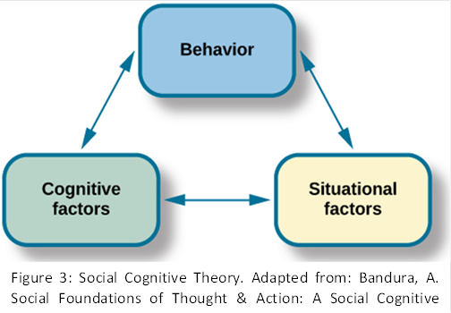
“”Social learning theory (SLT) has been renamed to Social Cognitive Theory (SCT)to accommodate later developments of theory focusing on motivational factors and the mechanisms of self-regulatory in relation to a person behavior. Social cognitive theory conceptualizes the interactional causal structure as triadic reciprocal causation, in which human functioning is a product of a reciprocal interplay of intrapersonal, behavioral, and environmental determinants (Bandura, 1977).” “Social cognitive theory provides insight into self-efficacy and explains where self-efficacy comes from and how it develops. In this theory, human behavior is motivated and regulated by the ongoing exercise of self-influence (Msaddux, 2002). SCT the cognitive formulation of social learning theory that has been best articulated by Bandura, explains human behavior in terms of a three-way, dynamic, reciprocal model in which personal factors, environmental influences, and behavior continually interact. The theory postulates that Individuals are active shapers of their environment, not merely passive reactors (Bandura, 1986, Barone, Maddux, and Snyder, 1997). The main self-regulative mechanism operates through three principal subfunctions, including the self-monitoring of behavior and of its determinants and effects and the judgment of behavior in relation to personal standards and the environment (Bandura, 1986).In social cognitive theory human behavior is extensively motivated and regulated by the ongoing exercise of self-influence. The major self-regulative mechanism operates through three principal subfunctions.” These include self-monitoring of individual behavior, its determinants, and its effects; judgment of individual behavior in relation to personal standards and environmental circumstances; and affective self-reaction. ” “Self-regulation also encompasses the self-efficacy mechanism, which plays a central role in the exercise of personal agency by its strong impact on thought, affect, motivation, and action. The equivalent self-regulative system is involved in moral conduct although compared to the achievement domain, in the moral domain the evaluative standards are additional stable, the judgmental factors additional varied and complex, and the affective self-reactions additional intense. In the interactionist perspective of social cognitive theory, social factors affect the operation of the self-regulative system.”

2.3.3 Optimism
“ Optimism involves the perceived ability to move toward goals with valued outcomes and to avoid those that are undesirable (Carver and Scheier, 1999). The optimistic person has goals and strives to achieve them. Anticipated and actual goal-pursuit outcomes, especially those that are negative, are attributed to external rather than internal forces (Synder, 2002).”

2.3.4 Self-esteem
“According to Synder (2002), goal-directed thinking is implicit in perceptions of self-esteem, in that self-esteem arises from successful quests for valued goals. However, the main difference between self-leadership theory and self-esteem models is that self-esteem is based upon a personal appraisal of how well one is performing in relation to specific activities (Synder, 2002).”

2.3.5 Self-efficacy
While discussing what is excluded and what is included to the term ‘self-efficacy’, Bandura asserts that self-efficacy is more than the possession of the required underlying skills for completing a particular task (1986). Therefore, self-efficacy is proposed as a generative entity that makes it possible to use skills, yielding a desired outcome, within various contexts. In this regard the concept is markedly different from outcome expectancies and can be delineated as an individual’s self-belief in attaining a certain level of performance. Bandura views self-efficacy as a functional mechanism rather than just a self-reflection on one’s own capabilities.
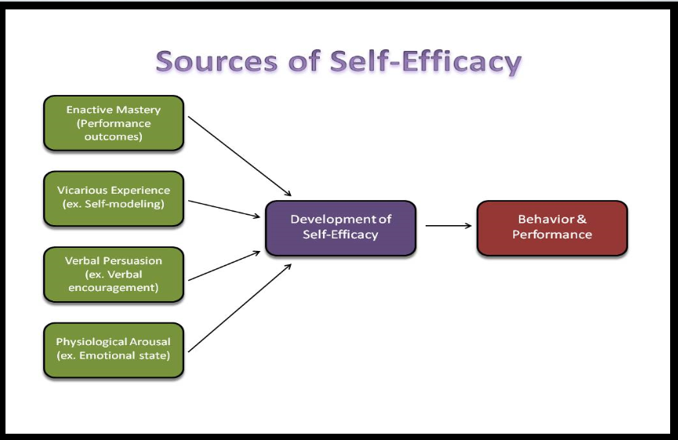
Figure 5: Source of Self-Efficacy
“ Self-efficacy is the extent to which individuals believe themselves capable of successfully performing a certain behavior (Bandura, 1986). Self-efficacy thinking becomes activated when a person is faced with a significant situation such as a specific goal relating to an outcome that is valued by the individual. To pursue an outcome, the person must believe they may attain it (Bandura, 1977).
Self-efficacy beliefs develop over time and through experience (Maddux, 2002). Self-efficacy refers to beliefs about individual personal capability to produce a desired effect through individual action (Bandura, 1997).“ In general, self-efficacy refers to an accumulation of life successes that have emerged as a result of previous experience (Bandura, 1977). “In social cognitive theory human behavior is extensively motivated and regulated by the ongoing exercise of self-influence. The major self-regulative mechanism operates through three principal subfunctions. These include self-monitoring of individual behavior, its determinants, and its effects; judgment of individual behavior in relation to personal standards and environmental circumstances; and affective self-reaction. Self-regulation also encompasses the self-efficacy mechanism, which plays a central role in the exercise of personal agency by its strong impact on thought, affect, motivation, and action. The equivalent self-regulative system is involved in moral conduct although compared to the achievement domain, in the moral domain the evaluative standards are additional stable, the judgmental factors additional varied and complex, and the affective self-reactions additional intense. In the interactionist perspective of social cognitive theory, social factors affect the operation of the self-regulative system. In social cognitive theory human behavior is” “extensively motivated and regulated by the ongoing exercise of self-influence. The major self-regulative mechanism operates through three principal sub functions. These include self-monitoring of individual behavior, its determinants, and its effects; judgment of individual behavior in relation to personal standards and environmental circumstances; and affective self-reaction. Self-regulation also encompasses the self-efficacy mechanism, which plays a central role in the exercise of personal agency by its strong impact on thought, affect, motivation, and action. The equivalent self-regulative system is involved in moral conduct although compared to the achievement domain, in the moral domain the evaluative standards are additional stable, the judgmental factors additional varied and complex, and the affective self-reactions additional intense. In the interactionist perspective of social cognitive theory, social factors affect the operation of the self-regulative system. Components of self-efficacy also develop on the basis of experience. For example, research has shown that the sense of success based on experience in certain areas helped strengthen self-efficacy in those areas (Bandura, 1977). These principles have proved relevant and applicable to leadership development. For example, in hindsight, managers viewed practical experience as a cardinal learning experience in their development as leaders (Akin, 1987; Kotter, 1988; McCall et al., 1988).“ These beliefs influence what challenges to undertake, how much determination to expend in the endeavor, and how long to endure difficulties (Bandura, 1989, p. 29). Therefore, the higher a person’s self-efficacy, the additional confident he or she is about the success of a particular task domain.

2.3.6 Self-management
“The literature clearly attests that self-leadership overlaps significantly with self-management because of their common theoretical background (Manz, 1992). The terms self-leadership and self-management are often used interchangeably. Lee (2004) used the concept of self-management while using Neck and Manz’s Self-Leadership Theory (SLT), claiming that self-leadership strategies fall within the self-management tradition (Lee, 2004). Self-leadership addresses high-powered, right-brain activity and lays the revalidation for effective self-influence and continuous improvement.“

2.4 United Arab Emirates and Self-leadership:
The UAE, established in 1970, is a federation of seven emirates that has developed a commercial and industrial center of the Middle East (Al-Ansari, 2014; Rettab, Brik, and Mellahi, 2009). The country is measured as the second-largest economy in the Arab world. The annual GDP growth rate of the UAE from 2000 to 2012 was at 4.7% (Schiliro, 2013); there is an excellent opportunity for businesses and investments to prosper and the economy to grow (Al-Banawi, 2012). An estimated 88% of the UAE’s population (UAEInteract, 2011) and more than 90% of its workforce is expatriate (UAEInteract, 2009).
Table 1: Global Competitiveness Rank out of 140
Source: Global Competitiveness Report 2013–2014
As shown in table 1, the UAE ranks seventeenth in the

The trend of the last five years has been promising. The nation’s outstanding macroeconomic environment, extremely developed infrastructure (ranked fourth), and solid institutions (ranked ninth) provide a strong base, and the Emirati economy is significantly more spread than are those of other Golf countries (Schwab, 2015, p. 44).
The UAE has a mix of different nationalities. Tables 2 and 3 show the country’s population by nationality in 2008 and 2010 respectively. According to the National Bureaus of Statistics, The UAE is a highly multicultural country with businesses comprised of employees from different nationalities. In 2015, 20% of the country was Emirati, 30% was Indian, 15% was Pakistani, and 15% was Iranian. Leadership skills development is a major part of the government’s business development strategy.
Table 2: Population by nationality (National-Non National) and sex (2008 mid-year estimates)
Nationality | Male | Female | Total
National | 457,248 | 447,609 | 904,857
Non-National | 5,582,723 | 1,586,046 | 7,163,769
Total | 6,039,971 | 2,033,655 | 8,073,626
Source: National Bureaus of statistics.

Table 3: Population by nationality (National-Non National) and sex (2010 midyear estimates)
Nationality | Male | Female | Total
National | 479,109 | 468,888 | 947,997
Non-National | 5,682,711 | 1,633,362 | 7,316,073
Total | 6,161,820 | 2,102,250 | 8,264,070
Source: National Bureaus of statistics.

UAE leaders have argued that Western-style democracy is not a necessity in the UAE. This is because Locals are able to express their problems directly to the leadership through traditional channel. One of these channels are the open councils held by many UAE leaders. Voting for a government or other representative body would certainly exaggerate long-dormant splits among tribes and could cause Islamist factions become a problem (Kenneth Katzman, 2013). The UAE leadership has been a great inspiration for UAE citizens since the UAE was founded by Sheik Zayed ben Sultan. On November 2, 2004, national leader Sheikh Zayed passed away after a long life of giving, achievement, and developing people and land. The nation has kept his vision under the leadership of UAE president His Highness Sheikh Khalifa bin Zayed Al Nahyan, the members of the Supreme Council of Rulers, and their crown princess (Katzman, 2013). HH Sheikh Khalifa has supervised histrionic changes in the government of Abu Dhabi, where specific attention has been paid to two aspects: efficiency and cost improvements in public services and the opening of much of the economy to enable greater scope for direct private investment and public–private partnerships (Katzman, 2013).
After His Highness Sheikh Mohammed bin Rashid Al Maktoum became the Ruler of Dubai, he exemplifies active and successful leadership. He is a man who keep promises; he has encourages government excellence; he shaped the role of leadership and has fulfilled it. Dubai is developing many outstanding projects that are gaining it international attention (Augsburg, Claus, and Randeree, 2009). Since Sheikh Mohammed became the Vice President and Prime Minister of the UAE and Ruler of Dubai, revolutionary initiatives have been revolved out at a surprising rate (Katzman, 2013). This has inspired all parts of Dubai society including organizations and businesses (Perry, 2011).
The UAE government seeks to improve the routine of the public sector by making substantial variations in its processes and principles. These changes will need creating innovative organizations, which will in turn require TL to be effective. To achieve this, organizations in the UAE—especially those in Dubai—have adapted to challenges through OI.
Amid this background, Dubai is seeking to implement a culture of innovation in all organizations. This underscores the importance of innovation and the access to OI in both the private and public sectors. Despite the growing reliance on innovation, no studies have yet examined the impact of leadership type (transformational versus transactional) within a Middle Eastern cultural setting. This research will provide a deeper understanding of this subject and investigate how leadership style affects OI.

2.4.1 Leadership research in the UAE
The UAE was ranked the thirty-first greatest-globalized market and the furthermost globalized Arab country in 2008–2009. It also the highest world’s third-largest economic expansion (World Economic Forum, 2008).
McLaurin (2008) examined leadership in Dubai by studying the teamwork competences of the leadership of Dubai Municipality as demonstrated by the teamwork. The participants were mid-and upper-level managers participating in the creation of strategic plan for the organization. The results of this study offer a unique look at leadership in Dubai by examining the realities of Dubai Municipality. According to the respondents, the teams in the municipality is strong in approving the active participation and not depending on rather than demanding modes of team management. This is shown through the teams’ high level of familiarity, leadership by example, strong communication, and consensual decision making. Such teamwork is important to benefiting from team members’ experience and diversity of thinking. (McLaurin, 2008).
“Butler (2008) studied how employees in a diverse organization preserve leadership of supervisors in the UAE. A large-scale questionnaire was designed and circulated to over 300 employees of the UAE’s university. The study found that the value of communication and relations between supervisors and dependents focused on work experience of workers, that leadership should be top-down and emphasize charisma to gain employees’ admiration and improve their satisfaction, and that obligation to the organization was related to the quality of supervisor–subordinate relationships.”
According to Prussia (1998) A key foundation of empowering organizations is employee self-leadership. This study examines the effects of self-leadership skills and self-efficacy perceptions on performance. Structural equations modeling determined whether the influence of self-leadership on performance is mediated by self-efficacy perceptions. Results for the sample of 151 respondents indicated self-leadership strategies had a significant effect on self-efficacy evaluations, and self-efficacy directly affected performance. Further, self-efficacy perceptions were found to fully mediate the self-leadership/performance relationship. Theoretical and practical implications are discussed. (Prussia., Anderson, and Manz,, 1998)

2.5 Leadership Research in the Arab World
Arab sociality is a unique setting, and many aspects affect its traditions and culture. Individuals in the Arab world have been affected by many elements, considering its location between East and West. Halim Barakat stated in his book The Arab World: Society, Culture, and State that
“Arab society is not a mere mosaic of sects, ethnic groups, tribes, local communities and regional entities. Rather, it carries within it the potential to assume that one or the other is necessarily dominant over time. This focus recognizes conditions that constantly pull contemporary Arab society between all sorts of polarities and conflicting orientations: unity versus fragmentation, tradition versus modernity, sacred versus secular, East versus West, local versus national.”

“Yaseen (2010) examined Arab women’s leadership styles (i.e., transformational, transactional, or laissez faire), The finding support that Arab men surpassed Arab women on two qualities: passive management by exception and active management by exception, whereas Arab women surpassed Arab men on contingent rewards. In contrary, Arab women surpassed Arab men on four transformational qualities: the attributes version of intellectual stimulation, individualized consideration, idealized influence, and inspirational motivation. Finally, Arab men was characterized with the laissez faire style (Yaseen, 2010).
Differing to social perceptions and stereotypes, In Oman, women in leading positions in different organization, public or private, are highly motivated. This is related to their upbringing and their childhood socialization experiences, which focused on education, highly supportive parents, and equality with their brothers. The main challenge to Omani women are their roles as female leaders. Practically relative to the dominating traditions, social values and society expectations towards women traditional role (Al-Lamky, 2007).”

Chapter 3: Research Methodology

3.1 Introduction
This chapter presents the research methodology, including the hypotheses and research questions, as well as the instrument used to gather data—the RSLQ, employed to determine how the following variables affect self-leadership: the sector of the organization the employee is working in, the age of the employee, the education level of the employee, the employee’s years of experience, the nationality of the employee, and the gender of the employee.
This chapter reviews quantitative and qualitative research methods and justifies this study’s use of quantitative research. The RSLQ is then described and its theoretical background and development are discussed. Next, the research questions and hypotheses are presented; they pertain to leadership in the UAE—specifically, how organization sector, age, education level, work experience, and gender affect the self-leadership of employees in middle management positions. The research methodology, data collection, instrument, and analysis are then elaborated, followed by a description of the respondents’ profiles.
The data collection for this study was done in several steps over the three months between March 2015 and May 2015. The data collection strategy involved contacting the HR manager in each of the targeted UAE organizations and seeking their permission to solicit employees’ participation. A random selection of middle management employees was decided and contacted via email to request their permission to participate in the survey. Questionnaires were sent as a link via email. As part of the survey administration, the researcher advised employees that their participation in the survey was totally voluntary and would remain anonymous. Upon completion of the survey, the questionnaires were handed in to the researcher, who collated the surveys and secured them for data analysis.

3.2 Research Methods
Research findings highly rely on upon the analysis, conducted based on the experience and knowledge gained during the data collection procedure. Any research design and plan process begins with the researcher’s philosophical assumptions (Creswell, 2007). The literature shows that there are few studies on self-leadership and none conducted in the UAE. No studies or theories have been tried that could help in answering the research questions.
Research can be either quantitative or qualitative. Quantitative research, on the other hand, searches for “facts” through a series of “what? questions, instead of the “why? questions associated with qualitative research (Glaser and Strauss, 2006). Qualitative research is used when a more deep understanding of the research subject attitudes, behavior, or motivations is desired (Mack, 2010).
There is no quantitative data about self-leadership assessments in the UAE and consequently no data on the issues affecting self-leadership in middle management employees in the public and private sectors in the UAE.
In this study, the variables are demographic variables: organization sector, age, education level, work experience, and gender of employees in middle management positions.

3.2.1 Qualitative vs. quantitative research methods
“Researcher have assumptions and beliefs that might control their action. These beliefs called called paradigms or worldviews, consisting of epistemology and ontology (Creswell, 2007; Mack, 2010). Epistemological assumptions drive researchers to be as close as possible to the research participants (Creswell, 2007). As epistemology has philosophy concerned with the nature, and validity of knowledge (Burrell and Morgan, 1979). Two philosophies are based on epistemological assumptions: positivism and antipositivism (Dogan, 2013). Positivism argues that parts of a whole should be linked by regular and causal connections. Positivist researchers obtain accurate knowledge through systematic observations, experiments, inferential statistics, hypothesis testing, and mathematical analysis (Dogan, 2013). The goal of positivism is to prove or disprove hypotheses (Mack, 2010). On the other hand, antipositivism originated as a reaction to positivism proposes that realities can be accessed only through involvement in them and through the opinions and experiences of participants and open-ended interviews, not through theories and structures (Dogan, 2013).
The axiological assumption is concerned about values. Valuable research is considered when the researcher is active. Such reasercher will be envoloved in all the stages of the research such as collecting the data, analyzing the finding, and evaluating research finding; research is value-free when the researcher’s bias is controlled and researcher influence is eliminated from the research findings (Gillham, 2000). According to Creswell (2007), researchers pursuing qualitative inquiries admit their value-laden nature.”
The methodological assumption is very important. There are two main methodological assumption. The ideographic approach nomothetic methodology. The ideographic approach is most common in the humanities and social sciences. Ideographic methods need to be analyzed in their own setting and are mostly used in qualitative studies. Case study is the known method. On the other hand, the nomothetic methodology use scientific and systematic processes to research and investigate reality, such process is hypothesis testing, which is used mainly in quantitative research, like this study (Dogan, 2013). This study proposes 16 hypotheses based on the research questions.

3.2.2 Rationale for using the quantitative approach
The differences between quantitative and qualitative research paradigms are significant. Quantitative research uses the positivist paradigm, which assumes the objective nature of reality. Positivists believe that reality can be explained through observation and predict research outcomes by controlling the research variables. “Quantitative research utilizes scientific methods such as experiments that do not directly influence the research outcomes (Mack, 2010). Qualitative research follows a somewhat different approach, on the assumption that reality cannot be understood because it is constantly shaped though social interactions (Creswell, 2007). Qualitative research follows an interpretivist paradigm; it believes in multiple truths and seeks to explain the construction of knowledge itself. In qualitative research, the researchers cannot detach themselves from the research phenomenon, as they bring their subjective experiences to it and base their conclusions on open questions (Mack, 2010).” Consequently, the qualitative approach is not suitable for this study.
One of the most important aspects of any research is the instrument used to collect the data. This study used the RSLQ, which is explained below.

3.3 Theoretical Background and Development of the RSLQ
“ As discussed, self-leadership skills are a construct that has generated considerable research attention over the past years (Manz, 1992; Manz and Neck, 1999; Manz and Sims, 2001). Self-leadership is an influence-related process through which individuals (and working groups) navigate, motivate, and lead themselves towards achieving desired behaviors and outcomes (Manz, 1992). Its roots can be traced back to theories of self-influence, which emphasize concepts of self-navigation (Carver and Scheier, 1981; Kanfer, 1970), self-control (Mahoney and Arnkoff, 1978), and self-management (Andrasik and Heimberg, 1982; Luthans and Davis, 1979; Manz and Sims, 1980). As a broader construct, self-leadership encompasses a set of three complementary cognitive and behavioral strategies, which impact subsequent outcomes:”
(1) behavior-focused strategies;
(2) natural reward strategies; and
(3) constructive thought pattern strategies.

“ The RSLQ was developed by building on the previous versions of self-leadership questionnaires (e.g., Anderson and Prussia, 1997; Cox, 1993) described above. Anderson and Prussia’s (1997) 50-item SLQ served as the primary basis for the RSLQ. To create the RSLQ, 17 ambiguous items were deleted from the Anderson and Prussia (1997), scale and two items were added from the Cox (1993) instrument. Specifically, items with primary loadings on an incorrect factor (i.e., loading on a dimension the item was not intended to represent), items with low primary factor loadings on the correct factor, and/or items with high cross-factor loadings (i.e., high”secondary loadings on an incorrect factor) were dropped from the scale. For example, the item “I try to build activities into my work that I like doing” was intended to assess the “focusing on natural rewards” dimension (Anderson and Prussia, 1997). In addition, five items from the Anderson and Prussia (1997) scale were reworded to better reflect self-leadership theory. For instance, the phrase “I often physically rehearse” was changed to “I often mentally rehearse” to better reflect the “visualizing successful performance” dimension. Similarly, the wording of the three items representing the “self-talk” dimension was changed from “talk out loud to myself” to “talk to myself (out loud or in my head)” to better reflect self-leadership’s conceptualization of internalized self-talk. Finally, two items from the Cox (1993) scale were added to represent the “focusing thoughts on natural rewards” dimension in an effort to increase the reliability of this subscale. As mentioned, this subscale showed the poorest reliability estimates (¬ = .69 and .62) of any of the dimensions in the Anderson and Prussia (1997) scale. The next section explains each of the self-leadership strategies.

3.3.1 Behavior-focused strategies
“Behavior-focused self-leadership strategies focus on encouraging optimistic, appropriate behaviors that lead to successful consequences and defeating negative, pessimistic behaviors that lead to unsuccessful consequences (Neck and Houghton, 2006). Behavior-focused strategies include using self-goal setting, self-observation, self-cueing and self-reward (Manz and Neck, 2004). Self-awareness is a critical requirement for changing or reducing ineffective and inefficient behaviors. Self-goal setting allows the focused action that is required to achieve behavior change. If these goals are achieved, self-rewards may be applied by the individual (Manz and Neck, 2004). Manz (1992) has drawn on the literature of “self-control, self-regulation, and self-management (Manz, 1983, 1986; Manz and Sims, 1980, 1989) to develop scales that assess six behavioral-focused strategies of self-leadership. The scale has 18 items for five factors:” self-goal, self-talk, self-reward, self-learning, and individualized consideration. A five-point Likert scale ranging from““not at all accurate” (1) to “completely accurate” (5) was used. Self-goal items include “I consciously have goals in mind for my work efforts,” “I establish specific goals for my own performance,” and “I work toward specific goals I have set for myself.” Self-talk questions include “Sometimes I find I’m talking to myself (out loud or in my head) to help me deal with difficult problems I face,” “Sometimes I talk to myself (out loud or in my head) to work through difficult situations,” and “When I’m in difficult situations, I will sometimes talk to myself (out loud or in my head) to help me get through it.” Self-reward questions include “When I do an assignment especially well, I like to treat myself to something or an activity I especially enjoy,” “When I do something well, I reward myself with a special event such as a good dinner, movie, shopping trip, etc.,” and “When I have successfully completed a task, I often reward myself with something I like.” Self-learning questions include “During task performance, when I find I lack any necessary skills, I try to find a way to obtain them so I can succeed,” “Before beginning a task, I prepare myself by looking for information that I believe I may need,” and “Before I start performing a task, I try to improve my knowledge so I can perform better.”

3.3.2 Natural reward strategies
“Natural reward strategies are intended to enhance the intrinsic motivation related to performance (Manz and Neck, 2004). Individuals apply two primary natural reward strategies because they are motivated by the enjoyable aspects of the task: building more enjoyable features into a given movement so that the task itself becomes naturally rewarding, and changing one’s own views by focusing on the task’s rewarding aspects rather than its unpleasant aspects (Neck and Houghton, 2006; Manz and Neck, 2004).“The scale for natural reward strategies has five items, including “I find my own favorite ways to get things done,” “I seek out activities in my work that I enjoy doing,” and “When I have a choice, I try to do my work in ways that I enjoy rather than just trying to get it over with.” All items used a five-point Likert scale ranging from “not at all accurate” (1) to “completely accurate” (5).

3.3.3 Constructive thought strategies
“Constructive thought strategies are reward-focused. They facilitate the formation of constructive thought patterns and typical ways of thinking that may positively impact performance (Neck and Houghton, 2006). Used for the creation of positive thinking, constructive thought strategies attempt to reduce dysfunctional beliefs, assumptions, and negative self-talk, while also increasing positive self-image (Alves et al., 2006). Individuals apply constructive thought strategies when they engage in visualizing activities (Neck, Stewart and Manz, 1995).”
The scale for natural reward strategies comprises 12 items, including “Employees tend to trust managers/leaders,” “I visualize myself successfully performing a task before I do it,” and “Sometimes I picture in my mind a successful performance before I actually do a task.” All items use a five-point Likert scale ranging from “not at all accurate” (1) to “completely accurate” (5).

3.4 Description and Applications of RSLQ
“ Self-leadership is measured using the revised self-leadership questionnaire (RSLQ). The RSLQ (shown in the Appendix B) consists of 35 items in nine distinct sub-scales representing the three primary self-leadership dimensions.
Table 4 provides a summary of the relationships between the nine RSLQ subscales and the three self-leadership dimensions. The behavior-focused dimension is represented by five sub-scales labeled:
(1) self-goal setting (five items);
(2) self-reward (three items);
(3) self-learn (four items);
(4) self-observation (four items); and
(5) self-cueing (two items).
A single sub-scale consisting of five items represents the natural rewards dimension. The constructive thought dimension is represented by three subscales labeled:
(1) visualizing successful performance (five items). (2) self-talk (three items). (3) evaluating beliefs and assumptions (four items).
Table 4: RSLQ sub scale.
Dimensions | Sub-scales | Scale items
Behavior-focused strategies | Self-goal setting  Self- reward  Self-learn  Self-observation  Self-cueing | 2, 11, 20, 28, 34  4, 13, 22  6,15, 24, 30  7, 16, 25, 31  9, 18
Natural reward strategies | Focusing thoughts on natural rewards | 8, 17, 26, 32, 35
Constructive thought pattern strategies | Visualizing successful performance  Self-talk evaluating beliefs and assumptions. | 1, 10, 19, 27, 33  3, 12, 21  5, 14, 23, 29

3.5 Demographic Variables”
The questionnaire also asks questions related to demographic variables. Seven questions are used to collect data for these variables. The first question asks about the respondent’s organizational sector; one of two answers is possible—the public sector or the private sector. The second question asks the participant’s age. There are four options: 18–29 years, 30–44, 45–54, or 55 years or older.
The third question asks about the participants’ nationality. Participants specify whether they are UAE citizens or not. The options are “local” or “non-local.”
The fourth question asks about the participants’ work experience. There are four options: less than a year, 1–3 years, 3–7 years, or more than seven years. The fifth question asks about the participants’ educational level. There are four options: high school, higher diploma, bachelor’s degree, master’s degree, or doctorate. The sixth question asks the participants’ gender. There are two options: male or female. In total, six questions are related to the demographic variables.

3.6 Research Questions and Hypotheses
Research questions were developed to specify the study’s interests and build hypotheses.

3.6.1 Q1. What kind of relationship exists between employee sector (Public/Private) and self-leadership constructs in the UAE?

All UAE employees work in either the public or private sector. The public sector consists of entities and organizations that operate under government supervision, such as municipalities, courts, and government councils. Abu Dhabi Municipality, the Department of Transport, and the Abu Dhabi Education Council are examples of public sector organizations that participated in this study. On the other hand, private companies or entities in the UAE are profit-driven, such as banks, restaurants, malls and other private businesses. HSBC Bank, ADCO, and Etihad Airline are examples of private sector organizations that participated in this study.
“ Public sector managers and Employees or workers frequently practice self-leadership strategies, and their self-leadership perception level is high (Tabak et al., 2011). Demographic variables such as gender, work experience, status, education level, and age appear to affect public sector managers’ and Employees or workers’ self-leadership perceptions. The research suggests that public sector managers practice self-leadership strategies additional frequently than do their Employees or workers (Tabak et al., 2011).”
This study explores how the distinction between public and private sector work is related to self-leadership in the UAE. The following hypothesis is proposed:
Hypothesis 1: Employee perceptions of self-leadership strategies differ significantly according to whether the employee works is in the UAE’s private or public sector.
This experiment examines whether any of the nine self-leadership constructs differ between leaders from the public and private sectors. The sub-hypotheses related to hypothesis 1 are presented in table 5.
Table 5: Sub-hypotheses related to hypothesis 1
Research hypotheses
H1a: There is a predictive association between employee perceptions of Visualize Successful Performance of self-leadership and employee sector.
H1b: There is a predictive association between employee perceptions of Self-goal Setting of self-leadership and employee sector.
H1c: There is a predictive association between employee perceptions of Self-talk of self-leadership and employee sector.
H1d: There is a predictive association between employee perceptions of Self-reward of self-leadership and employee sector.
H1e: There is a predictive association between employee perceptions of Evaluating Beliefs and Assumptions of self-leadership and employee sector.
H1f: There is a predictive association between employee perceptions of Self-learn of self-leadership and employee sector.
H1g: There is a predictive association between employee perceptions of Self-observation of self-leadership and employee sector.
H1h: There is a predictive association between employee perceptions of Natural Reward Strategy of self-leadership and employee sector.
H1i: There is a predictive association between employee perceptions of Self-cueing of self-leadership and employee sector.

3.6.2 Q2. What kind of relationship exists between employee age and self-leadership constructs in the UAE?
“Analyzing self-leadership perceptions in terms of the age variable reveals a difference among three separate age groups in terms of self-leadership strategy usage (Tabak et al., 2011). Age is an important aspect in determining the effectiveness of leadership: young leaders are less experienced and hence are more likely to have weak self-leadership (Politis, 2006). On the other hand, older leaders, who have more experience in leadership and management, generally have stronger self-leadership. This study explores the relationship between employee age and self-leadership in the UAE. The following hypothesis is proposed:”
Hypothesis 2: There is a predictive association between employee perceptions of self-leadership and employee age.
As mentioned, the research question examines whether a leader’s age has a significant influence on their self-leadership. The sub-hypotheses related to hypothesis 2 are presented in table 6.
Table 6: Sub Research hypothesis related to hypothesis 2
Research hypotheses
H2a: There is a predictive association between employee perceptions of Visualize Successful Performance of self-leadership and employee age.
H2b: There is a predictive association between employee perceptions of Self-goal Setting of self-leadership and employee age.
H2c: There is a predictive association between employee perceptions of Self-talk of self-leadership and employee age.
H2d: There is a predictive association between employee perceptions of Self-reward of self-leadership and employee age.
H2e: There is a predictive association between employee perceptions of Evaluating Beliefs and Assumptions of self-leadership and employee age.
H2f: There is a predictive association between employee perceptions of Self-learn of self-leadership and employee age.
H2g: There is a predictive association between employee perceptions of Self-observation of self-leadership and employee age.
H2h: There is a predictive association between employee perceptions of Natural Reward Strategy of self-leadership and employee age.
H2i: There is a predictive association between employee perceptions of Self-cueing of self-leadership and employee age.

3.6.3 Q3. What kind of relationship exists between an employee’s educational level and self-leadership constructs in the UAE?
According to Carmeli et al. (2006), as educational level increases, self-leadership strategy usage also increases. This study explores the relationship between an employee’s educational level (i.e., diploma, master’s, doctorate) and self-leadership in the UAE. The following hypothesis is proposed:
Hypothesis 3: Employee perceptions of self-leadership strategies differ significantly according to the employee’s educational level.
This experiment examines whether the education level of a leader has a significant association with any of the nine self-leadership constructs. The sub-hypotheses related to hypothesis 3 are presented in table 7.

Table 7: Sub Research hypothesis related to hypothesis 3
Research hypotheses
H3a: There is a predictive association between employee perceptions of Visualize Successful Performance of self-leadership and employee educational level.
H3b: There is a predictive association between employee perceptions of Self-goal Setting of self-leadership and employee educational level.
H3c: There is a predictive association between employee perceptions of Self-talk of self-leadership and employee educational level.
H3d: There is a predictive association between employee perceptions of Self-reward of self-leadership and employee educational level.
H3e: There is a predictive association between employee perceptions of Evaluating Beliefs and Assumptions of self-leadership and employee educational level.
H3f: There is a predictive association between employee perceptions of Self-learn of self-leadership and employee educational level.
H3g: There is a predictive association between employee perceptions of Self-observation of self-leadership and employee educational level.
H3h: There is a predictive association between employee perceptions of Natural Reward Strategy of self-leadership and employee educational level.
H3i: There is a predictive association between employee perceptions of Self-cueing of self-leadership and employee educational level.

3.6.4 Q4. What kind of relationship exists between employee work experience and self-leadership constructs in the UAE?
According to Alves et al. (2007), long-term-oriented people with long work experience may have better self-observation strategies than short-term-oriented individuals. Therefore, self-observation strategies are significant when factored in along with work experience (Tabak et al., 2011).
This study explores the relationship between employee work experience and self-leadership in the UAE. This includes all types of work experience, in both the public and private sectors. The following hypothesis is proposed:
Hypothesis 4: Employee perceptions of self-leadership strategies differ significantly according to the employee’s work experience.
As mentioned, this experiment examines whether the experience of a leader has a significant association with any of the nine self-leadership constructs. The sub-hypotheses related to hypothesis 4 are presented in table 8.
Table 8: Sub Research hypothesis related to hypothesis 4
Research hypotheses
H4a: There is a predictive association between employee perceptions of Visualize Successful Performance of self-leadership and employee work experience.
H4b: There is a predictive association between employee perceptions of Self-goal Setting of self-leadership and employee work experience.
H4c: There is a predictive association between employee perceptions of Self-talk of self-leadership and employee work experience.
H4d: There is a predictive association between employee perceptions of Self-reward of self-leadership and employee work experience..
H4e: There is a predictive association between employee perceptions of Evaluating Beliefs and Assumptions of self-leadership and employee work experience..
H4f: There is a predictive association between employee perceptions of Self-learn of self-leadership and employee work experience..
H4g: There is a predictive association between employee perceptions of Self-observation of self-leadership and employee work experience..
H4h: There is a predictive association between employee perceptions of Natural Reward Strategy of self-leadership and employee work experience..
H4i: There is a predictive association between employee perceptions of Self-cueing of self-leadership and employee work experience..

3.6.5 Q5. What kind of relationship exists between employee nationality and self-leadership constructs in the UAE?
According to the literature review, people from different cultures can be very different from one another in terms of behavior and thinking processes (Tabak et al., 2011). A study that used participants from different cultures (such as the US, China, Portugal, and South Africa) revealed that they had different perceptions of self-leadership (Friends, 2012).
This study explores the relationship between employee nationality and self-leadership in the UAE. Nationality is considered according to whether the participant is local or non-local. The following hypothesis is proposed:
Hypothesis 5: Employee perceptions of self-leadership strategies differ significantly according to employee nationality.
As mentioned, this experiment examines the relationship between the nationality of a leader and any of the nine self-leadership constructs. The sub-hypotheses related to hypothesis 5 are presented in table 9.

Table 9: Sub Research hypothesis related to hypothesis 5
Research hypotheses
H5a: There is a predictive association between employee perceptions of Visualize Successful Performance of self-leadership and employee nationality.
H5b: There is a predictive association between employee perceptions of Self-goal Setting of self-leadership and employee nationality.
H5c: There is a predictive association between employee perceptions of Self-talk of self-leadership and employee nationality.
H5d: There is a predictive association between employee perceptions of Self-reward of self-leadership and employee nationality.
H5e: There is a predictive association between employee perceptions of Evaluating Beliefs and Assumptions of self-leadership and employee nationality.
H5f: There is a predictive association between employee perceptions of Self-learn of self-leadership and employee nationality.
H5g: There is a predictive association between employee perceptions of Self-observation of self-leadership and employee nationality.
H5h: There is a predictive association between employee perceptions of Natural Reward Strategy of self-leadership and employee nationality.
H5i: There is a predictive association between employee perceptions of Self-cueing of self-leadership and employee nationality.

3.6.6 Q6. What kind of relationship exists between employee gender and self-leadership constructs in the UAE?
“Gender can have an indirect effect on the practice of self-leadership (D’Intino et al., 2007). For instance, women are more likely to engage in rumination or obstacle-type thinking in response to negative emotions than are their male counterparts (Nolen et al., 2004).
This study explores the relationship between employee gender and self-leadership in the UAE. The study participants included both male and female managers working in the UAE’s private and public sectors. The following hypothesis is proposed:”
Hypothesis 6: Employee perceptions of self-leadership strategies differ significantly between female and male employees.
As mentioned, this experiment examines the relationship between the nationality of a leader and any of the nine self-leadership constructs. The sub-hypotheses related to hypothesis 6 are presented in table 10.
Table 10: Sub Research hypothesis related to hypothesis 6
Research hypotheses
H6a: There is a predictive association between employee perceptions of Visualize Successful Performance of self-leadership and employee gender.
H6b: There is a predictive association between employee perceptions of Self-goal Setting of self-leadership and employee gender.
H6c: There is a predictive association between employee perceptions of Self-talk of self-leadership and employee gender.
H6d: There is a predictive association between employee perceptions of Self-reward of self-leadership and employee gender.
H6e: There is a predictive association between employee perceptions of Evaluating Beliefs and Assumptions of self-leadership and employee gender.
H6f: There is a predictive association between employee perceptions of Self-learn of self-leadership and employee gender.
H6g: There is a predictive association between employee perceptions of Self-observation of self-leadership and employee gender.
H6h: There is a predictive association between employee perceptions of Natural Reward Strategy of self-leadership and employee gender.
H6i: There is a predictive association between employee perceptions of Self-cueing of self-leadership and employee gender.

Self-leadership model and hypothesis
The research question for this section is To what extent are the self-leadership constructs (i.e., Visualize Successful Performance, Self-goal Setting, Self-talk, Self-Reward, Evaluating Beliefs and Assumptions, Self-learn, Self-observation, Natural Reward Strategy, and Self-Cueing) a good fit to the data collected from the UAE? This question is then transferred to a model to be tested.
There are eight research questions related the consideration of leadership constructs and wither it has good fit to the data collected from the UAE. The following section provides the specific research question along to the hypothesis.

3.6.7 Q7. To what extent is Visualize Successful Performance is a good fit to the data collected from UAE?
The below hypothesis is formulated in relation to this question.
Hypothesis 7: The fit between Visualize Successful Performance (Perform) and the Self-leadership latent construct is the tightest.
This experiment tests if the tightest fit is that between Visualize Successful Performance and the Self-leadership latent construct and determines whether there is a direct path coefficient between them.

3.6.8 Q8. To what extent is Self-goal Performance is a good fit to the data collected from UAE?
The below hypothesis is formulated in relation to this question.
Hypothesis 8: The fit between Self-goal Setting and the Self-leadership latent construct is the tightest.
This experiment tests if the tightest fit is that between Self-goal Setting and the Self-leadership latent construct. It also determines whether there is a direct path coefficient between them.

3.6.9 Q9. To what extent is Self-talk is a good fit to the data collected from UAE?
The below hypothesis is formulated in relation to this question.
Hypothesis 9: The fit between Self-talk and the Self-leadership latent construct is the tightest.
The purpose of this experiment is to assume that a tighter fit is present between self-talk and Self-leadership latent construct. As well as find out from the outcome of this study whether there is a direct path coefficient between self-talk and Self-leadership latent construct.

3.6.10 Q10. To what extent is Self-rewards Performance is a good fit to the data collected from UAE?
The below hypothesis is formulated in relation to this question.
Hypothesis 10: The fit between Self-reward and the Self-leadership latent construct is the tightest.
The purpose of this experiment is to assume that a tighter fit is present between self-reward and Self-leadership latent construct. As well as find out from the outcome of this study whether there is a direct path coefficient between self-reward and Self-leadership latent construct.

3.6.11 Q11. To what extent is Evaluating believes and assumptions is a good fit to the data collected from UAE?
The below hypothesis is formulated in relation to this question.
Hypothesis 11: The fit between Evaluating believes and assumptions and the Self-leadership latent construct is the tightest.
The purpose of this experiment is to assume that a tighter fit is present between Evaluating Believes and Assumptionsand Self-leadership latent construct. As well as find out from the outcome of this study whether there is a direct path coefficient between Evaluating Believes and Assumptionsand Self-leadership latent construct.

3.6.12 Q12. To what extent is Self-learn is a good fit to the data collected from UAE?
The below hypothesis is formulated in relation to this question.
Hypothesis 12: The fit between Self-learn and the Self-leadership latent construct is the tightest.
The purpose of this experiment is to assume that a tighter fit is present between self-learn and Self-leadership latent construct. As well as find out from the outcome of this study whether there is a direct path coefficient between self-learn and Self-leadership latent construct.

3.6.13 Q13. To what extent is Self-observation and assumptions is a good fit to the data collected from UAE?
The below hypothesis is formulated in relation to this question.
Hypothesis 13: The fit between Self-observation and the Self-leadership latent construct is the tightest.
The purpose of this experiment is to assume that a tighter fit is present between Self-observation and Self-leadership latent construct. As well as find out from the outcome of this study whether there is a direct path coefficient between Self-observation and Self-leadership latent construct.

3.6.14 Q14. To what extent is Natural Rewards and assumptions is a good fit to the data collected from UAE?
The below hypothesis is formulated in relation to this question.
Hypothesis 14: The fit between Natural Rewards and the Self-leadership latent construct is the tightest..
The purpose of this experiment is to assume that a tighter fit is present between natural rewards and Self-leadership latent construct. As well as find out from the outcome of this study whether there is a direct path coefficient between natural rewards and Self-leadership latent construct.

3.6.15 Q15. To what extent is Self-cueing is a good fit to the data collected from UAE?
The below hypothesis is formulated in relation to this question.
Hypothesis 15: The fit between Self-cueing and the Self-leadership latent construct is the tightest.
The purpose of this experiment is to assume that a tighter fit is present between Self-cueing (cueing) and Self-leadership latent construct. As well as find out from the outcome of this study whether there is a direct path coefficient between Self-cueing (cueing) and Self-leadership latent construct.

3.7 Data Collection Instrument and Analysis
Data were collected between March and May 2015 from middle managers working in the UAE. Twenty private and public sector organizations took part in this study. The organizations were selected based on three main criteria. First, 50% had to be public, and 50% had to be private. Second, each organization had to have more than 200 employees. Third, the organization had to have been operating for more than 10 years. The public sector consists of entities and organizations that work under government supervision, such as municipalities, courts, and government councils. As shown in table 11, Abu Dhabi Municipality, the Department of Transport, and the Abu Dhabi Education Council are examples of public sector organizations that participated in this study. Private companies and entities in the UAE are profit-driven, such as banks, restaurants, and malls. As shown in table 11, HSBC bank, ADCO, and Etihad Airline are some of the private sector organizations that participated in this study.

Table 11: The organization that participated in this study.
Entity name | Sector | Scope of location
Municipalities | Public | Abu Dhabi
Department of Transport | Public | AD
Abu Dhabi Education Council. | Public | AD
Municipalities | Public | UAE
Al Fotaim Group | Private | UAE
Mashreq Bank | Private | UAE
General Security of Executive Council. | Public | Abu Dhabi
Twam Hospital | Public | Abu Dhabi/AlAin
Police | Public | AbuDhabi
Abu Dhabi Water and Electricity | Public | Abu Dhabi
Seha/hospitals | Public | UAE
ADCO | Private | Abu Dhabi
Borooj | Private | Abu Dhabi
Abu Dhabi Capital Trading | Private | Abu Dhabi
Al Zahra Hospital | Private | Sharjah
Abu Dhabi Investment Authority | Private | Abu Dhabi
Khalifa Fund | Public | Abu Dhabi
Higher college of technology | Public | UAE
Etihad Airline | Private | UAE
HSBC | Private | UAE

The research questionnaire was approved by the Abu Dhabi Research Council. The questionnaire has two parts. The first measures self-leadership using the RSLQ. Another section covers respondents’ demographic data, including organization sector, employee age, level of education, gender, years of experience, and nationality. Participation to this study was voluntary. A cover letter was attached indicating the purpose of the questionnaire and assuring the confidentiality of the returnee. The informed consent was given to each volunteer participant before participating in the questionnaire. The study questions was restricted to a specific period to control the finding and results. Before starting the analysis, missing data were detached from the collected data. After that and the completed responses were analyzed. The survey data were analyzed using the multiple regression tool in the SPSS software. Statistical tests were conducted to present an examination, descriptive statics, and factor analyses. The researcher conducted a standard deviation test, mean evaluation, equal of variance analysis, and normality. In addition Cronbach’s alpha and Kuder–Richardson KS 20 were conducted for internal consistency as well as validity of scale. An analysis and test of the study hypothesis were performed. An examination of correction of coefficient (r) for the hypothesis, the relationship between X and Y was also checked. Also an explanation of the coefficient of determination (R square) amount of variance and ANOVA was explained and presented.

3.8 Ethical Considerations
As part of conducting a professional research study ethical considerations were taken into account. There are tour ethical rules followed as part of this study. The participants’ consent was obtained before they participated in the study (Kvale and Brinkmann, 2009). An electronic consent form was provided before the start of the electronic questionnaire to ensure that the participant agreed with the content of the consent form before beginning the questionnaire.
The next rule is confidentiality (Kvale and Brinkmann, 2009). Because participants may be hesitant to share data and information that they think is sensitive. In this study, assurance was given to participants that their identities would not be revealed.
Possible consequences of the research tasks were addressed (Kvale and Brinkmann, 2009). Participants were kept safe and comfortable during the testing. They were allowed to withdraw from the questionnaire at any time after starting it.

3.9 Conclusion
“Quantitative research is founded in the positivist paradigm that this study involves, while qualitative research is based on the phenomenological paradigm (Dogan, 2013). Of the 42 items in the questionnaire, 35 relate to the RSLQ, which measures self-leadership. The RSLQ consists of nine subscales representing the three primary self-leadership dimensions. These dimensions are related to the three main sub-strategies: (1) behavior-focused, (2) natural reward, and (3) constructive thought pattern (Manz, 1992; Manz and Neck, 1999; Manz and Sims, 2001). As discussed earlier, quantitative research is most appropriate for this study because it provide percentages and numbers, which are needed to reflect facts.
This chapter outlined the research questions and study interests. It also presented the hypotheses gleaned from the literature; these test the relationship between the self-leadership construct and the respondents’ demographic data concerning organization sector, age, gender, years of experience, education level, and nationality. Twenty private and public sector organizations took part in this study. This chapter also highlighted the study’s ethical considerations.”

Chapter 4: Discussion of Results

4.1 Introduction
This chapter discusses the results. First, it reviews the descriptive statistics of the construct. Then, it discusses the treatment of missing values and outliers and explains the normality distribution check results. The second section analyzes the respondents’ profiles and demographic data. The principal components analysis (PCA) method is then discussed, and a Bartlett’s test between the leadership construct and the demographic variables is conducted and the results presented. The research hypotheses involve the participants’ age, gender, work sector, nationality, education level, and work experience in relation to the self-leadership construct.
To obtain sufficient heterogeneity and ensure the stability of the relationships between the constructs, data were collected from middle managers working in public, semi-public, and private organizations.
A total of 20 UAE organizations were contacted for the data collection. Of the 330 questionnaires sent to the targeted organizations, 311 responses were received.

4.2 Data Preparation and Assumption Check
The questionnaire has two main parts. The first is the RSLQ, which measured the model’s variables with validated instruments using a five-point Likert scale ranging from “not at all accurate” (1) to “completely accurate” (5). Permission from the authors to use their questionnaire is attached in Appendix A, and the research questionnaire is attached in Appendix B.
A pilot study was conducted to test the validity and reliability of the variables during which 70 questionnaires were distributed to personnel in five public and private UAE organizations.
To test the relationship between these variables, the Statistical Package for the Social Sciences (SPSS) version 18.0 (SPSS Inc., Chicago, IL, USA) was used to analyze the data collected from the questionnaires through a statistical procedure that evaluated the model results. Descriptive statistical analysis, including frequencies and percentages, was used to assess the demographic characteristics of the sample, and intercorrelations and multiple regressions were used to test the validity of the hypotheses. The variance inflation factor (VIF, a collinearity statistic) between the self-leadership constructs and self-leadership shows low values (less than 10), indicating that the model design is strong. All model variables show significance at the .01 level, indicating that all variables have a strong relationship between them.
“Due to force completion, the data were free from missing values. To ensure that the relations were not attributable to one or a few outliers, a scatter plot and box plot were used to check for the presence of any outliers and for normality. table 2 shows the treatment of outliers. Outliers that deviated by more than three standard deviations were found and were replaced with a series mean.
Normal Q-Q Plots were used to check for normality. Preliminary analysis revealed that the data were normally distributed. All the constructs formed a normal distribution and were mostly negatively skewed, with cases falling in a more or less straight line.”

4.2.1 Descriptive statistics for the data
The collected data are distributed into two main sections. The first presents the results of the RSLQ, in which the participants selected one item out of the five Likert scale items for each RSLQ question. The second section presents data on the demographic variable questions that asked the participants about their age, work sector, nationality, education level, and work experience. table 12 presents the descriptive statistics for the constructs and demographic variables for this study.

Table 12 : Descriptive Statistics for Construct and demographic variables.
 | N | Mean | Std. Deviation
 | Statistic | Statistic | Statistic
Q35 age | 311 | 2.05 | .571
Q36 Gender | 311 | 1.44 | .497
Q37 Nationality | 311 | 1.25 | .434
Q38 education level | 311 | 3.53 | .810
Q39 organizational position | 311 | 2.68 | 1.066
Q40 years of experience | 311 | 3.56 | .763
Q42 sector | 311 | 1.18 | .382
Visualize successful Performance | 311 | 3.8248 | .84257
self-goal setting | 311 | 4.1878 | .65391
self-talk | 311 | 3.8060 | 1.04824
Self-reward | 311 | 3.7624 | 1.17008
Evaluating beliefs and assumption | 311 | 3.9188 | .67802
Self-learn | 311 | 4.3248 | .59261
Self-observation | 311 | 4.0740 | .64081
Focusing on natural rewards | 311 | 4.0926 | .59842
Self-cueing | 311 | 4.1141 | .94305
Valid N (listwise) | 311

4.2.2 Treatment of missing values
The questionnaire was an electronic questionnaire where a participant where forced to enter and select all the data. The answer of each question were mandatory, therefore participants had to answer the question before moving to the next question. Due to such force completion, data was free from missing value.
To ensure that the relations were not attributable to one or a few outliers, the scatterplots and Boxplot were used to examine presence of any outliers and to check for normality. table 13 shows treatment of outliers. Outliers that deviated by more than three standard deviations were found and were replaced with series mean.
Table 13: Treatment for outliers at Construct Level
Construct | Outlier (response No) | Treatment (Replaced with Mean value)
Visualize successful Performance | 124, 126, 128, 164 | 3.82
self-goal setting | 1, 8, 113, 147, 164 | 4.18
self-talk | 124, 126, 128, 248, 250, 256 | 3.80
Self-reward | 81, 96, 116, 264, 256, 300 | 3.76
Evaluating beliefs and assumptions | 3, 6, 8, 10, 105, 147, 164, 168, 229, | 3.91
Self-learn | 8, 75, 147, 164, 169, | 4.32
Self-observation | 8, 55, 75, 90, 169, 194, 268, 147 | 4.07
Focusing on natural rewards | 8, 111, 147, 164, 180, 238, 302, | 4.09
Self-cueing | 75, 147 | 4.11

4.2.3 Examination for Normality
Normal Q-Q Plots have used to check for normality. Preliminary analysis revealed that Data were normally distributed. All the constructs form a normal distribution with mostly negatively skewed and cases fall more or less in a straight line.

Data Analysis

4.3.1 Reliability Statistics
As shown in table 14, Cronbach's Alpha was used to test reliability of statistics. All scales have achieved more than 0.7 alpha values except Self-observation and Focusing on natural rewards. Score for Self-observation was 0.69 and score for Focusing on natural rewards 0.688 which were very close to preset acceptable value of 0.7. This little difference may be attributing to language difference as English version of the questionnaire was used while Arabic was dominating language for respondents.
Table 14: Reliability Statistics
Construct | Cronbach's Alpha | N of Items
Visualize successful Performance | 0.784 | 4
self-goal setting | 0.791 | 5
self-talk | 0.887 | 3
Self-reward | 0.912 | 3
Evaluating beliefs and assumptions | 0.726 | 4
Self-learn | 0.753 | 3
Self-observation | 0.690 | 4
Focusing on natural rewards | 0.688 | 5
Self-cueing | 0.774 | 2

4.3.2 Factor Analysis
As shown in table 15, An explorative factor analysis was employed in order to determine which of items formed related subsets. Principal Components Analysis (PCA) method was used to extract the underlying factors affecting the style of leadership. Result of factor analysis extracted two components. The main factor is Self-Leadership where all the constructs are aligned except self-reward. Self-reward has evolve as an independent factor.
Table 15: Explorative Factor Analysis
Component Matrixª
 | Component
 | 1 | 2
Visualize successful Performance | .697 | .084
self-goal setting | .740 | -.221
self-talk | .563 | .468
Self-reward | .504 | .653
Evaluating beliefs and assumptions | .644 | .319
Self-learn | .742 | -.353
Self-observation | .754 | -.368
Focusing on natural rewards | .726 | -.075
Self-cueing | .410 | -.241
Extraction Method: Principal Component Analysis.
a. 2 components extracted.

Total variance explained by two factors is 56%. KMO and Bartlett's Test were conducted (Table 16). Bartlett test of Sphericity achieved significant and Kaiser-Meyer_Olkin measure of sampling adequacy is .834 which is far greater than factor analysis rather explorative factor analysis.
Scree plot in figure 3p graphically displays the eigenvalues for the factors and suggests that there are two predominant factors.. These values in the first two columns of the table immediately above. From the third factor on, as shown the line is almost flat, meaning the each successive factor is accounting for smaller and smaller amounts of the total variance.

Table 16: KMO and Bartlett's Test
Kaiser-Meyer-Olkin Measure of Sampling Adequacy. |  | .834
Bartlett's Test of Sphericity | Approx. Chi-Square | 865.901
Bartlett's Test of Sphericity | Df | 36
Bartlett's Test of Sphericity | Sig. | .000
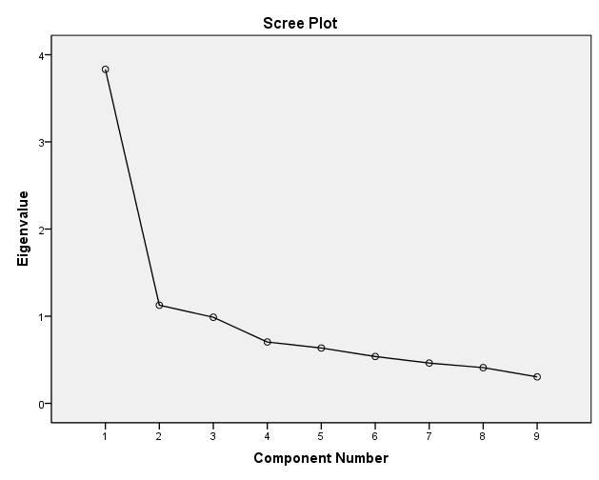

Figure 3: Scree Plot

4.3.3 Demographic Analysis
A total of 330 employee working in UAE were targeted for the study as part of non-probability sampling method. All respondent are working in large public and private entities in the UAE. The co-researcher personally administered the survey by visiting each company to ensure participants did not discuss the content with each other and they don’t get biased from respective organization. A sample of 311 respondents was collected with a response rate of 96.4%.
Out of 311 respondents (As shown in table 17), 10% (n=32) are aged between 18 to 29 years old, 77.8% (n=242) are aged between 30 to 44 years old, 8.4% (n=26) are aged between 45 to 55 years old, and 3.5 % (n=11) are aged above 55 years. Therefore, majority of respondents are aged between 30 to 44 years in the sample of our study.
Table 17: Q35 Age
 |  | Frequency | Percent | Valid Percent | Cumulative Percent
 | 18-29 | 32 | 10.3 | 10.3 | 10.3
 | 30-44 | 242 | 77.8 | 77.8 | 88.1
 | 45-54 | 26 | 8.4 | 8.4 | 96.5
 | 55+ | 11 | 3.5 | 3.5 | 100.0
 | Total | 311 | 100.0 | 100.0

Out of 311 respondents (As shown in table 18), 56% (n=175) were male and 44% (n=136) were female respondent. A reasonable balance between male and female respondents were achieved.
Table 18: Q36 Gender
 |  | Frequency | Percent | Valid Percent | Cumulative Percent
 | Male | 175 | 56.3 | 56.3 | 56.3
 | Female | 136 | 43.7 | 43.7 | 100.0
 | Total | 311 | 100.0 | 100.0

Out of 311 respondents who have answered this question (As shown in table 20), 75% (n=233) were local emirate citizens, and 25% (n=78) were expatriate respondents. Therefore, majority of respondents are local citizens from UAE.
Table 19: Q37 Nationality
 |  | Frequency | Percent | Valid Percent | Cumulative Percent
 | UAE Local | 233 | 74.9 | 74.9 | 74.9
 | Expatriate | 78 | 25.1 | 25.1 | 100.0
 | Total | 311 | 100.0 | 100.0

Out of 311 respondents (As shown in table 21), 3% (n=10) were high school graduate, 3% (n=9) were diploma holders, 39% (n=121) were bachelor degree holders, and 47% (n=147) were post-graduate qualification, and 8% (n= 24) have doctorate degree. Therefore, majority (83%) of respondents have at least bachelor level of education in the sample.
Table 20: Q38 education level
 |  | Frequency | Percent | Valid Percent | Cumulative Percent
 | High School | 10 | 3.2 | 3.2 | 3.2
 | Diploma | 9 | 2.9 | 2.9 | 6.1
 | Bachelor | 121 | 38.9 | 38.9 | 45.0
 | Master | 147 | 47.3 | 47.3 | 92.3
 | Doctorate | 24 | 7.7 | 7.7 | 100.0
 | Total | 311 | 100.0 | 100.0

Out of 311 respondents (As shown in table 22), 1% (n=4) have had less than three years work experience, 13% (n=40) have work experience between 3.1 to 7 years, 14% (n=44) have above 7 years of work experience, and 72% (n=223) above 7 years of work experience. Therefore, majority of respondents (more than 72%) have had more than 10 years of work experience in the sample. The sample represents leaders with extensive work experience working in both public and private sector in UAE.
Table21: Q40 years of experience
 |  | Frequency | Percent | Valid Percent | Cumulative Percent
 | Less than 3 years | 4 | 1.3 | 1.3 | 1.3
 | 3-7 years | 40 | 12.9 | 12.9 | 14.1
 | 7-10 years | 44 | 14.1 | 14.1 | 28.3
 | More than 10 years | 223 | 71.7 | 71.7 | 100.0
 | Total | 311 | 100.0 | 100.0

Out of 311 respondents (As shown in table 23), 9% (n=27) have had less than a year work experience as a supervisor, 20% (n=61) have work experience between 1 to 3 years as a supervisor, 31% (n=98) have work experience between 3.1 to 7 years as a supervisor, 40% (n=125) have above 7 years of work experience as a supervisor. Therefore, majority of respondents (more than 70%) have had more than three years of supervisory experience in the sample. All of the respondent have management experience as they are working in middle management position.
Table 22: Q41 Experience as supervisor
 |  | Frequency | Percent | Valid Percent | Cumulative Percent
 | Less than 1 years | 27 | 8.7 | 8.7 | 8.7
 | 1- 3 years | 61 | 19.6 | 19.6 | 28.3
 | >3-7 years | 98 | 31.5 | 31.5 | 59.8
 | More than 7 years | 125 | 40.2 | 40.2 | 100.0
 | Total | 311 | 100.0 | 100.0

Out of 311 respondents (As shown in table 24), 82% (n=256) were working in government sector, and 18% (n=55) were working in private sector. Therefore, majority of respondents are from public sector organizations.
Table 23: Q42 sector
 |  | Frequency | Percent | Valid Percent | Cumulative Percent
 | Public | 256 | 82.3 | 82.3 | 82.3
 | Private | 55 | 17.7 | 17.7 | 100.0
 | Total | 311 | 100.0 | 100.0

4.4 Research Questions and Hypotheses Related to the Demographic Variables
Preliminary analysis was performed to ensure that no violation of the assumptions on normality, linearity, and homogeneity of data variance occurred. The study’s hypotheses were “formulated after a careful review of the literature on self-leadership. A research model was developed to reflect the nature of work and organizations in the UAE. Normality of distribution was tested using a Kolmogorov–Smirnov test; the null hypothesis showed equality between the actual distribution of the variables and the expected distribution. The variables were thus normally spread. An alpha of .05 was used for all statistical tests. Under the decision rule, if the data base p-value is equal or smaller than .05, H0 is rejected. The following research questions are presented to represent what this study is particularly interested in: the hypotheses supported by the literature review presented in chapter 2.

4.4.1 Q1. What kind of relationship exists between employee sector (Public/Private) and self-leadership constraints in the UAE.
The min working sectors in the UAE is Public or Private. Employees may only work in one type of those two sectors in the UAE. The public sector consist of entities and organization that work under the government supervision, such organization are municipalities , courts, and government council. In this study an example of a public sector organization that participated in this study is Abu Dhabi Municipality, Department of Transport and Abu Dhabi Education Council. On the other hand, the private companies or entities in the UAE are companies that are profit driven. Such companies are banks, restaurants, malls and other private business. In this study an example of a private sector organization that participated in this study are HSBC bank, Marina Mall, and Etihad Airline. When the self- leadership perceptions are analyzed in terms of the age variable, it is seen that there is a difference for three separate age groups in terms of the usage of the self-leadership strategies. (Tabak et al., 2011).”
This study explores the relationship between employee sector of weather they are working in public or private sector and self-leadership in the UAE. The following research hypothesis have been developed.

Hypothesis 1: Employee perceptions of self-leadership strategies differ significantly according to whether the employee works is in the UAE’s private or public sector.
“As stated previously, The purpose of this experiment was to examine whether leaders from public sector or private sector make have any significant differences with any of the nine self-leadership constructs. The dependent variable (self-leadership ) which include all the constraints of self-leadership such as self-goal setting and self-observation. The independent variable included in this experiment is sector of the organization that the leader work. An ANOVA test showed (as shown in table 24) that only Visualized successful performance (F = 3.42, p < .065) is marginally associated with the sector of the leader. Private sector leaders are more (M= 4.03, SD=0.80) able to visualized successful performance in compared with public sector leaders (M= 3.81, SD=0.76).
Table 24: Sector and elf-leadership (significant)”
Construct/Groups |  | N | Mean | Std. Deviation | Df | F | Sig (p)
Visualize successful Performance | Public | 256 | 3.8195 | .76929
Visualize successful Performance | Private | 55 | 4.0331 | .80906
Visualize successful Performance | Total | 311 | 3.8572 | .77942 | 1 | 3.428 | .065

On the other hand, the other self-leadership constructs not associated with the sector of the organization of the leader (as shown in table 25)

Table 25: Sector and self-leadership (not significant)
Construct/Groups |  | N | Mean | Std. Deviation | Df | F | Sig (p)
self-goal setting | Public | 256 | 4.2130 | .54159
self-goal setting | Private | 55 | 4.3156 | .54950
self-goal setting | Total | 311 | 4.2312 | .54352 | 1 | 1.616 | .205
self-talk | Public | 256 | 3.8339 | .98807
self-talk | Private | 55 | 3.9636 | .94428
self-talk | Total | 311 | 3.8568 | .98023 | 1 | .793 | .374
Self-reward | Public | 256 | 3.8511 | 1.06439
Self-reward | Private | 55 | 3.6320 | 1.29536
Self-reward | Total | 311 | 3.8124 | 1.10960 | 1 | 1.770 | .184
Evaluating belive assumptions | Public | 256 | 3.9598 | .55817
Evaluating belive assumptions | Private | 55 | 4.0542 | .66737
Evaluating belive assumptions | Total | 311 | 3.9765 | .57893 | 1 | 1.204 | .273
Self-learn | Public | 256 | 4.3606 | .46550
Self-learn | Private | 55 | 4.3932 | .57419
Self-learn | Total | 311 | 4.3663 | .48562 | 1 | .204 | .652
Self-observation | Public | 256 | 4.1381 | .53785
Self-observation | Private | 55 | 4.0584 | .60595
Self-observation | Total | 311 | 4.1240 | .55032 | 1 | .950 | .330
Focusing on natural rewards | Public | 256 | 4.1201 | .51464
Focusing on natural rewards | Private | 55 | 4.2158 | .46711
Focusing on natural rewards | Total | 311 | 4.1370 | .50716 | 1 | 1.617 | .205
Self-cueing | Public | 256 | 4.1591 | .86045
Self-cueing | Private | 55 | 4.0182 | 1.10957
Self-cueing | Total | 311 | 4.1341 | .90905 | 1 | 1.088 | .298
Self_Leadership | Public | 256 | 4.0506 | .44113
Self_Leadership | Private | 55 | 4.0760 | .50259
Self_Leadership | Total | 311 | 4.0551 | .45185 | 1 | .143 | .705

In conclusion, the first hypothesis which is related to the perceptions of self-leadership strategies by employee sector has nine sub hypothesis. Those hypothesis are shown in table no 26. As presented in the table the outcomes shown that H2a is supported as a result of this study.
Table 26: Sub Research Hypothesis related to hypothesis 1
Research hypotheses: | Outcomes
H1a: There will be a predictive association between Employee perceptions of Visualize successful Performance of self-leadership and employee organization sector group. | Supported
H1b: There is a predictive association between employee perceptions of Self-goal Setting of self-leadership and employee sector. | Not Supported
H1c: There is a predictive association between employee perceptions of Self-talk of self-leadership and employee sector. | Not Supported
H1d: There is a predictive association between employee perceptions of Self-reward of self-leadership and employee sector. | Not Supported
H1e: There is a predictive association between employee perceptions of Evaluating Beliefs and Assumptions of self-leadership and employee sector. | Not Supported
H1f: There is a predictive association between employee perceptions of Self-learn of self-leadership and employee sector. | Not Supported
H1g: There is a predictive association between employee perceptions of Self-observation of self-leadership and employee sector. | Not Supported
H1h: There is a predictive association between employee perceptions of Natural Reward Strategy of self-leadership and employee sector. | Not Supported
H1i: There is a predictive association between employee perceptions of Self-cueing of self-leadership and employee sector.

This analysis support the first Hypothesis in which it shows that Employee perceptions of self-leadership strategies are significantly differs by employee sector and wither they are in private and public sectors in UAE.

4.4.2 Q2. What kind of relationship exists between employee age and self-leadership constraints in the UAE.
“When the self- leadership perceptions are analyzed in terms of the age variable, it is seen that there is a difference for three separate age groups in terms of the usage of the self-leadership strategies. (Tabak et al., 2011). According to Politis (2006), age is an important aspect in determining the effectiveness of leadership. Accordingly, young leaders are less experience hence would more likely have little self-leadership. On the other hand, older leader, who have more experience on leadership and management, generally have more self-leadership .
This study explores the relationship between employee age and self-leadership in the UAE. The following research hypothesis have been developed.
Hypothesis 2: There is a predictive association between employee perceptions of self-leadership and employee age.
As mentioned previously, the purpose of the research questions above is to examine whether age of a leader have any significant influence on their self-leadership. The dependent variable (self-leadership ) which include all the constraints of self-leadership such as self-goal setting and self-rewards. The independent variable included in this experiment is age of a leader. The age of leader was grouped into four different categories based on a range of age. An ANOVA test showed that age of a leader makes a significant association with Visualize successful Performance, self-goal setting, self-reward, and self-cueing.“

As shown in table 27 Visualize successful Performance is significantly ( F = 4.69, p < .003) influenced by the age of a leader. Leaders with age between 30 to 44 have highest capacity ( M = 3.93, SD = .77) in visualized successful performance and it is followed by next group of leaders with age above 55 ( M = 3.77, SD = .54). Senior age group (55+) leaders have lowest standard deviation which means respondents are having less disparity in their opinions. Young group of leaders with age ranging from 18 to 29 are having difficulty in visualizing success of their performance 5. Leaders with age group of 45 to 54 are able to visualized ( M = 3.70, SD = .81) moderate degree of success to their performance with a greater disparity in opinion. Therefore, it could be concluded that a young leader trends have less capacity to visualized success of their performance compared with middle or senior age leaders and the capacity reaches its peak at the middle of the career.
An ANOVA test showed that Self-goal setting construct has also found to be significantly (F = 2.69, p < .046) associated with age of leaders. Leaders with age between 30 to 44 have highest capacity (M = 4.27, SD = .51) in Self-goal setting. It is followed by next group of leaders with age ranging from 45-54 (M = 4.21, SD = .45) and this group has lowest disparity in opinions. Although young age group of leaders have comparatively lower score (M = 4.00, SD = .75) in goal setting construct, overall mean score is above four for all age group of managers. Therefore, it can be concluded that age has a significant positive relationship with leader’s capacity in goal setting.
An ANOVA test showed that Self-reward construct has marginally significant (F = 2.47, p < .062) relationship with age of leaders. Leaders with age between 45 to 54 have highest score (M = 3.97, SD = 1.03) in self-rewarding construct. It is followed by next group of leaders with age ranging from 30-45 (M = 3.85, SD = 1.10) in self-rewarding. Senior leaders with age of above 55 years have lowest score (M = 3.00, SD = 1.25) in self-rewarding construct. However, all age groups have quit high standard deviation (above one) score which indicated that there are disparities exist in their opinions regarding self-rewarding. Therefore, it can be concluded that age has a significant positive relationship with self-rewarding construct, leaders trends to prefer less self-rewarding as they approach close to retirement age, and disagreement exists in self-rewarding construct among all age groups.
An ANOVA test showed that Self-cueing construct is significantly (F = 3.83, p < .010) associated with the age of a leader. Senior leaders with age of above 55 years have highest mean score (M = 4.77, SD = 0.46) and least disparity in self-cueing construct. It is followed by leaders with age ranging from 18-29 (M = 4.19, SD = 0.80) in self-rewarding. Leaders with age between 45 to 54 have lowest score (M = 3.71, SD = 1.266) and highest disparity in self-cueing construct.

Table 27: Age and Self-Leadership Constructs (significant)
Construct/Groups |  | N | Mean | Std. Deviation | Df | F | Sig (p)
Visualize successful Performance | 18-29 | 32 | 3.4219 | .73627
Visualize successful Performance | 30-44 | 242 | 3.9353 | .77222
Visualize successful Performance | 45-54 | 26 | 3.7019 | .81553
Visualize successful Performance | 55+ | 11 | 3.7727 | .54146
Visualize successful Performance | Total | 311 | 3.8572 | .77942 | 3 | 4.687 | .003
Self-goal setting | 18-29 | 32 | 4.0063 | .74917
Self-goal setting | 30-44 | 242 | 4.2707 | .51369
Self-goal setting | 45-54 | 26 | 4.2154 | .45580
Self-goal setting | 55+ | 11 | 4.0545 | .55202
Self-goal setting | Total | 311 | 4.2312 | .54352 | 3 | 2.690 | .046
Self-reward | 18-29 | 32 | 3.6667 | 1.04384
Self-reward | 30-44 | 242 | 3.8510 | 1.10892
Self-reward | 45-54 | 26 | 3.9759 | 1.03481
Self-reward | 55+ | 11 | 3.0000 | 1.25610
Self-reward | Total | 311 | 3.8124 | 1.10960 | 3 | 2.470 | .062
Self-cueing | 18-29 | 32 | 4.1909 | .80011
Self-cueing | 30-44 | 242 | 4.1430 | .87570
Self-cueing | 45-54 | 26 | 3.7115 | 1.26628
Self-cueing | 55+ | 11 | 4.7727 | .46710
Self-cueing | Total | 311 | 4.1341 | .90905 | 3 | 3.834 | .010

On the other hand, the other self-leadership constructs not associated with the sector of the organization of the leader (as shown in table 28 )

Table 28: Age and Self-Leadership Constructs (not significant)
Construct/Groups |  | N | Mean | Std. Deviation | Df | F | Sig (p)
self-talk | 18-29 | 32 | 4.0417 | .78403
self-talk | 30-44 | 242 | 3.8601 | .97915
self-talk | 45-54 | 26 | 3.8077 | 1.10824
self-talk | 55+ | 11 | 3.3636 | 1.14944
self-talk | Total | 311 | 3.8568 | .98023 | 3 | 1.334 | .263
Evaluating beliefs and assumptions | 18-29 | 32 | 3.9056 | .40368
Evaluating beliefs and assumptions | 30-44 | 242 | 3.9998 | .58614
Evaluating beliefs and assumptions | 45-54 | 26 | 3.9712 | .67944
Evaluating beliefs and assumptions | 55+ | 11 | 3.6818 | .57108
Evaluating beliefs and assumptions | Total | 311 | 3.9765 | .57893 | 3 | 1.245 | .294
Self-learn | 18-29 | 32 | 4.3121 | .33799
Self-learn | 30-44 | 242 | 4.3717 | .51029
Self-learn | 45-54 | 26 | 4.3077 | .43126
Self-learn | 55+ | 11 | 4.5455 | .40202
Self-learn | Total | 311 | 4.3663 | .48562 | 3 | .766 | .514
Self-observation | 18-29 | 32 | 4.1372 | .46124
Self-observation | 30-44 | 242 | 4.1422 | .56848
Self-observation | 45-54 | 26 | 3.9712 | .52119
Self-observation | 55+ | 11 | 4.0455 | .43038
Self-observation | Total | 311 | 4.1240 | .55032 | 3 | .837 | .475
Focusing on natural rewards | 18-29 | 32 | 4.1216 | .58737
Focusing on natural rewards | 30-44 | 242 | 4.1583 | .48997
Focusing on natural rewards | 45-54 | 26 | 4.0385 | .61193
Focusing on natural rewards | 55+ | 11 | 3.9455 | .32362
Focusing on natural rewards | Total | 311 | 4.1370 | .50716 | 3 | 1.003 | .392
Self_Leadership | 18-29 | 32 | 3.9782 | .40660
Self_Leadership | 30-44 | 242 | 4.0814 | .45677
Self_Leadership | 45-54 | 26 | 3.9668 | .44305
Self_Leadership | 55+ | 11 | 3.9091 | .46742
Self_Leadership | Total | 311 | 4.0551 | .45185 | 3 | 1.299 | .275

In conclusion, the second hypothesis which is related to the perceptions of self-leadership strategies by employee sector has nine sub hypothesis. Those hypothesis are shown in table no 29. As presented in the table the outcomes shown that H2a, H2b and H2h is supported as a result of this study.
Table 29: Sub Research Hypothesis related to hypothesis 2
Research hypotheses | Outcomes
H2a: There is a predictive association between employee perceptions of Visualize Successful Performance of self-leadership and employee age. | Supported
H2b: There is a predictive association between employee perceptions of Self-goal Setting of self-leadership and employee age. | Not Supported
H2c: There is a predictive association between employee perceptions of Self-talk of self-leadership and employee age. | Supported
H2d: There is a predictive association between employee perceptions of Self-reward of self-leadership and employee age. | Not Supported
H2e: There is a predictive association between employee perceptions of Evaluating Beliefs and Assumptions of self-leadership and employee age. | Not Supported
H2f: There is a predictive association between employee perceptions of Self-learn of self-leadership and employee age. | Not Supported
H2g: There is a predictive association between employee perceptions of Self-observation of self-leadership and employee age. | Not Supported
H2h: There is a predictive association between employee perceptions of Natural Reward Strategy of self-leadership and employee age. | Supported
H2i: There is a predictive association between employee perceptions of Self-cueing of self-leadership and employee age.

This analysis support the second hypothesis in which it shows that there are a predictive association between employee perceptions of self-leadership and employee age group.

4.4.3 Q3. What kind of relationship exists between employee educational level and self-leadership constraints in the UAE.
According to Carmeli et al. ( 2006) As the educational level of the individuals increases, an increase of the usage of the individuals self-leadership strategies occurs? This study explores the relationship between employee educational level and self-leadership in the UAE. This include educational level such as Diploma, Master and Doctorate. The following research hypothesis have been developed.
Hypothesis 3: Employee perceptions of self-leadership strategies differ significantly according to the employee’s educational level.
The purpose of this experiment was to examine whether education level of a leader have any significant association with any of the nine self-leadership constructs. The dependent variable (self-leadership ) which include all the constraints of self-leadership. The independent variable included in this experiment is education level of a leader. As shown in table 30 an ANOVA test showed that education level of a leader have a significant relationship with only two constructs namely Visualized successful performance (F = 2.78, p < .027) and Evaluating beliefs and assumptions (F = 2.48, p < .044). A closer look shows that diploma degree holder (M = 4.13, SD= 0.53) are high in visualized successful performance while Doctorate degree holders are lowest (M= 3.40, SD = 1.16) in the same construct. Diploma degree holders (M = 4.08, SD= 0.50) and bachelor degree holders (M= 4.02, SD = 0.50) are also high in Evaluating beliefs and assumptions in comparism with Doctorate degree holders (M= 3.82, SD = 0.66) in the same construct. This may due to the reason that higher the education gives more in-depth understanding the situation and make more realistic assumptions about success of any performance and practical evaluation of self.
Table 30: Education and Self-Leadership Constructs (Significant)

Construct/Groups |  | N | Mean | Std. Deviation | Df | F | Sig (p)
Visualize successful Performance | High School | 10 | 3.9250 | .85025
Visualize successful Performance | Diploma | 9 | 4.1389 | .53196
Visualize successful Performance | Bachelor | 121 | 3.8240 | .77480
Visualize successful Performance | Master | 147 | 3.9359 | .69052
Visualize successful Performance | Doctorate | 24 | 3.4092 | 1.16618
Visualize successful Performance | Total | 311 | 3.8572 | .77942 | 4 | 2.787 | .027
Evaluating beliefs and assumptions | High School | 10 | 3.4910 | .74850
Evaluating beliefs and assumptions | Diploma | 9 | 4.0833 | .50000
Evaluating beliefs and assumptions | Bachelor | 121 | 4.0233 | .55019
Evaluating beliefs and assumptions | Master | 147 | 3.9884 | .56863
Evaluating beliefs and assumptions | Doctorate | 24 | 3.8296 | .66139
Evaluating beliefs and assumptions | Total | 311 | 3.9765 | .57893 | 4 | 2.481 | .044

On the other hand, the other self-leadership constructs not associated with the sector of the organization of the leader (as shown in table 31)

Table 31: Education and Self-Leadership Constructs (not significant)

Construct/Groups |  | N | Mean | Std. Deviation | Df | F | Sig (p)
self-goal setting | High School | 10 | 3.9200 | .55136
self-goal setting | Diploma | 9 | 4.0889 | .64893
self-goal setting | Bachelor | 121 | 4.1997 | .56687
self-goal setting | Master | 147 | 4.2854 | .50968
self-goal setting | Doctorate | 24 | 4.2408 | .56262
self-goal setting | Total | 311 | 4.2312 | .54352 | 4 | 1.452 | .217
self-talk | High School | 10 | 4.0000 | .47140
self-talk | Diploma | 9 | 3.6296 | 1.41857
self-talk | Bachelor | 121 | 3.7691 | .94724
self-talk | Master | 147 | 3.9850 | .93960
self-talk | Doctorate | 24 | 3.5389 | 1.26413
self-talk | Total | 311 | 3.8568 | .98023 | 4 | 1.691 | .152
Self-reward | High School | 10 | 4.1000 | .83222
Self-reward | Diploma | 9 | 3.8519 | .64788
Self-reward | Bachelor | 121 | 3.7934 | 1.03839
Self-reward | Master | 147 | 3.8331 | 1.16446
Self-reward | Doctorate | 24 | 3.6467 | 1.36921
Self-reward | Total | 311 | 3.8124 | 1.10960 | 4 | .323 | .862
Self-learn | High School | 10 | 4.0667 | .84327
Self-learn | Diploma | 9 | 4.2593 | .40062
Self-learn | Bachelor | 121 | 4.3936 | .45343
Self-learn | Master | 147 | 4.3695 | .45184
Self-learn | Doctorate | 24 | 4.3744 | .65437
Self-learn | Total | 311 | 4.3663 | .48562 | 4 | 1.162 | .327
Self-observation | High School | 10 | 3.7500 | .81650
Self-observation | Diploma | 9 | 4.1111 | .56057
Self-observation | Bachelor | 121 | 4.1490 | .54693
Self-observation | Master | 147 | 4.1499 | .47744
Self-observation | Doctorate | 24 | 4.0000 | .78712
Self-observation | Total | 311 | 4.1240 | .55032 | 4 | 1.617 | .170
Focusing on natural rewards | High School | 0 | 4.0800 | .39101
Focusing on natural rewards | Diploma | 9 | 4.0000 | .41231
Focusing on natural rewards | Bachelor | 121 | 4.1077 | .51603
Focusing on natural rewards | Master | 147 | 4.1530 | .49051
Focusing on natural rewards | Doctorate | 4 | 4.2621 | .63244
Focusing on natural rewards | Total | 311 | 4.1370 | .50716 | 4 | .696 | .595
Self-cueing | High School | 10 | 4.2500 | .35355
Self-cueing | Diploma | 9 | 3.5000 | 1.54110
Self-cueing | Bachelor | 121 | 4.1051 | .91941
Self-cueing | Master | 147 | 4.1905 | .91099
Self-cueing | Doctorate | 24 | 4.1250 | .62987
Self-cueing | Total | 311 | 4.1341 | .90905 | 4 | 1.313 | .265
Self_Leadership | High School | 0 | 3.9536 | .48833
Self_Leadership | Diploma | 9 | 3.9626 | .43080
Self_Leadership | Bachelor | 121 | 4.0406 | .45708
Self_Leadership | Master | 147 | 4.0990 | .43375
Self_Leadership | Doctorate | 24 | 3.9363 | .52317
Self_Leadership | Total | 311 | 4.0551 | .45185 | 4 | 1.013 | .401

In conclusion, the first hypothesis which is related to the perceptions of self-leadership strategies by employee sector has nine sub hypothesis. Those hypothesis are shown in table no 32. As presented in the table the outcomes shown that H3a is supported as a result of this study.
Table 32: Sub Research Hypothesis related to hypothesis 3
Research hypotheses | Outcomes
H3a: There is a predictive association between employee perceptions of Visualize Successful Performance of self-leadership and employee educational level. | Not Supported
H3b: There is a predictive association between employee perceptions of Self-goal Setting of self-leadership and employee educational level. | Not Supported
H3c: There is a predictive association between employee perceptions of Self-talk of self-leadership and employee educational level. | Not Supported
H3d: There is a predictive association between employee perceptions of Self-reward of self-leadership and employee educational level. | Not Supported
H3e: There is a predictive association between employee perceptions of Evaluating Beliefs and Assumptions of self-leadership and employee educational level. | Not Supported
H3f: There is a predictive association between employee perceptions of Self-learn of self-leadership and employee educational level. | Not Supported
H3g: There is a predictive association between employee perceptions of Self-observation of self-leadership and employee educational level. | Not Supported
H3h: There is a predictive association between employee perceptions of Natural Reward Strategy of self-leadership and employee educational level. | Not Supported
H3i: There is a predictive association between employee perceptions of Self-cueing of self-leadership and employee educational level.

This analysis support the second hypothesis in which it shows that there are a predictive association between employee perceptions of self-leadership and employee education level group.

4.4.4 Q4. What kind of relationship exists between employee work experience and self-leadership constraints in the UAE.
“According to Alves et al. (2007) , long-term oriented people with high work experiences may have improved self-observation strategies than those of short-term oriented individuals. Therefore, self-observation strategies found to be significant when factored with work experience. (Tabak A. et al., 2011).
This study explores the relationship between employee work experience and self-leadership in the UAE. This may include all type of working experience weather it’s in the public and private sector. The following research hypothesis have been developed.
Hypothesis 4: Employee perceptions of self-leadership strategies differ significantly according to the employee’s work experience.
As stated previously, the purpose of this experiment was to examine whether experience of a leader have any significant association with any of the nine self-leadership constructs. The dependent variable (self-leadership ) which include all the constraints of self-leadership such as self-observation and self-rewards. The independent variable included in this experiment is years of work experience of a leader As shown in table 33 an ANOVA test showed that experience of a leader have a significant relationship with only three constructs namely Visualized successful performance (F = 4.18, p < .006) and Self-talk (F = 2.36, p < .07, significant at .10 level). A closer look shows that leaders with more than 10 years of experience (M=3.94, SD= 0.73) have lower score in visualized successful performance compared with leaders with less than 3 years of experience (M= 4.25, SD= 1.00) which group has highest score in this construct. Similarly, leaders with more than 10 years of experience (M=3.78, SD= 1.00) are also lowest in Self-talk and leaders with less than 3 years of experience (M= 4.66, SD= 0.00) have the highest score in the same construct.”

Table 33: Experience and Self-Leadership Constructs (significant)
 | Construct/Groups |  | N | Mean | Std. Deviation |  | Df |  | F |  | Sig (p)
 | Visualize successful Performance | Less than 3 years | 4 | 4.2500 | 1.00000
 | Visualize successful Performance | 3-7 years | 40 | 3.5500 | .88107
 | Visualize successful Performance | 7-10 years | 44 | 3.6761 | .81693
 | Visualize successful Performance | More than 10 years | 223 | 3.9410 | .73199
 | Visualize successful Performance | Total | 311 | 3.8572 | .77942 |  | 3 |  | 4.187 |  | .006
 | self-talk | Less than 3 years | 4 | 4.6667 | .00000
 | self-talk | 3-7 years | 40 | 3.9167 | .98348
 | self-talk | 7-10 years | 44 | 4.1061 | .82835
 | self-talk | More than 10 years | 223 | 3.7824 | 1.00427
 | self-talk | Total | 311 | 3.8568 | .98023 |  | 3 |  | 2.368 |  | .071
Focusing on natural rewards |  | Less than 3 years | 4 | 4.6725 |  | .39961
 |  | 3-7 years | 40 | 4.2290 |  | .58255
 |  | 7-10 years | 44 | 4.1455 |  | .55299
 |  | More than 10 years | 223 | 4.1092 |  | .48029
 |  | Total | 311 | 4.1370 |  | .50716 |  | 3 |  | 2.177 |  | .091

On the other hand, the other self-leadership constructs not associated with the sector of the organization of the leader (as shown in table 34 )
Table 34: Experience and Self-Leadership Constructs (not significant)
Construct/Groups |  | N | Mean | Std. Deviation | Df | F | Sig (p)
self-goal setting | Less than 3 years | 4 | 4.4000 | .67330
self-goal setting | 3-7 years | 40 | 4.0540 | .66849
self-goal setting | 7-10 years | 44 | 4.2773 | .66011
self-goal setting | More than 10 years | 223 | 4.2509 | .48632
self-goal setting | Total | 311 | 4.2312 | .54352 | 3 | 1.761 | .155
Self-reward | Less than 3 years | 4 | 4.8333 | .33333
Self-reward | 3-7 years | 40 | 3.6440 | 1.09765
Self-reward | 7-10 years | 44 | 3.8561 | 1.11693
Self-reward | More than 10 years | 223 | 3.8157 | 1.11364
Self-reward | Total | 311 | 3.8124 | 1.10960 | 3 | 1.466 | .224
Evaluating beliefs and assumptions | Less than 3 years | 4 | 3.8125 | .37500
Evaluating beliefs and assumptions | 3-7 years | 40 | 3.9825 | .45898
Evaluating beliefs and assumptions | 7-10 years | 44 | 3.9830 | .68709
Evaluating beliefs and assumptions | More than 10 years | 223 | 3.9771 | .58067
Evaluating beliefs and assumptions | Total | 311 | 3.9765 | .57893 | 3 | .109 | .955
Self-learn | Less than 3 years | 4 | 4.3333 | .00000
Self-learn | 3-7 years | 40 | 4.3990 | .37913
Self-learn | 7-10 years | 44 | 4.4470 | .44862
Self-learn | More than 10 years | 223 | 4.3452 | .51296
Self-learn | Total | 311 | 4.3663 | .48562 | 3 | .610 | .609
Self-observation | Less than 3 years | 4 | 3.9375 | .62500
Self-observation | 3-7 years | 40 | 4.2195 | .44843
Self-observation | 7-10 years | 44 | 4.2061 | .61257
Self-observation | More than 10 years | 223 | 4.0940 | .55236
Self-observation | Total | 311 | 4.1240 | .55032 | 3 | 1.104 | .348
Self-cueing | Less than 3 years | 4 | 4.6250 | .25000
Self-cueing | 3-7 years | 40 | 4.1180 | .82768
Self-cueing | 7-10 years | 44 | 4.2045 | 1.04725
Self-cueing | More than 10 years | 223 | 4.1143 | .90253
Self-cueing | Total | 311 | 4.1341 | .90905 | 3 | .514 | .673
Self_Leadership | Less than 3 years | 4 | 4.3923 | .34870
Self_Leadership | 3-7 years | 40 | 4.0125 | .50188
Self_Leadership | 7-10 years | 44 | 4.1002 | .47161
Self_Leadership | More than 10 years | 223 | 4.0477 | .43965
Self_Leadership | Total | 311 | 4.0551 | .45185 | 3 | 1.027 | .381

In conclusion, the third hypothesis which is related to the perceptions of self-leadership strategies by employee sector has nine sub hypothesis. Those hypothesis are shown in table no 35. As presented in the table the outcomes shown that H4a and H4c is supported as a result of this study.

Table 35: Sub Research Hypothesis related to hypothesis 4
Research hypotheses | Outcomes
H4a: There will be a predictive association between Employee perceptions of Visualize successful Performance of self-leadership and employee work experience. | Supported
H4b: There is a predictive association between employee perceptions of Self-goal Setting of self-leadership and employee work experience. | Supported
H4c: There is a predictive association between employee perceptions of Self-talk of self-leadership and employee work experience. | Not Supported
H4d: There is a predictive association between employee perceptions of Self-reward of self-leadership and employee work experience. | Not Supported
H4e: There is a predictive association between employee perceptions of Evaluating Beliefs and Assumptions of self-leadership and employee work experience. | Not Supported
H4f: There is a predictive association between employee perceptions of Self-learn of self-leadership and employee work experience. | Not Supported
H4g: There is a predictive association between employee perceptions of Self-observation of self-leadership and employee work experience. | Not Supported
H4h: There is a predictive association between employee perceptions of Natural Reward Strategy of self-leadership and employee work experience. | Not Supported
H4i: There is a predictive association between employee perceptions of Self-cueing of self-leadership and employee work experience.

This analysis support the forth hypothesis in which it shows that employee perceptions of self-leadership strategies are significantly differs by the employee work experience.

4.4.5 Q5. What kind of relationship exists between employee Nationality and self-leadership constraints in the UAE.
According to the literature review, People in various cultures can be very different from one another in term of behavior and thinking process (Tabak et al., 2011). A study that include participant from different culture such as US, China, Portugal and South Africa, revealed different perception of participant for self-leadership (Friends, T., 2012).
This study explores the relationship between employee Nationality and self-leadership in the UAE. For the focus of this study an indication of weather the participants is a local or non-local is how the nationality was considered. The following research hypothesis have been developed.
Hypothesis 5: Employee perceptions of self-leadership strategies differ significantly according to employee nationality.
As mentioned previously, The purpose of this experiment was to examine relationship between the nationality of a leader and with any of the nine self-leadership constructs. The dependent variable (self-leadership ) which include all the constraints of self-leadership such as self-goal setting and self-rewards. The independent variable included in this experiment is nationality of the leader. As shown in table 35 an ANOVA test showed that nationality of a leader have a significant relationship with only two constructs namely self-reward (F = 6.14, p < .014) and self-learn (F = 6.96, p < .009). UAE national leaders have higher score (M = 3.90, SD = 1.04) in self-reward compared with expatriate leaders (M = 3.54, SD = 1.24). UAE national leaders have lower score (M = 4.49, SD = 0.41) in self-learning compared with expatriate leaders (M = 4.32, SD = 0.49).

Table 36: Nationality and Self-Leadership Constructs (significant)
Construct/Groups |  | N | Mean | Std. Deviation | Df | F | Sig (p)
Self-reward | UAE Local | 233 | 3.9019 | 1.04712
Self-reward | Expatriate | 78 | 3.5451 | 1.24767
Self-reward | Total | 311 | 3.8124 | 1.10960 | 1 | 6.140 | .014
Self-learn | UAE Local | 233 | 4.3247 | .49993
Self-learn | Expatriate | 78 | 4.4908 | .41890
Self-learn | Total | 311 | 4.3663 | .48562 | 1 | 6.966 | .009

On the other hand, the other self-leadership constructs not associated with the sector of the organization of the leader (as shown in table 37 )
Table 37: Nationality and Self-Leadership Constructs (not significant)

Construct/Groups |  | N | Mean | Std. Deviation | Df | F | Sig (p)
Visualize successful Performance | UAE Local | 233 | 3.8574 | .76181
Visualize successful Performance | Expatriate | 78 | 3.8567 | .83495
Visualize successful Performance | Total | 311 | 3.8572 | .77942 | 1 | .000 | .994
self-goal setting | UAE Local | 233 | 4.2161 | .54035
self-goal setting | Expatriate | 78 | 4.2762 | .55396
self-goal setting | Total | 311 | 4.2312 | .54352 | 1 | .712 | .399
self-talk | UAE Local | 233 | 3.8761 | .95115
self-talk | Expatriate | 78 | 3.7991 | 1.06680
self-talk | Total | 311 | 3.8568 | .98023 | 1 | .360 | .549
Evaluating beliefs and assumptions | UAE Local | 233 | 3.9541 | .57932
Evaluating beliefs and assumptions | Expatriate | 78 | 4.0435 | .57629
Evaluating beliefs and assumptions | Total | 311 | 3.9765 | .57893 | 1 | 1.395 | .239
Self-observation | UAE Local | 233 | 4.1028 | .55752
Self-observation | Expatriate | 78 | 4.1872 | .52662
Self-observation | Total | 311 | 4.1240 | .55032 | 1 | 1.374 | .242
Focusing on natural rewards | UAE Local | 233 | 4.1265 | .52644
Focusing on natural rewards | Expatriate | 78 | 4.1685 | .44628
Focusing on natural rewards | Total | 311 | 4.1370 | .50716 | 1 | .400 | .528
Self-cueing | UAE Local | 233 | 4.1206 | .89568
Self-cueing | Expatriate | 78 | 4.1745 | .95269
Self-cueing | Total | 311 | 4.1341 | .90905 | 1 | .204 | .651
Self_Leadership | UAE Local | 233 | 4.0534 | .45288
Self_Leadership | Expatriate | 78 | 4.0602 | .45166
Self_Leadership | Total | 311 | 4.0551 | .45185 | 1 | .013 | .909

In conclusion, the first hypothesis which is related to the perceptions of self-leadership strategies by employee sector has nine sub hypothesis. Those hypothesis are shown in table no 38. As presented in the table the outcomes shown that H5d and H5f is supported as a result of this study.
Table 38: Sub Research Hypothesis related to hypothesis 5
Research hypotheses | Outcomes
H5a: There will be a predictive association between Employee perceptions of Visualize successful Performance of self-leadership and employee nationality. | Not Supported
H5b: There is a predictive association between employee perceptions of Self-goal Setting of self-leadership and employee nationality. | Not Supported
H5c: There is a predictive association between employee perceptions of Self-talk of self-leadership and employee nationality. | Supported
H5d: There is a predictive association between employee perceptions of Self-reward of self-leadership and employee nationality. | Not Supported
H5e: There is a predictive association between employee perceptions of Evaluating Beliefs and Assumptions of self-leadership and employee nationality. | Supported
H5f: There is a predictive association between employee perceptions of Self-learn of self-leadership and employee nationality. | Not Supported
H5g: There is a predictive association between employee perceptions of Self-observation of self-leadership and employee nationality. | Not Supported
H5h: There is a predictive association between employee perceptions of Natural Reward Strategy of self-leadership and employee nationality. | Not Supported
H5i: There is a predictive association between employee perceptions of Self-cueing of self-leadership and employee nationality.

“This analysis support the fifth hypothesis in which it shows that employee perceptions of self-leadership strategies are significantly differs by the employee nationality.

4.4.6 Q6. What kind of relationship exists between employee gender and self-leadership constraints in the UAE.
Gender may have indirect effect on the practice of self-leadership (D’Intino et al., 2007). For instance, women are more likely to engage in rumination or obstacle type thinking in response to negative emotions than their male counterparts (Nolen et al. 2004).
This study explores the relationship between employee gender and self-leadership in the UAE. Both male and female manager working in the UAE in the private and the public sector had the chance to participate in the study. The following research hypothesis have been developed.
Hypothesis 6: Employee perceptions of self-leadership strategies differ significantly between female and male employees.
As mentioned previously, The purpose of this experiment was to examine relationship between the gender of a leader and with any of the nine self-leadership constructs. The dependent variable (self-leadership ) which include all the constraints of self-leadership such as self-goal setting and self-observation. The independent variable included in this experiment is gender of a leader. As shown in table 39 an n ANOVA test showed that gender of a leader have a significant relationship with only two constructs namely self-talk (F = 6.38, p < .012) and self-cueing (F = 4.07, p < .044). Female leaders have higher score (M = 4.01, SD = 0.94) in self-talk compared with male leaders (M = 3.73, SD = 0.99). Female leaders “also have higher score (M = 4.25, SD = 0.87) in self-cuing compared with male leaders (M = 4.04, SD = 0.92).
Table 39: Gender and Self-Leadership Construct (Significant)

construct/Groups |  | N | Mean | Std. Deviation | Df | F | Sig (p)
self-talk | Male | 175 | 3.7341 | .99385
self-talk | Female | 136 | 4.0147 | .94269
self-talk | Total | 311 | 3.8568 | .98023 | 1 | 6.380 | .012
Self-cueing | Male | 175 | 4.0429 | .92671
Self-cueing | Female | 136 | 4.2516 | .87523
Self-cueing | Total | 311 | 4.1341 | .90905 | 1 | 4.076 | .044

On the other hand, the other self-leadership constructs not associated with the sector of the organization of the leader (as shown in table 40)
Table 40: Gender and Self-Leadership Constructs (not Significant)

Construct/Groups |  | N | Mean | Std. Deviation | Df | F | Sig (p
Visualize successful Performance | Male | 175 | 3.8330 | .70150
Visualize successful Performance | Female | 136 | 3.8884 | .87120
Visualize successful Performance | Total | 311 | 3.8572 | .77942 | 1 | .385 | .535
self-goal setting | Male | 175 | 4.2341 | .49664
self-goal setting | Female | 136 | 4.2275 | .60036
self-goal setting | Total | 311 | 4.2312 | .54352 | 1 | .011 | .916
Self-reward | Male | 175 | 3.8628 | 1.06523
Self-reward | Female | 136 | 3.7475 | 1.16499
Self-reward | Total | 311 | 3.8124 | 1.10960 | 1 | .825 | .364
Evaluating beliefs and assumptions | Male | 175 | 4.0156 | .59140
Evaluating beliefs and assumptions | Female | 136 | 3.9262 | .56064
Evaluating beliefs and assumptions | Total | 311 | 3.9765 | .57893 | 1 | 1.831 | .177
Self-learn | Male | 175 | 4.3484 | .49753
Self-learn | Female | 136 | 4.3894 | .47067
Self-learn | Total | 311 | 4.3663 | .48562 | 1 | .544 | .461
Self-observation | Male | 175 | 4.0875 | .53122
Self-observation | Female | 136 | 4.1709 | .57252
Self-observation | Total | 311 | 4.1240 | .55032 | 1 | 1.759 | .186
Focusing on natural rewards | Male | 175 | 4.1205 | .47165
Focusing on natural rewards | Female | 136 | 4.1582 | .55056
Focusing on natural rewards | Total | 311 | 4.1370 | .50716 | 1 | .423 | .516
Self_Leadership | Male | 175 | 4.0310 | .44041
Self_Leadership | Female | 136 | 4.0861 | .46596
Self_Leadership | Total | 311 | 4.0551 | .45185 | 1 | 1.137 | .287

In conclusion, the first hypothesis which is related to the perceptions of self-leadership strategies by employee sector has nine sub hypothesis. Those hypothesis are shown in table no 41. As presented in the table the outcomes shown that H6c and H6h is supported as a result of this study.
Table 41: Sub Research Hypothesis related to hypothesis 6
Research hypotheses | Outcomes
H6a: There will be a predictive association between Employee perceptions of Visualize successful Performance of self-leadership and employee gender. | Not Supported
H6b: There is a predictive association between employee perceptions of Self-goal Setting of self-leadership and employee gender. | Supported
H6c: There is a predictive association between employee perceptions of Self-talk of self-leadership and employee gender. | Not Supported
H6d: There is a predictive association between employee perceptions of Self-reward of self-leadership and employee gender. | Not Supported
H6e: There is a predictive association between employee perceptions of Evaluating Beliefs and Assumptions of self-leadership and employee gender. | Not Supported
H6f: There is a predictive association between employee perceptions of Self-learn of self-leadership and employee gender. | Not Supported
H6g: There is a predictive association between employee perceptions of Self-observation of self-leadership and employee gender. | Not Supported
H6h: There is a predictive association between employee perceptions of Natural Reward Strategy of self-leadership and employee gender. | supported
H6i: There is a predictive association between employee perceptions of Self-cueing of self-leadership and employee gender.

This analysis support the sixth hypothesis in which it shows that employee perceptions of self-leadership strategies are significantly differs by for female or male

4.5 Conclusion
The findings show that the self-leadership constructs are related to the demographic variables. Some of the constructs are related to each of the demographic variables tested in this study. An ANOVA test showed that the leader’s sector makes a significant difference to Visualize Successful Performance, supporting H1a (“there is a predictive association between employee perceptions of Visualize Successful Performance of self-leadership and employee sector”). The leader’s age makes a significant difference to three constructs, supporting three sub-hypotheses: the first is H2a (“There is a predictive association between employee perceptions of Visualize Successful Performance of self-leadership and employee age”); the second is H2b (“there is a predictive association between employee perceptions of Self-goal Setting of self-leadership and employee age”); the third is H2d (“there is a predictive association between employee perceptions of Self-reward of self-leadership and employee age”).
Employee education level makes a significant difference to Visualize Successful Performance, supporting sub-hypothesis H3a (“there is a predictive association between employee perceptions of Visualize Successful Performance of self-leadership and employee education level”). Employee work experience makes a significant difference to Visualize Successful Performance and Self-talk, supporting two sub-hypotheses: H4a (“there is a predictive association between employee perceptions of Visualize Successful Performance of self-leadership and employee work experience”) and H4c (“there is a predictive association between employee perceptions of Self-talk of self-leadership and employee work experience”).
Likewise, leader nationality makes a significant difference to Self-learn, supporting sub-hypothesis H5f (“there is a predictive association between employee perceptions of Self-learn of self-leadership and employee nationality). Leader gender makes a significant difference to two leadership constructs: Self-talk, supporting sub-hypothesis H6c (“there is a predictive association between employee perceptions of Self-talk of self-leadership and employee gender”) and Self-cueing, supporting sub-hypothesis H6h (“there is a predictive association between employee perceptions of Self-cueing of self-leadership and employee gender”).
An ANOVA test failed to show any significant relationships between some of the constructs and the demographic variables, perhaps due to various cultural and environmental factors. Regarding nationality, for example, it is culturally expected in the UAE to celebrate people’s achievements; therefore, Self-reward is high among local participants. However, Self-learn is not part of the UAE norm, as local residents usually learn from those of higher social rank or power such as parents, teachers, and managers. Therefore, Self-learn is higher in non-local rather than local participants. The results show no relationship between nationality (local vs. non-local) and Self-observation, Self-cueing, or Visualize Successful Performance. The reason those constructs do not relate to locals or non-locals might be because UAE organizations may have policies and procedures that affect their use.

Chapter 5: Self-leadership Model and SEM Results

5.1 Introduction
“Self-leadership is a self-influence process through which people attain the self-motivation and self-direction needed to complete tasks and reach desired goals. Managers and employees in the public sector frequently use self-leadership strategies. The self-leadership perception level of public sector managers and employees is very high (Tabak et al., 2011). The self-influence process involves specific behavioral and cognitive strategies designed to motivate individual efficiency (Manz, 1986; Manz and Neck, 2004).
This study used SEM to conduct a simultaneous test of the entire system of variables in the hypothesized model to determine the extent to which it is consistent with the data (Byrne, 1994). First, the measurement model is explained. Then, the structural model is assessed to measure the impacts on self-leadership. Then, results are generated by testing the conceptual model, the pathway coefficients for the structural model, the model estimation, and finally the hypotheses. “

5.2 Self-leadership Model
Self-leadership has been tested in different contexts, including different cultural contexts. Based on the self-leadership questionnaire developed by Anderson and Prussia (1997), which was based on self-leadership strategies, Houghton and Neck (2002) developed the RSLQ, which supports the self-leadership model presented in this study. Using US samples, the questionnaire displayed promising reliability and construct validity. Other studies investigated different contexts. Ho”(2010) studied the Chinese context, for example; the sample consisted of 569 local Chinese students undertaking management studies at a community college in Hong Kong. The results support the validity and reliability of this modified version of the RSLQ as an acceptable measure of self-leadership skills and behaviors. Two expanded dimensions proposed for the modified RSLQ—relation-based natural rewards and social-oriented evaluation of beliefs and assumptions—emerged in two independent student samples.

5.3 Measurement Model
Structural equation modeling is used to conduct a simultaneous test of the entire system of variables in the hypothesized model to determine the extent to which it is consistent with the data (Byrne, 1994). The degree to which models are correctly specified and data are multivariate normal.

5.4 Assessment of the Structural Model
Figure 2 represents the self-leadership model. The right-hand side of the figure is a representation of self-leadership. This is linked to a representation of each self-leadership construct. An arrow representing the tested relationships points from self-leadership to the list of self-leadership constructs. These are presented in order as follows: Visualize Successful Performance, Self-goal Setting, Self-talk, Self-reward, Evaluating Beliefs and Assumptions, Self-learn, Self-observation, Natural Reward Strategy, and Self-cueing.”

Figure 2: Conceptual Model to be tested.
0.23
0.11
0.14
0.34
0.73

Evaluating Beliefs and assumptions
Self-Learn
Self-Observation
Natural Reward Strategy
Self-Cueing

0.37
0.14
0.77
1.04
Self-Talk
Self- Reward
Self-Goal Setting
Visualize successful Performance

Self-Leadership
1.00

5.4.1 Analysis of the self-leadership Model
Figure 2 represents the tested self-leadership model with labeled results for each of the construct. At the right side of the figure a representation of self-leadership is illustrated. An arrow representing the tested relationship is illustrated from self-leadership to the list of self-leadership constructs. Each arrow has a value of the result of Λ (β) and the t-value for the respective construct. This is explained in detail below in the section on model estimation and hypothesis testing. Appendix C shows the covariance matrix table related to the model.

Figure 3: Coefficient for the Self-Leadership structured models
0.39 (13.61)
0.23
0.11
0.14
0.34
0.73
0.33 (10.04)
0.36 (14.24)
0.41 (14.32)
0.34 (12.41)
0.31 (5.78)
Evaluating Beliefs and assumptions
Self-Learn
Self-Observation
Natural Reward Strategy
Self-Cueing
0.48 (11.29)
0.44 (7.77)
0.44 (6.70)
0.37
0.14
0.77
1.04
Self-Talk
Self- Reward
Self-Goal Setting
Visualize successful Performance

Self-Leadership
1.00

As shown in table 42 a representation and result of the parameter estimates λ, λ error, t-values, and R2 for Pathways defined in the structural model shows demonstrate that self-leadership model is a good fit to data. This will be explained in details in the upcoming section on model estimation and hypothesis testing.
Table 42: Parameter Estimates λ, λ error, t-values, and R2 for Pathways defined in the structural model

Pathways between Latent Constructs | Λ (β) | λ error | t-value | R2
Perform → SelfLead | 0.48 | 0.37 | 11.29 | 0.38
Self_Goal → SelfLead | 0.39 | 0.14 | 13.61 | 0.51
Self_Talk → SelfLead | 0.44 | 0.77 | 7.77 | 0.20
Self_reward→ SelfLead | 0.44 | 1.04 | 6.70 | 0.16
Self_beliefs → SelfLead | 0.33 | 0.23 | 10.04 | 0.32
Self_learn → SelfLead | 0.36 | 0.11 | 14.24 | 0.55
Self_Obser → SelfLead | 0.41 | 0.14 | 14.32 | 0.55
NatRewar → SelfLead | 0.34 | 0.34 | 12.41 | 0.44
Self_cueing→ SelfLead | 0.31 | 0.73 | 5.78 | 0.12
Goodness of Fit Statistics: Degrees of Freedom = 27, Squares Chi-Square = 152.68 (P = 0.0), (RMSEA) = 0.12, 90 Percent Confidence Interval for RMSEA = (0.10 ; 0.14), P-Value for Test of Close Fit (RMSEA < 0.05) = 0.00; Normed Fit Index (NFI) = 0.90; Comparative Fit Index (CFI) = 0.92; Incremental Fit Index (IFI) = 0.92; Critical N (CN) = 98.79; Root Mean Square Residual (RMR) = 0.049; Standardized RMR = 0.070; Goodness of Fit Index (GFI) = 0.90;

5.5 Research Question, Model estimation and hypotheses testing
The purpose of this experiment is to assume that a tighter fit is present between self-learn and Self-leadership latent construct. As well as find out from the outcome of this study whether there is a direct path coefficient between self-learn and Self-leadership latent construct.
The purpose of this experiment is to assume that a tighter fit is present between Self-observation and Self-leadership latent construct. As well as find out from the outcome of this study whether there is a direct path coefficient between Self-observation and Self-leadership latent construct.
The purpose of this experiment is to assume that a tighter fit is present between natural rewards and Self-leadership latent construct. As well as find out from the outcome of this study whether there is a direct path coefficient between natural rewards and Self-leadership latent construct.
The purpose of this experiment is to assume that a tighter fit is present between Self-cueing (cueing) and Self-leadership latent construct. As well as find out from the outcome of this study whether there is a direct path coefficient between Self-cueing (cueing) and Self-leadership latent construct.
There are eight research questions related the consideration of leadership constructs as part of the Model. These research questions determine wither it has good fit to the data collected from the UAE. The absolute fit indices determine how well the self-leadership model fits the data. The degree of freedom (= 27), chi-square (= 152.68), p<.001, and GFI= .90 demonstrate that the self-leadership model is a good fit to the data. The incremental fit statistics (Normed Fit Index = .90; Comparative Fit Index = .92; Incremental Fit Index = .92; Root Mean Square Residual = .049) also indicate that this model is a good fit to the data. The following section provides the specific research question along to the tested hypothesis and result finding.

5.5.1 Q7. To what extent is Visualize Successful Performance is a good fit to the data collected from UAE?
The below hypothesis is formulated in relation to this question.
Hypothesis 7: The fit between Visualize Successful Performance (Perform) and the Self-leadership latent construct is the tightest.
This study hypothesized the tightest fit between Visualize Successful Performance (Perform) and the Self-leadership latent construct. As shown in the table, the direct path coefficient between Visualize Successful Performance (Perform) and the Self-leadership latent construct indicates that self-leadership is significantly and positively (β=.48, t-value=11.29) affected by Visualize Successful Performance (Perform). Furthermore, Visualize Successful Performance (Perform) explains 38% of the variance in the Self-leadership latent construct. Specifically, Visualize Successful Performance (Perform) helps to promote Self-leadership among managers and leaders in the UAE. This finding is consistent with Hypotheses 7.

5.5.2 Q8. To what extent is Self-goal Performance is a good fit to the data collected from UAE?
The below hypothesis is formulated in relation to this question.
Hypothesis 8: The fit between Self-goal Setting and the Self-leadership latent construct is the tightest.
This study hypothesized the tightest fit between self-goal setting (Goal) and Self-leadership latent construct. As shown in Table, It is clear from the outcome of this study that the direct path coefficient between self-goal setting (Goal) and Self-leadership latent construct, indicates that self-leadership is significantly and positively (β=.39, t-value=13.61) affected by self-goal setting (Goal). Furthermore, self-goal setting (Goal) explains 51% of the variance of Self-leadership latent construct. More specifically, self-goal setting (Goal) helps to promote Self-leadership among managers and leaders in the UAE. This finding is consistent with Hypotheses 8.

5.5.3 Q9. To what extent is Self-talk is a good fit to the data collected from UAE?
The below hypothesis is formulated in relation to this question.
Hypothesis 9: The fit between Self-talk and the Self-leadership latent construct is the tightest.
“This study hypothesized the tightest fit between self-talk (talk) and Self-leadership latent construct. As shown in Table, It is clear from the outcome of this study that the direct path coefficient between self-talk (talk) and Self-leadership latent construct, indicates that self-leadership is significantly and positively (β=.44, t-value=7.77) affected by self-talk (talk). Furthermore, self-talk (talk) explains 20% of the variance of Self-leadership latent construct. More specifically, self-talk (talk) helps to promote Self-leadership among managers and leaders in the UAE. This finding is consistent with Hypotheses 9 of the present study.”

5.5.4 Q10. To what extent is Self-rewards Performance is a good fit to the data collected from UAE?
The below hypothesis is formulated in relation to this question.
Hypothesis 10: The fit between Self-reward and the Self-leadership latent construct is the tightest.
“This study hypothesized the tightest fit between self-reward (reward) and Self-leadership latent construct. As shown in Table, It is clear from the outcome of this study that the direct path coefficient between self-reward (reward) and Self-leadership latent construct, indicates that self-leadership is significantly and positively (β=.44, t-value=6.70) affected by self-reward (reward). Furthermore, self-reward (reward) explains 16% of the variance of Self-leadership latent construct. More specifically, self-reward (reward) helps to promote Self-leadership among managers and leaders in the UAE. This finding is consistent with Hypotheses 10.”

5.5.5 Q11. To what extent is Evaluating believes and assumptions is a good fit to the data collected from UAE?
The below hypothesis is formulated in relation to this question.
Hypothesis 11: The fit between Evaluating believes and assumptions and the Self-leadership latent construct is the tightest.
This study hypothesized the tightest fit between Evaluating Believes and Assumptions(beliefs) and Self-leadership latent construct. As shown in Table, It is clear from the outcome of this study that the direct path coefficient between Evaluating Believes and Assumptions(beliefs) and Self-leadership latent construct, indicates that self-leadership is significantly and positively (β=.33, t-value=10.04) affected by Evaluating Believes and Assumptions(beliefs). Furthermore, Evaluating Believes and Assumptions(beliefs) explains 32% of the variance of Self-leadership latent construct. More specifically, Evaluating Believes and Assumptions(beliefs) helps to promote Self-leadership among managers and leaders in the UAE. This finding is consistent with Hypotheses 11.

3.6.12 Q12. To what extent is Self-learn is a good fit to the data collected from UAE?
The below hypothesis is formulated in relation to this question.
Hypothesis 12: The fit between Self-learn and the Self-leadership latent construct is the tightest.
This study hypothesized the tightest fit between self-learn (Learn) and Self-leadership latent construct. As shown in Table, It is clear from the outcome of this study that the direct path coefficient between self-learn (Learn) and Self-leadership latent construct, indicates that self-leadership is significantly and positively (β=.36, t-value=14.24) affected by self-learn (Learn). Furthermore, self-learn (Learn) explains 55% of the variance of Self-leadership latent construct. More specifically, self-learn (Learn) helps to promote Self-leadership among managers and leaders in the UAE. This finding is consistent with Hypotheses 12.

5.5.7 Q13. To what extent is Self-observation and assumptions is a good fit to the data collected from UAE?
The below hypothesis is formulated in relation to this question.
Hypothesis 13: The fit between Self-observation and the Self-leadership latent construct is the tightest.
This study hypothesized the tightest fit between Self-observation (Observat) and Self-leadership latent construct. As shown in Table, It is clear from the outcome of this study that the direct path coefficient between Self-observation (Observat) and Self-leadership latent construct, indicates that self-leadership is significantly and positively (β=.41, t-value=14.32) affected by Self-observation (Observat). Furthermore, Self-observation (Observat) explains 55% of the variance of Self-leadership latent construct. More specifically, Self-observation (Observat) helps to promote Self-leadership among managers and leaders in the UAE. This finding is consistent with Hypotheses 13.

5.5.8 Q14. To what extent is Natural Rewards and assumptions is a good fit to the data collected from UAE?
The below hypothesis is formulated in relation to this question.
Hypothesis 14: The fit between Natural Rewards and the Self-leadership latent construct is the tightest..
This study hypothesized the tightest fit between Focusing on natural rewards (NatRewar) and Self-leadership latent construct. Furthermore the direct path coefficient between Focusing on natural rewards (NatRewar) and Self-leadership latent construct, indicates that self-leadership is significantly and positively (β=.34, t-value=12.41) affected by Focusing on natural rewards (NatRewar). Furthermore,”Focusing on natural rewards (NatRewar) explains 44% of the variance of Self-leadership latent construct. More specifically, Focusing on natural rewards (NatRewar) helps to promote Self-leadership among managers and leaders in the UAE.

5.5.9 Q15. To what extent is Self-cueing is a good fit to the data collected from UAE?
The below hypothesis is formulated in relation to this question.
Hypothesis 15: The fit between Self-cueing and the Self-leadership latent construct is the tightest.
This study hypothesized the tightest fit between Self-cueing (cueing) and Self-leadership latent construct. As shown in Table, It is clear from the outcome of this study that the direct path coefficient between Self-cueing (cueing) and Self-leadership latent construct, indicates that self-leadership is significantly and positively (β=.31, t-value=5.78) affected by Self-cueing (cueing). Furthermore, Self-cueing (cueing) explains 12% of the variance of Self-leadership latent construct. More specifically, Self-cueing (cueing) helps to promote Self-leadership among managers and leaders in the UAE. This finding is consistent with Hypotheses 15.

5.5.10 Summary of hypothesized relationships and answering the research questions
The research question presented in this chapter is: To what extent the self-leadership constant (Visualize successful performance, Self-Goal Setting, Self-Talk, Self-Reward, Evaluating Beliefs and Assumptions, Self-Learn, Self-Observation, Natural Reward Strategy and Self-Cueing) is a good fit to the data collected from UAE.? This question is then transferred to a module to be tested above. table 43 list the eight hypothesis related to our question and shows the supported outcomes for each of the hypothesis. As presented in the table, Hypothesis 8 to 16 are all supported by the outcomes of the current study. This means that the presented constructhelps to promote Self-leadership among managers and leaders in the UAE.

Furthermore, the direct path coefficient between self-goal setting (Goal) and Self-leadership latent construct, indicates that self-leadership is significantly and positively (β=.39, t-value=13.61) affected by self-goal setting (Goal). Furthermore, the direct path coefficient between self-talk (talk) and Self-leadership latent construct, indicates that self-leadership is significantly and positively (β=.44, t-value=7.77) affected by self-talk (talk). Furthermore, the direct path coefficient between self-reward (reward) and Self-leadership latent construct, indicates that self-leadership is significantly and positively (β=.44, t-value=6.70) affected by self-reward (reward). Furthermore, the direct path coefficient between Evaluating Believes and Assumptions(beliefs) and Self-leadership latent construct, indicates that self-leadership is significantly and positively (β=.33, t-value=10.04) affected by Evaluating Believes and Assumptions(beliefs). Furthermore, the direct path coefficient between self-learn (Learn) and Self-leadership latent construct, indicates that self-leadership is significantly and positively (β=.36, t-value=14.24) affected by self-learn (Learn). Furthermore, that the direct path coefficient between Self-observation (Observat) and Self-leadership latent construct, indicates that self-leadership is significantly and positively (β=.41, t-value=14.32) affected by Self-observation (Observat). Furthermore the direct path coefficient between Focusing on natural rewards (NatRewar) and Self-leadership latent construct, indicates that self-leadership is significantly and positively (β=.34, t-value=12.41) affected by Focusing on natural rewards (NatRewar). Furthermore,”Focusing on natural rewards (NatRewar) explains 44% of the variance of Self-leadership latent construct. More specifically, Focusing on natural rewards (NatRewar) helps to promote Self-leadership among managers and leaders in the UAE. This finding is consistent with Hypotheses 14..

Table 43. Summary of the Research Hypotheses Outcomes
Research hypotheses | Outcomes
Hypothesis 7: The fit between Visualize Successful Performance (Perform) and the Self-leadership latent construct is the tightest. | Supported
Hypothesis 8: The fit between Self-goal Setting and the Self-leadership latent construct is the tightest. | Supported
Hypothesis 9: The fit between Self-talk and the Self-leadership latent construct is the tightest. | Supported
Hypothesis 11: The fit between Evaluating believes and assumptions and the Self-leadership latent construct is the tightest. | Supported
Hypothesis 12: The fit between Self-learn and the Self-leadership latent construct is the tightest. | Supported
Hypothesis 12: The fit between Self-learn and the Self-leadership latent construct is the tightest. | Supported
Hypothesis 13: The fit between Self-observation and the Self-leadership latent construct is the tightest. | Supported
Hypothesis 14: The fit between Natural Rewards and the Self-leadership latent construct is the tightest.. | Supported
Hypothesis 15: The fit between Self-cueing and the Self-leadership latent construct is the tightest. | Supported

5.6 Conclusion
The model supported the relationship between self–leadership and the constructs (Visualize Successful Performance, Self-goal Setting, Self-talk, Self-reward, Evaluating Beliefs”and Assumptions, Self-learn, Self-observation, Natural Reward Strategy, and Self-cueing). They positively contribute to self-leadership, as the direct path coefficient between self-leadership and the eight constructs reveals. The absolute fit indices determine how well the model fits the data. The degree of freedom (= 27), chi square (= 152.68), p<.001, and GFI= .90 demonstrate that the self-leadership model is a good fit to the data. Moreover, the incremental fit statistics (Normed Fit Index = .901; Comparative Fit Index = .92; Incremental Fit Index = .92; Root Mean Square Residual = .049) also indicate that this model is a good fit to the data. This is also true for the eight constructs of self-leadership. The direct path coefficient between Visualize Successful Performance (Perform) and the Self-leadership latent construct indicates that self-leadership is significantly and positively (β=.48, t-value=11.29) affected by Visualize Successful Performance (Perform). The direct path coefficient between Self-goal Setting (Goal) and the Self-leadership latent construct indicates that self-leadership is significantly and positively (β=.39, t-value=13.61) affected by Self-goal Setting (Goal). The direct path coefficient between Self-talk (Talk) and the Self-leadership latent construct indicates that self-leadership is significantly and positively (β=.44, t-value=7.77) affected by Self-talk (Talk). The direct path coefficient between Self-reward (Reward) and the Self-leadership latent construct indicates that self-leadership is significantly and positively (β=.44, t-value=6.70) affected by Self-reward (Reward). The direct path coefficient between Evaluating Beliefs and Assumptions (Beliefs) and the Self-leadership latent construct indicates that self-leadership is significantly and positively (β=.33, t-value=10.04) affected by Evaluating Believes and Assumptions(Beliefs). The direct path coefficient between Self-learn (Learn) and the Self-leadership latent construct indicates that self-leadership is significantly and positively (β=.36, t-value=14.24) affected by Self-learn (Learn). The direct path coefficient between Self-observation (Observat) and the Self-leadership latent construct indicates that self-leadership is significantly and positively (β=.41, t-value=14.32) affected by Self-observation (Observat). The direct path coefficient between Focusing on Natural Rewards (NatRewar) and the Self-leadership latent construct indicates that self-leadership is significantly and positively (β=.34, t-value=12.41) affected by Focusing on Natural Rewards (NatRewar). Finally, the direct path coefficient between Self-cueing (Cueing) and the Self-leadership latent construct indicates that self-leadership is significantly and positively (β=.31, t-value=5.78) affected by Self-cueing (Cueing). The results support all the hypotheses discussed in this chapter.”

Chapter 6: Conclusion

6.1 Introduction
This chapter discusses the research results, highlighting their major points. The results of the research questions and hypotheses are presented. The hypotheses examine seven demographic variables: employee age, education level, and work experience. The correlations between the self-leadership constructs and these demographic variables are explained. Then, the Recommendations section outlines the need for a full awareness of self-leadership practice and its effects on all organizational levels, not just middle management. This section also suggests future studies that could be conducted in other countries or that could perform cross-cultural comparisons of self-leadership across different industries. Then, the study’s theoretical contributions are highlighted by linking theories drawn from the literature to this study’s findings. Finally, the study’s practical implications are described.

6.2 Context of Research
“ This research examines the nature of self-leadership in the UAE by assessing the relationship between self-leadership constructs and different demographic variables. Most research on the nature of self-leadership has been carried out in the West. Very few studies have been conducted in a Middle Eastern cultural setting (Yaseen, 2014), and most of these empirical studies focus on Western culture (Yaseen, 2014). Public sector organizations across the world are facing many challenges to their provision of public services; however, few empirical studies have focused on the public sector (Yaseen, 2014). Pursuing quantitative research, this study uses 42 questionnaire items, of which 35 are related to the RSLQ, to measure self-leadership. The RSLQ consists of nine subscales representing three primary self-leadership dimensions, which are related to three main sub-strategies: (1) behavior-focused, (2) natural reward, and (3) constructive thought pattern strategies (Manz, 1992; Manz and Neck, 1999; Manz and Sims, 2001). The study proposed hypotheses based on the literature concerning the relationship between the self-leadership constructs and respondents’ demographic data (organization sector, age, gender, work experience, education level, and nationality). The study targeted 20 organizations in the UAE’s private and public sectors.
”

6.3 Summary of Findings
The findings show that the self-leadership constructs are related to the demographic variables. Some of the constructs are related to each of the demographic variables tested in this study. An ANOVA test showed that the leader’s sector makes a significant difference to Visualize Successful Performance, supporting H1a (“there is a predictive association between employee perceptions of Visualize Successful Performance of self-leadership and employee sector”). The leader’s age makes a significant difference to three constructs, supporting three sub-hypotheses: the first is H2a (“There is a predictive association between employee perceptions of Visualize Successful Performance of self-leadership and employee age”); the second is H2b (“there is a predictive association between employee perceptions of Self-goal Setting of self-leadership and employee age”); the third is H2d (“there is a predictive association between employee perceptions of Self-reward of self-leadership and employee age”).

Employee education level makes a significant difference to Visualize Successful Performance, supporting sub-hypothesis H3a (“there is a predictive association between employee perceptions of Visualize Successful Performance of self-leadership and employee education level”). Employee work experience makes a significant difference to Visualize Successful Performance and Self-talk, supporting two sub-hypotheses: H4a (“there is a predictive association between employee perceptions of Visualize Successful Performance of self-leadership and employee work experience”) and H4c (“there is a predictive association between employee perceptions of Self-talk of self-leadership and employee work experience”).

Likewise, leader nationality makes a significant difference to Self-learn, supporting sub-hypothesis H5f (“there is a predictive association between employee perceptions of Self-learn of self-leadership and employee nationality). Leader gender makes a significant difference to two leadership constructs: Self-talk, supporting sub-hypothesis H6c (“there is a predictive association between employee perceptions of Self-talk of self-leadership and employee gender”) and Self-cueing, supporting sub-hypothesis H6h (“there is a predictive association between employee perceptions of Self-cueing of self-leadership and employee gender”).
An ANOVA test failed to show any significant relationships between some of the constructs and the demographic variables, perhaps due to various cultural and environmental factors. Regarding nationality, for example, it is culturally expected in the UAE to celebrate people’s achievements; therefore, Self-reward is high among local participants. However, Self-learn is not part of the UAE norm, as local residents usually learn from those of higher social rank or power such as parents, teachers, and managers. Therefore, Self-learn is higher in non-local rather than local participants. The results show no relationship between nationality (local vs. non-local) and Self-observation, Self-cueing, or Visualize Successful Performance. The reason those constructs do not relate to locals or non-locals might be because UAE organizations may have policies and procedures that affect their use.

The results of the SEM indicate a path coefficient between the latent constructs and self-leadership. The model supported the relationship between self–leadership and the constructs (Visualize Successful Performance, Self-goal Setting, Self-talk, Self-reward, Evaluating Beliefs”and Assumptions, Self-learn, Self-observation, Natural Reward Strategy, and Self-cueing). They positively contribute to self-leadership, as the direct path coefficient between self-leadership and the eight constructs reveals. The absolute fit indices determine how well the model fits the data. The degree of freedom (= 27), chi square (= 152.68), p<.001, and GFI= .90 demonstrate that the self-leadership model is a good fit to the data. Moreover, the incremental fit statistics (Normed Fit Index = .901; Comparative Fit Index = .92; Incremental Fit Index = .92; Root Mean Square Residual = .049) also indicate that this model is a good fit to the data. This is also true for the eight constructs of self-leadership. The direct path coefficient between Visualize Successful Performance (Perform) and the Self-leadership latent construct indicates that self-leadership is significantly and positively (β=.48, t-value=11.29) affected by Visualize Successful Performance (Perform). The direct path coefficient between Self-goal Setting (Goal) and the Self-leadership latent construct indicates that self-leadership is significantly and positively (β=.39, t-value=13.61) affected by Self-goal Setting (Goal). The direct path coefficient between Self-talk (Talk) and the Self-leadership latent construct indicates that self-leadership is significantly and positively (β=.44, t-value=7.77) affected by Self-talk (Talk). The direct path coefficient between Self-reward (Reward) and the Self-leadership latent construct indicates that self-leadership is significantly and positively (β=.44, t-value=6.70) affected by Self-reward (Reward). The direct path coefficient between Evaluating Beliefs and Assumptions (Beliefs) and the Self-leadership latent construct indicates that self-leadership is significantly and positively (β=.33, t-value=10.04) affected by Evaluating Believes and Assumptions(Beliefs). The direct path coefficient between Self-learn (Learn) and the Self-leadership latent construct indicates that self-leadership is significantly and positively (β=.36, t-value=14.24) affected by Self-learn (Learn). The direct path coefficient between Self-observation (Observat) and the Self-leadership latent construct indicates that self-leadership is significantly and positively (β=.41, t-value=14.32) affected by Self-observation (Observat). The direct path coefficient between Focusing on Natural Rewards (NatRewar) and the Self-leadership latent construct indicates that self-leadership is significantly and positively (β=.34, t-value=12.41) affected by Focusing on Natural Rewards (NatRewar). Finally, the direct path coefficient between Self-cueing (Cueing) and the Self-leadership latent construct indicates that self-leadership is significantly and positively (β=.31, t-value=5.78) affected by Self-cueing (Cueing). The results support all the hypotheses discussed in this chapter.”

6.4 Recommendations
As industries continue to develop in the UAE, it is imperative that leaders at all organizational levels understand their self-leadership abilities. Leaders need to be more aware of their own leadership abilities and their effects on the team and the organization as a whole. They need to know how to use all self-leadership dimensions in dealing with daily situations and different people. This study recommends that future research examine each self-leadership factor individually. For example, Self-goal Setting might affect the individual perspective. It is important to research the effect of these factors on leader organization and to consider other factors such as job satisfactions and performance. This will provide a deeper understanding of the real effect of these factors on leaders.
It is also advisable to study similar organizations but different job positions, such as first-line employees or executive directors. Focusing on a single gender might also be useful. Respondents’ ages could also be controlled by limiting the sample to a certain age group.
Overall, the following findings flow from this study:

- Young leaders tend to have less of a Visualize Successful Performance and Self-goal capacity than middle or senior-age leaders. Therefore, they are more likely to use self-leadership constructs.
- Highly educated leaders are more likely to use self-leadership constructs such as Self-talk and Visualize Successful Performance. Therefore, they are more likely to use self-leadership in some situations.
- Leaders with longer work experience are significantly related with Visualize Successful Performance. Therefore, they should play an active role when self-leadership is required.
- The nationality of the leader is significantly related with Self-reward and Self-learn only. Local leaders have weaker Self-learn than do non-local ones. Therefore, local leaders should develop the self-learning aspect of self-leadership.
- The leader’s sector (public vs. private) is significantly related with Visualize Successful Performance only. This capacity is stronger among private sector leaders than among public sector leaders. Therefore, public sector leaders should receive more training in self-leadership strategies.
- Self-leadership training should be assigned according to the leader’s age group. table 44 shows a comparison among age groups concerning self-leadership, showing that it can be used in different ways depending on the age group.

Table 44: Summary of the age group results for self-leadership
 | Age Group
Self-leadership construct | Above 55 | 45 to 54 | 30 to 44 | 18 to 29
Visualize Successful Performance | Next group of leaders in Visualize Successful Performance  (M = 3.77, SD = .54) | Able to visualize moderate degree of success in their performance with a greater disparity of opinion | Highest capacity in Visualize Successful Performance  ( M = 3.93, SD = .77) | Have difficulty with Visualize Successful Performance
Self-reward | lowest score (M = 3.00, SD = 1.25) | highest score  (M = 3.97, SD = 1.03) | second highest  (M = 3.85, SD = 1.10)
Self-goal Setting |  | next group of leadersو and this group has lowest disparity of opinion  (M = 4.21, SD = .45) | highest capacity  (M = 4.27, SD = .51) | lower score  (M = 4.00, SD = .75)
Self-cueing | highest mean score (M = 4.77, SD = .46) | lowest score (M = 3.71, SD = 1.266) |  | second highest  (M = 4.19, SD = .80)

6.5 Theoretical and Practical Contributions
This study contributes to the self-leadership literature in at least three ways. First, the RSLQ was used, the PCA method was discussed, Bartlett’s test between the leadership constructs and the demographic variables was conducted, and the results were presented in chapter 4. Evidence of the study’s reliability was presented. Second, a theory-based hierarchical model of self-leadership in the UAE was examined for the first time. The results provide support for this model of self-leadership and the RSLQ. Third, the findings provide a clear understanding of the relationship between the demographic variables and the constructs of self-leadership. The findings’ practical contributions are detailed below.

6.5.1 Theoretical contributions of the self-leadership model
“The research findings provide a path coefficient between the latent construct and self-leadership, as is clearly presented in the SEM above. Behavior-focused self-leadership strategies focus on encouraging optimistic, appropriate behaviors that lead to successful consequences, while defeating negative, pessimistic behaviors that lead to unsuccessful consequences (Neck and Houghton, 2006). Behavior-focused strategies include using self-goal setting, self-observation, self-cueing, and self-reward (Manz and Neck, 2004). Self-goal setting allows the focused action that is required to achieve behavior change. If these goals are achieved, self-rewards may be applied by the individual (Manz and Neck, 2004). This study found a direct path coefficient between Self-reward and the Self-leadership latent construct, indicating that self-leadership is significantly and positively affected by Self-reward. Based on the SEM, Self-talk helps to promote self-leadership among managers in the UAE; likewise, Self-cueing and Self-observation also help promote self-leadership among managers. In addition, there is a direct path coefficient between Self-goal Setting and the Self-leadership latent construct, indicating that self-leadership is significantly and positively affected by Self-goal Setting.”
According to Manz and Neck (2004), natural reward strategies are intended to enhance the intrinsic motivation related to performance. Individuals apply two primary natural reward strategies because they are motivated by the enjoyable aspects of the task: first, building more enjoyable features into a given movement so that the task itself becomes naturally rewarding, and, second, changing one’s own views by focusing on the task’s rewarding aspects rather than its unpleasant aspects. Our study’s SME shows a direct path coefficient between “focusing on natural rewards” and the Self-leadership latent construct, indicating that self-leadership is significantly and positively affected by focusing on natural rewards.
“Constructive thought strategies are reward-focused and facilitate the formation of constructive thought patterns and typical ways of thinking that may positively impact performance (Neck and Houghton, 2006). Used in the creation of positive thinking, constructive thought strategies attempt to reduce dysfunctional beliefs, assumptions, and negative self-talk while increasing positive self-image (Alves et al., 2006). Individuals apply constructive thought strategies when engaging in visualizing performance (Neck, Stewart and Manz, 1995). In this study, Visualize Successful Performance helps promote self-leadership among UAE managers; similarly, the SME indicates that Evaluating Beliefs and Assumptions helps promote self-leadership among managers.
This study shows that an acceptable and satisfactory level of self-leadership is present in middle management in the UAE. The model supported the relationship between self-leadership and Visualize Successful Performance, Self-goal Setting, Self-talk, Self-reward, Evaluating Beliefs and Assumptions, Self-learn, Self-observation, Natural Reward Strategy and Self-cueing, which all positively contribute to self-leadership. A direct path coefficient between self-leadership and self-leadership’s eight constructs was confirmed. The full model confirmed the hypotheses using the sample data.”

6.5.2 Practical contributions of the study
Tabak et al. (2011) showed that the level of self-leadership perception of Turkish public sector managers was very high for all constructs. The study showed that the leader’s sector (public vs. private) was significantly related only with Visualize Successful Performance. This suggests that the sector variable should be considered when the Visualize Successful Performance construct is important to the organization’s middle management leaders.
The study also finds that age is significantly related to most of the self-leadership constructs (i.e., Self-goal, Visualize Successful Performance, Self-reward, Self-cueing, and Self-reward). Examining self-leadership perceptions in terms of the age variable reveals a difference among three age groups concerning self-leadership strategy usage (Tabak et al., 2011). This is also supported by this study’s finding that different age groups perceive self-leadership in different ways. For example, leaders tend to prefer fewer self-rewards as they approach retirement age, and the Self-reward construct differs across the age groups. Senior leaders over 55 have the highest Self-reward mean score and the least disparity in the Self-cueing construct, followed by leaders between 18 and 29. Leaders between 45 and 54 have the lowest Self-reward score and the greatest disparity in the Self-cueing construct. One study has suggested that age is negatively related to self-leadership and that younger people engage in self-leadership more than do older people (Kazan and Earnest, 2000). This study finds otherwise, showing instead that young leaders tend to have weaker Visualize Successful Performance and Self-goal capacities than those of middle and senior leaders. This study is supported by D’Intino et al. (2007), however, who found that older people had already achieved many of their important career and personal goals. Therefore, the age variable should be considered when those constructs are important to the organization’s middle management leaders.
This study found that the education level of the leader has a significant relationship with only two self-leadership constructs (Self-talk and Visualize Successful Performance). Other studies, such as Carmli (2006), have shown that an increase in education level increases self-leadership strategy usage. Those studies support this one for only two constructs. On the other hand, Tabak (2011) revealed significant differences in the usage of the natural rewards strategy between High school graduates and master’s degree holders. Therefore, the education level variable should be considered when this construct is important to the organization’s middle management leaders.
The leader’s experience is significantly related with Visualize Successful Performance. Though Carmeli et al. (2006) suggested that work experience has no effect on self-leadership perceptions, Alves et al. (2007) found that people with long work experience may have better self-observation strategies than short-term-oriented individuals. This is supported by Tabak (2011), who found self-observation strategies to be significant when factored in with work experience, but it is not supported by the results for UAE employees. Therefore, the work experience of employees should be considered when this construct is important to the organization’s middle management leaders.
This study shows that the nationality of the leader is significantly related only with Self-reward and Self-learn. Other studies have shown that, although self-leadership can be used by anyone, it can differ depending on the person’s nationality. People from different cultures can differ greatly in terms of behavior and thought processes (Tabak et al., 2011). A study that used participants from different cultures (such as the US, China, Portugal, and South Africa) revealed that they had different perceptions of self-leadership (Friends, 2012). Therefore, the nationality of the employee should be considered when this construct is important to the organization’s middle management leaders.
This study shows that the gender of the leader has a significant relationship with only two constructs—Self-talk and Self-cueing. Previous research has found no relationship between gender and self-leadership (Kazan and Earnest, 2000; Kurman, 2001), but gender may have an indirect effect on it (D’Intino et al., 2007). Therefore, gender should be considered when Self-talk and Self-cueing are important to the organization’s middle management leaders.

6.6 Limitations of the Study
“This study has several limitations that can be addressed in future research. All in all, to figure out research findings and implications in the right perspective, it is vital to discuss the study limitation. Which can certainly inspire future research. We discuss both the limitations and possible avenues for future research below.
As this study was the first of its kind conducted in the UAE, it was difficult to compare with similar studies. The study has some limitation in term of the use of self-leadership in different managerial practices and the type of dependent variables.
We have not examined the managerial practices by which self-leadership skills may be improved, especially those that are specific for people in the UAE. Future research might benefit from refining the design of the study to create self-leadership skills specifically applicable to the UAE.
Only self-leadership constructs were examined. Work outcomes at the individual level constitute a multidimensional construct, and future studies may benefit from the incorporation of other descriptors of work outcome, such as creativities and task performance. It would also be interesting to extend the study to different work settings at both cultural and industry levels in the UAE. Furthermore, the sample could be expanded beyond the managerial level to include other organizational levels.”

Despite the limitation of this research, it is rewarding to find out this type of analysis about self-leadership in the UAE. These positive results recommend that self-leadership may be used in different sector in the UAE for the benefit of the organization and the individual.

6.7 Future research
The main finding of this research is that self-leadership exists in the UAE. Future research may focus on several dimensions based on these findings. First, since the SEM result supports the existence of self-leadership in the UAE, future studies can examine the relationship of self-leadership in the UAE to important organizational success factors in both the public and private sectors; public sector factors may include employee performance, job satisfaction, and innovation (the latter is currently important to the UAE government, as the president declared 2015 as the “year of innovation”); private sector factors may include entrepreneurship, network marketing, and home business. A study of the relationship between self-leadership and successful network marketing would be valuable for network marketers, not only in the UAE but also in the Gulf region as a whole.
Second, this research focused on the relationship between demographic variables and the self-leadership construct. Future studies may use the results in two different ways. They may conduct a further investigation of the elements of the demographic variables that affect the relationship. For example, a qualitative study may investigate the factors that would help employees over 50 visualize successful performance more effectively. Another qualitative study could investigate why highly educated leaders are more likely to use self-leadership methods such as self-talk and visualizing successful performance.
Future quantitative and qualitative studies should continue to investigate the use of self-leadership in both the private and public sectors, not only in the UAE but in neighboring countries as well.

6.8 Conclusion
The results of the research questions and hypotheses present promising future research on self-leadership in the area. The hypotheses examine seven demographic variables: employee age, education level, and work experience. This study revealed that self-leadership exist in the UAE. It is been used by people in both the public and private sector. The study verified different theory about self-leadership in correlation to different demographic diminution. It has been proven that self-leadership constraints has specific relation to middle manager in the UAE. Those constraints has different relationship with the middle manager demographic situation.
Although this study have some limitation, the Recommendations provide full awareness of self-leadership practice and its effects on all organizational levels, not just middle management. As young leaders tend to have less of a Visualize Successful Performance and Self-goal capacity. As a result they are more likely to use self-leadership constructs. Leaders experiences and leader’s sector (public vs. private) are significantly related with Visualize Successful Performance. Therefore, they should play an active role when self-leadership is required. Local leaders have weaker Self-learn than do non-local ones. Therefore, local leaders should develop the self-learning aspect of self-leadership.
Future studies suggests that similar studies can be conducted in other countries or that could perform cross-cultural comparisons of self-leadership across different industries within the UAE. Future studies may conduct a further investigation of the elements of the demographic variables that affect the relationship Then, the study’s theoretical contributions are highlighted by linking theories drawn from the literature to this study’s findings.

- End of Study -

References
Agnala, A. A. (1998). Management development in the Arab world. Education + Training, 40(4), 179-180.
Akin, G. (1987). Varieties of managerial learning. Organizational Dynamics, 16, 2, 36-48
Allio, R. J. (2012). Leaders and leadership – many theories, but what advice is reliable. Strategy & Leadership, 41, 4 - 14.
Alves, J.C., Lovelace, K.L., Manz, C.C., Matsypura, D., Toyasaki, F., & Ke, K.G. (2006). Cross-cultural perspective of. Journal of Managerial Psychology, 21(4), 338–359. http://dx.doi.org/10.1108/02683940610663123.
Andrasik, F. and Heimberg, J.S. (1982), “Self-management procedures”, in Frederikson, L.W. (Ed.), Handbook of Organizational Behavior Management, Wiley, New York, NY, pp. 219-47.
Anderson, J.S., & Prussia, G.E. (1997). The: Preliminary assessment of construct validity. The Journal of Leadership Studies, 4(2), 119–143. http://dx.doi.org/10.1177/107179199700400212
Andressen, P., & Konradt, U. (2007). Measuring: Psychometric test of the German version of the. Zeitschrift fur Personalpsychologie, 6, 117–128. 0;po.
Al-Ansari, Y. (2014). Innovation practices as a path to business growth performance: A study of small and medium sized firms in the emerging UAE market (PhD thesis). Southern Cross University, Lismore, NSW.
Al-Banawi, S. (2012). The unknown leader: Discover the leader in you. New York: Kogan Page Publishers.
Al-Lamky A.,(2007) "Feminizing leadership in Arab societies: the perspectives of Omani female leaders", Women in Management Review, Vol. 22 Iss: 1, pp.49 - 67
Avolio J. Bruce, (2005) Leadership Development in Balance: Made/Born. Lawrence erlabum Associates, Publishers Mahwah, New Jersey London UK.
Babbie E R, (2013) The Practice of Social Research, 13th Edition, Wadsworth Cengage learning, ISBN-13: 978-1133049791
Bandura, A. (1962). “Socual Learning through Imitation” In Marshall R. Jones, ed, Nebraska Symposium on Motivation. Nebraska Press.
Bandura, A. (1977). Self-efficacy: Toward a unifying theory of behavioural change. Psychological Review, 84, 191–215. http://dx.doi.org/10.1037/0033-295X.84.2.191, PMid:847061.
Bandura, A. (1982). `Self-ecacy in human agency', American Psychologist, 37, 122±147.
Bandura, A. (1986). Social Foundations of Thought and Action, Prentice-Hall, Englewood Cli€s, NJ.
Bandura, A. (1989). `Self-regulation of motivation and action through internal standards and goal systems'. In: Pervin, L. A. (Ed.) Goal Concepts in Personality and Social Psychology, Erlbaum, Hillsdale, NJ, pp. 19±85.
Bandura, A. (1991). Social cognitive theory of self-regulation. Organizational Behavior and Human Decision Processes, 50, 248–287.
Barhem, B., Younies, H., & Smith, P. C. (2011). Ranking the future global manager characteristics and knowledge requirements according to UAE business managers' opinions. Education, Business and Society Contemporary Middle Eastern Issues, 4(3), 229-247. doi:http://dx.doi.org/10.1108/17537981111159984.
Baddie, E (2013). The Basics of Social Research, sith edition, Wadsworth Gengage learning.
Bentler, P. M. (1990) ‘Comparative fit indexes in structural models.’ Psychological Bulletin, 107, 203-246.
Bollen, K.A. (1989) Structural equations with latent variables. NY: John Wiley and Sons.
Browne, M. W. (1974). Generalized least-squares estimators in the analysis of covariance structures. South African Statistical Journal, 8,1–24.
Browne, M. W. (1984). Asymptotically distribution-free methods for analysis of covariance structures. British Journal of Mathematical and Statistical Psychology, 37, 62–83.
Burns, J.M. (1978). Leadership. New Yourk, NY: Harper & Row.
Burrell, G., & Morgan, G. (1979). Sociological Paradigms and Organizational Analysis: Elements of the Sociology of Corporate Life. Heinemann, London.
Butler, C. Leadership in a multicultural Arab organisation. Leadership & Organization Development Journal Vol. 30 No. 2, 2009 pp. 139-151 q. Emerald Group Publishing Limited, 0143-7739.
Byrne, B. (1994) ‘Testing the factorial validity, replication, and invariance of a measuring instrument: A paradigmatic application based on the Maslach Burnout Inventory.’ Multivariate Behavioural Research, 29: 289-311.
Carmeli, A., Meitar, R., & Weisberg, J. (2006). skills and innovative behavior at work. International Journal of Manpower, 27, 75–90. http://dx.doi.org/10.1108/01437720610652853
Claes, M‐T. (1999), “Women, men and management styles”, International Labour Review, Vol. 138 No. 4, pp. 431‐46.
Carrigan, M.D., (2011). Motivation in public sector unionized organizations, Journal of Business&Economics Research, 9(1), 55-61.
Carver, C.S., & Scheier, M.F. (1981). Attention and self-regulation: A control theory approach to human behavior. New York: Springer-Verlag. http://dx.doi.org/10.1007/z978-1-4612-5887-2.
Cronbach, L.J. (1951), ``Coefficient alpha and the internal structure of tests’’, Psychometrika,
Vol. 16, pp. 297-334.
Cherian, J., & Farouq, S. (2013). Does effective leadership style drive financial performance of banks? Analysis in the context of UAE banking sector. International Journal of Economics and Finance, 5(7), 105-114. Retrieved from http://adezproxy.adu.ac.ae/docview/1444025357? accountid=26149.
Chou C-P, Bentler PM. Estimates and tests in structural equation modeling. In: Hoyle RH, editor. Structural equation modeling: Concepts, issues, and applications. Thousand Oaks, CA: Sage; 1995. pp. 37–54.
Curral, L., & Marques-Quinteiro, P. (2009). Self-leadership and work role innovation: Testing a mediation model with goal orientation and work motivation. Revista de psicología del trabajo y de las organizaciones, 25, 165–176.
Cox, J.F. (1993), ``The effects of superleadership training on leader behavior, subordinate selfleadership behavior, and subordinate citizenship’’, unpublished doctoral dissertation, University of Maryland, College Park,MD.
Ellis, A. (1962), Reason and Emotion in Psychotherapy, The Citadel Press, Secaucus, NJ.
Ellis, A. (1977), “The basic clinical theory of rational emotive therapy”, in Ellis, A. and Greiger, R. (Eds), Handbook of Rational Emotive Therapy, Springer, New York, NY, pp. 3-34.
Etisalat (2009). Etisalat‟s global customer base reaches 94million. Retrieved from http://www.etisalat.ae/index.jsp?lang=en&type=content&currentid=10c8e15c0b56a010VgnVCM1000000a0a0a0a____&contentid=495d5ade6cdb4210VgnVCM1000000c24a8c0RCRD&parentid=fa58800d1f52a010VgnVCM1000000a0a0a0a____
Furnham, A. (1990), The Protestant Work Ethic, Routledge, New York, NY.
Glaser & Strauss (2006), The Discovery of Grounded Theory. New Brunswick, NJ: Aldine Press.
Fillham, B (2000). Developing a questionnaire. London: Continuum.
Creswell, J. (2007). Qualitative inquiry & research design (2nd ed.). Thousand Oaks: Sage Publications, Inc.
Deci, E.L. and Ryan, R.M. (1985), Intrinsic Motivation and Self-determination in Human Behavior, Plenum, New York, NY.
Dedoussis, E. (2004). A cross-cultural comparison of organizational culture: evidence from universities in the Arab world and Japan. Cross Cultural Management: An International Journal, 11(1), 15-34.
Decker, P. J. (1984). `E€ects of di€erent symbolic coding stimuli in behavior modeling training', Personnel Psychology, 37, 711±720.
DiLiello, T.C., & Houghton, J.D. (2006). Maximizing organisational leadership capacity for the future: Toward a of, innovation and creativity. Journal of Managerial Psychology, 21(4), 319–337. http://dx.doi.org/10.1108/02683940610663114. International Journal of Leadership Studies, 7(2), 216–232.
Dogan, V. (2013). Analysis of Scientific Realism in the Dichotomy between Positivism and Anti-Positivism: An Implication for Social Sciences. International Journal of Business and Social Science, 4(6), 248-256.
Dogan, S., & Sahin, F. (2008). A study of reliability, validity and adaptation of revised self leadership questionnaire-RSLQ to Turkish context. Journal of Economics and Administrative Sciences, 26, 139-164.
Edmunds, J., Ntoumanis, N., & Duda, J.L. (2006). A test of self-determination theory in the
exercise domain. Journal of Applied Social Psychology, 36(9), 2240-2265.
Falkenström, F. (2007). The psychodynamics of self-observation. Pychoanalytic Dialogues, 17(4), 551-574.
Friends, T. (2012). A cross-cultural study of self-leadership in the asia multinational service industry (Order No. 3510687). Available from ProQuest Dissertations & Theses Full Text: The Humanities and Social Sciences Collection. (1018453391). Retrieved from http://adezproxy.adu.ac.ae/docview/1018453391?accountid=26149.
Gist, M. (1989). `The influence of training method on self-efficacy and idea generation among managers', Personnel Psychology, 42, 787±805.
Georgianna, S. (2007). Self-leadership: A cross-cultural perspective. Journal of Managerial Psychology, 22(6), 569-589. doi:http://dx.doi.org/10.1108/02683940710778440.
Hala Sabri, 2008.Jordanian managers leadership styles in comparison with the international air transport Association (IATA) and prospects for knowledge management in Jordan. International journal of Commerce and management. Vol. 17 ISs pp. 56-72
Halawah, I. (2005). The relationship between effective communication of high scholl principal and scholl climate. 126 (2), 334-346.
Hassan, D., & Faezeh, R. (2011). The impact of authentic leadership on job satisfaction and team commitment. Management and Marketing Challenges for the Knowledge Society, 6(3), 421–436.
Huck, S.W. (2012), Reading Statistics and Research, Pearson Publication, 6th edition.
HH Sheikh Mohammed Bin Rashid Al Maktoum. (2013, February 11). Interviews with His Highness. Retrieved December 20, 2013, from http://www.sheikhmohammed.ae
Houghton, J.D. and Neck, C.P. (2002), “The revised self-leadership questionnaire:
testing a hierarchical factor structure for self-leadership”, Journal of Managerial
Psychology, Vol.17, pp. 672-91.
Houghton, J.D., Neck, C.P. and Manz, C.C. (2003), “Self-leadership and superleadership: the heart and art of facilitating shared leadership”, in Pearce, C.L. and Conger, J.A. (Eds)
Howell, J.M., & Avolio, B.J. (1993). Transformational Leadership, Transacional Leadersip, Locus of Control, and Support for Innovations: Key Predictors of Consolidated-Business-Unit Performance. Journal of Applied Psychology, 78 (6), 891-902.

Leadership: Reframing the How’s and Why’s of Leadership, Sage Publications, Thousand
Oaks, CA, pp. 123-40.
Ho, J., & Nesbit, P. L. (2009). A refinement and extension of the self-leadership scale for the Chinese context. Journal of Managerial Psychology, 24, 450-476.
Jabnoun, N., & Al Rasasi, A. J. A. (2005). Transformational leadership and service quality in UAE hospitals. Managing Service Quality, 15(1), 70-81.
Hu, L., and Bentler, P. M., (1998) ‘Fit Indices in covariance structure modelling: sensitivity to under parameterized model misspecification.’ Psychological Methods, 3:424-453.
Ho J. (2010) MEASURING SELF-LEADERSHIP: INCORPORATING COLLECTIVIST VALUES Hong Kong Polytech University, Hong Kong

Kabacoff, R.I. (1998), “Gender differences in organizational leadership: a large sample study”, paper presented at the Annual American Psychology Association Convention held in San Francisco.
Kanfer, R., & Ackerman, P. L. (1989). Motivational and cognitive abilities: An integrative/aptitude-treatment interaction approach to skill acquisition. Journal of Applied Psychology, 74, 657–690.
Kanfer, F.H. (1970), “Self-regulation: research, issues and speculation”, in Neuringer, C. and
Michael, J.L. (Eds), Behavioral Modification in Clinical Psychology, Appleton-Century-Crofts, New York, NY, pp. 178-200.
Kamps, J.M., & Engelbrecht, A.S. (2011). The influence of emotional intelligence on diversity complexity cognition and the attitude towards diversity. South African Journal of Business Management, 42(3), 37–48.
Kazan, A . L. & Earnes t , G. W . (2000 b ). Self-leaderhip: is it only for the young? Paper presented at annual meeting of the international leadership association. Toronto, Canada.
Kaval, S. & Brinkmann, S. (2009): Interviews: ;earning the craft of qualitative research interviewing. Los Angeles, California, Sage.
Konradt, U., Andreßen, P., & Ellwart, T. (2009). Self-leadership in organizational teams: A multilevel analysis of moderators and mediators. European Journal of Work and Organizational Psychology, 18, 322–346.
Kristina Hauschildt. (2012 ) The effect of self-leadership on work role performance in teams, doi: 10.1177/1742715011429588 Leadership May 2012 vol. 8 no. 2 145-168.
Kirchmeyer, C. (1998), “Determinants of managerial career success: evidence and explanation of male/female differences”, Journal of Management.
Kotter, J. P. (1988) The Leadership Factor. New York: The Free Press.
Kurman, J. (2001). Is self-enhancement related to modesty or to individualism-
collectivism? A test with four Israeli groups. Asian Journal of Social Psychology, 4, 225-237.
Lantx, P., (2008) Gender and Leadership in healthcare administration: 21 st century progress and challenges, Journal of Healthcare Management, 53, (5), 291-301.
Lopez (Eds.), Handbook of positive psychology (pp. 277-287). New York: Oxford
University Press.
Luthans, F. and Davis, T.R.V. (1979), “Behavioral self-management (BSM): the missing link in managerial effectiveness”, Organizational Dynamics, Vol. 8 No. 1, pp. 42-60.
Locke, E.A. and Latham, G.P. (1990), A Theory of Goal Setting and Task Performance, Prentice-Hall, Englewood Cliffs, NJ.
Maddux, J.E. (2002). Self-efficacy: The power of believing you can. In C.R. Snyder & S.J.
Mahembe, B., Engelbrecht, A. S., & De Kock, F.,S. (2013). A confirmatory factor analytic study of a self-leadership measure in south africa. SA Journal of Human Resource Management, 11(1), 1-10. Retrieve from http://adezproxy.adu.ac.ae/docview/1448375321?accountid=26149.
Manz, C.C. (1986).: Toward an expanded theory of self-influence processes in organisations. Academy of Management Review, 11(3), 585–600. http://dx.doi.org/10.2307/258312, http://dx.doi.org/10.5465/AMR.1986.4306232.
Manz, C.C. (1992), Mastering Self-leadership: Empowering Yourself for Personal Excellence,Prentice-Hall, Englewood Cliffs, NJ.
Manz, C. C., & Sims, H. P., Jr. (1980). Self-management as a substitute for leadership: A social learning theory perspective. Academy of Management Review, 5, 361–367.
Manz, C. C., & Neck, C. P. (2004). Mastering Self-Leadership: Empowering Yourself
for Personal Excellence. Englewood Cliffs, NJ: Prentice-Hall.
Manz, C.C. and Neck, C.P. (1999), Mastering Self-Leadership: Empowering Yourself for Personal Excellence, 2nd ed., Prentice-Hall, Englewood Cliffs, NJ.
Manz, C. C., & Sims, H. P. Jr. (1980). Self-management as a substitute for leadership: A
social learning perspective. Academy of Management Review, 5, 361-367.
Manz, C.C. and Sims, H.P. Jr (2001), The New Superleadership: Leading Others to Lead
Themselves, Berrett-Koehler Publishers, San-Francisco, CA.
Mack, L. (2010). The philosophical underpinnings of educational research. Polyglossia, 19. 5–11.
Markham, S.E., & Markham, I.S. (1995). Self-management and re-examined: A levels of analysis perspective. Leadership Quarterly, 6, 343–359. http://dx.doi.org/10.1016/1048-9843(95)90013-6.
Markham, S. E., & Markham, I. S. (1998). Self-management and self-leadership reexamined: A levels of analysis perspective. In F. Dansereau & F. J. Yammarino (Eds.), Leadership: The multiple-level approaches, classical and new wave (pp. 193-210). Stanford, CT: JAI Press.
Mintzberg, H. (1973). The nature of managerial work. New York: Harper & Row.
Mahoney, M. J., & Arnkoff, D. B. (1979). Self-management: Theory, research, and application, In J. P. Brady & D. Pomerleau (Eds.), Behavioral medicine: Theory and practice (pp. 75-96). Baltimore, MD: Williams and Williams.
Malhotra, N. K., & Dash, S. (2011), Marketing Research-An Applied Orientation, Pearson Publication, 6th edition.
McNulty, Y. (2009). Measuring expatriate return on investment in global firms. Technical report, Department of Management, Monash University, Caufield East Victoria, Australia.
McLaurin J. (2008). TEAMWORK IN THE CITY OF GOLD: AN ARABIAN ADVENTURE OF MODERN MANAGEMENT CAPABILITIES IN THE 21ST CENTURY CONTINUES, the Academy for Studies in International Business, Volume 8, Number 1 Tunica.
Moore, M., & Hartley, J. (2008). Innovation in governance. Public Management Review, 10(1), 3–20.
Namaki. (2008). Strategy and Entrepreneurship in Arab Countries. New york: Pargrave Macmillan.
National Bureau of statics http://www.uaestatistics.gov.ae UAE.
Nederveen Pieterse, J. (2010). Views from Dubai: Oriental Globalization Revisted. Encounters. 2 (Spring), 15-37.
Neck, C. P., & Houghton, J. D. (2006). Two decades of self-leadership theory and research: Past developments, present trends, and future possibilities. Journal of Managerial Psychology, 21(4), 270-295.
Neck, C. P. (1996). Thought self-leadership: A self-regulatory approach towards overcoming resistance to change. International Journal of Organizational Analysis, 4, 202–216.
Neck, C.P., Stewart, G., & Manz, C.C. (1995). Thought as a framework for enhancing the performance of performance appraisers. Journal of Applied Behavioural Science, 31(3), 278–302. http://dx.doi.org/10.1108/02683940610663132.
Neck, C. P., & Manz, C. C. (1996). Thought self-leadership: the impact of mental strategies training on employee behavior, cognition, and emotion. Journal of Organizational Behavior, 17, 445-467.
Neck, C. P., & Manz, C. C. (2010). Mastering self-leadership: Empowering yourself for personal excellence (5th ed.). Upper Saddle River, NJ: Pearson Prentice Hall.
Nolan, M., Davies, S., Brown, J., Keady, J., & Nolan, J. (2004). Beyond ‘person-centred’ care: a new vision for gerontological nursing, International Journal of Older People Nursing [in association with the Journal of Clinical Nursing], 13(3a), 45-53
Ninan, K. Mathews. (2011). Leadership and teams in business: a study of IT projects in the United Arab Emirates. International Journal of Managing Projects in Business, 4(1), 28 – 48.
Norris, E. Sharon. (2008) An Examination of Self-Leadership Emerging Leadership Journeys, Vol. 1 Iss. 2, 2008, pp. 43-61
© 2008 School of Global Leadership & Entrepreneurship, Regent University
ISSN 1930-806X,
Peterson, S J & Luthans, F (2003) the positive impact and development of hopeful leaders, leadership and organization Development Journal.
Pedhazur, E. J., and Pedhazur-Schmelkin, L. (1991) Measurement Design and Analysis: An Integrated Approach. Hillsdale, NJ: Erlbaum.
Podsakoff, P. M., MacKenzie, S. B., Moorman, R. H., & Fetter, R. (1990). Transformational leader behaviors and their effects on followers’ trust in leader, satisfaction, and organizational citizenship behaviors. Leadership Quarterly, 1, 107-142.
Porter, M., & Schwab, K. (2008). The global competitiveness report 2008-2009. Retrieved from World Economic Forum website: www.weforum.org/pdf/GCR08/GCR08.pdf
Prussia, G.E., Anderson, J.S. and Manz, C.C. (1998), “Self leadership and performance outcomes: the mediating influence of self-efficacy”, Journal of Organizational Behavior, Vol. 19, pp. 523-38.
Raed Awamleh John Evans Ashaf Mahate (2005) A Test of Transformational and Transactional Leadership Styles on Employees' Satisfaction and Performance in the UAE Banking Sector, Republic of South Africa. (1998, October 19). Employment Equity Act. Government Gazette, No. 19370.
Reeve, J. (2002). Self-determination theory applied to educational settings. In E.L. Deci & R.M.
Rettab, B., Brik, A., & Mellahi, K. (2009). A study of management perceptions of the impact of corporate social responsibility on organisational performance in emerging economies: The case of Dubai. Journal of Business Ethics, 89, 371–390.
Ryan (Eds.), Handbook of self-determination research (pp. 183-203). Rochester, NY:
University of Rochester Press.
Burns, R. (1980), “Relation of aptitudes to learning at different points in time during instruction”, Journal of Educational Psychology, Vol. 72 No. 6, pp. 785-95.
D’Intino R. Goldsby M, Houghton J, Neck C (2007) Self-Leadership: A process for entrepreneurial success. Journal of leadership and organizational studies , 2007, Vol 13, No. 4.
Lee, F. K. (2004). Conscientiousness, neuroticism, and self-management strategies: A process model of personality and achievement outcomes (Ph.D.). University of Missouri - Columbia, Ann Arbor. Retrieved from ProQuest Dissertations & Theses Full Text: The Humanities and Social Sciences Collection. (305163944)
Tabak, A., Çelik, M., PhD, & Türköz, T. (2011). SELF-LEADERSHIP IN PUBLIC SECTOR. Interdisciplinary Journal of Contemporary Research In Business, 3(3), 114–133.
Tabachnick, B.G. and Fidell L.S. (2001) Using Multivariate Statistics. Fourth Edition. MA: Allyn and Bacon.
Thoresen, C.E., & Mahoney, M.J. (1974). Behavioural self-control. New York: Holt, Rinehart & Winston. PMid:16795484, PMCid:1311681.
Thorne, S. (2000). Data analysis in qualitative research. Evidence-Based Nursing, 3(3), 68-70.
Olsson, U. H., Troye, S. V.,&Howell, R. D. (1999). Theoretic fit and empirical fit: The performance of maximum likelihood versus generalized least squares in structural equation models Multivariate Behavioral Research, 34, 31–59.
Politis, J. D. (2005). Dispersed leadership predictor of the work environment for creativity and productivity. European journal of innovation management , 8 (2), 182-204. (LR4)
Politis, J.D. (2006). QFD: the role of various leadership styles. Emerald group Publishing Limited, 24, 181-192.
Randeree & Mathews. (2011). Leadership and teams in business: a study of IT projects in the United Arab Emirates.
Roberts, E., & Foti, R. J. (1998). Evaluating the interaction between self-leadership and work structure in predicting job satisfaction. Journal of Business and Psychology, 12, 257–267.
Salloum, H. (2003). Women in the United Arab Emirates. Contemporary Review, 283, 101- 105.
Sadeq H and khoury C,2006). Leadership styles in the Palestine large-scal industrial enterprises, journal of management development, vol.25 ISS 9 pp. 832-849.
Statistic Centre. (2013). Anual Statisic Book of Abu Dhabi. Abu Dhabi: Statistic Centre.
Schiliro,D (2013) Diversification and development of the UAE’s economy. MPRA Paper No. 47089, posted 20. May 2013.
Schwab, K. (2015). The Global Competitiveness Report 2015–2016. Geneva: World Economic Forum.
Seligman, M.E.P. (1991), Learned Optimism, Alfred A. Knopf, New York, NY.
Synder, C. R. (2002). Hope theory: Rainbows in the mind. Psychological Inquiry, 13, 249_275.
UAEInteract (2009). Emiratis in private sector make 0.3 percent of workforce. Retrieved fromhttp://www.uaeinteract.com/docs/Emiratis_in_private_sector_make_0.3_percent_of_workforce/36439.htm 211
UAEInteract (2010). Women empowerment a concrete reality: Sheikha Fatima. Retrieved from http://www.uaeinteract.com/english/news/default.asp?ID=313
Van Zyl, E. (2008). The relation between stress and characteristics among a group of first-line supervisors working in a state organisation. Tydskrif vir Geesteswetenskappe, 48, 454–466.
Van Zyl, E. (2009)p and leadership development. In E. van Zyl (ed.), Leadership in the African context (pp. 81–96). Cape Town: Juta.
Wamleh, R., Evans, J., & Mahate, A. (2005). A test of transformational and transactional leadership styles on employees' satisfaction and performance in the UAE banking sector. Journal of Comparative International Management , 8 (1).
Widaman, K. F., and Thompson, J. S. (2003) ‘On Specifying the null model for Research incremental fit indices in structural equation modelling’ Psychological Methods, 8: 16-37.
Women and Work Committee (2002), Al Maraa wa Al Eqtisad wa Musahamatiha fi Souq al Amal, Women and Work Committee, Muscat.
World Economic Forum. (2008). Countries economic growth comparison. Retrieved from https://members.weforum.org/pdf/FinancialDevelopmentReport/2008.pdf
Yaseen, Z. (2010). Leadership styles of men and women in the Arab world. Education, Business and Society: Contemporary Middle Eastern Issues, 3(1), 63-70.
Yun, S., Cox, J., & Sims, H.P. (2006). The forgotten follower: A contingency model of
leadership and follower self-leadership. Journal of Managerial Psychology, 21(4), 374-
388.
Yaseen, Z, (2010) "Leadership styles of men and women in the Arab world", Education, Business and Society: Contemporary Middle Eastern Issues, Vol. 3 Iss: 1, pp.63 - 70
Yaseen, Z.. (2014). Leadership styles of men and women in the Arab world. Education, Business and Society: Contemporary Middle Eastern Issues, 3, 63 – 7

Zahi Yaseen, (2010),"Leadership styles of men and women in the Arab world", Education, Business and Society: Contemporary Middle Eastern Issues, Vol. 3 Iss 1 pp. 63 - 70
Zhang, Y., & Wildemuth, M.B. (2009). Qualitative analysis of content. Wildemuth (Ed.), Applications of social research methods to questions in information and library science (pp. 308-319). Westport.

Appendix A. Permissions From Authors


Appendix B. Research Questionnaire

Participant information and consent form for research project:
Exploring the Nature of Self-Leadership in the UAE

The aim of this study is to provide an overview of the nature of self-leadership in the UAE. The study stresses the benefits of self-leadership perceptions at the public and private sector in the United Arab Emirate (UAE). In addition, the study evaluates self-leadership perceptions of middle manager at different organizational levels.
The survey is expected to take approximately 10 minutes to complete. The results from this study will be used for PhD thesis, journal articles or conferences presentations. A summary of results using this questionnaire data will be available at Abu Dhabi University. Only the student and the research supervisor will have access to the survey you are asked to complete.
Middle managers working in the public and private sector of the United Arab Emirates will be invited to participate in this study. There are no questions in the survey that ask participants to reveal any identifying information, therefore no participant will be identified in the research.
Your participation in this survey is completely voluntary and you may withdraw at any time. If you choose not to participate or withdraw early, there are no penalties or adverse consequences. As the survey does not ask for any identifying information, consent to participate in the study will be implied from the submission of this survey electronically.
If you have any further questions regarding this project or its methods, please contact the student investigator or the supervisor on their contact details provided below: March, 2015
Researcher
Muhra AL Muhairi
Doctoral Candidate
College of Business Administration
Abu Dhabi University
Abu Dhabi, UAE
Telephone: +97126664426
E-mail: muhra.almuhairi@gmail.com
Supervisor
Dr Chowdhury Hossan
Assistant Professor of Management
College of Business Administration
Abu Dhabi University
Abu Dhabi, UAE
Telephone: +9712 5015710
Fax: +9712 5860184
E-mail: chowdhury.hossan@adu.ac.ae

Part I
Supervisor
Dr Mohammed Parakandi
Assistant Professor of Management
College of Business Administration
Abu Dhabi University
Abu Dhabi, UAE
Telephone: +9712 5015834
E-mail: mohammed.parakandi@adu.ac.ae

Supervisor
Dr. Konstantinos Eleftheriou
Lecturer
Department of Economics
University of Piraeus
80 Karaoli & Dimitriou Street, 18534 Piraeus, Greece
Telephone: (+30) 210 4142282
E-mail: kostasel@otenet.gr

The following questions are developed to describe your leadership style as you perceive it. Please answer all items on this answer sheet. If an item is irrelevant, or if you are unsure or do not know the answer, please leave the answer blank.
Thirty-five descriptive statements are listed below. Judge how frequently each statement fits you. The word “others” may mean your peers, clients, direct reports, supervisors, and/or all of these individuals.
Use the following rating scale:

Not at all accurate  1 | Somewhat accurate  2 | A little accurate  3 | Mostly accurate  4 | Completely accurate  5

 | Question | K1 | 12 | 23 | 34 | 45
1 | I use my imagination to picture myself performing well on important tasks. | 0 | 1 | 2 | 3 | 4
2 | I establish specific goals for my own performance. | 0 | 1 | 2 | 3 | 4
3 | Sometimes I find I’m talking to myself (out loud or in my head) to help me deal with difficult problems I face. | 0 | 1 | 2 | 3 | 4
4 | When I do an assignment especially well, I like to treat myself to some thing or activity I especially enjoy. | 0 | 1 | 2 | 3 | 4
5 | I think about my own beliefs and assumptions whenever I encounter a difficult situation. | 0 | 1 | 2 | 3 | 4
6 | During task performance, when I find I lack any necessary skills, I try to find a way to obtain them so I can succeed.
7 | I make a point to keep track of how well I’m doing at work. | 0 | 1 | 2 | 3 | 4
8 | I focus my thinking on the pleasant rather than the unpleasant aspects of my job activities. | 0 | 1 | 2 | 3 | 4
9 | I use written notes to remind myself of what I need to accomplish. | 0 | 1 | 2 | 3 | 4
10 | I visualize myself successfully performing a task before I do it. | 0 | 1 | 2 | 3 | 4
11 | I consciously have goals in mind for my work efforts. | 0 | 1 | 2 | 3 | 4
12 | Sometimes I talk to myself (out loud or in my head) to work through difficult situations. | 0 | 1 | 2 | 3 | 4
13 | When I do something well, I reward myself with a special event such as a good dinner, movie, shopping trip, etc. | 0 | 1 | 2 | 3 | 4
14 | I try to mentally evaluate the accuracy of my own beliefs about situations I am having problems with. | 0 | 1 | 2 | 3 | 4
15 | Before beginning a task, I prepare myself looking for information that I believe I may need.
16 | I usually am aware of how well I’m doing as I perform an activity. | 0 | 1 | 2 | 3 | 4
17 | I try to surround myself with objects and people that bring out my desirable behaviours. | 0 | 1 | 2 | 3 | 4
18 | I use concrete reminders (e.g., notes and lists) to help me focus on things I need to accomplish. | 0 | 1 | 2 | 3 | 4
19 | Sometimes I picture in my mind a successful performance before I actually do a task. | 0 | 1 | 2 | 3 | 4
20 | I work toward specific goals I have set for myself. | 0 | 1 | 2 | 3 | 4
21 | When I’m in difficult situations I will sometimes talk to myself (out loud or in my head) to help me get through it. | 0 | 1 | 2 | 3 | 4
22 | When I have successfully completed a task, I often reward myself with something I like. | 0 | 1 | 2 | 3 | 4
23 | I openly articulate and evaluate my own assumptions when I have a disagreement with someone else. | 0 | 1 | 2 | 3 | 4
24 | I feel guilt when I perform a task poorly.
25 | I pay attention to how well I’m doing in my work. | 0 | 1 | 2 | 3 | 4
26 | When I have a choice, I try to do my work in ways that I enjoy rather than just trying to get it over with. | 0 | 1 | 2 | 3 | 4
27 | I purposefully visualize myself overcoming the challenges I face. | 0 | 1 | 2 | 3 | 4
28 | I think about the goals that I intend to achieve in the future. | 0 | 1 | 2 | 3 | 4
29 | I think about and evaluate the beliefs and assumptions I hold. | 0 | 1 | 2 | 3 | 4
30 | I sometimes openly express displeasure with myself when I have not done well.
31 | I keep track of my progress on projects I’m working on. | 0 | 1 | 2 | 3 | 4
32 | I seek out activities in my work that I enjoy doing. | 0 | 1 | 2 | 3 | 4
33 | I often mentally rehearse the way I plan to deal with a challenge before I actually face the challenge. | 0 | 1 | 2 | 3 | 4
34 | I write specific goals for my own performance. | 0 | 1 | 2 | 3 | 4
35 | I find my own favorite ways to get things done. | 0 | 1 | 2 | 3 | 4

Part II
Please select the box that best describes you.

- Age

18 – 29 45 – 54

- – 44 55+

- Gender

Male Female

- Nationality

Local Non Local

- Sector

Public Private

- What education level/qualification have you attained so far?

High school Diploma

Bachelor Master

Doctorate

- How do you describe your current Organizational Level?

Department manager Section manager

First Line Management/
Coordinator

Thank you for your participation in this study. If you have any questions or comments about the survey or the research project, please feel free to contact the researchers on the details provided.

Question Nos. 1 – 35
Not at all = 0
Once in a while = 1
Sometimes = 2
Fairly Often = 3
Frequently, if not always = 4

Question No. 36 (Age)
18-29 = 0
30-44 = 1
45-54 = 2
55+ = 3

Question No. 37 (Gender)
Male = 0
Female = 1

Question No. 38 (Nationality)
Local = 0
Non-Local = 1

Question No. 39 (Sector)
Public = 0
Private = 1

Question No. 40 (Educational Level)
High School = 0
Diploma = 1
Bachelor = 2
Master = 3
Doctorate = 4

Question No. 41 (Work Experience)
Less than a year = 0
1-3 years = 1
3-7 years = 2
More than seven years = 3

Appendix C. Covariance Matrix
Table 45 and table 46 highlights the outcome of latent constructs.
Table 45 Assessment of outcome latent construct (Covariance Matrix)
Perform Goal Talk Reward Beliefs Learn
-------- -------- -------- -------- -------- --------
Perform 0.61
Self- Goal 0.20 0.30
Self- Talk 0.32 0.14 0.96
Self-Reward 0.29 0.13 0.39 1.23
Ev. Beliefs 0.14 0.13 0.21 0.25 0.34
Self- Learn 0.16 0.14 0.10 0.11 0.11 0.24
Self- Observat 0.18 0.16 0.16 0.11 0.12 0.18
NatRewar 0.15 0.14 0.14 0.19 0.12 0.12
Self- Cueing 0.19 0.09 0.22 0.10 0.03 0.08

Table 46 Assessment of outcome latent construct (Covariance Matrix continued)

Observat NatRewar Cueing
-------- -------- --------
Self- Observat 0.30
NatRewar 0.12 0.26
Self-Cueing 0.16 0.14 0.83

Appendix E Statistical Evaluation Questions of RSLQ Questionnaire
Statistics
 |  | Q1 I use my imagination to picture myself performing well on important tasks. | Q2 I establish specific goals for my own performance. | Q3 Sometimes I find I’m talking to myself | Q4 I like to treat myself to some thing or activity I especially enjoy
N | Valid | 311 | 311 | 311 | 310
N | Missing | 0 | 0 | 0 | 1
Mean |  | 3.67 | 4.32 | 3.84 | 3.89
Std. Deviation |  | 1.219 | .771 | 1.188 | 1.171
Variance |  | 1.486 | .594 | 1.411 | 1.371
Skewness |  | -.792 | -1.312 | -.913 | -1.046
Std. Error of Skewness |  | .138 | .138 | .138 | .138
Kurtosis |  | -.351 | 2.126 | -.135 | .299
Std. Error of Kurtosis |  | .276 | .276 | .276 | .276

Statistics
 |  | Q5 I think about my own beliefs and assumptions | Q6 I try to find a way to obtain them so I can succeed | Q7 I make a point to keep track of how well I’m doing at work. | Q8 I focus my thinking on the pleasant
N | Valid | 311 | 311 | 311 | 311
N | Missing | 0 | 0 | 0 | 0
Mean |  | 4.01 | 4.30 | 3.95 | 3.91
Std. Deviation |  | 1.011 | .747 | .974 | 1.022
Variance |  | 1.022 | .559 | .949 | 1.043
Skewness |  | -.943 | -1.109 | -.893 | -.769
Std. Error of Skewness |  | .138 | .138 | .138 | .138
Kurtosis |  | .382 | 1.652 | .525 | .026
Std. Error of Kurtosis |  | .276 | .276 | .276 | .276

Statistics
 |  | Q9 I use written notes to remind myself | Q10 I visualize myself successfully performing a task before I do it. | Q11 I consciously have goals in mind for my work efforts. | Q12 Sometimes I talk to myself (out loud or in my head)
N | Valid | 311 | 311 | 311 | 311
N | Missing | 0 | 0 | 0 | 0
Mean |  | 4.15 | 3.76 | 4.25 | 3.80
Std. Deviation |  | 1.048 | 1.157 | .747 | 1.154
Variance |  | 1.099 | 1.338 | .558 | 1.332
Skewness |  | -1.209 | -.965 | -1.012 | -1.055
Std. Error of Skewness |  | .138 | .138 | .138 | .138
Kurtosis |  | .763 | .274 | 1.713 | .456
Std. Error of Kurtosis |  | .276 | .276 | .276 | .276

Statistics
 |  | Q13 I reward myself with a special event | Q14 I try to mentally evaluate the accuracy of my own beliefs | Q15 I prepare myself looking for information | Q16 I usually am aware of how well I’m doing
N | Valid | 311 | 311 | 311 | 311
N | Missing | 0 | 0 | 0 | 0
Mean |  | 3.72 | 3.86 | 4.36 | 4.09
Std. Deviation |  | 1.327 | .862 | .705 | .794
Variance |  | 1.762 | .743 | .497 | .631
Skewness |  | -.839 | -.831 | -1.315 | -1.057
Std. Error of Skewness |  | .138 | .138 | .138 | .138
Kurtosis |  | -.490 | 1.130 | 3.181 | 1.695
Std. Error of Kurtosis |  | .276 | .276 | .276 | .276

Statistics
 |  | Q17 I try to surround myself with objects and people | Q18 I use concrete reminders | Q19 Sometimes I picture in my mind a successful performance | Q20 I work toward specific goals
N | Valid | 311 | 311 | 311 | 311
N | Missing | 0 | 0 | 0 | 0
Mean |  | 4.04 | 4.07 | 3.85 | 4.17
Std. Deviation |  | .884 | 1.040 | .989 | .826
Variance |  | .782 | 1.082 | .978 | .682
Skewness |  | -.983 | -1.032 | -1.009 | -1.185
Std. Error of Skewness |  | .138 | .138 | .138 | .138
Kurtosis |  | 1.291 | .310 | 1.042 | 2.221
Std. Error of Kurtosis |  | .276 | .276 | .276 | .276

Statistics
 |  | Q21 I will sometimes talk to myself | Q22 I often reward myself with something I like | Q23 I openly articulate and evaluate my own assumptions | Q24 I try to improve my knowledge so I can perform better
N | Valid | 311 | 311 | 311 | 311
N | Missing | 0 | 0 | 0 | 0
Mean |  | 3.77 | 3.68 | 3.74 | 4.31
Std. Deviation |  | 1.140 | 1.302 | .902 | .720
Variance |  | 1.299 | 1.696 | .814 | .519
Skewness |  | -.950 | -.859 | -.595 | -1.277
Std. Error of Skewness |  | .138 | .138 | .138 | .138
Kurtosis |  | .205 | -.377 | .133 | 3.300
Std. Error of Kurtosis |  | .276 | .276 | .276 | .276

Statistics
 |  | Q25 I pay attention to how well I’m doing in my work | Q26 I try to do my work in ways that I enjoy | Q27 I purposefully visualize myself overcoming the challenges I face | Q28 I think about the goals I that intend to achieve in the future
N | Valid | 311 | 311 | 311 | 311
N | Missing | 0 | 0 | 0 | 0
Mean |  | 4.24 | 4.21 | 4.02 | 4.24
Std. Deviation |  | .824 | .874 | .938 | .840
Variance |  | .679 | .764 | .880 | .706
Skewness |  | -1.373 | -1.405 | -1.306 | -1.268
Std. Error of Skewness |  | .138 | .138 | .138 | .138
Kurtosis |  | 2.601 | 2.353 | 2.190 | 2.030
Std. Error of Kurtosis |  | .276 | .276 | .276 | .276

Statistics
 |  | Q29 I think about and evaluate the beliefs and assumptions I hold | Q30 I keep track of my progress on projects I’m working on | Q31 I seek out activities in my work that I enjoy doing | Q32 I often mentally rehearse the way I plan to deal
N | Valid | 311 | 311 | 311 | 311
N | Missing | 0 | 0 | 0 | 0
Mean |  | 4.06 | 4.02 | 4.10 | 3.91
Std. Deviation |  | .878 | .955 | .874 | .961
Variance |  | .770 | .913 | .764 | .924
Skewness |  | -.846 | -1.060 | -1.077 | -1.107
Std. Error of Skewness |  | .138 | .138 | .138 | .138
Kurtosis |  | .584 | 1.002 | 1.461 | 1.433
Std. Error of Kurtosis |  | .276 | .276 | .276 | .276

Statistics
 |  | Q33 I write specific goals for my own performance. | Q34 I find my own favorite ways to get things done. | Q35 age | Q36 Gender
N | Valid | 311 | 311 | 311 | 311
N | Missing | 0 | 0 | 0 | 0
Mean |  | 4.03 | 4.20 | 2.05 | 1.44
Std. Deviation |  | .935 | .820 | .571 | .497
Variance |  | .873 | .672 | .326 | .247
Skewness |  | -1.060 | -1.168 | 1.155 | .254
Std. Error of Skewness |  | .138 | .138 | .138 | .138
Kurtosis |  | 1.164 | 1.823 | 3.724 | -1.948
Std. Error of Kurtosis |  | .276 | .276 | .276 | .276

Statistical Evaluation of Demographic Variable Questions in the study.

Statistics
 |  | Q37 Nationality | Q38 education level | Q39 years of experience
N | Valid | 311 | 311 | 311
N | Missing | 0 | 0 | 0
Mean |  | 1.25 | 3.53 | 3.56
Std. Deviation |  | .434 | .810 | .763
Variance |  | .189 | .656 | .582
Skewness |  | 1.155 | -.751 | -1.528
Std. Error of Skewness |  | .138 | .138 | .138
Kurtosis |  | -.670 | 1.476 | 1.079
Std. Error of Kurtosis |  | .276 | .276 | .276

Statistics
 |  | Q40 Experience as supervisor | Q41 sector
N | Valid | 311 | 311
N | Missing | 0 | 0
Mean |  | 3.03 | 1.18
Std. Deviation |  | .973 | .382
Variance |  | .947 | .146
Skewness |  | -.635 | 1.702
Std. Error of Skewness |  | .138 | .138
Kurtosis |  | -.686 | .903
Std. Error of Kurtosis |  | .276 | .276

Statistics

Explore

Notes
Output Created |  | 01-Aug-2015 11:57:28
Comments
Input | Data | C:\Dropbox\ADU\DBA Thesis\Muhra\Data Analysis\Data Set\Muhra_MasterDataSet.sav
Input | Active Dataset | DataSet1
Input | Filter | <none>
Input | Weight | <none>
Input | Split File | <none>
Input | N of Rows in Working Data File | 311
Missing Value Handling | Definition of Missing | User-defined missing values for dependent variables are treated as missing.
Missing Value Handling | Cases Used | Statistics are based on cases with no missing values for any dependent variable or factor used.
Syntax |  | EXAMINE VARIABLES=Vis_Perform self_goal self_talk Self_reward beliefs Self_learn Self_observation Nat_Reward Self_cueing  /PLOT BOXPLOT HISTOGRAM NPPLOT  /COMPARE GROUPS  /STATISTICS DESCRIPTIVES EXTREME  /CINTERVAL 95  /MISSING LISTWISE  /NOTOTAL.
Resources | Processor Time | 00 00:00:07.114
Resources | Elapsed Time | 00 00:00:07.139

Case Processing Summary
 | Cases
 | Valid |  | Missing |  | Total
 | N | Percent | N | Percent | N | Percent
Visualize successful Performance | 310 | 99.7% | 1 | .3% | 311 | 100.0%
self-goal setting | 310 | 99.7% | 1 | .3% | 311 | 100.0%
self-talk | 310 | 99.7% | 1 | .3% | 311 | 100.0%
Self-reward | 310 | 99.7% | 1 | .3% | 311 | 100.0%
Evaluating beliefs and assumptions | 310 | 99.7% | 1 | .3% | 311 | 100.0%
Self-learn | 310 | 99.7% | 1 | .3% | 311 | 100.0%
Self-observation | 310 | 99.7% | 1 | .3% | 311 | 100.0%
Focusing on natural rewards | 310 | 99.7% | 1 | .3% | 311 | 100.0%
Self-cueing | 310 | 99.7% | 1 | .3% | 311 | 100.0%

Descriptive of Variables:
Descriptive
 |  |  | Statistic | Std. Error
Visualize successful Performance | Mean |  | 3.8210 | .04778
Visualize successful Performance | 95% Confidence Interval for Mean | Lower Bound | 3.7270
Visualize successful Performance | 95% Confidence Interval for Mean | Upper Bound | 3.9150
Visualize successful Performance | 5% Trimmed Mean |  | 3.8777
Visualize successful Performance | Median |  | 4.0000
Visualize successful Performance | Variance |  | .708
Visualize successful Performance | Std. Deviation |  | .84127
Visualize successful Performance | Minimum |  | 1.00
Visualize successful Performance | Maximum |  | 5.00
Visualize successful Performance | Range |  | 4.00
Visualize successful Performance | Interquartile Range |  | 1.25
Visualize successful Performance | Skewness |  | -.962 | .138
Visualize successful Performance | Kurtosis |  | 1.011 | .276
self-goal setting | Mean |  | 4.1852 | .03711
self-goal setting | 95% Confidence Interval for Mean | Lower Bound | 4.1121
self-goal setting | 95% Confidence Interval for Mean | Upper Bound | 4.2582
self-goal setting | 5% Trimmed Mean |  | 4.2348
self-goal setting | Median |  | 4.2000
self-goal setting | Variance |  | .427
self-goal setting | Std. Deviation |  | .65333
self-goal setting | Minimum |  | .00
self-goal setting | Maximum |  | 5.00
self-goal setting | Range |  | 5.00
self-goal setting | Interquartile Range |  | 1.00
self-goal setting | Skewness |  | -1.636 | .138
self-goal setting | Kurtosis |  | 6.672 | .276
self-talk | Mean |  | 3.8022 | .05951
self-talk | 95% Confidence Interval for Mean | Lower Bound | 3.6851
self-talk | 95% Confidence Interval for Mean | Upper Bound | 3.9192
self-talk | 5% Trimmed Mean |  | 3.8895
self-talk | Median |  | 4.0000
self-talk | Variance |  | 1.098
self-talk | Std. Deviation |  | 1.04773
self-talk | Minimum |  | 1.00
self-talk | Maximum |  | 5.00
self-talk | Range |  | 4.00
self-talk | Interquartile Range |  | 1.33
self-talk | Skewness |  | -1.098 | .138
self-talk | Kurtosis |  | .645 | .276
Self-reward | Mean |  | 3.7624 | .06646
Self-reward | 95% Confidence Interval for Mean | Lower Bound | 3.6316
Self-reward | 95% Confidence Interval for Mean | Upper Bound | 3.8931
Self-reward | 5% Trimmed Mean |  | 3.8471
Self-reward | Median |  | 4.0000
Self-reward | Variance |  | 1.369
Self-reward | Std. Deviation |  | 1.17008
Self-reward | Minimum |  | 1.00
Self-reward | Maximum |  | 5.00
Self-reward | Range |  | 4.00
Self-reward | Interquartile Range |  | 1.42
Self-reward | Skewness |  | -.953 | .138
Self-reward | Kurtosis |  | -.121 | .276
Evaluating beliefs and assumptions | Mean |  | 3.9153 | .03841
Evaluating beliefs and assumptions | 95% Confidence Interval for Mean | Lower Bound | 3.8397
Evaluating beliefs and assumptions | 95% Confidence Interval for Mean | Upper Bound | 3.9909
Evaluating beliefs and assumptions | 5% Trimmed Mean |  | 3.9507
Evaluating beliefs and assumptions | Median |  | 4.0000
Evaluating beliefs and assumptions | Variance |  | .457
Evaluating beliefs and assumptions | Std. Deviation |  | .67632
Evaluating beliefs and assumptions | Minimum |  | 1.00
Evaluating beliefs and assumptions | Maximum |  | 5.00
Evaluating beliefs and assumptions | Range |  | 4.00
Evaluating beliefs and assumptions | Interquartile Range |  | .75
Evaluating beliefs and assumptions | Skewness |  | -.807 | .138
Evaluating beliefs and assumptions | Kurtosis |  | 1.305 | .276
Self-learn | Mean |  | 4.3226 | .03364
Self-learn | 95% Confidence Interval for Mean | Lower Bound | 4.2564
Self-learn | 95% Confidence Interval for Mean | Upper Bound | 4.3888
Self-learn | 5% Trimmed Mean |  | 4.3781
Self-learn | Median |  | 4.3333
Self-learn | Variance |  | .351
Self-learn | Std. Deviation |  | .59231
Self-learn | Minimum |  | 1.00
Self-learn | Maximum |  | 5.00
Self-learn | Range |  | 4.00
Self-learn | Interquartile Range |  | .67
Self-learn | Skewness |  | -1.703 | .138
Self-learn | Kurtosis |  | 6.011 | .276
Self-observation | Mean |  | 4.0710 | .03633
Self-observation | 95% Confidence Interval for Mean | Lower Bound | 3.9995
Self-observation | 95% Confidence Interval for Mean | Upper Bound | 4.1425
Self-observation | 5% Trimmed Mean |  | 4.1102
Self-observation | Median |  | 4.0000
Self-observation | Variance |  | .409
Self-observation | Std. Deviation |  | .63968
Self-observation | Minimum |  | 1.00
Self-observation | Maximum |  | 5.00
Self-observation | Range |  | 4.00
Self-observation | Interquartile Range |  | .75
Self-observation | Skewness |  | -.954 | .138
Self-observation | Kurtosis |  | 1.903 | .276
Focusing on natural rewards | Mean |  | 4.0897 | .03392
Focusing on natural rewards | 95% Confidence Interval for Mean | Lower Bound | 4.0229
Focusing on natural rewards | 95% Confidence Interval for Mean | Upper Bound | 4.1564
Focusing on natural rewards | 5% Trimmed Mean |  | 4.1233
Focusing on natural rewards | Median |  | 4.0000
Focusing on natural rewards | Variance |  | .357
Focusing on natural rewards | Std. Deviation |  | .59715
Focusing on natural rewards | Minimum |  | 1.00
Focusing on natural rewards | Maximum |  | 5.00
Focusing on natural rewards | Range |  | 4.00
Focusing on natural rewards | Interquartile Range |  | .60
Focusing on natural rewards | Skewness |  | -1.041 | .138
Focusing on natural rewards | Kurtosis |  | 3.378 | .276
Self-cueing | Mean |  | 4.1113 | .05357
Self-cueing | 95% Confidence Interval for Mean | Lower Bound | 4.0059
Self-cueing | 95% Confidence Interval for Mean | Upper Bound | 4.2167
Self-cueing | 5% Trimmed Mean |  | 4.2025
Self-cueing | Median |  | 4.5000
Self-cueing | Variance |  | .890
Self-cueing | Std. Deviation |  | .94323
Self-cueing | Minimum |  | 1.00
Self-cueing | Maximum |  | 5.00
Self-cueing | Range |  | 4.00
Self-cueing | Interquartile Range |  | 1.50
Self-cueing | Skewness |  | -1.142 | .138
Self-cueing | Kurtosis |  | .777 | .276

Tests of Normality
 | Kolmogorov-Smirnova |  |  | Shapiro-Wilk
 | Statistic | Df | Sig. | Statistic | df | Sig.
Visualize successful Performance | .139 | 310 | .000 | .928 | 310 | .000
self-goal setting | .111 | 310 | .000 | .878 | 310 | .000
self-talk | .181 | 310 | .000 | .881 | 310 | .000
Self-reward | .200 | 310 | .000 | .869 | 310 | .000
Evaluating beliefs and assumptions | .140 | 310 | .000 | .946 | 310 | .000
Self-learn | .170 | 310 | .000 | .844 | 310 | .000
Self-observation | .120 | 310 | .000 | .934 | 310 | .000
Focusing on natural rewards | .130 | 310 | .000 | .923 | 310 | .000
Self-cueing | .208 | 310 | .000 | .846 | 310 | .000
a. Lilliefors Significance Correction

Visualize successful Performance

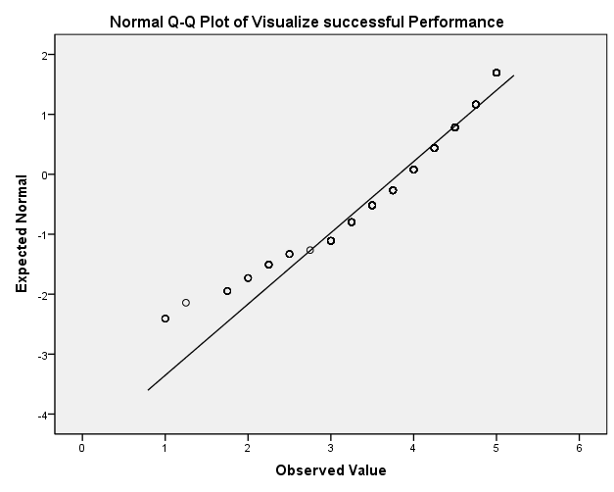
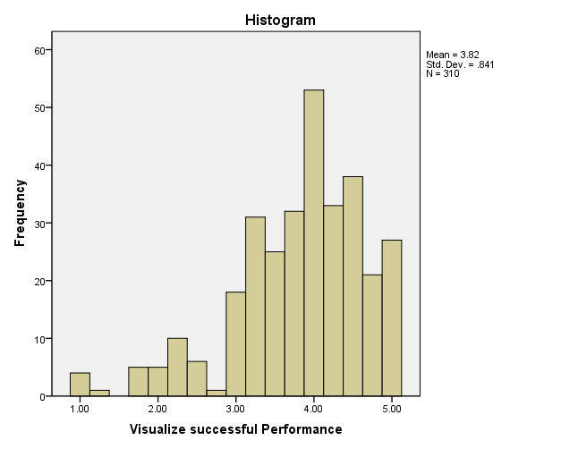

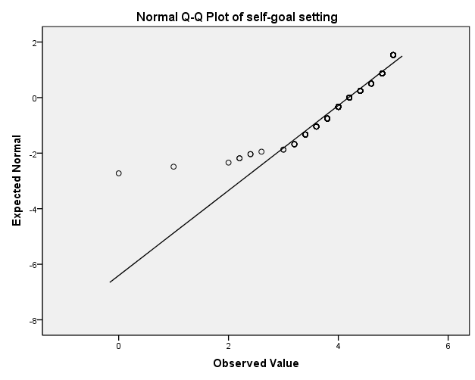
self-goal setting
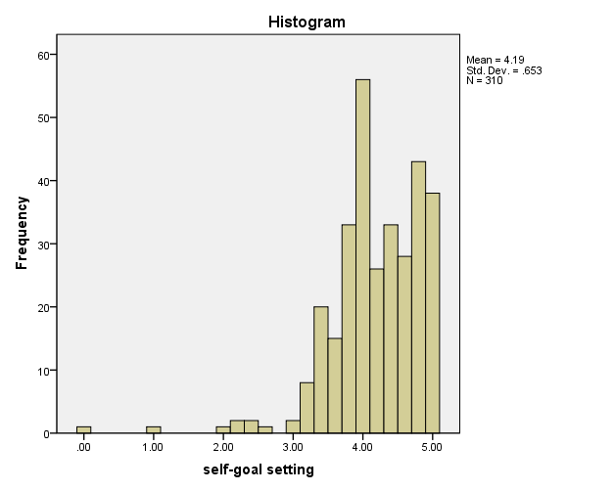

self-talk

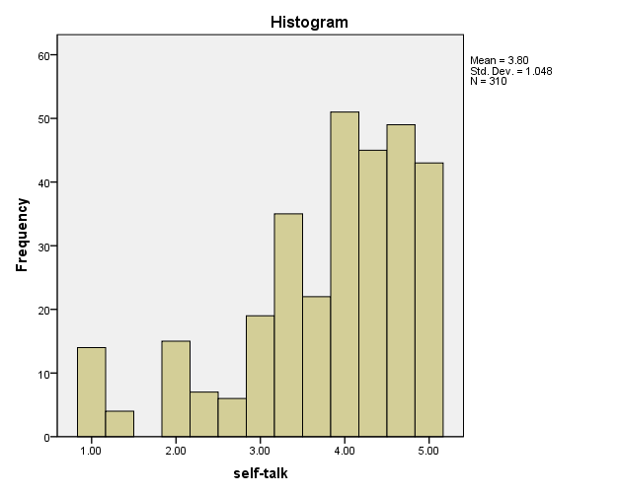
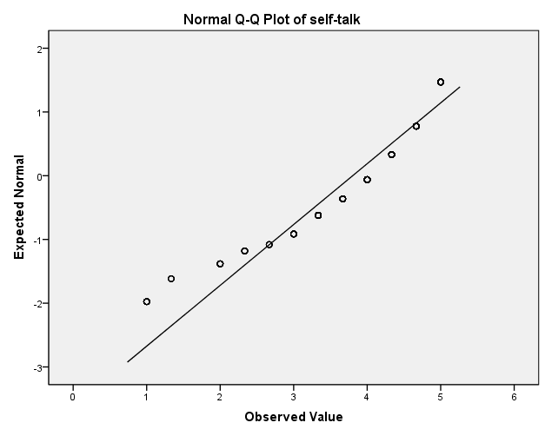

Self-reward

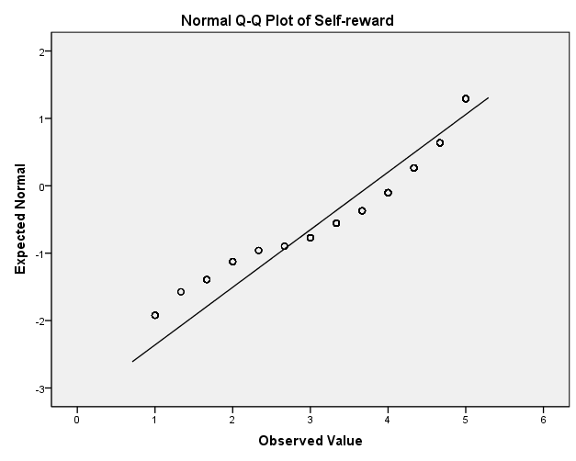
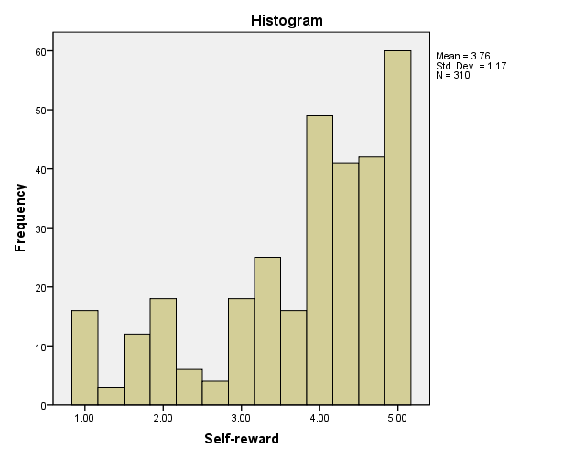

Evaluating beliefs and assumptions
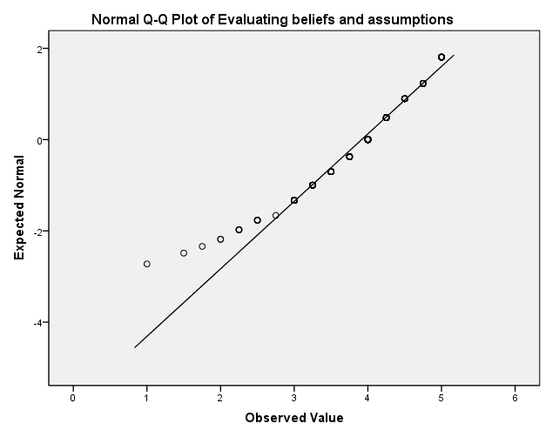
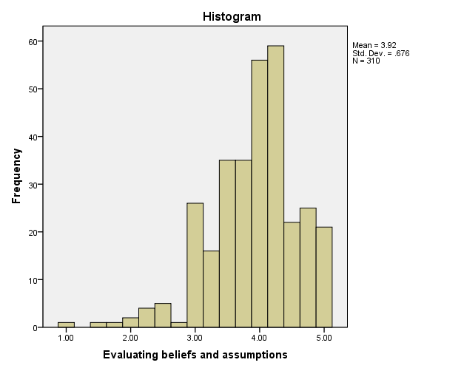

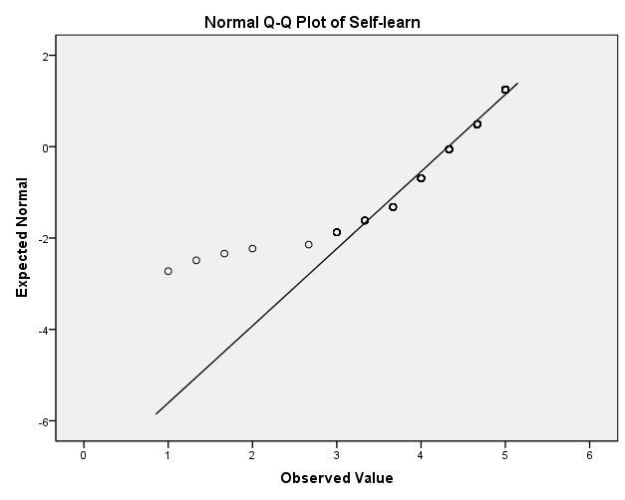
Self-learn
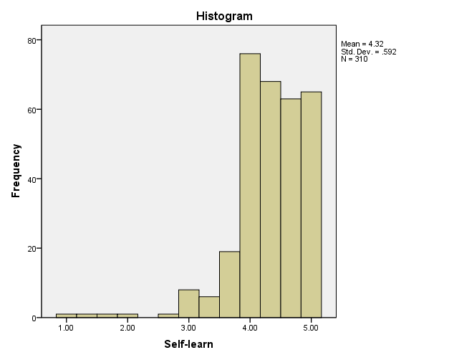

Self-observation
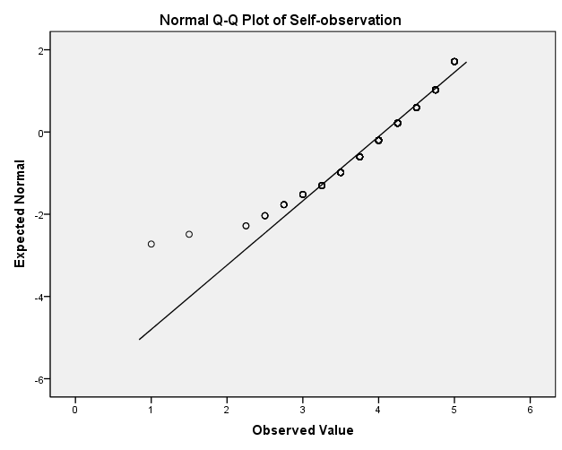
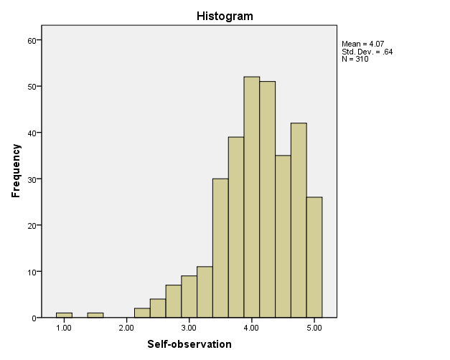
Focusing on natural rewards
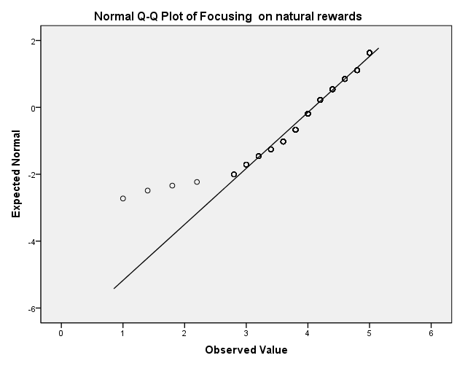
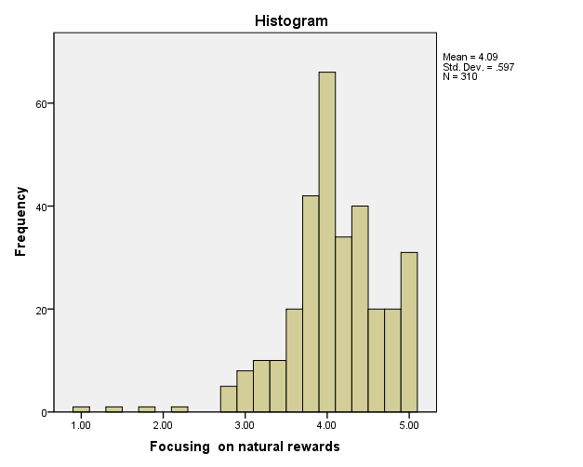

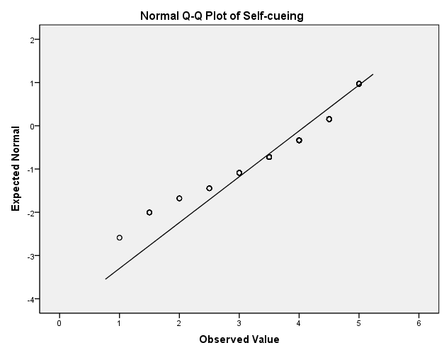
Self-cueing
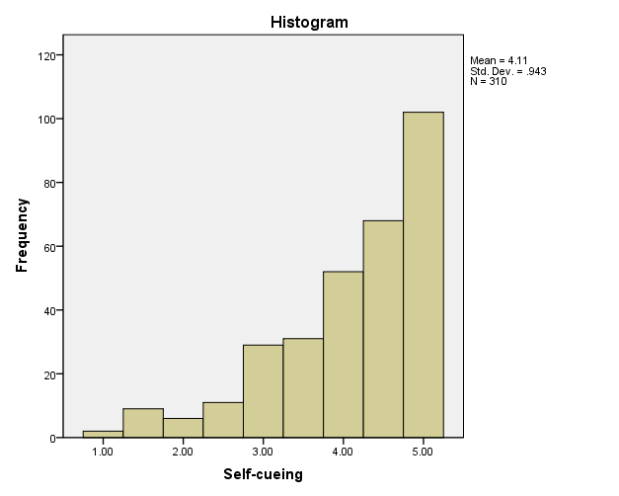
Descriptive

Notes
Output Created |  | 01-Aug-2015 12:00:05
Comments
Input | Data | C:\Dropbox\ADU\DBA Thesis\Muhra\Data Analysis\Data Set\Muhra_MasterDataSet.sav
Input | Active Dataset | DataSet1
Input | Filter | <none>
Input | Weight | <none>
Input | Split File | <none>
Input | N of Rows in Working Data File | 311
Missing Value Handling | Definition of Missing | User defined missing values are treated as missing.
Missing Value Handling | Cases Used | All non-missing data are used.
Syntax |  | DESCRIPTIVES VARIABLES=@35 @36 @37 @38 @39 @40 @41 @42 @43 @45 @46 @47 Vis_Perform self_goal self_talk Self_reward beliefs Self_learn Self_observation Nat_Reward Self_cueing  /STATISTICS=MEAN STDDEV KURTOSIS SKEWNESS.
Resources | Processor Time | 00 00:00:00.015
Resources | Elapsed Time | 00 00:00:00.005

Descriptive Statistics
 | N | Mean | Std. Deviation | Skewness
 | Statistic | Statistic | Statistic | Statistic
Q35 age | 311 | 2.05 | .571 | 1.155
Q36 Gender | 311 | 1.44 | .497 | .254
Q37 Nationality | 311 | 1.25 | .434 | 1.155
Q38 education level | 311 | 3.53 | .810 | -.751
Q39 organizational position | 311 | 2.68 | 1.066 | .292
Q40 years of experience | 311 | 3.56 | .763 | -1.528
Q41 Experience as supervisor | 311 | 3.03 | .973 | -.635
Q42 sector | 311 | 1.18 | .382 | 1.702
Q43 industry | 311 | 11.73 | 5.652 | .327
Q45 Emirat | 311 | 1.22 | .796 | 4.995
Q46 job satsfaction | 311 | 2.18 | .870 | .553
Q47 entrprunure | 311 | 1.78 | .414 | -1.368
Visualize successful Performance | 311 | 3.8248 | .84257 | -.959
self-goal setting | 311 | 4.1878 | .65391 | -1.632
self-talk | 311 | 3.8060 | 1.04824 | -1.099
Self-reward | 310 | 3.7624 | 1.17008 | -.953
Evaluating beliefs and assumptions | 311 | 3.9188 | .67802 | -.801
Self-learn | 311 | 4.3248 | .59261 | -1.701
Self-observation | 311 | 4.0740 | .64081 | -.950
Focusing on natural rewards | 311 | 4.0926 | .59842 | -1.035
Self-cueing | 311 | 4.1141 | .94305 | -1.146
Valid N (listwise) | 310

Descriptive Statistics
 | Skewness | Kurtosis
 | Std. Error | Statistic | Std. Error
Q35 age | .138 | 3.724 | .276
Q36 Gender | .138 | -1.948 | .276
Q37 Nationality | .138 | -.670 | .276
Q38 education level | .138 | 1.476 | .276
Q39 organizational position | .138 | -.369 | .276
Q40 years of experience | .138 | 1.079 | .276
Q41 Experience as supervisor | .138 | -.686 | .276
Q42 sector | .138 | .903 | .276
Visualize successful Performance | .138 | 1.003 | .276
self-goal setting | .138 | 6.640 | .276
self-talk | .138 | .647 | .276
Self-reward | .138 | -.121 | .276
Evaluating beliefs and assumptions | .138 | 1.285 | .276
Self-learn | .138 | 5.995 | .276
Self-observation | .138 | 1.884 | .276
Focusing on natural rewards | .138 | 3.341 | .276
Self-cueing | .138 | .784 | .276
Valid N (listwise)

Reliability
Notes
Output Created |  | 01-Aug-2015 12:22:43
Comments
Input | Data | C:\Dropbox\ADU\DBA Thesis\Muhra\Data Analysis\Data Set\Muhra_MasterDataSet.sav
Input | Active Dataset | DataSet1
Input | Filter | <none>
Input | Weight | <none>
Input | Split File | <none>
Input | N of Rows in Working Data File | 311
Input | Matrix Input
Missing Value Handling | Definition of Missing | User-defined missing values are treated as missing.
Missing Value Handling | Cases Used | Statistics are based on all cases with valid data for all variables in the procedure.
Syntax |  | RELIABILITY  /VARIABLES=Vis_Perform self_goal self_talk Self_reward beliefs Self_learn Self_observation Nat_Reward Self_cueing  /SCALE('ALL VARIABLES') ALL  /MODEL=ALPHA  /STATISTICS=DESCRIPTIVE SCALE HOTELLING CORR ANOVA  /SUMMARY=TOTAL.
Resources | Processor Time | 00 00:00:00.016
Resources | Elapsed Time | 00 00:00:00.011

Statistics
 |  | Q35 age | Q36 Gender | Q37 Nationality | Q38 education level
N | Valid | 311 | 311 | 311 | 311
N | Missing | 0 | 0 | 0 | 0
Mean |  | 2.05 | 1.44 | 1.25 | 3.53
Median |  | 2.00 | 1.00 | 1.00 | 4.00
Std. Deviation |  | .571 | .497 | .434 | .810
Skewness |  | 1.155 | .254 | 1.155 | -.751
Std. Error of Skewness |  | .138 | .138 | .138 | .138
Kurtosis |  | 3.724 | -1.948 | -.670 | 1.476
Std. Error of Kurtosis |  | .276 | .276 | .276 | .276

Statistics
 |  | Q39 organizational position | Q40 years of experience | Q41 Experience as supervisor | Q42 sector
N | Valid | 311 | 311 | 311 | 311
N | Missing | 0 | 0 | 0 | 0
Mean |  | 2.68 | 3.56 | 3.03 | 1.18
Median |  | 3.00 | 4.00 | 3.00 | 1.00
Std. Deviation |  | 1.066 | .763 | .973 | .382
Skewness |  | .292 | -1.528 | -.635 | 1.702
Std. Error of Skewness |  | .138 | .138 | .138 | .138
Kurtosis |  | -.369 | 1.079 | -.686 | .903
Std. Error of Kurtosis |  | .276 | .276 | .276 | .276

Statistics
 |  | Q43 industry | Q45 Emirat | Q46 job satsfaction | Q47 entrprunure
N | Valid | 311 | 311 | 311 | 311
N | Missing | 0 | 0 | 0 | 0
Mean |  | 11.73 | 1.22 | 2.18 | 1.78
Median |  | 10.00 | 1.00 | 2.00 | 2.00
Std. Deviation |  | 5.652 | .796 | .870 | .414
Skewness |  | .327 | 4.995 | .553 | -1.368
Std. Error of Skewness |  | .138 | .138 | .138 | .138
Kurtosis |  | -1.165 | 28.890 | -.093 | -.129
Std. Error of Kurtosis |  | .276 | .276 | .276 | .276

Pie Chart of variables
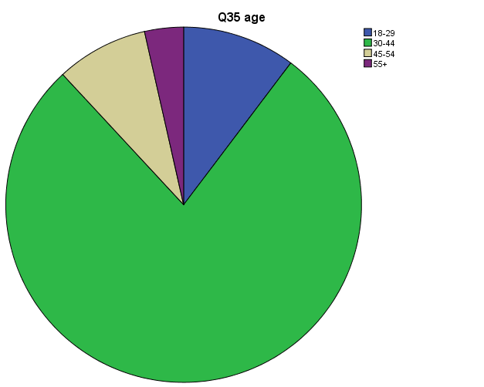
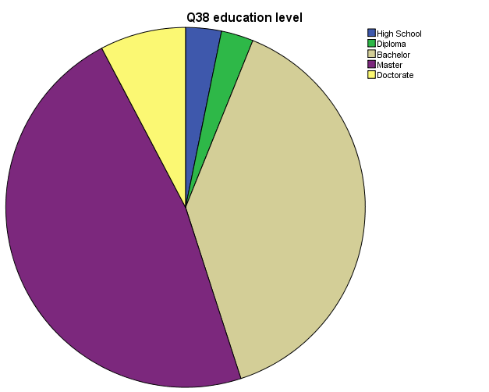

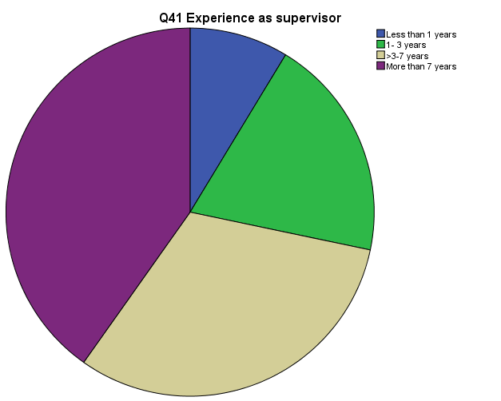
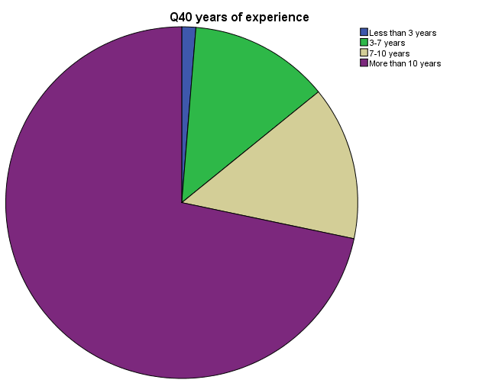

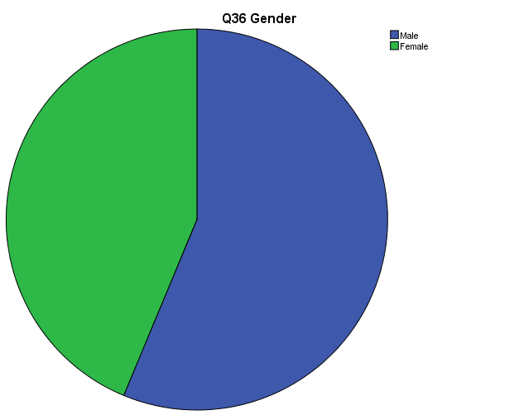

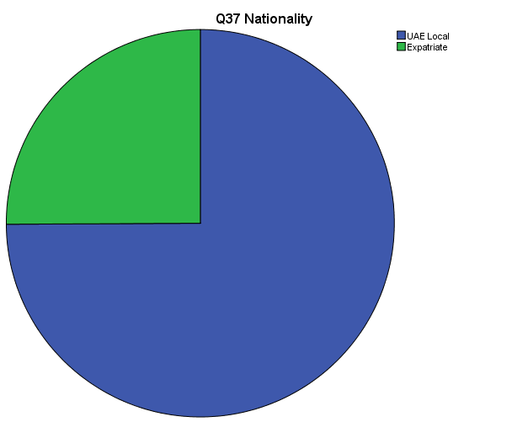
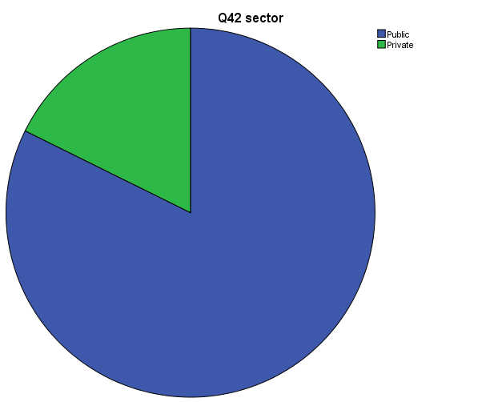

-The End -

