

College of Business

Prioritization of Factors Influencing Teachers’ Job Satisfaction in the Emirate of Abu Dhabi

Presented to
The Academic Faculty

By
Hareb E. Alkhyeli

In partial fulfillment
of the requirements for the degree of
Doctor of Business Administration

Abu Dhabi University
College of Business

Prioritization of Factors Influencing Teachers’ Job Satisfaction in the Emirate of Abu Dhabi

_________________________
Hareb E. Alkhyeli
APPROVED:
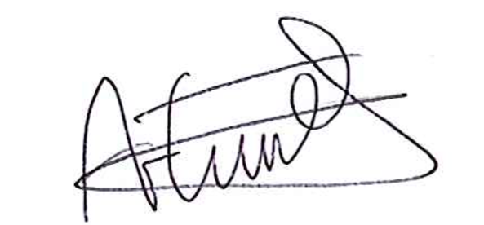


________________________ ________________________
Dr. Anne R. van Ewijk Dr. Ali Abu-Rahma
Assistant Professor Associate Dean / Assistant Professor
College of Business College of Business
Abu Dhabi University Abu Dhabi University
Committee Chair Internal Committee Member



_______________________
Dr. Masood Abdulla Badri
Professor, UAE University
Head of Researcher
Abu Dhabi Department of Education and Knowledge
External Committee Member

________________________
Professor Christos Pitelis
Dean of the College of Business
Abu Dhabi University

Copyright By
Hareb Eisa Alkhyeli
2018

ABSTRACT

The main objective of this empirical study is to support school managers in reducing the high turnover rate among private school teachers in the United Arab Emirates (in particular, the Emirate of Abu Dhabi) by identifying which factors are most likely to increase teacher job satisfaction (TJS). First, a narrative literature review (NLR) of conceptual and empirical studies suggests which theoretical frameworks are likely to provide predictors of TJS. This results in a preliminary model of TJS that outlines predictors from four theoretical areas: motivation, leadership style, job characteristics and cultural intelligence. Second, in order to make this model more comprehensive, a systematic literature review (SLR) covering three main databases and 67 selected papers reveals all proven determinants of TJS, which results in various changes and additions to the preliminary model. Third, a focus group session with local educational experts identifies predictors that are especially likely to be perceived as important for TJS in the Emirate of Abu Dhabi. These predictors then constitute a customized model, including variables from the theoretical areas of motivation, school leadership style, school climate and organisational justice. Fourth, the customized model is subjected to a multi-criteria decision-making analysis (analytic hierarchy process - AHP) based on 24 face-to-face interviews with private school teachers with experience at the kindergarten, elementary, intermediate, and secondary levels. The predictors of ‘pay’, ‘interactional justice’, ‘distributive justice’, ‘recognition’, ‘job security’, and ‘workload’ were perceived by teachers as most important for their job satisfaction. Based on these findings, private school managers and institutional actors, such as Abu Dhabi Educational Council, would do well to focus on these factors in order to decrease teacher turnover.
Keywords: teacher job satisfaction, turnover, predictors, narrative literature review, systematic literature review, focus group, AHP, United Arab Emirates, Abu Dhabi.

ACKNOWLEDGEMENTS

In the name of Allah, the Most Gracious, the Most Merciful
First and foremost, I would like to thank Allah, the Almighty, the Greatest of all, on whom we ultimately depend for sustenance and guidance for giving me the strength, knowledge and opportunity to start this research study, persist and complete it satisfactorily. Without his help and blessings, this accomplishment would not have been possible. Second, I would like to express deep appreciation to my supervisor, Dr. Anne Ewijk, for her extensive knowledge, encouragement, mentorship and guidance throughout the entire journey of this thesis. I would also like to thank my dissertation committee members, Dr. Ali Abu-Rahma and Dr. Masood Badri, for the support they have graciously offered. Third, I would like to acknowledge all the professors at Abu Dhabi University (ADU) who have contributed to my knowledge of methods and techniques, with special thanks to Dr. Matloub Hussain for training me on how to use the AHP technique. Furthermore, I wish to express my gratitude to Ms. Huda Iqbal from the ADU library for guiding me on how to conduct a systematic literature search. Fourth, I wish to express my sincere appreciations to my colleagues from the DBA fifth cohort, especially Dr. Abdulla Almarzooqi, for their help, encouraging comments and constructive criticisms during our research seminars throughout the thesis journey. Fifth, I would like to acknowledge all the educational experts and teachers who have voluntarily participated in the study; without them, there would have been no results. Special thanks to Professor Fahim I. Al Khumassi for his academic and educational advice. Lastly, but not least, I profoundly acknowledge the moral support of my family, my kids, and my friends.

TABLE OF CONTENTS
ABSTRACT iv
ACKNOWLEDGEMENTS vi
LIST OF TABLES xi
LIST OF FIGURES xii
ABBREVIATIONS xiii
CHAPTER 1 INTRODUCTION 1
1.1 Problem 1
1.2 Why UAE? 5
1.3 Purpose 7
1.4 Research Benefit 8
CHAPTER 2 METHODOLOGY 10
2.1 Literature Review 10
2.1.1 Narrative Literature Review (NLR) 11
2.1.2 Systematic Literature Review (SLR) 12
2.2 Empirical Data Collection 14
2.2.1 Focus Group 16
2.2.2 Analytic Hierarchy Process (AHP) 19
2.3 Case description: UAE and Abu Dhabi Education System Overview 21
CHAPTER 3 NARRATIVE LITERATURE REVIEW (NLR) 26
3.1 Teachers’ Job Satisfaction 27
3.2 Motivation 28
3.3 School Leadership Style 32
3.4 Job Characteristics 37
3.5 Cultural Intelligence 39
3.6 A Preliminary Model of Determinants of TJS 41
CHAPTER 4 SYSTEMATIC LITERATURE REVIEW (SLR) 43
4.1 SLR Steps 44
4.1.1 Review Question 44
4.1.2 Searching the Literature 45
4.1.3 Critical Assessment 45
4.1.4 Data Extraction 46
4.1.5 Data Synthesis 48
4.2 Data Analysis and Discussion 52
4.3 Form Preparation 58
CHAPTER 5 FOCUS GROUP INTERVIEW (FGI) 65
5.1 Meeting Preparation 65
5.2 The Meeting 68
5.3 Summarized Results 73
5.4 Final AHP Model 74
CHAPTER 6 AHP STEPS AND RESULTS 76
6.1 AHP Steps 76
6.2 Results 84
CHAPTER 7 DISCUSSION AND CONCLUSION 91
7.1 The Purpose 91
7.2 Summary of chapters 92
7.3 Summary of Findings 95
7.4 Discussion 97
7.4 Recommendations for Future Research 104
7.5 Recommendations for Future Practice 104
7.6 Study Limitations 105
7.7 Conclusion 106
REFERENCES 108
APPENDIX 1: FOCUS GROUP FORM AND MESSAGE TO PARTICIPANTS 138
APPENDIX 2: TEACHERS’ QUESTIONNAIRE 149

LIST OF TABLES

Table ‎2.1: Kysh (2013): Differences between NLR and SLR 12
Table ‎4.1: Predictors of teachers’ job satisfaction 48
Table ‎4.2: The newly mapped predictors of TJS added into the preliminary model categories 52
Table ‎4.3: Factors identified in both ALR and SLR, or ALR only 58
Table ‎5.1: Educational experts' detailed background 66
Table ‎5.2: Summary of focus group results 73
Table ‎6.1: 1 to 9 scale for AHP preferences 80
Table ‎6.2: Experienced Teachers’ Background information 81
Table ‎6.3: Random index 84
Table ‎6.4: Pairwise comparison of goal criteria 85
Table ‎6.5: Pairwise comparison of motivation sub-criteria 86
Table ‎6.6: Pairwise comparison of School Climate sub-criteria 86
Table ‎6.7: Pairwise comparison of Organizational Justice sub-criteria 87
Table ‎6.8: Pairwise comparison of school leadership styles sub-criteria 88
Table ‎6.9: Priorities ranking for the criteria and the sub criteria 88

LIST OF FIGURES

Figure ‎2.1: Research technique and methodology flow chart 25
Figure ‎3.1: A Preliminary Model of Determinants of TJS 42
Figure ‎4.1: Flow chart of research article selection process 48
Figure ‎5.1: The final AHP model 75
Figure ‎6.1: AHP methodology steps 77
Figure ‎6.2: The final AHP model (repeated from Fig. 5.1) 79
Figure ‎6.3: The ranking and percentages of 20 sub-factors 90
Figure ‎7.1: The 20 sub-factors ranking and percentage (repeated from fig. 6.3) 97
Figure ‎7.2: Priority ranking of all factors from highest to lowest from the study by Alkhyeli and Ewijk (2018) 99

ABBREVIATIONS

The following abbreviations are used in this dissertation.
ADEC | Abu Dhabi Education Council
AHP | Analytic Hierarchy Process
CQ | Cultural Intelligence
DSIB | Dubai School Inspection Bureau
FGI | Focused Group Interview
NLR | Narrative Literature Review
SCAD | Statistics Centre - Abu Dhabi
SLR | Systematic Literature Review
TJS | Teacher’s Job Satisfaction
UAE | United Arab Emirates

CHAPTER 1
INTRODUCTION

The United Arab Emirates (UAE), and Abu Dhabi in particular, have expanded rapidly in various sectors, including education, during the last 40 years, due to their vast oil income. The Abu Dhabi government has gone through an extensive reorganization and restructuring of its educational system in response to recent development, radical social change, and economic reform in the Middle East (Litz, Juma, & Carroll, 2016). One of the pillars of Abu Dhabi’s Economic Vision 2030 is “developing a highly skilled and highly productive workforce” (Abu Dhabi Government, 2008).
Sheikh Zayed, founder of the UAE, expressed his vision of education in the words, “the real asset of any advanced nation is its people, especially the educated ones, and the prosperity and success of the people are measured by the standard of their education” (Maitra, 2007). In line with this vision, the mission of the Abu Dhabi Education Council (ADEC) (ADEC, 2016), the educational authority in Abu Dhabi, is “to produce world-class learners who embody a strong sense of culture and heritage and are prepared to meet global challenges” (ADEC, 2016).

Problem
Even with this great attention and care from the Abu Dhabi Government to make its education system world class, the turnover rate among teachers is very high. Edward Murtagh, the inspection and monitoring division manager at ADEC, mentioned that the “annual turnover of teachers at most schools (is) in excess of 20 percent” (Olarte-Ulherr, 2014). Dubai, the neighbouring emirate, is also suffering from the same phenomenon. The headline of ‘Teacher turnover rate up to 60% a year at some schools in Dubai’ was terrifying (Alkhyeli & Ewijk, 2018). The writer of The National newspaper article, Afsha Ahmed, highlighted this fact from the Dubai School Inspection Bureau (DSIB) assessment of 136 schools from October 2010 till April 2011 (Ahmed, 2011). According to Dr. Abdulla Al Karam, Director General of the Knowledge and Human Development Authority, private schools in Dubai had an extremely high teacher turnover, commenting that the average teacher turnover of 15%, when compared to the 5% rates in other counties, is alarmingly high (Ahmed, 2011). The latest report by Dubai School Inspection Bureau indicates that the average teacher turnover rate remains very high, at approximately 16% (DSIB, 2016).
Many school managements, teachers, and students have been impacted by the high turnover rate in the UAE. According to the Statistics Centre - Abu Dhabi (SCAD) report in 2016, there are 444 schools (256 Public and 188 Private) in Abu Dhabi, with 351,501 students and 23,571 teachers in total (SCAD, 2016), which are affected directly by the high teacher turnover rate (above 20%) mentioned by Edward Murtagh. According to the Private Schools Educational Landscape 2013-2014 report, there are 158 private schools in Dubai, with 243,715 students and 14,333 teachers in total, also affected by the this turnover phenomenon (DSIB, 2013).
In 1957, McQuinn reported that, more than forty years ago, around forty percent of the school board heads in a study listed teacher turnover as the biggest issue facing their school (Norton, 1999). The departure of teachers causes the loss of their knowledge of teaching methods and affects the learning style of students, and the training, development and professionalism of school staff (Synar, 2010). In addition, some education experts say that teacher turnover harms schools by:
- Reducing the organization’s productivity (LaHuffman-Jackson, 2009);
- Disrupting the cohesion and relationships of school faculty (Merrill, 2013);
- Stymieing the change of an organization(Merrill, 2013);
- Burdening the school faculty who stays behind (Merrill, 2013);
- Having difficulties in hiring new teachers to cover the shortage of staff (Merrill, 2013);
- Requesting extra budget to cover the shortage of staff (Merrill, 2013).
Experts believe that the cost of teacher turnover is not quantifiable. The price tag is very high for many reasons. Hiring prices differ from place to place and there are hidden costs due to the difficulties of finding teachers, including signing bonuses and subject matter stipends. According to Benner (2000), there could be additional costs added to the bill, such as loss of teaching quality and declines in the achievement of students. In fact, the real cost of replacing teachers is not obvious because it is not highlighted in any line item of the administrator’s annual budget (Synar, 2010).
Teachers’ high turnover rates may negatively affect student learning because they will lead to a shortage of qualified teachers and loss of commitment and continuity. Decreasing the high teacher turnover rates and their negative impact on student achievement is critical, not only to the UAE but worldwide (Dajani, 2014). Teacher turnover affects teaching quality directly, because replacing a teacher contributes to instability and a low quality of instruction. The teacher commitment rate decreases when the teacher turnover rate increases, which discourages the teacher from engaging with students. Substitution of one teacher with another causes inadequate preparation and curricular consistency, which directly affects the academic performance of students (Terry and Kritsonis, 2008).
There have been multiple studies regarding the cause of turnover. In general, school teachers are usually under pressure from parties involved with the education system, including students, their parents, the school and society as a whole. In addition, school teachers face several challenges, which cause frustration, depression, dissatisfaction, and lack of motivation. There are other factors, which demotivate school teachers and make them dissatisfied with their job, such as low salary, lack of promotion, lack of communication, poor working environments and many more. In comparison to other professional groups, school teachers generally experience high work pressure, with low levels of motivation (Seebaluck & Seegum, 2013).
Judge and Hullin (1993) claimed that job satisfaction is connected to eight rudiments, which include turnover rate and absenteeism. Also, Borda and Norman (1997) identified job satisfaction as determining the variable of turnover; they are negatively related (Kessler, 2014; O’Reilly, Frank, Hazy, & Watz, 2005), which means an increase in job satisfaction is associated with a decrease in the turnover rate. Late in the 20th century, attention paid to teachers’ job satisfaction (TJS) increased because of an increase in teacher attrition (Macdonald, 1999) and high teacher turnover rates (Chambers, 2010).
In turn, numerous researchers have tried to highlight the sources of teacher satisfaction and dissatisfaction (Zembylas & Papanastasiou, 2004). Several of them have indicated that motivation (Nadim, Muhammad, Masood, & Riaz, 2012; Shabbir & Wei, 2015), school leadership style (Josanov-Vrgovic & Pavlovic, 2014), job characteristics (Na-Nan & Pukkeeree, 2013), and cultural intelligence (CQ) (Bücker, Furrer, Poutsma, & Buyens, 2014) play an important role in teacher satisfaction (Alkhyeli & Ewijk; 2018).

Why UAE?
The research will be conducted in the UAE for various reasons. First of all, most of the studies of the determinants of teacher satisfaction have been investigated in western, developed countries and little research has been done in the UAE. Second, the UAE and its education system are relatively new in comparison to other countries (Gaad, Arif, & Scott, 2006) and need many studies as a basis for improvement. Third, complaints of suffering have been reported by private schools in the UAE. Fourth, the turnover rate is very high compared to other countries, reaching 60 % at some schools in Dubai. Fifth, the UAE is an interesting context to study, due to its relatively high expatriate population, which might affect how teachers determine their job satisfaction, especially in relation to culture. It has one of the world's greatest net migration rates and expatriates make up roughly 70 % of the UAE population. The UAE is also particularly interesting to study because it has a diverse culture. It has workers from the USA, Philippines, India, Australia, Indonesia, and others. Cross-border mobility in the UAE causes interaction among people with diverse customs, languages and ethnic backgrounds (Al-Jenaibi, 2012; Gaad et al., 2006).
The study will focus on private schools in the Emirate of Abu Dhabi, which is the capital of the UAE and accounts for 87% of the UAE surface area, 83,600Km² (WSIS, 2014). Private schools have high variation in teachers’ salaries, quality of education, the education system they follow, and the nationality of their teachers, compared to public schools, which are managed and controlled directly by ADEC. Most of the private schools are considered to be intercultural schools (Keung & Rockinson-Szapkiw, 2013), which makes them a good choice to measure culture-related factors, such as CQ. The public schools have stricter control and monitoring by ADEC if compared to private schools, in spite of quality assurance by ADEC (ADEC, 2016). Furthermore, the Abu Dhabi government, and ADEC in particular, have invested a lot of money to improve the education system to make it world class, pushing all students to reach their full future potential and participate in building tomorrow’s sustainable competitive market environment (ADEC, 2016). Lastly, ADEC has formally acknowledged its support of this research and will contribute to the study by its resources if needed during the data collection.

Purpose
The main objective of the current empirical study is to find out which are the most important factors that increase teachers’ job satisfaction in the UAE, especially in Abu Dhabi, so that we can reduce the turnover rate among private school teachers. This can be achieved by pursuing five detailed objectives:
- To conduct a narrative literature review (NLR) of previous papers on teachers’ job satisfaction (TJS) to identify the initial factors and sub-factors that could be included in a preliminary model of determinants of TJS.
- To conduct a systematic literature review (SLR) of previous empirical studies to develop a model into an overview of factors and sub-factors, which influence TJS.
- To customize this model to the context of the UAE through consultation with experts from ADEC and the education field.
- To determine Abu Dhabi private school teachers’ preferences and priorities of the main factors and sub-factors which influence TJS in the teachers’ eyes.
- To test and validate the final proposed model on a wider scale of the Emirate of Abu Dhabi by surveying and interviewing private school expert teachers from kindergarten, elementary, intermediate, and secondary levels.

Research Benefit
This research will be the first to investigate a comprehensive model of teachers’ job satisfaction in the context of private school teachers in the UAE. It will also be the first study to investigate teachers’ job satisfaction using an analytic hierarchy process (AHP) methodology. This is a structured decision-making instrument for arranging and examining complex decisions that involve many criteria and alternatives (Unutmaz, 2014). Also, the Systematic Literature Review of TJS and its predictors will be the first such research to be conducted in this subject area.
The results will provide private school management in the Abu Dhabi with a broader view of the common problems facing teachers. This study could also lead to solutions for improving TJS. The recommendations for addressing the issues identified will lead to higher profitability for schools by reducing the high teacher turnover rate (Kroth, 2007). The findings will provide greater focus on positive changes that will enhance the school management’s efforts to increase teachers’ job satisfaction, which will result in improving the quality of teaching and the school achievement of pupils (Michaelowa & Wittmann, 2009). The ultimate goal of education is to pass on to our children the necessary information and skills that they will be using throughout their lifetime (Mitra, 2011). This research will be beneficial, not only to existing private school management and owners, but also to potential investors and ADEC (Alkhyeli & Ewijk, 2018). The upcoming chapter elaborates on the methodology and the dissertation stages. Chapter 3 presents the narrative literature review of the major concepts regarding teachers’ job satisfaction and presents the preliminary model. Chapter 4 describes the systematic literature review steps and provides a comprehensive overview of studies on predictors of the TJS. Chapter 5 outlines the focus group interview (FGI) and presents the interview results in the form of a customized model that will be used for the AHP analysis. Chapter 6 describes the steps in the AHP process and presents the survey results. Chapter 7 discusses the potential implications of the study findings and suggestions for future research.

CHAPTER 2
METHODOLOGY

This chapter will talk briefly about the technique and methodology that will be used in the research. It will also outline the stages that the research will go through and the outcome of each stage. The main objective of the study is to generate a customized model of teacher job satisfaction (TJS) through identifying all determinants of TJS. This will be achieved through a narrative literature review (NLR), followed by a systematic literature review (SLR). Once the model is complete, customization of the final analytic hierarchy process (AHP) model may take place during the empirical data collection phase through a focus group and the prioritization of determinants through AHP interviews. This chapter will first describe the literature review, which will include two stages; the NLR and SLR. This will be followed by an outline of the empirical data collection process, which will also include two stages; the focus group interview (FGI) and the AHP.

Literature Review
The current research will involve two types of literature review, NLR and SLR. The narrative, or traditional, literature review summarizes various primary studies, from which conclusions can be drawn to form a holistic explanation, based on the assessors’ own experience and existing models (Kirkevold, 1997; Kitson, Marshall, Bassett, & Zeitz, 2013). In contrast, the SLR is a methodology borrowed from the medical sciences, where it is embraced to produce research in a systematic, transparent, and reproducible way (Parris & Peachey, 2013). As explained by ten Ham-baloyi and Jordan (2016), “The systematic review process employs literature review methods to select only those studies that meet specific criteria which reasonably confirm the rigour of the ‘evidence’ produced by a previously published study”. The NLR will be conducted first to identify existing patterns and find connections among the researched subjects. There will be no restriction rule in building the preliminary model; it may include non-empirical studies to provide key terms that can later be used in the SLR.

Narrative Literature Review (NLR)
Articles considered in a NLR are usually publications that discuss and describe a state of a science or a theme or specific topic from a contextual and theoretical point of view. A review in this modality differs from a systematic review in numerous ways; it tends to be descriptive and does not involve a systematic literature search. It does not involve a methodological approach or a list of databases to conduct the review; nor does it involve an evaluation criterion for inclusion of selected articles during a database search. It usually focuses on a subset of studies of a certain topic, selected on the basis of the author’s experience and choice or availability. It offers readers the latest knowledge concerning a theme or specific topic (Staffoli et al., 2017), but is subject to the limitation of the author’s selection of articles for review.
The purpose of the NLR is to identify some of the well-known factors and their sub-factors and come up with a preliminary model of determinants of TJS based on existing studies and the researcher’s experience. The model will be further developed through the SLR, customized by the focus group and tested through the AHP process. It will be further discussed in chapter 3.

Systematic Literature Review (SLR)
Technological advances permit us to access scientific publications and different types of research from all parts of the world more easily than in the past. This has dramatically increased the interest in and use of SLR approaches over the last 25 years. SLR methods are now commonly used in many fields, such as medicine, ecology, social science and business. The SLR approach is considered the most reliable source of evidence in healthcare sciences, because of the high precision of the retrieved summary and the broader applicability of the results. It is now considered to be the standard way of synthesizing evidence in qualitative and quantitative studies (Fukushige, 2016).
The SLR approach has methodological advantages over NLR because the NLR uses a subjective selection process for its articles and, therefore, the studies that are chosen for inclusion in the review are liable to be biased. Also, the methodological approaches that are used in conducting the NLR are not stated. However, the SLR states the review process in a detailed and comprehensive way that makes the study selection process very clear. Any trained reviewer can replicate the same review process and results by following the review protocol (Fukushige, 2016). Some basic differences are presented by Kysh, (2013) in table 2.1.
Table ‎2.1: Kysh (2013): Differences between NLR and SLR
 | NLR | SLR
Definition | Qualitative. Summarises a topic, using informal or subjective measures to collect and interpret studies/ | High-level overview of primary research on a focused question that identifies, selects, synthesises, and appraises all high-quality research evidence relevant to that question.
Goals | Provide summary or overview of topic | Answer a focused question.  Eliminate bias.
Question | Can be a general topic or a specific question | Clearly defined and answerable question.
Components | Introduction  Methods  Discussion  Conclusion  Reference list | Pre-specified eligibility criteria  Systematic search strategy  Assessment of the validity of findings  Interpretation and presentation of results  Reference list
Number of authors | One or more | Three or more
Timeline | Weeks to months | Months to years
Requirements | Understanding of topic  Perform searches of one or more databases | Thorough knowledge of topic  Perform searches of all relevant databases  Statistical analysis resources (for meta-analysis)
Value | Provides summary of literature on topic | Connects practice to high-quality evidence  Supports evidence-based practice

The SLR involves several steps, which differ from one researcher to another and from one standard method to another; however, the sequence of steps is similar. The process described by Whittemore and Knafl (2005) will be the structured framework used in this study to conduct the SLR. It consists of five steps: review question, searching the literature, critical appraisal, data extraction, and data synthesis. These steps will be explained in more detail in chapter 4. The purpose of the SLR is to identify academically all factors that predict teachers’ job satisfaction. The most frequently mentioned factors would be considered the most important in the eye of academic researchers.

Empirical Data Collection
There are many ways of obtaining data; from interviews, questionnaires, tests, journals, diaries, classroom observations, etc. Quantitative methods usually use closed-ended questionnaires and tests so that data can be analysed and interpreted. On the other hand, qualitative methods typically make use of classroom observations, journals, interviews, open-ended questionnaires and diaries to get, analyse and explain the data (Zohrabi, 2013). In the current study, the data will be collected through two types of methodology; the focus group and interviews based on AHP.
Traditionally, business researchers used quantitative research methods and they started to use a qualitative approach only several decades later (Miller & Cameron, 2011). This research will be based on a qualitative phenomenological focus group method by interviewing Abu Dhabi educational experts face-to-face to recommend the most valuable factors and sub-factors that predict TJS. Learning is the most important objective of qualitative research (Boyer, 2013; Rossman & Rallis, 2003).
The quantitative method has a limitation from the perspective of the depth of the information collected, if compared to the qualitative method of examining human behaviour and the real-world experiences of the participants (Boyer, 2013). The qualitative method is more robust in gathering data and sensing reality because information comes from the experience and viewpoint of the participants (Creswell, 2007). Van Manen (1990) said “a good phenomenological description is collected by lived experience and recollects lived experience”. Lester (1999) noted that “Qualitative phenomenological methods seek essentially to describe rather than explain, starting from a perspective free from hypothesis or preconceptions” (Boyer, 2013). Williams and Katz (2001) commented that:
qualitative methods such as focus groups, participant observation, case studies, and individual interviews pay more attention to the original voices of actors in their everyday life, allowing researchers the possibility of observing and presenting a broader view of social reality within their research practices. (Williams and Katz, 2001)
In the qualitative research method, there are five approaches that are used, according to Moustakas (1994); empirical phenomenological research, heuristic research, hermeneutics, ethnography, and grounded theory. The researcher believes that a qualitative phenomenological approach is the most appropriate for this study. The hermeneutics method would be inappropriate because it involves interpreting meaning instead of description (Boyer, 2013). Also, Laverty (2003) states that “hermeneutic phenomenology is concerned with the live world or human experience as it is lived” (Boyer, 2013). The researcher also believes that the ethnography method would be inappropriate, because it involves interacting with individuals who belong to a particular cultural group (Moustakas, 1994). The grounded theory method also would be inappropriate, because it requires developing a theory based on data gathered (Boyer, 2013).
The list of factors and their sub-factors that will be produced through investigating literature, specifically the NLR and SLR, will be very large and some of them could be not very valuable to be tested in the Emirate of Abu Dhabi. Therefore, there will be a need for educational experts in Abu Dhabi to select the most valuable five factors and up to twenty five sub-factors, which will be the final model (the AHP Model), that predicts TJS through a focus group interview (FGI). The detail of the FGI will be discussed in chapter 5.

Focus Group
Williams and Katz (2001) defined the focus group as “a small gathering of individuals who have a common interest or characteristic, assembled by a moderator, who uses the group and its interactions as a way to gain information about a particular issue”. Powell and Single (1996) add that “this information can be used to identify potential areas of enquiry or to clarify subject matter that, by its nature, eludes other research instruments”. In the current study, the Abu Dhabi education experts’ recommendation of which are the most valuable factors and their sub-factors will be the needed information and output of the FGI.
The first record of research through a focus group appeared in an article by Bogardus in 1926. He tested his social distance model by using the findings of tiny discussion groups with students. The next academic attention to focus groups took place in an evaluation of audience replies to radio programs during the 1940s by Merton and his colleagues. In 1956, the first book dedicated to focus group methodology was produced by Merton, Fiske, and Kendall (Merton, Fiske & Kendall, 1956). Despite this offering, the use of focus groups as a practice was largely ignored by the social science community throughout the 1960s and 1970s. Between the 1980s and 1990s, focus groups gradually became popular as a data collection method, especially in the areas of health sciences, nursing, and medical sociology (Powell & Single, 1996).
The focus group is particularly useful when the current knowledge of a topic is insufficient and the production of new hypotheses is important before a legitimate questionnaire can be constructed. It is also useful when the topic under investigation is complicated and concurrent use of extra data collection techniques is needed to safeguard validity, or when the topic under investigation includes many variables, as in our case. A focus group allows the researcher to focus on the most valuable variables. In such cases, the findings of a quantitative survey may be misleading or vague and statistical associations need clarification and elaboration (Powell & Single, 1996).
Fatemeh Rabiee (2004) noted that many authors recommend that the number of focus groups could be three or four when using a simple research question. Also, she mentioned that the optimum number of participants for a focus group could vary. Krueger and Casey (2000) recommended between six and eight participants because smaller groups demonstrate greater potential (Rabiee, 2004). In the current research, the targeted participants to collect the needed data are a minimum of five educational experts who have a specific role in the Abu Dhabi Education Authority (ADEC) and some private school staff.
The first participant should be the head of research in ADEC. The second one should be the head of all private schools in the Emirate of Abu Dhabi. The third one should be a teacher who has worked in a private school in the UAE for at least 15 years. These previous three people must attend the working group meeting. The last two should be the heads of the education office in Al Ain and the Western Region or their representatives, and it would be good to have them in the meeting.
The final recommended AHP model, the outcome reported in chapter 5, will consist of many factors and sub-factors and it will be very difficult for an expert teacher to prioritize all of the factors that influence the job satisfaction of private school teachers in the Emirate of Abu Dhabi. There will, therefore, be a need for a technique to assist the expert teachers to rank all the recommended factors and their sub-factors. The AHP technique will be chosen as the most appropriate and useful approach to simplify ranking these factors and their sub-factors since it is widely used for solving multi-criteria decision-making problems such as this one. The AHP steps and results will be presented in detail in chapter 6. Chapter 7 will be the discussion, recommendation, and conclusion chapter (Alkhyeli & Ewijk, 2018).

Analytic Hierarchy Process (AHP)
The AHP as a concept was introduced in the 1970s (Saaty, 1983). It was originally developed by Saaty (1980) to provide a methodology for solving various kinds of multi-criterion decision problems, depending on the related priorities allocated to each criterion’s role in reaching the stated objective. It is a scoring model that depends on subjective managerial inputs on multiple factors (criteria) (Alkhyeli & Ewijk, 2018). These inputs are transferred into scores, which are employed to assess possible alternatives. It is a powerful management tool and is very valuable in structuring complicated multi-criterion, multi-person decisions in both economics and business (Handfield, Walton, Sroufe, & Melnyk, 2002).
The AHP was not invented to replace the thinking of decision-makers; it is designed to organize their thoughts. The strength of the AHP is that it treats the decision as a system, which is very hard for numerous decision-makers to do. Limited cognitive processes and bounded rationality make it almost impossible for decision-makers to take into account all of the factors that are involved in a complicated screening decision. Without tools such the AHP, decision-makers would decide based on a subset of criteria, while not comprehending their interactions and relative importance. The AHP simplifies complex decision processes by treating them in a systematic manner. Conducting this type of analysis allows decision-makers to prioritize the criteria in ways that might otherwise not be feasible (Handfield et al., 2002). The AHP makes the prioritization problem simpler and more meaningful by reducing the list into pairwise comparisons with a ratio assessment for each pair (Alkhyeli & Ewijk, 2018).
Lee and Drake (2010) and Ishizaka, Pearman, and Nemery (2012) explained that the AHP is an emerging solution to simplify multi-criteria decision-making and complex real-world problems (Hussain, Ajmal, Khan, & Saber, 2015). Since its invention, the AHP as a tool has been used widely by decision-makers and researchers in various situations, such as resource allocation, planning, selection of the best alternative, conflict resolution, optimization, and education. The AHP is very flexible and can be integrated with various techniques such as fuzzy logic, quality function deployment, linear programming, etc. (Vaidya & Kumar, 2006).
In most AHP research, decision-makers (experts) are required to provide verbal, qualitative statements regarding the relative importance of one criterion over another, relying on their experience and knowledge. In fact, the process of decision-making is complex and poses a great deal of uncertainty, which requires qualitative preference by using the pairwise comparisons approach. The pairwise comparisons approach does not involve unwieldy mathematics (Kundakçi, Adali, & Işik, 2016) and the qualitative methods are mainly inductive, in contrast to the deductive approaches of experimental science. Qualitative scholars argue that their work does not consist of testing hypotheses; they are mainly interested in understanding a specific situation or (sub) culture or individuals or groups of individuals, etc., instead of explaining and predicting future behaviours as hard sciences do (Bendassolli, 2013).

Case description: UAE and Abu Dhabi Education System Overview
The UAE is located in Southwest Asia between the Arabian Gulf and the Gulf of Oman, bordering Saudi Arabia and Oman. It is situated in a strategic vital transit location for world crude oil, the Straits of Hormuz. The education system of the UAE is relatively new in comparison to other countries (Gaad et al., 2006). It is a four-tier system covering 14 years of education: Kindergarten (4-5 years), Elementary (6-11 years), Intermediate (12-14 years), and Secondary (15-17 years). It is divided into two groups: private and public sector, the latter being funded by the UAE government. All UAE citizens have free access to all public schools, whereas expatriates are seldom admitted to them. Therefore, numerous expatriates have opened private schools to meet their education, cultural, and religious needs. In fact, the private schools are expanding faster than the public ones as various new schools open each year (Gaad et al., 2006). According to a report by Nagraj (2018), there were 627 private schools in UAE at the end of 2017 (Nagraj, 2018). These schools had students and teachers from a broad and diverse range of nationalities, including Emiratis (Dickson, Kadbey, & McMinn, 2015).
The aim of ADEC, the educational authority in Abu Dhabi, is to “develop education and educational institutions in the Emirate of Abu Dhabi, implement innovative educational policies, plans and programs that aim to improve education, and support educational institutions and staff to achieve the objectives of national development in accordance with the highest international standards” (ADEC, 2016). ADEC always seeks to improve the education system in the Emirate of Abu Dhabi, whether in the public or private sector. Even though private schools follow different educational standards, such as American, British, Indian or the UAE Ministry of Education, they will always be monitored and advised on how to improve. Currently, according to the ADEC database, there are 191 private schools located in three regions of the Emirate of Abu Dhabi; Abu Dhabi Capital District (121 private schools), Eastern Region (59 private schools), and Western Region (11 private schools) (ADEC, 2016).
ADEC usually inspects the performance all private schools every two years, in a programme they call “Irtiqaa”. They have three main rating bands or categories; Band A (High Performance), Band B (Satisfactory), and Band C (In need of significant improvement). Band A is further divided into three categories; Outstanding, Very Good, and Good. Band B has only one category, Acceptable. Band C is further divided into two categories; Weak and Very Weak. The inspection or evaluation involves six criteria; students’ achievement; students’ personal and social development and innovation skills; teaching and assessment; curriculum; the protection, care, guidance and support of students; and leadership and management (ADEC, 2016).
In each region of Abu Dhabi, the study of JTS will be conducted on two differently rated private schools (a high performance or satisfactory school and one identified as needing improvement), which also follow different educational standards, from each level of education from kindergarten to secondary or high school to test the final model (the AHP model) in various types of schools. At each level, one expert teacher will be interviewed and questioned in every school, which makes a total of four experts per school, a total of eight experts per region, and a total of twenty-four experts for this part of the study. The interviewed experts’ teaching experience should be at least 10 years, including at least 5 years’ experience in the UAE. The most experienced expert teacher will be selected first.
The researcher is planning to obtain prior permission to conduct the AHP study from Abu Dhabi University authority, ADEC, and 6 private school managements in Abu Dhabi. There will be one-to-one interviews with 4 participants from each private school. Each interview is expected to last from 45 minutes to one hour. Each participant should sign and date an informed consent form before the interview is conducted (Boyer, 2013). The interview should be at the participant’s site or their preferred choice, to enter the participant’s own environment (Creswell, 2007; McCoy, 2012). The researcher plans to establish a rapport with each participant at the beginning of each interview and establish the history of the participant’s experience as a teacher, as recommended by Rossman and Rallis (2003). The semi-structured interview will be recorded digitally.
In summary, the researcher will perform a NLR to come up with a base model, which will consist of the initial important factors and their sub-factors. Then, there will be a systematic review of all empirical studies to come up with a comprehensive list of factors and sub-factors that predict TJS. Later, a focus group of Abu Dhabi educational experts will select the most valuable factors to produce the final model (the AHP model) to conduct the main empirical study. Finally, there will be a prioritization of these factors and their sub-factors by a representative sample of experienced private school teachers to produce a ranking list of the most important factors and sub-factors that concern Abu Dhabi private school teachers, as presented in figure 2.1.

Figure ‎2.1: Research technique and methodology flow chart

CHAPTER 3
NARRATIVE LITERATURE REVIEW (NLR)

As outlined in chapter 1, many researchers have tried to highlight the sources of teacher satisfaction and dissatisfaction (Zembylas & Papanastasiou, 2004). Several of them have indicated that motivation (Nadim et al., 2012; Shabbir & Wei, 2015), school leadership style (Josanov-Vrgovic & Pavlovic, 2014), job characteristics (Na-Nan & Pukkeeree, 2013), and cultural intelligence (CQ) (Bücker, Furrer, Poutsma and Buyens, 2014) play an important role in teacher satisfaction (Alkhyeli & Ewijk, 2018).
In the current chapter, we are trying to browse literature to create a preliminary model of determinants of teacher’s job satisfaction (TJS) based on existing studies and the researcher’s experience. It is not part of the scope of this study to measure the relationship of the four factors mentioned above and their sub-factors to TJS, as in the usual quantitative studies. Also, we are not trying to prove and confirm the relationship between the identified factors and their sub-factors. In this study, we are trying to see if there are existing studies that the importance of these factors in relation to TJS or using an AHP method. At the end of this chapter, we need to come up with a preliminary model, also called an AHP base model, of the determinants of TJS, which will be the starting point of the systematic literature review (SLR), which aims to increase its comprehensiveness.

Teachers’ Job Satisfaction
Hoppock (1935) initiated the first detailed investigation of the concept of job satisfaction (Butler, 2010). The human relations movement has since affected the concept of satisfaction and emphasized the need for further research. Although there are many definitions of job satisfaction, there has been no scholarly agreement on the definition (Gkolia, Belias, & Koustelios, 2014). In fact, since it is a multidimensional and dynamic construct (Noori, Fatemi, & Najjari, 2014), the definition should change based on the research subject (Gkolia et al., 2014).
Job satisfaction, according to Hoppock, is “any combination of psychological, physiological, and environmental circumstances that cause a person truthfully to say, “I am happy with my job” (Butler, 2010), which serve as a definition for the current study. Carroll and Blumen (1973) describe it as an “affective orientation of the individual toward work” (as cited by Turner, 2007). Job satisfaction is one of the most examined concepts in the human resources field (Martínez- Gómez, Marín-García, & Giraldo-O'Meara, 2014).
The levels of TJS vary, depending on individual and school characteristics (Spear, Gould, & Lee, 2000). TJS also depends on teachers’ roles and their perception of those roles (Lawler III, 1973). Over the last twenty years, many researchers have tried to highlight the sources of teacher satisfaction and dissatisfaction. Teachers’ job satisfaction involves the capability to work with children; recognition; decision-making involvement; school’s leadership style that promotes participation; autonomy to be creative; personal and professional development; opportunities and intellectual challenges that teaching offers; cooperation; and friendships developed. Conversely, teachers’ job dissatisfaction involves the lack of empowerment and professional autonomy; low decision-making involvement; role confusion and ambiguity; substantial bureaucratic-administrative tasks and workload; poor pay; poor physical working conditions; inadequate resources; ambivalent evaluating criteria; frequent forced educational reforms; low professional development; lack of effective school administration; constant criticism; and low recognition by society for their contribution (Alkhyeli & Ewijk, 2018; Anastasiou & Papakonstantinou, 2014).

Motivation
Ryan and Deci (2000) expressed the opinion that “to be motivated means to be moved to do something. A person who feels no impetus or inspiration to act, is thus characterized as unmotivated, whereas someone who is energized or activated toward an end is considered motivated”. Kroth (2007) mentioned that the discussion of “what moves people, and then keeps them moving” has been going on since at least the time of ancient Greece.
Abraham Maslow was the first to address the scientific motivation theory. He said that humans have several needs because they are psychological and social entities. The purpose of his theory was to explain human motivation and the personal development needs of employees (Ozguner & Ozguner, 2014). Kroth (2007) said that the “Maslow theory is one of the most referenced motivational theories in academic and management literature”.
Maslow said that people go up in their hierarchy of needs as they satisfy each need. The needs that are not satisfied will be motivated until they are fulfilled. He imagined the hierarchy as a pyramid; the lower part of the pyramid is survival, then comes safety and security, next belongingness, followed by esteem, and lastly self- actualization (Kroth, 2007). In summary, he mentioned that there are five needs: physiological, survival, safety, love, and esteem, which must be fulfilled before an individual can act unselfishly (Boyer, 2013).
Apart from Maslow’s Hierarchy of Needs theory (Maslow, 1954), there are other well-known motivation theories, such as Herzberg’s motivation-hygiene theory and McGregor’s theory. According to Herzberg’s theory, job satisfaction and job dissatisfaction have different causes. Job satisfaction depends on motivators, whereas job dissatisfaction is the result of hygiene factors. He argued that motivators are intrinsic to the job, while hygiene factors are extrinsic to the job (Ozguner & Ozguner, 2014). Herzberg’s theory can be applied in the field of education, even though it has mostly been applied in the business field (Boyer, 2013).
The previous three theories, Maslow (1954), Herzberg (1974), and McGregor (1960), have stood the test of time and are precious lenses through which to review motivation. After that, the research field of motivation has grown rapidly. Self-efficacy, goal theory, perceived organizational support (POS), expectancy theory, organizational citizenship behaviour (OCB), and organizational justice are just a few of the more prominent motivation theories that are being researched today (Kroth, 2007).
Numerous instruments for measuring job satisfaction have been developed and used over the years (Gkolia et al., 2014). These instruments are designed and selected based on the specific type of research. One of the first instruments is the Job Descriptive Index (JDI). It has 5 sub-factors (motivators): work, payment, promotion, supervision and colleagues. The Minnesota Satisfaction Questionnaire (MSQ) has 20 sub-factors, which is the biggest subdomain of all the instruments. Some these surveys assess specific facets, such as Teacher Job Satisfaction Questionnaires (TJSQs) and JDI, while others assess more generally, such as Global Job Satisfaction (GJS). The MSQ is capable of measuring both global job satisfaction and its dimensions (Astrauskaite, Vaitkevicius and Perminas, 2011; Heneman & Schwab, 1985). All these instruments have their own motivators, some of which are similar while others are different. Not all of them can be incorporated in the current study because this would be too much information to present to the interviewees. However, the most valuable motivators should be investigated and incorporated in the study.
The TJSQs is the instrument most used to measure TJS (Ariffin, Hashim, & Sueb, 2013; Clark, 2006; Knox, 2011; Seco, 2002; Shabbir & Song, 2014). It consists of nine valuable motivators: supervision, colleagues, working conditions, pay, security, work itself, advancement, responsibility, and recognition (Best, 2006). Supervision generally refers to the style of management of the school principal and the administrators at the district level (Bumgartner, 2013) and will be covered and measured under the school leadership styles factor. Further, work itself will also be covered and measured under the job characteristics factor.
Advancement or Promotion: While most professions have many levels that allow the employee to improve and show initiative and progress, the profession of a teacher offers only one upper level to move to; the school administration (Derlin & Schneider, 1994).
Responsibility: “The opportunity to be accountable for one’s own work and the opportunity to take part in policy or decision-making activities” (Lester, 1982).
Colleagues: Employees are more satisfied if they work in an organisation that has the right structure and environment for positive interaction between its employees. (Bumgartner, 2013).
Recognition: Employees want appreciation for accomplishing their work, and this appreciation contributes to job satisfaction (Knox, 2011).
Working Conditions: All aspects of an organization, such as policies and procedures, affect the working conditions, whether they have a positive or negative impact on employee job satisfaction (Bumgartner, 2013).
Pay: The completion of normal tasks that are required by the nature of the job are rewarded with pay (Bumgartner, 2013).
Security or Job Security: Employees feel secure when they have policies to protect them with regard to dismissal, retirement, pension, and layoffs (Knox, 2011).
All seven motivators identified above influence job satisfaction, but their reported effects differ from place to place and from one study to other. A study by Thekedam (2010) that investigated the job satisfaction of higher secondary school teachers in Kerala, India, without using the AHP method, ranked nine factors (including the above seven) that needed to be investigated: 1) working conditions, 2) job security, 3) work itself, 4) pay, 5) responsibility, 6) recognition, 7) colleagues, 8) supervision, and 9) advancement or promotion. In a governmental employee study in Shiraz, Iran, Rad and Razavi (2015) ranked some of the previous factors, using the AHP method, as follows: 1) salary and benefits, 2) upgrade and promotion, 3) job type, 4) supervisor, and 5) co-workers (Alkhyeli & Ewijk, 2018).

School Leadership Style
Drucker defined a leader as “someone who has followers” (Brown, 2011). Other writers and researchers defined leadership differently. Stogdill defined it as a procedure in which leaders can affect the activities of an organization to achieve its goal. Hemphill said, “to lead is to engage in an act that initiates a structure–in–interaction as part of the process of resolving a mutual problem”. Finally, Burns defined a leader as someone who persuades his followers to act on particular objectives which represent the wants and needs, aspirations and expectations, and the values and motivations of both leaders and their followers (Harris, 2008).
The first generation leadership theory was the trait theory. Philosophers of this belief claimed that a person is born with the basic traits of leadership so that he or she can be a leader. Others believed that leaders could be generated, even though they were not born with the traits, by enhancing their traits through training and experience. In 1989, Gardner identified fourteen leadership attributes through a study of leaders across organizations in many fields (Brown, 2011).
According to Cronin, good leaders have nine leadership qualities which contribute to a positive climate in an organization: 1) Vision 2) Integrity 3) Flexibility 4) Morale-building 5) Self-confidence and Self-knowledge 6) Ability to focus on achieving goals and desires 7) Wisdom, Judgment, and Intelligence 8) The ability to listen and effectively communicate 9) Energy, Stamina, Courage, and Enthusiasm (Harris, 2008).
Teachers’ satisfaction and the school leadership style are two significant factors in the functioning of the school. Various studies have also concluded that school leadership style is one of the key factors influencing teachers’ satisfaction (Ali & Dahie, 2015; Heller, Clay, & Perkins, 1993; Josanov-Vrgovic & Pavlovic, 2014; Kashagate, 2013; Naureen & Noshaba, 2015; Waters, 2013). The following leadership styles are most often mentioned specifically in the education field (Ali & Dahie, 2015; Benoliel & Barth, 2017; Cerit, 2009; Kashagate, 2013; Waters, 2013). In the current study, they will be measured by a newly developed spectrum in relation to teachers’ job satisfaction:
Transformational Leadership was defined by Jean Brown in 1991 as leadership for change. Transformational leadership tries to influence the conditions that directly affect the quality of instruction and curriculum provided to students in school. It aims to change procedures by encouraging continuous learning among school employees, sharing knowledge within the organization and working hand-in-hand with the society to achieve wider organizational objectives (Onorato, 2013). The transformational school leadership theory became popular among the education community during the 90s, as a reaction towards top-down leadership styles; it raised the consciousness of teachers and students about the importance of school goals (Nedelcu, 2013). In 2001, Northouse mentioned that transformational leadership looks like a procedure of transforming individuals. The transformational leadership style increases the desire to change and lead others because of its effect on individuals. The transformational leadership style is the most favoured style of modern leaders of schools (Harris, 2008).
Transactional Leadership is where a leader exchanges one thing for another. In addition, a leader tries to reach goals based on individual needs, concentrating on strategic problems and favouring a system that supports bottom-line outcomes (Harris, 2008). The transactional leadership style also encourages teachers to participate in decision-making procedures. School leaders who adopt this style react to situations by concentrating on and delivering predictable goals. They can improve knowledge and the work environment for all school members because they are goal-oriented (Harris, 2008). Bass and Avolio (1994) subcategorized transactional leadership behaviour styles into three: 1) active management by exception 2) passive management by exception and 3) constructive transactional. School leaders practice the passive form by setting standards when they are waiting for key matters to arise prior to specific actions. Teachers who cooperate with school leaders under this type of behaviour believe that their roles and responsibilities should be helpful to protect the status of the school (Harris, 2008).
Participative Leadership is practiced by school leaders who consult with their teachers to make shared decisions. Teachers are asked for their input, which establishes a cooperative relationship (Ngotngamwong, 2012). Democratic management, empowerment, decentralization, power-sharing, consultation, and joint decision-making are other commonly used terms as synonyms of a participative leadership style (Ngotngamwong, 2012).
Situational leadership centres on the word ‘fit’ by matching the response of the leader to the needs of the individuals, the group, and the goals. Situational leaders apply different approaches based on the situation that they are facing (Kight, 2007). Marzano, Waters, and McNulty in 2005, defined the situational leader as someone who could adapt “her leadership to followers’ maturity, based on their willingness and ability to perform a specific task” (Kight, 2007). Blanchard and Hersey, in their study in 1970, said that leaders who have four strong leadership styles, such as telling, selling, participating, and delegating can use emotional intelligence to efficiently gauge which style will be most beneficial to the organization. Emotional intelligence is based on building quality, seeking agreement with others, and working to positively motivate them. Other examples of emotional intelligence characteristics are empathy, sensitivity, and respect. Some scholars believe that situational leaders can be created if they have training in the development of these behaviours, even though they were not born with them (Kight, 2007).
Servant Leadership was defined by Robert Greenleaf in 2003 as being less concerned with directing people and more focused on serving them. This theory is a combination between Christianity and a standard leadership style. Greenleaf, as reported in Brown (2011), believed that an organization would be more efficient and successful if the leader of the organization were to act more like a servant to the followers (Brown, 2011). The most important skill a servant leader requires is empathy. A servant leader usually combines two skills; emotional intelligence and empathy skills. The leader can hear new ideas and know the views of their staff about jobs if they listen empathetically to their employees. The relationship between the leader and their followers will be used to strength the organization. This leadership style highlights the importance of the relationship between leaders and their followers. The leader should know the skills needed to build a strong leader-follower relationship (Brown, 2011). Scholars have mentioned that there are many attributes of servant leaders. Some researchers, such as Robert Greenleaf, said that there are ten attributes,. Other scholars, however, have identified around 40 attributes of servant leadership.
Guagulwong (1981) and Smith (2000) examined the leadership styles of school leaders and the job satisfaction of teachers; their results indicated that the behaviours of the school leadership do not influence the teachers’ job satisfaction. However, Benit (1991) also examined this relationship and found a positive correlation between teacher’s job satisfaction and leadership styles (Eldred, 2010).
Many studies have found that transformational (Chin, 2007), transactional (Kieres, 2013), participative (Ngotngamwong, 2012), and servant (Cerit, 2009) school leadership styles have positive relationships with teachers’ job satisfaction. Although some studies have compared some of these styles, the author has not encountered any research that studied all five of the leadership styles mentioned. In a study of leadership style preference in influencing employee satisfaction in an Iranian oil company, Afshinpour, Germain, Tomlin, and Anderson (2014) ranked leadership styles, without using an AHP method, as follows: 1) situational, 2) transformational, 3) autocratic, 4) transactional, and 5) charismatic (Alkhyeli & Ewijk, 2018).

Job Characteristics
The Job Characteristics Model has been used extensively (Daryanto, n.d; Soler, 2000; Tien, 2018) due to its high adaptability to diverse employee groups and. different kinds of organizations. The theory is that particular job features can influence job involvement. These features could, therefore, affect the employees’ internal motivation (Leblanc, 2014) and job satisfaction (Hadi & Adil, 2010). Hackman and Oldham (1975) discovered five job characteristics that were sources of job satisfaction: skill variety, task identity, task significance, autonomy, and feedback (Leblanc, 2014).
Skill variety is the degree to which a task requires diverse activities to be completed. Task identity, on the other hand, is the degree to which a task involves executing all of the required processes from the start until a visible result is achieved, rather than merely performing one part of the job. Task significance is the importance of the organization’s existence. Autonomy is the freedom given to the worker to complete the task the way he/she chooses. Finally, feedback is the information that is given to the worker about the effectiveness of their task (Leblanc, 2014).
These five job characteristics can combine to create three critical positive psychological situations for workers: experienced meaningfulness, experienced responsibility, and knowledge of results. Experienced meaningfulness is always described as a situation of the mind in which employees feel that their work is valuable and worthwhile. Experienced responsibility is the feeling of a personal accountability for the job output. Meaningfulness is influenced by skill variety, task identity and task significance, whereas the sense of responsibility is influenced by autonomy (Leblanc, 2014).
Many studies have provided empirical proof of the positive relationship between these job characteristics and job satisfaction (Na-Nan & Pukkeeree, 2013). For example, feedback was found to be a significant factor for satisfaction in banks (Hadi & Adil, 2010). Hunter (2006) also found that four job characteristics (task significance, task variety, task identity, and feedback) are significant predictors of job satisfaction (Hadi & Adil, 2010). The author is not aware of any studies that use a job characteristics model in a school environment in relation to teachers’ job satisfaction, nor is he aware of any studies on prioritization among these five factors of job characteristics in relationship to job satisfaction (Alkhyeli & Ewijk, 2018).

Cultural Intelligence
Until the beginning of the 21st century, there was little systematic research into measuring adult intelligence. However, a new type of intelligence, the cultural intelligence (CQ), has recently been established by Earley and Ang (2003). CQ focuses on the ability to solve different kinds of problems explicitly in the cultural realm. The CQ concept was constructed within the professional discussion of Sternberg and Detterman’s (1986) integrative theoretical framework on multiple loci of intelligences to measure a set of capabilities (containing mental, motivational, and behavioural components) that focus explicitly on resolving cross-cultural problems. Gelfand, Imai, and Fehr (2008) described the construct of CQ as a ‘new kid on the scientific block’ (Ng, Van Dyne, & Ang, 2012).
The globalization phenomenon is a reality facing businesses, multinational organizations, educational institutions (Keung & Rockinson-Szapkiw, 2013), and countries such as the UAE, which has one of the world’s greatest net migration rates (Al-Jenaibi, 2012). The UAE has a diverse culture, which is a form of deep-level heterogeneity (Lauring & Selmer, 2013). Intercultural schools are a microcosm of the internationalization that is spreading all over the world, including in the UAE. Any international school is considered to be an intercultural school (Keung & Rockinson-Szapkiw, 2013), which includes most of the private schools in the UAE.
Earley & Ang (2003) defined the CQ as ‘a person’s capability for successful adaptation to new cultural settings; that is, for unfamiliar settings attributable to cultural context’ (as cited by Deng & Gibson, 2008) . At first, CQ was considered an individual level construct, but it has since been applied to groups, teams, organizations, and even nations. The CQ concept has drawn substantial attention worldwide and across various disciplines (Van Dyne, Ang, & Koh, 2008).
According to Earley and Ang (2003), CQ is a multidimensional construct containing metacognitive, cognitive, motivational, and behavioural dimensions. The metacognitive facet involves mental processes used to gain and comprehend cultural knowledge. Related abilities include planning, monitoring, and reviewing mental models of cultural norms. The cognitive facet includes knowledge of the norms, practices, and conventions in different cultures that are gained from personal experience and education, such as knowledge of the economy and basic frameworks of cultural values (Petrović, 2011). The motivational facet is related to guiding attention and power toward learning about and functioning in culturally different situations. Finally, the behavioural facet is related to the ability to exhibit verbal and nonverbal actions that are culturally appropriate while interacting with people who are from other cultures (Rockstuhl, Seiler, Ang, Van Dyne, & Annen, 2011).
Kim, Kirkman, and Chen (2008) mentioned, as a limitation of their study, that “future studies need to include other indicators of international assignment effectiveness, such as job satisfaction”. Barakat, Lorenz, Ramsey, and Cretoiu (2015) mentioned that CQ has a significant positive relationship with job satisfaction, whereas Diao and Park (2012) mentioned that CQ has a substantial positive relationships with “some specific aspects of job satisfaction”. Diao and Park (2012) found that both motivational and behavioural factors predict job satisfaction. However, there have been no direct measurements of the relationship between CQ and job satisfaction. The AHP method will allow for valuable measurements of the direct relationship between the CQ of the school principal and teachers’ job satisfaction in this study (Alkhyeli & Ewijk, 2018).

A Preliminary Model of Determinants of TJS
Figure 3.1 illustrates a preliminary model that includes four main factors on the top and their sub-factors beneath them, which all influence the TJS and are all derived from the NLR. This preliminary model has been tested by Alkhyeli (the author) and Ewijk (2018) in a study conducted in Al-Ain City based on the AHP method.

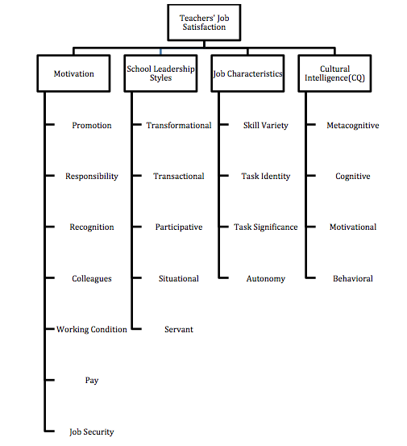
Figure ‎3.1: A Preliminary Model of Determinants of TJS

CHAPTER 4
SYSTEMATIC LITERATURE REVIEW (SLR)

The current chapter provides an investigation by systematic literature review (SLR) of all the predictors of teacher’s job satisfaction. The previous preliminary model was derived from sources found in the NLR. The previous literature review was not based on a systematic and objective method, or on rigorous criteria such as a systematic search strategy and procedures to critically evaluate identified articles; consequently, it is not possible to evaluate the quality or rigour of the methods of the included research (ten Ham-Baloyi & Jordan, 2016). There is a need to know all existing studies that talk about the predictors of teachers’ job satisfaction (TJS), in order to produce a list all of the factors that predict TJS.
There is also a need to know which factors have been academically researched most, which indicates the importance of that factor. A table of the previous factors and new factors derived from the SLR will be produced at the end of this chapter. This table will be produced in a form which includes all of the factors and sub-factors. In the next chapter, the form will be presented to academic experts to recommend the most valuable factors and their sub-factors in order to develop the final AHP model to conduct the field research.

SLR Steps
A systematic review is defined by The Cochrane Collaboration (2005) as:
review of a clearly formulated question that uses systematic and explicit methods to identify, select, and critically appraise relevant research, and to collect and analyse data from the studies that are included in the review. Statistical methods (meta-analysis) may or may not be used to analyse and summarize the results of the included studies (as cited By ten Ham-Baloyi & Jordan, 2016).
A systematic review involves a number of steps, which differ from one researcher to another; however, sequence of steps is similar. The system outlined by Whittemore and Knafl (2005), a structured framework, can be used as a process guideline to conduct an integrative literature review (ten Ham-Baloyi & Jordan, 2016).

Review Question
Step 1: There should be an answerable and searchable review question(s), which represent the objective of the systematic review (ten Ham-Baloyi & Jordan, 2016). The researcher is interested to know all of the predictors of teacher’s job satisfaction in addition to those mentioned in the previous section, in order to find out if there is a factor or factors that can usefully be added to the final model. The question that needs to be answered is, “What are the predictors of TJS?”

Searching the Literature
Step 2: This step includes the preparation of a search strategy that involves inclusion and exclusion criteria, researchable keywords, sources of proof, search documentation, and assortment of the study reports to be included (ten Ham-Baloyi & Jordan, 2016). The current systematic review involves seven inclusion and exclusion criteria:
- The research is written in the English language.
- The research is published in a peer-reviewed journal.
- The research includes any of the keywords ‘‘Teacher(s) Job Satisfaction’’, ‘‘Teacher(s) Satisfaction’’, “Educator(s) Job Satisfaction’’, “Educator(s) Satisfaction’’, “Instructor(s) Job Satisfaction’’, or “Instructor(s) Satisfaction’’.
- The research includes the predictors of teacher(s) job satisfaction.
- It is an empirical study and not a conceptual one.
- The research reports direct measures of predictors and teacher job satisfaction from kindergarten to high school.

Critical Assessment
Step 3: There should be a critical assessment of the selected studies. A researcher could use some tools to evaluate studies in a systematic review such as AMSTAR or the Johns Hopkins Nursing Evidence-Based Practice (JHNEBP). However, a researcher cannot apply one single tool for all studies. The validity and reliability of most of the critical assessment tools is very challenging and hard to carry (ten Ham-Baloyi & Jordan, 2016). Rakotonarivo, Schaafsma, and Hockley (2016) mentioned that “reliability refers to the degree of reproducibility of the results while validity refers to the degree to which the method is truly measuring what the researcher intended it to”. In the current systematic review, the researcher repeated the search process five times from the first until the end of the month of April 2017 and obtained the same outputs to ensure the validity and reliability of the assessment. In addition, the researcher has involved a second academic researcher who has experience in the SLR process to review the steps and preliminary results. Several iterations of separate analyses by the researcher and the reviewer took place to enhance the objectivity and reliability of the outcomes.

Data Extraction
Step 4: This step includes the data extraction process of selecting all relevant studies meeting the selection criteria that were mentioned in step 2 (ten Ham-Baloyi & Jordan, 2016). Studies for extraction were identified via searches of electronic databases that are accessible from Abu Dhabi University library system. Databases that are included in the current systematic review were1) ProQuest Central and its sub databases 2) Scopus database 3) EBSCOhost and its sub databases.
Figure 4.1 illustrates the selection process for the current study. The initial screening was to select articles that: 1) are published in English language 2) are issued in a peer- reviewed journal 3) have the keywords ‘‘Teacher(s) Job Satisfaction’’, ‘‘Teacher(s) Satisfaction’’, “Educator(s) Job Satisfaction’’, “Educator(s) Satisfaction’’, “Instructor(s) Job Satisfaction’’, or “Instructor(s) Satisfaction’’ in their titles or abstracts. There was no restriction on the date of the publication. The second screening was to retrieve full text articles only. The third screening was to select all articles that meet the inclusion criteria and, at the same time, to remove all duplicate articles that were retrieved from the three databases. Then, seven additional references were identified manually by searching the cited references on Google Scholar. Thus, the final sample of peer-reviewed articles that meet the inclusion criteria and that were published between 1998 and 2017 is seventy-six articles.
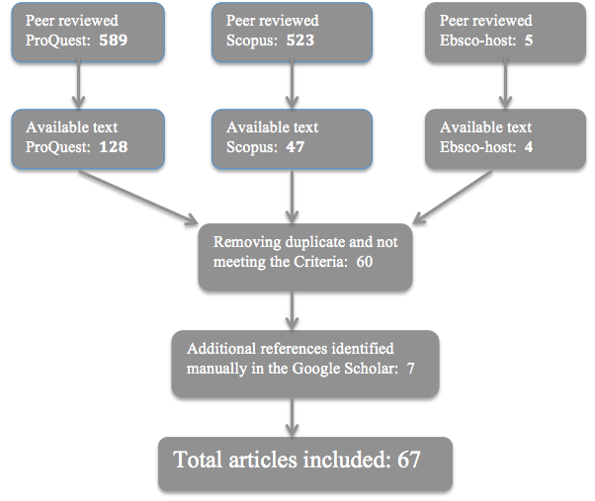
Figure ‎4.1: Flow chart of research article selection process

Data Synthesis
Step 5, the final step, is called data synthesis, where the final selected articles that meet the inclusion criteria are summarized as an outcome of the systematic review. The aim of this step is to aggregate study findings for all research articles meeting the inclusion criteria and answering the searchable review question (ten Ham-Baloyi & Jordan, 2016), which is, “What are the predictors of TJS?” Table 4.1 represents all the predictors of teachers’ job satisfaction and authors of all seventy-six articles, ordered from 1998 till 2017. It represents all factors that have been identified as having a positive or negative relationship with teachers’ job satisfaction. All factors that have been investigated and found to be unrelated to TJS are italicized and marked with an asterisk (‘*’).
Table ‎4.1: Predictors of teachers’ job satisfaction

No |  | Predictors | Authors |  | No | Predictors | Authors
1 |  | Participating in the career development system | Conley, Bas-Isaac, & Brandon (1998) |  | 35 | Organizational justice | Karakose (2014)
2 |  | Workplace conditions | Ma & MacMillan (1999) |  | 36 | Principal leadership style | Josanov-Vrgovic & Pavlovic (2014)
3 |  | Personal characteristics (gender, working experience, level of education, Material status*), nature of job itself, supervision, pay, and promotion | Koustelios (2001) |  | 37 | Teaching self-efficacy*, perceived stress, self-esteem, and demographic characteristics (age, gender, education,) | Reilly, Dhingra, & Boduszek (2014)
4 |  | Principal’s transformational leadership | Bogler (2001) |  | 38 | Pay, supervisors, co-workers, operating procedures, promotion, fringe benefits, rewards, work, and communication | Cerit (2014)
5 |  | School leadership , high-level communication, adequate school resources, and relationships with the community | Sari (2005) |  | 39 | Principal's leadership style and decision-making style | Hui et al. (2014)
6 |  | Transformational leadership | Nguni, Sleegers, & Denessen (2006) |  | 40 | Transformational leadership | Wahab, Fuad, Ismail, & Majid (2014)
7 |  | School climate | Xiaofu & Qiwen (2007) |  | 41 | Teachers’ motivation | Nyarko, Twumwaa, & Adentwi (2014)
8 |  | Principals who share humour | Recepoglu (2008) |  | 42 | Job characteristics (skill variety, task identity, task significance, autonomy and feedback) | Steyn & Vawda (2014)
9 |  | Intrinsic variables (working with students, job satisfaction, personal teaching efficacy) and Extrinsic variables (good students, teacher support, positive school environment, class size, role overload, low salary, parent support, student behaviour) | Perrachione, Petersen, & Rosser (2008) |  | 43 | Nature of work, communication, and supervision | Gligorović, Terek, Glušac, Sajfert, & Adamović (2014)
10 |  | Servant leadership | Cerit (2009) |  | 44 | Democratic leadership style, autocratic leadership style, and transactional leadership style* | Kiboss & Jemiryott (2014)
11 |  | Social support from colleagues, personal achievement, Emotional exhaustion, and Self-efficacy | Pérez, Urbieta, & Moreno (2010) |  | 45 | Competence, organizational culture, and job motivation | Arifin(2014)
12 |  | Organizational justice | Zainalipour, Fini, & Mirkamali (2010) |  | 46 | Leadership styles (directive, participative, supportive and achievement-oriented) of school heads | Naureen & Noshaba (2015)
13 |  | Gender* and experience | Menon & Athanasoula-Reppa (2011) |  | 47 | Organizational climate | Farooqi, Iqbal, & Tahir(2015)
14 |  | Value consonance, supervisory support, relations with colleagues, relations with parents, time pressure, discipline problems, emotional exhaustion, and motivation to leave the teaching profession | Skaalvik & Skaalvik (2011a) |  | 48 | Personal characteristics* of primary school educators (gender, age, family status, educational level, and the total years of service in public primary education) | Saiti & Papadopoulos (2015)
15 |  | Volume of non-teaching workload, equitability in the distribution of work, and professional autonomy | Lam & Yan (2011) |  | 49 | Transformational leadership | Ismail, Ibrahim, Ali, Dawi, & Ariff (2015)
16 |  | Value consonance and emotional exhaustion | Skaalvik & Skaalvik (2011b) |  | 50 | Transaction leadership style, transformational leadership style, and laissez-faire leadership style | Ali & Dahie (2015)
17 |  | Administrative support | Tickle, Chang, & Kim (2011) |  | 51 | Emotional intelligence and political skill | Taliadorou & Pashiardis(2015)
18 |  | School environment and locus of control | Basak & Ghosh (2011) |  | 52 | Teacher efficacy, perceptions of academic climate, support from colleagues, and supportive principal leadership | You, Kim, & Lim (2015)
19 | Career and working conditions, staff collegiality, administrative support, positive student behaviour and teacher empowerment |  | Shen, Leslie, Spybrook, & Ma (2012) |  | 53 | School climate | Malinen & Savolainen (2016)
20 | Intrinsic motivational factors and extrinsic motivational factors |  | Nadim et al. (2012) |  | 54 | Servant leadership | Al-Mahdy, Al-Harthi, & Salah El-Din (2016)
21 | Parental involvement |  | Li & Hung (2012) |  | 55 | School climate | Aldridge & Fraser (2016)
22 | Perceived Support |  | Berry (2012) |  | 56 | Motivating factors (imparting knowledge to others, serving the society, and having an internal desire to teach) and demotivating factors (inadequate salary, principals’ inattention to the teachers, not being encouraged to seek professional development, students’ lack of motivation to learn English, low occupational ,and social status) | Soodmand Afshar & Doosti (2016)
23 | Leadership style |  | Carlson (2012) |  | 57 | Transformational leadership style, rational decision-making style, laissez-faire leadership style, intuitive decision-making style, and avoidant decision-making | Hariri, Monypenny, & Prideaux (2016)
24 | Organizational support |  | Bogler & Nir (2012) |  | 58 | School organizational climate, responsibility factor, teachers’ gender, years of service | Ghavifekr & Pillai (2016)
25 | Teacher stress |  | Raju (2013) |  | 59 | Cynicism toward change in an education context | Yim & Moses (2016)
26 | Transformational leadership |  | Saefulloh (2013) |  | 60 | Teacher's job motivation* | Tukiyo (2016)
27 | Self-efficacy and career stages |  | Basak & Ghosh (2013) |  | 61 | Workplace spirituality | Nuzulia & Rupiati (2016)
28 | Principals' leadership commitment, organizational culture, and principals' leadership behaviour |  | Wijayati, Syamsudin, Retnowati, & Si (2013) |  | 62 | Loneliness at work | Tabancali (2016)
29 | Teachers' sense of responsibility* |  | Aliakbari & Kafshgar (2013) |  | 63 | Efficacy beliefs* (self-efficacy and collective efficacy) | Ramos et al. (2016)
30 | Teacher autonomy and self-efficacy |  | Skaalvik & Skaalvik (2014) |  | 64 | Transformational leadership | Eliophotou-Menon & Ioannou (2016)
31 | Organizational justice |  | Altahayneh, Khasawneh, & Abedalhafiz (2014) |  | 65 | Entrepreneurial behaviour | Amorim Neto, Picanço Rodrigues, & Panzer (2017)
32 | Transformational leadership |  |  | Tesfaw (2014) | 66 | Organisational communication |  | De Nobile (2017)
33 | Organisational support |  |  | Chinomona & Sandada (2014) | 67 | Proactive personality |  | Li, Wang, Gao, & You (2017)
34 | Organizational support, goal progress, and positive affect |  |  | Buyukgoze-Kavas, Duffy, Güneri, & Autin (2014)

Data Analysis and Discussion
The output of Table 4.1 can be much better presented when it is mapped to the previous AHP model categories as a base model for comparison. Table 4.2 presents the previous four factors and their sub-factors, plus the additional factors and their sub-factors discovered during the systematic literature review, which are shown in red.
Table 4.2 reveals that fifty five percent (37) of the studies talk about motivation and its sub-factors. Also, it reveals that thirty three percent (22) of the studies talk about leadership style and its sub-factors. In addition, it reveals that twenty one percent (14) of the studies talk about a new factor, called school climate and school environment. It also reveals that eight percent (5) of the studies talk about a new factor called personal characteristics and its sub-factors. Moreover, it reveals that five percent (3) of the studies talk about job characteristics and a new factor called organizational justice. It reveals, additionally, four new factors; organizational culture (2), emotional intelligence, political skill, and entrepreneurial behaviour. However, none of the studies talked about CQ.
Table ‎4.2: The newly mapped predictors of TJS added into the preliminary model categories
Main Factors Category | Predictors | Authors
Motivation | 37 out of 67 (55%) of studies focus on motivation
Responsibility  8 % of 37 studies | Participating in the career development system | Conley, Bas-Isaac, & Brandon (1998)
Responsibility  8 % of 37 studies | Teachers' sense of responsibility* | Aliakbari & Kafshgar (2013)
Responsibility  8 % of 37 studies | Responsibility factor | Ghavifekr & Pillai (2016)
Colleagues  11 % of 37 studies | Relations with colleagues | Skaalvik & Skaalvik (2011a)
Colleagues  11 % of 37 studies | Staff collegiality | Shen, Leslie, Spybrook, & Ma (2012)
Colleagues  11 % of 37 studies | Coworker | Cerit (2014)
Colleagues  11 % of 37 studies | Loneliness at work | Tabancali (2016)
Recognition & Promotion  8 % of 37 studies | Promotion | Koustelios (2001), Cerit (2014)
Recognition & Promotion  8 % of 37 studies | Career stages | Basak & Ghosh (2013)
Working Conditions  14 % of 37 studies | Workplace conditions | Ma & MacMillan (1999)
Working Conditions  14 % of 37 studies | nature of job itself | Koustelios (2001)
Working Conditions  14 % of 37 studies | Career and working conditions | Shen, Leslie, Spybrook, & Ma (2012)
Working Conditions  14 % of 37 studies | Operating procedures, Work | Cerit (2014)
Working Conditions  14 % of 37 studies | Nature of work | Gligorović, Terek, Glušac, Sajfert, & Adamović (2014)
Pay  11 % of 37 studies | Low salary | Perrachione, Petersen, & Rosser (2008)
Pay  11 % of 37 studies | Pay | Koustelios (2001), Cerit (2014)
Pay  11 % of 37 studies | Fringe benefits and rewards | Cerit (2014)
Pay  11 % of 37 studies | Inadequate salary | Soodmand Afshar & Doosti (2016)
Security or Job Security
0 % of 37 studies
Support
27 % of 37 studies
Support  27 % of 37 studies | Teacher support, parent support | Perrachione, Petersen, & Rosser (2008)
Support  27 % of 37 studies | Social support from colluage | Pérez, Urbieta, & Moreno (2010)
Support  27 % of 37 studies | Supervisory support | Skaalvik & Skaalvik (2011a)
Support  27 % of 37 studies | Administrative support | Tickle, Chang, & Kim (2011), Shen, Leslie, Spybrook, & Ma (2012)
Support  27 % of 37 studies | Perceived Support | Berry (2012)
Support  27 % of 37 studies | Organizational support | Bogler & Nir (2012), Chinomona & Sandada (2014), Buyukgoze-Kavas, Duffy, Güneri, & Autin (2014)
Support  27 % of 37 studies | Support from colleagues, and supportive principal leadership | You, Kim, & Lim (2015)
Communication  11 % of 37 studies | high-level communication | Sari (2005)
Communication  11 % of 37 studies | Communication | Gligorović, Terek, Glušac, Sajfert, & Adamović (2014) , Cerit (2014)
Communication  11 % of 37 studies | Organisational communication | De Nobile (2017)
Self-efficacy  24 % of 37 studies | Personal teaching efficacy | Perrachione, Petersen, & Rosser (2008)
Self-efficacy  24 % of 37 studies | Self-efficacy | Pérez, Urbieta, & Moreno (2010), Basak & Ghosh (2013), Skaalvik & Skaalvik (2014)
Self-efficacy  24 % of 37 studies | locus of control | Basak & Ghosh (2011)
Self-efficacy  24 % of 37 studies | Teaching self-efficacy* and self-esteem | (Reilly et al., 2014)
Self-efficacy  24 % of 37 studies | Teacher efficacy | You, Kim, & Lim (2015)
Self-efficacy  24 % of 37 studies | Efficacy beliefs*(self-efficacy and collective efficacy) | Ramos et al. (2016)
Self-efficacy  24 % of 37 studies | Proactive personality | Li, Wang, Gao, & You (2017)
Student relationship and behavior  5 % of 37 studies | Working with students, good students, and student behavior | Perrachione, Petersen, & Rosser (2008)
Student relationship and behavior  5 % of 37 studies | Positive student behavior | Shen, Leslie, Spybrook, & Ma (2012)
Parent relationship and involvement  5 % of 37 studies | Relations with parents | Skaalvik & Skaalvik (2011a)
Parent relationship and involvement  5 % of 37 studies | Parental involvement | Li & Hung (2012)
Work load  5 % of 37 studies | Class size, and role overload | Perrachione, Petersen, & Rosser (2008)
Work load  5 % of 37 studies | Volume of non-teaching workload and equitability in the distribution of work | Lam & Yan (2011)
Others motivation factors | Adequate school resources, and relationships with the community | Sari (2005)
Others motivation factors | Job satisfaction | Perrachione, Petersen, & Rosser (2008)
Others motivation factors | Personal achievement | Pérez, Urbieta, & Moreno (2010)
Others motivation factors | Value consonance and discipline problems | Skaalvik & Skaalvik (2011a)
Others motivation factors | Value consonance | Skaalvik & Skaalvik (2011b)
Others motivation factors | Teacher empowerment | Shen, Leslie, Spybrook, & Ma (2012)
Others motivation factors | Competence | Arifin(2014)
Others motivation factors | Cynicism toward change in an education context | Yim & Moses (2016)
Others motivation factors | Imparting knowledge to others, serving the society, principals’ inattention to the teachers, not being encouraged to seek professional development, students’ lack of motivation to learn English, low occupational ,and social status | Soodmand Afshar & Doosti (2016)
Motivation in general | Motivation to leave the teaching profession | Skaalvik & Skaalvik (2011a)
Motivation in general | Intrinsic motivational factors and extrinsic motivational factors | Nadim et al. (2012)
Motivation in general | Teachers’ motivation | Nyarko, Twumwaa, & Adentwi (2014)
Motivation in general | Job motivation | Arifin(2014)
Motivation in general | Teacher's job motivation* | Tukiyo (2016)
Motivation in general | Having an internal desire to teach | Soodmand Afshar & Doosti (2016)
School Leadership Style | 22 out of 67 (33%) of studies focus on leadership
Transformational Leadership  41 % of 22 studies | Principals' transformational leadership | Bogler (2001)
Transformational Leadership  41 % of 22 studies | Transformational leadership | Nguni, Sleegers, & Denessen (2006), Saefulloh (2013), Tesfaw (2014), Wahab, Fuad, Ismail, & Majid (2014), Ismail, Ibrahim, Ali, Dawi, & Ariff (2015), Ali & Dahie (2015), Hariri, Monypenny, & Prideaux(2016), Eliophotou-Menon & Ioannou (2016)
Transactional Leadership | Transactional leadership style* | Kiboss & Jemiryott (2014)
Transactional Leadership | Transaction leadership style | Ali & Dahie (2015)
Participative Leadership | Participative | Naureen & Noshaba(2015)
Situational leadership
Servant Leadership | Servant leadership | Cerit (2009), Al-Mahdy, Al-Harthi, & Salah El-Din (2016)
Others Leaderships Styles | Principals who share humor | Recepoglu (2008)
Others Leaderships Styles | Democratic leadership style, and autocratic leadership style | Kiboss & Jemiryott (2014)
Others Leaderships Styles | Directive, supportive and achievement-oriented | Naureen & Noshaba(2015)
Others Leaderships Styles | Laissez-faire leadership style | Ali & Dahie (2015)
Others Leaderships Styles | Rational decision-making style, laissez-faire leadership style, intuitive decision-making style, and avoidant decision-making | Hariri, Monypenny, & Prideaux(2016)
Leadership in General | School leadership | Sari (2005)
Leadership in General | Leadership style | Carlson (2012)
Leadership in General | Principals' leadership behavior | Wijayati, Syamsudin, Retnowati, & Si (2013)
Leadership in General | Principal leadership style | Josanov-Vrgovic & Pavlovic (2014)
Leadership in General | Principal's leadership style and decision making style | Hui et al. (2014)
Leadership in General | Supervision | Koustelios (2001), Gligorović, Terek, Glušac, Sajfert, & Adamović (2014), Cerit (2014)
Leadership in General | Principals' leadership commitment | Wijayati, Syamsudin, Retnowati, & Si (2013)
Job Characteristics | 3 out of 67 (5%) of studies focus on job characteristics
Skill Variety | Skill Variety | Steyn & Vawda (2014)
Task Identity | Task Identity | Steyn & Vawda (2014)
Task Significance | Task Significance | Steyn & Vawda (2014)
Feedback | Feedback | Steyn & Vawda (2014)
Autonomy | Professional autonomy | Lam & Yan (2011)
Autonomy | Autonomy | Steyn & Vawda (2014)
Autonomy | Teacher autonomy | Skaalvik & Skaalvik (2014)
Cultural Intelligence | 0 out of 67 (0%) of studies focus on CQ
Metacognitive
Cognitive
Motivational
Behavioural
New Category
Personal characteristics  5 out of 67 (8%) of studies focus on personal characteristics | Personal characteristics (gender, working experience, level of education, Material status*) | Koustelios (2001)
 | Gender* and experience | Menon & Athanasoula-Reppa (2011)
 | demographic characteristics (age, gender, education,) | (Reilly et al., 2014)
 | Personal characteristics* of primary school educators (gender, age, family status, educational level, and the total years of service in public primary education) | Saiti & Papadopoulos (2015)
 | teachers’ gender, years of service | Ghavifekr & Pillai (2016)
Organizational justice  3 out of 67 (5 %) of studies focus on organizational justice | Organizational justice | Zainalipour, Fini, & Mirkamali (2010), Altahayneh, Khasawneh, & Abedalhafiz (2014), Karakose (2014)
Organizational culture  2 out of 67 (3%) of studies focus on organizational culture | Organizational culture | Wijayati, Syamsudin, Retnowati, & Si (2013), Arifin(2014)
School climate and school environment  14 out of 67 (21%) of studies focus on school climate | School climate | Xiaofu & Qiwen (2007), Malinen & Savolainen (2016), Aldridge & Fraser (2016)
 | Positive school environment | Perrachione, Petersen, & Rosser (2008)
 | Emotional exhaustion | Pérez, Urbieta, & Moreno (2010), Skaalvik & Skaalvik (2011a), Skaalvik & Skaalvik (2011b)
 | School environment | Basak & Ghosh (2011) 8
 | Time pressure | Skaalvik & Skaalvik (2011a)
 | Teacher stress | Raju (2013)
 | Perceived stress | (Reilly et al., 2014)
 | Organizational climate | Farooqi, Iqbal, & Tahir(2015)
 | Perceptions of academic climate | You, Kim, & Lim (2015)
 | School organizational climate | Ghavifekr & Pillai (2016)
 | Workplace spirituality | Nuzulia & Rupiati (2016)
Others new categories | Emotional intelligence and political skill | Taliadorou & Pashiardis(2015)
 | Entrepreneurial behavior | Amorim Neto, Picanço Rodrigues, & Panzer (2017)

The previous academic studies indicate that motivation comes at the top of the list as most studied factor in predicting TJS. Support (27%) and self-efficacy (24%) are the most frequently studied motivators that predict TJS and then come working conditions (14%), colleagues (11%), pay (11%), and communication (11%) as frequently studied motivators. The least frequently studied motivators are responsibility (8%), recognition and promotion (8%), student relationships and behaviour (5%), parent relationships and involvement (5%), and work load (5%). No study has mentioned security or job security as a predictor of TJS. Sixteen percent of the studies talk about motivation in general and the rest are unimportant individual motivators.
The second most studied factor proves to be school leadership style, because thirty three percent of studies focus on leadership, of which forty one percent of them are astonishingly focused on transformational leadership. For most of the other leadership styles, only one study was found to discuss each, such as participative leadership style from the previous studies or democratic leadership style from the newly discovered studies. Two leadership styles are exceptional in that they are discussed in two studies; transaction and servant leadership style. However, none of the studies talks about the situational leadership style.
The third most studied factor is the school climate and school environment, covered by twenty one percent of the studies. Most of the studies are general and do not talk about sub-factors of school climate and environment, but many selected factors are related to them, such as emotional exhaustion and workplace spirituality.
The fourth factor most studied, with mentions in eight percent of the studies, is personal characteristics, such as gender and age. One study was found, Steyn & Vawda (2014), that talked about job characteristics and all their sub-factors, while two, Lam and Yan (2011) and Skaalvik & Skaalvik (2014), talked about autonomy as a sub-factor. The remaining factors, organizational justice, organizational culture, emotional intelligence, political skill, and entrepreneurial behaviour, were the least studied factors, other than the situational leadership style, which is not mentioned in any of the studies identified as relevant.

Form Preparation
Table 4.2 should be transformed into a form so that the educational experts can select the most valuable factors and sub-factors; however, some of the studies did not mention sub-factors of the items they discuss, such as school climate. Therefore, the missing sub-factors will be pooled from the literature and attached to their main factors in the new form. Table 4.3 represents summarized information of all the initially identified factors, together with those found in the SLR.
Table ‎4.3: Factors identified in both NLR and SLR, or NLR only
Main Factors | Sub-Factors
Main Factors | Existed | New | Missed
Motivation | Responsibility. colleagues, recognition& Promotion, working conditions, pay, security or job security, | Support, communication, self-efficacy(moved to entrepreneurial behavior), student relationship and behavior(moved to school climate community), parent relationship and involvement, work load(moved to school climate community), personal achievement, value consonance, teacher empowerment, competence(the rest of the remaining sub-factors are moved to other area or not that important such as students’ lack of motivation to learn English)
School Leadership Styles | Transformational, transactional, participative, situational, servant | Principals who share humor(is not a style), democratic(similar to participative), autocratic, directive, supportive, achievement-oriented, laissez-faire, rational decision-making, intuitive decision-making, avoidant decision-making
Job Characteristics | Skill variety, task identity, task significance, feedback, autonomy
Cultural Intelligence | Metacognitive, cognitive, motivational, behavioral
New Factors
Personal Characteristics |  | Gender, age, educational level, material status, working experience
Organizational justice |  | Distributive justice, procedural justice, interactional justice
Organizational culture |  |  | Innovation, risk taking, attention to detail, outcome orientation, people orientation, team orientation, aggressiveness, adaptability
School climate |  |  | Safety, academic, community, institutional environment
Emotional Intelligence |  |  | Self-awareness, self-regulation, social skill, empathy, motivation
Political Skill |  |  | Social astuteness, interpersonal influence, networking ability, apparent sincerity
Entrepreneurial behavior |  |  | Self-determination, self-identity, self-efficacy

The sub-factors of organizational justice were not presented in table 4.2 in the previously, even though Zainalipour, Fini, and Mirkamali (2010) discussed them in their study. According to their study, organizational justice is related to the fair treatment of employees in an organization and consists of three sub-factors: distributive justice, procedural justice, and interactional justice. They said that distributive justice is about the fairness of the results of a specific decision; procedural justice is about the fairness of the procedure that leads to the result. Interactional justice is about the fairness of the treatment that a person receives by an authority figure.
Of the remaining new factors, organizational culture, school climate, emotional intelligence, political skill, and entrepreneurial behaviour, no study mentioned their sub-factors during the SLR. Organizational culture is defined by Schein (1990) as:
(a) a pattern of basic assumptions, (b) invented, discovered, developed by a given group, (c) as it learns to cope with its problems of external adaptation and internal integration, (d) that has worked well enough to be considered valid and, therefore (e) is to be taught to new members as the (f ) correct way to perceive, think, and feel in relation to these problems. (as cited By Alom, 2018).
It is a multi-dimensional concept. Alom (2018) mentions that “scholars do not agree in identifying common cultural dimensions”. However, some of them agree with some of the dimensions, which are given different names by different authors. Therefore, only seven dimensions: innovation, risk-taking, attention to detail, outcome orientation, people orientation, team orientation, aggressiveness, and stability as suggested by O’Reilly III, Chatman and Caldwell (1991) and adaptability as suggested by Daniel Denison (1990), will be used as a measurement. Adaptability allows an organization to be broader and flexible, rather than stable, so that it will be selected instead of stability as a measurement.
Wang and Degol (2016) note that, until today, there is a lack of agreement on the definition and boundaries of measuring school climate, which means the term is frequently used to cover various aspects of the school environment. According to their definition, school climate is “shared beliefs, values, and attitudes that shape interactions between students and adults and set the parameters of acceptable behaviour and norms for the school”. It consists of four dimensions: safety, community, and the academic and institutional environments. Safety represents the physical and emotional security that is provided by the school. Community represents the overall quality of interpersonal relationships within the school. Academic environment represents the overall quality of the academic atmosphere, including curricula, professional development, teacher training, and instruction. Institutional environment represents the structural or organizational features of the school environment (Wang & Degol, 2016).
According to Salovey and Mayer (1990) emotional intelligence (EI) is "the subset of social intelligence that involves the ability to monitor one's own and others' feelings and emotions, to discriminate among them and to use this information to guide one's thinking and actions”. Goleman (1998) mentions 5 sub-factors of EI: self-awareness, self-regulation, social skill, empathy, and motivation. Self-awareness is related to knowing your ability and its impact on others to guide your decisions. Self-regulation is redirecting one's disruptive emotions and adapting to fluctuating circumstances. Social skill is the ability to use your relationship skill to drive people in the desired direction. Empathy is bearing in mind other people's feelings when making decisions. Motivation is an internal force to succeed for the sake of success (Goleman, 1998).
Political skill (PS) is “the ability to effectively understand others at work, and to use such knowledge to influence others to act in ways that enhance one’s personal and/or organizational objectives” (Ahearn, Ferris, Hochwarter, Douglas, & Ammeter, 2004). According to Meisler (2014), PS includes four sub-factors: networking ability, social astuteness, apparent sincerity, and interpersonal influence. Networking ability is about building beneficial and strong alliances and coalitions. Social astuteness is about a shrewd observation of people and being attuned to different social situations. Apparent sincerity is about a tactical skill of appearing honest to others. Interpersonal influence is the capability of exerting a powerful influence on people one deals with (Taliadorou & Pashiardis, 2015).
Mair (2005) defines entrepreneurial behaviours as “a set of activities and practices by which individuals, at multiple levels, autonomously generate and use innovative resource combinations to identify and pursue opportunities”. It consists of four dimensions: self-identity, self-determination, and self-efficacy. Self-identity is recognition of a person’s potential and qualities as an individual. Self-determination is the function of personal values as intrinsic motivators. Self-efficacy is a person’s belief in his or her ability to succeed (Kirkley, 2016).
After studying the literature and discovering the sub-factors and their meaning, some of the newly discovered sub-factors were relocated to the appropriate location in the new form. For example, self-efficacy has been moved to entrepreneurial behaviour, and student relationship and behaviour, parent relationship and involvement, and workload have been moved to school climate community. In addition, some sub-factors are similar to others and there is no need to mention them twice; for example, democratic leadership style is similar to participative leadership style. Moreover, some sub-factors, such as principals who share humour, are not, in fact, sub-factors of the main factor.
It should be noted that it is really difficult to present all the discovered sub-factors because some of them are not very important and it is not wise to bombard the participants with many sub-factors, such as students’ lack of motivation to learn English. The new focus group interview questionnaire or form is attached in Appendix 1. The form consists of eleven main factors and their sixty-seven sub-factors. Also, the form features explanations of the meaning of all sub-factors. The focus group members should select and recommend the appropriate number; however, the final recommended list should not be more than five main factors and twenty five sub-factors, to avoid confusing the interviewee expert teachers with an excessive number of factors.
In summary, if we would recommend four main factors to be measured, academic studies suggest motivation (55%), school leadership styles (33%), school climate and school environment (21%), and personal characteristics (8%) because they are the most frequently mentioned factors in studies of predictions of TJS as discovered in a systematic review. In the next chapter, an interview with a focus group of Abu Dhabi educational experts will be conducted to get their recommendations on which of the factors and their sub-factors are the most valuable measures to predict TJS in the Abu Dhabi context. In addition, the researcher did not find any study that used the AHP approach to measure teachers’ job satisfaction, even during a systematic review.

CHAPTER 5
FOCUS GROUP INTERVIEW (FGI)

This chapter discusses the focus group interview (FGI). Powell and Single (1996) recommend using the focus group when the topic under investigation is complicated and includes many variables, as in our case. In chapter 4, table 4.3 consists of many factors and sub-factors, which will be very difficult to test on Abu Dhabi private school teachers. Therefore, the list should be reduced; to achieve this, the five most valuable factors, with up to twenty-five sub-factors, will be recommended by educational experts who have a specific role in the Abu Dhabi Education Authority (ADEC) or private schools to come up with the final AHP model in order to conduct the field research. This simplified list will be the output of this chapter.

Meeting Preparation
A focus group should identify vital issues and illuminate difficult psychosocial phenomena. It should consist of participants from a varied range of views, backgrounds, and experiences. It should include between six and 10 members who don’t know each other and comprise people with shared fundamental characteristics relevant to the study (Powell & Single, 1996). The ADEC staff were approached and only two staff agreed to participate in the study; an experienced researcher who has worked in the research section at ADEC for over twenty-five years and contributed to many published studies and articles; and the head of all private schools in the Emirate of Abu Dhabi, who has over twenty years of experience. Many private school teachers were approached and one female and one male teacher agreed to participate in the study after they understood its benefits. The female teacher is a British math teacher in the 3rd grade in a highly rated private school in Abu Dhabi City, who has seventeen years’ teaching experience, including seven in the UAE. The male teacher is an Arabic science teacher in the 11th grade in a low-rated private school in Al Ain City, who has twenty-one years teaching experience, with 15 of them in the UAE.
Alternatively to the head of education officers, many private school administrators were approached and two males agreed to participate in the study after they also understood its benefits. The first is an American who manages a highly rated private school in Abu Dhabi City and has eighteen years of school management experience, ten of them in the UAE. The second is an Indian who manages a low-rated private school in Abu Dhabi City, who has twenty three years of school management experience, including fifteen in the UAE. Details of these educational experts are provided in table 5.1.
Table ‎5.1: Educational experts' detailed background
Region |  | Speciality | Years of Experience | Gender | Nationality
Abu Dhabi | ADEC Researcher |  | 25 | M | Arabic
Abu Dhabi | ADEC Private |  | 20 | M | Arabic
Abu Dhabi | School Head |  | 18 | M | American
Abu Dhabi | School Head |  | 23 | M | Indian
Abu Dhabi | Math Teacher |  | 17 | F | British
Al-Ain | Science Teacher |  | 21 | M | Arabic
The six volunteer participants have a varied range of views, backgrounds, and experiences and, except the two who work for ADEC, they do not know each other. The ADEC researcher has extensive knowledge of all studies that have been conducted in the education field in the UAE, especially those that are related to teachers in the Abu Dhabi area. The head of all private schools in the Emirate of Abu Dhabi is familiar with all external issues that concern the private school teachers. The administrators are aware of all of management issues that concern the private school teachers. The teachers are familiar with all issues that they and their colleagues are facing.
Powell and Single(1996) suggested that the focus group session should take ninety to one hundred and twenty minutes and the duration of the session is generally determined by the number of participants attending the group or the complexity of the topic that is under investigation. Also, they suggest notifying the members of the group between ten to fourteen days in advance to plan their schedules carefully. The current six participants were contacted at the beginning of December 2017 and they recommended scheduling the meeting in the second week of January. The meeting was arranged for the tenth of January 2018 at 5PM for one hour and a half; there were only six participants and the subject was not very complex.
The participants were required to select up to five of the most important main factors and twenty five sub-factors out of the listed eleven main factors and sixty-seven sub-factors, as shown in Appendix 1, and to explain the reasons behind their selection.
The meeting place should be neutral, should have no bearing on the topic under investigation and should have no unique significance to the focus group members. The focus group meeting should have a moderator who is a good listener and good note-taker (Powell & Single, 1996). The researcher reminded the six participants of the meeting a week ahead of time and informed them of the location of the meeting. He chose a café, a calm place, which was neutral and central to all participants. The researcher moderated the meeting, took notes of the whole meeting and recoded the meeting digitally as a backup.

The Meeting
All the participants arrived at the cafe ahead of the scheduled time. The researcher introduced himself and the participants to each other and provided them with coffees and teas and let them interact informally, as recommended by Powell and Single (1996). The informal interaction broke the ice and promoted an encouraging atmosphere for a valuable discussion. The researcher has distributed the focus group form to all participants and re-emphasized the value of the study. He provided a full assurance that all gathered and recorded information would be safeguarded as the usual procedure of any scientific research. He told them that they were present, not representing their organization, but to share their knowledge and contribute valuable information to conduct a beneficial study.
The purpose of the study was again explained in detail and the researcher went through all the factors and their sub-factors. Then, the participants were given 10 minutes to go over all the questionnaires. After everything was clearly understood, the participants all agreed that they did not want to bombard their expert teacher interviewees with many factors and make them confused. They, therefore, recommended that there should be at most four main factors and twenty sub-factors to be measured in the final stage.
The researcher at ADEC started first to talk, offering to initiate the discussion and inviting everyone to add any information as she or he wished. He said that, “motivation is the most important driving force of all action, as suggested by many studies, and we recommend it be the first to be tested”. He selected seven sub-factors; colleagues, recognition, pay, job security, support, communication, and workload, commenting, “we recommend testing these seven motivation sub-factors because we use them sometimes to measure the job satisfaction of our staff and they are also recommended by some job satisfaction instruments”.
The science teacher agreed with the seven selected motivators and he added: “The private schools vary a lot and salary differs a lot. For example, one school could pay a teacher with the same quality and experience 5,ooo Dhs and another school 40,000 Dhs, so the pay is an appropriate measure”. He said that there is no good communication between teachers and their management and teachers are not supported properly. The math teacher also agreed with the seven selected motivators and she stated that, “Our teachers are paid fairly; however, the most important thing that concerns them is recognition and they are scared of losing their job any time”. It was apparent by looking at their smiling faces that the rest of the participants agreed with him and they did not object at all. It looked as if he was talking about the Teacher Job Satisfaction Questionnaire (TJSQ); however, two of his points, support and work load, are not usually measured by the TJSQ.
The head of all private schools said that “ADEC put a lot of emphasis on school leadership. We believe that great leaders create great schools. Our principals sit in a hot seat to improve learning and teaching”. He recommended that school leadership style should be selected as a main factor to be measured. The math teacher added that their school management was equipped with many leadership skills. The ADEC researcher stated that, “they should be visionaries, curriculum leaders, disciplinarians, assessment experts, budget analysts, public relations experts, community builders, and legal and policy experts”.
The American administrator recommended measuring only six leadership styles; transformational, participative, servant, directive, achievement-oriented, and rational decision-making leadership style. He said that, “the six recommended leadership styles are more practical than the others and they cover many aspects of leadership styles”. Both ADEC staff agreed with him and the rest did not object to his recommendation. He added that a transformational leader has a long-lasting moral and motivational relationship with his or her followers, not just short and limited relationship, as transactional leaders do with their followers”. In addition, the ADEC researcher said, “the transformational leadership style is based on vision, setting group goals, supporting followers, and high performance expectations”.
The American administrator continued, explaining that the participative leadership style invites employees to participate in all company decisions and encourages the employees to accept all policies and decisions that they are involved in and feel responsible for the company’s success. He also stated:
A servant leadership style overlaps with many leadership styles, such as self-sacrificing leadership, spiritual leadership, empowering leadership, ethical leadership, authentic leadership, and transformational leadership, whereas the directive leadership style should be practiced on inexperienced staff by setting clear objectives and rules for them to make sure that directions and expectations are clearly defined and understood. (Focus group participant, American administrator)
He continued supporting his view by explaining that achievement-oriented leaders set challenging goals for themselves and their team, based on a clear vision and mission statement, which will lead them to a high level of performance. Finally, he mentioned that rational decision-making leaders encourage consistent and high-quality decisions, based on clear facts, removing subjectivity and uncertainty from the decision-making process.
The head of an Abu Dhabi private school said that, “We need to know how good is our school climate for our teachers and students and we need to know if our teachers are happy with all the four factors”. The math teacher agreed to investigate the school climate and stated, “The curriculum is unstable and always changes for improvement in the UAE”. The Indian administrator added, “A positive school climate will benefit teachers, students, and school staff because it impacts the teachers’ morale and students’ achievement”. The ADEC researcher commented, “We recommend the school climate and its sub-factors should be tested among our teachers because it has not been measured academically before in Abu Dhabi”.
“As teachers we are suffering from injustice and unfairness in our school and I believe it is related to teacher turnover and job satisfaction, which require an investigation”, was a comment from the science teacher. The math teacher hoped that the current study will assess teachers’ perception of fairness in Abu Dhabi. The head of the private schools said that, “One of the core values of ADEC is organizational justice in all Abu Dhabi schools and it focuses on teachers’ perception of fairness”. Also, the ADEC researcher recommended measuring organizational justice as it has not been measured academically before in Abu Dhabi.
The focus group sometime has some limitations. Some participants could dominate the meeting in a negative way, which could affect the outcome and influence the comments provided by other individuals. However, these limitations could be overcome by cautious moderating, as the current moderator carefully tried to do. The moderator has less control over the data produced because they are unavoidable. He or she should let members communicate with each other freely, ask questions and express their doubts and opinions, as was allowed by the current moderator. In fact, the focus group cannot be entirely predetermined because it is an open-ended research method (Moodley, 2007).

Summarized Results
The members of the focus group recommended Motivation, School Leadership Style, School climate, and Organizational Justice as the main factors to be measured, together with their sub-factors, and they provided various reasons for their recommendations as shown in the summary table 5.2.
Table ‎5.2: Summary of focus group results
Recommended by | Recommended factors | Recommended sub-factors | Reasons for selection
ADEC Researcher | Motivation | Colleagues, recognition, pay, job security, support, communication, and workload | -Motivation is driving force for of all action  -The 7 sub-factors are often measured in their research and recommended by many instruments  -There is a salary disparity, not good communication, not good support,  -Teachers need recognition and job security
American School Head | School Leadership Style | Transformational, participative, servant, directive, achievement-oriented, and rational decision-making leadership style | -ADEC pay high attention to school leaders to create great schools to improve learning and teaching  - School leaders should have many leadership skills and they should be visionaries, curriculum leaders, disciplinarians, assessment experts, budget analysts, public relations experts, community builders, and legal and policy experts  -The 7 leadership styles are practical and represent many feature of most leadership styles  - Transformational leader has a long-lasting moral and motivational relationship, based on vision, setting group goals, supporting followers, and high performance expectations  - Participative leader encourages participate on all company decisions and encourages employees accept all policies and decisions and make them feel liable for the company success  - Servant leadership style overlaps with many leadership styles  - Achievement-oriented leaders set challenging goals for themselves and their team based on clear vision and mission statements to increase their performance  - Decision-making leaders encourage good decisions based on clear facts, removing subjectivity and uncertainty from the decision-making process
ADEC Private School Head | School climate | Safety, academic, community, and institutional environment | -School climate has not been measured academically before in Abu Dhabi  - The curriculum is unstable and needs to be improved  - Positive school climate will improve teacher morale and student achievement
Science Teacher | Organizational Justice | Distributive justice, procedural justice, and interactional justice | -Organizational Justice has not been measured academically before in Abu Dhabi  -Teachers suffer from both injustice and unfairness and this is related to teacher turnover and job satisfaction  -Organizational Justice is a core value of ADEC, focusing on teachers’ perception of fairness

Final AHP Model
Figure 5.1 illustrates the final model, with the four main factors on the top and their sub-factors beneath them, all as recommended by the educational experts in the focus group, to be measured in the final procedure using the AHP method.

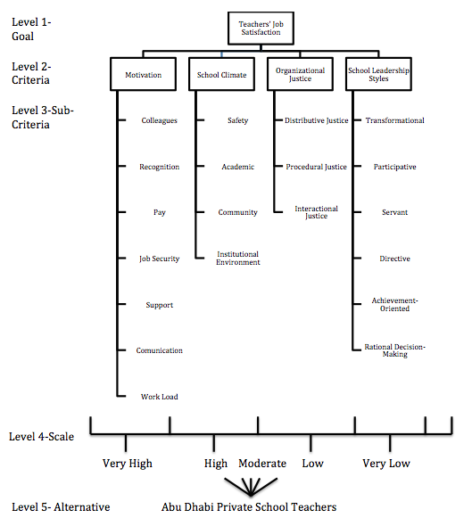
Figure ‎5.1: The final AHP model

CHAPTER 6
AHP STEPS AND RESULTS

The current chapter will discuss the AHP steps and explain the measurement of the four main factors and their sub-factors using the AHP method, based on the Final AHP Model. Also, it will present the final results of questionnaires through the pairwise comparisons technique.

6.1 AHP Steps
The 20 sub-factors that were recommended previously by the Abu Dhabi educational experts constitute a large number of factors and need a special technique to identify their relative importance in order to measure their priority. It needs a multi-criteria decision-making technique because there are many factors considered for analysis in the current study. Therefore, the AHP technique was chosen as the most appropriate and useful approach to simplify ranking the four main factors and their 20 sub-factors, since it is widely used for solving multi-criteria decision-making problems such as this one (Alkhyeli & Ewijk, 2018).
In the current study, the expert teachers will face a major challenge in prioritizing the main four factors and sub-factors at once without a multi-criteria decision tool such as the AHP. The AHP is the most appropriate tool to determine preferences and prioritize all of the factors that influence the job satisfaction of private school teachers in Abu Dhabi. Figure 6.1 summarizes
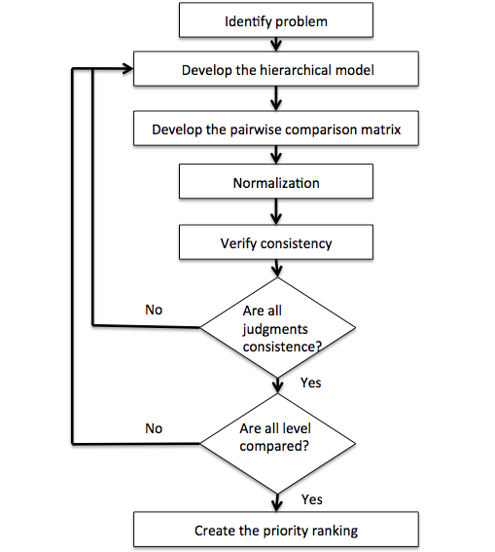
the steps of the AHP methodology (Saaty, 1990).

Figure ‎6.1: AHP methodology steps

According to the AHP methodology, the first step is to identify the problem. The purpose of the study is to determine the teachers’ preference for and prioritization of the factors that influence their job satisfaction through the eyes of their own experts. In this step, all factors must be determined and examined. The four main factors and their sub-factors have been recommended by Abu Dhabi educational experts, resulting in a total of 20 factors.
In step 2, a hierarchical model is developed to assess the problem systematically. The problem is simplified and broken into more easily understood sub-problems so that each of them is analysed independently. Figure 5.1 illustrates the previous final AHP model for measuring the factors that influence teachers’ job satisfaction. In the AHP structure, first, the hierarchy is built and then criteria and sub-criteria are classified to make pairwise comparisons. The goal (teachers’ job satisfaction) can be seen at level 1. The four ranking criteria (competitive priorities) can be seen at the second level. The sub-criteria, which are used to measure the criteria, can be seen at the third level. The rating scale, which is used to evaluate the impact of individual alternatives (components) on the sub-criteria, can be seen at level 4. The alternatives (components) that need to be evaluated can be seen at the last level ( Alkhyeli & Ewijk, 2018;Drake, Myung Lee, & Hussain, 2013).

Figure ‎6.2: The final AHP model (repeated from Fig. 5.1)
In step 3, the questionnaire form is developed, containing pairwise comparisons between main criteria and sub-criteria for each main criterion. Saaty (1983) recommended a nine-point scale, as presented in Table 6.1, to determine pairwise comparison criteria. For example, if a teacher strongly identifies motivation as more important than school leadership styles, the former is marked ‘5’ and the latter ‘1/5’ and so on (Hussain et al., 2015). Ishizaka and Labib (2009) explained that, “psychologists argue that it is easier and more accurate to express one’s opinion on only two alternatives than simultaneously on all the alternatives”( Alkhyeli & Ewijk, 2018).
Table ‎6.1: 1 to 9 scale for AHP preferences
Intensity importance | Definition | Explanation
1 | Equal importance | Equally favouring one factor to the other
3 | Moderate importance | Slightly favouring one factor over the other
5 | Strong importance | Strongly favouring one factor over the other
7 | Very strong importance | Very strongly favouring one factor over the other
9 | Extreme importance | The highest preference of one factor over the other
2,4,6,8 | Middle values | The intermediate values used to represent compromise between the priorities listed above

The questionnaires were pilot-tested by two experienced teachers who have over ten years of teaching in a private school and two academic professional faculty members who are specialized in education. Certain items in the questionnaire were rephrased to be more representative of the anticipated constructs. The pilot test respondents made sure that all questions were clear and understandable. Four expert teachers from two differently rated private schools (one high performance or satisfactory school and one rated ‘improvement needed’), which also follow different educational standards from each level from kindergarten to secondary or high school. A total of eight experts were identified as an evaluation team from each of the three regions of the Emirate of Abu Dhabi; Al-Ain, Abu Dhabi City, and Al Dhafra, also called the Western Region. The twenty-four experenced teachers’ detailed information is presented in Table 6.2.
Historically, the AHP has been applied in studies with small sample sizes to determine a hierarchical analysis according to expert opinions (Kil, Lee, Kim, Li, & Newman, 2016). From the AHP methodology perspective, the AHP reduces the fatigue of survey processes, and according to Cheng and Li (2001) and Hussain, Malik, and Al Neyadi (2016), a small sample size is acceptable. Kil et al. (2016) mentioned that ‘several studies reported findings from AHP with small numbers of experts: five respondents (Peterson, Silsbee, & Schmoldt, 1994); five participants (Al-Harbi, 2001); seven participants (Armacost, Componation, Mullens, & Swart, 1994); 18 participants (Mawapanga & Debertin, 1996); and 25 respondents (Huang & Yeh, 2008)’.
These experienced teachers were approached informally through friends and relatives in all of the three regions. Some of them were interviewed individually in their schools and the rest were interviewed in their preferred choice, such as the nearest cafe or hotel, to enter the participant’s own environment (Creswell, 2007; McCoy, 2012). Most of the interviews took one hour, though a few of them took one hour and a half, between 13 May 2018 and 12 June 2018. They were assured that their information would not be exposed or known by anybody else and signed a consent form.
Table ‎6.2: Experienced Teachers’ Background information
Region |  | School | Speciality | Years of Experience | Gender | School Stage
Al-Ain | School A |  | Class Teacher (KG) | 26 | F | KG
 | School A |  | Math | 18 | F | Primary
 | School A |  | Science | 14 | M | Middle
 | School A |  | Arabic | 20 | M | High
 | School B |  | Class Teacher (KG) | 15 | F | KG
 | School B |  | Social | 18 | M | Primary
 | School B |  | Math | 14 | M | Middle
 | School B |  | Chemistry | 20 | M | High
Abu Dhabi | School A |  | Class Teacher (KG) | 17 | F | KG
 | School A |  | Music | 18 | F | Primary
 | School A |  | Science | 14 | M | Middle
 | School A |  | Physics | 20 | M | High
 | School B |  | Class Teacher (KG) | 12 | M | KG
 | School B |  | PE | 22 | F | Primary
 | School B |  | Science | 19 | F | Middle
 | School B |  | History | 15 | M | High
Al Dhafra or Western | School A |  | Class Teacher (KG) | 10 | M | KG
 | School A |  | English | 12 | M | Primary
 | School A |  | Science | 14 | F | Middle
 | School A |  | Geography | 25 | M | High
 | School B |  | Class Teacher (KG) | 13 | F | KG
 | School B |  | Computer | 14 | F | Primary
 | School B |  | English | 18 | M | Middle
 | School B |  | Islamic Studies | 21 | M | High

The researcher established a rapport with the participant at the beginning of each interview and obtained the history of their experience, as recommended by Rossman and Rallis (2003). He explained to them the purpose of the study and how to respond to the questions – in particular, those that applied pairwise comparisons. In addition, he explained the meaning of all the factors and their sub-factors to clear up any ambiguity. The quality of responses seemed to be logical and reasonable for the purposes of this research because the consistency ratio (CR) was low, as shown from tables 6.4 to 6.8 (lowest = 0.01 highest = 0.04) (Alkhyeli & Ewijk, 2018; Forman & Selly, 2001; Mu & Pereyra-Rojas, 2017). A sample of the questionnaires is attached in Appendix 2.
The interviewees come from different parts of the world, such as the USA, India, England, Egypt, Jordan, Syria, and the UAE, and have different specialities and years of experience; their experience varied from ten to twenty-six years. Ten (42%) of the twenty-four experts were women and fourteen (58%) were men. They were happy to participate in the study and some of them asked to see the end result of it.
In steps 4 and 5, all the data collected in step 3 were compiled. All the data were entered in Microsoft Excel, and the normalized weights of the criteria were computed. The geometric mean and normalized weightings were calculated from the comparison matrix (Sarder, Miller, & Ziaul, 2014). Then, the consistency ratio (CR) of the pairwise comparison matrix was checked to determine whether it was within the required boundary (CR ≤ 0.1). Saaty (1990) explained that if CR ≤ 0.10, then the inconsistency is acceptable. The CR is the ratio of the Consistency Index (CI) to the random index (RI), as given below(Alkhyeli & Ewijk, 2018). RI is a random index, as depicted in Table 6.3.
𝐶𝐼 = $\frac{\left({}_{max}-n\right)}{\left(n-1\right)}$ (1)
𝐶𝑅 = $\frac{CI}{RI}$ (2)

Table ‎6.3: Random index
N | 1 | 2 | 3 | 4 | 5 | 6 | 7 | 8 | 9 | 10
RI | 0.00 | 0.00 | 0.58 | 0.90 | 1.12 | 1.24 | 1.32 | 1.41 | 1.45 | 1.48
Note: N is the number of factors.

The last step is to calculate the overall (or global) weights. The priority vectors (priority weight) for the main criteria are used to produce global weights for all of the factors. The priority vector of each main criterion (e.g., motivation) is multiplied by its sub-criteria priority vectors (e.g., pay) to produce the global weight for each sub-criterion. The rank or weight of the sub-criteria is measured by its rank among the weighted parent criteria (Drake et al., 2013).

Results
The purpose in general at this stage is to determine how Abu Dhabi private school teachers prioritize the factors that influence their job satisfaction. In other words, we need the ranking of all twenty sub-factors. We need to know the priority vectors (priority weight) for the main criteria and sub-criteria and to check whether the inconsistency is acceptable. The AHP methodology makes it very simple to apply the formulas explained above and produce the results shown in the tables below. The priority weights are given on the right column of Tables 4 through 8. We can also see in Tables 6.4 to 6.8 that the consistency ratio ranges from 0.01 to 0.04, which is below the 0.10 threshold that indicates the consistency and acceptability of the pairwise comparison matrix of the main criteria and sub-criteria(Alkhyeli & Ewijk, 2018).
Table 6.4, which displays the main criteria, shows that the teachers believe 57% of teachers’ satisfaction in the UAE comes from motivation, 25% comes from organizational justice, 11% comes from the style of school leadership, and only 6% comes from the school climate. Thus, 83% of the teachers’ satisfaction was affected by motivation and organizational justice factors, and only 17% was affected by the style of school leadership style and school climate factors.
Table ‎6.4: Pairwise comparison of goal criteria
Goal | Motivation | School Climate | Organizational Justice | School Leadership Styles | Priority weight
Motivation | 1.00 | 8.42 | 2.81 | 4.42 | 0.57
School Climate | 0.12 | 1.00 | 0.25 | 0.58 | 0.06
Organizational Justice | 0.36 | 4.00 | 1.00 | 2.78 | 0.25
School Leadership Styles | 0.23 | 1.72 | 0.36 | 1.00 | 0.11
CR value: 0.02 < 0.10 (acceptable)

Table 6.5, which reports the motivation sub-criteria, shows that the teachers believe that 36% of UAE teachers’ satisfaction comes from pay, 18% comes from recognition, 17% comes from job security, 14% comes from work load, 8% comes from support, 4% comes from colleagues, and only 3% comes from communication. Thus, 71% of teachers’ satisfaction was affected by pay, recognition, and job security factors, 22% was affected by work load and support factors, and only 7% was affected by colleagues and communication factors.
Table ‎6.5: Pairwise comparison of motivation sub-criteria
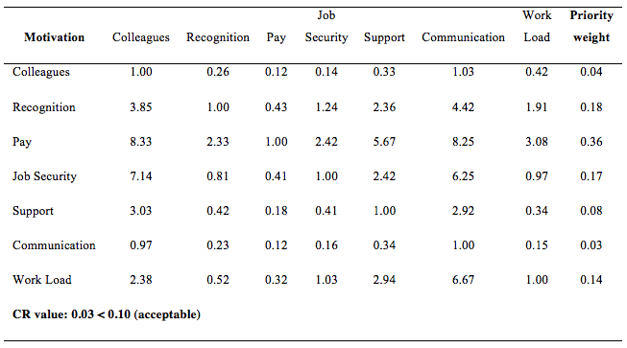
Table 6.6, which shows the school climate sub-criteria, shows that the teachers believe that 55% of the teachers’ satisfaction comes from safety, 25% comes from academic, 10% comes from community, and 10% comes from institutional environment. Thus, 80% of the teachers’ satisfaction was affected by safety and academic factors, and 20% was affected by community and institutional environment factors.
Table ‎6.6: Pairwise comparison of School Climate sub-criteria
Job Characteristics | Safety |  | Academic | Community | Institutional Environment | Priority weight
Safety |  | 1.00 | 2.92 | 4.75 | 4.75 | 0.55
Academic |  | 0.34 | 1.00 | 3 | 2.89 | 0.25
Community |  | 0.21 | 0.33 | 1.00 | 1.02 | 0.10
Institutional Environment |  | 0.21 | 0.35 | 0.98 | 1.00 | 0.10
CR value: 0.03 < 0.10 (acceptable)
Table 6.7, which presents the organizational justice sub-criteria, shows that the teachers believe that 52% of UAE teachers’ satisfaction comes from interactional justice, 40% from distributive justice, and 10% from procedural justice. Thus, 90% of the teachers’ satisfaction was affected by interactional justice and distributive justice factors and only 10% was affected by procedural justice factors.
Table ‎6.7: Pairwise comparison of Organizational Justice sub-criteria
Job Characteristics | Distributive Justice | Procedural Justice | Interactional Justice | Priority weight
Distributive Justice | 1.00 | 4.33 | 0.72 | 0.40
Procedural Justice | 0.23 | 1.00 | 0.23 | 0.10
Interactional Justice | 1.39 | 4.35 | 1.00 | 0.50
CR value: 0.01 < 0.10 (acceptable)

Table 6.8, which shows the school leadership styles sub-criteria, shows that experienced teachers believe that 35% of the UAE teachers’ satisfaction comes from achievement oriented leadership, 33% from rational decision-making, 14% from participative leadership, 9% from transformational leadership, 5% from directive leadership, and only 4% from servant-style leadership. Thus, 82% of the teachers’ satisfaction was affected by achievement oriented, rational decision-making, and participative factors, while only 18% was affected by transformational, directive, and servant factors.

Table ‎6.8: Pairwise comparison of school leadership styles sub-criteria
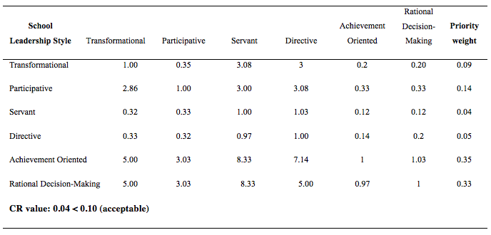
Table 6.9 shows the ranking of all twenty sub-factors. The global weights are calculated by multiplying the local weight of each main criterion with the local weights of its sub-criteria. Each factor is then given the deserved rank. The first ranked factor (Pay) has the highest global weight, whereas the last ranked factor (Servant) has the lowest global weight.
Table ‎6.9: Priorities ranking for the criteria and the sub criteria
Main criteria | Local weight | Sub criteria | Local weight | Global weight | Rank
Motivation | 0.571 | Colleagues | 0.037 | 0.0211 | 12
 |  | Recognition | 0.175 | 0.0999 | 4
 |  | Pay | 0.362 | 0.2067 | 1
 |  | Job Security | 0.174 | 0.0994 | 5
 |  | Support | 0.075 | 0.0428 | 7
 |  | Communication | 0.032 | 0.0183 | 13
 |  | Work Load | 0.144 | 0.0822 | 6
School Climate | 0.065 | Safety | 0.545 | 0.0354 | 10
 |  | Academic | 0.255 | 0.0166 | 14
 |  | Community | 0.100 | 0.0065 | 17
 |  | Institutional Environment | 0.100 | 0.0065 | 18
Organizational Justice | 0.254 | Distributive Justice | 0.399 | 0.1013 | 3
 |  | Procedural Justice | 0.103 | 0.0262 | 11
 |  | Interactional Justice | 0.497 | 0.1262 | 2
School Leadership Styles | 0.111 | Transformational | 0.088 | 0.0098 | 16
 |  | Participative | 0.138 | 0.0153 | 15
 |  | Servant | 0.040 | 0.0044 | 20
 |  | Directive | 0.045 | 0.0049 | 19
 |  | Achievement Oriented | 0.355 | 0.0394 | 8
 |  | Rational Decision-Making | 0.334 | 0.0371 | 9
Total | 1.00 | Total |  | 1.000

Figure 6.3 shows all 20 sub-factors, organized in descending order from the most important to the least. Pay is the most important factor, falling in the high range category between 13 and 21% and accounting by itself for 21% of teachers’ satisfaction among all the twenty sub-factors. Five factors fall between 8 and 13%, which is in the middle range category and, together, account for 51% of teachers’ satisfaction: Interactional Justice (12.6%), Distributive Justice (10%), Recognition (9.9%), Job Security (9.9%), and Work Load (8.2%). The remaining factors all fall in the lower range category between 0 and 5%, accounting for a total of 28% of teachers’ satisfaction. It is remarkable that the high and middle range categories do not include any sub-factors of the school climate or school leadership style criteria.
Figure ‎6.3: The ranking and percentages of 20 sub-factors

CHAPTER 7
DISCUSSION AND CONCLUSION

This chapter comprises the last piece of an artistic picture of the dissertation. It discusses the purpose of the study and summarizes all the previous chapters and the study findings. After that, it will discuss the findings in detail and come up with recommendations. It comments on the limitations of the study and presents the conclusion.

The Purpose
The main objective of the study is to find out which are the most important factors that increase UAE teachers’ job satisfaction, especially in Abu Dhabi, so that we can reduce the turnover rate among the private school teachers. The main objective can be achieved through conducting five detailed objectives:
- To conduct a narrative literature review (NLR) to produce a preliminary model of determinants of teachers’ job satisfaction (TJS) based on existing studies and the researcher’s experience.
- To conduct an investigation of the systematic literature review (SLR) of all the predictors of teachers’ job satisfaction identified in previous academic studies.
- To get a recommendation from educational experts to select the most valuable factors and their sub-factors out of the list produced during the NLR and SLR to put them in a final AHP Model in order to conduct the field research.
- To determine the Abu Dhabi private school teachers’ preference and priority of the main factors and their sub-factors influencing teachers’ job satisfaction, as selected by the experts, by means of an analytical hierarchical process (AHP) model.
- To test and validate the proposed model on a wider scale of the Emirate of Abu Dhabi by surveying and interviewing private school expert teachers at kindergarten, elementary, intermediate, and secondary levels.

Summary of chapters
Chapter one examined the problem of teacher turnover, which is very high, despite great attention and care from the UAE education authorities, especially the Abu Dhabi Government, to improve the education system to world-class standards. Ahmed (2011) mentioned ‘teacher turnover rate up to 60% a year at some schools in Dubai’ and Edward Murtagh said that turnover rate is above 20% in Abu Dhabi (SCAD, 2016). This terrifying data was behind conducting the study. The study is aimed at identifying the most important factors that increase Abu Dhabi teachers’ job satisfaction in order to reduce the high turnover rate among private school teachers.
Chapter two described the techniques and methodology used in the current
study. A literature review would be conducted using two techniques, narrative literature review (NLR) and systematic literature review (SLR). The NLR would be used to develop a base model to be used for comparison, and the SLR would be used to produce a list of factors and sub-factors which previous research had found to predict TJS. Data would then be collected through two methods; the focus group interview (FGI) and analytic hierarchy process (AHP). The FGI method would engage experts to select the most important factors to produce the final AHP model and conduct the main empirical study. The AHP method would be used with experienced private school teachers to prioritize factors and their sub-factors to produce a ranking list of the most important factors and sub-factors that concern Abu Dhabi private school teachers.
Chapter three reported a survey of literature to identify all well-known sub-factors of motivation, school leadership style, job characteristics, and cultural intelligence to come up with a preliminary model of determinants of TJS based on existing studies and the researcher’s experience. The identified sub-factors have not previously been prioritized using the AHP methodology and some of them have not been measured in relation to TJS, such as job characteristics and cultural intelligence. The preliminary model was tested by Alkhyeli (the author) and Ewijk (2018).
Chapter four talked explained a need for a list of all the factors previously found to predict teachers’ job satisfaction and how this can be achieved by systematic literature review (SLR). The SLR involves certain steps and, although these steps differ from one researcher to another, the sequence is similar. A structured framework described by Whittemore and Knafl (2005) was used for the current SLR, which involves 5 steps to produce a list of articles. Seventy-six articles were identified in the current study. All the predictors of TJS in the previous list were mapped to the preliminary AHP model categories. The percentages of most studied factors and their sub-factors were identified to indicate their importance. In addition, the researcher did not find any AHP study that measured teachers’ job satisfaction, even during the systematic review.
Chapter five reported the focus group interview (FGI), which was chosen as a method because the topic under investigation is complicated and includes many variables, as identified in the previous chapter. FGI is the method recommended for such complex investigations by Powell and Single (1996). The huge list of variables needed to be reduced and put in a form so that the education experts could select the main factors and their sub-factors easily. Some of the studies found in the SLR did not mention sub-factors of a category, such as school climate, so the missing sub-factors were pooled from the literature and attached to their main factors in the new form. By grouping similar items, the list was reduced to eleven main factors and sixty-seven sub-factors. The focus group then selected only four main factors and twenty sub-factors to avoid over-complicating the study and these were put into a final AHP model. The selections made by the focus group were supported by their explanations and comments.
Chapter six explained the need for a multi-criteria decision-making technique to measure and rank all the recommended factors and their sub-factors because of the large number of variables to be considered for analysis. The AHP technique was chosen as the most appropriate and useful approach to simplify ranking the four main factors and their 20 sub-factors. The AHP involved the following steps to reach the final ranking: 1) identifying the problem 2) developing a hierarchical model 3) developing a questionnaire consisting of pairwise comparisons tables 4) collecting the data and computing the normalized weights 5) calculating the overall (or global) weights.

Summary of Findings
A narrative review revealed a preliminary model that had not been tested before, except by Alkhyeli (the author) and Ewijk (2018) in a separate study. This empirical study was the first to investigate teachers’ job satisfaction in relation to the four main factors together in one model. It was also the first research to investigate teachers’ job satisfaction using the AHP method. The author found only one study that prioritized some factors of motivation, which is one of the main criteria, in relation to teachers’ job satisfaction using the AHP method. The other three main criteria have not previously been investigated using the AHP method.
The systematic review revealed the first metadata of all the predictive factors of teachers’ job satisfaction. The metadata comprises sixty-seven studies. This metadata is one of the main contributions of the current study. Some studies did not mention sub-factors along with main factors, so sub-factors were identified in the pooled literature and attached to their main factors in a new form. The form produced consisted of eleven main factors and sixty-seven sub-factors.
The focus group of educational experts recommended four main factors and twenty sub-factors. They have recommended motivation, school leadership styles, school climate, and organizational justice as the main factors. They said that motivation is considered to be the driving force of all actions, as recommended by many studies. In addition, they said too that they were greatly concerned about school leadership. Lastly, they mentioned that both school climate and organizational justice have not been measured academically before.
All the detailed results can be found in chapter 6 but the highest level will be presented here. The interviewed expert teachers think that 57% of teachers’ satisfaction in Abu Dhabi comes from motivation, 25% comes from organizational justice, 11% comes from the style of school leadership styles, and only 6% comes from the school climate. The figure below summarizes the ranking and the percentage of the 20 sub-factors considered. Pay is identified as the most important factor; it falls in the high range category between 13 and 21 %, and accounts by itself for 21% of teachers’ satisfaction as measured by the twenty sub-factors. Five factors fall between 8 and 13%, which is the middle range category, and these together account for 51% of teachers’ satisfaction: interactional justice (12.6%), distributive justice (10%), recognition (9.9%), job security (9.9%), and work load (8.2%). The remaining factors all fall in the lower range category between 0 and 5%, and account for 28% of teacher’s satisfaction. It is noteworthy that the high and middle range categories do not include any of the sub-factors of the school climate and school leadership categories.

Figure ‎7.1: The 20 sub-factors ranking and percentage (repeated from fig. 6.3)

Discussion
This empirical study is the first to investigate teachers’ job satisfaction in relationship to motivation, school climate, organizational justice, and school leadership styles, together with their sub-factors, in one model. However, it is not the first research to investigate teachers’ job satisfaction using the AHP method. The first research to investigate teachers’ job satisfaction using the AHP method was conducted by Alkhyeli (the author) and Ewijk (2018) using the current preliminary model, which consists of motivation, school leadership styles, job characteristics, and cultural intelligence with their sub-factors. Other than this, the author did not find any similar previous study using the AHP method, except one study that prioritized some factors of motivation, one of the main criteria in the current study.
The study by Alkhyeli and Ewijk (2018) was conducted in Al-Ain using the preliminary model. It was conducted on two highly ranked private schools. Three expert teachers from each school, who worked at various levels from kindergarten to high school, responded to questionnaires. These teachers believed 61% of teachers’ satisfaction in the UAE comes from motivation, 21% comes from job characteristics, 13% comes from the style of school leadership, and only 5% comes from cultural intelligence. Figure 7.1 summarizes the ranking and the percentage of the first study.

Figure ‎7.2: Priority ranking of all factors from highest to lowest from the study by Alkhyeli and Ewijk (2018)
Both studies are similar in using motivation and school leadership styles as main factors but the other factors are different. In the first study, recognition was the most concerning factor then came the pay whereas in the current study, pay is the most concerning factor and recognition comes in the fourth position. This could be explained by the fact that the first study was conducted in two highly ranked schools, where teachers are usually paid well, whereas the second study was conducted in schools with mixed ratings, some of which tend to pay teachers poorly.
It is not a surprise that 57% of teachers’ satisfaction in the UAE comes from motivation, because satisfaction and motivation are related concepts. Peretomode (1991) mentioned, as cited by Ololube (2004), that “the two terms are related but are not synonymous”. However, what is really surprising is that organizational justice scored higher than the remaining factors, at 25%. Teachers in private schools need fairness in their schools at all levels. They want to be treated fairly and treated with respect and dignity. They want fairness in salary levels, promotions, bonuses, housing allowances, workloads, and work schedules. They want their procedures to be consistent and not biased.
The high rank of the motivation factor in this study could mean that teachers are more concerned by that factor. The most important motivation factors were pay and recognition. Pay scored high and positioned itself far from the other factors. In digging deep for an explanation, some reports highlighted that there is a great salary disparity among private schools. In 2013, ADEC reported that, in 86 schools out of 133 schools that disclosed salary, their starting monthly salary was AED 5,000 or less, which is equivalent to $1,360 (Pennington, 2016). Pennington (2016) mentioned that 86 private schools in Al-Ain City paid wages ranging from AED 2,700 at a Ministry of Education school to AED 14, 300 for a British-American curriculum school. Atik Munshi, Managing Partner, added that the "teacher salaries in Asian curriculum schools are normally dramatically less compared to their western counterparts” (Munshi, cited by Clarke, 2016). In Abu Dhabi public schools, in contrast, wages ranged from AED 12,500 to AED 20,500, depending on qualifications and experience (Pennington, 2016). Manoj George said, "the gap in salaries being offered in private school sectors will drive away the best talent and experienced teachers" (George, cited by Report, 2016).
The education authorities in the UAE, especially ADEC should think of introducing a minimum salary for all private school teachers in order to raise the standards. Even though there are education authorities that regulate private schools in Dubai (Knowledge and Human Development Authority (KHDA) and Abu Dhabi (ADEC), neither of them regulates teachers' wages; both of them let private businesses structure and set their own pay and wages (Clarke, 2016). A representative from Dubai’s KHDA said that, "we look after private schools, and private businesses are able to set their own salary structure for teachers" and a representative from ADEC said similarly, "each private school is in charge of setting its own pay trends for their teachers" (KHDA representative, cited in Clarke, 2016).
Teachers in the UAE need to be recognized, appreciated, valued, and treated fairly; they don’t want to be neglected and ignored. Also, they complain of instability in their work and they need a secure job. Furthermore, they complain of high workloads. Education authorities in the UAE should first determine what their teachers really value and appreciate; they should then develop appropriate policies to deal with these issues, especially reward policies, and as a third step, they should enforce these policies at all levels (Danish & Usman, 2010).
Interactional justice was ranked as the most important organizational justice factor, with distributive justice ranked second. Fernandes and Awamleh (2006) studied the influence of the three kinds of organizational justice on both expatriates and UAE nationals in the UAE, with data collected from different organizations. They found that both distributive and interactional justice have a great influence on satisfaction. Interactional justice fairness is related to the interpersonal interaction among individuals, teams, and groups. Teachers need fair interactive treatment in their school with their managers and their colleagues (Fernandes & Awamleh, 2006).
Distributive justice denotes the concerns expressed by the private school teachers in relation to the distribution of resources and outcomes. They determine fairness through comparison with others. They want fair salaries, bonuses, promotions, housing allowances, workloads, and work schedules. The concern over distributive justice is connected with the previously mentioned concern over pay. Diaz-Serran and Vieira (2005) explained that ‘low-pay workers report a lower level of job satisfaction when compared with their higher paid counterparts in most countries’. The concern about pay indicates that there is inequality in salaries among school teachers, especially those in the same school. It is almost inevitable that teachers will discover their colleagues’ salaries, so if the differences are not perceived as fair, this may lead to lower motivation or teacher attrition.
In the current study, it is really surprising that achievement-oriented and rational decision-making leadership styles scored higher than servant leadership style, because, in the first study by Alkhyeli and Ewijk (2018), servant leadership style scored higher than any other leadership style. However, it scored the lowest among all the twenty sub-factors in the current study, which needs a new investigation. The current study has covered a wider area and more teachers (24) than the first study, which was conducted only in Al-Ain city and interviewed only eight teachers. The private teachers want administrators who are decision-makers and who set challenging goals so they that perform at their highest level and to boost their morale to get confidence in achieving these challenging goals (Hause & Mitchell, 1974). In fact, the local education expert focus group recommended both the achievement-oriented and rational decision-making leadership styles to be evaluated and said that achievement-oriented leaders set challenging goals for themselves and their teams, based on clear vision and mission statements, which will lead them to high levels of performance. Decision-making leaders encourage consistent and high-quality decisions, based on clear facts, removing subjectivity and uncertainty from the decision-making process.
Safety was ranked as the most important school climate factor, and community ranked second. Winter and Sweeney (1994) claim that, “school climate is a little like the weather. It is difficult to get a handle on, but it is felt everywhere”. In fact, safe and positive school environments allow effective learning and teaching. It affects everyone related to the school: staff, students, parents, and the community. School misconduct, ignorance or disagreement of rules among teachers and administrators, and students who do not believe in rules, all contribute to unsafe schools (Hernández & Seem, 2004). School Community represents the overall quality of interpersonal relationships within the school (Wang & Degol, 2016). Social relationships are a fundamental feature of school climate. Some teachers do not build a relationship with their co-workers, other than as acquaintances. They should work as a team with their co-workers to build a trusted and supportive climate. This type of interpersonal relationship will result in a positive learning climate and improve student achievement (Winter & Sweeney, 1994).

Recommendations for Future Research
The systematic literature review (SLR) outputs open the door for many future investigations. Many models for predicting teachers’ job satisfaction (TJS) can be created out of the discovered factors and their sub-factors, and they can be tested using the analytic hierarchy process (AHP) methodology in the UAE or worldwide. In fact, not many studies have been conducted in relation to TJS using the AHP methodology. In addition, the SLR outputs indicate that there are gaps, with many factors that have not been tested before for a relationship with TJS. The SLR tables could be used as reference in conducting new research on factors that have not previously been mentioned as predictors to test their relationship with TJS. Lastly, both the preliminary model and the final model can be used in conducting new quantitative studies, whether in the UAE or worldwide.

Recommendations for Future Practice
Schools need to assess and monitor their rules, procedures, pay fairness, reward systems, praise and so on. In addition, they need to check frequently the quality of the relationship between administrators and teachers. They could do that by surveying their teachers to get their opinions about these concerns instead of speculating and predicting them. The perception of fairness could mean different things to school administrators and teachers, so there is a need to plant organizational justice and fairness in schools from teachers’ points of view. It is clear that teachers nowadays are looking for schools that provide fair and just workplaces where they feel respected, valued, and accepted. School fairness and justice should be adopted because it is a significant societal value. In addition, feelings of fairness among teachers have a great impact on the school community and the school climate. In fact, school fairness and justice deserve the attention of education authorities and school managers and should be developed in accordance with teachers’ point of view.

Study Limitations
Any study will always have limitations and uncontrollable elements. In the current study, the researcher was not able to examine all studies that have been published worldwide because he has a limited access to database and studies. For example, all the pooled studies were retrieved from only three reachable databases: 1) ProQuest 2) Scopus 3) EBSCOhost during the systematic literature review. In addition, he accessed only the articles that were available for reading online. Lastly, the study would be more valuable if the participants during the AHP stage were asked their reasons behind their preference, which was neglected in order to reduce the survey complexity.

Conclusion
In fact, many studies have tried to determine the reasons for high teacher turnover and low teacher retention, with the objectives of identifying the origin of the issue and finding appropriate solutions. Resolving the issue of teacher turnover and improving teacher retention is a challenging task that falls on the shoulders of school leaders (Ngotngamwong, 2012) and the UAE education authorities. Pay, interactional justice, distributive justice, recognition, job security, and workload scored highest among teachers’ concerns according to the final ranking table. The UAE education authorities and school leaders need to pay attention to these insights to address teachers’ concerns. The turnover phenomenon does not exist only in the UAE, but also worldwide. There is a high cost that is linked to this phenomenon, but perhaps more important than the material cost is the effect on the next generation (Alkhyeli & Ewijk, 2018). According to Weston (2014), the National Bureau of Educational Research found that, “Students assigned to high value-added teachers are more likely to attend college, attend higher-ranked colleges, earn higher salaries, live in higher SES neighbourhoods, and save more for retirement. They are also less likely to have children as teenagers.”
The objective of any education authority is to improve the education quality in all types of schools, whether private or public. The UAE education authority and the regional education authorities, such as ADEC, need to increase the level of satisfaction among private school teachers in order to reduce the high turnover rate. To do this effectively, they must investigate why their teachers are not motivated. They need to evaluate all the factors that influence teachers’ job satisfaction, not only the ones mentioned above, and try to improve them. The authorities should also consider the importance of organizational justice and positive school climate when redesigning teachers’ jobs. Lastly, they should hire great school leaders because they play an important role in students’ achievement and teachers’ retention(Alkhyeli & Ewijk, 2018).

REFERENCES
Abu Dhabi Government. (2008). Abu Dhabi economic vision 2030. (). Retrieved from https://www.ecouncil.ae/PublicationsEn/economic-vision-2030-full-versionEn.pdf
ADEC. (2016). Retrieved from https://www.adec.ac.ae
Afshinpour, S., Germain, M. G., Tomlin, M. E. T., & Anderson, T. (2014). The role of situational leadership style in employee satisfaction in an Iranian oil company. مجله پژوهش های مدیریت منابع سازمانی, 3(3), 135-151.
Ahearn, K. K., Ferris, G. R., Hochwarter, W. A., Douglas, C., & Ammeter, A. P. (2004). Leader political skill and team performance. Journal of Management, 30(3), 309-327.
Ahmed, A. (2011, July 6). Teacher turnover rate up to 60% a year at some schools. The National Newspaper, pp. Retrieved from http://www.thenational.ae/news/uae-news/education/teacher-turnover-rate-up-to-60-a-year-at-some-schools;.
Aldridge, J. M., & Fraser, B. J. (2016). Teachers’ views of their school climate and its relationship with teacher self-efficacy and job satisfaction. Learning Environments Research, 19(2), 291-307.
Al-Harbi, K. M. A. (2001). Application of the AHP in project management. International Journal of Project Management, 19(1), 19-27.
Ali, A. Y. S., & Dahie, A. M. (2015). Leadership style and teacher job satisfaction: Empirical survey from secondary schools in Somalia. Leadership, 5(8)
Aliakbari, M., & Kafshgar, N. B. (2013). On the relationship between teachers' sense of responsibility and their job satisfaction: The case of Iranian high school teachers. European Online Journal of Natural and Social Sciences, 2(2s), 487.
Al-Jenaibi, B. (2012). The scope and impact of workplace diversity in the United Arab Emirates–A preliminary study. Malaysia Journal of Society and Space, 8(1), 1-14.
Alkhyeli, H. E., & Ewijk, A. V. (2018). Prioritisation of factors influencing teachers' job satisfaction in the UAE. International Journal of Management in Education, 12(1), 1-24.
Al-Mahdy, Y. F., Al-Harthi, A. S., & Salah El-Din, N. S. (2016). Perceptions of school principals’ servant leadership and their teachers’ job satisfaction in man. Leadership and Policy in Schools, 15(4), 543-566.
Alom, M. M. (2018). Proactive transparency and outward accountability of frontline public bureaucracies: An integrated model. International Journal of Productivity and Performance Management, (just-accepted), 00-00.
Altahayneh, Z. L., Khasawneh, A., & Abedalhafiz, A. (2014). Relationship between organizational justice and job satisfaction as perceived by Jordanian physical education teachers. Asian Social Science, 10(4), 131.
Anastasiou, S., & Papakonstantinou, G. (2014). Factors affecting job satisfaction, stress and work performance of secondary education teachers in Epirus, NW Greece. International Journal of Management in Education, 8(1), 37-53.
Ariffin, A. H., Hashim, H., & Sueb, R. (2013). Identifying teachers’ job satisfaction. Retrieved September, 8, 2016.
Arifin, H. M. (2014). The influence of competence, motivation, and organisational culture to high school teacher job satisfaction and performance. International Education Studies, 8(1), 38.
Armacost, R. L., Componation, P. J., Mullens, M. A., & Swart, W. W. (1994). An AHP framework for prioritizing customer requirements in QFD: An industrialized housing application. IIE Transactions, 26(4), 72-79.
Astrauskaite, M., Vaitkevicius, R., & Perminas, A. (2011). Job satisfaction survey: A confirmatory factor analysis based on secondary school teachers’ sample. International Journal of Business and Management, 6(5), 41.
Barakat, L. L., Lorenz, M. P., Ramsey, J. R., & Cretoiu, S. L. (2015). Global managers: An analysis of the impact of cultural intelligence on job satisfaction and performance. International Journal of Emerging Markets, 10(4), 781-800.
Basak, R., & Ghosh, A. (2011). School environment and locus of control in relation to job satisfaction among school teachers–A study from Indian perspective. Procedia-Social and Behavioral Sciences, 29, 1199-1208.
Basak, R., & Ghosh, A. (2013). Teacher job satisfaction in the light of career stages and self-efficacy. International Journal of Education and Management Studies, 3(4), 396.
Bass, B. M., & Avolio, B. J. (1994). Transformational leadership and organizational culture. The International Journal of Public Administration, 17(3-4), 541-554.
Bendassolli, P. F. (2013). (2013). Theory building in qualitative research: Reconsidering the problem of induction. Paper presented at the Forum Qualitative Sozialforschung / Forum: Qualitative Social Research, , 14(1) Retrieved from http://www.qualitative-research.net/index.php/fqs/article/view/1851/3497
Benit, D. A. (1991). The relationship between principal leadership style and teacher job satisfaction. Dissertation Abstracts International, 53(3), 668.
Benner, A. D. (2000). The cost of teacher turnover. Austin, TX: Texas Center for Educational Research.
Benoliel, P., & Barth, A. (2017). The implications of the school’s cultural attributes in the relationships between participative leadership and teacher job satisfaction and burnout. Journal of Educational Administration, 55(6), 640-656.
Berry, A. B. (2012). The relationship of perceived support to satisfaction and commitment for special education teachers in rural areas. Rural Special Education Quarterly, 31(1), 3.
Best, E. E. (2006). Job satisfaction of teachers in krishna primary and secondary schools (Doctoral dissertation). Available from ProQuest Dissertations & Theses Global: The Humanities and Social Sciences Collection. (3212536). doi:305282574 Retrieved from http://adezproxy.adu.ac.ae/docview/305282574?accountid=26149
Bogler, R. (2001). The influence of leadership style on teacher job satisfaction. Educational Administration Quarterly, 37(5), 662-683.
Bogler, R., & Nir, A. E. (2012). The importance of teachers' perceived organizational support to job satisfaction: What's empowerment got to do with it? Journal of Educational Administration, 50(3), 287-306.
Borda, R. G., & Norman, I. J. (1997). Factors influencing turnover and absence of nurses: A research review. International Journal of Nursing Studies, 34(6), 385-394.
Boyer, D. (2013). A qualitative phenomenological study of veteran teachers to increase novice teacher retention (Doctoral dissertation). Available from ProQuest Dissertations & Theses Global: The Humanities and Social Sciences Collection. (3583439). doi:1559962024 Retrieved from http://adezproxy.adu.ac.ae/docview/1559962024?accountid=26149
Brown, L. A. (2011). The relationship between employee turnover and leadership: A mixed-methodology investigation (Doctoral dissertation). Available from ProQuest Central. (3473127). doi:894428611 Retrieved from http://adezproxy.adu.ac.ae/docview/894428611?accountid=26149
Bücker, J. J., Furrer, O., Poutsma, E., & Buyens, D. (2014). The impact of cultural intelligence on communication effectiveness, job satisfaction and anxiety for Chinese host country managers working for foreign multinationals. The International Journal of Human Resource Management, 25(14), 2068-2087.
Bumgartner, M. (2013). A study of factors that impact teacher job satisfaction in rural schools. (Unpublished doctoral dissertation). University of Nevada, Reno, NV.
Butler, S. G. (2010). Analysis of a conceptual framework to express teacher job satisfaction (Doctoral dissertation). Available from ProQuest Dissertations & Theses Global: The Humanities and Social Sciences Collection. (3428420). doi:818744212 Retrieved from http://adezproxy.adu.ac.ae/docview/818744212?accountid=26149
Buyukgoze-Kavas, A., Duffy, R. D., Güneri, O. Y., & Autin, K. L. (2014). Job satisfaction among Turkish teachers: Exploring differences by school level. Journal of Career Assessment, 22(2), 261-273.
Carlson, C. L. (2012). The profession that eats its young: The effect of principal leadership on the survival rate of teachers. Journal of Arts and Humanities, 1(3), 48.
Carroll, B., & Blumen, M. W. (1973). Job satisfaction: A review of the literature. Ithaca, NY: ILR Press.
Cerit, Y. (2009). The effects of servant leadership behaviours of school principals on teachers’ job satisfaction. Educational Management Administration & Leadership, 37(5), 600-623.
Cerit, Y. (2014). The relationship between classroom teachers' job satisfaction and organizational collectivism and individualism. Egitim Ve Bilim, 39(173)
Chambers, S. K. B. (2010). Job satisfaction among elementary school teachers. The University of North Carolina at Chapel Hill.
Cheng, E. W., & Li, H. (2001). Analytic hierarchy process: An approach to determine measures for business performance. Measuring Business Excellence, 5(3), 30-37.
Chin, J. M. (2007). Meta-analysis of transformational school leadership effects on school outcomes in Taiwan and the USA. Asia Pacific Education Review, 8(2), 166-177.
Chinomona, R., & Sandada, M. (2014). Organisational support and its influence on teachers job satisfaction and job performance in Limpopo province of South Africa. Mediterranean Journal of Social Sciences, 5(9), 208.
Clark, M. (2006). Teacher job satisfaction in secondary schools in southeastern Georgia.
Clarke, K. (2016, September 19, 2016). Why such disparity in teachers' salary in UAE?. Khaleej Times Retrieved from https://www.khaleejtimes.com/the-disparity-in-teachers-pay
Conley, S., Bas-Isaac, E., & Brandon, J. (1998). What matters to whom: Predictors of teacher satisfaction in a career development plan. Journal of Personnel Evaluation in Education, 11(4), 299-322.
Creswell, J. (2007). Research design: Qualitative, quantitative, and mixed methods approaches (3rd ed.). Thousand Oaks, CA: Sage.
Dajani, A. E. (2014). Qualitative investigation of principal behaviors that impact teacher turnover intention and job satisfaction in an American international school. Northcentral University.
Danish, R. Q., & Usman, A. (2010). Impact of reward and recognition on job satisfaction and motivation: An empirical study from Pakistan. International Journal of Business and Management, 5(2), 159.
Daryanto, E. A study on vocational school teachers’ satisfaction in Deli Serdang North Sumatera Indonesia. International Journal of Sciences: Basic and Applied Research (IJSBAR),
De Nobile, J. (2017). Organisational communication and its relationships with job satisfaction and organisational commitment of primary school staff in Western Australia. Educational Psychology, 37(3), 380-398.
Deng, L., & Gibson, P. (2008). A qualitative evaluation on the role of cultural intelligence in cross-cultural leadership effectiveness. International Journal of Leadership Studies, 3(2), 181-197.
Denison, D. R. (1990). Corporate culture and organizational effectiveness. John Wiley & Sons.
Derlin, R., & Schneider, G. T. (1994). Understanding job satisfaction principals and teachers, urban and suburban. Urban Education, 29(1), 63-88.
Diao, A., & Park, D. S. (2012). Culturally intelligent for satisfied workers in a multinational organization: Role of intercultural communication motivation. African Journal of Business Management, 6(24), 7296.
Dickson, M., Kadbey, H., & McMinn, M. (2015). Comparing reported classroom practice in public and private schools in the United Arab Emirates. Procedia-Social and Behavioral Sciences, 186, 209-215.
Drake, P. R., Myung Lee, D., & Hussain, M. (2013). The lean and agile purchasing portfolio model. Supply Chain Management: An International Journal, 18(1), 3-20.
DSIB. (2013). Private schools landscape in Dubai 2012-2013. Dubai, UAE: Knowledge and Human Development Authority.
DSIB. (2016). Private schools landscape in Dubai 2015-2016. Dubai, UAE: Knowledge and Human Development Authority.
Earley, P. C., & Ang, S. (2003). Cultural intelligence: Individual interactions across cultures. Palo Alto: CA: Stanford University Press.
Eldred, J. A. (2010). A study to determine the relationship between the perceived leadership styles of school principals and teacher job satisfaction at selected elementary schools (Doctoral dissertation). Available from ProQuest Central; ProQuest Dissertations & Theses Global: The Humanities and Social Sciences Collection. (3412477). doi:743815153 Retrieved from http://adezproxy.adu.ac.ae/docview/743815153?accountid=26149
Eliophotou-Menon, M., & Ioannou, A. (2016). The link between transformational leadership and teachers' job satisfaction, commitment, motivation to learn, and trust in the leader. Academy of Educational Leadership Journal, 20(3), 12-22.
Farooqi, M. T. K., Iqbal, A., & Tahir, M. S. (2015). Relationship of organizational climate with teachers' job satisfaction. Journal of Educational Research, 18(1), 56.
Fernandes, C., & Awamleh, R. (2006). Impact of organisational justice in an expatriate work environment. Management Research News, 29(11), 701-712.
Forman, E. H., & Selly, M. A. (2001). The analytic hierarchy process and expert choice. World Scientific Book Chapters, , 43-125.
Fukushige, M. (2016). Systematic review and meta-analysis of the effects of treatment and immunization against schistosomiasis.
Gaad, E., Arif, M., & Scott, F. (2006). Systems analysis of the UAE education system. International Journal of Educational Management, 20(4), 291-303.
Gelfand, M. J., Imai, L., & Fehr, R. (2008). Thinking intelligently about cultural intelligence. In S. Ang, & L. Van Dyne (Eds.), Handbook on cultural intelligence: Theory, measurement and applications (pp. 375-388). Armonk, NY: M.E. Sharpe.
Ghavifekr, S., & Pillai, N. S. (2016). The relationship between school’s organizational climate and teacher’s job satisfaction: Malaysian experience. Asia Pacific Education Review, 17(1), 87-106.
Gkolia, A., Belias, D., & Koustelios, A. (2014). Teacher’s job satisfaction and self efficacy: A review. European Scientific Journal, 10(22), 321-342.
Gligorović, B., Terek, E., Glušac, D., Sajfert, Z., & Adamović, Ž. (2014). Job satisfaction and gender differences in job satisfaction of teachers in Serbian primary schools. Journal of Engineering Management and Competitiveness (JEMC), 4(2), 94-100.
Goleman, D. (1998). Working with emotional intelligence Bantam.
Guagulwong, T. (1981). Leadership styles, maturity levels, and job satisfaction in elementary schools (Doctoral dissertation). Available from ProQuest Dissertations & Theses Global: The Humanities and Social Sciences Collection. (8116597). doi:303194416 Retrieved from http://adezproxy.adu.ac.ae/docview/303194416?accountid=26149
Hackman, J. R., & Oldham, G. R. (1975). Development of the job diagnostic survey. Journal of Applied Psychology, 60(2), 159.
Hadi, R., & Adil, A. (2010). Job characteristics as predictors of work motivation and job satisfaction of bank employees. Journal of the Indian Academy of Applied Psychology, 36(2), 294-299.
Handfield, R., Walton, S. V., Sroufe, R., & Melnyk, S. A. (2002). Applying environmental criteria to supplier assessment: A study in the application of the analytical hierarchy process. European Journal of Operational Research, 141(1), 70-87.
Hariri, H., Monypenny, R., & Prideaux, M. (2016). Teacher-perceived principal leadership styles, decision-making styles and job satisfaction: How congruent are data from Indonesia with the anglophile and western literature? School Leadership & Management, 36(1), 41-62.
Harris, L. M. (2008). The relationship between leadership styles of school principals and teacher retention. (Unpublished doctoral dissertation). Capella University, (An online university).
Hause, R., & Mitchell, T. (1974). Path-goal theory of leadership. J.Contemporary Bus., Autumn, Br, 4, 81-97.
Heller, H. W., Clay, R., & Perkins, C. (1993). The relationship between teacher job satisfaction and principal leadership style. Journal of School Leadership, 3(1), 74-86.
Heneman III, H. G., & Schwab, D. P. (1985). Pay satisfaction: Its multidimensional nature and measurement. International Journal of Psychology, 20(1), 129-141.
Hernández, T. J., & Seem, S. R. (2004). A safe school climate: A systemic approach and the school counselor. Professional School Counseling, 7(4), 256-262.
Herzberg, F. (1974). Motivation-hygiene profiles: Pinpointing what ails the organization. Organizational dynamics.
Hoppock, R. (1935). Job satisfaction. New York: Harper.
Huang, R., & Yeh, C. (2008). Development of an assessment framework for green highway construction. Journal of the Chinese Institute of Engineers, 31(4), 573-585.
Hui, H., Jenatabadi, H. S., Ismail, B., Azina, N., Radzi, W. M., & Jasimah, C. W. (2014). Principal's leadership style and teacher job satisfaction: A case study in China.
Hunter, P. E. (2006). Viability of the job characteristics model in a team environment: Prediction of job satisfaction and potential moderators. (Unpublished doctoral dissertation). University of North Texas, Denton, TX. Retrieved from http://digital.library.unt.edu/ark:/67531/metadc5456/m2/1/high_res_d/dissertation.pdf
Hussain, M., Ajmal, M. M., Khan, M., & Saber, H. (2015). Competitive priorities and knowledge management: An empirical investigation of manufacturing companies in UAE. Journal of Manufacturing Technology Management, 26(6), 791-806.
Hussain, M., Malik, M., & Al Neyadi, H. S. (2016). AHP framework to assist lean deployment in Abu Dhabi public healthcare delivery system. Business Process Management Journal, 22(3), 546-565.
Ishizaka, A., & Labib, A. (2009). Analytic hierarchy process and expert choice: Benefits and limitations. OR Insight, 22(4), 201-220.
Ishizaka, A., Pearman, C., & Nemery, P. (2012). AHPSort: An AHP-based method for sorting problems. International Journal of Production Research, 50(17), 4767-4784.
Ismail, K., Ibrahim, A. H., Ali, A. H., Dawi, A. H., & Ariff, M. S. M. (2015). Relationship between principal’s transformational leadership style and teacher’s job satisfaction. Advanced Science Letters, 21(7), 2459-2462.
Josanov-Vrgovic, I., & Pavlovic, N. (2014). Relationship between the school principal leadership style and teachers’ job satisfaction in Serbia. Montenegrin Journal of Economics, 10(1), 43-58.
Judge, T. A., & Hulin, C. L. (1993). Job satisfaction as a reflection of disposition: A multiple source causal analysis. Organizational Behavior and Human Decision Processes, 56(3), 388-421.
Karakose, T. (2014). The empirical study of organizational justice and job satisfaction for high school teachers in Turkey. Pakistan Journal of Statistics, 30(6)
Kashagate, R. (2013). Influence of Leadership Style on Teachers’ Job Satisfaction in Tanzania: The Case of Public Secondary Schools in Musoma Municipal Council,
Kessler, L. L. (2014). The effect of job satisfaction on IT employees turnover intention in Israel. The Annals of the University of Oradea, 1026.
Keung, E. K., & Rockinson-Szapkiw, A. J. (2013). The relationship between transformational leadership and cultural intelligence: A study of international school leaders. Journal of Educational Administration, 51(6), 836-854.
Kiboss, J. K., & Jemiryott, H. K. S. (2014). Relationship between principals’ leadership styles and secondary school teachers’ job satisfaction in Nandi south district, Kenya: American research institute for policy development. Journal of Education and Human Development, 3(2), 493-509.
Kieres, K. H. (2013). A study of the value added by transformational leadership practices to teachers' job satisfaction and organizational commitment (Doctoral dissertation). Available from ProQuest Dissertations & Theses Global: The Humanities and Social Sciences Collection. (3579651). doi:1509821371 Retrieved from http://adezproxy.adu.ac.ae/docview/1509821371?accountid=26149
Kight, L. C. (2007). The relationship between principal's leadership style and teacher absenteeism (Doctoral dissertation). Available from ProQuest Dissertations & Theses Global: The Humanities and Social Sciences Collection. (3284839). doi:304704455 Retrieved from http://adezproxy.adu.ac.ae/docview/304704455?accountid=26149
Kil, S., Lee, D. K., Kim, J., Li, M., & Newman, G. (2016). Utilizing the analytic hierarchy process to establish weighted values for evaluating the stability of slope revegetation based on hydroseeding applications in south korea. Sustainability, 8(1), 58.
Kim, K., Kirkman, B. L., & Chen, G. (2008). Cultural intelligence and international assignment effectiveness. In S. Ang, & L. Van Dyne (Eds.), Handbook of cultural intelligence: Theory, measurement, and applications (pp. 71-90). Armonk, NY: M.E. Sharpe.
Kirkevold, M. (1997). Integrative nursing research—an important strategy to further the development of nursing science and nursing practice. Journal of Advanced Nursing, 25(5), 977-984.
Kirkley, W. W. (2016). Entrepreneurial behaviour: The role of values. International Journal of Entrepreneurial Behavior & Research, 22(3), 290-328.
Kitson, A., Marshall, A., Bassett, K., & Zeitz, K. (2013). What are the core elements of patient‐centred care? A narrative review and synthesis of the literature from health policy, medicine and nursing. Journal of Advanced Nursing, 69(1), 4-15.
Knox, J. A. (2011). Teachers’ perceptions of job satisfaction and school climate in an era of accountability: A mixed methods study of two high schools on Tennessee’s high priority list. (Unpublished doctoral dissertation). The University of Tennessee, Knoxville, TN. Retrieved from http://trace.tennessee.edu/utk_graddiss/1199
Koustelios, A. D. (2001). Personal characteristics and job satisfaction of greek teachers. International Journal of Educational Management, 15(7), 354-358.
Kroth, M. (2007). Maslow—move aside! A heuristical motivation model for leaders in career and technical education. Journal of Industrial Teacher Education, 44(2), Retrieved from http://scholar.lib.vt.edu/ejournals/JITE/v44n2/kroth.html.
Krueger, R., & Casey, M. A. (2000). Overview of focus groups. Focus Groups: A Practical Guide for Applied Research, , 3-19.
Kundakçi, N., Adali, E. A., & Işik, A. T. (2016). Tourist hotel location selection with analytic hierarchy process. Journal of Life Economics, , 47-58. Retrieved from http://www.jlecon.com/Makaleler/296830419_3%20N%C4%B1lsenKUNDAKCI.pdf;.
Kysh, L. (2013). (2013). Difference between a systematic review and a literature review. Paper presented at the Medical Library Group of Southern California & Arizona (MLGSCA) and the Northern California and Nevada Medical Library Group (NCNMLG) Joint Meeting,
LaHuffman-Jackson, R. (2009). An analysis of the impact of working conditions on teacher turnover in low-performing schools in north carolina.
Lam, B., & Yan, H. (2011). Beginning teachers’ job satisfaction: The impact of school-based factors. Teacher Development, 15(3), 333-348.
Lauring, J., & Selmer, J. (2013). Highly task-related diversity vs. less task-related diversity among university staff. International Journal of Management in Education, 7(1-2), 163-179.
Laverty, S. M. (2003). Hermeneutic phenomenology and phenomenology: A comparison of historical and methodological considerations. International Journal of Qualitative Methods, 2(3), 21-35.
Lawler III, E. E. (1973). Motivation in work organizations. Monterey, CA: Brooks/Cole Publishing Company.
Leblanc, C. M. (2014). The relationships between job characteristics and job satisfaction among call center workers (Doctoral dissertation). Available from ProQuest Dissertations & Theses Global: The Humanities and Social Sciences Collection. (3619384). doi:1532187592 Retrieved from http://adezproxy.adu.ac.ae/docview/1532187592?accountid=26149
Lee, D. M., & Drake, P. R. (2010). A portfolio model for component purchasing strategy and the case study of two South Korean elevator manufacturers. International Journal of Production Research, 48(22), 6651-6682.
Lester, P. E. (1982). Teacher job satisfaction questionnaire. Brookville, NY: Long Island University.
Lester, S. (1999). An introduction to phenomenological research.
Li, C., & Hung, C. (2012). The interactive effects of perceived parental involvement and personality on teacher satisfaction. Journal of Educational Administration, 50(4), 501-518.
Li, M., Wang, Z., Gao, J., & You, X. (2017). Proactive personality and job satisfaction: The mediating effects of self-efficacy and work engagement in teachers. Current Psychology, 36(1), 48-55.
Litz, D., Juma, Q. A., & Carroll, K. S. (2016). School leadership styles among educators in Abu Dhabi. International Journal of Comparative Education and Development, 18(2), 81-99.
Ma, X., & MacMillan, R. B. (1999). Influences of workplace conditions on teachers' job satisfaction. The Journal of Educational Research, 93(1), 39-47.
Mair, J. (2005). Entrepreneurial behavior in a large traditional firm: Exploring key drivers. Corporate entrepreneurship and venturing (pp. 49-72) Springer.
Maitra, J. (2007). Zayed: From challenges to union Center for Documentation & Research.
Malinen, O., & Savolainen, H. (2016). The effect of perceived school climate and teacher efficacy in behavior management on job satisfaction and burnout: A longitudinal study. Teaching and Teacher Education, 60, 144-152.
Martinez-Gomez, M., Marin-Garcia, J. A., & Giraldo-O’Meara, M. (2013). Validation of the work characteristics scales applied to educational university environments. Intangible Capital, 9(4), 1170-1193.
Maslow, A. H. (1954). Motivation and personality (1st ed.). New York, NY: Harper.
Mawapanga, M. N., & Debertin, D. L. (1996). Choosing between alternative farming systems: An application of the analytic hierarchy process. Review of Agricultural Economics, 18(3), 385-401.
McCoy, M. S. (2012). A Qualitative Study on Factors Influencing Teacher Retention in the Southeast Region of North Carolina's Public Schools,
Meisler, G. (2014). Exploring emotional intelligence, political skill, and job satisfaction. Employee Relations, 36(3), 280-293.
Menon, M. E., & Athanasoula-Reppa, A. (2011). Job satisfaction among secondary school teachers: The role of gender and experience. School Leadership & Management, 31(5), 435-450.
Merton, R. K., Fiske, M., & Kendall, P. A. (1956). The focused interview; a manual of problems and procedures.
Merrill, E. (2013). The relationship between teacher turnover and school performance in New York City's middle schools.
MacGregor, D. (1960). The human side of enterprise (Vol. 21, No. 166-171). McGraw‐Hill: New York.
Michaelowa, K., & Wittmann, E.Teacher job satisfaction, student achievement and the cost of primary education. Discussion Paper Series, 26273
Miller, P. J., & Cameron, R. (2011). Mixed method research designs: A case study of their adoption in a doctor of business administration program. International Journal of Multiple Research Approaches, 5(3), 387-402.
Mitra, D. (2011). Pennsylvania’s best investment: The social and economic benefits of public education. Education Law Center,
Moodley, C. (2007). The Impact Employee Satisfaction Levels have on the Quality of Customer Service in the Service Utility: Telkom SA,
Moustakas, C. (1994). Phenomenological research methods Sage.
Mu, E., & Pereyra-Rojas, M. (2017). Understanding the analytic hierarchy process. Practical decision making (pp. 7-22) Springer.
Nadim, M., Muhammad, S., Masood, N. K., & Riaz, T. (2012). Effects of motivational factors on teachers' job satisfaction: A study on public sector degree colleges of Punjab, Pakistan. The Journal of Commerce, 4(4), 25.
Nagraj, A. (2018). International schools in UAE made over $4.7bn in fees last year – report. Gulf Business. Retrieved from http://gulfbusiness.com/international-schools-uae-made-4-7bn-fees-last-year-report/
Na-Nan, K., & Pukkeeree, P. (2013). Influence of job characteristics and job satisfaction effect work adjustment for entering labor market of new graduates in Thailand. International Journal of Business and Social Science, 4(2), 95-103.
Naureen, G., & Noshaba, A. (2015). Relationship between leadership styles of school heads and their teachers' job satisfaction as moderated by locus of control and task structure. Journal of Educational Research, 18(2), 14.
Nedelcu, A. (2013). Transformational approach to school leadership: Contribution to continued improvement of education. Manager Journal, 17(1), 237-244.
Neto, R. D. C. A., Rodrigues, V. P., & Panzer, S. (2017). Exploring the relationship between entrepreneurial behavior and teachers' job satisfaction. Teaching and Teacher Education, 63, 254-262.
Ng, K., Van Dyne, L., & Ang, S. (2012). Cultural intelligence: A review, reflections, and recommendations for future research. In A. M. Ryan, F. T. L. Leong & F. L. Oswald (Eds.), Conducting multinational research: Applying organizational psychology in the workplace (pp. 29-58). Washington, DC: American Psychological Association.
Ngotngamwong, R. (2012). Effects of participative leadership on teacher job satisfaction. AU Journal of Management, 10(2), 15-30.
Nguni, S., Sleegers, P., & Denessen, E. (2006). Transformational and transactional leadership effects on teachers' job satisfaction, organizational commitment, and organizational citizenship behavior in primary schools: The Tanzanian case. School Effectiveness and School Improvement, 17(2), 145-177.
Noori, N., Fatemi, M. A., & Najjari, H. (2014). The relationship between EFL teachers’ motivation and job satisfaction in mashhad language institutions. Open Access Library Journal, 1(7), 1-14.
Norton, M. S. (1999). Teacher retention: Reducing costly teacher turnover. Contemporary Education, 70(3), 52.
Nuzulia, S., & Rupiati. (2016). The relationship between teachers' workplace spirituality and job satisfaction with the perception of transformational leadership as a variable moderator. Social Sciences (Pakistan), 11(7), 1242-1247. doi:10.3923/sscience.2016.1242.1247
Nyarko, K., Twumwaa, D. A., & Adentwi, K. I. (2014). The influence of motivation on the job satisfaction of junior high school teachers in Ghana. Journal of Education and Practice, 5(5), 202-209.
O’Reilly, R., Frank, M., Hazy, T., & Watz, B. (2005). Rewards are timeless: The primary value and learned value (PVLV) Pavlovian learning algorithm. Manuscript Submitted for Publication,
Olarte-Ulherr, O. (2014, 22/10/2014). Quality teaching a challenge for Abu Dhabi's private schools. Khaleej Times
Ololube, N. P. (2004). (2004). Professionalism: An institutional approach to teachers’ job effectiveness in Nigerian schools. Paper presented at the Paper Presented at Seventh International LLinE Conference, Helsinki, Finland.
Onorato, M. (2013). Transformational leadership style in the educational sector: An empirical study of corporate managers and educational leaders. Academy of Educational Leadership Journal, 17(1), 33.
O'Reilly III, C. A., Chatman, J., & Caldwell, D. F. (1991). People and organizational culture: A profile comparison approach to assessing person-organization fit. Academy of Management Journal, 34(3), 487-516.
Ozguner, Z., & Ozguner, M. (2014). A managerial point of view on the relationship between Maslow’s hierarchy of needs and Herzberg’s dual factor theory. International Journal of Business and Social Science, 5(7), 207-215.
Parris, D. L., & Peachey, J. W. (2013). A systematic literature review of servant leadership theory in organizational contexts. Journal of Business Ethics, 113(3), 377-393.
Pennington, R. (2016, August 3, 2016). Majority of Abu Dhabi private school teachers paid less than Dh10,000 a month. The National Retrieved from https://www.thenational.ae/uae/majority-of-abu-dhabi-private-school-teachers-paid-less-than-dh10-000-a-month-1.138210
Peretomode, V. F. (1991). Educational administration: Applied concepts and theoretical perspectives for students and practitioners. Lagos, Nigeria: Joja Educational Research and Publishers Limited.
Pérez, E. B., Urbieta, C. T., & Moreno, A. A. (2010). Job satisfaction of secondary school teachers: Effect of demographic and psycho-social factors. Revista De Psicología Del Trabajo Y De Las Organizaciones, 26(2), 115.
Perrachione, B. A., Petersen, G. J., & Rosser, V. J. (2008). Why do they stay? elementary teachers' perceptions of job satisfaction and retention. The Professional Educator, 32(2), 1.
Peterson, D. L., Silsbee, D. G., & Schmoldt, D. L. (1994). A case study of resources management planning with multiple objectives and projects. Environmental Management, 18(5), 729-742.
Petrović, D. S. (2011). How do teachers perceive their cultural intelligence? Procedia-Social and Behavioral Sciences, 11, 276-280.
Powell, R. A., & Single, H. M. (1996). Focus groups. International Journal for Quality in Health Care, 8(5), 499-504.
Rabiee, F. (2004). Focus-group interview and data analysis. Proceedings of the Nutrition Society, 63(4), 655-660.
Rad, M. G., & Razavi, M. (2015). Identifying and ranking the factors affecting job satisfaction of employees of urban development department of Shiraz by AHP method. Indian Journal of Fundamental and Applied Life Sciences, 5(54), 199-208.
Raju, T. (2013). Relationship between teacher stress and job satisfaction. Indian Journal of Health and Wellbeing, 4(2), 371.
Rakotonarivo, O. S., Schaafsma, M., & Hockley, N. (2016). A systematic review of the reliability and validity of discrete choice experiments in valuing non-market environmental goods. Journal of Environmental Management, 183, 98-109.
Ramos, A. F. H., Fernandez, A. P. d. O., Furtado, K. C. N., Ramos, E. M. L. S., Silva, S. S. d. C., & Pontes, F. A. R. (2016). The teacher job satisfaction: An analysis from the social cognitive model of job satisfaction and collective efficacy from teachers. Estudos De Psicologia (Natal), 21(2), 179-191.
Recepoglu, E. (2008). The effects of principals' humor on teachers' job satisfaction. Egitim Ve Bilim, 33(150), 74.
Reilly, E., Dhingra, K., & Boduszek, D. (2014). Teachers’ self-efficacy beliefs, self-esteem, and job stress as determinants of job satisfaction. International Journal of Educational Management, 28(4), 365-378.
Report, W. (2016, September 20, 2016). Pay disparity across all jobs in UAE: Readers. Khaleej Times Retrieved from https://www.khaleejtimes.com/nation/dubai/pay-disparity-across-all-jobs-in-uae-readers
Rockstuhl, T., Seiler, S., Ang, S., Van Dyne, L., & Annen, H. (2011). Beyond general intelligence (IQ) and emotional intelligence (EQ): The role of cultural intelligence (CQ) on cross‐border leadership effectiveness in a globalized world. Journal of Social Issues, 67(4), 825-840.
Rossman, G. B., & Rallis, S. F. (2003). Learning in the field: An introduction to qualitative research Sage.
Ryan, R. M., & Deci, E. L. (2000). Intrinsic and extrinsic motivations: Classic definitions and new directions. Contemporary Educational Psychology, 25(1), 54-67.
Saaty, T. L. (1980). The analytic hierarchy process: Planning, priority setting, resources allocation. New York, NY: McGraw-Hill.
Saaty, T. L. (1983). Priority setting in complex problems. IEEE Transactions on Engineering Management, EM-30(3), 140-155.
Saaty, T. L. (1990). Decision making for leaders: The analytic hierarchy process for decisions in a complex world. Pittsburgh, PA: RWS Publications.
Saefulloh. (2013). The influence of organizational culture, transformational leadership and job satisfaction on the performance of elementary school head teachers. Indian Journal of Health and Wellbeing, 4(2), 201-207.
Saiti, A., & Papadopoulos, Y. (2015). School teachers’ job satisfaction and personal characteristics: A quantitative research study in Greece. International Journal of Educational Management, 29(1), 73-97.
Salovey, P., & Mayer, J. D. (1990). Emotional intelligence. Imagination, Cognition and Personality, 9(3), 185-211.
Sarder, M. D., Miller, C., & Ziaul, A. (2014). (2014). Understanding the reshoring decision-making process using AHP approach. Paper presented at the Paper Presented at IIE Annual Conference. 2672-2681. Retrieved from http://adezproxy.adu.ac.ae/docview/1622308689?accountid=26149.
Sari, H. (2005). How do principals and teachers in special schools in Turkey rate themselves on levels of burnout, job satisfaction, and locus of control? Alberta Journal of Educational Research, 51(2)
SCAD. (2016). Abu Dhabi statistical yearbook – 2016. Retrieved from https://www.scad.ae/PressRelease%20Documents/SYB-2016%20Press%20Release.pdf
Schein, E. H. (1990). Organizational culture: What it is and how to change it. Human resource management in international firms (pp. 56-82) Springer.
Seco, G. M. d. S. B. (2002). (2002). Teacher satisfaction: Some practical implications for teacher professional development models. Paper presented at the European Conference on Educational Research,
Seebaluck, A. K., & Seegum, T. D. (2013). Motivation among public primary school teachers in Mauritius. International Journal of Educational Management, 27(4), 446-464.
Shabbir, M., & Song, W. (2014). Job satisfaction status of public primary school teachers: A case of Pakistan administrative Kashmir. European Journal of Educational Sciences, 1(4), 56-71.
Shabbir, M., & Wei, S. (2015). Job satisfaction variance among public and private school teachers, case of Pakistan administrative Kashmir. Mediterranean Journal of Social Sciences, 6(4), 574.
Shen, J., Leslie, J. M., Spybrook, J. K., & Ma, X. (2012). Are principal background and school processes related to teacher job satisfaction? A multilevel study using schools and staffing survey 2003-04. American Educational Research Journal, 49(2), 200-230.
Skaalvik, E. M., & Skaalvik, S. (2011a). Teacher job satisfaction and motivation to leave the teaching profession: Relations with school context, feeling of belonging, and emotional exhaustion. Teaching and Teacher Education, 27(6), 1029-1038.
Skaalvik, E. M., & Skaalvik, S. (2011b). Teachers' feeling of belonging, exhaustion, and job satisfaction: The role of school goal structure and value consonance. Anxiety, Stress & Coping, 24(4), 369-385.
Skaalvik, E. M., & Skaalvik, S. (2014). Teacher self-efficacy and perceived autonomy: Relations with teacher engagement, job satisfaction, and emotional exhaustion. Psychological Reports, 114(1), 68-77.
Smith, J. M. (2000). Analysis of the relationship between principal leadership style and teacher job satisfaction. (Unpublished doctoral dissertation). University of North Carolina, Charlotte, NC.
Soler, C. H. (2000). The relationship of organizational structure and job characteristics to teachers' job satisfaction and commitment (Doctoral dissertation, ProQuest Information & Learning).
Soodmand Afshar, H., & Doosti, M. (2016). An investigation into factors contributing to Iranian secondary school english teachers’ job satisfaction and dissatisfaction. Research Papers in Education, 31(3), 274-298.
Spear, M., Gould, K., & Lee, B. (2000). Who would be a teacher? A review of factors motivating and demotivating prospective and practising teachers. Slough, Berkshire: NFER Slough.
Staffoli, S., Romeo, U., Amorim, R., Migliau, G., Palaia, G., Resende, L., & Polimeni, A. (2017). The effects of low level laser irradiation on proliferation of human dental pulp: A narrative review. La Clinica Terapeutica, 168(5), e320-e326.
Sternberg, R. J., & Detterman, D. K. (1986). What is intelligence?. Norwood, NJ: Ablex Publishing Corporation.
Steyn, R., & Vawda, N. (2014). Job characteristics: Their relationship to job satisfaction, stress and depression. Journal of Psychology in Africa, 24(3), 281-284.
Synar, E. A. (2010). Examination of the financial costs of teacher turnover in mid-sized urban school districts (Doctoral dissertation). Available from ProQuest Central. (3402996). doi:305213192 Retrieved from http://adezproxy.adu.ac.ae/docview/305213192?accountid=26149
Tabancali, E. (2016). The relationship between teachers’ job satisfaction and loneliness at the workplace. Eurasian Journal of Educational Research, (66), 263-280.
Taliadorou, N., & Pashiardis, P. (2015). Examining the role of emotional intelligence and political skill to educational leadership and their effects to teachers’ job satisfaction. Journal of Educational Administration, 53(5), 642-666.
ten Ham-Baloyi, W., & Jordan, P. (2016). Systematic review as a research method in post-graduate nursing education. Health Sa Gesondheid, 21, 120-128.
Tesfaw, T. A. (2014). The relationship between transformational leadership and job satisfaction: The case of government secondary school teachers in Ethiopia. Educational Management Administration & Leadership, 42(6), 903-918.
The Cochrane Collaboration. (2005). Glossary terms in the Cochrane collaboration. Available at: www.cochrane.org Accessed 10 May 2014.
Thekedam, J. S. (2010). A study of job satisfaction and factors that influence it. Management and Labour Studies, 35(4), 407-417.
Tickle, B. R., Chang, M., & Kim, S. (2011). Administrative support and its mediating effect on US public school teachers. Teaching and Teacher Education, 27(2), 342-349.
Tien, T. N. (2018). Determinants of job satisfaction among teachers in Vietnam. Journal of Education & Social Policy, 5(1)
Tukiyo. (2016). Elementary school teacher's job motivation and satisfaction in Klaten Regency, Central Java province. Social Sciences (Pakistan), 11(15), 3819-3823. doi:10.3923/sscience.2016.3819.3823
Turner, H. C. (2007). Predictors of teachers' job satisfaction in urban middle schools (Doctoral dissertation). Available from ProQuest Central; ProQuest Dissertations & Theses Global: The Humanities and Social Sciences Collection. (3310959). doi:304832007 Retrieved from http://adezproxy.adu.ac.ae/docview/304832007?accountid=26149
Unutmaz, S. (2014). Factors affecting job satisfaction of employees in a public. (Unpublished MSc in Industrial Engineering). Middle East Technical University, Retrieved from http://etd.lib.metu.edu.tr/upload/12618253/index.pdf
Vaidya, O. S., & Kumar, S. (2006). Analytic hierarchy process: An overview of applications. European Journal of Operational Research, 169(1), 1-29.
Van Dyne, L., Ang, S., & Koh, C. (2008). Development and validation of the CQS: The cultural intelligence scale. In S. Ang, & L. Van Dyne (Eds.), Handbook of cultural intelligence: Theory, measurement, and applications (pp. 16-38). Armonk, NY: M.E.Sharpe.
Van Manen, M. (1990). Hermeneutic phenomenological reflection. Researching Lived Experience: Human Science for an Action Sensitive Pedagogy, , 77-109.
Wahab, J. A., Fuad, C. F. M., Ismail, H., & Majid, S. (2014). Headmasters' transformational leadership and their relationship with teachers' job satisfaction and teachers' commitments. International Education Studies, 7(13), 40-48.
Wang, M., & Degol, J. L. (2016). School climate: A review of the construct, measurement, and impact on student outcomes. Educational Psychology Review, 28(2), 315-352.
Waters, K. K. (2013). The relationship between principals’ leadership styles and job satisfaction as perceived by primary school teachers across NSW independent schools.
Weston, D. A. (2014). An analysis of the link between teacher perception of leadership and teacher retention in american overseas schools in the NESA region. (Unpublished doctoral dissertation). Lehigh University, Bethlehem, PA.
Whittemore, R., & Knafl, K. (2005). The integrative review: Updated methodology. Journal of Advanced Nursing, 52(5), 546-553.
Wijayati, T., Syamsudin, A., Retnowati, H. R., & Si, M. (2013). The effect of leadership behavior, organizational culture and job satisfaction on teachers' organizational commitment. International Journal of Education and Management Studies, 3(1), 35.
Williams, A., & Katz, L. (2001). The use of focus group methodology in education: Some theoretical and practical considerations, 5 (3). IEJLL: International Electronic Journal for Leadership in Learning, 5
Winter, J. S., & Sweeney, J. (1994). Improving school climate: Administrators are key. NASSP Bulletin, 78(564), 65-69.
WSIS. (2014). 10 YEAR REPORT 2013 – 2014. Retrieved from http://wsis.ae/en/
Xiaofu, P., & Qiwen, Q. (2007). An analysis of the relation between secondary school organizational climate and teacher job satisfaction. Chinese Education & Society, 40(5), 65-77.
Yim, J. S., & Moses, P. (2016). Work factors and teacher satisfaction: The mediating effect of cynicism toward educational change. Issues in Educational Research, 26(4), 694-709.
You, S., Kim, A. Y., & Lim, S. A. (2015). Job satisfaction among secondary teachers in Korea: effects of teachers’ sense of efficacy and school culture. Educational Management Administration & Leadership, , 1741143215587311.
Zainalipour, H., Fini, A. A. S., & Mirkamali, S. M. (2010). A study of relationship between organizational justice and job satisfaction among teachers in Bandar Abbas middle school. Procedia-Social and Behavioral Sciences, 5, 1986-1990.
Zembylas, M., & Papanastasiou, E. (2004). Job satisfaction among school teachers in Cyprus. Journal of Educational Administration, 42(3), 357-374.
Zohrabi, M. (2013). Mixed method research: Instruments, validity, reliability and reporting findings. Theory and Practice in Language Studies, 3(2), 254-262.

APPENDIX 1: FOCUS GROUP FORM AND MESSAGE TO PARTICIPANTS

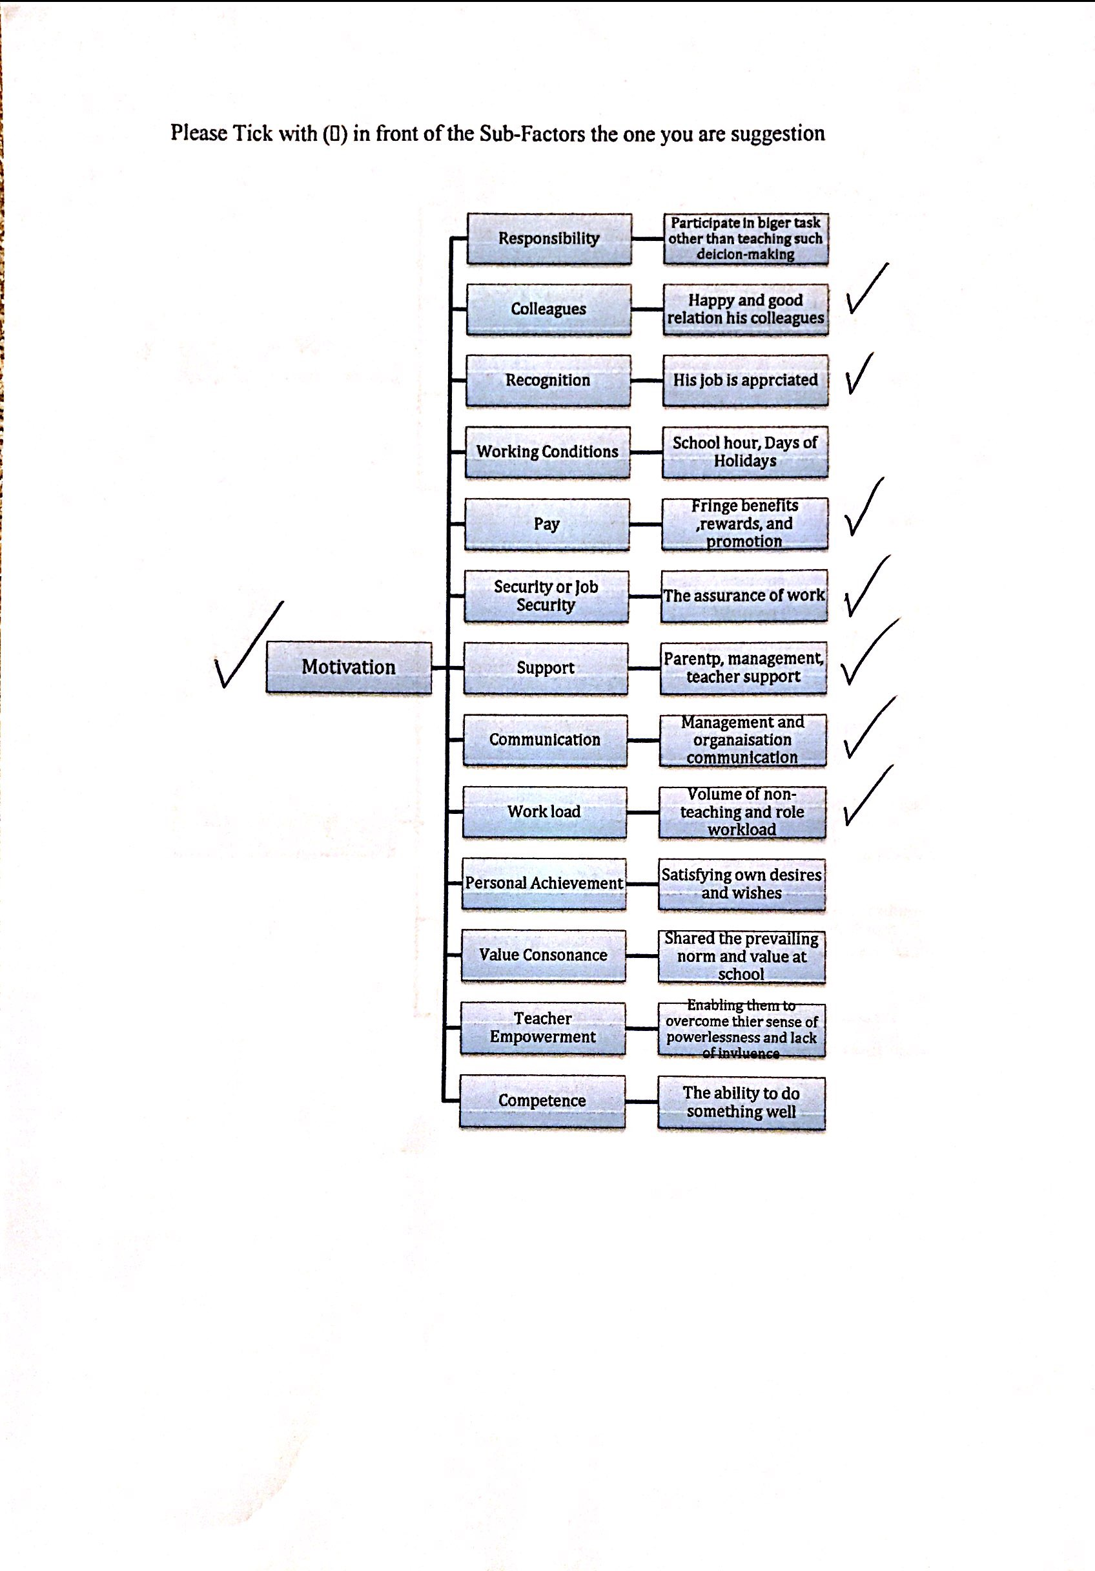
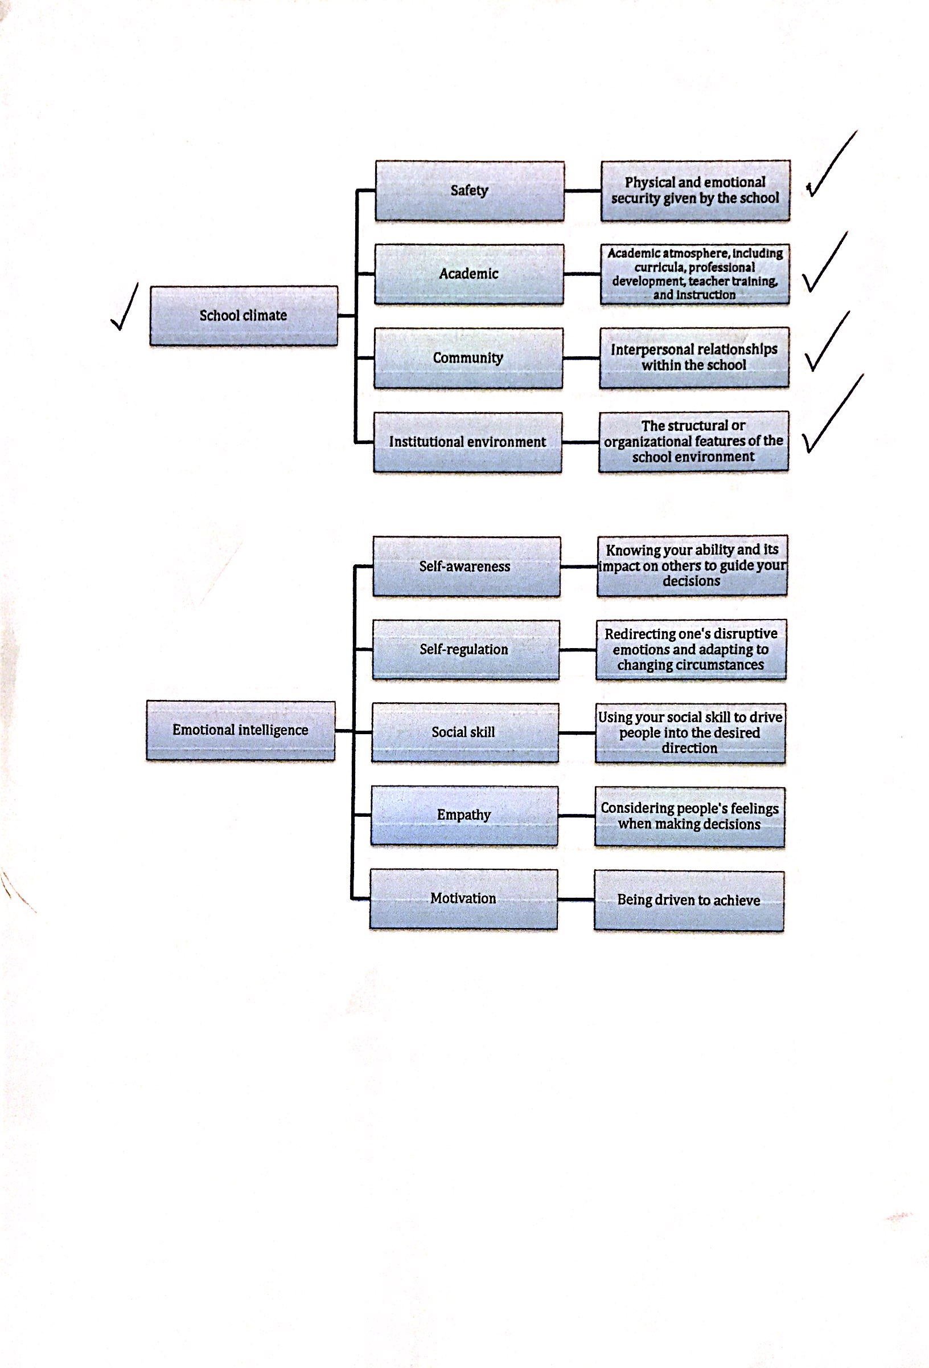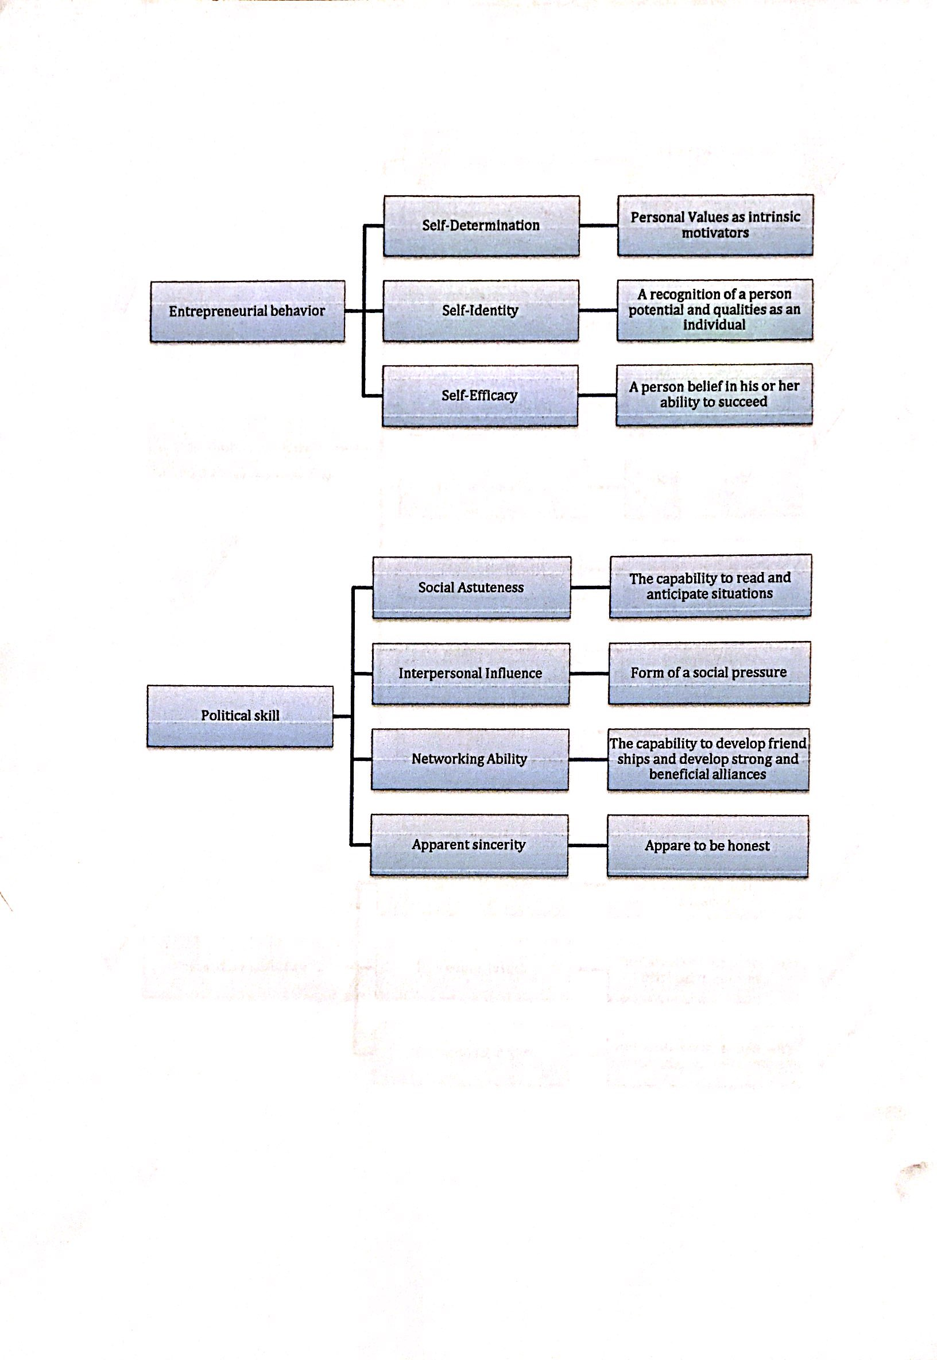
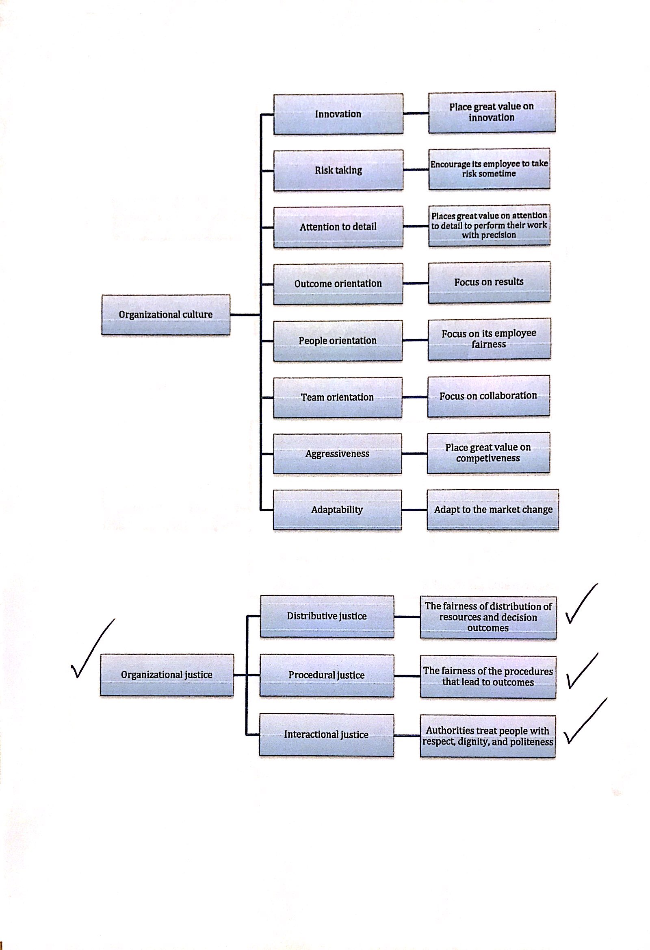
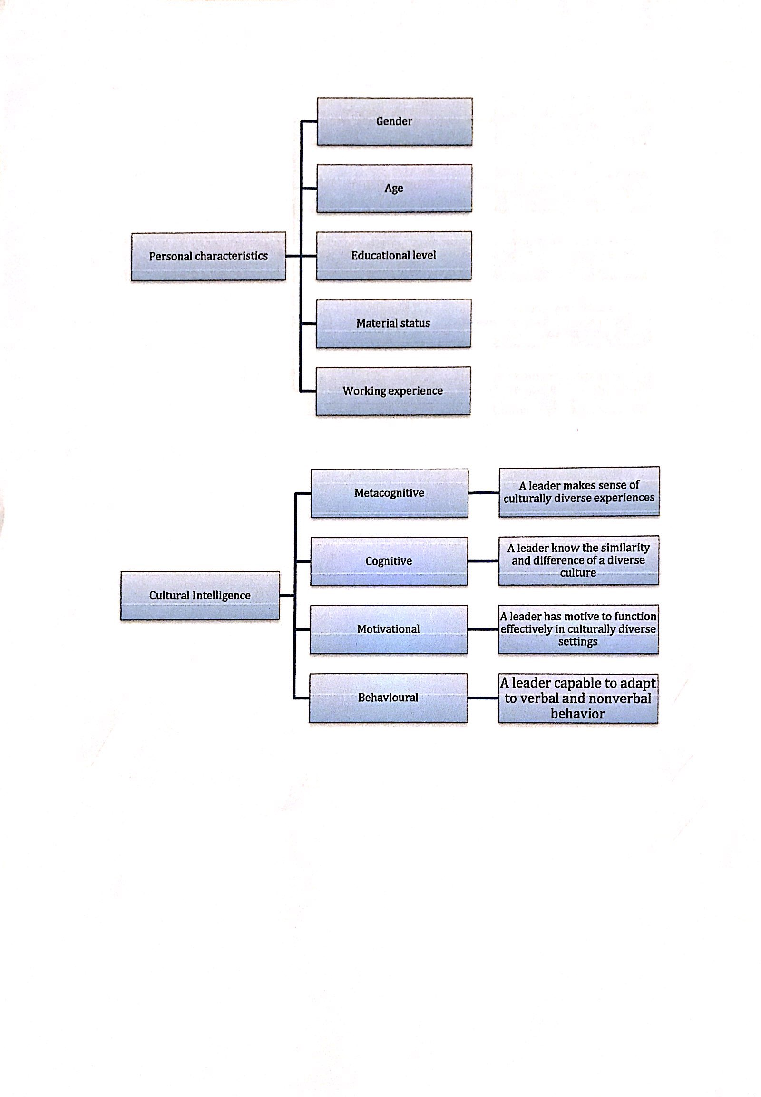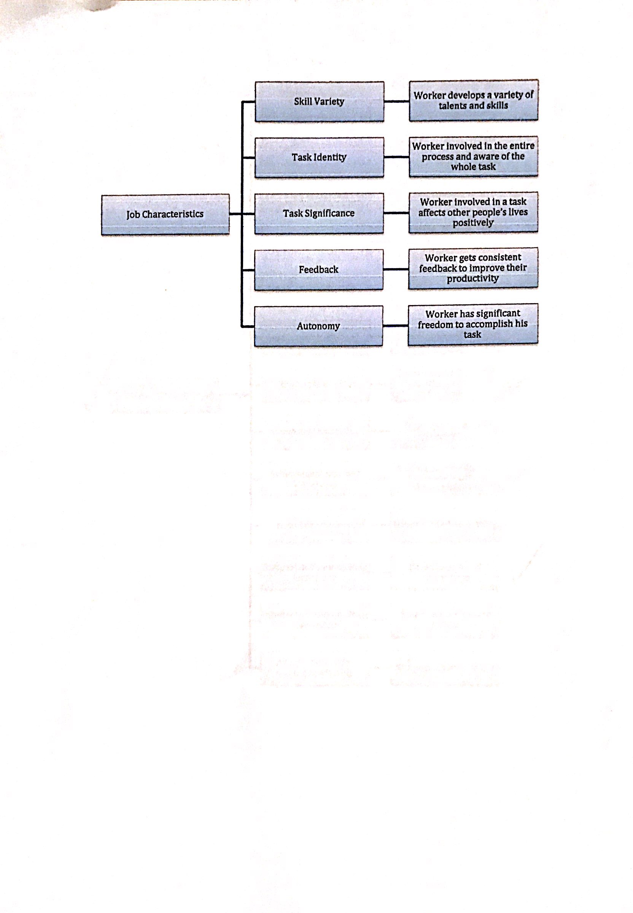
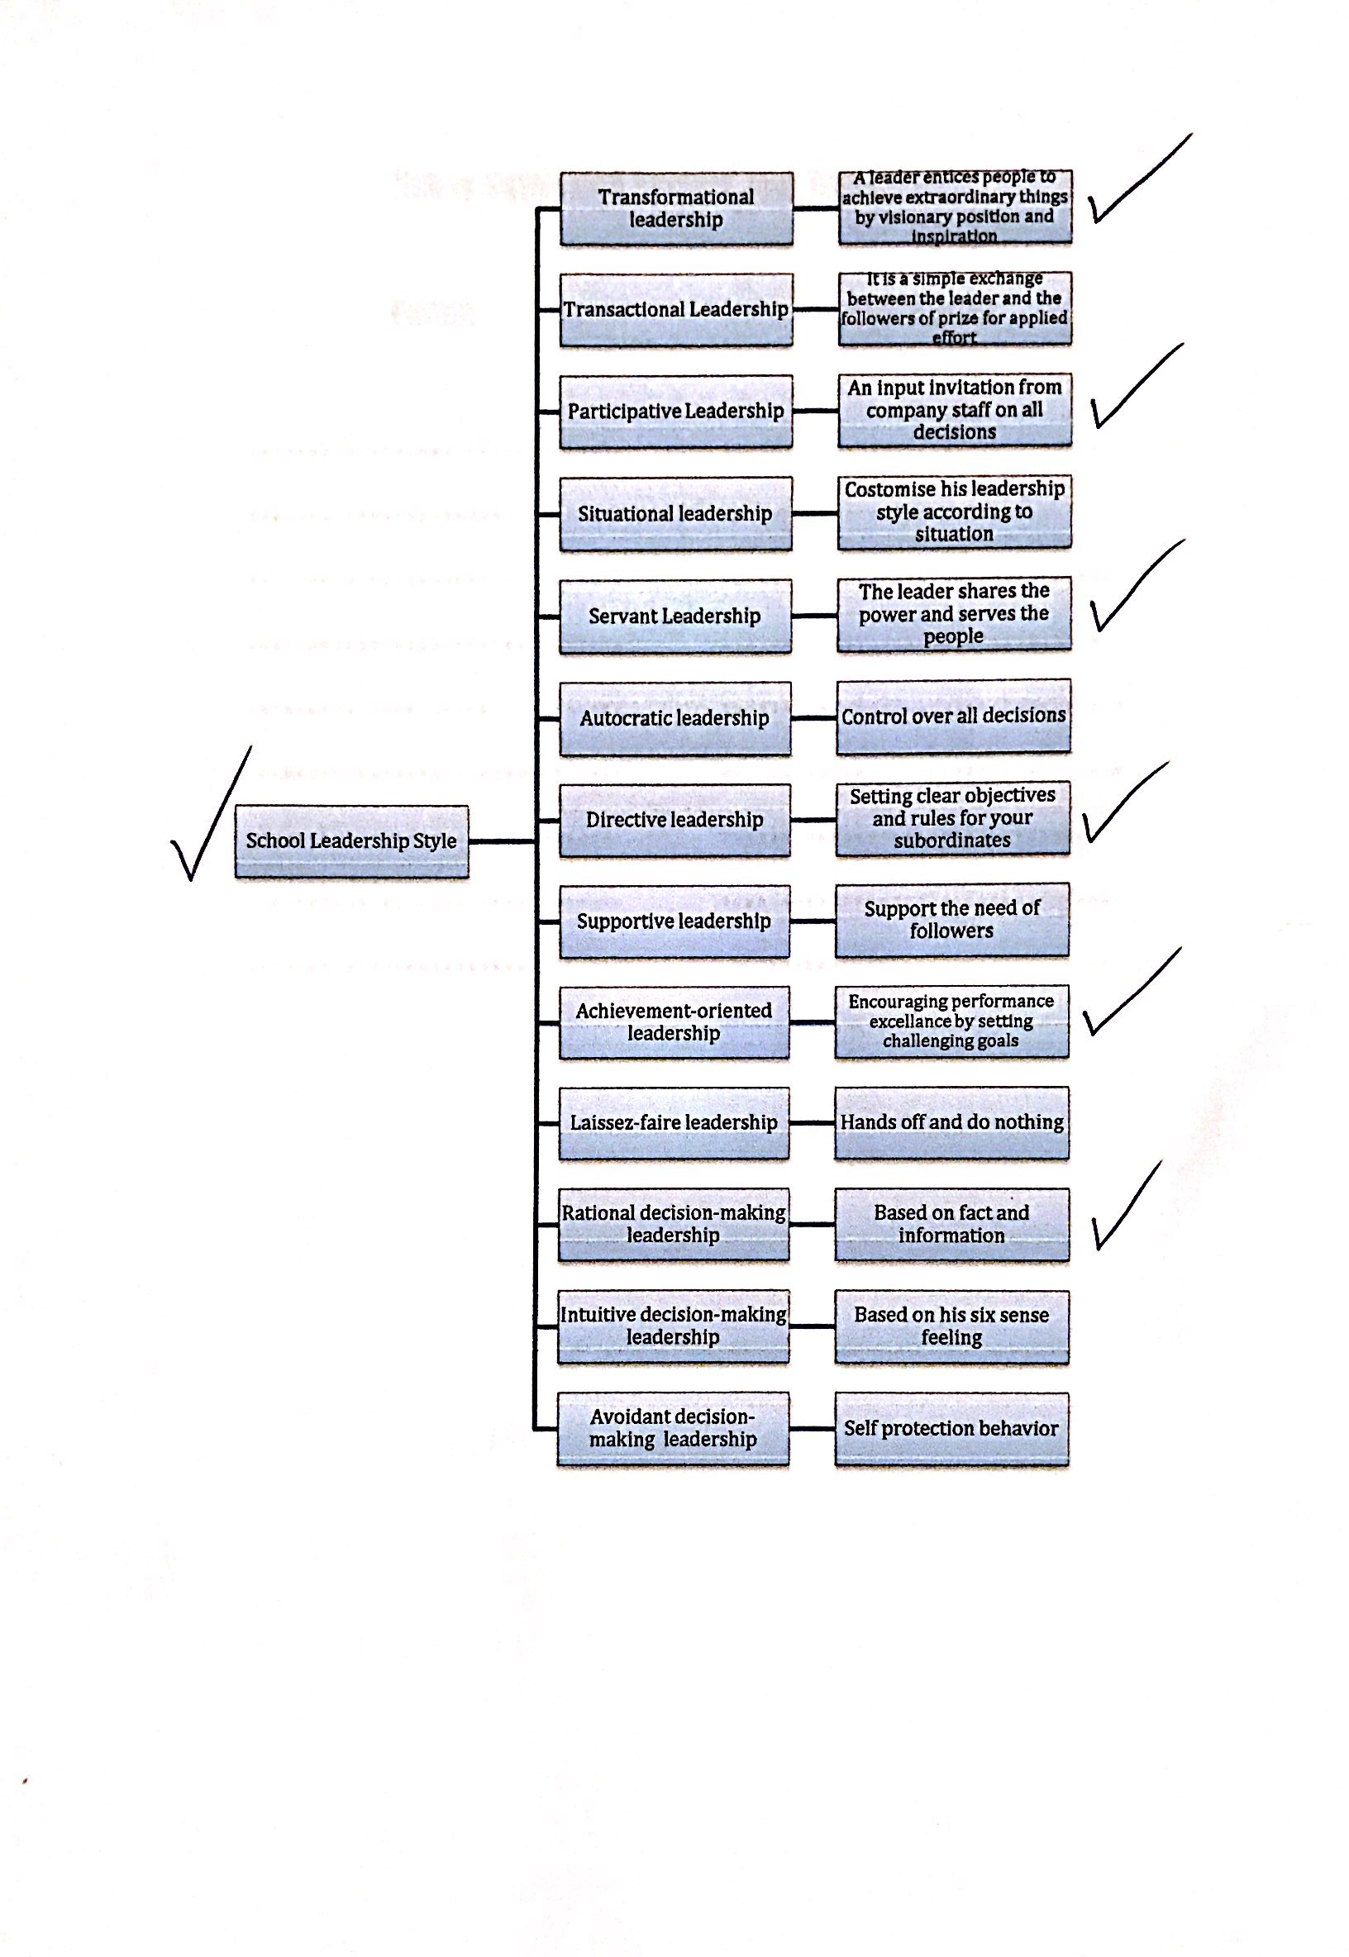



APPENDIX 2: TEACHERS’ QUESTIONNAIRE

