COVEPAGE

THE EFFECTS OF ENTERPRISE RESOURCE PLANNING (ERP) SYSTEMS POST-IMPLEMENTATION ON STRENGTHENING THE TECHNOLOGY CAPACITY FOR DIGITAL GOVERNMENT EXCELLENCE

Presented to
The Academic Faculty

By
Mohamad Abu Ghazaleh

In Partial Fulfillment
of the Requirement for the Degree of
Doctor of Business Administration

Abu Dhabi University
College of Business
Abu Dhabi, UAE

Dec 1, 2019

© Copyright by
Mohamad Abu Ghazaleh

SIGNATORY PAGE
THE EFFECTS OF ENTERPRISE RESOURCE PLANNING (ERP) SYSTEMS POST-IMPLEMENTATION ON STRENGTHENING THE TECHNOLOGY CAPACITY FOR DIGITAL GOVERNMENT EXCELLENCE


_________________________
Mohamad Abu Ghazaleh

Approved:

_________________________
Dr. Salam Abdallah, PhD
Assistant dean of PG & Professor of MIS,,
College of Business
Abu Dhabi University
Committee Chair

_________________________
Dr. Mohammed El Adly, PhD
Head of Marketing, International Business, and Innovation Division& Associate Professor of Marketing
College of Business
Abu Dhabi University
Committee Member

_________________________
Professor Barry O'Mahony
Dean, College of Business
Abu Dhabi University

COPYRIGHT INFORMATION
- Mohamad, A. G., Abdallah, S., & Zabadi, A. (2019). Promoting successful ERP post-implementation: A case study. Journal of Systems and Information Technology, 21(3), 325-346. doi:http://dx.doi.org.adu-lib-database.idm.oclc.org/10.1108/JSIT-05-2018-0073
- Mohamad, A. G., Abdallah, S., & Khan, M. (2019). Critical internal organization’s forces influencing sustainability of post ERP in UAE service industry. International Journal of Organizational Analysis, 27(3), 759-785. doi:http://dx.doi.org.adu-lib-database.idm.oclc.org/10.1108/IJOA-03-2018-1375
- Abu Ghazaleh, M. and Zabadi, A. (2019), "Promoting a revamped CRM through Internet of Things and Big Data: an AHP-based evaluation", International Journal of Organizational Analysis, Vol. ahead-of-print No. ahead-of-print. https://doi.org/10.1108/IJOA-12-2018-1602
- Abu Ghazaleh, M. and Zamberi Ahmad, S. (2018), "Ajman Digital Government: the way forward to digest digitalization", Emerald Emerging Markets Case Studies, Vol. 8 No. 2. https://doi.org/10.1108/EEMCS-08-2017-0198
- Mohammad Saleem Al - Shura , Abdelrahim M. Zabadi , Mohamad Abughazaleh , Marwa A. Alhadi . "Critical Success Factors for Adopting Cloud Computing in the Pharmaceutical Manufacturing Companies." Advances in Economics and Business 6.3 (2018) 168 - 178. doi: 10.13189/aeb.2018.060303.
- Mohammad Saleem ALSHURA & Abdelrahim ZABADI & Mohammad Abu Ghazaleh, 2018. "Big Data in Marketing Arena. Big Opportunity, Big Challenge, and Research Trends: An Integrated View," Management and Economics Review, Faculty of Management, Academy of Economic Studies, Bucharest, Romania, vol. 3(1), pages 75-84, June.

ABSTRACT
Government authorities are embracing digitalization to provide user-friendly services to citizens and simultaneously reduce the cost of offering such services. There are success stories, but failures also abound. Technology is not the only determinant of failure; other determinants include process, people, and structural issues within institutions. The purpose of this quantitative study, guided by previous studies, is to determine some of the barriers that governments have encountered following the implementation of enterprise resource planning (ERP) systems in a digital government context. It also aims to investigate the strategies used to ensure the continued success of ERP post-implementation and the impact of these strategies on strengthening the technical capacity of digital government transformation by studying the opinions of ERP system users working in government authorities in the United Arab Emirates (UAE). The study also tests the mediating effects of ERP post-implementation success on the adoption of digital government.
A survey was sent to government employees who are using enterprise systems representing a sample of 450 participants within the United Arab emirates. The questionnaire was administered during the special big technology event of 2019 in UAE. The measurement model was created using EFA. Reliability, convergent validity, and discriminant validity were also assessed using CFA followed by SEM and path analysis to test the hypotheses and to identify significant predictors of current Post ERP practices and digital government excellence.
The main factors and strategies included peoples’ readiness, process readiness, absorptive capacity, shared understanding, interactive communication, ERP post-implementation success, and digital government excellence. Results showed that the proposed determinant factors of ERP post-implementation success had a statistically significant relationship with the successful implementation of ERP systems. Furthermore, results showed a statistically significant relationship between ERP post-implementation success and digital government excellence.
The findings have important theoretical and practical implications; there are still obstacles facing digital government that lead to a high failure rate. Therefore, the UAE’s technology decision makers in should frame their strategic approach with a comprehensive change management plan throughout the firm founded on organizational readiness, effective communication, and knowledge management. Change includes the potential to improve the government authorities’ readiness, cultivate more knowledgeable employees, increase digital government excellence indicators, spread knowledge, increase ERP users’ experience and expertise in government, and improve the digital government excellence overall.
Finally, one key implication of this research is that it provides evidence of the relationship between government back-end systems and digital citizen services. This should encourage government authorities to assist decision makers in paying more attention to their ERP systems, process, people, and structural issues within organizations. The primary theoretical objective of this research is to contribute to the body of knowledge regarding both ERP systems post-implementation and digital government excellence.

Keywords: ERP post-implementation, Systems integration, Digital government excellence, United Arab Emirates.

LIST OF ABBREVIATIONS
ADU Abu Dhabi University
AMOS Analysis of a Moment Structures (statistical software package)
DGE Digital government excellence
AVE average variance extracted
BPR business process reengineering
CEO chief executive officer
CFA confirmatory factor analysis
CFI comparative fit index
CIO chief information officer
CLF common latent factor
CMB common method bias
CMIN chi-square statistic
CR composite reliability
EFA exploratory factor analysis
ERP enterprise resource planning
GDP gross domestic product
HRM human resource management
HR human resource
ICT information and communications technology
IMD Institute for Management Development
IT information technology
KMO Kaiser–Meyer–Olkin
MLE maximum likelihood estimation
MRP material requirements planning
MRP II manufacturing resources planning
NFI normed fit index
RMSEA root mean square of error approximation
RMR root mean square residual
SD standard deviation
SEM structural equation modeling
SPSS Statistical Package for Social Sciences (statistical software package)
TAM technology acceptance model
TFR technological frames of reference
TLI Tucker–Lewis index
UAE United Arab Emirates
VIF variance inflation factor

ACKNOWLEDGMENTS
Alhamdulillah. I thank Allah SWT for giving me the strength and courage to complete my dissertation. Many individual sacrifices have been made to support, encourage, and guide me, and to relieve my stress throughout this successful journey. This journey has been very long and very enjoyable at the same time, but it has not been without its challenges as this journey has given me many opportunities to explore business administration in general and the field of technology in particular, with a focus on the digital aspects of technology. Individual work never creates success stories; there are always there hidden soldiers working day and night with a watchful eye that does not sleep. First and fore-most among those behind my success story is my lovely wife; I must raise my hat to her for her tireless and continuous support. Thank you for putting up with me and being supportive for years on end. I must also thank my loving and wonderful children for their unconditional support during the long journey; they have always encouraged me to “never give up!”
There are many other acknowledgments to disclose. I am grateful to all of those with whom I have had the pleasure to work during this journey. Each of the members of my Dissertation Committee has provided me extensive professional and personnel guidance. I would especially like to thank Dr. Salam Abdallah, chair of my Dissertation Committee. I am profoundly grateful thankful to Dr. Abdallah for serving as my thinking partner, my career coach, and my friend; he was always my teacher and mentor, providing excellent guidance to enrich the research. In addition, I wish to thank Dr. Mohammad El Adly; as a member of my dissertation committee, Dr. El Adly ’s guidance was substantial and constructive in researching and analyzing this project. It was a great privilege and honor to work and study under their supervision. I am incredibly grateful for their friendship, empathy, and great sense of humor.

THANK YOU ALL

TABLE OF CONTENTS

COVEPAGE i
SIGNATORY PAGE ii
COPYRIGHT INFORMATION iii
ABSTRACT v
LIST OF ABBREVIATIONS viii
ACKNOWLEDGMENTS x
TABLE OF CONTENTS xii
LIST OF FIGURES xv
LIST OF TABLES xvii
CHAPTER 1: INTRODUCTION TO THE STUDY 1
1.1 Introduction 1
1.2 Background of the Study 2
1.3 Problem Statement 4
1.4 Nature of the Study 6
1.5 Purpose of the Study 7
1.6 Significance of the Study 9
1.6.1 Significance to Practice 10
1.6.2 Significance to Theory 12
1.7 Theoretical background 13
1.7.1 Research Problem 13
1.7.2 Research Question 15
1.7.3 Model Factors 16
1.8 Structure of the Study 16
1.9 Summary 20
CHAPTER 2: LITERATURE REVIEW 21
2.1 Introduction 21
2.2 ERP Systems 22
2.2.1 History and Definition 22
2.2.2 Key ERP Benefits 24
2.2.3 Key ERP Drawbacks 26
2.2.4 Enterprise System Adoption in Digital Government 28
2.2.5 The Importance of Enterprise Systems Post-Implementation 30
2.3 An Overview of Digital Government Systems 31
2.3.1 Definition 31
2.3.2 Enterprise Systems in the Digital Environment 32
2.3.3 Challenges Facing Government in a Digital World 35
2.4 Role of Enterprise Systems in Digital Government 43
2.5 Embracing Continuous Change in Digital Government 46
2.6 ERP System Users: the Cornerstone of Success 50
2.7 The Effects of ERP Post-Implementation Practices in Digital Government Excellence 52
2.7.1 Organizational Readiness and Ongoing Support 52
2.7.2 Knowledge Management 57
2.7.3 Interactive Communication 64
2.7.4 ERP Post-Implementation Success 67
2.7.5 Ensuring Digital Government Excellence 68
2.8 Theoretical Framework 70
2.8.1 Model Factors 70
2.8.2 Hypotheses 71
2.8.3 Framework Development 72
2.9 Literature Review Summary 75
2.10 Summary 78
CHAPTER 3: RESEARCH METHODOLOGY 80
3.1 Introduction 80
3.2 UAE Digital Government Profile 82
3.3 Justification for the Research Method 83
3.4 Research Design 86
3.5 Research Instrument 88
3.6 Population 89
3.7 Sample Size 90
3.8 Questionnaire Validation 92
3.9 Data Collection 97
3.10 Data Analysis 100
3.10.1 Data and Variable Screening 100
3.10.2 Descriptive Analysis 101
3.10.3 Correlation Matrix 101
3.10.4 Regression Analyses 101
3.10.5 Procedures for Exploratory Factor Analysis (EFA) 102
3.10.6 Validity and Reliability 103
3.10.7 Conformity Factor Analysis (CFA) 104
3.10.8 Common Method Bias (CMB) 104
3.10.9 Structural Equation Modeling (SEM) 105
3.11 Ethical Considerations 105
3.12 Summary 106
CHAPTER 4: DATA ANALYSIS AND RESULTS 107
4.1 Introduction 107
4.2 Process for Testing the Research Model 107
4.2.1 Developing a Theoretical Model 108
4.2.2 Screening of Participants’ Data 109
4.2.3 Screening of Data Variables 110
4.2.4 Descriptive Analysis 111
4.2.5 Measures of Central Tendency 112
4.2.6 Exploratory Factor Analysis (EFA), Validity, and Reliability Analyses 113
4.2.7 Confirmatory Factor Analysis (CFA) 120
4.2.8 Convergent and Discriminant Validity Assessment 123
4.2.9 Common Method Bias (CMB) 125
4.2.10 Structural Equation Model (SEM) and Hypotheses Testing 127
4.3 Summary 149
CHAPTER 5: DISCUSSION 151
5.1 Introduction 151
5.2 Demographic Data 152
5.3 People readiness, ERP Post-Implementation Success, and Digital Government Excellence 153
5.4 Absorptive Capacity, ERP post-implementation success, and Digital Government Excellence 155
5.5 Interactive Communication, ERP Post-Implementation Success, and Digital Government Excellence 158
5.6 Shared Understanding, ERP Post-Implementation Success, and Digital Government Excellence 161
5.7 Process Readiness, ERP Post-Implementation Success, and Digital Government Excellence 163
5.8 Moderation of ERP User’s Involvement in the Relationship Between ERP Post-Implementation Success and Digital Government Excellence 167
5.9 Moderation of ERP users’ government experience in the relationship between ERP Post-Implementation Success and Digital Government Excellence 168
5.10 Summary 174
CHAPTER 6: CONCLUSIONS, IMPLICATIONS, LIMITATIONS, AND FUTURE RESEARCH 175
6.1 Introduction 175
6.2 Limitations and Barriers 175
6.3 Conclusion 178
6.3.1 Academic Implications 182
6.3.2 Practical Implications 183
6.4 Future Research 185
6.5 Summary 186
REFERENCES 189
APPENDICES 231
APPENDIX 1: LITTER OF INVITATION TO PRATICIPATE (ENGLISH) 231
APPENDIX 2: LITTER OF INVITATION TO PRATICIPATE (ARABIC) 232
APPENDIX 3: QUESTIONNAIRE FOR THE STUDY (ENGLISH) 233
APPENDIX 4: QUESTIONNAIRE FOR THE STUDY (ARABIC) 244
APPENDIX 5: RESEARCH POOL FROM WHICH POST ERP-DIGITAL GOVERNMENT EXCELLENCE PRACTICES’ FACTORS ARE DRAWN 255

LIST OF FIGURES
Figure 1. Conceptual Framework 74
Figure 2. The Research Process Flow Chart 87
Figure 3. Data Collection Process 99
Figure 4. Process for Testing the Research Model 108
Figure 5. Outlier Analysis (Experience, Education, and Age) 110
Figure 6. The First-Order Measurement Model for Digital Government Excellence 122
Figure 7. The Measurement Model with CLF for Digital Government
Excellence 126
Figure 8. Second-Order Path Model for ERP Post-Implementation Success
and Digital Government Excellence 128
Figure 9. Estimated Coefficients 129
Figure 10. People Readiness and ERP Post-Implementation Success (H1) 132
Figure 11. Process Readiness and ERP Post-Implementation Success (H2) 133
Figure 12. Absorptive Capacity and ERP Post-Implementation Success (H3) 134
Figure 13. Shared Understanding and ERP Post-Implementation
Success (H4) 136
Figure 14. Interactive Communication and ERP Post-Implementation
Success (H5) 137
Figure 15. ERP Post-Implementation Success and digital Government
Excellence (H6) 138
Figure 16. ERP Post-Implementation Success Mediation Effect for People Readiness on Digital Governance Excellence (H7) 140
Figure 17. ERP Post-Implementation Success Mediation Effect for Process Readiness on Digital Government Excellence (H8) 141
Figure 18. ERP Post-Implementation Success Mediation Effect
for Absorptive Capacity on Digital Government Excellence (H9) 143
Figure 19. ERP Post-Implementation Success Mediation Effect
for Shared Understanding on Digital Government Excellence (H10) 144
Figure 20. ERP Post-Implementation Success Mediation Effect
for Shared Understanding on Digital Government Excellence (H11) 146

LIST OF TABLES
Table 1. Historical Evolution of ERP Systems 24
Table 2. Causes of Failure for Projects 39
Table 3. Factors for ERP Post-Implementation Practices
and Digital Government Excellence 70
Table 4. Response Rate from the Government Authorities Studied 94
Table 5. Summary of EFA Requirements for the Dataset 103
Table 6. Initial Data Screening 109
Table 7. Kurtosis Statistical Analysis 111
Table 8. Summary of Respondents’ Demographic Data 111
Table 9. Measures of Central Tendency 113
Table 10. KMO Test and Bartlett’s Test of Sphericity 114
Table 11. Assessment of the Measurement Model 117
Table 12. Goodness-of-Fit Indices for the Measurement Model 121
Table 13. Suggested Threshold for Goodness-of-Fit Indices 121
Table 14. CR, AVE, and Correlation Among Variables 124
Table 15. Path Model Fit Indices 127
Table 16. Hypotheses Testing Results of the Structural Model. 130
Table 17. Multi-Group Analyses (ERP Systems Involvement) (H12) 147
Table 18. Multi-Group Analysis: Experience (1–5 Years vs. 6–10 Years) 148
Table 19. Multi-Group Analysis: Experience (6–10 Years vs. 11–20 Years) 149

CHAPTER 1: INTRODUCTION TO THE STUDY

1.1 Introduction
This chapter provides an overview of the research structure. It gives an outline for the importance of this research in the context of the post-implementation phase of information systems as the back-end for supporting digital government services. In addition, it provides the general background to enterprise resource planning (ERP) as the back-end information system supporting digital government and the value of its integration with digital government. The research work presented in this dissertation is a case-based study focusing on digital government excellence in the United Arab Emirates (UAE). This chapter also explains the variables used to assess ERP post-implementation and digital government, drawing on previous research, and provides information about the research site and the economic environment, including government vision and strategic objectives. Furthermore, it sheds a light on the importance of the study, highlighting the research gap in the literature review, developing the research question, identifying the expected results, and explaining the contribution of the study to the body of knowledge and to managerial practices in the business sector.

1.2 Background of the Study
Digital transformation is the journey that never ends; digital government is a global phenomenon, and governments around the world are in the process of adopting novel ways to leverage technology to better serve their citizens. The relationships of power between government authorities and civil society in the context of digital transformations around the world have long been subject to widespread criticisms for reasons such as inefficient service delivery and poor performance, especially in developing countries (Siddiquee, 2016). Although there is a tendency to distinguish between digital government and e-government (Siddiquee, 2016), this research adopts the difference in meaning as defined by Meulen (2016) in that e-government is judged by the number of online published services made available to citizens, while digital government is measured by a reduction in the number of discrete services in favor of an integrated system to receive and process online services through back-end government systems.
E-government was the starting point of digital government and was initially proposed in 1997 by the US government using information and communications technology (ICT) in the public sector to improve administrative efficiency, enhance the quality of services, engage with citizens, and provide citizens with more convenient access to government services (Sánchez-Torres et al., 2017). Nowadays, citizens themselves are more aware of the value of e-service and demand more online services to be available 24/7 (Anwar et al., 2016).
Gartner’s digital government maturity model summarizes and outlines the five key stages on the journey from e-government to digital government. According to this maturity model, establishing e-government is just the first step towards a matured digital organization (Perkov et al., 2017). The first level in the maturity model is called “initial/ e-government,” in which the main focus is digitizing existing services, such as employment services, vehicle registration, and taxation. The success of this phase is measured by the number of online services driving efficiency and cost-savings. The second level is called “developing/ open;” this phase often takes the form of promoting transparency and citizen engagement and focuses on the consumption of open data through the development of mobile applications and dashboards reports. The third level, “defined/ data-centric,” is considered as the real inflection point in a digital government transformation, where data becomes the key focus. This stage requires matured ERP to aggregate and analyze data within and across government authorities. At the fourth level, “managed/ fully digital,” the government has fully recognized the importance of a data-centric approach to the transformation. At this stage, governments regularly pursue opportunities for innovation and access the data across all government authorities. The last level is “optimization/ smart,” in which digital transformation is now the norm, and the innovation process is repeatable and predictable.
Although there has been much research investigating the reasons for the failure and success of the e-government, less literature has identified the factors that inhibit the full implementation of digital government (Meiyanti et al., 2017; Qureshi et al., 2017). Most of the previous researches reported that more effort has been expended in reviewing and evaluating the quality of e­ government services as compared to other areas of e-government which include customer satisfaction and technical capabilities without paying attention to employee satisfaction and the link between digital government and enterprise systems (Qureshi et al., 2017). Challenges remain, specifically in relation to maintaining a high level of services considering the definition of digital government and its integration with back-end ERP systems.

1.3 Problem Statement
The relationship between ERP post-implementation and efficient digital government is also a relatively new area for research. The business environment in which the system is adopted is the main driver for making or breaking such systems, with business-related risk inherent in the post-implementation phase (Poba-Nzaou et al., 2008). Abdullah et al. (2016) highlighted that the main factors contributing to IT service failure are technology, people, and process. In examining the literature, no studies – to the best of the researcher’s knowledge – have examined the extent to which these three combined factors in ERP systems post-implementation can contribute to digital government excellence.
Previous studies have revealed that more than 60% of digital government projects fail in some way (Sánchez-Torres et al., 2017; Sultan et al., 2012) and that 31% of new enterprise systems projects are canceled before going live (Standish Group, 2014). Although the ERP system post-implementation in the government context has been widely studied (Althonayan & Althonayan, 2017; Ebrahim and Irani, 2005; Lam, 2005), there is limited research on the relationship between ERP post-implementation activities and efficient digital government. It is still not clear how governments should manage ERP post-implementation activities (Kharabe, 2012; Munkuli, 2015). There is a lot of research focused on how citizens adopt the -government and how to provide more online services to citizens (Seo et al., 2018). However, less attention has been paid to how these services are received, processed, and accomplished by government employees through ERP systems. These concerns are significant issues and represent the reasons for the failure of improvement projects in the digital government context (Stefanovic et al., 2016).
The link between ERP post-implementation and digital government excellence has many challenges, especially in developing countries (Sorn-in et al., 2015). In addition, very few studies of digital governments have achieved excellent performance, and very few have attained a high degree of maturity (Philipson, 2017).
Recent studies (e.g. Abdullah et al., 2016; Sánchez-Torres et al., 2017; Sultan et al., 2012; Seo et al., 2018) have reported that, although citizens, government, and business communities receive the most comprehensive array of benefits from the digital government, evaluation records reveal disappointing and inconsistent performance (according to the UN E-Government Knowledgebase reports of 2016 and 2018). These UN reports have concluded that governments should be encouraged to take into account not only the demand side of online services (from citizens) but also what is needed by the target users (i.e. employees) in the digital government. Accordingly, this research will try to highlight the needs of government employees who are using these enterprise systems to provide and process citizens’ services. Therefore, it would be useful to investigate the determinants of ERP post-implementation success from the perspective of system users that might contribute to the efficiency of digital government in the UAE context.

1.4 Nature of the Study
The UAE is a federation of seven states (Abu Dhabi, Dubai, Sharjah, Ajman, Umm Al Quwain, Ras Al Khaimah, and Fujairah) and is considered as one of the Middle East’s most important economic centers (United Arab Emirates Country Profile, 2018). Abu Dhabi is the capital of the UAE and the second most populous city after Dubai. The UAE gross domestic product (GDP) increased from USD 1.76 billion in 1971 to USD 460 billion in 2019. Meanwhile, GDP in the USA increased from USD 1.16 trillion to USD 20.51 trillion over the same period, an increase of just 1,768% compared to 24,545% in the UAE. The UAE population in 2019 was estimated to be 9.7 million at the beginning of 2019 (Arabian Business Global, 2019; government.ae, 2018, 2019; Organization of the petroleum exporting countries, 2018; Statista, 2018; worldometers, 2019).

1.5 Purpose of the Study
The basis of ERP solutions is the integration of government functions and automation of citizen-facing processes in e-government. The interaction of citizens with each contact point in government through the citizen portal is essential to ensure a consistent level of service (Klinger, 2011). Digital government is a tool to enable governments to publish digitally, allowing what is published to be more quickly accessed by citizens, and to enable citizens’ requests to be processed and accomplished more quickly. To achieve this goal, governments need to review their strategies continually to understand the issues and challenges facing new digital government and its relationship with back-end enterprise systems and adopt the right approach to provide the best service to citizens through digital government platforms.
Previous research has focused on two aspects separately. The first aspect is studying the success of e-government by measuring citizens’ satisfaction. The other aspect relates to measuring the success of the ERP back-end system from the point of view of employees, without the presence of any link or relationship between the government ERP back-end systems and digital government excellence. This research aims to analyze the issues and challenges that may influence ERP post-implementation practices in a digital government context by looking at the effect of ERP post-implementation factors on digital government excellence. It is expected that the findings of this research will be significant for governments in terms of improving public services to their citizens through one integrated digital government platform and enterprise system.
The study builds upon previous research by first investigating the hypothetical relationships of factors influencing post-implementation practices in digital government. Second, it conceptualizes and analyzes the relationship between ERP post-implementation and digital government excellence. Third, it discusses the challenges facing the association between ERP post-implementation and efficient digital government. Fourth, it contributes to efficient digital government from a government-employee perspective. Finally, it discusses strategies for implementation.
Decision makers in digital government environments seek approaches with in-depth analysis allowing the government to determine which areas are worth focusing on to support digital government environment initiatives (Munkuli, 2015). Thus, a broad perspective on ERP systems’ evaluation is needed in the post-implementation phase to identify the determinants of ERP post-implementation success that contribute to efficient digital government in the UAE government, taking a user perspective. More and more governments are investing heavily in transforming the design of digital government portals (Chen et al., 2006), but there exists an identified gap between digital government portals and integrated service delivery (Kharabe, 2012). This study, therefore, expects that governments, researchers, and enterprise solutions providers will be able to identify factors, challenges, and issues in ERP post-implementation practices that promote digital government excellence.

1.6 Significance of the Study
The importance of aligning enterprise systems and digital government to exploit capabilities and change business practices has increased as governments strive for competitive advantage in a diverse marketplace. Governments have invested in enterprise systems as a necessary technological infrastructure to provide more efficient services to their citizens. Earlier studies have acknowledged the disruptive nature of ERP systems and identified some of the transformations that it might bring to the organizations (Doherty et al., 2010; Molla & Bhalla, 2006). However, digital government transformation in the context of ERP is often assumed rather than examined.
The gap in studying the link between ERP post-implementation and digital government excellence is more significant in the UAE and the Middle East, because digital government projects often fail, especially in developing countries (Sorn-in et al., 2015). Therefore, this study aims to fill the apparent gap in information technology (IT) fields, namely ERP post-implementation and digital government literature. Its goal is to assist academics and practitioners in the digital government in seeing the importance of ERP to digital government excellence. For academics; the research findings should stimulate academic interest in the importance of ERP solutions in relation to digital government excellence and the need to expand research beyond concentrating only on the citizens as digital government users and pay attention instead to government ERP users. For practitioners, the research results should assist them in seeing the strengths in pooling and integrating their resources for ERP post-implementation activities that can be beneficial to digital government excellence.
Addressing the research aims will provide insights to researchers, governments, and enterprise solution providers in relation to realizing the underlying constraints and issues related to ERP post-implementation to drive efficient e-government operations. The focus on the integration of digital government and ERP post-implementation activities in this study will assist governments’ cost-cutting through understanding the link between ERP post-implementation and digital government and how ERP-post implantation activities can make or break digital government excellence. This study has the potential to help demonstrate ERP post-implementation and digital government integration in action to practitioners and provide an example of how ERP post-implementation activities are essential for digital government excellence.

1.6.1 Significance to Practice
The anticipated key contributions to practice are detailed below:
- Provide evidence of the correlation between ERP post-implementation activities and digital government excellence. This study provides proof of the relationship between government back-end systems and digital citizen services, which leads to paying more attention to ERP post-implementation practices.
- Previous studies have reported that most of the studies that have investigated digital government have focused on the interaction between government and citizens (Alawneh et al., 2013; Sipior et al., 2011; Stefanovic et al., 2016) without paying attention to government employees and ERP post-implementation practices. Therefore, this study introduces a practical guide to support the digital government transformation journey from an ERP user’s perspective.
- The findings from this study should also prove invaluable to developing countries in general, and the UAE in particular, given that many developing countries are still struggling with the implementation of their digital government initiatives. Previous studies have revealed that more than 60% of e-government projects fail in some way (Sánchez-Torres et al., 2017; Sultan et al., 2012) and that 31% of new software projects are canceled before going live (Standish Group, 2014).
- Help UAE technology decision makers in framing new strategic approaches through a strong foundation consisting of organizational readiness, absorptive capacity, shared understanding, and interactive communication. Change includes the potential to improve government authorities’ readiness, to cultivate more knowledgeable employees, to increase digital government excellence indicators, to spread knowledge, to improve ERP users’ experience, and to improve overall digital government excellence.
- Developing a new strategy utilizing a common platform of ERP systems and digital government systems will pave the way to better understanding digital government decision making in technological emerging markets.
- Achieving the desired goal of this study will require more cooperation and effective communication among government authorities in the UAE.

1.6.2 Significance to Theory
The anticipated key contributions to theory are detailed below:
- The primary theoretical objective of this research is to contribute to the body of knowledge regarding both ERP systems post-implementation and digital government excellence.
- Identify the essence of ERP in government by establishing boundaries between ERP systems post-implementation and digital government excellence as most of the related previous works have investigated digital government by focusing solely on interaction with citizens (Alawneh et al., 2013; Kharabe, 2012; Klinger, 2011; Sipior et al., 2011; Stefanovic et al., 2016) without paying attention to government employees and enterprise systems.
- Identify the common ground and connection between both ERP post-implementation activities and digital government excellence by addressing the concerns reported by previous studies (Alawneh et al., 2013; Sipior et al., 2011; Stefanovic et al., 2016).
- Although more and more governments are investing heavily in digital government portals (Chen et al., 2006), the gap identified between digital government portals and enterprise systems (Kharabe, 2012) still exists. This study, therefore, aims to introduce an integrated model of ERP systems post-implementation practices and digital government excellence and test the developed model in the UAE context.
- In sum, this study aims to fill these gaps by proposing a theoretical model based on the ERP system users’ perspective in the context of the UAE’s digital government.

1.7 Theoretical background
The theoretical framework for the study facilitated understanding of the various elements of Post ERP practices and digital government excellence, investigate Post ERP practices, and promote understanding of the digital government excellence concepts.

1.7.1 Research Problem
Digital transformation is the journey that never ends. Although ERP post-implementation and digital government excellence have been widely studied (Althonayan & Althonayan, 2017; Ebrahim & Irani, 2005; Lam, 2005), There is minimal research on the relationship between ERP post­ implementation and digital government excellence. It is still not clear how digital government should manage following ERP implementation (Kharabe, 2012; Munkuli, 2015). Findings regarding digital excellence reveal that ERP projects tend to focus primarily on citizen portals (i.e. users) without paying attention to government employees. Failure in ERP applications has been reported to be a significant reason why improvement projects fail within the government in their attempts to implement efficient digital government (Stefanovic et al., 2016).
Another study revealed that the gap in studying the link between ERP post-implementation and digital government excellence is more significant in the UAE and the Middle East, because digital projects often fail, especially in the developing countries (Sorn-in et al., 2015). It is estimated that there are also very few studies that have found digital government achieving excellent performance. Weerakkody et al.’s (2011) empirical research in developing countries reported that developing countries are not in an advanced state of digital and e-government development. The relationship between ERP post-implementation and digital government excellence is also a relatively new area for research. Stefanovic et al. (2016) reported that most studies that have investigated digital government are focused on interaction with citizens (Alawneh et al., 2013; Sipior et al., 2011; Stefanovic et al., 2016) without paying attention to government employees and ERP applications.
The adoption of digital government services persists as a prime concern among governments (Seo et al., 2018). Given that the UAE is moving quickly towards digital and smart government, there is a pressing need to understand factors that underlie the continued success of ERP post-implementation in supporting and promoting the growing needs of digital government excellence. Recent studies have highlighted that the main factors that contribute to IT service failure are technology, people, and process (Abdullah et al., 2016; Sánchez-Torres et al., 2017; Seo et al., 2018; Sultan et al., 2012). However, relatively few studies have examined to what extent these combined factors in ERP systems post-implementation contribute to digital government service disruptions. Studies have revealed that more than 60% of digital government projects fail in some way (Sánchez-Torres et al., 2017; Sultan et al., 2012) and that 31% of new software projects are canceled before going live (Standish Group, 2014).
Decision makers in digital government environments seek approaches with in-depth analysis allowing the government to determine which areas are worth concentrating on to support digital government environment initiatives (Munkuli, 2015). Thus, a broad perspective on ERP systems evaluation is needed in the post-implementation phase to identify the determinants of ERP post-implementation success that contribute to digital government excellence taking a user perspective.

1.7.2 Research Question
Identification of the research problem supported the development of the research question and research objectives relevant to addressing the research problem. The previous chapter explained that the objective of this research is to investigate the influence of continued ERP success on driving digital government excellence in the UAE. With a view in addressing this research aim, the following research question was constructed:
What are the determinants for successful ERP post-implementation that drive efficient digital government?
Answering this question will provide insights for researchers, governments, strategies related to people and performance, and IT solution providers by highlighting the underlying constraints and issues related to ERP post-implementation to driving efficient digital government operations.

1.7.3 Model Factors
To identify the model factors related both to ERP post-implementation practices and digital government excellence, the literature was reviewed and examined to provide relevant theories related to both areas in the technology industry. The outcome of the literature review was used to establish the model-related factors: “Process readiness, People readiness, Absorptive capacity, Shared understanding, Interactive communication, ERP post-implementation success, and Digital government excellence”.

1.8 Structure of the Study
This dissertation consists of the following six chapters:
- Chapter 1: Introduction to the Study
- Chapter 2: Literature Review
- Chapter 3: Research Methodology
- Chapter 4: Data Analysis and Results
- Chapter 5: Discussion
- Chapter 6: Conclusions, Implications, Limitation, and Future Research
Below is the summary of each chapter:
Chapter 1 | It provides an overview of the research problem, the significance and importance of the study, and the gap in the literature.
Chapter 2 | It reviews the available literature about the history and definition of ERP systems, key ERP benefits and drawbacks, and ERP post-implementation practices. It provides an overview of digital and e-government systems, the history of e-government and digital government, understanding the role of ERP systems in digital excellence, and how to achieve government excellence through ERP systems. This chapter also highlights well-established theories and models of ERP post-implementation practices and digital governments.  This chapter also explains the development of the research hypotheses by reviewing the most relevant literature and the relationships between the constructs of this study. It covers the associations between ERP post-implementation practices (organizational readiness and ongoing support, absorptive capacity, shared understanding, and interactive communication) and the continued success of ERP post-implementation. It also examines the potential impact of these factors on strengthening the technology capacity of digital government and highlights the most significant findings.
Chapter 3 | It covers the methodology followed in this research, defining the dependent, independent, and moderating variables used in the research. This chapter gives a brief description of the procedure followed for data collection and analysis, and discusses sample size, justification, and sampling frame for choosing particular sampling techniques. It also covers the pilot study and ethical considerations.
Chapter 4 | It details the statistical technique used in the study. It covers the results and findings of hypothesis testing and data analysis using structural equation modeling (SEM) with statistical programs including Statistical Package for Social Sciences (SPSS) and Analysis of a Moment Structures (Amos), and path analysis, as well as the interaction approach for moderation testing. The scale validity, validity, reliability, and model fitness are tested using exploratory factor analysis (EFA) and confirmatory factor analysis (CFA). To characterize the data based on its properties, descriptive statistics were used for demographic information. Due to the nature of the complex relationships among the construct, SEM was used.
Chapter 5 | It focuses on the complex relationships between ERP systems post-implementation and their roles in strengthening the technology capacity of digital government. It provides a better understanding of ERP post-implementation practices and digital government excellence by including multiple variables and theorizing about their interrelationships. This chapter also explains some of the mechanisms through which these effects lead both to theoretical and practical implications. It compares the results of data analysis with existing literature findings, setting them in the UAE context.
Chapter 6 | It brings together the lessons from the study, summarizes the answer to the research question, and links them to the findings of previous studies. This chapter investigates and establishing relationships between ERP post- implementation practices and strengthening the technology capacity of digital government. It discusses the limitations of the study and implications of the results, both theoretically and practically. In relation to theory, it explains how the findings contribute to the body of knowledge, and in relation to practice, it explains how executives and decision makers in digital government should use the findings to improve the results digital government transformation journey by promoting the continued success of ERP systems post-implementation. This chapter also includes recommendations for future research.

1.9 Summary
This chapter ties together all the elements presented in the dissertation, delineates the most important factual reporting of the study, and provides an initial summary of the findings in relation to the research question. This chapter also sheds light on the importance of studying the impact of the continued success of ERP post-implementation on achieving digital government excellence and summarizes the current research gap on the relationship between ERP post-implementation and digital government.

CHAPTER 2: LITERATURE REVIEW

2.1 Introduction
This chapter provides a comprehensive review of the literature on ERP systems post-implementation, digital government, and promoting the continued success of ERP post-implementation in the digital government environment. It examines the history and definition of ERP post-implementation and digital government, as well as the diverse approaches used to conceptualize it. It also sets out some of the different IT models that are used in technology environments, and it sets out different approaches to measuring ERP post-implementation practices. It goes on to consider the dramatic growth of ERP in the digital government context. It focuses in particular on the fundamental concepts of the continued success of ERP post-implementation practices in digital government, considering criteria including organizational readiness and ongoing support, absorptive capacity, shared understanding, and interactive communication.
Finally, the chapter covers the importance of ERP post-implementation in strengthening the technology capacity of digital government and the different methods used to handle it, providing the foundation for the research question.

2.2 ERP Systems

2.2.1 History and Definition
This research considers modern ERP systems, which are different from traditional ERP systems that started in the late 1970s and early 1990s (Miranda & Kavanagh, 2005). This section will present these differences to clear up any confusion about what makes a modern ERP system different from a traditional one.
In the late 1970s, traditional ERP systems were used to support production planning and logistic control for material requirements planning (MRP) and became the basis for what evolved into ERP systems. The MRP systems were designed to plan and manage materials and quantities needed in production to ensure efficient production control. A few years later, MRP was extended to include other functions such as capacity planning and sales forecasting using the production scheduling concept and was known as manufacturing resources planning (MRP II) (Gupta et al., 2004; Li, 2001; Okrent & Vokurka, 2004; Rondeau & Litteral, 2001).
The next stage in the ERP journey involved integrating and coupling different functional enterprise systems. These enterprise systems developed in various business areas such as accounting, finance, and human resource management (HRM). Some of these enterprise system companies specialized in accounting, such as SAP, while Oracle specialized in databases, and PeopleSoft specialized in human resource (HR) information systems. However, many concerns about these systems were raised, such as operating independently in silos, which led to multiple silos in information and systems, inefficiencies, and data inconsistencies. Therefore, all ERP software suppliers, more or less, went through different development stages starting from financial, accounting, logistic functions, project management, HRM, and payroll systems. The focus then shifted to supply chain management and to integrate external parties into the ERP system, including customer relationship management, quality management, workflow management, and even knowledge management (Elbertsen et al., 2006; Frank, 2004; Ming-Hui et al., 2004).
According to Mahmood and Miller (2017, p. 668), ERP systems generally comprise different software applications, which allow the business environment to automate and integrate the business functions through aiming to access and sharing common information across the enterprise in real time. Some of the expertise in the technology field do not agree that ERP software lives up to its acronym. Wailgum (2017) claimed that it does not relate to planning and nothing to do with the resources, and that it is only associated with the enterprise part. Instead, he defined the ERP as an attempt to integrate all business units and functions across a company into a single system to serve all those different departments’ particular needs.
Mahmood and Miller (2017, p. 668) explained the ERP, from a technical point of view: “it is a central database that draws data from, and feed data into a series of systems supporting diverse company functions to streamline the flow of information throughout a business.” The same study (p. 668) defined the operational level of ERP as: “comprehensive software solution, which seeks to integrate the complete range of business functions and business processes to present a holistic view of the business from a unified architecture.” Similarly, Mahmood and Miller (2017, p. 668) defined ERP systems as a “business software system that enables firms to efficiently and effectively manage resources (human resources, material, finance, etc.) by providing integrated systems for an organization’s information-processing needs.” Table 1 shows the historical evolution of ERP systems in detail.

Table 1. Historical Evolution of ERP Systems
Years | ERP Scope
2000s | Extended ERP
1990s | Enterprise Resource Planning (ERP)
1980s | Manufacturing Resources Planning (MRP II)
1970s | Material Requirements Planning (MRP)
1960s | Reorder Point Systems (Inventory Control Packages)
Source: Hwang (2011).

2.2.2 Key ERP Benefits
One of the main concerns facing the enterprise is the low level of awareness of the benefits of an end-to-end ERP system (Esteves, 2009). The realization of an ERP system could provide significant benefits for organizations. ERPs make remarkable improvements in managing human resources, customer service, customer experience, inventory, and production management (Annamalai & Ramayah, 2011; Arthur, 2016; Eid et al., 2017; Esteves, 2009). Previous studies have reported various benefits of ERP: easy access to information; reduction in data entry effort; reduced lead times; improved decision-making process; data accuracy; data quality and timely access; adapting to changes in business and technology environment; avoiding duplication of data; user efficiency; and improved employee productivity (Arthur, 2016; Eid et al., 2017; Snider et al., 2009).
Miranda and Kavanagh (2005), Bachman (2010), and Motwani and Sharma (2016) noted the ability of ERP systems to standardize firms’ business best practices. Arthur (2016) indicated that the central ERP stored database enabled businesses to make holistic decisions from the enterprise point of view rather than the individual departments separately. The ERP system helps in reducing the processing time for any transaction (Guido et al., 2007), which leads to improving the firm’s competitiveness through improving labor productivity, level of investment, quality performance of business operations, speeding up processes, and reducing redundancy (Chian-Son, 2005; Lee et al., 2004; Novotny and Sabati, 2008; Nurmilaakso, 2009). Another benefit reported is that implementing ERP improves financial management, transactions accuracy, and better managerial decision making (Hsueh-Ju et al., 2012; Lee and Kwak, 2011).
Successful ERP systems can help streamline business processes and decisions by making employees more involved, as opposed to working in silos. Arthur (2016) summarized the desired results from successful ERP systems as follows: (a) cash management benefits, including reducing the risk, streamlining the process, and decreasing the accounts receivable in the collection cycle; (b) decision-making benefits from improving efficiency and having timely access to the information; (c) achieving business strategic benefits resulting from enhanced customer service and customer excellence; and (d) communication and interaction benefits through the system interactions between employees, which can lead to more significant advantages of completing organization tasks on time.
Barker and Frolick (2003), Annamalai and Ramayah (2011), and Kale et al. (2010) noted that the actual tangible and intangible benefits of ERP systems occur after implementation. Intangible benefits differed across business industries and it was reported that the most often realized intangible benefits were integration within the organization, enhancing the information quality and visibility, and information accessibility. The tangible benefits can be summarized as operations benefits, such as reducing cost, improving business performance and customer service, simplifying business processes, enhancing accounts receivable collection time, setting business globally, and supporting business strategies (Arthur, 2016).

2.2.3 Key ERP Drawbacks
Despite the benefits expected from the ERP systems, the relationship between organizational performance and ERP adoption is inconclusive (Kharuddin et al., 2015; Yang & Su, 2009). According to Wah (2000) and Kharuddin et al. (2015), many ERP systems fail, and many governments fail to gain significant benefits from ERP (Ha & Ahn, 2014; Klinger, 2011). ERP systems face functional and technical implementation difficulties because of employees’ resistance (Alhirz & Sajeev, 2015; Aladwani, 2001; Garg & Garg, 2013). Although there are numerous advantages to ERP systems, there are also several disadvantages and drawbacks. ERP systems are considered very complicated and require a lot of investments in human capital and organizational capital; these ERP systems are cumbersome and expensive (Dey, 2010). ERP systems require a lot of time commitment from the organization’s technology employees and business users. These systems have substantial costs, such as consulting fees and license fees. Therefore, the consequences of an ERP system’s failure may lead to initial losses that outweigh gains in productivity. In addition, it can be very challenging and time-consuming (Dey et al., 2010; Ghosh, 2012; Kanungo & Bagchi, 2000; Payne, 2002; Samander et al., 2017).
ERP might cause substantial dissatisfaction and system failure due to: (a) the massive of business process re-engineering in the organization’s business process; (b) colossal customization involved in the system implementation; (c) lack of top management support; (d) unclear goals and objectives; (e) effective communication; and (f) lack of personalized training (Alghamdi, 2018; Parthasarathy et al., 2016). Ruivo (2012) also reported that ERP customization to suit the firm’s requirements would lead to high costs.
Due to the digital environment and globalization, business models have changed dramatically during the last decades, and these changes have led to new expectations for enterprise systems. As a consequence, firms require continuous improvement in enterprise systems (Kim & Mouritsen, 2013). The complexity of ERP requires extensive effort and time to deliver. Thus, the organization may depend on external vendors for implementation and support; this can lead to the exertion of market power and vendor lock by the vendor, which results in increased maintenance fees. Data are also crucial in the digital environment, and it is claimed that any wrong information captured in the ERP systems will be processed improperly, ultimately resulting in chaos and disaster in terms customer experience (Arthur, 2016).

2.2.4 Enterprise System Adoption in Digital Government
Previous studies have developed measurements to assess ERP adoption in small, medium, and large enterprises. The results of these studies offer practical help for organizations to better understand ERP adoption. Government entities, for example, invest in digital channels in order to improve citizen satisfaction in service delivery, to enhance economic competitiveness, and to increase the productivity of public services (Kalling, 2003; Ram et al., 2014). Chand et al. (2005) developed a new model to assess the level of success of ERP system adoption called the “ERP scorecard.” This new model is based on three stages: (i) automate; (ii) informate; and (ii) transformate. The first stage focuses on streamlining and improving data quality. The second stage relates to enhanced customer service delivery and offers better management decision making, while the last stage focuses on the development of the organization’s competitive advantages of by embracing new technology and innovative strategies. Other determinants of the adoption of ERP include cost reduction, enhanced competitive edge, and growth in sales revenue (Congden et al., 2005; Lakshmana, 2008; Wen-Lung et al., 2009).
Technology advantages can only be realized by integrating the technology with organizational resources and capabilities to improve the quality of decision making. Davis’ technology acceptance model (TAM) (see Venkatesh & Bala, 2008) explains why some technologies are accepted by system users better than others. TAM posits that an individual user’s intention to use a system, which is the main objective, depends on the perceived usefulness and perceived ease of use. Stefanovic et al. (2016) tried to apply TAM to e-government and presented a new model of e-government adoption based on three frameworks considering only the front-end web technology, without paying attention to back-end enterprise systems and ERP users’ needs (i.e. TAM, trustworthiness, and diffusion of innovation). Similarly, another group of studies has investigated satisfaction from the point of behavior (Alawneh et al., 2013). Several studies have discussed the adoption of ERP generally, while other studies have addressed the adoption of digital government, but studies combining the two are lacking. Therefore, the intention of this research is to evaluate both ERP and digital government adoption together.

2.2.5 The Importance of Enterprise Systems Post-Implementation
Enterprise systems’ implementation progresses through sequential phases: conceptualization; planning; execution; and termination (Rosacker et al., 2008). Post-implementation is the phase that usually involves independent parties who are in charge of making the practical determinations regarding ERP users’ satisfaction and how the ERP system will be used to run the business (Zhao, 2007). The continuation and enhancement of ERP will contribute to sustaining seamless alignment between an organization’s structure and its ERP applications (Peng & Nunes, 2017). However, companies are still encountering numerous challenges in the post-implementation phase, such as post-implementation support structure, organizational structure, human-related issues, in-house IT experts, system users, and system integration (Gallagher et al., 2012; Pan et al., 2011).
Researches consider that ERP users are essential in the post-implementation phase, and their satisfaction relates to the success of ERP post-implementation (Bradley & Lee, 2007). However, there is continued user resistance to adopting enterprise systems due to the number of employees who continue to use their preferred manual systems (Maheshwari, 2008). Skills and expertise can be achieved by capitalizing on the expertise of ERP system users (Beheshti & Beheshti, 2010). The most prominent issues the company face comes not from the implementation, but from the ERP post-implementation stage, such as the expectations of management, system users, and stakeholders (Garg & Grag, 2014). Therefore, the success of the ERP system post-implementation is a shared responsibility that requires combined effort (Abdolvand et al., 2008; Nikookar et al., 2010).

2.3 An Overview of Digital Government Systems

2.3.1 Definition
The relationships of power between government authorities and civil society in the context of digital transformations around the world have long been subject to widespread criticisms for inefficient service delivery and poor performance, especially in developing countries (Siddiquee, 2016). There is no clear differentiation between e-government and digital government in the literature, but expertise in technology has established clear boundaries for both concepts. Gardiner (2015) claimed that e-government is the past and digital government is the future. In Ovum’s 2016 report on government technology, the technology advisory firm said that traditional e-government methods are passé. The report distinguished between “e-government,” where technology is used to improve on existing processes, and “digital government,” where services are imagined and delivered in innovative new ways by paying more attention to back-end enterprise systems (Gardiner, 2015). The report assessed maturity levels of digital government based on back-end enterprise systems and continuous upgrades.
The present research also differentiates between e-government and digital government, as defined by Meulen (2016). E-government is judged by the number of online published services made available to citizens, while digital government is measured by the reduction in the number of discrete services in favor of an integrated system experience through integrated back-end enterprise systems to receive and process the citizen’s services and to achieve sustainable online government services. E-government refers to electronic government and was proposed in 1997 by the US government using ICT in the public sector to improve administrative efficiency, enhance the quality of services, and engage with more citizens (Sánchez-Torres et al., 2017). Previous research has claimed that e-government is one of the most exciting areas in e-commerce that improves communication between government authorities and their constituents by offering online access to information and services (Chen et al., 2006).

2.3.2 Enterprise Systems in the Digital Environment
An ERP system is an IT-based integrated information system that is considered a cornerstone of managing complex business operations and of effective decision making in areas of purchasing, production, customer relationships, customer service, sales, accounting, and after-sales service (Park, 2018). It is defined as a tool for managing the internal and external transactions of a business and information sharing across departments, covering four major components: the software; the user mindset; the flow of processes; and change management (Marnewick & Labuschagne, 2005). De Toni et al. (2015) defined an ERP system as a type of management information system to optimize the distribution of enterprise resources and integrate all system resources for rapid and useful applications to improve operational performance and enhance the organization’s competitiveness. The consideration for these components is essential in managing the government’s ability to serve all its authorities’ and stakeholders’ needs effectively (Dezdar & Ainin, 2011).
ERP systems are used by executive management and staff to access real-time operational information. These systems are expected to provide seamless integration of business processes and to result in standardized business practices and thus to enhance information flow (Seethamraju, 2005). As enterprise resource planning evolves, governments search for better ways to operate and provide innovative services to the public (Park, 2007). ERP systems can provide an enterprise-wide view by integrating the various silos of any government activity (Jones & Young, 2006; Sternad et al., 2011). ERP applications are now often known as enterprise solutions because of their ability to take a customer request and provide the right road map for automating the different steps to fulfill the request (Ahmad & Mehmood, 2015; Brown, 2006).
Government organizations have been making continuous and significant efforts to use technology to facilitate the workflow of their services and to act as an instrument of change to provide advanced services to their citizens. Previous studies (e.g. Bachman, 2010; Miranda & Kavanagh,2005; Motwani and Sharma, 2016) have discussed how ERP systems are capable of standardizing the firm’s business processes. Other research has focused on ERP user satisfaction and its relationship with ERP post-implementation success and ease of use (Bradley & Lee, 2007). Arthur (2016) discussed how the central ERP database could help business decisions. Other studies (e.g. Chian-Son, 2005; Lee et al., 2004; Novotny & Sabati, 2008; Nurmilaakso, 2009) have discussed to what extent the post-implementation phase of ERP can improve firm competitiveness through improving labor productivity, increasing the level of investment, increasing competition in markets, increasing quality, reducing redundancy, improving the performance of business operations, and speeding up processes. Further studies have discussed how enterprise systems enhance financial management by introducing more accurate transactions, improving managerial decision making and cash management, achieving strategic business benefits, and improving communication (Arthur, 2016; Hsueh-Ju et al., 2012; Lee & Kwak, 2011).
Other studies offer practical help for organizations to understand better ERP adoption and the capabilities that could help to gain and sustain their competitive advantages and how it can result in enhancing business efficiency and data accuracy (e.g. Al-Mashari, 2002; Allen, 2011; Kalling, 2003; Ram et al., 2014; Parthasarathy and Sharma, 2017). A few studies have developed new models to assess the level of success of ERP system adoption (Chand et al., 2005). Despite the benefits of ERP adoption, the relationship between organizational performance and ERP adoption is inconclusive (Kharuddin et al., 2015; Yang and Su, 2009). Companies are still encountering numerous challenges in the post-implementation phase such as post-implementation support structure, organizational structure, human-related issues, in-house IT experts, system users, and system integration (Gallagher et al., 2012; Pan et al., 2011).
This research also focuses on digital government excellence and its relationship with ERP post-implementation activities. Previous studies have focused on citizen satisfaction and how it is affected by services available through multiple channels, instant access to information, information quality, and process performance (Deng et al., 2018). The focus has been on providing better services to citizens (Amoretti & Musella, 2011; Qureshi et al., 2017). In addition, other studies have discussed the determining effects of demographic characteristics in the use of e-government systems (Sipior et al., 2011; Stefanovic et al., 2016). Sorn-in et al. (2015) revealed that e-government projects often fail, especially in developing countries. What is still missing is a complete and end-to-end automation workflow that includes receiving the citizens’ service requests electronically and processing them electronically through the back-end government enterprise systems (Klinger, 2011).

2.3.3 Challenges Facing Government in a Digital World
Digital government initiatives promise a more citizen-centric government and aim to reduce operational cost (Saxena, 2005). Unfortunately, most of these planned initiatives have not been able to achieve the benefits claimed (Nirmaljeet & Ravi, 2013). Citizens are becoming more demanding of e-government services, expecting to have services available round the clock (Anwar et al., 2016). Therefore, citizen satisfaction is affected by services available through multiple channels, instant access to information, information quality, and process performance (Deng et al., 2018). Governments also are concerned with the use of enterprise systems for the efficient functioning of government authorities (Althonayan & Althonayan, 2017; Pedersen, 2017).
The new vision of government service delivery attempts to move the customer relationship management concepts slowly by creating and delivering effective and efficient services for citizens, which has given birth to a new area of knowledge called “citizen relationship management” (Kannabiran et al., 2005; Vaxevanidou, 2007). A citizen is a consumer of government services, and citizens should be treated as customers of business organizations (Fakhoury & Baker, 2016; Lee & Lev, 2014).
Digital government in developing countries follows three phases that can be considered as vital aspects of digital government (Klinger, 2011):
- Publish: governments publish an enormous amount of information to the citizen (Klinger, 2011).
- Interact: this phase involves two-way communications such as email contact information for government authorities or published feedback forms that allow the citizen to submit comments and feedback (Butt, 2014).
- Transact: a transact phase will offer a direct link to government services at any time (Joshi et al., 2018).
In order to achieve these goals, it is essential to look at the internal government processes and understand the relationships between various government authorities, the sharing of information between authorities, and IT required to support these aspects. Therefore, identifying the essence of ERP in government for the integration of government processes and the connectivity of citizens and stakeholders is very important.
Lutes (2016) expressed his concerns about the digital government, explaining that digital government cannot happen only by uploading and bringing government services online. These traditional online services cannot be considered as digital services. Amazon, Uber, and Airbnb are considered commercial digital examples. Likewise, for citizen administration, online services, online payment, processing, and accomplishing the service constitute digital transformation. To make this clearer, digital transformation is not easy where government policy and politics create more challenges than the technology. Most government policies were made for a different age. However, technology enables new approaches and makes it possible to drive the policy changes that make digital government possible (Lutes, 2016).
Despite the great efforts that have been made by governments, many e-government projects are unsuccessful (Sánchez-Torres et al., 2017). Sorn-in et al. (2015) revealed that e-government projects often fail, especially in developing countries. Some of these failure factors are misunderstanding of the implementation requirements, user involvement, lack of clarity of vision and strategy, lack of government support, poorly defined goals, and strong citizens’ expectations (Morgan & Chen, 2003; Phippen & Lacohée, 2006)). Other studies have reported that technology plays an essential role in the development of digital government, and it can act both as an obstacle or enabler to success (Stefanovic et al., 2016). Therefore, this study will help weigh the critical barriers affecting the success of ERP post-implementation that affect the performance and evolution of digital government excellence.
Table 2 presents a brief review of the reasons for the failure faced by governments in the implementation of digital initiatives, highlighting the most crucial factors.

Table 2. Causes of Failure for Projects
Main criteria | Definition | References
Acquisition Process | The acquisition process requires a holistic view of the government for evaluating and identifying the right solution regarding managing the full implementation as a project. The solution should cater to the entire government. The challenging task is creating an IT organization structure to support this implementation process within the government structure, considering multiple government authorities supporting citizens. | Klinger (2011), Sharma and Panigrahi (2015), Weerakkody et al. (2011), Zhao et al. (2012), Aladalah et al. (2015)
Expectations, Performance, and Citizen Satisfaction | Citizens are becoming more demanding as they compare and benchmark government services with other digital services like banking. Citizens do not want to be forced to queue at public offices to process straightforward services, and they expect services to be offered round the clock whenever and wherever they need them. | Baharon et al. (2017), Irani et al. (2012), Wirtz and Kurtz (2016), Anwar et al. (2016), Seng et al. (2017), Chan et al. (2010), Klinger (2011)
Service Integration | Governments need to change their processes and align them to best practices. In implementing such solutions, governments often lose sight of the fact that each government authority has its policies, rules, and procedures that make it unique. | Klinger (2011), Sarikas et al. (2007), Joshi et al. (2018), Virili and Sorrentino (2009), Choudrie and Weerrakody (2007), Melin and Wihlborg (2018), Saleh et al. (2013), Svärd (2017), Lam (2005), Weerakkody and Dhillon (2008), Zhao et al. (2012), Zhao et al. (2012), Setiawan and Yulianto (2018)
Clean Master Data | Many ERP projects in e-government failed due to data quality issues; governments embarking on an ERP must take care of the efforts needed to develop clean master data. | Bartholomew (2003), Mohammed et al. (2012), Fuentes-Moya et al. (2014), Alenezi et al. (2015), Myeong et al. (2014), Elenezi et al. (2017), Milano et al. (2007), Klinger (2011)
Information Security | Managing a secure e-government environment in an era of integrated services and processing sensitive data such as financial and citizen information stored on ERP systems, governments should ensure they take every possible measure to maximize information security. | Ramtohul and Soyjaudah (2016), Liu et al. (2014), Wangwe et al. (2012), Reddick (2009), Perez and Pauli (2012), Choi (2016), Rehman et al. (2012), Srinivasan (2014), Noe et al. (2018), Ziemba et al. (2016), Klinger (2011)
The Acceptance of the Change and Project Management | The people inside the government are essential to achieving digital government success. The most critical challenge is to get people to adopt new enterprise systems to improve the ways they do their jobs. Most enterprise system implementations fail due to resistance to change and poor clarity on the project, such as time, scope, cost, and resource requirements. | Melin and Wihlborg (2018), Klinger (2011), Sarantis et al. (2010), Furlong and Al-Karaghouli (2010), Ke et al. (2006), Nasim and Sushil (2010), Melin and Axelsson (2009), Irani et al. (2007), Lappi and Aaltonen (2017), Babu and Dalal (2006)
ERP Implementation Strategy and Strategic Planning | The system enterprise implementation strategies are essential and should be classified into different streams: organizational; people; and technical strategy. The “organizational” strategy should cover strategic planning, project management, business alignment, and change management. The “people” strategy should cover communication, ongoing support, and managing resistance to change. The “technology” strategy should include solution architecture, information security, and business process mapping. | Klinger (2011), Mahmood and Miller (2017), Soja (2008), Aladwani (2001), Marciniak et al. (2014), HassabElnaby et al. (2012), Al-Shamlan and Al-Mudimigh (2011), Capaldo and Rippa (2009), Avram et al. (2012), Chin-Fu et al. (2004), Schniederjans and Kim (2003)
Business Process Mapping | Simplifying business procedures, restructuring government functions, and rationalizing business processes. | Joshi et al. (2018), Alkhawaldah et al. (2017), Akkermans and Helden (2002), Groznik et al. (2008), Kovacic (2007), Sharif et al. (2010), Corradini et al. (2010), Klinger (2011)

2.4 Role of Enterprise Systems in Digital Government
The field of digital government lacks a substantial body of well-developed theory and one strategy to overcome the theoretical immaturity (Leif & Rose, 2005). A literature review on digital governance leads to several observations that will help researchers in redefining the use of enterprise systems in digital government. First, most governments have not changed their back-end enterprise systems (Klinger, 2011). Second, many efforts made by governments to create “citizen portals” have resulted in taking attention away from internal government enterprise systems and processes to fulfill and process citizen requests (Kharabe, 2012), which results in a large gap between a citizen portal and improving service delivery. Therefore, governments today need a consistent and flexible enterprise system that can support the growing needs of digital government change. The implementation of ERP systems in government and public administration poses many challenges, such as continues business requirements enhancement, difficulties in adapting the new changes, the system quality factors (flexibility, data availability, ease of use, and timeliness), service quality factors (reliability, tangibility, and responsiveness), and business process (Almishal & Almashari, 2015; Althonayan & Althonayan, 2017; Ziemba & Obłąk, 2013).
Although internal government factors have an impact on the achievement of digital government benefits (Saha, 2016), previous research has neglected the post-implementation perspectives on ERP user satisfaction and ERP sustainability (Glowalla & Sunyaev, 2014). Decision makers in digital environments seek approaches allowing the government to determine which areas are worth paying attention to in order to support the digital environment (Munkuli, 2015). Thus, a broad perspective on ERP system evaluation is needed in the post-implementation phase of ERP to identify and investigate factors from the employees’ perspective that underlie the continued success of ERP systems post-implementation in supporting and promoting the growing needs of digital government. It is essential to think beyond citizen portal automation towards redesigning the back-end government systems and workflow within the government that might require structural and functional reengineering (Klinger, 2011).
There is a vital need to promote ERP implementation to support the growing request for digital government. However, there remain significant challenges related to overcoming the problem of “citizen portal” systems and “back-end” systems not talking to each other smoothly (Hurbean, 2008). Therefore, ERP systems and digital government integration might be considered as a critical success factor for achieving a mature digital government. Previous research has classified the significant ERP barriers into four categories: technology; policy; organization; and strategy. Governments are increasingly adopting various methods to discover, analyze, measure, improve, and optimize ERP systems’ adoption to increase the efficiency and effectiveness of digital government. Therefore, there is a need for more in-depth research into the use of ERP systems and related practices in the digital government (Ziemba & Obłąk, 2013). Given that more and more governments are investing heavily in interface design and portals (Chen et al., 2006), this study aims to address the research gap of identifying the determinants for successful ERP post-implementation to drive digital government excellence from the ERP users’ perspective.
ERP systems provide an enterprise-wide view and integrate various silos of activities within the organization. Such an integrated approach has substantial payback if appropriately implemented (Ip, 2010; Wickramasinghe & Karunasekara, 2012). Understanding the challenges of ERPs will help governments to achieve sustainable success using the enterprise system (Pan et al., 2011). While many governments experience difficulties after implementing ERPs, examining the ERP users involved in post-implementation activities (Abdinnour & Saeed, 2015) and continuous enterprise system assessment will help in sustaining a seamless alignment between the back-end processes of a government and its ERP applications (Peng & Nunes, 2017). Peng and Nunes (2017) clearly showed that enterprise systems post-implementation are still encountering many challenges and problems. Currently, available ERP research does not adequately investigate the issue of internal government forces and their effect on ERPs post-implementation, and more efforts are needed to increase high-level e-government adoption such as integration (Jain, 2008; Sarikas & Weerakkody, 2007; Thi et al., 2014).
With citizens growing awareness, governments are under pressure to implement and deliver timely, efficient, and transparent services, such as motor licenses, education, and municipal services (Marche & McNiven, 2003). To respond to this demand, ERP can play a role of communication agent between citizens and the government to offer delivery of cross-functional services (Klinger, 2011). Digital government services are possible only when the government examines the inter-relationships between citizens and government authorities, which result in real efficiencies of ERP solutions (Klinger, 2011). What important is how the government redesigns and improves the back-end processes (Bartholomew, 2003). Governments today expect strategic support from enterprise systems to achieve control and efficiency. Collectively, all the functionalities of back-end transactions need to be automated through ERP to operate on a single database, allowing government authorities to work more quickly to share information and communicate with each other (Cordella & Hesse, 2015; Klinger, 2011). Therefore, the focus of this research is relating digital government to successful ERP systems post-implementation that promise efficient digital government.

2.5 Embracing Continuous Change in Digital Government
This research focuses on the human element in the context of technology, namely enterprise systems and digital government. The reason is the vital role that technology plays in human societies (Coccia, 2019). The study suggests a new definition of integrated technologies considering the fact technology is a complex system that is composed of more than one entity and system, which is precisely the case for this research study. Overall, technology changes the mode of cognition and action to enable decision makers and business users to accept new changes (Coccia, 2019). Therefore, proposing a new theoretical framework from the system users’ perspective lays a foundation for the development of more sophisticated concepts and theories that explain the required changes to human society and the environment.
In considering these facts, there is a pressing need to understand the required changes in the government environment; governments have a need to change the way they work. Therefore, the role of change management models nowadays has become increasingly important due to the complexity and dynamism of organizational changes (Talmaciu, 2014). Implementing and promoting any new change requires a good understanding of how far to go concerning the new change, and what its influence is on organizations (Greer et al., 2009). The model of Kurt Lewin dominated the practice of change management for over 40 years using Lewin’s three-step approach: (i) unfreeze the present developmental stage by building trust between employees and involvement in recognizing problems (this stage is to take people from a condition of being unready and make them ready); (ii) movement, where development of new beliefs, values, attitudes, and behaviors are attained; and (iii) refreezing stages of changing, which is intended to sustain the new system after the change has been implemented and to have the new values inculcated among employees. However, this three-step model has been criticized in various studies. According to Burnes (2004), Lewin assumed that most organizations operate in a stable mode and did not consider organizational power and politics. Rosenbaum et al. (2018) concluded that Lewin’s approach is still relevant to the modern world and suggested an extension to the model, presenting a new framework for planned change and ongoing development because, after implementing any project, continuous procedural steps to support evolution are essential.
Many researchers acknowledge the significant contribution of Kurt Lewin’s model to organizational change. However, over the last 30 years, with the rapid technological transformational change, Lewin’s work has been seen as an outdated and irrelevant model to the needs of modern and transformational organizations. Though there are studies that adopt this view, there are other studies pointing to the similarities between Lewin’s theory and the complexity of modern and transformational organizations; these studies draw out the main implications based on the common ground between the two views (Burnes, 2004).
While Lewin’s change model can help to understand the internal organizational changes that governments will need to implement in the context of digital government, it is limited in scope to appreciate the complexities of an evolving digital government. In this respect, Lewin’s model was extended and modified to capture a more detailed picture of internal organizational change contexts by offering seven comprehensive stages (scouting, entry, diagnosis, planning, action, stabilization and evaluation, and finally the termination stage), which allows for more aspects of organizational change, such as e-government and digital government (Al-Shafi, 2009).
Another theory that is relevant in the organizational change context is systems theory, which focuses on the interdependence between the groups of activities that form a system (McElyea, 2003). Systems theory, strategic framework, organizational development, complexity theory, and social world theory all have a practical impact and contribute to enriching the understanding of how these indicators work in prompting excellence and quality improvements (Rhydderch et al., 2004). Organizational complexity theory also contributes significantly in discovering the hidden order of complex systems and uses it to make the most of those systems by using a continually evolving organizational strategy that responds to changing conditions (Robbins, 2003). These theories, as mentioned earlier, focus mainly on personal behavioral and internal organizational aspects in different areas that influence the implementation and acceptance of the new change; however, they fail to address technological elements, digital government, or enterprise systems. Post-implementation systems can be influenced by several internal aspects that might lead to new organizational change initiatives promoting digital government excellence. Accepting the close links that human dimensions have with ERP post-implementation and digital government will facilitate a better understanding of the evolving concept and offer a well-balanced conceptual framework. However, this will require further examination in terms of ERP post-implementation activities and the associated challenges faced by digital government implementation.

2.6 ERP System Users: the Cornerstone of Success
System users are essential for technology stabilization (Mohamad et al., 2019). When a user begins to understand and use the technology, this will inevitably increase the user’s focus on system features and engender certainty among system users about the meaning and practice of the technology (Davidson, 2006; Lusignan, 2002; Mohamad et al., 2019). Technology is critical in influencing system users’ actions toward achieving the desired outcomes. The technological frames of reference (TFR) theory addresses this and has formed the basis of studies on the interpretive aspects of technology and organizational change and has been cited across a wide range of researches (Davidson, 2006; Harnisch et al., 2013; Mohamad et al., 2019; Orlikowski, 2000).
TFR theory offers guidance related to changing the frame structure and its implications for organizational outcomes and technology stabilization (Mohamad et al., 2019). The present research builds upon the cognitions and values of ERP system users by proposing a new approach, “technological frames,” for understanding the expectations and knowledge that ERP users have about technology in a digital government context. The study suggests that the technological frames of key groups of system users are essential to the smooth running of ERP systems post-implementation and influence digital government excellence. The technological frames offer a useful analytic perspective for explaining and promoting ERP post-implementation success in terms of driving digital excellence, which cannot easily be obtained using other theoretical lenses. Based on the TRF perspective, this research identifies five key ERP users’ determinants for ERP post-implementation success: people’s readiness; process readiness; absorptive capacity; shared understanding; and interactive communication.
Governments worldwide have been making efforts to use technology as an instrument of change to facilitate workflows to provide better services to citizens; digital government does not happen with outstandingly artistically designed websites and more computers (Flak et al., 2008). Digital government has to focus on back-end enterprise systems and system users that can support government change and service delivery cost-effectively. Linking the front-end digital government citizens’ interface and back-end enterprise systems (ERPs) is needed to transform the way the government interacts with the citizens and introduce a new integrated platform (Ziemba et al., 2016).
Despite the wide recognition of enterprise systems, limited data are available in the literature to support and validate the link. Therefore, this study identifies the determinants of ERP post-implementation success from ERP the users’ perspective that contributes to digital government excellence, which contributes to improved performance in government and making enterprise systems better at doing what they are supposed to do. In turn, it speeds up digital transformation. These determinants together will promote the success of ERP systems post-implementation and speed up the digital transformation of governments. Consequently, the following hypotheses were developed:
- User involvement in systems implementation moderates the relationship between ERP post-implementation success and digital government excellence.
- User experience in the government sector moderates the relationship between ERP post-implementation success and digital government excellence.

2.7 The Effects of ERP Post-Implementation Practices in Digital Government Excellence

2.7.1 Organizational Readiness and Ongoing Support
Change management experts emphasize that various strategies are required for establishing organizational readiness for significant change. When organizational readiness for change is high, the organization is more likely to appreciate the change, exert more significant effort, and display more cooperative behavior. The theory of organizational readiness for implementing change was developed to determine the organizational readiness for change in general (Weiner, 2009). The theory can be applied within a digital government setting and is best suited for examining organizational changes where collective change behavior is necessary to effectively maintain ERP post-implementation success. Therefore, the study treats organizational readiness as a shared common state in which people in the organization feel committed to implementing an organizational change and have confidence in their business processes to do so; this will require further measurement development and careful sampling decisions.
2.7.1.1 People Readiness. Organizational readiness and ongoing support have been found to have a significant favorable influence on post-implementation success and performance (Mohamad et al., 2019). Governmental employees’ readiness refers to the degree to which a government authority prepares the environment and workforce to accept and use the new technology (Finney and Corbett, 2007; Hwang, 2011; Soja, 2006; Somers & Nelson, 2004). Previous studies have proved that the success of enterprise systems and communication projects depends on the readiness of the beneficiaries to accept change (Bowonder et al., 2005). Goulding and Lou’s (2013) findings highlight the importance of people in embracing technology, which was considered a priority area for technology operationalization. However, while citizens, government, and business communities receive the most comprehensive array of benefits from digital government, evaluation records reveal disappointing and inconsistent performance, according to the UN E-Government Knowledgebase Reports of 2016 and 2018; some of these issues include organizational factors, including people’s readiness (Goulding & Lou, 2013).
According to Hwang (2011), organizational researchers presume people’s resistance to change originates from cultural stability. The existing culture should provide a corporate framework that gives guidance on existing issues related to the running of the ERP systems, such as how tasks are done, the use of ERP systems, and how people should think. Hwang (2011) considered people as the heart of an organization’s actions in enhancing its overall effectiveness and the quality of its services and products. Maas (2000) classified the primary elements of ERP systems into two parts: (i) people readiness; and (ii) technology readiness. People readiness is about training end-users and to make them adapt to the systems. Therefore, ERP users’ ongoing training and readiness are critical factors in the ERP post-implementation stages.
Other technology researchers have assessed IT readiness, including employees’ skills and infrastructure, in relation to configuring and maintaining enterprise systems (Hwang, 2011; Nelson, 2004) and have reported that firms fail to optimize organizational effectiveness through enterprise systems due to poor ERP system users’ acceptance of new technologies (Lee et al., 2007). Strong technical expertise and training availability have been identified as essential to improving the core competencies (Hwang, 201; Ravichandran & Lertwongsatien, 2005). A firm with a higher level of technical expertise can be expected to master the technical issues of ERP systems and contribute more to performance than firms with a lower level of technical knowledge. Therefore, technical skills are necessary beyond the time of ERP implementation; post-implementation support is more important to refine and adjust specific system attributes on an ongoing basis.
Since ERP systems run in a dynamic business environment (Hwang, 2011), these systems must adapt to changes and should be part of the strategic government focus. The ERP team, including the project manager and technical team members, should not only be technologically competent but should also understand the business needs of the government. Ongoing ERP user training is considered an essential factor that reduces the resistance of change and positively affects the possibility of a successful ERP system post-implementation (Bradley, 2008). With ongoing training and an efficient education program, there will be a higher possibility of successful ERP implementation. Hwang (2011) classified critical people factors for successful ERP, such as top management support and people characteristics, including background, education, training, and user involvement. Consequently, the following hypotheses were developed:
- People readiness has a significant positive effect on ERP post-implementation success.
- ERP post-implementation success mediates the positive effect of people readiness on digital government excellence.
2.7.1.2. Process Readiness. Organizational processes are defined as “the way things are done in government, its routines of current practice and learning” (Hwang, 2011, p. 23). The enterprise system’s implementation and ongoing support are not easy: it is complicated and lengthy. It entails significant changes in government business processes and resource management, thus requiring extensive financial and human resources (Ip, 2010). An enterprise systems is a continuous operational process. Therefore, the pre-implementation processes are considered key factors to strengthen the success of the post-implementation phase and user satisfaction (Longinidis & Gotzamani, 2009). In e-readiness research in the construction context, Goulding and Lou (2013) highlighted the importance of process in embracing technology, considering it a priority area for technology operationalization and identifying three critical primary themes: people, process, and technology. Therefore, these were recognized as the main supportive themes, with people leadership, managing business businesses, change management, and system information seen as the primary enablers.
The critical dimension that contributes to the success of ERP post-implementation is the business process (Schmidt, 2016). The theoretical framework identified by Hwang (2011) considered the business process as a unique organizational capability that provides better business efficiency and effectiveness and creates a firm’s competitive advantage over its competitors. If the goals are set, this can help at the later stage of ERP post-implementation and reduce the failure (Mohamad et al., 2019). The maturity and readiness of business processes are significant for introducing any business change; whether it involves market need, customers, or competitors, process re-engineering is always the solution (Jackson, 1997; Mohamad et al., 2019). Therefore, agile business processes are considered as organizational readiness indicators to measure critical success and failure.
In general, the literature on dynamic capabilities focuses on process dimensions to integrate and reconfigure the organization’s structure (Hwang, 2011). However, there remains a need to review and revisit the existing business process both now and later. The literature has focused on business process reengineering (BPR) as a prerequisite for implementing enterprise systems. BPR refers to the degree to which a firm designs its processes and how it carries out day-to-day workflows in an attempt to achieve the strategic objectives to increase efficiency, improved quality, reduce costs, and improve customer satisfaction (Hakim et al., 2016; Tigkiropoulos et al., 2009). Many researchers have confirmed that BPR exercises represent one of the critical success factors in enterprise system implementation (Al-Mashari et al., 2003; Hwang, 2011; Mohamad et al., 2019). Hwang (2011) considered BPR in ERP implementation as the cornerstone of successful ERP systems’ implementation. Subramoniam et al. (2009) claimed that the simultaneous implementation of BPR and ERP systems is the most effective method in redesigning existing business processes. Consequently, the following hypotheses were developed:
- Process readiness has a significant positive effect on ERP post-implementation success.
- ERP post-implementation success mediates the positive effect of process readiness on digital government excellence.

2.7.2 Knowledge Management
In this study, the definition of knowledge is adopted from Shih-Wei et al. (2013), which refers to a justified belief related to the implementation of complex enterprise systems, including resources, rules, and guidelines that enable employees and individuals to take effective action when implementing ERP systems. Most of the existing research has examined the variables that moderate the relationships between organizational fit and ERP success from the perspective of the social shaping of technology, including ERP, process adoption, and organizational resistance (Kyung-Kwon & Young-Gul, 2002; Shih-Wei et al., 2013). Such research has provided valuable insight and can be extended by considering ERP success from a knowledge-based perspective of the firm. Using this perspective helps in understanding how ERP system users acquire the needed knowledge for using sophisticated software packages such as ERP because an ERP user usually lacks the knowledge and skills required for the ERP system. Thus, the successful transfer of knowledge to ERP users plays a crucial role in meeting the perceived needs of ERP users.
For example, knowledge includes the understanding of how the flow of a digital government transaction affects other functional areas, which in turn may trigger a change in customer satisfaction and performance indicators for other system users. In summary, examining ERP post-implementation based on a knowledge-based perspective (that includes both absorptive capacity and shared understanding) advances knowledge of the drivers of the success of ERP post-implementation in driving efficient digital government.
Knowledge is a reliable strategic tool necessary for sustaining a competitive advantage in any organization (Mohamad et al., 2019). Successful knowledge management is the most crucial aspect in nurturing organizational culture as it is the driver for knowledge management (Shu-Mei, 2011). Knowledge management is a combination of technology and culture (Klinger, 2011). User satisfaction, user experience, and system usability and are vital players of the post-implementation success of any ERP system. Three main factors can affect the continued success of ERP systems post-implementation: (1) level of interactions with IT employees; (2) pre-implementation processes; and (3) degree of ERP adaptability (Longinidis & Gotzamani, 2009). Some studies have insisted that the participation of ERP system users in the implementation phase will always strengthen the continued success post-implementation (Ji-Tsung & Marakas, 2006). Other research has concluded that the employee’s education level, educational background, and computer experience positively impact the continued success of ERP (Longinidis & Gotzamani, 2009). Therefore, knowledge and talent are challenges that impact the continued success of ERP and have been identified as critical success factors. However, a review of the existing literature shows a lack of comprehensive research on the role of knowledge and talent in the success of ERP post-implementation in the digital government environment.
Other studies have shown a significant positive impact of post-implementation knowledge and that knowledge retention positively affects post-implementation success (Migdadi & Khair Saleem, 2016). Resource capability and knowledge management have a strong relationship with knowledge creation, which further influences the continued success ERP post-implementation (Jeng & Dunk, 2013). Other studies have recommended identifying the knowledge within the organization, which is considered critical for system success and enterprise system sustainability (Lech, 2014). In summary, strong knowledge management supports the continued use of ERP and consequently leads to promoting the continued success of the ERP system post-implementation (Chaabouni & Yahia, 2014). Li et al. (2006) proposed a knowledge-management flow consisting of different knowledge platforms that can effectively manage and enhance enterprise systems. Knowledge factors in this study focused on what facilitates knowledge transfer and communication between technology experts (as a support function) and ERP system users, and vice versa, including two antecedents (absorptive capacity and shared understanding). Communication factors impact the extent to which ERP users and technology support can decode and encode messages, which in turn enable the transfer of knowledge.
2.7.2.1 Absorptive Capacity. The aim of absorptive capacity as a knowledge factor of ERP post-implementation success is to facilitate knowledge flow and knowledge sharing between ERP users and their technology experts. Absorptive capacity refers to an ERP user’s ability to recognize the importance of ERP knowledge, assimilate it, and apply it. Therefore, absorptive capacity emphasizes using and applying the transferred knowledge (Shih-Wei et al., 2013). Park et al. (2007) examined the effect of absorptive capacity for users regarding their success in using an ERP system in a Korean context considering the three components of absorptive capacity in relation to ERP knowledge: understanding; assimilating; and applying. The research concluded that that the absorptive capacity of users had both direct and indirect effects on ERP value. Thus, ERP users assimilating and applying knowledge was found to influence ERP performance. Therefore, ERP users absorbing and applying the knowledge was found to affect ERP continued success.
Dong-Gil et al. (2005) identified absorptive capacity as one of the most challenging knowledge factors in controlling the relationship between source and recipient that influence the transfer of knowledge in the information system context. As ERP users’ absorptive capacity increases, the system users are able to assimilate and apply the received knowledge to improve their performance using the ERP systems to increase their productivity (Park et al., 2007). Other researchers have used the absorptive capacity concept to explain various organizational phenomena by measuring the impact of absorptive capacity on the competitive advantage of a firm (Zahra & George, 2002). These arguments have been used to explain the relationships between knowledge factors and ERP success that can be employed in the ERP post-implementation environment. This is because, in an ERP and digital government context, the need for cooperative and ongoing relationships between individuals, authorities, and their IT corporate support has been highlighted. The success of ERP -implementation depends on the continued use of knowledge, which is dependent on the interactions between all parties (Dong-Gil et al., 2005; Shih-Wei et al., 2013). Finally, the more the firms’ ability to value, assimilate, and apply knowledge, the more they will be capable of understanding how ERP-system best practices of can be applied to their firms (Park et al., 2007). Thus, this study expects that absorptive capacity will be positively related to ERP post-implementation success in the digital government context. Consequently, the following hypotheses were developed:
- Absorptive capacity has a significant positive effect on ERP post-implementation success.
- ERP post-implementation success mediates the positive effect of absorptive capacity on digital government excellence.
2.7.2.2 Shared Understanding. The aim of shared understanding as a knowledge factor in relation to ERP post-implementation success is to facilitate knowledge flow and knowledge sharing between ERP users and their IT departments. It is defined as the extent to which the problem-solving approaches, norms, and experience are based on the system and similarities to prior work (Shih-Wei et al., 2013). Shared understanding, as reported by various researchers, influences knowledge transfer in the ERP context (Dong-Gil et al., 2005; Shih-Wei et al., 2013) as shared understanding focuses on leveraging knowledge. When external technology consultants’ experience and problem-solving approaches are similar to those of the technology experts and system users in government (high shared understanding), the two parties are more willing to share and transfer their knowledge (Nelson and Cooprider, 1996; Shih-Wei et al., 2013).
According to Shih-Wei et al. (2013), shared understanding facilitates the movement of knowledge in the organization and emphasizes the importance of managing the intangible relationships. This is because, even with the building of the required relationships between partners, without shared understanding philosophies of how things should be done, these partners are less likely to research a consensus on how and why they should be doing something.
One of the significant issues facing the designers of enterprise systems is the increasing pressure from executive management to demonstrate the business value of the firm’s investment in the technology (Nelson & Cooprider, 1996). The working relationship between the technology department and other members can have a significant contribution to increasing system success (Shih-Wei et al., 2013). Nelson and Cooprider (1996) explored the relationship of shared understanding between the technology department, as a service provider, and their customers, as a contributor to system performance. They reported that shared understanding of knowledge was achieved through mutual trust and influence between the groups involved (technology experts and ERP system users).
Organizations must employ the concept of shared understanding and build a greater sense of connectedness at all levels (Lorenz, 2008). The uniqueness of shared understanding between technologist groups and their system users was explained by Nelson and Cooprider (1996) through the new shared knowledge model. Nelson and Cooprider’s study concluded that the primary responsibility of technology experts in technology groups was to be continuously involved in the technology-transfer processes. Their study explained the need to operate from a shared knowledge base in the ERP system project life cycle, beginning in the requirements phase, but continuing throughout post-implementation maintenance and support. Therefore, this study proposes that technology experts and ERP-system user groups develop shared understanding to improve the relationship between them and to increase the amount of shared information regarding ERP problems, related processes, and opportunities for enhancing the ERP system. When shared knowledge occurs, understanding and appreciation among these groups or parties will follow. Shared understanding between different parties plays an essential role in the achievement of information system success through mutual trust and influence (Nelson & Cooprider, 1996). Consequently, the following hypotheses were developed:
- Shared understanding has a significant positive effect on ERP post-implementation success.
- ERP post-implementation success mediates the positive effect of shared understanding on digital government excellence.

2.7.3 Interactive Communication
Experience and research have proved that communication is a fundamental process for breaking down barriers to change. In this regard, managing enterprise systems requires adequate dedicated skills and a clear road map and agenda with clear deliverables and milestones (Maheshwari et al., 2010; Upadhyay et al., 2011). People must understand how the ERP changes will affect citizens, the organization, and themselves (Althonayan & Althonayan, 2017; Chandiwana & Pather, 2016). The success of information and communication projects depends on the readiness of the beneficiaries to accept change (Bowonder et al., 2005), which will require more persistent, continuous, and interactive communication.
The post-implementation stage is where the real challenges occur; most companies encounter difficulties in using a new ERP system after the implementation (Pan et al., 2011). The participation of users in ERP implementation is one of the most significant determinants for ensuring a successful ERP implementation is delivered (Barki et al., 2008). The interactive communication and relationship between system users and IT staff affect the outcome of enterprise systems. Therefore, supporting and continuing the dialogue with the system’s users is crucial to enhancing users’ feelings toward the system (Pei-Hung et al., 2016). Longinidis and Gotzamani (2009) reported two main factors that have a significant effect on the success of post-implementation: (1) the interactions of the system users with technology employees; and (2) users’ participation. Previous studies have proposed that the involvement of system users in the system implementation journey will always positively impact the post-implementation success of ERP (Ji-Tsung & Marakas, 2006).
In summary, user involvement and interactions with the technology staff leads to more significant user commitment and greater ERP success (Pei-Hung et al., 2016). Developing a digital strategic plan and identifying all stakeholders that need to on board is a crucial step in implementing and supporting ERP in digital government through excellent communication (Klinger, 2011; Lim, 2007). ERP imposes its logic on the company’s strategy and culture. Therefore, governments need to be technically and culturally prepared to understand the procedural changes in decision making, as well as internal functioning, that are required to make a success of digital government and ERP implementation.
Interactions and participation empower system users to have more control over their day-to-day activities in the work environment (Wagner & Newell, 2007). The ERP users develop feelings of ownership for the system when they participate in the implementation journey of ERP; these interactions of the individual users transform the ERP system functionalities and create great success in the ERP post-implementation phase (Barki et al., 2008; Liu et al., 2011). Reported ERP failure factors are found to depend on factors related to system-user involvement and system interactions (Jameel Qureshi & Abdulkhalaq, 2015). Some of studies have gone beyond involving only the system users in the ERP implementation journey, emphasizing the importance of involving non-ERP users such as any external system users who can add value to the post-implementation phase. Consequently, the following hypotheses were developed:
- Interactive communication has a significant positive effect on ERP post-implementation success.
- ERP post-implementation success mediates the positive effect of interactive communication on digital government excellence.

2.7.4 ERP Post-Implementation Success
It is clear from the previous studies that ERP projects need ongoing assessment (Muscatello & Parente, 2006). This study, therefore, examines the effects of ERP post-implementation on digital government excellence. The study addresses the required knowledge, ongoing support, and interactive communication to change and assess ERP post-implementation in the digital government context. This research extends the theories on ERP post-implementation by exploring and analyzing extra factors that determine the continued success of ERP post-implementation and its impact on digital government excellence.
The ERP post-implementation phase is defined as the extent to which post-implementation success is aligned with the organization’s overall strategy. It is critical to ensure that the entire organization understands the strategy and reasons behind ERP implementation. According to Parks et al. (2018), the three primary considerations in creating the strategy are: (1) to clarify the role of digital vision and technology in the citizen lifecycle; (2) to outline the responsibilities of the government and employees; and (3) to offer guidelines for continued success. Therefore, such a strategy might encompass training programs, communication, knowledge management, ongoing support, and directions for IT functions in driving digital government excellence. Understanding these strategies will help in promoting the continued success of ERP post-implementation to ensure system users’ satisfaction as much as possible. By having these kinds of supporting strategies within the IT area, organizations can increase system usage and user satisfaction (Mohamad et al., 2019; Moore et al., 2007).
Ram et al. (2013) stated that certain critical success factors in any business environment have to be accomplished in an ERP system to be successful. To achieve organizational performance improvements, firms should investigate these essential factors of success in practice and the role that successful ERP post-implementation may play in influencing the relationship between the success factors and digital government excellence. This research proposes new principles for digital government strategies that include the study of the association between ERP post-implementation practices: (1) organizational readiness and ongoing support; (2) absorptive capacity; (3) shared understanding; and (4) interactive communication. This research also addresses the potential impact of these factors on digital government excellence and highlights the most significant findings. Consequently, the following hypothesis was developed:
ERP post-implementation success has significant positive effect on digital government excellence.

2.7.5 Ensuring Digital Government Excellence
Molla and Bhalla (2006) investigated the transformative potential of ERP systems and reported that ERP systems greatly enable transformation. Research into ERP systems has investigated how ERP systems add value to an organization in various fields: work–life; organizational structure; accounting practices; organizational capabilities; organizational performance; streamlining organizations processes; money and time savings; and customer value (Booth et al., 2000; Doherty et al., 2010; Hwang, 2011; Mohamad et al., 2019; Saade & Nijher, 2016). This study takes a slightly different approach by exploring the potential of ERP post-implementation practices that can help to ensure digital government excellence. Molla and Bhalla (2006) indicated that the critical dimensions of an organization (i.e. its structure, organization strategy, system, employees, skills, and shared values) materially changed following ERP implementation.
There has been considerable debate about the role of ERP systems in driving competitive advantage (Ram et al., 2014). ERP software typically can do much more than automating business processes and replace legacy technology. Most current ERP systems have grown in overall functionality to encompass, for example, planning, analytics, business intelligence, and artificial intelligence, all of which can enhance competitive advantage (Mazilescu et al., 2014). The success of ERP becomes increasingly difficult to achieve when companies have no clear direction, goals, or strategies in the post-implementation stage. Therefore, the government should focus on the bigger picture and create a clear vision for the ERP system and its role in digital government projects.
Overall, previous literature reveals little regarding how enterprise systems contribute to digital government excellence. Earlier studies have acknowledged the importance of these enterprise systems and identified some of the transformations that they might bring in relation to the structure and people of organizations (Doherty et al., 2010; Molla & Bhalla, 2006). However, digital government transformation in the context of ERP is often assumed rather than examined.

2.8 Theoretical Framework

2.8.1 Model Factors
To identify the model factors related both to ERP post-implementation practices and digital government excellence, the literature was reviewed and examined to provide relevant theories related to both areas in the technology industry. The outcome of the literature review was used to establish the model-related factors, as shown in Table 3.
Table 3. Factors for ERP Post-Implementation Practices and Digital Government Excellence
Factor | References
Process readiness | Chao et al. (2017), Hwang and Min (2013), Jayawickrama et al. (2017), Kale et al. (2010), Lee-Post (2009)
People readiness | Chao et al. (2017), Hwang and Min (2013), Jayawickrama et al. (2017), Kale et al. (2010), Lee-Post (2009)
Absorptive capacity | Chao et al. (2017), Hwang and Min (2013), Jayawickrama et al. (2017), Kale et al. (2010)
Shared understanding | Chao et al. (2017), Hwang and Min (2013), Jayawickrama et al. (2017), Kale et al. (2010)
Interactive communication | Chao et al. (2017), Hwang and Min (2013), Jayawickrama et al. (2017)
ERP post-implementation success | Kale et al. (2010)
Digital government excellence | Kale et al. (2010)

2.8.2 Hypotheses
To understand and discuss the relationships between the research components, several research hypotheses were developed. In total, 13 hypotheses were developed to examine the research question:
H1: People readiness has a significant positive effect on ERP post-implementation success.
H2: Process readiness has a significant positive effect on ERP post-implementation success.
H3: Absorptive capacity has a significant positive effect on ERP post-implementation success.
H4: Shared understanding has a significant positive effect on ERP post-implementation success.
H5: Interactive communication has a significant positive effect on ERP post-implementation success.
H6: ERP post-implementation success has significant positive effect on digital government excellence.
H7: ERP post-implementation success mediates the positive effect of people readiness on digital government excellence.
H8: ERP post-implementation success mediates the positive effect of process readiness on digital government excellence.
H9: ERP post-implementation success mediates the positive effect of absorptive capacity on digital government excellence.
H10: ERP post-implementation success mediates the positive effect of shared understanding on digital government excellence.
H11: ERP post-implementation success mediates the positive effect of interactive communication on digital government excellence.
H12: Involvement in systems implementation moderates the relationship between ERP post-implementation success and digital government excellence.
H13: Experience in the government sector moderates the relationship between ERP post-implementation success and digital government excellence.

2.8.3 Framework Development
After developing the research model, proposing hypotheses to represent the model, and detailing the theoretical background of the research, the research framework can be developed. Specifically, this study has identified factors contributing to the success of ERP post-implementation in driving digital government excellence in the UAE context. The research framework depicted in Figure 1 was developed to assess the presence and the strength of the relationship between successful ERP post-implementation practices and digital government excellence.

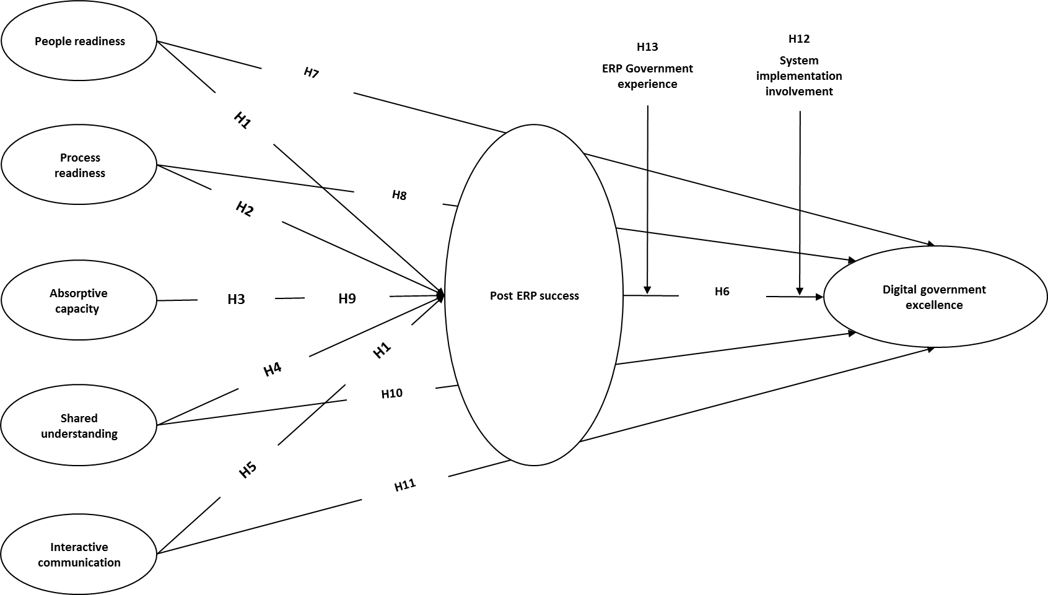
Figure 1. Conceptual Framework

2.9 Literature Review Summary
This chapter provides an overview of previous research on Post enterprise system practices and digital government excellence. It discusses the ERP adoption in digital government and investments maid by government entities to improve citizen satisfaction and to increase the productivity of public services (Kalling, 2003; Ram et al., 2014). It also discusses the capabilities that could help to gain and sustain their competitive advantages and how it can result in enhancing business efficiency and data accuracy (e.g., Al-Mashari, 2002; Allen, 2011; Kalling, 2003; Ram et al., 2014; Parthasarathy and Sharma, 2017).
The literature sheds light also on the challenges facing the government in a digital world and how citizens are becoming more demanding of e-government services and expecting to have services available round the clock (Anwar et al., 2016). It discusses governments' concerns with the use of enterprise systems for the efficient functioning of government authorities (Althonayan & Althonayan, 2017; Pedersen, 2017). Lutes (2016) expressed his concerns about the digital government, explaining that digital government cannot happen only by uploading and bringing government services online. Despite the great efforts that have been made by governments, many e-government projects are unsuccessful (Sánchez-Torres et al., 2017). Sorn-in et al. (2015) revealed that e-government projects often fail, especially in developing countries.
The research discusses the focus of previous studies; previous studies have focused on citizen satisfaction and how to provide better services to citizens (Amoretti & Musella, 2011; Qureshi et al., 2017). Also, other studies have discussed the determining effects of demographic characteristics in the use of e-government systems (Sipior et al., 2011; Stefanovic et al., 2016). What is still missing is a complete and end-to-end automation workflow that includes receiving the citizens’ service requests electronically and processing them electronically through the back-end government enterprise systems (Klinger, 2011). The link between ERP post-implementation and digital government excellence has many challenges, especially in developing countries (Sorn-in et al., 2015). Also, very few studies of digital governments have achieved excellent performance, and very few have attained a high degree of maturity (Philipson, 2017).
There has been much research and discussion conducted on the interaction between government and citizens (Stefanovic et al., 2016; Glyptis, et al., 2020; Yera et al., 2020) without paying attention to government employees and ERP post-implementation practices. The majority of studies reported in ERP and digital government literature have focused on two aspects separately. The first aspect is studying the success of e-government by measuring citizens’ satisfaction without paying attention to government employees (Glyptis, et al., 2020; Yera et al., 2020). The other aspect relates to measuring the success of the ERP back-end system from the point of view of employees, without the presence of any link or relationship between the government ERP back-end systems and digital government excellence. For example, (Alawneh et al., 2013; Baykasoğlu & Gölcük, 2020; Mahraz et al. 2020; Stefanovic et al., 2016; Sánchez-Torres et al., 2017; Motwani & Sharma, 2016; Bradley & Lee, 2007; Deng et al., 2018; Glowalla & Sunyaev, 2014). Several studies have discussed the adoption of ERP generally, while other studies have addressed the adoption of digital government, but studies combining the two are lacking. Therefore, the intention of this research is to evaluate both ERP and digital government adoption together.
It is evident from the research reviewed that the gaps in the current literature reveal a lack of research linking ERP practices and digital government excellence. This research review’s purpose also is to help the reader understand different aspects posed by the research on the relationship between government ERP back-end systems and digital government excellence. The chapter discussed the importance of ERP post-implementation in strengthening the technology capacity of digital government and the different methods used to handle it, providing the foundation for the research question. Decision makers in digital environments seek approaches allowing the government to determine which areas are worth paying attention to in order to support the digital environment (Munkuli, 2015). Thus, a broad perspective on ERP system evaluation is needed in the post-implementation phase of ERP to investigate and understand factors from the employees’ perspective that underlie the continued success of ERP systems post-implementation in supporting and promoting the growing needs of digital government. It is essential to think beyond citizen portal automation towards redesigning the back-end government systems and workflow within the government that might require structural and functional reengineering (Klinger, 2011).
The study introduces a practical guide to support the digital government transformation journey from an ERP user’s perspective. The reason is that research still showing that the most critical risks among the potential failures are failure to ensure vital user involvement and failure to ensure integration between enterprise-wide systems (Baykasoğlu & Gölcük İlker, 2020). There is a pressing need to understand factors that underlie the continued success of ERP post-implementation in supporting and promoting the growing needs of digital government excellence.

2.10 Summary
This chapter has highlighted the importance of ERP post-implementation practices from different perspectives. It has set out and explained the history of ERP, digital government, and the relationship between both components to measure the continued success of ERP post-implementation in general and in driving digital government excellence in particular. The chapter concluded by introducing the theoretical framework after by identifying the research problem and research question, identifying the model factors, and proposing the hypotheses.
In summary, the gaps in the current literature reveal a lack of research linking ERP practices and digital government excellence, indicating that the current research contributes significantly to empirical investigations related to the impact of ERP post-implementation activities on digital government excellence. The following research gaps were identified after a thorough review of the literature:
- The current literature focuses on successful and failed adoption of ERP systems in many industries, such as manufacturing, supply chain, and services. However, the study of ERP post-implementation in the digital government environment is not well represented.
- The literature does not identify the boundaries between ERP post-implementation activities and digital government excellence.
- The current literature lacks a conceptual framework integrating ERP post-implementation activities and digital government excellence.

CHAPTER 3: RESEARCH METHODOLOGY

3.1 Introduction
Choosing the appropriate methodology is an essential part of conducting research and takes place after deciding on the topic and setting the research aims; the research method provides the required data to complete the research (Avgousti, 2013). Therefore, it is necessary to find the most appropriate research for a particular purpose and then to decide on the instruments for the data collection. As Holm (2017) suggested, it is an iterative process, in which research challenges are redefined as new information comes to light.
This chapter describes the research design, research methodology, and the research measures of the study in order to test the hypotheses presented in the previous chapter. It presents the rationale for the selection of the specific procedures and methods. It explains the reasons behind the chosen methodology first, followed by a description of the quantitative phase of the study covering both the design and administration processes of the online survey. It also explains the sampling process by which the case-study institution was selected. The procedural approach to data collection, validation, and analysis, along with limitations, are also discussed and defined.
This study proposes an empirical study, focusing on collecting data from employees assigned to digital government services. First, it generated a list of ERP issues in digital government from previous studies. Then the list was grouped into seven categories: people readiness; process readiness; absorptive capacity; shared understanding; interactive communication; ERP post-implementation success; and digital government excellence. Using this model of seven constructs, a survey with a total of 54 items (nine items for people readiness, seven items for process readiness, seven items for absorptive capacity, four items for shared understanding, eight items for interactive communication, 11 items for ERP post-implementation success, and eight items for digital government excellence) was designed.
This chapter explains and justifies the selection of the research survey, the research sample size and type, the pilot study. It then describes the data-collection procedure, communication protocols with the target companies, the overall research protocol used for data collection and analysis, and covers ethical considerations for action taken to protect data from unauthorized access and use. Then, it provides the number of responses received from each authority and the response rate. Finally, it reports in detail the results of the research methodology, which acts as a framework for conducting the empirical inquiry.
Upon collection of the data, data analysis was performed using factor analysis on each factor separately, following which the cross-correlations among all factors were examined. The outcome of this study was four instruments that together measure the factors that influence ERP post-implementation success in driving digital government excellence.

UAE Digital Government Profile
The UAE government has been continuously seeking different strategies and models to provide world-class services to its citizens, expatriates, and visitors by adopting various types of technologies to enhance productivity and efficiency. The UAE government has launched the E-government Strategic Plan 2011–2013, which incorporates the use of ICT in all products and services across different governmental sectors (Al-Khouri, 2012). The UAE government’s vision for 2021 was announced in 2010 with a clear focus on improving the quality of work in most public sectors (UAE Vision, 2010).
The UAE has developed a federal e-government strategic framework that maps out the digital government initiatives. According to Al-Khouri (2012), the framework is aimed at contributing to:
- UAE Vision 2021, which aims to make the UAE one of the best countries in the world; and
- UAE government strategy, which aims to put citizens first and develop an accountable and innovative government.
The Institute for Management Development (IMD) World Digital Competitiveness Ranking results revealed that the digital competitiveness index of UAE is 86%, which leaves room for improvement. The results also showed that none of the developing countries is among the top ten ranked countries in digital competitiveness. The top five countries in the survey were the USA, Singapore, Sweden, Denmark, and Switzerland, with digital competitiveness indices of 100%, 99.422%, 97.453%, 96.764, and 95.851%, respectively (IMD World Digital Competitiveness Center, 2017). The UN E-Government Knowledgebase Survey (2019) reported that the UAE had reached sixth position globally in the smart electronic services index and the second position in the Telecommunication Infrastructure Index (WAM, 2019).
UN E-Government Knowledgebase Survey uses three indices to measure the e-government development: Telecommunications Infrastructure Index (TII); Human Capital Index (HCI); and Online Service Index (OSI). This type of report does not measure the effectiveness and efficiency of online services. It is not subject to the back-end system that government uses, but instead measures the percentage of individuals using the Internet, landline subscriptions percentage, mobile subscriptions percentage, number of online communications channels, and number of published services. Thus, this study provides useful grounds for discussing the challenges faced by the digital landscape of government information and creating a sustainable environment for ERP post-implementation in digital government.

3.3 Justification for the Research Method
The quantitative method is used to understand and identify practices and experiences of Post-ERP link with digital government excellence. It is particularly useful for exploring the determinants of ERP post-implementation success that contribute to digital government excellence.
Quantitative research in technology field usually involves a systematic and empirical investigation of phenomena through mathematics and the processing of numerical data; the process of quantitative research provides the fundamental link between empirical observations and the mathematical expression of quantitative relations (Basias & Pollalis, 2018). A review of the recent literature shows that much of the research on digital government and ERPs in developing countries focuses on the issues of technology acceptance and adoption. Given the limited reported studies on digital government excellence (Almalki et al., 2013), however, it is difficult to make a judgment regarding what findings and results exist in the literature on information systems success or its ERP applications to fully understand digital government excellence.
Quantitative research is widely used in IT for different reasons, such as: (a) if there is a need to address and process large volumes of data to test a theory and verify hypotheses; (b) if there is uncertainty related to theories under consideration (this is the case in technology due to unprecedented growth in technology usage and associated risk); or (c) because it can be effectively used with questionnaires containing simple questions and short answers (Basias & Pollalis, 2018). Therefore, this study proposes a conceptual framework that uses different models/ theories for evaluating the determinants of ERP post-implementation success that contribute to digital government excellence, adopting a ERP-user point of view. SEM was employed to identify the causal relationship between variables. Finally, the outcomes were reported, interpreted, and translated into practical recommendations.
According to Levine (2006), quantitative research is usually used to answer research questions or hypotheses; when the research question is formulated, thought must be given to how the research variables are to be defined, quantified, and analyzed. Also, the quantitative approach is very powerful in statistical methodology, where the qualitative approach can cover all modes of inquiry that do not rely on numbers and statistical methods (Tripp-Reimer & Kelley, 2006). Therefore, instruments measuring the excellence of digital government perceived by government ERP employee participants can be analyzed through a quantitative approach. Findings from this study will speak directly to decision makers in digital government, chief information officers (CIOs), chief executive officer (CEOs), governments, and government employees looking to improve digital government excellence. This new research design aims to provide a better understanding of the complex relationships among the functionality of ERP post-implementation applications and digital government excellence.
An online survey tool (SurveyMonkey) was used as a channel to collect the data. The survey was designed to be attractive and provide the best possible participant experience by having the survey available on desktop, tablet, and mobile, and by being compatible with any mobile browser. Hence, it was easy to reach the targeted audience anywhere and at any time. The survey was open to participants for four months, from September 2019 to December 2019.

3.4 Research Design
A research design is the adopted plan and process of investigation used to obtain answers to research study questions as validly, accurately, and objectively as possible (Kim, 1996; Yin, 2003). Due to the nature of the research problem identified, the research design was based on the quantitative method, which was appropriate to investigate the hypothesized relationships among the proposed variables of digital government excellence and ERP post-implementation success (Basias & Pollalis, 2018). The research design is a rational plan including several main steps for progressing from the “original set of questions to be answered” to “answers about these questions” (Yin, 2003).
Researchers often use the research design as a structured process that can aid decision making and propose guidelines based on reliable and valid research results. Thus, the research design is concerned with producing the right answers to the research question (Irani, 2012). This research aims to discover factors that underlie the continued success of ERP systems post-implementation in supporting and promoting the growing needs of digital government excellence via 13 hypotheses. Figure 2 shows the research process flow chart used to answer the research question.

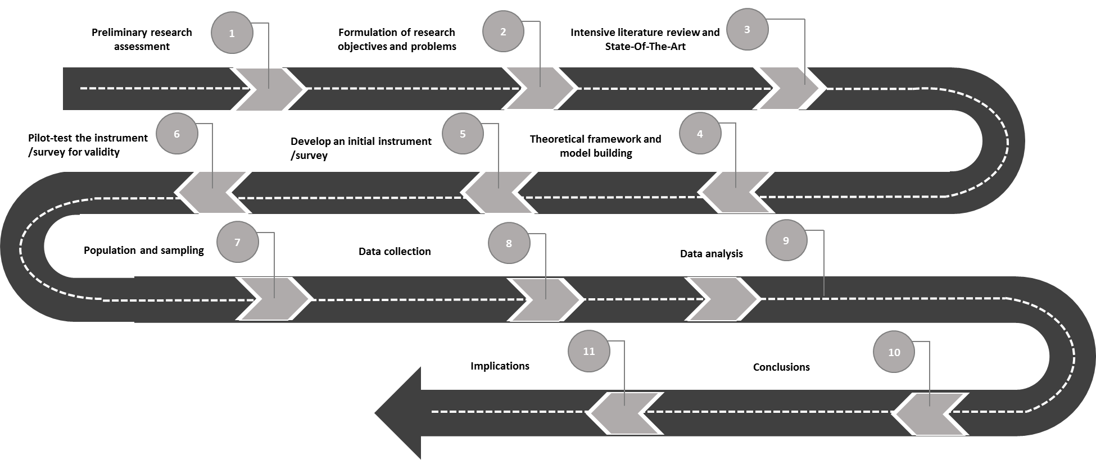
Figure 2. The Research Process Flow Chart

3.5 Research Instrument
The primary purpose of the questionnaire was to understand the determinants of ERP post-implementation success in driving digital government excellence in the UAE. All questions were evaluated based on a five-point Likert scale ranging from 1 (Strongly disagree) to 5 (Strongly agree). The study instrument was developed as a questionnaire survey based on existing survey instruments. The study instrument included five main sections:
Section 1: Cover letter explaining the main purpose of the questionnaire.
Section 2: General and demographic questions related to each respondent’s business unit, position, educational qualifications, age, gender, work experience, and whether the respondent was part of the system implementation or not.
Section 3: Questions to investigate and measure the organizational readiness and ongoing support of the ERP system post-implementation (people readiness and process readiness).
Section 4: Questions to investigate and measure knowledge management of the ERP system post-implementation (shared understanding and absorptive capacity).
Section 5: Questions to investigate and measure interactive communication related to the ERP system post-implementation.
Section 6: Questions to investigate and measure the mediation role of the continued success of ERP post-implementation on digital government excellence.
Section 7: Questions to investigate and measure digital government excellence.

3.6 Population
The study population comprised government authorities in the UAE. A total of 51 entities were listed as government authorities, 13 of which were connected with digital government (Abu Dhabi Government, 2019). Technology and digital transformation conferences, government events, and exhibitions such as GITEX 2019 were essential means to meeting technology decision makers. An introductory email sent to these authorities explaining the purpose of the research and details regarding the confidentiality of the collected information. A quantitative methodology was applied to examine the relationship between the variables. A total of 13 entities were approached through executive digital representatives; seven entities responded to accept participation in the research. A random sampling of the targeted research population is used to collect data from 450 respondents. The random sampling mechanism eliminates bias by giving all individuals an equal chance to be chosen and will have an equal opportunity for selection from the population (Wilson, 2012).
Ewout and Per (2018) revealed that system users are the most crucial factor in ERP system implementation in the overall organizational hierarchy (senior and junior). Therefore, in this research, all the primary data were collected from all staff who were full-time specialized ERP system users supporting government entities who were familiar with digital-government–ERP-implementation projects. A total of 450 experts were selected from seven different government authorities in the UAE.
Reiter et al. (2018) recommended that the end-users of the systems are vital informants and the most suitable for research on IT projects, including all users, from the executives at the senior level, through middle management, to the junior level. In this research, all the primary data were collected from all levels of ERP project participants, i.e. all levels who were familiar with ERP implementation projects in digital government. Therefore, participants in the study were all professionals working under government authorities in the UAE from a variety of job types in different government authorities. To accurately measure and understand the study findings, the study targeted different categories of employees (executive management, middle management, and junior staff); thus, respondents in the selected government entities were working across all levels. Respondents were chosen from all levels because they can give informed feedback about the ERP post-implementation practices that addresses different criteria.

3.7 Sample Size
According to Browin (2015), the sample size determines the stability and precision of the model. The required sample size relies on factors such as the proposed data analysis techniques. In this research, CFA and SEM were used as data analysis techniques as they are very sensitive to sample size and considered less reliable when using small samples (Khine, 2013). The literature review indicated that there are no generally accepted criteria for determining precise sample sizes using CFA and SEM (Hair et al., 2010). However, Hair et al. (2010) suggested different criteria for sampling: (1) the minimum sample size should be 100 when considering a model containing five or fewer constructs, with each construct having more than three items; (2) the minimum sample size should be 150 when the model includes seven or fewer constructs with modest communalities 0.5; (3) the minimum sample size should be 300 when models contain seven or fewer constructs with lower communalities “below .45”; (4) the minimum sample size should be 500 when models contain a large number of constructs with lower commonalities; or (5) the sample size should be at least five times the number of indicators. Since the proposed model has five variables involving 54, the required sample size is 270 (54 × 5). To increase the chances that results may be replicated, this dissertation study, therefore, targeted 450, which is deemed more than adequate.
All seven government authorities were approached by email and by phone to facilitate distribution of the survey. The questionnaire was also communicated via an online portal to facilitate the process of data gathering. The questionnaire was sent to 610 employees. However, only 450 filled the surveys and sent them back (a response rate of 73.7%).

3.8 Questionnaire Validation
Testing the questionnaire is a critical stage before collecting the data to avoid any content, grammar, or format issues (Mengistie, 2012). Therefore, a pilot survey was conducted to increase the content validity of the research instrument before performing the primary survey. The questionnaire was administered to a senior management representative and senior-level project managers during GITEX Technology Week, Dubai, in 2019. To allow greater generalizability across Arabic-speaking respondents in government authorities, and to make sure all the respondents could answer the questionnaire efficiently and adequately, Arabic translations of the questionnaires was developed, as recommended by Alsous et al. (2017), and tested for consistency, validity, and reliability on a group of respondents. The questionnaire was translated into Arabic to allow respondents the option to choose between two languages (Arabic and English). Two bilingual translators cooperated in this research to translate the questionnaire, both of whom were native Arabic. Using the forward-backward method, as recommended by Mousazadeh et al. (2017). First, the expert translated the questionnaire into Arabic. Second, the other expert back-translated it into English. Finally, both results were compared to the two versions to produce the final translated Arabic version of the questionnaire.
The pilot survey was developed using both offline through paper-based and online through the SurveyMonkey online portal. A total of 15 questionnaires (five paper-based and ten online-based) were distributed to the participants selected using a purposive sampling technique as recommended by Suen et al. (2014), aiming for each participant to provide unique and precious information of value to the study. Respondents included two directors, eight ERP system end-users, and the remaining five were consultants for digital government and ERP projects. Based on responses received from the pilot survey, the contents of the questionnaires were updated, including the elimination of some questions.
The validity of the paper-based questionnaires was tested using face validity and content validity, while the online questionnaires were tested using content validity. The face-validity approach is the most widely used form of validity in developing countries. Face validity is used to review and agree on whether the test is a valid measure of the concept being measured, just “on the face of it.” If an instrument does not have good face validity, it will most likely not give the information required (Bolarinwa, 2015; Mostafavi et al., 2016). It is the purest and most subjective form of validity measurement. This study followed the face-validity criteria reported by Mousazadeh et al. (2017) and Ye et al. (2008) for inclusion and exclusion. The inclusion criteria were: age range of 26–45 years; ERP user in digital governments; and willing to participate in the study.
The questionnaire was tested using face validity by asking for evaluation from five respondents who were ERP system users who were familiar with digital government and ERP projects. The respondents were then required to assess the questions concerning ambiguity, relativity, proper terms, understandability, and grammar using a five-point Likert scale ranging from 1 (Not important at all) to 5 (Highly important). The exclusion criteria were: failure to respond; and failure to respond to all questions. The impact score was then computed for each item for all the questionnaires to eliminate inappropriate items in the questionnaire using the formula “Impact score = Frequency (%) × Importance” as recommended by Ashtiani et al. (2018). “Frequency” is the number of ERP system who users rated the item 4 or 5, while “Importance” is the mean score of the item on the 1–5 rating scale (Nahid et al., 2019). An Impact score of 2 was considered acceptable as recommended by Mousazadeh et al. (2017); other studies have accepted scores of 1.5 (Sadat et al., 2018). After calculating the impact score (see Table 4), all the participants confirmed that all the questionnaire items were clear, simple, and related to the objectives.
Table 4. Response Rate from the Government Authorities Studied
Item | Frequency (%) | Importance | Impact score
Question 1 | 0.60 | 3.4 | 2.04
Question 2 | 0.60 | 4.2 | 2.52
Question 3 | 0.80 | 4.4 | 3.52
Question 4 | 0.80 | 4.4 | 3.52
Question 5 | 0.80 | 4.4 | 3.52
Question 6 | 0.60 | 3.8 | 2.28
Question 7 | 0.80 | 4.2 | 3.36
Question 8 | 0.60 | 3.4 | 2.04
Question 9 | 0.60 | 3.4 | 2.04
Question 10 | 0.80 | 3.8 | 3.04
Question 11 | 0.80 | 3.8 | 3.04
Question 12 | 0.80 | 4.2 | 3.36
Question 13 | 0.60 | 3.6 | 2.16
Question 14 | 0.60 | 3.6 | 2.16
Question 15 | 0.60 | 3.8 | 2.28
Question 16 | 1.00 | 4.6 | 4.60
Question 17 | 0.80 | 4.2 | 3.36
Question 18 | 0.60 | 3.8 | 2.28
Question 19 | 0.60 | 4.0 | 2.40
Question 20 | 0.60 | 3.4 | 2.04
Question 21 | 0.60 | 3.8 | 2.28
Question 22 | 0.60 | 3.6 | 2.16
Question 23 | 0.80 | 3.8 | 3.04
Question 24 | 0.80 | 3.8 | 3.04
Question 25 | 0.60 | 3.4 | 2.04
Question 26 | 0.60 | 3.4 | 2.04
Question 27 | 0.60 | 3.4 | 2.04
Question 28 | 0.80 | 3.8 | 3.04
Question 29 | 0.60 | 3.6 | 2.16
Question 30 | 0.60 | 3.6 | 2.16
Question 31 | 0.60 | 3.6 | 2.16
Question 32 | 0.60 | 3.6 | 2.16
Question 33 | 0.60 | 3.6 | 2.16
Question 34 | 0.80 | 3.6 | 2.88
Question 35 | 0.80 | 3.6 | 2.88
Question 36 | 0.80 | 3.4 | 2.72
Question 37 | 0.80 | 3.4 | 2.72
Question 38 | 0.80 | 3.4 | 2.72
Question 39 | 0.80 | 3.6 | 2.88
Question 40 | 0.80 | 4.0 | 3.20
Question 41 | 0.80 | 4.0 | 3.20
Question 42 | 0.60 | 3.8 | 2.28
Question 43 | 0.60 | 4.0 | 2.40
Question 44 | 0.60 | 4.0 | 2.40
Question 45 | 0.60 | 3.6 | 2.16
Question 46 | 0.80 | 3.8 | 3.04
Question 47 | 0.80 | 3.8 | 3.04
Question 48 | 0.80 | 3.6 | 2.88
Question 49 | 0.80 | 3.6 | 2.88
Question 50 | 0.80 | 3.6 | 2.88
Question 51 | 0.80 | 3.6 | 2.88
Question 52 | 0.80 | 4.0 | 3.20
Question 53 | 0.80 | 4.0 | 3.20
Question 54 | 0.80 | 4.0 | 3.20

The frequency (percentage) in Table 4 also represents the content-validity index. The same sample of participants who met the inclusion criteria were asked to assess the quality of the content validity of the questionnaire and to comment on any issues such as clarity and grammar for each item, the correct placement of items, the use of the right words, and scoring. Therefore, the content-validity index was measured as proposed by Ashtiani et al. (2018) and Mousazadeh et al. (2017).

3.9 Data Collection
The questionnaire was administered by two digital government executives who worked in digital government. Then, approval from the Institutional Review Board at Abu Dhabi University (ADU) was obtained. An online survey was used for data collection; the questionnaire, accompanied by an informational cover letter explaining the purpose of the research and ensuring confidentiality, was then distributed to the target population. The questionnaire had five parts that, between them, encompassed the cover letter, demographic information, organizational readiness and ongoing support, knowledge management, interactive communications, ERP post-implementation systems, and digital government excellence (see Appendix 1, 2, 3, and 4). A five-point Likert-type scale ranging from 1 (Strongly disagree) to 5 (Strongly agree) was used to provide an ordinal-level measure of Post enterprise systems practices in digital government. Likert-type scales are often used in survey research, where participants express certain responses in terms of ordinal-level categories (Alghamdi, 2018). The five-point scale appears to be less confusing, readily comprehensible to participants and enables them to express their views, and it is quite simple for the interviewer to read out the complete list of scale descriptors (Babakus and Mangold, 1992).
An online survey tool (SurveyMonkey) was used as a channel to collect the data. The survey was designed to be attractive and provide the best possible participant experience by having the survey available on desktop, tablet, and mobile, and by being compatible with any mobile browser. Hence, it was easy to reach the targeted audience anywhere and at any time. The survey was open to participants for four months, from September 2019 to December 2019.
The data collection was conducted through the distribution of the survey to 610 of the target population through email stating that all questionnaires are received anonymously, participation in this survey is voluntary, participants may choose not to participate, and participants may withdraw from participating at any time. The total number of valid responses was 450 from seven authorities, representing a response rate of 73.7%. Nulty (2008) reported that online surveys are much less likely to achieve response rates as high as administrated paper surveys, with an average response of less than 50%. Therefore, this response rate is considered very good. Figure 3 shows the flow of the data-collection process.
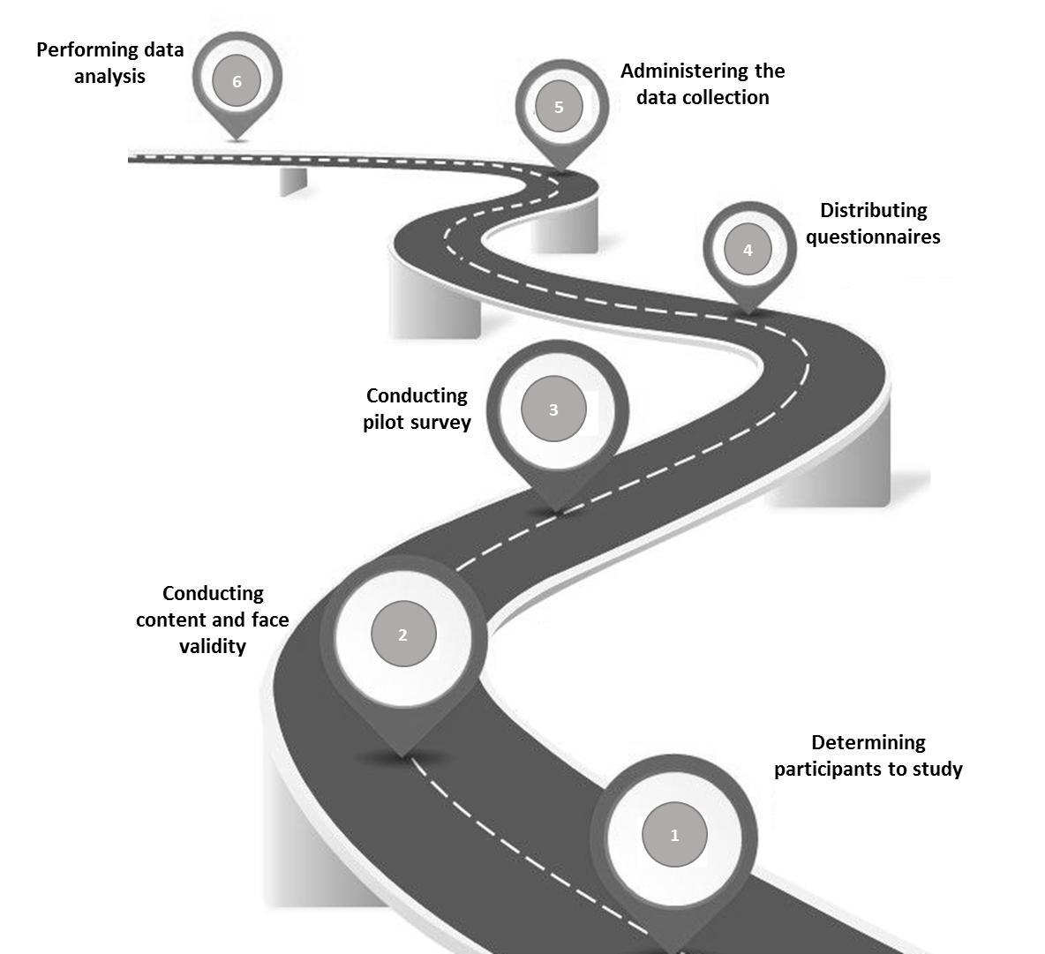
Figure 3. Data Collection Process

Within the data-collection process, a total of 450 were fully completed and 25 having some fields missing. This was either due to the respondents clicking the survey link but going no further or due to then failing to complete the survey. In order to avoid any artificial increase in the model relationships, all questionnaires with missing data were excluded. In total, there were 25 cases with missing data in fewer than 10% of the survey questions, which is considered acceptable (Hair et al., 2010). Two more scenarios were considered in the data cleansing of the questionnaires: respondents who had given the same answer to all questions; and respondents who completed the questionnaire in less than one minute. Both scenarios were considered to be unengaged. The standard deviation (SD) for each questionnaire was calculated, considered questionnaires with SD = 0 as unengaged. The final analysis of engaged questionnaires was 382.

3.10 Data Analysis
The analyses applying statistical and logical techniques were conducted using SPSS 20.0 (Basias & Pollalis, 2018). These analysis techniques involved descriptive statistics, normality, linearity, quantitative data analysis using EFA, CFA, and SEM. CFA was used to validate construct measurements, while SEM was used for assessing the hypothesized relationships.

3.10.1 Data and Variable Screening
The data screening process is the process of ensuring that the collected data is ready for the statistical analyses. It can improve the quality and increase the trustworthiness of collected data; low-quality data can distort the hypothesis testing of the research (DeSimone & Harms, 2018). Therefore, data screening can influence the statistical results of a study. Altman (1980) considered this step as a must before proceeding to the analysis. Data screening primarily checks whether the collected values are plausible. Each variable was cross-checked against other relevant information to find if there were any inconsistencies, such as an 18-year-old respondent with 20 years’ experience.
Data screening in this research was addressed by case and by variable; the process began by looking at the dataset and to see if there were any missing data from individual respondents. It then considered unengaged responses by calculating the SD of the p-value for each respondent to see if there were any responses with the same value for every question so they could be removed.

3.10.2 Descriptive Analysis
The frequency count, measures of central tendency (mean, median, mode, SD, and variance), percentage of participants, ERP-system experience, education level, age groups, and values of each dependent and independent items were calculated.

3.10.3 Correlation Matrix
To summarize the collected data as an input into a more advanced analysis, a correlation matrix was used to show the correlation coefficients between variables. The inter-item correlations among the factors were calculated and analyzed.

3.10.4 Regression Analyses
A linear regression technique was used to investigate the relationship between a target and predictor factors (dependent and independent factors) and to evaluate the extent to which ERP post-implementation determinant factors explained variance in indicators for digital government excellence. In addition, the maximum likelihood estimation (MLE) method was used to estimate the parameters of the statistical model and to enable factor analysis.

3.10.5 Procedures for Exploratory Factor Analysis (EFA)
EFA seeks to explore the underlying structure of a large set of variables and identify underlying variables and factors that explain the pattern of correlations within a set of observed variables. Hair et al. (2010) described the main reasons for using factor analysis is to categorize several factors that explain most of the variance observed:
- Reduce a large number of items to a smaller number of factors for modeling purposes.
- Choose a subset of variables from a broader set according to which original variables have the highest correlations with the principal factors.
- Generate a set of factors to be treated as uncorrelated items.
- Validate a scale and its items load on the same factor and remove scale items that cross-load on more than one factor.
Harvey (2009) summarized that exploratory factor analysis comprises three major stages: (a) factor analysis and assessment; (b) factor extraction; and (c) factor rotation. Table 5 summarizes of assumptions in the preliminary analysis performed to check for data suitability by conducting EFA. Hair et al. (2010) described multicollinearity, which refers to the degree to which a variable’s effects can be predicted or accounted for by the other variables in the data analysis; this was checked for using variance inflation factor (VIF) and tolerance.
Table 5. Summary of EFA Requirements for the Dataset
Scope | Requirement | Reference
Outliers | No outliers accepted | Hair et al. (2010)
Normality | Normally distributed | Hair et al. (2010)
Linearity | No multicollinearity; variance inflation factor (VIF) < 10 | Hair et al. (2010)
Sample size | Minimum: 5 cases to each study item | Harvey (2009)
Kaiser–Meyer–Olkin (KMO) | ≥ 0.5 | Hair et al. (2010)
Bartlett’s test of sphericity | Be significant (p < .05) | Leslie (2016)

3.10.6 Validity and Reliability
Validity and reliability were tested using EFA. EFA is a powerful tool for investigating variable constructs in the technology field (Mohamad et al., 2019; Mykota, 2015). It is also a popular statistical tool in communication research. The core of ERP systems and digital government is founded upon communication (Hee et al., 2002). Convergent validity in EFA is defined as items that load highly on their factor; it is the degree of confidence that a trait is well measured by its indicators (Mirzaei et al., 2019). There were no cross-loadings, and the loadings were high enough to achieve the discriminant validity (Henseler et al., 2015).
The validity of the scales was assessed using EFA through MLE with eigenvalues more than 1 to extract the number of factors to examine the content of questions that loaded highly and on the same factor to identify common themes. Finally, The Kaiser–Meyer–Olkin (KMO) test and Bartlett’s test of sphericity were conducted to assess whether the correlation among the items was sufficient to run factor analysis.

3.10.7 Conformity Factor Analysis (CFA)
The CFA statistical technique was performed to assess the measurement and the adequacy of the hypothesized model on all items simultaneously (seven constructs and 54 items) in the 382 usable questionnaires using the software Amos 20. CFA is a critical in the two-step SEM process, which is specified as a method to provide a comprehensive means for validating the model for latent variables (Mohamad et al, 2019). It is also used to assess the convergent validity and discriminant validity of the measurement model (Hair et al., 2010).

3.10.8 Common Method Bias (CMB)
Questionnaire surveys often provide the information used to measure both the independent and dependent variables in research analysis. However, such a method introduces the risk of CMB, and this challenge has not received much research attention (Jakobsen & Jensen, 2015). Therefore, the common latent factor (CLF) technique was used by introducing a new latent single variable in such a way that all manifest variables were related to it, as suggested by Podsakoff et al. (2003, 2012). Both studies used a single common factor score, in which all items are loaded into one common factor.

3.10.9 Structural Equation Modeling (SEM)
After analyzing the proposed model using CFA, SEM was conducted to check the hypothesized relationships and test the second-order model (Mohamad et al., 2019). The importance of SEM lies in the assessment of the strength of the relationships between model items for direct and indirect relationships and in calculating the fit indices of the proposed model (Garg and Khurana, 2017; Henseler et al., 2015).

3.11 Ethical Considerations
This research assured the confidentiality of participants in interviews and online survey interactions. All aspects of this research were based on the ADU code of ethical conduct and the accepted ethical standards of scientific research, academic integrity standards, and policy. To protect the rights and dignity of all participants, the ADU Institutional Review Board committee were approached by submitting the official research application and supplemental information packages for it to be reviewed and approved. The dissertation chair and committee members were periodically consulted on ethical concerns throughout the research project lifecycle. Once the ADU Institutional Review Board committee had approved the proposal, participants received an online letter of invitation (see Appendix 2 for English version and Appendix 3 for the Arabic version) seeking their willingness to participate in the study.
The study survey was designed in a way to assure that the choice to participate was voluntary and that participants were free to quit the survey at any time. The covering letter was written with clear information to the participants about the study background, objective, and scope, as well as assuring them of the anonymity and confidentiality of their personal information and answers.

3.12 Summary
This chapter has presented a detailed discussion of the research model and its constructs and the chosen research method, design, the data collection, pilot study, content validity and face validity, the sample size, and the analysis methods used to conduct the research study. These steps have been addressed in light of the research objectives explained in chapter 1, as well as the literature review in chapter 2. Statistical analysis techniques (i.e. EFA, CFA, and SEM) have been discussed. In the following chapter, the research findings of the survey and analysis will be presented. Implications of the results and suggested directions for further research will be reported.

CHAPTER 4: DATA ANALYSIS AND RESULTS

4.1 Introduction
This chapter aims to discuss the determinants of ERP post-implementation success in driving digital government excellence by investigating the relationships between each type of post-implementation determinant (people readiness, process readiness, absorptive capacity, shared understanding, and interactive communication) and digital government excellence. It also aims to examine the moderating role of system experience and user involvement in system implementation on these relationships. To accommodate these relations, the measurement model was created using EFA, as recommended by Anderson and Gerbing (1982). The psychometric properties (i.e. reliability, convergent validity, and discriminant validity) were also assessed using CFA. The study used SEM and path analysis to test the hypotheses. Descriptive statistics were also used to show the demographic characteristics of the study sample. Analyses of this study was conducted using SPSS 20.0 and Amos 20 and Microsoft Excel 2019.

4.2 Process for Testing the Research Model
Figure 4 explains the analysis process for testing the research model and hypotheses.

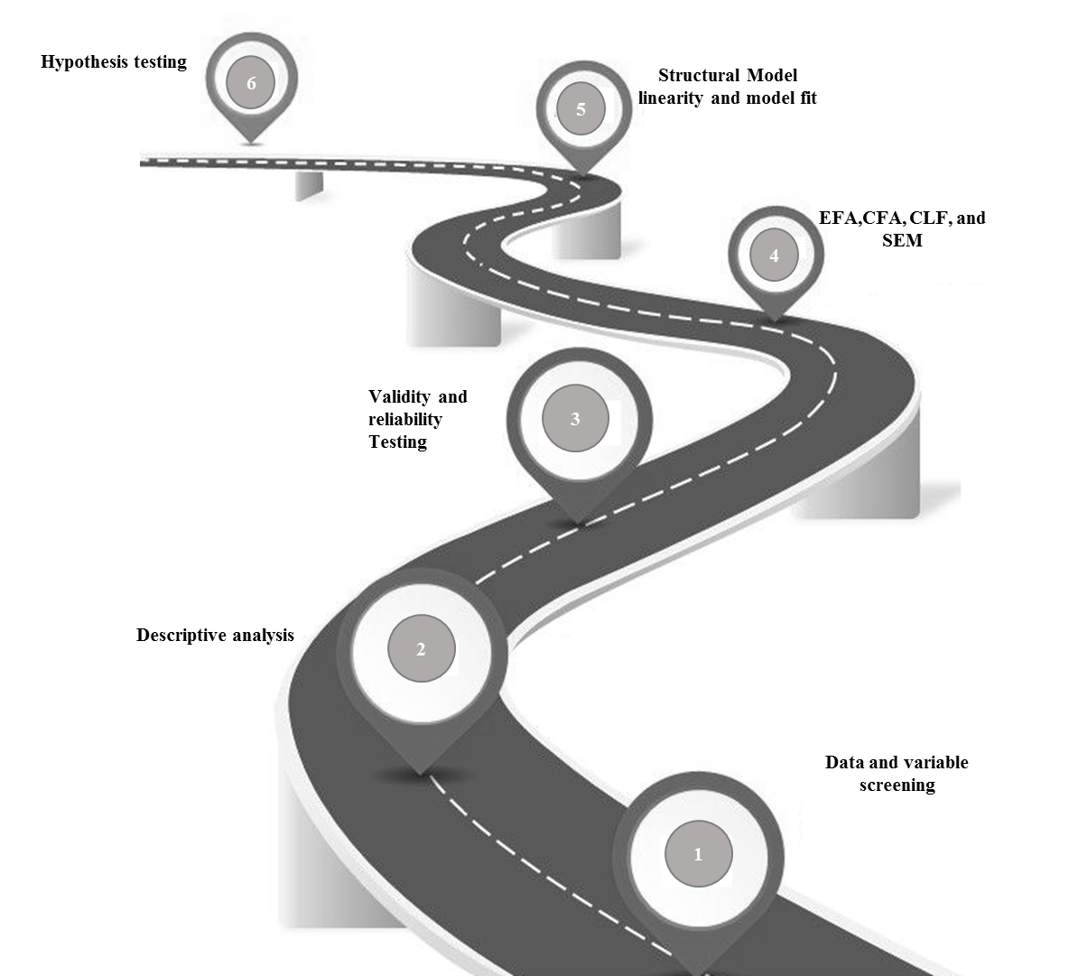
Figure 4. Process for Testing the Research Model

4.2.1 Developing a Theoretical Model
The process started by developing a good theoretical model and then developing some hypotheses to represent that model, as presented in chapter 2. The model was designed to understand the determinants for successful ERP post-implementation in driving digital government excellence from the ERP users’ perspective.

4.2.2 Screening of Participants’ Data
Data were screened by examining the dataset to make sure there were no missing data from any single respondent. This was measured by counting the blank values for each respondent; only a few respondents were deleted due to useless or missing data. Unengaged responses were then calculated using the SD for each respondent. SD was used to see if there were responses with the same value for all questions in order to eliminate these responses (where the SD was less than 0.1). Outliers were also considered for variables such as age, experience, and education using a boxplot process in SPSS; this is a way to show the spread and centers of a dataset. Measures of spread include the interquartile range and the mean of the dataset, where measures of the center include average and median (Ker et al., 2013). The missing data on education variables were replaced with the median. After eliminating the unengaged responses, 382 valid responses remained. Table 6 shows the initial analysis of data screening. Figure 5 presents the outlier analysis.

Table 6. Initial Data Screening
Data screening | Screened Reponses | Responses after Processing
Missing data in rows | 13 | 401
Unengaged responses | 19 | 382
Outliers | 2 | 382

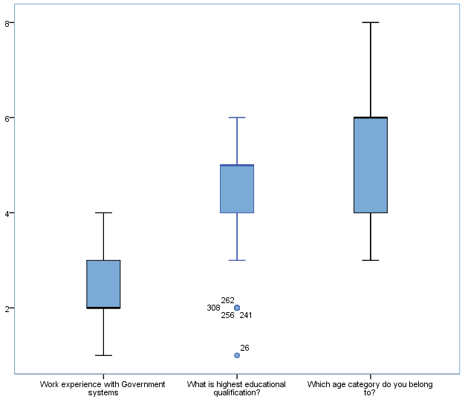
Figure 5. Outlier Analysis (Experience, Education, and Age)

4.2.3 Screening of Data Variables
Data variables were screened using descriptive frequencies to create the missing data table and replace those values with the median for non-demographic variables and the mean for more continuous variables such as age and experience. Kurtosis was also used to measure the tailedness of the probability distribution of the research variables. The kurtosis of the normal distribution was zero. The rule to evaluate the kurtosis and conclude that there is no kurtosis issue is: (a) if the absolute value of the kurtosis is less than three times the standard error, then the kurtosis is not significantly different from that of the normal distribution; b) if the overall kurtosis score is 2.2 or less (Gaskin, 2020). Only two variables had kurtosis values exceeding 2.20, as shown in Table 7). However, the reported variables were examined while conducting EFA to make sure that they would not cause any problems if they had low communality values, irrespective of whether they were or were not loaded on any single factor.

Table 7. Kurtosis Statistical Analysis
 | Question 34 | Question 35
Reponses | 382 | 382
Kurtosis | 2.225 | 2.494

4.2.4 Descriptive Analysis
Descriptive analysis was conducted to present the respondents profile through identifying the demographic characteristics of the respondent’s sample. A summary of the respondent profiles is presented in Table 8.

Table 8. Summary of Respondents’ Demographic Data
Variable | Count | Percentage | Cumulative Percentage
Age (Years)
21–25 | 35 | 9.2 | 9.2
26–30 | 70 | 18.3 | 27.5
31–35 | 74 | 19.4 | 46.9
36–40 | 110 | 28.8 | 75.7
41–45 | 69 | 18.1 | 93.7
46–50 | 24 | 6.3 | 100
Total | 382 | 100 | 100
Education Level
Middle school | 1 | 0.3 | 0.3
High school | 8 | 2.1 | 2.4
College | 28 | 7.3 | 9.7
Bachelor’s | 144 | 37.7 | 47.4
Master’s | 165 | 43.2 | 90.6
Total | 382 | 100 | 100
Experience (Years)
1–5 | 50 | 13.1 | 13.1
6–10 | 157 | 41.1 | 54.2
11–20 | 139 | 36.4 | 90.6
Over 20 | 36 | 9.4 | 100
Total | 382 | 100 | 100
Gender
Female | 143 | 37.4 | 37.4
Male | 239 | 62.6 | 100
Total | 382 | 100 | 100
Users’ Involvement in System Implementation
Yes | 253 | 66.2 | 66.2
No | 129 | 33.8 | 100.0
Total | 382 | 100 | 100

4.2.5 Measures of Central Tendency
Table 9 shows the measures of central tendency for each research construct. All constructs were measured on a five-point Likert-type scale, ranging from 1 (Strongly disagree) to 5 (Strongly agree). The mean is the sum of all scores for the items divided by the number of respondents. The median is the value separating the higher half from the lower half of a data sample. The SD measures how spread out the values in a dataset are around the mean. The SD of the data ranged from 0.59 for people readiness to 0.81 for interactive communication. This indicates that people readiness scores do not vary greatly since all government authorities tend to adapt similarly to government excellence.

Table 9. Measures of Central Tendency
 | PROCR | ACK | PEOPR | IC | SUK | PERPS | DGE
Mean | 4.02 | 3.56 | 3.75 | 2.29 | 2.77 | 3.95 | 2.89
Median | 4.00 | 3.71 | 3.75 | 2.00 | 2.75 | 4.00 | 3.00
Mode | 4.00 | 4.00 | 4.00 | 2.00 | 3.00 | 4.00 | 2.00
SD | 0.61 | 0.77 | 0.59 | 0.81 | 0.79 | 0.60 | 0.73
Variance | 0.37 | 0.59 | 0.34 | 0.65 | 0.63 | 0.35 | 0.54
Notes: PEOPR = People readiness; ACK = Absorptive capacity; PROCR = Process readiness; IC = Interactive communication; SUK: Shared understanding; PERPS = ERP post-implementation success; DGE = Digital government excellence

4.2.6 Exploratory Factor Analysis (EFA), Validity, and Reliability Analyses
To conclude the analysis of the variable constructs, EFA was used as it is a powerful tool for use in the technology field as reported by Mykota, (2015) and Mohamad et al. (2019). It is also a top-rated statistical tool in communication research, and the core of ERP and the digital government model are founded upon communication (Hee et al., 2002). Convergent validity in EFA is defined as items loading highly on their factor; it represents the degree of confidence that a trait is well measured by its indicators (Mirzaei et al., 2019). There were no cross-loadings and the loadings were high enough to assure discriminant validity (Henseler et al., 2015).
The validity of the scales was assessed using EFA through the MLE method, with eigenvalues of more than 1 to extract the number of factors to examine the content of questions that loaded highly and on the same factor to identify common themes. The Promax method was used to rotate variables. The analysis suggested that there were seven constructs, and that all variables loaded under the related constructs. The loading values were above 0.5, except for one (the ERP post-implementation success construct, for which the loading value was 0.42); there were no low loading items or any cross-loading issues. The KMO test and Bartlett’s test of sphericity were conducted to determine ERP post-implementation success and digital government excellence in the data. The results are shown in Table 10.

Table 10. KMO Test and Bartlett’s Test of Sphericity
KMO Measure of Sampling Adequacy |  | 0.926
Bartlett’s Test of Sphericity | Approx. χ² | 14,710.773
 | Df | 1,035
 | Sig. | 0.000

According to the KMO test and Bartlett’s test of sphericity (KMO > 0.5), these items are suitable and there are no serious issues in the data. Bartlett’s test of sphericity (significant at p < 0.05) shows that the correlation among the items was sufficient to run factor analysis (Daldal & Kiliç, 2014).
Item loadings and factor patterns are presented in a rotated component matrix in Table 11. The items loading on factor 1 seemed to relate to different aspects of excellence in digital government; therefore, this factor was labeled “Digital government excellence” (comprising nine items and accounting for 30% of the variance). Items loading highly on factor 2 all seemed to relate to different aspects of business processes and, therefore, this was labeled “Process readiness” (comprising seven items and accounting for 8.54% of the variance). The items loaded highly on factor 3 all seemed to relate to absorptive capacity; therefore, this factor was labeled “Absorptive capacity” (comprising seven items and accounting for 8.86% of the variance). The items that loaded highly on factor 4 all seemed to relate to people readiness; therefore, this factor was labeled “People readiness” (comprising eight items and accounting for 7.27% of variance). The items that loaded highly on factor 5 all seemed to relate to user interaction and communication; therefore, this factor was labeled “Interactive communication” (comprising 6 items and accounting for 4.28% of variance). The items that loaded highly on factor 6 all seemed to relate to factors required to make the post-implementation phase of ERP a success; therefore, this factor was labeled “ERP post-implementation success” (comprising five items and accounting for 4.22% of variance). Finally, the items loaded highly on the last factor all seemed to relate to shared understanding; therefore, this factor was labeled “Shared understanding” (comprising four items and accounting for 3.20% of the variance). The reliability of internal consistency was measured using the Cronbach’s alpha coefficient for each factor for the total sample. All values for the Cronbach’s alpha coefficient were within the range of 0.82 to 0.98, noticeably exceeding the standard threshold value of 0.7 (Matkar, 2012). Table 11 shows the results for EFA loading and reliability testing. The total variance explained by the seven constructs was 66.41%.

Table 11. Assessment of the Measurement Model
Model Construct | Item | Loading | Variance (%) | Cronbach’s Alpha
Digital Government Excellence | DGE1: Simplifying business processes | 0.67 | 30.03 | 0 .94
Digital Government Excellence | DGE2: Saving citizens time | 0.86
Digital Government Excellence | DGE3: Government–citizen relationship | 0.76
Digital Government Excellence | DGE4: Reducing paperwork | 0.87
Digital Government Excellence | DGE5: Information availability | 0.62
Digital Government Excellence | DGE6: Relationship between departments | 0.66
Digital Government Excellence | DGE7: Interactions among employees | 0.90
Digital Government Excellence | DGE8: Individual productivity | 0.87
Digital Government Excellence | DGE9: Group productivity | 0.82
Process Readiness | PROCR1: Organization support | 0.67 | 8.54 | 0.94
Process Readiness | PROCR2: Business processes documentation | 0.87
Process Readiness | PROCR3: Testing the business processes | 0.93
Process Readiness | PROCR4: Alignment of business needs and processes | 0.82
Process Readiness | PROCR5: Alignment of user needs and processes | 0.83
Process Readiness | PROCR6: Accommodating processes changes | 0.95
Process Readiness | PROCR7: Alignment of system flows and practices | 0.74
Absorptive Capacity | ACK1: Common understanding of systems scope | 0.90 | 8.86 | 0.94
Absorptive Capacity | ACK 2: Clear vision | 0.86
Absorptive Capacity | ACK 3: Using the most modern technology | 0.81
Absorptive Capacity | ACK 4: Clear understanding of the new systems | 0.66
Absorptive Capacity | ACK 5: Understand the technical knowledge | 0.86
Absorptive Capacity | ACK 6: Leadership understanding | 0.86
Absorptive Capacity | ACK 7: Understanding the recent technology | 0.82
People Readiness | PEOPR 1: Top management support | 0.53 | 7.27 | 0.90
People Readiness | PEOPR 2: Strong management information system | 0.50
People Readiness | PEOPR 4: Good implementation partner | 0.77
People Readiness | PEOPR 5: System users’ involvement | 0.90
People Readiness | PEOPR 6: Good understanding of the new systems | 0.66
People Readiness | PEOPR7: Professional IT development team | 0.99
People Readiness | PEOPR 8: Technical and professional support skills | 0.77
People Readiness | PEOPR 9: Effective IT service desk | 0.64
Interactive Communication | IC1: Communicating expected risks of the project | 0.89 | 4.28 | 0. 98
Interactive Communication | IC2: Communicating expected project outcomes | 0.91
Interactive Communication | IC3: Proficiency in communication | 0.77
Interactive Communication | IC4: Easy IT–business communication | 0.85
Interactive Communication | IC5: Collaboration between IT and employees | 0.87
Interactive Communication | IC6: Good staff relationships across departments | 0.90
ERP Post-Implementation Success | PERPS6: Increasing productivity | 0.99 | 4.22 | 0 .91
ERP Post-Implementation Success | PERPS7: Improving competitive position | 0.92
ERP Post-Implementation Success | PERPS8: Improving communication | 0.42
ERP Post-Implementation Success | PERPS10: Improving overall process | 0.83
ERP Post-Implementation Success | PERPS12: Improving decision making | 0.87
Shared Understanding | SUK1: Importance of business’s priorities | 0.68 | 3.20 | 0 .82
Shared Understanding | SUK2: Common language between business and IT | 0.75
Shared Understanding | SUK3: Understanding the business processes | 0.73
Shared Understanding | SUK4: Comprehensive users’ training program | 0.74

4.2.7 Confirmatory Factor Analysis (CFA)
CFA was performed to assess the measurement and adequacy of the hypothesized model for all items simultaneously (seven constructs and 54 items) in the 382 usable questionnaires. To examine convergent and discriminant validity, Amos 20 software was used. CFA was conducted based on the outcome of the factors of EFA: “People readiness;” “Process readiness;” “Absorptive capacity;” “Shared understanding;” “Interactive communication;” “ERP post-implementation success;” and “Digital government excellence” (see Table 11).
The model-fit indices including the comparative fit index (CFI), root mean square of error approximation (RMSEA), normed fit index (NFI), and Tucker–Lewis index (TLI) were selected to judge the model fit (Bandyopadhyay et al., 2011; Garg & Khurana, 2017; Satapathy, 2014). To obtain an acceptable model fit, CFI, NFI, and TLI should be greater than 0.9, and RMSEA must be lower than 0.08 (Garg & Khurana, 2017). Table 12 shows a summary of indices for the measurement model. The chi-square statistic (CMIN) is associated with “probability” or p-value, which should not be statistically significant if there is a good model fit. However, the χ² statistic is very sensitive to sample size and is no longer relied upon as a basis for model acceptance or rejection (Cole et al., 2006). CFA performed with seven factors indicated a good fit of the model to the data. The cut-off ranges of fit indices were within the recommended levels with a highly scored value for χ² (CMIN/df = 1.694), root mean square residual (RMR) = 0.035, and RMSEA = 0.043. The factor loadings were well above the cut-off value of 0.50 for each item of the model (Riaz & bin Mohamed, 2017). The Suggested threshold statistics model goodness-of-fit indices are shown in Table 13 and the first-order measurement model goodness-of-fit indices are shown in Figure 6.

Table 12. Goodness-of-Fit Indices for the Measurement Model
Goodness-of-fit indices | Value
CMIN/df | 1.55
Adjusted goodness-of-fit index (AGFI) | 0.769
Normed fit index (NFI) | 0.895
Comparative fit index (CFI) | 0.954
Tucker–Lewis index (TLI) | 0.950
Root mean square of error approximation (RMSEA) | 0.043

Table 13. Suggested Threshold for Goodness-of-Fit Indices
Statistic | Suggested Threshold
χ²/df | ≤5
Goodness-of-fit index (GFI) | ≥0.90
Adjusted goodness-of-fit index (AGFI) | ≥0.80
Comparative fit index (CFI) | ≥0.90
Incremental fit index (IFI) | ≥0.90
Root mean square of error approximation (RMSEA) | ≤0.10

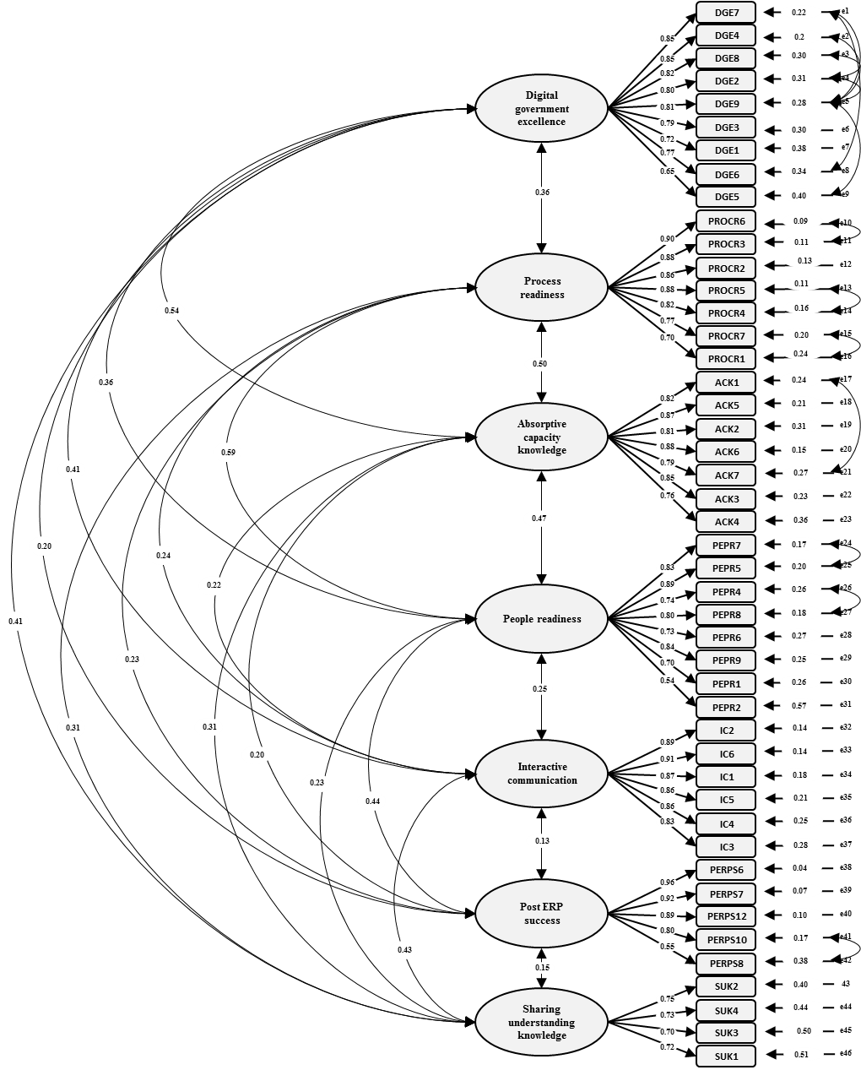
Figure 6. The First-Order Measurement Model for Digital Government Excellence

4.2.8 Convergent and Discriminant Validity Assessment
Table 14 shows the Pearson product–moment correlation coefficient analysis results. The model shows positive relationship at p < 0.01. The analysis shows that there are no discriminant validity concerns since the square root of the average variance extracted (AVE) of each construct is higher than the inter-construct correlations between any pairs in the model (Fornell & Larcker, 1981). In addition, convergent validity was confirmed since there were acceptable levels for the factor loadings, with composite reliability (CR) exceeding the threshold of 0.8 (McDonald, 1978), and the AVE of each construct exceeding the threshold of 0.5 (Fornell & Larcker, 1981; Hamid et al., 2017).

Table 14. CR, AVE, and Correlation Among Variables
 | CR | AVE | PERPS | DGE | PROCR | KMAC | PEOPR | IC | KMSU
PERPS | 0.918 | 0.699 | 0.836
DGE | 0.935 | 0.618 | 0.197 | 0.786
PROCR | 0.940 | 0.694 | 0.235 | 0.360 | 0.833
KMAC | 0.938 | 0.684 | 0.199 | 0.541 | 0.504 | 0.827
PEOPR | 0.905 | 0.546 | 0.439 | 0.360 | 0.593 | 0.470 | 0.739
IC | 0.949 | 0.756 | 0.130 | 0.412 | 0.236 | 0.225 | 0.254 | 0.869
KMSU | 0.817 | 0.527 | 0.153 | 0.409 | 0.312 | 0.311 | 0.226 | 0.427 | 0.726
Notes: CR= Composite reliability; AVE = Average variance extracted. PEOPR = People readiness; ACK = Absorptive capacity; PROCR = Process readiness; IC = Interactive communication; SUK = Shared understanding; PERPS = ERP post-implementation success; DGE = Digital government excellence.

4.2.9 Common Method Bias (CMB)
The second technique used was CLF, involving introducing a new latent single variable in such a way that all manifest variables are related to it (see Figure 7). It is one of the simplest ways to test if CMB is using a single common factor score, in which all items are loaded on to one common factor. If the total variance for a single factor is less than 50%, it suggests that CMB does not affect the data (Podasakoff et al., 2003, 2012). This technique allows for measurement error. Therefore, the method factor may represent multiple biases. The analysis was based on analyzing the result of the variance of CFA after adding the CLF. All variances after adding the CLF were under 50%, thus allowing the study to progress to the structural model.
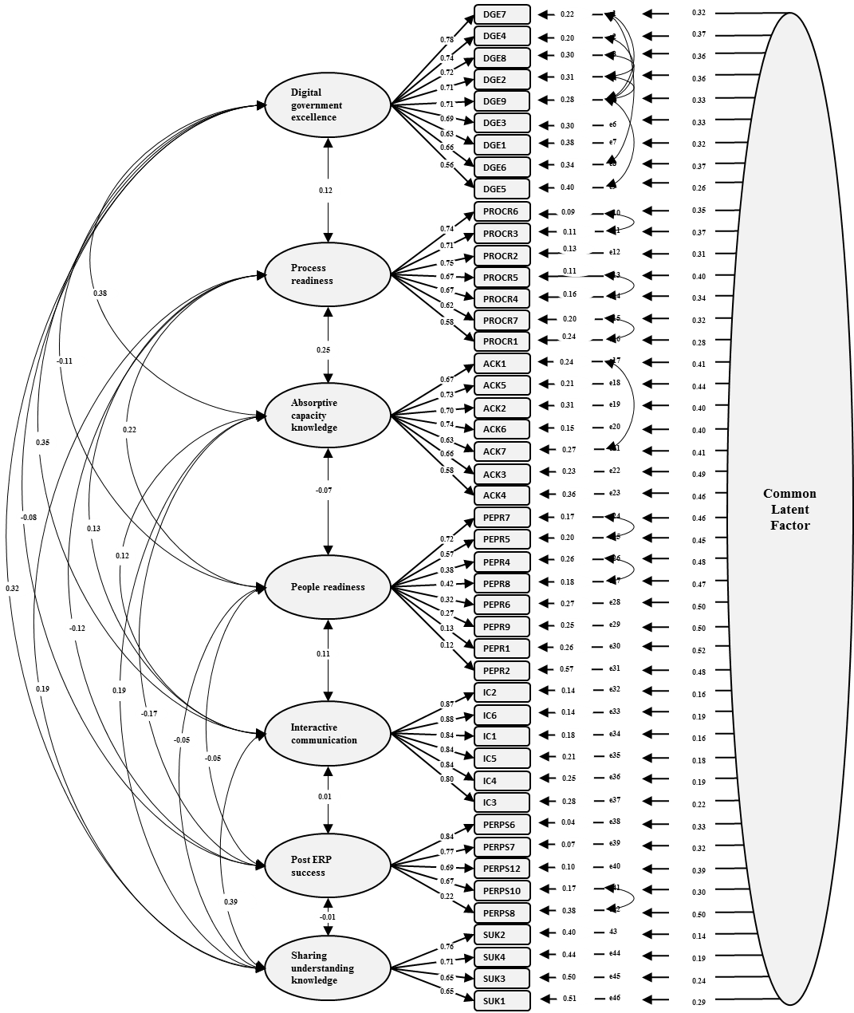

Figure 7. The Measurement Model with CLF for Digital Government Excellence
$χ^{2}$ = 1394 | TLI = 0.961 | CFI = 0.966
CMIN/df = 1.55 | NFI = 0.909 | RMSEA = 0.037

4.2.10 Structural Equation Model (SEM) and Hypotheses Testing
After analyzing the proposed model using CFA, the structural model and hypothesized relationships were assessed (see Table 15). An examination of the path model shows excellent goodness-of-fit for the second-order model for the overall traits of ERP post-implementation success and digital government excellence(Figure 8). Figure 9 shows the estimated coefficients. The remainder of this section is devoted to testing the hypotheses.

Table 15. Path Model Fit Indices
Goodness-of-Fit Indices | Value
χ² | 1,537
NFI | 0.841
CFI | 0.959
TLI | 0.956
CMIN/df | 1.62
RMSEA | 0.04

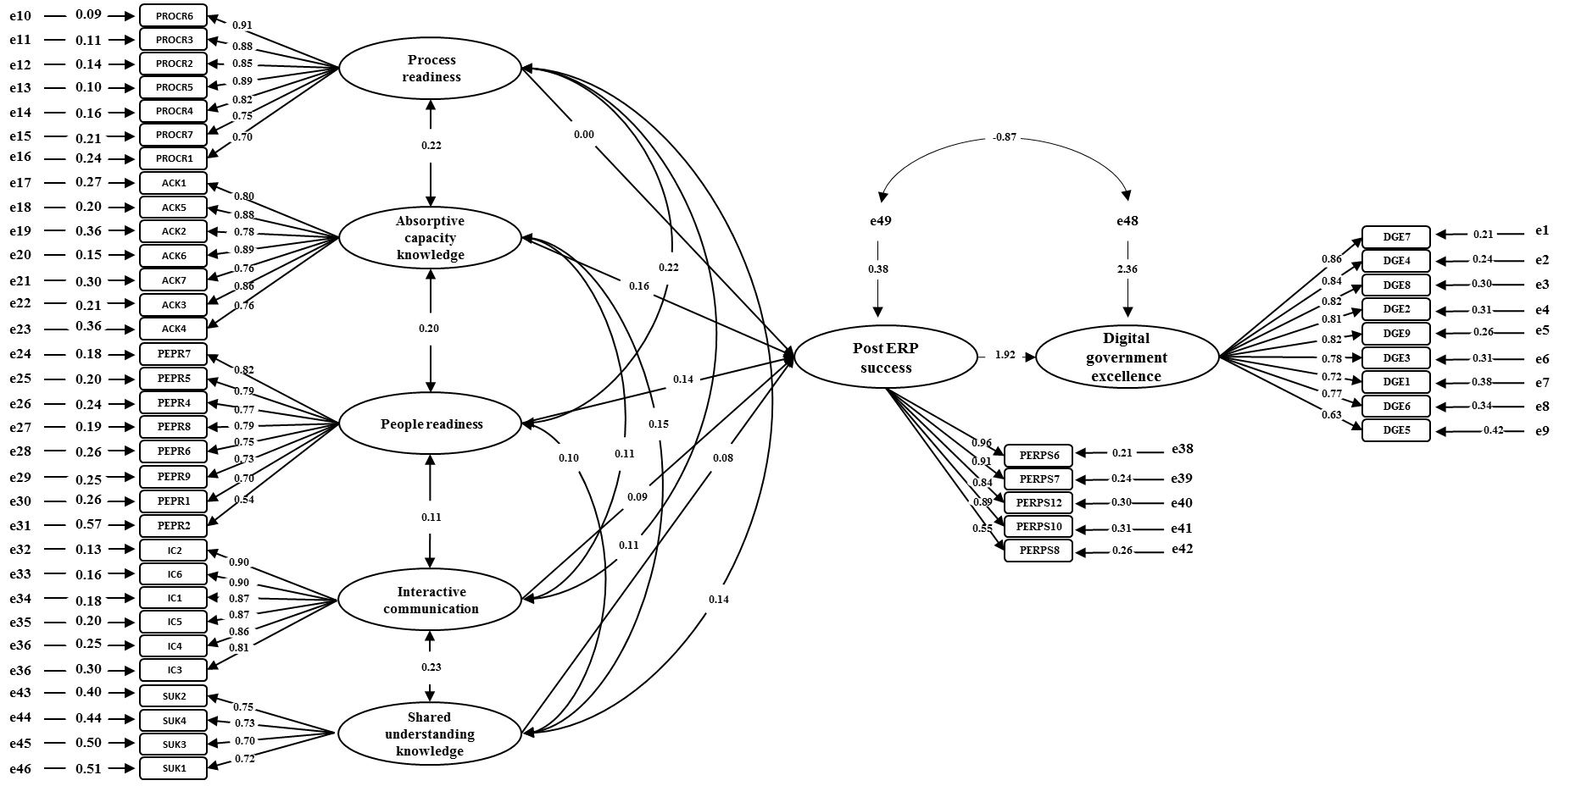
Figure 8. Second-Order Path Model for ERP Post-Implementation Success and Digital Government Excellence
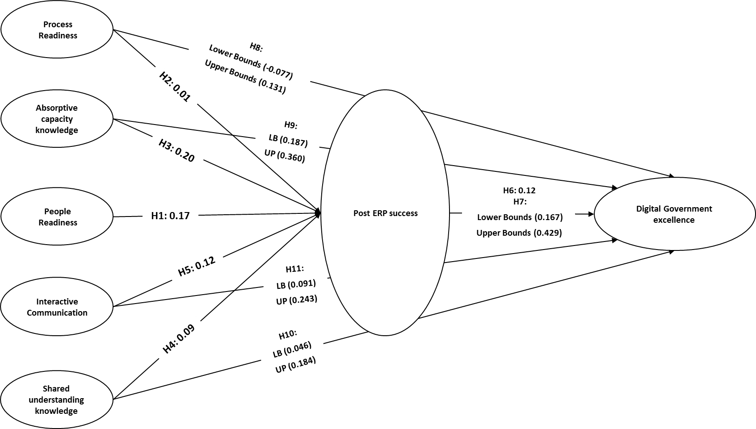
Figure 9. Estimated Coefficients

Table 16 shows the hypotheses tests based on estimated coefficient values for the hypothesized relations.
Table 16. Hypotheses Testing Results of the Structural Model.
Hypothesis | Result
H1 | Supported
H2 | Not supported
H3 | Supported
H4 | Supported
H5 | Supported
H6 | Supported
H7 | Supported
H8 | Not supported
H9 | Supported
H10 | Supported
H11 | Supported
H12 | Supported
H13 | Partially Supported

H1 (People readiness has a significant positive effect on ERP post-implementation success). Figure 10 shows that the research model supports this relationship. It had a standardized coefficient of 0.17 and was significant at the 0.01 level. That means the people readiness has a significant positive direct effect on ERP post-implementation success and can explain 17% of the variance in ERP post-implementation success.
H2 (Process readiness has a significant positive effect on ERP post-implementation success). Figure 11 shows that the research model does not support this relationship as it had a very low standardized coefficient value (0.01), and the p-value was not significant (0.74). That means process readiness does not have a significant positive effect on ERP post-implementation success.
H3 (Absorptive capacity has a significant positive effect on ERP post-implementation success). Figure 12 shows that this relationship is supported by the research model at a significance level of 0.001 and a score of 0.20 for the standardized coefficient. Absorptive capacity, therefore, has a significant positive effect on ERP post-implementation success and can explain 20% of the variance.

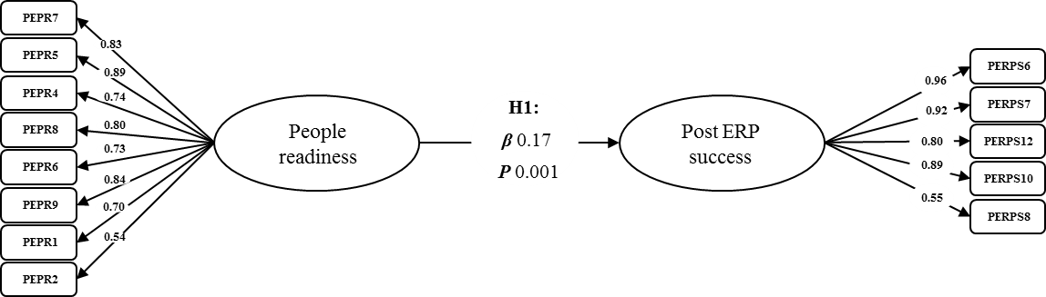

Figure 10. People Readiness and ERP Post-Implementation Success (H1)

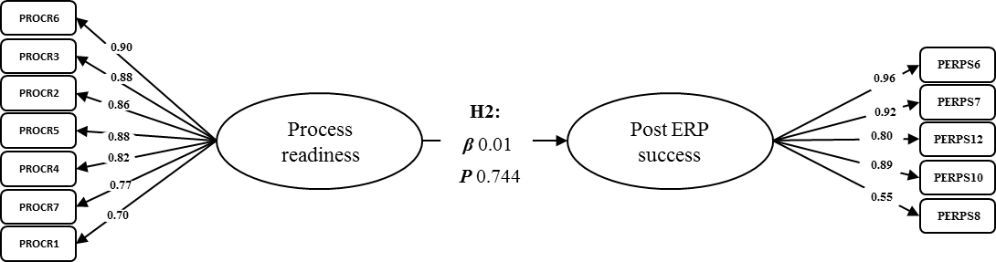

Figure 11. Process Readiness and ERP Post-Implementation Success (H2)

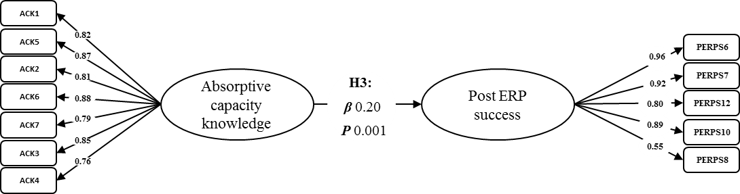
Figure 12. Absorptive Capacity and ERP Post-Implementation Success (H3)

H4 (Shared understanding has a significant positive effect on ERP post-implementation success). Figure 13 shows that this relationship is supported by the research model at a significance level of 0.002 and a score of 0.09 for the standardized coefficient for shared understanding. Therefore, it has a significant positive relationship with ERP post-implementation success and can explain 9% of the variance.
H5 (Interactive communication has a significant positive effect on ERP post-implementation success). Figure 14 shows that this relationship is supported by the research model at a significance level of 0.001 and a score of 0.12 for the standardized coefficient for interactive communication. Therefore, it has a significant positive relationship with ERP post-implementation success and can explain 12% of the variance.
H6 (ERP post-implementation success has significant positive effect on digital government excellence). Figure 15 shows that this relationship is supported by the research model at a significance level of 0.001 and a score of 0.12 for the standardized coefficient for ERP post-implementation success. Therefore, it has a significant positive effect on digital government excellence and can explain 12% of the variance.

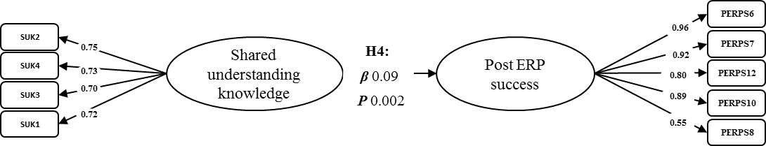

Figure 13. Shared Understanding and ERP Post-Implementation Success (H4)

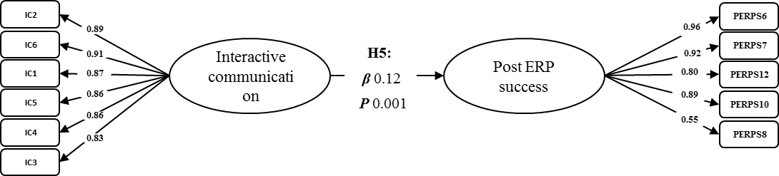
Figure 14. Interactive Communication and ERP Post-Implementation Success (H5)

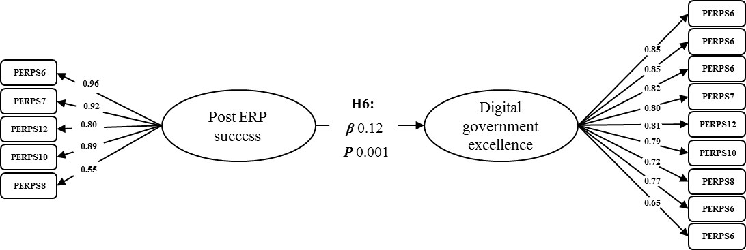
Figure 15. ERP Post-Implementation Success and digital Government Excellence (H6)

H7 (ERP post-implementation success mediates the positive effect of people readiness on digital government excellence). To test the mediation effects, the bootstrap method was used. Bootstrapping is an advanced statistical method for testing hypotheses about mediation effects that provides more accurate tests (Levy et al., 2011). The concept of mediated or indirect effects has been used previously in the technology context (Yu et al, 2012). Figure 16 shows that the indirect relationship of people readiness on digital government excellence through ERP post-implementation success was significant. The lower bound and upper bound intervals of the indirect effect ranged from 0.167 to 0.004. Zero does not fall between the lower bound and the upper. Therefore, the indirect effect is statistically significant, and people readiness has a positive effect on digital government excellence when the mediating effect of ERP post-implementation success is controlled.
H8 (ERP post-implementation success mediates the positive effect of process readiness on digital government excellence). Figure 17 shows that the indirect relationship of process readiness on digital government excellence through ERP post-implementation success was not significant. The lower bound and upper bound intervals of the indirect effect ranged from –0.077 to 0.133. Zero falls between the lower bound and the upper. Therefore, the indirect effect is not statistically significant, and process readiness does not affect digital government excellence when the mediating effect of ERP post-implementation success is controlled.

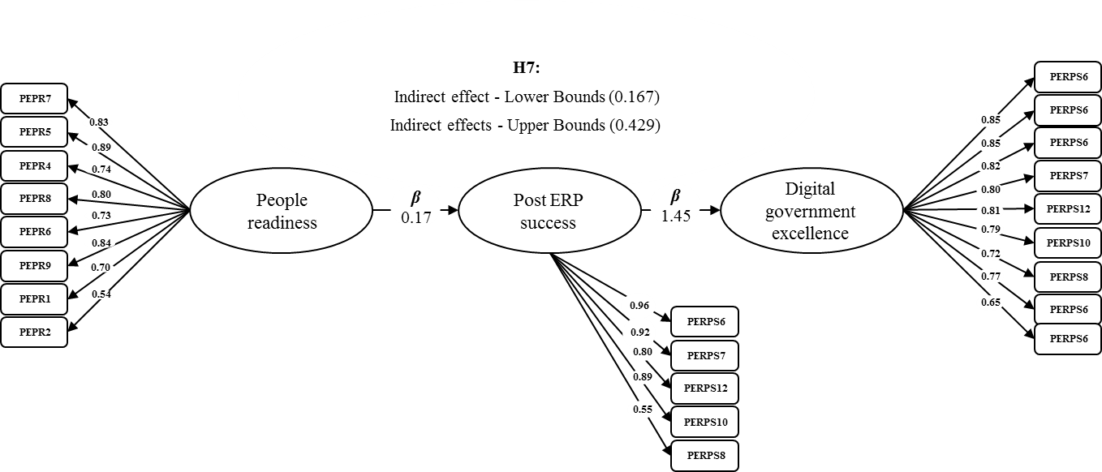
Figure 16. ERP Post-Implementation Success Mediation Effect for People Readiness on Digital Governance Excellence (H7)

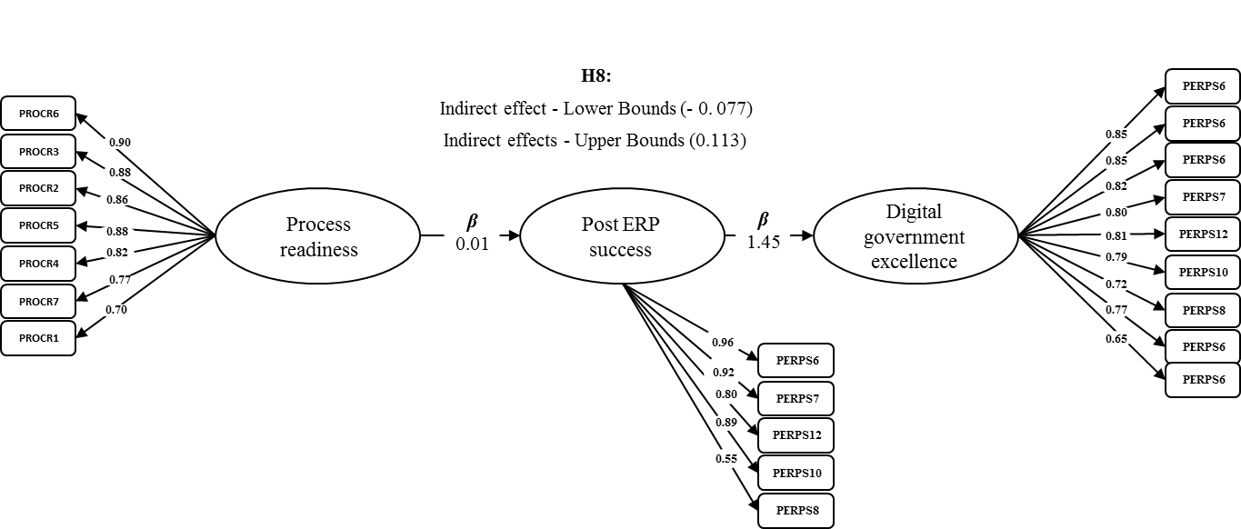

Figure 17. ERP Post-Implementation Success Mediation Effect for Process Readiness on Digital Government Excellence (H8)

H9 (ERP post-implementation success mediates the positive effect of absorptive capacity on digital government excellence). Figure 18 shows that the indirect relationship of absorptive capacity on digital government excellence through ERP post-implementation success was significant. The lower bound and upper bound intervals of the indirect effect ranged from 0.187 to 0.360. Zero does not fall between the lower bound and the upper. Therefore, the indirect effect is statistically significant, and absorptive capacity has a positive effect on digital government excellence when the mediating effect of ERP post-implementation success is controlled.
H10 (ERP post-implementation success mediates the positive effect of shared understanding on digital government excellence). Figure 19 shows that the indirect relationship of shared understanding on digital government excellence through ERP post-implementation success was significant. The lower bound and upper bound intervals of the indirect effect ranged from 0.046 to 0.184. Zero does not fall between the lower bound and the upper. Therefore, the indirect effect is statistically significant, and shared understanding has a positive effect on digital government excellence when the mediating effect of ERP post-implementation success is controlled.

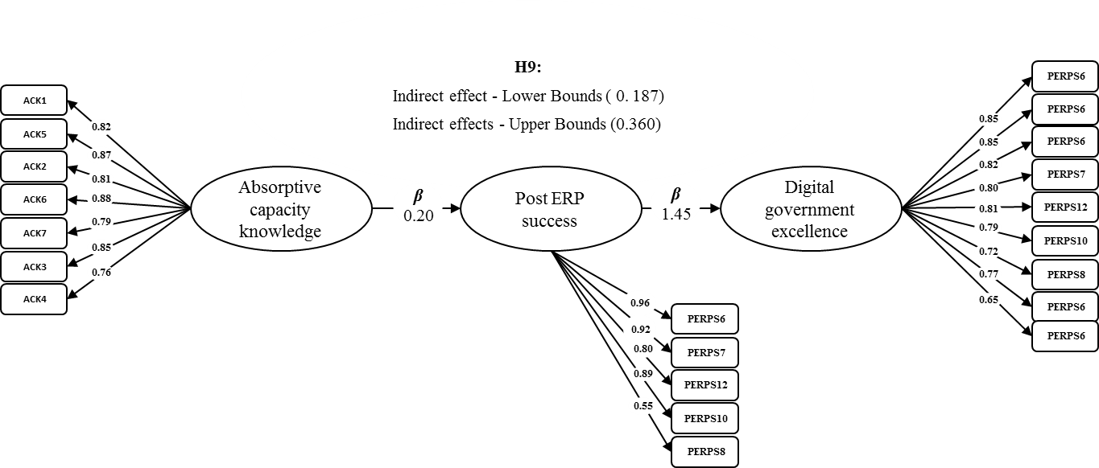

Figure 18. ERP Post-Implementation Success Mediation Effect for Absorptive Capacity on Digital Government Excellence (H9)

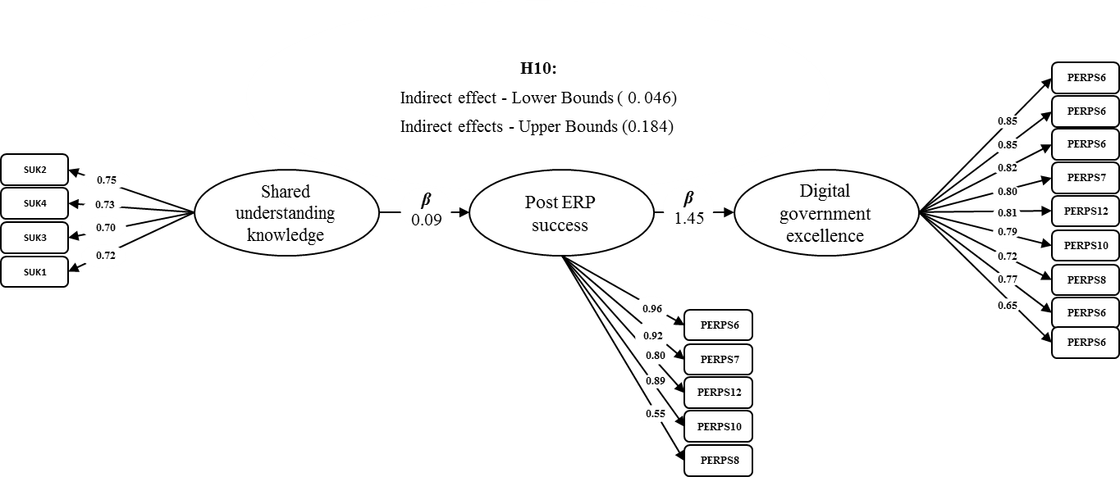
Figure 19. ERP Post-Implementation Success Mediation Effect for Shared Understanding on Digital Government Excellence (H10)

H11 (ERP post-implementation success mediates the positive effect of interactive communication on digital government excellence). Figure 20 shows that the indirect relationship of interactive communication on digital government excellence through ERP post-implementation success was significant. The lower bound and upper bound intervals of the indirect effect ranged from 0.091 to 0.243. Zero does not fall between the lower bound and the upper. Therefore, the indirect effect is statistically significant, and interactive communication has a positive effect on digital government excellence when the mediating effect of ERP post-implementation success in controlled.
H12 (Involvement in systems implementation moderates the relationship between ERP post-implementation success and digital government excellence). Involvement in ERP systems implementation was investigated as a moderator to assess the extent to which the relationship between ERP post-implementation success and digital government excellence would be strengthened or weakened as a result of the involvement in ERP implementation. The dataset for the moderation was presented as two set of values: (1) for those employees who were involved in the systems implementation, and (2) for those who were not involved. To achieve this, multi-group analysis in Amos 25 was conducted. The results of the multi-group analysis is presented in Table 17.

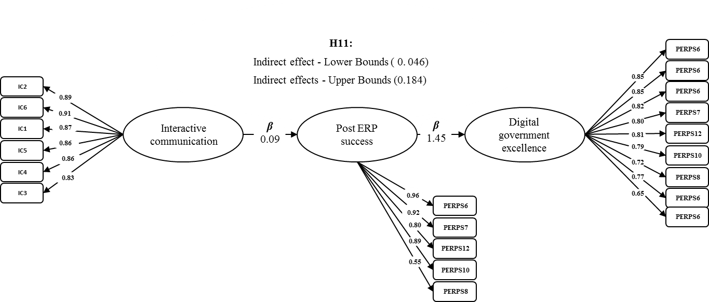
Figure 20. ERP Post-Implementation Success Mediation Effect for Shared Understanding on Digital Government Excellence (H11)

Table 17. Multi-Group Analyses (ERP Systems Involvement) (H12)
Path | Involved (β) | Not involved (β) | Difference (β) | p-Value | Interpretation
PERPS → DGE | 1.830*** | 4.410 | –2.580 | 0.027 | The positive relationship between DGE and PERPS is stronger for “Involved”
Notes: *** p < 0.001. PERPS = ERP post-implementation success; DGE = Digital government excellence.

As illustrated in Table 17, ERP post-implementation success is significantly and positively affects digital government excellence only for those who are involved in the systems implementation. This means that the relationship between ERP post-implementation success and digital government excellence is strengthened as a result of involvement in systems implementation. Therefore, it can be concluded that involvement in the ERP implementation is considered a moderator, supporting H12.
H13 (Experience in the government sector moderates the relationship between ERP post-implementation success and digital government excellence). Experience in the government sector was investigated as a moderator to assess the extent to which the relationship between ERP post-implementation success and digital government excellence would be strengthened or weakened due to ERP experience in the government sector. Experience in the government sector was measured by the number of years of service in government. Four groups of employees were categorized according to the years of experience [1–5 years (group 1), 6–10 years (group 2), 11–20 years (group 3), and above 20 years (group 4)]. To achieve this, multi-group analysis in Amos 25 was conducted. However, due to the small size of groups 1 and 4 (50 and 39 employees, respectively), multi-group analysis was run only for the differences between groups 1 and 2 and groups 2 and 3. Although Table 18 illustrates that the positive relationship between ERP post-implementation success and digital government excellence was stronger for group 2 (6–10 years), the p-value was 0.083 and not significant at the 95% confidence level. This result was supported when investigating the moderating effect between groups 3 and 4, since there was no significant difference between the two groups (see Table 19). From these results, it can be concluded that experience in government is not considered a moderating between ERP post-implementation success and digital government excellence, rejecting H13.

Table 18. Multi-Group Analysis: Experience (1–5 Years vs. 6–10 Years)
Path | 1–5 Years (β) | 6–10 Years (β) | Difference (β) | p-Value | Interpretation
PERPS → DGE | 5.017 | 1.712*** | 3.305 | 0.083 | The positive relationship between DGE and PERPS is stronger for 6–10 years
Notes: *** p < 0.001. PERPS = ERP post-implementation success; DGE = Digital government excellence.

Table 19. Multi-Group Analysis: Experience (6–10 Years vs. 11–20 Years)
Path | 6–10 Years (β) | 11–20 Years (β) | Difference (β) | p-Value | Interpretation
PERPS → DGE | 1.712*** | 1.347*** | 0.364 | 0.584 | There is no difference
Notes: *** p < 0.001. PERPS = ERP post-implementation success; DGE = Digital government excellence.

4.3 Summary
This chapter has set out how the advanced statistical techniques of SEM and multivariate analysis were used to test the research hypotheses. The results showed that most hypotheses were supported. Four factors (people readiness, absorptive capacity, shared understanding, and interactive communication) were found to have a significant positive effect on ERP post-implementation success. Process readiness had no significant impact on ERP post-implementation success. ERP post-implementation success was also found to mediate the relationship between four factors (specifically people readiness, absorptive capacity, shared understanding, and interactive communications) and digital government excellence. However, ERP post-implementation success was not found to mediate the relationship between process readiness and digital government excellence. This chapter also presented the mediation effect of employee involvement and ERP users’ government experience on the link between ERP post-implementation success and digital government excellence, showing that involvement in systems implementation moderates the relationship between ERP post-implementation success and digital government excellence but that experience in government does not.

CHAPTER 5: DISCUSSION

5.1 Introduction
This study aimed to understand how government authorities improve their ERP usage in the post-implementation phase in driving digital government excellence. This last chapter discusses the findings concerning ERP post-implementation success in driving digital excellence. The chapter concludes by summarizing the findings and its contributions and aims to discuss the data analysis results and relate them to previous studies. Also, new tentative arguments and proposals are put forward within the UAE context. After conducting the statistical analysis detailed in the previous chapter, the data analysis identified four factors that directly influence the success of ERP post-implementation success and government excellence: people readiness; absorptive capacity; interactive communication; and shared understanding. Therefore, this chapter provides more insight into the importance of ERP post-implementation activities, such as ongoing training programs, system implementation approaches, continuous system enhancement, IT structure and environment, and digital- and knowledge-management strategies to increase digital government excellence. Also, this chapter shows that management practices in different areas such as communications, knowledge, and investment in people are both essential are interrelated. Therefore, this study suggests that these factors should be considered as managerial strategies in the digital era in driving ERP post-implementation success to drive digital government excellence.
Finally, this study reveals the complex relationships between ERP post-implementation activities and digital government excellence. It provides a better understanding of digital government success by including multiple factors driving ERP post-implementation and theorizes on their interrelationships. It also provides theoretical and practical implications.

5.2 Demographic Data
In total, 382 questionnaires were considered complete and valid. Based on educational descriptive analysis, 9.2% of respondents were aged 21–25 years, 18.3% were aged 26–30, 19.4% were aged 31–35, 28.8% were aged 36–40, 18.1% were aged 41-45, and 6.3% were 46–50. The high number of respondents from three groups (31–45) is because of the experience and seniority of the targeted employees. The analysis also showed that 90.3% of respondents held a graduate and post-graduate degree, and that 9.7% had an undergraduate degree. This is due to the high level of education needed in government positions in most government sectors in the UAE. Around 9.4% held doctorates, and 9.7% held either a college or high school diplomas; this low percentage was expected since top managers and very junior employees were excluded from this study as senior management and junior positions are often not involved in the day-to-day system operation.

5.3 People readiness, ERP Post-Implementation Success, and Digital Government Excellence
The results of this study support the positive relationship between people readiness, ERP post-implementation success, and digital government excellence, in line with Zhu et al. (2010), Mohamad et al. (2019), and Federici (2009). Several different variables were identified that might affect, and thus can be used to measure, the critical success and failure of ERP identified: (1) leadership; (2) the IT working environment and supportive management; (3) highly skilled IT application teams; (4) good implementation partners; (5) system users’ involvement in gathering requirements; and (6) effective IT service desks to provide high-quality and efficient services. These variables together will have an impact on ERP post-implementation success, which in turn will have a positive effect on digital government excellence. It is crucial to establish people’s performance indicators that can support the feasibility of organizational readiness (Garg & Garg, 2014; Zabjek et al., 2009). Organizational and people readiness play an active role in leading ERP post-implementation projects.
The significant relationship between people readiness and ERP post-implementation success, which drives digital government excellence, is also consistent with the conclusion drawn by Clark (2016) that people are always associated with technology success. Therefore, this study firmly asserts that people are the greatest resource and the best investment that can be made. By investing in people, we invest in our future (Mayor, 2013) and this will reflect positively on technology. Previously, finalizing ERP implementation or digital government implementation has been viewed as the ultimate goal, yet ongoing improvements in ERP systems are not limited to the implementation phases (Worrell, 2008). Previous studies have illustrated the importance of ERP users’ involvement during system implementation (Ewout & Per 2018; Mohamad et al., 2019; Mukkamala, 2013), and the lack of user involvement has even been identified as the main factor that leads to major failures. The investigation of people readiness in relation to ERP post-implementation success promises a significant contribution to driving digital government excellence, more successful implementation, and more effective continuous operation in digital government.
The findings also support previous research that has reported the business benefits achievable through investing in people (Orte & González, 2016) when the context of investing in people is examined. At present, the aim of investing in people aim is to achieve excellence through human capital management, meeting the strategic development goals. It is noteworthy that investment in people can be applied regardless of the size or the type of organization (Orte & González, 2016). Therefore, achieving excellence is a journey, and investing in people is a culture that the company should consider. The findings from the present study introduce the essence of ERP in the digital government as a tool for the integration of back-end government functions. This study has the potential to help demonstrate ERP post-implementation activities and digital government integration in action to practitioners, providing an example of how to enhance digital government excellence and conduct better assessments of ERP post-implementation in the digital government environment by checking people readiness and investing more in employees.
Research on organizational change has suggested that people and technology aspects should be addressed; Lim (2006) reported that organizational transformation can occur through individual changes in relation to remaining competitive. Keeping government authorities competitive and future-ready will require governments to tackle current people-readiness challenges, make use of new opportunities for growth, and optimize the scope for digitalization. To achieve this, people readiness is a key issue that needs addressing in relation to ERP post-implementation success and digital government excellence. Therefore, remain competitive in digital government excellence needs scalable learning and the development of entirely new skills for employees. People readiness plays an active role in leading ERP post-implementation projects in the digital environment.

5.4 Absorptive Capacity, ERP post-implementation success, and Digital Government Excellence
The study examined the influence of absorptive capacity on ERP outcomes and success at the user level in the digital government context. The concept of absorptive capacity has been interpreted in the light of people’s capabilities in government authorities who are using ERP systems. Other researchers have suggested focusing on the absorptive capacity of the firm will shed more light on how to use ERP and make it successful (Haro-Domínguez et al., 2007). Unlike the results for people readiness, absorptive capacity was the most important and closely related factor for ERP post-implementation success in relation to digital government excellence. This study measured absorptive capacity in terms of understanding the technological needs, the vision of what the systems are trying to achieve, and understanding of organizational goals of the implemented systems, which are all considered organizational absorptive-capacity indicators that can be used to measure the critical success and failure of ERP post-implementation success, which leads to driving digital government excellence.
These findings are consistent with previous studies. Shih-Wei et al. (2013), for example, addressed ERP knowledge-based activities and found that ERP success was influenced by ERP knowledge factors acquired in the ERP implementation phase. Specifically, their study considered that absorptive capacity represents one’s ability to listen and understand; the present study confirms this in the ERP post-implementation phase in the digital government context. Shih-Wei at al.’s (2013) research focused on knowledge factors that facilitate knowledge transfer from ERP vendors to clients and vice versa. In contrast, this study used the same factor to emphasize the extent to which individuals ERP users can decode and encode messages between IT and system business users, which in turn enables the transfer of knowledge. The aim of the knowledge factor, in terms of absorptive capacity, is to facilitate knowledge flow and sharing between IT and employees of government authorities using the ERP systems.
Absorptive capacity was also found to significantly affect digital government excellence. This finding was expected and consistent with previous studies that have proved that innovation is an essential component of the excellence and reported that individuals’ engagement in open-innovation practices are explained not only by individuals’ motivations but also by their abilities to absorb knowledge (Lichtenthaler, 2016; Merrill, 2018). This finding is also in line with the Lowik et al. (2017) in that the absorptive capacity factor is essential to capture value from new knowledge sources. Previous studies have also adopted the concept of absorptive capacity, which refers to a firm’s ability to explore, retain, and exploit knowledge, and it has become one of the most influential concepts in organizational-theory literature. Therefore, absorptive capacity is essential to use and apply the transferred knowledge to increase individuals’ absorptive capacity. This study adds further insight regarding the concept of absorptive capacity in the context of government employees’ ability to explore, retain, and exploit technology knowledge.
This is consistent with the work of Lichtenthaler (2016), who found that prior related knowledge is critical to benefiting from external technological knowledge and developed a proposition concerning the effects of absorptive capacity on technology orientation. Absorptive capacity refers not only to the acquisition of information in the technology field by an organization but also to the organization’s ability to exploit this information (Haro-Domínguez et al., 2007). In this study, absorptive capacity in relation to decisions about ERP post-implementation knowledge acquisitions influences both external and internal acquisition types of knowledge positively.

5.5 Interactive Communication, ERP Post-Implementation Success, and Digital Government Excellence
The study found that there was a positive effect of interactive communication on ERP post-implementation success as a signiﬁcant dimension, indicating that achieving ERP post-implementation success relies heavily on interactive communication. This result confirms the results of Mohamad et al. (2019), Arthur (2016), and Fryling (2010). Effective communication strategy, as reported by Arthur (2016), includes multiple ways of keeping the team members informed of developments related to the ERP implementation project. The same can be applied in the context of ERP post-implementation in the digital government environment. Effective communication is a common critical thread in an ERP system (Arthur, 2016; Livermore & Rippa, 2010).
Qian et al. (2015) reported the same in the context of the pre-implementation phase, i.e. robust communication is a critical factor in the implementation process. Therefore, increased communication effectiveness between each ERP team and their government authority employees, in addition to the interactions among other government authorities, will improve strategic decision making for each government authority as well as digital government in its entirety. This kind of communication will reflect positively on digital government excellence. This is also in line with the results of Mohamad et al. (2019), Pei-Hung et al. (2016), Barki et al. (2008), and Liu et al. (2011), which indicated the importance of user participation and communication in ERP implementation as one of the most effective ways of delivering success in the ERP post-implementation phase. Furthermore, these findings show that interactive communication increases the ERP team’s ability to predict and understand factors related to ERP post-implementation success.
Through communication and system users’ participation, users feel they have a greater influence on the development of process and their systems. Therefore, ERP post-implementation success is not possible without continuous communication activities involving the formal or informal exchanges of facts, business needs, users’ opinions, visions, and concerns regarding the ERP system. Therefore, technology and digital government leaders must provide system users with opportunities to make their own system needs and desires known to other key actors in the digital government context. Digital government leaders should listen to other government authorities and discuss each party’s concerns about the system and its impacts on digital government, which confirms the results of the previous studies in the ERP context (but not in the digital government context) (Barki et al., 2008; Mohamad et al., 2019; Pei-Hung, et al., 2016). It is reasonable to expect that, when system users are given incrementally more attention regarding their needs through communication and hands-on activities, such as designing data-input screens and involvement in testing the system’s interface, then their overall level of satisfaction and the success of ERP post-implementation will increase.
The current findings indicate that, overall, ERP post-implementation activities (e.g. communicating the expected outcomes of ERP post-implementation projects to upper management in advance, communicating expected outcomes among workers within departments, proficiency in communication among departments, making IT–business communication as easy as possible, collaboration between IT and employees, and good staff relationships across departments) also contribute to ERP post-implementation success. All these factors combined will lead to an increase in digital government excellence. As noted by Barki et al. (2008), such activities are typically assigned to a small number of user representatives. To expand communication between all concerned in all government authorities, and to create a sense of responsibility in a more significant number of users, this study proposes seeking additional development activities that lead to a sense of responsibility. In short, active and the meaningful communication and participation of users in ERP post-implementation development and implementation processes are likely to enhance their feelings of control, knowledge, and self-investing, which are the roots of ERP post-implementation success and digital government excellence.
The study confirms that the relationship, interactions, and interactive communication between IT staff and system users likewise affect the outcome of the ERP systems and digital government excellence. Digital government authorities should have interactive communication channels and dedicated resources in each government authority that works closely with other authorities to understand the entire journey both from the customer and citizen perspective to control and support digital government authorities. The digital government authorities should establish an interactive communication plan for all authorities and ensure that the interactive communications plan is carefully monitored and assessed. Furthermore, it is necessary to set up a detailed communication plan with a clear vision, objectives, processes, and deliverables with measurable results. Finally, the digital government authorities should communicate all aspects of the project to all government authorities, including required resource enhancements and a road map both for ERP post-implementation and digital government projects.

5.6 Shared Understanding, ERP Post-Implementation Success, and Digital Government Excellence
The aim of shared understanding as a knowledge factor of ERP post-implementation success is to facilitate knowledge flow and sharing between ERP users and their IT support functions in the digital environment context. It is defined as the extent to which the problem-solving approaches, norms, and experience based on system and prior work are similar (Shih-Wei et al., 2013). The analysis showed that there was a positive relationship between shared understanding and ERP post-implementation success as a signiﬁcant dimension, indicating that achieving ERP post-implementation success relies heavily on shared understanding. This study identified shared understanding among all employees in different areas (e.g. the importance of the business’s priorities, a common language between business and IT, the business processes, and comprehensive users’ training programs). These are all considered organizational shared understanding indicators that measure the critical aspects of the success or failure of ERP post-implementation, which leads to driving digital government excellence.
These implications are consistent with prior work, which has found that initial organizational fit can play a crucial role in ERP success and can persist through the system implementation cycle (Shih-Wei et al., 2013; Wang et al., 2006). Extending these findings, this research suggests that leveraging government authorities and their IT function support to have shared understanding may help increase the positive impact on ERP post-implementation success which in turn drives digital movement excellence. Both ERP system users and government authorities play a crucial role in having a common ground of shared knowledge, specifically with the help of the ERP users’ shared understanding and favorable relationships between the ERP users and the other government authorities. Thus, this study reveals how the establishment of a shared understanding of the ERP post-implementation activities can support and promote digital government excellence.
Previous studies have reported shared understanding as a critical factor influencing knowledge transfer in the ERP context (Dong-Gil et al., 2005; Shih-Wei et al., 2013), although not in the digital government context. Shih-Wei et al. (2013), for example, discussed how shared understanding focuses on leveraging knowledge in ERP knowledge transfer. The present research confirms that shared understanding among ERP users and problem-solving approaches in different government authorities will promote excellence in digital government. The findings of this research also highlight the need for a more participatory process between all government authorities in the development of digital government strategies. All government authorities’ engagement in strategy development should be reflected in a shared vision that will help promote digital government excellence. By setting a shared understanding of a shared vision and common objectives of ERP post-implementation systems and digital government, this strategy becomes a tool that supports ERP post-implementation success in promoting digital government excellence.

5.7 Process Readiness, ERP Post-Implementation Success, and Digital Government Excellence
Organizational processes are defined as “the way things are done in government, its routines of current practice and learning” (Hwang, 2011, p. 23). The results of this study show that this relationship is not supported by the research model in ERP post-implementation and the digital government context. Although the zero correlation coefficient indicates no strength of the relation between two variables (Hair et al., 2010), it does not imply that there is no relationship at all; it means that there is no linear relationship between the factors. Nevertheless, according to the findings of the results, process readiness does not have a significant positive correlation with ERP post-implementation success. The indirect relationship of process readiness on digital government excellence through ERP post-implementation was not significant, and process readiness did not affect digital government excellence when the mediating role of ERP post-implementation success was controlled. Arthur (2016) explained in his study “Successful enterprise resource planning system implementation” how people engaged in the adoption of an ERP system experience changes such as the redesigning of business processes. This can lead to a possible change in the perception of ERP users in the ERP post-implementation phase in the digital government context, taking in to account the massive and increasing development of new technologies in the digital environment. Business processes should be able to run effectively in the real world, which gives users and government authorities more control over processes and helps them make faster, more effective decisions. To do this, it is suggested that government authorities should produce predictive analytics and actionable insights on their business processes and introduce new solutions for all future issues.
The findings of the study contradict some of the previous literature. Therefore, it is mandatory to discuss these discrepancies and offer some speculation regarding reconciling them. Roach (2015), in his research in the medical field, addressed this concern about conflicting results, which is extremely common. Nash (2009) agreed that study design and methodology play a critical role in evaluating study findings. Conflicting studies often prompt researchers to do follow-up and conduct further studies. Nash (2009) also highlighted that contradictory studies based on experience with respondents are common. Longinidis and Gotzamani (2009), in their case study in a single organization and a single technology context, indicated that the main component of ERP user satisfaction was pre-implementation processes. In another study in the construction context, Goulding and Lou (2013) claimed that process, along with five core enablers deemed priority areas for organization operationalization, were key. The study was restricted, however, to the construction field. The theoretical framework developed by Hwang (2011) considered business processes as a unique organizational capability that provides better business efficiency and effectiveness and creates a firm’s competitive advantage over its competitors. The study was conducted in the manufacturing-industry context to measure drivers of ERP implementation and the impact of ERP on organizational capabilities. The difference in Hwang’s study is that all respondents were from managerial levels, and none of them were ERP system users. This confirms the finding of Nash (2009), who reported that study design and methodology play a critical role in evaluating study findings.
Given these results, the present study opens the door for future research to review several matters related to business-process readiness measures, including how business processes are documented, the method of testing business processes, to what extent compatibility and alignment between business needs and organizational processes s required, alignment between ERP user needs and organizational processes, and how organizational processes changes can be accommodated in the system. These results require careful consideration of the maturity of ERP systems, as the results show a difference concerning two main points, namely (1) the nature of the people who answered the questionnaire, and (2) whether the ERP system is in the implementation phase or the post-implementation phase. In general, the literature on dynamic capabilities focuses on process dimensions to integrate and reconfigure an organization’s structure (Hwang, 2011). Other literature focused has on BPR, which is a prerequisite to implementing ERP and refers to the degree to which a firm designs its processes and day-to-day workflows as a means to achieving the strategic objectives, increasing efficiency, improving quality, reducing costs, and generating greater customer satisfaction (Hakim et al., 2016; Tigkiropoulos et al.,2009).
The research findings regarding process readiness are in line with Kony’s (2014) research, although it addressed mobile applications rather than ERP applications. The study claimed that companies found that most mobile apps failed because of a lack of user adoption caused by poor design and experience, and that the majority of application implementations did not fail due to technology or processes, but due to the lack of adoption by users within the organization. The digital lifestyle has gained momentum, and it has disrupted established businesses. Kodak, for example, invented the digital camera but did not grasp how quickly the world was changing; the processes were fine, and their systems were up and running. Therefore, the nature of new technology is changing drastically, and a fundamentally different system design concept is needed, one that suits the nature of the evolving technology infrastructure. This study’s results are in line with those of Bernard (2017), which related to cloud platform environments. Bernard (2017) stated that the nature of the technology is changing drastically, and that technology drives business models in the modern world. Therefore, business models should respond to technology changes, not the other way around. Kingery (2016) also reported that the new technology is driving business models.

5.8 Moderation of ERP User’s Involvement in the Relationship Between ERP Post-Implementation Success and Digital Government Excellence
Multi-group analysis was used to assess the moderating role of users’ involvement in systems implementation. The main question addressed in the multi-group analysis for the moderator “user’s involvement” was this: does users’ involvement moderate the relations specified in the model? The study showed that ERP post-implementation success in relation to driving digital government excellence was stronger when the ERP system users were involved in the system implementation phase of ERP.
Some researchers have previously suggested that the participation of ERP system users in the implementation phase will always strengthen the continued success of ERP post-implementation (e.g. Ji-Tsung & Marakas, 2006). Similarly, Barki et al. (2008) reported that the participation of users in ERP implementation was one of the most powerful determinants for ensuring the successful delivery of ERP implementation. The ERP users develop feelings of ownership for the system when they participate in the implementation journey of ERP; these interactions of the individual users transform the ERP system functionalities and create great success in ERP phase (Barki et al., 2008; Liu et al., 2011). Previous studies have focused on ERP implementation only, however, rather than on ERP post-implementation in the digital government context.
The conclusions drawn from this study provide new insight into these relationships, but in the context of the ERP post-implementation phase and digital government. The findings, therefore, justify the importance of users’ involvement in the initial implementation phase. Establishing a training program for all employees, or new starters, will help tackle this issue. Lack of personalized training is one of the primary reasons for dissatisfaction and system failure (Alghamdi, 2018; Parthasarathy et al., 2016).

5.9 Moderation of ERP users’ government experience in the relationship between ERP Post-Implementation Success and Digital Government Excellence
Multi-group analysis was used to examine the differences between employees’ experience. Due to the small sample per groups 1 and 4, the multi-group analysis completed the comparison only for two groups (1–5 vs. 6–11 years and 6–10 vs. 11–200 years). The analysis showed no significant difference at the 95% confidence level between groups of employees based on their years of experience in the government. Therefore, years of experience was not considered as a moderator. This result contradicts the previous literature, which has emphasized the importance of the experience of system users in relation to improvement and innovation (Beck et al., 2019). Two reasons can be posited for this finding: (1) the small sample size per group of employees, which inhibited conducting the comparisons for all groups; and (2) experience in government does relate exactly to the experience of being involved in the system implementation.
In summary, notwithstanding the distinct differences in results for the role of post ERP practices, the results indicate that these practices do, in fact, influence the digital government excellence. Therefore, Linking the front-end digital government citizens’ interface and back-end enterprise systems (ERPs) is needed to transform the way the government interacts with the citizens and introduce a new integrated platform (Ziemba et al., 2016). Despite the wide recognition of enterprise systems, limited data are available in the literature to support and validate the link. The study results provided insights into the nature of the capabilities and practices required to create value from Post ERP systems and those required to sustain it over a longer period in the digital government environment. The significant relationship between Post enterprise system practices and digital government excellence highlights the importance of post-implementation practices to achieve digital government excellence. This is consistent with the study of Choudrie et al., (2017), which examined the organisational issues of implementing an enterprise system within the context of e-Services project. Findings revealed that ERP implementation practices were a key readiness factor that negatively impacted e-services project implementation efforts due to conflicts of employee's cross-cultural differences.
The majority of studies reported in ERP and digital government literature have focused on two aspects separately. The first aspect is studying the success of e-government by measuring citizens’ satisfaction. The other aspect relates to measuring the success of the ERP back-end system from the point of view of employees, without the presence of any link or relationship between the government ERP back-end systems and digital government excellence. For example, (Alawneh et al., 2013; Sipior et al., 2011; Stefanovic et al., 2016; Sánchez-Torres et al., 2017; Sultan et al., 2012; Standish Group, 2014; Kharabe, 2012; Klinger, 2011; Bachman, 2010; Miranda & Kavanagh,2005; Motwani & Sharma, 2016; Bradley & Lee, 2007; Deng et al., 2018; Glowalla & Sunyaev, 2014).
This research analyzed the issues and challenges that may influence ERP post-implementation practices in a digital government context by looking at the effect of ERP post-implementation factors on digital government excellence. The findings of this research will be significant for governments in terms of improving public services to their citizens through one integrated digital government platform and enterprise system. Focusing on the integration of ERP post-implementation practices and the digital government will assist governments’ cost-cutting through understanding the link between ERP post-implementation and digital government and how ERP-post implantation practices can make or break digital government excellence. This study has the potential to help demonstrate ERP post-implementation and digital government integration in action to practitioners and provide an example of how ERP post-implementation practices are essential for digital government excellence.
The gaps in the current literature reveal a lack of research linking ERP practices and digital government excellence, indicating that the current research contributes significantly to empirical investigations related to the impact of ERP post-implementation activities on digital government excellence. The Post ERP success's construct used in this study refers to the required knowledge, ongoing support, and interactive communication practices to adapt a successful ERP post-implementation in the digital government context. The significant relationship between Post ERP practices and digital government excellence implies that the way in which governmental employees interact with and use an ERP system determines the value that the government derives from an ERP system to support digital government excellence. This finding is important because it provides insight into how digital government excellence can be enhanced by encouraging ERP users to continues seeking the required knowledge, ongoing support, and interactive communication.
The significant challenges facing governments today is how to leverage their existing resources and assets (Jain, 2008). There are already substantial investments made by governments on software and hardware platforms. But even so, integrating all of those enterprise systems still represent a big challenge and can be a long term process (Vrabie, 2009). the other major challenge of e-government implementation is the high failure of e-government due to digital culture and human resources (Meiyanti et al., (2018). The failure rate is very high, and the literature estimates that from more than 40 e-government implementation projects in developing and transitional countries, 50% partially failed, and 35% were total failures (Meiyanti et al., (2018). This study will open new horizons in the perspective of failure and success of digital government away from the causes of failure that have been reported in previous studies such as software and hardware. The study proves the failure of digital governments from a new perspective and is the perspective of digital government employees. Therefore, Governments must pay attention and focus on these challenges to ensure the successful implementation of digital government.
In the context of enterprise systems and digital government excellence, it means that governments first have to understand what leads to post-implementation success and how to keep things running as smoothly as possible. Practices in Communication, knowledge, ongoing support are essential for a government’s operations to run smoothly. Once enterprise systems have been deployed successfully, governments need to move beyond implementation issues. In other words, governments should pay attention to the drivers of post ERP success and its impacts on digital government excellence. Second, governments have to understand the significant moderating effect of ERP user’s experience and their involvement in system implementation on the relationship between ERP post-implementation success and digital government excellence.
Digital government excellence is a journey and very daunting and requires adopting new practices. However, the digital government implementation process itself can, at times, take the focus away from the role of other factors (such as the required knowledge, ongoing support, and interactive communication practices in influencing the value that digital government systems bring to a government. In the presence of a lower capability to understand the link between Post ERP practices and digital government excellence, it is unlikely that ERP functions will enhance government excellence. In fact, past gains in ERP value may be eroded due to a focus primarily on citizen portals without paying attention to government employees and their enterprise systems.
The statistically significant nature of all three key Post-ERP practices (required knowledge, ongoing support, and interactive communication) in influencing digital government excellence suggests an exciting finding. It highlights the need to focus not only on technical and managerial capabilities associated with enterprise systems but also on users’ practices in the post ERP phase to leverage ERP systems. The other findings in this study are associated with capabilities related to sustained Post ERP value as proven that Post-ERP value will have a significant relationship with digital government excellence. The study results demonstrate significant moderating effects of user involvement on the relationship between Post-ERP success and digital government excellence. However, the moderating effect of system experience was not found to be statistically significant.
These results form an exciting finding because they are partially contrary to the hypothesized relationships. The results also provide a fascinating insight into the nature of Post ERP practices influence on sustained digital government excellence. It means that any changes in Post ERP practices to support digital government excellence may, in fact, cause disruption in the value obtained from enterprise systems, leading to lower sustained digital government excellence. However, this needs to be investigated further in order to fully conceptualize the role of post ERP practices in supporting digital government excellence.

5.10 Summary
This chapter has discussed the study’s results regarding the impact of ERP post-implementation practices on digital government excellence in the digital government context. The results identified the determinants of ERP post-implementation success that contribute to digital government excellence in the UAE government; the result reveal that ERP post-implementation practices do have a positive impact on digital government excellence.

CHAPTER 6: CONCLUSIONS, IMPLICATIONS, LIMITATIONS, AND FUTURE RESEARCH

6.1 Introduction
This chapter aims to explain the implications of the research results in two aspects: theoretical implications and contributions to the body of knowledge; and how the findings can be employed in practice, i.e. practical implications for decision makers in digital government. The implications drawn from the research findings can be used to achieve better results in developing digital government policies, including service delivery models, citizens, government employees, and overall digital government excellence. This chapter also sets out the current research limitations and provides recommendations for future research.

6.2 Limitations and Barriers
As new services and features enabled by the digital revolution continue to be added to digital government and digital services, triggered by increasing demand for new services and emerging technology, government leadership continues its journey towards digital government. A one-time study of technologies and digital government phenomena is insufficient (Park, 2007). Therefore, continued research studies are needed to examine the new technologies, the progress, and the effectiveness of governments in delivering digital services to the public, facilitating citizens’ participation, and supporting government employees in their day-to-day needs. Since the digital government encompasses various types of digital services for citizens, with different abilities and rights, it faces multiple issues in providing digital services. Examples of the issues include human interventions related to receiving and processing citizens’ requests in the context of digital services based on people readiness, shared understanding, absorptive capacity, and interactive communication. These types of unique determinants and situations are specific and large enough to demand separate research. Although the study has addressed digital government services at some level of specificity, it is still mainly focused on general issues faced by digital government employees instead of service-specific issues.
According to Park (2007), many governments lack the organizational culture, fundamental infrastructure, resources, and understanding for a digital transformation. Therefore, each study is specific to its unique factors and context; for example, the instrument development for eliciting responses from this study reflected only one country and was limited to government authorities. With the globalization of digital government implementations, the research effort will need to trace the similarities and differences in the behavioral and attitudinal responses of digital government users in different countries at various levels. Specific issues need to be addressed while designing instruments for collecting data from different counties, such as the maturity of digital government in each country.
Due to the nature of conducting online surveys, this study may have a certain amount of bias in the method (online versus offline instruments), which required participants to interpret the questions for themselves and may have resulted in introducing errors into the data. Different digital government system users might view the value of the same digital government services differently. Some employees in this study may have found the government services convenient and easy to use, while other system users experienced the digital government services as overly difficult. Thus, the net value for digital government services could significantly differ from one individual to another. Further, measuring instruments are becoming more sophisticated; they evolve are not static in nature (Park, 2007). Hence, the instruments developed in this research will need to be revisited in the future as new technologies and digital services emerge.
Another potential limitation is the relatively small size of the study sample. Therefore, the sample size can be expanded in future studies. Also, the data were collected from various government authorities, such as small, medium, and large authorities, which apply different back-end technologies and ERP systems. Back-end technologies for all government authorities were assumed to have the same technologies. However, different technologies may apply to different authorities, depending on their context. Therefore, for better results, the back-end technologies of government authorities should be considered collectively in specific data analyses. The study covered government authorities only; public agencies should be included in future surveys such as insurance companies and hospitals to make the findings more generalizable. Also, all the respondents were government system users, as other players were not included in the survey. One of the fundamental limitations in this study is the small sample size of employee experiences groups (group 1 had only 50 respondents and group 4 had only 39). Amos failed to run the multi-group analysis when these two groups were included in the analysis. Therefore, it is crucial to pay attention to other groups in future research. Finally, the conclusions of this study are limited to the UAE context only and may not be generalizable to other countries.

6.3 Conclusion
This research aimed to analyze the issues and challenges that may influence ERP post- practices in a digital government context by looking at the effect of ERP post-implementation factors on digital government excellence. Based on a quantitative analysis of donation intention, it can be concluded that the findings of this research will be significant for governments in terms of improving public services to their citizens through one integrated digital government platform and enterprise systems. The results inform governments around the globe about how the Post ERP practices influence digital government excellence. This study, though, provides adequate evidence for the role of key post ERP practices required to create digital government excellence. Such practices include people’s readiness, absorptive capacity, shared understanding, and interactive communication.
This research has conceptualized the value of ERP post-implementation practices in digital government and developed instruments to measure factors that influence the success of ERP post-implementation practices and their impact on driving digital government excellence. It is an applied research study into ideas suggested by different researchers claiming that the human element of the organization is the most crucial in the digital era, and that the concept of technology plays a vital role in human societies (Coccia, 2019). This research identified several core human elements in ERP post-implementation practices that can drive digital government excellence. These values represent a real paradigm shift in the way governments view the interaction between digital government and back-end operations in the modern era of digitization. Perhaps the most interesting finding identified what determinants caused digital government to fail, taking to account the ERP post-implementation practices, including:
- Difficulty making digital transitions and changes without paying attention to the government back-end systems.
- Citizens and government employees are imperative and critical players in the digital excellence. This study examined five critical areas where governments can harness digital technologies to create better outcomes for citizens by addressing ERP system users’ concerns.
- In the age of the digital revolution, adaptability and quick decisions are the keys to survival. The findings of this study can help decision makers in government to understand their citizens and employees better and achieve better outcomes, such as provide services to citizens more effectively and efficiently, proposing and developing new solutions to strategy challenges, and developing new service delivery models.
Savoldelli et al. (2013) stated that further research is required to monitor the evolution of digital government systems and the emerging challenges from a technical and public policy perspective continuously. This is needed to satisfy the need for policymakers and to respond to the ever-increasing potential made available from citizens’ data and other stakeholders. Given the rapid development of technologies and solutions, understanding the degree of citizen and employee satisfaction becomes a critical factor for digital government. This dissertation represents an empirical study of the factors influencing of ERP post-implementation systems in relation to strengthening the technology capacity of digital government excellence. Through empirical analysis, the results have shown that organization readiness and ongoing support (i.e. people readiness), absorptive capacity, shared understanding, and interactive communication are the key factors that will affect citizens’ satisfaction and digital government excellence.
According to Yan and Du (2016), understanding the degree of consumer satisfaction becomes a critical factor for online interactions from the consumers’ perspective. This study differs from such studies by paying attention to challenges faced by government employees and using the results to increase the effectiveness of digital government. This view corresponds to the outcome of the Rotchanakitumnuai’s (2008) study, which suggested the perceived value of digital government service is linked to service quality, which consists of service design, technical support, web site design, and customer support quality. The findings of this study can be analyzed to understand the influences of these results on enhancing the results of previous studies, e.g. how these factors (people readiness, absorptive capacity, shared understanding, and interactive communication) affect service delivery.
A study by Keeney (1999) attempted to develop a sample of customer values where the customer was the citizen using e-government. The study asserted that Internet services (e-government) have the potential to offer customers better services, and that businesses must focus more on the values of their customers. This current study considered the customer as an employee working for the digital government to support citizens’ requests over via digital government channels. This study identified broad determinants necessary for the diffusion of digital government innovation initiatives that continue to be salient. This study is the first to study the causal relationships of ERP post-implementation determinants and their impacts on digital government excellence through SEM. It is also the first to identify a measure of ERP post-implementation practices in relation to the adoption of digital government. This study has attempted to help decision makers in digital government to understand the ERP post-implementation activities better from their employees’ perspective to provide services to citizens more effectively and efficiently. The findings related to ERP determinants that drive digital government excellence ranged from organization readiness and ongoing support (i.e. people readiness), absorptive capacity, shared understanding, and interactive communication. The ERP post-implementation determinants for ERP post-implementation success in driving digital government excellence for digital government services were generated from different studies (see Appendix 5.
Finally, this study provides evidence that there is a strong correlation between ERP post-implementation practices and enhancing digital government excellence. It is highly recommended that governments should pay attention to back-end system practices and the determinants driving efficient digital government efficiently. Therefore, there is an urgent need to introduce a new service delivery model for all decision makers in digital government based on these findings. The academic and practical implications of the current research can be summarized as below.

6.3.1 Academic Implications
The seven major academic implications of this research are:
- Drawing boundaries between ERP post-implementation practices and digital government excellence, as there is a lack of studies in this regard, particularly in relation to digital government interactions with back-end systems.
- No previous studies have examined the relationship between ERP post-implementation determinants and digital government excellence, together with the moderating effect of government system users’ experience. Most previous studies have focused only on the successful adoption of digital government from the citizens’ perspective.
- This study considered digital government excellence criteria from a broader perspective than other studies, i.e. from the government system users’ perspective.
- Introducing an integrated model of ERP post-implementation determinants and digital government excellence and testing the developed model in the UAE context.
- Testing the role of government system users and their involvement in the ERP post-implementation stage in the context of digital government excellence.

6.3.2 Practical Implications
The 12 major practical implications of this research are:
- Providing evidence of enhancing digital government excellence by paying attention to the back-end ERP post-implementation practices.
- Digital government authorities and their government subsidiaries can use these research findings to improve their overall digital government performance. This may be by building robust links between the digital authorities and their subsidiaries.
- Government authorities must start assessing their existing ERP post-implementation practices and then make improvements designed to achieve greater digital governance excellence.
- Government authorities should pay attention to the underlying indices and attributes for ERP post-implementation practices.
- Leaders in the digital government can use the research findings to improve citizens’ satisfaction. To do so, they should work on four particular types of ERP post-implementation determinants: people readiness; absorptive capacity; shared understanding; and interactive communication.
- Leaders in digital government should take action to encourage a team working culture across all government authorities and a feeling of shared responsibility, ensuring all government employees are working towards the same overall goals and objectives, i.e. digital government excellence.
- Leaders in the digital movement should ensure they have a clear mission to consider the ERP post-implementation operations and practices.
- Governments may also use the results to improve government employee satisfaction to promote digital government excellence. This should be based on clear and shared government authorities’ values.
- Encouraging government authorities to invest in back-end operations for digital government transformation.
- Presenting the actual ERP post-implementation determinants in driving digital government excellence from the government system users’ perspective.
- Encouraging digital government decision makers to formulate suitable strategies regarding the adoption of an ERP system and the provision of ongoing support.
- Supporting government regulations regarding the future of technology and how to enrich citizens’ lives and increase the impact of digital government by delivering innovative digital services.

6.4 Future Research
This research covered the five types of ERP post-implementation determinants in driving digital government excellence (people readiness, process readiness, absorptive capacity, shared understanding, and interactive communication). Future studies may focus on the measures and indices related to each determinant type to provide more contributions to the body of knowledge. Digital government excellence and ERP post-implementation determinant constructs were measured subjectively using an online questionnaire; future studies may instead use assessment results and apply the scores to measure digital government excellence. This assessment and scores measure may help future researches to test the association of ERP post-implementation determinants with digital government excellence.
Future studies may expand the range of target governments and include other success stories in the analysis, mainly within the region, which will produce more generalizable results. It is also recommended that future researches avoid the limitations of this research study, for example by including more control variables such as the business area of government authorities. Future studies may also utilize a longitudinal study research design that involves repeated employee observations of the same variables over time. Another suggestion for future research would be to investigate citizens’ satisfaction after adopting this research model in digital government to measure the effectiveness of the research results.
Any implications for technology lie in the nature of work, economic growth, and productivity (Park, 2007). Therefore, technology could potentially create new ideas, values, and satisfy customer needs effectively. The instrument developed in this research can be used as a measuring tool to assess this potential. This research also provided a useful list of comprehensive concepts for developing and improving digital government initiatives. To apply the research results in the practice, the objectives identified by the research instruments can be used in developing strategic plans for driving digital government excellence, and can also directly be implemented or tailored to government-specific digital services. Continued studies in the technology field are needed to assess the progress and effectiveness of digital government in delivering new services. Furthermore, a qualitative study is recommended to get more rich feedback about ERP users’ deep feelings and their perceptions about post-implementation enterprise system practices in a digital government context. The qualitative method, as reported by Alghamdi (2018) includes a focus on processes, experiences, and practices resulting in a production of broad concepts. Finally, the scale developed in this study, within its context, might need to be changed over time.

6.5 Summary
This research has theoretical implications based on the introduction of an integrated model that includes defining the relationship between ERP post-implementation success, ERP post-implementation determinants, and digital government excellence. It has also aimed to understand the role of system users’ experience regarding the adoption and implementation process of ERP post-implementation and digital government excellence. Practically, the study has confirmed that ERP post-implementation practices, and its link with the digital government, will enhance digital government excellence and introduce value for all stakeholders in digital government authorities.
The study has revealed that system users are the key to digital government and represent an essential factor in the success of digital government and in developing successful ERP post-implementation practices. This study has also addressed the two main goals of this research: (1) to conceptualize the value of ERP post-implementation in digital government; and (2) to develop new instruments to measure factors that influence ERP post-implementation success. For this research, factor analysis helped to combine the analytic and empirical components to connect theory to social phenomena (ERP post-implementation practices and digital government excellence).
As new services and features continue to be added to digital government initiatives, triggered by emerging technology and ever-increasing demand, governments continue their journey towards e-government. Therefore, continued studies are needed to examine ERP post-implementation practices and digital government excellence. To apply the research results, the objectives identified can not only be put to use at a high level, such as developing strategic plans, but can also directly be implemented or tailored to specific digital services. In addition, the new model in this research provides a foundation for developing a quantitative model of digital government excellence. Finally, it must again be acknowledged that online self-administered questionnaire is one of the limitations of this study, as is the limited number of government authorities participating.

REFERENCES

Abdinnour, S., & Saeed, K. (2015). User perceptions towards an ERP system. Journal of Enterprise Information Management, 28(2), 243-259. Retrieved from http://adezproxy.adu.ac.ae/docview/1652625782?accountid=26149

Abdolvand, N., Albadvi, A., & Ferdowsi, Z. (2008). Assessing readiness for business process reengineering. Business Process Management Journal, 14(4), 497-511.https://doi.org/10.1108/14637150810888046

Abdul Rahman, M., Zamri, S., & Eu, L. (2017). International Journal of Academic Research in Business and Social Sciences. International Journal of Academic Research in Business and Social Sciences. doi:10.6007/IJARBSS/v7-i4/2915

Abdullah, N. A. S., Mohd Noor, N. L., & Mior Ibrahim, E. N. (2016). Contributing factors to E-government service disruptions. Transforming Government: People, Process and Policy, 10(1), 120-138. doi:http://dx.doi.org.adu-lib-database.idm.oclc.org/10.1108/TG-10-2014-0045

Abdullah, N. A. S., Mohd Noor, N. L., & Mior Ibrahim, E. N. (2016). Contributing factors to E-government service disruptions. Transforming Government: People, Process and Policy, 10(1), 120-138. doi:http://dx.doi.org.adu-lib-database.idm.oclc.org/10.1108/TG-10-2014-0045

Abu Dhabi Government, 2019. Abu Dhabi Government Entities. [Online] Available at: https://www.tamm.abudhabi/en/abu-dhabi-government-entities[Accessed 30 1 2019].
Ahmad, N., & Mehmood, R. (2015). Enterprise systems: Are we ready for future sustainable cities. Supply Chain Management, 20(3), 264-283. Retrieved from http://adezproxy.adu.ac.ae/docview/1676541013?accountid=26149

Akers, E. J. (2006). A study of the adoption of digital government technology as public policy innovation in the american states (Order No. 3225245). Available from ProQuest Central. (305360820). Retrieved from http://adezproxy.adu.ac.ae/docview/305360820?accountid=26149

Akkermans, H., & K van Helden (2002). Vicious and virtuous cycles in ERP implementation: A case study of interrelations between critical success factors.European Journal of Information Systems, 11(1), 35-46. doi:http://dx.doi.org.adu-lib-database.idm.oclc.org/10.1057/palgrave.ejis.3000418
Akter, S., Wamba, S. F., Gunasekaran, A., Dubey, R., & Childe, S. J. (2016). How to improve firm performance using big data analytics capability and business strategy alignment? International Journal of Production Economics, 182, 113. Retrieved from http://adezproxy.adu.ac.ae/docview/1837891136?accountid=26149

Aladalah, M., Cheung, Y., & Lee, V. (2015). Enabling citizen participation in gov 2.0: An empowerment perspective. Electronic Journal of E-Government, 13(2), 77-93. Retrieved from http://adezproxy.adu.ac.ae/docview/1759902089?accountid=26149

Aladwani, A. M. (2001). Change management strategies for successful ERP implementation. Business Process Management Journal, 7(3), 266-275. Retrieved from http://adezproxy.adu.ac.ae/docview/220316653?accountid=26149

Alawneh, A., Al-Refai, H., & Batiha, K. (2013). Measuring user satisfaction from e-Government services:. elsevier. Retrieved 2018, from https://www-sciencedirect-com.adu-lib-database.idm.oclc.org/science/article/pii/S0740624X13000361

Alenezi, H., Tarhini, A., & Sharma, S. K. (2015). Development of quantitative model to investigate the strategic relationship between information quality and e-government benefits. Transforming Government: People, Process and Policy, 9(3), 324-351. doi:http://dx.doi.org.adu-lib-database.idm.oclc.org/10.1108/TG-01-2015-0004

Alghamdi, M. (2018). Success factors of implementing enterprise resource planning systems in north american organizations (Order No. 10933348). Available from ProQuest Central; ProQuest Dissertations & Theses Global: The Humanities and Social Sciences
Collection. (2116175977). Retrieved from http://adu-lib-database.idm.oclc.org/login?url=https://search-proquest-com.adu-lib-database.idm.oclc.org/docview/2116175977?accountid=26149

Alhirz, H., & Sajeev, A. S. M. (2015). Do cultural dimensions differentiate ERP acceptance? A study in the context of saudi arabia. Information Technology & People, 28(1), 163-194. doi:http://dx.doi.org.adu-lib-database.idm.oclc.org/10.1108/ITP-07-2013-0127

Alkhawaldah, A., Zan, Z. M., & Melan, M. (2017). The factors affecting information communication technology towards EGovernment: Evidence from the jordanian public organizations. International Journal of Economic Perspectives, 11(2), 347-358. Retrieved from http://adezproxy.adu.ac.ae/docview/2038227065?accountid=26149

Al-Khouri, Ali M. (2012). eGovenment strategies: The case of the United Arab Emirates (UAE). European Journal of ePractice, 17, 126-150. Retrieved from

Allen, T. (2011). Improve your business processes for ERP efficiency. Strategic Finance, 92(11), 54-59. Retrieved from http://adezproxy.adu.ac.ae/docview/866747987?accountid=26149
Almalki, O., Duan, Y., & Frommholz, I. (2012). An exploratory study on eGovernment systems success in saudi arabia. Paper presented at the 38-XII. Retrieved from http://adezproxy.adu.ac.ae/docview/1328337862?accountid=26149

Almalki, O., Duan, Y., & Frommholz, I. (2013). Developing a conceptual framework to evaluate e-government portals' success. Kidmore End: Academic Conferences International Limited. Retrieved from http://adezproxy.adu.ac.ae/docview/1400450798?accountid=26149

Al-Mashari, M. (2002). Enterprise resource planning (ERP) systems: A research agenda. Industrial Management & Data Systems, 102(3), 165-170. doi:http://dx.doi.org.adu-lib-database.idm.oclc.org/10.1108/02635570210421354

Al-Mashari, M., Al-Mudimigh, A., & Zairi, M. (2003). Enterprise resource planning: A taxonomy of critical factors. European Journal of Operational Research, 146(2), 352-364. Retrieved from http://adezproxy.adu.ac.ae/docview/204196596?accountid=26149

Almishal, A., & Almashari, M. A. (2015, 11 2). Implementing ERP Systems in Government: Case Study of Saudi Organization. doi:10.7763/LNSE.2015.V3.177.

Al-Shafi, S. (2009). Factors affecting e-government implementation and adoption in the state of qatar (Order No. U507301). Available from ProQuest Dissertations & Theses Global: The Humanities and Social Sciences Collection. (898787212). Retrieved from http://adezproxy.adu.ac.ae/docview/898787212?accountid=26149

Al-Shamlan, H., & Al-Mudimigh, A. (2011). The chang management strategies and processes for successful ERP implementation: A case study of MADAR.International Journal of Computer Science Issues (IJCSI), 8(2), 399-407. Retrieved from http://adezproxy.adu.ac.ae/docview/921425955?accountid=26149

Alsous, M., Alhalaiqa, F., Rana, A. F., Mariam, A. J., McElnay, J., & Horne, R. (2017). Reliability and validity of arabic translation of medication adherence report scale (MARS) and beliefs about medication questionnaire (BMQ)–specific for use in children and their parents. PLoS One, 12(2) doi:http://dx.doi.org.adu-lib-database.idm.oclc.org/10.1371/journal.pone.0171863

Althonayan, M., & Althonayan, A. (2017). E-government system evaluation.Transforming Government: People, Process and Policy, 11(3), 306-342. Retrieved from http://adezproxy.adu.ac.ae/docview/1954348864?accountid=26149

Althonayan, M., & Althonayan, A. (2017). E-government system evaluation.Transforming Government: People, Process and Policy, 11(3), 306-342. Retrieved from http://adezproxy.adu.ac.ae/docview/1954348864?accountid=26149
Althonayan, M., & Althonayan, A. (2017). E-government system evaluation.Transforming Government: People, Process and Policy, 11(3), 306-342. Retrieved from http://adezproxy.adu.ac.ae/docview/1954348864?accountid=26149

Altman, D. G. (1980). Statistics and ethics in medical research. collecting and screening data. British Medical Journal, 281(6252), 1399. doi:http://dx.doi.org.adu-lib-database.idm.oclc.org/10.1136/bmj.281.6252.1399

Amatayakul, M. (2005). EHR? assess readiness first. Healthcare Financial Management, 59(5), 112-3. Retrieved from http://adezproxy.adu.ac.ae/docview/196373162?accountid=26149

Amoretti, F., & Musella, F. (2011). Toward the european administrative space: The role of e-government policy. European Political Science Review : EPSR, 3(1), 35-51. doi:http://dx.doi.org.adu-lib-database.idm.oclc.org/10.1017/S1755773910000263

Anderson, J. C., & Gerbing, D. W. (1982). Some methods for respecifying measurement models to obtain unidimensional construct measurement. JMR, Journal of Marketing Research (Pre-1986), 19(000004), 453. Retrieved from http://adezproxy.adu.ac.ae/docview/208834238?accountid=26149

Annamalai, C., & Ramayah, T. (2011). Enterprise resource planning (ERP) benefits survey of indian manufacturing firms. Business Process Management Journal, 17(3), 495-509. doi:http://dx.doi.org.adu-lib-database.idm.oclc.org/10.1108/14637151111136388

Annamalai, C., & Ramayah, T. (2011). Enterprise resource planning (ERP) benefits survey of indian manufacturing firms. Business Process Management Journal, 17(3), 495-509. doi:http://dx.doi.org.adu-lib-database.idm.oclc.org/10.1108/14637151111136388

Anwar, M., Esichaikul, V., Rehman, M., & Anjum, M. (2016). E-government services evaluation from citizen satisfaction perspective. Transforming Government: People, Process and Policy, 10(1), 139-167. doi:http://dx.doi.org.adu-lib-database.idm.oclc.org/10.1108/TG-03-2015-0017

Anwar, M., Esichaikul, V., Rehman, M., & Anjum, M. (2016). E-government services evaluation from citizen satisfaction perspective. Transforming Government: People, Process and Policy, 10(1), 139-167. doi:http://dx.doi.org.adu-lib-database.idm.oclc.org/10.1108/TG-03-2015-0017

Arabian Business Global. (2019, 4 18). UAE's GDP forecast to grow to $460bn in 2019. Retrieved 12 30, 2019, from arabianbusiness.com: https://www.arabianbusiness.com/politics-economics/418088-uaes-gdp-forecast-to-grow-to-460bn-in-2019

Arthur, E. A. (2016). Successful enterprise resource planning system implementation: A higher educational managerial perspective (Order No. 10243473). Available from ProQuest Central. (1844988606). Retrieved from http://adezproxy.adu.ac.ae/docview/1844988606?accountid=26149

Ashtiani, A., Afzali, S., Ebadi, A., & Hassanabadi, H. (2018). Design and assessment of psychometric features of life skills inventory. Journal of Education and Health Promotion, 7(1), 86. doi:http://dx.doi.org.adu-lib-database.idm.oclc.org/10.4103/jehp.jehp_41_15
Asogwa, B. E. (2013). Electronic government as a paradigm shift for efficient public services. Library Hi Tech, 31(1), 141-159. doi:http://dx.doi.org.adu-lib-database.idm.oclc.org/10.1108/07378831311303985

Avgousti, K. (2013). RESEARCH PHILOSOPHY, METHODOLOGY, QUANTITATIVE AND QUALITATIVE METHODS. The Cyprus Journal of Sciences, 11, 33-43. Retrieved from http://adezproxy.adu.ac.ae/docview/1516144410?accountid=26149

Avram, C. D., Zota, R. D., & Ciovica, L. (2012). Developing an ERP strategy based on the IT solution life cycle. Academy of Economic Studies.Economy Informatics, 12(1), 26-41. Retrieved from http://adezproxy.adu.ac.ae/docview/1069255716?accountid=26149

Azzahra, M., Ayuningtias, H. G., Anggadwita, G., & Nurbaiti, A. (2019). The effect of work discipline on employees' performance of PT wiratanu persada tama jakarta. Review of Integrative Business and Economics Research, 8, 136-144. Retrieved from http://adezproxy.adu.ac.ae/docview/2113234966?accountid=26149

Babakus, E., & Mangold, W. G. (1992). Adapting the SERVQUAL scale to hospital services: An empirical investigation. Health Services Research, 26(6), 767. Retrieved from http://adu-lib-database.idm.oclc.org/login?url=https://search-proquest-com.adu-lib-database.idm.oclc.org/docview/211718506?accountid=26149

Babu, T. K. S., & Dalal, S. S. (2006). ERP implementation issues in SMEs: 'microsoft great plains' implementation in a BPO organization. South Asian Journal of Management, 13(1), 61-75. Retrieved from http://adezproxy.adu.ac.ae/docview/222724750?accountid=26149

Bachman, C. A. (2010). Private and public sector enterprise resource planning system post-implementation practices: A comparative mixed method investigation (Order No. 3413133). Available from ProQuest Central; ProQuest Dissertations & Theses Global: The Humanities and Social Sciences Collection. (746606208). Retrieved from http://adezproxy.adu.ac.ae/docview/746606208?accountid=26149

Baharon, B. M., Yap, C. S., Ashar, S. F. E., Hanafi, M. H. H. M., & Hazmi, M. S. R. M. (2017). Citizen satisfaction with E-government portals in malaysia.International Journal of Business and Information, 12(3), 289-309. doi:http://dx.doi.org.adu-lib-database.idm.oclc.org/10.6702/ijbi.2017.12.3.3

Balaban, I., Mu , E., & Divjak, B. (2012). Development of an electronic Portfolio system success model: An information systems approach. Computers & Education, . Retrieved , from https://www-sciencedirect-com.adu-lib-database.idm.oclc.org/science/article/pii/S036013151200173X

Baller, S., Dutta, S., & Lanvin, B. (2016). The Global Information Technology Report (p. 254). World Economic Forum. Retrieved from http://www3.weforum.org/docs/GITR2016/WEF_GITR_Full_Report.pdf?bcsi_scan_a07a6598c0a22d03=0&bcsi_scan_filename=WEF_GITR_Full_Report.pdf
Barker, T., & Frolick, M. N. (2003). Erp Implementation Failure: A Case Study. Information Systems Management, 20(4), 43–49. https://doi-org.adu-lib-database.idm.oclc.org/10.1201/1078/43647.20.4.20030901/77292.7

Barki, H., Paré, G., & Sicotte, C. (2008). Linking IT implementation and acceptance via the construct of psychological ownership of information technology. Journal of Information Technology, 23(4), 269-280. doi:http://dx.doi.org.adezproxy.adu.ac.ae/10.1057/jit.2008.12

Bartholomew, D. (2003). ERP learning to be lean. Industry Week, 252(7), 19. Retrieved from http://adezproxy.adu.ac.ae/docview/219740737?accountid=26149

Basias, N., & Pollalis, Y. (2018). Quantitative and qualitative research in business & technology: Justifying a suitable research methodology. Review of Integrative Business and Economics Research, 7, 91-105. Retrieved from http://adezproxy.adu.ac.ae/docview/1969776018?accountid=26149

Baykasoğlu Adil, & Gölcük İlker. (2020). Comprehensive fuzzy FMEA model: A case study of ERP implementation risks. Operational Research, 20(2), 795-826. doi:http://dx.doi.org.adu-lib-database.idm.oclc.org/10.1007/s12351-017-0338-1
Beck, D., Jung, J., Park, J., & Park, W. (2019). A study on user experience of automotive HUD systems: Contexts of information use and user-perceived design improvement points. International Journal of Human - Computer Interaction, 35(20), 1936-1946. doi:http://dx.doi.org.adu-lib-database.idm.oclc.org/10.1080/10447318.2019.1587857

Beheshti, H. M., & Beheshti, C. M. (2010). Improving productivity and firm performance with enterprise resource planning. Enterprise Information Systems, 4(4), 445-472.https://doi.org/10.1080/17517575.2010.511276
Bernard, Ray,P.S.P., C.H.S.-I.,II. (2017, 02). Technology transformation and your business model. Security Dealer & Integrator, 39, 26-28. Retrieved from http://adezproxy.adu.ac.ae/docview/1866507441?accountid=26149

Bilandi, R. R., PhD., Farahamni, F. K., PhD., Ahmadi, F., PhD., Kazemnejad, A., PhD., Mohamadi, R., M.D., & Amiri, M., M.Sc. (2015). Psychometric properties of the iranian version of modified RHAQWRA questionnaire. Journal of Family & Reproductive Health, 9(4), 184-192. Retrieved from http://adezproxy.adu.ac.ae/docview/1779956592?accountid=26149
Bobay, K. L. (2003). Relationships among the hypothesized components leading to complex reflective thinking in emergency nursing practice (Order No. 3106020). Available from ProQuest Central. (288344153). Retrieved from http://adezproxy.adu.ac.ae/docview/288344153?accountid=26149

Bokhari, R. H. (2005). The relationship between system usage and user satisfaction: A meta-analysis. Journal of Enterprise Information Management, 18(1), 211-234. doi:http://dx.doi.org.adu-lib-database.idm.oclc.org/10.1108/17410390510579927

Bolarinwa, O. (2015). Principles and methods of validity and reliability testing of questionnaires used in social and health science researches. The Nigerian Postgraduate Medical Journal, 22(4) doi:http://dx.doi.org.adu-lib-database.idm.oclc.org/10.4103/1117-1936.173959
Booth, P., Matolcsy, Z., & Wieder, B. (2000). The impacts of enterprise resource planning systems on accounting practice--the australian experience.Australian Accounting Review, 10(3), 4-18. Retrieved from http://adezproxy.adu.ac.ae/docview/217575911?accountid=26149

Bowonder, B., Mastakar, N., & Sharma, K. J. (2005). Innovative ICT platforms: The indian experience. International Journal of Services Technology and Management, 6(3-5), 225-240. Retrieved from http://adezproxy.adu.ac.ae/docview/219270366?accountid=26149

Bradley, J. (2008). Management based critical success factors in the implementation of enterprise resource planning systems. International Journal of Accounting Information Systems, 9(3), 175-200. Retrieved from http://adezproxy.adu.ac.ae/docview/217187028?accountid=26149

Bradt, Joke,PhD., M.T.-B.C., Burns, Debra S,PhD., M.T.-B.C., & Creswell, J. W., PhD. (2013). Mixed methods research in music therapy research. Journal of Music Therapy, 50(2), 123-48. Retrieved from http://adezproxy.adu.ac.ae/docview/1403485335?accountid=26149

Brown, R. W. (2006). Implementation of enterprise information systems: A comparative study of enterprise application integration (EAI) vs enterprise resource planning (ERP) (Order No. 3221216). Available from ProQuest Central. (304903078). Retrieved from http://adezproxy.adu.ac.ae/docview/304903078?accountid=26149

Brown, T., 2015. Confirmatory factor analysis for applied research, 2nd edition (2015). . Beaverton: Ringgold Inc. Retrieved from http://adezproxy.adu.ac.ae/docview/1669970937?accountid=26149

Burnes, B. (2004). Kurt lewin and complexity theories: Back to the future? Journal of Change Management, 4(4), 309-325. Retrieved from http://adezproxy.adu.ac.ae/docview/194790857?accountid=26149

Butt, M. (2014). Result-oriented e-government evaluation: Citizen's perspective.Webology, 11(2), 1-33. Retrieved from http://adezproxy.adu.ac.ae/docview/1664260287?accountid=26149

Capaldo, G., & Rippa, P. (2009). A planned-oriented approach for EPR implementation strategy selection. Journal of Enterprise Information Management, 22(6), 642-659. doi:http://dx.doi.org.adu-lib-database.idm.oclc.org/10.1108/17410390910999567

Carter, S. R. (2016). Using confirmatory factor analysis to manage discriminant validity issues in social pharmacy research. International Journal of Clinical Pharmacy, 38(3), 731-737. doi:http://dx.doi.org.adu-lib-database.idm.oclc.org/10.1007/s11096-016-0302-9

Chaabouni, A., & Yahia, I. B. (2014). Contribution of ERP to the decision-making process through knowledge management. Journal of Decision Systems, 23(3), 303-317. Retrieved from http://adezproxy.adu.ac.ae/docview/1626833522?accountid=26149

Chan, F. K. Y., Thong, J. Y. L., Venkatesh, V., Brown, S. A., Hu, P. J., & Tam, K. Y. (2010). Modeling citizen satisfaction with mandatory adoption of an E-government technology. Journal of the Association for Information Systems, 11(10), 519-549. Retrieved from http://adezproxy.adu.ac.ae/docview/763329984?accountid=26149

Chand, D., Hachey, G., Hunton, J., Owhoso, V., & Vasudevan, S. (2005). A balanced scorecard based framework for assessing the straegic impacts of ERP systems. Computers in Industry, 56(6), 558-572. Retrieved from http://adezproxy.adu.ac.ae/docview/235767636?accountid=26149

Chandiwana, T., & Pather, S. (2016). A citizen benefit perspective of municipal enterprise resource planning systems. Electronic Journal of Information Systems Evaluation, 19(2), 85-98. Retrieved from http://adezproxy.adu.ac.ae/docview/1792067791?accountid=26149

Chang, S., Yen, D. C., Chang, I. -., & Chou, J. (2012). Study of the digital divide evaluation model for government agencies-a taiwanese local government's perspective. Information Systems Frontiers, 14(3), 693-709. doi:http://dx.doi.org.adu-lib-database.idm.oclc.org/10.1007/s10796-011-9297-x

Chen, Y. N., Chen, H. M., Huang, W., & Ching, R. K. H. (2006). E-government strategies in developed and developing countries: An implementation framework and case study. Journal of Global Information Management, 14(1), 23-46. doi:http://dx.doi.org.adu-lib-database.idm.oclc.org/10.4018/jgim.2006010102

Chian-Son Yu. (2005). Causes influencing the effectiveness of the post-implementation ERP system. Industrial Management & Data Systems, 105(1), 115-132. doi:http://dx.doi.org.adu-lib-database.idm.oclc.org/10.1108/02635570510575225

Chin-Fu, H., Wu, W., & Yi-Ming, T. (2004). Strategies for the adaptation of ERP systems. Industrial Management & Data Systems, 104(3), 234-251. doi:http://dx.doi.org.adu-lib-database.idm.oclc.org/10.1108/02635570410525780

Chiu, C., Chiu, C., & Chang, H. (2007). Examining the integrated influence of fairness and quality on learners’ satisfaction and Web-based learning continuance intention.. Information Systems Journal, . Retrieved , from http://web.a.ebscohost.com.adu-lib-database.idm.oclc.org/ehost/detail/detail?vid=11&sid=8d6a7ec2-3610-4a5a-b3f3-abb00aebd3d1%40sessionmgr4007&bdata=JnNpdGU9ZWhvc3QtbGl2ZQ%3d%3d#AN=25317051&db=aci

Choi, M. (2016). Leadership of information security manager on the effectiveness of information systems security for secure sustainable computing. Sustainability, 8(7), 638. doi:http://dx.doi.org.adu-lib-database.idm.oclc.org/10.3390/su8070638

Choudrie, J., & Weerrakody, V. (2007). Horizontal process integration in E-government: The perspective of a UK local authority. International Journal of Electronic Government Research, 3(3), 22-39. doi:http://dx.doi.org.adu-lib-database.idm.oclc.org/10.4018/jegr.2007070102

Choudrie, J, Zamani, E.D.,Umeoji, E., Emmanuel, A. (2017). Implementing E-government in Lagos State: Understanding the impact of Cultural Perceptions and Working Practices. Global Information Quarterly, 34 (4), pp. 646-657

Clark, B. B., Robert, C., & Hampton, S. A. (2016). The technology effect: How perceptions of technology drive excessive optimism. Journal of Business and Psychology, 31(1), 87-102. doi:http://dx.doi.org.adu-lib-database.idm.oclc.org/10.1007/s10869-015-9399-4

Coccia, M. (2019). What is technology and technology change? A new conception with systemic-purposeful perspective for technology analysis. Journal of Social and Administrative Sciences, 6(3), 145-169. doi:http://dx.doi.org.adu-lib-database.idm.oclc.org/10.1453/jsas.v6i3.1957

Cole, M. S., Bedeian, A. G., & Feild, H. S. (2006). The measurement equivalence of web-based and paper-and-pencil measures of transformational leadership: A multinational test. Organizational Research Methods, 9(3), 339-368. Retrieved from http://adezproxy.adu.ac.ae/docview/195095724?accountid=26149

Congden, S. W., Desplaces, D. E., & Kim, E. B. (2005). DIFFERENCES IN DRIVERS OF ERP ADOPTION BETWEEN LARGE AND SMALL FIRMS. Journal of Business and Entrepreneurship, 17(1), 85-95. Retrieved from http://adezproxy.adu.ac.ae/docview/214232396?accountid=26149

Cordella, A., & Hesse, J. (2015). E-government in the making: An actor network perspective. Transforming Government: People, Process and Policy, 9(1), 104-125. doi:http://dx.doi.org.adu-lib-database.idm.oclc.org/10.1108/TG-02-2014-0006

Corradini, F., Polini, A., Polzonetti, A., & Re, B. (2010). Business processes verification for e-government service delivery. Information Systems Management, 27(4), 293. Retrieved from http://adezproxy.adu.ac.ae/docview/814378354?accountid=26149

Cortada, J. W. (2013). How new technologies spread: Lessons from computing technologies. Technology and Culture, 54(2), 229-261. Retrieved from http://adezproxy.adu.ac.ae/docview/1415750299?accountid=26149

DALDAL, K., & KILIÇ, S. (2014). Factors affecting mobile tagging awareness; A research on social media consumers. Journal of Economic Development, Environment and People, 3(4), 69-86. Retrieved from http://adezproxy.adu.ac.ae/docview/1660471312?accountid=26149
database.idm.oclc.org/10.3390/su10093080

Davidson, E. (2006). A technological frames perspective on information technology and organizational change. The Journal of Applied Behavioral Science, 42(1), 23-39. doi:http://dx.doi.org.adu-lib-database.idm.oclc.org/10.1177/0021886305285126

De Toni, A. F., Fornasier, A., & Nonino, F. (2015). The impact of implementation process on the perception of enterprise resource planning success. Business Process Management Journal, 21(2), 332-352. doi:http://dx.doi.org.adu-lib-database.idm.oclc.org/10.1108/BPMJ-08-2013-0114

DeLone, W. H. , & McLean, E. R. (2003). The DeLone and McLean Model of Information Systems Success: A Ten-Year Update. Database for Journal of management information systems / Spring 2003, Vol. 19, No. 4, pp. 9-30. Retrieved from http://search.ebscohost.com.adu-lib-database.idm.oclc.org/login.aspx?direct=true&db=aci&AN=9460622&site=ehost-live

Deng, H., Karunasena, K., & Xu, W. (2018). Evaluating the performance of e-government in developing countries. Internet Research, 28(1), 169-190. Retrieved from http://adezproxy.adu.ac.ae/docview/1994329046?accountid=26149
DeSimone, J. A., & Harms, P. D. (2018). Dirty data: The effects of screening respondents who provide low-quality data in survey research. Journal of Business and Psychology, 33(5), 559-577. doi:http://dx.doi.org.adu-lib-database.idm.oclc.org/10.1007/s10869-017-9514-9

Dey, P. K., Clegg, B. T., & Bennett, D. J. (2010). Managing enterprise resource planning projects. Business Process Management Journal, 16(2), 282-296. doi:http://dx.doi.org.adu-lib-database.idm.oclc.org/10.1108/14637151011035606

Dezdar, S., & Ainin, S. (2011). Examining ERP implementation success from a project environment perspective. Business Process Management Journal, 17(6), 919-939. doi:http://dx.doi.org.adu-lib-database.idm.oclc.org/10.1108/14637151111182693

Doherty, N. F., Champion, D., & Wang, L. (2010). An holistic approach to understanding the changing nature of organisational structure. Information Technology & People, 23(2), 116-135. doi:http://dx.doi.org.adu-lib-database.idm.oclc.org/10.1108/09593841011052138

Dong-Gil, K., Kirsch, L. J., & King, W. R. (2005). ANTECEDENTS OF KNOWLEDGE TRANSFER FROM CONSULTANTS TO CLIENTS IN ENTERPRISE SYSTEM IMPLEMENTATIONS1. MIS Quarterly, 29(1), 59-85. Retrieved from http://adezproxy.adu.ac.ae/docview/218118486?accountid=26149

Dorobat, I. (2014). Models for measuring E-learning success in universities: A literature review. Informatica Economica, 18(3), 77-90. Retrieved from http://adezproxy.adu.ac.ae/docview/1617056234?accountid=26149

Ebrahim, Z., & Irani, Z. (2005). E-government adoption: Architecture and barriers. Business Process Management Journal, 11(5), 589-611. Retrieved from http://adezproxy.adu.ac.ae/docview/220299045?accountid=26149

Eid, M. I. M., & Abbas, H. I. (2017). User adaptation and ERP benefits: Moderation analysis of user experience with ERP. Kybernetes, 46(3), 530-549. Retrieved from http://adezproxy.adu.ac.ae/docview/1881411480?accountid=26149

Elbertsen, L., Benders, J., & Nijssen, E. (2006). ERP use: Exclusive or complemented? Industrial Management & Data Systems, 106(6), 811-824. doi:http://dx.doi.org.adu-lib-database.idm.oclc.org/10.1108/02635570610671498

Elenezi, H., Tarhini, A., Masa'deh, R., Alalwan, A., & Al-Qirim, N. (2017). Factors affecting the adoption of e-government in kuwait: A qualitative study. Electronic Journal of E-Government, 15(2), 84-102. Retrieved from http://adezproxy.adu.ac.ae/docview/1882023602?accountid=26149
Enterprise information systems; concepts, methodologies, tools and applications; 3v. (2011). Reference and Research Book News, 26(2) Retrieved from http://adezproxy.adu.ac.ae/docview/860695077?accountid=26149

Esteves, J. (2009). A benefits realisation road-map framework for ERP usage in small and medium-sized enterprises. Journal of Enterprise Information Management, 22(1), 25-35. doi:http://dx.doi.org.adu-lib-database.idm.oclc.org/10.1108/17410390910922804

Ewout, R., & Per, H. (2018). Critical success factors for ERP system implementation: A user perspective. European Business Review, 30(3), 285-310. doi:http://dx.doi.org.adu-lib-database.idm.oclc.org/10.1108/EBR-04-2017-0075
Extra to be reviewed:

Fakhoury, R., & Baker, D. S. (2016). Governmental trust, active citizenship, and E-government acceptance in lebanon. Journal of Leadership, Accountability and Ethics, 13(2), 36-52. Retrieved from http://adezproxy.adu.ac.ae/docview/1819933815?accountid=26149

Federici, T. (2009). Factors influencing ERP outcomes in SMEs: A post-introduction assessment. Journal of Enterprise Information Management, 22(1), 81-98. doi:http://dx.doi.org.adu-lib-database.idm.oclc.org/10.1108/17410390910922840

Finney, S., & Corbett, M. (2007). ERP implementation: A compilation and analysis of critical success factors. Business Process Management Journal, 13(3), 329-347. doi:http://dx.doi.org.adu-lib-database.idm.oclc.org/10.1108/14637150710752272

Flak, L. S., Nordheim, S., & Munkvold, B. E. (2008). Analyzing stakeholder diversity in G2G efforts: Combining descriptive stakeholder theory and dialectic process Theory1. E - Service Journal, 6(2), 3-23. Retrieved from http://adezproxy.adu.ac.ae/docview/194892422?accountid=26149

Fornell, C., & Larcker, D. F. (1981). Structural equation models with unobservable variables and measurement error: Algebra and statistics. JMR, Journal of Marketing Research, 18(3), 382. Retrieved from http://adezproxy.adu.ac.ae/docview/235208759?accountid=26149

Frank, L. (2004). Architecture for integrated of distributed ERP systems and e-commerce systems. Industrial Management & Data Systems, 104(5), 418-429. Retrieved from http://adezproxy.adu.ac.ae/docview/234906955?accountid=26149

Fuentes-Moya, C., Caro-Gutiérrez, M. A., & Rodríguez-Ríos, A. E. (2014). Influencia de la calidad de datos en la preferencia de los ciudadanos en aplicaciones de e-government Municipal/Influence of data quality in the preferences of citizens in municipal e-government applications. Revista Facultad De Ingeniería Universidad De Antioquia, (73), 176-186. Retrieved from http://adezproxy.adu.ac.ae/docview/1638901135?accountid=26149

Furlong, S., & Al-Karaghouli, W. (2010). Delivering professional projects.Transforming Government: People, Process and Policy, 4(1), 73-94. doi:http://dx.doi.org.adu-lib-database.idm.oclc.org/10.1108/17506161011028812

Gallagher, K. P., James L. "Jamey" Worrell, & Mason, R. M. (2012). The negotiation and selection of horizontal mechanisms to support post-implementation ERP organizations. Information Technology & People, 25(1), 4-30. doi:http://dx.doi.org.adu-lib-database.idm.oclc.org/10.1108/09593841211204326

Gardiner, B. (2015, 12 10). E-government is pass? – digital government is the future: report. Retrieved 01 2020, 10, from CIO: https://www.cio.com/article/3497027/e-government-is-pass-digital-government-is-the-future-report.html

Garg, P., & Garg, A. (2013). An empirical study on critical failure factors for enterprise resource planning implementation in indian retail sector. Business Process Management Journal, 19(3), 496-514. doi:http://dx.doi.org.adu-lib-database.idm.oclc.org/10.1108/14637151311319923

Garg, P., & Garg, A. (2014). Factors influencing ERP implementation in retail sector: An empirical study from india. Journal of Enterprise Information Management, 27(4), 424-448. doi:http://dx.doi.org.adu-lib-database.idm.oclc.org/10.1108/JEIM-06-2012-0028

Garg, P., & Khurana, R. (2017). Applying structural equation model to study the critical risks in ERP implementation in indian retail. Benchmarking, 24(1), 143-162. doi:http://dx.doi.org.adu-lib-database.idm.oclc.org/10.1108/BIJ-12-2015-0122

Gaskin, J (2020), Statwiki http://statwiki.kolobkreations.com/index.php?title=Data_screening retrieved 3/3/2020

Ghosh, R. (2012). A comprehensive study on ERP failures stressing on reluctance to change as a cause of failure. Journal of Marketing and Management, 3(1), 123-134. Retrieved from http://adezproxy.adu.ac.ae/docview/1736298229?accountid=26149

Gil-Garcia, J. (2005). Enacting state websites: A mixed method study exploring e -government success in multi -organizational settings (Order No. 3177548). Available from ProQuest Central. (305362275). Retrieved from http://adezproxy.adu.ac.ae/docview/305362275?accountid=26149

GITEX 2019, 2019. GITEX 2019. [Online] Available at: https://www.gitex.com/gitex-2019-agenda [Accessed 1 6 2018].
Glowalla, P., & Sunyaev, A. (2014). ERP system fit - an explorative task and data quality perspective. Journal of Enterprise Information Management, 27(5), 668-686. doi:http://dx.doi.org.adu-lib-database.idm.oclc.org/10.1108/JEIM-08-2013-0062

Glyptis, L., Christofi, M., Vrontis, D., Del Giudice, M., Dimitriou, S., & Michael, P. (2020). E-government implementation challenges in small countries: The project manager's perspective. Technological Forecasting and Social Change, 152, 1. doi:http://dx.doi.org.adu-lib-database.idm.oclc.org/10.1016/j.techfore.2019.119880
Goulding, J. S., & Lou, E. C. W. (2013). E-readiness in construction: An incongruous paradigm of variables. Architectural Engineering and Design Management, 9(4), 265-280. Retrieved from http://adezproxy.adu.ac.ae/docview/1492865895?accountid=26149

Government.ae. (2018, 01 01). History. Retrieved 2018, from government: https://government.ae/en/about-the-uae/history
government.ae. (2019, 9 1). UAE. Retrieved 12 15, 2019, from government.ae: https://government.ae/en/more/history-of-the-uae

government.ae. (2019, Jan 01). About Ajman. Retrieved March 15, 2019, from government.ae: https://government.ae/en/about-the-uae/the-seven-emirates/ajman

Greer, B. M., & Ford, M. W. (2009). MANAGING CHANGE IN SUPPLY CHAINS: A PROCESS COMPARISON. Journal of Business Logistics, 30(2), 47-VII. Retrieved from http://adezproxy.adu.ac.ae/docview/212666420?accountid=26149

Groznik, A., Kovacic, A., & Trkman, P. (2008). THE ROLE OF BUSINESS RENOVATION AND INFORMATION IN E-GOVERNMENT. The Journal of Computer Information Systems, 49(1), 81-89. Retrieved from http://adezproxy.adu.ac.ae/docview/232574900?accountid=26149

Guido, C. guido. capaldo@unina. i., Lelio, R. lelio. raffa@unina. i., & Pierluigi, R. pierippa@unina. i. (2007). A Methodological Approach to Assess the Feasibility of ERP Implementation Strategies. (cover story). Journal of Global Information Technology Management, 10(4), 35–53. https://doi-org.adu-lib-database.idm.oclc.org/10.1080/1097198X.2007.10856454

Gupta, O., Priyadarshini, K., Massoud, S., & Agrawal, S. K. (2004). Enterprise resource planning: A case of a blood bank. Industrial Management & Data Systems, 104(7), 589-603. doi:http://dx.doi.org.adu-lib-database.idm.oclc.org/10.1108/02635570410550250

Ha, Y. M., & Ahn, H. J. (2014). Factors affecting the performance of enterprise resource planning (ERP) systems in the post-implementation stage. Behaviour & Information Technology, 33(10), 1065. doi:http://dx.doi.org.adu-lib-database.idm.oclc.org/10.1080/0144929X.2013.799229

Hair, J.F., Black, W.C., Babin, B.J., & Anderson, R.E. (2010). Multivariate Data Analysis. Seventh Edition. Prentice Hall, Upper Saddle River, New Jersey. Retrieved from https://is.muni.cz/el/1423/podzim2017/PSY028/um/_Hair_-_Multivariate_data_analysis_7th_revised.pdf

Hakim, A., Gheitasi, M., & Soltani, F. (2016). Fuzzy model on selecting processes in business process reengineering. Business Process Management Journal, 22(6), 1118-1138. doi:http://dx.doi.org.adu-lib-database.idm.oclc.org/10.1108/BPMJ-05-2015-0057

Hamid, M & Sami, Waqas & Sidek, M. (2017). Discriminant Validity Assessment: Use of Fornell & Larcker criterion versus HTMT Criterion. Journal of Physics: Conference Series. 890. 012163. 10.1088/1742-6596/890/1/012163.

Harnisch, S., Kaiser, J., & Buxmann, P. (2013). Technological frames of reference in software acquisition decisions: Results of a multiple case study. St. Louis: Federal Reserve Bank of St Louis. Retrieved from http://adezproxy.adu.ac.ae/docview/1698191768?accountid=26149

Hart, C. A., & Snaddon, D. R. (2014). THE ORGANISATIONAL PERFORMANCE IMPACT OF ERP SYSTEMS ON SELECTED COMPANIES. South African Journal of Industrial Engineering, 25(1), 14-28. Retrieved from http://adezproxy.adu.ac.ae/docview/1536115080?accountid=26149

Harvey, K. L. L. (2009). SPSS survival manual: A step-by-step guide to data analysis using SPSS version 15. Nurse Researcher (through 2013), 16(3), 89. Retrieved from http://adezproxy.adu.ac.ae/docview/200784503?accountid=26149

HassabElnaby, H. R., Hwang, W., & Vonderembse, M. A. (2012). The impact of ERP implementation on organizational capabilities and firm performance.Benchmarking, 19(4), 618-633. doi:http://dx.doi.org.adu-lib-database.idm.oclc.org/10.1108/14635771211258043

Heavner, K., & Burstyn, I. (2015). A simulation study of categorizing continuous exposure variables measured with error in autism research: Small changes with large effects. International Journal of Environmental Research and Public Health, 12(8), 10198-10234. Retrieved from http://adezproxy.adu.ac.ae/docview/1711615312?accountid=26149

Hee, S. P., Dailey, R., & Lemus, D. (2002). The use of exploratory factor analysis and principal components analysis in communication research. Human Communication Research, 28(4), 562-577. Retrieved from http://adezproxy.adu.ac.ae/docview/199400049?accountid=26149

Henseler, J., Ringle, C. M., & Sarstedt, M. (2015). A new criterion for assessing discriminant validity in variance-based structural equation modeling. Journal of the Academy of Marketing Science, 43(1), 115-135. doi:http://dx.doi.org.adu-lib-database.idm.oclc.org/10.1007/s11747-014-0403-8

Holland, C. P., & light, B. (2001). A stage maturity model for enterprise resource planning systems use. Database for Advances in Information Systems, 32(2), 34-45. Retrieved from http://adezproxy.adu.ac.ae/docview/196631915?accountid=26149

Holm, J. E. W., & van der Merwe, ,G.P.R. (2019). QUALITY RESEARCH MANAGEMENT IMPROVES DESIGN RESEARCH EFFECTIVENESS. South African Journal of Industrial Engineering, 30(3), 238-252. doi:http://dx.doi.org.adu-lib-database.idm.oclc.org/10.7166/30-3-2246

Hsu, P., Yen, H. R., & Chung, J. (2015). Assessing ERP post-implementation success at the individual level: Revisiting the role of service quality. Information & Management, 52(8), 925. Retrieved from http://adezproxy.adu.ac.ae/docview/1732577937?accountid=26149

Hsueh-Ju, C., Shaio, Y. H., An-An, C., & Fu-Chuan Pai. (2012). The ERP system impact on the role of accountants. Industrial Management & Data Systems, 112(1), 83-101. doi:http://dx.doi.org.adu-lib-database.idm.oclc.org/10.1108/02635571211193653
https://www.ica.gov.ae/assets/kKbkN9NSOGI.pdf.aspx

Hurbean, L. (2008). Information integration - an essential pillar in e-government development. St. Louis: Federal Reserve Bank of St Louis. Retrieved from http://adezproxy.adu.ac.ae/docview/1699216115?accountid=26149

Hwang, W. (2011). The drivers of ERP implementation and its impact on organizational capabilities and performance and cutomer value (Order No. 3474762). Available from ProQuest Central. (898914252). Retrieved from http://adezproxy.adu.ac.ae/docview/898914252?accountid=26149

IMD World Digital Competitiveness Center. (2017). IMD World Digital Competitiveness Yearbook 2017 Results. Retrieved March 15, 2019, from IMD: https://www.imd.org/wcc/world-competitiveness-center-rankings/world-digital-competitiveness-rankings-2017/

Ip, C. (2010). Critical success factors in enterprise resource planning system implementation: An analysis (Order No. 3425878). Available from ProQuest Central; ProQuest Dissertations & Theses Full Text: The Humanities and Social Sciences Collection. (759240980). Retrieved from http://adezproxy.adu.ac.ae/docview/759240980?accountid=26149

Irani, Z., Elliman, T., & Jackson, P. (2007). Electronic transformation of government in the U.K.: A research agenda. European Journal of Information Systems, 16(4), 327-335. doi:http://dx.doi.org.adu-lib-database.idm.oclc.org/10.1057/palgrave.ejis.3000698

Irani, Z., Weerakkody, V., Kamal, M., Nitham, M. H., Osman, I. H., Anouze, A. L., . . . Al-Ayoubi, B. (2012). An analysis of methodologies utilised in e-government research. Journal of Enterprise Information Management, 25(3), 298-313. doi:http://dx.doi.org.adu-lib-database.idm.oclc.org/10.1108/17410391211224417

Jackson, S. (1997). Development of a self-assessment model of organisation readiness for business process re-engineering (Order No. U099731). Available from ProQuest Dissertations & Theses Global: The Humanities and Social Sciences Collection. (301608280). Retrieved from http://adezproxy.adu.ac.ae/docview/301608280?accountid=26149

Jain, V. (2008). A framework for sustainable ERP value (Order No. 3316122). Available from ProQuest Central. (304641599). Retrieved from http://adezproxy.adu.ac.ae/docview/304641599?accountid=26149

Jakobsen, M., & Jensen, R. (2015). Common method bias in public management studies. International Public Management Journal, 18(1), 3. doi:http://dx.doi.org.adu-lib-database.idm.oclc.org/10.1080/10967494.2014.997906

Jameel Qureshi, M. a., & Abdulkhalaq, A. a. (2015). Increasing ERP Implementation Success Ratio by Focusing on Data Quality & User Participation. International Journal Of Information Engineering & Electronic Business, 7(3), 20-25.

Jeng, D. J., & Dunk, N. (2013). KNOWLEDGE MANAGEMENT ENABLERS AND KNOWLEDGE CREATION IN ERP SYSTEM SUCCESS. International Journal of Electronic Business Management, 11(1), 49-59. Retrieved from http://adezproxy.adu.ac.ae/docview/1353551844?accountid=26149

Ji-Tsung, B. W., & Marakas, G. M. (2006). THE IMPACT OF OPERATIONAL USER PARTICIPATION ON PERCEIVED SYSTEM IMPLEMENTATION SUCCESS: AN EMPIRICAL INVESTIGATION. The Journal of Computer Information Systems, 46(5), 127-140. Retrieved from http://adezproxy.adu.ac.ae/docview/232577399?accountid=26149

Jones, M. C., & Young, R. (2006). ERP usage in practice: An empirical investigation. Information Resources Management Journal, 19(1), 23-42. doi:http://dx.doi.org.adu-lib-database.idm.oclc.org/10.4018/irmj.2006010102
Joshi, P. R., & Islam, S. (2018). E-government maturity model for sustainable E-government services from the perspective of developing countries.Sustainability, 10(6), 1882. doi:http://dx.doi.org.adu-lib-database.idm.oclc.org/10.3390/su10061882

Kahraman, C., Nihan Çetin Demirel, & Demirel, T. (2007). Prioritization of e-government strategies using a SWOT-AHP analysis: The case of turkey.European Journal of Information Systems, 16(3), 284-298. doi:http://dx.doi.org.adu-lib-database.idm.oclc.org/10.1057/palgrave.ejis.3000679

Kale, P. T., Banwait, S. S., & Laroiya, S. C. (2010). Performance evaluation of ERP implementation in indian SMEs. Journal of Manufacturing Technology Management, 21(6), 758-780. doi:http://dx.doi.org.adu-lib-database.idm.oclc.org/10.1108/17410381011064030

Kalling, T. (2003). ERP systems and the strategic management processes that lead to competitive advantage. Information Resources Management Journal, 16(4), 46-67. doi:http://dx.doi.org.adu-lib-database.idm.oclc.org/10.4018/irmj.2003100104

Kannabiran, G., Xavier, M. J., & Anantharaaj, A. (2005). ENABLING E-GOVERNANCE THROUGH CITIZEN RELATIONSHIP MANAGEMENT-CONCEPT, MODEL AND APPLICATIONS. Journal of Services Research, 4(2), 223-236,238-240. Retrieved from http://adezproxy.adu.ac.ae/docview/195553990?accountid=26149

Kanungo, S., & Bagchi, S. (2000). Understanding user participation and involvement in ERP use. Journal of Management Research, 1(1), 47-63. Retrieved from http://adezproxy.adu.ac.ae/docview/237232032?accountid=26149

Ke, W., & Wei, K. K. (2006). Understanding E-government project management: A positivist case study of singapore. Journal of Global Information Technology Management, 9(2), 45-61. Retrieved from http://adezproxy.adu.ac.ae/docview/275130617?accountid=26149

Keeney, R. L. (1999). The value of internet commerce to the customer. Management Science, 45(4), 533-542. Retrieved from http://adezproxy.adu.ac.ae/docview/213241996?accountid=26149

Ker, H., Lee, Y., & Lin, C. (2013). Development of prediction models for joint faulting using long-term pavement performance database. International Journal of Pavement Research and Technology, 6(5), 658-666. Retrieved from http://adezproxy.adu.ac.ae/docview/1448255268?accountid=26149

Kharabe, A. T. (2012). Organizational agility and complex enterprise system innovations: A mixed methods study of the effects of enterprise systems on organizational agility (Order No. 3530110). Available from ABI/INFORM Global. (1143247461). Retrieved from http://adezproxy.adu.ac.ae/docview/1143247461?accountid=26149
Kharuddin, S., Soon-Yau Foong, & Senik, R. (2015). Effects of decision rationality on ERP adoption extensiveness and organizational performance. Journal of Enterprise Information Management, 28(5), 658-679. doi:http://dx.doi.org.adu-lib-database.idm.oclc.org/10.1108/JEIM-02-2014-0018

Khayun, V., Ractham, P., & Firpo, D. (2012). ASSESSING e-EXCISE SUCESS WITH DeLONE AND McLEAN'S MODEL. The Journal of Computer Information Systems, 52(3), 31-40. Retrieved from http://adezproxy.adu.ac.ae/docview/1017541469?accountid=26149

Khine, M. S. (2013). Application of Structural Equation Modeling in Educational Research and Practice. Rotterdam, The Netherlands: Brill | Sense. Retrieved from http://search.ebscohost.com.adu-lib-database.idm.oclc.org/login.aspx?direct=true&db=e000xww&AN=662778&site=ehost-live

Kim, S. H., & Mouritsen, J. (2013). Enterprise resource planning, operations and management. International Journal of Operations & Production Management, 33(8), 1075-1104. Retrieved from http://adezproxy.adu.ac.ae/docview/1428864990?accountid=26149

Kingery, V. (2016). The new manufacturing IT and OT team -- using technology to drive business growth. Manufacturing Business Technology, Retrieved from http://adezproxy.adu.ac.ae/docview/1784010351?accountid=26149

Klinger, Kristin (2011). Enterprise information systems; concepts, methodologies, tools and applications; 3v. Retrieved from http://adezproxy.adu.ac.ae/docview/860695077?accountid=26149

Kony. (12AD, November 2014). Enterprise Mobility Survey Shows Poor User Experience Is the Leading Cause of Enterprise Mobile App Failures. Business Wire (English). Retrieved from http://search.ebscohost.com.adu-lib-database.idm.oclc.org/login.aspx?direct=true&db=bwh&AN=bizwire.c59095828&site=ehost-live

Kovacic, A. (2007). PROCESS-BASED KNOWLEDGE MANAGEMENT: TOWARDS E-GOVERNMENT IN SLOVENIA. Management : Journal of Contemporary Management Issues, 12(1), 45-64. Retrieved from http://adezproxy.adu.ac.ae/docview/221191017?accountid=26149

Krčál, M. (2016). Penetration effect on HR portals enhancement justification: Initial evidence from expert interviews. Paper presented at the 100-107. Retrieved from http://adezproxy.adu.ac.ae/docview/1949081392?accountid=26149

Kyung-Kwon, H., & Young-Gul, K. (2002). The critical success factors for ERP implementation: An organizational fit perspective. Information & Management, 40(1), 25-40. Retrieved from http://adezproxy.adu.ac.ae/docview/237040536?accountid=26149

Lakshmana Rao (2008). ERP implementation - facts and costs. Management Accountant, 43(2), 42-44. Retrieved from http://adezproxy.adu.ac.ae/docview/197663957?accountid=26149

Lam, W. (2005). Barriers to e-government integration. Journal of Enterprise Information Management, 18(5), 511-530. doi:http://dx.doi.org.adu-lib-database.idm.oclc.org/10.1108/17410390510623981

Lappi, T., & Aaltonen, K. (2017). Project governance in public sector agile software projects. International Journal of Managing Projects in Business, 10(2), 263-294. doi:http://dx.doi.org.adu-lib-database.idm.oclc.org/10.1108/IJMPB-04-2016-0031

Lech, P. (2014). Managing knowledge in IT projects: A framework for enterprise system implementation. Journal of Knowledge Management, 18(3), 551-573. Retrieved from http://adezproxy.adu.ac.ae/docview/1660768499?accountid=26149

Lee, A., & Levy, Y. (2014). The effect of information quality on trust in e-government systems' transformation. Transforming Government: People, Process and Policy, 8(1), 76-100. Retrieved from http://adezproxy.adu.ac.ae/docview/1648547962?accountid=26149

Lee, C. W., & Kwak, N. K. (2011). Strategic enterprise resource planning in a health-care system using a multicriteria decision-making model. Journal of Medical Systems, 35(2), 265-75. doi:http://dx.doi.org.adu-lib-database.idm.oclc.org/10.1007/s10916-009-9362-x

Lee, C., Lee, G., & Lin, H. (2007). The role of organizational capabilities in successful e-business implementation. Business Process Management Journal, 13(5), 677-693. doi:http://dx.doi.org.adu-lib-database.idm.oclc.org/10.1108/14637150710823156

Lee, S., Arif, A. U., & Jang, H. (2004). Quantified benefit of implementing enterprise resource planning through process simulation. Canadian Journal of Civil Engineering, 31(2), 263-271. Retrieved from http://adezproxy.adu.ac.ae/docview/213338930?accountid=26149

Leif, S. F., & Rose, J. (2005). Stakeholder governance: Adapting stakeholder theory to E-government. Communications of the Association for Information Systems, 16, 1. Retrieved from http://adezproxy.adu.ac.ae/docview/200723674?accountid=26149

Leslie, M. (2016). Factor analysis of personality assessment inventory (PAI) for use with the community supervision sex offender population (Order No. 10167586). Available from ProQuest Central. (1831357382). Retrieved from http://adezproxy.adu.ac.ae/docview/1831357382?accountid=26149
Levine, E. (2006). Quantitative research (2nd. ed. ed.). New York: Springer Publishing Company. Retrieved from http://adezproxy.adu.ac.ae/docview/189458051?accountid=26149

Levy, J. A., Landerman, L. R., & Davis, L. L. (2011). Advances in mediation analysis can facilitate nursing research. Nursing Research, 60(5), 333. doi:http://dx.doi.org.adu-lib-database.idm.oclc.org/10.1097/NNR.0b013e318227efca

Li, L. X., Chaudhry, S. S., Chaudhry, P. E., & Wang, Y. (2001). Evaluation of a acquiring and implementing a manufacturing resource planning system.Production and Inventory Management Journal, 42(3), 1-8. Retrieved from http://adezproxy.adu.ac.ae/docview/199915847?accountid=26149

Li, Y., Liao, X. W., & Lei, H. Z. (2006). A knowledge management system for ERP implementation. Systems Research and Behavioral Science, 23(2), 157-168. Retrieved from http://adezproxy.adu.ac.ae/docview/196896216?accountid=26149

Lichtenthaler, U. (2016). Determinants of absorptive capacity: The value of technology and market orientation for external knowledge acquisition. The Journal of Business & Industrial Marketing, 31(5), 600-610. doi:http://dx.doi.org.adu-lib-database.idm.oclc.org/10.1108/JBIM-04-2015-0076

Lim, E. T. K., Chee-Wee, T., & Shan-Ling, P. (2007). E-government implementation: Balancing collaboration and control in stakeholder management. International Journal of Electronic Government Research, 3(2), 1-28. doi:http://dx.doi.org.adu-lib-database.idm.oclc.org/10.4018/jegr.2007040101

Lim, P. S. (2006). Organizational change and the impact on the individual: A phenomenological study of the transitioning experience of employees in the context of transformational change in organizations (Order No. 3237040). Available from ProQuest Central; ProQuest Dissertations & Theses Global: The Humanities and Social Sciences Collection. (305332289). Retrieved from http://adezproxy.adu.ac.ae/docview/305332289?accountid=26149

Liu, B. F., Tao, T., & Zhang, B. (2014). How to design the E-government information security legislation. Applied Mechanics and Materials, 556-562, 5367-5370. doi:http://dx.doi.org.adu-lib-database.idm.oclc.org/10.4028/www.scientific.net/AMM.556-562.5367

Liu, B. F., Zhong, H. H., & Wang, M. (2014). How to design the cloud computing used in E-government's information security. Applied Mechanics and Materials, 536-537, 616-619. doi:http://dx.doi.org.adu-lib-database.idm.oclc.org/10.4028/www.scientific.net/AMM.536-537.616

Liu, L., Feng, Y., Hu, Q., & Huang, X. (2011). From transactional user to VIP: How organizational and cognitive factors affect ERP assimilation at individual level. European Journal of Information Systems, 20(2), 186-200. doi:http://dx.doi.org.adezproxy.adu.ac.ae/10.1057/ejis.2010.66

Livermore, C. R., & Rippa, P. (2010). WHAT IS THE DIFFERENCE? THE CASE OF TWO ERP IMPLEMENTATIONS: JITCAR JITCAR JITCA. Journal of Information Technology Case and Application Research, 12(2), 60-77. Retrieved from http://adezproxy.adu.ac.ae/docview/608836686?accountid=26149

Longinidis, P., & Gotzamani, K. (2009). ERP user satisfaction issues: Insights from a greek industrial giant. Industrial Management & Data Systems, 109(5), 628-645. doi:http://dx.doi.org.adezproxy.adu.ac.ae/10.1108/02635570910957623

Lorenz, D. M. (2008). The perceived effect of trust as it relates to knowledge transfer between multigenerational employees (Order No. 3310910). Available from ProQuest Central. (89204989). Retrieved from http://adezproxy.adu.ac.ae/docview/89204989?accountid=26149

Lowik, S., Kraaijenbrink, J., & Groen, A. J. (2017). Antecedents and effects of individual absorptive capacity: A micro-foundational perspective on open innovation. Journal of Knowledge Management, 21(6), 1319-1341. doi:http://dx.doi.org.adu-lib-database.idm.oclc.org/10.1108/JKM-09-2016-0410

Luna-Reyes, L. F., Mellouli, S., & Bertot, J. C. (2013). Key factors and processes for digital government success. Information Polity: The International Journal of Government & Democracy in the Information Age, 18(2), 101–105. https://doi-org.adu-lib-database.idm.oclc.org/10.3233/IP-130307

Lusignan, R. P. (2002). Enhancing the implementation and use of groupware technologies and knowledge management practices: The integration of a technology -enabled change process through the examination of ‘cognitive frames’ (Order No. 3043309). Available from ProQuest Central; ProQuest Dissertations & Theses Global: The Humanities and Social Sciences Collection. (304799957). Retrieved from http://adezproxy.adu.ac.ae/docview/304799957?accountid=26149

Lutes, T. (2016, 12 5). IBM. Retrieved 12 16, 2019, from IBM: https://www.ibm.com/blogs/insights-on-business/government/e-government-digital-government-tax-administrations/

Ma del, C. H., Arias-Aranda, D., Llorens-Montes, F., & Antonia, R. M. (2007). The impact of absorptive capacity on technological acquisitions engineering consulting companies. Technovation, 27(8), 417-425. Retrieved from http://adezproxy.adu.ac.ae/docview/195872538?accountid=26149
Maas, J. (2000). Mission critical: Realizing the promise of enterprise systems. Sloan Management Review, 41(3), 102-103. Retrieved from http://adezproxy.adu.ac.ae/docview/224967310?accountid=26149

Maheshwari, B. (2008). ERP systems institutionalization: The effect of organizational and perceived technological characteristics (Order No. NR36789). Available from ABI/INFORM Global. (304665475). Retrieved from http://adezproxy.adu.ac.ae/docview/304665475?accountid=26149

Maheshwari, B., Kumar, V., & Kumar, U. (2010). Delineating the ERP institutionalization process: Go-live to effectiveness. Business Process Management Journal, 16(4), 744-771. doi:http://dx.doi.org.adu-lib-database.idm.oclc.org/10.1108/14637151011065982

Mahmood, A., & Miller, L. (2017). ERP system implementation in large enterprises – a systematic literature review. Journal of Enterprise Information Management, 30(4), 666-692. doi:http://dx.doi.org.adu-lib-database.idm.oclc.org/10.1108/JEIM-07-2014-0071

Mahraz, M., Benabbou, L., & Berrado, A. (2020). A compilation and analysis of critical success factors for the ERP implementation. International Journal of Enterprise Information Systems, 16(2), 107. doi:http://dx.doi.org.adu-lib-database.idm.oclc.org/10.4018/IJEIS.2020040107
Mandal, K., Bandyopadhyay, G., & Roy, K. (2011). Quest for different strategic dimensions of channel management: An empirical study. Journal of Business Studies Quarterly, 3(2), 25-44. Retrieved from http://adezproxy.adu.ac.ae/docview/1009899761?accountid=26149

Marche, S., & McNiven, J. D. (2003). E-government and e-governance: The future isn't what it used to be. Canadian Journal of Administrative Sciences, 20(1), 74-86. Retrieved from http://adezproxy.adu.ac.ae/docview/204889669?accountid=26149

Marchionini, G., Samet, H., & Brandt, L. (2003). Digital government. Association for Computing Machinery.Communications of the ACM, 46(1), 24-27. doi:http://dx.doi.org.adu-lib-database.idm.oclc.org/10.1145/602421.602440

Marciniak, R., Amrani, R. E., Rowe, F., & Adam, F. (2014). Does ERP integration foster cross-functional awareness? challenging conventional wisdom for SMEs and large french firms. Business Process Management Journal, 20(6), 865-886. doi:http://dx.doi.org.adu-lib-database.idm.oclc.org/10.1108/BPMJ-05-2013-0056
Marnewick, C., & Labuschagne, L. (2005). A conceptual model for enterprise resource planning (ERP). Information Management & Computer Security, 13(2), 144-155. Retrieved from http://adezproxy.adu.ac.ae/docview/212328467?accountid=26149

Matkar, A. (2012). Cronbach's alpha reliability coefficient for standard of customer services in maharashtra state cooperative bank. IUP Journal of Bank Management, 11(3), 89-95. Retrieved from http://adezproxy.adu.ac.ae/docview/1077266841?accountid=26149

Mayor, K. C. (2013, Mar 27). Invest in our people, invest in our future. The Tribune Retrieved from http://adezproxy.adu.ac.ae/docview/1321129846?accountid=26149

Mazilescu, V., Nistor, C., Nistor, R., & Stanciu, S. (2014). AN INTELLIGENT SYSTEM FOR RESOURCE ALLOCATION AS A KNOWLEDGE MANAGEMENT SYSTEM.Met alurgia International, 19(5), 71-77. Retrieved from http://adezproxy.adu.ac.ae/docview/1545536359?accountid=26149

McDonald, R. P. (1978). Generalizability in Factorable Domains: “Domain Validity and Generalizability.” Educational and Psychological Measurement, 38(1), 75. Retrieved from http://search.ebscohost.com.adu-lib-database.idm.oclc.org/login.aspx?direct=true&db=eric&AN=EJ184205&site=ehost-live

McElyea, B. E. (2003). Organizational change models. Futurics, 27(1), 57. Retrieved from http://adezproxy.adu.ac.ae/docview/219811631?accountid=26149

Meiyanti, R., Misbah, M., Napitupulu, D., Kunthi, R., Nastiti, T. I., Sensuse, D. I., & Sucahyo, Y. G. (2017). Systematic review of critical success factors of E-government: Definition and realization. Piscataway: The Institute of Electrical and Electronics Engineers, Inc. (IEEE). Retrieved from http://adezproxy.adu.ac.ae/docview/2010397725?accountid=26149

Meiyanti, R., Utomo, B., Sensuse, D. I., & Wahyuni, R. (2018). e-government challenges in developing countries: A literature review. Piscataway: The Institute of Electrical and Electronics Engineers, Inc. (IEEE). Retrieved from http://adu-lib-database.idm.oclc.org/login?url=https://search-proquest-com.adu-lib-database.idm.oclc.org/docview/2200847512?accountid=26149
Melin, U., & Axelsson, K. (2009). Managing e-service development - comparing two e-government case studies. Transforming Government: People, Process and Policy, 3(3), 248-270. doi:http://dx.doi.org.adu-lib-database.idm.oclc.org/10.1108/17506160910979351

Melin, U., & Wihlborg, E. (2018). Balanced and integrated e-government implementation – exploring the crossroad of public policy-making and information systems project management processes. Transforming Government: People, Process and Policy, 12(2), 191-208. doi:http://dx.doi.org.adu-lib-database.idm.oclc.org/10.1108/TG-12-2017-0080

Mengistie, A. A. (2012). Analysis of the critical success factors for ERP systems implementation in U.S. federal offices (Order No. 3523280). Available from ProQuest Central. (1038140491). Retrieved from http://adezproxy.adu.ac.ae/docview/1038140491?accountid=26149

Merrill, P. (2018, 11). Innovation and excellence. Quality Progress, 51, 54-57. Retrieved from http://adezproxy.adu.ac.ae/docview/2155633156?accountid=26149

Metaxiotis, K., Larios, Y., & Assimakopoulos, V. (2010). Strengthening governments to formulate integrated digital strategies. IEEE Technology & Society Magazine, 29(2), 54-62. doi:http://dx.doi.org.adu-lib-database.idm.oclc.org/10.1109/MTS.2010.937028

Meulen, R. (2016, 5 26). Digital Government Is Both Different From E-Government and More of the Same. Retrieved 06 04, 2019, from gartner: https://www.gartner.com/smarterwithgartner/when-less-becomes-more-the-journey-to-digital-government/

Mezei, Z., Sándor, Á., & Gubán, Á. (2016). Impact of the ICT tools on the hungarian small and medium-sized enterprises (SMEs). Forum on Economics and Business, 19(127), 3-23. Retrieved from http://adezproxy.adu.ac.ae/docview/1966390443?accountid=26149

Migdadi, M. M., & Abu Zaid, M.,Khair Saleem. (2016). An empirical investigation of knowledge management competence for enterprise resource planning systems success: Insights from jordan. International Journal of Production Research, 54(18), 5480-5498. doi:http://dx.doi.org.adezproxy.adu.ac.ae/10.1080/00207543.2016.1161254

Milano, D., Scannapieco, M., & Catarci, T. (2007). Measuring and diffusing data quality in a peer-to-peer architecture. International Journal of Enterprise Information Systems, 3(1), 61-84. doi:http://dx.doi.org.adu-lib-database.idm.oclc.org/10.4018/jeis.2007010104

Ming-Hui, H., Wang, J., Yu, S., & Chui-Chen, C. (2004). Value-added ERP information into information goods: An economic analysis. Industrial Management & Data Systems, 104(8), 689-697. doi:http://dx.doi.org.adu-lib-database.idm.oclc.org/10.1108/02635570410561681

Miranda, R. A., & Kavanagh, S. C. (2005). Achieving government transformation through ERP systems. Government Finance Review, 21(3), 36-42. Retrieved from http://adezproxy.adu.ac.ae/docview/229711285?accountid=26149

Mirzaei, N., Dehdari, T., Mohammad, H. T., & Zare, N. (2019). Development of an instrument based on the theory of planned behavior variables to measure factors influencing iranian adults’ intention to quit waterpipe tobacco smoking. Psychology Research and Behavior Management, 12, 901-912. doi:http://dx.doi.org.adu-lib-database.idm.oclc.org/10.2147/PRBM.S196417
Mohamad Abu Ghazaleh, Syed Zamberi Ahmad, (2018) "Ajman Digital Government: the way forward to digest digitalization", Emerald Emerging Markets Case Studies, Vol. 8 Issue: 2, pp.1-20, https://doi.org/10.1108/EEMCS-08-2017-0198

Mohamad, A. G., Abdallah, S., & Khan, M. (2019). Critical internal organization’s forces influencing sustainability of post ERP in UAE service industry.International Journal of Organizational Analysis, 27(3), 759-785. doi:http://dx.doi.org.adu-lib-database.idm.oclc.org/10.1108/IJOA-03-2018-1375

Mohamad, A. G., Abdallah, S., & Zabadi, A. (2019). Promoting successful ERP post-implementation: A case study. Journal of Systems and Information Technology, 21(3), 325-346. doi:http://dx.doi.org.adu-lib-database.idm.oclc.org/10.1108/JSIT-05-2018-0073

Mohammed, M., Anad, M., Mzher, A., & Hasson, A. (2012). Meta-data and data mart solutions for better understanding for data and information in E-government monitoring. International Journal of Computer Science Issues (IJCSI), 9(6), 78-83. Retrieved from http://adezproxy.adu.ac.ae/docview/1315193000?accountid=26149

Molla, A., & Bhalla, A. (2006). Business transformation through ERP: A case study of an asian company. Journal of Information Technology Case and Application Research, 8(1), 34-54. Retrieved from http://adezproxy.adu.ac.ae/docview/214905026?accountid=26149

Moore, R., Jackson, M. J., & Wilkes, R. B. (2007). END-USER COMPUTING STRATEGY: AN EXAMINATION OF ITS IMPACT ON END-USER SATISFACTION. Academy of Strategic Management Journal, 6, 69-89. Retrieved from http://adezproxy.adu.ac.ae/docview/215101338?accountid=26149

Morgan, A., & Chen, C. (2003). Integrity, internal control and security in information systems: Connecting governance and technology. Journal of the American Society for Information Science and Technology, 54(10), 976-977. doi:http://dx.doi.org.adu-lib-database.idm.oclc.org/10.1002/asi.10271

Mostafavi, F., Najimi, A., Sharifirad, G., & Golshiri, P. (2016). Beliefs about medicines in patients with hypertension: The instrument validity and reliability in iran. Materia Socio-Medica, 28(4), 298-302. doi:http://dx.doi.org.adu-lib-database.idm.oclc.org/10.5455/msm.2016.28.298-302
Motwani, B., & Sharma, R. K. (2016). The effect of ERP system on organizational performance: A comparative study. IUP Journal of Information Technology, 12(2), 45-61. Retrieved from http://adezproxy.adu.ac.ae/docview/1810859685?accountid=26149

Mousazadeh, S., Rakhshan, M., & Mohammadi, F. (2017). Investigation of content and face validity and reliability of sociocultural attitude towards appearance questionnaire-3 (SATAQ-3) among female adolescents. Iranian Journal of Psychiatry, 12(1), 15-20. Retrieved from http://adezproxy.adu.ac.ae/docview/1879929720?accountid=26149

Mukkamala, H. K. (2013). Critical success factors for the implementation of PeopleSoft enterprise resource planning in a public organization (Order No. 3603963). Available from ProQuest Central; ProQuest Dissertations & Theses Global: The Humanities and Social Sciences Collection. (1473907330). Retrieved from http://adezproxy.adu.ac.ae/docview/1473907330?accountid=26149

Munkuli , T. (2015). AN EVALUATION OF E-GOVERNMENT IMPLEMENTATION: THE CASE OF HARARE CITY COUNCIL. SUNScholar Research Repository, 28. Retrieved 10 25, 2018, from https://scholar.sun.ac.za/handle/10019.1/98013

Muscatello, J. R., & Parente, D. H. (2006). Enterprise resource planning (ERP): A postimplementation cross-case analysis. Information Resources Management Journal, 19(3), 61-62,66-68,73-80. doi:http://dx.doi.org.adu-lib-database.idm.oclc.org/10.4018/irmj.2006070105

Myeong, S., Kwon, Y., & Seo, H. (2014). Sustainable E-governance: The relationship among trust, digital divide, and E-government. Sustainability, 6(9), 6049-6069. doi:http://dx.doi.org.adu-lib-database.idm.oclc.org/10.3390/su6096049

Mykota, D. B. (2015). A replication study on the multi-dimensionality of online social presence. TOJET : The Turkish Online Journal of Educational Technology, 14(1) Retrieved from http://adezproxy.adu.ac.ae/docview/1676565239?accountid=26149 reliabA replication study on the multi-dimensionality of online social presence. TOJET : The Turkish Online Journal of Educational Technology, 14(1) Retrieved from http://adezproxy.adu.ac.ae/docview/1676565239?accountid=26149

Nahid, D. N., Mohammad, A. Y., Seylani, K., & Navab, E. (2019). Development and psychometric evaluation of coronary artery disease treatment adherence scale. Cardiology and Therapy, , 1-13. doi:http://dx.doi.org.adu-lib-database.idm.oclc.org/10.1007/s40119-019-0135-4
Nash, K. (2009). Conflicting results. Dermatology Times, 30(1), 12-12,14. Retrieved from http://adezproxy.adu.ac.ae/docview/231191078?accountid=26149
Nasim, S., & Sushil. (2010). Managing continuity and change: A new approach for strategizing in e-government. Transforming Government: People, Process and Policy, 4(4), 338-364. doi:http://dx.doi.org.adu-lib-database.idm.oclc.org/10.1108/17506161011081327

Nelson, K. M., & Cooprider, J. G. (1996). The contribution of shared knowledge to IS group performance. MIS Quarterly, 20(4), 409-432. Retrieved from http://adezproxy.adu.ac.ae/docview/218130399?accountid=26149

Newcombe, T. (2017, Sep 22). Can government change the online citizen experience? TCA Regional News Retrieved from http://adezproxy.adu.ac.ae/docview/1941597649?accountid=26149

Nikookar, G., Yahya Safavi, S., Hakim, A., & Homayoun, A. (2010). Competitive advantage of enterprise resource planning vendors in Iran. Information Systems, 35(3), 271-277. https://doi.org/10.1016/j.is.2009.09.002

Nils, U., Stefan, S., & Gerold, R. (2010). An empirical investigation of employee portal success. Journal of Strategic Information Systems, . Retrieved , from http://web.a.ebscohost.com.adu-lib-database.idm.oclc.org/ehost/detail/detail?vid=6&sid=8d6a7ec2-3610-4a5a-b3f3-abb00aebd3d1%40sessionmgr4007&bdata=JnNpdGU9ZWhvc3QtbGl2ZQ%3d%3d#AN=54364960&db=aci

Nirmaljeet, S. K., & Ravi, K. (2013). E-governance success factors. The International Journal of Public Sector Management, 26(4), 320-336. doi:http://dx.doi.org.adu-lib-database.idm.oclc.org/10.1108/IJPSM-08-2011-0101

Noe, E., Yang, L., Chao, F., & Cao, Y. (2018). A framework of blockchain-based secure and privacy-preserving E-government system. Wireless Networks, , 1-11. doi:http://dx.doi.org.adu-lib-database.idm.oclc.org/10.1007/s11276-018-1883-0

Novotny, D., & Sabati, Z. (2008). How implementation of enterprise resources planning systems can improve a company's competitiveness?. Varazdin: Faculty of Organization and Informatics Varazdin. Retrieved from http://adezproxy.adu.ac.ae/docview/1314945415?accountid=26149

Nulty, D. D. (2008). The adequacy of response rates to online and paper surveys: What can be done? Assessment and Evaluation in Higher Education, 33(3), 1. Retrieved from http://adezproxy.adu.ac.ae/docview/203775277?accountid=26149

Nurmilaakso, J. (2009). ICT solutions and labor productivity: Evidence from firm-level data. Electronic Commerce Research, 9(3), 173-181. doi:http://dx.doi.org.adu-lib-database.idm.oclc.org/10.1007/s10660-009-9034-4
Okrent, M. D., & Vokurka, R. J. (2004). Process mapping in successful ERP implementations. Industrial Management & Data Systems, 104(8), 637-643. doi:http://dx.doi.org.adu-lib-database.idm.oclc.org/10.1108/02635570410561618
Organization of the petroleum exporting countries. (2018, 01 01). UAE facts and figures. Retrieved from opec: https://www.opec.org/opec_web/en/about_us/170.htm

Orlikowski, W. J. (2000). Using technology and constituting structures: A practice lens for studying technology in organizations. Organization Science, 11(4), 404-428. Retrieved from

Orte, R. V., & González, M. P. (2016). ANÁLISIS DE RESULTADOS DEL MODELO INVESTORS IN PEOPLE EN ORGANIZACIONES DE LA CAPV/ANALYSIS OF THE INVESTORS IN PEOPLE STANDARD RESULTS IN SOME BASQUE COUNTRY ORGANIZATIONS. Boletín De Estudios Económicos, 71(217), 151-169. Retrieved from http://adezproxy.adu.ac.ae/docview/1785964347?accountid=26149

Pan, K., Miguel, B. N., & Chao, G., Peng. (2011). Risks affecting ERP post-implementation. Journal of Manufacturing Technology Management, 22(1), 107-130. doi:http://dx.doi.org.adu-lib-database.idm.oclc.org/10.1108/17410381111099833

Park, J., Hyun-Ju Suh, & Hee-Dong, Y. (2007). Perceived absorptive capacity of individual users in performance of enterprise resource planning (ERP) usage: The case for korean firms*. Information & Management, 44(3), 300. Retrieved from http://adezproxy.adu.ac.ae/docview/237011816?accountid=26149

Park, K. O. (2018). The relationship between BPR strategy and change management for the sustainable implementation of ERP: An information orientation perspective. Sustainability, 10(9), 3080. doi:http://dx.doi.org.adu-lib-

Park, R. (2007). Measuring factors that influence the success of e -government initiatives (Order No. 3251351). Available from ProQuest Central. (304716904). Retrieved from http://adezproxy.adu.ac.ae/docview/304716904?accountid=26149://dx.doi.org.adu-lib-database.idm.oclc.org/10.1111/1540-6237.00140

Parks, R., Parrish, J., & Taylor, A. (2018). Creating a digital credential strategy. College and University, 93(2), 71-76. Retrieved from http://adezproxy.adu.ac.ae/docview/2137429795?accountid=26149

Parthasarathy, S. parthatce@gmail. co., & Daneva, M. m. daneva@utwente. n. (2016). An approach to estimation of degree of customization for ERP projects using prioritized requirements. Journal of Systems & Software, 117, 471–487. https://doi-org.adu-lib-database.idm.oclc.org/10.1016/j.jss.2016.04.006

Parthasarathy, S., & Ramachandran, M. (2008). Requirements engineering method and maturity model for ERP projects. International Journal of Enterprise Information Systems, 4(4), 1-14. doi:http://dx.doi.org.adu-lib-database.idm.oclc.org/10.4018/jeis.2008100101

Parthasarathy, S., & Sharma, S. (2017). Impact of customization over software quality in ERP projects: An empirical study. Software Quality Journal, 25(2), 581-598. doi:http://dx.doi.org.adu-lib-database.idm.oclc.org/10.1007/s11219-016-9314-x

Payne, W. (2002). The time for ERP? Work Study, 51(2), 91-93. Retrieved from http://adezproxy.adu.ac.ae/docview/218385501?accountid=26149

Pedersen, K. (2017). Realizing e-government benefits with minimal capabilities.Transforming Government: People, Process and Policy, 11(2), 262-285. Retrieved from http://adezproxy.adu.ac.ae/docview/1908696810?accountid=26149

Pei-Hung, J., Hsiao-Lan, W., & Chung-Che, T. (2016). Model of post-implementation user participation within ERP advice network. Asia Pacific Management Review, 21(2), 92-101. doi:10.1016/j.apmrv.2015.11.001

Peng, G. C., & Nunes, M. (2017). Establishing an evidence-based 9D evaluation approach for ERP post-implementation. Industrial Management & Data Systems, 117(2), 398-424. Retrieved from http://adezproxy.adu.ac.ae/docview/1874315445?accountid=26149

Perez, T., & Pauli, J., P. (2012). Municipal E-government security: Insights from municipalities in orange county, california. Paper presented at the 1-6. Retrieved from http://adezproxy.adu.ac.ae/docview/1349774683?accountid=26149

Perkov, J., Panjkota, A., & Volić, I. M. (2017). INDICATORS AND METRICS FOR E-GOVERNMENT MATURITY MODEL IN CROATIA *. Business Excellence, 11(2), 85-106. doi:http://dx.doi.org.adu-lib-database.idm.oclc.org/10.22598/pi-be/2017.11.2.85

Petter, S., DeLone, W. D., & McLean, E. R. (2013). Information systems success: The quest for the independent variables. Journal of Management Information Systems, 29(4), 7. Retrieved from http://adezproxy.adu.ac.ae/docview/1370366871?accountid=26149

Philipson, G. (2017, 11 27). Digital transformation in local government – the way ahead. Retrieved 12 30, 2019, from governmentnews: https://www.governmentnews.com.au/digital-transformation-local-government-way-ahead/

Phippen, A., & Lacohée, H. (2006). eGovernment -- issues in citizen engagement.BT Technology Journal, 24(2), 205. doi:http://dx.doi.org.adu-lib-database.idm.oclc.org/10.1007/s10550-006-0061-6
Pitt, L., Watson, R., & Kavan, B. (1995). Service Quality: A Measure of Information Systems Effectiveness. Management Information Systems Research Center. Retrieved 10 16, 2018, from http://search.ebscohost.com.adu-lib-database.idm.oclc.org/login.aspx?direct=true&db=aci&AN=9507260424&site=ehost-live

Poba-Nzaou, P., Raymond, L., & Fabi, B. (2008). Adoption and risk of ERP systems in manufacturing SMEs: A positivist case study. Business Process Management Journal, 14(4), 530-550. doi:http://dx.doi.org.adu-lib-database.idm.oclc.org/10.1108/14637150810888064
Podasakoff, P. M., MacKenzie, S. B., Lee, J., & Podsakoff, N. P. (2003). Common method biases in behavioral research: A critical review of the literature and recommended remedies. Journal of Applied Psychology, 88(5), 879-903. doi:http://dx.doi.org.adu-lib-database.idm.oclc.org/10.1037/0021-9010.88.5.879

Podsakoff, P. M., MacKenzie, S. B., & Podsakoff, N. P. (2012). Sources of method bias in social science research and recommendations on how to control it. Annual Review of Psychology, 63, 539. doi:http://dx.doi.org.adu-lib-database.idm.oclc.org/10.1146/annurev-psych-120710-100452

Qian, L., Schmidt, E. K., & Scott, R. L. (2015). ERP pre-implementation framework for higher education institution: A case study in purdue university. Piscataway: The Institute of Electrical and Electronics Engineers, Inc. (IEEE). Retrieved from http://adezproxy.adu.ac.ae/docview/1759051478?accountid=26149

Qin, W., Guangping, Z., & Xuyan, T. (2017). Information technology project portfolio implementation process optimization based on complex network theory and entropy. Entropy, 19(6), 1-23. doi:10.3390/e19060287

Qureshi, H. A., Salman, Y., Irfan, S., & Jabeen, N. (2017). A SYSTEMATIC REVIEW OF E-GOVERNMENT EVALUATION. Pakistan Economic and Social Review, 55(2), 327-362. Retrieved from http://adezproxy.adu.ac.ae/docview/2028118666?accountid=26149

Ram, J., Corkindale, D., & Wu, M. (2013). Implementation critical success factors (CSFs) for ERP: Do they contribute to implementation success and post-implementation performance? International Journal of Production Economics, 144(1), 157. Retrieved from http://adezproxy.adu.ac.ae/docview/1353193428?accountid=26149

Ram, J., Corkindale, D., & Wu, M. (2014). ERP adoption and the value creation: Examining the contributions of antecedents. Journal of Engineering and Technology Management, 33, 113. Retrieved from http://adezproxy.adu.ac.ae/docview/1616171322?accountid=26149

Ramtohul, A., & Soyjaudah, K. M. S. (2016). Information security governance for e-services in southern african developing countries e-government projects.Journal of Science and Technology Policy Management, 7(1), 26-42. Retrieved from http://adezproxy.adu.ac.ae/docview/1764135442?accountid=26149

Ravichandran, T., & Lertwongsatien, C. (2005). Effect of information system resources and capabilities on firm performance: A resource-based perspective: JMIS JMIS. Journal of Management Information Systems, 21(4), 237-276. Retrieved from http://adezproxy.adu.ac.ae/docview/218925409?accountid=26149

Reddick, C. G. (2009). Factors that explain the perceived effectiveness of E-government: A survey of united states city government information technology directors. International Journal of Electronic Government Research, 5(2), 1-15. doi:http://dx.doi.org.adu-lib-database.idm.oclc.org/10.4018/jegr.2009040101

Rehman, M., Esichaikul, V., & Kamal, M. (2012). Factors influencing e-government adoption in pakistan. Transforming Government: People, Process and Policy, 6(3), 258-282. doi:http://dx.doi.org.adu-lib-database.idm.oclc.org/10.1108/17506161211251263

Reiter, D., Meyer, W., Parrott, L., Baker, D., & Grace, P. (2018). Increasing the effectiveness of environmental decision support systems: Lessons from climate change adaptation projects in canada and australia. Regional Environmental Change, 18(4), 1173-1184. doi:http://dx.doi.org.adu-lib-database.idm.oclc.org/10.1007/s10113-017-1255-9

Rhydderch, M., Elwyn, G., Marshall, M., & Grol, R. (2004). Organisational change theory and the use of indicators in general practice. Quality & Safety in Health Care, 13(3), 213. doi:http://dx.doi.org.adu-lib-database.idm.oclc.org/10.1136/qshc.2003.006536
Riaz, A., & bin Mohamed, N. A. (2017). Development and validation of an instrument for multidimensional top management support. International Journal of Productivity and Performance Management, 66(7), 873-895. doi:http://dx.doi.org.adu-lib-database.idm.oclc.org/10.1108/IJPPM-12-2015-0182

Roach, K. (2015, Oct 01). Conflicting results frustrate patients. South Florida Sun - Sentinel Retrieved from http://adezproxy.adu.ac.ae/docview/1718298246?accountid=26149

Rondeau, P. J., & Litteral, L. A. (2001). Evolution of manufacturing planning and control systems: From reorder point to enterprise resource planning. Production and Inventory Management Journal, 42(2), 1-7. Retrieved from http://adezproxy.adu.ac.ae/docview/199915966?accountid=26149

Rosacker, K. M., & Olson, D. L. (2008). Public sector information system critical success factors. Transforming Government: People, Process and Policy, 2(1), 60-70. doi:http://dx.doi.org.adu-lib-database.idm.oclc.org/10.1108/17506160810862955
Rosenbaum, D., More, E., & Steane, P. (2018). Planned organisational change management. Journal of Organizational Change Management, 31(2), 286-303. doi:http://dx.doi.org.adu-lib-database.idm.oclc.org/10.1108/JOCM-06-2015-0089

Rotchanakitumnuai, S. (2008). Measuring e-government service value with the E-GOVSQUAL-RISK model. Business Process Management Journal, 14(5), 724-737. doi:http://dx.doi.org.adu-lib-database.idm.oclc.org/10.1108/14637150810903075

Rowe, S. F. (2013). Exploring lessons learned: A qualitative study on knowledge sharing for information technology program management (Order No. 3558976). Available from ProQuest Central; ProQuest Dissertations & Theses Global: The Humanities and Social Sciences Collection. (1353098112). Retrieved from http://adezproxy.adu.ac.ae/docview/1353098112?accountid=26149

Ruivo, P., Oliveira, T., & Neto, M. (2012). ERP use and value: Portuguese and spanish SMEs. Industrial Management & Data Systems, 112(7), 1008-1025. doi:http://dx.doi.org.adu-lib-database.idm.oclc.org/10.1108/02635571211254998

Saade, R. G., & Nijher, H. (2016). Critical success factors in enterprise resource planning implementation. Journal of Enterprise Information Management, 29(1), 72-96. doi:http://dx.doi.org.adu-lib-database.idm.oclc.org/10.1108/JEIM-03-2014-0028

Sadan, V. (2014). Mixed methods research: A new approach. International Journal of Nursing Education, 6(1), 254-260. Retrieved from http://adezproxy.adu.ac.ae/docview/1505352499?accountid=26149

Sadat, Z., Ghofranipour, F., Seyed, A. A., Montazeri, A., Goshtasebi, A., Bagheri, A., & Barati, E. (2018). Development and psychometric evaluation of the sexual knowledge and attitudes scale for premarital couples (SKAS-PC): An exploratory mixed method study. Iranian Journal of Reproductive Medicine, 16(1), 41-50. doi:http://dx.doi.org.adu-lib-database.idm.oclc.org/10.29252/ijrm.16.1.41
Saha, R. (2016). FACTORS INFLUENCING ORGANIZATIONAL COMMITMENT - RESEARCH AND LESSONS. Management Research and Practice, 8(3), 36-48. Retrieved from http://adezproxy.adu.ac.ae/docview/1827601495?accountid=26149

Saleh, Z. I., Obeidat, R. A., & Khamayseh, Y. (2013). A framework for an E-government based on service oriented architecture for jordan. International Journal of Information Engineering and Electronic Business, 5(3), 1-10. doi:http://dx.doi.org.adu-lib-database.idm.oclc.org/10.5815/ijieeb.2013.03.01

Samander, B. A., Siam, M. R. A., Basri, W. S., & Hamed, A. A. (2017). Enterprise resources planning acceptance in the airline industry of saudi arabia: A mediating effect of job security. International Journal of Economic Perspectives, 11(2), 327-340. Retrieved from http://adezproxy.adu.ac.ae/docview/2038224381?accountid=26149
Sánchez-Torres, ,J.M., & Miles, I. (2017). The role of future-oriented technology analysis in e-government: A systematic review. European Journal of Futures Research, 5(1), 1-18. doi:http://dx.doi.org.adu-lib-database.idm.oclc.org/10.1007/s40309-017-0131-7

Sarantis, D., Smithson, S., Charalabidis, Y., & Askounis, D. (2010). A critical assessment of project management methods with respect to electronic government implementation challenges. Systemic Practice and Action Research, 23(4), 301-321. doi:http://dx.doi.org.adu-lib-database.idm.oclc.org/10.1007/s11213-009-9161-9

Sarikas, O. D., & Weerakkody, V. (2007). Realising integrated e-government services: A UK local government perspective. Transforming Government: People, Process and Policy, 1(2), 153-173. doi:http://dx.doi.org.adu-lib-database.idm.oclc.org/10.1108/17506160710751986

Satapathy, S. (2014). An analysis for service quality enhancement in electricity utility sector of india by SEM. Benchmarking, 21(6), 964-986. doi:http://dx.doi.org.adu-lib-database.idm.oclc.org/10.1108/BIJ-10-2012-0071
Savoldelli, A., Misuraca, G., & Codagnone, C. (2013). Measuring the public value of e-government: The eGEP2.0 model: EJEG EJEG. Electronic Journal of E-Government, 11(1), 373-388. Retrieved from http://adezproxy.adu.ac.ae/docview/1522269749?accountid=26149
Saxena, A. (2013, Dec 26). DIGITAL DIVIDE 'POSES MAJOR CHALLENGES'. McClatchy - Tribune Business News Retrieved from http://adezproxy.adu.ac.ae/docview/1470730779?accountid=26149

Saxena, K. B. C. (2005). Towards excellence in e-governance. The International Journal of Public Sector Management, 18(6), 498-513. doi:http://dx.doi.org.adu-lib-database.idm.oclc.org/10.1108/09513550510616733

Schmidt, M. (2016, 10 7). Building Business case analysis. Retrieved 10 7, 2016, from business-case-analysis.co: https://www.business-case-analysis.com/business-case.html

Schniederjans, M. J., & Kim, G. C. (2003). Implementing enterprise resource planning systems with total quality control and business process reengineering: Survey results. International Journal of Operations & Production Management, 23(3), 418-429. Retrieved from http://adezproxy.adu.ac.ae/docview/232358897?accountid=26149

Scott, M., Delone, W., & Golden, W. (2016). Measuring eGovernment success: A public value approach. European Journal of Information Systems, 25(3), 187-208. doi:http://dx.doi.org.adu-lib-database.idm.oclc.org/10.1057/ejis.2015.11

Seddon, P. B. (1997). A respecification and extension of the DeLone and McLean model of IS success. Information Systems Research, 8(3), 240-253. Retrieved from http://adezproxy.adu.ac.ae/docview/208162509?accountid=26149
Seddon, P. B. (1997). A respecification and extension of the DeLone and McLean model of IS success. Information Systems Research, 8(3), 240-253. Retrieved from http://adezproxy.adu.ac.ae/docview/208162509?accountid=26149

Seethamraju, R. (2005). ENTERPRISE RESOURCE PLANNING SYSTEMS - IMPLICATIONS FOR MANAGERS AND MANAGEMENT. Australian Accounting Review, 15(3), 90-96. Retrieved from http://adezproxy.adu.ac.ae/docview/217547586?accountid=26149

Seng, W. M., Nishimoto, H., Nishigaki, Y., & Jackson, S. (2017). Use of satisfaction-satisfaction matrix (SSM) to evaluate japanese E-government services.Electronic Journal of Information Systems Evaluation, 20(1), 3-10. Retrieved from http://adezproxy.adu.ac.ae/docview/1926955150?accountid=26149

Seo, D., Tan, C., & Warman, G. (2018). Vendor satisfaction of E-government procurement systems in developing countries: An empirical research in indonesia. Information Technology for Development, 24(3), 554-581. doi:http://dx.doi.org.adu-lib-database.idm.oclc.org/10.1080/02681102.2018.1454878

Setiawan, A., & Yulianto, E. (2018). E-government interoperability and integration architecture modeling using TOGAF framework based on service oriented architecture. The Asian Journal of Technology Management, 11(1), 26-45. doi:http://dx.doi.org.adu-lib-database.idm.oclc.org/10.12695/ajtm.2018.11.1.3

Sharif, A. M., Irani, Z., & Weerakkoddy, V. (2010). Evaluating and modelling constructs for e-government decision making. The Journal of the Operational Research Society, 61(6), 929-952. doi:http://dx.doi.org.adu-lib-database.idm.oclc.org/10.1057/jors.2010.11

Sharma, R., & Panigrahi, P. K. (2015). Developing a roadmap for planning and implementation of interoperability capability in e-government. Transforming Government: People, Process and Policy, 9(4), 426-447. Retrieved from http://adezproxy.adu.ac.ae/docview/1758618360?accountid=26149

Shaul, L., & Tauber, D. (2013). Critical success factors in enterprise resource planning systems: Review of the last decade. ACM Computing Surveys, 45(4), 1. Retrieved from http://adezproxy.adu.ac.ae/docview/1433903909?accountid=26149

Shih-Wei Choua, *., I-Hua, H., & Yu-Chieh Changc. (2013). Understanding the antecedents of ERP implementation success--the perspective of knowledge transfer. Asia Pacific Management Review, 18(3) Retrieved from http://adezproxy.adu.ac.ae/docview/1491080952?accountid=26149

Shu-Mei Tseng. (2011). The effects of hierarchical culture on knowledge management processes. Management Research Review, 34(5), 595-608. doi:http://dx.doi.org.adu-lib-database.idm.oclc.org/10.1108/01409171111128742
Siddiquee, N. A. (2016). E-government and transformation of service delivery in developing countries. Transforming Government: People, Process and Policy, 10(3), 368-390. doi:http://dx.doi.org.adu-lib-database.idm.oclc.org/10.1108/TG-09-2015-0039

Sipior, J. C., Ward, B. T., & Connolly, R. (2011). The digital divide and t-government in the united states: Using the technology acceptance model to understand usage. European Journal of Information Systems, 20(3), 308-328. doi:http://dx.doi.org.adu-lib-database.idm.oclc.org/10.1057/ejis.2010.64

Snider, B., Giovani JC, d. S., & Balakrishnan, J. (2009). ERP implementation at SMEs: Analysis of five canadian cases. International Journal of Operations & Production Management, 29(1), 4-29. doi:http://dx.doi.org.adu-lib-database.idm.oclc.org/10.1108/01443570910925343

Soiferman, L. K. (2010). Compare and Contrast Inductive and Deductive Research Approaches. Online Submission. Online Submission. Retrieved from http://search.ebscohost.com.adu-lib-database.idm.oclc.org/login.aspx?direct=true&db=eric&AN=ED542066&site=ehost-live
Soja, P. (2006). Success factors in ERP systems implementations: Lessons from practice. Journal of Enterprise Information Management, 19(6), 646-661. doi:http://dx.doi.org.adu-lib-database.idm.oclc.org/10.1108/17410390610708517

Soja, P. (2008). Examining the conditions of ERP implementations: Lessons learnt from adopters. Business Process Management Journal, 14(1), 105-123. doi:http://dx.doi.org.adu-lib-database.idm.oclc.org/10.1108/14637150810849445

Somers, T. M., & Nelson, K. G. (2004). A taxonomy of players and activities across the ERP project life cycle. Information & Management, 41(3), 257-278. Retrieved from http://adezproxy.adu.ac.ae/docview/237054623?accountid=26149

Sorn-in, K., Tuamsuk, K., & Chaopanon, W. (2015). Factors affecting the development of e-government using a citizen-centric approach. Journal of Science and Technology Policy Management, 6(3), 206-222. Retrieved from http://adezproxy.adu.ac.ae/docview/1712602696?accountid=26149

Srinivasan, D. (2014). The impact of trust in E-government on electronic health literacy. World Medical & Health Policy, 6(1), 22-38. doi:http://dx.doi.org.adu-lib-database.idm.oclc.org/10.1002/wmh3.86

Standish Group. (2014). The Standish Group Report. Retrieved July 13, 2017, from projectsmart: http://www.projectsmart.co.uk/white-papers/chaos-report.pdf

statista . (2018). Retrieved 10 8, 2018, from nternet user penetration in the United Arab Emirates from 2013 to 2019: https://www.statista.com/statistics/484923/internet-user-reach-uae/

Statista. (2018, 01 01). Gross domestic product (GDP) of the United States 2022. Retrieved 01 01, 2019, from Statista: https://www.statista.com/statistics/263591/gross-domestic-product-gdp-of-the-united-states/

Stefanovic, D., Marjanovic, U., Delic, M., Culibrk, D., & Lalic, B. (2016). Assessing the success of e-government systems: An employee perspective. Information & Management, 53(6), 717. Retrieved from http://adezproxy.adu.ac.ae/docview/1813890552?accountid=26149

Sternad, S., Gradisar, M., & Bobek, S. (2011). The influence of external factors on routine ERP usage. Industrial Management & Data Systems, 111(9), 1511-1530. doi:http://dx.doi.org.adu-lib-database.idm.oclc.org/10.1108/02635571111182818

Stuart, K. (2017). Methods, methodology and madness. Records Management Journal, 27(2), 223-232. Retrieved from http://adezproxy.adu.ac.ae/docview/1919995794?accountid=26149

Subramoniam, S., Tounsi, M., & Krishnankutty, K. V. (2009). The role of BPR in the implementation of ERP systems. Business Process Management Journal, 15(5), 653-668. doi:http://dx.doi.org.adu-lib-database.idm.oclc.org/10.1108/14637150910987892

Suen, L. W., Huang, H., & Lee, H. (2014). A comparison of convenience sampling and purposive sampling. Hu Li Za Zhi, 61(3), 105-11. Retrieved from http://adezproxy.adu.ac.ae/docview/1537381331?accountid=26149

Sultan, A., AlArfaj, K. A., & AlKutbi, G. A. (2012). Analytic hierarchy process for the success of e-government. Business Strategy Series, 13(6), 295-306. doi:http://dx.doi.org.adu-lib-database.idm.oclc.org/10.1108/17515631211286146

Svärd, P. (2017). A proactive and holistic information management approach is crucial to e-government development. ESARBICA Journal, 36, 1-11. Retrieved from http://adezproxy.adu.ac.ae/docview/1977718424?accountid=26149

Talmaciu, I. (2014). Comparative analysis of different models of organizational change. Valahian Journal of Economic Studies, 5(4), 77-86. Retrieved from http://adezproxy.adu.ac.ae/docview/1685862337?accountid=26149

Thi, L., Lim, H., & Al-Zoubi, M. (2014). ESTIMATING INFLUENCE OF TOE FACTORS ON E-GOVERNMENT USAGE: EVIDENCE OF JORDANIAN COMPANIES.International Journal of Business and Society, 15(3), 413-436. Retrieved from http://adezproxy.adu.ac.ae/docview/1667358198?accountid=26149
Tigkiropoulos, K., Kyratsis, P., & Dinopoulou, V. (2009). BUSINESS PROCESS REENGINEERING THROUGH BUSINESS PROCESS SIMULATION: A CASE STUDY. The Cyprus Journal of Sciences, 7, 73-91. Retrieved from http://adezproxy.adu.ac.ae/docview/366949647?accountid=26149

Tonelli, M. J., & Zambaldi, F. (2018). QUALITATIVE RESEARCH, QUANTITATIVE RESEARCH, AND BEYOND. Revista De Administração De Empresas, 58(5), 449-450. doi:http://dx.doi.org.adu-lib-database.idm.oclc.org/10.1590/S0034-759020180501

Tripp-Reimer, T., & Kelley, L. S. (2006). Qualitative research (2nd. ed. ed.). New York: Springer Publishing Company. Retrieved from http://adezproxy.adu.ac.ae/docview/189461422?accountid=26149

Tzeng, H., & Yin, C. (2017). A multihospital survey on effective interventions to prevent hospital falls in adults. Nursing Economics, 35(6), 304-313. Retrieved from http://adezproxy.adu.ac.ae/docview/1979465745?accountid=26149

UN E-Government Knowledgebase. (2018, 8 2). publicadministration. Retrieved 6 10, 2019, from UN E-Government Knowledgebase: https://publicadministration.un.org/egovkb/en-us/Reports/UN-E-Government-Survey-2018

UN E-Governmet Knowledgebase. (2018, 7 19). UAE 6th in the Global Smart Services Index. Retrieved 12 15, 2019, from UN E-Government Knwledgebase: https://publicadministration.un.org/egovkb/en-us/Resources/E-Government-Survey-in-Media/ID/1918/UAE-6th-in-the-Global-Smart-Services-Index

United Arab Emirates country profile. (2018, 05 14). Retrieved 5 2, 2019, from BBC: https://www.bbc.com/news/world-middle-east-14703998

Unreich, R. (2003, Dec 27). Yin and yang of 2003: 1 FIRST edition]. Herald Sun Retrieved from http://adezproxy.adu.ac.ae/docview/360551970?accountid=26149

Upadhyay, P., Jahanyan, S., & Dan, P. K. (2011). Factors influencing ERP implementation in indian manufacturing organisations. Journal of Enterprise Information Management, 24(2), 130-145. doi:http://dx.doi.org.adu-lib-database.idm.oclc.org/10.1108/17410391111106275

Vaxevanidou, M. (2007). CITIZEN RELATIONSHIP MANAGEMENT: THE CASE OF THE GREEK PUBLIC ADMINISTRATION. The Cyprus Journal of Sciences, 5, 183-199. Retrieved from http://adezproxy.adu.ac.ae/docview/206562429?accountid=26149

Venkatesh, V., & Bala, H. (2008). Technology acceptance model 3 and a research agenda on interventions. Decision Sciences, 39(2), 273. Retrieved from http://adezproxy.adu.ac.ae/docview/198119893?accountid=26149
Virili, F., & Sorrentino, M. (2009). Value generation in e-government from service-based IT integration. Transforming Government: People, Process and Policy, 3(3), 227-247. doi:http://dx.doi.org.adu-lib-database.idm.oclc.org/10.1108/17506160910979342

Vrabie, C. (2009). E-government challenges in romania. Raziskave in Razprave, 2(2), 28-50. Retrieved from http://adu-lib-database.idm.oclc.org/login?url=https://search-proquest-com.adu-lib-database.idm.oclc.org/docview/1038370759?accountid=26149
Wagner, E. L., & Newell, S. (2007). Exploring the importance of participation in the post-implementation period of an ES project: A neglected area. Journal of the Association for Information Systems, 8(10), 508-524. Retrieved from http://adezproxy.adu.ac.ae/docview/198898900?accountid=26149

Wah, L. (2000). Give ERP a chance. Management Review, 89(3), 20-24. Retrieved from http://adezproxy.adu.ac.ae/docview/206689819?accountid=26149

Wailgum, T. (2017). What is ERP? definition and FAQs. Cio, Retrieved from http://adezproxy.adu.ac.ae/docview/1919042734?accountid=26149

WAM. (2019, 6 19). UAE 6th in the Global Smart Services Index. Retrieved 12 15, 2019, from gulfnews.com: https://gulfnews.com/uae/government/uae-6th-in-the-global-smart-services-index-1.2254198

Wang, E. T. G., Klein, G., & Jiang, J. J. (2006). ERP misfit: Country of origin and organizational factors: JMIS JMIS. Journal of Management Information Systems, 23(1), 263-292. Retrieved from http://adezproxy.adu.ac.ae/docview/218933213?accountid=26149

Wang, Y., Wang , H., & Sheea, D.Y. (2007). Measuring e-learning systems success in an organizational context: Scale development and validation. Computers in Human Behavior, . Retrieved , from https://www-sciencedirect-com.adu-lib-database.idm.oclc.org/science/article/pii/S0747563205000890?via%3Dihub

Wang, Y.-S. yswang@cc. ncue. edu. t., & Liao, Y.-W. d934020007@nsysu. edu. t. (n.d.). https://doi-org.adu-lib-database.idm.oclc.org/10.1016/j.giq.2007.06.002

Wang, Yi-Shun; Liao, Yi-Wen (2008). Assessing eGovernment systems success: A validation of the DeLone and McLean model of information systems success. The Journal of Computer Information Systems, 52(3), 31-40. Retrieved from https://doi-org.adu-lib-database.idm.oclc.org/10.1016/j.giq.2007.06.002

Wangwe, C. K., Eloff, M. M., & Venter, L. (2012). A sustainable information security framework for e-government - case of tanzania. Technological and Economic Development of Economy, 18(1), 117. Retrieved from http://adezproxy.adu.ac.ae/docview/1035256039?accountid=26149
Weerakkody, V., & Dhillon, G. (2008). Moving from E-government to T-government: A study of process reengineering challenges in a UK local authority context.International Journal of Electronic Government Research, 4(4), 1-16. doi:http://dx.doi.org.adu-lib-database.idm.oclc.org/10.4018/jegr.2008100101

Weerakkody, V., El-Haddadeh, R., & Al-Shafi, S. (2011). Exploring the complexities of e-government implementation and diffusion in a developing country. Journal of Enterprise Information Management, 24(2), 172-196. doi:http://dx.doi.org.adu-lib-database.idm.oclc.org/10.1108/17410391111106293

Weiner, B. J. (2009, 8 1). A theory of organizational readiness for change. Retrieved 6 13, 2019, from springermedizin: https://www.springermedizin.de/a-theory-of-organizational-readiness-for-change/9629452

Wen-Lung Shiau, Ping-Yu, H., & Jun-Zhong, W. (2009). Development of measures to assess the ERP adoption of small and medium enterprises. Journal of Enterprise Information Management, 22(1), 99-118. doi:http://dx.doi.org.adu-lib-database.idm.oclc.org/10.1108/17410390910922859

Wickramasinghe, V., & Karunasekara, M. (2012). Impact of ERP systems on work and work-life. Industrial Management & Data Systems, 112(6), 982-1004. doi:http://dx.doi.org.adu-lib-database.idm.oclc.org/10.1108/02635571211238554

Williams, J. (2004). Resampling and distribution of the product methods for testing indirect effects in complex models (Order No. 3152477). Available from ProQuest Central. (305212709). Retrieved from http://adezproxy.adu.ac.ae/docview/305212709?accountid=26149

Wilson, C. V. (2012). Postimplementation planning and organizational structure of enterprise resource planning systems (Order No. 3512581). Available from ProQuest Central; ProQuest Dissertations & Theses Global: The Humanities and Social Sciences Collection. (1027120942). Retrieved from http://adu-lib-database.idm.oclc.org/login?url=https://search-proquest-com.adu-lib-database.idm.oclc.org/docview/1027120942?accountid=26149

Wirtz, B. W., & Kurtz, O. T. (2016). Local e-government and user satisfaction with city portals - the citizens' service preference perspective. International Review on Public and Non - Profit Marketing, 13(3), 265-287. doi:http://dx.doi.org.adu-lib-database.idm.oclc.org/10.1007/s12208-015-0149-0

worldometers. (2018). Retrieved 10 8, 2018, from United Arab Emirates Population: http://www.worldometers.info/world-population/united-arab-emirates-population/
worldometers. (2019, Jan 01). United Arab Emirates Population. Retrieved March 15, 2019, from worldometers: https://www.worldometers.info/world-population/united-arab-emirates-population/

Worrell, J. L. (2008). Running the ERP marathon: Enhancing ERP-business fit in the post-implementation phase (Order No. 3340774). Available from ProQuest Dissertations & Theses Global: The Humanities and Social Sciences Collection. (250806956). Retrieved from http://adezproxy.adu.ac.ae/docview/250806956?accountid=26149

Y. Xue, H. Liang, W.R. Boulton, C.A. Snyder.(2005). ERP implementation failures in China: case studies with implications for ERP vendors. International Journal of Production Economics, 97 (3) , pp. 279-295
https://doi.org/10.1016/j.ijpe.2004.07.008

Yan, Y., & Du, S. (2016). Empirical study for the influence factors of customer satisfaction based on B2C online shopping. Revista Ibérica De Sistemas e Tecnologias De Informação, , 300-308. Retrieved from http://adezproxy.adu.ac.ae/docview/1898933129?accountid=26149

Yang, C., & Su, Y. (2009). The relationship between benefits of ERP systems implementation and its impacts on firm performance of SCM. Journal of Enterprise Information Management, 22(6), 722-752. doi:http://dx.doi.org.adu-lib-database.idm.oclc.org/10.1108/17410390910999602

Ye, L., Liang, Z., & Weaver, T. E. (2008). Predictors of health-related quality of life in patients with obstructive sleep apnoea. Journal of Advanced Nursing, 63(1), 54. doi:http://dx.doi.org.adu-lib-database.idm.oclc.org/10.1111/j.1365-2648.2008.04652.x

Yera, A., Arbelaitz, O., Jauregui, O., & Muguerza, J. (2020). Characterization of e-government adoption in europe. PLoS One, 15(4) doi:http://dx.doi.org.adu-lib-database.idm.oclc.org/10.1371/journal.pone.0231585
Yi-Shun , W., & Yi-Wen , L. (2008). Assessing eGovernment systems success: A validation of the DeLone and McLean model of information systems success. Government Information Quarterly, . Retrieved , from https://www-sciencedirect-com.adu-lib-database.idm.oclc.org/science/article/pii/S0740624X07000615?via%3Dihub

Yu, K., Lin, K., Han, F., & Hsu, I. -. (2012). A model of junior high school students' attitudes toward technology. International Journal of Technology and Design Education, 22(4), 423-436. doi:http://dx.doi.org.adu-lib-database.idm.oclc.org/10.1007/s10798-011-9154-8

Zahra, S. A., & George, G. (2002). Absorptive capacity: A review, reconceptualization, and extension. Academy of Management.the Academy of Management Review, 27(2), 185-203. Retrieved from http://adezproxy.adu.ac.ae/docview/210985112?accountid=26149

Zhao, F. (2007). An empirical study of enterprise system upgrades (Order No. 3260511). Available from ABI/INFORM Global. (304827646). Retrieved from http://adezproxy.adu.ac.ae/docview/304827646?accountid=26149

Zhao, F., Annibal JosÃ© Scavarda, & Marie-France Waxin. (2012). Key issues and challenges in e-government development. Information Technology & People, 25(4), 395-422. doi:http://dx.doi.org.adu-lib-database.idm.oclc.org/10.1108/09593841211278794

Zhao, F., José Scavarda, A., & Waxin, M. (2012). Key issues and challenges in e-government development. Information Technology & People, 25(4), 395. doi:http://dx.doi.org.adu-lib-database.idm.oclc.org/10.1108/09593841211278794

Zhu, Y., Li, Y., Wang, W., & Chen, J. (2010). What leads to post-implementation success of ERP? an empirical study of the chinese retail industry: SSIS. International Journal of Information Management, 30(3), 265. doi:http://dx.doi.org.adu-lib-database.idm.oclc.org/10.1016/j.ijinfomgt.2009.09.007

Ziemba, E., & Obłąk, I. (2013). Critical Success Factors for ERP Systems Implementation in Public Administration. Interdisciplinary Journal of Information, Knowledge & Management, 8, 1–19. Retrieved from http://search.ebscohost.com.adu-lib-database.idm.oclc.org/login.aspx?direct=true&db=asn&AN=89382833&site=ehost-live

Ziemba, E., Papaj, T., & Jadamus-Hacura, M. (2016). Adopting state and local e-government: Empirical evidence from poland. Paper presented at the 255-264. Retrieved from http://adezproxy.adu.ac.ae/docview/1803416485?accountid=26149

Zinbarg, R. E., Pinsof, W., Quirk, K., Kendall, A., Goldsmith, J., Hardy, N., . . . Latta, T. (2018). Testing the convergent and discriminant validity of the systemic therapy inventory of change initial scales. Psychotherapy Research, 28(5), 734-749. doi:http://dx.doi.org.adu-lib-database.idm.oclc.org/10.1080/10503307.2017.1325022

APPENDICES

APPENDIX 1: LITTER OF INVITATION TO PRATICIPATE (ENGLISH)
Dear Employee,
We value your cooperation to answer the following questionnaire, which
aims to apply the principle of employee participation in the development of digital government strategies. Therefore, we would like to obtain your feedback on your experience on how internal government authorities’ systems can drive Digital government more efficiently.
The questionnaire will take about 10 minutes to complete. Click here to complete the questionnaire in English where all data will be treated confidentially and will only be used for analytical purposes.

APPENDIX 2: LITTER OF INVITATION TO PRATICIPATE (ARABIC)

عزيزي الموظف
نثمن لكم تعاونكم للإجابة على أسئلة الإستبيان التالي، والذي يهدف الى تطبيق مبدأ مشاركة االموظفين في تطوير استراتيجيات الحكومة الرقمية ذات التنافسية العالمية وتقديم أفضل الخدمات للمتعاملين من خلال دراسة أهمية أنظمة الجهات الحكومية الألكترونية الداخلية في تعزيز استمرارية نجاح الحكومة الرقمية بشكل فعال.
سوف يستغرق الاستبيان حوالي 10 دقائق لاستكماله. اضغط هنا لاستكمال الأستبيان بالعربية حيث سيتم التعامل مع كافة البيانات بسرية تامة ولن يتم إستخدامها إلا للأغراض التحليلية فقط.

APPENDIX 3: QUESTIONNAIRE FOR THE STUDY (ENGLISH)
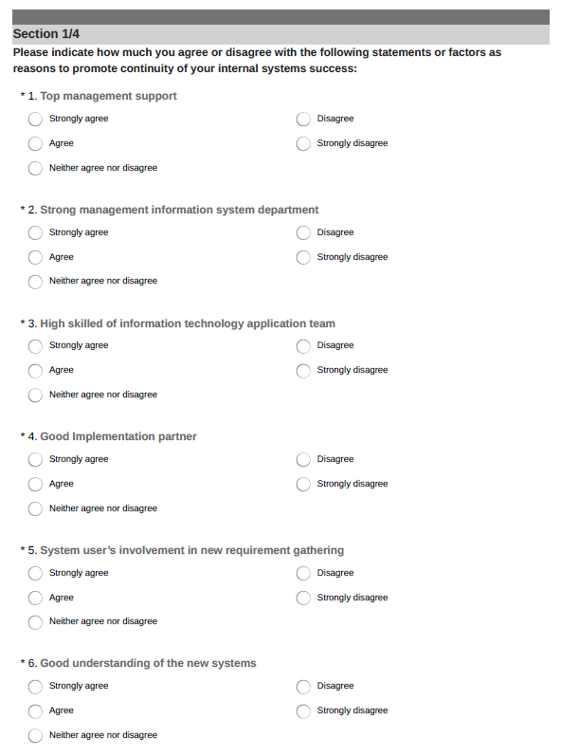
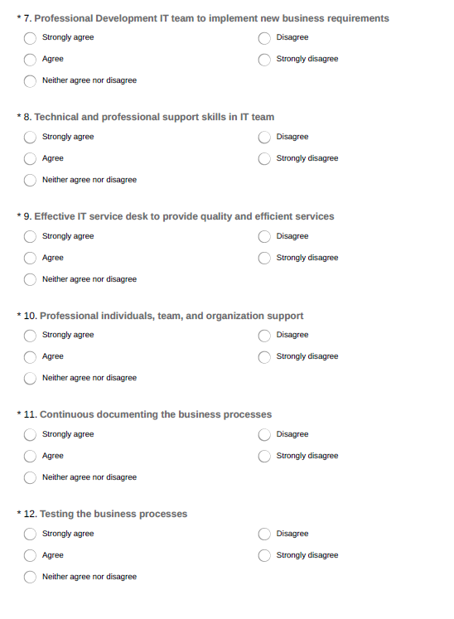

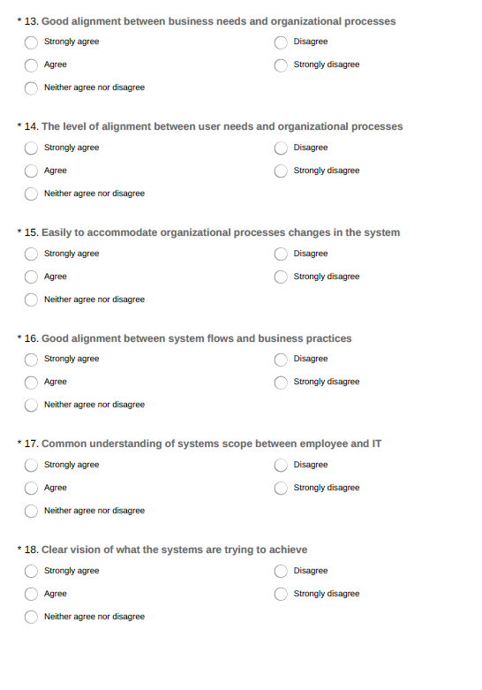

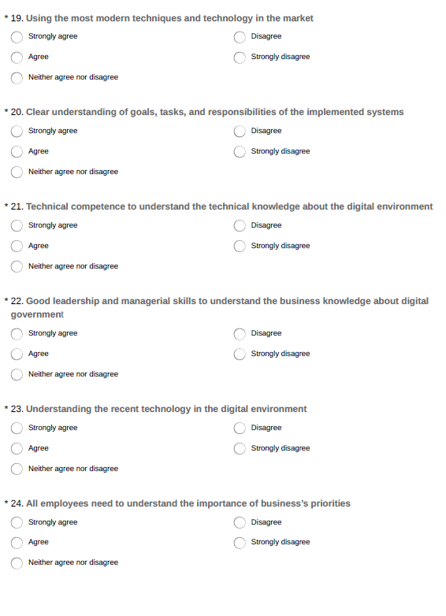

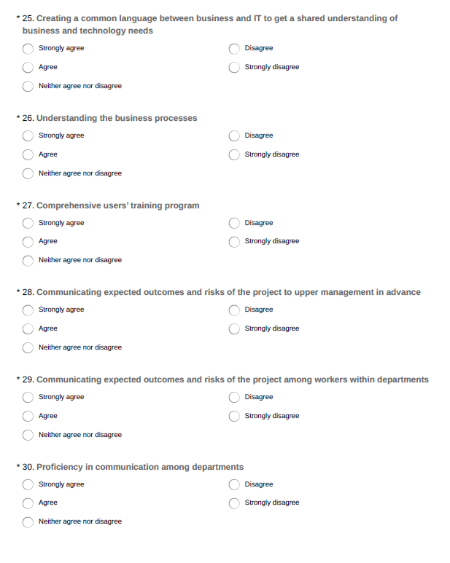

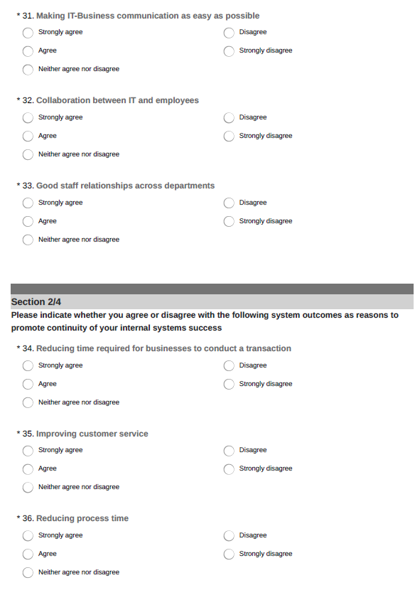

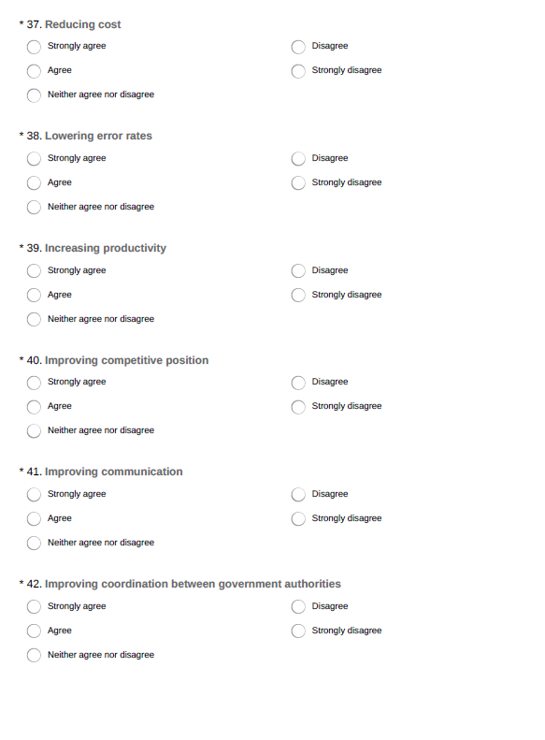
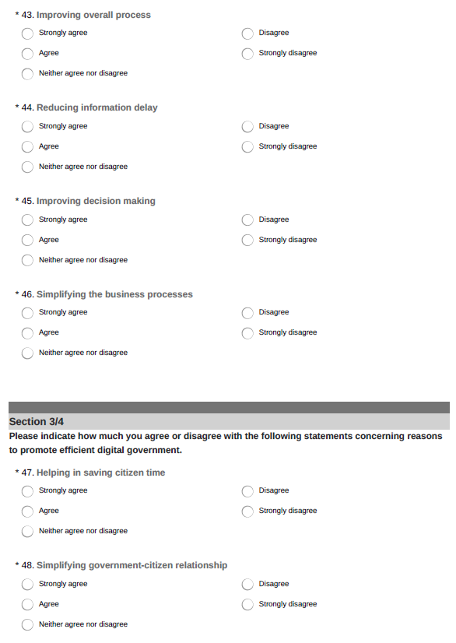

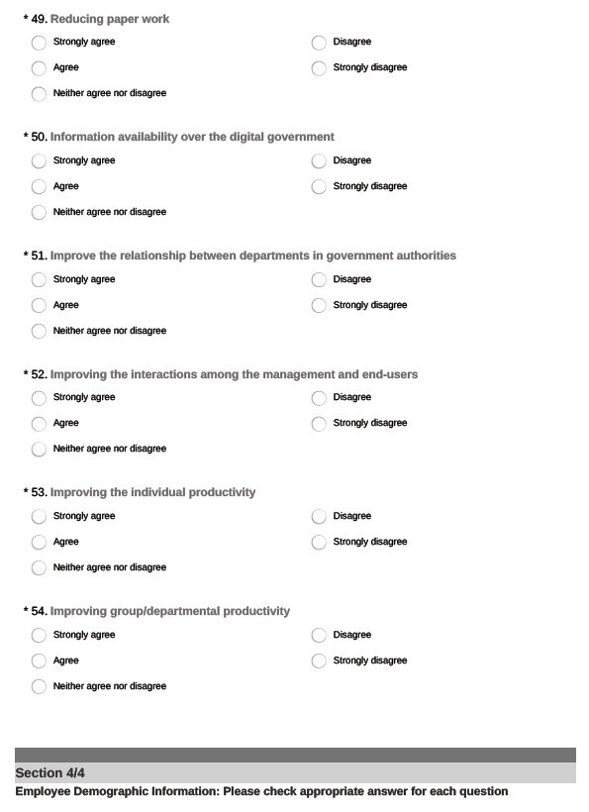
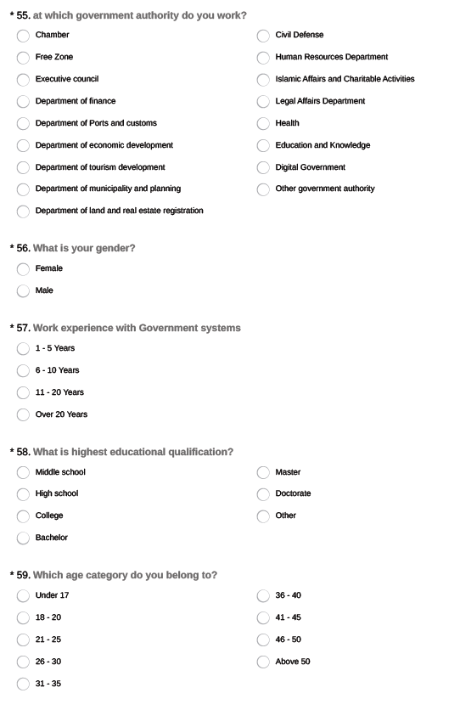


APPENDIX 4: QUESTIONNAIRE FOR THE STUDY (ARABIC)


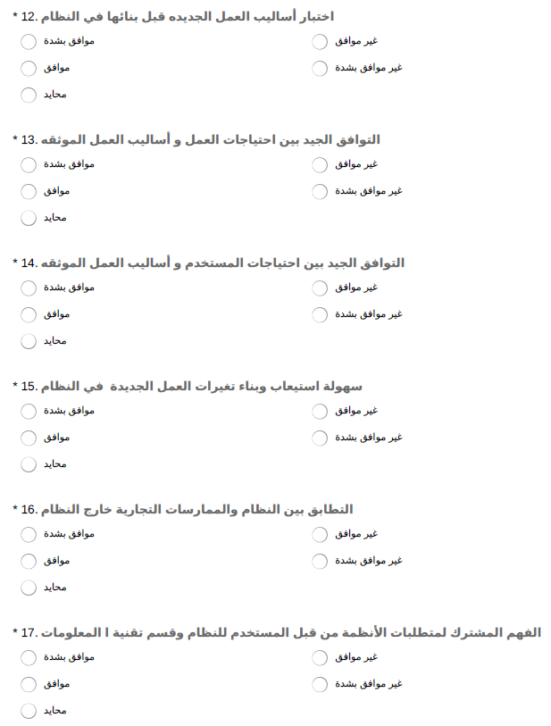

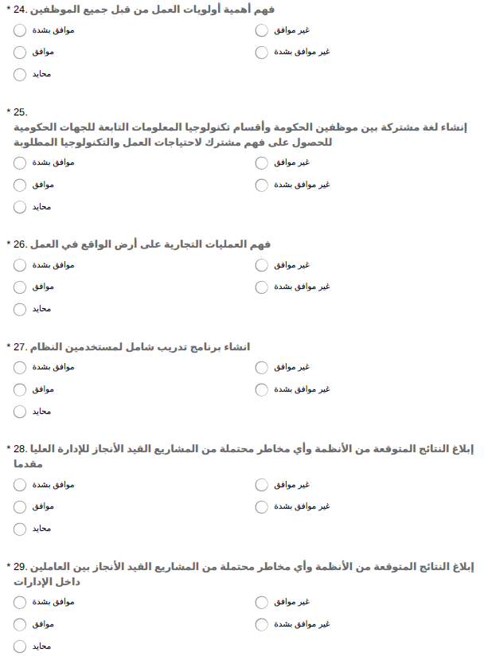

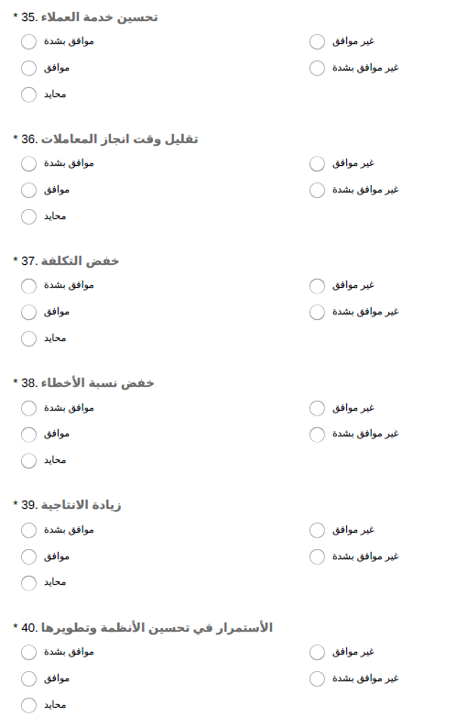






APPENDIX 5: RESEARCH POOL FROM WHICH POST ERP-DIGITAL GOVERNMENT EXCELLENCE PRACTICES’ FACTORS ARE DRAWN

ERP and Digital government Techniques | References
Process readiness | Kale et al., 2010; Hwang and Min, 2013; Lee-Post, 2009; Chao et al., 2017; Jayawickrama et al., 2017
People readiness | Kale et al., 2010; Hwang and Min, 2013; Lee-Post, 2009; Chao et al., 2017; Jayawickrama et al., 2017
Absorptive capacity knowledge | Jayawickrama et al., 2017; Kale et al., 2010; Hwang and Min, 2013; Jayawickrama et al., 2017; Chao et al., 2017
Shared understanding | Jayawickrama et al., 2017; Kale et al., 2010; Hwang and Min, 2013; Jayawickrama et al., 2017; Chao et al., 2017
Interactive communication | Jayawickrama et al., 2017; Chao et al., 2017; Hwang and Min, (2013)
Post ERP success | Kale et al., (2010)
Digital government excellence | Kale et al., (2010)

