
Determinants of Operational Efficiency in the Oil and Gas Sector: A Balanced Scorecard Perspective

Dissertation

Presented to
The Academic Faculty

By
Salama Saeed Al-Qubaisi

In Partial Fulfillment
of the Requirement for the Degree of
Doctor of Business Administration

Abu Dhabi University
College of Business
Abu Dhabi, UAE

January, 31, 2018

© Copyright by
Salama S. Al Qubaisi

Determinants of Operational Efficiency in the Oil and Gas Sector:
A Balanced Scorecard Perspective

_________________________
Salama Saeed Al-Qubaisi

Approved:

_________________________
Mian Ajmal, PhD
Associate Professor, College of Business Administration
Abu Dhabi University
Committee Chair

_________________________
Kongkiti Phusavat, PhD
Associate Professor, Department of Industrial Engineering
Faculty of Engineering, Kasetsart University
Bangkok, Thailand
Committee Member

_________________________

_________________________
Dr. Jacob Chacko
Dean, College of Business Administration
Abu Dhabi University

Abstract
The oil and gas industry have experienced several boom and bust cycles. The industry is known to hardly, if ever, react in a constant manner to the highs and lows. External economic factors pressurize the industry to be more efficient and cost effective without compromising the health, safety and environment (HSE) performance. All these factors provide the opportunity to explore the realization of Operational Efficiency (OE). The impact of Knowledge Management Practices (KMP) and Organizational Culture (OC) in realizing Operational Efficiency (OE) has been evaluated in this study. The use of KMP initiatives is fast gaining popularity worldwide. The competitive benefits of Knowledge Management Practices (KMP) initiatives were established within the private and public sectors as well as academia during the early 21st century. Many researchers have been interested in KMPs and their role in making Oil and Gas organizations more efficient and effective. Organizational Culture (OC) on the other hand plays a significant role in improving the learning capability of the organization and is considered a critical success factor in Knowledge Management (KM). However, existing studies have found the relationship between OC and OE unclear. This is attributed partially to the limited research in this particular area, and partially because OE is a relatively new area and most studies have focussed on it as a whole, rather than examining specific elements. While understanding how KMP can be implemented to maximize the efficiency of the organizations, strategic business managers should also know how to assess and measure performance improvement and the impact of KM implementation by creating the right OC. Numerous studies suggest that strategic management tools, such as the Balanced Scorecard (BSC), can be used to evaluate the performance of KMP, as they play a vital role in the success of any project, business or operation. It has been claimed that well-developed BSC could align KMPs to business objectives and consequently, link the output to the input (investment). There is limited research that indicates the relation between KMPs, OC and OE using Balanced Scorecard (BSC) four strategic perspectives, specifically in the Oil and Gas sector. However, this relationship has not yet been acknowledged through empirical tests. This research aims to fill this gap by providing a better understanding of that relationship and its importance with regard to the business outcomes, and by attaining a theoretical model that is validated and empirically tested in the context of Oil and Gas organizations. This study also seeks to provide empirical evidence for the theoretical assertion that OC can visibly improve OE through KMPs that are capable of leveraging intellectual assets.
In order to achieve these objectives, a quantitative study was conducted, and data were collected from questionnaires, in the context of a total of 568 valid responses from one of the biggest Oil and Gas Company in the United Arab Emirates (UAE). A two-step methodology for structural equation modeling (SEM) has been implemented using AMOS version 20.0: In step one, a confirmatory factor analysis (CFA) was employed to measure the suggested measurement model fit and constructs validity. In step two the proposed structural model was developed and estimated for testing the importance of theoretical relationships. The outcomes of SEM analyses demonstrated that the suggested measurement model and structural model satisfied the necessary fit conditions. Therefore, six research hypotheses were tested to address the three research questions. All KMPs were found to have significant relationship with OE and OC. Additionally, KMPs mediate the relationship between OC and OE.
Furthermore, the study aims to make several practical recommendations to theoretical contributions for business executives, especially those operating in Oil and Gas. The results may help academicians and managers provide valuable and practical guidance to business leaders to successfully achieve world-class performance (Operational Excellence) by creating and sustaining the right culture to implement KMPs throughout the organization with regard to business outcomes. This helps achieve E triple P (improving Performance of the Operational Efficiency, developing competence of the People, and Profitability) for long-term competitive benefits. Some limitations of the study are also indicated, recommending opportunities for future research. One of the research limitations is the type of organization. Future research may include other industries such as manufacturing and construction. Only the operational variable is evaluated, and there is no consideration of other dimensions such as leadership type, organizational structure and technology. This study is the first in the UAE, which is the first region to examine the relationship between OC and KMPs by considering OE from Balanced Scorecard (BSC) four perspectives with the mediating impact of (KMPs).

Key Words: Organizational Culture, Knowledge Managements, Performance, Balanced Scorecard, Structural Equation Modeling, Oil and Gas, United Arab Emirates, Efficiency, Excellence

Acknowledgments
A considerable amount of effort and time has been spent in the preparation of this dissertation. I have received assistance from many people, without whose help this work would never have been completed.
First and foremost, I wish to express my most sincere thanks to my dissertation chair, Dr. Mian Ajmal, who played his part in making this work a success with his support and guidance. My gratitude goes to Dr. Kongkiti Phusavat and Dr. Mehmood Khan, for their guidance and support through the period of writing this dissertation. I would also like to appreciate the encouragement that I have continually received from Dr. Jacob Chacko and Dr. Syed Zamberi for their management and support.
My gratitude also goes to all the Senior Management in the UAE biggest offshore oil and gas company who encouraged me, believed in the significance of this research and gave me their vital support during the data collection process. I would also like to thank all those who responded to my survey and helped me complete it.

May God bless you all abundantly.

List of Abbreviations
UAE | United Arab Emirates
OC | Organizational Culture
KMP’s | Knowledge Managements Practices
OE | Operational Efficiency
BSC | Balanced Scorecard
TRU | Trust
COM | Commitment
COL | Collaboration
COP | Competence
KM | Knowledge Management
KMS | Knowledge Management System
KC | Knowledge Creation
KS | Knowledge Sharing
KU | Knowledge Utilization
KI | Knowledge Internalization
FP | Financial Performance
CS | Customer Satisfaction
IBP | Internal Business Process
LG | Learning and Growth
EFA | Exploratory Factor Analysis
HSE  IT | Health Safety and Environment  Information Technology
AMOS | Analysis of Moment Structure Software Package
CFA | Confirmatory Factor Analysis
CFI | Comparative Fit Index
IFI | Increment Fit Index
GFI | Goodness-of-Fit Index
df | degree of freedom
RMSEA | Root Mean Square Error of Approximation
SPSS | Statistical Analysis Software
KPI | Key Performance Indicator
SEM | Structural Equation Modeling

Table of Contents
Abstract iii
Acknowledgments vi
List of Abbreviations vii
Table of Contents ix
List of Figures xvii
List of Tables xix
CHAPTER ONE: INTRODUCTION 1
1.1 Introduction 1
1.2 Research Overview 3
1.2.1 Knowledge Management and Organizational Culture 3
1.2.2 Operational Efficiency 4
1.2.3 Oil and Gas in the UAE Context 5
1.2.4 Balanced Scorecard 7
1.3 Research Problem 9
1.4 Research Objective 12
1.5 Research Question 13
1.6 Research Hypothesis and Model 13
1.7 Purpose of the Research 15
1.8 Significance of the Study and Anticipated Output 15
1.9 Assumptions of Research 19
1.10 Delimitation of Research 19
1.11 Limitations of the Research 19
1.12 Definition of Terms 20
1.13 Structure of the Research 23
1.14 Summary 26
CHAPTER TWO: LITERATURE REVIEW 23
2.1 Introduction 23
2.2 Theoretical Background 25
2.3 Organizational Culture Elements 32
2.3.1 Definition and Importance of Culture – 32
2.3.2 Synthesis of Organizational Culture - Previous Theories and Models – 33
2.3.2.1 Trust 35
2.3.2.2 Commitment 36
2.3.2.3 Collaboration 37
2.3.2.4 Competence 37
2.4 Knowledge Management 38
2.4.1 Definition and Importance of Knowledge Management 38
2.4.2 Synthesis of Knowledge Management - Previous Theories and Models – 39
2.5 Aspects of Knowledge Management 41
2.6 Knowledge Management Approach 42
2.7 Knowledge Management Practices 44
2.7.1 Knowledge Creation 48
2.7.2 Knowledge Utilization 48
2.7.3 Knowledge Sharing 49
2.7.4 Knowledge Internalisation 50
2.7.5 Knowledge Management Practices within the Oil and Gas Sector 51
2.8 Optimizing Operational Efficiency 52
2.9 Balanced Scorecard 54
2.10 Contribution of Balanced Scorecard to Key Dimension of Operational Efficiency… 57
2.11 Summary 64
CHAPTER THREE: DEVELOPMENT OF RESEARCH HYPOTHESES 65
3.1 Introduction 65
3.2 Hypothesis Development 67
3.2.1 Organizational Culture (OC) 67
3.2.2 Knowledge Management Practices (KMPs) 69
3.2.3 Operational Efficiency (OE) 70
3.2.4 Organizational Culture (OC) and Knowledge Management Practices (KMP’s) 73
3.2.5 Knowledge Management Practices (KMP’s) and Operational Efficiency (OE) 77
3.2.6 Organizational Culture (OC) and Operational Efficiency (OE) 81
3.2.7 Linkage of Organizational Culture (OC) and Operational Efficiency to Knowledge Management practices (KMP’s) 86
3.3 Proposed Theoretical Model 90
3.4 Summary 93
CHAPTER FOUR: RESEARCH METHODOLOGY 94
4.1 Introduction 94
4.2 Purpose of the Study 96
4.3 Justification of the Quantitative Pattern 97
4.3.1 Qualitative Research 98
4.3.2 Quantitative Research 98
4.3.3 Advantages and Disadvantages of Qualitative Method: 99
4.3.4 Advantages and Disadvantages of Quantitative Method 99
4.4 Justification of the Survey Research Method 100
4.5 Procedures 101
4.6 Questionnaire Design 105
4.6.1 Operationalization of Measures 105
4.6.1.1 Measuring Organizational Culture 106
4.6.1.2 Measuring Knowledge Management Practices 107
4.6.1.3 Measuring Operational Efficiency 109
4.6.2 Preparation of Draft Questionnaire 111
4.7 Pilot Survey 112
4.8 Main Survey 115
4.8.1 Sample Design 115
4.8.2 Questionnaire Administration 118
4.9 Data Analysis Techniques 119
4.9.1 Goodness-of-Fit Assessment 121
4.9.1.1 Absolute Fit Measures 121
4.9.1.2 Incremental Fit Measures 123
4.9.1.3 Parsimony Fit Measures 125
4.9.2 Unidimensionality and Construct Validity 126
4.9.3 Structural Model Testing 128
4.10 Ethical Considerations 128
4.10.1 Confidentiality 129
4.10.2 Potential Risks and Discomforts 129
4.10.3 Potential benefits to participants and /or to the society 130
4.10.4 Identification of Review Board 130
4.11 Summary 131
CHAPTER FIVE: DATA ANALYSIS 132
5.1 Introduction 132
5.2 Pilot Study 134
5.3 Main Study Sample Profile 141
5.3.1 Respondent Profile 142
5.4 Normality Assessment 145
5.5 Measurement Model Development 148
5.5.1 Trust (TRU) 148
5.5.2 Commitment (COM) 150
5.5.3 Collaboration (COL) 151
5.5.4 Competence (COP) 152
5.5.5 Organizational Culture (OC) 155
5.5.6 Knowledge Creation (KC) 157
5.5.7 Knowledge Sharing (KS) 158
5.5.8 Knowledge Utilization (KU) 160
5.5.9 Knowledge Internalization (KI) 161
5.5.10 Knowledge Management Practices (KMP) 164
5.5.11 Financial Performance (FP) 166
5.5.12 Customer Satisfaction (CS) 168
5.5.13 Internal Business Process (IBP) 169
5.5.14 Learning and Growth (LG) 170
5.5.15 Operational Efficiency (OE) 173
5.5.16 Overall Measurement Model 175
5.6 Structural Equation Modeling 184
5.6.1 Overall Structural Model Fit 185
5.6.2 Hypothesis Testing 187
5.7 Summary 190
CHAPTER SIX: DISCUSSION 192
6.1 Introduction 192
6.2 Discussion on research questions 193
6.2.1 Question 1: What are the key dimensions of the Operational Efficiency of a firm?....... 193
6.2.2 Question2: How do the key dimensions of the Operational Efficiency of a firm relate to each other? 200
6.2.3 Question 3: How are the key dimensions of the Operational Efficiency (OE) of a firm affected by Organizational Culture (OC) and Knowledge Management Practices (KMP’s)? 203
6.3 Summary 209
CHAPTER SEVEN: CONCLUSIONS AND IMPLICATIONS 212
7.1 Introduction 212
7.2 Theoretical Contributions 215
7.3 Practical Implications 219
7.4 Limitations Of The Study 229
7.5 Future Research 231
7.6 Conclusion 232
BIBLIOGRAPHY 236
APPENDICES 264
Appendix 1a: Ethics Electronic Approval (mail attached) 265
Appendix 2a: Cover Letter Company Approval (English version) 269
Appendix 3a: Invitation Cover Letter (English version) 273
Appendix 4a: Final Questionnaire (English version). 275
Appendix 5a: Reminder Letter (English version). 279
Appendix 6a: Case Studies of Successful KM. 281

List of Figures
Figure 1.1: Chapter One Outline 2
Figure 1.2: Conceptual Research Model 14
Figure 2 .1: Chapter Two Outline 24
Figure 2 .2: Integrated research framework for KM 40
Figure 3.1: Chapter Three Outline 66
Figure 3.2: Conceptual Research Model 92
Figure 4.1: Chapter Four Outline 95
Figure 4.2: Demonstrates the proposed research development process 104
Figure 5 .1: Chapter Five Outline 133
Figure 5 .2 (a-d): Summary of view and constructs CFA for (OC) First Order. 154
Figure 5 .3.a: CFA Results for Organizational Culture (OC) 156
Figure 5 .3.b: Within Construct Discriminant Validity for Organizational Culture (OC) 157
Figure 5 .4. (a-d): Summary of view and constructs CFA for (KMP)-First Order. 163
Figure 5 .5.a: CFA Results for Knowledge Management Practices (KMP) 165
Figure 5.5.b: Within Construct Discriminant Validity for Knowledge Management 166
Figure 5.6. (a-d): Summary of view and constructs CFA for (OE)-First Order. 172
Figure 5.7.a: CFA Results for Operational Efficiency (OE) 174
Figure 5.7.b: Within Construct DiscriminantValidity for Operational Efficiency (OE) 175
Figure 5.8: CFA Results for Final Measurement Model 177
Figure 5.9: Structural Equation Modeling of Theoretical Model 186
Figure 6.1: Chapter Six Outline 192
Figure 6.2: OC and KMP -Based OE of a firm as a Multi-dimensional Construct 200
Figure 6.3: Theoretical Model OC and KMP -Based OE 208
Figure 7.1: Chapter Seven Outline 214

List of Tables
Table 2.1: A list of Knowledge Management enablers 25
Table 2.2: An overview of some researches on KM, BSC and organizational researchers. 27
Table 2.3: Key literature review summary –on organizational culture elements. 35
Table 2.4: Summary of common Knowledge Management practices (2007-2016). 47
Table 2.5: Key Literature Review summary on OE and BSC 56
Table 2.6: Linkage BSC Perspective and Operational Efficiency (OE) in the Oil and Gas 59
Table 3.1: Relationship between Enablers (OC) and Process (KMPs). 76
Table 3.2: Relationship between Process (KMP’s) and organization performance (OE-BSC). 80
Table 3.3: Relationship between Enablers (OC) and organization performance (OE-BSC). 85
Table 3.4: Research Questions and Hypotheses 90
Table 4 .1 :Item Measures of Organizational Culture 106
Table 4 .2: Item Measures of Knowledge Management Practices 108
Table 4 .3: Item Measures of OE used in this study considers four “BSC” perspectives. 110
Table 4 .4: Characteristics of absolute fit measures 122
Table 4 .5: Characteristics of Incremental Fit Indices 124
Table 4 .6: Characteristics of Incremental Fit Indices 125
Table 5.1: Results of the Pilot Study 137
Table 5.2: Final Constructs Measurements Scales 139
Table 5.3: Number and percentage of the questionnaire respondents, categorized by basic 144
Table 5.4: Skewness and Kurtosis Statistics 146
Table 5.5.a: Standardised Regression Weights (λ) and Composite Reliability Estimates (CR) First-order Constructs 178
Table 5.5.b: Standardised Regression Weights (λ) and Composite Reliability Estimates (CR) - Second-order Constructs 181
Table 5.6: Standardised Inter-Construct Correlation Estimates 183
Table 5.7: Construct Discriminant Validity for (OC,KMP,OE) 184
Table 5.8: Goodness of Fit Statistics for the measurement model and structural model 185
Table 5.9: Summary of statistically estimates of structural model significant effect and hypotheses 188
Table 5.10: Summary of Hypotheses Testing Results 191
Table 6.1: Summary of the Research Results 211

CHAPTER ONE: INTRODUCTION
  - Introduction
Chapter One provides an introduction to the research by illustrating an overview of an inclusive study’s framework, followed by other relevant chapters. It begins with a high-level overview of the background to this research, followed by an explanation of the importance of this study and a comprehensive analysis of the gaps in the literature related to the relationships between Organizational Culture (OC), Knowledge Management Practices (KMPs) and Operational Efficiency (OE), by considering the Balanced Scorecard (BSC) perspectives, specifically in the oil and gas sector.
The next section deals with the research problem, research objective, research questions, research assumptions and research limitations. The chapter reviews the importance of this study, describes the terms used and the scope of study followed by a framework of the thesis. The outline of Chapter One has been provided in Figure 1.1.

Figure 1.1: Chapter One Outline

  - Research Overview

Knowledge Management and Organizational Culture
In the current knowledge-based economy, Knowledge Management (referred to as KM henceforth) is one of the most important strategic actions in organizations. Knowledge Management Practices revolve around knowledge and human contribution (Davenport et al., 1998). Drucker (2002) emphatically stated that the most valuable resource in the current century is the knowledge worker. Knowledge can be grouped into tacit or explicit (Polanyi, 2009). Either way, tacit or explicit knowledge is retained by employees, hence the term knowledge workers. Explicit knowledge may be easily captured in books, documents, videos and other tangible forms. But tacit knowledge is not available in forms that can be transmitted or stored. Since this tacit part of organizational knowledge amounts to a large proportion, Knowledge Management performance relies on its successful realization through human interaction. Communicating the same among employees is impacted by various aspects due to the social, economic and political background of human beings. An organization is a socioeconomic engine that comprises of people linked by some common goals and motives. Organizational culture itself could impact the way people behave in an organizational setting. Many studies have emphasized that organizational culture plays an essential role in knowledge creation and management in organizations due to the way people gain and part with knowledge. Hence, an organizational culture that creates knowledge-friendly exchanges needs to be encouraged to ensure the successful execution of KM strategies (Rai, 2011; Choi et al., 2008; Ryan & Prybutok, 2001; Wild et al., 2002; Gupta et al., 2000). People who possess critical organizational knowledge influence how well an organization performs. Many organizations believe that human resources are their greatest competitive asset (Boudreau & Ramstad, 2007; Huselid,et al., 1997), yet they fail to consistently invest in cultivating their workers’ learning and growth. Nevertheless, it is imperative to have a better understanding of KM and its practical implications in an organization. For KM to become a strategic resource, the organization should be able to apply KM principles to complement its existing practices, enhance operational efficiency and add value to organizational knowledge ( Mavodza, & Ngulube, 2013).

Operational Efficiency
Understanding ‘Operational Efficiency’ (referred to as OE henceforth) is vital from a business perspective. In simple terms, OE is the ratio of the output to input (Coelli, et al., 2005). The input might indicate money (cost), people (manpower) or time and effort, while the output might be financial (revenue, profit), competitive advantage, speed, customer loyalty, innovation, productivity, quality, etc., which is seen as business performance at a superior level (Wu & Chen, 2014). Therefore, increasing OE improves the output for every unit of input. Coelli et al. (2005) stated that OE is not just about efficiency, but also needs to be seen in the context of continual operational improvement. Often, operating excellence is used with the same meaning as operational efficiency. Thus, the aggregation of knowledge leads to process improvement.
In the oil and gas sector, the improvement of maintenance and reliability of the plant facilities is reflected in reduced downtime, increased predictability and reduced breakdown. For instance, Operational Efficiency (OE) systems can enhance machine uptime, offer higher capacity and even lower production costs. According to McKinsey, only the top class of oil and gas operators are able to attain 95–98% reliability and 30% lower maintenance expenses when compared to the industry average (Laurens & van der Molen, 2010). A high efficiency in maintenance indicates a high level of OE. This study enables oil and gas firms to improve sales and reduce working capital by better risk management efforts (McCreery et al., 2013).
The linchpin of better Knowledge Management is the ability to communicate best industry practices and the utilization of knowledge. Leading oil and gas companies, such as Chevron Texaco, Schlumberger and ExxonMobil have enhanced their efficiency by entrenching knowledge sharing within their work culture. These organizations find Knowledge Management increasingly complex as they continue collecting data. While data has increased greatly, the time and effort invested in understanding has not. The next step in KM management is building better systems that can make sense of the data and reduce the time taken to finding better solutions to known problems (Leavitt, 2002).
Companies operating in oil and gas sectors recognize the importance of KM, as they face an almost continual need to create and develop employee knowledge. The failure to do so and not keeping abreast of technology can seriously affect their performance. Effective KM strategies (Zheng et al., 2010; Ramanigopal, 2013) can help these companies maximize their employees’ competence and strengthen the internal knowledge sharing culture. The bottom line is that KM will be maximizing the efficiency of the organizations (Asl & Rahmanseresht, 2007).

Oil and Gas in the UAE Context
The United Arab Emirates (UAE) is one of the most well-known developed country. UAE is a constitutional federation of seven emirates starting with Abu Dhabi, Dubai, Sharjah, Ajman, Umm Al Quwain, Ras Al Khaimah and lastly Fujairah, which was formed in 1971. The UAE, located along the southeast Arabian Peninsula, covers an area of about 84 thousand square kilometres with a population of over 9.8 million. More than one million people live in the capital, Abu Dhabi (aboo dub-bee), which is the federal capital of the United Arab Emirates and the largest Emirate in the UAE (UAE Government, 2017). The UAE ranked seventh or eighth in the world as the having the largest proved reserves of both oil and natural gas, valued at 97.8 million barrels and 215 trillion cubic feet respectively, which is 4 percent of the world’s proven oil reserves and 3.5 percent of proven gas reserves. Hence, around 40 percent of the country’s gross domestic product (GDP) is directly from oil and gas are in Abu Dhabi, both offshore and onshore (OPEC, 2017).
In the UAE, the oil and gas sector is classified into upstream, midstream and downstream, depending on where they are in the supply chain. Upstream companies engage in oil and gas exploration and production; midstream includes transportation and storage, while downstream overlooks the refineries and marketing of oil and gas products. While most of the oil and gas companies function within a specific area within the supply chain, there are also larger enterprises that have operations spanning both upstream and downstream (Investopedia, 2016; UAE Interact,2016).
These apparently distinct business streams require unique, knowledgeable, competent and reliable resources to handle its KM requirements. Understandably, the capability to manage knowledge has turned into a critical business function within the industry. As the importance of OE rises within the business community, so does the value of KM in business transformation and in building sustainable competitive advantage (Jennex, 2007). Various studies have found that more and more organizations are moving towards knowledge driven systems, which can intelligently process raw data and effectively improve OE, rather than information driven systems (Mills & Smith, 2011; Theriou et al. 2011; Zack et al., 2009; Rivard et al., 2006; Gold et al., 2001; Guillén, 2000; Demarest, 1997). KM is recognized as an asset and incorporated in all their activities. Hence, various benefits, such as better decision making, knowledge resources, improved processes and environment, improved response to customers, better service offering, motivated employees and well defined operational processes resulting in better organizational performance, can be identified from KM practices (Spring, 2003). Additionally, Banker et al. (2006) stated the importance of effective internal processes and superior infrastructure in achieving OE.
Considering Knowledge Management (KM) and Operational Efficiency (OE), it has been found that the Operational Excellence Management System (OEMS) is a good example of an application that leads people to engage in better discipline and pursue higher levels of competence (Chevron, 2010). Such an OEMS adapts to the constantly evolving business climate. This is feasible due to the growth of relevant tools and is reinforced by suitable organizational policies and procedures. A system engrained in best practices could pave the path for reduced operational costs, while at the same time deliver better returns, eventually building the firm’s competitive advantage (Caruso et al., 2013).

Balanced Scorecard
Many studies recommend strategic management tools, such as the Balanced Scorecard (referred to as BSC henceforth). A Balanced Scorecard is a popular model that links organizational strategy with a set of performance measures. It includes both financial and non-financial objectives (Kaplan & David, 1996). The Balanced Scorecard is a framework for measuring performance and brings the entire organization to focus on a common goal. The focus is equally on non-financial measures and includes every function of the organization (Chavan, 2007; Brewer & Speh, 2000).
Usually organizations factor only in short-term financial goals. The Balanced Scorecard extends this to measures related to the customer, business processes and learning needs of the people (Manuel Pedro et al., 2010; Latshaw & Choi, 2002). A well-developed BSC could align KM activities with business objectives, and therefore, link the output to the investment (input) (Lin, 2015; Chen & Mohamed, 2008). In contrast, Bititci et al. (2004) found that organizational culture and management styles hugely impacted the implementation of an OEMS. On the other hand, Kaplan and Norton (2004) found that organizations that succeeded in implementing BSC were mostly those whose mission, vision and core values were manifested through the ‘organizational culture’ (referred to as OC henceforth) and its people. In spite of the credible evidence within KM literature suggesting the strong links between OC and BSC, further research in this area is justified. Empirical evidence validating the relation between organizational culture (OC), Knowledge Management Practices (KMPs) and Operational Efficiency (OE) while considering BSC perspectives is limited, specifically within the context of oil and gas organizations (Lyu et al., 2016; Ho et al., 2014; Rašula et al., 2012; Zack et al., 2009; Chen & Mohamed, 2008 and Lee & Choi, 2003).
Further, research pointed out the limited relationship between factors such as organizational culture, Knowledge Management practices and Operational Efficiency by considering the Balanced Scorecard, specifically in the oil and gas sector. An overview of the Literature Review is presented in Table 2.2 in Chapter 2. In order to realize the mission and vision of oil and gas firms, performance measurements that evaluate the efficiency of their facilities is of vital importance. It is well understood that what does not get measured does not get done (Gesage et al., 2015). A balanced measurement framework would look as much on financial measures as on measures focussed on customer satisfaction, process efficiency and human capital (Al Matarneh, 2011; Preston, 2011).
This study seeks to provide empirical evidence for the theoretical assertion that organizational culture can visibly improve the operational efficiency of the organization, through Knowledge Management practices that are capable of leveraging intellectual assets (Phusavat, 2013; Tseng, 2008; Chen & Mohamed, 2008; Cavaleri, 2004; Lee & Choi, 2003). The study also explores and analyses the link between OC, KMPs and OE measured by BSC four strategic perspectives (Kaplan & David, 1996). The final objective of the study, namely, the theoretical model that is validated and empirically tested in the context of the oil and gas organizations is attained during the process of identifying relationships between the variables. The results may help academicians and managers provide valuable and practical guidance to business leaders in achieving world-class performance (operational excellence) by creating and sustaining the right culture to implement KM practices throughout the organization. This helps achieve E triple P—improving Performance of the Operational Efficiency, developing competence of the People, and Profitability—for long-term competitive benefits.
  - Research Problem
With oil and gas prices susceptible to various economic and political factors, the industry has seen its highs and lows. During times of high oil prices, oil and gas firms have increased spending on asset purchase and manpower at vastly inflated rates. During times of low oil prices, there is a desperate attempt to cut costs by reducing headcount and cancelling projects. Neither of these approaches benefit long-term sustainability considering that the world energy demand is set to grow by 37 percent by 2040, according to the IEA’s World Economic Outlook 2017 (IEO, 2017). To meet the forecasted demand, analysts expect the industry to pump in over $900 billion a year in upstream activities by 2030. By this time, unconventional gas will have accounted for around 60 percent of the global supply growth. At the same time, producers are facing unprecedented challenges around market volatility, resource availability, safety and regulatory issues and the current skills gap (UAE Interact, 2016; Maceda, 2015; ADIPEC, 2013). The key challenges that the industry needs to address are as follows:
- Market Volatility: Volatile oil markets affect industry and consumers alike, but producers are among those most impacted. The need is for cost containment and efficiency not just in the short term but also for the future. Employees need to be able to gain entry to several sites, have a decent amount of useful data to make effective decisions. This enables lowering the downtime, as such situations can be pre-empted by rapidly diagnosing and effectively responding to the issues.
- Resource availability: As the oil and gas industry is seeing more of its existing oilfields mature, the growing demand, often in hostile, remote locations, has to be met in other ways. Subsea installations, for example, present a variety of challenges including water pressure, temperature, access for service and the cost of deploying vessels for installation and service. In existing fields, aged assets that are not as efficient need to be maintained well enough to ensure viable production.
- Risks and regulation: Regulations and reputation dictate that producers take every measure possible to avert health, safety and environmental incidents. Effective production control, monitoring and predictive shutdown systems are fundamental to safe and secure operations in remote locations. Rather than becoming a barrier and incurring additional costs, an effective safety strategy using the right equipment can be a productivity driver that maximizes efficiency and minimizes downtime.
- Talent and experience: The oil and gas industries across the world are finding it increasingly hard to find competent manpower, as the highly competent and experienced workforce is facing retirement or otherwise leaving the organization (Enzer, 2014). The average retirement age within the industry is 60 (The UAE Ministry of Labour, 1999), but in some regions, it is as low as 56. A known people-sourcing agency in the region stated that top-notch talent needs to be recruited actively to sustain the current growth curve. This is quite a challenge, considering the fact that almost half of the engineers are looking at retirement within the next decade. A dearth of talent means that the oil and gas sector needs to look at alternative solutions to fill the roles (Grainger, 2014).
At the same time, there is currently a trend of cutting staff size in both technical and operational areas in the oil and gas industry around the world as a result of the falling oil prices and declining profit margins. Several major companies have taken action to downsize, reduce the operational costs and offset their margins during the downturn (Grunfeld, 2016). In return, Harhara et al. (2015) have stated that the organizations must assume responsibility for both direct and indirect expenses associated with employee turnover. The direct costs are related to new recruitment, training and benefits, while the indirect costs such as the loss of valuable organizational knowledge and diminished employee motivation are non-financial in nature.
The UAE economy is primarily based on oil and gas revenues. Therefore, in order to achieve maximum production, the UAE has to achieve high reliability and availability of offshore and onshore plants that are supported by the competence of knowledgeable people and robust processes, which consequently affect the organizational performance (Grunfeld, 2016; ADCED, 2008). To sustain its oil and gas industry performance, the UAE must look at and address the key factors involving its Knowledge Management Practices (KMPs), including the collaboration and contribution of human capital (Smith, 2001).
In order to effectively use KM to enable organizational performance, there is a need to bridge the gap in the availability of sufficient statistical methods that demonstrate the direct impact of KM on operational efficiency and organizational performance, while also considering organizational culture (OC) elements (Kasie & Belay, 2013). An extensive study of relevant literature and theoretical development has made it possible to identify the key research objectives and questions. This has led to framing a list of research hypotheses that helps test the importance of the theoretical relationships and the purpose of the research that has been proposed.
  - Research Objective
The study seeks to fill a void in the areas of OC, KMP and OE and has the following objectives:
- Provide empirical evidence for the theoretical assertion that organizational culture can visibly improve operational efficiency through Knowledge Management practices that are capable of leveraging intellectual assets.
- Help organizations explore and analyse the link between OC, KMPs and OE measured by BSC four strategic perspectives.
The final objective of the study is attained during the process of identifying the relationships between the variables, i.e., the theoretical model is validated and empirically tested in the context of oil and gas organizations. The results may help academicians and managers provide valuable and practical guidance to business leaders in order to achieve world-class performance (operational excellence) by creating and sustaining the right culture to implement KM practices throughout the organization. This helps achieve E triple P—improving Performance of the Operational Efficiency, developing competence of the People, and Profitability—for long-term competitive benefits.
  - Research Question
In order to meet the objectives stated above, the study identifies the following research questions:
- Question 1: What are the key dimensions of the Operational Efficiency of a firm?
- Question2: How do the key dimensions of the Operational Efficiency of a firm relate to each other?
- Questiion3: How are the key dimensions of the Operational Efficiency (OE) of a firm affected by Organizational Culture (OC) and Knowledge Management Practices (KMP’s)?
  - Research Hypothesis and Model
Six hypotheses were formed after conducting an extensive literature review, which need to be tested in order to answer the questions that have been developed for the suggested conceptual model. They are as follows:
Hypothesis 1: | Organizational Culture is a second-order latent construct composed of trust, commitment, collaboration and competence.
Hypothesis 2: | Knowledge Management Practices is a second-order latent construct comprising knowledge creation, knowledge sharing, knowledge utilization and knowledge internalization.
Hypothesis 3: | Operational Efficiency is a second-order latent construct comprising of financial performance, customer satisfaction, internal business process and learning and growth.
Hypothesis 4: | Organizational Culture (OC) has a significant relationship with Knowledge Management Practices (KMP).
Hypothesis 5: | Knowledge Management Practices (KMP) have a significant relationship with Operational Efficiency (OE).
Hypothesis 6: | Organizational Culture (OC) has a significant relationship with Operational Efficiency (OE).
The interrelationships between the variables as stated in the above hypotheses can be illustrated in the following proposed theoretical model, Figure 1.2.
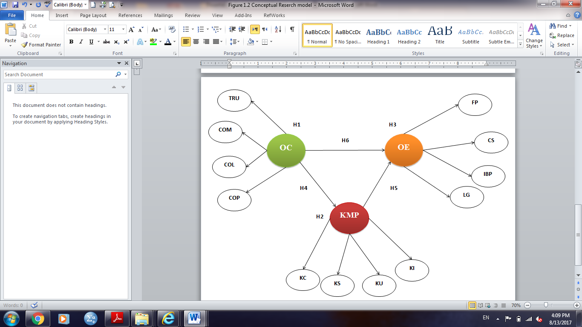

Figure 1.2: Conceptual Research Model

Abbreviations:
OC | Organizational Culture | KU | Knowledge Utilization
TRU | Trust | KI | Knowledge Internalization
COM | Commitment | OE | Operational Efficiency
COL | Collaboration | FP | Financial Performance
COP | Competence | CS | Customer Satisfaction
KMP | Knowledge Management Practices | IBP | Internal Business Process
KC | Knowledge Creation | LG | Learning and Growth
KS | Knowledge Sharing | LG | Learning and Growth

  - Purpose of the Research
The purpose of this study is to support the initiatives in implementing an integrated approach that takes into account Organizational Culture (OC), Knowledge Management Practices (KMPs) and Operational Efficiency (OE) from Balanced Scorecard Perspectives (BSC) within an oil and gas operating company in the UAE. In addition, the long-term goal is to provide the organization with a basis for its measurement, stimulate management for what is vital while providing justification of investment in KMPs and creating the culture suitable for effective operations and management (Phusavat, 2013; Theriou et al. 2011; Tseng, 2008; Chen & Mohamed, 2008; Cavaleri, 2004; Lee & Choi, 2003; Demarest, 1997; Kaplan & David, 1996).
  - Significance of the Study and Anticipated Output
This research is considered significant for several reasons.
Knowledge Management is an exercise that adds value to the strategic plans of an organization. KM practices are expected to benefit the bottom line and the firm’s competitive advantage (Duffy, 2000). KM is being seen as vital to organizations that seek to enhance their operational efficiency and competitive strengths (Rowley, 1999; Davenport & Prusak, 1998). KM’s recognition as critical to business success in the knowledge economy is the first significance of this research.
Secondly, in spite of a great deal of existing research on KM variables, only a handful of studies considered the Resource-Based View of the firm to evaluate the role of knowledge infrastructure in building organizational excellence. Additionally, these KM practices have not been studied in connection with factors like organizational culture (Zheng, 2005). Existing Literature Review shows that the impact of the KM enablers’ variables, culture and Knowledge Management practices or activities on operational efficiency has remained largely unexplored (Chen & Mohamed, 2008), and in addition, the influence of organizational culture link with the BSC and KM is yet to be explored (Lyu et al., 2016; Lin, 2015; Valmohammadi & Ahmadi, 2015; Rehman et al., 2015; Ho et al., 2014; Husain & Farooq, 2013; Darvish,et al., 2012; Rašula et al., 2012; Mills & Smith, 2011; Deem et al., 2010; Huang, 2009; Zack et al., 2009; Chen & Mohamed, 2008; Sveiby, 2007; Choy & Suk, 2005; Lee & Choi, 2003; Hoque & James, 2000). An empirical study of the matter in this background is therefore necessary to evaluate the validity and accuracy of stated measures.
Thirdly, identifying a reliable set of organizational performance indicators has remained limited to financial accounting terms until the emergence of the Balanced Scorecard (BSC) as a framework for understanding the links between strategy and business performance (Kaplan &David, 1996). Traditionally, financial measures have more importance as compared to other non-financial measures, such as customer satisfaction (Banker, 2004). Financial measures provide only a partial view of a firm’s performance. It does not provide a consolidated overview of how well the firm is doing or what customers and employees think of its efforts (Calhoun, 2004). Studies have raised concerns about this one sided view of evaluating organizational performance (Gesage et al., 2015). This substantiates the need for a consolidated performance measure that gives due importance to the strategic objectives of the organization. The Balanced Scorecard (BSC) is one such measurement approach (Anne, 2005; Kaplan & Norton, 2004). BSC seeks to align the entire organization with corporate strategy, thus increasing the effectiveness and efficiency of the organization. A study that demonstrates a clear link between KMP, OC and operational efficiency (OE) could radically reshape the corporate landscape. BSC is both a strategic mapping and implementation system of goals and initiatives. It blends financial measures with operational measures by bringing on board the needs of customers, process management and innovation.
Thirdly, the companies operating in the oil and gas sector recognize the importance of KM, as they are faced with the necessity of updating their employees’ knowledge on a regular basis. Failing to do so and not keeping pace with technology can seriously affect their performance. Effective KM strategies can help these companies maximize the competence of their employees and strengthen the internal knowledge sharing culture. One of the main advantages of using KM will be maximizing the efficiency within the organization (Asl & Rahmanseresht, 2007). This research can help both the practitioners and academics understand the underlying factors affecting value creation and management of risks to improve operational efficiency and business performance in the oil and gas sector. The proposed framework can be adapted for use in other similar industries as well. This study is original, in the sense that it is the first one in the United Arab Emirates (UAE) as well as the Middle East. It is of vital importance too, because it is aligned with Abu Dhabi’s strategic goal of transitioning from an oil-based economy to a knowledge-based economy (ADCED, 2008).
Fourthly, techniques for evaluating organizational performance in Knowledge Management can be grouped as follows: Financial (Bierly & Chakrabarti, 1996), intellectual capital (Sveiby,1997), tangible and intangible benefits (Simonin, 1997) and Balanced Scorecard (Kaplan & Norton, 2000). This study builds on a particular measure proposed and validated by Drew (1997) and Deshpandé et al. (1993). This measure is seen as a modified version of the Balanced Scorecard method. The Balanced Scorecard combines financial measures with parameters that measure future potential. BSC also shows the cause and effect relationship between KM and organizational strategies (Kaplan & Norton, 2000)

Finally, and what may be the most important factor in creating sustained change is the rise of younger workers committed to serving a broader purpose through work beyond simple economics, and their impact on organizational culture. This goal will drive the organizational change and long-term gain through the good times and bad.
An implication of this study is that the organizations may find that investment in KM does not match the expected operational performance, without building the right organizational culture (OC). This requires improving the competence levels of people and building better communication networks. It is believed that the results of this research could be of use to managers who are looking for ways to enhance OE by better KM practices and understanding of OC. The future focus of this research could determine if the BSC performance indicators could be associated with current strategic planning.
  - Assumptions of Research
The management and diffusion of knowledge will be analysed from the perspective of companies that have a knowledge-intensive environment. This is the result of KM strategies on organizations that have identified a crucial requirement for improvements in KM practices.
The study has also taken into account the relevant historical KM aspects of progress throughout the period of KM development. However, the tools used for sharing knowledge across different industries are not part of the study. For the purpose of the study, the key factors, issues and dimensions of KM in an oil and gas company located in Abu Dhabi, UAE has been selected.
  - Delimitation of Research
The delimitation of the study is that it will involve one company in the United Arab Emirates (UAE) that is mainly working in projects and operations in the oil and gas sector.
  - Limitations of the Research
This part will be explained in detail in Chapter 7 where the research encounters several limitations, including the type of organization chosen. For further studies, other industries, such as manufacturing and construction may also be included. Additionally, no consideration has been given to factors other than operational variable. Additionally, a lack of consideration of other dimensions, such as leadership type, technology and structure of the organization, is also a major limitation.
  - Definition of Terms
The terminology adopted in the study, which has been used by academics and in business, may vary according to the perspective in which they are used. Under this section, the definitions of the important terms used in this study can be found.
The first group where numbers of methodological terminologies are adopted from Hair et al. (2010) and Hair et al. (2006) are as follows:
Structural equation modelling (SEM): A multivariate method that combines different aspects of factor analysis and multiple regression that equips the researcher to simultaneously research a series of interrelated dependence relationships between the measured variables and latent constructs and also between several latent constructs (Hair et al., 2010; Hair et al., 2006).
Measurement model: This is the first step of the two in a comprehensive SEM analysis that touches specifically upon the indicators for each construct and makes an assessment of the possible construct validity (Hair et al., 2010; Hair et al., 2006).
Confirmatory factor analysis: This refers to the use of a multivariate method in order to test (confirm) a relationship that has been pre-specified (Hair et al., 2010; Hair et al., 2006).
Exploratory Factor Analysis: This is a statistical method that is used in order to unearth the underlying structure of a comparatively big set of variables (Hair et al., 2010; Hair et al., 2006).
Structural model: Refers to the set of one or more dependence relationships connecting the hypothesized model constructs that can be represented visually (Hair et al., 2010; Hair et al., 2006).
Construct validity: The extent to which a group of measured variables depicts the theoretical latent construct those variables are designed to measure (Hair et al., 2010; Hair et al., 2006).
Convergent validity: The extent to which the measures of a particular construct converge or share a large proportion of variance that they have in common (Hair et al., 2010; Hair et al., 2006).
Discriminant validity: The extent to which a construct is truly different from its counterparts (Hair et al., 2010; Hair et al., 2006).
Content validity: The extent to which the content of the items is in line with the construct definition, based merely on the judgment of the researcher (Hair et al., 2010; Hair et al., 2006).
Construct reliability: The measure of reliability and also the internal consistency of the measured variables that represent a latent construct (Hair et al., 2010; Hair et al., 2006).
The second group consists of special terms derived and developed from the literature of KM, OC, OE and BSC, including:
Resources Based View Theory (RBV): The RBV of the firm focusses particularly on the inside of the company, its resources and capabilities in order to better explain the profit and value of the organization (Makhija, 2003; Grant, 1996; Peteraf, 1993; Barney, 1991; Wernerfelt, 1984; Penrose, 1980).
Human Capital Theory: This theory acknowledges the contribution of employees’ human capital on developing intellectual capital (Birasnav et al., 2011).
Model of T-shaped skills or T-shaped persons: It is a concept symbol used in job enrolment to define the “abilities of persons in the workforce. The vertical bar on the T represents the depth of related skills and expertise in a single field known as I –shaped, whereas the horizontal bar is the ability to collaborate across disciplines with experts in other areas and to apply knowledge in areas of expertise other than one’s own known as T shaped” ( Heinemann, 2009).
Systems thinking theory: It is a “management discipline that concerns considerate of a system by examining the linkages and interactions between the components that include the whole of that defined system” (Weinberg, 2011; Tate, 2009).
Knowledge Based View Theory (KBV): This theory considers knowledge as the most strategically significant resource of a firm (Curado, 2006).
Flexible Leadership Theory: This theory touches upon the process involved in determining the firm’s financial performance through top-level decision making (Yukl, 1999).
The Transaction Cost Theory: This theory lays down that the choice to internalize or externalize a component of the human resources needs a transaction (Williamson, 1975).
Nonaka’s Dynamic Theory of Organizational Knowledge Creation: According to this theory, organizational knowledge is formed due to an on-going dialogue between tacit and explicit knowledge, via four different ways of interactions, socialization, combination, internalization and externalization. While explicit knowledge refers to codified knowledge that can be transmitted in formal, systematic language, tacit knowledge means personalized knowledge that is difficult to formalize and communicate and deeply rooted in action, commitment and involvement in context (Polanyi, 1962).
Balanced Scorecard (BSC): The BSC is an alignment mechanism for an organization and is a performance management tool developed by Robert Kaplan and David Norton in 1990 (Niven, 2005) for measuring whether small-scale operational activities of a company are aligned with its large-scale objectives in terms of vision and strategy (Chen, et al., 2009). It keeps the organization focussed on its core business activities and their achievement.
Operational efficiency: This is vital from a business perspective, and is known as the ratio between the input to run business operation and the output gained from the business (Coelli et al., 2005).
Enablers of Knowledge Management: Techniques and technologies that ensure that knowledge is created, captured, shared and leveraged (Valmohammadi & Ahmadi, 2015).
Knowledge: Information that gives guidance to take an action is termed as ‘knowledge’ and constitutes of a mix of different experiences, values, contextual information and expert insight providing a structure for measuring and incorporating new experiences and information (Grant, 2013).
Culture: It is defined as a collection of beliefs that create an organization’s identity and in turn describes the way the organization runs (Choy & Suk, 2005).
  - Structure of the Research
The research consists of eight chapters, as given below:
- Chapter One: Introduction to the Study – This chapter provides an introduction to the research by illustrating an overview of an inclusive study’s framework. It starts with an overview of the research background. The importance of this study is then explained, and the extensive gaps in the literature of the relationships between organizational cultures (OC), Knowledge Management practices (KMPs) and operational efficiency (OE) by considering the Balanced Scorecard (BSC), specifically in the oil and gas sector, is identified. The next section defines the research problem, research objectives, research questions, research assumptions and research delimitations and limitations. The chapter also discusses the significance of the study, defining the scope and the important terms used in the study, followed by an outline of the structure of the thesis and the summary.
- Chapter Two: Literature Review – This chapter defines the research variables and discusses the findings of previous studies on OC, KMPs, OE and BSC as well as identifies the gaps in it. It highlights the theories and definitions and methods of measuring the variables and shows how they relate in the UAE framework. This chapter also develops a theoretical model through a comprehensive review of existing literature.
- Chapter Three: Development of the Research Hypothesis – This chapter aims to develop the research hypothesis by reviewing the most relevant literature and the relationships between the study variables, which have been covered in the previous chapter (Chapter Two). The chapter covers the general associations between Organizational Culture (OC), Knowledge Management Practices (KMPs) and Operational Efficiency (OE) by considering the Balanced Scorecard (BSC) perspectives and highlights the most significant findings.
- Chapter Four: Research Methodology – In this chapter, a justification of the research methodology chosen and more information about the research design process used to empirically examine the theoretical model developed in Chapter Two can be found. The key focus of this chapter is on designing, developing and refining the questionnaire through a two-step process of item generation and the pilot study. Data analysis techniques and ethical considerations are also explained after describing the sample design and questionnaire administration used to conduct the main survey.
- Chapter Five: Data Analysis and Results – This chapter presents the results of the pre-test instrument (pilot survey), trailed by the descriptive analyses for the main study. In the first place, the instrument is pre-tested using factor analysis and Cronbach’s alpha calculation on the results of the pilot survey to measure instruments’ validity and reliability. Later on, as per the results of the pilot survey, the questionnaire was firmed up for the main study. Next, the data examining, normality assessment and sample description were carried out using the SPSS version 20.0. Then, the two-step methodology for structural equation modeling (SEM) was implemented using AMOS version 20.0 to check if the suggested measurement model and structural model satisfied the necessary fit conditions. In step one, a confirmatory factor analysis (CFA) was employed to measure the fitness of the suggested measurement model, construct validity and reliability. In step two, the proposed structural model was developed and estimated for testing the importance of theoretical relationships via related hypotheses and the research questions were stated. Furthermore, the demographic information’s were displayed using the descriptive statistics.
- Chapter Six: Discussion – This chapter provides the results of the data analysis and relates them to previous findings in Chapter Five by making a link between the research questions identified in Chapter One, and setting them in the UAE framework. This is followed by the chapter summary.
- Chapter Seven: Conclusion and Implications, limitations and future research – This is the last chapter of the research. In this chapter, conclusions about the research issues are provided by making a link between the research questions identified in Chapter One with the main findings shown in Chapter Five and Chapter Six, which is then linked back to the findings of former studies.
The chapter highlights the theoretical contributions and practical implications of the research and how the findings of this research acknowledge the implementation of Knowledge Management Practices in the organization. This needs to be considered by academics and practitioner managers who are looking to improve the operational efficiency in oil and gas firms by improving the organizational culture and by retaining organizational knowledge. The limitations of the study and recommendations for future research are also provided. References and appendices follow this.
  - Summary
This chapter lays the foundations for all other chapters of this thesis. It first gives an introduction to the research background and a brief description of research questions and objectives, which leads to different research hypotheses and the proposed theoretical model. The following chapter provides the importance of the research, based on gaps found after Literature Review, and the expected output. It gives research assumptions; the delimitations and the limitations of the research are also discussed. The important terms used in the study are then defined and a detailed outline of the research is provided. The next chapter will review the Literature on OC variables, KMP variables, OE and the elements of BSC to develop a research model that explains the interrelationships between KMPs and OC and their impact on OE using BSC perspectives.

CHAPTER TWO: LITERATURE REVIEW
  - Introduction
This chapter defines the research variables and discusses the findings of previous studies on organizational culture (OC), Knowledge Management Practices (KMPs), Operational Efficiency (OE) and Balanced Scorecard (BSC). This chapter also aims to identify the gaps in the previous studies, to highlight theories and definitions and methods of measuring the variables, and to show how they relate within the oil and gas sector in the UAE framework.
This chapter continues with the discussions about the OC elements and KMPs as intermediate factors of the organization by considering the KM approach in the organization, to provide a foundation leading to the theoretical model and related hypothesis. This is carried out through a comprehensive review of the existing literature used to deal with the research questions proposed in Chapter One and by identifying the aspects of operational efficiency from the Balanced Scorecard (BSC) perspectives. The structure of Chapter Two is presented in the following Figure 2.1

Figure 2 .1: Chapter Two Outline

  - Theoretical Background
Knowledge Management (KM) is labelled as an import export approach, wherein the knowledge supported enablers exchange and get continuous performance improvement. There are many researches related to KM enablers. For instance, the accumulated six studies (Valmohammadi & Ahmadi, 2015; Ho et al., 2014; Park et al., 2004; Lee & Choi, 2003; Hasanali, 2002; Holsapple & Joshi, 2000) concluded that the outcome of Knowledge Management processes was affected by the following enablers: leadership, culture, competency, measurement, technology, training, reward and incentive systems/process, value and model. These enablers have also been classified into three groups – a) internal organizational variables, b) external organizational variables and c) facilitating variables (Sensuse et al., 2015). Table 2.1 lists the key enablers who have significantly contributed to KM’s body of knowledge.
Table 2.1: A list of Knowledge Management enablers
Author (year) | Enablers
(Holsapple & Joshi, 2000) | Leadership, culture, external factors, technology, organizational adjustments and employee motivation.
(Hasanali, 2002) | Organizational culture, leadership, structure, roles and responsibilities, IT infrastructure and measurement.
(Lee & Choi, 2003) | Organizational culture, technology, people and organizational structure.
(Park et al., 2004) | Systems and IT infrastructure, culture, KM organization, effective and systematic processes and measures.
(Ho et al., 2014) | Organizational culture, structure and KM process.
(Valmohammadi & Ahmadi, 2015) | Organizational culture, leadership, measurement and technology.

However, the impact of the KM enablers’ variables, culture and Knowledge Management practices or activities on operational efficiency has remained largely unexplored (Chen & Mohamed, 2008) and additionally, the influence of the organizational culture link with the BSC and KM is yet to be explored (Lyu et al., 2016; Lin, 2015; Valmohammadi & Ahmadi, 2015; Rehman et al., 2015; Ho et al., 2014; Husain & Farooq, 2013; Darvish et al., 2012; Rašula et al., 2012; Mills & Smith, 2011; Deem et al., 2010; Huang, 2009; Zack et al., 2009; Chen & Mohamed, 2008; Sveiby, 2007; Choy & Suk, 2005; Lee & Choi, 2003; Hoque & James, 2000).
Table 2.2 presents an overview of some researches on KM, BSC and organizational researchers

Table 2.2: An overview of some researches on KM, BSC and organizational researchers.
N. | Researchers  (Year) |  | Research/ method | Important findings | Future research | Country of study
1 | (Hoque & James, 2000) |  | Empirical/  Survey | Greater usage of BSC is associated with improved performance. | Investigate why and how companies implement BSC to improve performance. | Australia
2 | (Lee & Choi, 2003) |  | Empirical/  Survey | KM enablers affect KM process, which in turn affect organizational performance through intermediate impacts. | 1) Carry out further research between KM enablers and organizational performance.  2) Consider that the Balanced Scorecard retain financial performance and supplement it with measures on the drivers of future potential. | Korea
3 | (Choy & Suk, 2005). |  | Empirical/  Survey | Eleven critical KM enablers’ factors have been found, which provide a greater understanding to the researchers and practitioners about the enablers of a successful KM program. | Develop a performance measurement system to capture the impact of knowledge on the individual and organizational performance by using BSC technique. | Malaysia
4 | (Sveiby, 2007) |  | Conceptual | Various methods introduced, including BSC, to assess intellectual capitals and enumeration of their strengths and weaknesses. | Recommends selecting suitable method for intellectual assets assessment. | Qatar
5 | (Chen & Mohamed, 2008) |  | Empirical/  Survey | Knowledge utilization is the strongest contributor to general business performance. The impact of KM activities on the lagging performance indicators of BSC. | Paid attention to the efficiency of KM. Such an investigation requires considerations of additional contextual constructs, for example, organizational culture and technological infrastructure. | Hong Kong
6 | (Huang, 2009) |  | Analytic Hierarchy Process (AHP) method | Provided an intelligent knowledge-based system for strategic planning that sets or selects firm strategy based on the BSC perspectives. | Validating BSC and knowledge based system (KBS) and associated strategic objectives and performance measures, implementing BSC and KBS to other organizations to test its effectiveness for strategic planning. | Taiwan
7 | (Zack et al., 2009) |  | Empirical/  Survey | There was no direct relationship found between KM practices and financial performance. | Investigate the influence of geography and culture link on BSC and KM. | North America & Australia
8 | (Deem et al., 2010) |  | Empirical/  Survey | The statistical analysis of survey results confirmed the positive link between BSC effectiveness and organizational culture. | Investigations should further elucidate the relationship between organizational culture and BSC effectiveness as well as the interrelationship among organizational culture and BSC effectiveness. | United States
9 | (Mills & Smith,  2011) |  | Empirical/  Survey | Evaluate the impact of specific KM resources (i.e. Knowledge Management enablers and processes) on organizational performance. | Explore links between knowledge capabilities and organizational performance, on a larger scale. | West Indies, Jamaica
10 | (Darvish et al.,2012) |  | Empirical/  Survey | Empirically clarifies the effect of Knowledge Management indices on the advancement of the four Balanced Scorecard perspectives. | The relationship between KM and BSC can be realized theoretically via studying literature. | Saipan
11 | (Rašula et al., 2012) |  | Empirical/  Survey | Information technology, organization and knowledge positively affect organizational performance. | Explore the impact of organizational elements (culture, collaboration etc.) and Knowledge Management practices on performance in different countries. | Slovenia
12 | (Husain & Farooq, 2013) |  | Empirical/  Survey | Develop a reliable and valid instrument to measure the performance of change and BSC in business organizations. | Explore the attitude (culture) of organizations towards change management using other dimensions of BSC and organizational effectiveness. | India
13 | (Ho et al., 2014) |  | Empirical/  Survey | Organizational culture positively impact knowledge circulation processes (KCP), which in turn has positively impacted job performance, while the autonomous organizational structure did not. | BSC financial dimension generally has an indirect and slow influence on KM performance and the causal relationship is difficult to track. This can be explored in future studies. | Taiwan
14 | (Rehman et al., 2015) |  | Empirical/  Survey | KM practices’ influence the overall performance of firms and further investigate the mediating role of business process capability and organizational learning using BSC. | Explore other contextual factors, such as critical success factors (e.g. KM strategy, capabilities and knowledge assets) as intermediate measures. | Pakistan
15 | (Valmohammadi & Ahmadi, 2015) |  | Empirical/  Survey | The results revealed that KM practices positively and meaningfully (though weak) had an impact on the overall organizational performance. | Explore the statistical and comprehensive methods such as BSC to find out how KM makes a difference on organizational performance. | Iran
16 | (Lin, 2015). | Empirical/  Survey |  | Develop the decomposed model to examine the influence of Knowledge Management Orientation (KMO) dimensions on Balanced Scorecard outcomes. | Explore how different KMO dimensions affect individual, group and organizational-level KM effectiveness and gain a deeper understanding of the consequences of a well-organized KMO implementation. | Taiwan
17 | (Lyu et al., 2016) | Synthetic evaluation method using triangular fuzzy numbers |  | Feasibility of the Balanced Scorecard (BSC) method in enterprise KM and proposes a simplified and applicable performance evaluation model based on the BSC approach. | Conduct empirical studies to further verify the robustness and applicability of mapping between KM and BSC. | China

  - Organizational Culture Elements

Definition and Importance of Culture –
Culture is one of the main important factors of the internal organizational variables required for a successful implementation of KM in the organization (Lee & Choi, 2003). Hence, culture can be defined as a collection of beliefs that create an organization’s identity and which, in turn, describes the way the organization runs (Choy & Suk, 2005). Culture also dictates working relationships among employees, defines interpersonal behaviour, conduct communication within and outside the organization (Tseng, 2010). Many studies have emphasized that organizational culture plays an essential role in knowledge creation and management in organizations due to the effects of how members learn, acquire and share knowledge. Hence, an organizational culture that creates knowledge-friendly exchanges needs to be encouraged to ensure the successful execution of KM strategies (Rai, 2011; Choi et al., 2008; Ryan & Prybutok, 2001; Wild et al., 2002; Gupta et al., 2000).
According to Koudsi (2000), KM is more of a cultural issue than a technological challenge. The lack of trust and knowledge-hoarding mentality of the staff lead to situations where sharing knowledge within the organization proved to be ineffective (Moffett et al., 2003). A study by the American Productivity and Quality Center illustrated the importance of having a corporate culture that supports knowledge sharing (McDermott & O’Dell, 2001). Additionally, as indicated by Ho et al. (2014), it is a knowledge-friendly culture that facilitates the implementation of KM practices. Moreover, Gupta et al. (2000) have stated that an organizational culture, which is formed by bringing together skills and experiences of individuals, is more successful than one that ignores the employee contributions to KM. David and Fahey (2000) recommended creating an organizational culture where knowledge sharing thrived. In fact, culture is seen as a critical factor for the success of any KM initiative. Therefore, an analysis of the organization’s culture is a key step to be carried out early on in a KM implementation. Buckman (1999) argued that knowledge creation and sharing are intangible and therefore, cannot be forced upon individuals.

Synthesis of Organizational Culture - Previous Theories and Models –
Earlier theories on Knowledge Management indicate that a Resource Based View (RBV) of human capital plays a vital role in determining the performance of individuals (Al-Khouri, 2014). However, the influence of human resource (HR) on operational systems has often been neglected (Boudreau et al., 2003). In spite of HR being intrinsically tied in with operations in most businesses, the influence of OC on operations has largely been ignored (Chen & Mohamed, 2008). The importance of employee communication, employee competence, leadership strategy and their influence on operational performance has largely been left unexplored in the existing management literature (Lopes & Pilatt, 2013; Terra, 2005). Organizational culture is interpreted as having a shared meaning among organizational followers. Many cultures are known to show more alignment in practice, than in their opinions and beliefs (West & Turner, 2013).
However, Zamantılı Nayır and Uzunçarşılı (2008) argued that organizational culture is the most difficult to manage while implementing an effective KM, and subsequently, it will influence the performance of organization. On the other hand, Uddin et al., (2012) highlighted that OC positively affects the performance of the organization. Similarly, Sveiby and Simons (2002) claimed in their research that collaboration is one of the key factors that affect the efficiency of the KM implementation in the organization, as efficient and effective KM required creation of supportive and celebrative culture. Another fundamental feature of Knowledge Management is trust, according to Hassan and Semerciöz (2010); trust is a desirable trait in KM implementations that lead to effective performance in the organization, as a positive relationship built on trust will be valuable in the implementation of knowledge activities within the organization. Likewise, Gholipour et al. (2010) indicated that care is a powerful enabler for building organizational relationships. In other words, knowledge can be created and shared in places where trust and care among colleagues is evident. Another empirical study by Humphreys et al. (2006) and Rao et al. (2006) stated that trust and commitment are enablers of relationship building. Once committed, the parties are more willing to contribute towards the task at hand and work harder to prove that they are reliable. Agha et al. (2011) stated that core competences had an important impact on competitive advantage. Therefore, this study places an emphasis on organizational values such as trust, collaboration, commitment and competence (Sammons et al., 2016;Eppler & Sukowski, 2000).
Table 2.3 presents a summary of key literature related to Organizational Culture containing information regarding who all have contributed to the KM and overall performance of an organization.

Table 2.3: Key literature review summary –on organizational culture elements.
Author/Year | Research Design | Results and Conclusions
(Uddin et al., 2012) | Case Study | Organizational culture has significant positive effect on the performance of an organization.
(Hassan & Semerciöz, 2010) | Quantitative research | A positive relationship built on trust will be valuable to the implementation of knowledge activities within the organization.
(Zamantılı Nayır & Uzunçarşılı, 2008) | Case study | One of the most significant hurdles to the implementation of an effective Knowledge Management is organizational culture itself.
(Humphreys et al., 2006; Rao et al., 2006) | Quantitative research | Trust and commitment are enablers of relationship building. Once committed, the parties are more willing to contribute towards the task at hand and work harder to prove that they are reliable.
(Sveiby & Simons, 2002) | Quantitative research | Collaboration is one of the key factors that affect efficiency of the KM implementation in the organization, as efficient and effective KM required the creation of supportive and celebrative culture.
(Agha et al., 2011) | Quantitative research | Competencies have had a significant impact on competitive advantage.

Trust
Valmohammadi and Ahmadi (2015) has indicated that a culture of confidence and trust is a fundamental aspect of knowledge sharing. Trust among follower’s leads to greater agility, acceptance of change, collaboration among members and affinity to adapt to new terms. Trusting followers will be more willing to accept change and have an affinity to adapt to the new terms and also collaborate with the members in the organization. The impact of trust management on operational efficiency was studied by Pearlman et al. (2002), demonstrating the differences in the trust of employees towards CEOs and line managers. Leveraging trust within the organization yields great results in the performance of employees as well as in the growth rates in the firm. Within the oil and gas sector, firms that win the trust of its people see a higher rate of skills’ growth. The organizations in the oil and gas industry should take the lead in applying KM, without focussing on the organizational size as a goal (O’Brien & Rounce, 2001). An organization cannot excuse itself for not implementing Knowledge Management and adopting Knowledge Management strategies (Grant, 2013). As Hassan and Semerciöz (2010) emphasised in their study, when the employees within an organization start to trust each other and trust their managers, they become more enthusiastic about creating and sharing knowledge. Therefore, a positive relationship constructed on trust would be beneficial to the implementation of knowledge activities within the organization. Knowledge creation is critical, as it ensures that KM acts as a catalyst to improving performance as well as enabling the “soft” KM mechanisms, such as open communication, consideration, trust and respect (Lin, 2015).

Commitment
Studies have found that engagement with the employees led to them having a sense of ownership of the task, which in turn led to organizational commitment (Gupta et al., 2000). Some studies have found trust as a foundation to commitment (e.g., Kilburn et al., 2006; MacMillan et al., 2005). Trust and commitment are enablers of relationship building (Humphreys et al., 2006;Rao et al., 2006).
Once committed, the parties are more willing to contribute towards the task at hand and work harder to prove that they are reliable. A robust process with leadership commitment will be vital to its success and to improve the performance of the company (Gino & Staats, 2015).

Collaboration
A collaborative culture encourages the expression and exchange of knowledge, skills and ideas among the group. Fundamental to effective knowledge exchange is that individuals come together, interact and exchange ideas (Valmohammadi, 2010). Initiating trust within organizations improves cooperation and collaboration among teams and organizations (Lee & Choi, 2003). Hence, the collaboration culture can help in creating a platform for learning and growth for various competencies and in preventing the repetitive mistakes.

Competence
As mentioned previously, learning embodies the acquisition of new knowledge (Gholipour et al., 2010). Breakthrough innovation is possible when individuals call upon their learning faculty, bring together knowledge from several sources and reconfigure it in an original manner (Nonaka, 2002). RBV advocates that competitive advantage is quite closely associated with competence-based advantage (Helfat & Peteraf, 2003). Moreover, Ho et al. (2014) and Alavi et al. (2005) emphasized that people with expertise (I-Shape) elevates professional status, encouraging the sharing of knowledge with others, and thus improving the overall KM performance. On the other hand, Yeh et al. (2006) recommended that individuals with (T-shaped) skills are an asset to any organization, since they possess the competence of combining theoretical and practical knowledge and knowledge regarding how different domains complement each other (Lee & Choi, 2003). Gholipour et al. (2010) and Soon and Zainol (2011) determined that learning and (T-shaped) skills are key enablers of organizational creativity and performance. These are the same people that create the value and worth of business processes, customer service, sales and many more important activities and objectives that need to be accomplished. It is safe to say that proper management of the various competencies available in a company is the most crucial aspect when it comes to operational excellence, as competence is the driving force behind it. As companies and organizations struggle to achieve their business goals, a gap in competence management may prove to hinder their operational excellence (Bersin, 2006). It is claimed that an open culture that is founded on bringing together individual skills and experience into organizational knowledge is a more successful approach to KM (Gupta et al., 2000).

  - Knowledge Management

Definition and Importance of Knowledge Management
Knowledge Management can be defined as a combination of knowledge, experience and expertise. It requires planning, designing, creating, operating and sustaining a Knowledge Management system (KMS) that can provide the model for assessing and incorporating new experiences and information. It is the conscious design of processes, better policies, procedures, tools and structures to increase, renew, disseminate and improve the utilization of structural, human and social capital (Grant, 2013; Spring, 2003; Bhatt, 2001).
With knowledge comes experience and expertise. Knowledge is accessible from different sources such as documents, work experience and practices of the organization (Zhang & Zhao 2006). Knowledge Management (KM) involves creating, storing, sharing and improving processes that impact the knowledge in the organization (Darvish et al., 2012). Extensive literature, which divided the elements of KM processes, was reviewed. KM has been a very significant and visibly original approach to management during the past decades. KM entails a set of practices and strategies to create, acquire, store, retrieve and diffuse knowledge or experience internally. Currently, knowledge-based economies depend on the implementation of Knowledge Management (KM) best practices to improve operational efficiency (OE) (Rooney et al., 2009; Jennex, 2007; Prusak, 1997;). KM provides solutions to handle business problems with some differences (Prusak, 1997). There is a rising recognition for companies that apply KM to manage business concerns and progress. Consequently, KM becomes an orderly approach in decision making (Linderman et al., 2010).

Synthesis of Knowledge Management - Previous Theories and Models –
Numerous previous researchers have highlighted three major factors for Knowledge Management: enablers, process and organizational performance. As emphasized by Lee and Choi (2003) and Ho et al. (2014), studies that represent a conceptual framework provide a view of KM through the application of system thinking theory (Rubenstein-Montano et al., 2001; Chun et al., 2009; Emerson, 2015), which integrates the relation among the enablers, process and organizational performance and considers the input-process-output (IPO) framework, as stated by Hackman and Warnow-Blewett (1987) and Chen and Mohamed (2008). This model emphasizes the relation between KM enablers, KM activities and the output of the organizational performance as operational efficiency. This framework is based on classic system thinking theory (Weinberg, 2011; Tate, 2009). This states that the general structure of a system is as important in determining how effectively it will function as its individual components (see Figure 2.2).
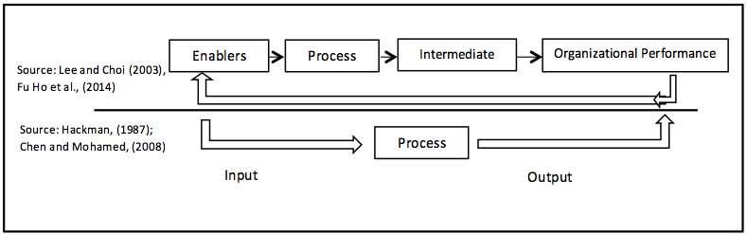
Figure 2 .2: Integrated research framework for KM

Taking into consideration the RBV, the knowledge-based view (KBV) of the firm emphasize the importance of a particular type of resources, i.e., knowledge, while RBV gives a wide variety of resources type in common requirements. The KBV is identified by individuals and not by the firms, and takes their form of either tacit or explicit knowledge (Choo & Bontis, 2002; Grant, 2000).
Hence, Curado and Bontis (2006) suggested that knowledge based competence can stay with the firm, and consequently a firm can create competitive advantages by organizing, collecting and assimilating the specialized knowledge that support the development of its individual employee. And this can take place via directive rules and group problems solving along with decision making.

  - Aspects of Knowledge Management
There are four major aspects of Knowledge Management: knowledge creation, knowledge sharing, knowledge utilisation and knowledge internalization. Knowledge creation comprises of those activities that are involved in the development, acquisition, codification and storage of knowledge. During this stage, knowledge can be created by internal knowledge workers through processes such as research, experimentation or experiential learning. In addition to this, knowledge can also be acquired from external sources such as market channels, customers, suppliers and competitors, through scanning and searching. Once some sort of new knowledge is obtained, it is converted into accessible and applicable formats through the process of codification, and this can be stored in the organisation’s knowledge repository. The next aspect—knowledge sharing or transfer—refers to the distribution or dissemination of knowledge between two points–the point of generation and the point of use. This can occur at different organizational levels, such as between different individuals, groups, departments and divisions, through both formal and informal channels. Knowledge transfer is a very important step, as without it, the impact of existing knowledge on organizational performance will be diminished. However, this step may not be easy to achieve, as important and valuable knowledge can be inherent in individuals, contexts or locations. The third aspect—knowledge integration or utilisation—refers to the ability of an organisation to organise, restructure and interpret the existing knowledge in order to reduce redundancy, enhance consistency, replace out-dated knowledge and maximise knowledge synergy. Knowledge application or internalisation refers to the actual use of knowledge in order to develop the organisation’s competencies and to locate the source of competitive advantage. Moreover, the application of knowledge can bring about a change in the behaviour of recipients, development of new products, improvement of operational excellence, enhancement of external relationships, adjustment of strategic direction and in competitive conditions. Furthermore, knowledge process capabilities can be defined as a formative construct with the four Knowledge Management process indications discussed above (Chen, 2014). To sum up, it can be said that the concept of knowledge goes way beyond mere data or information. The whole idea of Knowledge Management is rooted in human experience as well as the social context (Oltra, 2005; Alavi et al., 2005).
Therefore, managing it draws attention not only on the information technology, but also on the people involved in the organisation (Zamantılı Nayır & Uzunçarşılı, 2008; Havens & Knapp, 1999).
  - Knowledge Management Approach
Tacit Knowledge encompasses personal experiences, perceptions, aptitudes, expertise and insights that are implied/indicated, but not necessarily expressed, because it is kept within individuals and teams. The term ‘explicit knowledge’ refers to the knowledge conveyed to others using dialogue, media, demonstrations, documentation, illustrations etc. In short, it means knowledge that has been clearly expressed and is readily observable (Saisuthanawit et al., 2013). On the other hand, the term ‘implicit knowledge’ means knowledge that is expressed indirectly or implied. Explicit knowledge comes from structured sources and data (McAdam et al., 2007). The former US President, Bill Clinton, has gone on record and stated that what “one earns today is directly proportional to what one has learned”.
Several approaches and methods related to managing knowledge have been discussed in articles, books, journals and procedural papers. The research looks carefully at the growth of Knowledge Management Systems (KMS) as well as theoretical approaches and involvements that have occurred in the field of knowledge. The most pertinent data has been included in the research to provide a solid base. According to Asl and Rahmanseresht (2007) and Pankaj (2004), there were four approaches that have been selected and deemed suitable for this study: (a) Mechanistic approach (b) Systematic approach (c) Core capability approach and (d) The cultural/behavioural approach.
- The mechanistic approach to KM involves utilizing technology and resources, or in other words, to be more efficient in using technology and technical “know how”. This approach focusses on better access to information, including improved access methods and document reuse.
- The systematic approach involves using systematic practices and processes to distribute knowledge and information among capable employees at a suitable time in order to create more value and profit.
- The core competencies approach supports a mechanism to improve or change core knowledge skills, to become more productive and efficient. The core-performance competencies are processes that empower organizations to deliver high quality productions and services, without compromising on speed and efficiency.
- The cultural and behavioural approach plays a crucial role in the organization to encourage the employees to adopt the technology along with the KM system, and concentrates on innovation, creation and sharing the knowledge.
The above-mentioned four approaches were utilized in this study to develop a suitable model, which can be implemented in an oil and gas context.
  - Knowledge Management Practices
The acquisition and diffusion of the knowledge has become vital factors of an organization’s competitiveness. For instance, an organization such as industrial or offshore plant in the knowledge age is one that becomes skilled at, retains information and performs according to the available best practices, knowledge and management know-how. Organizations need to learn from their past mistakes and avoid repeating them in the future (Nguyen & Mohamed, 2011). A dynamic theory of organizational knowledge creation model may consist of the re-use of prior knowledge and skills in a new application setting (Hargadon & Sutton, 1997). KM application is one of the major attractions among researchers and practitioners (Hargadon & Sutton, 1997).
As Parent et al. (2007) concluded, after conducting several general interviews for main KM practice, the results in the organization are as follows: 1) knowledge generation/creation, 2) knowledge dissemination, 3) knowledge absorption and 4) knowledge transfer. Additionally, Beesley and Cooper (2008) developed conceptual framework for Knowledge Management in which the KM practices are categorized within five main practices 1) knowledge generation/creation, 2) knowledge sharing/dissemination, 3) knowledge transfer, 4) knowledge adoption, and 5) generative learning. However Zack et al. (2009) believed that KM practices depend only on two practices: 1) knowledge creation and 2) knowledge sharing, and in the following year, Niu (2010) conducted a four industrial clusters from the USA (CU), China (CC), Taiwan (CT) and Sweden (CS) to explore KM practices; the results identified two main practices, which are :1) knowledge acquisition and 2) knowledge creation.
Nguyen and Mohamed (2011) highlighted through developed empirical study results that there were three categories for KM practice, namely 1) knowledge exchange, 2) knowledge socialization and 3) knowledge internalization. Similarly, Jayasingam et al. (2013) proposed three key ingredients of KM practices for making Knowledge Management successful in organization, namely 1) knowledge acquisition, 2) knowledge dissemination and 3) knowledge utilization.
Moreover, another empirical study conducted by Mavodza and Ngulube, (2012) suggested a more extensive list of KM practices; this list consisted of 1) knowledge capture and/or acquisition, 2) knowledge retention and organization, 3) knowledge dissemination and re-use and 4) responsiveness to new knowledge that will achieve successful results in the organization. Likewise, Ho et al. (2014) proposed after conducting an empirical study that KM practices categorized within main five practices that can be successfully implemented in the organization, namely 1) knowledge creation, 2) knowledge accumulation, 3) knowledge sharing, 4) knowledge utilization and 5) knowledge internalization. Moreover Lin (2015) created a four main KM practices model that supported performance in the organization; the four practices were 1) organizational memory, 2) knowledge sharing, 3) knowledge absorption and 4) knowledge receptivity.
Finally, another Knowledge Management model that could be mentioned is the one developed by Lyu et al., (2016); in this model, four KM practices were identified and emphasized for successful KM implementation in the organization: 1) knowledge acquisition, 2) knowledge storage, transfer and sharing, 3) knowledge application and 4) knowledge creation
There are several variables that influence a successful KM implementation. Studies identify these as critical success factors. These are vital aspects of management planning and execution that impact OE. However, as Lwoga (2011) and Valmohammadi and Ahmadi (2015) stated after studying KM models, all these models and their related practices focus on business and organizational settings. As shown in Table 2.4, KM is a fusion of several practices. This study identified the following components: 1) Knowledge Creation (KC) – creating original knowledge (Nonaka & Takeuchi, 1995), 2) Knowledge Sharing (KS) – sharing among people, both formally and informally (Probst, 2002), 3) Knowledge Utilization (KU) – how the knowledge can be effectively put to use (Gold et al., 2001), 4) Knowledge Internalization (KI) – how explicit knowledge can be internalized by turning it into implicit knowledge (Ho et al., 2014).
Consequently, in line with this discussion, and following current literature, some of the important facets of KM shall be explored in more detail as follows.

Common KM practices  Table 2.4: Summary of common Knowledge Management practices (2007-2016). | Authors/Years | Field
1) Knowledge Acquisition, 2) Knowledge Storage, Transfer and Sharing, 3) Knowledge Application and 4) Knowledge Creation | (Lyu et al., 2016) | China enterprises firm, Research paper
1) Organizational memory, 2) Knowledge sharing,  3) Knowledge absorption and 4) Knowledge receptivity. | (Lin, 2015). | Taiwanese firms and manufacturers, Research paper
1) Knowledge creation, 2) Knowledge accumulation,  3) Knowledge sharing, 4) Knowledge utilization and  5) Knowledge internalization. | (Ho et al., 2014) | Taiwan-based enterprises, Research paper
1) Knowledge Acquisition, 2) Knowledge dissemination and 3) Knowledge utilization | (Jayasingam et al., 2013) | Malaysian Firms and manufacturers (small, medium & large), Research paper
1) Knowledge capture and/or acquisition, 2) Knowledge retention and organization, 3) Knowledge dissemination and re-use and 4) Responsiveness to the new knowledge | (Mavodza & Ngulube,2012) | New York Libraries, Research paper
1) Knowledge exchange, 2) Knowledge socialization and 3) Knowledge internalization | (Nguyen & Mohamed, 2011) | Australia, Small-to-medium sized enterprises (SMEs) Operating, Research paper
1) Knowledge acquisition and 2) Knowledge creation | (Niu, 2010) | Four industrial clusters from the  USA (CU), China (CC), Taiwan (CT), and Sweden (CS), Research paper
1) Knowledge Creation and 2) Knowledge sharing | (Zack et al., 2009) | Canada and in the USA, Business school, Research paper
1) Knowledge Generation/Creation, 2) Knowledge sharing/dissemination, 3) Knowledge transfer 4) Knowledge adoption, and 5) Generative learning | (Beesley & Cooper, 2008) | Australia, Conceptual paper
1) Knowledge Generation/Creation, 2) Knowledge dissemination, 3) Knowledge absorption and 4) Knowledge transfer | (Parent et al., 2007) | Canada, General literature review

Knowledge Creation
The origin and dispersion of knowledge has become an integral part of the current knowledge economy (Rooney et al., 2009; Jennex, 2007; Prusak, 1997). The process of generating knowledge internally is called knowledge creation (Parent et al., 2007).
Nonaka and Takeuchi (1995) described the dynamic theory of organizational knowledge creation the reuse of formerly gained knowledge and skills in a new application setting. It consists of a two-dimensional model. The epistemological dimension identifies people who forge knowledge, and the organizational knowledge heightens the knowledge and gives shape to it. The ontological dimension, on the other hand, describes the synergy between implicit and explicit knowledge (Nonaka & Takeuchi, 1995)

Knowledge Utilization
Knowledge Utilization refers to executing plans to ensure that the knowledge gained is efficiently applied in the organization. Probst (2002) and Heisig (2009)’s definition of a knowledge-based economy indicated a recognition of the number of significant factors. The responsibility of an individual lies in the creation and utilization of knowledge and the connected inherent value of the information; importance of the relationship between individuals in the form of networks, primarily in connection to their positions as actors in the creation procedure (Omotayo, 2015; Schönström, 2005; Castells, 2001). Even though there has been a general consensus from different sectors about the importance of internal knowledge, many organizations still have ineffective processes and gaps in management and augmentation of the organization’s knowledge base, thereby affecting business and operational performance. An organization is made up of different people each with their own roles and responsibilities (Hall & Goody, 2007).
The acquisition and diffusion of the knowledge has become vital for an organization’s competitiveness. For instance, an organization, such as an industrial or offshore plant in the knowledge age, is one that becomes skilled at, retains information and performs according to the available best practices and managerial know-how. Organizations should study past failures to avoid repeating them (Nguyen & Mohamed, 2011). Knowledge utilization is a substantial contributor to business achievement. KM impacts BSC lagging indicators such as financial performance indirectly and leading indicators such as internal process directly.

Knowledge Sharing
Knowledge Sharing refers to the extent to which individuals share their knowledge (Tannenbaum & Alliger, 2000). Knowledge Management refers to the planned and coordinated efforts that add value, by bringing people, technology and process together (Edwards, 2009; Davenport et al., 1998). Coordination comes from the exchange of knowledge, lessons learnt and the best practices that enable organizational learning. Mouritsen et al., (2005) are of the opinion that technology and people have got the lion’s share of attention at the expense of processes.
In the oil and gas industry across the world, there is vast knowledge, skills, expertise and technical know-how, all within the oil and gas companies, contractors and consultants and regulatory bodies. Therefore, sharing knowledge can help overcome problems and share the KM strategy (Oluikpe, 2012; Gao et al., 2008; Choi et al., 2008), including sharing intuition by encouraging everyone to collaborate and exchange ideas, insights and experiences, saving time to find solutions and improving the way of working in the future, to become more efficient and effective by avoiding repeating the same mistakes (De Treville et al., 2004; Frohlich & Westbrook, 2002).

Knowledge Internalisation
Dubberly and Evenson (2011) developed the SECI model of knowledge creation that includes socialization, externalization, combination and internalisation. Nonaka (2002) proposed that knowledge conversion happens when both tacit and explicit knowledge connect with each other (McAdam et al., 2007).
Internalisation or Internalization is the process of interpreting and then transferring explicit knowledge into the tacit knowledge held by individuals (Nonaka & Takeuchi, 1995). Increasing the efficiency of knowledge creation process and knowledge-intensity allows the organizations to continuously create new knowledge and new competitive advantages. Increased knowledge creation process flow accelerates knowledge creation, accumulation, sharing, utilization and internalization (Lee & Choi, 2003).
The SECI model emphasizes on collaborative learning in an organization. Many models have been developed to establish the KM systems; however, this study will consider the SECI Model (Socialization Externalization Combination Internalization Model). The reason behind the selection of Nonaka’s Theory of Organizational Knowledge Creation, which focusses on the SECI model, is that this model is a well-cited theory in Knowledge Management (Nonaka & Takeuchi, 1995). The SECI model will support the knowledge creation process work in any organization and is a driver that engages explicit and tacit knowledge in the process. The internalization process shares and then converts knowledge to implicit knowledge. At this stage, knowledge is utilized in practical situations and applied across new practices (Gourlay, 2003). For example, learning new skills and creating new ideas based on the existing knowledge.

Knowledge Management Practices within the Oil and Gas Sector
Knowledge Management in oil and gas companies is particularly difficult and complex, because knowledge is distributed; additionally, it is also not always easy to find knowledge from the most accurate sources. The knowledge is also fragmented and multidimensional, usually caused by the modular structure of an organization (drilling, projects, operation and maintenance) (Grant, 2013). Knowledge structures of oil and gas companies regularly need to be flexible and incorporate changes occurring in their dynamic business environment. The characteristics of its operations make it very important to exchange knowledge and expertise with service companies on regular basis. Operational knowledge is also tacit in nature and owned by professionals who may have different constraints, including distance and motivation to share it (Ramanigopal, 2013).
Companies operating in the oil and gas sector recognize the importance of KM, since they need to ensure that their employees’ knowledge is up-to-date. Failing to do so and not keeping pace with technology can seriously affect their performance. Effective KM strategies can help these companies maximize the competence of their employees and strengthen the internal knowledge sharing culture. The advantages of using KM include maximizing the efficiency within the organization (Asl & Rahmanseresht, 2007; Zamantılı Nayır & Uzunçarşılı, 2008).
In studies carried out by both López-Nicolás and Meroño-Cerdán (2011) and Myers (2015), it was demonstrated that someone, somewhere, has had the same problem before, and therefore, an exchange of ideas to make improvements is possible. However, while the oil and gas industry is generally good in sharing, it is not particularly good at realizing effective benefits of the shared material (Rhambasi, 2010). Hence, the current knowledge-driven economy demands that knowledge be the key ingredient of success, to help businesses achieve reduced operational costs, higher utilization, better uptimes and improved market positioning.
  - Optimizing Operational Efficiency
Operational excellence relates to an explicit business strategy that helps organizations become efficient and effective in their processes, while offering products and services at a competitive price (Wu & Chen, 2014). Optimum Operational Efficiency is expressed as an Operational Excellence Management System (OEMS), which includes a set of rules that will guide a company in its operations, in order to achieve operational competence. This system is based on teamwork, leadership and creative problem solving. This leads to a continual improvement cycle across the organization. It focusses on the shareholder and customers, empowers employees and optimizes existing activities in the process (Chevron, 2010). OE refers to a system that identifies accountabilities across the organizational hierarchy and triggers continual improvement (Caruso et al., 2013). As the organization becomes more productive and competitive, it uses operational practices that focus on eliminating waste and effective utilization of resources. Practically, productivity improves the organization’s capability to produce more for a lower cost. Better productivity has a positive impact on human resource, by developing their capabilities and competence, capital through expansion and scheduled upkeep, materials through quality improvement, meeting customer demands and long-term partnership and suppliers by reducing wastage (Phusavat, 2013). Operation management of the organization revolves around efficient resource utilization to produce goods and services (Joseph & Monks, 2004). Operational efficiency (OE) needs the following conditions to succeed: superior capture and effective utilization of data and information, robust continual improvement culture, continual people development efforts, compelling KM best practices, advanced systems that capture improvement, top management commitment to create and sustain performance improvement (Operational Excellence—Impact Solutions, 2012).
As stated previously, operational efficiency has typically meant standardization by rule and is guided by the phrase “it is not just about cost cutting” as coined by Burrows (2012). Looking back, efficiency is a measure of whether the correct amount of resources (inputs) has been used to deliver a process, service or activity. If a process results in lower resource utilization for the same output in a way that it results in less consumption than planned, it is referred to as being efficient (Phusavat, 2007). Globally, the oil and gas sector is struggling from the drop in oil price. The continuous decay in crude oil prices has severely impacted the profit margins of oil companies. Many firms have opted to cut their manpower to avoid high operational costs (Grunfeld, 2016; Maceda, 2015). Many companies have been forced to downsize or abort drilling operations, leading to bankruptcy in certain cases. Currently, the low oil prices are having a destructive impact on expansion, growth and profit margins. This implies a downward pressure on oil and gas revenue and the need to reduce cost. Oil and gas firms that can keep their production cost low have traditionally been the winners. Therefore, technologies that provide the much-needed operational efficiency cannot be overlooked (Sebastian, 2015;Ramanigopal, 2013).

  - Balanced Scorecard
Balanced Scorecard (BSC) is a performance management tool that was designed by Robert Kaplan and David Norton in 1990 for measuring the alignment of small operational activities and large visions and strategy (Chen et al., 2009; Niven, 2005 ). It keeps the organization focussed on its core business activities and its achievement. BSC includes four performance indicators: financial, customer, internal process, learning and growth (Kaplan & David, 1996). As mentioned earlier, in order to measure the effects of KM on operational efficiency and to understand organizational performance, BSC will be employed. The BSC model provides an integrated framework that can help organizations convert strategic objectives to a set of performance indicators. The BSC differentiates from other frameworks by its capability to link different kinds of business performance indicators—financial and non-financial. It is a tool to not only share strategy across the organization, but also to dictate the implementation strategy (Valmohammadi & Servati, 2011; Lee & Choi, 2003). There is a strong influence of strategy on execution and the right strategy ensures better planning and execution (Amaratunga et al., 2002).
Hoque and James (2000) highlighted through the empirical study that greater usage of BSC is associated with improved performance; however, it has been pointed that the organization shall investigate why and how companies implement BSC to improve performance. In addition, Chen and Mohamed, (2008) suggested that knowledge utilization is the strongest contributor to general business performance as though the study emphasized the impact of KM practices on the lagging performance indicators of BSC but he proposed that paying attention towards the efficiency of KM is not enough. Such an investigation requires considerations of additional contextual constructs, for example, organizational culture and technological infrastructure. On the other hand, another empirical study conducted by Rehman et al. (2015) suggested that KM practices influence the overall performance of firms; however, the investigation of the mediating role of business process capability and organizational learning using BSC are yet to be conducted.
Valmohammadi and Ahmadi (2015) argued that through the conducted empirical study result that KM practices positively and meaningfully (though weak) impacted the overall organizational performance since it has been claimed that statistical and comprehensive methods like BSC are yet to be explored to find out how KM makes a difference to organizational performance or efficiency. In spite of previous results, Lin (2015) developed a model to examine the influence of Knowledge Management Orientation (KMO) dimensions on Balanced Scorecard outcomes though it been pointed out that different KMO dimensions affect individual, group and organizational-level KM effectiveness to be explored by considering BSC. Finally, Van Looy and Shafagatova (2016) developed a conceptual framework for KM in which they suggested that knowledge utilization is a substantial contributor to business achievement, as has been stressed in the conducted study that KM impacts BSC lagging indicators such as financial performance indirectly and leading indicators such as internal process directly; however, the empirical study shall be conducted and whether or not the effect of KM on BSC is associated with improved performance shall be verified.
In Table 2.5, key related researches on KM, BSC and organizational researchers have been presented. The BSC complements financial performance indicators with drivers for future growth, such as learning. Such intangible measures demonstrate the association between strategy and organizational knowledge (Kaplan & Norton, 2000).

Table 2.5: Key Literature Review summary on OE and BSC
Author/Year | Research Design | Results & Conclusions
(Hoque & James, 2000) | Empirical/  survey | Greater usage of BSC is associated with improved performance.
(Chen & Mohamed, 2008) | Empirical /survey | Knowledge utilization is the strongest contributor to general business performance. The impact of KM activities on the lagging performance indicators of BSC.
(Rehman,et al., 2015) | Empirical /survey | KM practices influence the overall performance of firms and furthermore, to investigate the mediating role of business process capability and organizational learning using BSC.
(Valmohammadi & Ahmadi, 2015) | Empirical /survey | The results revealed that KM practices positively and meaningfully (though weak) impacted the overall organizational performance.
(Lin, 2015). | Empirical /survey | Develops the decomposed model to examine the influence of Knowledge Management Orientation (KMO) dimensions on Balanced Scorecard outcomes.
(Van Looy & Shafagatova, 2016) | Conceptual study | Knowledge utilization is a substantial contributor to business achievement. KM impacts BSC lagging indicators such as financial performance indirectly and leading indicators such as internal process directly.
  - Contribution of Balanced Scorecard to Key Dimension of Operational Efficiency
There were several studies that linked financial factors such as improvement in revenue growth and improvement of profit margin to operational efficiency. Such studies found a significant link between operational efficiency and features such as profitability, financial accuracy and quality services for end consumers (Mutinda, 2014; Tardivo & Viassone, 2010). Thus, operational efficiency is an amalgam of productivity, growth and performance, technical efficiency and profitability (Pasiouras et al., 2009). Dydacomp (2014) stated that an improvement in revenue or sales growth can be achieved by accomplishing seven operational improvements, such as building brand loyalty, integrating shipping, labelling and rates, making and providing top-notch customer services, gaining visibility, controlling inventory throughout sales channels, enhancing business growth using different channels, applying an integrated retail strategy and by the integration of new systems, as the business grows gradually.
Gilmore (2014) emphasized that operational efficiency could be increased by using five approaches based on profit margins. Firstly, by measuring current performance by setting and examining the organization’s Key Performance Indicators (KPIs). It would assist the firms in understanding their existent performance and in recognizing current inadequacies. Secondly, it can be done by assessing the management of capacity and resources. This includes assessing employees’ skills develop their knowledge and their relation with their job roles, using past projects for guiding new project plans and reviewing timesheets for identifying idle resources. Thirdly, operational efficiency can be enhanced by increasing workforce capacity and relocating resources accordingly. Next, operational efficiency can be boosted by improving project management and thus creating maximum profits. The improvement can be made in areas such as unbillable work and skills. Finally, operational efficiency can also be enhanced by updating technology to save time in manual work and thus positively affecting profit margins.
One of the most important approaches for improving operational efficiency was developing employee knowledge and assessing their skills to measure their employee performance and organization performance prerequisite management’s tools. Hence, irrespective of the terms used, it has to be taken into consideration that the Knowledge Managements embedded in an organization’s culture influences organizational performance (Marsick & Watkins, 2003; Wilson, 2001). Many researches have defined how to measure the KMPs separately, for financial and non-financial parameters. But, none of the studies measured the improvement of operational efficiency through BSC approach, by linking KM and OC with tangible results for the oil and gas firm (Gholipour et al., 2010). Kaplan and David (1996) highlighted the importance of BSC performance indicators, such as financial, customer and learning, on overall strategy. KM fits in well with this approach, by relating to the Learning and Growth indicator aspect of BSC. As Fairchild (2002) indicated, the practice of Balanced Scorecard (BSC) in reflecting Knowledge Management agreed that knowledge included notions such as culture, custom, values, training, expertise and skills as the essential parts of knowledge. On the other hand, Tardivo and Viassone (2010) stated that the Learning and Growth indicator aspect of BSC is based on intangible assets and interlinked with human capital concepts (competence, knowledge) organizational capital (Organizational culture, leadership style, and teamwork managements) and technological capital ( IT system). This suggests that KM impacts other processes.
BSC allows the management to monitor progress against set objectives by providing various measurement metrics. Such metrics provide a valuable reference point for measuring KM implementation against planned goals (Mutinda, 2014). This study therefore tests whether KMP plays a significant role in mediating the relationship between OC and OE. The following Table 2.6 indicates the linkage of four perspectives of the BSC and OE by providing real example from the oil and gas industry, which explicate clearly how and why the BSC was used to examine the term OE when it was already part of the BSC.

Table 2.6: Linkage BSC Perspective and Operational Efficiency (OE) in the Oil and Gas
sector
BSC  Perspective | Explanations | Justification of Operational Efficiency (OE) in the Oil and Gas sector
Financial Perspective | Most organizations value financial indicators. Such organizations attempt to improve revenue reduces costs, mitigate risks and raise productivity through the use efficient use of assets. Getting better financial results in organizations is the benchmark of success. Measuring and analysing financial indicators provides an insight into their strengths and weaknesses (Darvish et al., 2012). | In the oil and gas sector, improving maintenance and reliability of the plant facilities is reflected by reduced downtime, increased predictability and reduced breakdown.  Operational Efficiency best practices help improve the machine uptime, offer better capacity utilization, lower maintenance and production costs. According to McKinsey, top global oil and gas operators attain a reliability of 95–98% and are able to lower maintenance costs to at least 30% below industry averages (Laurens & van der Molen, 2010).  Hence from the Finance perspective, it can map the expectations of the business’ shareholders. For example:  Goal: Are the shareholders satisfied with an Increase in Total Shareholder Return?  Possible leading indicators:  - Total shareholder return  - Return on capital employed
Customer Perspective | Ensuring customer’s satisfaction is vital for most businesses, as is other non-financial indicators such as production quality, price, customer service and speed of delivery. Customer satisfaction is a predictor of customer loyalty in most organizations (Chen et al. 2006).). | In the oil and gas sector, productivity and quality improvements include potential increases in high quality product, capacity release and waste reduction.  According to Bain and Co., better maintenance planning can reduce breakdown and emergency repairs by as much as 80–90% in oil and gas companies (McCreery et al., 2013)  In one example, a well-known company in upstream oil and gas exploration, and production with a market capital of $18 Billion was growing both organically and through acquisitions. With a spate of acquisitions, the organization lost transparency in the vendor management program. The result was inefficient supply chain management, higher spending, undue delays in material and poor delivery times. Through process re-engineering and technology/automation, the company has generated a 20% reduction in the maverick spend (Sebastian, 2015).  Hence, Customers perspective needs to map the customers’ expectation from the company. These might be: how should an oil and gas company appear to the customers?  For example, create a product that reduces energy costs. Goal: Create energy products that benefit customers.  For example: reducing their carbon footprint. Goal: Help customers to reduce their environmental impact.  Possible leading indicators:  - Increase Sales  - Optimize Operating Costs  - Better Quality Products  - On time deliveries  - Client Satisfaction/Image
Internal Business Process Perspective | This perspective determines internal business processes that allow the organization to align with stakeholder needs and expectations (Figge et al.,2002). | In the oil and gas sector, the well delivery management software automates, integrates and streamlines numerous pre-drilling tasks and departments (resource development, land, geology, project development, drilling, completions, regulatory and production) to allow the management of activities on one integrated platform. This software can lower the time required for planning and drilling by an average of 5%, allowing companies to begin production and reach targets for their numerous wells several days early (Sebastian, 2015).  The impact on improved rig scheduling and utilization alone (where each day can save between $30,000/rig to $100,000/rig) typically generates millions of dollars in annual savings (Sebastian, 2015)  From the Internal business process perspective, it needs to map the goals that will ensure achieving the goals specified in the Customer perspective above. For example:  Goal: Improve operational efficiency and effectiveness for  Upstream (exploration, development, production and storage) and  Downstream (manufacturing, transportation and supply).  Possible leading indicators:  - Gross average production (barrel/day)  - Plant availability (%)  - Well production ($/rig)
Learning and Growth Perspective | One of the four BSC aspects is learning and growth of organizational assets and their role in the strategy.  The fourth aspect of Balanced Scorecard describes learning and growth, intangible assets of organizations and their role in the strategy. Organizations can grow and innovate when it is able to develop its skills and leadership and also learn from its mistakes and other organizations’ behaviours and be able to create new techniques for itself. Intangible assets are divided into three categories (Kaplan & Norton, 2005; Darvish et al., 2012).  - Human capital: skills, knowledge and talented staff;  - Information capital: databases, information systems, networks and information infrastructures;  - Organizational capital: culture, leadership, staff coordination, and teamwork and Knowledge Management. | McKinsey estimated that frontline workers at oil and gas companies spend 50–60% of their time on value-adding activities, compared to an industry average of half that. In addition, implementing best practice operating procedures can reduce safety incidents by up to 50%, according to Bain and Co., by helping identify and mitigate potential hazards (Laurens & van der Molen, 2010).  Another example by Schlumberger, the In Touch system, created a centralized knowledge-based organization with easy access to information. The results were $150 million cost savings a year, a 95 per cent reduction in time to resolve technical queries, and a 75 per cent reduction in time to update engineering modifications (Leavitt, 2002).  Finally, in the Learning and Growth perspective, an organization needs to shape their learning directions. How will oil and gas sustain ability to change and improve? For example:  Goal: Finding and implementing energy-efficient technologies  Goal: Provide a safe working environment  Possible leading indicators:  - Injuries rate, or its equivalent Lost Time Injury Frequency (LTIF)  - Staff turnover %
  - Summary
This chapter emphasizes the importance of theoretical background toward organizational culture (OC), Knowledge Managements practices (KMPs), operational efficiency (OE), and Balanced Scorecard (BSC), while also identifying the gaps in it. It indicates the importance and definitions of the constructs and the synthesis of previous models and theories of each of this construct were discussed. The aspect of Knowledge Management and KM practices in the oil and gas context were also emphasized. Finally, the contributions of the Balanced Scorecard in the operational efficiency were deliberated upon.
The next chapter will explore the relationships between the research components and use these as a foundation to develop the research hypotheses.

CHAPTER THREE: DEVELOPMENT OF RESEARCH HYPOTHESES
  - Introduction
The aim of this chapter is to shape the research hypotheses by reviewing relevant literature exploring the relationships between the study variables. The chapter also highlights the most significant findings, while identifying the said relationships.
This chapter continues with discussions of OC elements and (KMPs) as an intermediate factor of the organization by considering the KM approach that relates to managing knowledge in the organization. It also seeks to provide a foundation to the theoretical model and related hypothesis through a comprehensive review of existing literature used to deal with the research questions proposed in Chapter One, and by identifying the aspects of operations efficiency from Balanced Scorecard (BSC) perspective.
The hypotheses are largely derived from theoretical statements made in the literature on Knowledge Management’s practices, organizational culture elements and operational efficiency and Balanced Scorecard. The structure of Chapter Three is presented in Figure 3.1

Figure 3.1: Chapter Three Outline

  - Hypothesis Development

Organizational Culture (OC)
Due to the environmental and the market contingencies, organizational cultures (OC) usually changes toward the changes over the time period of their adjustment, as culture is identity or DNA for every organization that has its own particular culture and distinctive practices (David, 2012; Schein, 1984)
According to Yeh et al.(2006), an effective culture for Knowledge Management involves characteristics, norms and practices that directs its employees’ daily working relationships and provide a direction as to how to behave and communicate within the organization and how the organizational hierarchy is built (Akhavan et al., 2014). Hence, an effective culture where people derived from human experience for Knowledge Management implementation is constructed (West & Turner, 2013; Gupta & Govindarajan, 2000).
As identified in the Literature Review previously, several studies piloted to investigate the cause of KMP initiatives implementation failures in the organization by considering the three pillars of KM, namely people, process and technology; however. it can be recognized that organizational cultures is the main obstacles to KM success and performance of the organization (Tuggle & Shaw, 2000). Culture is a wide concept that contains several facets; firstly, trust is a fundamental aspect of knowledge sharing (Valmohammadi & Ahmadi, 2015). Trust among followers leads to greater agility and acceptance of changes, subsequently creating the second facet, which is collaboration among members and the affinity to adapt to new terms. Collaboration has also been empirically verified as an important contributor to knowledge creation and growth in the firm. Hence, the collaboration culture can help in creating a platform for learning and growth for various competencies and prevents repetitive mistakes. Thus supports the creation of the third facet, competence. As mentioned previously, learning embodies the acquisition of new knowledge (Gholipour, et al., 2010). Breakthrough innovation is possible when individuals call upon their learning faculty, bring together knowledge from several sources and reconfigure it in an original manner (Nonaka, 2002). In other words, people expertise (I-Shape) and (T-shape) play vital role in the organization learning—as explained previously in chapter 2—as Alavi et al. (2005) elevated professional status and encouraged the sharing of knowledge with others, thus improving overall KM performance. Another fundamental facet of KMP to be implemented successfully in the organization is commitment as many studies found that engaging with employees led to them having a sense of ownership of the task, leading to organizational commitment (Gupta et al., 2000). Some studies found trust as a foundation to commitment (e.g., Kilburn et al., 2006; MacMillan et al., 2005). Therefore, this study places emphasis on organizational values such as trust, collaboration, commitment and competency (Sammons et al., 2016; Eppler & Sukowski, 2000).
A broad range of these elements has been identified in the Literature (as presented in Table 2.3) in Chapter 2. These key dimensions of OC are adapted from the Literature and tested in the study through the following hypothesis:
H 1: | Organizational Culture is a second-order latent construct composed of trust, commitment, collaboration and competence.

Knowledge Management Practices (KMPs)
KM provides solutions to handle business problems with some differences; there is a rising recognition for companies that apply KM to manage business concerns and progress. KM enables the creation of user-friendly technology that enables the handling of information with association and access. KM is not measurable and quantifiable. Consequently, KM becomes an orderly approach to decision making of location and the process of investing (Linderman et al., 2010; Halawi et al., 2006). The definition of a knowledge-based economy indicates recognition of the number of significant factors. The responsibility of an individual lies in creation and utilization of knowledge and the connected inherent value of the information, the importance of the relationship between individuals in the form of networks, primarily in connection to their positions as actors in the creation procedure (Omotayo, 2015; Schönström, 2005; Castells, 2001).
Even though there has been a general consensus from different sectors about the importance of internal knowledge, many organizations have ineffective processes and gaps in management and augmentation of the organization’s knowledge base affecting business and operational performance. An organization is made up of different people each with their own roles and responsibilities (Hall & Goody, 2007). Therefore, there are four major aspects of Knowledge Management practices, namely knowledge creation, knowledge sharing, knowledge utilisation and knowledge internalization; 1) Knowledge Creation (KC): refers to the creation of original knowledge and comprises of those activities that are involved in the development, acquisition, codification and storage of knowledge (Nonaka & Takeuchi, 1995), 2) Knowledge Sharing (KS): refers to the sharing among people, both formally and informally (Probst, 2002), 3) Knowledge Utilization (KU): refers to how knowledge can be effectively put to use (Gold et al., 2001), 4) Knowledge Internalization (KI): defines how explicit knowledge can be internalized by turning it into implicit knowledge (Ho et al., 2014). By examining all of the above KMP aspects that were a combination of practices adopted by several previous researchers in their model, as presented in Table 2.4 in Chapter 2, this study grouped them into four main KM practices that ensured successful implementation in the organization and led to increased Operational efficiency (Demarest, 1997). Therefore the following hypothesis could be developed:
H2: | Knowledge Management Practices is a second-order latent construct comprising knowledge creation, knowledge sharing, knowledge utilization and knowledge internalization.

Operational Efficiency (OE)
As mentioned previously in the Literature Review, Gilmore (2014) emphasized that operational efficiency could be increased using five approaches based on profit margins. One of the approaches is by measuring current performance of organization or company by setting and examining the organization’s Key Performance Indicators (KPIs). Most companies track their KPI’s using Balanced Scorecard (BSC) (Kaplan & David, 1996), as it is very well known that BSC have been used in strategic business managements to monitor key performance indicators, and are intended to provide structure to manage resources. A BSC can be described at the business unit or cooperate level, and can be adjusted in a government and non-profit context; this elasticity makes it an attractive measurement tool for the management in any organization. Establishment of BSC initiate with the identification of an organization vision and mission as well as the values (Kaplan & David, 2004). By describing organization vision and mission, the executives are allowed to choose the anticipated results. Once these results are described, managers can link the anticipated financial results with customer results, internal business process, and learning and growth strategies, the final of which forms the basis of the Balanced Scorecard for the organization; the absence of learning and growth, and the overall business strategy can’t be performed in view of the BSC initiators. There are four basic perspectives that need to be taken with the KPI Balanced Scorecard (Kaplan & David, 1996) :

- Financial perspectives – monitor the financial performance. In other words, to enlarge the financial indicators to include leading indicators instead of accounting measures. “Leading financial indicators like revenue growth and revenue mix provide insight into new business sources that could be different than previously known” (Kaplan & David, 1996).
- Customer perspectives – monitor customer satisfaction, feedback, attitude, loyalty and market shares goals.
- Internal business process perspectives – focus on business operation goals that are required to meet customer objectives basically by looking at the efficiency and the quality of the product.
- Learning and growth or innovation perspectives – imperceptible drivers for future success such as human capital, employee capability, culture, training, information system, etc.

The indication is that these four perspectives are reliant and ranked, as growth is driven by continuous learning and innovation that lead to the improvement of the internal business process. Subsequently these improvements through the KPI balanced scorecard then support an increase in operating efficiency, which results in higher customer satisfaction and increase financial performance (Kaplan & David, 1996). While the explanation of the balanced scorecard differs relies on the bases, the main idea of relating strategy to operational approach remains sound and solid structure to map any organizational progress toward success.
There are many researchers who claim that the evidence of the BSC effect on organizational performance is limited and unclear in the Literature, which mostly focus on financial performance improvements (Capelo & Dias, 2009; Tapinos et al., 2008; Chenhall, 2005). For instance, Nørreklit (2003) stated that there were no comprehensive arguments made by Kaplan and Norton to demonstrate that the BSC had actual remarkable results, for the results they claimed were based on the structure developed for the BSC. Therefore Kaplan and Norton (2001a) in their third edition book labelled the performance of many organizations and companies who adopted the BSC as having achieved remarkable results. Hence, the BSC has promptly become one of the broadly used management tools around the world. Ever since, several studies have been conducted to verify its practicality, such as a study by Bain and Company (2013), who piloted on more than 12,000 respondents around the world indicating that the BSC is the fifth widely used management tool in the world that gives remarkable results to the companies. Likewise, another study also ranked the BSC at the topmost of the lists in Europe, Middle East and Africa (Rigby & Bilodeau, 2011). In spite of this, a study conducted by De Geuser et al. (2009) claimed that a successful BSC implementation indicates a wide variety of performance improvements, both financial and non-financial, confirming a positive influence of the BSC adoption on organizational performance. There was a lack of studies that measured the improvement of operational efficiency through the BSC approach, by linking KM and OC with tangible results for the oil and gas firms (Gholipour et al., 2010). As mentioned earlier, in order to measure the effects of KM on operational efficiency and to understand organizational performance, BSC will be employed.
H 3: | Operational Efficiency is a second-order latent construct comprising of financial performance, customer satisfaction, internal business process and learning and growth.
Therefore, the following hypothesis was postulated:

Organizational Culture (OC) and Knowledge Management Practices (KMP’s)
Knowledge is understood as the most significant and important asset for organizations in dynamic business environments. It is the ability of an enterprise to take on board the knowledge of its team, make new knowledge and direct their knowledge more successfully than their competitors, resulting in it attaining a competitive advantage (Drucker, 2002). Rhambasi (2010) insisted that knowledge is the basis of the 21st century enterprises that have a flair for innovative advances in all areas of organization. Knowledge is also understood as an important tool to aid an enterprise towards achieving its goals (Zhang et al., 2012). The goal of Knowledge Management is to come up with an atmosphere where people are empowered to converse with each other and share knowledge more competently (Margaryan et al., 2011). According to Yang (2010), the word ‘Knowledge Management’ can be identified as the modus operandi of generating, collecting and producing organizational knowledge, to develop fresh prospects and increase the performance of an organization. Organizational knowledge covers complete strategies and implicit knowledge that people have on areas such as manufacturing and business systems and the unambiguous knowledge encrypted in guides, databases and factual systems. Organizational knowledge also takes under its umbrella the strategic facts and figures that are collaborated in a joint manner in firms, such as schedules, cultures and expertise set in social development (Grant, 1996). Regarding the link between Knowledge Management (KM) and organizational culture (OC), it has been found that Knowledge Management processes gain focus and direction from creating a culture rooted in thinking about business risk and the value created. The knowledge again is orientated to support the main aim of the business of managing the risk and describing its value (Leavitt et al., 2002). According to a study by Choy and Suk (2005), before the implementation of Knowledge Management strategies, it is very important to take into consideration the cultural environment of a company. Furthermore, it was claimed by Gupta et al. (2000) that an open culture, which revolves around blending the innate skills and experiences of the individuals into the spectrum of organizational knowledge, would yield better results, as there are numerous studies examining the relationship between organizational cultures and Knowledge Management (Mudor, 2014; Moradi et al., 2012; Allameh et al., 2011; Foss et al., 2010).
Zamantılı Nayır and Uzunçarşılı, (2008) stated that one of the most significant hurdles to the implementation of an effective Knowledge Management was organizational culture itself and a positive relationship constructed on trust would be beneficial to the implementation of Knowledge Management practices within the organization (Hassan & Semerciöz, 2010). Furthermore, knowledge that is embedded in an organization’s culture can affect how that organization performs. The notion of a knowledge culture in organizations is progressively remarkable in human performance researchers (Marsick & Watkins, 2003). A knowledge culture is formed by the same mechanisms as an organizational culture (Wilson, 2001). As highlighted in the previous Literature Review Chapter, Table 3.1 illustrates some previous studies that indicate that OC is significantly related to KMP. Hence, based on the review of relevant literature, the following hypothesis was postulated:
H4: | Organizational Culture (OC) has a significant relationship with Knowledge Management Practices (KMP).

Table 3.1: Relationship between Enablers (OC) and Process (KMPs).
Source | Enablers |  |  |  | Process
Source | Organizational Culture (OC) |  |  |  | Knowledge Practices /activities (KMPs)
Source | Collaboration | Trust | Commitment | Competence | Knowledge Creation | Knowledge Sharing | Knowledge Utilization | Knowledge Internalization
(Gupta, et al., 2000) |  | x |  |  | x | x | x
(Lee & Choi, 2003) | x | x | x | x | x |  |  | x
(Hassan & Semerciöz, 2010) |  | x |  |  | x | x
(Gholipour,et al., 2010) | x | x | x | x
(Niu, 2010) |  | x |  |  | x
(Ho, et al., 2014) | x | x | x |  | x | x | x | x

Knowledge Management Practices (KMP’s) and Operational Efficiency (OE)
While many studies contributed to assessing the link between KM and organization performance (Chen & Mohamed, 2008), there was an ambiguity towards measuring organizational performance only from financial and non-financial perspectives (Lin, 2015). As organizations have judged performance based largely on financial perspectives, there is insufficient literature assessing the performance based on non-financial aspects of performance, such as learning and growth, customer satisfaction and internal business process (Figge et al., 2002).
Theriou et al. (2011) and Demarest (1997) emphasized that the implementation of KM practices in the organization would promote organizational learning, improved intellectual asset management and increased operational efficiency as well as continual improvement. Hence, KM meets the requirements of both financial and non-financial measures (Lin, 2015; Chen & Mohamed, 2008). As knowledge utilization is a substantial contributor to business achievement, KM impacts BSC lagging indicators such as financial performance indirectly and leading indicators such as internal process directly (Van Looy & Shafagatova, 2016). However, Zack et al. (2009) argued that there was no direct relationship between KM practices and financial performance. Darvish et al. (2012) empirically clarified the effect of Knowledge Management indices on the advancement of the four balanced scorecard perspectives. A Knowledge Management strategy that is efficient would lead to an increase in the organizational memory as well as its capacity to gather, evaluate and also put into the knowledge to use for its own advantage. Consequently, knowledge competencies affect not only the present but also the future of the organization’s performance (Quintane et al., 2011). In order to gain an advantage over their competition, the organizations must compete for their survival through continuous improvement and innovation. As far as the current business environment is concerned, in order to ensure success in the business environment, it is not just enough to invest in areas such as capital, manpower and procurement of raw material but also in the capacity for knowledge innovation from all the staff of a company (Koontz & Donnell, 1993). Goh (2003) and Ollila (2011) emphasized that the role of Balanced Scorecard card implementation in achieving efficiency by maintaining that the frequency at which an organization incessantly learns innovative ways for doing things might cultivate the only sustainable source of organization efficiency; this has been emphasized by another study by who also emphasize. However, there is a slight disagreement to the principle that BSC is a competence that all organizations should develop in a competitive environment (Hamel & Prahalad, 1994), as most researches have not clearly linked BSC with efficiency as is the case with intellectual capital (knowledge based resources) via resource-based view of the firm.
Having an organization with experienced people is essential to conduct the organization’s business, and the day they walk out of door, the organization would face serious problems. While the organization can hire a replacement, very often, the replacements lack competence and experience, resulting in reduced operational performance. Experienced people are often more expensive to hire and retain, not to mention difficult to integrate. So how does an organization retain and transfer its expertise? This explains why organizations and leaders are turning to the KM model to manage risks and develop value (Avram, 2007). Operating companies are now able to appreciate the use of Knowledge Management Practices (KMPs), since they are faced with the necessity of continuously updating their employees’ knowledge and promoting this constantly. By implementing KMPs, they can maximize the employee’s competence as well as the organization’s level of knowledge as a whole (Enzer, 2014). As highlighted in the previous Literature Review Chapter, Table 3.2 depicts some previous studies that indicated that KMP is significantly related to OE. Hence, based on the relevant Literature, the following hypothesis could be developed:
H5: | Knowledge Management Practices (KMP) have a significant relationship with Operational Efficiency (OE).

Table 3.2: Relationship between Process (KMP’s) and organization performance (OE-BSC).
Source | Process |  |  |  | Organization Performance
Source | Knowledge Practices /Activities (KMPs)(Mediator) |  |  |  | Operational Efficiency (BSC)
Source | Knowledge Creation | Knowledge Sharing | Knowledge Utilization | Knowledge Internalization | Financial performance | Customer stratification | Internal business Process | Learning and Growth
(Lin, 2015) | x | x | x |  | x
(Alavi, et al., 2005) | x | x | x | x |  | x
(Zheng, et al., 2010) | x |  |  |  | x
(Lee,et al.,2012) | x |  |  |  | x
(Hsu, 2014) | x | x |  |  | x

Organizational Culture (OC) and Operational Efficiency (OE)
In this section, the link between organizational culture (OC) and operational efficiency (OE) will be scrutinized. Introducing KMPs into a company leads to the development of competencies that are knowledge-based, which in turn leads to harmonization and diffusion of tacit and explicit knowledge and generates the integration of knowledge principles and practices into all processes, routine activities and employees. An effective KM will boost the organizational memory and the capability of that company to gather, evaluate and also put into practice the knowledge required for the company’s benefit. The end result of this is that knowledge competencies affect not just the present, but also the future performance of the company (Quintane et al., 2011). It affirms Desouza’s (2011) insight that processes and technology alone are not enough to drive an organization. Rather, it is the human assets (people: staff) that are the important components in an organization’s success. Omotayo (2015) emphasized that Knowledge Management is a key driver of organizational performance and a vital tool for organizational survival, competitiveness and profitability.
As the employee learns more from their own performance, the knowledge assets increase. According to another study, Knowledge Management can benefit the overall performance of a company in a number of ways: (1) by leading to an improvement in the effectiveness and efficiency of the business processes; (2) by empowering employee learning from both internal as well as external sources and (3) encouraging the creation of unique knowledge-based products or the betterment of the ones that are already in existence and which provide significant additional value to the organization (Argote & Ingram, 2000; Conner & Prahalad, 1996).
Still, there are some other studies that resist KM initiatives and argue that KM does not always positively impact business performance and often fail to result in improved task outcomes in an organization’s operational performance (Sabherwal & Sabherwal, 2007). Based on the above varying outcomes of previous studies, it has been observed that Knowledge Management's effects on a firm’s performance are not unanimous (Smith & McKeen, 2005). Yet, various conceptual studies stated that KM can improve corporate performance and competitiveness (Holsapple & Jones, 2004; DeTienne & Jackson, 2001; Civi, 2000).
Tseng (2008) pointed out that in order for the Knowledge Management strategies to yield better results, it is imperative to have an improvement in the corporate performance. As a result, it is important to measure how Knowledge Management contributes to performance in reality, and this is particularly important since currently there are no conclusive research studies available, which studies the relationship between Knowledge Management and organizational performance (Yang, 2010; Tayebi et al., 2010; Nikpour & Salajegheh, 2010).
In line with the findings from the review of relevant KM literature, the results also show that KM practices have a positive relationship with the performance of the company. (Omotayo, 2015; Ho et al., 2014). Organizational culture positively impacts Knowledge Processes (KP), which subsequently positively impacts job performance. Corporate culture has a direct impact on the achievement of management tools that are utilized to help the companies in process improvement and decision-making (Ho et al., 2014). On the other hand, there is a direct relationship between organizational culture and the successful implementation of BSC (Bititci et al., 2006; Bititci et al., 2004). According to Chong and Besharati (2014), the hurdles to knowledge creation mostly originate because of a poor culture in the company. The different barriers to creating knowledge can be divided into three sections, namely individual (people), organizational and technological barriers. For Knowledge Management to provide value to the organization, it is important that the above mentioned barriers should come together in such a way that they are complimentary to one another.
Based on previous studies, it was indicated that OC is positively related to organizational performance and efficiency (Ho et al., 2014;Gholipour et al., 2010; Hassan & Semerciöz, 2010; Lee & Choi, 2003; Gupta et al., 2000) In addition, Organizational Culture plays a significant role in improving the learning capability of the workforce and is considered a critical success factor in KM (Rehman et al., 2015; Gold et al., 2001). Previous studies have indicated that there is a positive correlation between organizational culture and employee satisfaction after the implementation of BSC (Ángel et al., 2014). The results of a study lead by Zheng et al. (2010) suggested that KM fully mediates the impact of organizational culture on organizational efficiency. Knowledge process capabilities and creative organizational learning, in turn, mediate the relationship between KM infrastructure, including culture and organizational performance (Lee et al., 2012). As highlighted in the previous Literature Review Chapter, Table 3.3 indicates some previous studies that shows that OC is significantly related to OE. Consequently, based on the review of relevant literature, the following hypothesis was proposed:
H6: | Organizational Culture (OC) has a significant relationship with Operational Efficiency (OE).

The following conceptual model is proposed to develop a maturity model with four elements—trust, collaboration, commitment and competency—embedded in organizational culture (OC). If OC elements are achieved through the Knowledge Management Practices (KMPs) (creation, utilization, sharing and internalization), then operational efficiency can be optimized to achieve maximum production and consequently, better business performance. According to Ahmed et al. (2014), competence can be defined as the capability of an organization to seek operational efficiency and effectiveness by managing the internal processes. As per Hall and Goody (2007), OC has a vital role in strengthening the learning ability of employees. This is a success factor for KM (Gold et al., 2001). Hence, the organizational culture affects the operational efficiency (productivity) of the organization (Coelli et al., 2005). Overall, this research proposes a model (see Figure 3.2) that extends the initial model and states that KMP mediates the relationship between OC and OE.

Table 3.3: Relationship between Enablers (OC) and organization performance (OE-BSC).
Source | Enablers |  |  |  | Organization Performance
Source | Organizational Culture (OC) |  |  |  | Operational Efficiency (BSC)
Source | Collaboration | Trust | Commitment | Competence | Financial performance | Customer stratification | Internal business Process | Learning and Growth
(Chase, 1997) |  |  | x
(Coelli, et al., 2005) | x |  |  |  | x
(Valmohammadi & Ahmadi, 2015) | x | x |  |  | x | x | x | x

Linkage of Organizational Culture (OC) and Operational Efficiency to Knowledge Management practices (KMP’s)
The word ‘Knowledge Management’ can be considered as the modus operandi of generating, collecting and producing organizational knowledge to develop fresh prospects and increasing the performance of an organization (Yang, 2010). Thus, the goal of Knowledge Management is to come up with an atmosphere for people where they are empowered to converse with each other and share knowledge more competently (Margaryan et al., 2011). Knowledge Management as a concept includes a set of strategies and practices in order to create, capture, store and spread knowledge and experience within the organizations (Patrick et al., 2001). The advantages of using Knowledge Management will be demonstrated through managing risk, creating value and maximizing the efficiency within the organization. One disadvantage is the survival instinct: individuals believe that one might benefit from holding onto information. One of the primary challenges is to ensure an incentive rewards system based on sharing information instead of holding it, as many studies have proved that incentive programs have a vital role to play in determining the success of Knowledge Management initiatives (Ajmal et al., 2010; Massey et al., 2002; Alavi & Leidner, 2001; Jarvenpaa et al., 1998; Davenport et al., 1998).

Hence, leadership needs to demonstrate trust along with this understanding and remove the obstacles to sharing information and knowledge across organizations (Chevron, 2010). In order for the organizations to gain competitive advantage, they must compete for their survival through constant improvement and innovation. In the present business scenario, for the success of an enterprise, it is not simply enough to invest in capital, man power and raw material but also in enhancing the capability for its staff members for knowledge innovation (Koontz & Donnell, 1993) Having an organization with experienced people is essential to conduct the organizational business, the day they walk out of door, the organization will face a problem, and though the organization can hire replacements, the replacements often lack competence and experience, resulting in reduced operational performance. The experienced people are often more expensive, not to mention difficult to integrate, hence it becomes difficult to keep the expertise in the organization. Hence, organizations and leaders are turning to KM models to manage the risks and develop value (Avram, 2007). Operating companies are now able to appreciate the use of Knowledge Management since they are faced with the necessity of continuously updating their employees’ knowledge and promoting this constantly, to keep up with the technology evolution and plant performance. By following Knowledge Management strategies, they can maximize the employee competency as well as the organization level of knowledge as a whole (Enzer, 2014) .

Though the attributes of employee competencies, attitudes, values, and commitment are considered intangible assets, human capital on the other hand is considered as tangible assets because it strengthens the company’s competitive advantage and operational efficiency (Hitt & Duane, 2002). It can be observed that the effect of human capital is more indirect rather than direct because is only after the display of skills and motivation in workplace can it lead to efficiency in the performance of the work (Mahsud et al., 2011). Empowering workforce through value formation and skills development can greatly benefit an organization. They practically aid the sound formulation of strategy and effective implementation. A dedicated as well as skilled workforce is truly an asset for an organization that cannot be easily replaced and can help the company implement right business strategies (Marimuthu et al., 2009). Human capital encompasses a firm’s technological character. Whether or not a firm is technology advanced, human capital affects the productivity and the market value of the firm (Ramirez & Hachiya, 2006). Investing in human capital can be mutually beneficial for a firm in terms of productivity, as quantified by its Return on Assets (Marimuthu et al., 2009). According to Zheng et al. (2010), the impact exerted by the culture of an organization on its efficiency is mediated by Knowledge Management. Additionally, according to a study conducted by Lee et al. (2012), knowledge process capabilities and creative organizational learning in turn mediate the relationship between KM infrastructure, including for e.g culture and organizational performance.
Hsu’s (2014) research evaluated the effect of Knowledge Management on the IT strategy, culture and learning of an organization. Currently, there is a growing appreciation for the value of human capital as an indicator of a firm’s performance in the strategic management literature. Crediting the firm’s competitive advantage to its employee talent has been gaining ground in the area of human resources management. This new development drives the need to strengthen human capital to contribute to greater competitive advantage (Collin & Smith, 2006). The achievement of greater company efficiency as well as innovative adaptation can be attributed to the presence of highly motivated and talented employees (Mahsud et al., 2011). These kinds of employees deliver better results for the company in relation to its goals and objectives. Yukl (2008) explained the flexible leadership theory by mentioning the process involved in determining the firm’s financial performance through top level decision making. The three performance indicators, which are human capital, innovative flexibility and process and efficiency reliability, greatly influence organization effectiveness. Human capital cannot be simply disregarded by an organization. It is so very critical that it dictates how the company can have competitive advantage. It is a vital resource in the company’s sustainability. Human capital is the combination of skills, experience and knowledge that are present in the people in the organization (Hatch & Dyer, 2004). In fact, human capital cannot be distinguished from the person who possesses it as opined by Kor and Leblebici (2005).
The set of skills and knowledge acquired by the person in an organization dictate the effectiveness of the human capital (Delery & Gupta, 2016). It can be also determined from the perspective of the number of people in the organization who possesses it to deliver effective performance for the organization (Yukl, 2008). The value of social capital is in how it contributes to competitive advantage and its intangibility (Hatch & Dyer, 2004). More and more studies show that human capital is very vital to the overall performance of a firm (Delery & Gupta, 2016). It is vital that organizations apply internalization process to employment in its effort to cut down costs and efficiently improve operations (Cheng-Hua, 2015). Continuously building internal or in-house employee expertise is called internalization. The transaction cost theory (Jenssen & Nybakk, 2013) stated that the choice to internalize or externalize a component of the human resources need of the organization needs to be carefully analysed to reflect the transactional costs that are essentially involved. Not looking into the cost implications of such an approach will not be strategic. It should be viewed from a long-term perspective. Using externalization of a certain human resource need can potentially lessen bureaucratic cost and complexities but can also pose a negative impact on the longevity of an organization and its survival in the marketplace (Magelssen et al., 2015). Continued dependence on outsourced human resources skills can inhibit the ability of the organization to develop in-house core expertise needed to compete in the marketplace. Ensuring organizational core competencies, skills, knowledge and experience that are key assets is very vital. As per human capital theory, these are considered as assets that generate economic rent (Bidwell et al., 2014). However, this theory is limited only to productivity gains as a function of human resource. It does not consider the knowledge stored in the human resources system as an asset that cannot be disregarded. Recently, human resources systems have become a strategic path for value creation and asset generation. Human resources practitioners and researchers have recognized that such value creation goes beyond just reducing costs (Delery & Gupta, 2016).
  - Proposed Theoretical Model
As a result of the Literature Review, six hypotheses were formed to be tested, in order to answer the three questions developed for the suggested conceptual model:
Table 3.4: Research Questions and Hypotheses
Q1. : What are the key dimensions of the Operational Efficiency of a firm?
H1: | Organizational Culture is a second-order latent construct composed of trust, commitment, collaboration and competence.
H2: | Knowledge Management Practices is a second-order latent construct comprising knowledge creation, knowledge sharing, knowledge utilization and knowledge internalization.
H 3: | Operational Efficiency is a second-order latent construct comprising of financial performance, customer satisfaction, internal business process and learning and growth.
Q2. How do the key dimensions of the Operational Efficiency of a firm relate to each other?
H4: | Organizational Culture (OC) has a significant relationship with Knowledge Management Practices (KMP).
Q3. How are the key dimensions of the Operational Efficiency (OE) of a firm affected by Organizational Culture (OC) and Knowledge Management Practices (KMP’s)?
H 5: | Knowledge Management Practices (KMP) have a significant relationship with Operational Efficiency (OE).
H 6: | Organizational Culture (OC) has a significant relationship with Operational Efficiency (OE).

The following conceptual model (Figure 3.2) was proposed to develop a maturity model, with four elements of organizational culture (OC) (trust, collaboration, commitment and competency) embedded in it. If OC elements are achieved through Knowledge Management Practices (KMPs) (creation, utilization, sharing and internalization), then, the operational efficiency can be optimized to achieve maximum production, and consequently, business performance. Ahmed et al., (2014) stated that competencies referred to a firm’s capability to pursue operational efficiency and effectiveness by the management of internal processes. As per Hall and Goody (2007), organizational culture plays an important role in improving the learning capability of the employees and is considered as a critical success factor in KM (Gold et al., 2001). Hence, organizational culture affects the operational efficiency (productivity) of the organization (Coelli et al., 2005).
The nature of the correlations between the three dimensions of the organizational culture and its relation to Knowledge Management practices and their impact on the operational efficiency of the organization, particularly in the oil and gas industry, can further be described as follows:
- OC (Independent) variable and KMPs (Dependent) are variable
- KMPs (Independent) variable and OE (Dependent) are variable.
- OC (Independent) variable and KMPs are mediators of OE (Dependent) variable.

Figure 3.2 presents the relationship between the variables in the theoretical model as follows:

Figure 3.2: Conceptual Research Model

Abbreviations:
OC | Organizational Culture | KU | Knowledge Utilization
TRU | Trust | KI | Knowledge Internalization
COM | Commitment | OE | Operational Efficiency
COL | Collaboration | FP | Financial Performance
COP | Competence | CS | Customer Satisfaction
KMP | Knowledge Managements Practices | IBP | Internal Business Process
KC | Knowledge Creation | LG | Learning and Growth
KS | Knowledge Sharing | LG | Learning and Growth

  - Summary
This chapter has reviewed the two parent disciplines of OC and OE, along with the intermediate Knowledge Management practices (KMPs) based on BSC perspectives of the company in order to find out the gaps in the extant literature, and three hypotheses were formed in order to answer the three main research questions. An integrative theoretical model was proposed to show the relationships among relevant variables offered in the study.
The key components were identified as the four components of organizational culture (OC): trust, commitment, collaboration and competence. The Knowledge Management practices (KMPs) are identified by four constructs, including knowledge creation, knowledge sharing, knowledge utilization and knowledge internalization. Additionally, the operational efficiency (OE) used in this study considers four “Balanced Scorecard” perspectives: financial performance perspective, customer satisfaction perspective, learning and growth perspective and internal business process perspective.
The next chapter will discuss the methodology employed to validate and examine this theoretical model.

CHAPTER FOUR: RESEARCH METHODOLOGY
  - Introduction
The earlier chapters found a gap in the existing research variables and discussed the findings of previous studies on Organizational Culture (OC), Knowledge Management Practices (KMPs) and Operational Efficiency (OE) from the Balanced Scorecard (BSC) perspective among the firms and created a theoretical model, by critically reviewing that literature which already exists. The model constitutes 54 first-order latent constructs and three second-order latent constructs, namely organizational culture, Knowledge Management practices and operational efficiency. In order to find a solution to three research questions and to conduct an experimental analysis of the oil and gas sector, three hypotheses were formulated. The intent of the chapter is to rationalize and sketch the procedure that has been used for testing the theoretical model developed in Chapter 3. Figure 4.1 represents the outline of this chapter.

Figure 4.1: Chapter Four Outline

  - Purpose of the Study
Business research can take three forms; it can be empirical, descriptive or causal (Zikmund et al., 2013). By pursuing to explain the research questions, this study is constructed in such a way that it provides a complete overview of OC, KMPs and OE. In addition to this, the study also seeks to describe the characteristics of KM enablers and KM process activities of the firm through a review of existing literature by emphasizing the relation between KM enablers: OC element, KM practices (KMPs) and the output of the organizational performance as operational efficiency (OE). The proposed integrated framework is based on classic system thinking theory (Weinberg, 2011; Tate, 2009). To find a solution for the research questions, the aspects of KM, including OC, OE and the BSC approach, have been studied from the existing literature. This study also seeks to elucidate how the various components of OC relate to each other and affect OE, using the RBV resource based theory of the firm combined with assessment of the effect of KMP on OC and OE through the dynamic theory of organizational knowledge creation blended with theoretical approaches and involvements that occurred in the field of knowledge. The following approaches were used: a) mechanistic approach (b) systematic approach (c) core capability approach and (d) the cultural/behavioural approach. The study empirically identifies the link between OC, KMPs and OE, measured from the four strategic perspectives of the BSC (Kaplan & Norton, 1996), within the background of oil and gas organizations. The study has also developed a hypothesis to experimentally check the validity of the theoretical model. Thus, both descriptive and causal research is used in this exercise.
The purpose of this research is to complete gaps identified while reviewing existent literature in the field of OC, KM and OE. The aims have been identified as: first, to provide empirical evidence for the theoretical claim that KM can visibly improve and leverage intellectual assets of an organization’s performance (Cavaleri, 2004; Tseng, 2008; Chen & Mohamed, 2008). Second, to help companies to apply Knowledge Management (KM) by formulating an integrated model, by considering organizational culture (OC), Knowledge Management Practices (KMPs) and operational efficiency (OE).
Hence, this also aims to help companies to apply KM through the creation of an integrated model, OC, KMPs and OE within an oil and gas operating company in the United Arab Emirates (UAE). In addition, the long-term goal is to provide the organization with a basis for its measurement, stimulate management for what is vital and also provide justification of investment in KMPs.
  - Justification of the Quantitative Pattern
The term ‘research paradigm’ refers to a structure or a set of assumptions regarding the researcher’s needs to explain the interrelationships between variables and to describe relevant research techniques (Guba & Lincoln, 1994). The two most popular research approaches are quantitative, also called positivist, and qualitative, also known as constructivist, phenomenological or interpretivist (Collis & Hussey, 2013).

Qualitative Research
Qualitative research reports an incident in its natural setting. This approach views life subjectively and attempts to describe behaviour using anthropological and ethnographic techniques. Intrusion is minimised in qualitative research by observing the participants inconspicuously. This approach is valuable when the studied phenomena is difficult to measure quantitatively, to fully understand potential causal mechanisms and to study special populations. The approach can be: Ethnography, Phenomenology, Field Research, Grounded Theory/Historical Research, Case Study, Ethology, Ethno-methodology, Symbolic Interaction or Action Research. Qualitative research, however, lacks a clear framework or validation process that is universally accepted (Boudreau & Robey, 2005; Denzin & Lincoln, 2000).

Quantitative Research
Quantitative research methods consist of generating models, theories and hypotheses that require the collection and analysis of data. This could either be experimental or descriptive. Experimental research verifies the precision of a theory by checking the effect of the independent variable(s) (controlled by the researcher) on the dependent variable (the variable being measured). This research uses instruments such as surveys and correlation studies to determine the causality of a statistically acceptable range, allowing the researcher to draw conclusions on a population by researching a sample (Venkatesh et al., 2003; Ryan & Bernard, 2000) The population could be large or small, but shall include every individual that meets the narration of the group being studied. If the same result is obtained over several iterations, the measurement is said to be reliable. A quantitative study without reliability measures is invalid (Venkatesh et al., 2013).

Advantages and Disadvantages of Qualitative Method:
Advantages: Qualitative techniques are of great use, when a topic is so complicated that it cannot be explained by a simple yes or no condition. The design is easier to arrange and execute. They are also useful when budgets need to be taken into account. The way a qualitative research is designed means that there are some useful observations even if it is not conclusive. Qualitative research methods can be applied irrespective of the sample size.
Disadvantages: Planning is critical in designing qualitative tests. Mathematical analysis is not possible for the test results. Qualitative methods yield trends and observations that are subjective rather than concrete objective results (Venkatesh et al., 2013; Patton, 2002) .

Advantages and Disadvantages of Quantitative Method
. Advantages: Quantitative research design is suitable for gaining a clear “yes-no” result for a hypothesis. The approach is widely accepted with minimal changes over the centuries. The results of quantitative research are seen as more legitimate and unbiased. Quantitative tests can be used in scenarios where multiple experiments lead to a final result (Creswell, 2013; Smith & Osborn, 2009).
Disadvantages: Quantitative research is difficult and more expensive to carry out. They require careful planning to allow proper randomization sample population. Such studies need detailed statistical analysis, which are difficult for those without a statistical or mathematical background. Usually the confidence level in statistical analysis is very high; consequently it is rare that all experiments prove a hypothesis conclusively. In most cases, additional resources and researcher time is required to further refine the design to get proven results with negligible uncertainty. Therefore, studies involving Psychology and human nature are very difficult to undertake using quantitative methods (Creswell, 2013; Smith & Osborn, 2009).
To summarize, this research will consider adopting a quantitative method research. Due to the reason that the quantitative method is a standardized method, it gives researchers the freedom to summarize many different data sources. The use of standardized procedures makes it more reliable. It also ensures that the researcher’s bias does not influence the results. It enables the researcher to study the relationship between the independent and dependent variables. Since the data collection is structured, irrelevant variables are not introduced in the study.
  - Justification of the Survey Research Method
The research will consider primary data. Therefore, the study needed to find and explore empirical results toward the proposed framework using a deductive (Theory—Hypothesis—Confirmation) quantitative research approach because this approach studies the interrelationships between variables to determine the cause and affect hypothesis. The focus is on analysing the relationship between several variables (Ghauri & Gronhaug, 2010; Manning, 2006).
Consequently, a quantitative analysis will lend a deeper understanding of concepts surrounding the research questions. A quantitative design would allow coding of responses and allow a statistical analysis of OC, KMPs and OE, using the BSC approach. The findings from the Literature Review provided the hypotheses for this study. Of the available business research methods, the chosen methods were experiments, surveys, observation and secondary data, studies (surveys, questionnaires, samplings) (Zikmund et al., 2013).The reasons for this choice were several: First, it is easy to carry out the research (surveys, questionnaire). Second, it is relatively fast to collect research data. Third, it provides an accurate and numerical research data. Fourth, it is helpful for large sampling size. Fifth, it is relatively quicker to evaluate research data through (SPSS) and sixth, it is easier to interpret research data (Zikmund et al., 2013;Field,2009).
Moreover, a review of previous empirical studies about KMPs, OC and BSC demonstrate the popularity of surveys measuring this theory. Relevant literature is shown in Table 2.2 (Chapter 2). In this study, the survey was distributed using email and Google survey tools to the sampling group.
  - Procedures
. Figure 4.2 demonstrates the proposed research development procedure and process in a three-step approach: (1) questionnaire design (2) a pilot survey and (3) the actual survey.
The first stage involves the operationalization of measures. The questionnaire will be designed based on well-established and tested scales from the Literature Review. In step two, the researcher will conduct a pilot study, which can also be the pre-testing or ‘trying out’ of a specific research instrument (van Teijlingen & Hundley, 2002). One of the major benefits of carrying out a pilot study is that it will provide advance intimation about the areas where the research study could falter, where research codes may be violated or the instruments used in the study are not suitable (van Teijlingen & Hundley, 2002). This stage will be discussed in detail in the pilot study procedure and principled considerations.
Once the step two shows positive results—“yes”—as expected, then the researcher will collect the actual data, by distributing a questionnaire to the sample population. The sample size will be 600 people, who will be selected from the executive level, middle management and lower level, across all the functions in the organization of the oil and gas sector. The reason behind selecting the sample population from all levels is that the influence of OC includes the involvement of all functions in applying knowledge practices and consequently affects the company profitability and operational efficiency as it is they who know the limitations of the top management as well as expectations of the people in the lower level bottom-line support. It will be an appropriate sample. Hence, the researcher will send the respondents an email, which includes a hyperlink to the online survey. The researcher will either post the survey online and collect data or will provide the participant a hard copy in a closed envelope and ensure that the participant fill the survey and return it in a sealed envelope.
The survey will be administered to all employees. Respondents will be sent an invitation through an email and they will also get a link to a password-protected web page that contains the survey. The survey respondents should complete the survey online and have the option to quit the survey at any time. In addition, the respondent could interrupt and re-enter the survey as needed (Ilieva et al., 2002).
The protocols of good questionnaire design will be stuck to avoid personal biases and enhance the reliability of data collection. The questions that collect demographic information will only have questions relevant to the research model and will avoid sensitive financial information.
Questions regarding race-ethnicity will be not included while developing the demographic information. The demographic elements, which have been included in this research, are as follows: age, function, education, number of years that you have had the same kind of job (tasks), number of years that you have had been employed in this company, types of businesses.
The collected data will be screened for any missing responses or incompleteness. Incomplete or abandoned surveys (those who only have a few initial responses and were never completed) will be eliminated from eligibility in the analysis because imputing responses is unreliable for this sample.

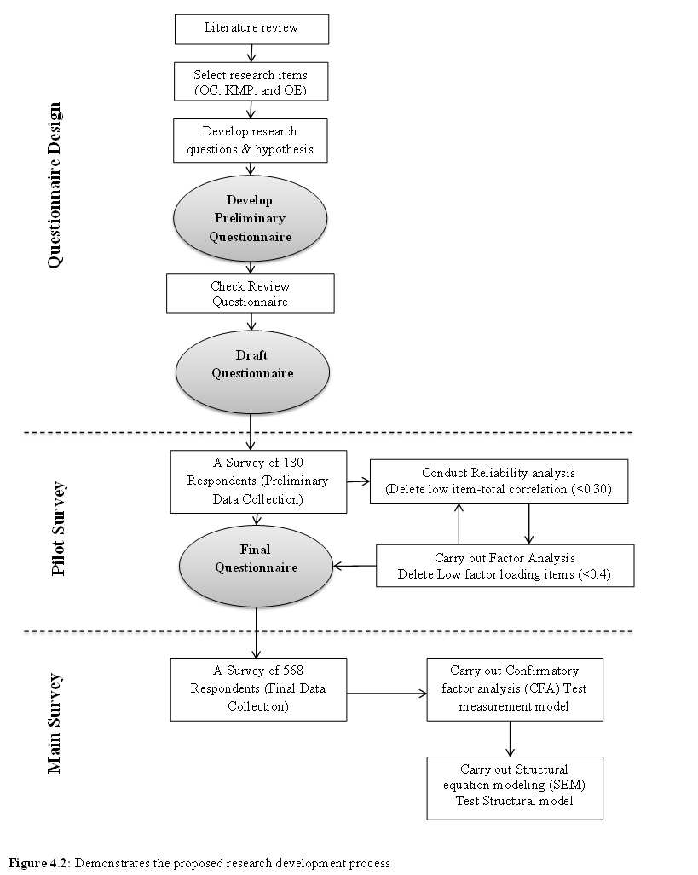
Figure 4.2: Demonstrates the proposed research development process
  - Questionnaire Design
The initial stage in the process of research design was designing and developing the questionnaire. The primary exercise was to develop the items that needed to be measured to quantify the constructs of the proposed model.

Operationalization of Measures
All 54 constructs of the postulated research model are latent constructs, among which are organizational culture (the independent variables) (identified by the eighteen dimensions of trust, commitment, collaboration and competence) and Knowledge Management practices (the mediator variables), identified by the sixteen dimensions of knowledge creation, knowledge sharing, knowledge utilization, knowledge internalization and operational efficiency using “Balanced Scorecard” perspective (the dependent variables identified by the twenty dimensions of financial performance, customer satisfaction, learning and growth and internal business process perspectives).
Fifty-four latent constructs were quantified using multiple items to improve the authenticity of the measures. The survey used a five-point Likert scale that varied from strongly disagree to strongly agree. According to Hair et al. (2006), each construct should be measured by a minimum of three indicators. The next section describes the measures for all the proposed variables.

4.6.1.1 Measuring Organizational Culture
The most important obstacle to effectively implementing KM is organizational culture (Gold et al., 2001) OC can be interpreted as a sum total of shared values, beliefs and norms of people within an organization (McDermott & O’Dell, 2001). Dimensions of organizational culture (OC) refer to the major aspects of attitude and behaviour that must be spread in the organization, between the employees and the management. Hence, based on several previous researches, these aspects are identified within four main dimensions in this research, which are measured within eighteen items and are adopted by Ho et al. (2014), Marques et al. (2011), Chen and Mohamed (2008) and Lee and Choi (2003).This measure was made up of four components of OC: trust (TRU), commitment (COM), collaboration (COL) and competence (COP). While trust and competence were measured using five variables, commitment and collaboration were measured using four variables. Table 4.1 presents the scale that has been adopted in this study.
Table 4 .1 :Item Measures of Organizational Culture
Item code | Trust, Members of our company […]:
TRU1 | 1. [...] can trust the attitudes and behaviour of other members.
TRU2 | 2. [...] have relationships based on reciprocal faith.
TRU3 | 3. [...] have reciprocal faith in others' ability.
TRU4 | 4. [...] are generally trustworthy.
TRU5 | 5. [...] have reciprocal faith in others’ behaviour to work toward organizational goals.
Item code | Commitment, Do you […]:
COM1 | 1. [...] would you be very happy to spend the rest of your career with this organization?
COM2 | 2. [...] really feel that this organization’s problems are yours?
COM3 | 3. [...] feel a sense of belonging in this organization?
COM4 | 4. [...] feel emotionally attached to this organization?
Item code | Collaboration, Members of our company are […]:
COL1 | 1. [...] satisfied with the degree of mutual cooperation.
COL2 | 2. [...] able to help and support each other.
COL3 | 3. [...] willing to cooperate between departmental units.
COL4 | 4. [...] able take responsibility for their own learning.
Item code | Competence, Our company members […]:
COP1 | 1. [...] can understand not only their own tasks, but also others' tasks.
COP2 | 2. [...] can make suggestions about the task of others'.
COP3 | 3. [...] can communicate well within their own and other department members.
COP4 | 4. [...] are specialists in their own task and responsibilities.
COP5 | 5.[...] can perform their own task effectively and adopt any organizational changes.

4.6.1.2 Measuring Knowledge Management Practices
Fu Ho et al. (2014) believes that a culture that is knowledge-friendly enables the effective implementation of KM practices in an organization. Research on knowledge creation and organizational learning reveal that cultural values of individuals exert an influence on the knowledge-sharing activities (Jennex, 2007; Hutchings & Michailova, 2004; Hofstede & Hofstede, 2001; Pfeffer & Sutton, 1999). Hence, Knowledge Management Practices (KMPs) is assessed within sixteen questions adopted from Lyu et al. (2016); Lin (2015); Ho et al. (2014); Wu and Chen (2014); Rašula et al. (2012); Zack et al. (2009) ;Chen and Mohamed (2008) and Lee and Choi (2003).
In this study, KMPs are measured as four constructs, including knowledge creation (KC), knowledge sharing (KS), knowledge utilization (KU) and knowledge internalization (KI), with each dimension consisting of four items, as shown in Table 4.2
Table 4 .2: Item Measures of Knowledge Management Practices
Item code | Knowledge Creation, My organization has capability […]:
KC1 | 1. [...] to develop knowledge from internal knowledge workers.
KC2 | 2. [...] to codify the acquired knowledge into accessible and applicable formats.
KC3 | 3. [...] to store acquired knowledge into organizational knowledge archive.
KC4 | 4. [...] to train adequately by the successor(s) to undertake the duties.
Item code | Knowledge Sharing, My organization has a process for sharing knowledge […]:
KS1 | 1. [...] between individuals.
KS2 | 2. [...] across teams.
KS3 | 3. [...] throughout the organization.
KS4 | 4. [...] among our business partners.
Item code | Knowledge Utilization, My organization […]:
KU1 | 1. [...] promotes teamwork through the circulation of inter-departmental information and knowledge circulation.
KU2 | 2. [...] encourages a culture of knowledge sharing  (i.e. rewarding employees who have new knowledge, ideas or suggestions).
KU3 | 3. [...] conducts research surveys and education training.
KU4 | 4. [...] uses a knowledge management system in the spread and awareness of knowledge among employees.
Item code | Knowledge Internalization, My organization […]:
KI1 | 1. [...] provides education and training to raise employee proficiency at new work tasks.
KI2 | 2. [...] can systematically manage its expertise and knowledge  (i.e. customer knowledge, demand forecasting).
KI3 | 3. [...] can establish standards for information resources, including data and knowledge, which are suitable for use within the organization.
KI4 | 4. [...] has regularly updated and properly maintained professional knowledge and information in a proper manner.

4.6.1.3 Measuring Operational Efficiency
A study by the American Productivity and Quality Centre illustrated the importance of having a corporate culture that supports knowledge sharing and subsequently, improves the performance of the organization (McDermott & O’Dell, 2001). Hence, the measurement scale of operational efficiency used in this study considers four “Balanced scorecard” perspectives. Balanced scorecard were measured and quantified using twenty item scales derived from that proposed by Fen Lin (2015) and Rehman et al. (2015). This construct covered all four-balanced scorecard perspectives with five items: financial performance (FP), customer satisfaction (CS), internal business process perspectives (IBP) and learning and growth (LG). This variable is considered to be part of the balanced scorecard (Kaplan & David, 1996), as shown in Table 4.3
Table 4 .3: Item Measures of OE used in this study considers four “BSC” perspectives.
Item code | Financial Performance (FP), After the implementation of knowledge management practices, my organization has improved its ability […]:
FP1 | 1. [...] to increase net benefit.
FP2 | 2. [...] to improve economic value added.
FP3 | 3. [...] to enhance sales growth.
FP4 | 4. [...] to Improve operating efficiency.
FP5 | 5. [...] to increase return on investment.
Item code | Customer Satisfaction (CS), After the implementation of knowledge management practices, my organization has improved its ability […]:
CS1 | 1. [...] to improve growth in market share.
CS2 | 2. [...] to increase customer satisfaction.
CS3 | 3. [...] to improve response time when handling customer complaints.
CS4 | 4. [...] to create new customers and retain existing customers.
CS5 | 5. [...] to increase corporate image and reputation by increasing the delivery in efficiency.
Item code | Internal Business Process (IBP), After the implementation of knowledge management practices, my organization has improved its ability […]:
IBP1 | 1. [...] to systematize corporate internal processes.
IBP2 | 2. [...] to improve product or service quality.
IBP3 | 3. [...] to increase production efficiency.
IBP4 | 4. [...] to innovate new products or services.
IBP5 | 5. [...] to rapidly commercialize new innovations.
Item code | Learning and Growth (LG), After the implementation of knowledge management practices, my organization has improved its ability […]:
LG1 | 1. [...] to improve skills of its employee skills.
LG2 | 2. [...] to improve employee satisfaction.
LG3 | 3. [...] to improve awareness of shared visions, objectives and values.
LG4 | 4. [...] to improve new product or service development to market.
LG5 | 5. [...] to improve sharing of worker knowledge relevant to core abilities and enhanced task efficiency.

Preparation of Draft Questionnaire
In order to ensure that there were no bias, good questionnaire design principles were used. It also helped enhance the reliability of the data that was collected. Questions to collect demographic information were limited to just those relevant in the theoretical model while avoiding sensitive questions related to income and revenue.
The questionnaire was designed based on the information collected during Literature Review. The language used was English, because it is a commonly used language in the oil and gas industry. The draft questionnaire has been developed after check and review (Craig & Douglas, 2000).
The questionnaire was well structured with two sections providing definitions and descriptions of the terms used in the survey (Bourque, 2003; Bourque & Fielder, 1995). In the first section, the respondents were asked to mention their personal information and place of employment. In the next section, key questions were in Likert-type scales. Questions on similar subjects were organized together. Finally, the English version of the draft questionnaire was inspected by experienced researchers and the research supervisor.
  - Pilot Survey
A pre-test was carried out with the draft questionnaire to identify and repair likely errors in designing questionnaires, before carrying out the main survey (Malhotra, 2007; Polit & Beck, 2006; Diamantopoulos & Winklhofer, 2001). This also refined the questionnaire while enhancing the reliability of the measures and making it user-friendly (Flynn et al., 1990). Additionally, this pre-test would allow estimation of probable response rates for the questionnaire. In this manner, the pilot study is generally considered a vital element of the survey design (Green et al., 1998). Van Teijlingen and Hundley (2002) highlighted the following reasons for why such pilot studies are invaluable: 1) Building and verifying the adequacy of research instruments 2) Evaluating the feasibility of a (full-scale) study/survey 3) Determining if the sampling size and technique are adequate 4) Developing the research question and research plan for funding purposes.
With regards to the SEM analysis, Hair et al., (2006) has underlined the value of pre-testing, when the data is taken from different sources. The measurement scales of constructs in this research were originally designed at the background of advanced developed or newly industrialized countries viewed from the perspective of a major corporate. Therefore, it is necessary to conduct a pre-test to review the measures in the context of UAE.
Green et al. (1998) are of the opinion that pre-test subjects should be as close to the final group as possible. At the same time, typical and extreme respondents should also reflect in the formation of the main survey. Pilot studies may, however, employ convenience sampling (Calder et al. 1981) with a suggested sample size of about 12 to 30 (Hunt et al., 1982) or in a range from 25 to 100 (Emory & Cooper, 1991). Therefore, this pilot survey distributed 600 questionnaires (20–30% response rate) directly to employees working in one of the biggest offshore oil and gas companies in the remote areas of the city of Abu Dhabi in the UAE.
To carry out an initial assessment of the measurement scales of the questionnaire, item-total correlations and principal component analysis (PCA) were used to verify the construct accuracy, and the coefficient alpha was determined to understand the reliability of composite variables. SPSS software version 20.0 was used to carry out these calculations.
The validity of a measure meant how much it really measured what it is supposed to measure (Manning & Munro, 2007). If the composite variable truly does not equate a single underlying property (or concept), the components shall be homogenous (also referred to as internally consistent). Gregory (2010) stated that a popular way of estimating the homogeneity of a composite variable was by correlating every component item with the composite variable, fabricated by summing the components together. This way of determining homogeneity is called the item-to-total correlation (or item-total correlation). The logic behind this approach is that if every item measures the same thing as the total, then the scale will be homogenous or internally consistent. The criteria is that the item-to-total correlations should exceed 0.50 (Hair et al., 2006) or 0.30 (Nunnally, 1978). Consequently, the entire set of items that show correlations lower than the particular criteria should be removed.
A more refined method of verifying the homogeneity of a scale is to carry out a PCA, a type of factor analysis that can present the relationships between variables mentioned in a correlation matrix (Manning & Munro, 2007). If the items determine a single underlying concept, the PCA should provide only one underlying component with eigenvalues greater than 1.0. It is argued that items with absolute values of component loadings greater than 0.50 (Hair et al., 2006) or 0.40 (Gerbing & Anderson, 1988) provide superior measures of the underlying construct. Therefore, all items with component loadings lower than this value should be removed from the measurement instrument. If a PCA selects more than one component with eigenvalues higher than 1.0, the scree plot would usually be used to further bring down the number of components from the number that might be acquired on the basis of eigenvalues. Varimax rotation can be carried out to make sense of the theoretical underlying components (or “dimensions” or “factors”) produced by PCA (Manning & Munro, 2007; Hair et al., 2006).
Reliability of a measure is the repeatability of the results every time the same item is measured using Coefficient (or Cronbach’s) alpha (Hair et al., 2006). Coefficient alpha is a measure of the internal consistency of the items and also a convenient measure of reliability (Gregory, 2010). Reliability will be on the higher side if the scale items are quite correlated. As a standard of reliability, values of coefficient alpha above 0.70 are given to equate adequate reliability; those above 0.80 to represent good reliability and those above 0.90 to represent excellent reliability. However, during the initial stages of a study or exploratory research, a lower acceptable limit of 0.60 may be acceptable (Hair et al., 2006).
  - Main Survey
After carrying out the pilot study and analysing its results, the draft questionnaire was further refined, finalized and incorporated as part of the main survey. The method of main survey sampling and questionnaire management is given in this section.

Sample Design
Zikmund (2003) ratified that the sampling process included knowing the target population, determining the sampling frame, choosing a sampling method, figuring out the sample size and choosing the sample elements
(1) Defining the target population
The term ‘target population’ refers to the full set of the specific population that are important to the study (Zikmund, 2003). Population is the entire group that is being probed, while element is the section from which the required data is taken (Davis, 2000). Participants were employees working in one of the biggest offshore oil and gas companies in remote areas of the city of Abu Dhabi in the UAE. They are broadly classified into upstream, midstream and downstream activities. Upstream refers to oil and gas exploration and production. Midstream includes transportation and storage, while downstream accounts for the refineries and marketing of oil and gas products. While most oil and gas companies function within a specific area within the supply chain, there are also larger enterprises that have operations spanning both upstream and downstream (Investopedia, 2016). Hence, the participants in this study belong to senior upper and middle level managers, operational and technical engineers, consultants, engineers, operators, assistant engineers, project managers and administrative staff. This research project carried out an empirical test in the context of the oil and gas sector in the UAE, to examine the relationships between organizational cultures (OC), Knowledge Management practices (KMPs) and operational efficiency (OE) measured from BSC four strategic perspectives.
(2) Identifying the sampling frame
A sampling frame is the catalogue of population elements from which the sample is taken to equate to the target population (Dillman, 2011; Davis, 2004; Zikmund, 2003). It is also called a working sample. In this study, the sampling frame was based on the list of all employees working particularly for the oil and gas field, its operations and projects. Hence, this company has a multinational workforce in both areas.

(3) Selecting the sampling method
There are two key methods for sampling—probability and non-probability sampling (Zikmund, 2003). In probability sampling, the components of the population present a known likelihood of being chosen as sample subjects. On the other hand, in non-probability sampling, the items of the population do not have a known likelihood of being chosen as subjects.
In this research project, the probability method was selected because it is universally accepted and presents a high level of generalization of results. There are several types of probability sampling techniques, such as, simple random, systematic, stratified, cluster, and multistage area sampling. In this study, random sampling was selected for several reasons: (1) it easy to use and ease of assembling the sample (2) it made sure that that the sample was an accurate representation of the larger population (Zikmund, 2003). Stratified sampling is a variation of simple, random and systematic sampling that is developed to be more accurate and representative (DeVaus, 2002).

(4) Determining the sample size
Based on the large-sample distribution theory, the SEM analysis needs a larger sample to be able to provide better estimates (Joreskog & Sorbom, 1996; Raykov & Widaman, 1995). Although the matter of sample size has not been concluded, it depends on the type of statistical technique used and resolved (Hair et al., 2006). Hair et al. (2006) suggested that using SEM requires that the proportion of sample size to the number of indicators must be at least 5:1. Considering that the response rate is in the range of 20–30%, a sample of 1,000 respondents were selected using random sampling method for the primary survey.

(5) Selecting the sample elements
The final stage in the sampling method is to pick real sample units prior to actually running the fieldwork (Zikmund, 2003). This requires listing particular units of analysis for data collection (Davis, 2004). This study is based on the one of the biggest offshore oil and gas companies in remote areas of the city of Abu Dhabi in the UAE. They are broadly classified into upstream, midstream and downstream activities; the sample elements were from one selected firm.
The use of main messengers from organizations for data collection is widely used in many research projects (Huber & Power, 1985). Such respondents usually come from the top management of the organization and possess vital knowledge regarding the organization and its strategy. For the purpose of this research, the key messengers were required to have a thorough awareness of their firm’s value, of Knowledge Management practices and implementation of the right culture it needs to create and sustain the knowledge culture in the organization and to make an impact on the organization performance. Thus, suitable survey respondents were senior management executives (such as senior vice president and vice president, senior managers and middle managers), quite common to other studies that focus on strategic management.

Questionnaire Administration
To issue and manage the questionnaire, the mail survey technique was used, and reason for doing so has been justified in Section 4.3 and 4.4. The study utilised the said procedure to conduct the mail survey in a better way.
Initially, the risk of low response rate needed to be eliminated, which was done by reaching out to the respondents through email and telephone calls to ensure only those keen to participate were invited. A participant information sheet and questionnaire (presented in Appendices 3a, 4a) was issued along with the invitation.
The information sheet contained the university’s official logo, a mention of the context of the study and a request for participation in the study. A letter of approval from the company was attached to make them aware of the value of the study (presented in Appendices 1a, 2a). The participants were promised that they could access a brief of the study results as compensation to complete the questionnaire. An envelope with the address was provided for the respondents to send back the completed questionnaire. Emphasis was also placed on the privacy and confidentiality of the respondent and the use of survey results.
Additionally, to ensure a good response rate and quick return, reminders were sent via email and calls, periodically: first follow-up two weeks after mailing to confirm the receipt of the questionnaire to request completion of the survey; a copy of the questionnaire is sent five weeks afterwards just in case the first questionnaire was not received and to remind them of the value of finishing the questionnaire and mailing it back (reminder letter presented in Appendices 5a), a telephone call reminder is done seven weeks after the first mail to remind them again.
  - Data Analysis Techniques
Upon completion of data collection, analysis is conducted on the data. The questionnaires were verified to ensure accuracy of data entry and to check for missing values. Descriptive statistics analyses supplied an overview of the sample and helped summarise demographic information about the sample. The data was then inspected for distribution of variables using the SPSS software version 20.0.
Later, SEM, utilizing the AMOS software version 20.0 was used to verify the theoretical model. Hair et al., (2006) argued that SEM is extends to several multivariate techniques, such as multiple regression and factor analysis. Therefore, SEM helps the researcher evaluate the contribution of each scale item, check the ability of the scale to measure the concept and determine the relationship between the dependent and independent variables (Sánchez et al., 2005).
Sánchez et al. (2005) explained the structural equation model as one that is flexible enough to allow complex modelling of multivariate data. Hair et al. (2006) mentioned that SEM is a very efficient method of inspecting several inter-related dependence relationships among the measured variables and latent constructs. The authors further differentiated structural equation models based on three key factors: (1) whether they allow the simultaneous calculation of multiple and inter-related dependence relationships; (2) their confidence in representing unobserved concepts in these relationships and error correction, and (3) the ability of the model to describe the full set of relationships.
SEM is a widely used multivariate method, which finds application in social sciences research, and hence was also selected for the purpose of this study.
Gerbing and Anderson (1988) and Hair et al. (2006) are in favour of conducting two steps in a total SEM analysis. When using a measurement model, the preliminary step is to evaluate the model validity by checking the goodness-of-fit of the measurement model and testing for evidence of construct validity. In this situation, CFA can give a confirmatory test of the measurement theory that describes a set of relationships suggesting how sets of measured variables surmise a set of latent constructs. When a CFA model shows goodness-of-fit and provides construct validity, the accuracy of the measurement theory is supported. This is the prime condition for the structural theory testing, the second step in SEM (Hair et al., 2010; Hair et al., 2006). The fit statistics of the complete structural model are evaluated and the individual parameter calculations are examined to check the hypothesized theoretical relationships. The following subsections present more details relating to these processes.

Goodness-of-Fit Assessment
Goodness-of-fit (hereafter referred to as GOF) describes the effectiveness of the specified model in mirroring the covariance matrix among the indicator items (Hair et al., 2006). Chi-square (χ2) is the key measure of fit used in SEM to measure the variances between the observed and estimated covariance matrices. Additionally, there are several other GOF measures such as: (1) absolute fit indices (2) incremental fit indices and (3) parsimonious fit indices (Hair et al., 2006).

4.9.1.1 Absolute Fit Measures
Absolute fit indices directly quantify the way a model emulates the observed data (Kenny & McCoach, 2003). The most vital absolute fit indices are the Chi-square (χ2) statistic, the goodness-of-fit index (GFI), the root means square residual (RMSR), the standardized root mean residual (SRMR) and the root mean square error of approximation (RMSEA) as per Hair et al., (2006). These indices and their attributes are summarized in Table 4.4 below.
Table 4 .4: Characteristics of absolute fit measures
Name | Symbol | Acceptable level | Remarks
Chi-square  statistic | χ 2 | p>0.05 (insignificant)  p<0.05(N>250,m>12)  χ2 > 0.001 , | Sensitive to the size sample and model complexity. Possibly greater when size or the number of observed variables increases, even if the difference between the observed and estimated covariance matrices are similar. (Barney, 2001)
Chi-square  Statistic to degree of freedom | χ2/df | χ2/df ≤ 3), | χ2 > 0.001 ,  χ2/df ≤ 3),  (Barney, 2001; Holmes&Dyall-Smith,2000)
Goodness of  fit index | GFI | > 0.90 (N>250, m>30)  >0.95 (N>250, m<12) | Lower sensitivity to sample size. Range of values is 0 (poor fit) to 1 (perfect fit). ≥ 0.80 (Seyal, et al.,2002)  Higher values indicate better fit.  No absolute threshold level for acceptability.  (Baumgartner & Homburg, 1996)
Root mean  square  residual | RMSR | Set by researcher,  difficult to compare | An average of the residuals between individual observed and estimated covariance and variance terms. Lower values represent better fit (badness-of-fit measures)

Table 4.4 (Cont.) – Absolute Fit Indices
Name | Symbol | Acceptable level | Remarks
Standardized  root mean residual | SRMR | <0.08 (m>12)  Biased (m<12) | A standardized value of root mean square residual (RMSR).  No statistical threshold level for acceptability.
Root mean  square error  of approximation | RMSEA | Between 0.03  and 0.08 | Used to correct the impact of sample size or model complexity on χ 2.  Lower values indicate better fit (badness-of-fit measures). Values over 0.10 indicate poor fit.
Increment Fit Index | IFI | Close to 1 | Close to 1 indicate a very good fit. (Bentler, 2004)
Comparative Fit Index | CFI | Close to 1 | Close to 1 indicate a very good fit. (Bentler, 2004)

4.9.1.2 Incremental Fit Measures
Incremental fit indices (also referred to as comparative fit indices) are different from absolute fit indices since they evaluate the fit of a specific model and another baseline model (Hair et al., 2006). The most accepted baseline model is called a null model, expecting that all observed variables are uncorrelated. Normed fit index (NIF), comparative fit index (CFI), the Tucker Lewis index (TLI) and the relative non-centrality index (RNI) describe the most widely applied incremental fit statistics (Bentler, 2004). A summary of these fit indices and their characteristics are displayed in Table 4.5 below.
Table 4 .5: Characteristics of Incremental Fit Indices
Name | Symbol | Acceptable level | Remarks
Increment Fit Index | IFI | Close to 1 | Quite insensitive to model complexity.  Values range between 0 (poor fit) and 1 (perfect fit). Higher values indicate better fit (Bentler, 2004)..
Normed fit  index | NFI | >0.90 (N>250,m>30)  >0.95 (N>250,m<12) | A ratio of the difference in the χ 2 value for the fitted model and a null model divided by the χ 2 value for the null model.  Range of values is 0 (poor fit) to 1 (perfect fit).
Comparative  fit index | CFI | >0.90(N>250, m>30)  >0.95(N>250, m<12) | An improved version of NFI. Quite insensitive to model complexity.  Values range between 0 (poor fit) and 1 (perfect fit). Higher values indicate better fit. (Bentler, 2004)
Tucker Lewis  index | TLI | >0.90 (N>250,m>30)  >0.95 (N>250,m<12) | Values can fall below 0 and above 1. Higher values suggest a better fit.  As a concept it is similar to CFI and so, provides very similar values.
Relative non centrality  index | RNI | >0.90 (N>250,m>30)  >0.95(N>250, m<12) | Values range between 0 (poor fit) and 1 (perfect fit).  Higher values represent better fit.

4.9.1.3 Parsimony Fit Measures
The final type of fit measure is called parsimonious fit indices, which is made up to supply information regarding which is the best and most simple model (Hair et al., 2006). The most popular applied parsimony fit indices include the parsimonious goodness-of-fit index (PGFI) and the parsimonious normed fit index (PNFI). Table 4.6 below describes the level of fit of the model with parsimonious fit measures. The parsimony ratio of any specific model becomes the basis for these measures and is calculated as the ratio of degrees of freedom used by a model to the total degrees of freedom available (Marsh & Balla, 1994).

Table 4 .6: Characteristics of Incremental Fit Indices
Name | Symbol | Acceptable level | Remarks
Parsimonious  goodness of  fit index | PGFI | Not  applicable | Adjusts GFI using the parsimony ratio. Values range between 0 and 1.  Used in comparing one model with another. (Hair et al., 2006).
Parsimonious  normed fit  index | PNFI | Not  applicable | Adjusts NFI by multiplying it times the parsimony ratio. Higher values represent better fit. Used in comparing one model with another. (Hair et al., 2006).

Hair et al., (2006) supports the use of multiple fit indices of varying types, along with modifying the index cut-off values based on the aspects of the model that include the size of the sample and complexity of the model. The Chi-square value along with the relevant degrees of freedom, one incremental index and one absolute index is to be reported. It is suggested that the information required to evaluate a model are the Chi-square value and degrees of freedom, the CFI (Comparative Fit Index) and the RMSEA (Root Mean Square of Approximation). These indices provide the necessary information that there is a model fit.
The CFI is an incremental fit index, which is comparatively less sensitive to model complexity, and the GFI (Goodness-of-Fit index) is an absolute fit index that is insensitive to sample size. Their values range from 0 (no fit) to 1 (perfect fit) with higher values suggesting better fit (Hair et al., 2006). On the other hand, RMSEA, also an absolute fit measure, is known as a badness-of-fit index. Higher values of RMSEA suggest worse fits. RMSEA is a good indication of the suitability of the model fit to the population as it corrects both model complexity and sample size. RMSEA values are usually below 0.10 for the most acceptable models (Hair et al., 2006).

Unidimensionality and Construct Validity
Unidimensional measures are indicators that have just one underlying latent construct (Hair et al., 2006). Gerbing and Anderson (1988) are of the opinion that unidimensional measures have two types of relationships among variables. One where the behaviour of a single variable depends on more than one construct, i.e., cross-loadings are not fixed at zero. The second type of relationship is the covariance between the error terms of two variables—within-construct error variance and between-construct error covariance. Hair et al. (2006) argued that the researcher should not any of the paths in CFA even if they enhance the model fit, because doing so could disrupt the premise of good measurement. The existence of these relationships is evidence for a lack of construct validity. Having such relationships suggests a lack of construct validity.
Hair et al. (2006) mentioned that construct validity is the amount by which the measured items mirror the theoretical latent construct that these items were originally designed to measure. Construct validity has three key parts: convergent validity, discriminant validity and face (or content) validity.
Convergent validity is described as the amount by which the indicators of a certain construct meet or shares a high part of variance (Hair et al., 2006). CFA gives a range of information used for assessing the comparative amount of convergent validity among item measures such as factor loadings, variance extracted and constructs reliability. In particular, adequate convergent validity can be achieved if (1) all factor loadings of the measurement items are statistically significant and substantial (0.5 or higher) (Hair et al., 2006; Gerbing & Anderson, 1988), (2) the average percentage of variance selected among a set of construct items is strong (0.5 or higher) (Hair et al., 2006; Fornell & Larcker, 1981), and (3) the construct reliability value can be accepted (0.7 or higher) (Hair et al., 2006 ;Bacon et al., 1995; Fornell & Larcker, 1981).
Hair et al. (2006) stated that discriminant validity is the level to which a construct is different from other constructs. It also implies that individual measured items should equate only one latent construct and thus, the existence of significant cross-loadings show a lack of discriminant validity. Confirmatory factor analysis is suggestive of two ways of evaluating discriminant validity. Discriminant validity is sufficient when (1) the correlation between any two constructs is majorly distinct from unity with the cut-off value that is 0.90 (Bagozzi et al., 1991) and (2) the variance retrieved percentages for any two constructs should be greater than the square of the correlation estimate between these two constructs (Gerbing & Anderson, 1988; Bagozzi & Foxall, 1996; Fornell & Larcker, 1981). In addition to between-construct discriminant validity, Bagozzi and Foxall (1996) also talked about within-construct discriminant validity, which is the difference between the components of a construct.
The last component of construct validity is face (or content) validity. This links to the content or meaning of every measurement item and must be determined before any theoretical testing using CFA (Hair et al., 2006).

Structural Model Testing
After the measurement model is validated, the next stage in SEM analysis is to check the correctness of the structural model and its related hypothesised relationships (Hair et al., 2006; Gerbing & Anderson, 1988). First, the overall fit of the structural model is evaluated using the same criteria as the measurement model. Next, the individual parameter estimates that represent each specific hypothesis are assessed. If the model shows good fit and if the hypothesized paths are significant and in the direction hypothesised, then the structural model is confirmed.
  - Ethical Considerations
Ethical considerations have a huge importance in the business research process (Beauchamp & Bowie, 2004; Zikmund, 2003). In this case human beings are being studied, therefore every possible measure has been adopted, in order to prevent any harm whatsoever (Fontana & Frey, 1998). Some examples of harm are physical and psychological abuse, stress, loss of self-esteem and legal perils (Neuman, 2002). Other ethical concerns are voluntary participation, provision of informed consent, privacy and confidentiality. Anonymity of respondent is ensured at every stage of the research (Manning, 2006) .

Confidentiality
To keep the respondents’ personal information confidential, the research will be conducted anonymously and no personal details will be collected. Demographic questions shall not seek information that could identify the respondent by name or department/company name. Personal information of the respondents will be scrubbed from the data file and the responses will be given a unique code prior to analysis.
Google Survey will protect the answers during the process of data collection. The researcher will secure and code the responses to ensure that confidentiality is maintained during data analysis. This preserves confidentiality and reduces any bias the researcher might have while analysing the data. The researcher is responsible for ensuring that the responses are protected and only used as per the research procedures allowed by the Abu Dhabi University Institutional Review Board (IRB).

Potential Risks and Discomforts
The risks of participating in this study were minimal. Some individuals might have felt discomfort at giving up some of their time to complete the survey. Participants completed an online survey, which could have been in conflict with corporate computer use policies. Participants were advised to adhere to computer use policies at their workplace, if they chose to complete the survey at their place of employment.
In case the respondents’ do not wish to complete online survey, they may request a paper copy, by providing a valid postal mailing address to s-alqubaisi@hotmail.com. The researcher will mail them a copy, along with a self-addressed stamped envelope, for return, or the researcher shall give the respondent a printed copy that is retuned in a sealed envelope.

Potential benefits to participants and /or to the society
This research is expected to benefit the society at large by building the knowledge of how OC could improve operational efficiency using the BSC approach. The management in the oil and gas contexts may find the results useful for informing practice in organizations and implementation.

Identification of Review Board
The Abu Dhabi University Institutional Review Board reviewed and approved the final questionnaire and other documents, including the consent letter, to ensure that data would be used only for academic purposes and that the names of company would be kept confidential or utilized, based on their Company Department Review. A confidentiality statement is included in the survey instrument as well as the solicitation for participating in the survey (attached Appendix 3 a).
This brief, which includes the research purpose, is supplied to potential survey participants within the Participant Information Sheet. Information regarding the ethics approval number for this research (presented in Appendices 1a, 2a), granted by the Abu Dhabi University Institutional Review Board, was also communicated.
Every requirement was adhered to in this study. Firstly, there is no risk or abuse to the respondents involved, as explained in Section 4.9.2. Secondly, the participation in the survey was voluntary and participants had the option to quit at any time during the process without any obligation. Also, all data given from the respondent was safeguarded, made anonymous and kept confidentially. Information such as names and others, which could lead to identification of the person, was not gathered. However, in some cases, if the respondents wanted to receive an overview of the research findings, then their contact details were collected. The responses received were analysed and presented as consolidated data without mentioning individual responses. This study was carried out as required, in fulfilment of a doctoral program and will not be used for any other purposes.
  - Summary
In this chapter, a justification for the methodology chosen for the research, the procedure for distribution of the sample and more information of the process for research design adopted to experimentally evaluate the theoretical model has been provided. The objective was to build a survey instrument that included questionnaire design and a pilot study. After providing an overview of the sample selection and techniques applied for managing the survey, the method of data analysis and ethical issues were detailed. In light of the presented methodology, the next chapter provides the results from the collected data.

.

CHAPTER FIVE: DATA ANALYSIS
  - Introduction
The preceding chapter articulates the research methodology that was employed for testing the theoretical framework alongside the hypotheses that were advanced in Chapter Three, and presented a case for the use of such research design. This research methodology takes into account the operationalization of twelve constructs as well as the research design of preliminary as well as primary studies. Further discussed in the chapter are the findings of the study. The questionnaire was initially assessed on an estimated population of 180 participants, making use of the factor analysis coupled with Cronbach’s alpha computation to evaluate its reliability and validity. The analysis was conducted using SPSS version 20.0. Based on the results from the preliminary study, the questionnaire was tailored for the primary research.
The next procedure was to perform an analysis and interpretation of the data obtained from the primary research heralded by data validation and cleaning as well as sample description. A two-step technique of SEM was then employed, including an evaluation of construct validity and suitability of the measurement model pursuant to the testing of the structural framework based on AMOS version 20.0.
Three measurement models for the main constructs (Organizational culture, Knowledge Managements Practices and Operational Efficiency) and the overall measurement model were determined through CFA and established statistical techniques of examining the relations between sets of latent and observed variables, three measurement frameworks for the primary constructs, namely Organizational Culture, Knowledge Management Practices and Operational Efficiency, alongside the inclusive measurement framework were determined (Taris, 2002; Byrne, 2001). For the objectivity of the SEM, the standard distribution of the data was also investigated. The last procedure was to advance the structural framework for analysing the study questions as well as exhibiting the hypothetical relations that were investigated via the six established hypotheses. Figure 5.1 illustrates the chapter’s structure.

Figure 5 .1: Chapter Five Outline

  - Pilot Study
As argued in the previous chapter, a preliminary research was undertaken to eradicate potential flaws and weaknesses in the initial questionnaire and to preliminarily evaluate the reliability and validity of the pertinent measures of a construct in a particular context, resulting in an ultimate questionnaire that was used to conduct the research. The questionnaires were distributed to at least 600 possible respondents who took part in the study. The subjects were employees of one of the largest offshore gas and oil firms in Abu Dhabi, UAE.
A sum of 195 responses was received, with an impressive rate of response standing at 32.5 percent. Nonetheless, of the received responses, data was missing in 15 of them, and hence, were not taken into consideration in the data analysis. Consequently, the data obtained from 180 participants were utilized to enhance the variable measurement degree by evaluating their reliability and validity. Cronbach coefficient alpha and item-total correlations were computed. Principal component analysis (PCA) was also performed on each construct’s item measures, trailed by a varimax gyration when multiple factors were derived.
As argued previously, items that had item-total correlations lower than 0.3 alongside a factor loading score below 0.4 were deleted (Hair et al., 2006; Gerbing & Anderson, 1988; Nunnally, 1978). Coefficient alpha values in excess of 0.7 are satisfactory and such reduced acceptable limit might be in the preliminary stages of the study to 0.6 (Hair et al., 2006; Nunnally & Brenstein, 1994).
According to these criteria, the findings of the preliminary research, as revealed in Table 5.1, revealed that all variable measurement gradations exhibited acceptable Cronbach’s coefficient alpha levels (in excess of 0.6) alongside item-total relations (in excess of 0.3). The principal component analysis for the composite constructs (with values exceeding 0.4), with eigenvalues higher than 1, explained approximately 34.66 to 73.10 percent of the total variation in the original variable set, and hence, unidimensionality was assumed. Furthermore, all pertinent items were reported to depict component loading in excess of the threshold value (0.4). Subsequently, the ultimate measurement gradations of twelve constructs were utilized in the primary research. The items that were used to assess four dimensions of Organizational culture (Ho et al., 2014; Marques et al., 2011; Chen & Mohamed, 2008; Lee & Choi, 2003), with five items for trust and competence and four items for commitment and collaboration (Wu & Chen, 2014; Lin ,2015), were used to determine the four extents of Knowledge Management practices, namely creation, sharing, utilization and internalization. Operational Efficiency, the remaining variable, was evaluated utilizing an adapted measure (Lin, 2015; Rehman et al., 2015; Lee & Choi, 2003). This construct covered all four Balanced Scorecard viewpoint with five items for Financial Performance viewpoint, customer satisfaction viewpoint, internal business process viewpoint and the learning and growth viewpoint. This variable is considered to be part of the balanced scorecard.
In terms of Knowledge Management practices (Knowledge Internalization), one component accounting for 83.37 % of the total variation was derived with eigenvalues in excess of 1. Three items, namely KI1, KI2, KI3, had significantly huge loadings (ranging from 0.888 to 0.971) on the second component, though (KI4) only loaded in the third component with an elevated factor loading of 0.8 with eigenvalues in excess of 1, which accounted for 81.502 percent of the total variation. Nonetheless, according Hair et al. (2006) and Nunnally (1978), with a total-item correlation of 0.18 that is significantly less 0.3, KI4 were deleted. Based on the pattern of these findings, it was concluded that component two should not be interpreted and the composite variable should be recomputed using the three objects KI1, KI2 and KI3. The new variable has been reported to have a desired reliability level (0.95) and an eigenvalue in excess of 1, which explains 59.35 percent of the total variation, and hence, was utilized on a determinant scale of Knowledge Management in the primary research.

Correspondingly, the operational efficiency’s construct (learning and growth) loads onto two components that have eigenvalues exceeding 1, which accounts for 34.66 percent of the total variation. The findings reveal that the items LG1, LG2 and LG3 have huge loadings within the range 0.97–0.99 on the first component, yet LG4 and LG5 have large loadings of 0.97 and 0.72 correspondingly, on the third component. Manning and Munro (2007) and Manning (2006) argued that if a component is loaded onto by less than four items, then it is considered to be unreliable. In the light of that argument, the items LG4 and LG5 were obliterated so as to enhance the reliability and validity of the study’s measures. The new variable is reported to have a desired reliability level (0.98); moreover, a screen test reveals that a single-component solution could be the most suitable for the data set. Consequently, it was concluded that the three objects for re-test in the primary research should be maintained.

Table 5.1: Results of the Pilot Study
Construct | Cronbach alpha  ( P>0.7) | Item-total correlation  ( P>0.3) |  | PCA |  | Item deleted
Construct | Cronbach alpha  ( P>0.7) |  |  | Component Loading (P>0.4) | Variance extracted | Item deleted
Trust | 0.823 | TRU1 | 0.63 | .732 | 73.10 % | None
Trust | 0.823 | TRU2 | 0.54 | .629 | 73.10 % | None
Trust | 0.823 | TRU3 | 0.35 | .425 | 73.10 % | None
Trust | 0.823 | TRU4 | 0.58 | .686 | 73.10 % | None
Trust | 0.823 | TRU5 | 0.63 | .698 | 73.10 % | None
Commitment | 0.812 | COM1 | 0.55 | .595 | 73.10 % | None
Commitment | 0.812 | COM2 | 0.58 | .629 | 73.10 % | None
Commitment | 0.812 | COM3 | 0.53 | .695 | 73.10 % | None
Commitment | 0.812 | COM4 | 0.48 | .543 | 73.10 % | None
Collaboration | 0.837 | COL1 | 0.66 | .720 | 73.10 % | None
Collaboration | 0.837 | COL2 | 0.58 | .682 | 73.10 % | None
Collaboration | 0.837 | COL3 | 0.59 | .642 | 73.10 % | None
Collaboration | 0.837 | COL4 | 0.48 | .585 | 73.10 % | None
Competence | 0.820 | COP1 | 0.45 | .510 | 73.10 % | None
Competence | 0.820 | COP2 | 0.54 | .631 | 73.10 % | None
Competence | 0.820 | COP3 | 0.51 | .589 | 73.10 % | None
Competence | 0.820 | COP4 | 0.58 | .669 | 73.10 % | None
Competence | 0.820 | COP5 | 0.61 | .651 | 73.10 % | None

Table 5.1 (Cont.) -- Results of the Pilot Study
Construct | Cronbach alpha  ( P>0.7) | Item-total correlation  ( P>0.3) |  | PCA |  | Item deleted
Construct | Cronbach alpha  ( P>0.7) |  |  | Component Loading (P>0.4) | Variance extracted | Item deleted
Knowledge Creation | 0.977 | KC1 | 0.97 | .970 | 59.35 % | None
Knowledge Creation | 0.977 | KC2 | 0.80 | .888 | 59.35 % | None
Knowledge Creation | 0.977 | KC3 | 0.92 | .941 | 59.35 % | None
Knowledge Creation | 0.977 | KC4 | 0.97 | .970 | 59.35 % | None
Knowledge Sharing | 0.970 | KS1 | 0.91 | .888 | 59.35 % | None
Knowledge Sharing | 0.970 | KS2 | 0.91 | .970 | 59.35 % | None
Knowledge Sharing | 0.970 | KS3 | 0.91 | .888 | 59.35 % | None
Knowledge Sharing | 0.970 | KS4 | 0.85 | .941 | 59.35 % | None
Knowledge Utilization | 0.977 | KU1 | 0.97 | .970 | 59.35 % | None
Knowledge Utilization | 0.977 | KU2 | 0.80 | .888 | 59.35 % | None
Knowledge Utilization | 0.977 | KU3 | 0.92 | .941 | 59.35 % | None
Knowledge Utilization | 0.977 | KU4 | 0.97 | .970 | 59.35 % | None
Knowledge Internalization | 0.952 | KI1 | 0.94 | .970 | 59.35 % | KI4
Knowledge Internalization | 0.952 | KI2 | 0.80 | .888 | 59.35 % | KI4
Knowledge Internalization | 0.952 | KI3 | 0.89 | .941 | 59.35 % | KI4
Financial Performance | 0.990 | FP1 | 0.99 | .994 | 34.66% | None
Financial Performance | 0.990 | FP2 | 0.98 | .979 | 34.66% | None
Financial Performance | 0.990 | FP3 | 0.99 | .994 | 34.66% | None
Financial Performance | 0.990 | FP4 | 0.99 | .994 | 34.66% | None
Financial Performance | 0.990 | FP5 | 0.98 | .979 | 34.66% | None
Customer Satisfaction | 0.998 | CS1 | 0.99 | .994 | 34.66% | None
Customer Satisfaction | 0.998 | CS2 | 0.99 | .994 | 34.66% | None
Customer Satisfaction | 0.998 | CS3 | 0.96 | .979 | 34.66% | None
Customer Satisfaction | 0.998 | CS4 | 0.99 | .994 | 34.66% | None
Customer Satisfaction | 0.998 | CS5 | 0.99 | .994 | 34.66% | None
Internal Business Process | 0.997 | IBP1 | 0.98 | .979 | 34.66% | None
Internal Business Process | 0.997 | IBP2 | 0.99 | .994 | 34.66% | None
Internal Business Process | 0.997 | IBP3 | 0.99 | .994 | 34.66% | None
Internal Business Process | 0.997 | IBP4 | 0.98 | .979 | 34.66% | None
Internal Business Process | 0.997 | IBP5 | 0.99 | .994 | 34.66% | None
Learning and Growth | 0.979 | LG1 | 0.99 | .994 | 34.66% | LG4, LG5
Learning and Growth | 0.979 | LG2 | 0.96 | .979 | 34.66% | LG4, LG5
Learning and Growth | 0.979 | LG3 | 0.99 | .994 | 34.66% | LG4, LG5

Based on the findings of the highlighted initial analysis, Table 5.2 highlights the ultimate instruments utilized in the primary research. Besides determining the reliability and validity of the gradations, the outcomes of this preliminary research also presents a case for the need for the definition of keywords in the questionnaire in detail, citing specific illustrations, so as to improve understanding.

Table 5.2: Final Constructs Measurements Scales

Construct | Measurement Scale: Members of our company […]:
Trust | TRU1: [. . .] can trust the attitudes and behavior of other members.
Trust | TRU2: [. . .] have relationships based on reciprocal faith.
Trust | TRU3: [. . .] have reciprocal faith in others' ability.
Trust | TRU4: [. . .] are generally trustworthy.
Trust | TRU5: [. . .] have reciprocal faith in others' behaviors to work toward organizational goals.
Construct | Measurement Scale: Do you […]:
Commitment | COM1: [. . .] Would you be very happy to spend the rest of your career with this organization?
Commitment | COM2: [. . .] really feel as if this organization’s problems are yours?
Commitment | COM3: [. . .] feel a sense of belonging in this organization?
Commitment | COM4: [. . .] feel emotionally attached to this organization?
Construct | Measurement Scale: Members of our company are […]:
Collaboration | COL1: [. . .] Satisfied with the degree of mutual cooperation.
Collaboration | COL2: [. . .] able to help and support each other.
Collaboration | COL3: [. . .] willing to cooperate between departmental units.
Collaboration | COL4: [. . .] able take responsibility for their own learning.
Construct | Measurement Scale: Our company members […]:
Competence | COP1: [. . .] can understand not only their own tasks, but also others' tasks.
Competence | COP2: [. . .] can make suggestions about others' task.
Competence | COP3: [. . .] can communicate well with their own and other department members.
Competence | COP4: [. . .] are specialists in their own task and responsibilities.
Competence | COP5: [. . .] can perform their own task effectively and adopt any organizational changes.

Table 5.2 – (Cont.) Final Constructs Measurements Scales.
Construct | Measurement Scale: My organization has capability […]:
Knowledge Creation | KC1: [. . .] to develop knowledge from internal knowledge workers.
Knowledge Creation | KC2: [. . .] to codify acquired knowledge into accessible and applicable formats.
Knowledge Creation | KC3: [. . .] to store acquired knowledge into organizational knowledge repository.
Knowledge Creation | KC4: [. . .] to train adequately by the successor(s) to undertake the duties.
Construct | Measurement Scale: My organization has a process for sharing knowledge […]:
Knowledge Sharing | KS1: [. . .] between individuals.
Knowledge Sharing | KS2: [. . .] across teams.
Knowledge Sharing | KS3: [. . .] throughout the organization.
Knowledge Sharing | KS4: [. . .] among our business partners.
Construct | Measurement Scale: My organization […]:
Knowledge Utilization | KU1: [. . .] promotes teamwork through inter-departmental information and knowledge circulation.
Knowledge Utilization | KU2: [. . .] encourages a culture of knowledge sharing (i.e. rewarding employees who have new knowledge, ideas, or suggestions).
Knowledge Utilization | KU3: [. . .] conducts research surveys and education training.
Knowledge Utilization | KU4: [. . .] uses knowledge management system in transferring and educating employee.
Construct | Measurement Scale: My organization […]:
Knowledge Internalization | KI1: [. . .] Provides education and training to raise employee proficiency at new work tasks.
Knowledge Internalization | KI2: [. . .] can systematically manage its expertise and knowledge (i.e. customer knowledge, demand forecasting).
Knowledge Internalization | KI3: [. . .] can establish standards for information resources, including data and knowledge which are appropriate for use throughout the organization.

Table 5.2 – (Cont.) Final Constructs Measurements Scales.

Construct | Measurement Scale: After the implementation of knowledge management practices, my organization has improved its ability […]:
Financial Performance | FP1: [. . .] to increase net benefit.
Financial Performance | FP2: [. . .] to improve economic value added.
Financial Performance | FP3: [. . .] to improve sales growth.
Financial Performance | FP4: [. . .] to Improve operating efficiency.
Financial Performance | FP5: [. . .] to increase return on investment.
Customer Satisfaction | CS1: [. . .] to improve market share growth.
Customer Satisfaction | CS2: [. . .] to increase customer satisfaction.
Customer Satisfaction | CS3: [. . .] to improve customer complaint response time.
Customer Satisfaction | CS4: [. . .] to create new customers. And to keep current customers.
Customer Satisfaction | CS5: [. . .] to increase corporate image and reputation by increasing the delivery in efficiency.
Internal Business Process | IBP1: [. . .] to streamline corporate internal processes.
Internal Business Process | IBP2: [. . .] to improve product or service quality.
Internal Business Process | IBP3: [. . .] to increase production efficiency.
Internal Business Process | IBP4: [. . .] to innovate new products or services.
Internal Business Process | IBP5: [. . .] to rapidly commercialize new innovations.
Learning and Growth | LG1: [. . .] to improve employee skills.
Learning and Growth | LG2: [. . .] to improve employee satisfaction.
Learning and Growth | LG3: [. . .] to improve awareness of shared visions, objectives, and values.

  - Main Study Sample Profile
The preliminary posting of the survey questionnaires to approximately 1000 subjects resulted in the receipt of 265 responses initially, 145 responses after the first reminder, 100 responses after the second and 71 responses following the third reminder. The aggregate rate of response stood at 58.1 percent. Kline (2015) posited that instances of incomplete data sets must be excluded, particularly if the values of the items involved in specific calculations (pairwise method) are missing. Moreover, Hair et al. (2006) suggested that instances involving missing values for the dependent variables are often deleted to avoid unprecedented surge in the relations with the independent variable. Since all research variables had multiple-item measurement extents, 13 received questionnaires that had a high number of incomplete objects involved in variable calculation and inferential statistics were omitted from the analyses. Nonetheless, another 19 instances involving missing descriptive values were upheld. Such inclusion had no influence on the hypothesis testing. In succession, 568 responses in total could be used and hence were utilized in the analysis, resulting in a desired response rate (56.8%). According to Hair et al. (2006), this sample population was realistic in size because it met the threshold ration of 5:1 for the count of the questionnaires that could be used to the amount of study parameters.
The sample’s descriptive statistics that relate to the participants are given in the successive sections.

Respondent Profile
. The participants were grouped based on gender, level of education, years of experience, age and job function or profile. As illustrated in Table 5.3, it was revealed that 77.8 percent of the sample population was male while 22.2 percent was female. A significant percentage of the population (40.3 percent) was elderly, aged between 41 and 50. 39.4 percent was aged between 31 and 40, 9.3 percent was aged between 26 and 30, 4.8 percent was aged between 51 and 60, 3.7 percent was aged between 20 and 25, 1.8 percent had over 60 years and finally 0.7 percent was below 20 years of age.
When considering the levels of experience, it was found that 32.2 percent of sample groups had 11 to 15 years of work experience, 29.0 percent had 7 to 10 years of work experience, and 15.3 percent had more than 15 years of experience, while 3.5 percent had less than 3 years of experience. With respect to educational level, it was revealed that 85.0 percent of the sample population had a Bachelor’s degree, 4.9 percent held a Master’s Degree, 2.1 percent held a Ph.D. (Doctorate) and 1.8 percent had undergone Elementary school education.
The research focussed on senior management level staff and engineers as primary informants; in fact, most participants, 24.6 percent were departmental heads, 8.5 percent being project team leaders and 9.0 percent being operational managers. The cohort that comprised of engineers was the largest as it accounted for 38.4 percent of the total participants; operators accounted for 5.3 percent, consultants accounted for 1.4 percent, while other employees accounted for 12.9 percent.

Table 5.3: Number and percentage of the questionnaire respondents, categorized by basic
character of the sample group (n=568)
General Information |  | Frequency | Percent
Gender | Male | 442 | 77.8
Gender | Female | 126 | 22.2
Age | less than 20 | 4 | 0.7
Age | 20 to 25 | 21 | 3.7
Age | 26 to 30 | 53 | 9.3
Age | 31 to 40 | 224 | 39.4
Age | 41 to 50 | 229 | 40.3
Age | 51 to 60 | 27 | 4.8
Age | >60 years | 10 | 1.8
Education | Elementary school | 10 | 1.8
Education | High school diploma | 35 | 6.2
Education | University degree | 483 | 85.0
Education | Master degree | 28 | 4.9
Education | Ph.D. (Doctorate) | 12 | 2.1
Experience | 0 to 3 | 20 | 3.5
Experience | 4 to 6 | 113 | 19.9
Experience | 7 to 10 | 165 | 29.0
Experience | 11 to 15 | 183 | 32.2
Experience | More than 15 years | 87 | 15.3
Function | Consultant | 8 | 1.4
Function | Project Manager | 48 | 8.5
Function | Department Manager | 140 | 24.6
Function | Operation Manager | 51 | 9.0
Function | Operator | 30 | 5.3
Function | Engineer | 218 | 38.4
Function | Others | 73 | 12.9
Total |  | 568 | 100.00

  - Normality Assessment
Kline (2015) and Looney (1995) argued that the univariate distribution’s normality of the internal variables should be examined to determine the suitable estimation technique in SEM. According to Kline (1998), whenever the absolute values of kurtosis exceeded seven and skew exceeded two, the data is said to have a severe non-normality (Kline, 2015). In this case, various alternative estimation methods of SEM must be used, such as asymptotically distribution free (ADF), generalized least squares (GLS) and weighted least square (WLS). On the contrary, if the variable values’ distribution does not vary extensively from the normal, maximum likelihood estimation, one of the most applied SEM technique could be used (Hair et al., 2010). For that reason, the kurtosis and skew values were computed for the values’ distribution for the 12 first-order constructs in the study, as illustrated in Table 5.4. These values were less than the absolute values of kurtosis and skewedness, i.e., seven and two respectively. Consequently, the data was regarded to bear an averagely normal distribution and hence, maximum likelihood estimation had to be employed.

Table 5.4: Skewness and Kurtosis Statistics

Item | N | Mean | Std. Deviation | Skewness |  | Kurtosis
Item | Statistic | Statistic | Statistic | Statistic | Std. Error | Statistic | Std. Error
TRU1 | 568 | 4.89 | 0.393 | -5.019 | 0.103 | 36.241 | 0.205
TRU2 | 568 | 4.83 | 0.384 | -1.956 | 0.103 | 2.433 | 0.205
TRU3 | 568 | 4.58 | 0.501 | -0.406 | 0.103 | -1.624 | 0.205
TRU4 | 568 | 4.76 | 0.438 | -1.316 | 0.103 | 0.094 | 0.205
TRU5 | 568 | 4.74 | 0.451 | -1.266 | 0.103 | 0.074 | 0.205
COM1 | 568 | 4.74 | 0.449 | -1.190 | 0.103 | -0.256 | 0.205
COM2 | 568 | 4.73 | 0.455 | -1.221 | 0.103 | -0.053 | 0.205
COM3 | 568 | 4.75 | 0.457 | -1.598 | 0.103 | 2.252 | 0.205
COM4 | 568 | 4.75 | 0.461 | -1.639 | 0.103 | 2.424 | 0.205
COL1 | 568 | 4.71 | 0.486 | -1.549 | 0.103 | 2.633 | 0.205
COL2 | 568 | 4.72 | 0.478 | -1.482 | 0.103 | 1.797 | 0.205
COL3 | 568 | 4.70 | 0.511 | -1.645 | 0.103 | 3.265 | 0.205
COL4 | 568 | 4.78 | 0.446 | -1.862 | 0.103 | 3.425 | 0.205
COP1 | 568 | 4.76 | 0.462 | -1.829 | 0.103 | 3.944 | 0.205
COP2 | 568 | 4.71 | 0.497 | -1.550 | 0.103 | 2.019 | 0.205
COP3 | 568 | 4.72 | 0.467 | -1.261 | 0.103 | 0.242 | 0.205
COP4 | 568 | 4.77 | 0.433 | -1.489 | 0.103 | 0.770 | 0.205
KC1 | 568 | 4.64 | 0.570 | -1.415 | 0.103 | 1.321 | 0.205
KC2 | 568 | 4.51 | 0.588 | -0.785 | 0.103 | -0.077 | 0.205
KC3 | 568 | 4.63 | 0.577 | -1.344 | 0.103 | 1.100 | 0.205
KC4 | 568 | 4.60 | 0.577 | -1.149 | 0.103 | 0.626 | 0.205
KS1 | 568 | 4.60 | 0.580 | -1.181 | 0.103 | 0.689 | 0.205
KS2 | 568 | 4.59 | 0.578 | -1.116 | 0.103 | 0.548 | 0.205
KS3 | 568 | 4.61 | 0.581 | -1.228 | 0.103 | 0.794 | 0.205
KS4 | 568 | 4.56 | 0.594 | -1.036 | 0.103 | 0.333 | 0.205
KU1 | 568 | 4.61 | 0.575 | -1.218 | 0.103 | 0.793 | 0.205
KU2 | 568 | 4.60 | 0.576 | -1.175 | 0.103 | 0.687 | 0.205
KU3 | 568 | 4.57 | 0.590 | -1.070 | 0.103 | 0.413 | 0.205
KU4 | 568 | 4.64 | 0.568 | -1.381 | 0.103 | 1.240 | 0.205

Table 5.4 (Cont.) – Skewness and Kurtosis Statistics

Item | N | Mean | Std. Deviation | Skewness |  | Kurtosis
Item | Statistic | Statistic | Statistic | Statistic | Std. Error | Statistic | Std. Error
KI1 | 568 | 4.59 | 0.584 | -1.153 | 0.103 | 0.610 | 0.205
KI2 | 568 | 4.60 | 0.577 | -1.158 | 0.103 | 0.646 | 0.205
KI3 | 568 | 4.60 | 0.582 | -1.203 | 0.103 | 0.730 | 0.205
FP1 | 568 | 4.70 | 0.535 | -1.556 | 0.103 | 1.503 | 0.205
FP2 | 568 | 4.58 | 0.567 | -0.954 | 0.103 | -0.093 | 0.205
FP3 | 568 | 4.66 | 0.547 | -1.334 | 0.103 | 0.819 | 0.205
FP4 | 568 | 4.65 | 0.549 | -1.304 | 0.103 | 0.736 | 0.205
FP5 | 568 | 4.64 | 0.554 | -1.275 | 0.103 | 0.655 | 0.205
CS1 | 568 | 4.65 | 0.548 | -1.314 | 0.103 | 0.763 | 0.205
CS2 | 568 | 4.65 | 0.550 | -1.285 | 0.103 | 0.683 | 0.205
CS3 | 568 | 4.65 | 0.554 | -1.285 | 0.103 | 0.680 | 0.205
CS4 | 568 | 4.64 | 0.558 | -1.283 | 0.103 | 0.675 | 0.205
CS5 | 568 | 4.64 | 0.551 | -1.256 | 0.103 | 0.605 | 0.205
IBP1 | 568 | 4.65 | 0.553 | -1.294 | 0.103 | 0.706 | 0.205
IBP2 | 568 | 4.63 | 0.554 | -1.200 | 0.103 | 0.460 | 0.205
IBP3 | 568 | 4.64 | 0.552 | -1.228 | 0.103 | 0.531 | 0.205
IBP4 | 568 | 4.65 | 0.552 | -1.313 | 0.103 | 0.759 | 0.205
IBP5 | 568 | 4.64 | 0.553 | -1.219 | 0.103 | 0.507 | 0.205
LG1 | 568 | 4.63 | 0.556 | -1.155 | 0.103 | 0.347 | 0.205
LG2 | 568 | 4.63 | 0.559 | -1.174 | 0.103 | 0.393 | 0.205
LG3 | 568 | 4.66 | 0.547 | -1.334 | 0.103 | 0.819 | 0.205

  - Measurement Model Development
One of the initial steps of a complete analysis of a structural equation model is the development of a measurement model. According to Gerbing and Anderson (1988), the process involves the specification of indicators or rather observed measures for the latent variables or constructs, hence determining construct reliability and validity, as stated by Hair et al. (2006). The measurement gradations used to measure the 12 first-order variables as well as the three second-order variables were borrowed from previous research works. These measurement gradations are documented in the Literature Review and were initially tested in the preliminary study.
As a result, a CFA was conducted in the primary research. The objective of this undertaking was to offer a confirmation test of the suggested measurement model for model suitability and variable validity (Hair et al., 2006). The outcomes of the CFA assessment for validity and suitability of the 12 first-order variables as well as the three second-order variables trailed by the ultimate aggregate measurement framework are presented in the following sections. In essence, the suitability indices, construct reliability, factor loading and correlations were investigated.

Trust (TRU)
Being an organizational culture variable, trust was postulated as a unidimensional variable, which could be evaluated using the five items: TRU1, TRU2, TRU3, TRU4 and TRU5. The variable’s measurement scale was analysed based on CFA. The initial CFA results revealed that the model suitability indices failed to meet the fitness conditions like χ2/df=5.106, p=0.00 (significant) and RMSEA=0.09 (in excess of 0.08), as argued by Hair et al. (2010) and Bentler (2004), As a result, various model diagnostics such as standardized residuals, path estimates and adaptation or modification keys were utilized to enhance the suitability levels of the trust measurement framework (Hair et al., 2010; Arbuckle, 2010; Gerbing & Anderson, 1988).
It was also found that the factor loading estimate and standardized regression weights were positive and within the 0.21–0.67 range. In investigating the modification indices, it was revealed that fit or suitability can be enhanced greatly by liberating the conforming error covariance values between error instances for measured variable pairs, TRU4 with TRU3. Similar results were reported for the pairs, TRU1 with TRU4, TRU4 with TRU5 and TRU4 with TRU3. As argued by Arbuckle (2010), these findings implied that the reported errors for the measured constructs indicated more than mere measurement errors.
A modified CFA was further applied to determine the enhanced model fit levels. A summary of fit indices, as given by the CFA output, are illustrated in Figure 5.2(a). The value of a chi-square test was 0.6 for the degree of freedom of 1. The corresponding p-value for this test was insignificant or irrelevant at p=0.44. As a result, the χ2 suitability statistic revealed that there was a match between the computed covariance matrix and projected covariance matrix within sampling variation. Moreover, the CFI value was 1.00 though the fit indices’ values were 1.00 for suitability and 0.00 for RMSEA. These outcomes proposed that the trust measurement framework offered a rationally good fit. Furthermore, the factor loadings estimations were considerably in excess of 0.50 while the variable reliability was reported to be sufficient (CR=0.82). Coupled up, the evidence buttressed unidimensionality as well as congregated validity. Consequentially, five objects: TRU1, TRU2, TRU3, TRU4 and TRU5 were upheld to evaluate the organizational culture as trust variable.

Commitment (COM)
Being the second variable, commitment was proposed to measure organizational culture as a unidimensional variable based on the items COM1, COM2, COM3 and COM4. CFA was used to analyse this construct’s measurement scale. Depicted in Figure 5.2 (b) is the summary of the suitability as given by the CFA output. According to Hair et al. (2010), the preliminary outcomes of the CFA revealed that the model suitability indices failed to meet the suitability conditions like χ2/df=4.189 as well as CFI=0.88. Hair et al. (2010), Arbuckle (2010) and Gerbing and Anderson (1988) argued that as a result, various model diagnostics such as standardized residuals, modification indices and path estimates were utilized to enhance the fit levels of the measurement model for the commitment construct.
The factor loading estimations, standardized regression weight, were positive. They were also within the 0.45–0.46 range. In investigating the modification indices, it was found that the fit can be enhanced by releasing the conforming error covariance variables between the values of errors for the observed constructs’ pairs: COM4 with COM2. Similar results were reported for the pairs, COM1 with COM2, COM2 with COM3, COM4 with COM3 and COM 4 with COM1. As argued by Arbuckl (2010), these findings implied that the reported errors for the measured constructs indicated more than just the observed errors.
A modified CFA was further applied to determine the enhanced model fit levels. A summary of fit indices as given by the CFA output are illustrated in Figure 5.2(b). The value of a chi-square test was 0.32 for 0 degrees of freedom (Hair et al., 2010). The variable could not be distinctly assessed for goodness-of-fit and was incorporated into the general measurement framework to allow for the construct interconnections to offer the required degree of freedom to ascertain the total framework. Nonetheless, the estimations of the factor loadings significantly exceeded 0.50; they varied within the 0.68–0.70 range. The variable’s reliability was reported to be sufficient (CR=0.78). Coupled up, the evidence buoyed unidimensionality alongside congregated validity, and hence, all four objects were retained to evaluate the organizational culture as commitment variables.

Collaboration (COL)
Collaboration was proposed to measure organizational culture as a unidimensional variable based on the items COL1, COL2, COL3 and COL4. CFA was used to analyse this construct’s measurement scale. According to Hair et al. (2010), the preliminary outcomes of the CFA revealed that the model suitability indices failed to meet the suitability conditions of χ2/df=5.054. Hair et al. (2010), Arbuckle (2010) and Gerbing and Anderson, (1988) argued that as a result, various model diagnostics such as standardized residuals, modification indices and path estimates were utilized to enhance the fit levels of the measurement model for the collaboration construct.
The factor loading estimations, standardized regression weight, were positive. They were also above 0.50, with the exception of one related to COL3 (λ=0.42) and hence, COL3 had to be deleted. An investigation of modification keys revealed that fit can be enhanced greatly by liberating the consistent errors for measured constructs: COL1 with COL2 and COL1 with COL4. As a result, a complete evaluation of CFA diagnostic measures proposed item COL3 to be obliterated. Hair et al. (2010) stated that the re-modified collaboration measurement model then had three indicators, as revealed in Figure 5.2 (c), which was considered to be a saturated or just-identified model with zero degrees of freedom. The variable cannot be evaluated for suitability distinctly and was incorporated into the aggregate measurement framework in order to allow for the interrelations between variables to offer the required degree of freedom to ascertain the general framework.
Nonetheless, the estimations of factor loading estimations were evaluated and revealed to be positive; they varied between 0.76 and 0.96. It was also found that the variable was reliable (CR=0.89). Coupled up, the evidence buoyed the model’s unidimensionality and congregated validity and hence the three objects (COL1, COL2, and COL4) were retained to evaluate the organizational culture as collaboration variable.

Competence (COP)
Competence was proposed to measure organizational culture as a unidimensional variable based on five items: COP1, COP2, COP3, COP4 and COP5. CFA was used to analyse this construct’s measurement scale. According to Hair et al. (2010), the preliminary outcomes of the CFA revealed that the model suitability indices failed to meet the suitability conditions; χ2/df=13.906, p=0.00, CFI=0.760 and RMSEA=0.15. Hair et al. (2010), Arbuckle (2010) and Gerbing and Anderson (1988) argued that as a result, various model diagnostics such as standardized residuals, modification indices and path estimates were utilized to enhance the fit levels of the measurement model for the competence construct.
The estimations of factor loadings, standardized regression weight, were positive, and within the 0.41–0.54 range. According to Arbuckle (2010), an investigation of modification keys revealed that fit can be enhanced greatly by liberating the conforming errors for measured constructs: COP2 with COP1, COP2 with COP3, COP3 with COP4, COP5 with COP4 and COP2 with COP4.
Hair et al. (2010) stated that the re-modified collaboration measurement model then had three indicators, as revealed in Figure 5.2 (d) that is considered to be a saturated or just-identified model with zero degrees of freedom. The variable cannot be distinctly evaluated for suitability and was incorporated into the aggregate measurement framework in order to allow for the interrelations between variables to offer the required degree of freedom to ascertain the general framework. Nonetheless, the factor loadings’ estimations were positive and within the 0.50–0.97 range. They were significantly higher than 0.50. It was also found that the variable was reliable (CR=0.84). Coupled up, the evidence buoyed the model’s unidimensionality and congregated validity, and hence, the five objects (COP1, COP2, COP3, COP4 and COP5) were retained to evaluate the organizational culture as the collaboration variable.

Figure 5.2 (a)-Trust Construct  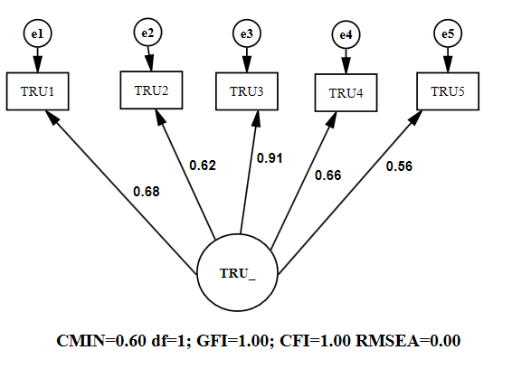 | Figure 5.2 (b)-Commitment Construct  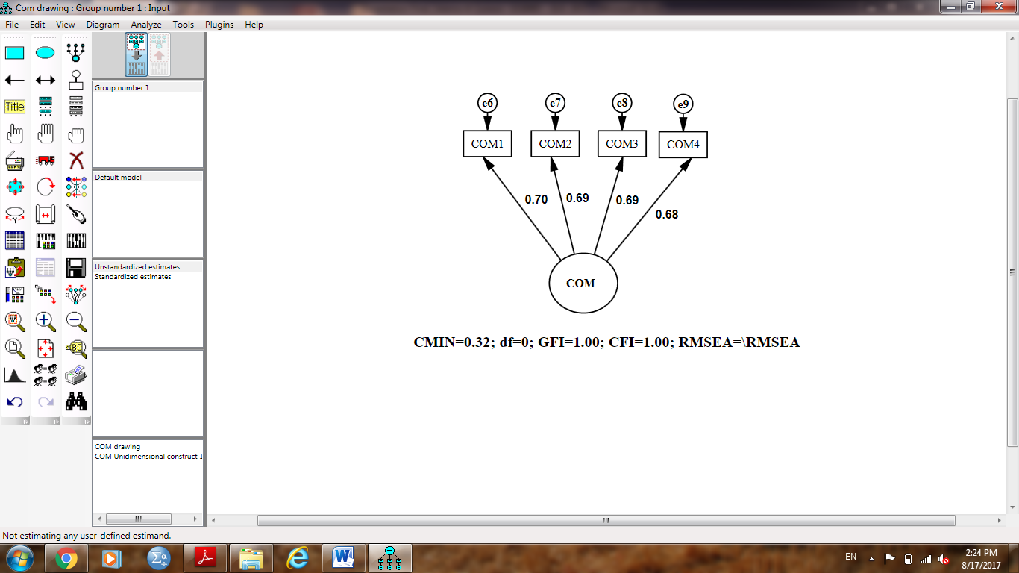
Figure 5.2 (c)-Collaboration Construct  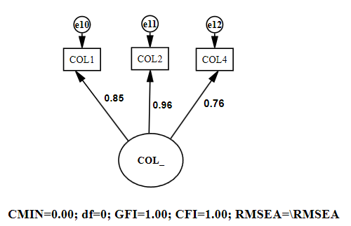 | Figure 5.2 (d)- Competence Construct  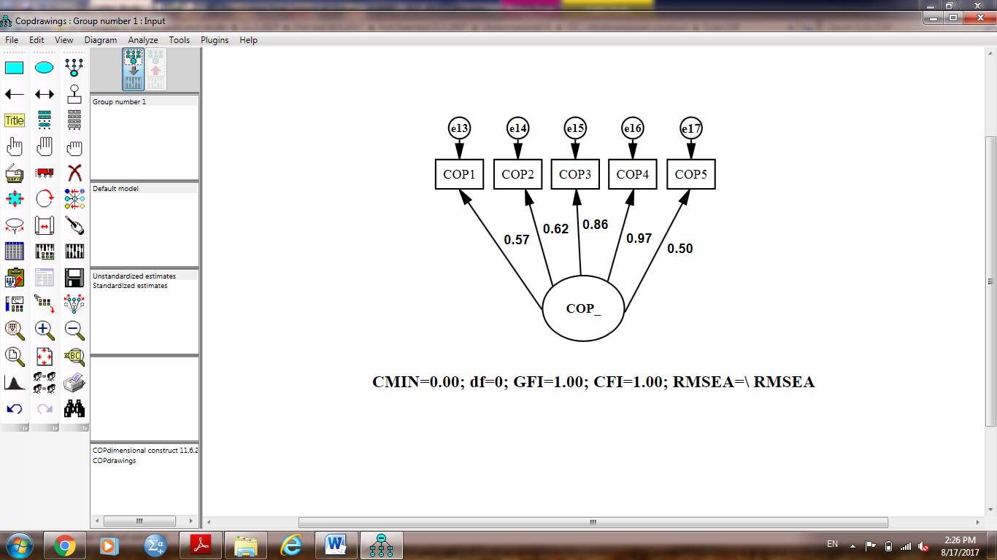
Figure 5 .2 (a-d): Summary of view and constructs CFA for (OC) First Order.

Organizational Culture (OC)
Organizational culture was proposed as a second-order variable characterized by the four first-order constructs: trust, collaboration, commitment and competence. The validity evaluation of this measurement framework revealed that the model fit level was met, as indicated in Figure 5.3 (a), which précised the fit keys given by the outcome of CFA. The outcome of the Chi-square test is 218.59 with a degree of freedom of 100. Even though the p-value related with this outcome was relevant at p= 0.00 and provided that the size of the sample population was significantly large at 568, as argued by Hair et al. (2010), a considerable p-value was imminent. Besides the Chi-square outcome, the incremental index (CFI) value was 0.96, yet the absolute fit indices for goodness-of-fit and badness-for-fit (RMSEA) were 0.92 and 0.05 respectively. These findings submit that the measurement framework of organizational culture offers a rationally good fit.

Moreover, the estimations of the factor loading were ideal and significant (at p=0.00, and was above 0.70), varying between 0.73 and 0.94, and the second-order latent variable also has a desired reliability value (CR=0.90). The evaluation of the interrelations between the four scopes of organizational culture as revealed in Figure 5.3 (b) indicated that all estimates significantly varied between 0.56 and 0.87 below cut-off value 0.90. This finding suggested distinctiveness in the content of the construct or rather discriminant validity as is the case with SEM application. The renowned measurement framework is the con-generic measurement framework that articulated that each measure is related only to one latent variable and all the co-variations between measures are caused by the associations between the construct and measures (Hair et al., 2010). Therefore, the con-generic measurement framework with unidimensional variables did contained cross-loadings amongst the measured constructs: COP2 with COP1, COP2 with COP3, COP3 with COP4, COP5 with COP4, COP2 with COP4, COL1 with COL2, COL1 with COL4, COM1 with COM2, COM4 with COM1, COM2 with COM3, COM4 with COM3, TRU1 with TRU4, TRU4 with TRU3, TRU4 with TRU5, and had amongst the error terms, TRU4 with TRU3. Coupled with these findings was the measurement framework’s validity, and the Hypothesis 1 that states that the Organizational Culture is a second-order latent construct composed of trust, commitment, collaboration and competence, was ascertained in some way.

Figure 5 .3.a: CFA Results for Organizational Culture (OC)
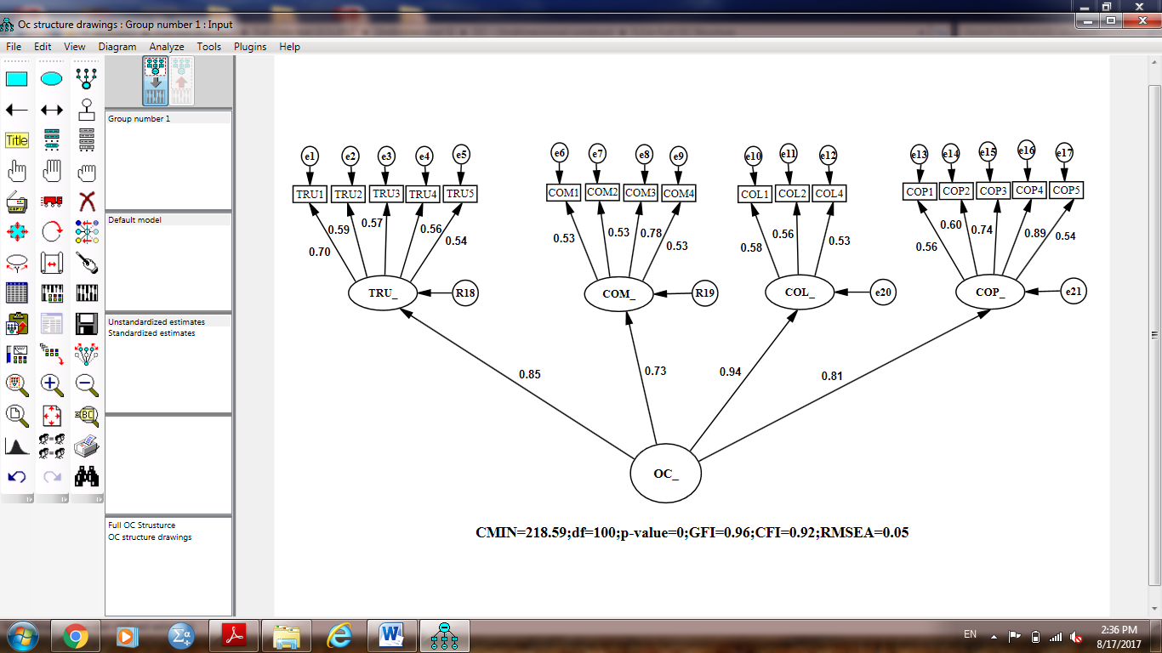

Figure 5 .3.b: Within Construct Discriminant Validity for Organizational Culture (OC)

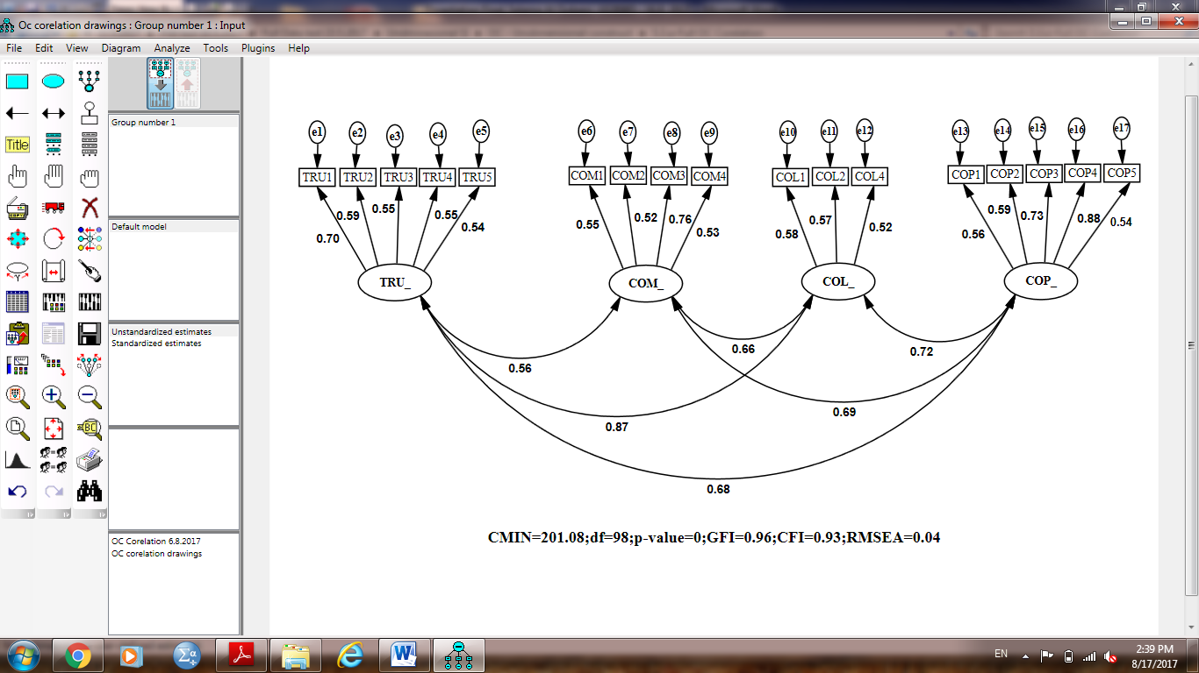

Knowledge Creation (KC)
As a construct of Knowledge Management practices, knowledge creation was proposed as a unidimensional variable that can be assessed based on the four objects KC1, KC2, KC3 and KC4. CFA was undertaken to evaluate the validity of the measurement framework of this variable. The CFA’s preliminary results indicated that the indices of the model fit failed to meet the fit conditions like χ2/df=9.09, p=0.00, and RMSEA=0.12 (above 0.10) (Hair et al., 2010). As a result, multiple model diagnostics such as standardized residuals, path estimates alongside modification scopes were utilized to enhance the structural infrastructure’s fit level to determine the enhanced level of the framework fit (Hair et al., 2010; Arbuckle, 2010; Gerbing & Anderson, 1988). All factor loading estimates (also referred to as standardised regression weights) were found to be positive, and ranged from 0.61 to 0.88. An assessment of modification keys revealed that the fit can be enhanced greatly by relaxing the analogous error co-variance bounds between the measurement framework and the error terms for the observed variables’ pairs: KC1 with KC4 and KC2 with KC4 (Arbuckle, 2010).
The revised summary of the fit indices, which is given by the CFA results is depicted in Figure 5.4 (a). The CFA output was referred to as a just-identified or saturated model with 0 degrees of freedom (Hair et al., 2010). The construct could not be tested for goodness of-fit separately and was integrated into the overall measurement model so that the interconnections between constructs could provide the necessary degrees of freedom to identify the overall model. However, all factor loadings were determined and found to be positive, and ranged from 0.57 to 0.92 and the construct’s reliability was sufficient (CR=0.91). Coupled up, the evidence buttressed the measurement framework’s unidimensionality and congregated validity. Hence, the four objects, namely KC1, KC2, KC3 and KC4, were utilized to evaluate Knowledge Management exercises as knowledge creation variable.

Knowledge Sharing (KS)
Postulated as a unidimensional variable, knowledge sharing was evaluated by four items: KS1, KS2, KS3 and KS4. CFA was undertaken to determine the validity of the variables’ measurement model. The preliminary findings of CFA revealed that the model did not get to meet the fit conditions; χ2/df=41.024, p=0.00 and RMSEA=0.27 (Hair et al., 2010). As a result, various model diagnostics such as modification indices, path estimates and standardized residuals were utilized to enhance the fit levels of the structural setup’s measurement framework as it has been utilized in knowledge sharing (Hair et al., 2010; Arbuckle, 2010; Gerbing & Anderson, 1988). The estimations of the factor loadings estimations were positive, they varied between 0.72 and 0.81. According to Arbuckle (2010), an assessment of modification keys revealed that fit can be enhanced greatly by relaxing or liberating the analogous error co-variance bounds between the error concepts for the observed variables’ pairs: KS1 with KS4 and KS3 with KS4.
An altered CFA was performed again to determine the enhance model fit level. Figure 5.4 (b) revealed the summary of fit indices given by the CFA result that is referred to as a saturated or just-identified framework with a degree of freedom of 0 (Hair et al., 2010). The variable cannot be assessed for suitability distinctively and it was incorporated into the entire measurement framework in order to allow the constructs’ interconnections to offer the desired degrees of freedom needed to pinpoint the general model. Nonetheless, upon assessment, it was revealed that the factor loading estimations were positive; they varied between 0.70 and 0.96. It was also found that the construct was reliable (CR=0.94). Coupled up, the evidence buttressed the measurement model’s unidimensionality and congregated validity. Hence, the items (KS1, KS2, KS3 and KS4) were utilized for measuring Knowledge Management undertakings as knowledge creation variable.

Knowledge Utilization (KU)
As a construct of Knowledge Management practice, knowledge utilization was proposed as a unidimensional variable, which can be assessed based on the four objects KU1, KU2, KU3 and KU4. CFA was undertaken to determine the validity of the variable’s measurement model. The preliminary findings of CFA revealed that the framework did not meet the fit conditions; χ2/df=9.54, p=0.00 and RMSEA=0.123 (Hair et al., 2006). As a result, various model diagnostics such as modification indices, path estimates and standardized residuals were utilized to enhance the fit levels of the structural setup’s measurement framework as it has been utilized in knowledge creation and sharing (Hair et al., 2010; Arbuckle, 2010; Gerbing &Anderson, 1988). The factor loading estimations were positive; they varied between 0.72 and 0.88 According to Arbuckle (2010), an assessment of modification keys revealed that fit can be enhanced greatly by liberating the analogous error co-variance bounds between the error concepts for the observed variables’ pairs: KU1 with KU3.

A revised CFA was repeated to examine the improved level of model fit. Figure 5.4 (c) displays the fit indices summary provided by the CFA output. The Chi-square value was 0.52 with 1 degree of freedom. The p-value associated with this result was insignificant at p=0.47. Thus, the χ2 goodness-of-fit statistic indicated that the observed covariance matrix matched the estimated covariance matrix within the sampling variance. In addition to the χ2 result, the value of CFI, an incremental fit index, was 1.00 while the values for absolute fit indices were 1.00 for GFI (goodness-of-fit) and 0.00 for RMSEA (badness-of-fit). These results suggested that the measurement model of structural infrastructure provided a reasonably good fit. Moreover, all factor loadings estimates considerably exceeded 0.50 and the construct reliability was found to be adequate (CR=0.92). Taken together, the evidence supported the unidimensionality and convergent validity of the measurement model, and, as a result, four items (KU1, KU2, KU3 and KU4) were utilized in measuring Knowledge Management undertakings as the knowledge creation variable.

Knowledge Internalization (KI)
Postulated as a unidimensional variable, knowledge internalization was evaluated by four items: KI1, KI2, KI3 and KI4. CFA was undertaken to determine the validity of the measurement model of the variable. The preliminary findings of CFA revealed that the model failed to meet the prerequisite fit conditions; χ2/df=3.46, p=0.03. As a result, various model diagnostics such as modification indices, path estimates and standardized residuals were utilized to enhance the fit levels of the measurement framework (Hair et al., 2010; Arbuckle, 2010; Gerbing &Anderson, 1988).
The factor loading estimations were significantly higher than 0.50 with the exception of one that had relations with KI4 (λ=0.48). Thus KI4 had to be deleted. An examination of modification indices suggested that fit could be improved significantly by freeing the corresponding error covariance parameter between the error terms for the measured variables KI3 and KI1. An overall check of diagnostic measures from CFA suggested that items KI4 was prime candidates for being dropped from the model. Given that the remaining questions still satisfied the content validity of the Knowledge Internalization construct, the candidate items for deletion were dropped from the measurement model.

The re-evaluated measurement framework of knowledge utilization construct had only three items as revealed in Figure 5.4 (d), which is considered to be a saturated or just-identified framework with a degree of freedom of 0 (Hair et al., 2010). The variable cannot be assessed for suitability distinctively and was incorporated into the entire measurement framework in order to allow the constructs’ interconnections to offer the desired degrees of freedom needed to pinpoint the general model. Nonetheless, upon assessment, the standard regression values were positive; they varied between 0.72 and 0.75. It was also found that the construct was reliable (CR=0.86). Coupled up, the evidence buttressed the measurement model’s unidimensionality and congregated validity. Hence, the items (KI1, KI2, KI3 and KI4) were utilized in measuring Knowledge Management undertakings as the Knowledge Internalization variable.
Figure 5 .4. (a-d): Summary of view and constructs CFA for (KMP)-First Order.

Figure 5.4 (a)-Knowledge Creation Construct  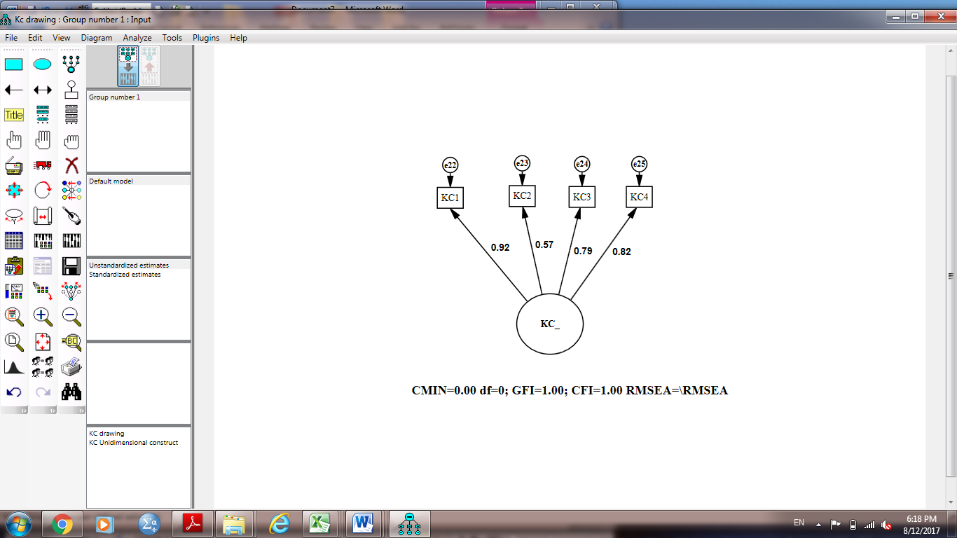 | Figure 5.4 (b)- Knowledge Sharing Construct  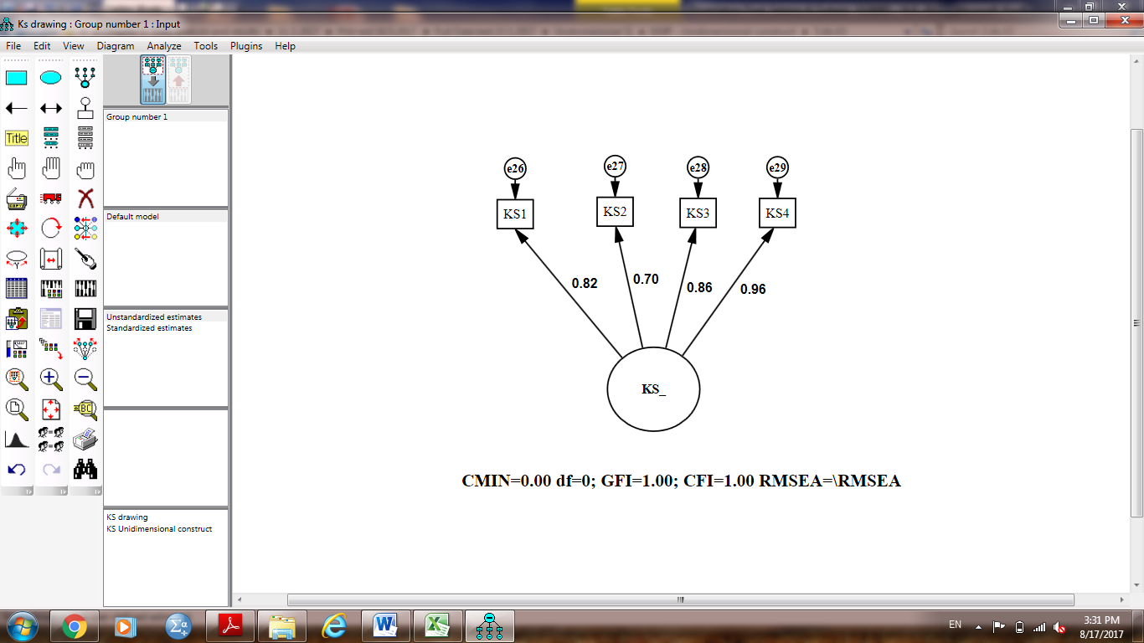
Figure 5.4 (c)- Knowledge Utilization Construct  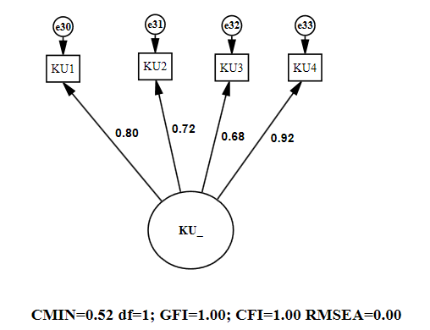 | Figure 5.4 (d)- Knowledge Internalization Construct  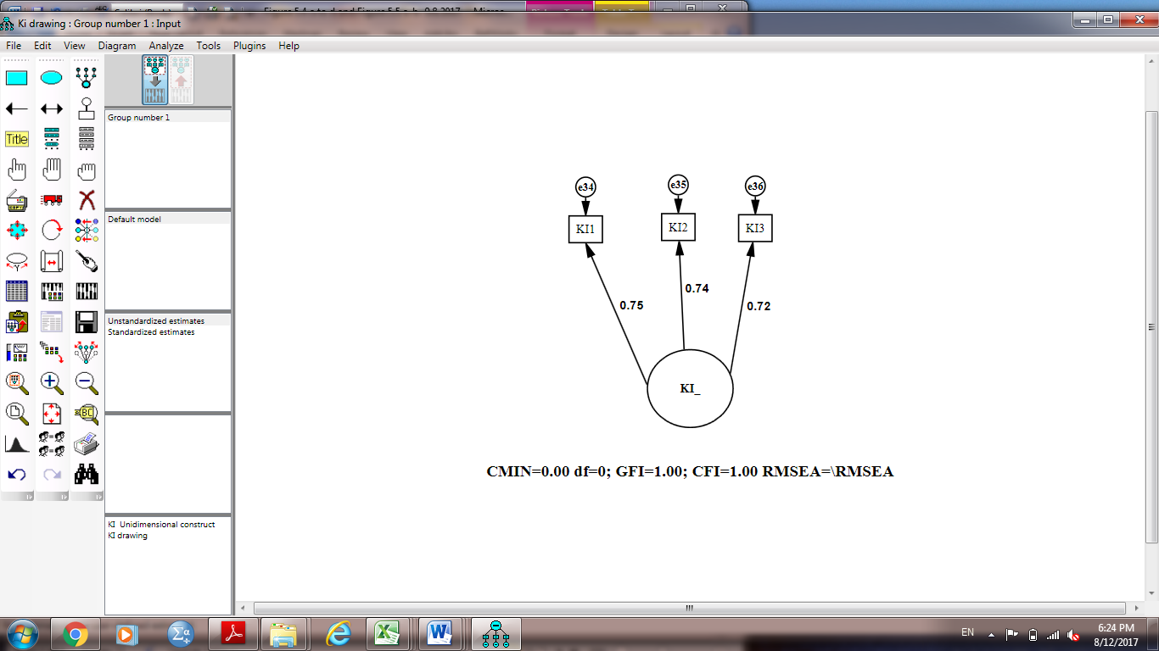

Knowledge Management Practices (KMP)
Knowledge Management Practices as a variable was assumed to be a second-order construct known by the four constructs, knowledge creation, knowledge internalization, knowledge sharing and knowledge utilization. This measurement model’s validity inspection indicated that the model fit level was met. Figure 5.5 (a) depicted the summary of the fit indices given in the CFA printout. The value of Chi-square was 242.07, given 67 degrees of freedom. Even though the p-value related with this outcome was relevant at p= 0.00, and provided that the size of the sample population was significantly large at 568, a considerable p-value was imminent as argued by Hair, et al., (2006). Besides the Chi-square outcome, the incremental index (CFI) value was 0.97, yet the fit estimate for goodness-of-fit and badness-for-fit (RMSEA) was 0.95 and 0.07 respectively. These findings suggest that the measurement framework of Knowledge Management practices offers a rationally good fit.
Moreover, the estimations of the factor loading were ideal and significant (at p=0.00, and was above 0.70), varying between 0.96 and 0.99, and the second-order latent variable also has a desired reliability index (CR=0.99). An evaluation of the interrelations between the four scopes of Knowledge Management practices as revealed in Figure 5.5 (b) indicated that all estimates were considerably higher than the threshold value of 0.90, and varied between 0.95 and 0.98. This finding suggests distinctiveness in the content of the construct or rather discriminant validity. The renowned measurement framework is the con-generic measurement framework that articulates that each measure is related to only one latent variable and all the co-variations between measures are caused by the associations between the construct and measures (Hair et al., 2006). Therefore, the con-generic measurement framework with unidimensional variables contained cross-loadings amongst the measured constructs: KI2 with KI1 and amongst the error concepts: KI2 with KU4, KI2 with KU2, KI2 with KS1, KI2 with KS3, KI2 with KC2, KU3 with KU2, KU3 with KS4, KU3 with KS3, KU2 with KC2, KU1 with KS4, KS4 with KC1, KS3 with KC2, KS3 with KS1, KS1 with KC4, KC4 with KC1, KC2 with KC3, KI40 with KC37 and KC39 with KC37. Coupled up these findings buttressed the measurement framework’s validity, and Hypothesis 2 that states that Knowledge Management Practices is a second-order latent construct comprising knowledge creation, knowledge sharing, knowledge utilization and knowledge internalization, was confirmed in some way.

Figure 5 .5.a: CFA Results for Knowledge Management Practices (KMP)
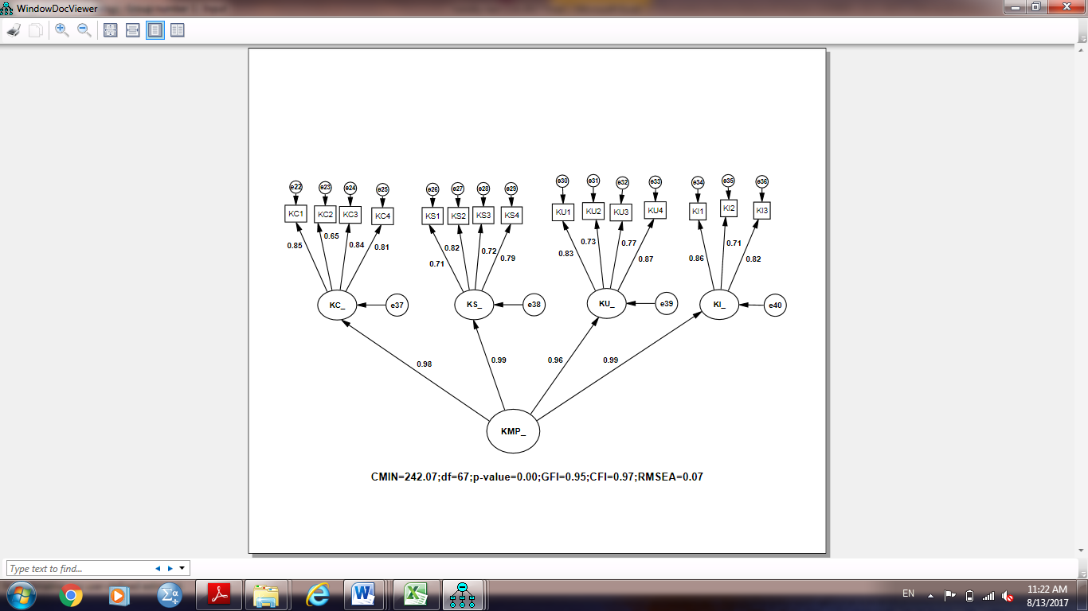

Figure 5.5.b: Within Construct Discriminant Validity for Knowledge Management
Practices (KMP)
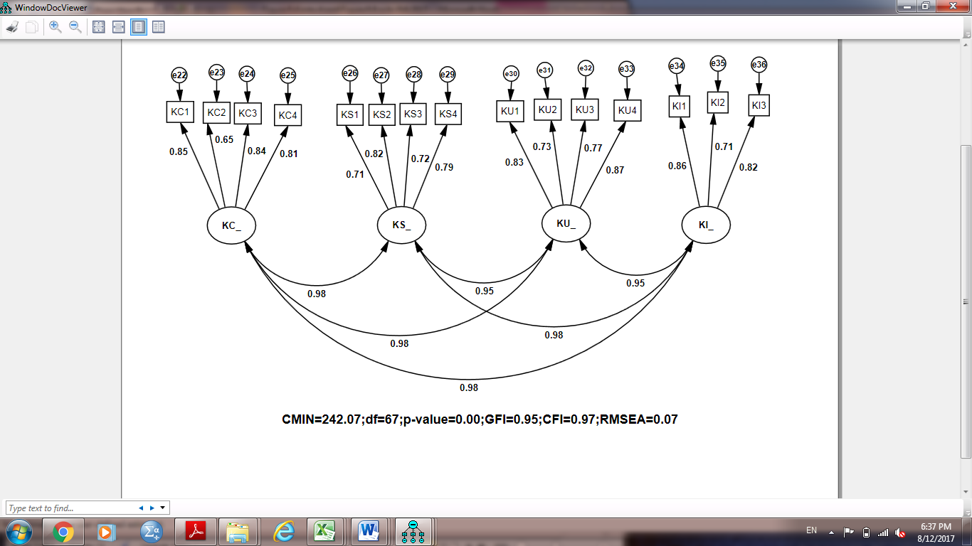

Financial Performance (FP)
Financial performance as the first viewpoint of balanced scorecard variable to assess the operational efficiency was hypothesized as a unidimensional variable determined by the use of five items: FP1, FP2, FP3, FP4 and FP5. CFA was used to analyse the scope of measurement for the construct. The preliminary findings of CFA revealed that the framework did not get to meet the fit conditions: χ2/df=44.26, p=0.00 and RMSEA=0.12 (Hair et al., 2010). As a result, various model diagnostics such as modification indices, path estimates and standardized residuals were utilized to enhance the fit levels of the organizational setup’s measurement framework (Hair et al., 2010; Arbuckle, 2010; Gerbing & Anderson, 1988). Nonetheless, the estimations of the factor loadings were positive; they varied between 0.73 and 0.86. According to Arbuckle, (2010), an assessment of modification keys revealed that fit can be enhanced greatly by relaxing the analogous error co-variance bounds between the error concepts for the observed variables’ pairs: FP1 with FP3, and for the observed variables’ pairs: FP5 with FP3, FP5 with FP2 and FP1 with FP2. According to Arbuckle (2010), the error concepts for the measure constructs epitomized more than mere observation errors.
Figure 5.6 (a) reveals the summary of fit indices given by the CFA result. The value of Chi-square was 2.77 given 1 degree of freedom. Because the p-value related with this outcome was relevant at p= 0.10, the χ2 suitability value revealed that the computed co-variance matrix resembled the computed co-variance matrix given by the sampling variance. Provided that the sample population size was significantly large at 568, a considerable p-value was imminent, as argued by Hair et al. (2006).
Besides the Chi-square outcome, the incremental index (CFI) value was 1.00, yet the absolute fit indices for goodness-of-fit and badness-for-fit (RMSEA) was 1.00 and 0.06 respectively. These findings suggest that the cultural infrastructure’s measurement framework offers a rationally good fit. Furthermore, the estimations of the factor loading were ideal and significant (above 0.50), varying between 0.65 and 0.89, and the second-order latent variable also has a desired reliability (CR=0.90).
Coupled up, the evidence buttressed the measurement model’s unidimensionality and congregated validity. Hence, all the five items were utilized in measuring operational efficiency as a financial performance variable.

Customer Satisfaction (CS)
Customer satisfaction as the second viewpoint of balanced scorecard variable to assess the operational efficiency that was hypothesized as a unidimensional variable was determined by the use of five items: CS1, CS2, CS3, CS4 and CS5. CFA was used to analyse the scope of measurement for the construct. The preliminary findings of CFA revealed that the framework did not get to meet the fit conditions; χ2/df=11.17, p=0.00 and RMSEA=0.13 (Hair et al., 2010). As a result, various model diagnostics such as modification indices, path estimates and standardized residuals were utilized to enhance the fit levels of the organizational setup’s measurement framework (Hair et al., 2010; Arbuckle, 2010; Gerbing &Anderson, 1988).
Nonetheless, the factor loading estimations were positive; they varied between 0.83 and 0.85, and the standardized residual were less than 2.5. According to Arbuckle, (2010), an assessment of modification keys revealed that fit can be enhanced greatly by relaxing the analogous error co-variance bounds between the error concepts using the measure variables’ pairs: CS4 with CS5, CS1 with CS2, CS3 with CS4 and CS2 with CS3.
Figure 5.6 (b) reveals the summary of fit indices given by the CFA result. The value of Chi-square was 2.34 given 3 degrees of freedom. Because the p-value related with this outcome was irrelevant at p= 0.05, the χ2 suitability value revealed that the computed co-variance matrix resembled the computed co-variance matrix given by the sampling variance. Besides the Chi-square outcome, 1.00 was the observed incremental index (CFI) value, yet the fit values for goodness-of-fit and badness-for-fit were 0.998 and 0.00 respectively. These findings suggest that the framework of acquisition procedure offers a rationally good fit. Furthermore, the estimations of the factor loading were ideal and significant (above 0.50), varying between 0.66 and 0.84, and the second-order latent variable also had a desired reliability (CR=0.92). Coupled up, the evidence buttressed the measurement model’s unidimensionality and congregated validity. Hence, all the five items were utilized in measuring operational efficiency as a consumer satisfaction variable.

Internal Business Process (IBP)
Internal Business Process as the third viewpoint of balanced scorecard variable to assess the operational efficiency was hypothesized as a unidimensional variable determined by the use of five items: IBP1, IBP2, IBP3, IBP4 and IBP5. CFA was used to analyse the scope of measurement for the construct. The preliminary findings of CFA revealed that the framework did not meet the fit conditions; χ2/df=10.627, p=0.00; and RMSEA=0.130 (Hair et al., 2010). As a result, various model diagnostics such as modification indices, path estimates and standardized residuals were utilized to enhance the fit levels of the organizational setup’s measurement framework (Hair et al., 2010; Arbuckle, 2010; Gerbing &Anderson, 1988).
The factor loading estimations were positive; they varied between 0.80 and 0.85., and the standardized residual was less than 2.5. According to Arbuckle (2010), an assessment of modification keys revealed that fit can be enhanced greatly by relaxing the analogous error co-variance bounds between the error concepts making use of the measure variables’ pairs: IBP5 with IBP4 and IBP2 with IBP1.
Reviewed CFA was re-introduced to determine the enhanced model fit level. Figure 5.6 (c) reveals the summary of fit indices given by the CFA result. The value of Chi-square was 13.00 given 5.0 degrees of freedom. Because the p-value related with this outcome was relevant at p= 0.023, the χ2 suitability value revealed that the computed co-variance matrix resembled the computed co-variance matrix given by the sampling variance. Besides the Chi-square outcome, the incremental index (CFI) value was 0.996 yet the absolute fit indices for goodness-of-fit and badness-for-fit (RMSEA) was 0.991 and 0.05 respectively. These findings suggest that the framework for protection procedure offered a rationally good fit.
Furthermore, the estimations of the factor loading was ideal and significant (above 0.70), varying between 0.79 and 0.86, and the second-order latent variable also had a desired reliability (CR=0.92). Coupled up, the evidence buttressed the measurement model’s unidimensionality and congregated validity. Hence, all the five objects (IBP1, IBP2, IBP3, IBP4, and IBP5) were utilized in measuring internal business process variable.

Learning and Growth (LG)
Learning and growth is the third viewpoint of balanced scorecard variable to assess the operational efficiency that was hypothesised as a unidimensional variable determined by the use of five items: LG1, LG2, LG3, LG4 and LG5. CFA was used to analyse the scope of measurement for the construct. The preliminary findings of CFA revealed that the framework did not get to meet the fit conditions; χ2/df=2.55, p=0.026; CFI=0.99; GFI=0.99 and RMSEA=0.05 (Hair et al., 2006). As a result, various model diagnostics like modification indices, path estimates and standardised residuals were utilised to enhance the fit levels of the organizational setup’s measurement framework (Hair et al., 2010; Arbuckle, 2010; Gerbing & Anderson, 1988). The standard regression estimations were positive, above 0.50, with the exception of two that were associated with LG4 (λ=0.34) and LG5 (λ=0.13). As a result, the two items LG4 and LG5 were deletion candidates.
An all-inclusive diagnostic methods’ check from CFA revealed that items LG4 and LG5 were ideal candidates for deletion from the framework. Provided that the remaining inquisitions meet the context validity requirements of the knowledge utilisation construct, the items marked for deletion were deleted.
The re-evaluated measurement framework of knowledge utilisation construct had only three items, as revealed in Figure 5.6 (d), which is considered to be a saturated or just-identified framework with a degree of freedom of 0 (Hair et al., 2010). The variable cannot be assessed for suitability distinctively and thus, was incorporated into the entire t framework in order to allow the constructs’ interconnections to offer the desired degrees of freedom needed to pinpoint the general model. Nonetheless, upon assessment, it was revealed that the estimations of factor loadings were positive; they varied between 0.67 and 0.87. Additionally, it was found that the construct was reliable (CR=0.84). Coupled up, the evidence buttressed the measurement model’s unidimensionality and congregated validity. Hence, the items LG1, LG2 and LG3 were utilised in measuring the learning and growth variable.

Figure 5.6. (a-d): Summary of view and constructs CFA for (OE)-First Order.

Figure 5.6(a)- Financial Performance Construct  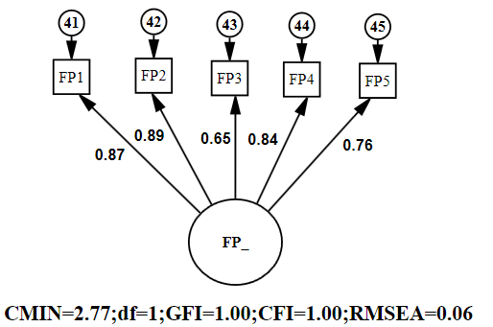 | Figure 5.6 (b)- Customer Satisfaction Construct  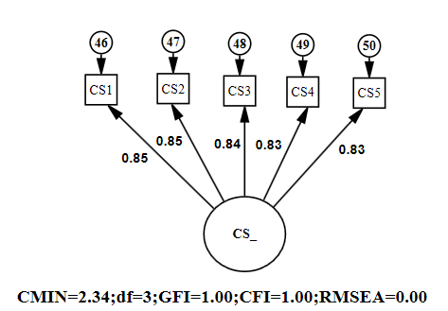
Figure 5.6 (c)- Internal Business Process Construct  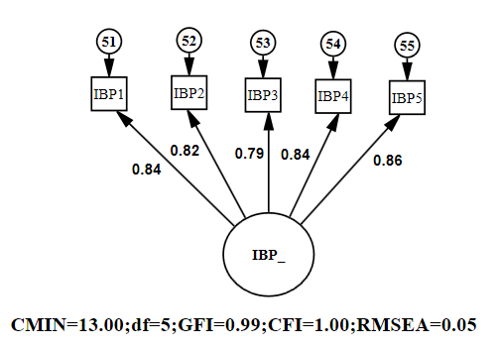 | Figure 5.6 (d)- Learning and Growth Construct  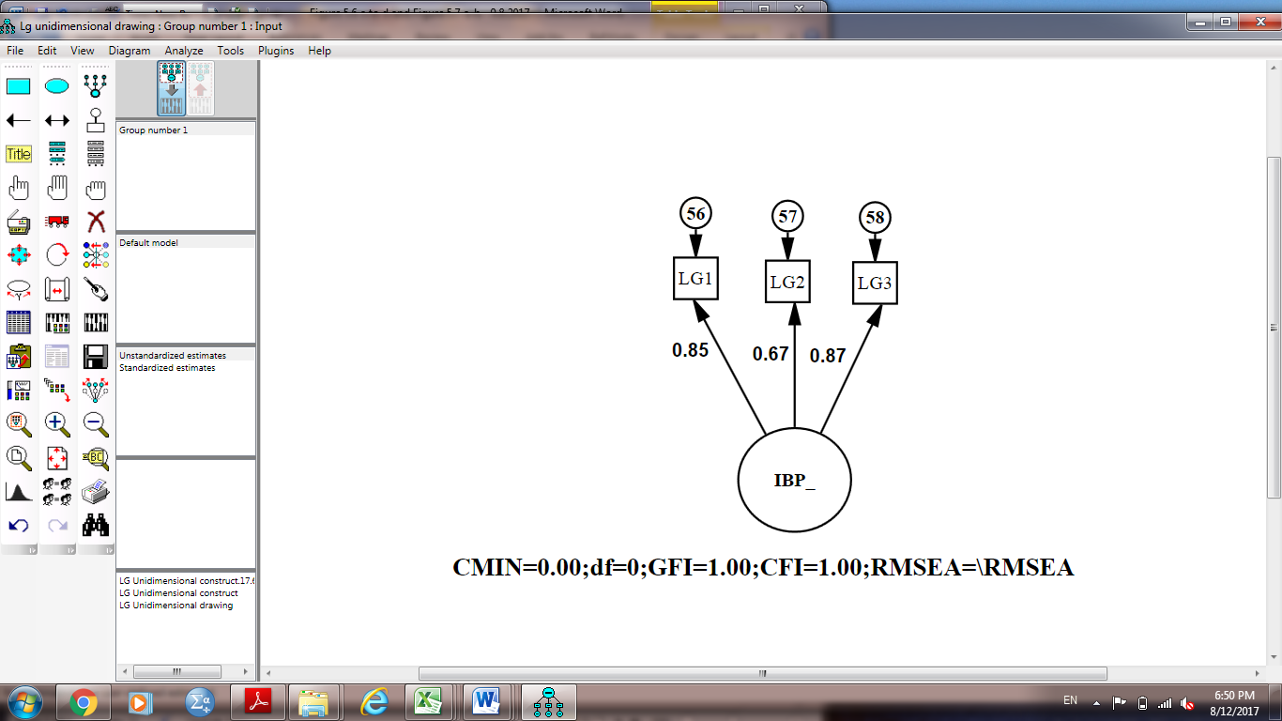

Operational Efficiency (OE)
Operational Efficiency Balanced scorecard strategy is utilised in examining operational efficiency rating from four viewpoints; thus, operational efficiency was hypothesised as a second-order variable characterised by the four first-order constructs, namely, customer satisfaction, financial performance, learning and growth and internal business process. The measurement model’s validity inspection suggested that the model fit’s level was met.
Figure 5.7 (a) depicts the summary of the fit indices given in the output of CFA. The value of Chi-square was 414.47 given 119 degrees of freedom. Even though the p-value related with this outcome was relevant at p= 0.00, and provided that the size of the sample population was significantly large, 568, then, as argued by Hair, et al., (2006), a considerable p-value was imminent. Besides the Chi-square outcome, the incremental index (CFI) value was 0.97, yet the fit values for goodness-of-fit and RMSEA were 0.93 and 0.07, respectively. These findings suggest that the measurement framework of Operational efficiency offers a rationally good fit.
Moreover, the estimations of the factor loading were ideal and significant (at p=0.00, was above 0.70), varying between 0.96 and 0.99, and the second-order latent variable also had a desired reliability value (CR=0.99). An evaluation of the interrelations between the four scopes of Operational efficiency, as revealed in Figure 5.5 (b), indicated that all estimations were considerably higher than the threshold value of 0.90 and varied between 0.95 and 0.98. This finding suggests distinctiveness in the content of the construct or rather discriminant validity. The renowned measurement framework is the con-generic measurement framework that articulates that each measure is related to only one latent variable and all the co-variations between measures are caused by the associations between the construct and measures (Hair, et al., 2006). Therefore, the con-generic measurement framework with unidimensional variables contained cross-loadings amongst the measured constructs: LG1 with LG2, FP5 with FP4, FP4 with FP3, FP3 with FP2 and FP2 with FP1, and amongst the error concepts: FP5 with CS1, CS2 with CS3, CS2 with CS4, CS5 with IBP1, IBP5 with LG1, LG1 with LG3, and CS60 with LG62. Coupled up, these findings buttressed the measurement framework’s validity and in some way, Hypothesis 3, which states that the Operational Efficiency is a second-order latent construct comprising of financial performance, customer satisfaction, internal business process and learning and growth, was confirmed.

Figure 5.7.a: CFA Results for Operational Efficiency (OE)

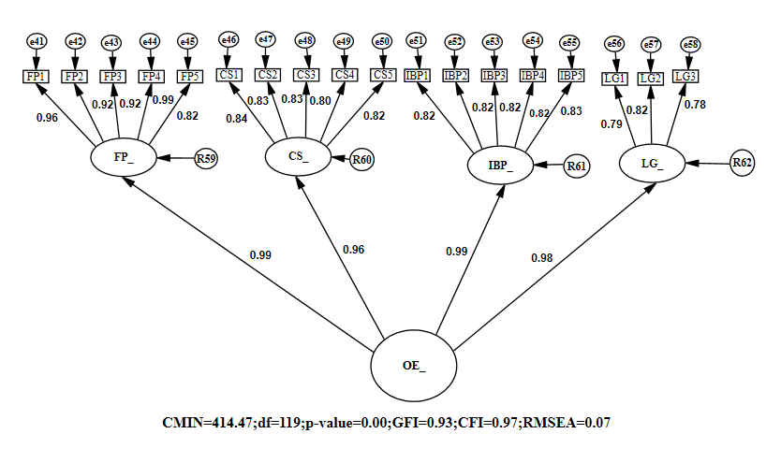

Figure 5.7.b: Within Construct DiscriminantValidity for Operational Efficiency (OE)

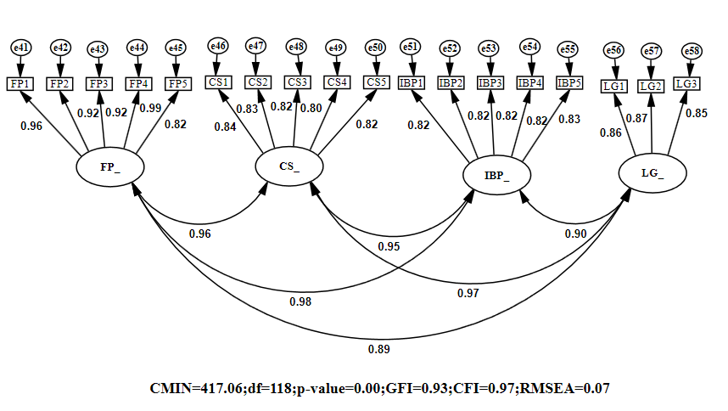

Overall Measurement Model
After evaluating the validity for single latent constructs, both first-order and second-order, a complete measurement model was further assessed using CFA. The complete measurement model’s validity inspection revealed that the model fit’s level was met. Figure 5.8 depicts the summary of the fit indices given in the CFA printout. The value of Chi-square was 1910.09 given 1117 degrees of freedom. P-value related to this outcome was relevant at p= 0.00. Beside the Chi-square outcome, the incremental index (CFI) value was 0.96, yet the absolute fit indices for goodness-of-fit and badness-for-fit (RMSEA) was 0.88 and 0.04, respectively. The sample population is significantly large (N=568) (number of observations N=127) and the study’s model is complex (number of observed variables m=50); the results indicate that the overall measurement framework offered a desirable fit of the data set. The parameter estimations for the constructs are illustrated in Tables: 5.5 (a) and 5.5 (b). All standardised regression values significantly exceeded the desired value (0.50) and varied extensively from 0.50 to 0.99 for the items COP5 and FP, IBP, KS and KI. The compound reliability for the single constructs was acceptable; it exceeded 0.70.
The investigation of inter-variable correlations (revealed in Table 5.6) highlighted an average to high association level amongst variables. All estimates of correlation coefficient were significantly within the range 0.56–1.06 at p=0.00, which indicates distinctness in discriminant validity or construct content (See Table 5.7).
The general measurement framework with all unidimensional variables contained no cross-loadings amongst the measured variables and the error concepts. These results reinforce the overall measurement framework’s construct validity and model fit. Therefore, the preliminary stage of SEM was finalised, resulting in the successive evaluation of the structural framework.

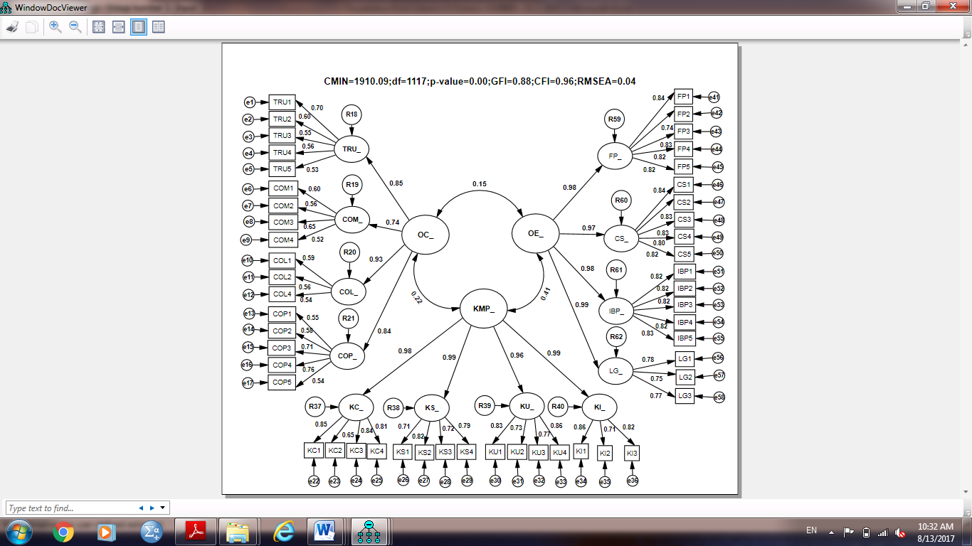
Figure 5.8: CFA Results for Final Measurement Model

 | Table 5.5.a: Standardised Regression Weights (λ) and Composite Reliability Estimates (CR) First-order Constructs
 | Item | (TRU) | (COM) | (COL) | (COP) | (KC) | (KS) | (KU) | (KI) | (FP) | (CS) | (IBP) | (LG) | t-value | SMC (r2)
 | Item | λ | λ | λ | λ | λ | λ | λ | λ | λ | λ | λ | λ | t-value | SMC (r2)
 | TRU1 | 0.68 |  |  |  |  |  |  |  |  |  |  |  | 12.30 | 0.48
 | TRU2 | 0.62 |  |  |  |  |  |  |  |  |  |  |  | 12.02 | 0.34
 | TRU3 | 0.91 |  |  |  |  |  |  |  |  |  |  |  | 2.10 | 0.16
 | TRU4 | 0.66 |  |  |  |  |  |  |  |  |  |  |  | 5.20 | 0.20
TRU5 |  | 0.56 |  |  |  |  |  |  |  |  |  |  |  | 8.14 | 0.25
COM1 |  |  | 0.70 |  |  |  |  |  |  |  |  |  |  | 4.68 | 0.20
COM2 |  |  | 0.69 |  |  |  |  |  |  |  |  |  |  | 4.68 | 0.28
COM3 |  |  | 0.69 |  |  |  |  |  |  |  |  |  |  | 4.68 | 0.35
COM4 |  |  | 0.68 |  |  |  |  |  |  |  |  |  |  | 4.68 | 0.26
COL1 |  |  |  | 0.85 |  |  |  |  |  |  |  |  |  | 10.25 | 0.29
COL2 |  |  |  | 0.96 |  |  |  |  |  |  |  |  |  | 2.45 | 0.22
COL4 |  |  |  | 0.76 |  |  |  |  |  |  |  |  |  | 2.89 | 0.23
COP1 |  |  |  |  | 0.57 |  |  |  |  |  |  |  |  | 6.51 | 0.27
COP2 |  |  |  |  | 0.62 |  |  |  |  |  |  |  |  | 7.72 | 0.22
COP3 |  |  |  |  | 0.86 |  |  |  |  |  |  |  |  | 5.97 | 0.24
COP4 |  |  |  |  | 0.97 |  |  |  |  |  |  |  |  | 2.70 | 0.31
COP5 |  |  |  |  | 0.50 |  |  |  |  |  |  |  |  | 9.50 | 0.26
KC1 |  |  |  |  |  | 0.92 |  |  |  |  |  |  |  | 22.57 | 0.73
KC2 |  |  |  |  |  | 0.57 |  |  |  |  |  |  |  | 13.73 | 0.41
KC3 |  |  |  |  |  | 0.79 |  |  |  |  |  |  |  | 19.35 | 0.70
KC4 |  |  |  |  |  | 0.82 |  |  |  |  |  |  |  | 18.66 | 0.66
KS1 |  |  |  |  |  |  | 0.82 |  |  |  |  |  |  | 21.44 | 0.50
KS2 |  |  |  |  |  |  | 0.70 |  |  |  |  |  |  | 17.61 | 0.69
KS3 |  |  |  |  |  |  | 0.86 |  |  |  |  |  |  | 22.46 | 0.53
KS4 |  |  |  |  |  |  | 0.96 |  |  |  |  |  |  | 18.53 | 0.63

Table 5.5a (Cont.)– Standardised Regression Weights (λ) and Composite Reliability Estimates (CR) First-order Constructs
Item | (TRU) | (COM) | (COL) | (COP) | (KC) | (KS) | (KU) | (KI) | (FP) | (CS) | (IBP) | (LG) | t-value | SMC (r2)
Item | λ | λ | λ | λ | λ | λ | λ | λ | λ | λ | λ | λ | t-value | SMC (r2)
KU1 |  |  |  |  |  |  | 0.80 |  |  |  |  |  | 21.23 | 0.70
KU2 |  |  |  |  |  |  | 0.72 |  |  |  |  |  | 18.66 | 0.47
KU3 |  |  |  |  |  |  | 0.68 |  |  |  |  |  | 17.03 | 0.60
KU4 |  |  |  |  |  |  | 0.92 |  |  |  |  |  | 25.86 | 0.74
KI1 |  |  |  |  |  |  |  | 0.75 |  |  |  |  | 4.32 | 0.63
KI2 |  |  |  |  |  |  |  | 0.74 |  |  |  |  | 8.37 | 0.47
KI3 |  |  |  |  |  |  |  | 0.72 |  |  |  |  | 8.49 | 0.66
FP1 |  |  |  |  |  |  |  |  | 0.87 |  |  |  | 21.94 | 0.87
FP2 |  |  |  |  |  |  |  |  | 0.89 |  |  |  | 6.91 | 0.90
FP3 |  |  |  |  |  |  |  |  | 0.65 |  |  |  | 12.38 | 0.65
FP4 |  |  |  |  |  |  |  |  | 0.84 |  |  |  | 21.94 | 0.84
FP5 |  |  |  |  |  |  |  |  | 0.76 |  |  |  | 19.54 | 0.75
CS1 |  |  |  |  |  |  |  |  |  | 0.85 |  |  | 23.66 | 0.70
CS2 |  |  |  |  |  |  |  |  |  | 0.85 |  |  | 28.05 | 0.57
CS3 |  |  |  |  |  |  |  |  |  | 0.84 |  |  | 28.05 | 0.67
CS4 |  |  |  |  |  |  |  |  |  | 0.83 |  |  | 26.53 | 0.68
CS5 |  |  |  |  |  |  |  |  |  | 0.83 |  |  | 26.53 | 0.66
IBP1 |  |  |  |  |  |  |  |  |  |  | 0.84 |  | 23.94 | 0.70
IBP2 |  |  |  |  |  |  |  |  |  |  | 0.82 |  | 26.55 | 0.71
IBP3 |  |  |  |  |  |  |  |  |  |  | 0.79 |  | 26.55 | 0.69
IBP4 |  |  |  |  |  |  |  |  |  |  | 0.84 |  | 28.99 | 0.68
IBP5 |  |  |  |  |  |  |  |  |  |  | 0.86 |  | 28.99 | 0.69

Table 5.5a (Cont.)– Standardised Regression Weights (λ) and Composite Reliability Estimates (CR) First-order Constructs

Item | (TRU) | (COM) | (COL) | (COP) | (KC) | (KS) | (KU) | (KI) | (FP) | (CS) | (IBP) | (LG) | t-value | SMC (r2)
Item | λ | λ | λ | λ | λ | λ | λ | λ | λ | λ | λ | λ | t-value | SMC (r2)
LG1 |  |  |  |  |  |  |  |  |  |  |  | 0.85 | 22.47 | 0.61
LG2 |  |  |  |  |  |  |  |  |  |  |  | 0.67 | 17.07 | 0.57
LG3 |  |  |  |  |  |  |  |  |  |  |  | 0.87 | 22.95 | 0.60
CR  ( Value >0.7), | 0.82 | 0.78 | 0.89 | 0.84 | 0.91 | 0.94 | 0.92 | 0.86 | 0.90 | 0.92 | 0.92 | 0.84 | --- | ---
AVE  ( Value >0.5) , | 0.50 | 0.50 | 0.74 | 0.53 | 0.62 | 0.71 | 0.62 | 0.54 | 0.65 | 0.71 | 0.69 | 0.64 | --- | ---
Convergent validity | √ | √ | √ | √ | √ | √ | √ | √ | √ | √ | √ | √ | --- | ---

Table 5.5.b: Standardised Regression Weights (λ) and Composite Reliability Estimates (CR) - Second-order Constructs

Item | Organization Culture (OC) | Knowledge Management Practice (KMP) | Operational Efficiency (OE) | t-value | SMC (r2)
Item | λ | λ | λ | t-value | SMC (r2)
TRU_ | 0.85 |  |  | 7.66 | 0.85
COL_ | 0.74 |  |  | 7.10 | 0.73
COM_ | 0.93 |  |  | 7.66 | 0.94
COP_ | 0.84 |  |  | 8.31 | 0.81
KC_ |  | 0.98 |  | 23.73 | 0.97
KS_ |  | 0.99 |  | 18.84 | 0.99
KU_ |  | 0.96 |  | 22.56 | 0.91
KI_ |  | 0.99 |  | 17.55 | 0.98
FP_ |  |  | 0.99 | 19.91 | 0.99
CS_ |  |  | 0.96 | 19.91 | 0.93
IBP_ |  |  | 0.99 | 22.89 | 0.98
LG_ |  |  | 0.98 | 12.22 | 0.97
CR  ( Value >0.7) , | 0.90 | 0.99 | 0.99 | ---- | ----
AVE  ( Value >0.5) | 0.71 | 0.96 | 0.96 | ---- | ----
Convergent validity | √ | √ | √ | ---- | ----

Composite Reliability (CR) and Average Variance Extracted (AVE) is defined by (Hair, et al.,2010; Fornell & Larcker, 1981; Joreskog, 1971).
Composite Reliability (CR), (Value >0.7):$$CR=\frac{{\left(\sum_{i=1}^{ρ}{λi}\right)}^{2}}{{\left(\sum_{i=1}^{ρ}{λi}\right)}^{2}+\sum_{i=1}^{ρ}{(1-{λi}^{2})}}$$
Average Variance Extracted (AVE), (Value >0.5):
$$AVE= \frac{{\sum_{i=1}{λi}}^{2}}{{\sum_{i=1}{λi}}^{2}+\sum_{i=1}{var (εi)}}$$

Whereby, λ (lambda) is the standardised factor loading for item i of latent variable on its corresponding factor;
$(1-{λi}^{2})$ is the variance of measurement error of each indicator;
$var \left(εi\right)$ is the squared measurement error of indicator i
p is the number of indicators.
Table 5.6: Standardised Inter-Construct Correlation Estimates
Inter-Construct Correlation | Estimate | Standard Error | t-value
OC Measurement Model
TRU_ <--> COM_ | 0.56 | 0.009 | 5.49
COL_ <--> TRU_ | 0.87 | 0.008 | 7.38
COP_ <--> TRU_ | 0.68 | 0.007 | 6.88
COL_ <--> COM_ | 0.66 | 0.01 | 6.43
COP_ <--> COM_ | 0.69 | 0.011 | 6.58
COL_ <--> COP_ | 0.72 | 0.008 | 7.50
KMP Measurement Model
KC_ <--> KS_ | 0.98 | 0.015 | 12.65
KC_ <--> KU_ | 0.98 | 0.016 | 13.91
KC_ <--> KI_ | 0.98 | 0.019 | 12.31
KS_ <--> KU_ | 0.95 | 0.015 | 12.40
KS_ <--> KI_ | 0.98 | 0.018 | 11.27
KU_ <--> KI_ | 0.95 | 0.019 | 12.02
OE Measurement Model
FP_ <--> IBP_ | 0.98 | 0.018 | 12.851
FP_ <--> LG_ | 0.89 | 0.017 | 12.569
FP_ <--> CS_ | 0.96 | 0.017 | 12.872
IBP_ <--> LG_ | 0.90 | 0.014 | 13.284
CS_ <--> IBP_ | 0.95 | 0.015 | 13.542
CS_ <--> LG_ | 0.97 | 0.015 | 13.865
Overall Measurement Model
OC_ <--> OE_ | 0.15 | 0.004 | 2.79
OC_ <--> KMP_ | 0.22 | 0.005 | 3.92
KMP_ <--> OE_ | 0.41 | 0.012 | 7.21

Table 5.7: Construct Discriminant Validity for (OC,KMP,OE)

Item | CR | AVE | MSV | ASV | MaxR(H) | KMP_ | OC_ | OE_ | Discriminant Validity
KMP_ | 0.99 | 0.96 | 0.17 | 0.029 | 0.993 | 0.98 |  |  | √
OC_ | 0.91 | 0.71 | 0.05 | 0.002 | 0.994 | 0.22 | 0.84 |  | √
OE_ | 0.99 | 0.96 | 0.17 | 0.029 | 0.996 | 0.41 | 0.15 | 0.98 | √
Note: CR = Composite Reliability; AVE = Average Variance Extracted; Maximum Shared Variance (MSV), Average Shared Variance (ASV), and MaxR (H) = Maximum Reliability; (H) and average factor loadings.
Discriminant Validity achieved:
MSV < AVE, ASV < AVE, Square root of AVE greater than inter-construct correlations (Shaffer, et al., 2016;Hair, et al.,2010).
  - Structural Equation Modeling
The ultimate general framework that was advanced and examined in the preceding sections comprises 12 basic constructs: TRU, COM, COL, COP, KC, KS, KU, KI, FP, IBP, CS and LG as the first-order latent variables and three basic constructs: KMP, OE and OC as the second-order latent variables. The construct validity and fit of the measurement model were revealed to be substantial based on various assessment techniques like homogeneous factor loadings, various fit indices, inter-construct correlations and composite reliability. Founded on these outcomes, the structural framework was successively specified and investigated to determine the theoretical connections between the latent constructs.

Overall Structural Model Fit
The two-phased SEM framework articulates that the amount of structural relations is equated to the amount to potential associations in the CFA; hence, it is regarded as a saturated structural framework. Hair et al., (2006) stated that the fit values of the saturated hypothetical model must resemble those collected for the CFA model. Particularly, the outcomes of SEM revealed that the structural framework met the desired model fit level. The value of a Chi-square test was relevant, χ2/df=1.71, p=0.00; it was a value expected for a large sample population. The CFI value was 0.96 even though the absolute fit indices’ value for GFI and RMSEA were 0.88 and 0.04, respectively. Table 5.8 summarises the results of these tests.
Table 5.8: Goodness of Fit Statistics for the measurement model and structural model
Type | Index | Measurement  Model | Structured  model | Recommended value for satisfactory fit for a model to data
χ2 test | χ2 | 1910.09 | 1910.09 | χ2 > 0.001 ,  χ2/df ≤ 3),  (Barney, 2001)  (Holmes & Smith, 2000)
χ2 test | df | 1117 | 1117
χ2 test | χ2/df | 1.71 | 1.71
Absolute fit index | GFI(goodness-of-fit index) | 0.88 | 0.88 | ≥ 0.80 (Seyal et al., 2002)
Comparative fit index | CFI: Comparative Fit Index | 0.96 | 0.96 | Close to 1 indicate a very good fit. (Bentler, 2004)
Comparative fit index | IFI: Increment Fit Index | 0.95 | 0.95 | Close to 1 indicate a very good fit. (Bentler, 2004)
Comparative fit index | RMSEA: Root Mean Square Error of Approximation | 0.04 | 0.04 | RMSEA ≤ 0.08, (Bentler, 2004)
Due to the model’s complexity and the large size of the sample, these findings buttress the general structural framework fit. As a result, the theoretical framework illustrated in Figure 5.9 was utilised to answer the primary research questions and confirm the study hypotheses.

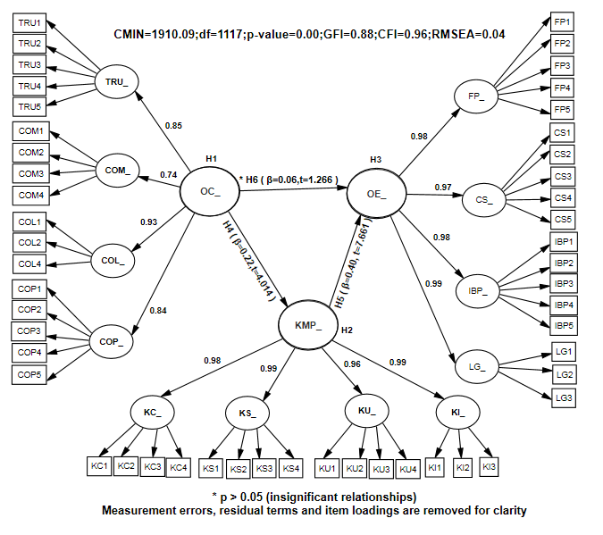
Figure 5.9: Structural Equation Modeling of Theoretical Model

Hypothesis Testing

After the general structural framework fit was investigated and ascertained, the next procedure involved the examination of single parameter estimates to assess the causal relations. KMP and OC are two independent latent constructs, but OE is a dependent variable in the organizational framework. The first question touches on the basic scopes of the Knowledge Management capacity of an organization:

Q1: What are the key dimensions of the Operational Efficiency of a firm?
An organization’s operational efficiency is theorised to be comprised of Knowledge Management practices, operational efficiency and organization culture. The dimensions of measuring knowledge management capability; knowledge process capability and social knowledge management infrastructure capacity are characterised by three hypotheses, namely H1, H2 and H3. The three hypotheses were evaluated and confirmed, and the findings were offered in the preceding sections. The outcomes confirm the OC, OE and KMP measurement model’s construct validity and model fit, thus, backing the hypotheses. Particularly, the first hypothesis states that Organizational Culture is a second-order latent construct composed of trust, commitment, collaboration and competence. On the other hand, the second hypothesis states that the Knowledge Management Practices is a second-order latent construct comprising of Knowledge Creation, Knowledge Sharing, Knowledge Utilisation and Knowledge Internalisation. Finally, the third hypothesis states that the Operational Efficiency is a second-order latent construct comprising of financial performance, customer satisfaction, internal business process and learning and growth. Thus, research question one addresses the basic dimensions of the elements that influence the enhancement of Operational Efficiency.
Responding to the remaining research questions required the development of additional three hypotheses, H4, H5 and H6, to address the interrelations amongst constructs. Structural equation prototyping was employed to test these hypotheses via the t-values and path coefficients (Table 5.9).

Table 5.9: Summary of statistically estimates of structural model significant effect and hypotheses
test

Hypothesis | Path | Beta | S.E. | t-value | p-value | Result
H4** | KMP_ <--- OC_ | 0.22 | 0.131 | 4.014 | *** | Extremely Significant
H5** | OE_ <--- KMP_ | 0.40 | 0.043 | 7.661 | *** | Extremely Significant
H6* | OE_ <--- OC_ | 0.06 | 0.095 | 1.266 | 0.206 | Not Significant
*P < 0.05 it is Significant ; **P<0.01 it is extremely Significant,**t-value >.1.96

Q2: How do the key dimensions of the Operational Efficiency of a firm relate to each other?

H4: Organizational Culture (OC) has a significant relationship with Knowledge Management Practices (KMP).
This hypothesis suggests that Organizational Culture (OC) is a driver of Knowledge Management Practices (KMP) and subsequently, enhancement in the preceding relation would result in a significant enhancement in the ultimate relation. The SEM outcomes revealed that the standardised regression values of the organizational alleyway between KMP and OC were expressively correlated; coefficient of the path=0.22, t=4.014 and p=0.00. Hence, the fourth hypothesis, H4, is backed by the dataset.

Q3: How are the key dimensions of the Operational Efficiency (OE) of a firm affected by Organizational Culture (OC) and Knowledge Management Practices (KMP’s)?

H5: Knowledge Management Practices (KMP) have a significant relationship with Operational Efficiency (OE).
This hypothesis submits that Knowledge Management Practices (KMP) offer a relevant input to Operational Efficiency (OE) within a firm. SEM results revealed that the standardised regression values of the structural conduit between OE and KMP were expressively connected; coefficient of the path λ=0.40, t=7.661 and p=0.00. Hence, H5 is backed by the dataset.

H6: Organizational Culture (OC) has a significant relationship with Operational Efficiency (OE).
H6 submits that OC is an important predictor for OE. The SEM output revealed that the standardised regression values of the structural conduit between OE and KMP were not expressively connected; coefficient of the path λ=0.06, t=1.266 and p=0.206. Hence, H6 is not backed by the dataset. Nonetheless, it has been revealed that OC has an indirect influence on OE with λ=0.06. Taking into consideration the outcomes of H5 and H6, it is apparent that KMP mediates between OC and OE within the organization.
Moreover, the structural framework depicted desirable explanatory influence for OE; it is projected that OE’s predictors elucidate on 17.3 percent of its variance. That is, OE’s error variance is roughly 82.7% of the OE’s variance. Although OC portrays insignificant direct influence on OE, the variations in this findings are primarily explained by KMP. It is estimated that the predictors of KMP_ explain 4.6 percent of its variance. In other words, the error variance of KMP_ is approximately 95.4 % of the KMP’s variance.
  - Summary
This chapter describes the outcome of the framework’s pre-test pursued by the results’ descriptive analyses from the primary study. The SEM’s two-step technique was utilised to make use of the statistic software, AMOS version 20.0. The measurement model fit and construct validity were initially evaluated via CFA to ensure that the overall measurement framework met SEM’s first procedure. Thus, the structural framework was quantified and shown to satisfy the model fit prerequisites and hence, was employed in addressing the study questions and testing the theoretical relation via the research hypotheses. Table 5.10 summarises the findings of the highlighted hypothesis testing.

Table 5.10: Summary of Hypotheses Testing Results
Hypothesis | Statements | Result
H1 | Organizational Culture is a second-order latent construct composed of trust, commitment, collaboration and competence. | Significant
H2 | Knowledge Management Practices is a second-order latent construct comprising knowledge creation, knowledge sharing, knowledge utilisation and knowledge internalisation. | Significant
H3 | Operational Efficiency is a second-order latent construct comprising of financial performance, customer satisfaction, internal business process and learning and growth. | Significant
H4 | Organizational Culture (OC) has a significant relationship with Knowledge Management Practices (KMP). | Extremely Significant
H5 | Knowledge Management Practices (KMP) have a significant relationship with Operational Efficiency (OE). | Extremely Significant
H6 | Organizational Culture (OC) has a significant relationship with Operational Efficiency (OE). | Not Significant

The next chapter will provide further discussions on the main findings and research question.

CHAPTER SIX: DISCUSSION
  - Introduction
Chapter 5 outlined the result of data analysis that used based on the research methodology developed in chapter 4, which was employed to test the theoretical and research model of the hypothesis developed in Chapter 3. This chapter explains the discussion of the major findings from the analysed data comparing it with past studies and more details of the theoretical base identified with the research questions. This chapter’s structure is shown in Figure 6.1.

Figure 6.1: Chapter Six Outline

  - Discussion on research questions
The result of data analysis of the SEM analysis indicates that the suggested measurement and structural model fulfill the expected conditions. Based on these findings, the six hypotheses of the research were tested to tackle the three research titles. The following part discusses the research questions and their relation to the findings from the analysed data while comparing with the past studies and includes a discussion of the theoretical base

Question 1: What are the key dimensions of the Operational Efficiency of a firm?

The CFA results indicated that the first three hypotheses were supported by the given data, with a specific reference to the measurement model of Knowledge Management Practices -based operational efficiency good fit indices achievement. This refers to the fact that the validity and reliability of the three constructs Organizational Culture (OC), Knowledge Management Practices (KMP) and Operational Efficiency (OE) using BSC perspectives were satisfied. A correlations examination between the capabilities supports the relationship of these dimensions is consistent with results of the previous studies (Uddin et al., 2012; Zheng et al., 2010), which argue that Organizational Culture have significant positive influence on the performance of the organization and KM fully mediates the impact of Organizational Culture on Organizational Efficiency. These results imply that an Organizational Culture that is formed by bringing together skills and experiences of individuals is more successful than one that ignores the employee contributions to KM (Gupta et al., 2000).

Three key dimensions constituting the determinants of improving Operational Efficiency of a firm, namely Organizational Culture (OC), Knowledge Management Practices (KMP) and Operational Efficiency (OE), were second-order inactive constructions and their measures were examined by Hypotheses 1, 2 and 3 in the relative manner.

H1: Organizational Culture is a second-order latent construct composed of trust, commitment, collaboration and competence.

The measurement model of Organization culture (OC) was adopted from Ho et al., (2014); Marques et al., (2011); Chen and Mohamed, (2008) and Lee and Choi, (2003). This measure includes four main components of OC: trust (TRU), commitment (COM), collaboration (COL) and competence (COP). Whereas trust and competence were measured using five variables, commitment and collaboration were measured using four variables. The dimension of every OC component had been discussed in the literature, which was rooted from “The shared values, beliefs and practices of the people in the organization” (McDermott & O’Dell, 2001). Additionally, it is proved in the previous case study by Uddin et al. (2012) that Organizational Culture have significant positive influence over the performance of an organization. Moreover, it is proved in the findings of the studies by Humphreys et al. (2006) and Rao et al. (2006) that the trust and commitment are enablers of relationship building.

The result of examining by utilising the measurement model is in support of the occurrence of these dimensions, emphasising on (1) leveraging trust within the organization yields great results in the performance of employees, as well as in the growth rates in the firm, (2) trust and commitment complement each other. Once trust is created among the employee and the organization, the parties are more willing to contribute towards the task at hand and work harder, to prove that they are reliable, (3) initiating trust within organization improves cooperation and collaboration among teams and subsequently collaboration culture can help in creating a platform for learning and growth for various competencies and (4) creating T-shaped competence and I-shape skills are an asset to any organization. These are the same people that create the value and worth of business processes, customer service, sales and many more important activities and objectives that need to be accomplished.
In addition, the correlations are examined between the components of Organization Culture (OC) and also support a study of their interrelationship, which further supports the extensive discussion in the literature review as it has been observed that trust is the key to initiate other cultures. Once trust is established among the organization management and the employee, among employee and employee, it priotrises/stresses on commitments to get the task accomplished on time with high quality. Additionally, it follows with collaboration among the team and exchanges that knowledge to learn and help others to get the job done. Consequently, this also leverages building the right competence with the right skill knowledge and attitude for people in the organization. Hence, it can be concluded that creating right culture is an organization’s foundational DNA (Roth, 2012); Watson Wyatt illustrated that the culturally aligned organizations returned 286% more value to stakeholders (Fields, 2008; Gostick & Elton, 2012).
For the four components, the standardised weights regression recommends that commitment is the most notable outlook followed by competence, trust and then finally, collaboration. This empirical finding proved that commitment and trust are key enablers that complement each other, which leads to employees working hard and being competent to get the task done by collaborating with the team (Humphreys et al., 2006; Rao et al., 2006). Therefore, these dimensions of trust, commitment, competence and collaboration are interrelated in the way they influence the Organizational Culture issues and Efficiency and it must receive highest consideration as the most significant facilitator of efficient knowledge creation and allocation of the effective implementation of KM that leads to high performance in the organization.

H2: Knowledge Management Practices is a second-order latent construct comprising knowledge creation, knowledge sharing, knowledge utilisation and knowledge internalisation.

The measurement model of Knowledge Management Practices (KMPs) was adopted from Lin (2015), Ho et al. (2014), Wu and Chen (2014) and Lee and Choi (2003) . In this study, KMPs are measured as four constructs, including (Knowledge Creation (KC), Knowledge Sharing (KS), Knowledge Internalisation (KI) and Knowledge Utilisation (KU)). The analysis results of the measurement model support the existence of these components, emphasising the importance of each KMP’s in particular: (1)Knowledge Creation is creating new knowledge out of an existing one through collaboration (Nonaka & Takeuchi, 1995), (2) Knowledge Sharing is sharing among people, both formally and informally (Probst, 2002), (3) Knowledge Utilisation is how the knowledge can be effectively put to use (Gold et al., 2001) And (4) Knowledge Internalisation is how explicit knowledge can be internalised by turning into implicit knowledge (Ho et al., 2014).

An overview of the correlation in line with the component of KMPs also supports an opinion of their interrelationships, which is consistent with the results of the previous studies (Omotayo, 2015; Edwards, 2009; Schönström, 2005; Lee & Choi, 2003; Castells, 2001; Nonaka & Takeuchi, 1995). Additionally, it can be claimed that the output of a process can be the input of other process that integrate the relation among the enablers, process and organizational performance, considering the input-process-output (IPO) (Chen & Mohamed, 2008 ; Hackman & Warnow-Blewett, 1987), for example, increasing the efficiency of knowledge creation process and knowledge-intensity allows the organizations to continuously create new knowledge and new competitive advantages. Increased knowledge creation process flow accelerates knowledge creation, accumulation, sharing, utilisation, and internalisation (Lee & Choi, 2003).

In each of the four components, the standardised regression weights implied that the Knowledge Creation and Knowledge Internalisation were highly valuable as a Knowledge Management Practice, whereas Knowledge Utilization had little effect. This result is in accordance with the findings of Darvish et al. (2012) that Knowledge Management (KM) involves creating, storing, sharing and improving processes that impact the knowledge of the firm. The empirical results show that while the four main practices combine in determining the KM practices, the implementation practices ought to be highlighted and strengthened to use different types of practical implementation toward KM practices to achieve firm objectives. As KM provides solutions to handle business problems with some differences, there is a rising recognition for companies that apply KM to manage business concerns and progress. Consequently, KM becomes an orderly approach to decision making (Linderman et al., 2010).

H3: Operational Efficiency is a second-order latent construct comprising of financial performance, customer satisfaction, internal business process and learning and growth.

The measurement model of operational efficiency (OE), adopted in this study, considers four “Balanced Scorecard” perspectives. Balanced Scorecard were measured and quantified using a twenty-item scale derived from that proposed by Rehman et al. (2015) and Lin (2015). This construct covered all four Balanced Scorecard perspectives with four items: financial performance perspective, customer satisfaction perspective, learning and growth perspective and internal business process perspective. The BSC differentiates from other frameworks by its capability to link different kinds of business performance indicators – financial and non-financial (Valmohammadi & Servati, 2011). The result of the measurement model testing support the existence of these dimensions, emphasising that operational efficiency could be increased by using five approaches based on profit margins; Gilmore (2014) defined those approaches: (1) measuring current performance by setting and examining the organization’s Key Performance Indicators (KPIs) that assist the firms in understanding their existent performance and in recognising current inadequacies, (2) assessing the management of capacity and resources by assessing employees’ skills and their relation with their job roles, using past projects for guiding new project plans and reviewing timesheets for identifying idle resources, (3) Operational Efficiency can be enhanced by increasing workforce capacity and relocating resources accordingly, (4) Operational Efficiency can be boosted by improving project management and thus, creating maximum profits and (5) Operational Efficiency can also be enhanced by updating technology to save time in manual work and thus, positively affecting profit margins.
An examination of the correlation among the component of OE considered that the four “Balanced Scorecard” perspectives also lend credibility to interrelationships that is in line with the findings from earlier studies (Valmohammadi & Servati, 2011; Chen et al., 2009; Niven, 2005; Lee & Choi, 2003; Kaplan & David, 1996), such as improvement in revenue growth and improvement of profit margin to Operational Efficiency and the drivers for future growth such as learning. For all four components, the standardised regression weights propose that the learning and growth and financial performance are the most significant perspectives, while the internal business process has least influence. The empirical findings make sense because improvement in revenue or sales growth can be achieved by accomplishing seven operational improvements such as building brand loyalty, integrating shipping, labeling and rates, making and providing top-notch customer services, gaining visibility, controlling inventory throughout sales channels, enhancing business growth by using different channels, applying an integrated retail strategy and by the integration of new systems as the business grows gradually (Dydacomp, 2014). Thus, these four BSC perspective interrelated in the way they represent the OE measurement in the firm. The results of examining the first three hypotheses concerning the measurement model Knowledge Management Practices -based operational efficiency of a firm are illustrated in Figure 6.2.
Figure 6.2: OC and KMP -Based OE of a firm as a Multi-dimensional Construct
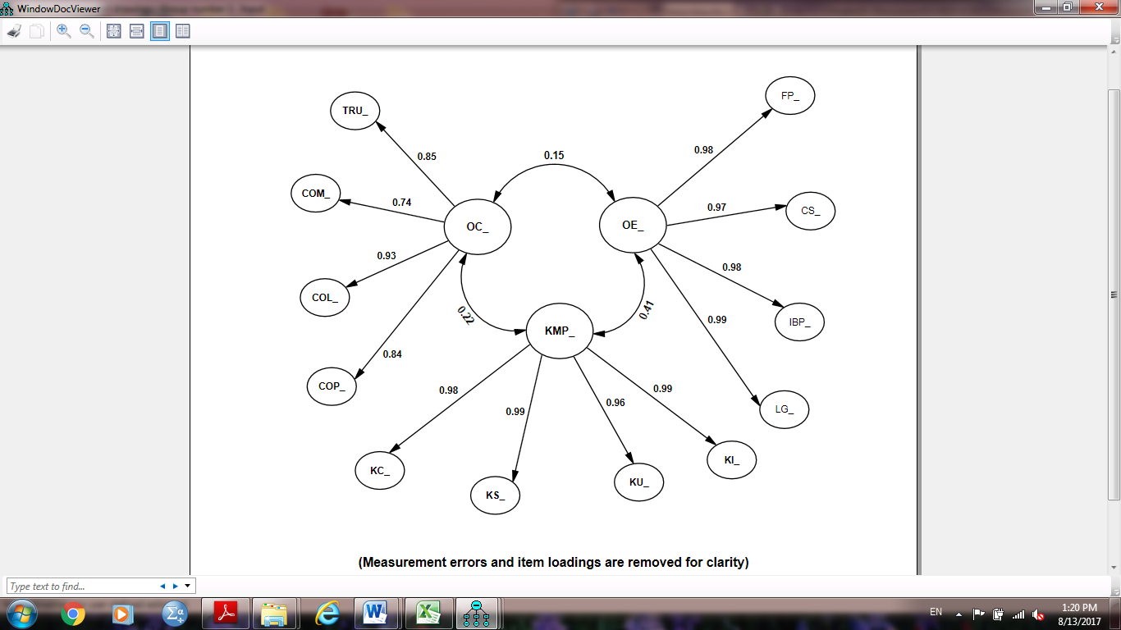

Question2: How do the key dimensions of the Operational Efficiency of a firm relate to each other?

Question 2 investigates the relationships between OC and KMPs. To better understand this question, the structural model was evaluated and the literature on the theory of KM and OC was examined. First, the reason of the connection between OC and KMP has been emphasised, as highlighted by Zamantılı Nayır and Uzunçarşılı (2008), who stated that one of the most significant hurdles to the implementation of an effective Knowledge Management is organizational culture itself and a positive relationship constructed on trust would be beneficial to the implementation of Knowledge Management Practices within the organization (Hassan & Semerciöz, 2010). This indicates that OC is significantly related to KMP. There are numerous studies that examine the association between Organizational Cultures and Knowledge Management (Mudor, 2014; Moradi et al., 2012; Allameh et al., 2011; Foss et al., 2010).

Linking with Kaplan & David (1996), findings the importance of BSC performance indicators, such as financial, customer and learning, on overall strategy. KM fits in well with this approach by relating to the Learning and Growth indicator. This suggests that KM impacts other processes. BSC allows the management to monitor progress against set objectives by providing various measurement metrics. Such metrics provide a valuable reference point for measuring KM implementation against planned goals. Therefore, this study tests whether KMP plays a significant role in mediating the relationship between OC and OE. This result, which supports Hypothesis 4, adds value to the interrelationship between OC and KMP of OE. Hence, based on the relevant literature that supports the relation between OC and KMPs, the following hypothesis was formulated:

H4: Organizational Culture (OC) has a significant relationship with Knowledge Management Practices (KMP).
The structural model assessment supports hypothesis 4. A further examination of the standardised regression weights indicated that KMPs’ significantly influential improvement in OC led to strong significant improvement in OE.

According the theory of KBV, the firm is reliable with the attitude with organizations culture (Balogun & Jenkins, 2003). Per se, they learn through KM practices and adapt over time. Organizational learning enables the firm to acquire, change and preserve its organizational capabilities (Curado & Bontis, 2006). It was further suggested that the differences (more than 80%) in Operational Efficiency across firms could be well understood by management practices and implementation with the appropriate Organization Culture.

The implication was consistent with the findings of Lin (2015), Gholipour et al. (2010), Zheng et al. (2010) and Lee and Choi (2003), suggesting that the implementation of knowledge practices in organization and the success of KM are mostly associated with the right organizational culture that are converted to the organization values. It has been found that Knowledge Management Practices gain focus and direction from creating a culture rooted in thinking about business risk and the created value (Leavitt et al., 2002). This links well to the basis that culture defines the main beliefs, values and rules with regards to knowledge creation, sharing, utilisation and internalisation in a given organization (Zheng et al., 2010; Zhang& Zhao, 2006). The results of structural model assessment supported H4. The testing outcome of the relationships between OC and KMP are illustrated in Figure 6.3.

Question 3: How are the key dimensions of the Operational Efficiency (OE) of a firm affected by Organizational Culture (OC) and Knowledge Management Practices (KMP’s)?

After examination of the main components constituting of (OC, KMP and OE) and the interrelationships between the OC and KMP of an organization, the last research tried to determine the effect of each component on the firms OE by using the Balanced Scorecard perspective. In answering the question regarding the RBV of the firm being combined with the human capital theory along with KBV perception, a dynamic theory of organizational knowledge was created. According to Asl and Rahmanseresht (2007) and Pankaj (2004), the four approaches that have been selected and deemed suitable for this study: (a) Mechanistic approach, (b) Systematic approach, (c) Core capability approach and (d) The cultural/behavioral approach and the all four BSC (Kaplan & Norton, 2000) were utilised to present the background for the definition and understanding of the key dimensions of Operational Efficiency in a firm .

Although the characteristics toward organization culture of employee competencies, attitudes, values and commitment are considered as intangible assets. On the other hand, human capital is considered as a tangible asset because it strengthens the company’s competitive advantage and operational efficiency (Hitt & Duane, 2002). As it been observed from the literature review that the effect of human capital is more indirect rather than direct because it is only after the display of knowledge, skills and behaviors in workplace can lead to efficiency in the performance of the work (Mahsud et al., 2011). Hence, the results of the study proved what was suggested by Zheng et al. (2010) that KM fully reconciles the impact of organizational culture on organizational efficiency. In KBV of the firm, trust is implied (Lee & Choi, 2003; Von Krogh et al., 2001; Nonaka et al., 2000; Nonaka & Takeuchi, 1995)in concern and care as Gholipour et al. ( 2010) indicated, stating that care is a powerful enabler for building organizational relationships. In other words, knowledge can be created and shared in places where trust and care among colleagues are evident. Trust drops the collaboration related to transaction cost and vice versa, it increases the transaction rate (Jenssen & Nybakk, 2013; Blomqvist, 2002).
Trust plays a crucial role among followers, leading to greater agility, acceptance of changes, collaborations among members and affinity to adapt to new terms and enhance communication and creation of capabilities (Valmohammadi & Ahmadi, 2015). The organizational culture (OC) is a fundamental aspect of Knowledge Management Practices, which is socially implanted and created, and is robust continual improvement culture overtime. Accordingly, OC can be a firm’s assets and liability that influences communication, engagements, problem-solving and support management in decision making as well as supports to generate a higher level of collaboration, commitment and people competence (Mudor, 2014). Subsequently, OC can result in efficiency of the firm because an efficient process results in lower resource utilisation for the same output in a way that it results in less consumption than planned; thus, it is referred to as being efficient (Phusavat, 2007).
A study conducted by Zamantılı Nayır and Uzunçarşılı (2008) stated that effective Knowledge Management Practices mediating with a unique corporate culture will empower the firms to perform efficiently and effectively. In other words, KMPs is one of the most significant hurdles for the implementation of an effective Knowledge Management, which was an organizational culture itself. Moreover, a positive relationship constructed on trust would be beneficial for the implementation of Knowledge Management Practices within the organization (Hassan & Semerciöz, 2010). Therefore, the study hypothesized that:

H5: Knowledge Management Practices (KMP) have a significant relationship with Operational Efficiency (OE).
H6: Organizational Culture (OC) has a significant relationship with Operational Efficiency (OE).
The structural model assessment results supported H5 and rejected H6. Initially, the relationship between OC and firm’s OE was significant in the absence of KMP. However, in the presence of KMP, in the relation between OC and firm’s OE, it seems significant. Hence, their indirect effect was confirmed by the data as the standardised indirect effect (0.043 < 0.05), which indicated that there is a KMP mediate effect looking towards the indirect effect of OC and the direct effect of firms OE that is insignificant (0.206 > 0.05), which indicates a full mediation impact. Their effects are settled through KMP and therefore, dependent on their strength in reinforcing OE of the firms using the BSC perspective.
The findings indicated that the significant correlation between OC and KMP mechanism, as supported by the canonical correlation coefficient, was 0.46 (Garson, 2015). Thus, it shows that OC and KMP mechanisms’ relation is significantly strong correlated as the higher appreciation of organizations toward OC; the higher KMP may occur. As supported by Zheng et al., (2010) and Lai and Lee, (2007) Organizational Culture has greater positive contribution impact on Knowledge Management. Combined with the findings from Hypothesis 4, this finding has various implications.
First, the findings of Hypothesis 5 give a strong support for the KBV theory (Grant, 2002; Wiig, 1997), which suggests that Knowledge Management is one of the main drivers that support organization to work systematically and evidently implement consideration and application of knowledge to improve the efficiency of the firm and activities based on the relevant literature. Organizational assimilation and forming new organizational structures within and between organizations support efficiency and effectiveness in leveraging dispersed knowledge (Kirsimarja & Aino, 2015). Therefore, the findings of this study empirically proved the suggested statements of previous research that Knowledge Management indices lead to the advancement of the four balanced scorecard perspectives. An effective KMP would enhance organization recollection, and its capacity to collect, analyse and put to use the knowledge to its own advantage. As a result, knowledge competencies affect the present and the future of the organization’s performance (Darvish et al., 2012; Quintane et al., 2011).

Second, the insignificant hypothesis 6 specified that OC with the presence of KMP is indirectly affected by the OE Firms’ using BSC perspective. This finding is contrary to the result of the previous study (Bititci et al., 2006; Bititci et al., 2004; Von Krogh et al., 2001; Nonaka, et al., 2000; Nonaka & Takeuchi, 1995), and did not support the RBV of the organization with a KBV perspective. The findings suggest that when OC elements are investigated individually, without the presence of KMP (Ángel et al., 2014), they may significantly contribute to OE firms. However, it is misleading that such effect is insignificant once KMP is included in the model as a mediator and all theoretical hypothesis are evaluated at the same time. This is because the OC along with the KMPs becomes the key drivers of the OE of the firms’ using the BSC Perspectives.

These incidental impacts of OC on OE can also be described by the current business environment that Knowledge Management is viewed as the main source of competitive advantage. Omotayo (2015) and Jennex (2007) emphasised that management of knowledge is a crucial driver of Organizational Achievement and a vital tool for business survival, competitiveness and profitability. However, according to previous studies, Organizational Culture is the most important factor of Knowledge Management effectiveness. In other words, knowledge can be created and shared in places where trust and care among colleagues is evident. As trust drops, the collaboration related to transaction cost or vice versa increases the transaction benefit (Jenssen & Nybakk, 2013; Blomqvist, 2002).
Trust plays a crucial role among followers, which leads to greater agility, acceptance of changes, collaborations among members and affinities to adapt to new terms and enhance communication, creation of capabilities (Valmohammadi & Ahmadi, 2015). Thus, results of this study conclude that KMP fully mediates the impact of organizational culture on operational efficient (OE) (Zheng et al., 2010; Zhang& Zhao, 2006).
The results further indicate that most of the consistencies in OE (above 80 %) in companies would be described by the KMP of creation, sharing, utilisation, and internalization facilitating them to enhance the organizations results. This implication is in line with the statements by Ho et al., (2014) and Jennex (2007), who identified that in current knowledge-based economies, dependence on Knowledge Management (KM) best practices improved the Operational Efficiency (OE) and the Organizational Culture positively impacts knowledge practices that subsequently positively impacts business, job or organization performance.

The findings of the structural links between the three components of OC, KMP and OE are displayed in Figure 6.3.

Figure 6.3: Theoretical Model OC and KMP -Based OE
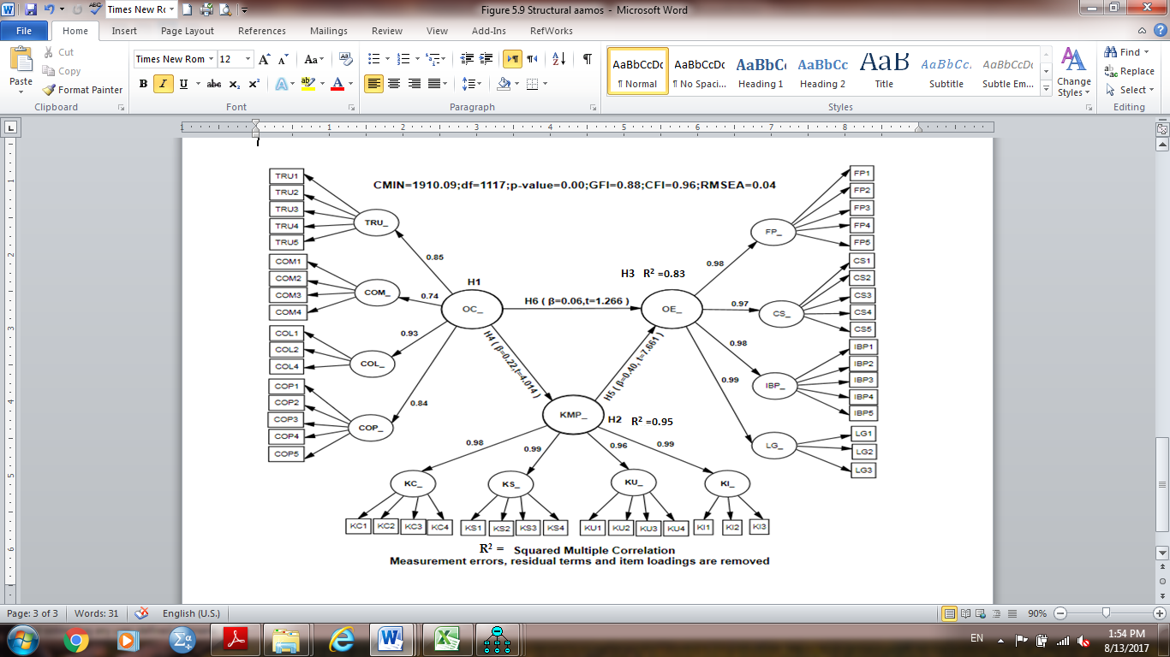

  - Summary
The study proposes and tests the research model that examines the influence of OC with mediating impact of KMP on OE based on the BSC approach. The empirical analysis demonstrates several major findings. Explanations based on these findings were highlighted as follows. First, the result provides clear support for all hypotheses except hypothesis 6. The result is consistent with the finding that the success of the firm can provide the basis for future success, as Valmohammadi & Ahmadi (2015) indicates that the culture of confidence and trust in knowledge sharing is a fundamental aspect and leveraging culture within the organization leads to better performance of employees as well as growth in the firm. Second, when the followers in the organization have trust, they will be agiler for change acceptance and have an affinity to adaptation with new terms and collaboration between members in the organization. Pearlman et al. (2002) emphasised on the impact of trust management towards operational efficiency, which was demonstrated in this study by differences in trust of the employees towards CEOs and line managers. Within the oil and gas sector, firms that win the trust of its people see a higher rate of skills growth. Third, organizations in oil and gas industry should take the lead in applying KM without focusing on the organizational size as a goal (O’Brien & Rounce, 2001). An organization cannot excuse itself for not having implemented and adopted Knowledge Management strategies (Grant, 2013). Once committed, the parties are more willing to contribute towards the task at hand and work harder to prove that they are reliable. Fourth, a robust process with top management commitment will be vital to its success and lead to improvement in the organizational performance (Gino & Staats, 2015).
In short, this study developed a more inclusive measurement model of Knowledge Management Practices -based Operational Efficiency (Research Question 1) and confirmed that this model is practical in oil and gas industry; the developed countries could be reviewed to be appropriate in the context of developing economy like the UAE. The interrelationship between the two components of Organizational Culture and Knowledge Management Practices were investigated in Research Question 2. The result is reliable with the finding that Organizational Culture plays a significant role in improving learning capability of the workforce and is considered a critical success factor for KM (Rehman et al., 2015; Gold et al., 2001). Additionally, the study examined the impact of each element (KMP and OC on OE using BSC perspective) in the oil and gas industry (Research Question 3) and found that KMP directly affects the OE, and the OC indirectly affects the OE through the full mediation by KMP, which is the key driver along with OC of OE in the firms using the BSC Perspectives.
Table 6.1 summarises the final result of the six hypotheses, which addresses the three research questions of this study.

Table 6.1: Summary of the Research Results
Research Question | Research Hypothesis | Result
Q1: What are the key dimensions of the Operational Efficiency of a firm? | H1: Organizational Culture is a second-order latent construct composed of trust, commitment, collaboration and competence. | Supported
 | H2: Knowledge Management Practices is a second-order latent construct comprising knowledge creation, knowledge sharing, knowledge utilisation and knowledge internalisation. | Supported
 | H3: Operational Efficiency is a second-order latent construct comprising of financial performance, customer satisfaction, internal business process and learning and growth. | Supported
Q2: How do the key dimensions of the Operational Efficiency of a firm relate to each other? | H4: Organizational Culture (OC) has a significant relationship with Knowledge Management Practices (KMP). | Supported
Q3: How are the key dimensions of the Operational Efficiency (OE) of a firm affected by Organizational Culture (OC) and Knowledge Management Practices (KMP’s)? | H5: Knowledge Management Practices (KMP) have a significant relationship with Operational Efficiency (OE). | Supported
 | H6: Organizational Culture (OC) has a significant relationship with Operational Efficiency (OE). | Not Supported

The next chapter will provide the conclusion of the study, the theoretical contributions and practical implications. One case study of successful KM is given to further describe some of the results and implications. Finally, the limitations of the research and recommendations for future studies are also provided (See Appendix 6a).

CHAPTER SEVEN: CONCLUSIONS AND IMPLICATIONS
  - Introduction
The objective of this research was to create a hypothetical framework of Knowledge Management Practices-based Operational Efficiency of the organization and to pragmatically implement the model within the oil and gas context of the UAE. The essence of the six chapters shown in the thesis is given as follows.
Chapter One provides a high-level overview of the research project and postulates the following three research questions:

- Question 1: What are the key dimensions of the Operational Efficiency of a firm?
- Question2: How do the key dimensions of the Operational Efficiency of a firm relate to each other?
- Questiion3: How are the key dimensions of the Operational Efficiency (OE) of a firm affected by Organizational Culture (OC) and Knowledge Management Practices (KMP’s)?

To answer these key queries, Chapter Two points out the existing knowledge gaps by reviewing existing research work on OC, KMP and OE, using BSC perspectives. Next, in Chapter Three, the interrelationship among the components has been studied and discussed as well as the mediating effect of KMP on OE. Based on the Resource-Based View of the firm, Human Capital theory is blended with Knowledge-Based View, organizational Knowledge-Creation theory and Knowledge-Creation’s SECI model, four KM approaches, alongside System Thinking theory and Transaction Cost theory with the BSC approach.
A theoretical framework and six hypotheses are proposed to justify the research questions identified in Chapter One.
After that, Chapter Four defines the research design used to examine the research hypotheses and the theoretical model and provide valid explanations on the selection of this design. The operationalisation of fifteen variables and the pilot’s design of research and vast scholarly works employed to examine the biggest offshore oil and gas company in Abu Dhabi’s remote areas are drawn. Additionally, this chapter talks about the data analysis methodologies as well as the possible ethical considerations.
Then, Chapter Five conveys the findings of the preliminary survey and shows the descriptive statistics as well as the analytical methods for the main research. The two-step SEM technique is employed utilising the statistic software Amos version 20.0 to rate the theoretical framework and examine the research hypotheses that is advanced in Chapter Three.
Next, Chapter Six discusses the findings from the data analysis, drawing a connection with previous studies and discussing the theoretical basis that has been drawn for each hypothesis related to the three research questions outlined in Chapter Two and Three.
The last chapter presents the final conclusion and key implications of the study. It starts with a discussion of the theoretical contribution and practical implications, denotes how the research has efficiently assisted the existing body of knowledge as well as the exercise of Organizational Improvement and Operational Efficiency. One case study of effective KM is given to further exemplify the results and inferences. Last, the limitations of the research are discussed; hence, advancing the basis on which future research work can be advanced. Figure 7.1 illustrates the outline of chapter seven.

Figure 7.1: Chapter Seven Outline

This study can help both practitioners and academicians understand the underlying factors affecting value creation and managing risk to improve Operational Efficiency and business performance in the oil and gas sector.

  - Theoretical Contributions
This research endeavours to develop outstanding empirical footprint in knowledge and strategic management by developing various important contributions. The study begins by providing a critical appraisal of the existing scholarly works on OC, KMP and OE, resulting in a comprehensive insight into relevant research works. Additionally, it explores and analyses the link between OC, KMPs and OE measured by BSC four strategic perspectives, from which the knowledge gaps have been identified and an all-inclusive theoretical framework of KMP-oriented OE of the organization was advanced.
This framework represents the initial exertions to synthesize theories and model resources-oriented organizational perspective, Human Capital theory combined with knowledge-oriented perspective, organizational knowledge creation concept and knowledge-creation’s SECI model, four KM approach, along with system thinking theory, and transaction cost theory with BSC strategy of investigating various complementary and integrated KM capability modules alongside their influences on OE.
Particularly, the research ratifies that OC and KMP are two distinct but interrelated components that contribute to enhancing the performance of the OE of the firm. In this case, the measurement model measures the twelve first-order variables alongside the three second-order constructs. Organization culture is composed of four dimensions, including trust, commitment, collaboration and competence, which are the most critical dimensions. Four dimensions also characterised Knowledge Management Practices, namely, knowledge creation, knowledge utilisation, knowledge sharing and knowledge internalisation. On the other hand, Operational Efficiency is characterised by four dimensions: financial performance, learning and growth, internal business process and customer satisfaction. Drawing from the hypotheses, it is deduced that OC has substantial influence on KMP while KMP has a weighty influence on the firms’ OE. Through KMP, OC indirectly influences OE because KMP acts as a mediating channel for the OC/OE relation.
Moreover, this model works in isolation; it fails to take into account the approaches to knowledge sharing as applied in various fields. It has taken into account the relevant historical perspectives on the development of KM. The purpose of the study is to focus on the key factors, issues and dimensions of KM for an oil and gas company located in Abu Dhabi, the UAE’s capital. This approach conforms with the interleaved dynamics of some organizational factors like human intelligence and culture, while not conforming to some other aspects such as IT infrastructure. Rather, this study emphasises greatly on the strong relations between them. In addition, the model accentuates KMP’s significance as the impact of the KM enablers’ variables, culture and Knowledge Management Practices on Operational Efficiency, which has remained largely unexplored (Chen & Mohamed, 2008) and in addition, the influence of organizational culture’s link with the BSC and KM is yet to be explored (Rašula et al., 2012; Donate & Guadamillas, 2011; Zack et al., 2009; Choy &Suk, 2005). Therefore, the interrelationships between OC, KMP and OE using BSC perspective were also examined to identify their prized integrated influence on the organization’s performance.
As discussed, there is little empirical knowledge to validate the relations between Organizational Culture (OC), Knowledge Management Practices (KMPs) and Operational Efficiency (OE), while considering the BSC limited perspective within the context of oil and gas organizations (Lyu et al., 2016; Ho et al., 2014; Rašula et al., 2012; Zack et al., 2009; Chen & Mohamed, 2008; Lee & Choi, 2003). This research filled this void by presenting the findings of a questionnaire-guided survey of one of the biggest offshore oil and gas firms in Abu Dhabi to examine the theoretical connections in the projected framework. The pragmatic results buoyed the abstract model advanced in this research and superimposed the idea that Organizational Culture plays a significant role to improve KMP of the workforce and is considered a critical success factor for KM; and subsequently, the implementation of KM practices in the organization would promote Organizational Learning, enhanced scholarly asset management as well as augmented Operational Efficiency. Nonetheless, OC does not influence the organization’s OE directly. Their effect is totally mediated via KMP and hence, relies on the organization’s capacity in facilitating KM practices. As organizational culture plays an essential role in knowledge creation and organizational management due to the effects of how people learn, acquire and share knowledge, it is the important function of Knowledge Management Practices as it is the dynamic key driver of organizational performance and a vital tool for organizational survival, competitiveness and profitability in the organization, which contributes to the desired significance of the research framework. Additonally, the research findings endorse that the knowledge-based economies depend on Knowledge Management (KM) best practices to be implemented to improve Operational Efficiency (OE) (Jennex, 2007).

Another significant relevance of this research is how it addresses methodological concerns. The technique employed in measuring OC, KMP and OE of twelve individual first-order variables was adapted from previous research studies. A significant number of conceptual frameworks of OC, KMP distinctively aligned with organization performance have been advanced and verified in industrialized economies like: Australia (Hoque & James, 2000), Korea (Lee & Choi, 2003), Malaysia (Choy & Suk, 2005), Qatar (Sveiby, 2007), Hong Kong (Chen & Mohamed, 2008), Taiwan ( Lin, 2015; Ho et al., 2014; Huang, 2009), North America & Australia (Zack, et al., 2009), United States (Deem et al., 2010), West Indies, Jamaica (Mills & Smith, 2011), Saipan (Darvish et al., 2012) ,Slovenia ( Rašula et al., 2012), India (Husain & Farooq, 2013), Pakistan (Rehman et al., 2015), Iran (Valmohammadi & Ahmadi, 2015), China (Lyu et al., 2016). This research contributes to existing empirical knowledge by testing and adapting the measurement framework within the UAE organizational setting. The findings sanction that the model that was adapted from exploits grounded in industrialised economies is reliable and valid in a dynamic developing economy granting that some components were deleted to enhance the model fit level. This framework may be utilised for future research and could still be re-evaluated and modified in other settings like other developing economies where cultural factors differ extensively from those found in the economies where the framework was originally developed and introduced.

Eventually, the use of the two-phased SEM technique to examine the structural and measurement frameworks bear considerable relevance. A huge chunk of previous empirical works investigating the relations between Knowledge Management Practices (KMPs), Organizational Culture (OC) and Operational Efficiency using BSC employed various analytical techniques like multi-factor and regression analysis that allowed for the test of one relation between independent and dependent variables at a single instance. In this case, SEM, a methodology that uses multivariate analytic techniques in an intricate way, is specifically useful. To begin with, SEM allows the scholar to examine measurement aspects and assess the basic theoretical relations with a single approach. It is also possible to expose unobserved ideas in these relations and allow for measurement errors in the approximation procedures. Remarkably, SEM techniques can test a sequence of dependence relations concurrently in which a hypothesized dependent construct is transformed into an independent construct in a consequent, dependent relation (e.g., OC → KMP’s; OC → OE; and KMP’s → OE in the research). This approach also renders it possible to synthesize correlation and dependence relations amongst endogenous and exogenous variables in one SEM model; for instance, the relationship between OC and KMP’s, OC and OE in the research, hence allowing for the creation of a framework to elucidate on the complete set of relations. All these aspects of the two-phased SEM methodology were used to assess the model offered in the research and hence, enhanced the exactitude of the results compared with the results from previous works. This study is the first to examine the factor structure by using CFA to test the operational efficiency in the oil and gas industry in the UAE.
  - Practical Implications
The oil and gas industry has been benefitting from KM developments for close to a decade. During this period, the industry has witnessed swift changes both internally and externally. The advantages of KM have played a part in making operational processes more organized. KM teams provide support through the transfer of knowledge, administrative as well as asset management.
Once a business has identified the need for capacity planning or cost management, KM plays a part by improving estimation and planning for better resource utilisation. KM can support and increase speed and suitability. KM advantages can be extended to report the technology adoption of point-of-sale and efficiency of procedures. KM has irrefutably proven to increase the valuation of the stock market, helped in growth through mergers, led to the better development of products and encouraged leadership that is intelligent for early adopters in organizations that have implemented KM. KM implementation in organizations should have the tools and processes that focus on providing the correct piece of information to the desired audience at a desired time and within a desired environment so they can make the best choices, exploiting opportunities in businesses and promoting innovative ideas. After many years of KM implementation across different industries, existing KM practices can be an economical means of resolving new or relevant functioning issues in the oil and gas industry. Additionally, many companies are regulating their best performing repetitive workflow using automation to reduce interruption at field locations around the world.
Knowledge Management in the oil and gas companies is particularly difficult and complex, because knowledge is distributed and it is also not always easy to find it from the most accurate sources. Additionally, knowledge is fragmented and multidimensional, usually caused by the modular structure of an organization (drilling, projects, operation and maintenance). The knowledge structure of the oil and gas companies needs to be flexible to incorporate the changes occurring in their dynamic business environment. The characteristics of the companies’ operations make it very important to exchange knowledge and expertise with service companies on a regular basis. Operational Knowledge, being tacit in nature, is a repository of professionals who may have many types of limitations, for example, the distance and motivation to share it. As far as the oil and gas companies are concerned, their staffs are also usually subject to the confidential nature of the activities being carried out, which leads to constraints on knowledge sharing. Therefore, the KM approach also needs to be adapted accordingly and should be multi-levelled and comprehensive (Al Muzahmi, 2015; Coelli et al., 2005; Pankaj, 2004; Leavitt, 2002). By knowing the cultural impact on knowledge, managers can ask probing questions that require the organization to take pertinent actions to bring about the behavioural change. Whatever is the goal of Knowledge Management Strategy, from innovation to response to market; a knowledge initiative can bring about a change in culture leading to a change in behaviour.

Attaining Operational Efficiency (Operational Excellence) is often one of the primary goals of every business. Knowledge is considered as an inevitable source within the competitive context of businesses. In fact, previous research indicates that knowledge is the only reliable source that can help in the creation of a sustainable and competitive advantage within a company (Lee & Choi, 2003). However, to be successful in achieving world-class performance, Operational Excellence needs to create and sustain the right culture to implement KM practices throughout the organization. A KM system can reduce costs by helping the organization address operational issues that would otherwise have been impossible. The KM system would retain and disseminate knowledge during an age where the competent workforce is decreasing. Additionally, several organizations are sprucing up their processes to further improve downtime at sites. This helps achieve E triple P (improving Performance of the Operational Efficiency, developing competence of the People, and Profitability) for long-term competitive benefits. As a result, the most vital cause of distress amongst senior managers ought to be on how to create the right culture and how to advance and meritoriously utilise such proficiencies to enhance the organization’s operational efficiency. This research offers various practical recommendations to guide business managers and executives, particularly those who operate in the UAE, so as to be effective KM practices to realise strategic goals in project and operation fields. These solutions are as follows:

- Making learning an integral part of Organizational Culture. It is suggested that if learning were an element of the organization’s culture, knowledge transfer would be a routine activity. This could be achieved by having it as a vision, mission and value statement, embedding it within the job description, etc. Employers should highlight the importance of knowledge sharing so that employees feel comfortable doing it. The management team should lead by example and even offer rewards for employees.
- Interviewing employees in informal settings would also encourage them to share knowledge. Additionally, interviewing retiring and departing employees is a knowledge building exercise.
- Create lecturing session by retired and experts to share their practical oil and gas experience thru (Storytelling).
- Succession planning could be a source of the organization’s competitive advantage. The benefits of succession planning are plenty. It encourages competent employees to stay within the organization and reduces the likelihood of losing vital knowledge when people leave. Succession planning ensures the organization against future risks. Moreover, developing core capabilities by implementing a variety of KMP in succession planning.
- The senior management can do differently to minimize the Losses of skills and competency of the workforce by creating categories that will help to support Succession planning and download the tacit knowledge of the expert. By having a safe and skilled workforce, can UAE oil and gas energy supply can be sustained and security of supply be maintained. The following are some of the suggested categories to be considered for Succession planning implementation:

- Develop a small work stream who will identify requirements through benchmarking with Company shareholders to set up common Knowledge Management system and the required organization team that shall drive and sustain the system, this team should be part of cooperate organization as part of Technical & Operation Excellence team to be in charge of standardising/categorising captured lessons and drive knowledge sharing and champion proposed enhancements to company processes, guidelines and procedures for the Company.
- Since Knowledge is Strategic, it is proposed that Senior Management Quarterly Reviews Lesson learned implementation & Link with Risk Register Rank One.
- Consider Lessons learned as part of individual new appraisal system and Divisional KPI.
Balanced Scorecard is a vital tool to have a performance management strategy. It has the following two key objectives:
- To be familiar with development within the organization, allowing better decision making.
- To ensure that everyone within the organization is aware and aligned with strategic goals, thus raising organizational efficiency.

The study considers Balanced Scorecard as a strategic planning tool that incorporates financial and non-financial measures to manage knowledge effectively. The study recommends:

- Organizations need to implement Balanced Scorecard to align financial and non-financial aspects of the strategy. This approach points towards acquiring intangible assets for future growth.
- The Balanced Scorecard is expected to improve communication across the various stakeholders while meeting customer needs and expectations. Customers demand quality product or service. Customer complaints cannot be ignored or overlooked to ensure they stay loyal for a longer time.
- To develop the most important business key indicators that result in customer satisfaction, which is, sometimes, a reflection of operational efficiency. The effectiveness and efficiency of the process depend on human quality factors such as competence, authorities and supporting information systems.
- An effective implementation of the BSC enables the top management to gain a high-level overview of how strategy is operational.

Hence, the study recommends the need for organizations to apply the Balanced Scorecard so as to be able to trail financial and non-financial results while at the same time, monitoring progress through building the capabilities and as well obtaining the intangible assets they would need future growth.
As empirical results also confirm that the knowledge-based economies depend on Knowledge Management (KM) best practices implementation to improve operational efficiency (OE) and Organizational Culture (OC) plays a significant role in improving the KMP of the workforce. Hence, the study First recommends that business executives must develop and understand a universal way of implementing complete Operational Efficiency (OE) in the firm, which is composed of the two main elements of Organization Culture (OC), and Knowledge Management Practices (KMPs). These correlated and harmonizing OE performances of the firms must not be considered separately; rather they must be combined and integrated to sustain and leverage OE.
Oil and gas companies, aiming for operational excellence, demand a cultural change across the organization. With the hindsight of the overall strategy, the organizational leadership needs to layout a short, medium-term plan and long-term for achieving operational excellence. Oil and gas companies need to also integrate health, safety and environment (HSE) within their operations.
Second, the research recommends that practicing managers must understand the culture of the organization before the changes, during the changes and after the changes; the changes could be downsizing, merging companies depending on globalisation issues, and undertake risk assessment and mitigation. Managers should record risk and develop mitigation plans to avoid such risks in future. For instance, downsizing can result in high business risk such as losing highly skilled expertise hence creating a huge void in the workforce’s competence.
Thirdly, the study emphasises the achievement of Operational efficiency (OE) among practicing managers need the following conditions to succeed - superior capture and effective utilisation of data and information, robust continual improvement culture, continual people development efforts, compelling KM best practices, advanced systems that capture improvement, top management commitment to create and sustain performance improvement (Operational Excellence- Impact Solutions, 2012).
Fourth, a survey undertaken by KPMG (PC Week, 1999) on 43 firms reported the following benefits as a result of improved knowledge sharing: 70% reduced costs of reworks, 68% improved productivity and 86% improvement in decision making. This study suggests to establish a corporate Knowledge Management policy that paves the way to establishing a Knowledge Management system creating sustainable learning opportunities from existing in-house experiences and capabilities that will support firms journey to technical, operational and business excellence by learning efficiently from positive and negative experiences to reduce and control risks. The Knowledge Management policy will support the workforce in strengthening the company’s performance driven culture and shall be in line with the company’s vision, mission and values (Koenig & Srikantaiah, 2004).
The benefits of the idea will mainly be realized over the longer term: by achieving and sustaining performance excellence through E and triple P (Efficiency, Performance, People, and Profitability) for long-term competitive benefits. The Knowledge Management practices shall provide validated justifications for amending existing ways of doing things in order to:
People: Improve capability & the UAE nationals ‘development. Perform jobs more effectively. Systematic knowledge transfer. Performance: Utilise firm’s knowledge effectively to improve performance. Create value, reduce/ control risks. Improve execution and delivery of the task. Profitability: Reduce Cost. Efficiency: Time-saving. Avoid re-works. Avoid recurrent failures. Improve effectiveness. Improve planning to carry out the task.
Fifth, the study suggests that the mangers should develop specific firm’s norm behaviour contract which is linked with the company vision, mission, values and culture that remind them how they will hold each other accountable. It has been known in the physiological researches (Peysakhovich & Rand, 2015) that a norm contract is an outright agreement that stipulates the standards for individuals’ conduct. A contract could include the values and rules such as how individuals will cooperate, communicate, make decisions, share knowledge and information, trust and support each other. So as to make it successfully work, the manager or team leader must hold meetings with the team members to expose the prevailing norms that affect team functioning. This will enhance the management supervision toward the task to be done more efficiently and effectively. The case study (discussed in Appendix 6a) is an instance of these inferences proving that KM is more a cultural issue than a technological challenge in achieving organization outcomes (Koudsi, 2000).
Sixth, the study suggests that operational efficiency can be measured using BSC perspectives (Kaplan & David, 1996) that encourage the use of five approaches based on profit margins. Firstly, by measuring current performance by setting and examining the organization’s Key Performance Indicators (KPIs) would assist firms in understanding their existent performance and in recognising current inadequacies. Secondly, it can be done by assessing the management of capacity and resources. This includes assessing employees’ skills and their relation to their job roles, using past projects for guiding new project plans and reviewing timesheets for identifying idle resources. Thirdly, operational efficiency can be accomplished by increasing workforce capacity and relocating resources accordingly. Next, operational efficiency can be boosted by improving project management and thus creating maximum profits. The improvement can be made in areas such as unbillable work and skills. Finally, operational efficiency can be enhanced by updating technology to save time in manual work and thus positively affecting profit margins (Gilmore 2014).
The proposed framework can be generalized and utilized in other similar industries as well. This study is original in the sense that it is the first one in the United Arab Emirates (UAE) as well as the Middle East. It is of vital importance too because it is aligned to Abu Dhabi's strategic goal of transitioning from an oil-based economy to a knowledge-based economy (ADCED, 2008).
An implication of this study is that organizations may find that investment in KM does not match the expected operational efficiency performance without building the right organizational culture. This requires improving the competence levels of people and better communication networks for knowledge sharing. The findings of this research can be utilized by managers who are looking to improve Operational Efficiency in oil and gas firms by improving organizational culture, thereby leading to retention of organizational knowledge. Knowledge Management as a concept includes a set of strategies and practices in order to create, capture, store and spread knowledge and experience within organizations (Patrick et al., 2009). The advantages of using Knowledge Management will be demonstrated through managing risk, creating value and maximizing the efficiency within the organization. One disadvantage is the survival instinct - individuals believe that one might benefit from holding onto information. One of the key challenges is to ensure an incentive rewards system based on sharing information instead of holding it, as many studies proved that incentive campaigns play a significant role in the success of KM endeavours (Ajmal et al., 2010; Alavi et al., 2005; Davenport et al., 1998; Jarvenpaa et al., 1998). Hence, leadership needs to demonstrate trust along with this understanding and remove the obstacles to sharing information and knowledge across organizations (Chevron, 2010). Management should create incentives and motivation systems for new employees and experts so that they can share the knowledge with trust and commitment within the organization.
As mentioned previously, Operational Efficiency, more attention should be paid to, Knowledge culture, especially cultural aspects issues because they have a considerably stronger influence on knowledge practices than the technology aspects do. Similarly, while combining all knowledge processes, more effort needs to be engaged on applying and utilising knowledge-based resources. Finally, the industrial management shall recognize that the most important factor in creating sustained change is the rise of younger workers committed to serving a broader purpose through work beyond simple economics and their impact on organizational culture. It is that purpose that will drive true transformation and bring stability and carry sustained benefits of Operational efficiency, through both volatile markets for oil and gas sector.
  - Limitations Of The Study
Even though this study gives robust evidence concerning the effect of OC and KMP on OE using, the result must be considered in relation to its inherency in the research’s limitations. To begin with, the data is cross-sectional; non-longitudinal, the postulated casual relations cannot be proved. Future empirical studies must obtain longitudinal data to define the causal relations more overtly.
The measurement scale of several constructs such as collaboration, knowledge internalization and learning and growth, were also condensed to three objects to amplify the model fit level. This move could have inhibited the accuracy of the constructs’ measures. Even though having three-pointers per variable is desirable, especially when other variables have exceedingly more, it is recommended that figures under the re-design of the CFA framework on a compressed scale need cross-validation exertions to reassess the measurement framework and scrutinise its generalizability. Nonetheless, because of the model’s complexity and resource limitations, only a one sample was acquired and hence, the re-estimation of the model could not be done. Further empirical work can address this issue.
The experimental findings also precluded the hypothesis that OC is significantly related to OE, contrary to prior research findings. Even though an explanation for this finding has been offered, the theoretical relations must be re-examined in upcoming empirical works in multicultural settings. Furthermore, it must be admitted that there are other aspects of OC that were not examined; for instance, employee communication and leadership strategy. In future studies, these aspects could be considered to offer a broad picture of the interrelation amongst these aspects, their qualified significance on KMP as well as their influence to OE. Another limitation of the study is the only the operational variable is evaluated and there is no consideration of other dimensions such as leadership type, management style, organizational structure and technology.
Finally, the study has been administered in the UAE context specially oil and gas sector. The proposed relationships should be examined in various cultures to increase the generalizability of the results. Future research may include other industries such as Nuclear, manufacturing and construction to test the hypothesis.

  - Future Research
The above-mentioned limitations of the research provide various conditions for impending empirical work to advance the current realm of organization culture and knowledge in KM practices, OC and OE of an organization. First, imminent research can examine each of the Knowledge Management practices highlighted in the framework by synthesising both qualitative and quantitative research methodologies to advance a deep understanding of each aspect and offer a rich and increasingly precise data in a particular environment. For instance, while Organizational Culture has been sanctioned as the fundamental driver of KMP in this study that leads to OE of the firms using the BSC perspectives, imminent empirical studies can utilize case study methods to elucidate profoundly why organization culture is affecting the KMP and then, it leads to Organizational Outcome.
Second, in addition to looking at this study for the practical implication of the executive management, the results of this study could have been analysed with a different approach. For instance, a comparison of different industries could have yielded interesting outcomes through using BSC perspectives. To explain why and how the management supervision can be effect in the KM practices implementation that leads to increased OE of the firms. Investigate why and how companies implement BSC to improve performance
Third, based on the findings of Hair et al., (2006) it is prudent to use a high number of indicators, at least three, to measure variables. In this research, the measurement dimension of collaboration, knowledge internalisation and learning and growth were condensed to three items with the aim of increasing the model fit level. As a result, the shortened scope of the measures because of the CFA framework re-specification needs cross-validation research pursuits to re-assess the measurement framework and scrutinise its generalisability. Cross-validation works may be undertaken in different or similar cultures.
Fourth, as mentioned before, the hypothesis on OC and OE relations was precluded in the present theoretical framework. This result requires further tests in different or similar settings to re-sanction the pragmatic result as well as theoretical approaches such as cultural or behavioural methodology; particularly, in emerging economies. Other aspects that constitute organizational culture could also be incorporated into the framework such as leadership strategy, employee communication; other dimensions could be considered of such as leadership type, management style, organizational structure and technology.
Finally, the study can also be replicated across different regions to ascertain the generalizability and applicability of the findings reported here in other sectors.

  - Conclusion
Looking at the current knowledge-driven economy demands that knowledge be the key ingredient of the success of firms in today’s dynamic marketplace, and considering the fact that culture is seen as a critical factor for the success of any KM practices. This research contributes significantly to the existing knowledge base on KM practices and Operational efficiency by combining the Resources-Based View of the firm along with Human Capital theory blended with knowledge-based view, organizational knowledge-creation concept and knowledge-creation’s SECI model, four KM approaches, along with system thinking theory, and transaction cost theory with BSC approach to advance an integrative conjectural framework of KM practices-oriented OE of the organization. However, there exists a dearth of research within this field in the context of industrialized economies. Additionally, the research contributes to the existing empirical findings within the specifics of the UAE’s economic environment via a questionnaire-guided survey with over 100 respondents including senior management in Abu Dhabi.
The empirical outcomes of the two-step SEM analysis of dataset obtained from 568 valid responses endorse the effectiveness of the framework within the UAE context. In the UAE, as well as in other developed countries the determinate for OE using BSC perspectives in the firms are composed of KM practices and OC. As highlighted, Organizational Culture has four scopes namely trust, collaboration, commitment and competence. KMP has four perspectives namely, Knowledge Creation, Knowledge Sharing, Knowledge Utilisation and Knowledge Internalisation. Operational Efficiency has four dimensions, namely, financial performance, customer satisfaction, internal business process, learning and growth.
KMP and OC are robustly correlated; both are OE enablers. This helps achieve E triple P (improving Performance of the Operational Efficiency, developing competence of the People, and Profitability) for long-term competitive benefits. Consequently, the indirect influence of OC on OE is totally mediated via KMP. Besides the hypothetical contributions, the research also offers various practical commendations for business managers, particularly those who operate in the UAE, on proven ways of implementing KM practices to realise business’ strategic goals and operational brilliance.
Future empirical studies could further examine KMP and OC elements to advance a detailed understanding of the specific aspects of interest, could examine other aspects to offer a detailed illustration of the relations between organizational KM practices, OC and OE. Cross-validation research may also be pursued in multicultural settings to enhance the generalization of the results and to ascertain the Operational Efficiency level through using BSC in each context. This study can help both practitioners and academicians understand the underlying factors affecting value creation and managing risk to improve operational efficiency and business performance in the oil and gas sector. The proposed framework can be generalised and used in other similar industries as well.
This study is original in the sense that it is the first one in the United Arab Emirates (UAE) as well as the Middle East. It is of vital importance too because it is aligned to Abu Dhabi's strategic goal of transitioning from an oil-based economy to a knowledge-based economy (ADCED, 2008).
In conclusion, the allocation of more funds for official learning would not automatically result in positive organizational performance outcomes, unless it is augmented by adaptations to managerial practices and the right Organizational Culture. The management and culture of the organization should put emphasis on taking time to learn, to reflect on the mistakes made, to analyse situations and to integrate new knowledge. Learning as an activity should be integrated with an organization’s daily practices and instead of seeing it as a cost, it should be seen as an investment to better the future of the company. For this, learning should be seen as a cultural element of the organization. Additionally, a company may provide training courses, professional development opportunities, mentoring; coaching and it may even invest in a learning management system and attempt Knowledge Management practices.
However, this alone will not guarantee that the organization will achieve organizational or financial success. This is because, even when an organization has all of these going on, their Organizational Culture may be something that limits learning among the employees. Therefore, it results in an organization that is good at supporting individual learning, but not so good at providing group learning or allowing new knowledge to flow through the organization. In order to develop this flow of knowledge, the organizations should become learning organizations and develop learning cultures. This learning culture is a vital factor that makes superior organizational performance possible. However, the progression from individual to group to organizational learning is not smooth and cannot be guaranteed and there are many intervening components that can inhibit the progression of learning through organizational levels. In order to avoid this problem, learning must be managed strategically and systematically, so that the organization can reap benefits and ensure it transcends organizational levels (Fuentes, 2008).
A dedicated and skilled workforce is truly an asset to an organization that cannot be easily replaced and can help the company implement right business strategies (Marimuthu et al., 2009). Human capital encompasses the firm’s technological character. Whether or not a firm is technologically advanced, human capital affects the productivity and the market value of the firm (Ramirez & Hachiya, 2006). Investing in human capital can be mutually beneficial for a firm in terms of productivity as quantified by its Return on Assets (Marimuthu et al., 2009).

BIBLIOGRAPHY
Argote, L., & Ingram, P. (2000). Knowledge transfer: A basis for competitive advantage in firms. Organizational Behavior and Human Decision Processes, 82(1),150-169.
Alavi, M., & Leidner, D. (2001). Review: Knowledge Management and Knowledge Management Systems: Conceptual Foundations and Research Issues. MIS Quarterly, 25(1), 107-136.
Alavi, M., Kayworth, T. R., & Leidner, D. E. (2005). An empirical examination of the influence of organizational culture on knowledge management practices. Journal of Management Information Systems, 22(3), 91-224.
Asl, N. S. & Rahmanseresht, H. (2007). Knowledge management approaches and knowledge gaps in organizations. Paper presented at Managing Worldwide Operations & Communications with Information Technology: IRMA International Conference, Vancouver, Canada. Retrieved from http://www.irma-international.org/viewtitle/33382/
Avram, G. (2007). Knowledge Work Practices in Global Software Development. The Electronic Journal of Knowledge Management. 5(4), 347-356.
ADCED. (2008). The Abu Dhabi economic vision 2030. Retrieved from: https://www.ecouncil.ae/PublicationsEn/economic-vision-2030-full-versionEn.pdf, [Accessed on 11th June 2017].
Ajmal, M., Helo, P., & Kekäle, T. (2010). Critical factors for knowledge management in project business. Journal of Knowledge Management, 14(1), 156-168.
Arbuckle J.L. (2010) IBM SPSS® Amos™ 19 User's Guide. Chicago, IL. SPSS, Inc., Amos Development Corporation, 635. Available at:
(http://www.sussex.ac.uk/its/pdfs/Amos_19_user_guide.pdf).

Agha, S., Alrubaiee, L., & Jamhour, M. (2011). Effect of core competence on competitive advantage and organizational performance. International Journal of Business and Management, 7(1), 192.
Allameh, M., Zamani, M., & Davoodi, S. M. R. (2011). The relationship between organizational culture and knowledge management: (A case study: Isfahan University). Procedia Computer Science, 3(2011), 1224-1236.
Al Matarneh, G. (2011). Performance evlauaon and adoption of balanced scorecard (BSC) in Jordanian industrial companies. Euorpean Journal of Economics, Finance and Administrative Sciences, 35(2011), 38-46.
Ahmed, M.U., Kristal, M.M. and Pagell, M. (2014). Impact of operational and marketing capabilities on firm performance: evidence from economic growth and downturns’, International Journal of Production Economics, 154 (Aug 2014), 59-71.
Akhavan, P., Ebrahim Sanjaghi, M., Rezaeenour, J., & Ojaghi, H. (2014). Examining the relationships between organizational culture, knowledge management and environmental responsiveness capability. VINE: The Journal of Information and Knowledge Management Systems, 44(2), 228-248.
Al-Khouri, A. M. (2014). Fusing knowledge management into the public sector: A review of the field and the case of the emirates identity authority. Journal of Knowledge Management, Economics and Information Technology, IV(3), 1-89.
Ángel Calderón Molina, M., Manuel Hurtado González, J., Palacios Florencio, B., & Luis Galán González, J. (2014). Does the balanced scorecard adoption enhance the levels of organizational climate, employees’ commitment, job satisfaction and job dedication? Management Decision, 52(5), 983-1010.
Al Muzahmi, S. (2015). Challenges in knowledge management: Insights from oil and gas industry Interdisciplinary Journal of Contemporary Research in Business, 6(11), 1-19.
Bagozzi, R. P., Yi, Y., & Phillips, L. W. (1991). Assessing construct validity in organizational research. Administrative Science Quarterly, 36(3), 421-458.
Browne, M. W. and Cudeck, R. (1993). “Alternative ways of assessing model fit”. In testing structural equation models, Edited by: Bollen, K. A. and Long, J. S. pp.136–162. Newbury Park, CA: Sage Publications.
Bacon, D. R., Sauer, P. L., & Young, M. (1995). Composite reliability in structural equations modeling. Educational and Psychological Measurement, 55(3), 394 -406.
Bourque, LB & Fielder, EP. (1995). How to Conduct Self‐administered and Mail Surveys, London, Sage Publications Thousand Oaks.
Bagozzi, R. P., & Foxall, G. R. (1996). Construct validation of a measure of adaptive-innovative cognitive styles in consumption. International Journal of Research in Marketing, 13(3), 201-213.
Baumgartner, H., & Homburg, C. (1996). Applications of structural equation modeling in marketing and consumer research: A review. International Journal of Research in Marketing, 13(2), 139-161.
Bierly, P., & Chakrabarti, A. (1996). Generic knowledge strategies in the US pharmaceutical industry. Strategic Management Journal, 17(S2),123-135.
Brewer, P. C., & Speh, T. W. (2000). Using the balanced scorecard to measure supply chain performance. Journal of Business Logistics, 21(1), 75.
Barney, J. B. (2001). Is the resource-based “view” a useful perspective for strategic management research? Yes. Academy of management review, 26(1), 41-56.
Bell DeTienne, K., & Jackson, L. A. (2001). Knowledge management: Understanding theory and developing strategy. Competitiveness Review: An International Business Journal, 11(1), 1-11.
Bhatt, G. D. (2001). Knowledge management in organizations: Examining the interaction between technologies, techniques, and people. Journal of Knowledge Management, 5(1), 68-75.
Byrne, B. (2001). Structural equation modeling with AMOS: Basic concepts, applications, and programming. London, UK, Lawrence Erlbaum Associates, Mahwah, N.J.
Blomqvist, K. (2002). A thesis in Partnering in the dynamic environment: The role of trust in asymmetric technology partnership formation (thesis for the degree of Doctor of Science). University of Lappeenranta: Acta Universitatis Lappeenrantaensis 122. Retrieved from: https://pdfs.semanticscholar.org/6705/bdcb4033f74516d4deb0998597907806ecc2.pdf, [Accessed 21st.January. 2017].
Balogun, J., & Jenkins, M. (2003). Re-conceiving change management: A knowledge-based perspective. European Management Journal, 21(2), 247-257.
Boudreau, J., Hopp, W., McClain, J. O., & Thomas, L. J. (2003). On the interface between operations and human resources management. Manufacturing and Service Operations Management, 5(3), 179-202.
Bourque, L. (2003). How to conduct self-administered and mail survey (2nd ed.), USA, Sage Publications, Inc.
Bititci, U. S., Mendibil, K., Nudurupati, S., Turner, T., & Garengo, P. (2004). The interplay between performance measurement, organizational culture and management styles. Measuring Business Excellence, 8(3),28-41.
Banker, R. (2004). A balanced scorecard approach to performance metrics. European Journal of Operational Research, 15(4),423-436.
Beauchamp, T. L., & Bowie, NE. (2004). Ethical theory and business. , New York, Upper Saddle River, NJ. Prentice Hall. Oxford University Press.
Bentler PM (2004) EQS 6 Structural Equations Program Manual, Encino CA, Multivariate Software, Inc.
Boudreau, M., & Robey, D. (2005). Enacting integrated information technology: A human agency perspective. Organization Science, 16(1), 3-18.
Banker, R. D., I. R. Bardhan, H. Chang and S. Lin. (2006). Plant information systems, manufacturing capabilities, and plant performance, MIS Quarterly, 30(2), 315-337.
Bersin, J. (2006). Competency management: What is it? Why now? Business and finance at the University of Michigan. Retrieved from: http://www.bf.umich.edu/docs/KeyReferenceArticles.pdf, [Accessed on 11th May 2017].
Bititci, U. S., Mendibil, K., Nudurupati, S., Garengo, P., & Turner, T. (2006). Dynamics of performance measurement and organizational culture. International Journal of Operations & Production Management, 26(12), 1325-1350.
Boudreau, J. W., & Ramstad, P. M. (2007). Beyond HR: The New Science Of Human Capital, USA, Harvard Business School Press.
Beesley, L. G. A., & Cooper, C. (2008). Defining knowledge management (KM) activities: Towards consensus. Journal of Knowledge Management, 12(3), 48-62.
Birasnav, M., Rangnekar, S., & Dalpati, A. (2011). Transformational leadership and human capital benefits: The role of knowledge management. Leadership & Organization Development Journal, 32(2), 106-126.
Burrows.M. (2012). Operational efficiency – it’s not just about cost cutting.
. Retrieved from: http://www.bsmreview.com/oppseff.shtml, [Accessed on 3rd May 2017].
Bidwell, M. J., Won, S., Barbulescu, R., & Mollick, E. (2013). I used to work at Goldman! How organizational status creates rents in the market for human capital. In Academy of Management Proceedings, 2013 (1), 10472.
Bichage, G. M., Kuira, J., & Mbaeh, E. K. (2015). A balanced scorecard approach to measuring performance of five star hotels in nairobi, Kenya. African Journal of Tourism Hospitality and Leisure Studies, 1(1), 2413-4120.
Calder, B. J., Phillips, L. W., & Tybout, A. M. (1981). Designing research for application. Journal of Consumer Research, 8(2), 197-207.
Conner, K. R., & Prahalad, C. K. (1996). A resource-based theory of the firm: Knowledge versus opportunism. Organization Science, 7(5), 477-501.
Chase, R. L. (1997). The Knowledge‐Based organization: An international survey. Journal of Knowledge Management, 1(1), 38-49.
Craig, C. S., & Douglas, S. P. (2000). Configural advantage in global markets. Journal of International Marketing, 8(1), 6-26.
Civi, E. (2000). Knowledge management as a competitive asset: A review. Marketing Intelligence & Planning, 18(4), 166-174.
Chen, F., Bollen, K. A., Paxton, P., Curran, P. J., & Kirby, J. B. (2001). Improper solutions in structural equation models: Causes, consequences, and strategies. Sociological Methods & Research, 29(4), 468-508.
Choo, C. W., & Bontis, N. (2002). The strategic management of intellectual capital and organizational knowledge, New York, Oxford University Press.
Castells, M. (2001). The internet galaxy: Reflections on the internet, business, and society. Retrieved from http://www.amazon.com/Internet-Galaxy-Reflections Clarendon Management/dp/0199255776#reader_019, [Accessed on 3rd June 2017].
Cavaleri, S. A. (2004). Leveraging organizational learning for knowledge and performance. The Learning Organization, 11(2), 159-176.
Calhoun, Beverly Dianne. (2004). Using the Balanced Scorecard to Determine Corporate Information Needs. Corporate Information Environment, Denver, Autumn Quarter, University College.
Chenhall, R. H. (2005). Integrative strategic performance measurement systems, strategic alignment of manufacturing, learning and strategic outcomes: An exploratory study. Accounting, Organizations and Society, 30(5), 395-422.
Choy, C. S., & Suk, C. Y. (2005). Critical factors in the successful implementation of knowledge management. Journal of Knowledge Management Practice, 6(1), 234 -258.
Coelli, Timothy J., Dodla Sai Prasada Rao, Christopher J. O'Donnell, and George Edward Battese. (2005). An introduction to efficiency and productivity analysis, USA, Springer Science & Business Media.
Curado, C., & Bontis, N. (2006). The knowledge-based view of the firm and its theoretical precursor. International Journal of Learning and Intellectual Capital, 3 (4), 367-381.
Collins C. J., Smith K. G. (2006). Knowledge exchange and combination: The role of human resource practices in the performance of high-technology firms. Academy of Management Journal, 49(3), 544-560.
Curado, C. (2006). Organizational learning and organizational design. The Learning Organization, 13(1), 25-48.
Chavan, M. (2007). The balanced scorecard: A new challenge: Business department, division of economic and financial studies. North Ryde, AU, Macquarie University.
Choi, B., Poon, S. K., & Davis, J. G. (2008). Effects of knowledge management strategy on organizational performance: A complementarity theory-based approach. Omega, 36(2), 235-251.
Chen, L., & Mohamed, S. (2008). Contribution of knowledge management activities to organizational business performance. Journal of Engineering, Design and Technology, 6(3), 269-285.
Chen, M., Huang, M., & Cheng, Y. (2009). Measuring knowledge management performance using a competitive perspective: An empirical study. Expert Systems with Applications, 36(4), 8449-8459.
Capelo, C., & Dias, J. F. (2009). A system dynamics‐based simulation experiment for testing mental model and performance effects of using the balanced scorecard. System Dynamics Review, 25(1), 1-34.
Chevron. (2010). Operational excellence management system an overview of the OEMS. Retrieved from http://www.chevron.com/documents/pdf/OEMS_Overview.pdf, [Accessed on 15th March 2017].
Caruso, P., Cigala, F. & Gay, J. C. (2013). What "good" looks like: Creating an operational excellence management system. Retrieved from http://www.bain.com/publications/articles/what-good-looks-like-creating-an-operational-excellence-management-system.aspx, [Accessed on 3rd April 2017].
Collis, J., & Hussey, R. (2013). Business research: A practical guide for undergraduate and postgraduate students, London, Palgrave MacMillan.
Creswell, J. W. (2013). Research design: Qualitative, quantitative, and mixed methods approaches, USA, Sage publications.
Chong, C. W., & Besharati, J. (2014). Challenges of knowledge sharing in the petrochemical industry. Knowledge Management & E-Learning: An International Journal (KM&EL), 6(2), 171-187.
Cheng-Hua, T. (2015). Organizational strategy toward core competency workforce in hospitality industry. International Review of Management and Business Research, 4(2), 469.
Darvish, H., Mohammadi, M., & Afsharpour, P. (2012). Studying the knowledge management, effect of promoting the pour balanced scorecard perspectives: A case study at SAIPA automobile manufacturing. Economic Insights Trends and Challenges, 64(1), 9-23.
David Roth. (2012). Creating a great culture -- your company's foundational DNA,
Forbes 2 issue. Retrieved from: https://www.forbes.com/sites/davidroth/2012/05/29/creating-a-great-culture-your-companys-foundational-dna/. [Accessed on 11th March 2017].

Davenport, T. H., De Long, D. W., & Beers, M. C. (1998). Successful knowledge management projects. MIT Sloan Management Review, 39(2), 43.
Davenport, T. H., & Prusak, L. (1998). Working knowledge: How organizations manage what they know, USA, Harvard Business Press.
Davis, D. (2000). Business research for decision making, Cole., Thomson, Canada Brooks.
Davis D. (2004). Business research for decision making (6th ed). Belmont, CA. Cole., Thomson.
Deem, J. W., Barnes, B., Segal, S., & Preziosi, R. (2010).The relationship of organizational culture to balanced scorecard effectiveness. SAM Advanced Management Journal, 75(4), 31.
De Geuser, F., Mooraj, S., & Oyon, D. (2009). Does the balanced scorecard add value? empirical evidence on its effect on performance. European Accounting Review, 18(1), 93-122.
Delery, J., & Gupta, N. (2016). Human resource management practices and organizational effectiveness: Internal fit matters. Journal of Organizational Effectiveness: People and Performance, 3(2), 139-163.
Demarest, M. (1997). Understanding knowledge management. Long Range Planning, 30(3), 321374-322384.
Denzin, N. K., & Lincoln, Y. (2000). Qualitative research., USA ,Thousand Oaks.
Deshpandé, R., Farley, J. U., & Webster Jr, F. E. (1993). Corporate culture, customer orientation, and innovativeness in Japanese firms: A quadrad analysis. The Journal of Marketing, 57(1), 23-37.
Desouza, K. C. (Ed.). (2011). An introduction to knowledge management (In: K. C. Desouza and S. Paquette (Eds.), Knowledge Management: An Introduction ed.), NY: New York, NealSchuman Publishers, Inc.
De Treville, S., Shapiro, R. D., & Hameri, A. (2004). From supply chain to demand chain: The role of lead time reduction in improving demand chain performance. Journal of Operations Management, 21(6), 613-627.
Duffy, J. (2000). Something funny is happening on the way to knowledge management, Information Management, 34(4),64.
Diamantopoulos, A., & Winklhofer, H. M. (2001). Index construction with formative indicators: An alternative to scale development. Journal of Marketing Research, 38,(2),269-277.
Dillman, D. A. (2011). Mail and internet surveys: The tailored design method--2007 update with new internet, visual, and mixed-mode guide, Canada, John Wiley & Sons.
Donate, M. J., & Guadamillas, F. (2011). Organizational factors to support knowledge management and innovation. J of Knowledge Management, 15(6), 890-914.
Drew, S. A. (1997). From knowledge to action: The impact of benchmarking on organizational performance. Long Range Planning, 30(3), 427-441.
Drucker, P. F. (2002). They're not employees, they're people. Harvard Business Review, 80(2),70–82.
Dydacomp. (2014). Drive your retail sales growth with operational efficiencies eBook: 7 retail operational improvements that make a difference. Retrieved from www.dydacomp.com, [Accessed on 12th January 2017].
Edwards, A. (2009). Understanding boundaries in inter-professional work. The Scottish Educational Review, 41(1), 5-21.
Emory, W. & Cooper, D. R. (1991). Business research methods (4th ed) , NewYork. Homewood, IL: : Richard D. Irwin, Inc.
Enzer, G. (2014). Oil & gas is facing a severe talent shortage. Retrieved from: http://www.arabianoilandgas.com/article-12091-oil-gas-is-facing-a-severe-talent-shortage/1/print/, [Accessed on 12th February 2017].
Eppler, M. J., & Sukowski, O. (2000). Managing team knowledge: Core processes, tools and enabling factors. European Management Journal, 18(3),334-341.
Fairchild, A. M. (2002, January). Knowledge management metrics via a balanced scorecard methodology. Paper presented at In System Sciences, 2002. HICSS. Proceedings of the 35th Annual Hawaii International Conference IEEE, USA, doi: 10.1109/HICSS.2002.994356
Field, Andy. (2009). Discovering Statistics Using SPSS, 3rd Edition, London, Sage Publications.
Figge, F., Hahn, T., Schaltegger, S., & Wagner, M. (2002). The sustainability balanced scorecard–linking sustainability management to business strategy. Business Strategy and the Environment, 11(5), 269-284.
Flynn, B. B., Sakakibara, S., Schroeder, R. G., Bates, K. A., & Flynn, E. J. (1990). Empirical research methods in operations management. Journal of Operations Management, 9(2), 250-284.
Fontana, A. & Frey, J. H. (1998). Interviewing: The art of science. In Denzin, N. K. & Lincoln, Y. S. (Eds.), Collecting and interpreting qualitative materials, USA. Thousand Oaks, CA: Sage Publications, Inc.
Fornell, Claes., & Larcker, David. F. (1981). Structural equation models with unobservable variables and measurement error: Algebra and statistics. Journal of marketing research, 18(3) ,382-388.
Foss, N. J., Husted, K., & Michailova, S. (2010). Governing knowledge sharing in organizations: Levels of analysis, governance mechanisms, and research directions. Journal of Management Studies, 47(3),455-482.
Frohlich, M. T., & Westbrook, R. (2002). Demand chain management in manufacturing and services: Web-based integration, drivers and performance. Journal of Operations Management, 20(6), 729-745.
Fuentes, S. C. G. (2008). The link between learning culture and organizational performance in organizations using the balanced scorecard, Albuquerque, New Mexico, The University of New Mexico.
Gao, F., Li, M., & Clarke, S. (2008). Knowledge, management, and knowledge management in business operations. Journal of Knowledge Management, 12(2),3-17.
Garson, G. D. (2015). GLM multivariate, MANOVA, and canonical correlation. USA, Asheboro, Statistical Associates Publishing.
Gerbing, D. W., & Anderson, J. C. (1988). An updated paradigm for scale development incorporating unidimensionality and its assessment. Journal of Marketing Research, 25(20),186-192.
Gilmore, F. (2014). How to improve efficiency in your business to increase your profit margin. Retrieved from https://www.linkedin.com/pulse/how-improve-efficiency-your-business-increase-profit-margin-gilmore, [Accessed on 15th March 2017].
Gino, F., & Staats, B. (2015). Why organizations don’t learn. Harvard Business Review, 93(11),110-118.
Ghauri, P., & Gronhaug, K. (2010). Research methods in business studies (4th ed) ,London, Pearson education limited.
Gholipour, R., Jandaghi, G., & Hosseinzadeh, S. A. A. (2010). Explanation of knowledge management enabler as a latent variable: A case study of SMEs in Iran. African Journal of Business Management, 4(9),1863-1872.
Goh, S. C. (2003). Improving organizational learning capability: Lessons from two case studies. The Learning Organization, 10(4),216-227.
Gold, A. H., A. Malhotra and A. H. Segars. (2001). Knowledge management: An organizational capabilities perspective. Journal of Management Information Systems, 18(1),185-214.
Gostick, A., & Elton, C. (2012). All in: How the best managers create a culture of belief and drive big results, New York, Simon and Schuster, Inc.
Gourlay, S. (2003). The SECI model of knowledge creation: Some empirical shortcomings. , UK, Kingston Hill, Kingston upon Thames
Grainger, D. (2014). NES global talent taps into oil and gas opportunities in Middle East. Retrieved from http://www.nesglobaltalent.com/media/press-releases/nes-global-talent-taps-oil-and-gas-opportunities-middle-east,[ Accessed on 21st May 2017].
Grant, R. M. (1996). Toward a knowledge‐based theory of the firm. Strategic Management Journal, 17(S2), 109-122.
Grant, Robert M. ( 2002). The knowledge-based view of the firm. In C. W. Choo (Ed.), The strategic management of intellectual capital and organizational knowledge (pp. 133-148),USA , Oxford: Oxford University Press.
Grant, R. M. (2013). The Development of Knowledge Management in the Oil and Gas Industry. Universia Business Review, 40 (2013), 92-125.

Green, PE, Tull, DS & Albaum, G. (1998). Research for marketing decisions (5th ed). US, Prentice Hall. New Jersey.
Gregory, R. (2010). Psychological testing: History, principles, and applications. (6th ed.) Boston: Allyn & Bacon.
Grunfeld, D. (2016). Why middle east companies should avoid job cuts in these times of low oil prices. Retrieved from https://www.thenational.ae/business/why-middle-east-companies-should-avoid-job-cuts-in-these-times-of-low-oil-prices-1.219688 [Accessed on 17th October 2017].
Guba, E. G., & Lincoln, Y. S. (1994). Competing paradigms in qualitative research. Handbook of Qualitative Research, 2(163-194), 105.
Guillén, M. F. (2000). "Business groups in emerging economies: A resource-based view". Journal Academy of Management, 43(3), 362-380.
Gupta, B., Iyer, L. S., & Aronson, J. E. (2000). Knowledge management: Practices and challenges. Industrial Management & Data Systems, 100(1),17-21.
Gupta, A. K., & Govindarajan, V. (2000). Knowledge management's social dimension: Lessons from nucor steel. MIT Sloan Management Review, 42(1),71.
Hackman, L., & Warnow-Blewett, J. (1987). The documentation strategy process: A model and a case study. The American Archivist, 50(1),12-47.
Hair, J. F., Black, W. C., Babin, B. J., Anderson, R. E. (2010). Multivariate Date Analysis. A Global Perspective, 7th edition. Upper Saddle River, NJ: Pearson.
Hair, J.F., Black, W.C., Babin, B.J., Anderson, R.E., & Tatham, R.L. (Ed.). (2006). Multivariate data analysis (6th ed.). New Jersey.US, Prentice Hall.
Halawi, L. A., McCarthy, R. V., & Aronson, J. E. (2006). Knowledge management and the competitive strategy of the firm. The Learning Organization, 13(4), 384-397.
Hall, H. & Goody, M. (2007). KM, culture and compromise: Interventions to promote knowledge sharing supported by technology incorporate environments. Journal of Information Science, 33(2), 181-188.
Hamel, G., & Prahalad, C. K. (1994). Competing for the future. Harvard Business Review, 72(4), 122-128.
Hargadon, A., Sutton, R. (1997). Technology brokering and innovation in a product development firm. Administrative Science Quarterly, 42(4), 716-749.
Harhara, A. S., Singh, S. K., & Hussain, M. (2015). Correlates of employee turnover intentions in oil and gas industry in the UAE. International Journal of Organizational Analysis, 23(3), 493-504.
Hasanali, F. (2002). Critical Success Factors of Knowledge Management, Retrieved from www.kmadvantage.com/docs/km_articles/Critical_Success_Factors_of_KM.pdf. [Accessed on 20th July 2017].
Hassan, M., & Semerciöz, F. (2010). Trust in personal and impersonal forms its antecedents and consequences: A conceptual analysis within organizational context. International Journal of Management and Information Systems, 14(2), 67.
Hatch, N. W., & Dyer, J. H. (2004). Human capital and learning as a source of sustainable competitive advantage. Strategic Management Journal, 25(12), 1155–1178.
Havens, C., & Knapp, E. (1999). Easing into knowledge management. Strategy & Leadership,27(2), 4-9.
Heisig, P. (2009). Harmonisation of knowledge management – comparing 160 KM frameworks around the globe. Journal of Knowledge Management, 13(4), 4-31.
Helfat, C. E., & Peteraf, M. A. (2003). The dynamic resource‐based view: Capability lifecycles. Strategic Management Journal,24(10), 997-1010.
Hitt, M. A., & Duane, R. (2002). The essence of strategic leadership: Managing human and social capital. Journal of Leadership & Organizational Studies, 9(1),3-14.
Ho, C., Hsieh, P., & Hung, W. (2014). Enablers and processes for effective knowledge management. Industrial Management & Data Systems, 114(5), 734-754.
Heinemann, Elizabeth, (2009). Educating T-Shaped Professionals. Paper presented at American Conference on Information systems (AMCIS): AIS Electronic Library (AISeL) Proceedings. 693, USA. Retrieved from: https://aisel.aisnet.org/amcis2009/693.
Hofstede, G. H., & Hofstede, G. (2001). Culture's consequences: Comparing values, behaviors, institutions and organizations across nations. USA, Sage Publications.
Holmes, M. L., & Dyall‐Smith, M. L. (2000). Sequence and expression of a halobacterial β‐galactosidase gene. Molecular Microbiology, 36(1),114-122.
Holsapple, C. W., & Joshi, K. D. (2000). An investigation of factors that influence the management of knowledge in organizations. The Journal of Strategic Information Systems, 9(2), 235-261.
Holsapple, C. W., & Jones, K. (2004). Exploring primary activities of the knowledge chain. Knowledge and Process Management, 11(3), 155-174.
Hoque, Z., & James, W. (2000). Linking balanced scorecard measures to size and market factors: Impact on organizational performance. Journal of Management Accounting Research, 12(1),1-17.
Husain, Z., & Farooq, A. (2013). Instrument development to measure organizational change and balanced scorecard. The Business & Management Review, 3 (2), 1.
Huang, H. (2009). Designing a knowledge-based system for strategic planning: A balanced scorecard perspective. Expert Systems with Applications, 36(1), 209-218.
Huber, G. P., & Power, D. J. (1985). Retrospective reports of strategic‐level managers: Guidelines for increasing their accuracy. Strategic Management Journal, 6(2),171-180.
Humphreys, P., McIvor, R., & Lehtonen, T. (2006). Collaborative relationships in facility services. Leadership & Organization Development Journal, 27(6), 429-444.
Hunt, S. D., Sparkman Jr, R. D., & Wilcox, J. B. (1982). The pretest in survey research: Issues and preliminary findings. Journal of Marketing Research, 19(2), 269-273.
Huselid, M. A., Jackson, S. E., & Schuler, R. S. (1997). Technical and strategic human resources management effectiveness as determinants of firm performance. Academy of Management Journal, 40(1), 171-188.
Hutchings, K., & Michailova, S. (2004). Facilitating knowledge sharing in Russian and Chinese subsidiaries: The role of personal networks and group membership. Journal of Knowledge Management, 8(2), 84-94.
Hsiu-Fen Lin. (2015). Linking knowledge management orientation to balanced scorecard outcomes. Journal of Knowledge Management, 19(6),1224-1249.
Hsu, S. (2014). Effects of organization culture, organizational learning and IT strategy on knowledge management and performance. Journal of International Management Studies, 9(1), 50.
IEO. (2017). International energy outlook ,U.S. energy information administration . Retrieved from www.eia.gov/outlooks/ieo, [Accessed on 2nd November 2017].
Ilieva, J., Baron, S., & Healey, N. M. (2002). Online surveys in marketing research: Pros and cons. International Journal of Market Research, 44(3), 361.
Ing, Wu Jian, L., & Chen, L. (2014). Knowledge management driven firm performance: The roles of business process capabilities and organizational learning. Journal of Knowledge Management, 18(6), 13.
Investopedia. (2016). Integrated oil & gas company. Retrieved from http://www.investopedia.com/terms/i/integrated-oil-gas-company.asp, [Accessed on 25th July 2017].
Jarvenpaa, S. L., Knoll, K., & Leidner, D. E. (1998). Is anybody out there? Antecedents of trust in global virtual teams. Journal of Management Information Systems, 14(4),29-64.
Jayasingam, S., Ansari, M. A., Ramayah, T., & Jantan, M. (2013). Knowledge management practices and performance: Are they truly linked quest. Journal of Knowledge Management Research & Practice,11(3), 255-264.
Jenssen, J. I., & Nybakk, E. (2013). Inter-organizational networks and innovation in small, knowledge-intensive firms: A literature review. International Journal of Innovation Management, 17(02), 1350008.
Jennex, M. E. (2007). Knowledge management in modern organizations, USA, United Kingdom , San Diego University.
Jennex, M. E., Smolnik, S., & Croasdell, D. T. (2009). Towards a consensus knowledge management success definition. Vine, 39(2),174-188.
Joseph & Monks, G. (2004). Theory and problems of operations management (2nd ed.), s.l. India, Tata McGraw-Hill Publishing Company Limited.
Jöreskog,, K. G. (1971). Statistical analysis of sets of congeneric test. Psychometrika, 36,(2),33-109.

Jöreskog, K. G., & Sörbom, D. (1996). LISREL 8: User's reference guide. Scientific Software International,Inc.,USA.
Jöreskog, K. G. (1999). How large can a standardized coefficient be. Retrieved from http://www.ssicentral.com/lisrel/techdocs/HowLargeCanaStandardizedCoefficientbe.pdf ,[Accessed on 12th February 2017].
Kaplan, R. S., & David, N., (1996). Using the balanced scorecard as a strategic management system. Harvard Business Review, 74(1), 75-85.
Kaplan, R. S., & Norton, D. P. (2000). 'Having trouble with your strategy? Then map it'. Focusing Your Organization on Strategy—with the Balanced Scorecard, 7(85), 167-176.
Kaplan, P.S. and Norton, D.P. (2001a), The Strategy‐Focused Organization: How Balanced Scorecard Companies Thrive in the New Business Environment, MA:Boston,Harvard Business School Press.
Kaplan, R. S., & Norton, D. P. (2004). The strategy map: guide to aligning intangible assets. Strategy & leadership, 32(5),10-17.
Kaplan, R. S., & Norton, D. P. (2005). The balanced scorecard: Measures that drive performance. MA:Boston, Harvard Business School Publishing.
Kasie, F. M., & Belay, A. M. (2013). The impact of multi-criteria performance measurement on business performance improvement. Journal of Industrial Engineering and Management, 6(2), 595.
Kenny, D. A., & McCoach, D. B. (2003). Effect of the number of variables on measures of fit in structural equation modeling. Structural Equation Modeling, 10(3),333–351.
Kilburn, A., Thieme, J., & Boller, G. (2006). The positive and negative consequences of internal customer orientation on internal customer-supplier relationship quality. Paper presented at 2006 American Marketing Association (AMA) Winter Educators’ Conference: Marketing Theory and Applications, Chicago.
Kirsimarja, B., & Aino, K. (2015). Knowledge-Based View of the firm–Theoretical Notions and Implications for Management, Retrieved from http://www.lut.fi/documents/10633/109 602/tijo-valintakoeartikkeli-2015.pdf., [Accessed on 20th March 2017].

Kline, R. B. (2015). Principles And Practice Of Structural Equation Modeling , NY: New York, Guilford publications.
Mavodza, J., & Ngulube, P. (2013). Knowledge management practices at an institution of higher learning. South African Journal of Information Management, 15(1), 1-8.
Koontz, H., & Donnell, C. (1993). Introduction To Management, NY: New York, McGraw-Hill, Inc.
Kor, Y. Y., & Leblebici, H. (2005). How do interdependencies among human‐capital deployment, development, and diversification strategies affect firms' financial performance? Strategic Management Journal, 26(10), 967-985.
Koudsi, S. (2000). Actually, it is like brain surgery. Fortune, 141(6),233-234.
Lai, M., & Lee, G. (2007). Relationships of organizational culture toward knowledge activities. Business Process Management Journal, 13(2),306-322.
Latshaw, C. A., & Choi, Y. (2002). The balanced scorecard and the accountant as a valued" strategic partner". Review of Business, 23(1),27.
Laurens, C., & van der Molen, O. (2010). This is the time to deliver on upstream operational excellence, MacKinsey company oil & gas. Retrieved from https://www.mckinsey.com/industries/oil-and-gas/our-insights/this-is-the-time-to-deliver-on-upstream-operational-excellence, [Accessed on 2nd .November. 2017].

Leavitt, P. (2002), Applying Knowledge Management to Oil and Gas Industry Challenges, Houston, TX, American Productivity and Quality Center, Retrieved from :https://philarchive.org/archive/ESTNATv1

Lee, H. and Choi, B. (2003). Knowledge management enablers, process, and organizational performance: An integrative view and empirical examination. Journal of Management Information Systems, 20(1),179-228.

Lee, S., Gon Kim, B., & Kim, H. (2012). An integrated view of knowledge management for performance. Journal of Knowledge Management, 16(2),183-203.

Linderman, K., Schroeder, R. G. & Sanders, J., (2010). A knowledge framework underlying process management. Journal of the Decision Sciences, 41(4),689-719.

Looney, S. W. (1995). How to use tests for univariate normality to assess multivariate normality. The American Statistician, 49(1),64-70.

Lopes Ferreira, C., & Pilatti, L. A. (2013). Analysis of the seven dimensions of knowledge management in organizations. Journal of Technology Management & Innovation, 8(5), 53-63.

López-Nicolás, C., & Meroño-Cerdán, Á L. (2011). Strategic knowledge management, innovation and performance. International Journal of Information Management, 31(6), 502-509.

Lwoga, T.,Edda. (2011). Knowledge management approaches in managing agricultural indigenous and exogenous knowledge in tanzania. Journal of Documentation, 67(3),407-430.

Lyu, H., Zhou, Z., & Zhang, Z. (2016). Measuring knowledge management performance in organizations: An integrative framework of balanced scorecard and fuzzy evaluation . Journal of MDPI AG (Information), 7(2),29.

Maceda, C. (2015, 30 July). Job cuts' reported in oil and gas industry in UAE. Gulf News, pp.1-2.

MacMillan, K., Money, K., Money, A., & Downing, S. (2005). Relationship marketing in the not-for-profit sector: An extension and application of the commitment–trust theory. Journal of Business Research, 58(6),806-818.
Magelssen, C., Sanchez, F., & Damanpour, F. (2015). Learning from outsourcing: The effects of outsourcing strategy on organizational efficiency. Academy of Management Proceedings,1 (2015),17468.
Mahsud, R., Yukl, G., & Prussia, G. E. (2011). Human capital, efficiency, and innovative adaptation as strategic determinants of firm performance. Journal of Leadership Organizational Studies, 18(2), 229-246.
Makhija, M. (2003). Comparing the resource‐based and market‐based views of the firm: Empirical evidence from Czech privatization. Strategic Management Journal, 24(5),433-451.
Malhotra, N. K. (2007). Marketing Research An Applied Orientation (5th ed.). India, ID:Pearson Education.
Manning, M. (2006). Quantitative research methods: Study guide (2nd ed.). Australia ,Southern Cross University.
Manning, M. L., & Munro, D. (2007). The survey researcher's SPSS cookbook. Australia, AU: Pearson Education.
Margaryan, A., Milligan, C., & Littlejohn, A. (2011). Validation of davenport's classification structure of knowledge-intensive processes. Journal of Knowledge Management,15,(4), 568-581.
Marimuthu, M., Arokiasamy, L., & Ismail, M. (2009). Human capital development and its impact on firm performance: Evidence from developmental economics. The Journal of International Social Research, 2,(8), 265-272.
Marques, T., Suárez-González, I., Pinheiro da Cruz, P., & Portugal Ferreira, M. (2011). The downsizing effects on survivors: A structural equation modeling analysis. Management Research: Journal of the Iberoamerican Academy of Management, 9,(3),174-191.
Marsh, H. W., & Balla, J. (1994). Goodness of fit in confirmatory factor analysis: The effects of sample size and model parsimony. Quality & Quantity,28(2), 185-217.
Marsick, V. J., & Watkins, K. E. (2003). Demonstrating the value of an organization's learning culture: The dimensions of the learning organization questionnaire. Advances in Developing Human Resources,5(2),132-151.
Massey, A.P., Montoya-Weiss, M.M. and O’Driscoll, T.M. (2002) ‘Knowledge management in pursuit of performance: insights from Nortel networks’, MIS Quarterly, 26(3),269-289.

Mavodza, J., & Ngulube, P. (2012). Knowledge management practices at an institution of higher learning. SA Journal of Information Management,14(1), 8.
McAdam, R., Mason, B., & McCrory, J. (2007). Exploring the dichotomies within the tacit knowledge literature: Towards a process of tacit knowing in organizations. Journal of Knowledge Management, 11(2),43-59.
McCreery, J., Phillips, E. & Cigala, F. (2013).Operational excellence: The imperative for oil and gas companies. Retrieved from: http://www.bain.com/publications/articles/operational-excellence-the-imperative-for-oil-and-gas-companies.aspx, [Accessed on 30th October 2017].

McDermott, R., & O’Dell, C. (2001). Overcoming cultural barriers to sharing knowledge. Journal of Knowledge Management, 5(1), 76–85.
Michael E. D. Koenig, Taverekere Srikantaiah. (2004). Knowledge management lessons learned: What works and what doesn't - ‎Business & economics (2nd ed.). US, New Jersey, American Society for information Science and Technology by Information Today Inc.
Mills, A. M. and T. A. Smith. (2011). Knowledge management and organizational performance: A decomposed view, Journal of Knowledge Management, 15(1), 156-171.
Moffett, S., McAdam, R., & Parkinson, S. (2003). An empirical analysis of knowledge management applications. Journal of Knowledge Management, 7(3), 6-26.
Moradi, E., Saba, A., Azimi, S., & Emami, R. (2012). The relationship between organizational culture and knowledge management. International Journal of Innovative Ideas, 12(3), 30-46.
Mouritsen, J., Thorsgaard Larsen, H., & Bukh, P. N. (2005). Dealing with the knowledge economy: Intellectual capital versus balanced scorecard. Journal of Intellectual Capital, 6(1), 8-27.
Mudor, H. (2014). Organizational Cultures, Knowledge Management, Organizational Effectiveness: The Relationship and Conceptual Framework. Paper presented at 9th International Academic Conferences International Institute of Social and Economic Sciences (IISES), Istanbul. Retrieved from: http://iises.net/proceedings/9th-international-academic-conference-istanbul/table-of-content/detail?cid=1&iid=95&rid=248
Mutinda, F. M. (2014). Effectiveness of the Balance Scorecard in Enhancing Efficiency in Customer Service Department of Organizations (Master’s thesis). United States International University- Africa. (Available at: http://erepo.usiu.ac.ke/handle/11732/82 )

Myers, CG., (2015). Is Your Company Encouraging Employees to Share What They Know? Harvard Business Review, pp.1-9. Available at: https://hbr.org/2015/11/is-your-company-encouraging-employees-to-share-whatthey-know. [Accessed online: 2nd.November. 2017].
Neuman, L. W. (2002). Social research methods: Qualitative and quantitative approaches (5th ed.). Boston, US. Sage, Allyn & Bacon.
Nguyen, H. N., & Mohamed, S. (2011). Leadership behaviors, organizational culture and knowledge management practices: An empirical investigation. Journal of Management Development, 30(2),206-221.
Nikpour, A., & Salajegheh, S. (2010). Investigating the relationship between knowledge management and organizational culture from the viewpoint of the academic staff members of medical sciences university of Kerman. Journal of Productivity Management (Beyond Management), 414), 7 -18.
Niu, K. (2010). Organizational trust and knowledge obtaining in industrial clusters. Journal of Knowledge Management, 14(1),141-155.
Niven, P. R. (2005). Driving focus and alignment with the balanced scorecard. The Journal for Quality and Participation, 28(4), 21.
Nonaka, I. (2002). A dynamic theory of organizational knowledge creation. In Chun Wei Choo & Nick Bontis (Ed.), The Strategic Management of Intellectual Capital and Organizational Knowledge, (pp.437-462). USA : Oxford University Press,Inc.
Nonaka, I., & Peltokorpi, V. (2006). Objectivity and subjectivity in knowledge management: A review of 20 top articles. Knowledge and Process Management, 13(2), 73-82.
Nonaka, I., & Takeuchi, H., (1995). The knowledge creating company: How Japanese companies create the dynamics of innovation, NY: New York, Oxford University Press.
Nonaka, I., Toyama, R., & Konno, N. (2000). SECI, ba and leadership: A unified model of dynamic knowledge creation. Long Range Planning, 33(1), 5-34.
Nørreklit, H. (2003). The balanced scorecard: What is the score? A rhetorical analysis of the balanced scorecard. Accounting, Organizations and Society,28(6), 591-619.
Nunnally, J. (1978). Psychometric theory, NY: New York, Mcgraw-hill Publication Co Limited.
Nunnally, J. C., & Bernstein, I. (1994). The assessment of reliability. Psychometric Theory, 3(1), 248-292.
O’Brien, D., & Rounce, J. (2001). Managing knowledge management. Oilfield Review, Spring, pp.66–83, Retrived from: http://www.slb.com/~/media/Files/resources/oilfield_review/ors01/spr01/p66_83.ashx
Ollila, A. (2011). Proposals for the implementation and improvement of ISO 9001. Global Journal of Business Research,6(2), 71-81.
Oltra, V. (2005). Knowledge management effectiveness factors: The role of HRM. Journal of Knowledge Management, 9(4), 70-86.
Oluikpe, P. (2012). Developing a corporate knowledge management strategy. Journal of Knowledge Management, 16(6), 862-878.
Omotayo, F. O. (2015). Knowledge management as an important tool in organizational management: A review of literature. Library Philosophy and Practice,1(2015), 1-23.

OPEC. (2017). Annual statistical bulletin 2017. (Annual No. 52). Vienna, Austria: Organization of the Petroleum Exporting Countries. Retrieved from http://www.opec.org/opec_web/static_files_project/media/downloads/publications/ASB2017_13062017.pdf, [Accessed on 2nd.November.2017].

Operational Excellence- Impact Solutions. (2012). Operational excellence- impact solutions. Retrieved from http://impact-solutions.co.uk/operational-excellence.php, [Accessed on 27th .March. 2017].
Pankaj, S. (2004). Knowledge management. India: APH Publishing CorpPasiouras, F., Gaganis, C., Liadaki, A., Doumpos, M., & Zopounidis, C. (2009). Estimating and analyzing the efficiency and productivity of bank branches: Evidence from Greece. Managerial Finance, 35(2),202-218.
Parent, R., Roy, M., & St-Jacques, D. (2007). A systems-based dynamic knowledge transfer capacity model. Journal of Knowledge Management,11(6), 81-93.
Park, H., Ribière, V., & Schulte, W. D. (2004). Critical attributes of organizational culture that promote knowledge management technology implementation success. Journal of Knowledge Management, 8(3), 106-117.
Patrick M. Wright,Benjamin B. Dunford a& Scott A. Snell. (2001). Human resources and the resource based view of the firm. Journal of Management, 27(6), 701-721.
Patrick, S. W., Fong, S. Y. K., & Choi. (2009). The processes of knowledge management in professional services firms in the construction industry: A critical assessment of both theory and practice. Journal of Knowledge Management, 13(2),110-126.
Patton, M. Q. (2002). Two decades of developments in qualitative inquiry: A personal, experiential perspective. Qualitative Social Work, 1(3), 261-283.
Pearlman, M. R., Degnan, J. J., & Bosworth, J. (2002). The international laser ranging service. Advances in Space Research, 30(2), 135-143.
Penrose, R. (1980). Golden oldie. General Relativity and Gravitation,12(3), 225–264.
Peteraf, M. A. (1993). The cornerstones of competitive advantage: A resource‐based view. Strategic Management Journal, 14(3), 179-191.
Peysakhovich, A., & Rand, D. G. (2015). Habits of virtue: Creating norms of cooperation and defection in the laboratory. Management Science, 62(3), 631-647.
Phusavat, K. (2007). Roles of performance measurement in SMEs' management processes. International Journal of Management and Enterprise Development, 4(4), 441-458.
Phusavat, K. (2013). Productivity management in an organization: Measurement and analysis. Bangkok, ToKnowPress.
Polanyi, M. (1962). Tacit knowing: Its bearing on some problems of philosophy. Reviews of Modern Physics, 34(4), 601.
Polanyi, M. (2009). The tacit dimension. with a new forward Amartya Sen, USA: University of Chicago press.
Polit D F and Beck C T. (2006) Essentials of nursing research: methods, appraisal, and utilization. (6th ed). Philadelphia: Lippincott Williams & Wilkins.
Porter, M. E. (1996). Strategy for Business: A Reader. In Mariana Mazzucato (Ed.),What is strategy. (pp. 10-31), Great Britain : SAGE Publications, Inc.
Preston, I. ( 2011). Using the Balanced Scorecard and Key Performance Indicators to Drive Your Business. New York: McGraw-Hill.
Probst, R. A. R. (2002). In. Wiley. West Sussex (Ed.), Managing knowledge, building blocks for success. England: Wiley Publisher.

Prusak, L. (1997), Knowledge in Organizations, Boston: MA, Butterworth‐Heinemann.
Quintane, E., Mitch Casselman, R., Sebastian Reiche, B., & Nylund, P. A. (2011). Innovation as a knowledge-based outcome. Journal of Knowledge Management, 15(6), 928-947.
Rai, R. K. (2011). Knowledge management and organizational culture: A theoretical integrative framework. Journal of Knowledge Management, 15(5), 779-801.
Ramanigopal, C. (2013). Knowledge management for the oil and gas industry-opportunities and challenges. Advances in Management, 6(8), 3.
Ramirez, P. G., & Hachiya, T. (2006). How do firm-specific organizational capital and other intangibles affect sales, value and productivity? Evidence from Japanese firm-level data. International Journal of Innovation and Technology Management, 3(03), 265-282.
Rao Tummala, V. M., Phillips, C. L. M., & Johnson, M. (2006). Assessing supply chain management success factors: A case study. Journal of Supply Chain Management 11(2), 179-192.
Rašula, J., Vukšić, V. B., & Štemberger, M. I. (2012). The impact of knowledge management on organizational performance. Economic and Business Review, 14(2), 147-168.
Raykov, T., & Widaman, K. F. (1995). Issues in applied structural equation modeling research. Structural Equation Modeling: A Multidisciplinary Journal, 2(4), 289 -318.
Rehman, W. U., Asghar, N., & Ahmad, K. (2015). Impact of km practices on firms'performance: A mediating role of business process capability and organizational learning. Pakistan Economic and Social Review, 53 (1), 47.
Rhambasi DL. (2010). The knowledge resource: Thinking in turbulent times.
Journal of Organizational Development, 12(3), 66-87.
Rigby, D., & Bilodeau, B. (2011). Management tools & trends 2011. London, Bain & Company.
Rodríguez Bolívar, M. P., López Hernández, A. M., & Ortiz Rodríguez, D. (2010). Implementing the balanced scorecard in public sector agencies: An experience in municipal sport services. Academia, Revista Latinoamericana de Administración, 45(2010),116–139.Retrivedfrom http://www.redalyc.org/html/716/71615503009/
Rooney, D., Hearn, G., & Ninan, A. (2005). Handbook on the knowledge economy. Great Britain : Edward Elgar Publishing,Inc.
Rowley, J. (1999). What is knowledge management? Library Management, 20(8), 416 -420.
Ryan G. W., Bernard H. R. (2000). Data management and analysis methods. In Denzin N. K., Lincoln Y. S.(Eds.), Handbook of qualitative research (2nd ed.), (pp.769-802), Y.S. Sage, Thousand Oaks, CA.
Ryan, S.D. and Prybutok, V.R. (2001). Factors affecting knowledge management technologies: A discriminative approach, journal of computer information systems, 41(3), 31-37.
Shun‐Hsing Chen, Ching‐Chow Yang, Jiun‐Yan Shiau, (2006) "The application of balanced scorecard in the performance evaluation of higher education", The TQM Magazine, 18(2), 190-205,
Sabherwal, R., & Sabherwal, S. (2007). How do knowledge management announcements affect firm value? A study of firms pursuing different business strategies. IEEE Transactions on Engineering Management, 54(3), 409 - 422.
Saisuthanawit, S., Wayuparb, A., & Buranajarukorn, P. (2013). A confirmatory factor analysis of knowledge management in electricity generation process. International Journal of Scientific and Research Publications, 3(7), 1- 6.
Sammons, P., Lindorff, A. M., Ortega, L., & Kington, A. (2016). Inspiring teaching: Learning from exemplary practitioners. Journal of Professional Capital and Community-Emerland, 1(2), 124-144.
Sánchez, B. N., Budtz-Jørgensen, E., Ryan, L. M., & Hu, H. (2005). Structural equation models: A review with applications to environmental epidemiology. Journal of the American Statistical Association, 100(472), 1443-1455.
Schein, E. H. (1984). Culture as an environmental context for careers. Journal of Organizational Behavior, 5(1), 71-81.
Schönström, M. (2005). Creating knowledge networks: Lessons from practice. Journal of Knowledge Management, 9(6), 17-29.
Shaffer, J. A., DeGeest, D., & Li, A. (2016). Tackling the problem of construct proliferation: A guide to assessing the discriminant validity of conceptually related constructs. Organizational Research Methods, 19(1), 80-110.
Sebastian, J. (2015). Optimizing operational efficiency. Oil and Gas Financial Journal, 12(9), 1-4. Retrieved from http://www.ogfj.com/articles/print/volume-12/issue-9/features/optimizing-operational-efficiency.html
Sensuse, D. I., Cahyaningsih, E., & Wibowo, W. C. (2015). Identifying knowledge management process of Indonesian government human capital management using analytical hierarchy process and Pearson correlation analysis. Procedia Computer Science, 72(2015), 233-24.

Seyal, A. H., Rahman, M. N. A., & Rahim, M. M. (2002). Determinants of academic use of the internet: A structural equation model. Behaviour & Information Technology, 21,(1), 71-86.

Simonin, B. L. (1997). The importance of collaborative know-how: An empirical test of the learning organization. Academy of Management Journal,40(5), 1150-1174.
Smith, C. J., & Osborn, A. M. (2009). Advantages and limitations of quantitative PCR (Q-PCR)-based approaches in microbial ecology. FEMS Microbiology Ecology, 67(1), 6-20.

Smith, E. A. (2001). The role of tacit and explicit knowledge in the workplace. Journal of Knowledge Management, 5(4), 311-321.

Smith, H. A., & McKeen, J. D. (2005). Developments in practice XVII: A framework for KM evaluation. Communications of the Association for Information Systems, 16(1), 9.
Soon, T. T., & Zainol, F. A. (2011). Knowledge management enablers, process and organizational performance: Evidence from Malaysian enterprises. Asian Social Science, 7(8), 186.
Spring, M. (2003). Knowledge management in extended operations networks. Journal of Knowledge Management, 7(4),29-37.
Spring, M. (2006). Learning-by-doing in transnational operations networks. The Learning Organization, 13(6), 560-568.
Sveiby, K.E. (1997) The New Organizational Wealth: Managing and Measuring Knowledge Based Assets, Berrett Koehler, San Francisco, CA. The chapter on measuring intangibles is Available on-line: http://www.sveiby.com/articles/MeasureIntangibleAssets.html
Sveiby, K., & Simons, R. (2002). Collaborative climate and effectiveness of knowledge work–an empirical study. Journal of Knowledge Management, 6(5),420–433.
Sveiby, K. (2007). Methods for measuring intangible assets, Berrett Koehler, San Francisco, CA. The chapter on measuring intangibles is available on-line: http://www.sveiby.com/articles/MeasureIntangibleAssets.html,
Tannenbaum, S. I., & Alliger, G. M. (2000). Knowledge Management: Clarifying the Key Issues. Chicago: IHRIM International Association for Human Resource Information Management.
Tuggle, F.D. and Shaw, N.C. (2000), The effect of organizational culture on the implementation of knowledge management”, Florida Artificial Intelligence Research Symposium (FLAIRS), Orlando, FL, Reterived from : https://pdfs.semanticscholar.org/44f6/27205cc836373eeb6efe09a44bfef5072968.pdf
Taris, TW. (2002). B.M. Byrne, Structural equation modeling with AMOS: Basic concepts, applications, and programming, European Journal of Work and
Organizational Psychology, 11(2), 243-246.
Terra, J. C. C. (April.2005). Bridging the gap between KM theory and practice, Paper Presented at the Faculty of Information,University of Toronto ON.Presetaion, Toronto, Reterived from http://www.slideshare.net/jcterra/knowledge-management-1896839, [ Accessed on 1st July 2017].
Tseng, S. (2008). Knowledge management system performance measure index. Expert Systems with Applications, 34(1),734-745.
Tate W, (2009) The Search for Leadership: An Organisational Perspective, Axminster,Triarchy ress Limited.
Tardivo, Giuseppe & Viassone, Milena (2010). Creating an innovative social assistential performance management system: Beyond the economic-financial perspective: Empirical research findings. Journal of Financial Management & Analysis, 23(2), 99-110.
Tayebi, N. R., Moghadasnejhad, F., & Hasani, A. (2010). Analysis of Pavement Management Activities Programming by Particle Swarm Optimization. Paper presented at 5th Civil Engineering Conference: in the Asian Region and Australasian Structural Engineering Conference, Sydney: Australia, (Available at:https://www.researchgate.net/profile/Abolfazl_Hassani/publication/228405708_Analysis_of_Pavement_Management_Activities_Programming_by_Particle_Swarm_Optimization/links/56cb1c2c08ae1106370b70e5.pdf).

Theriou, N., Maditinos, D., & Theriou, G. (2011). Knowledge management enabler factors and firm performance: An empirical research of the Greek medium and large firms. European Research Studies, 14(2), 97.
Tapinos, E., Dyson, R. G., & Meadows, M. (2011). Does the Balanced Scorecard make a difference to the strategy development process?. Journal of the Operational Research Society, 62(5),888-899.
UAE Government. (2017). About the UAE. Retrieved from http://government.ae/en/history, [Accessed on 2nd November 2017].
UAE Interact. (2016). The economy - oil and gas- ADNOC launches new identity aligned with strategic focus of efficiency, performance, profitability and people. Retrieved from http://www.uaeinteract.com/news/default3.asp?ID=221, [Accessed on 2nd .November. 2017].
UAE Ministry of labor. (1999). UAE labor law. Retrieved from https://www.moid.gov.ae/Laws/UAE_Labour_Law.pdf, [Accessed on 1st February 2016].
Uddin, M. J., Luva, R. H., & Hossain, S. M. M. (2012). Impact of organizational culture on employee performance and productivity: A case study of telecommunication sector in Bangladesh. International Journal of Business and Management, 8(2), 63.
Ulrich, D. (1998). Intellectual capital= competence x commitment. Sloan Management Review, 39(2), 15.
Van Looy, A., & Shafagatova, A. (2016). Business process performance measurement: A structured literature review of indicators, measures and metrics. SpringerPlus, 5 (1),1797.
Valmohammadi, C. (2010). Investigation and assessment of critical success factors of knowledge management implementation in Iranian small-to-medium sized enterprises. Journal of Applied Sciences(Faisalabad), 10(19), 2290-2296.
Valmohammadi, C., & Servati, A. (2011). Performance measurement system implementation using balanced scorecard and statistical methods. International Journal of Productivity and Performance Management, 60(5), 493-511.
Valmohammadi, C., & Ahmadi, M. (2015). The impact of knowledge management practices on organizational performance: A balanced scorecard approach. Journal of Ent Info Management, 28(1), 131-159.
van Teijlingen, E., & Hundley, V. (2002). The importance of pilot studies. Nursing Standard (Royal College of Nursing (Great Britain): 1987), 16(40), 33-36.
Venkatesh, V., Brown, S. A., & Bala, H. (2013). Bridging the qualitative-quantitative divide: Guidelines for conducting mixed methods research in information systems. MIS Quarterly, 37(1), 21-54.
Venkatesh, V., Morris, M. G., Davis, G. B., & Davis, F. D. (2003). User Acceptance of Information Technology: Toward a Unified View. MIS Quarterly, 27(3), 425-478.
Von Krogh, G., Nonaka, I., & Aben, M. (2001). Making the most of your company's knowledge: A strategic framework. Long Range Planning, 34(4), 421-439.
Weinberg, G. M. (2011). An introduction to general systems thinking , NY:New York, John Wiley &Sons.
Wernerfelt, B. (1984). A resource‐based view of the firm. Strategic Management Journal, 5(2), 171-180.
West, R., & Turner, L. H. (2013). Introducing communication theory: Analysis and application (2013 ed.). New York, McGraw Hill Companies, Inc.
Wiig, K. M. (1997). Knowledge management: Where did it come from and where will it go? Expert Systems with Applications, 13(1), 1-14.
Wild, R. H., Griggs, K. A., & Downing, T. (2002). A framework for e‐learning as a tool for knowledge management. Industry Mnagmnt & Data Systems, 102(7), 371-380.
Williamson, Oliver (1975). Markets and hierarchies. New York: Ed, The Free Press.
Wilson, A. M. (2001). Understanding organisational culture and the implications for corporate marketing. European Journal of Marketing, 35(3/4), 353-367.
Wu, Anne. (2005). The integration between balanced scorecard and intellectual capital. Journal of Intellectual Capital, 6(2), 267-284.
Wu, C., Lin, C., & Tsai, P. (2008). Financial service of wealth management banking: Balanced scorecard approach. Journal of Social Sciences, 4(4), 255-263.
Wu, I., & Lin, H. (2009). A strategy-based process for implementing knowledge management: An integrative view and empirical study. Journal of the American Society for Information Science and Technology, 64(4),789-802.
Yang, J. (2010). The knowledge management strategy and its effect on firm performance: A contingency analysis. International Journal of Production Economics,125(2), 215-223.
Yeh, Y., Lai, S., & Ho, C. (2006). Knowledge management enablers: A case study. Industry Mnagmnt & Data Systems, 106(6), 793-810.
Yukl, G. (1999). An evaluation of conceptual weaknesses in transformational and charismatic leadership theories. The Leadership Quarterly, 10(2), 285-305.
Yukl, G. (2008). How leaders influence organizational effectiveness. The Leadership Quarterly, 19(6), 708–722.
Zack, M., J. Mckeen and S. Singh. (2009). Knowledge management and organizational performance: An exploratory analysis, Journal of Knowledge Management, 13(6), 392-409.
Zamantılı Nayır, D., & Uzunçarşılı, Ü. (2008). A cultural perspective on knowledge management: The success story of sarkuysan company. Journal of Knowledge Management, 12(2),141-155.
Zhang L, Wang H, Cao X, Wang X, Zhao K. (2012). Knowledge management component in managing human resources for enterprises. Information Technology and Management, 13(4), 9-341.
Zheng, W. (2005). The impact of organizational culture, structure, and strategy on knowledge management effectiveness and organizational effectiveness. MN:Minneapolis, University of Minnesota.
Zheng, W., Yang, B., & McLean, G. N. (2010). Linking organizational culture, structure, strategy, and organizational effectiveness: Mediating role of knowledge management. Journal of Business Research, 63 (7), 763-771.
Zikmund, G. W. (2003). Sample designs and sampling procedures. In Business Research Methods , Ohio, Thomson: South Western.
Zikmund, W. G., Babin, B. J., Carr, J. C., & Griffin, M. (2013). Business research methods Cengage Learning (9th ed.). USA,South Western Publising.
Zhang, D., & Zhao, J. L. (2006). Knowledge management in organizations. Journal of Database Management, 17(1), I.

APPENDICES

Appendix 1a: Ethics Electronic Approval (mail attached).
Appendix 2a: Cover Letter Company Approval (English version).
Appendix 3a: Invitation Cover Letter (English version).
Appendix 4a: Final Questionnaire (English version).
Appendix 5a: Reminder Letter (English version).
Appendix 5: Case Studies of Successful KM.

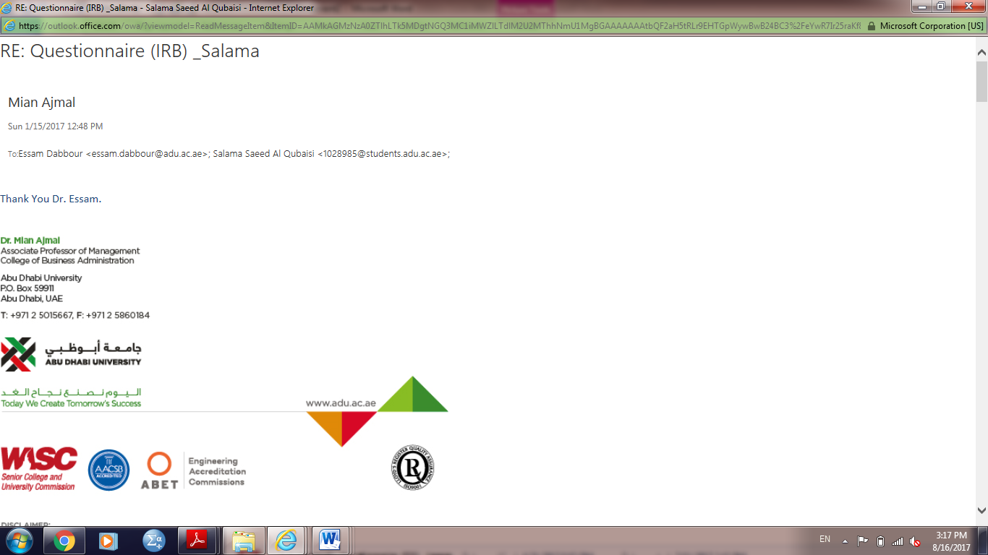

Appendix 1a: Ethics Electronic Approval (mail attached)

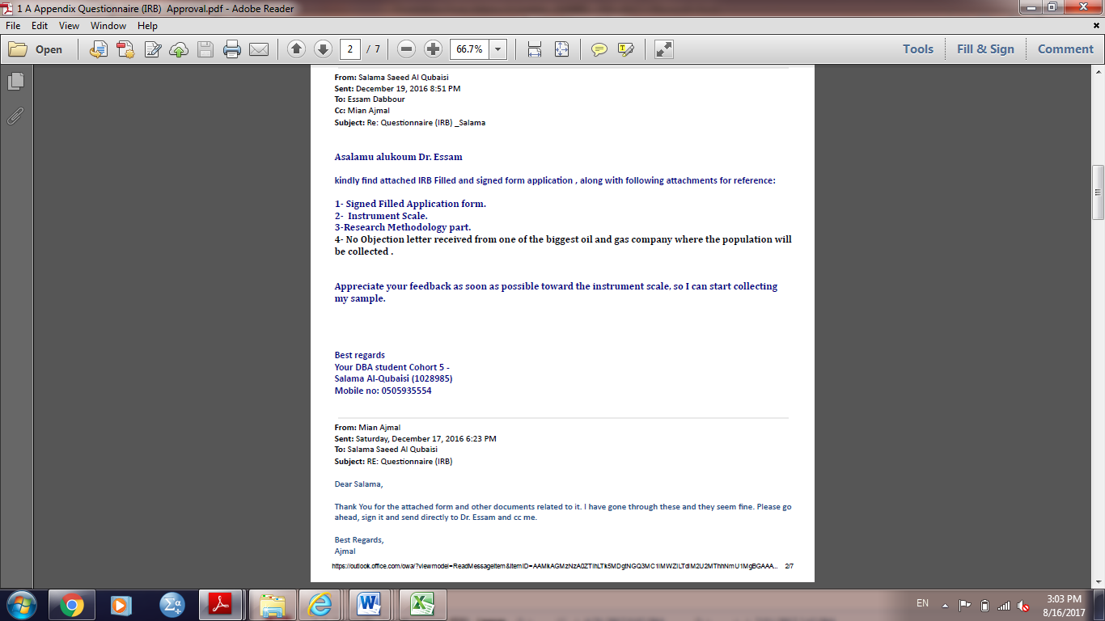
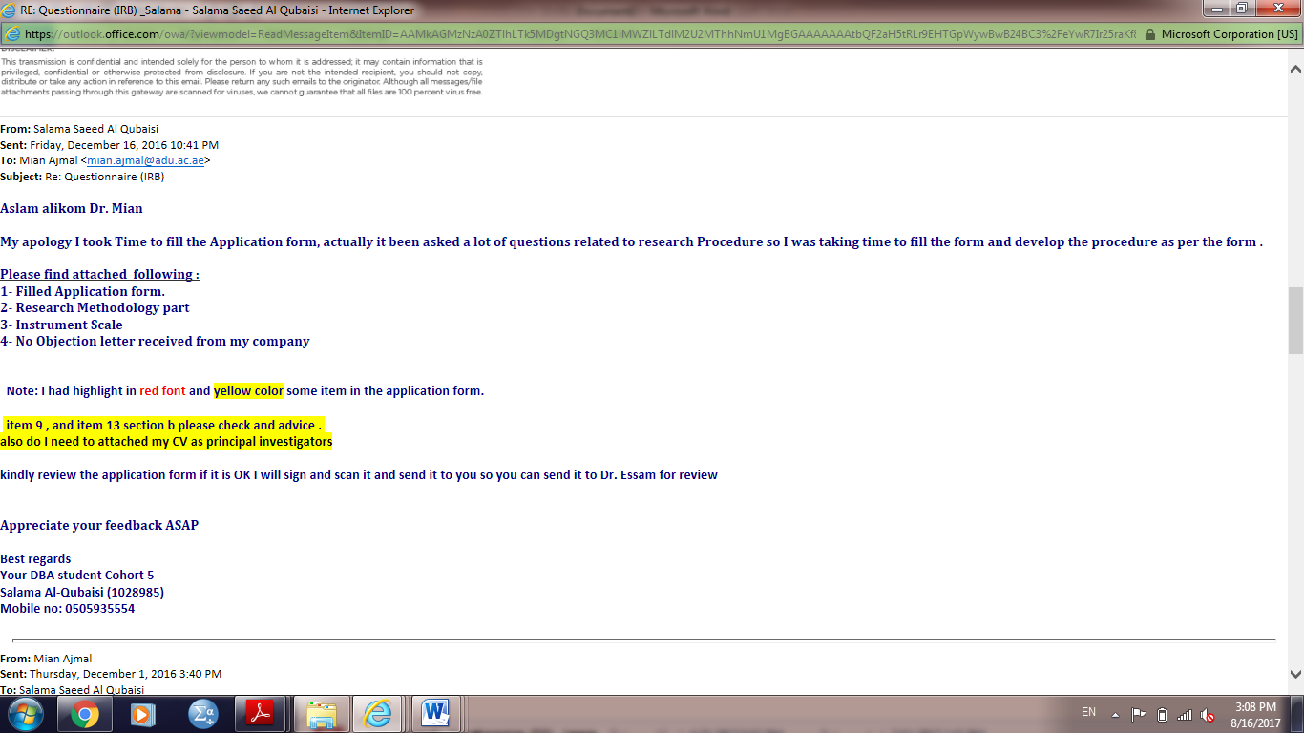


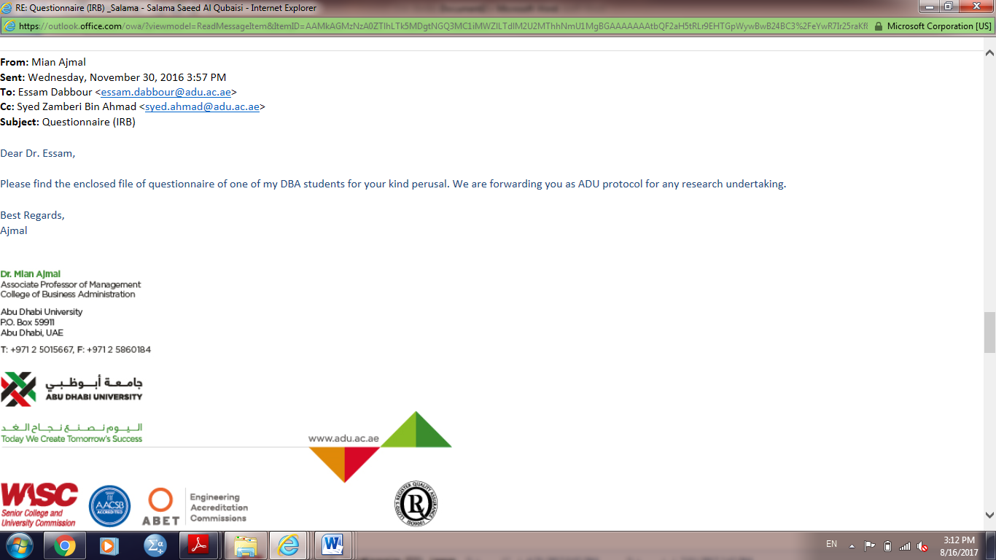


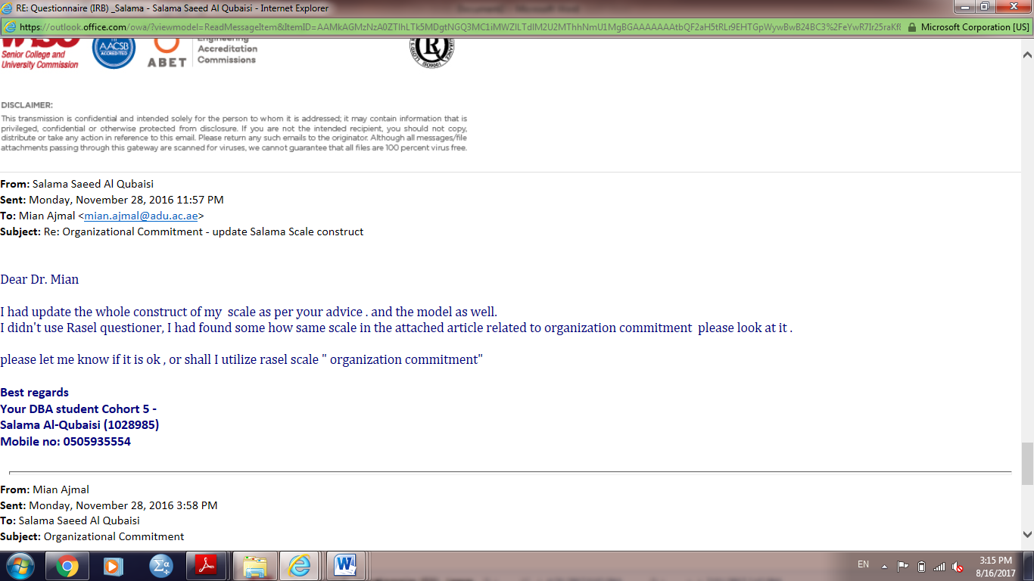


Appendix 2a: Cover Letter Company Approval (English version)

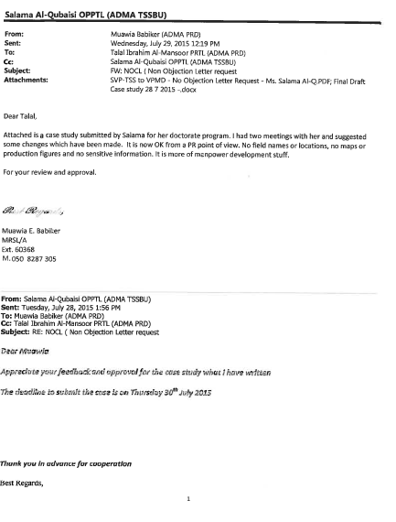





Appendix 3a: Invitation Cover Letter (English version)
SURVEY PARTICIPATIONS INVITATION COVER LETTER

Date: 16 January 2017

DEAR SURVEY PARTICIPANTS,

I am a Doctor of Business Administration candidate at the Business Administration in Abu Dhabi University, United Arab Emirates, in this program; all candidates are required to undertake a research project that examines a significant issue relating to a field of business. The issue I am investigating is the relation between Knowledge Management Practices (KMP’s), organizational culture (OC) and operational efficiency performance (OE) by using Balanced Scorecard (BSC) specifically in oil and gas sector in UAE. In today’s dynamic turbulent market place, businesses are required to adapt by developing new knowledge to generate new skills and capabilities. As a result, knowledge management has become as a powerful weapon for organizations to remain competitive.

In the trends of integration and merging big Offshore Oil and Gas Company together, Offshore Oil and Gas Company has emerged as a potential market with challenges and opportunities. Though knowledge management might still be a relatively new concept, it is becoming one of the critical issues that UAE oil and gas sector have to face, develop and exploit as a determinant of success.

As such, the purpose of this study is to provide practicing managers with useful comprehensive insights on knowledge management and assist them in answering the question “how the firms need to be effectively managed for their overall knowledge management capability to achieve, leverage, exploit, and sustain a competitive advantage in the current context of complex and challenging economic landscape?”

The questionnaire of this survey should be filled out by the senior executives of businesses, senior managers, leaders, middle managers, engineers, operators and administration operating in offshore Oil and Gas Company, who are knowledgeable of their organization’s knowledge as well as its culture. Completion of the survey is voluntary and you may withdraw at any time without any consequence. Data collected is anonymous, strictly confidential and will be kept in a secure place.

If you are willing to participate, please read the questionnaire carefully and answer all questions to the best of your knowledge. It would be much appreciated if you could return the survey in the return envelope before 15th March 2017.

If you would like to receive a summary of the research results when it is available, please send me a request to the address given below.

The ethical aspects of this study have been approved by the Committee in Abu Dhabi University Institutional Review Board (IRB). If you have any complaints or reservations about any ethical aspect of your participation in this research, you may contact the Committee through the Ethics Complaints Officer, Dr. Essam Dabbour (Tel: +971-2-501-5634, essam.dabbour@adu.ac.ae )
Any complaint you make will be treated in confidence and you will be informed of the outcome.

Should you have any queries about the survey please do not hesitate to contact me through below details. Thank you very much for your time and efforts and your contribution is highly appreciated.

Kind regards,

Researcher  Salama S. Al-Qubaisi  Student Doctor of College of Business Administration  Abu Dhabi University  Abu Dhabi, UAE  s-alqubaisi@hotmail.com | Researcher Supervisor  Dr. Mian M. Ajmal  Associate Prof. of Management  Department of Management  College of Business Administration  Abu Dhabi University  P.O. Box 59911, Abu Dhabi, UAE  mian.ajmal@adu.ac.ae

Appendix 4a: Final Questionnaire (English version).
Dear Responded:
The study examines the relationships among organizational culture, knowledge management practices and operational efficiency variables. There is no right or wrong answer. Several general questions about you and your company are included here. The approximate time to answer this questionnaire is 10 minutes; all individual data will be kept anonymous and will not be shared. Please start to fill the below demographic information section.
And thank you in advance for your cooperation for taking time out of your busy schedule to respond to questions in this survey.
Part1 :Demographic Information
Gender
0 |  |  |  |  | 1
Female |  |  |  |  | Male
Age
1 |  | 2 |  | 3 | 4 |  | 5 | 6 |  |  | 7
< 20 |  | 20-25 |  | 26-30 | 31-40 |  | 41-50 | 51-60 |  |  | >60 years
Function
1 |  |  | 2 | 3 | 4 |  | 5 | 6 |  |  | 7
Consultant |  |  | Project Manager | Department Manager | Operation Manager |  | Operator | Engineer |  |  | Others
Number of years that you have had the same kind of job (tasks)
1 | 2 |  |  | 3 |  |  | 4 |  | 5
0-3 | 4-6 |  |  | 7-10 |  |  | 11-15 |  | More than 15 years
Number of years that you have had been employed in this company
1 | 2 |  |  | 3 |  |  | 4 |  | 5
0-3 | 4-6 |  |  | 7-10 |  |  | 11-15 |  | More than 15 years
Education
1 | 2 |  |  | 3 |  |  | 4 |  |  | 5
Elementary school | High school diploma |  |  | University degree |  |  | Master degree |  |  | Ph.D. ( Degree)
Type of Business your organization
1 |  |  |  | 2 |  | 3 | 4 |  |  | 5
Service Oil and gas company  (consultant/vendor/contractors) |  |  |  | Exploring and producing Oil and Gas |  | Export and Import Oil and gas | Processing oil and gas |  |  | Institution of oil and gas

Scale items Part 2: Organization culture

Item | Trust, Members of our company […]: | 1-Strongly Disagree | 2-Disagree | 3-Undecided | 4-Agree | 5-Strongly Agree
TRU1 | 1. [...] can trust the attitudes and behaviour of other members.
TRU2 | 2. [...] have relationships based on reciprocal faith.
TRU3 | 3. [...] have reciprocal faith in others' ability.
TRU4 | 4. [...] are generally trustworthy.
TRU5 | 5. [...] have reciprocal faith in others' behaviour to work toward organizational goals.
Item | Commitment, Do you […]: | 1-Strongly Disagree | 2-Disagree | 3-Undecided | 4-Agree | 5-Strongly Agree
COM1 | 1. [...] would you be very happy to spend the rest of your career with this organization?
COM2 | 2. [...] really feel that this organization’s problems are yours?
COM3 | 3. [...] feel a sense of belonging in this organization?
COM4 | 4. [...] feel emotionally attached to this organization?
Item | Collaboration, Members of our company are […]: | 1-Strongly Disagree | 2-Disagree | 3-Undecided | 4-Agree | 5-Strongly Agree
COL1 | 1. [...] satisfied with the degree of mutual cooperation.
COL2 | 2. [...] able to help and support each other.
COL3 | 3. [...] willing to cooperate between departmental units.
COL4 | 4. [...] able take responsibility for their own learning.
Item | Competence, Our company members […]: | 1-Strongly Disagree | 2-Disagree | 3-Undecided | 4-Agree | 5-Strongly Agree
COP1 | 1. [...] can understand not only their own tasks, but also others' tasks.
COP2 | 2. [...] can make suggestions about the task of others'.
COP3 | 3. [...] can communicate well within their own and other department members.
COP4 | 4. [...] are specialists in their own task and responsibilities.
COP5 | 5.[...] can perform their own task effectively and adopt any organizational changes.

Scale items Part 3: Knowledge Managements Practices –
Item | Knowledge Creation, My organization has capability […]: | 1.Strongly Disagree | 2.Disagree | 3.Undecided | 4.Agree | 5.Strongly Agree
KC1 | 1. [...] to develop knowledge from internal knowledge workers.
KC2 | 2. [...] to codify the acquired knowledge into accessible and applicable formats.
KC3 | 3. [...] to store acquired knowledge into organizational knowledge archive.
KC4 | 4. [...] to train adequately by the successor(s) to undertake the duties.
Item | Knowledge Sharing, My organization has a process for sharing knowledge […]: | 1.Strongly Disagree | 2.Disagree | 3.Undecided | 4.Agree | 5.Strongly Agree
KS1 | 1. [...] between individuals.
KS2 | 2. [...] across teams.
KS3 | 3. [...] throughout the organization.
KS4 | 4. [...] among our business partners.
Item | Knowledge Utilization, My organization […]: | 1.Strongly Disagree | 2.Disagree | 3.Undecided | 4.Agree | 5.Strongly Agree
KU1 | 1. [...] promotes teamwork through the circulation of inter-departmental information and knowledge circulation.
KU2 | 2. [...] encourages a culture of knowledge sharing  (i.e. rewarding employees who have new knowledge, ideas or suggestions).
KU3 | 3. [...] conducts research surveys and education training.
KU4 | 4. [...] uses a knowledge management system in the spread and awareness of knowledge among employees.
Item | Knowledge Internalization, My organization […]: | 1.Strongly Disagree | 2.Disagree | 3.Undecided | 4.Agree | 5.Strongly Agree
KI1 | 1. [...] provides education and training to raise employee proficiency at new work tasks.
KI2 | 2. [...] can systematically manage its expertise and knowledge  (i.e. customer knowledge, demand forecasting).
KI3 | 3. [...] can establish standards for information resources, including data and knowledge, which are suitable for use within the organization.
KI4 | 4. [...] has regularly updated and properly maintained professional knowledge and information in a proper manner.

Scale items Part 3: Balanced Scorecard
Item | Financial Performance (FP), After the implementation of knowledge management practices, my organization has improved its ability […]: | 1.Strongly Disagree | 2.Disagree | 3.Undecided | 4.Agree | 5.Strongly Agree
FP1 | 1. [...] to increase net benefit.
FP2 | 2. [...] to improve economic value added.
FP3 | 3. [...] to enhance sales growth.
FP4 | 4. [...] to Improve operating efficiency.
FP5 | 5. [...] to increase return on investment.
Item | Customer Satisfaction (CS), After the implementation of knowledge management practices, my organization has improved its ability […]: | 1.Strongly Disagree | 2.Disagree | 3.Undecided | 4.Agree | 5.Strongly Agree
CS1 | 1. [...] to improve growth in market share.
CS2 | 2. [...] to increase customer satisfaction.
CS3 | 3. [...] to improve response time when handling customer complaints.
CS4 | 4. [...] to create new customers and retain existing customers.
CS5 | 5. [...] to increase corporate image and reputation by increasing the delivery in efficiency.
Item | Internal Business Process (IBP), After the implementation of knowledge management practices, my organization has improved its ability […]: | 1.Strongly Disagree | 2.Disagree | 3.Undecided | 4.Agree | 5.Strongly Agree
IBP1 | 1. [...] to systematize corporate internal processes.
IBP2 | 2. [...] to improve product or service quality.
IBP3 | 3. [...] to increase production efficiency.
IBP4 | 4. [...] to innovate new products or services.
IBP5 | 5. [...] to rapidly commercialize new innovations.
Item | Learning and Growth (LG), After the implementation of knowledge management practices, my organization has improved its ability […]: | 1.Strongly Disagree | 2.Disagree | 3.Undecided | 4.Agree | 5.Strongly Agree
LG1 | 1. [...] to improve skills of its employee skills.
LG2 | 2. [...] to improve employee satisfaction.
LG3 | 3. [...] to improve awareness of shared visions, objectives and values.
LG4 | 4. [...] to improve new product or service development to market.
LG5  *************************************Thank you ******************************************************* | 5. [...] to improve sharing of worker knowledge relevant to core abilities and enhanced task efficiency.

Appendix 5a: Reminder Letter (English version).
REMINDER SURVEY PARTICIPATIONS INVITATION COVER LETTER
Date: 15th February 2017

DEAR SURVEY PARTICIPANTS,

Last month an invitation letter seeking your input on email survey of knowledge management entitled with research Determinants of Operational Efficiency in the Oil & Gas Sector: A Balanced Scorecard Perspectives was mailed to you. I would much appreciate it if you could complete the questionnaire. If you have already responded, thank you very much for your assistance.

Background: I am a Doctor of Business Administration candidate at the Business Administration in Abu Dhabi University, United Arab Emirates, in this program; all candidates are required to undertake a research project that examines a significant issue relating to a field of business. The issue I am investigating is the relation between Knowledge Management Practices (KMP’s), organizational culture (OC) and operational efficiency performance (OE) by using Balanced Scorecard (BSC) specifically in oil and gas sector in UAE. In today’s dynamic turbulent market place, businesses are required to adapt by developing new knowledge to generate new skills and capabilities. As a result, knowledge management has become as a powerful weapon for organizations to remain competitive.

In the trends of integration and merging big Offshore Oil and Gas Company together, Offshore Oil and Gas Company has emerged as a potential market with challenges and opportunities. Though knowledge management might still be a relatively new concept, it is becoming one of the critical issues that UAE oil and gas sector have to face, develop and exploit as a determinant of success.

As such, the purpose of this study is to provide practicing managers with useful comprehensive insights on knowledge management and assist them in answering the question “how the firms need to be effectively managed for their overall knowledge management capability to achieve, leverage, exploit, and sustain a competitive advantage in the current context of complex and challenging economic landscape?”

The questionnaire of this survey should be filled out by the senior executives of businesses, senior managers, leaders, middle managers, engineers, operators and administration operating in offshore Oil and Gas Company, who are knowledgeable of their organization’s knowledge as well as its culture. Completion of the survey is voluntary and you may withdraw at any time without any consequence. Data collected is anonymous, strictly confidential and will be kept in a secure place.

If you are willing to participate, please read the questionnaire carefully and answer all questions to the best of your knowledge. It would be much appreciated if you could return the survey in the return envelope before 15th March 2017.

If you would like to receive a summary of the research results when it is available, please send me a request to the address given below.

The ethical aspects of this study have been approved by the Committee in Abu Dhabi University Institutional Review Board (IRB). If you have any complaints or reservations about any ethical aspect of your participation in this research, you may contact the Committee through the Ethics Complaints Officer, Dr. Essam Dabbour (Tel: +971-2-501-5634, essam.dabbour@adu.ac.ae )
Any complaint you make will be treated in confidence and you will be informed of the outcome.

Should you have any queries about the survey please do not hesitate to contact me through below details. Thank you very much for your time and efforts and your contribution is highly appreciated.

Kind regards,

Researcher  Salama S. Al-Qubaisi  Student Doctor of College of Business Administration  Abu Dhabi University  Abu Dhabi, UAE  s-alqubaisi@hotmail.com | Researcher Supervisor  Dr. Mian M. Ajmal  Associate Prof. of Management  Department of Management  College of Business Administration  Abu Dhabi University  P.O. Box 59911, Abu Dhabi, UAE  mian.ajmal@adu.ac.ae

Appendix 6a: Case Studies of Successful KM.

Case study ADMA –OPCO Knowledge Management Challenges

The Abu Dhabi Marine Operating Company (ADMA-OPCO) is a group of the Abu Dhabi National oil company (ADNOC) group. ADMA-OPCO is a major producer of oil and gas from the offshore areas of the Emirate of Abu Dhabi. Abu Dhabi is the federal capital of the United Arab Emirates and is the largest Emirate in the UAE. The UAE is a constitutional federation of seven emirates including Abu Dhabi, Dubai, Sharjah, Ajman, Umm Al Quwain, Ras Al Khaimah and lastly, Fujairah, which was formed in 1971. ADMA-OPCO company prides itself on being a pioneering offshore oil and gas producer organization in this part of the world, whose operations date back to the 1960s and are centered in the offshore areas of Abu Dhabi city of United Arab Emirates (UAE), having completed nearly half a century of oil and gas production.

The Oil and gas production comes from two major offshore oil fields with crude oil being transferred to Terminal Island for processing, storage and export. In 1962, the first crude shipment which came from offshore was exported from Abu Dhabi through Terminal Island. Furthermore, work is also in full swing in developing three more new fields.
The last five decades have seen ADMA-OPCO take a remarkable journey, which is reflected today in the unimaginable change in Abu Dhabi. In line with Abu Dhabi’s Vision 2030, ADMA-OPCO is playing a key role as the Emirate develops into a world city. (ADMA-OPCO 2014 Anuual Review, 2015)
ADMA-OPCO has long been aware of the importance of improved Knowledge Management and their practices in order to continuously sustain its excellence in operations. Embedded in its core values is the retention of knowledge in its operations, made easily accessible to the company to ensure operational efficiencies and the sustainability of its operations over time.
In-depth interviews were conducted one two key experienced people: the Senior Vice President technical standards and Manager Operation (MO). Throughout ADMA-OPCO organization, they initiated that the establishment of a “Lessons Learned” culture as part of knowledge sharing and supporting methodology, which they viewed to be vital in the pursuit of outstanding projects, operation delivery and functional excellence in engineering and project management. The Senior Vice President’s views on the matter illustrate his observations made from his experience in the Company: “Lessons can be simply defined as learning from our own and others’ experiences that have been physically implemented creating business value within a culture of continuous performance improvement. Success stories and hurdles / failures of ongoing and past activities may be relevant to build on or avoid in other ongoing or future activities for example: in projects, operations, drilling wells, commercial etc.”

The SVP declared that in the recent past, there had been various initiatives to put in place systems in ADMA-OPCO organization that record knowledge and lessons and make them available to staff.
In contrast, SVP had explained to ADMA-OPCO the complete Lessons Learned system that has been developed and is currently entering the implementation phase. It provides all the elements necessary to capture, analyse and take remedial action on any issue and to communicate and share results to achieve continuous improvement. With regard to information technology, they use collaboration and distributed learning technologies to allow their members to work together and collaborate interactively (e.g., e-learning, teleconferencing, video-conferencing, etc.). The foundational elements in the ADMA-OPCO Lessons Learned system include: leadership, structure, process and tools as pillars, all of which are needed to support information sharing. The main problem of the culture was missing. Whilst providing useful tools, they have only focussed on a single element of the knowledge/lessons transfer process and have not been wholly successful in creating an environment that actively promotes a learning culture.

Hence, the ADMA –OPCO Knowledge Management Challenges Losing ADMA-OPCO corporate knowledge is a major risk to the company, and the company requires competent employees to plan its field development and to operate and maintain its facilities in a safe and efficient manner. Since knowledge-based operations are highly valued in the company, it needs to start to develop mechanisms to establish a continuous flow of knowledge among its employees to ensure capturing the knowledge of its experienced employees. The Company must look at and address the key factors to sustain success of a Knowledge Management (KM) system, including the involvement and contribution of human capital, thereby giving more attention to not only the technological aspect but also the people consuming it. Through a robust process, Leadership commitment will be paramount to its success and improve the performance operational efficiency of the Company.
To solve the problem, the company revisited their Company vision, mission and values and they embedded the knowledge culture as part of company DNA by creating a right knowledge friendly culture and supporting methodology that actively promotes lessons learned across the entire organization and encourages all members of staff to provide and receive lessons on all topics pertaining to the Business Units activities. The new Strategy focusses on providing a holistic process that covers all aspects of Lessons Learned from capturing to delivering them into practice and will address both a) providing and transferring the lessons and b) receiving and implementing them. The intent is to make Lessons Learned a Business Unit core process that will have associated Key Performance Indicators (KPIs). Moreover, they should start focusing on T-shaped skills and knowledge of the employees via intensive training and job rotation and thus, the employees can understand not only their own tasks but also others’ tasks and are specialists in their own field of expertise.

The company realised that foundations of Mindset and Leadership are the fundamental social and cultural climate that the company needs for an effective Lesson Learned System. Information sharing provides the capstone that ensures the system works. To ensure the effectiveness of the Lessons Learned system. The Company had developed The Lessons Learned system that shall provide the elements necessary to capture, analyse and take remedial action on any issue and to communicate and share results to achieve improvement. The key elements of the Lessons Learned system are shown in Figure (A). These elements are represented as structure, process and tools pillars, all of which are needed to support information sharing.

Figure (A) Lessons Learned System
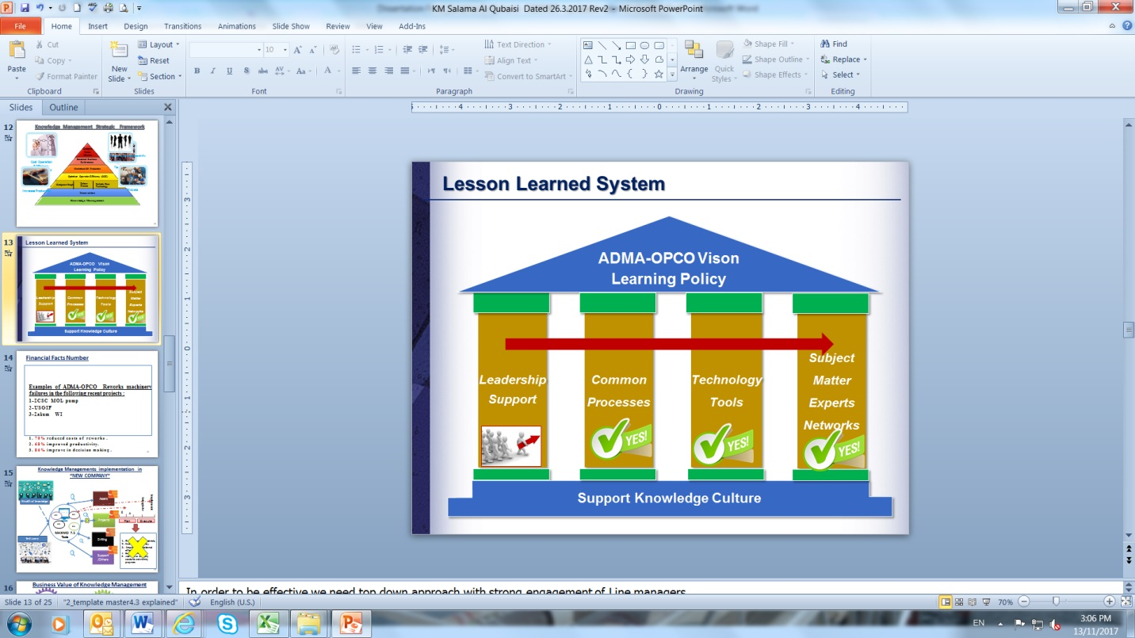

Vision Learning Policy
Leadership
Support Learning Culture (System)
Common Process
Technology Tools
Structure SME’s Networks
Leadership: | ADMA-OPCO with Leaderships will ensure sustaining the Lessons Learned culture.
Common Process: | ADMA-OPCO will have a common Lessons Learned process to develop lessons, to include Sharing and utilising it appropriately.
Technology Tools: | ADMA-OPCO will use technology to support collection, storage, staffing and sharing of Lessons Learned information
Subject Matter Experts (SME’s) Networks: | ADMA-OPCO will have an available network of SMS’s to support lesson learning system and approved Common Business Process Lesson Learned Management System.

